Tom Bennett, President NSSA

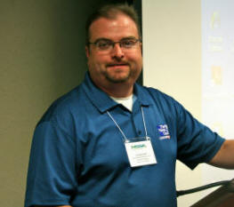
Tom Bennett is a board member of the National Storm Shelter Association and President of NSSA. He serves as Vice-President and General Manager of Jim Giles' Safe Rooms, LLC., based in the heart of tornado alley, Tulsa, Oklahoma. Tom is a meteorologist for the Tulsa CBS station.

Tom and Jim Giles worked together in TV weather for 16 years until Jim's retirement in 2006. After his life changing experience with an F4 tornado that moved through east Tulsa in 1975, Tom has been devoted to studying the severity of weather storms and also how to protect people from them.

