NFIP INSURANCE/LEGAL
1 Day WORKSHOP
January 8, 2018
State Office Building Auditorium
(Lunch Provided)

This Workshop will be composed of three elements.
- Why Utah Needs the NFIP
- Understanding the Basics of Flood Insurance
- Understanding the legal Implications of the NFIP
Register on Eventbrite
https://www.eventbrite.com/e/nfip-national-flood-insurance-program-insurancelegal-workshop-tickets-40798483362
Sponsored by the Utah Floodplain Program, FEMA, and UFSMA
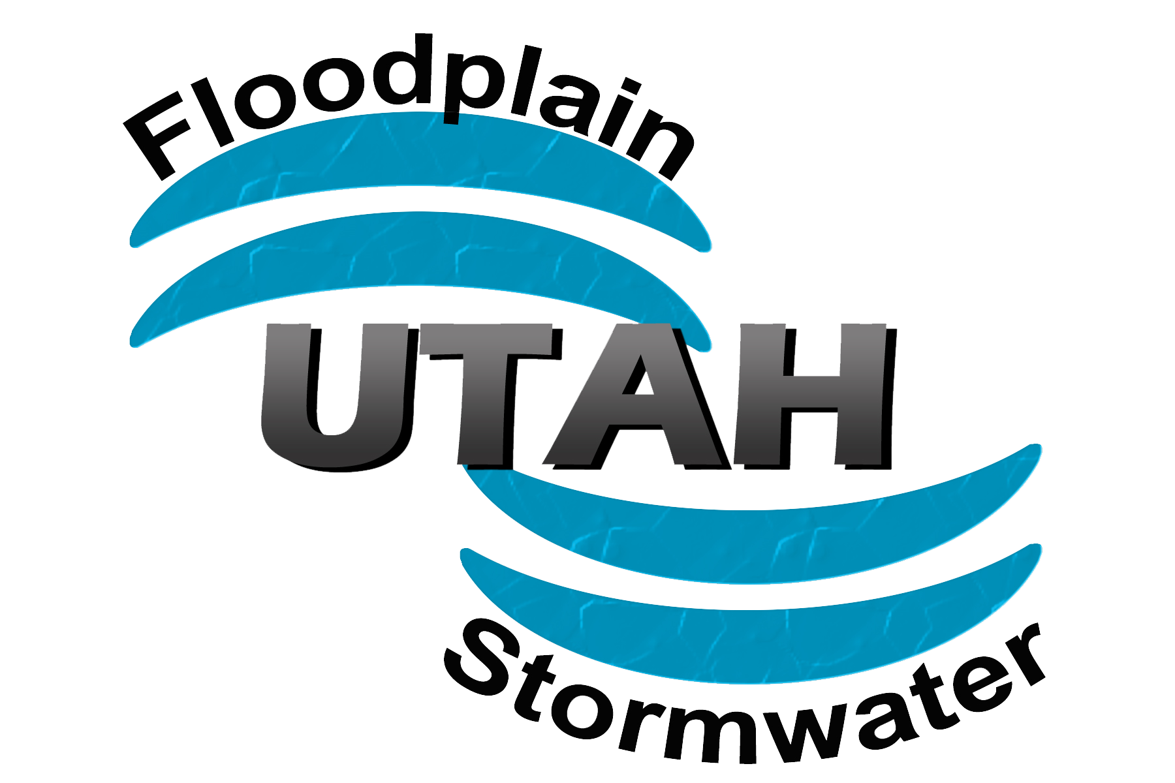
Workshop Components Descriptions and Bios:

Why Utah Needs the NFIP

Facilitators Bio:
Kathy Holder is the State Floodplain Manager/ National Flood Insurance Coordinator for the State of Utah. She has had 10 years’ experience in emergency management. She is a Certified Floodplain Manager. Kathy holds a position on the board of the Utah Floodplain and Stormwater Management Association. She holds degrees in Masters of Business Administration, Bachelors of Public Administration, and a General Science degree. She has taught at the University level for over 11 years.

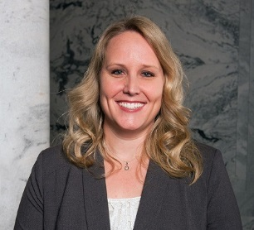

Facilitators Bio:

Jamie Huff has been the Risk MAP Program Manager for the Utah Division of Emergency Management since September 2015. As the Risk MAP Program Manager coordinates with Federal, State, Tribal, and local community partners to provide flood risk information and data, training, education, and resources in order to identify risk, assess risk, communicate risk, and mitigate natural hazard risks within Utah. Previous to DEM, she was with the Federal Emergency Management Agency (FEMA) Region 10 office, where she spent almost 13 years of her career holding several positions such as the Region’s Policy and Program Analyst, Floodplain Management Specialist, and Acting Mitigation Planning Manager. Jamie received her Bachelor of Science degree in Geography from the University of Utah in 2002 and also attended Texas A&M University for three years. Jamie is a Certified Floodplain Manager (CFM) and is a member of the UFSMA Board.

We will discuss examples of Utah flooding and types of flood hazards. The benefits of the National Flood Insurance Program and how you can mitigate flood risk. Flood Risk Mapping in Utah
Timing: 1 hour

Understanding the Legal Aspects of the NFIP

Facilitator BIO:
Edward A. Thomas, Esq.
Two Sentence biography: Ed Thomas is a Floodplain Manager, and Disaster Response and Recovery Specialist, who is also an Attorney. His primary concern is the prevention of misery to disaster victims, the public purse, and to the environment. Hazard Mitigation and Climate Adaptation through the Law is his chosen method of accomplishing this goal.
Ed Thomas is the President of the Natural Hazard Mitigation Association. He is both an elected Fellow of the American Bar Association Foundation and an elected member of the Council of the State and Local Government Section of the American Bar Association (ABA). He was also appointed to be a member of the ABA Disaster Response and Preparedness Committee and also to be the Chair of the Hazards Sub-Committee of the Land Use Planning and Zoning Committee, of the ABA. In addition, Ed serves on the Advisory Committee of the Natural Hazards Center of the University of Colorado. He is an active member of the American Society of Adaptation Professionals, and the Association of State Wetland Managers. He is a former Board Member of the Association of State Floodplain Managers (ASFPM); and currently serves as the Senior Liaison and Legal Liaison to the ASFPM No Adverse Impact Committee.
Ed retired from the Department of Homeland Security-Federal Emergency Management Agency after nearly thirty-five years of Public Service. During his time in government, he worked primarily in Disaster Mitigation, Preparedness and Response. He also was extensively involved in Community Development, during his nearly 10 years with the Department of Housing and Urban Development. Ed also worked for the Michael Baker Jr. Engineering firm for over eight years.
Ed worked on about two hundred disasters and emergencies, serving as the President’s on scene representative, the Federal Coordinating Officer, dozens of times.
Attorney Thomas is a graduate of Fordham College and a magna cum laude graduate of the New England School of Law in Boston. He a frequent lecturer on Emergency Management issues, especially the Constitutional and Legal Aspects of Floodplain Regulations. He has authored dozens of publications and articles on various Disaster Risk Reduction related issues and regularly participates as a member of National Task Forces and other boards in developing National disaster-related and floodplain management policies.
Ed has received numerous national and international awards including the nation’s highest award for Floodplain Management: The Goddard-White Award from the Association of State Floodplain Managers. In addition, he received the Gulf of Maine Visionary Award from the International Gulf of Maine Council, for his efforts in helping develop the NOAA StormSmart Coasts Program; as well as the first lifetime achievement award from the Georgia Association of Floodplain Management. He also received the Arkansas Floodplain Management Association Superior Excellence Award as well as twice receiving their “Silver Sandbag” Award.
He manages a private practice of Law, Edward A. Thomas Esq., LLC and lives with his wife in the floodplain of beautiful Marina Bay in Quincy, Massachusetts.
Contact information:
Edward A. Thomas Esq., LLC
21 Schooner Lane
Quincy, MA 02171-1550
edwathomas@aol.com 617-515-3849
The Legal and Policy portion of the Utah Floodplain Managers Workshop is designed for everyone involved in making community development decisions: Legal experts, Insurance Agents, Surveyors, Real estate Agents, community officials, developers, architects, engineers, government leaders, floodplain managers are strongly encouraged to attend.
This workshop will:
a) explain the ancient legal roots of the National Flood Insurance Program and “No Adverse Impact”, or :Safe Development” ;
b) demonstrate how floodplain management and other forms of regulation designed to prevent harm can be structured to avoid much, if not all, of the uncertainty surrounding the “Takings” issue;
c) explain how property rights principles support floodplain and other natural hazard regulations;
d) demonstrate that local floodplain management designed upon the “Safe Development” or “No Adverse Impact” concept is not anti-development but rather protects property rights of everyone in our State,
Timing: 3 Hours
Understanding the Basics of Flood Insurance

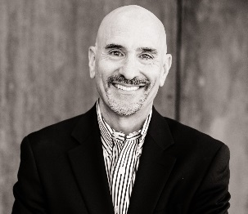

Facilitator Bio: Bruce A. Bender, CFM, is an outreach and insurance specialist who has been providing community engagement, outreach and training/facilitation services and acting as a flood insurance specialist since 2002. He has consulted on FEMA’s Map Mod and Risk MAP efforts, as well as on FloodSmart, the NFIP’s national marketing campaign. Bruce has also assisted CTPs and local counties and communities with their outreach needs related to map changes as well as provide training on flood insurance and the Community Rating System (CRS). Previously, he managed one of the largest Write Your Own (WYO) flood insurance programs for more than 10 years and an insurance agency. Bruce has a B.S. in Geology from The College of William and Mary……and a flood insurance policy!

Flood insurance has become an extremely complicated product, which even the most seasoned insurance professionals sometimes find challenging to write. While three hours will not make you an expert, this course provides the ABCs behind the policy to allow participants to engage in basic dialog with community members. It also includes an update on the latest changes being implemented by FEMA in response to recent NFIP reform legislation, along with strategies for reducing the risk and the cost. In addition, the impacts of map changes on flood insurance and available rating options will be reviewed. At the end of the course, participants should be equipped to answer basic flood insurance questions, understand the impacts and rating options related to map changes, discuss mitigation actions that can lower rates, and direct community members to additional resources.

Objectives: Participants will:
- Learn
  - What an NFIP flood insurance policy does and does not cover
  - Basic definitions, several of which are unique to flood insurance
  - About the essential elements needed to write a policy
  - How elevation differences and flood zones impact rating
  - The effects of map changes on insurance and rating options
- Receive an update on the latest changes to the insurance program
- Be introduced to additional flood insurance resources
- Hear strategies for reducing flood risk and hence the rate charged

Format: This workshop is offered as a three-hour workshop with presentation slides and set Q&A periods with a Q&A at the end.

Timing: 3 hour

Audience: This workshop is suitable for Floodplain Managers and other local officials, Insurance Agents, Surveyors, Real estate Agents, and other related stakeholders.

The Utah State Bar may also provide CLE credits for this course, on an individual basis to Attorneys who practice in this area of law. The Association of State Floodplain Managers has been requested to provide credits for Certified Floodplain Managers. Insurance Agent credit is also available.

