Tips for Accessing WebEx
There are two primary ways to access a WebEx webinar: through a temporary extension or by installing the extension. Both methods work equally well. Installing the extension may make future WebEx logins faster. Below are instructions for both methods.

Installing a Temporary Extension
Step 1: Click on the link provided in the meeting appointment
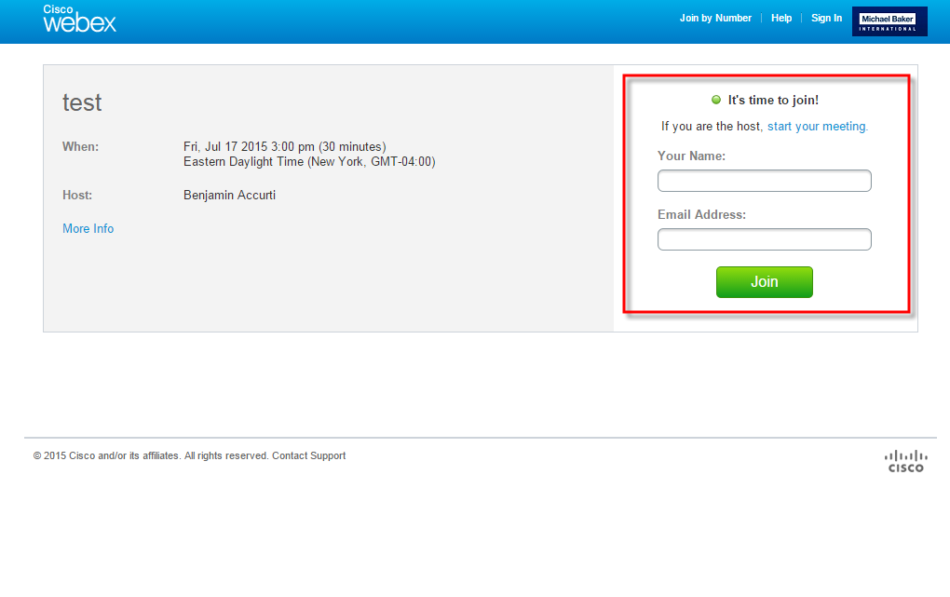
Step 2: Sign in using your name and affiliation. For example, “John Doe, FEMA Region I.”

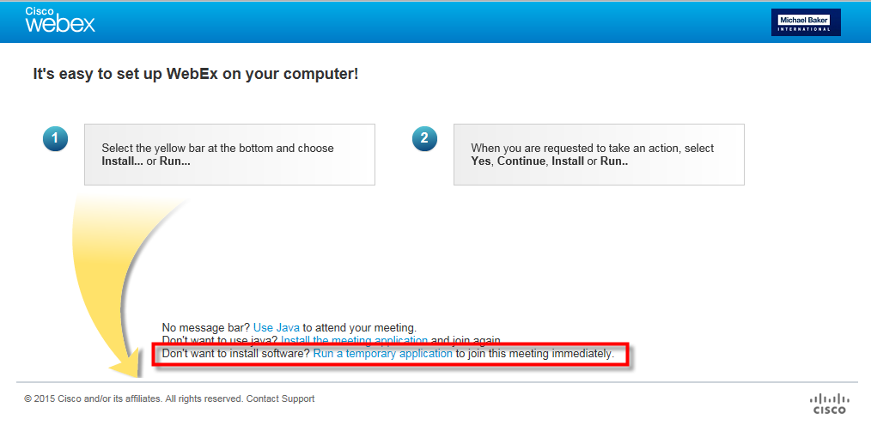
Step 3: Click the third option for Don’t want to install software? Run a temporary application to join this meeting immediately.
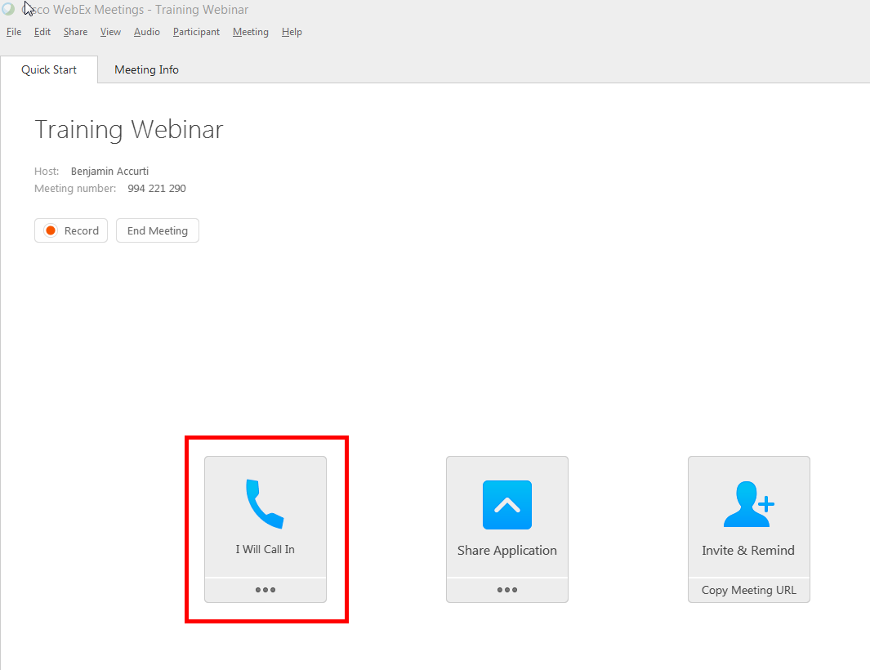
Step 4: Once you are in the WebEx application, you will be prompted to select an option for how you would like to dial into the audio portion of the webinar. Select the I Will Call In option. An access code and an Attendee ID will be assigned to you.

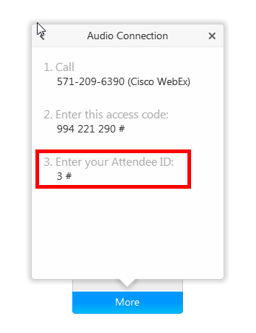
Step 5: Dial the phone number and enter the access code. When prompted by the automatic operator, enter the Attendee ID number. This will synch your computer with the presentation audio and identify you by name in the attendee list.

Installing an Extension
NOTE: Please log in approximately 5 minutes before the webinar starts to allow time for the extension to load.

Step 1: Click on the link provided in the meeting appointment

Step 2: Sign in.

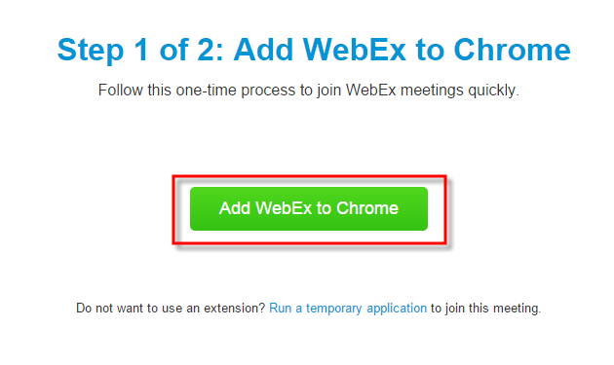

Step 3: Click the green Add WebEx button

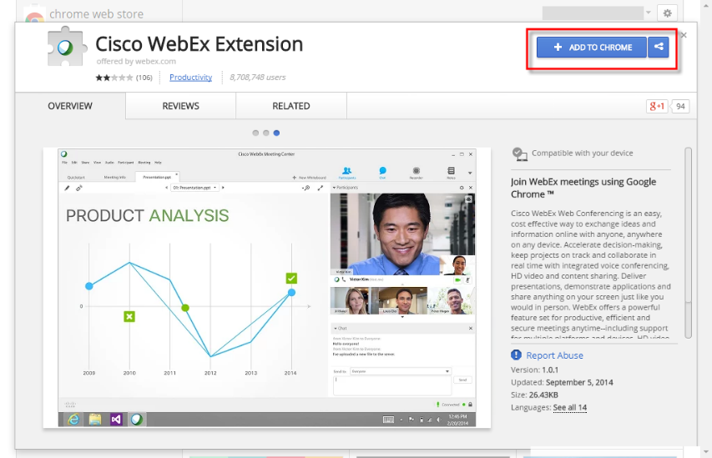
Step 4: Click the blue + ADD TO button

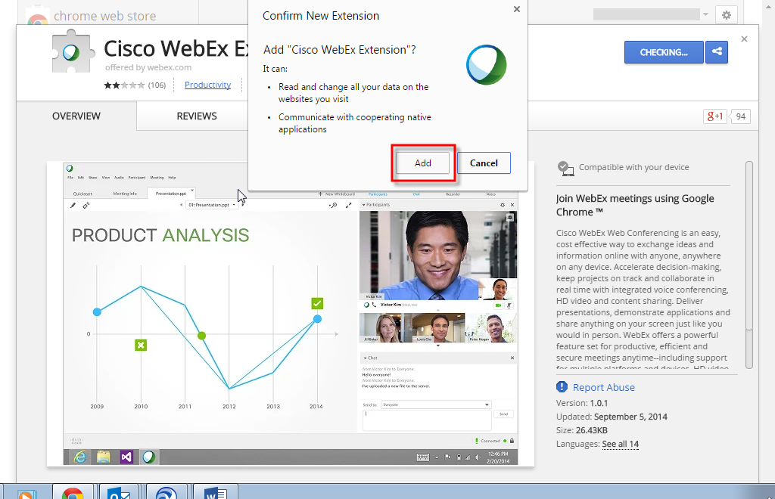
Step 5: Click the Add button

Step 6: Once you are in the WebEx application, you will be prompted to select an option for how you would like to dial into the audio of the webinar. Select the I Will Call In option. An access code and an Attendee ID will be assigned to you.

Step 7: Dial the phone number and enter the access code. When prompted by the automatic operator, enter the Attendee ID number. This will synch your computer with the audio and identify you in the attendee list.

