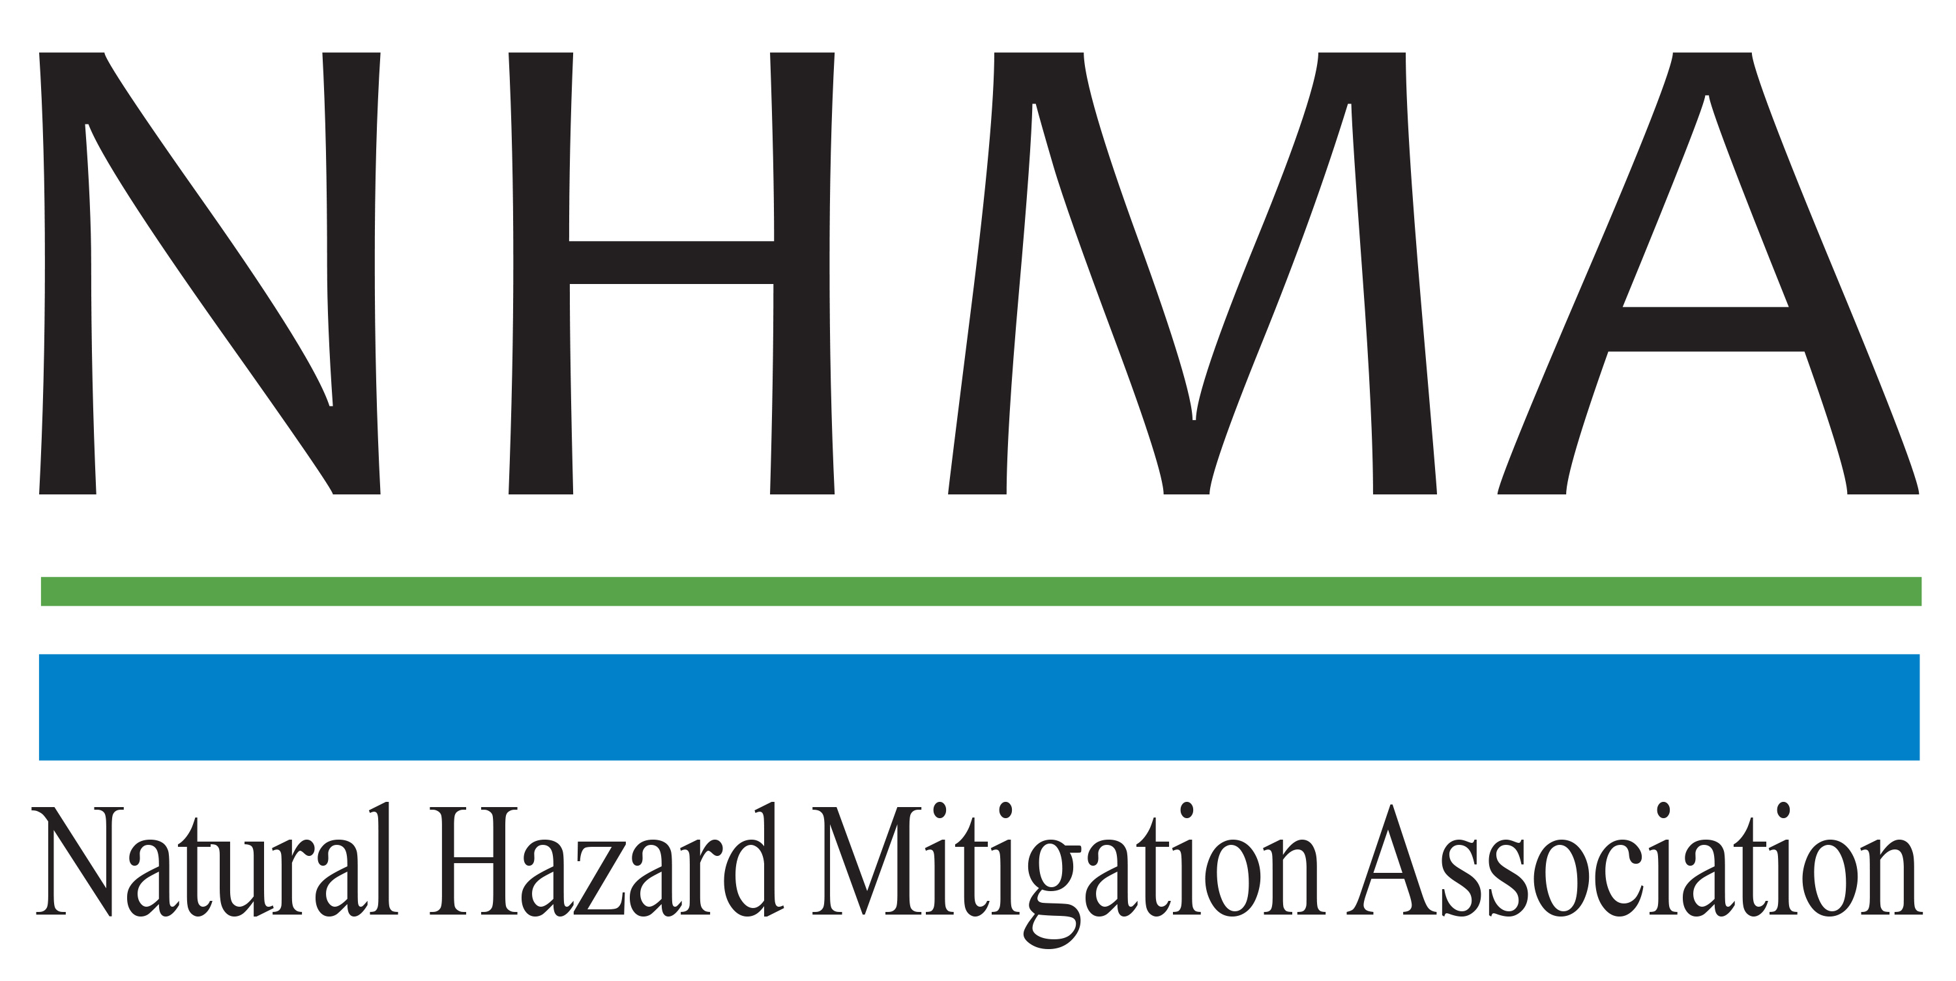

Disaster Risk Reduction (DRR) Ambassador Curriculum

Instructor Guide

Module 1:

Introduction to the
Natural Hazard Mitigation Association (NHMA)
and Disaster Risk Reduction (DRR)
Ambassador Curriculum

THE DRR AMBASSADOR CURRICULUM
The goal of the DRR Ambassador Curriculum is to facilitate Disaster Risk Reduction efforts for the whole community by:
- Engaging in discussion of how disasters can be reduced through local action
- Sharing insights among local leaders and technical experts to enable the development of cross functional solutions
- Acquiring the best-available information, knowledge of best practices, and analytic tools to enable better-informed decisions before, during, and after disasters
It is important for instructors of DRR Ambassador Curriculum modules to remember this is one module in a 24-module curriculum. The “DRR Ambassador Curriculum At-a-Glance” table, located at the end of this document, lists the modules of the Curriculum. Keep in mind the following context for the module(s) you conduct:
DRR-A CURRICULUM TARGET AUDIENCE
The target audience includes those involved in community development decision-making, such as local community staff, volunteer and stakeholder groups, and federal and state officials.
METHODS OF DELIVERY
Varied delivery methods will provide multiple options for access by the target audience. The DRR Ambassador modules may be presented via webinars hosted by NHMA or partner organizations, presented in conferences and/or classrooms by qualified DRR Ambassador Curriculum instructor(s), or are downloadable for individual study from the NHMA website.
COURSE MATERIALS
Instructors are expected to use the instructional materials housed on the NHMA website to conduct DRR Ambassador Curriculum modules (Instructor Guide, supporting visuals, Participant Guides, and handouts). Instructors may tailor modules to specific audiences or locations as long as they do not revise the learning objectives and do not revise the materials in such a way that the participants cannot correctly complete the post-test. Instructors request the current pre/post-test for the module from NHMA.
CERTIFICATES OF COMPLETION
Certificates of Completion will be awarded by NHMA to participants who successfully complete NHMA-sponsored DRR Ambassador modules. A DRR Ambassador Certificate will be awarded to individuals completing all 24 modules. Participants who choose not to take the post-test may be issued a Certificate of Attendance. Contact NHMA about obtaining certificates. Inform participants to ask their certifying boards about acceptance of NHMA DRR Ambassador certificates for continuing education credits.

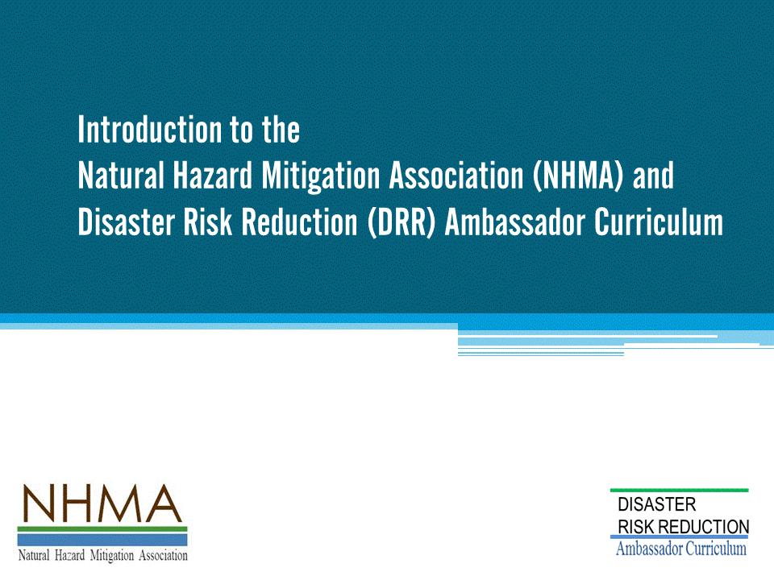
Approximate delivery time: 45-60 minutes

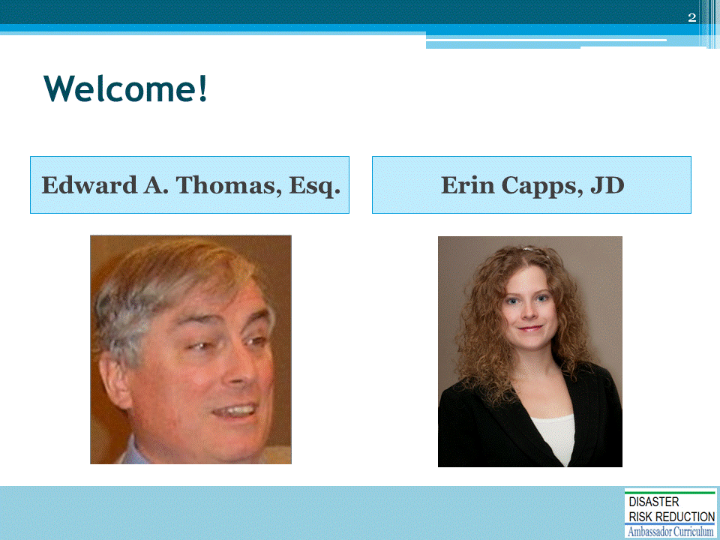
Introductions:
- Each presenter introduces her/himself, including affiliation and brief background.
- OPTIONAL: Have each participant briefly introduce him/herself
Mention: NHMA presentations are based on general principles of law, engineering, policy and emergency management.

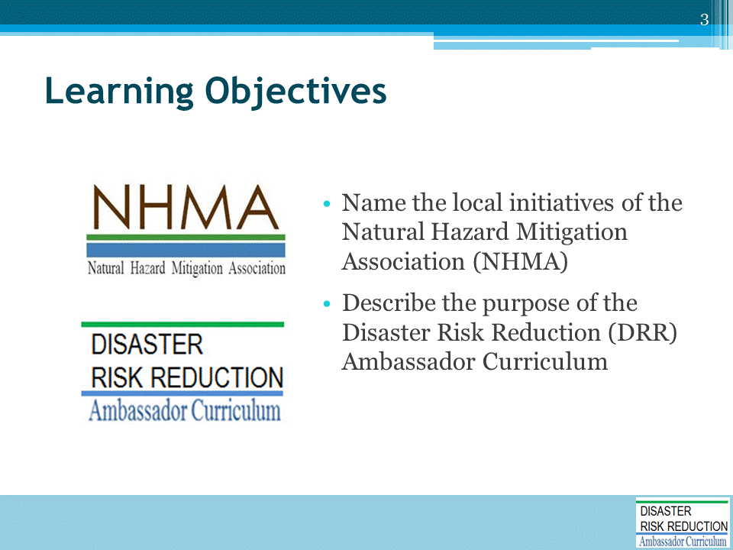

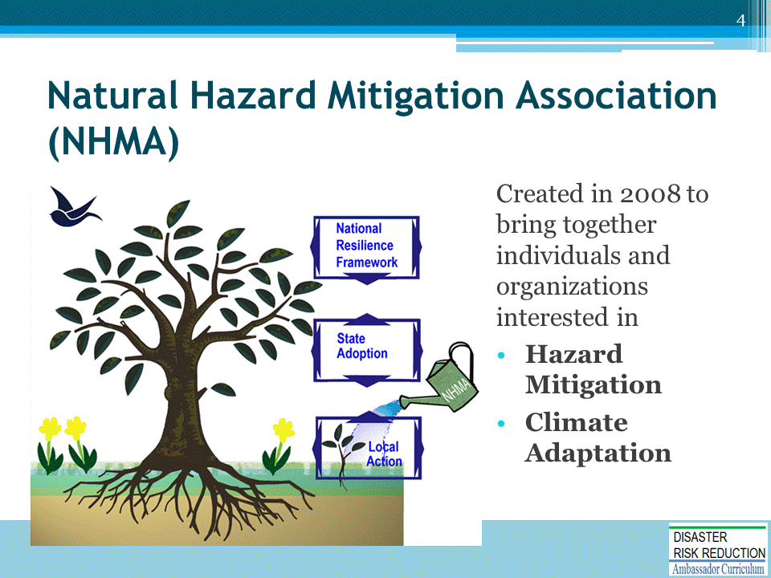
Point out the NHMA vertical integration from national policy (National Resilience Framework) to local action.
- We promote good, thoughtful development that does not harm people and property.
- Disaster Risk Reduction will take place or not take place mostly based on local decisions.

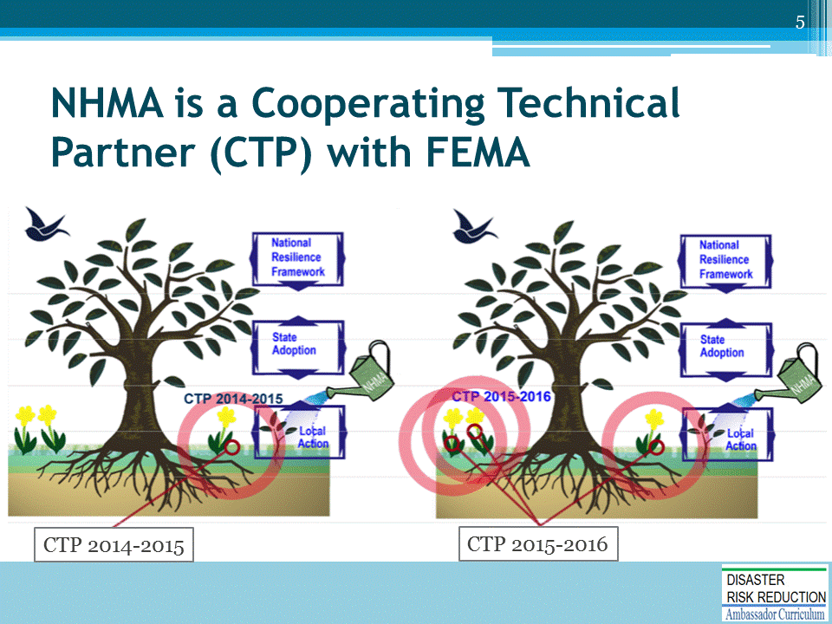
NHMA is the recipient of a Cooperating Technical Partner (CTP) grant through the Federal Emergency Management Agency (FEMA) in support of the Resilient Neighbors Network (RNN) and education and training for communities.
LEFT PANEL: CTP 2014-2015 focus is to support local community leaders to be informed and effective participant in grassroots Disaster Risk Reduction (DRR) programs and projects.
RIGHT PANEL: CTP 2015-2016 focus is to enlarge RNN community participation, demonstrating meaningful progress in DRR through innovative partnerships and training resources.

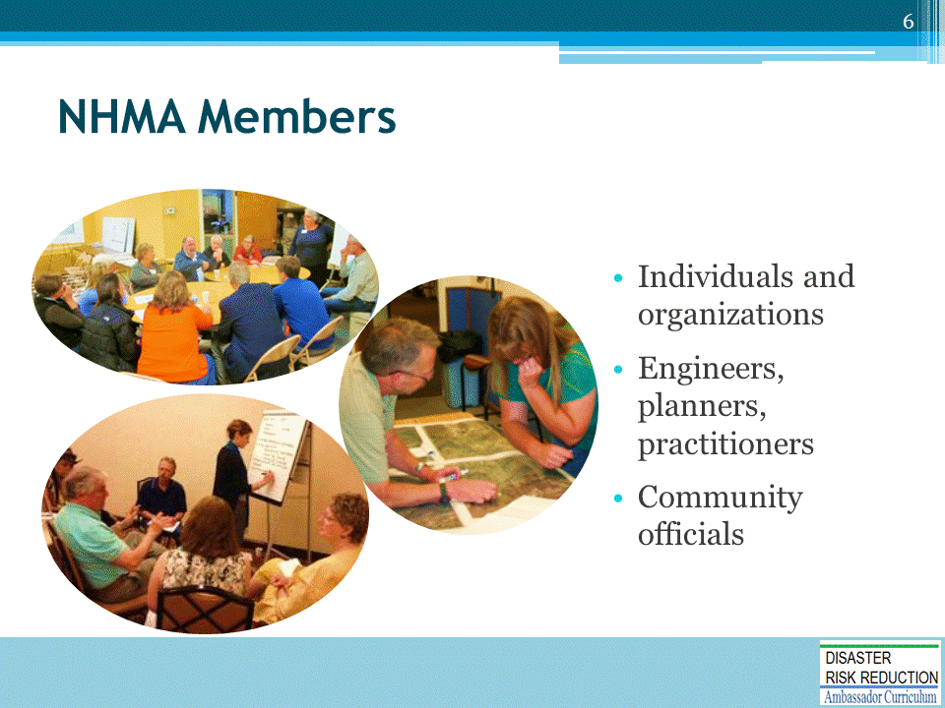
NHMA members include:
- Individuals and organizations who want to make a difference and mitigate natural disasters.
- Engineers, planners, floodplain managers, government officials, community activists, academics, practitioners, students, and more
- People involved in building resilient organizations and communities
We wish membership included some of you!
There is a special rate for partner organizations like local governments.

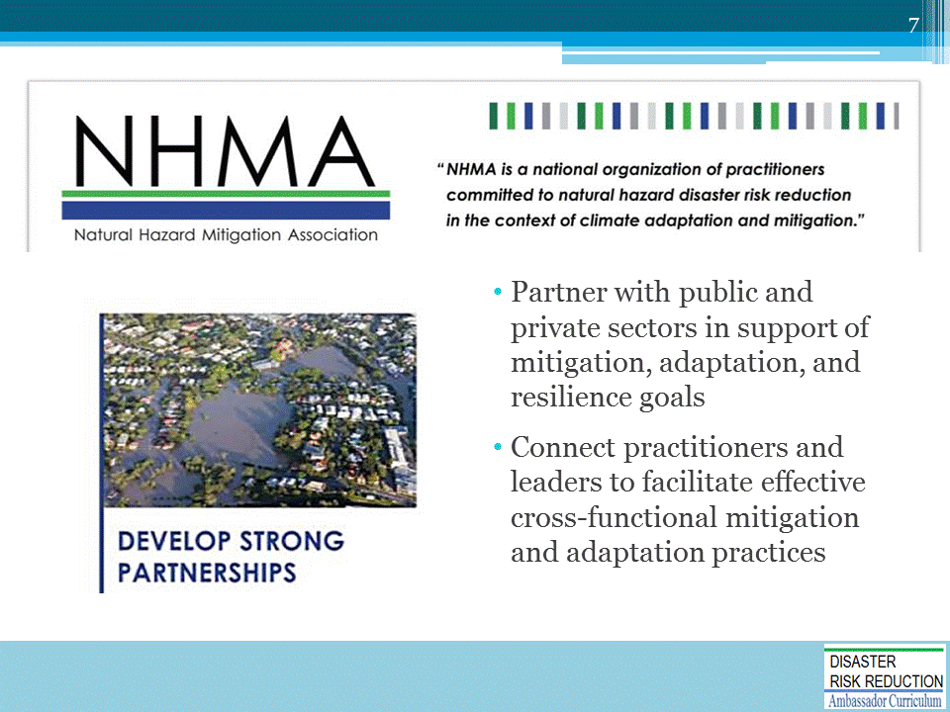
NHMA promotes natural hazard mitigation and adaptation through Disaster Risk Reduction (DRR). This is accomplished by creating an all-inclusive community forum to:
- Share ideas and experiences.
- Develop a thoughtful and unified voice.
- Promote greater awareness of the social, economic, and environmental components of safe and resilient development.
- Create more equitable, safe, and sustainable hazard mitigation programs so that that foreseeable natural events do not become disasters.

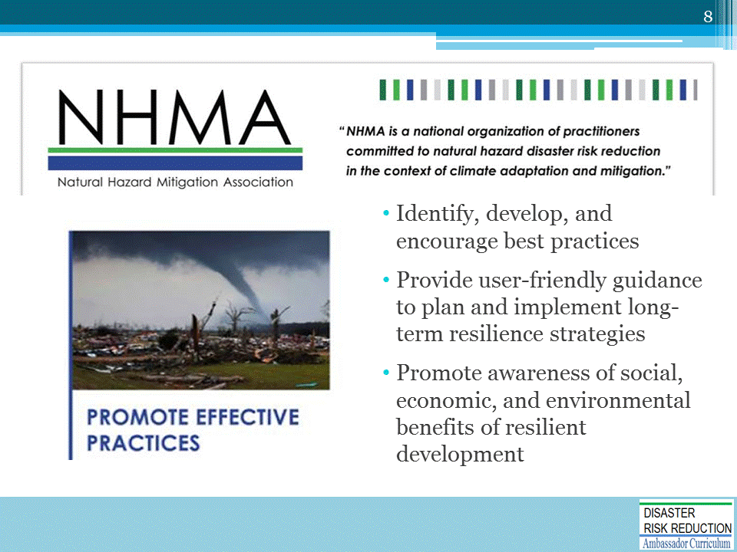

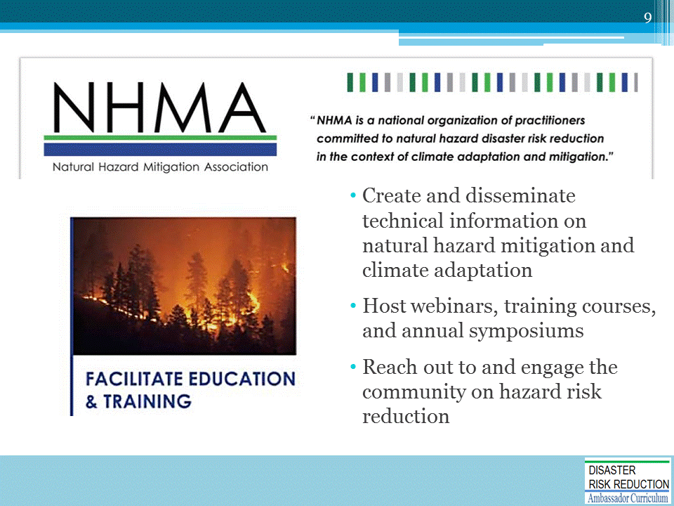

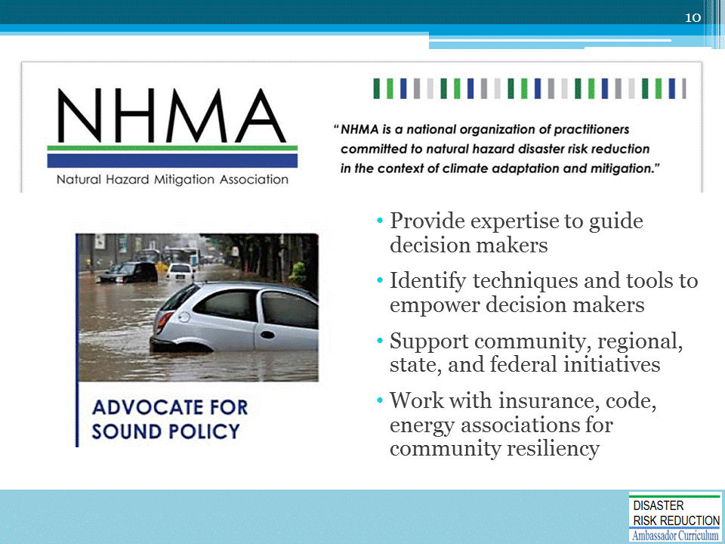

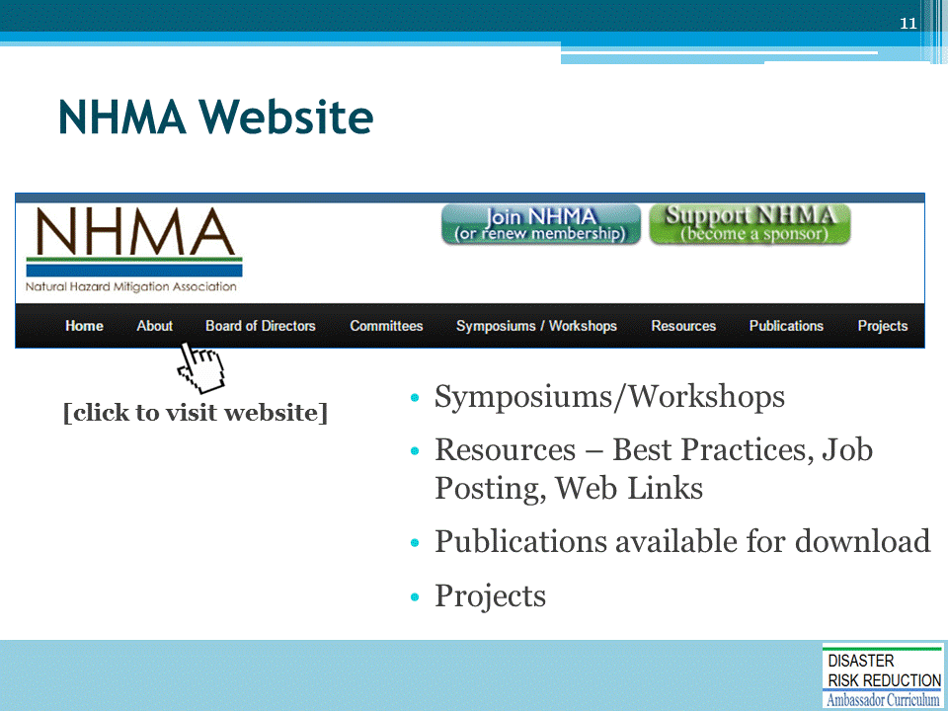
NHMA Website: http://nhma.info/

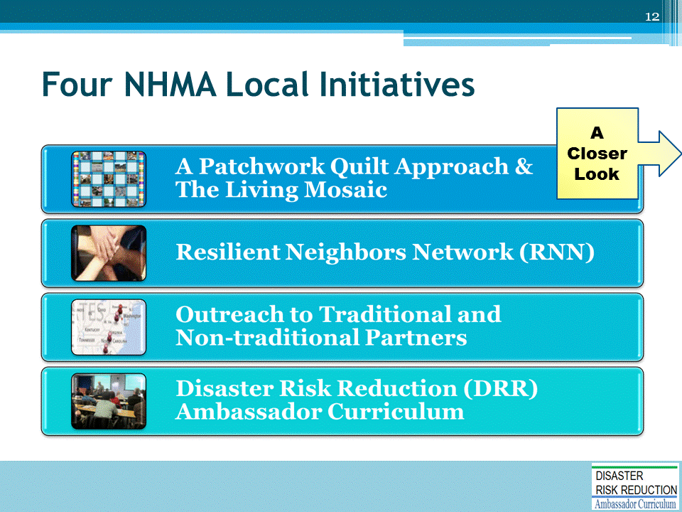
NHMA has four local initiatives. Each will be described in detail on the following slides.

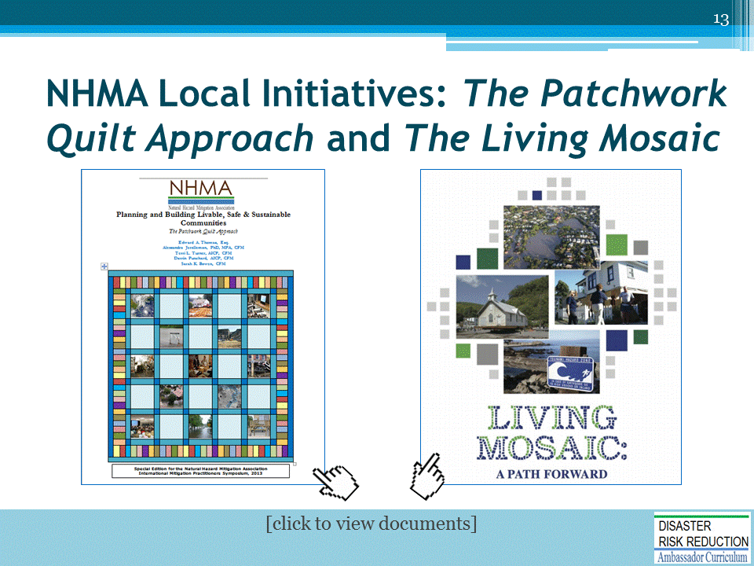
These documents were developed and updated by NHMA members.
- Urge bringing all available resources to bear on solving problems related to Disaster Risk Reduction for all in the entire community
- Are go-to publications that provide resources based on all aspects of the disaster cycle
A Patchwork Quilt Approach: http://nhma.info/publications/the-patchwork-quilt/
The Living Mosaic: http://nhma.info/wp-content/uploads/2016/04/A_Living_Mosaic_FINAL.pdf

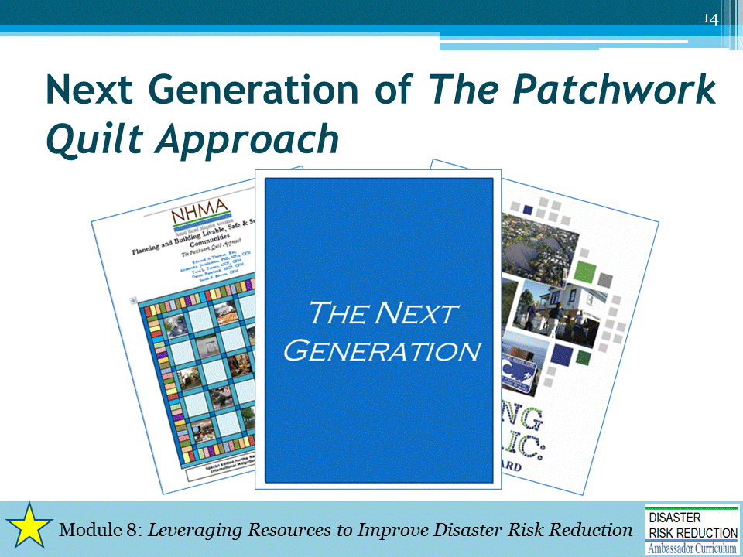
This document builds upon the predecessor documents, The Living Mosaic and The Patchwork Quilt Approach.
- Includes new and updated content
- Describes actionable paths to get to disaster resilient rebuilding, including examples that illustrate how the paths can be, and has been, followed
MENTION this document is more fully described in Module 8 of the DRR Ambassador Curriculum, Leveraging Resources to Improve DRR

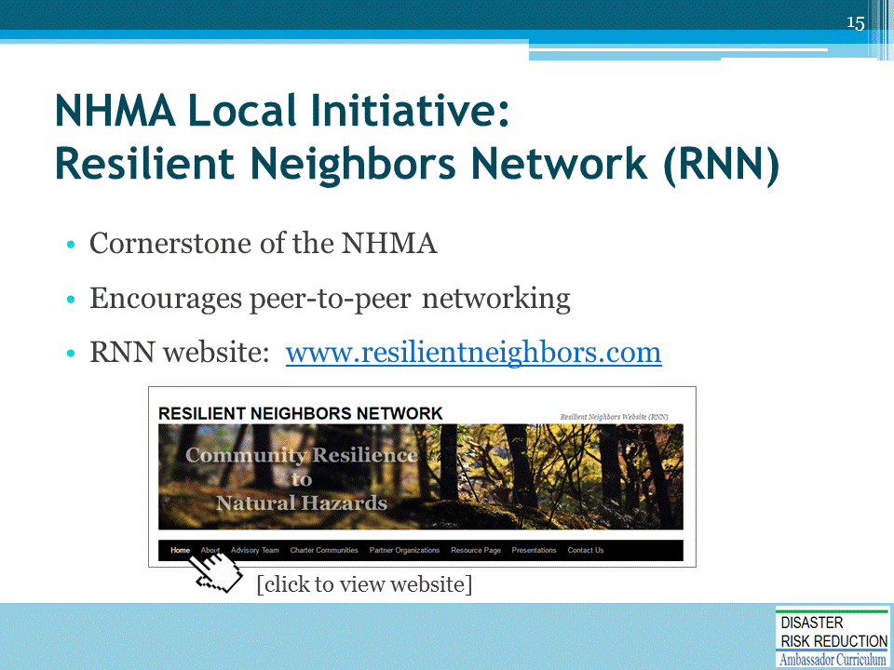
NHMA has found the RNN Framework to be incredibly beneficial to help create peer-to-peer networking between and among professionals representing communities actively working towards Disaster Risk Reduction and reducing disaster costs, risks, and consequences
- A peer that does your job elsewhere with same or different hazards and risks - but that knows the city, county, or state level – where the rubber hits the road.
- Locals wear many hats – the RNN allows the opportunity to brainstorm, get advice, capture lessons learned, and to not recreate the wheel.
- Learn from others who have been where you are within the Mayor’s Office, Planner’s Office, Emergency Managers Office, or all of the above.
The conversation and sharing of information on the monthly RNN calls are very inspiring.
Organically, the RNNs are being called on by other communities to provide technical assistance and guidance – for example…
Year 1 RNN Accomplishments:
- Creation of Steering Committee composed of 10 pilot communities and NHMA facilitators
- Creation of an Advisory Team
- Completion of an initial framework plan
- Various educational webinars, presentations, and other opportunities for the exchange of knowledge
- RNN communities provided comments to various federal agencies regarding local impacts of initiatives.

(Continued)
Year 2 RNN Goals:
- Expand and strengthen peer-sharing network of communities and advisory team
- Test and document peer-sharing and mentoring models and methods for resilience
- Document resilience best practices
- Provide practitioners feedback on policy and practices for FEMA and others
- Expand community engagement and resilience strategy framework in July workshop
- Update RNN Framework

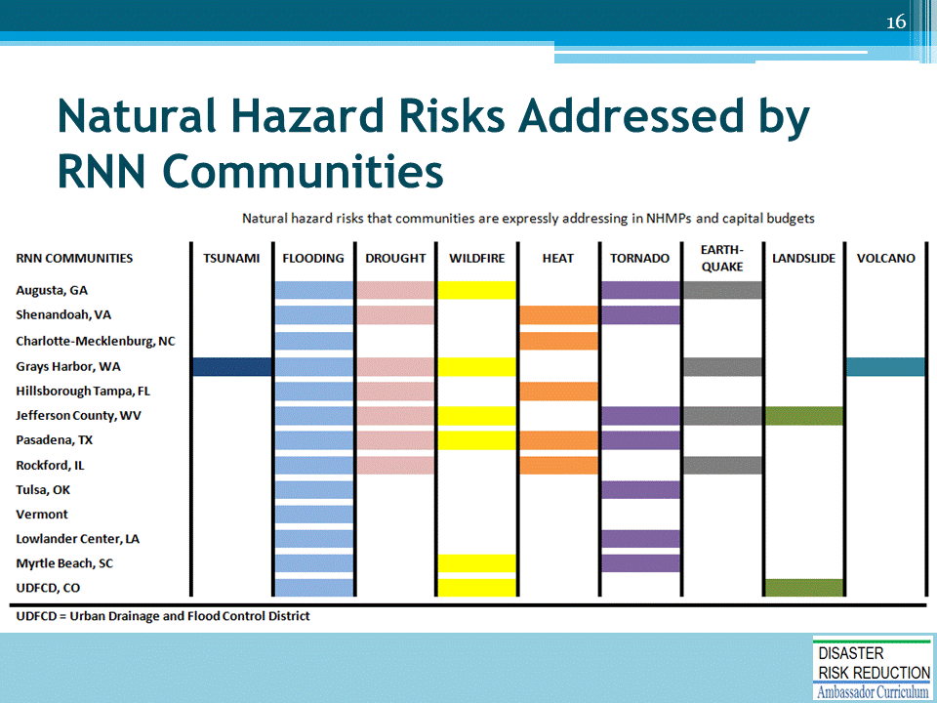
The NHMA RNN began in 2013.
Briefly describe table.
- Nine (9) natural hazards risks in are addressed by the RNN communities
- Flooding is a risk in all the RNN communities

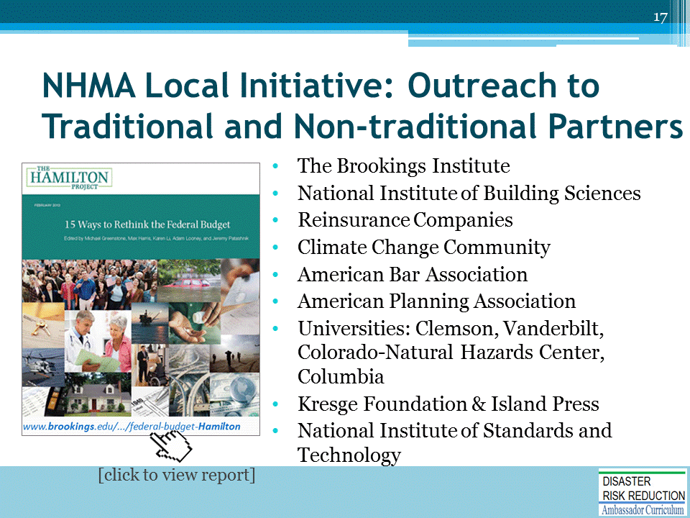
The NHMA helped develop a report for the Brookings Institute, which makes an economic case for Hazard Mitigation and Climate Adaptation.
We work with others to get the concept of Hazard Mitigation/Climate Adaptation into Resilient Community, Sustainable Community, and Low Impact discussions.
The Hamilton Project, 15 Ways to Rethink the Federal Budget: http://www.hamiltonproject.org/assets/legacy/files/downloads_and_links/THP_15WaysRethinkFedDeficit_Feb13_rev_1.pdf

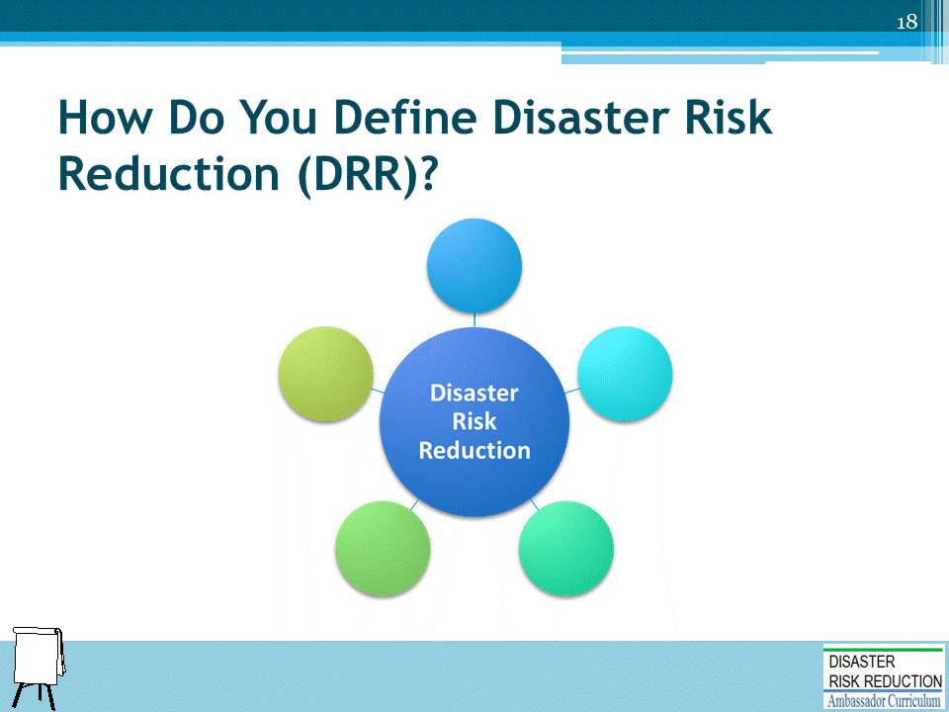
Ask for volunteers to briefly describe what DRR means to them, or have participants brainstorm words or phrases that describe DRR.
[OPTIONAL] Record on easel pad participant responses.
A common definition of DRR: The concept and practice of reducing disaster risks through systematic efforts to analyze and manage the causal factors of disasters, including through reduced exposure to hazards, lessened vulnerability of people and property, wise management of land and the environment, and improved preparedness for adverse events.
Source: The United Nations Office for Disaster Risk Reduction (UNISDR). 2009. http://www.unisdr.org/we/inform/terminology
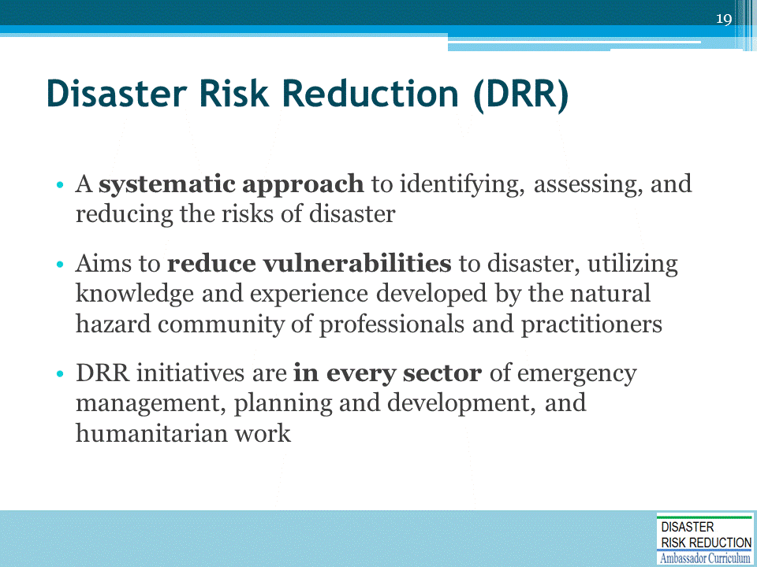
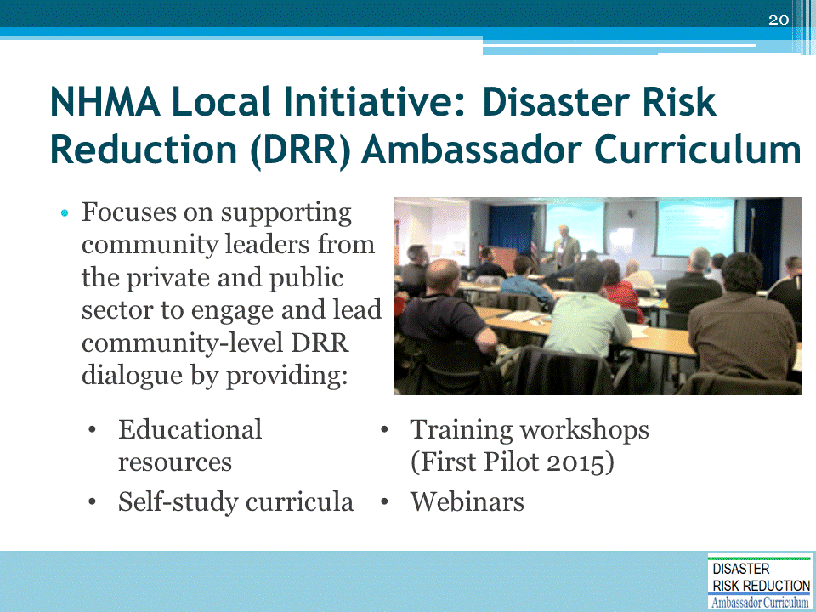
The DRR Ambassador Curriculum is a FEMA-funded “flagship” initiative of NHMA.
- NHMA has partnered with State Floodplain Managers and other sponsors in previous peer-to-peer workshops, which set the stage for the DRR Ambassador Curriculum.
- Each DRR Ambassador Workshop will be designed to provide opportunity for expertise addressed to specific local challenges.
- Each Workshop focuses on building local capacities to continue training and networking.
- Emphasis is placed on the concept of disaster resilience, or “the ability to prepare and plan for, absorb, recover from, and more successfully adapt to adverse events” (National Research Council 2012)
The curriculum provides citizen leaders with:
- Best practices
- The science underlying our understanding of natural hazards phenomena
- A critical analysis of the policies, programs, and plans in place that are intended to help societies manage the effects of natural hazards and disasters, to include actions that increase disaster resilience
PHOTO: At the end of a Montana Workshop, local professionals establish working groups to address their shared challenges.

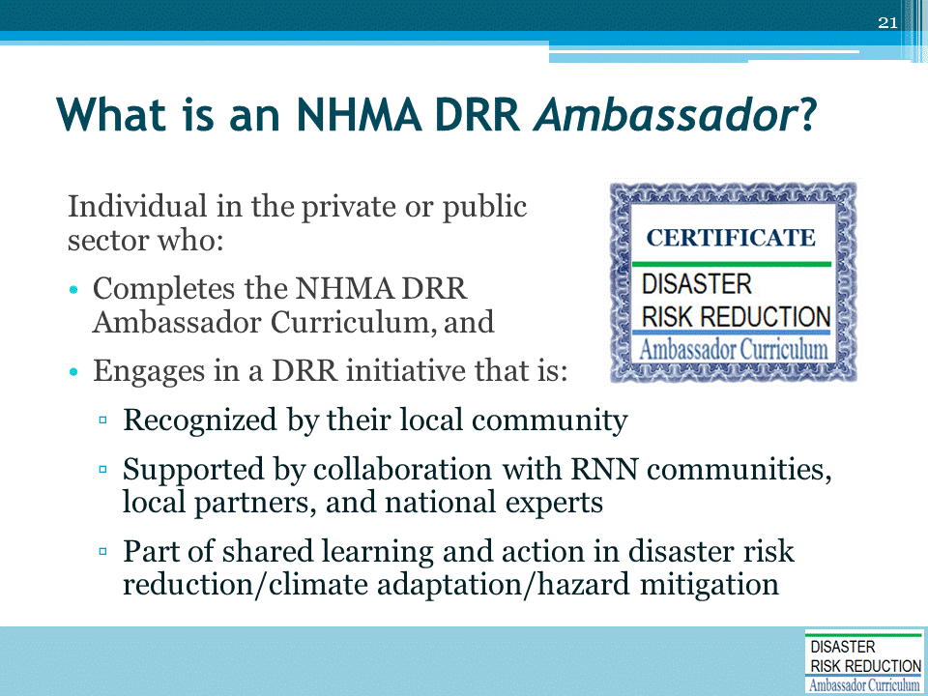
The NHMA DRR Ambassador (DRR-A) Curriculum consists of 24 courses, which will be discussed later in this module.
NOTE: The full curriculum is not yet developed. For the Harrisburg Pilot DRR Workshop, all will receive credit for attendance, whether in person or by webinar.

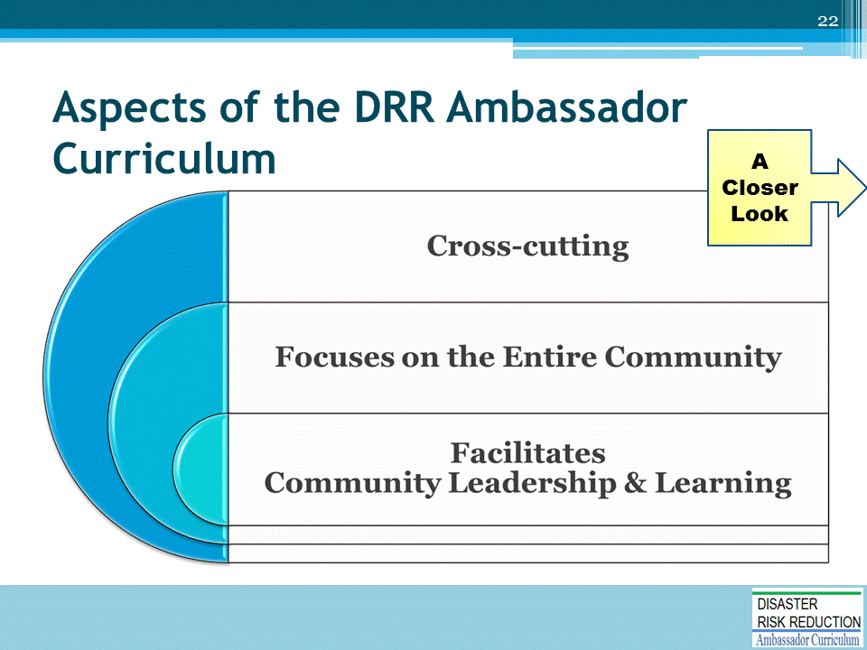
There are three major aspects of the Curriculum. Each will be described in detail on the following slides.

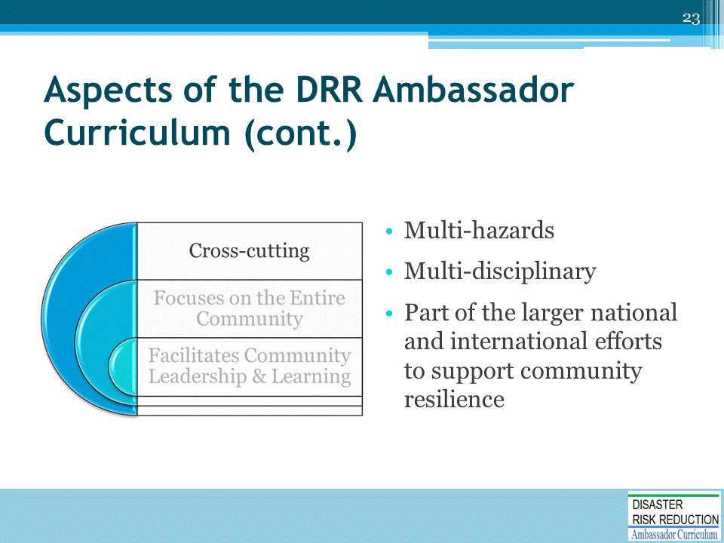
Multi-hazards:
- Curriculum addresses the broad set of DRR natural hazards and risks, and best mitigation practices, to improve economic, social, and environmental quality of life, and to protect public health and safety
Multi-disciplinary:
- Curriculum provides an overview of many expert disciplines, to show connections gained through collaborative teamwork
Part of the larger national and international efforts to support Community Resilience:
- Curriculum recognizes the need to connect across the separate silos or sectors of those engaged in the larger scope of climate science, emergency management, and comprehensive planning, to coordinate with others committed to build a more resilient future

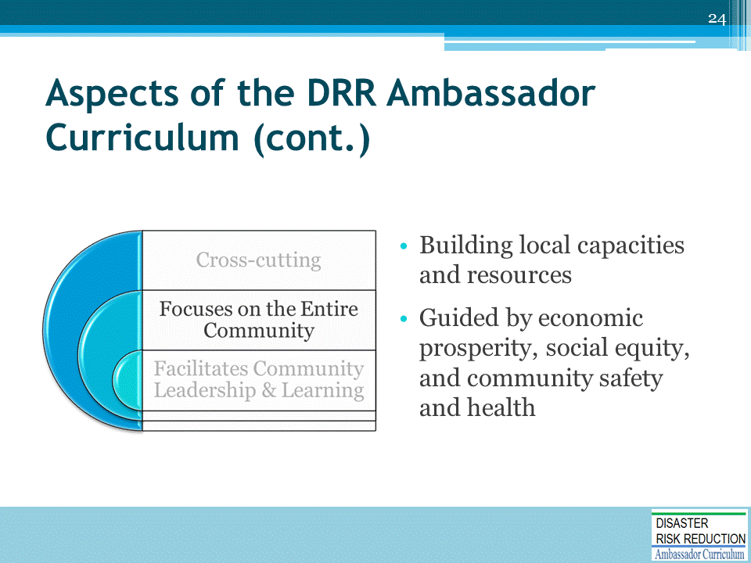
Building local capacities and resources:
- Curriculum learning objectives are designed to build local community preparedness and DRR
- Utilizes voluntary and combined private-, business-, and public-sector resources inherent in communities that work together
Guided by economic prosperity, social equity, and community safety and health:
- Addresses needs and opportunities based on sound economics, non-partisan
- Builds a strong legal, moral, and equitable basis of safe and proper development, redevelopment, and governance

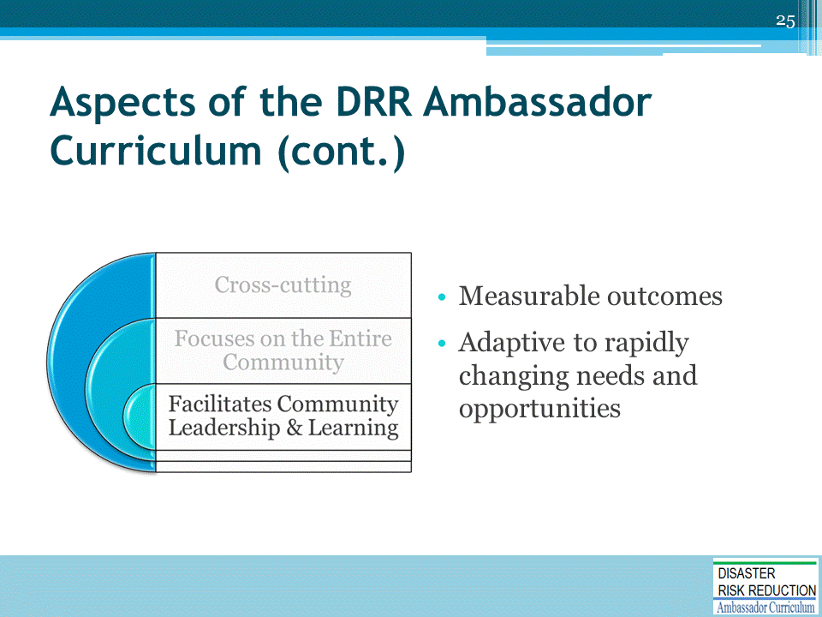
Measurable outcomes:
- Individuals who have completed the DRR Ambassador Curriculum will have improved knowledge of concepts, resources, and tools to be able to advocate for and support effective Disaster Risk Reduction in their local communities.
Adaptive to rapidly changing needs and opportunities:
- Curriculum modules and study plans can be custom-tailored and updated to local needs, to facilitate community progress over time

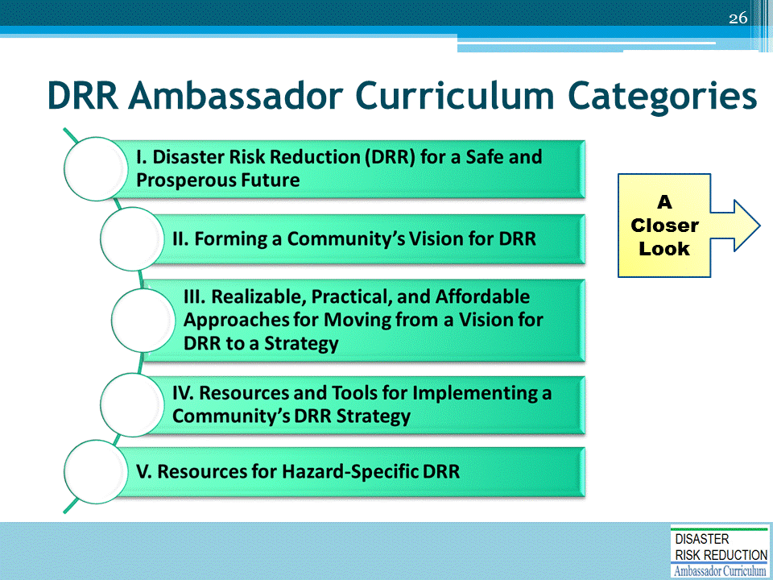
The Curriculum is segregated into categories, each consisting of 3 to 8 presentations covering various DRR-related topics (called modules).
- The Curriculum program and modules are based on an extensive interviews with over 60 stakeholders.
We focus on learning objectives, which are brief statements that describe what you will be expected to learn by the end of the module.
- The modules are approximately 60-75 minutes long.
- Each module has a pre-test and post-test to determine if the training contributed to learning.

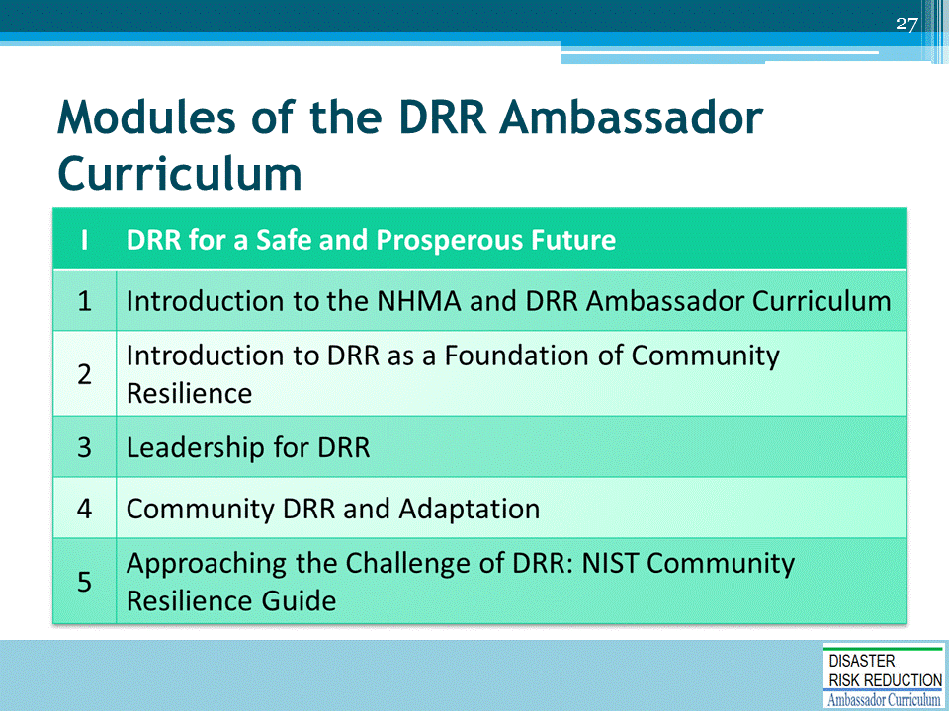
NOTE: Module 3, Leadership for Disaster Risk Reduction, will be developed later this year.

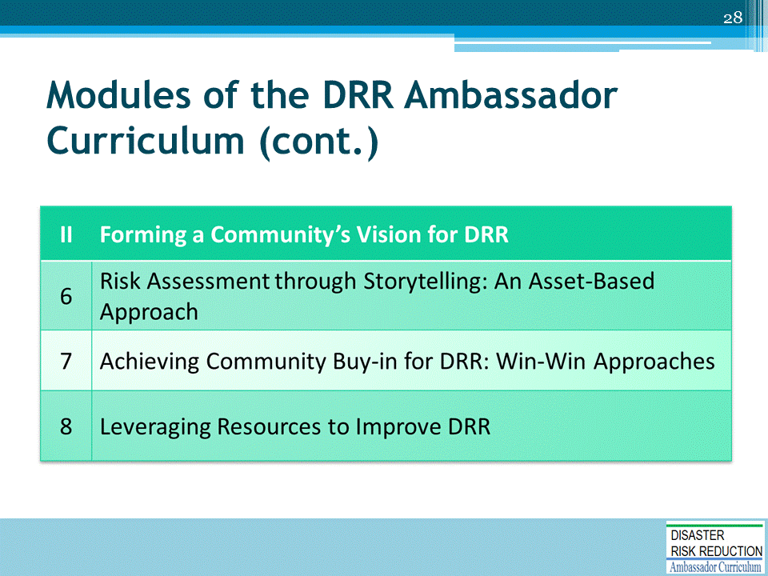

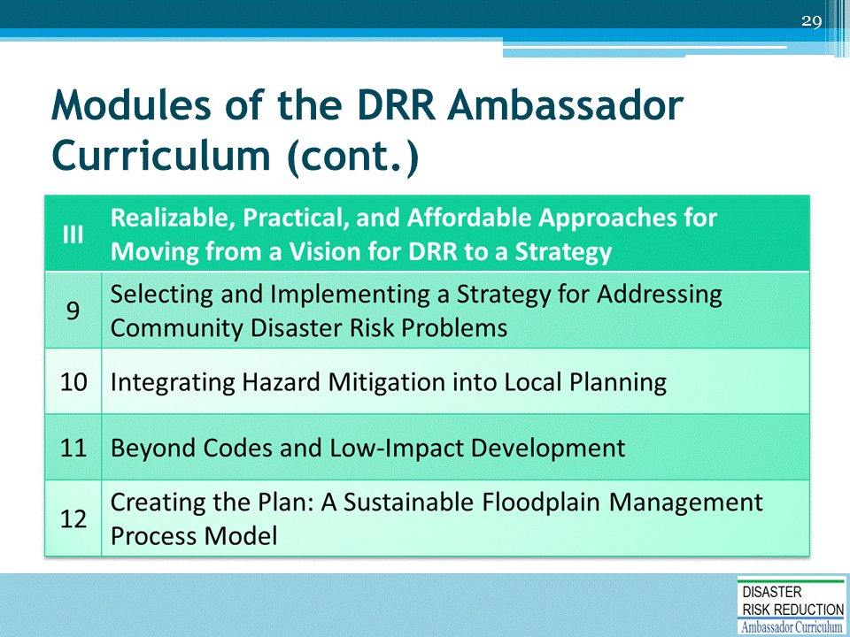
NOTE: Module 11, Beyond Codes and Low-Impact Development, will be developed later this year.

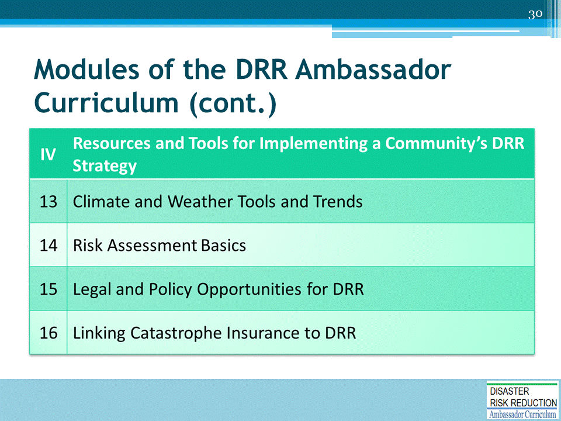
NOTE: Module 13, Climate and Weather Tools and Trends, will be developed later this year.

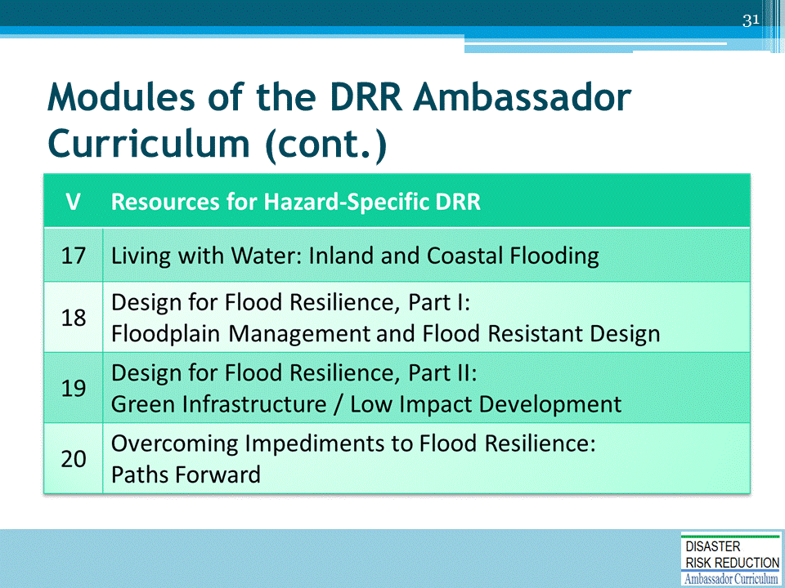
NOTE: Module 17, Living with Water: Inland and Coastal Flooding, will be developed later this year.

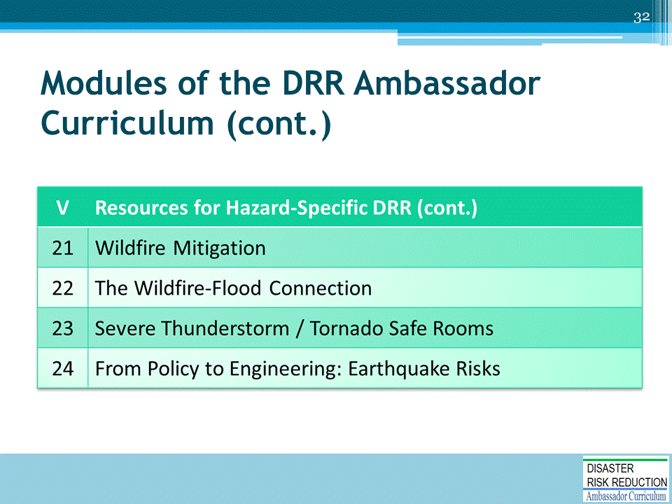
NOTE: These modules will be developed later this year

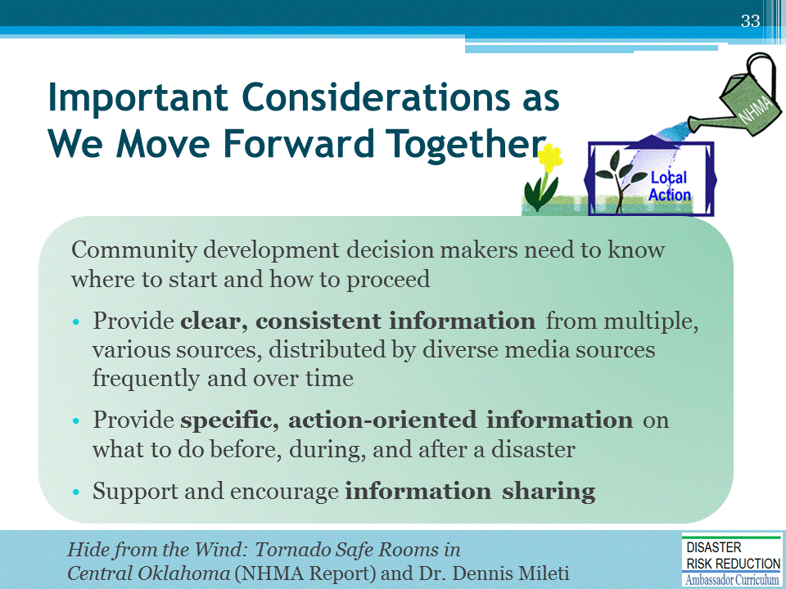
Dr. Dennis Mileti is the former Director of the Natural Hazards Center and Professor Emeritus at the University of Colorado at Boulder.

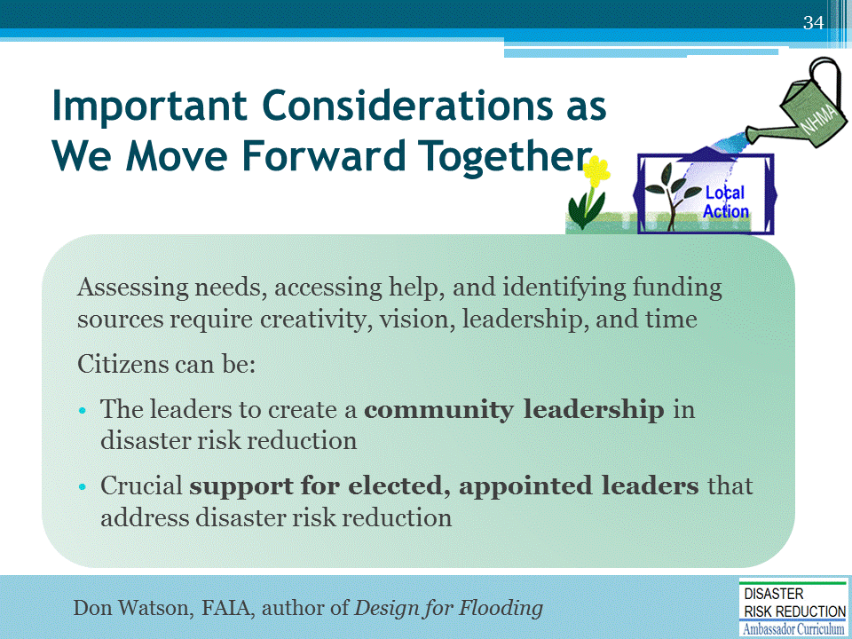

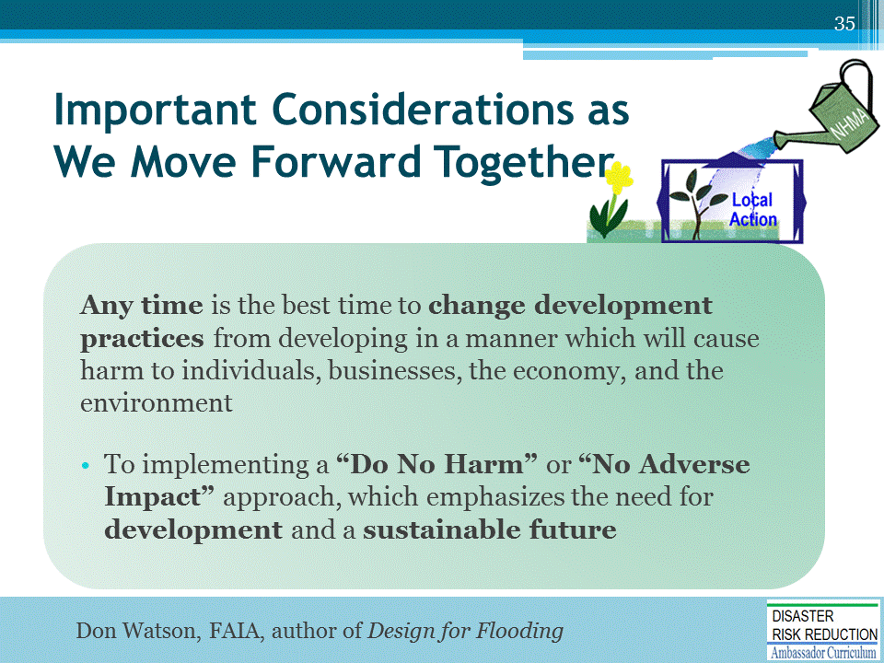

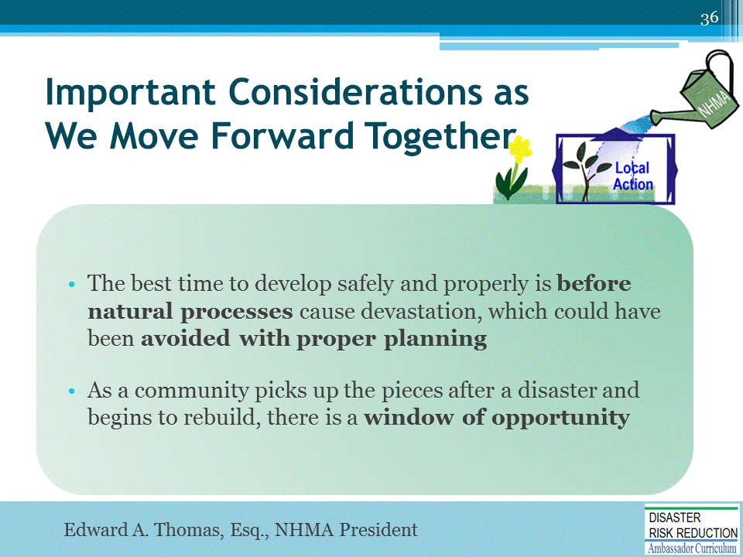

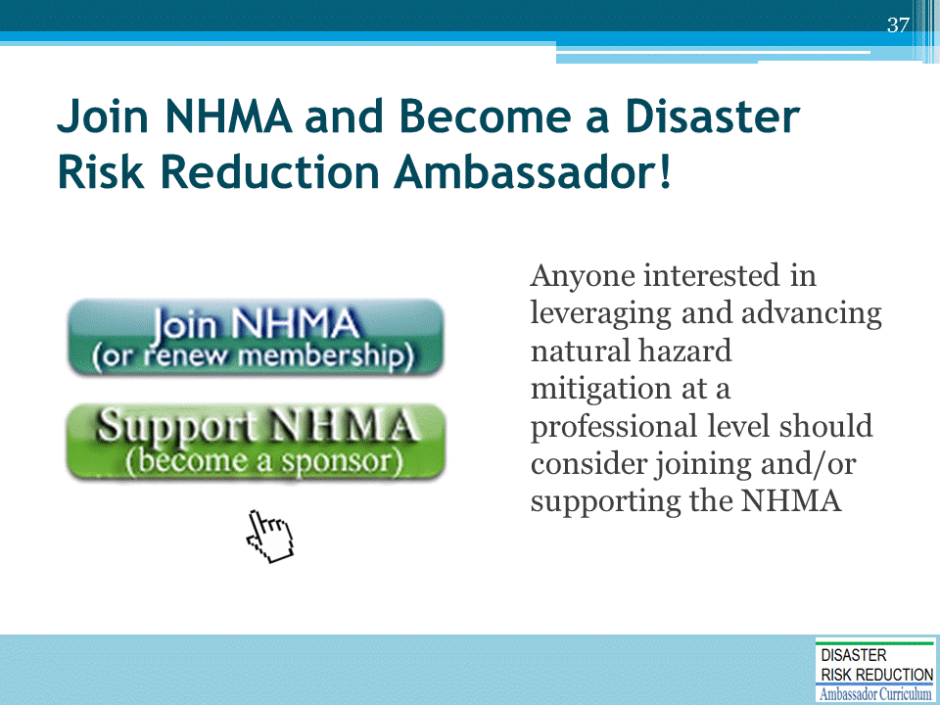
Mention that there is a special rate for partner organizations, such as local governments.

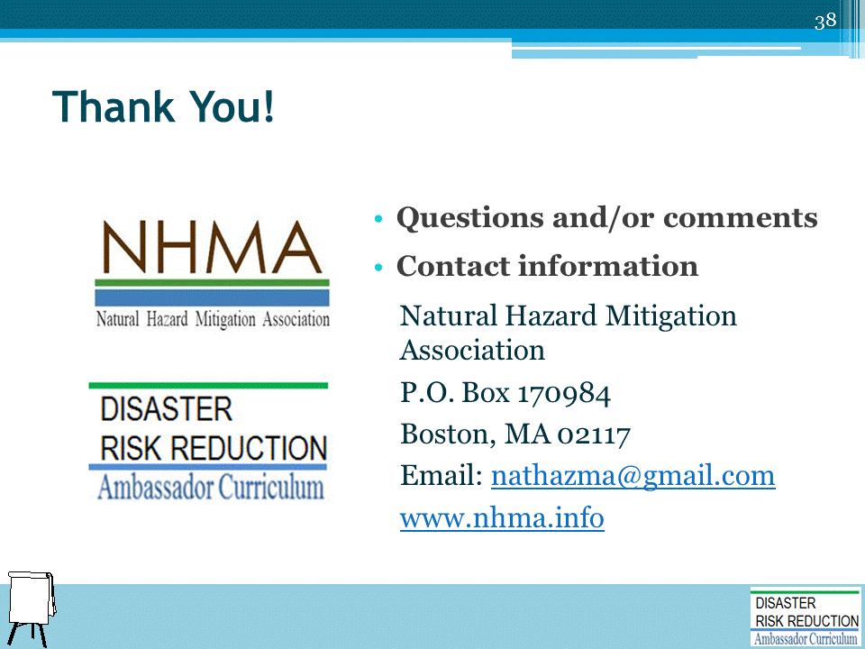
Record on easel pad any recommendations or questions to be addressed outside of the presentation.

DRR AMBASSADOR CURRICULUM AT-A-GLANCE
I. Disaster Risk Reduction for a Safe and Prosperous Future
1 | Introduction to the Natural Hazard Mitigation Association and Disaster Risk Reduction Ambassador Curriculum
2 | Introduction to Disaster Risk Reduction as a Foundation of Community Resilience
3 | Leadership for Disaster Risk Reduction
4 | Community Disaster Risk Reduction and Adaptation
5 | Approaching the Challenge of Disaster Risk Reduction: NIST Community Resilience Guide
II. Forming a Community’s Vision for Disaster Risk Reduction
6 | Risk Assessment through Storytelling: An Asset-Based Approach
7 | Achieving Community Buy-in for Disaster Risk Reduction: Win-Win Approaches
8 | Leveraging Resources to Improve Disaster Risk Reduction
III. Realizable, Practical, and Affordable Approaches for Moving from a Vision for Disaster Risk Reduction to a Strategy
9 | Selecting and Implementing a Strategy for Addressing Community Disaster Risk Problems
10 | Integrating Hazard Mitigation into Local Planning
11 | Beyond Codes and Low-Impact Development
12 | Creating the Plan: A Sustainable Floodplain Management Process Model
IV. Resources and Tools for Implementing a Community’s Disaster Risk Reduction Strategy
13 | Climate and Weather Tools and Trends
14 | Risk Assessment Basics
15 | Legal and Policy Opportunities for Disaster Risk Reduction
16 | Linking Catastrophe Insurance to Disaster Risk Reduction
V. Resources for Hazard-Specific Disaster Risk Reduction
17 | Living with Water: Inland and Coastal Flooding
18 | Design for Flood Resilience: Part I: Floodplain Management and Flood Resistant Design
19 | Design for Flood Resilience: Part II: Green Infrastructure / Low Impact Development
20 | Overcoming Impediments to Flood Resilience: Paths Forward
21 | Wildfire Mitigation
22 | The Wildfire-Flood Connection
23 | Severe Thunderstorm/ Tornado Safe Rooms
24 | From Policy to Engineering: Earthquake Risks

