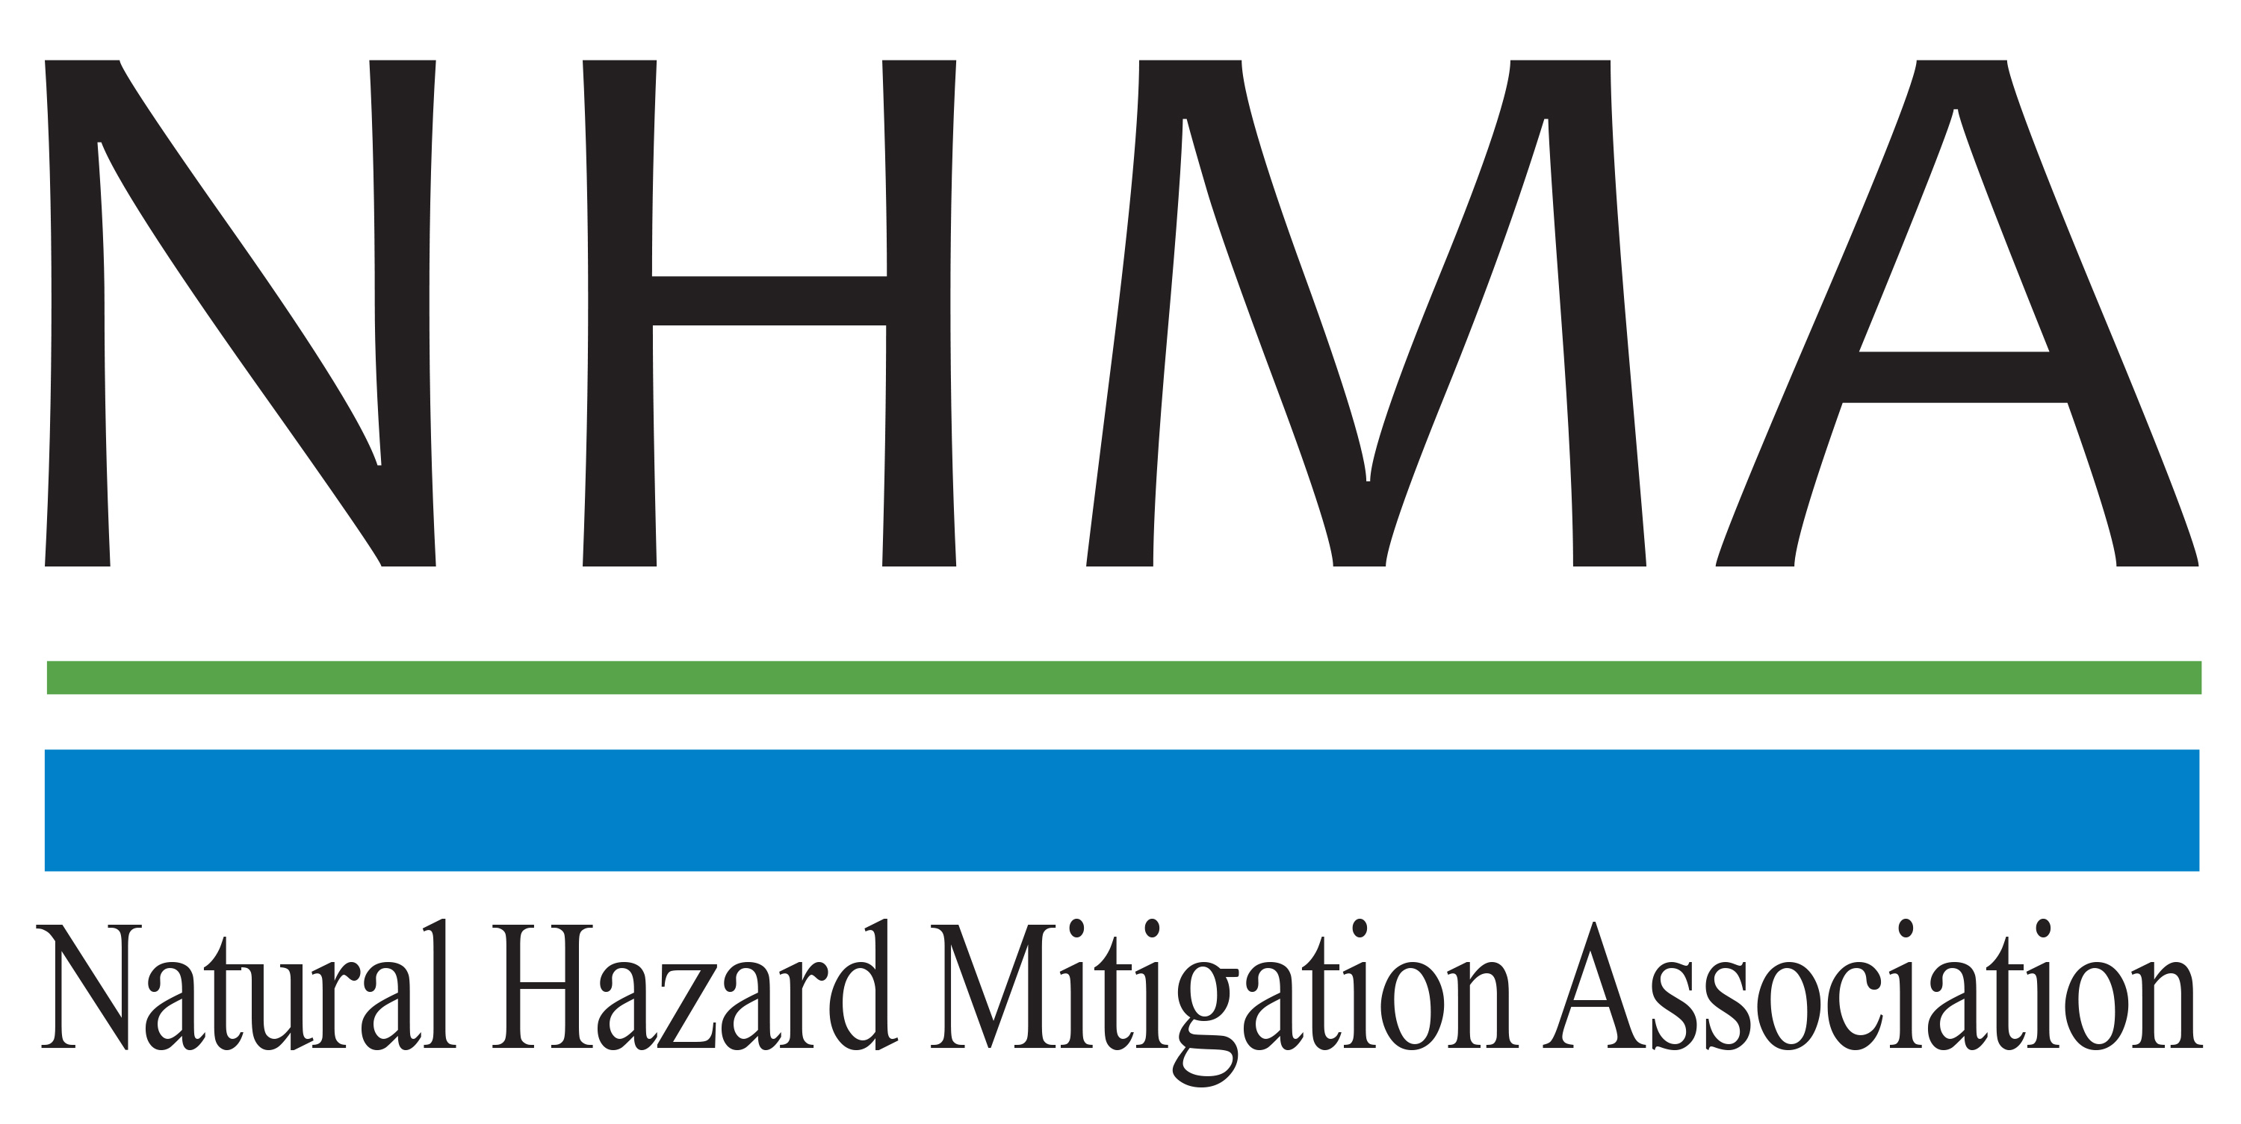

Disaster Risk Reduction (DRR) Ambassador Curriculum

Instructor Guide

Module 2:

Introduction to Disaster Risk Reduction
as a Foundation of Community Resilience

THE DRR AMBASSADOR CURRICULUM
The goal of the DRR Ambassador Curriculum is to facilitate Disaster Risk Reduction efforts for the whole community by:
- Engaging in discussion of how disasters can be reduced through local action
- Sharing insights among local leaders and technical experts to enable the development of cross functional solutions
- Acquiring the best-available information, knowledge of best practices, and analytic tools to enable better-informed decisions before, during, and after disasters
It is important for instructors of DRR Ambassador Curriculum modules to remember this is one module in a 24-module curriculum. The “DRR Ambassador Curriculum At-a-Glance” table, located at the end of this document, lists the modules of the Curriculum. Keep in mind the following context for the module(s) you conduct:
DRR-A CURRICULUM TARGET AUDIENCE
The target audience includes those involved in community development decision-making, such as local community staff, volunteer and stakeholder groups, and federal and state officials.
METHODS OF DELIVERY
Varied delivery methods will provide multiple options for access by the target audience. The DRR Ambassador modules may be presented via webinars hosted by NHMA or partner organizations, presented in conferences and/or classrooms by qualified DRR Ambassador Curriculum instructor(s), or are downloadable for individual study from the NHMA website.
COURSE MATERIALS
Instructors are expected to use the instructional materials housed on the NHMA website to conduct DRR Ambassador Curriculum modules (Instructor Guide, supporting visuals, Participant Guides, and handouts). Instructors may tailor modules to specific audiences or locations as long as they do not revise the learning objectives and do not revise the materials in such a way that the participants cannot correctly complete the post-test. Instructors request the current pre/post-test for the module from NHMA.
CERTIFICATES OF COMPLETION
Certificates of Completion will be awarded by NHMA to participants who successfully complete NHMA-sponsored DRR Ambassador modules. A DRR Ambassador Certificate will be awarded to individuals completing all 24 modules. Participants who choose not to take the post-test may be issued a Certificate of Attendance. Contact NHMA about obtaining certificates. Inform participants to ask their certifying boards about acceptance of NHMA DRR Ambassador certificates for continuing education credits.

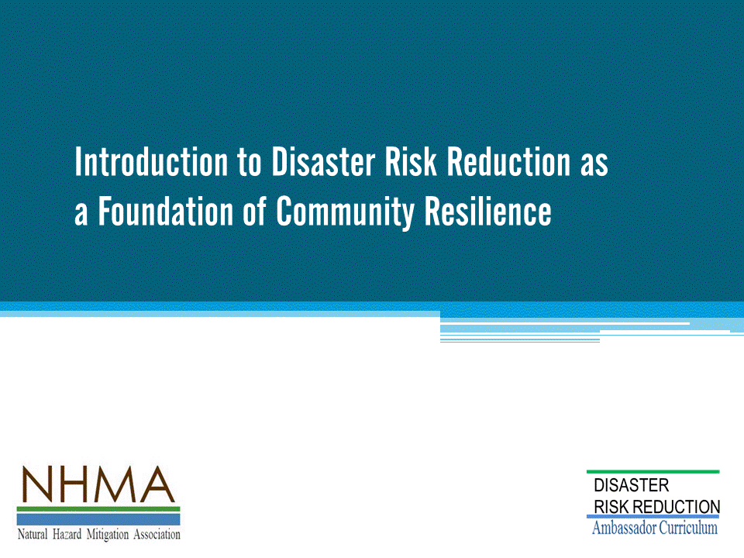
Approximate delivery time: 60-75 minutes

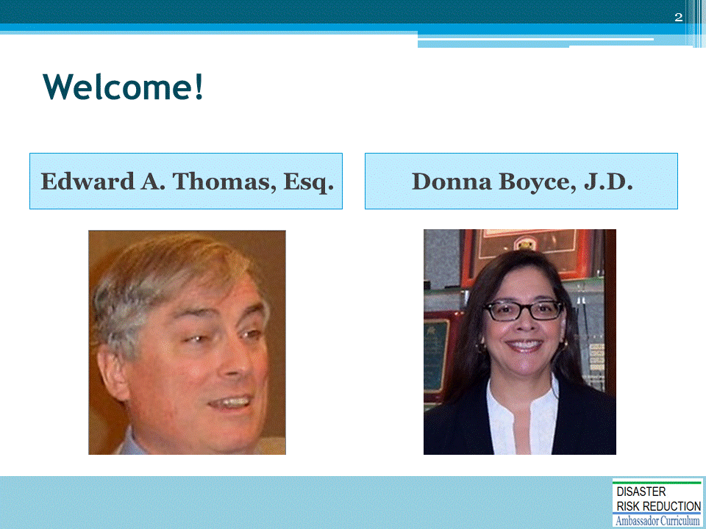
Introductions:
- Each presenter introduces her/himself, including affiliation and brief background.
- OPTIONAL: Have each participant briefly introduce him/herself
Mention: NHMA presentations are based on general principles of law, engineering, policy and emergency management.
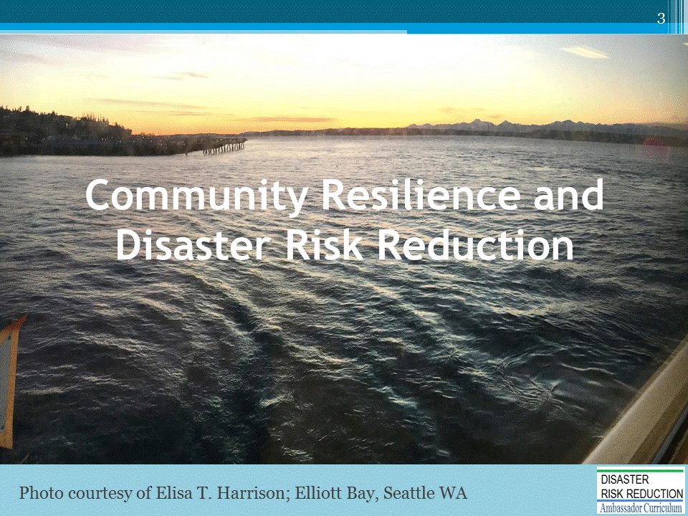
The purpose of this module is to:
- Introduce basic concepts of resilience and disaster risk reduction
- Provide rationale for the need for disaster risk reduction as a foundation of community resilience

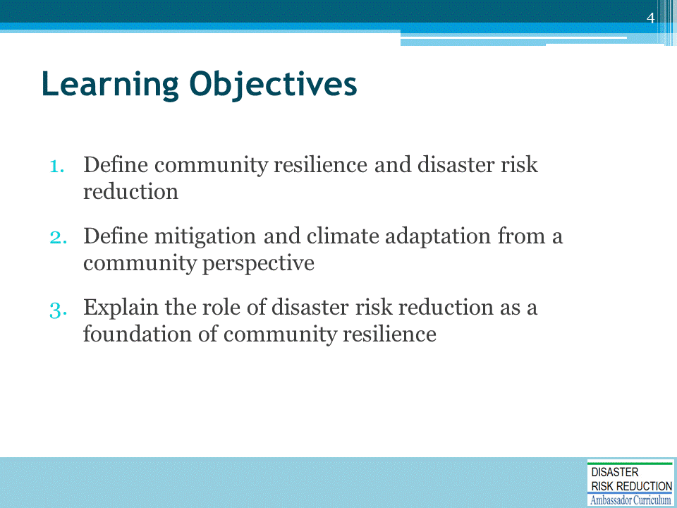
NHMA’s focus is on the Disaster Risk Reduction portion of Climate Adaptation and Resilience.

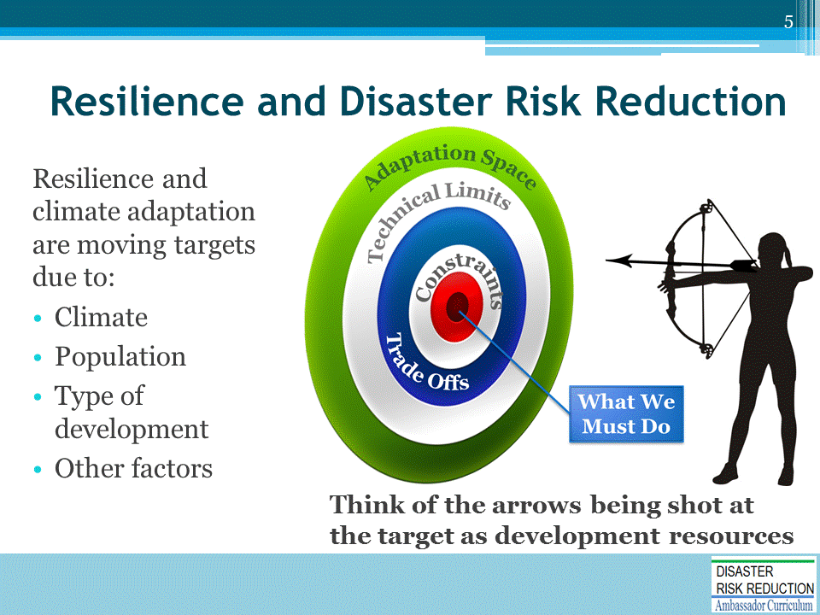
The goal (bullseye):
- Shown as a moving target, just as climate varies and changes; and
- Shown as a bullseye, at which we shoot the arrows of community development resources both public and private, all too often not aligned in real world community development practice with anything resembling resilience.
  - The target is instead on actions which may well benefit one stakeholder in the short term, but are externalized such that the bulls-eye ends up on the head or chests of innocent bystanders like: the taxpayer, the environment, threatened and endangered species, the economy etc.
  - Development resource arrows thus go all over, maladaptively cutting down and possibly murdering those innocent bystanders."
“Policymakers need another story than ‘We need to prevent a disaster!’ The real story of adaptation is that it leads to improving things. It is the poor, not the rich, that are heavily affected by climate change. Developing countries need help to develop in a robust way. And there are a lot of investment opportunities out there.”
— Stéphane Hallegatte, Senior Economist, Climate Change Group at the World Bank

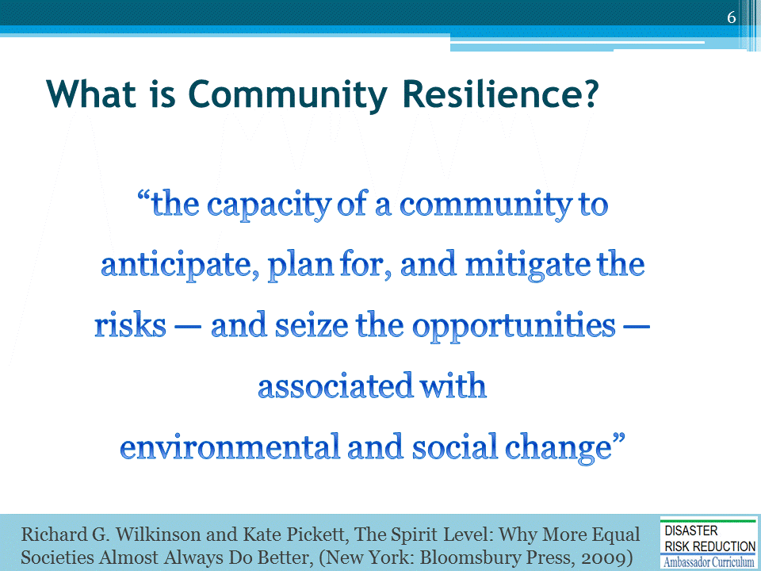

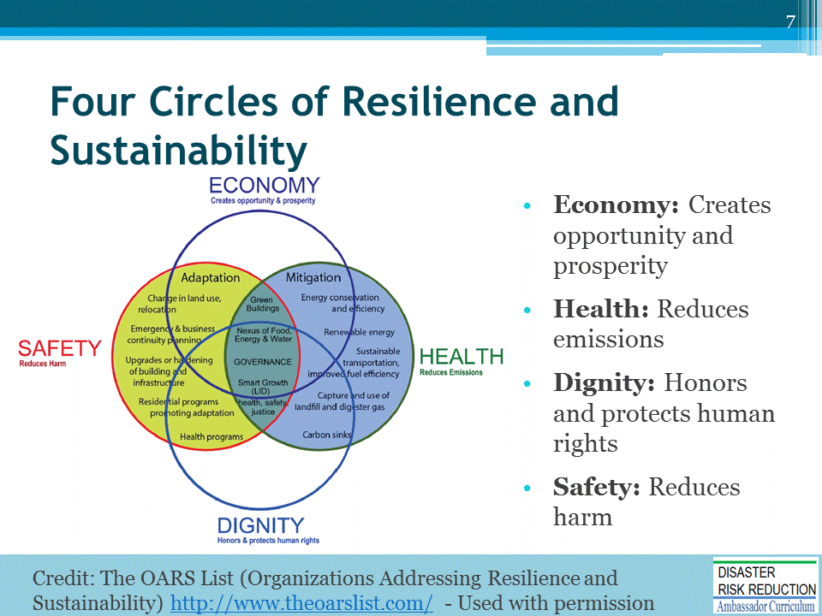
INTRODUCE the graphic:
These four circles represent an approach to "lift all boats" to capture the largest constituency.
The overall four Circles are:
- Economy: Creates opportunity and property
- Health: Reduces emissions
- Dignity: Honors and protects human rights
- Safety: Reduces harm
NOTE: Greenhouse Gas (GHG) reduction may not be acceptable as a goal everywhere-highly polarized-political issue.
The following slides cover the information in the Adaptation and Mitigation Circles.

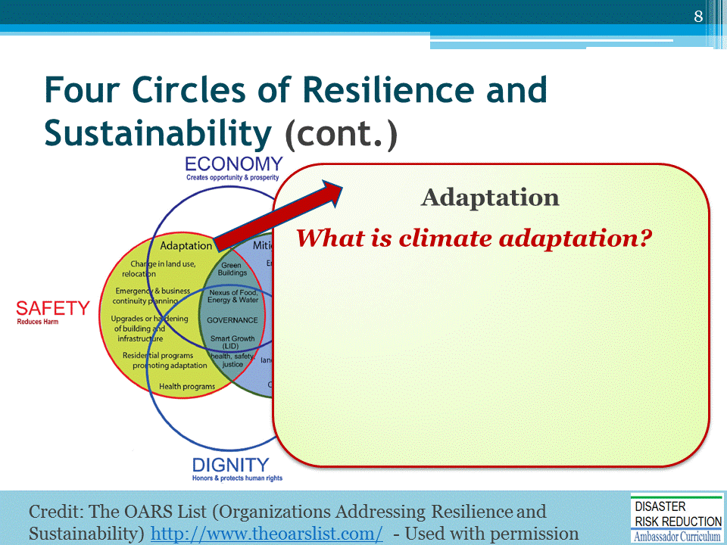
ASK the question and solicit several answers from participants before proceeding to the next slide.

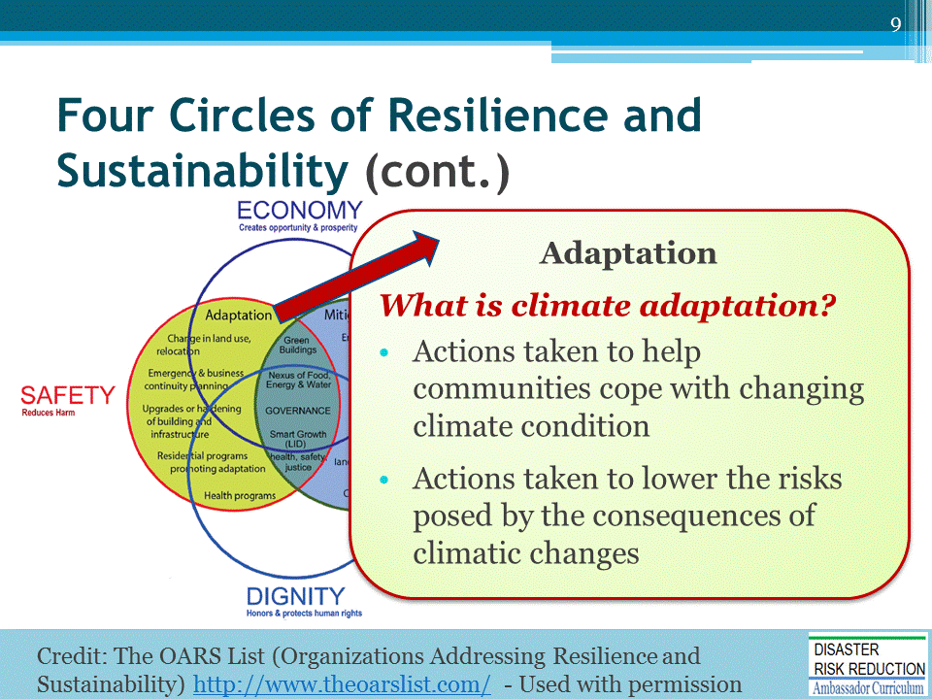

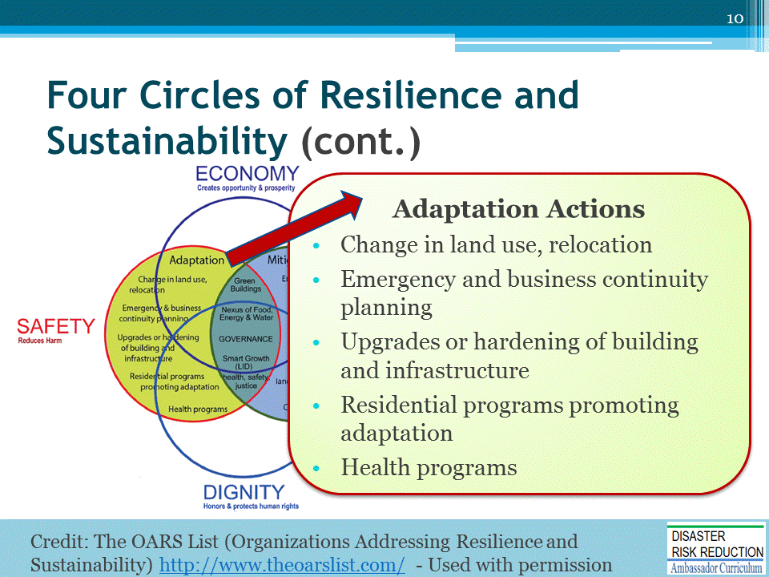
BRIEFLY DISCUSS the Adaptation Actions.

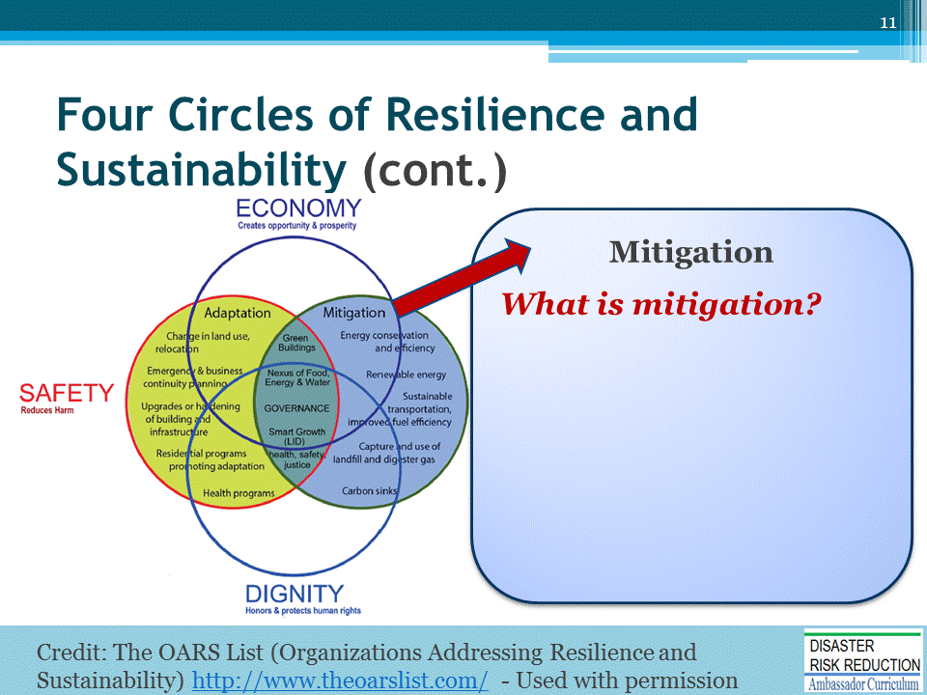
ASK the question and solicit several answers from participants before proceeding to the next slide.

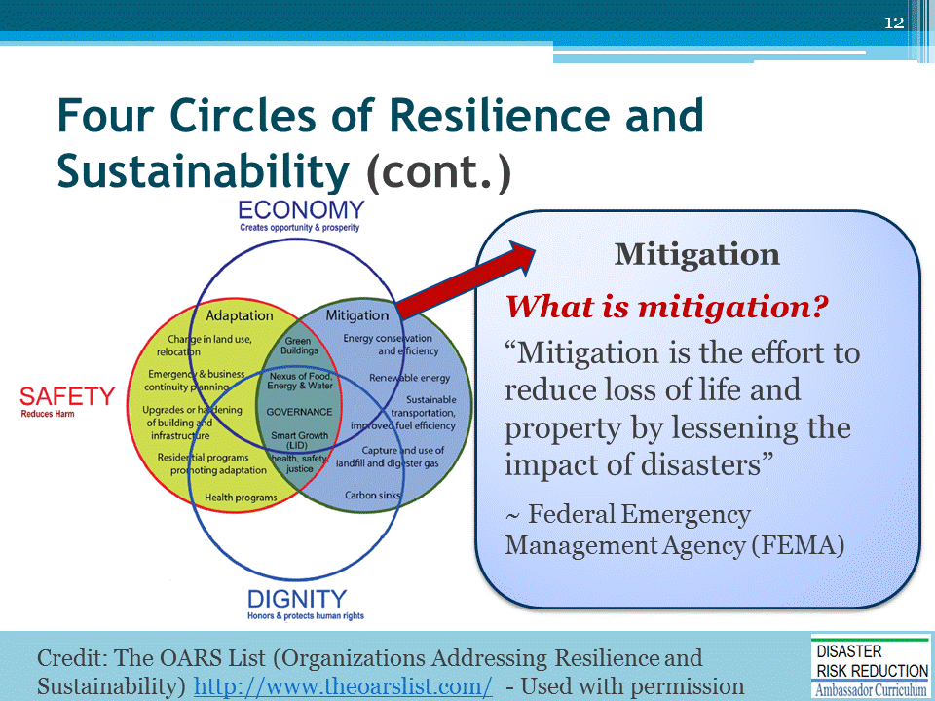
NHMA is about Disaster Risk Reduction. Thus we focus on FEMA Definition.
Climate Change GHG reduction discussion can be highly political/polarizing.

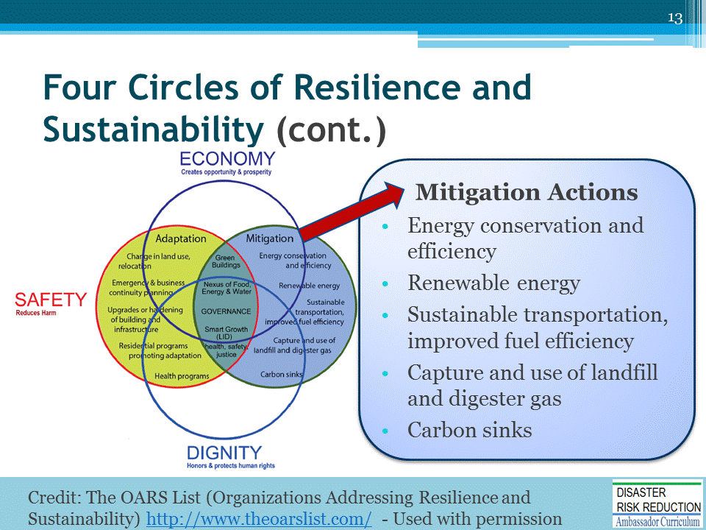
BRIEFLY DISCUSS the Mitigation Actions.

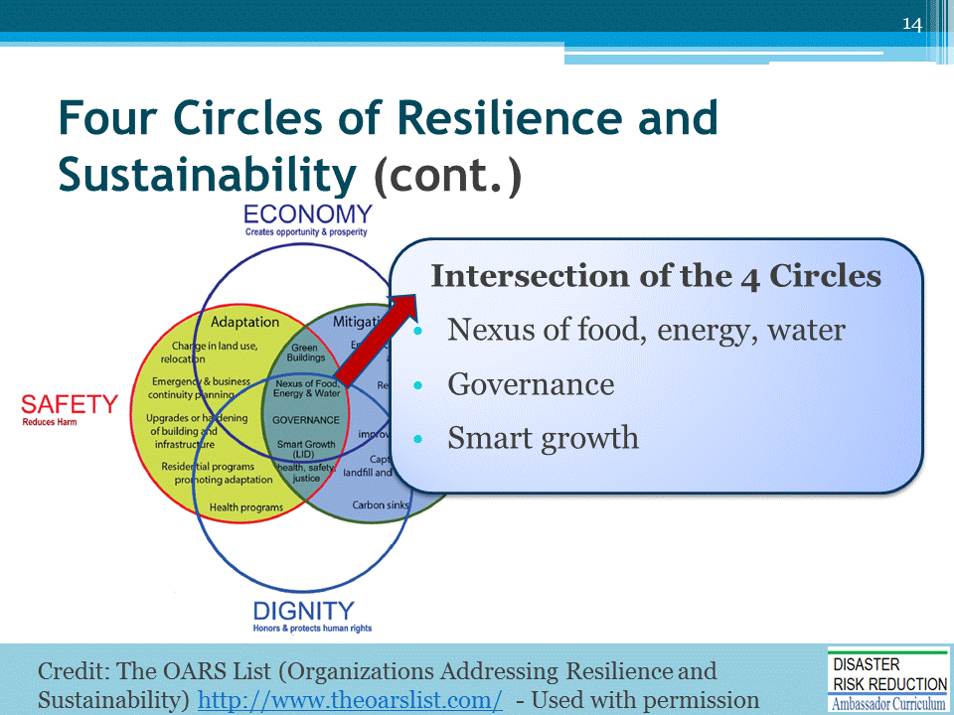
DISCUSS the intersection of the four circles:
- Nexus of food, energy, water
- Governance
- Smart growth

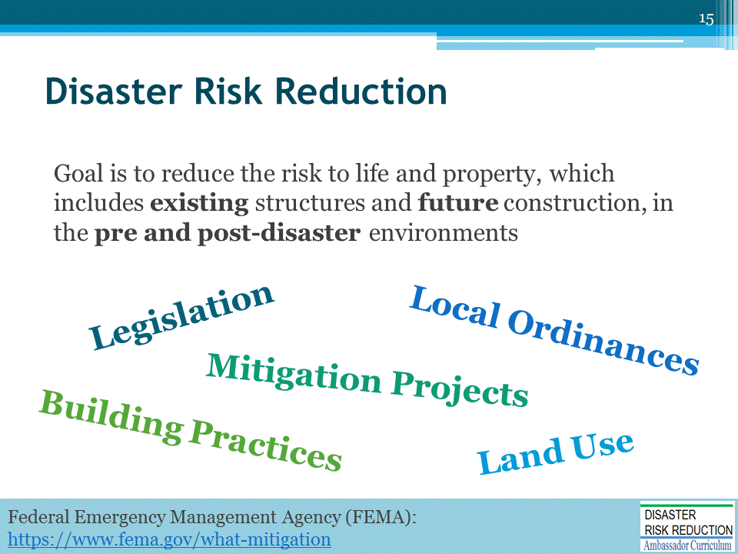
This goal is achieved through regulations, local ordinances, land use, and building practices and mitigation projects that reduce or eliminate long-term risk from hazards and their effects.

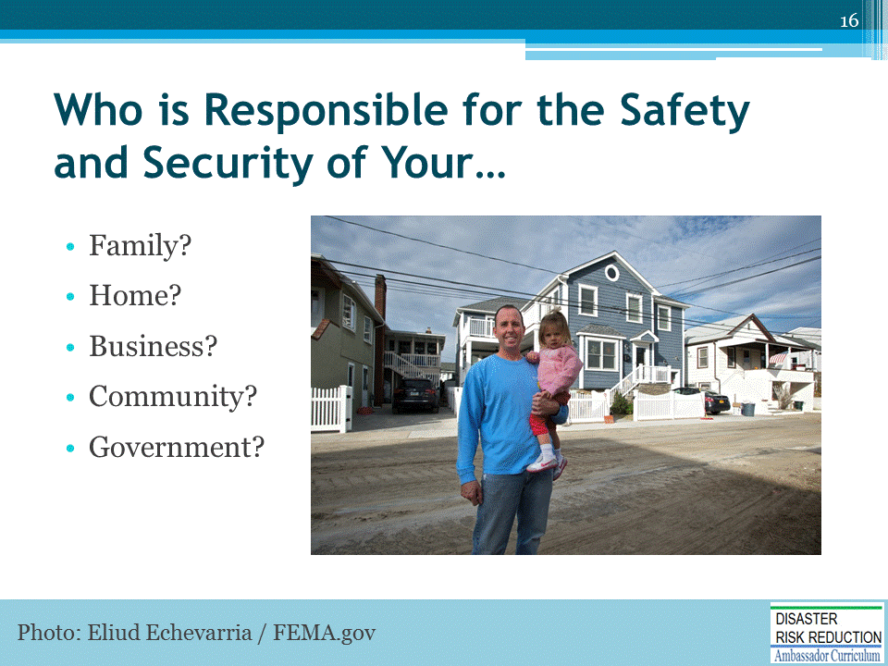
All have shared responsibilities, including all levels of government, for health and safety.
PHOTO DESCRIPTION: Community citizen, pictured with his daughter, is satisfied with the construction of his home, which was built before Hurricane Sandy. After the hurricane, most of the houses around his were damaged due to the floods but his house remained intact due to his following the state building requirements. Mitigation success stories help home owners understand how to construct or improve construction to prevent damages in any future disaster event. Eliud Echevarria / FEMA
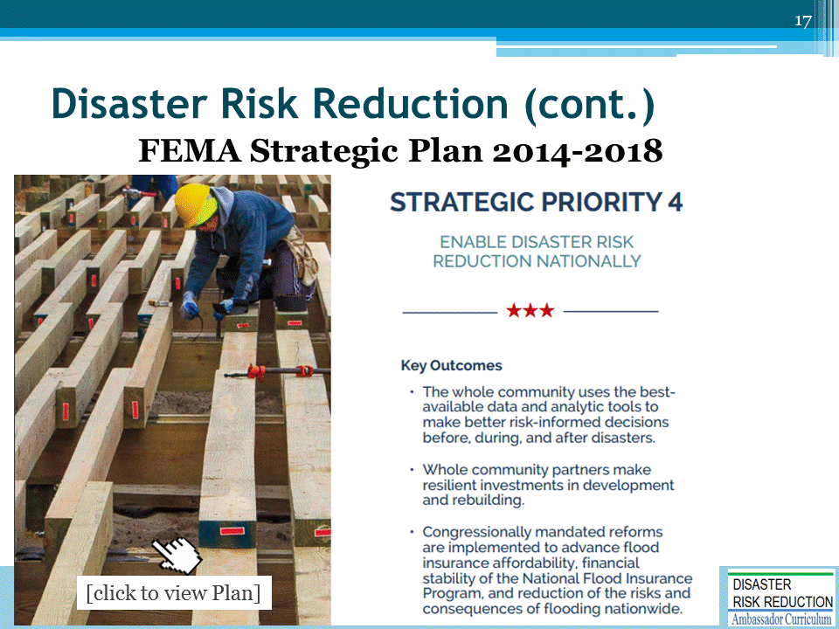

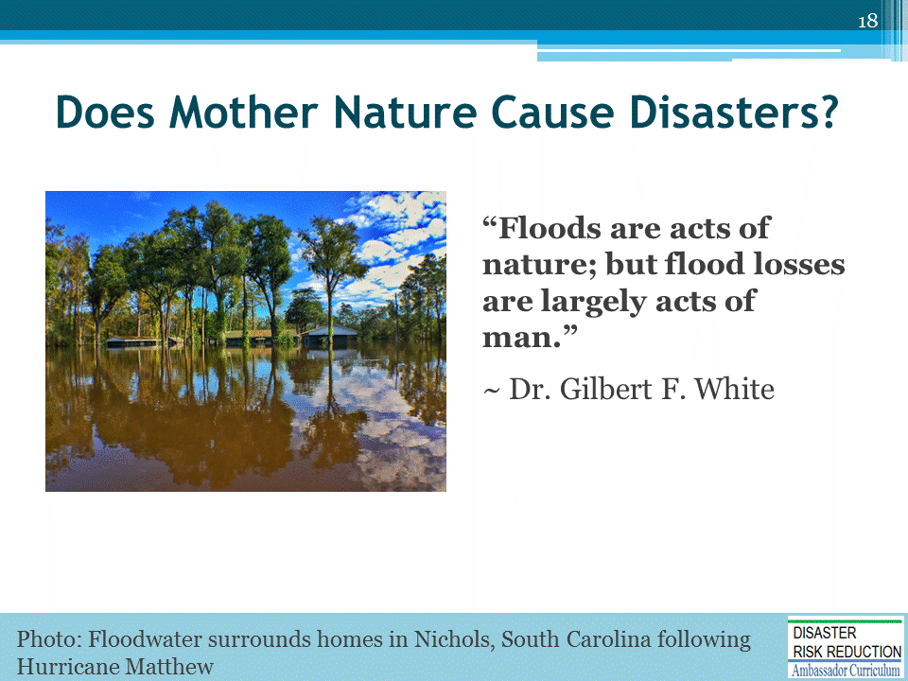
Dr. White is known predominantly for his work on natural hazards, particularly flooding, and the importance of sound water management in contemporary society.
- Human decisions, in areas which are often known to be hazardous, are the culprit. Nature does what it will, and often we know what will happen, but do nothing anyway.
- Most losses from foreseeable natural events also are acts of man
- Many wish to solve the problem of disaster losses through the new concept of “Resilience”
- Others advocate “Climate Adaptation”
PHOTO: Nichols, SC, USA--Floodwater surrounds homes in Nichols, South Carolina following Hurricane Matthew. Photo by Dominick Del Vecchio - Oct 12, 2016
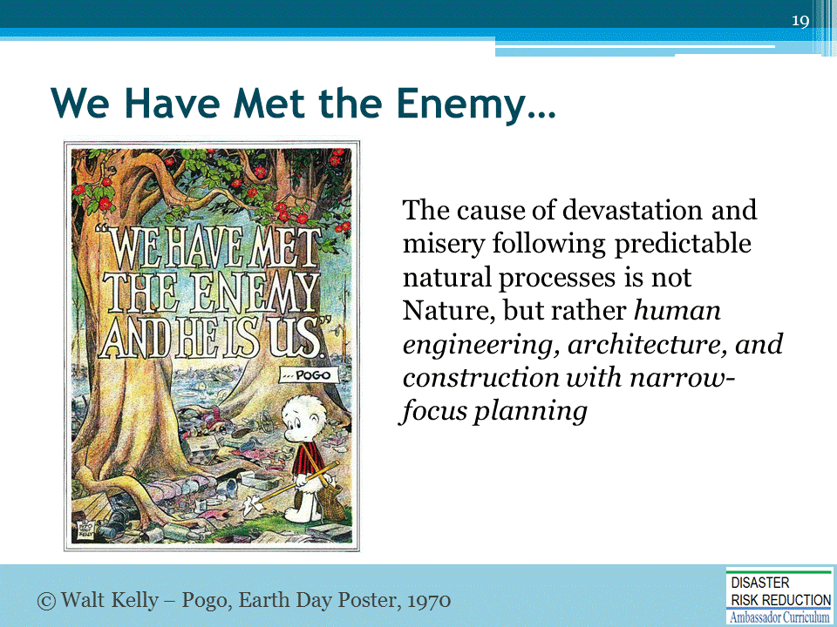
This means building improperly in areas where natural processes, like tsunamis, tornadoes, floods, hurricanes, and wildfires, will foreseeably take place.

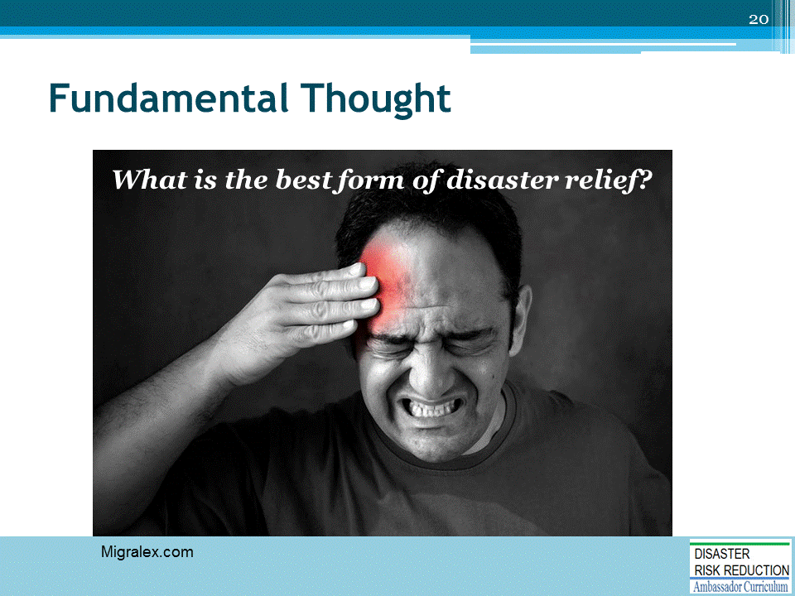
ASK the question and solicit several answers from participants before proceeding to the next slide.

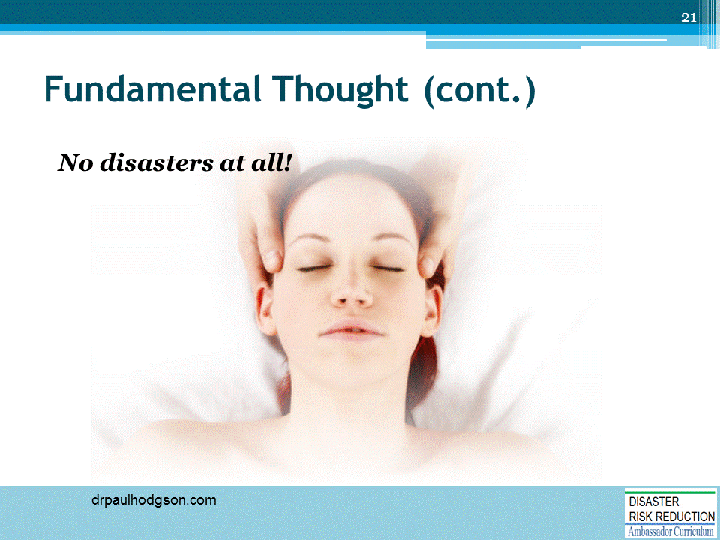
No “disaster relief” needed; we build safely and properly so as to account for foreseeable natural events.

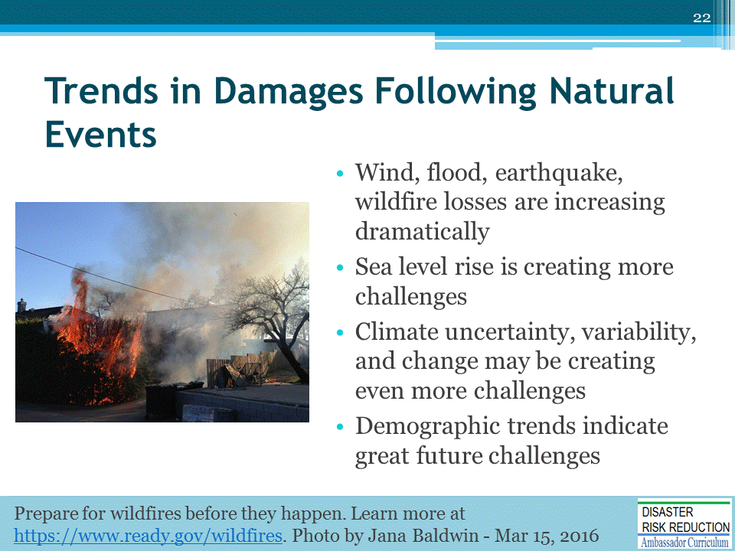
- Problems include changing hydrology, sea level rise, fire risks and exposures, and other climate impacts
- We must stop making things worse as investments and populations inevitably increase
- Our system rewards dangerous behavior that hurts too many, now and for a long time.
From The Living Mosaic: “In the United States, there has been an unprecedented increase in the number of Americans moving to live near the nation’s shorelines over the past few decades. Combined with a measurable increase in violent weather events, these two phenomena have resulted in spiraling costs associated with helping disaster victims and replacing damaged infrastructure.”

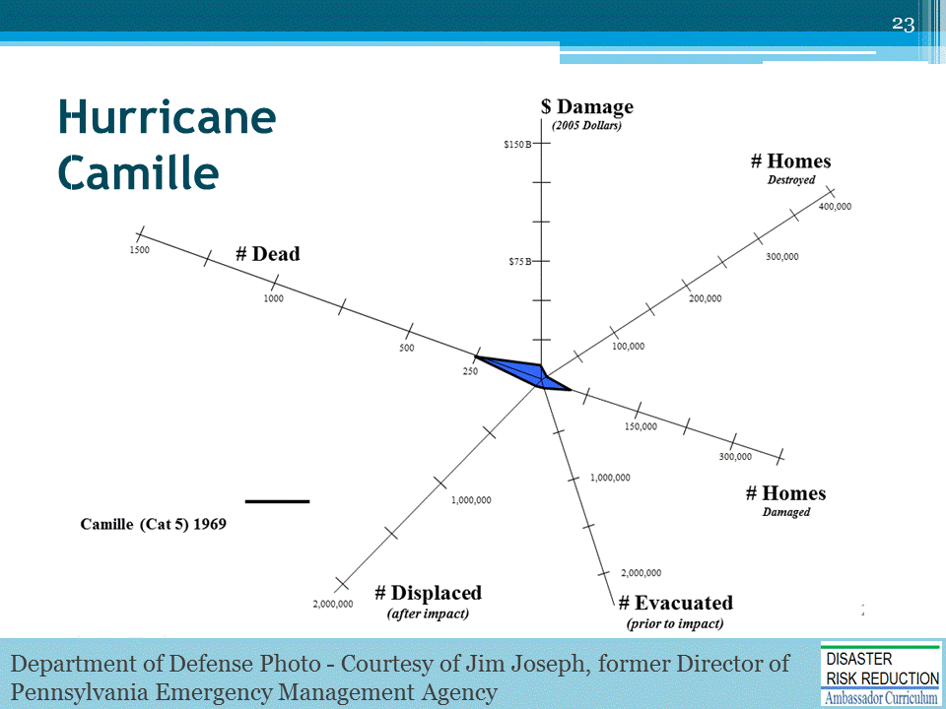
EXAMPLE: Hurricane Camille was a horrible and devastating storm.

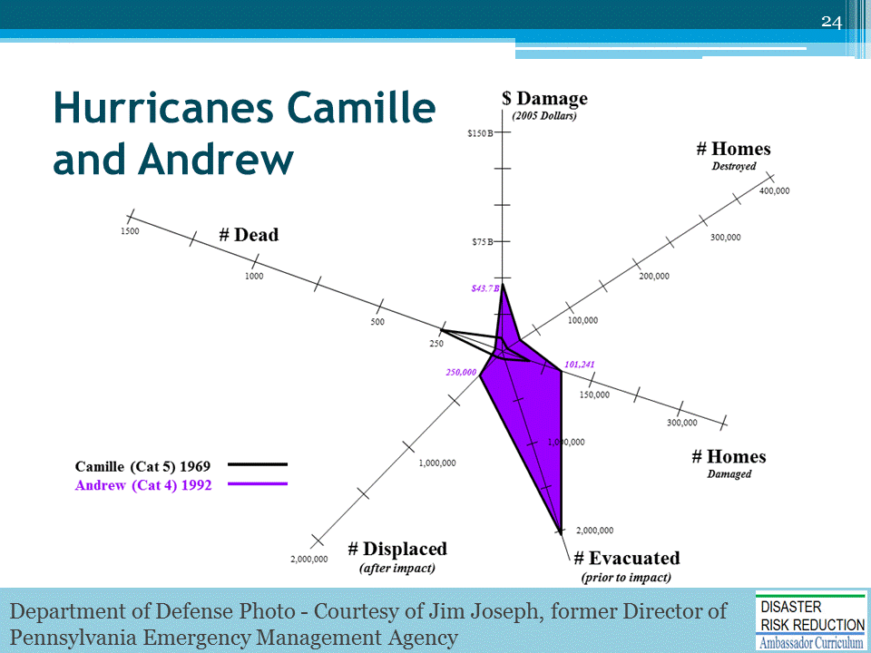
Andrew devastated Dade County - at least the poorest and most vulnerable lower 1/3 of the county.

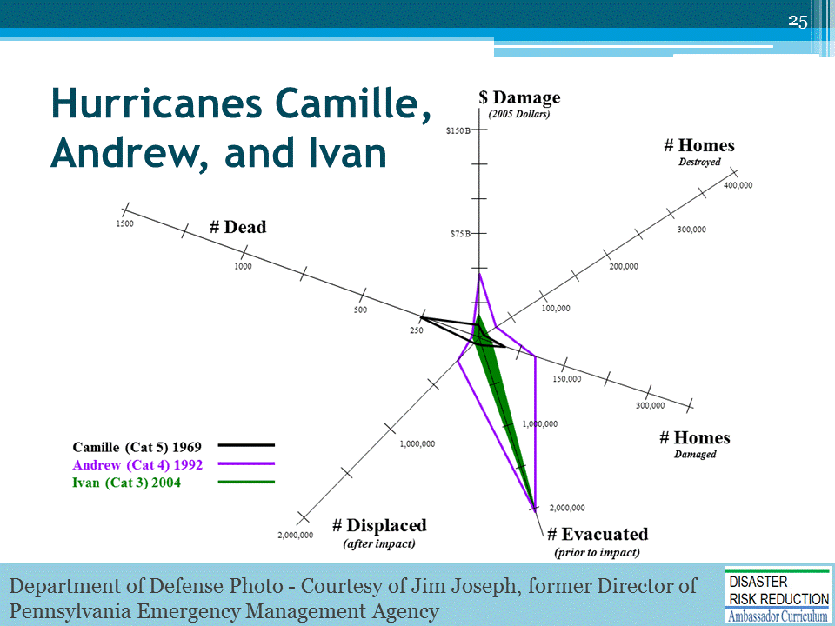

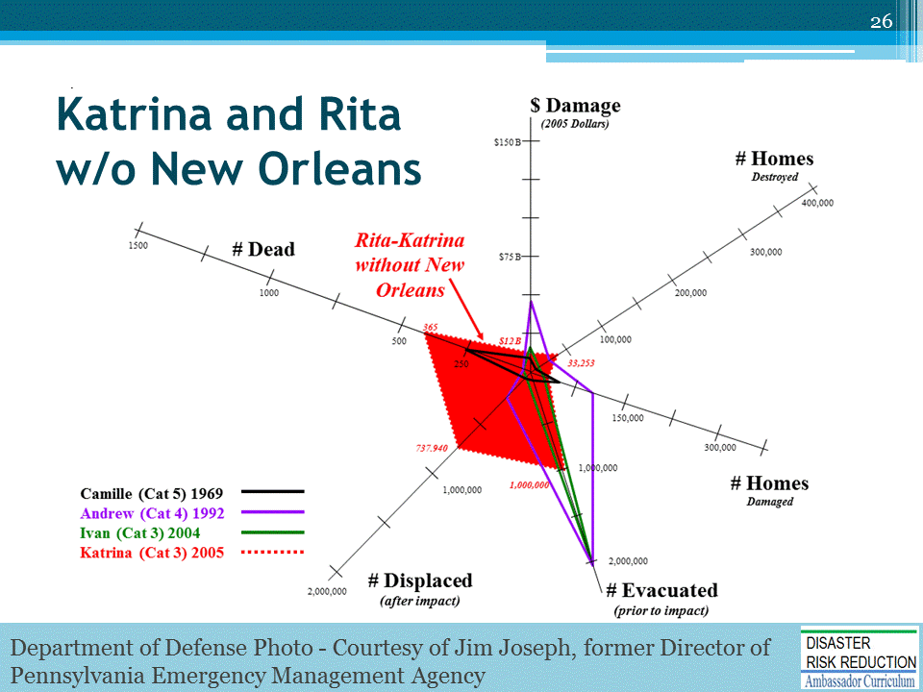

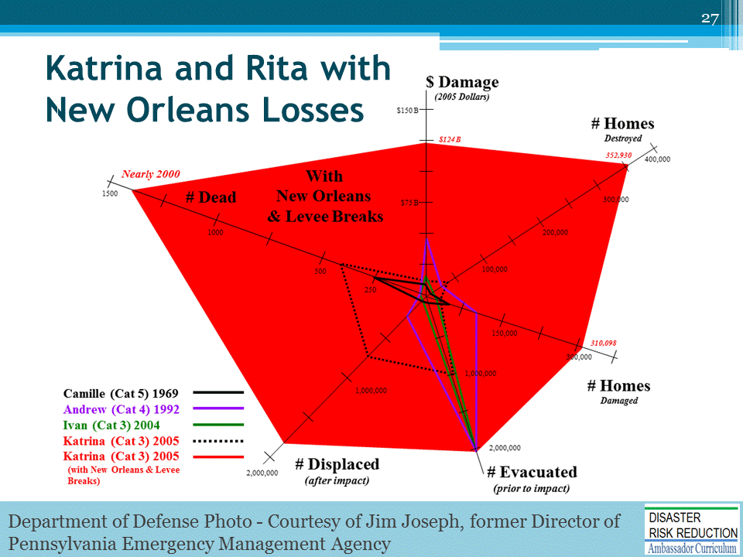
So what happened in New Orleans?

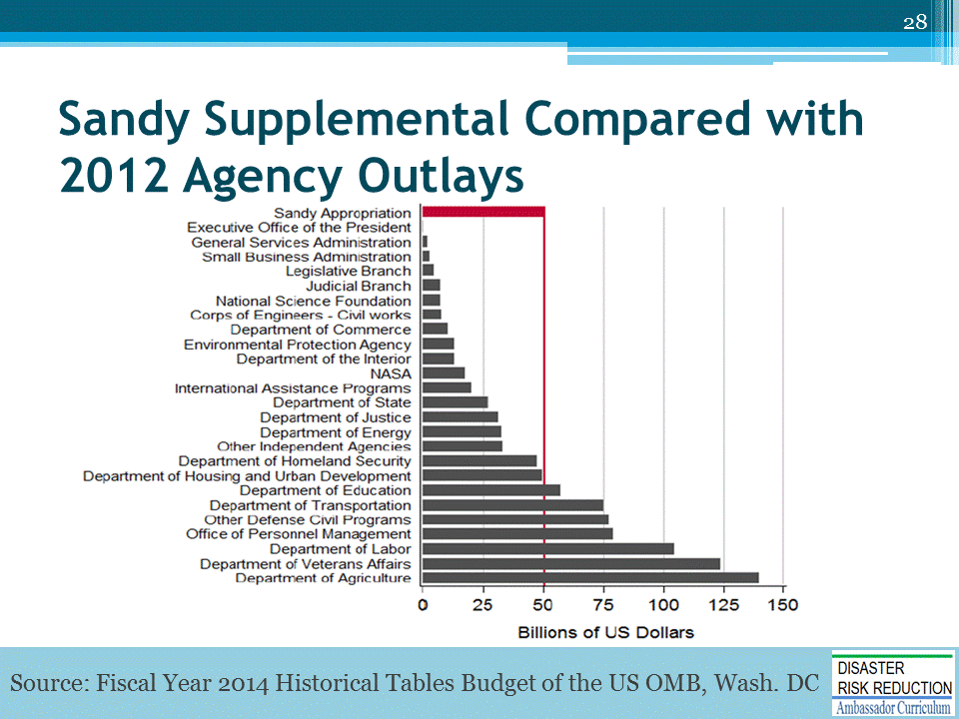
So what happened with Hurricane Sandy?

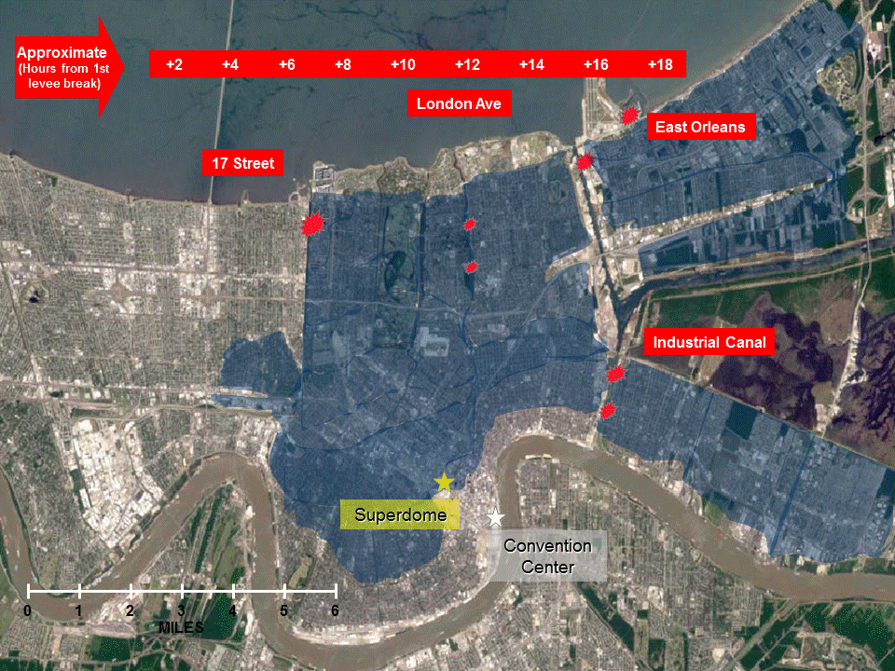
[NOTE: This slide is animated when in “Slide Show” view. The first click reveals location labels. The second click shows the spread of water over 18+ hours since the first levee break.]
This is New Orleans, but it could be anywhere in Oklahoma, the South West, the West, and the Nation.
Department of Defense Photo - Courtesy of Jim Joseph, former Director of Pennsylvania Emergency Management Agency

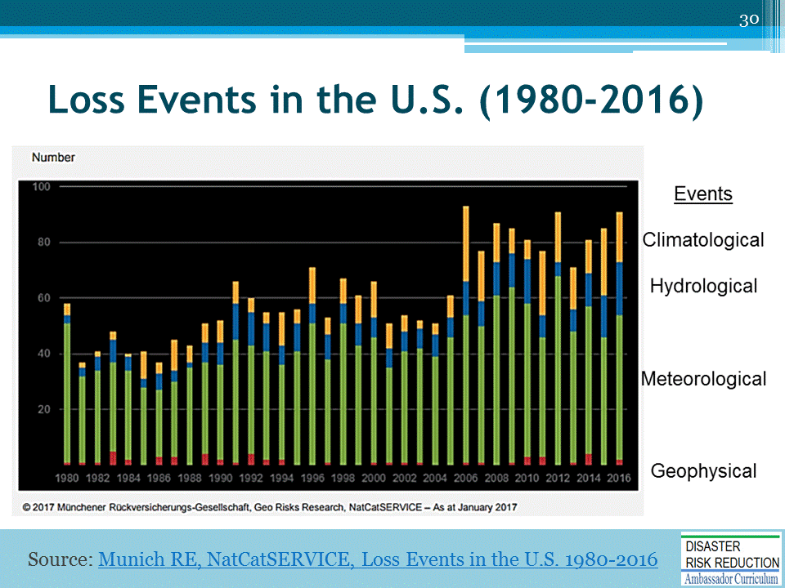
Flood and wind disasters have been increasing most.
FIGURE LEGEND
Red bars: Geophysical events (earthquake, tsunami, volcanic activity)
Green bars: Meteorological events (tropical storm, extratropical storm, convective storm, local storm)
Blue bars: Hydrological events (flood, mass movement)
Orange bars: Climatological events (extreme temperature, drought, forest fire)
https://www.munichre.com/site/mram-mobile/get/documents_E1982729150/mram/assetpool.mr_america/Images/5_Press_News/Press%20Releases/2016/1980_2016_Paket_USA.pdf

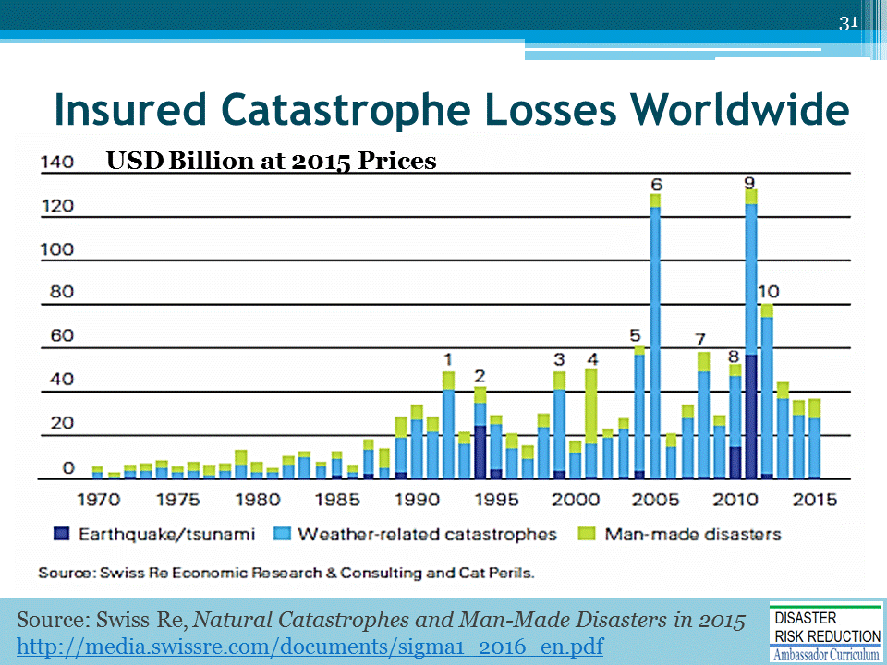
Some people think that the “recent dip” is a trend.
- Is it? NOT Likely

FIGURE LEGEND
- 1992: Hurricane Andrew
- 1994: Northridge earthquake
- 1999: Winter Storm Lothar
- 2001: 9/11 attacks
- 2004: Hurricanes Ivan, Charley, Frances
- 2005: Hurricanes Katrina, Rita, Wilma
- 2008: Hurricanes Ike, Gustav
- 2010: Chile, New Zealand earthquakes
- 2011: Japan, New Zealand earthquakes, Thailand flood
- 2012: Hurricane Sandy

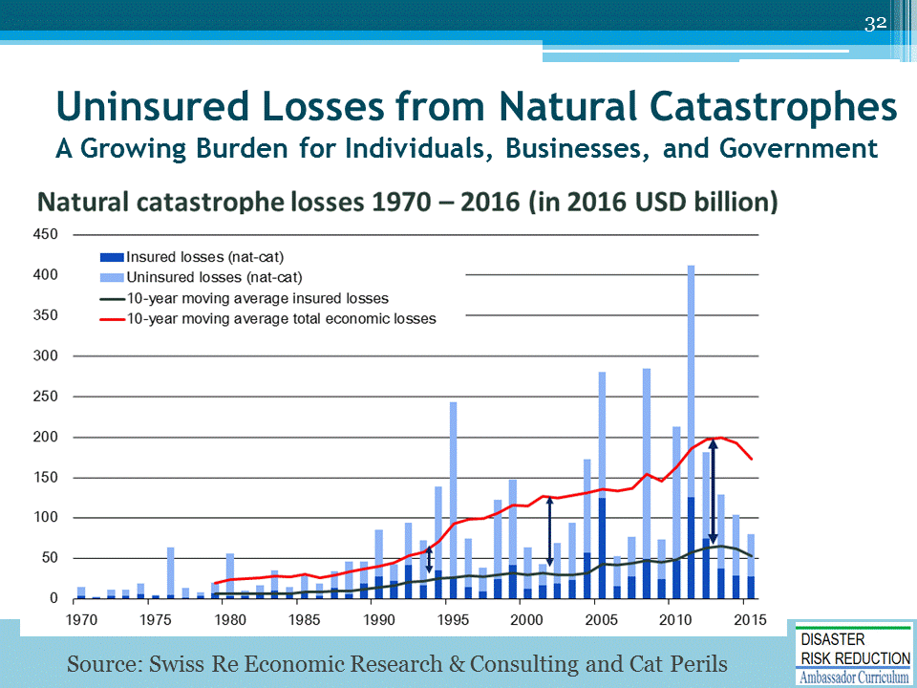

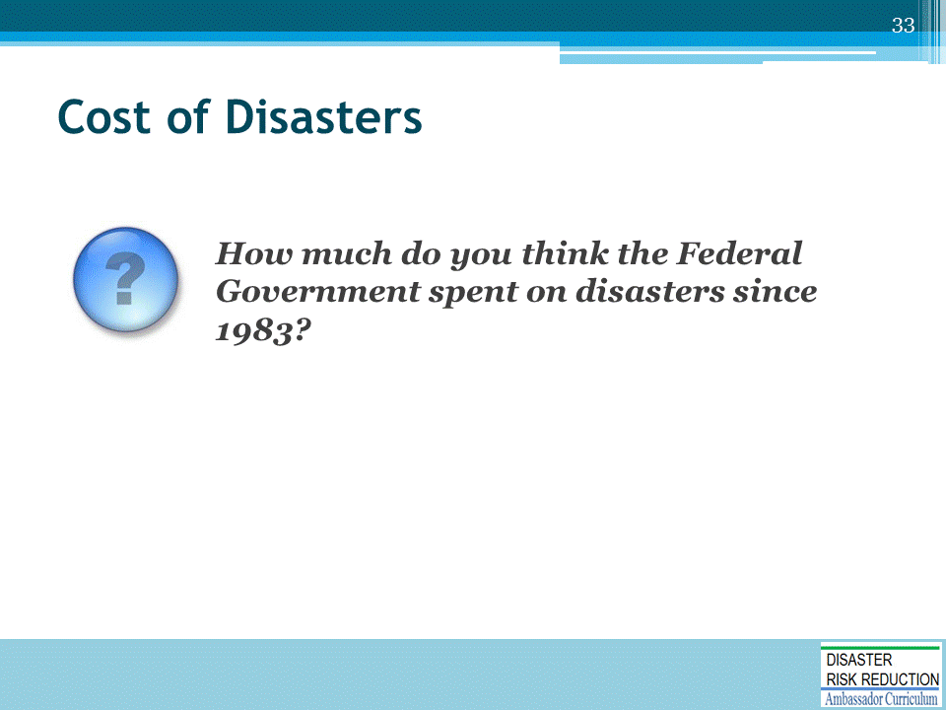
ASK the question and solicit educated guesses from participants before moving on to the next slide.

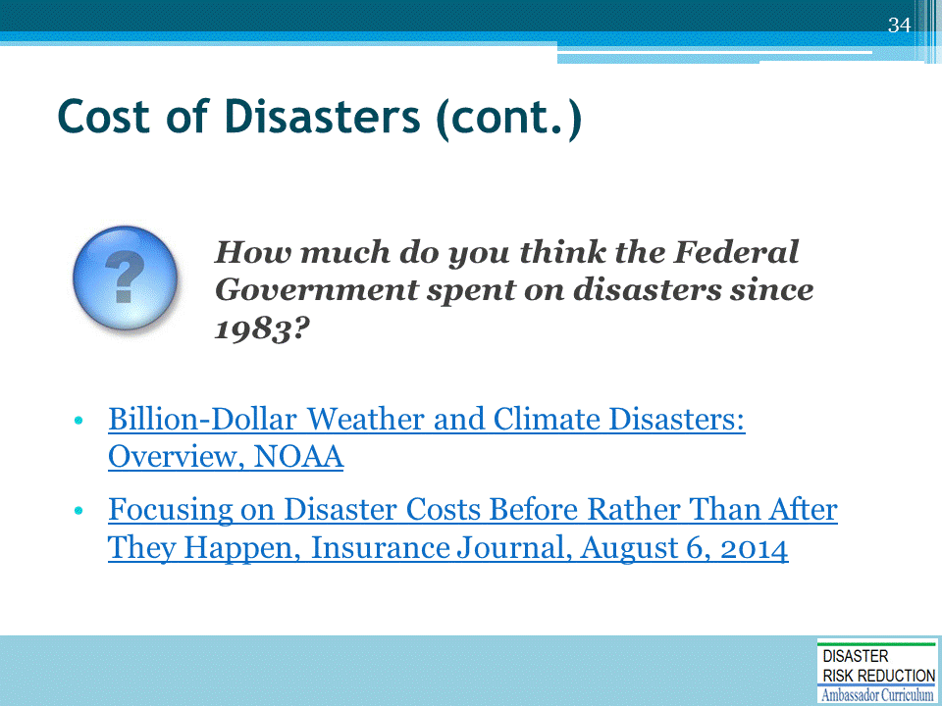
Billion-Dollar Weather and Climate Disasters: Overview, NOAA (https://www.ncdc.noaa.gov/billions/)
- “The U.S. has sustained 203 weather and climate disasters since 1980 where overall damages/costs reached or exceeded $1 billion (including CPI adjustment to 2016).
- The total cost of these 203 events exceeds $1.1 trillion.
Focusing on Disaster Costs Before Rather Than After They Happen, Insurance Journal, August 6, 2014 (http://www.insurancejournal.com/news/national/2014/08/06/336796.htm)
- “For decades, the federal government has increased disaster funding to meet the rising costs. Since 1983, the federal government has spent nearly $1 trillion on disaster recovery and rebuilding efforts. Supplemental disaster funds were appropriated in 17 of the 22 budget years between fiscal year 1989 and 2010, according to the Congressional Research Service.”
- Billion-Dollar Weather and Climate Disasters: Overview, NOAA: https://www.ncdc.noaa.gov/billions/
That is just dollars; how about the suffering and misery?

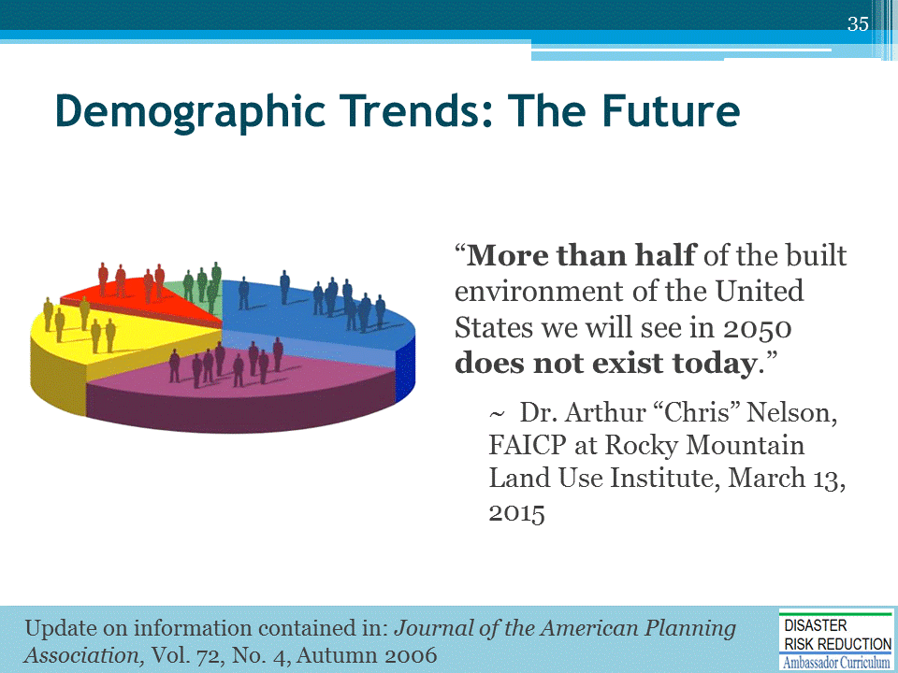
Among the demographic projections Dr. Nelson makes:
- The US will be the fastest growing Nation in the world, except India only, (in sheer numbers not percentage) over the next 30 or so years. Our next 100 million population should come in about 20 years. It took 37 years to get from US 200 million to the new total of 300 million. To be clear, he says we will be growing in sheer numbers faster than China or Indonesia.
- Our need for housing and commercial space is going to change dramatically by type-from low % of lot coverage to high % coverage. The implications of this are huge from a floodplain management perspective: building construction that will have higher value per acre; including construction which will generally require closed pipe stormwater flow, as well as excellent engineering and planning for stormwater and floodplain management purposes. In general this new wave of development is even less forgiving of ignoring natural processes than our current construction.
- Other observations:
  - Housing demand will be for more units per acre-townhouse, condo, shopping malls that go from 0.2 usable space per acre ratio to somewhere between 1.6 and 2.0 ratio of usable space per occupied acre (high value-tight spaces-high runoff-low storage w/o NAI planning);
  - Housing built post WWII should have a life expectancy of around 150 years;
  - Shopping malls with traditional parking lots have a life expectancy of about 12-20 years; and will be likely redeveloped into much higher density and value malls;
  - Demand for homes on large lots (greater than 7,000 sq. ft.) will drop to the point that these homes may be white elephants;
  - Demand for condos, single family housing will soar.
- Dr. Nelson did not mention this, but it is also worth noting that much of this rapid development and re-development will take place in the Arid West, and other areas which will have a growing scarcity of potable water. He has spoken about this at the EPA Large Production Builders Conference, and written about it in the APA Magazine. A the reference for his article for APA is noted on the slide.

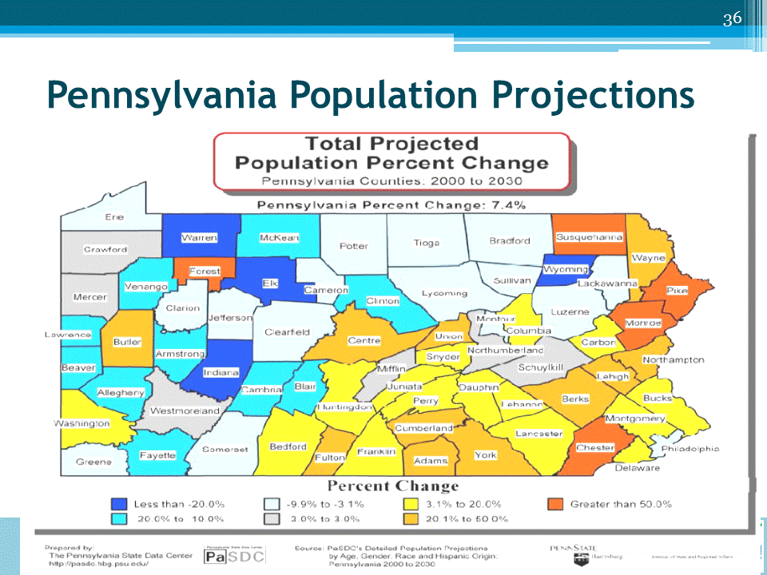

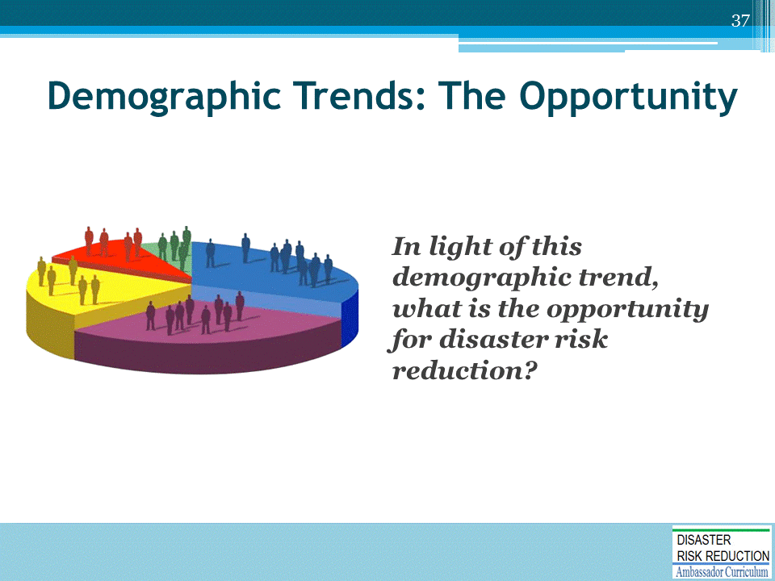
Facilitate discussion around opportunities to reduce risk today, in light of the demographic trend.

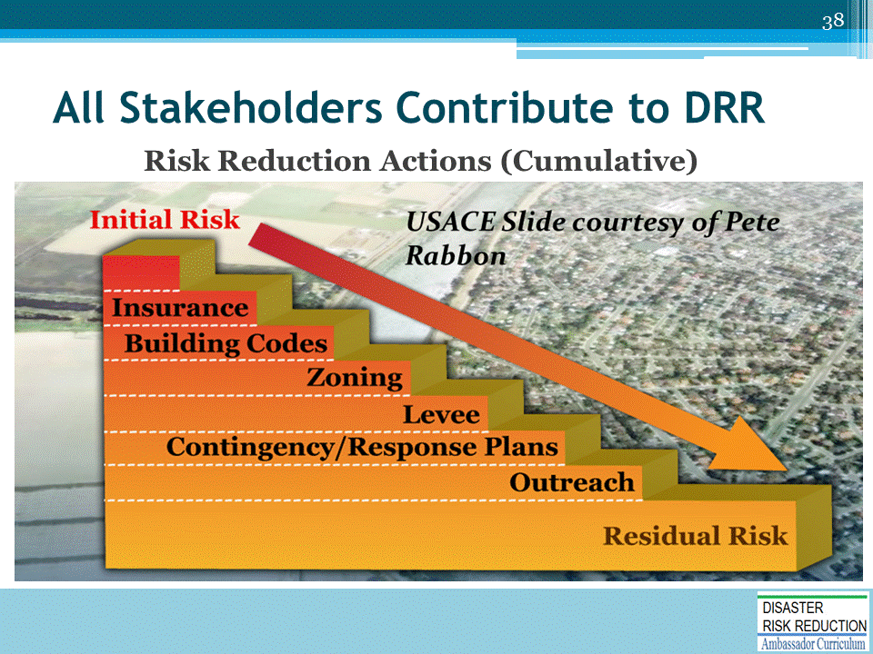
- All stakeholders contribute to reducing risk.
- The “ideal” concept is we start with an initial risk and reduce it through human activity.

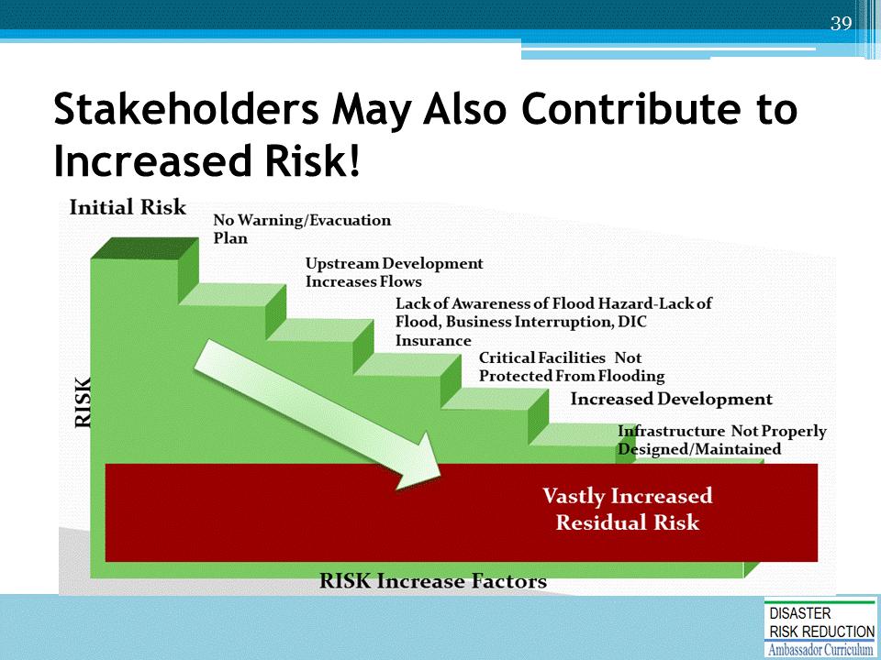

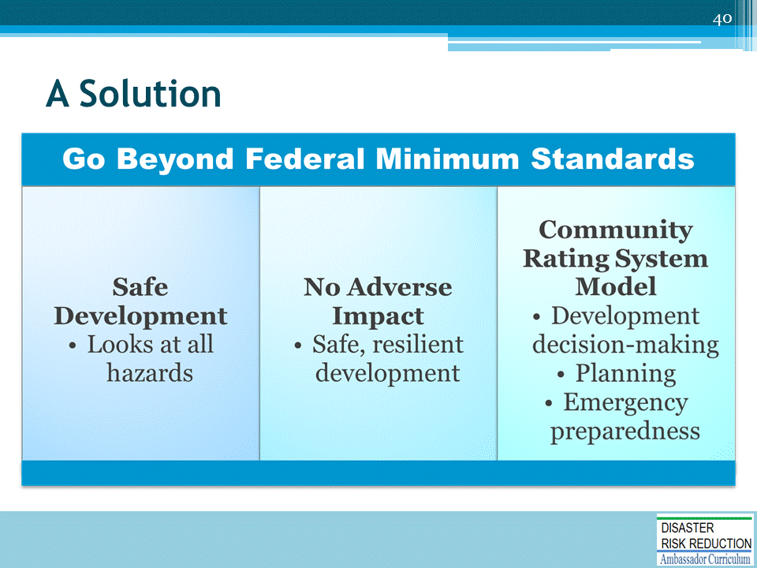

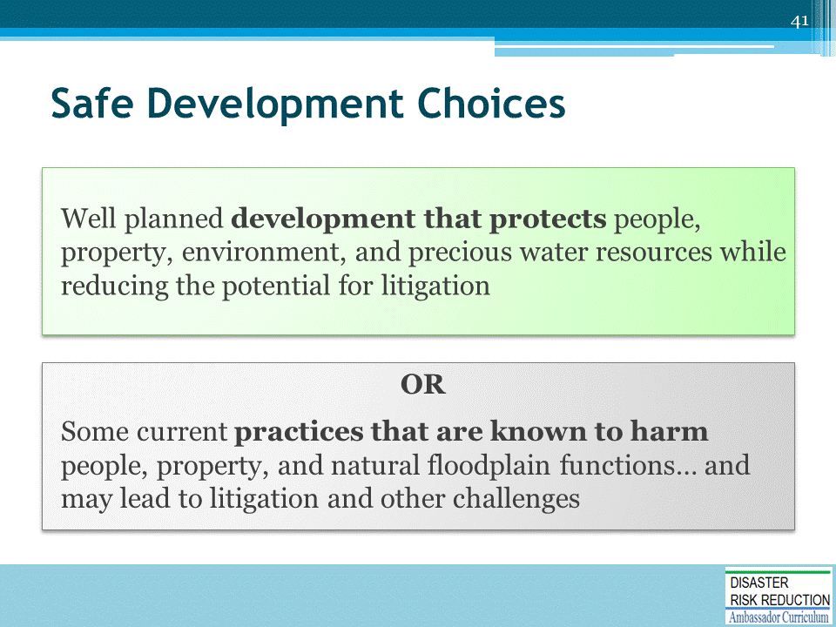
Sustainability and Triple Bottom Line (TBL)

Explanation of Triple Bottom Line
Excerpt from article, The Triple Bottom Line: What Is It and How Does It Work?
By Timothy F. Slaper, Ph.D. and Tanya J. Hall
http://www.ibrc.indiana.edu/ibr/2011/spring/article2.html
“The TBL [Triple Bottom Line] is an accounting framework that incorporates three dimensions of performance: social, environmental and financial. This differs from traditional reporting frameworks as it includes ecological (or environmental) and social measures that can be difficult to assign appropriate means of measurement. The TBL dimensions are also commonly called the three Ps: people, planet and profits.
Well before [John] Elkington introduced the sustainability concept as "triple bottom line," environmentalists wrestled with measures of, and frameworks for, sustainability. Academic disciplines organized around sustainability have multiplied over the last 30 years. People inside and outside academia who have studied and practiced sustainability would agree with the general definition of Andrew Savitz for TBL. The TBL "captures the essence of sustainability by measuring the impact of an organization's activities on the world ... including both its profitability and shareholder values and its social, human and environmental capital.”

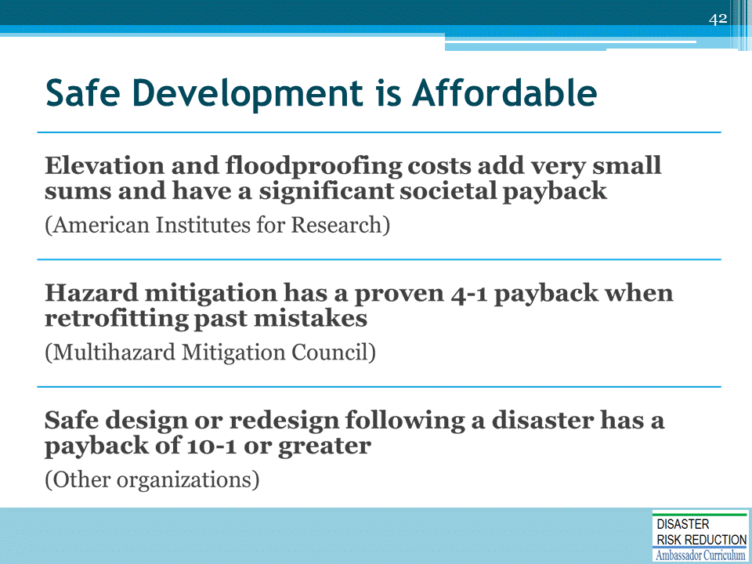
- The American Institutes for Research has conducted a detailed study on the cost of floodproofing and elevation
  - That study supports the idea that elevation and floodproofing costs add very small sums and have a significant societal payback
- The Multihazard Mitigation Council, which includes private industry representatives, reports that hazard mitigation has a proven 4-1 payback when retrofitting past mistakes
- Other organizations (such as Wharton School of the University of Pennsylvania and the insurance company Swiss Re) calculate that safe design or redesign following a disaster has a payback of 10-1 or greater
  - Hazard Mitigation in Disaster Recovery, by Edward A. Thomas, Esq., and Lincoln Walther, FAICP, in Planning for Post Disaster Briefing Papers, American Planning Association, 2015. Located at: https://www.planning.org/research/postdisaster/briefingpapers/hazardmitigation.htm

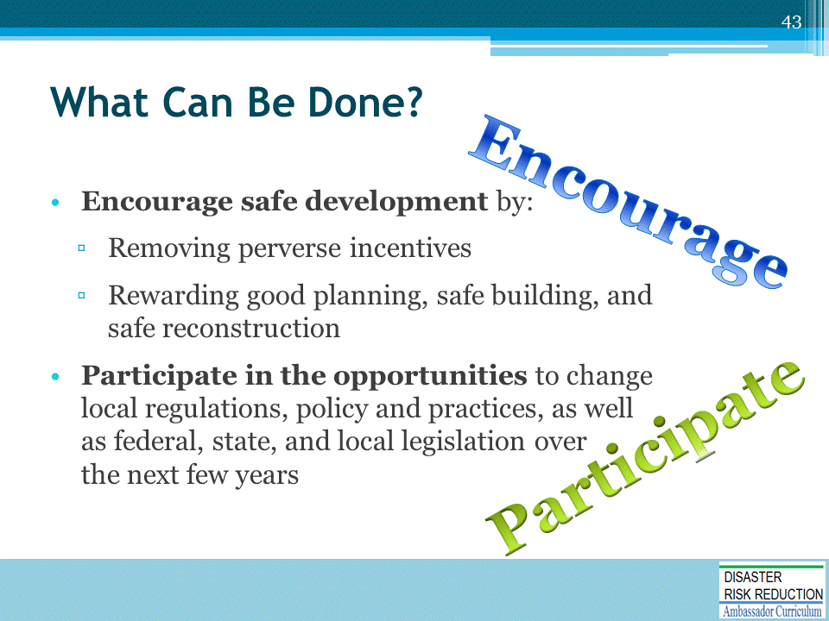

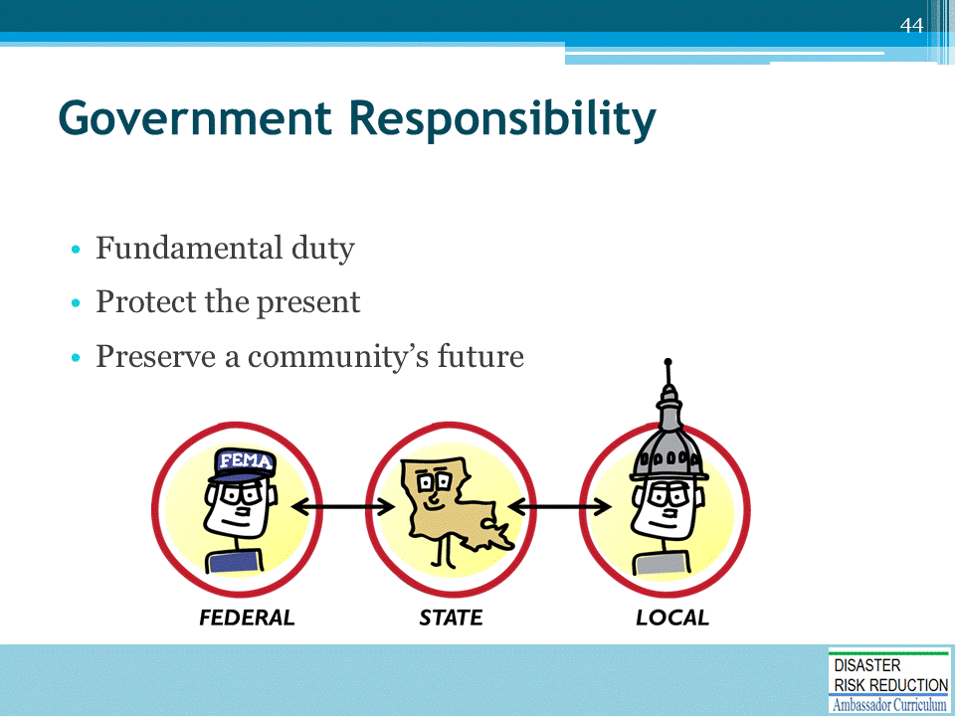
Why should the government do something?

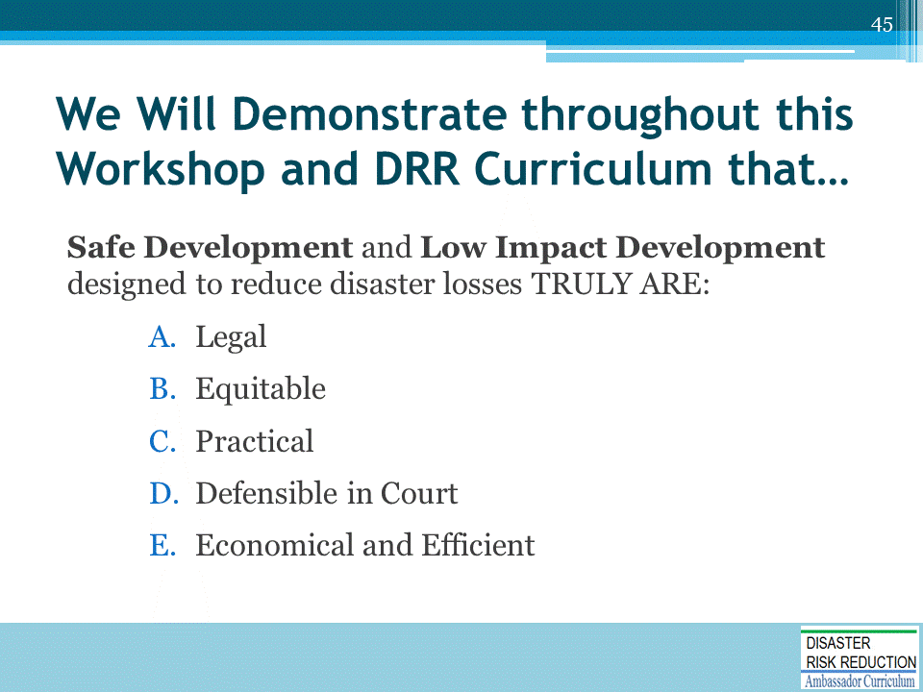
Don’t Flood Thy Neighbor!!!!

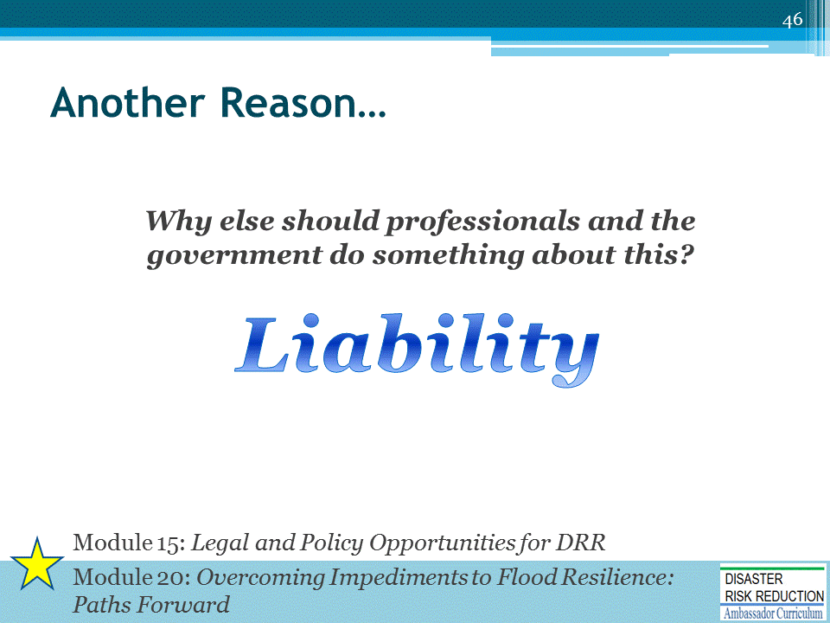
The word liability is one of the most significant words in the field of law.
- Liability means legal responsibility for one's acts or omissions.
- Failure of a person or entity to meet that responsibility leaves him/her/it open to a lawsuit for any resulting damages or a court order to perform (as in a breach of contract or violation of statute).
Source: http://dictionary.law.com/Default.aspx?selected=1151
MENTION that these topics are covered more fully in Modules 15 and 20 of the DRR Ambassador Curriculum.
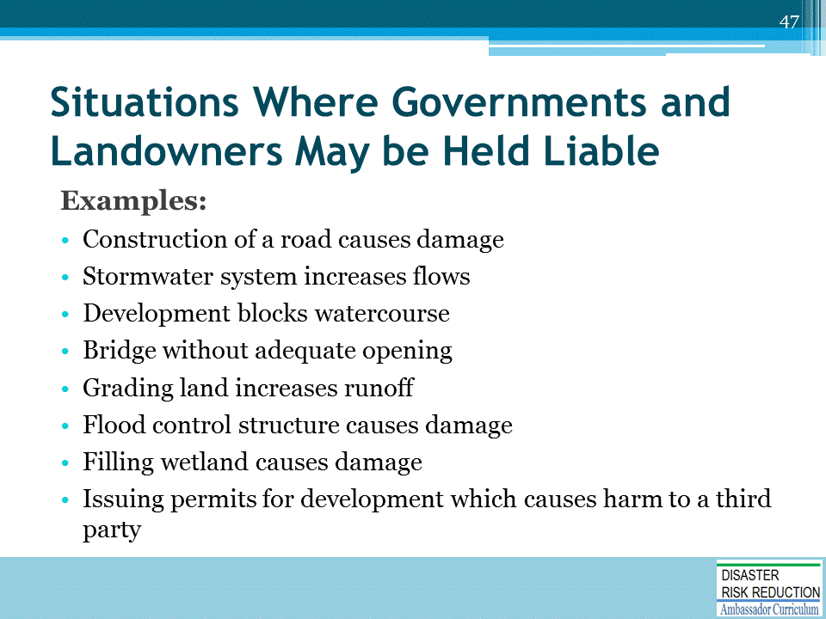
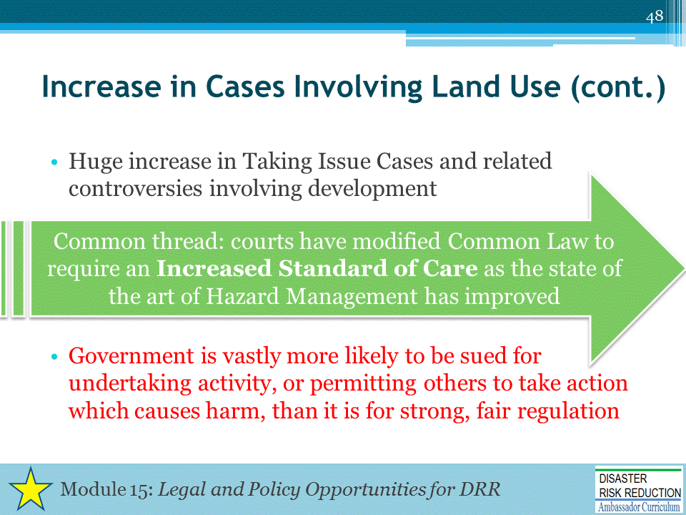
Thousands of cases were reviewed by Jon Kusler, Ed Thomas, and others
STOP!!
Funny you might think from talking to some developers that they were winning all over - wishful thinking
TALK!!
Vastly more likely to be sued for permitting development that causes problems-roads, stormwater systems bridges runoff etc. When I say VASTLY I mean not one but TWO full orders of magnitude more likely to be successfully sued - ONE HUNDRED (100) times more likely to be sued for permitting or doing improper development!!!

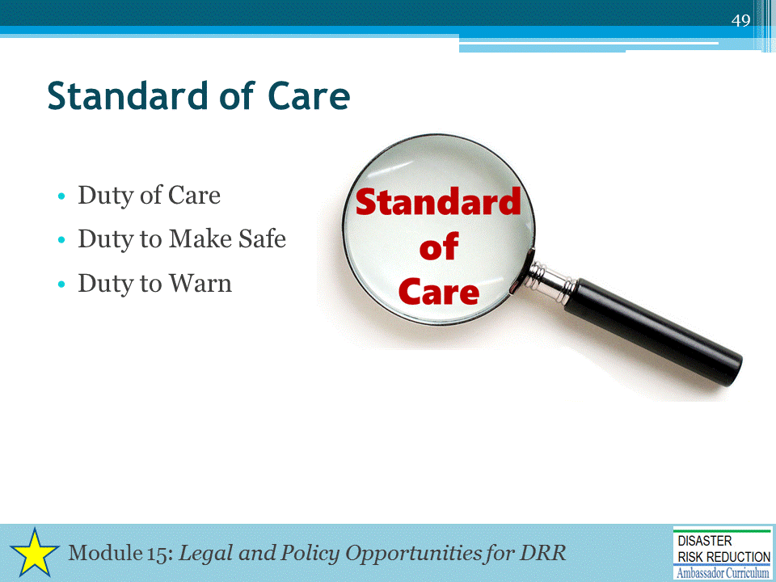
These terms are the legal foundations for concepts of liability, negligence, etc.
MENTION that these terms are covered more fully in Module 15 of the DRR Ambassador Curriculum.

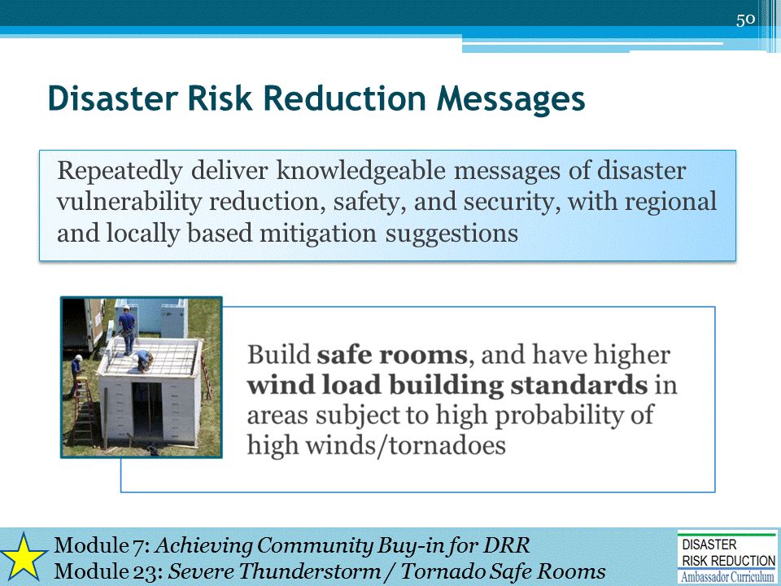
MENTION that this is covered more fully in Module 23 of the DRR Ambassador Curriculum, Severe Thunderstorm / Tornado Safe Rooms

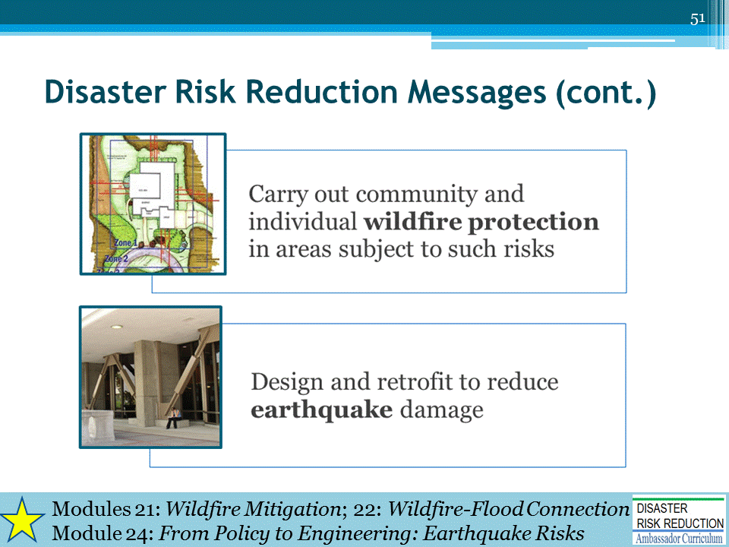
MENTION that these topics are covered more fully in DRR Ambassador Curriculum:
- Module 21, Wildfire Mitigation
- Module 22, The Wildfire-Flood Connection
- Module 24, From Policy to Engineering: Earthquake Risks
- As of April 2017, these modules are not yet available.

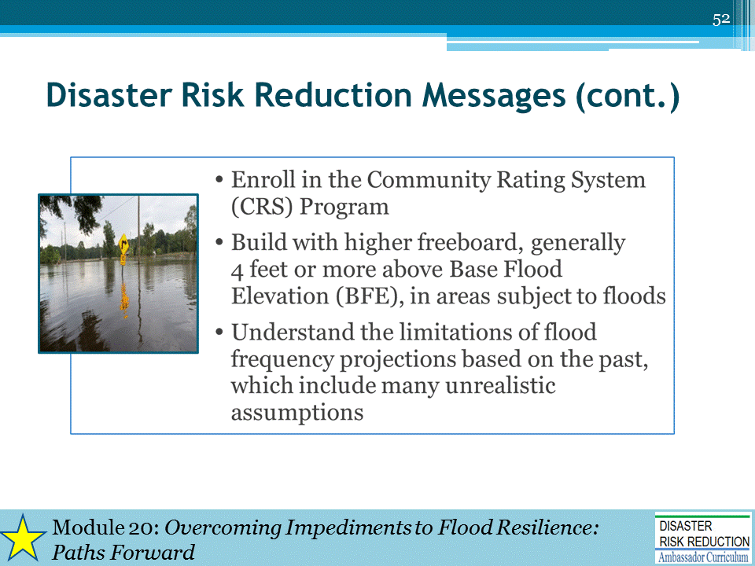
Regarding the second bullet, “4-feet or more above BFE”:
Many States and communities have incorporated freeboard requirements into the elevation and floodproofing requirements stipulated by the NFIP. Freeboard requirements range up to 4 feet, and it is up to the community to decide what is most appropriate given their location and other community conditions.
MENTION that this is covered more fully in Module 20 of the DRR Ambassador Curriculum, Overcoming Impediments to Flood Resilience: Paths Forward
NOTE: Briefly describe CRS in case there are audience members who do not know about that program.
What is the CRS?
- A voluntary program for the National Flood Insurance Program's (NFIP's) participating communities.
- Purpose: to promote the awareness of flood insurance, mitigate flood losses, and facilitate accurate insurance rating
- Benefit: A chief way in which the CRS mitigates losses is to provide incentives (i.e., premium discounts) for communities to extend beyond the minimum floodplain management requirements by developing extra measures to provide protection from flooding. For a community to qualify for the CRS, it must be in full compliance with all aspects of the NFIP.
Goals of the CRS:
- Reduce flood damage to insurable property,
- Strengthen and support the insurance aspects of the NFIP, and
- Encourage a comprehensive approach to floodplain management.

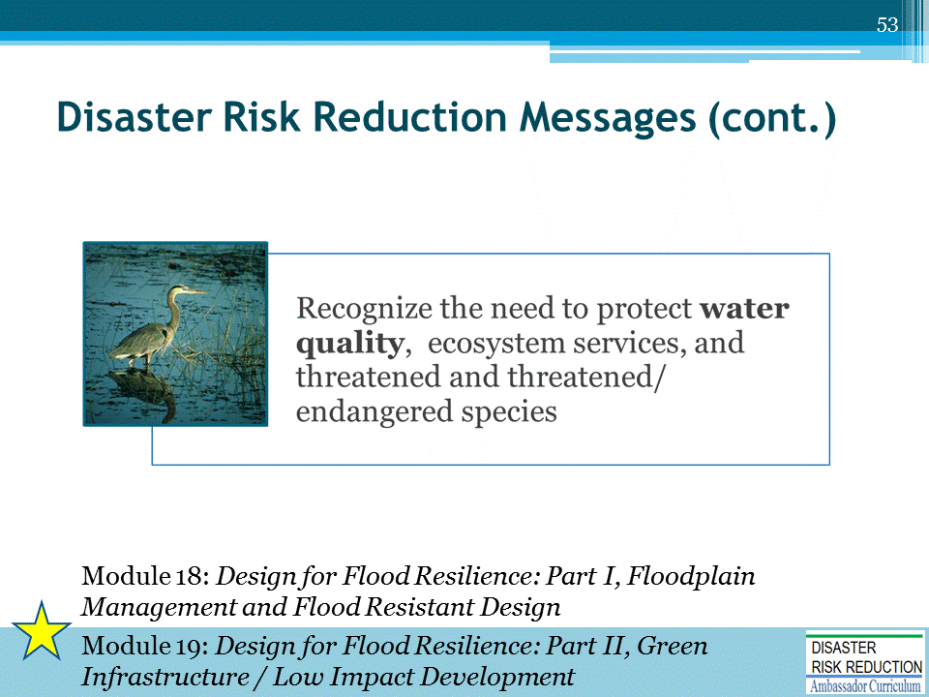

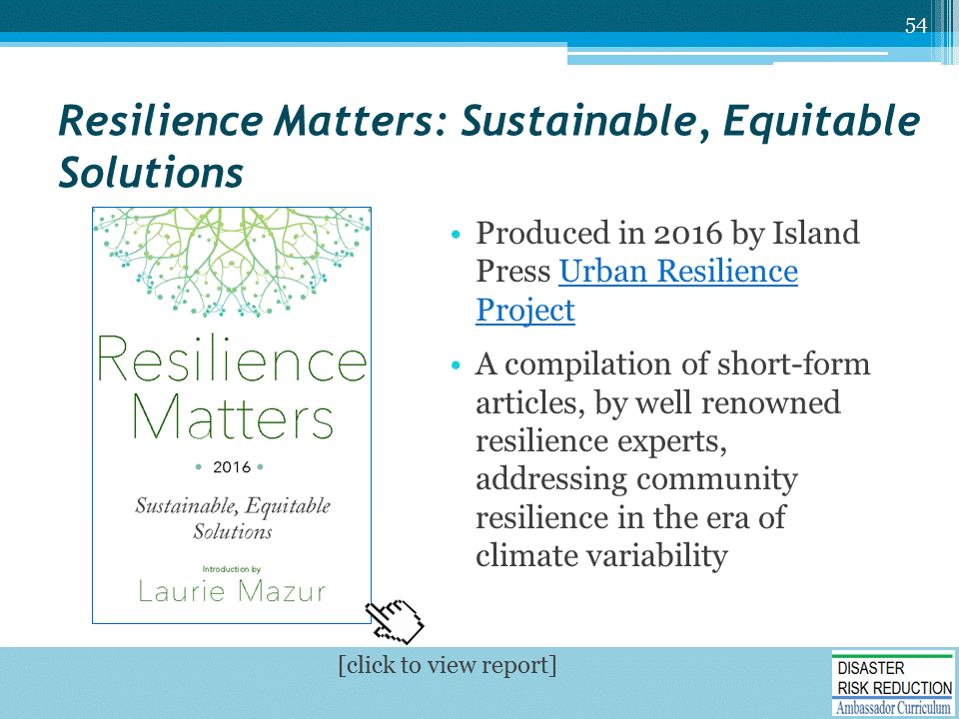
EXCELLENT RESOURCE
Available from NHMA website: http://nhma.info/new-e-book-resilience-matters-2016-sustainable-equitable-solutions/

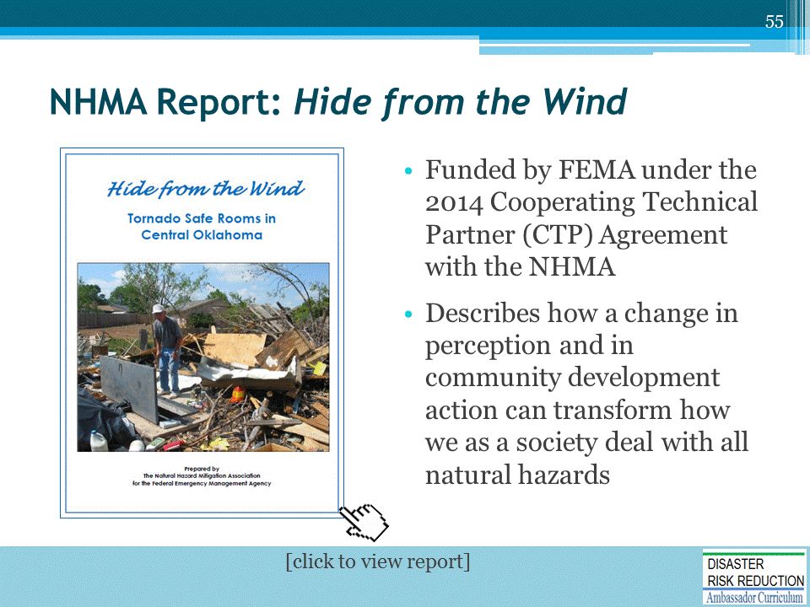
EXCELLENT RESOURCE
- This report, funded by FEMA under the 2014 Cooperating Technical Partner (CTP) Agreement with the NHMA, documents how staff from FEMA, other public agencies, non‐government organizations, grass roots organizations, the media, academia and local practitioners have designed standards, and developed and implemented a new program to encourage the construction of safe rooms in areas with a high risk of devastation caused by tornado activity.
  - This program now provides life‐saving safe room and storm shelter protection for thousands of people in the United States.
- This report briefly summarizes how the program and results were achieved, and how a change in risk perception led to thousands of people and organizations taking action to lessen the risks and consequences of natural events.
  - The findings in this report, describe how a change in perception and in community development action can transform how we as a society deal with all natural hazards.
Thus, the findings have enormous implications for current national efforts to build a more resilient society in an era of climate uncertainty.

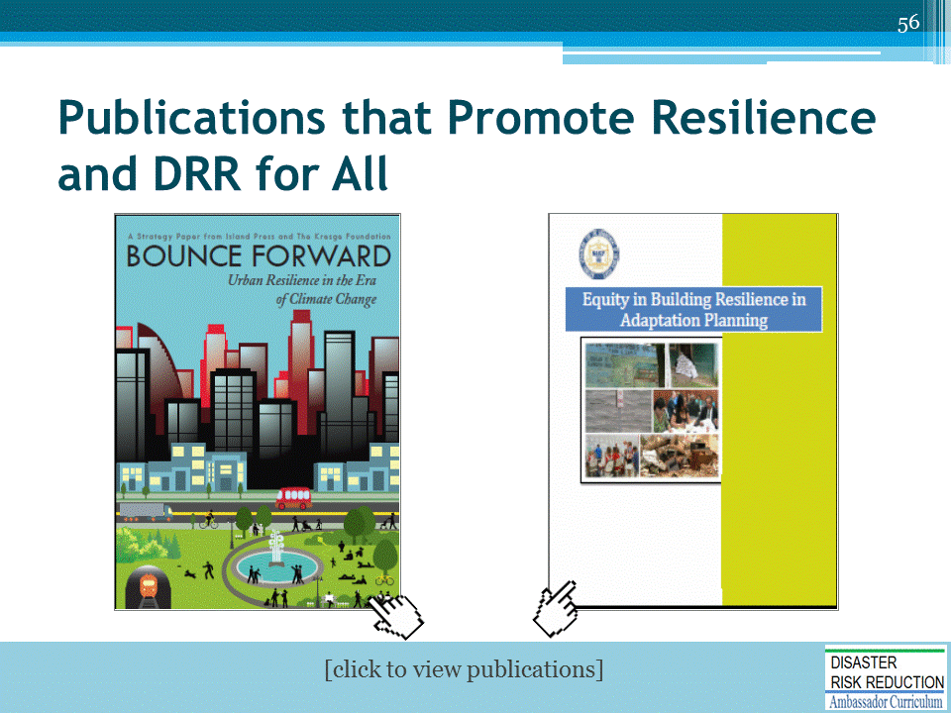
EXCELLENT RESOURCES
Other resources also are available from the NHMA website; see Recommendations from NHMA: http://nhma.info/resources/recommended-reading/

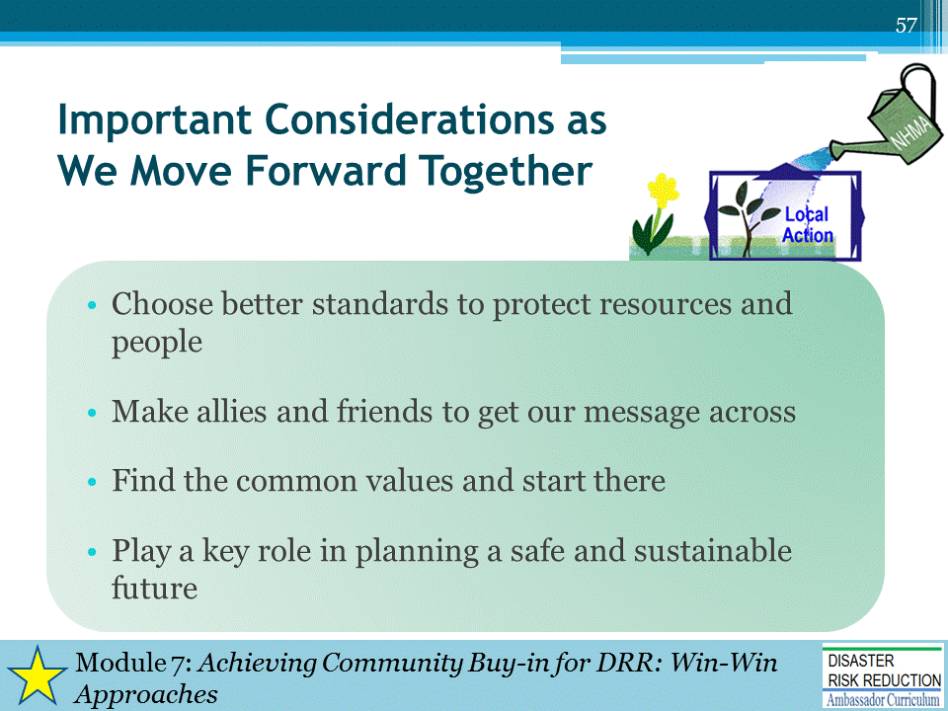

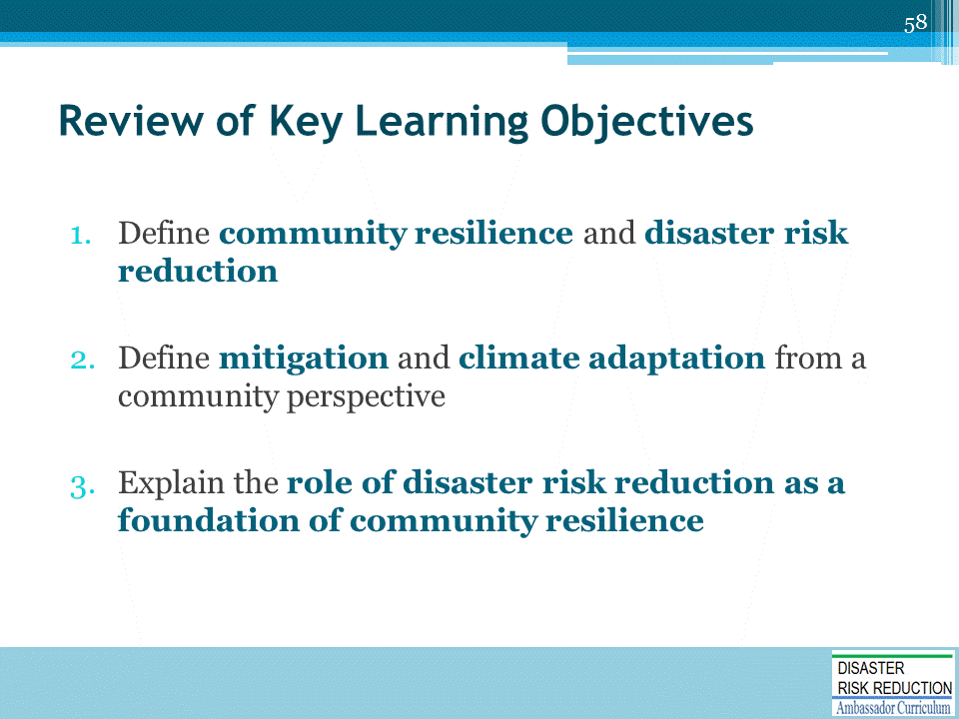
Discussion to engage participants and to assist achievement of Learning Objectives (repetition and review)
For example, ask attendees to discuss and answer:
- What is community resilience?
- What is the goal of disaster risk reduction?
- What are some examples of mitigation activities?
- What are some examples of climate adaptation activities?
- What DRR message(s) will you bring back to your community?

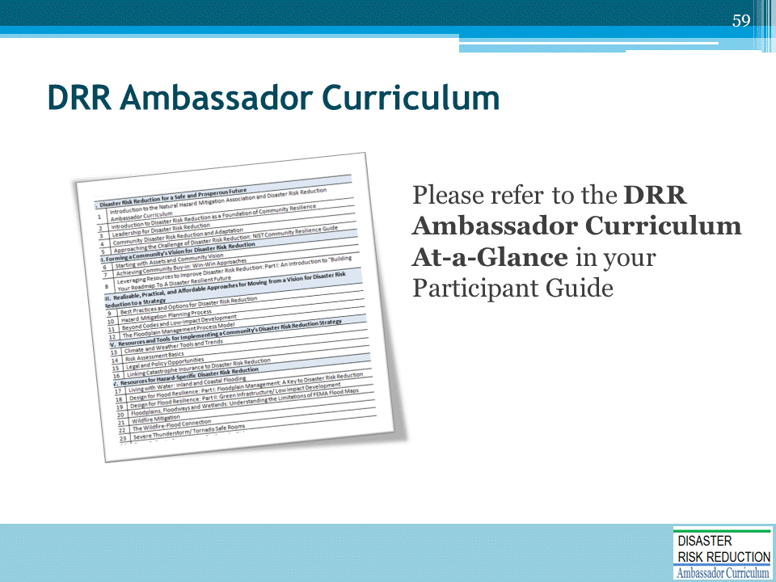
Refer participants to the DRR Ambassador Curriculum At-a-Glance table, located in their Participant Guide. (If available, refer to the DRR Ambassador Curriculum poster)
- Encourage the audience members to take advantage of the wide array of DRR Curriculum modules offered through workshops and webinars
- Provide information on upcoming workshops and webinars
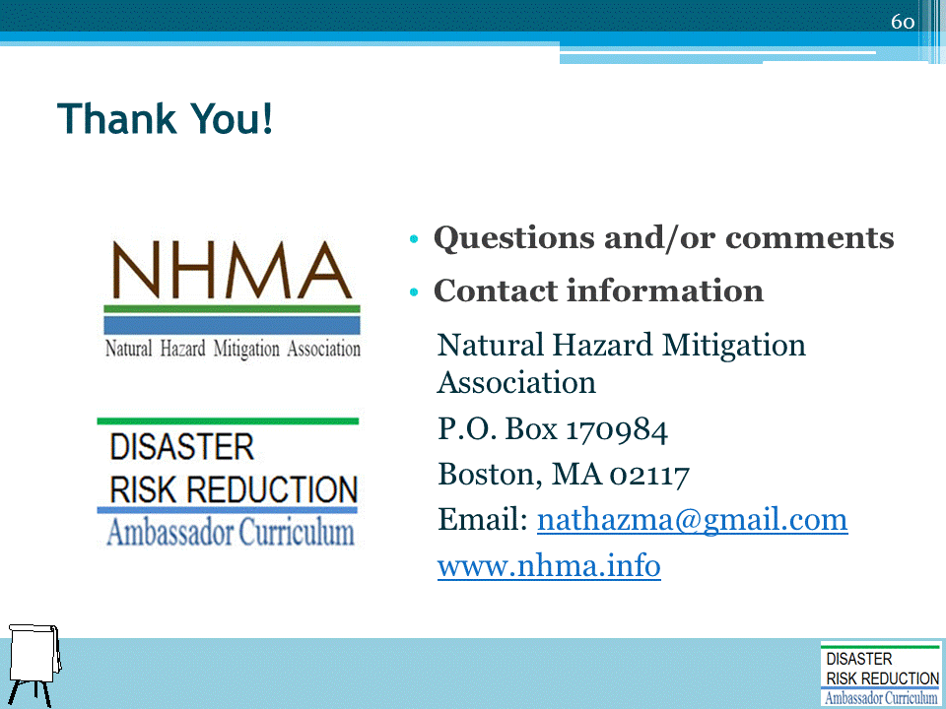
Record on easel pad any recommendations or questions to be addressed outside of the presentation.

DRR AMBASSADOR CURRICULUM AT-A-GLANCE
I. Disaster Risk Reduction for a Safe and Prosperous Future
1 | Introduction to the Natural Hazard Mitigation Association and Disaster Risk Reduction Ambassador Curriculum
2 | Introduction to Disaster Risk Reduction as a Foundation of Community Resilience
3 | Leadership for Disaster Risk Reduction
4 | Community Disaster Risk Reduction and Adaptation
5 | Approaching the Challenge of Disaster Risk Reduction: NIST Community Resilience Guide
II. Forming a Community’s Vision for Disaster Risk Reduction
6 | Risk Assessment through Storytelling: An Asset-Based Approach
7 | Achieving Community Buy-in for Disaster Risk Reduction: Win-Win Approaches
8 | Leveraging Resources to Improve Disaster Risk Reduction
III. Realizable, Practical, and Affordable Approaches for Moving from a Vision for Disaster Risk Reduction to a Strategy
9 | Selecting and Implementing a Strategy for Addressing Community Disaster Risk Problems
10 | Integrating Hazard Mitigation into Local Planning
11 | Beyond Codes and Low-Impact Development
12 | Creating the Plan: A Sustainable Floodplain Management Process Model
IV. Resources and Tools for Implementing a Community’s Disaster Risk Reduction Strategy
13 | Climate and Weather Tools and Trends
14 | Risk Assessment Basics
15 | Legal and Policy Opportunities for Disaster Risk Reduction
16 | Linking Catastrophe Insurance to Disaster Risk Reduction
V. Resources for Hazard-Specific Disaster Risk Reduction
17 | Living with Water: Inland and Coastal Flooding
18 | Design for Flood Resilience: Part I: Floodplain Management and Flood Resistant Design
19 | Design for Flood Resilience: Part II: Green Infrastructure / Low Impact Development
20 | Overcoming Impediments to Flood Resilience: Paths Forward
21 | Wildfire Mitigation
22 | The Wildfire-Flood Connection
23 | Severe Thunderstorm/Tornado Safe Rooms
24 | From Policy to Engineering: Earthquake Risks

