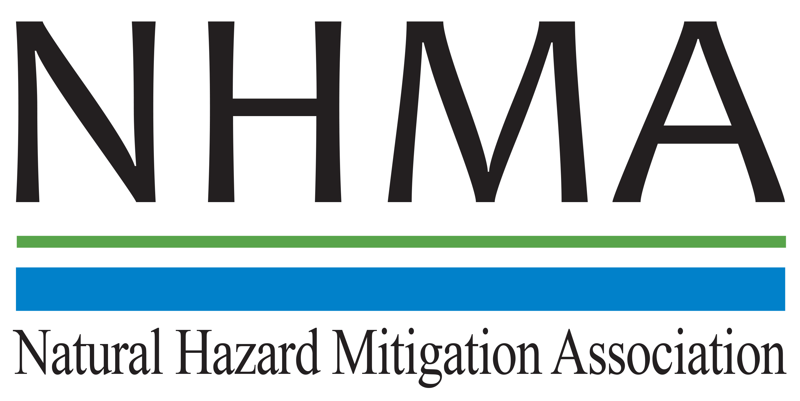

Disaster Risk Reduction (DRR) Ambassador Curriculum

Instructor Guide

Module 4:
Community Disaster Risk Reduction and Adaptation

THE DRR AMBASSADOR CURRICULUM
The goal of the DRR Ambassador Curriculum is to facilitate Disaster Risk Reduction efforts for the whole community by:
- Engaging in discussion of how disasters can be reduced through local action
- Sharing insights among local leaders and technical experts to enable the development of cross functional solutions
- Acquiring the best-available information, knowledge of best practices, and analytic tools to enable better-informed decisions before, during, and after disasters
It is important for instructors of DRR Ambassador Curriculum modules to remember this is one module in a 24-module curriculum. The “DRR Ambassador Curriculum At-a-Glance” table, located at the end of this document, lists the modules of the Curriculum. Keep in mind the following context for the module(s) you conduct:
DRR-A CURRICULUM TARGET AUDIENCE
The target audience includes those involved in community development decision-making, such as local community staff, volunteer and stakeholder groups, and federal and state officials.
METHODS OF DELIVERY
Varied delivery methods will provide multiple options for access by the target audience. The DRR Ambassador modules may be presented via webinars hosted by NHMA or partner organizations, presented in conferences and/or classrooms by qualified DRR Ambassador Curriculum instructor(s), or are downloadable for individual study from the NHMA website.
COURSE MATERIALS
Instructors are expected to use the instructional materials housed on the NHMA website to conduct DRR Ambassador Curriculum modules (Instructor Guide, supporting visuals, Participant Guides, and handouts). Instructors may tailor modules to specific audiences or locations as long as they do not revise the learning objectives and do not revise the materials in such a way that the participants cannot correctly complete the post-test. Instructors request the current pre/post-test for the module from NHMA.
CERTIFICATES OF COMPLETION
Certificates of Completion will be awarded by NHMA to participants who successfully complete NHMA-sponsored DRR Ambassador modules. A DRR Ambassador Certificate will be awarded to individuals completing all 24 modules. Participants who choose not to take the post-test may be issued a Certificate of Attendance. Contact NHMA about obtaining certificates. Inform participants to ask their certifying boards about acceptance of NHMA DRR Ambassador certificates for continuing education credits.

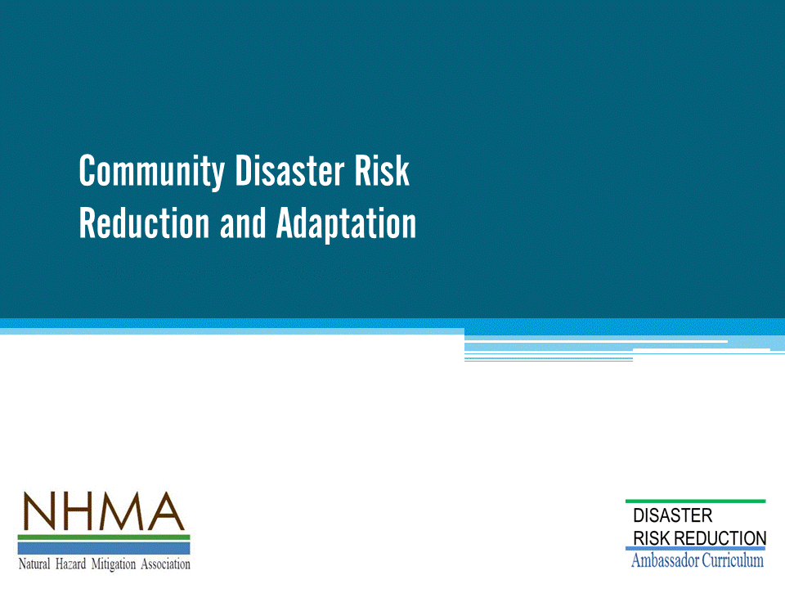
Approximate delivery time: 45-60 minutes

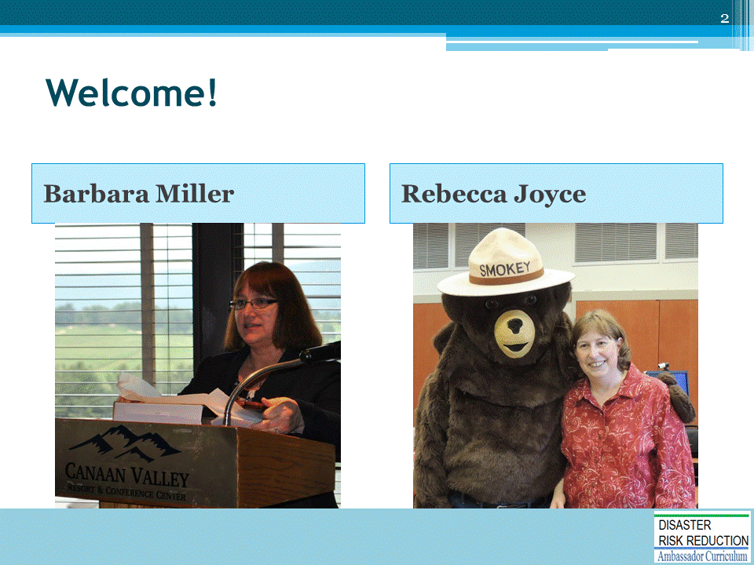
Introductions:
- Each presenter introduces her/himself, including affiliation and brief background.
- OPTIONAL: Have each participant briefly introduce him/herself
Mention: NHMA presentations are based on general principles of law, engineering, policy and emergency management.
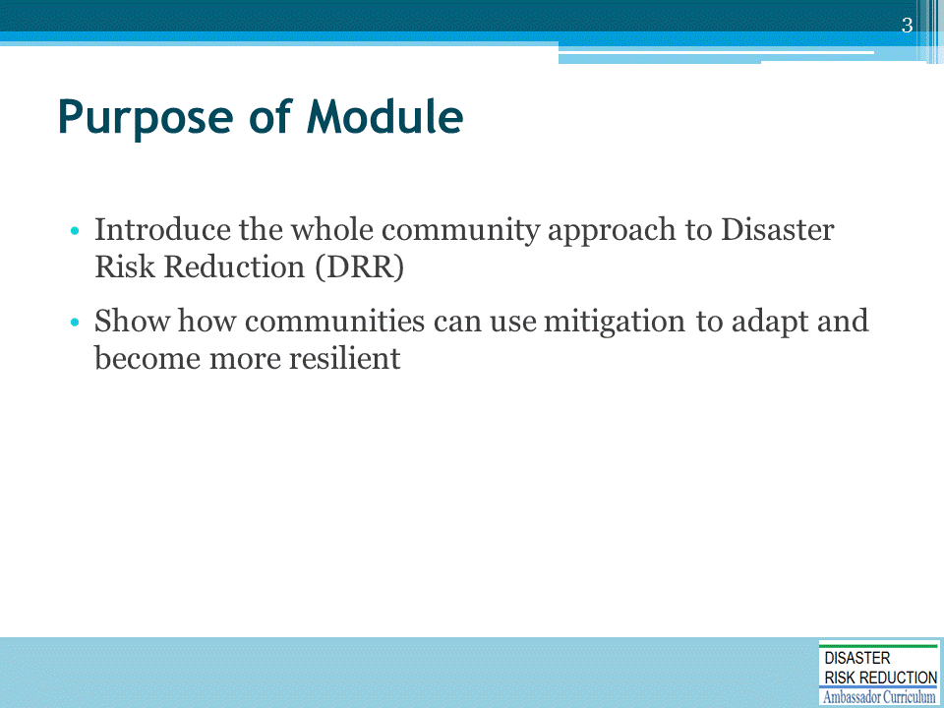

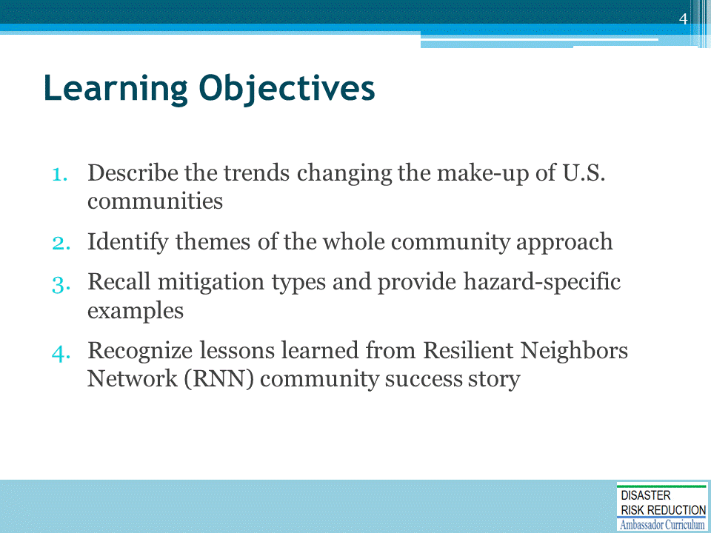

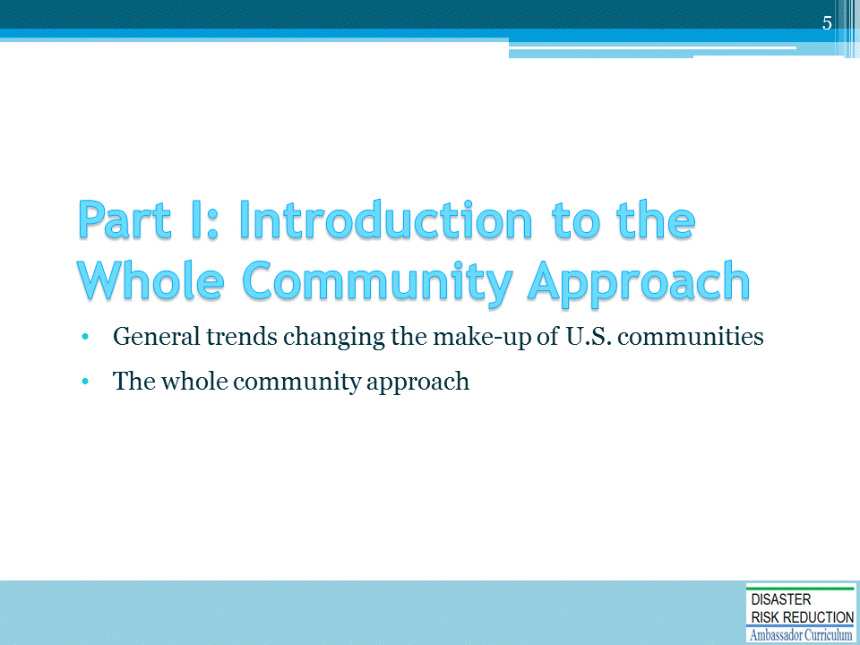

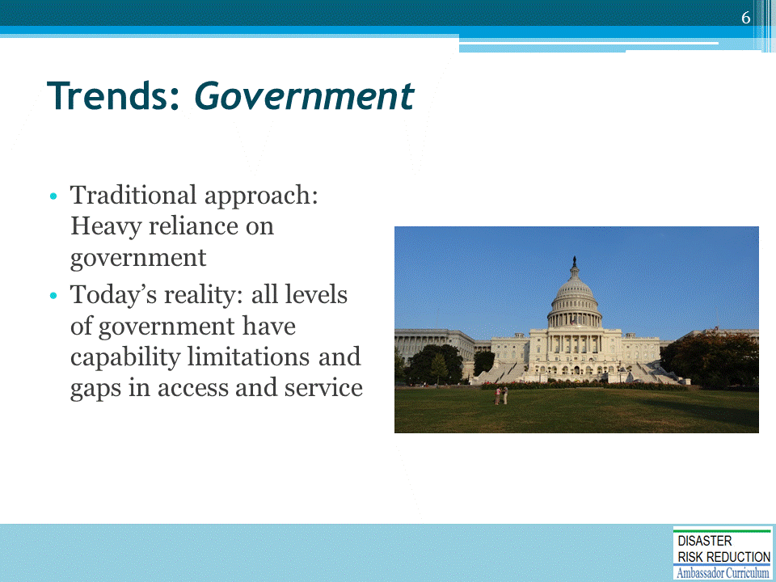
General trends changing the make-up of U.S. communities

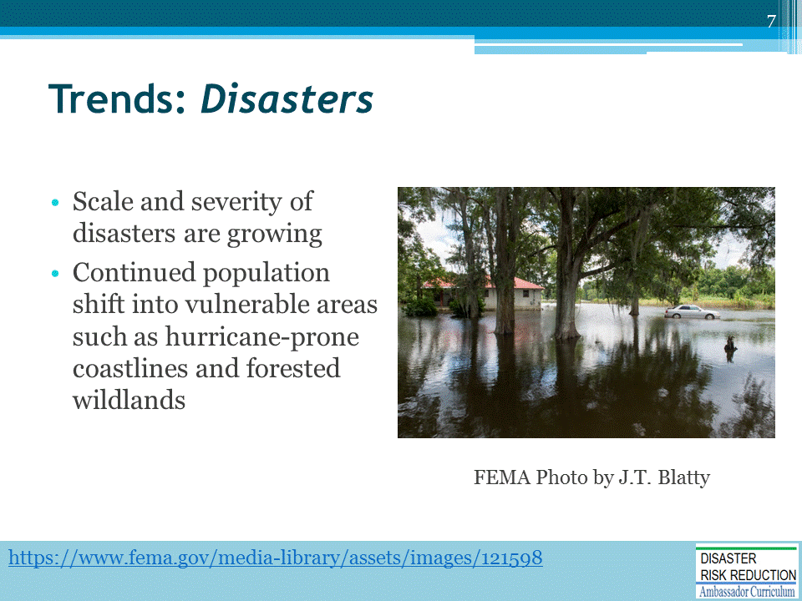
General trends changing the make-up of U.S. communities

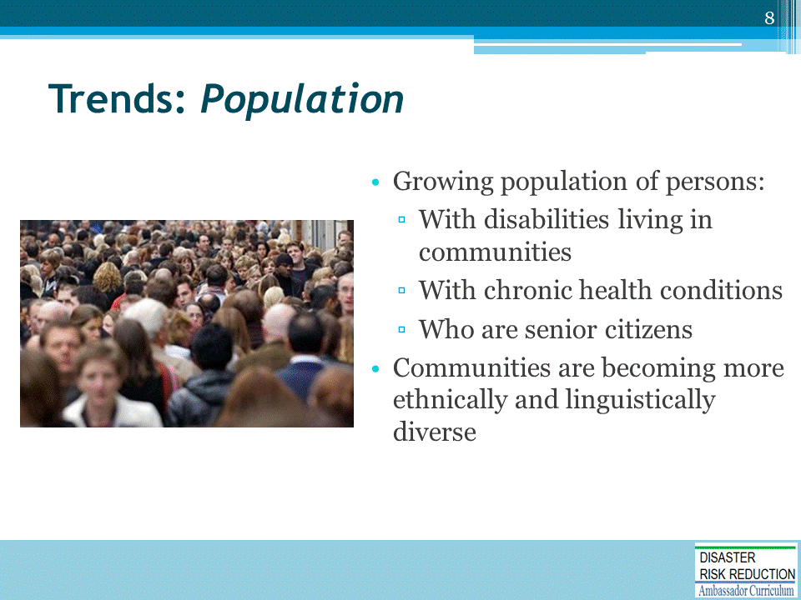
General trends changing the make-up of U.S. communities

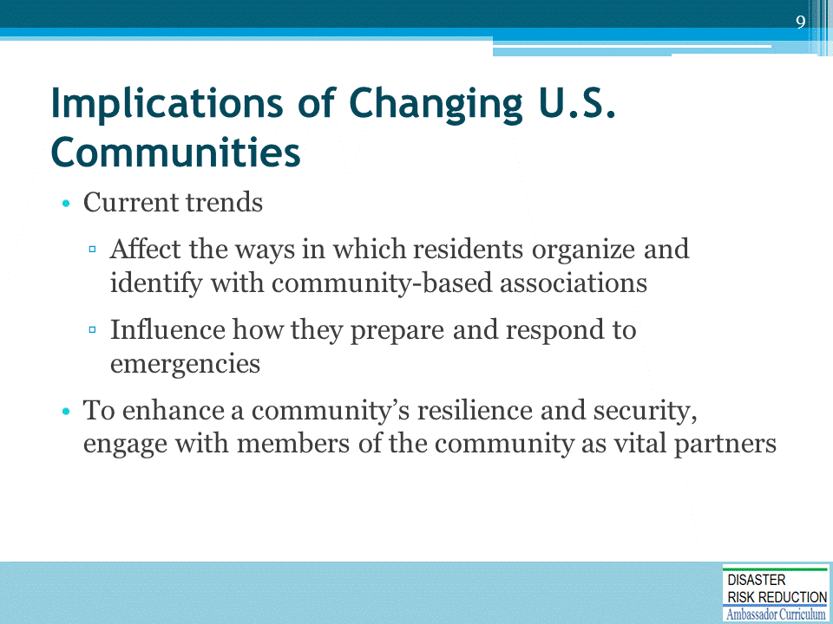
“ … a government-centric approach to disaster management will not be enough to meet the challenges posed by a catastrophic incident.” – W. Craig Fugate, Administrator, FEMA

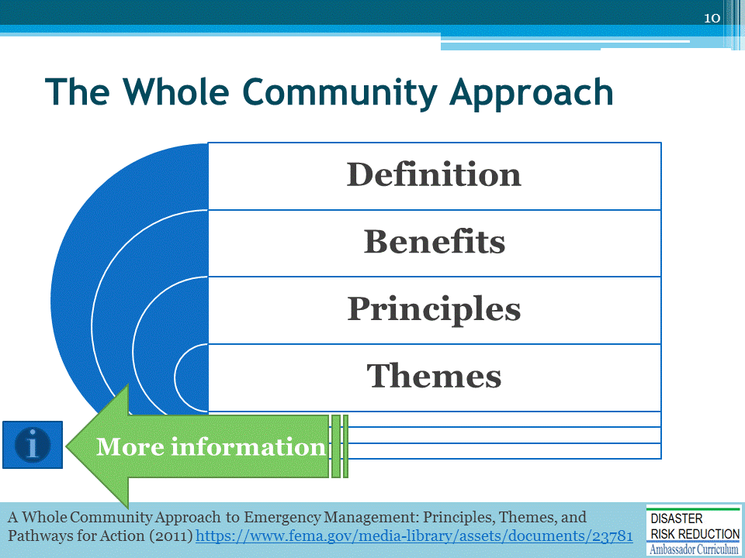
https://www.fema.gov/media-library/assets/documents/23781

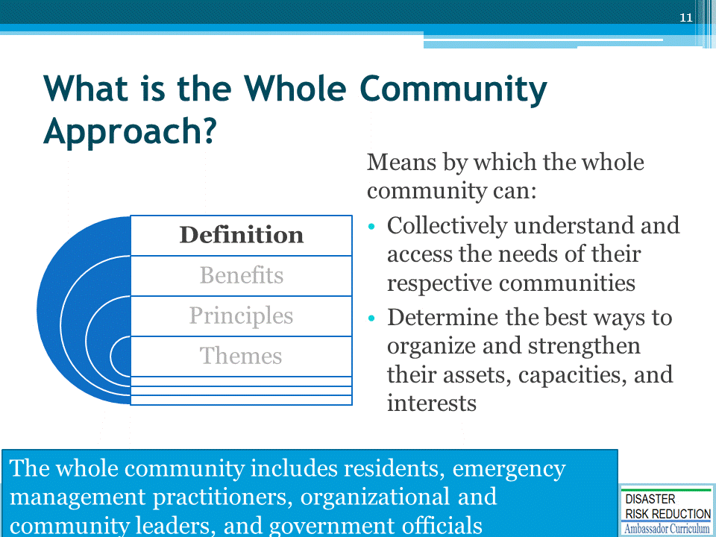

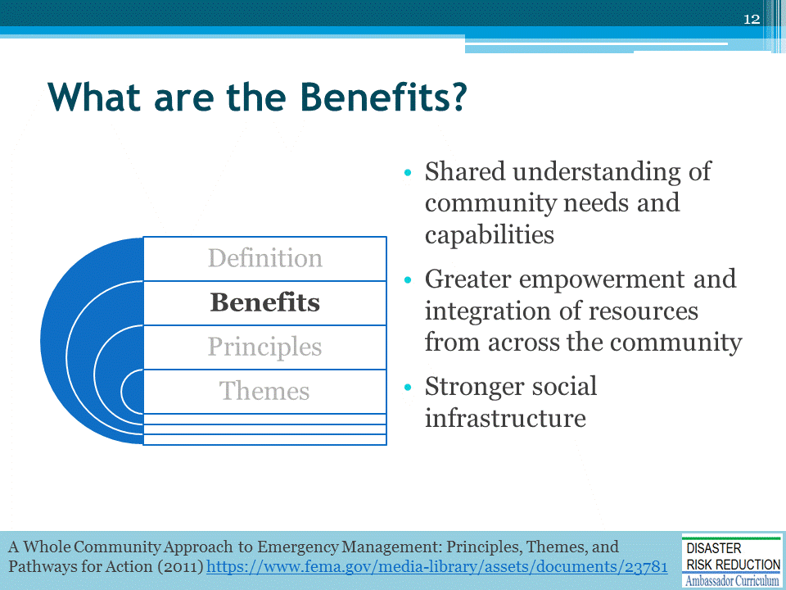

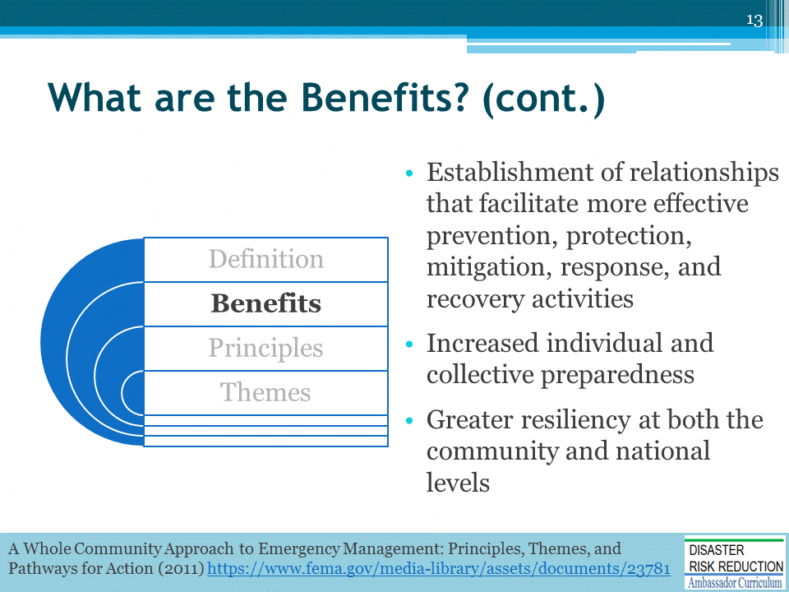

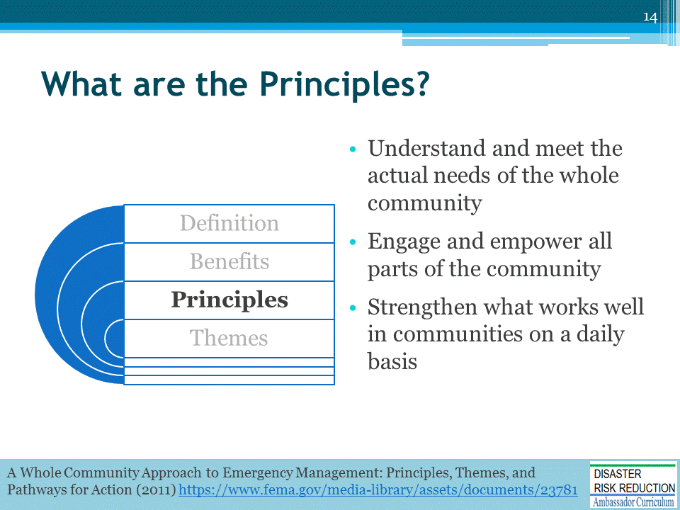
There are three principles that represent the foundation for establishing a whole community approach to emergency management emerged during the national dialogue
- Understand and meet the actual needs of the whole community
- Accomplished through a deeper understanding of a community’s unique values, structure, relationships, and networks
- Comprehension of real-life safety and sustainability needs highlights community members’ engagement in emergency management-related activities
- Engage and empower all parts of the community
- Allows for better planning by stakeholders to meet community’s actual needs and strengthen capacity
- Emergency management team including the following groups:
  - Social and community service
  - Faith-based
  - Persons with disabilities
  - Academia
  - Private and nonprofit sectors
  - Professional associations
  - Government agencies not involved in emergency management
- Strengthen what works well in communities on a daily basis.
- Support networks, institutions, assets that exist in daily life.
- Leverage and empower existing structures involved in daily lives of individuals, families, businesses, and organizations.

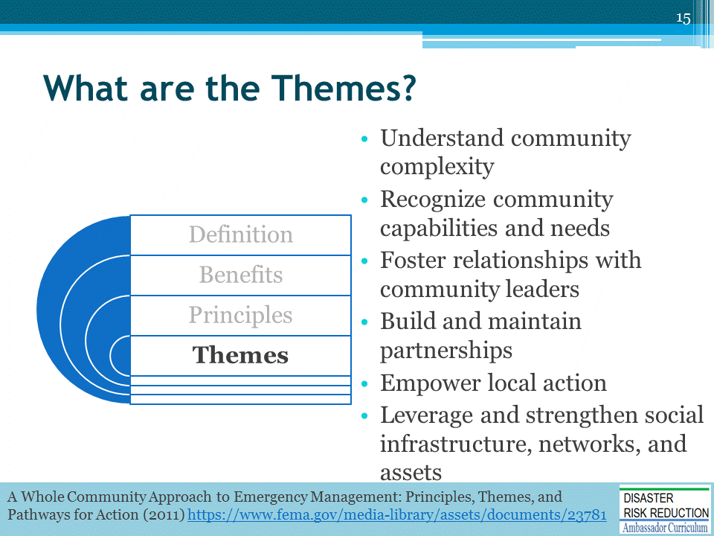

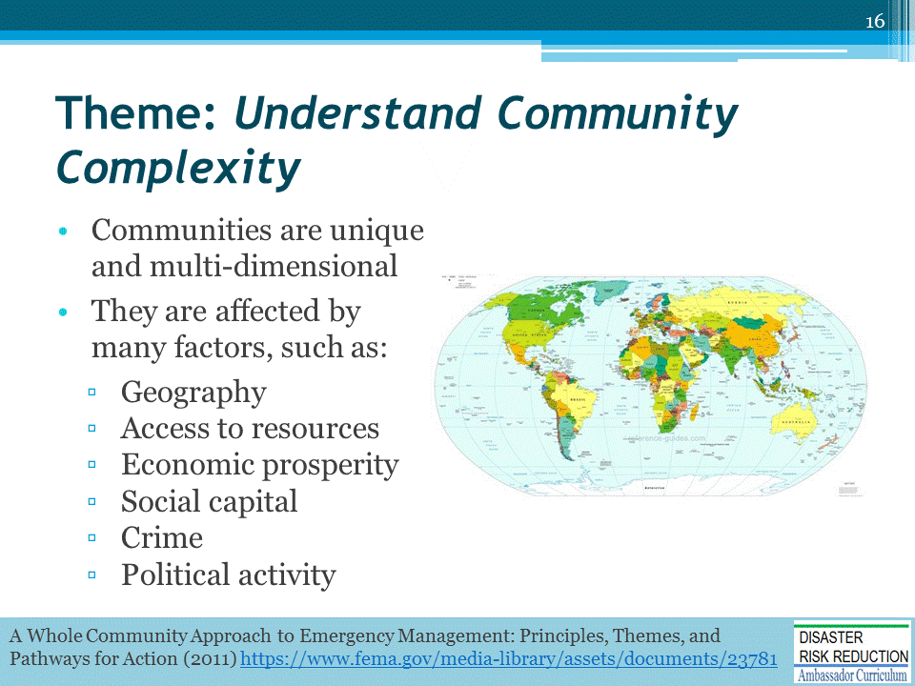

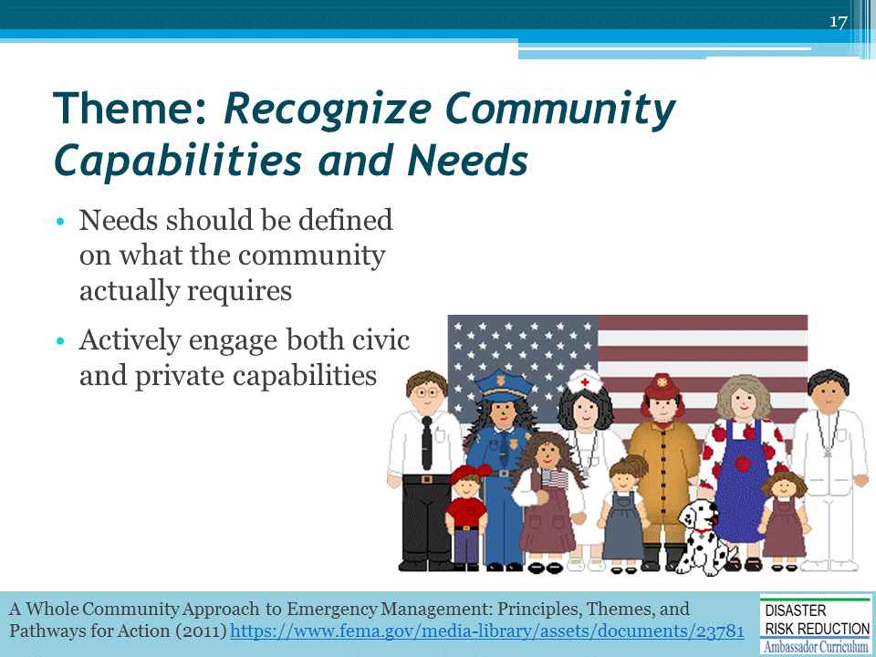

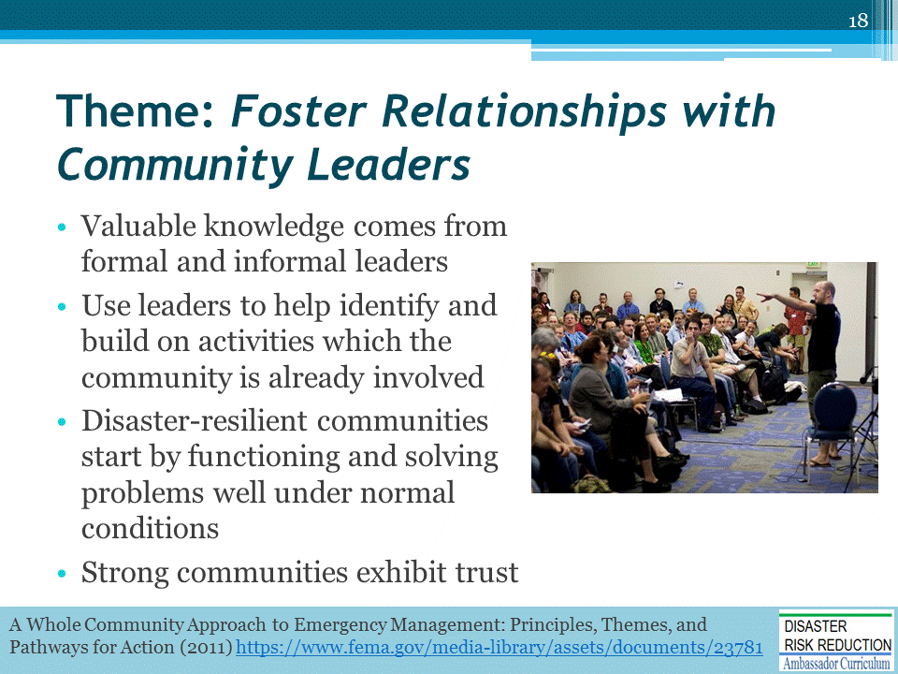

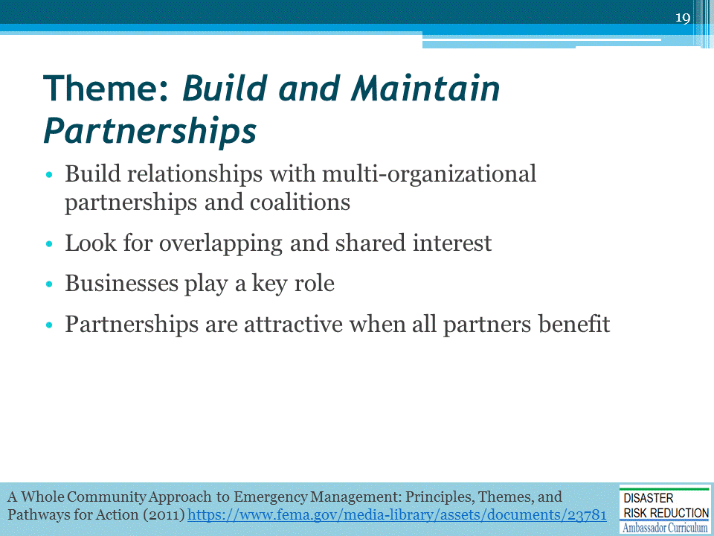

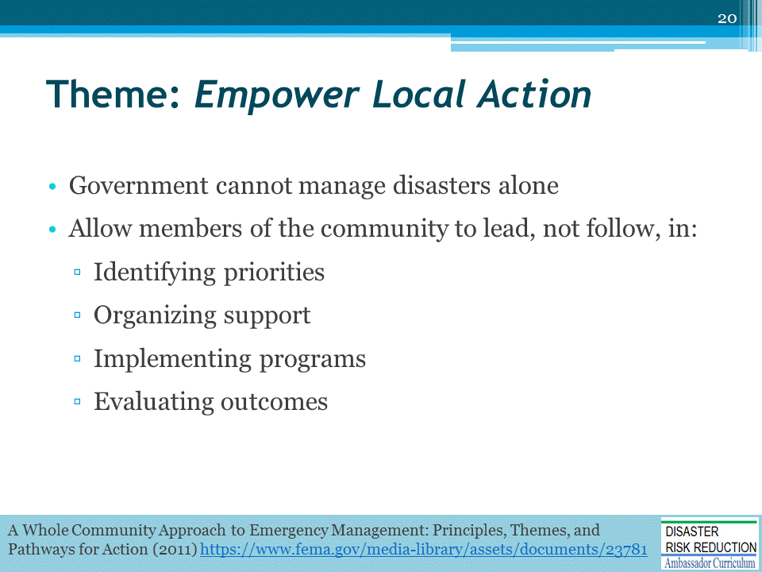

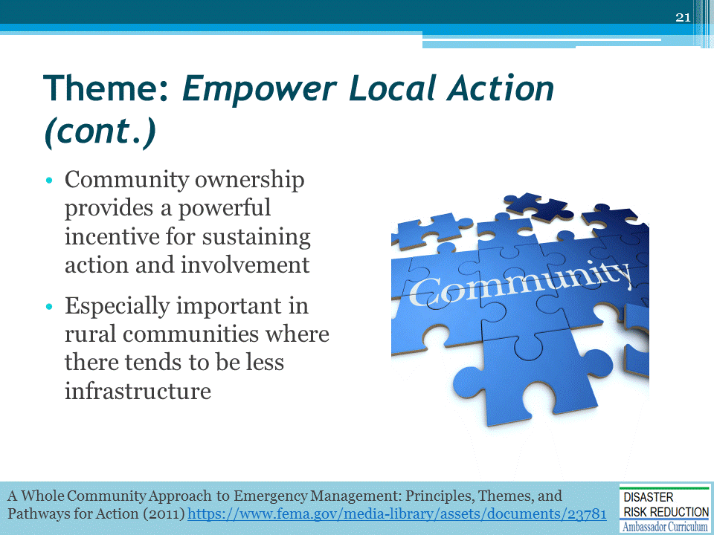

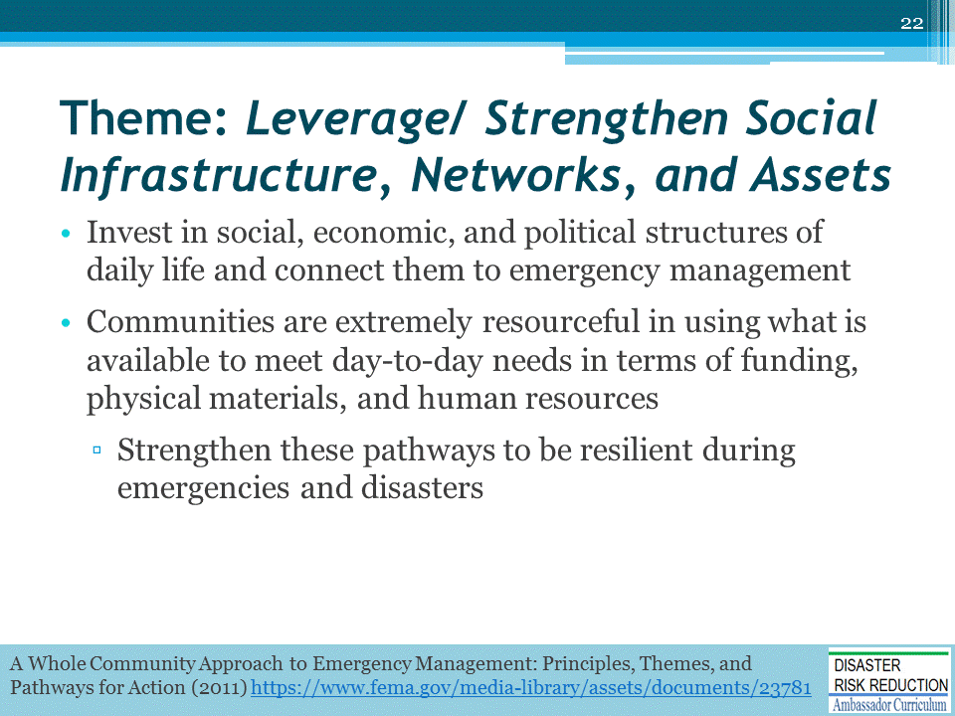

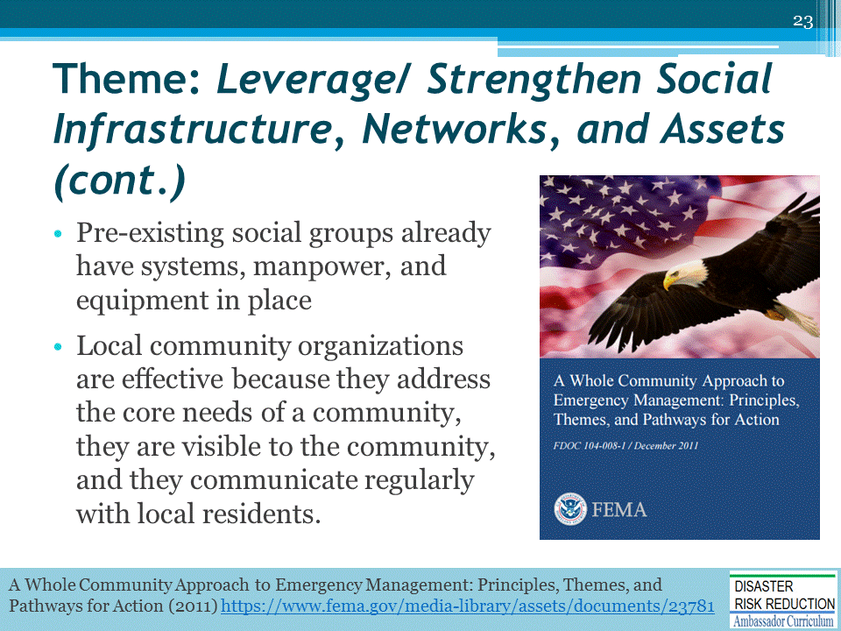

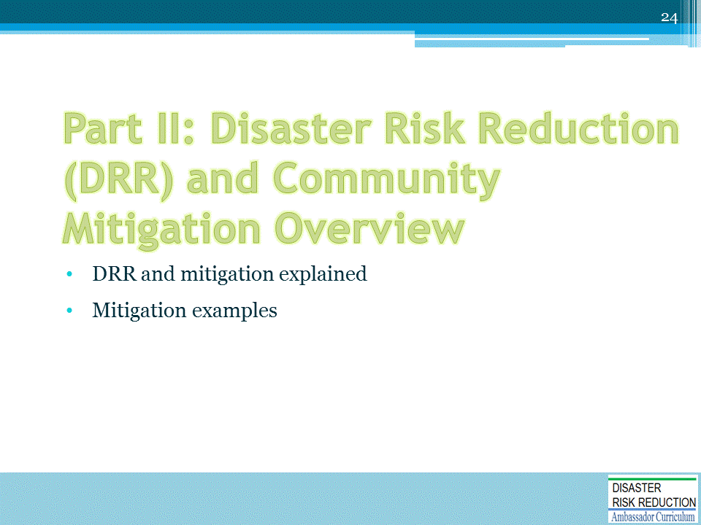

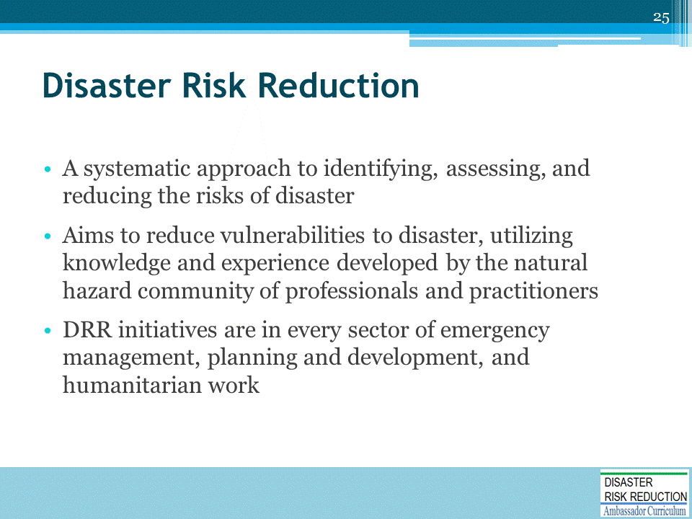

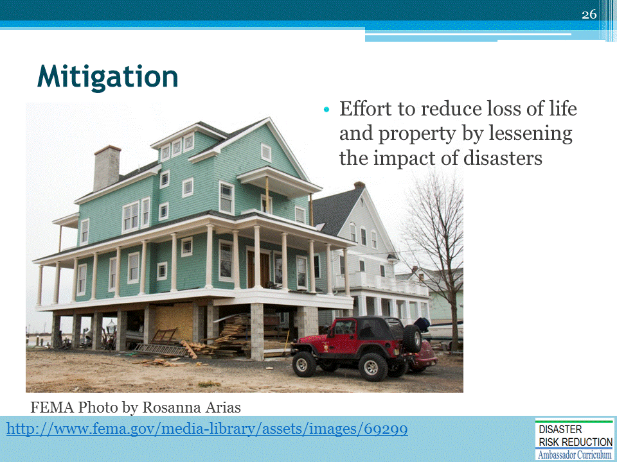

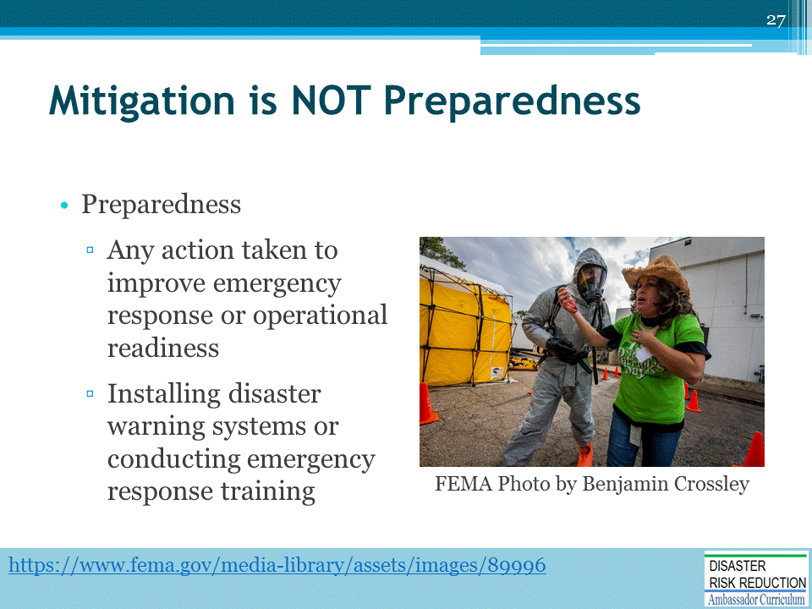

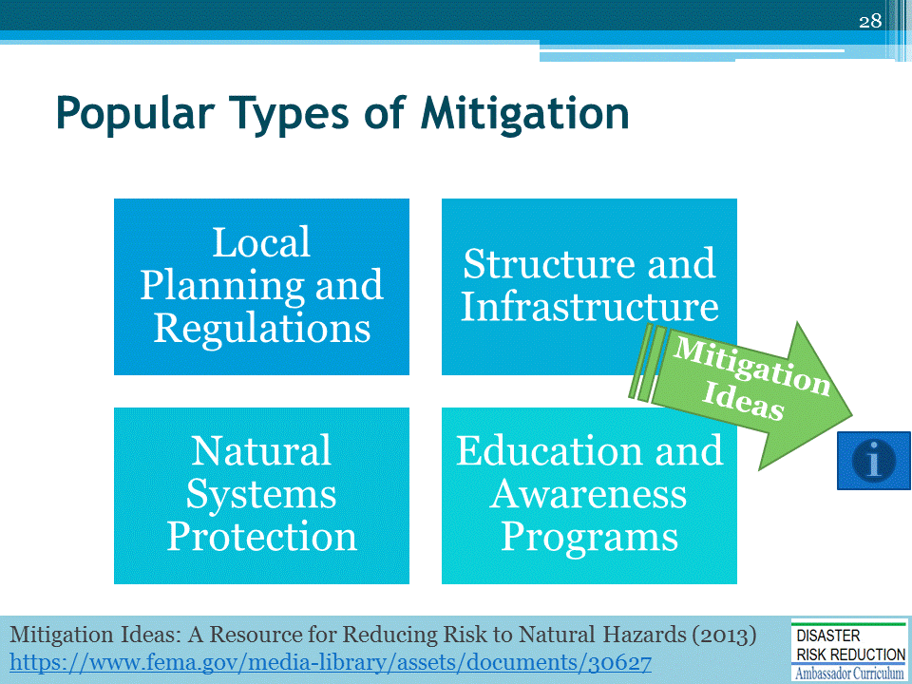
This module will focus on four types of mitigation.
For more information, please take a look at the source document "Mitigation Ideas: A Resource for Reducing Risk to Natural Hazards" https://www.fema.gov/media-library/assets/documents/30627
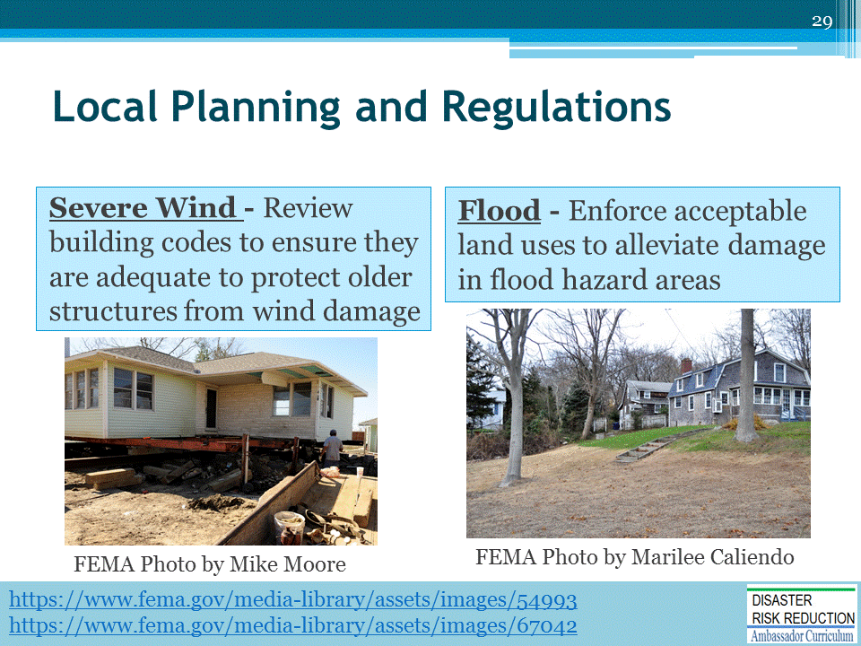

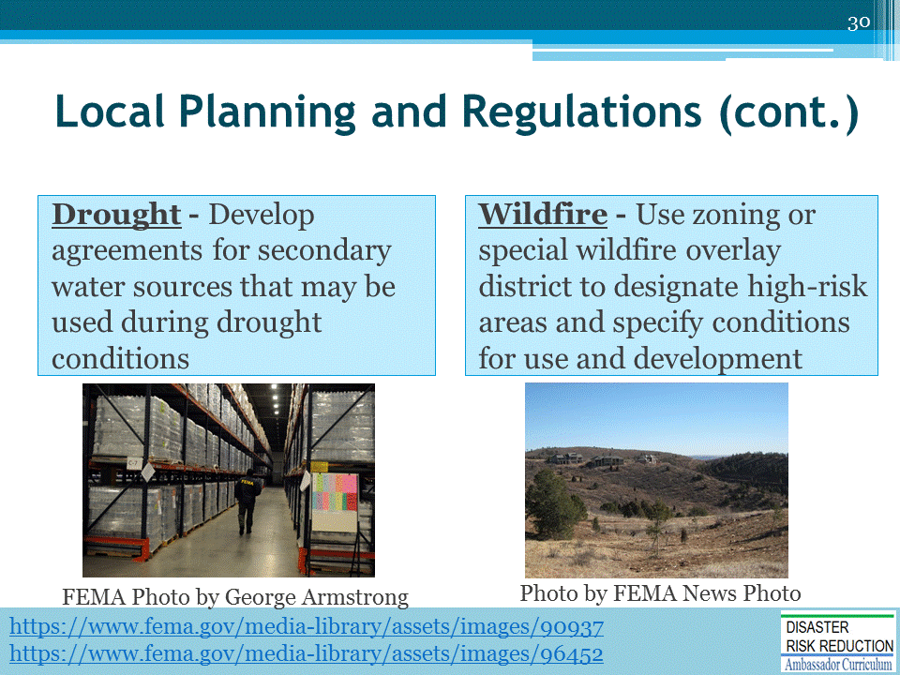

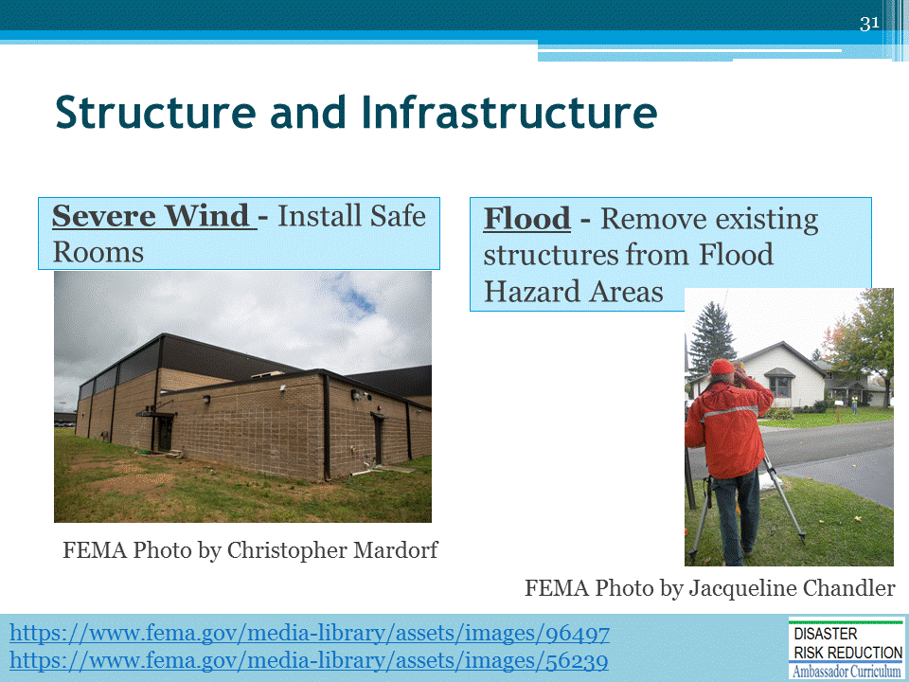

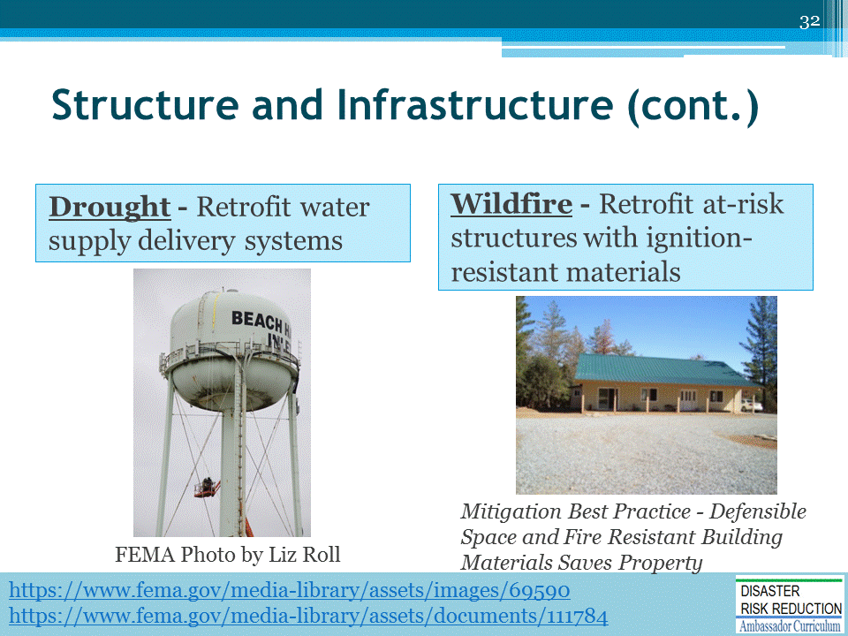

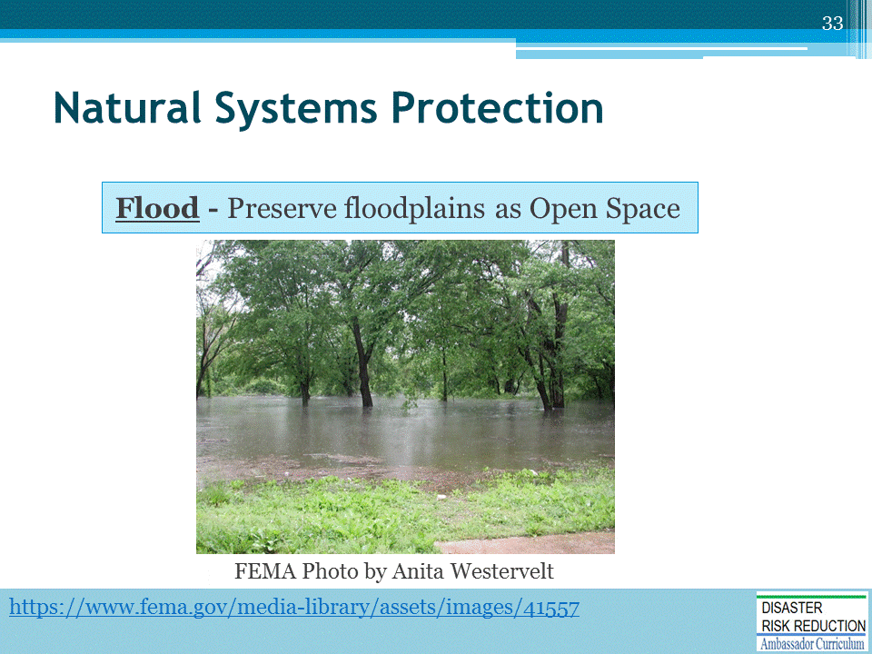

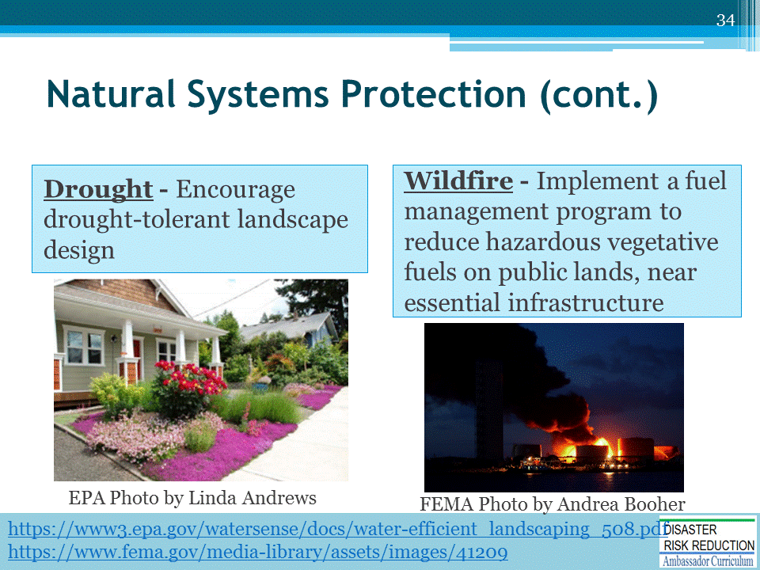

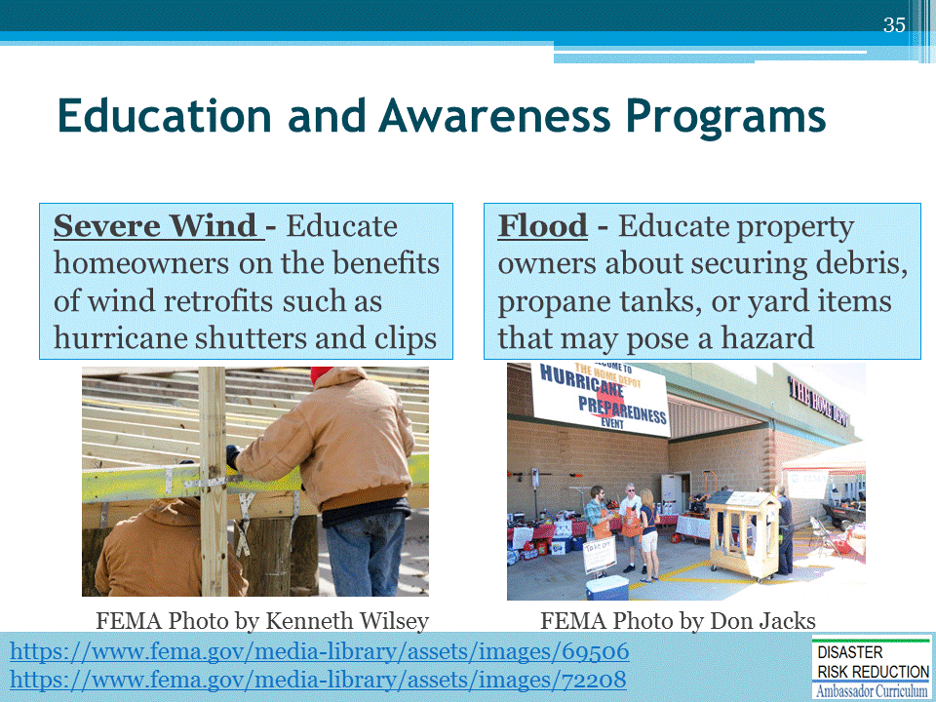

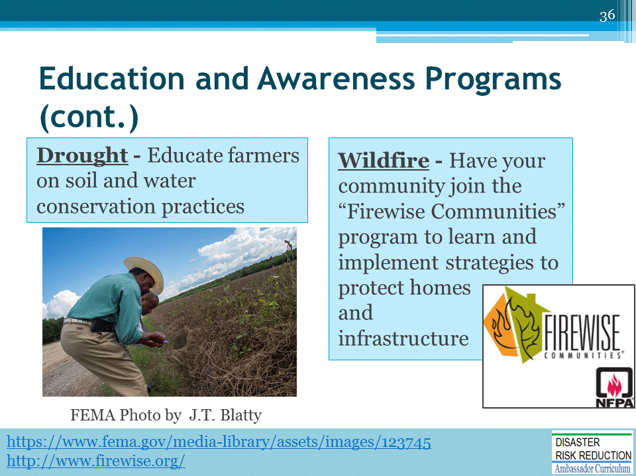

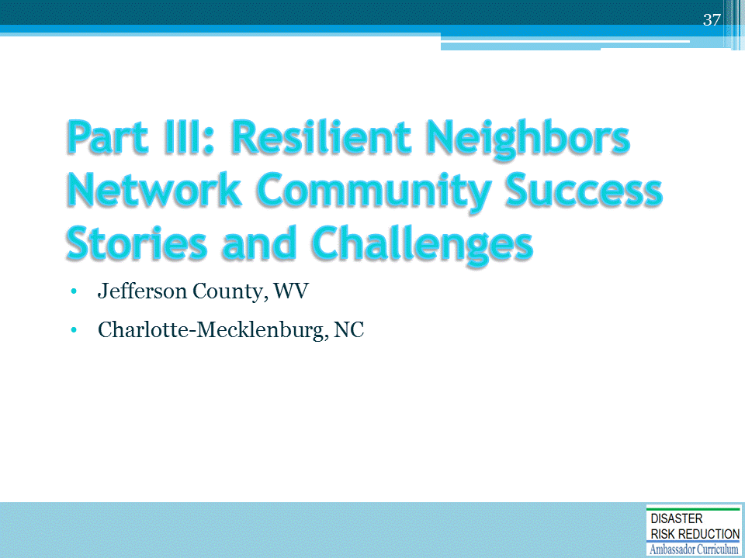

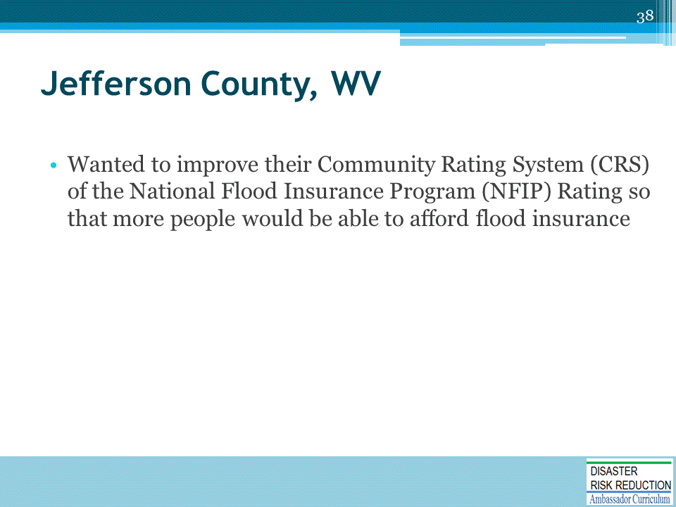
CRS awards “points” for completing activities in 18 different categories.

Based upon accumulating points, communities are rewarded by giving flood insurance policy holders discounts on their flood insurance premiums.
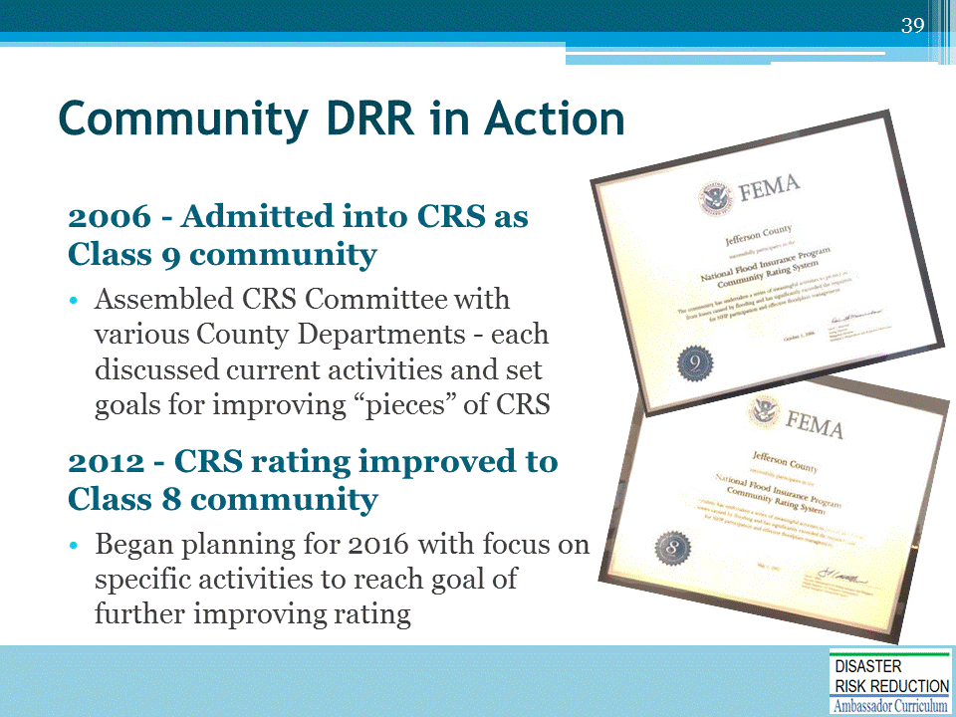

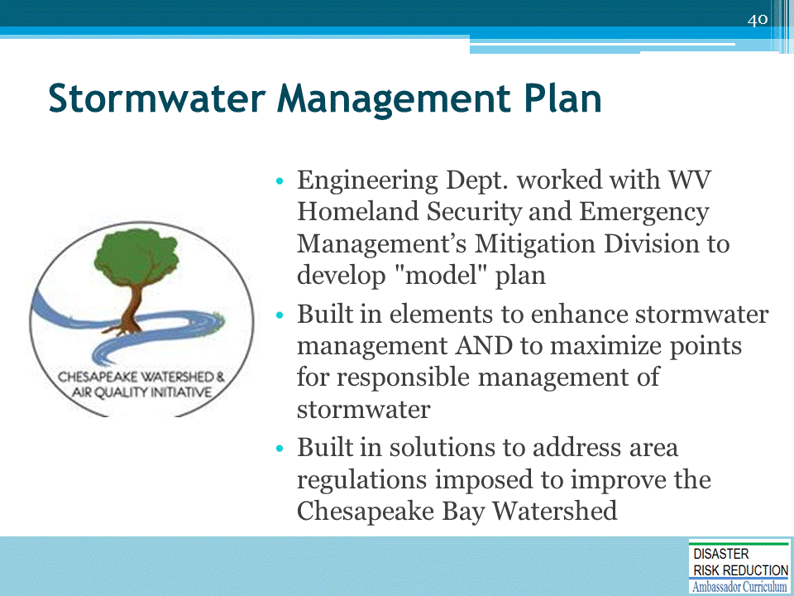

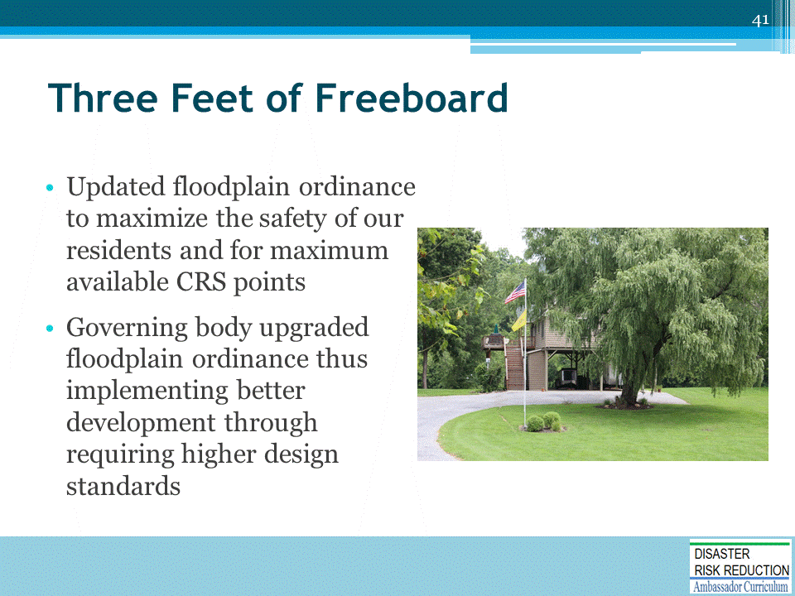
Remind participants to:
- Always do a COMMON SENSE validity check to make sure it is a reasonably safe and logical recommendation before blindly applying it
- Stand back and look at the big picture and make sure the recommendations are applicable to the unique situation they are facing
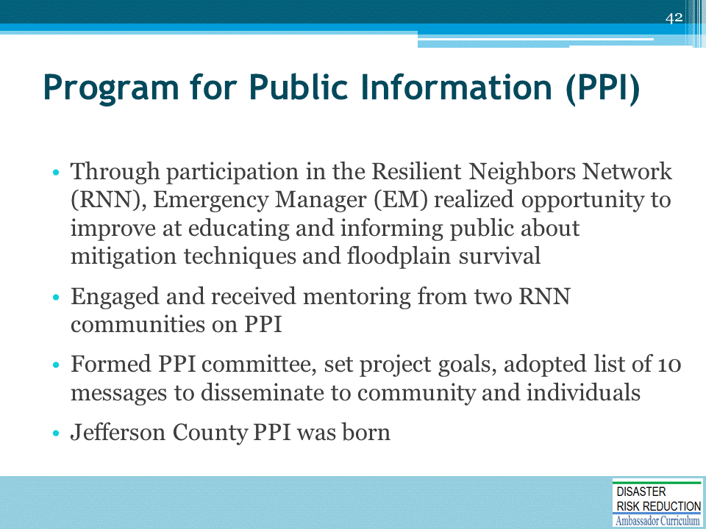
The Emergency Management Public Awareness Committee also acts as the PPI Committee.
The Emergency Management Public Information Officer assists with implementing the program.
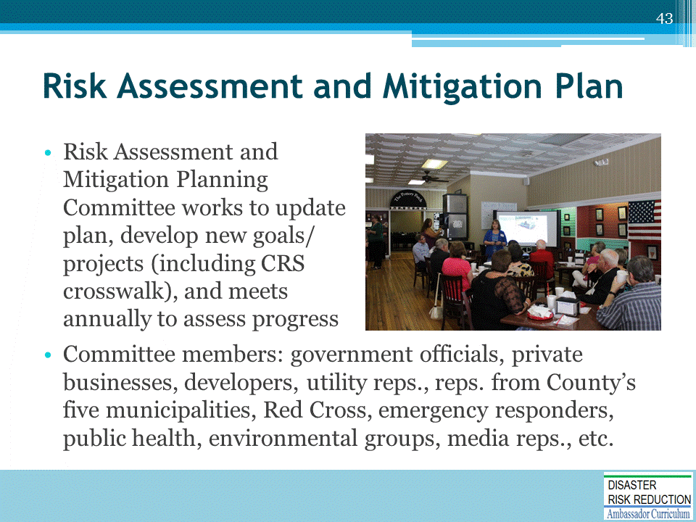
Diverse group supports the plan and the planning efforts, ensuring local buy in of the effort and establishing a grass roots approach to planning.

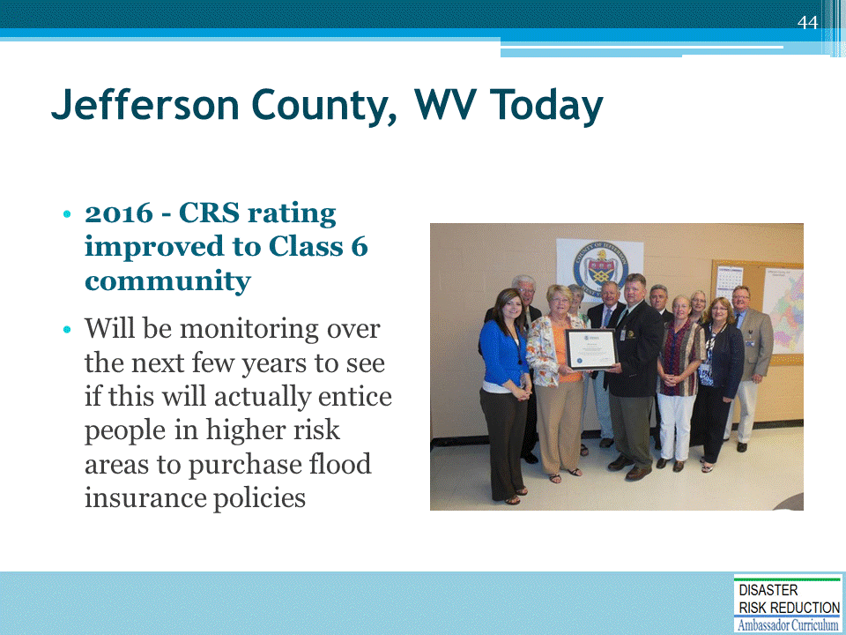
Explain the points that CRS offers for PPI, if there are questions.

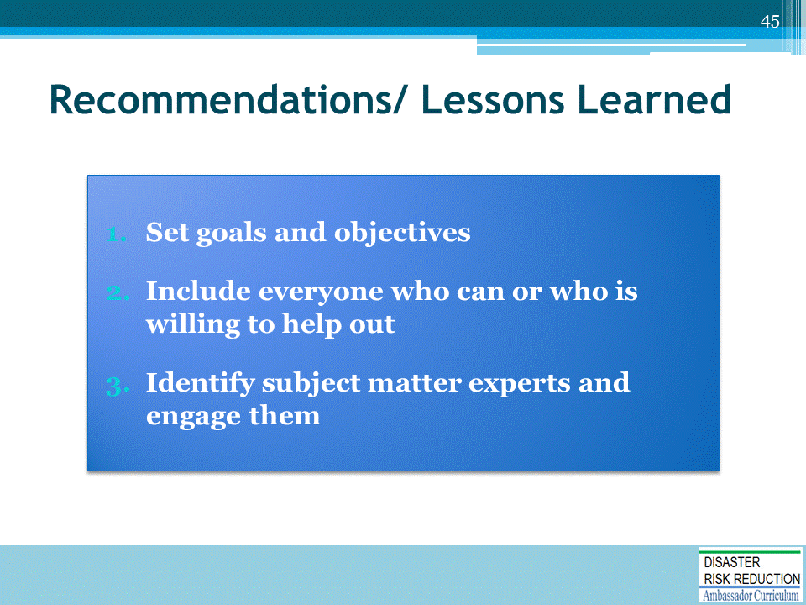

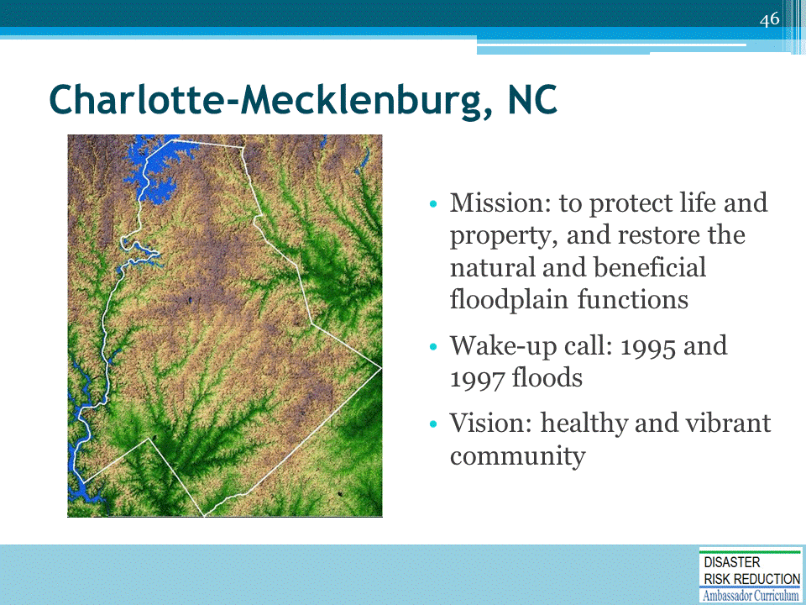
In the late 1990’s, Charlotte-Mecklenburg was at a crossroads related to future flood risks.
Floods in 1995 and 1997 served as a wake-up call that being part of the NFIP and managing floodplains to minimal standards was not sustainable.
In addition, the community was clamoring for more trails and open space as part of the vision for a healthy and vibrant community.
In 1998, a thorough evaluation of the storm water and floodplain management program was completed.
This “Floodplain Management Guidance Document” provided the foundation for 7 key programs and initiatives that would put Charlotte-Mecklenburg on a track to drastically reduce future flood risk while continuing to grow as a vibrant community.
***One of the best exemplars in US of flood mapping on future probable conditions

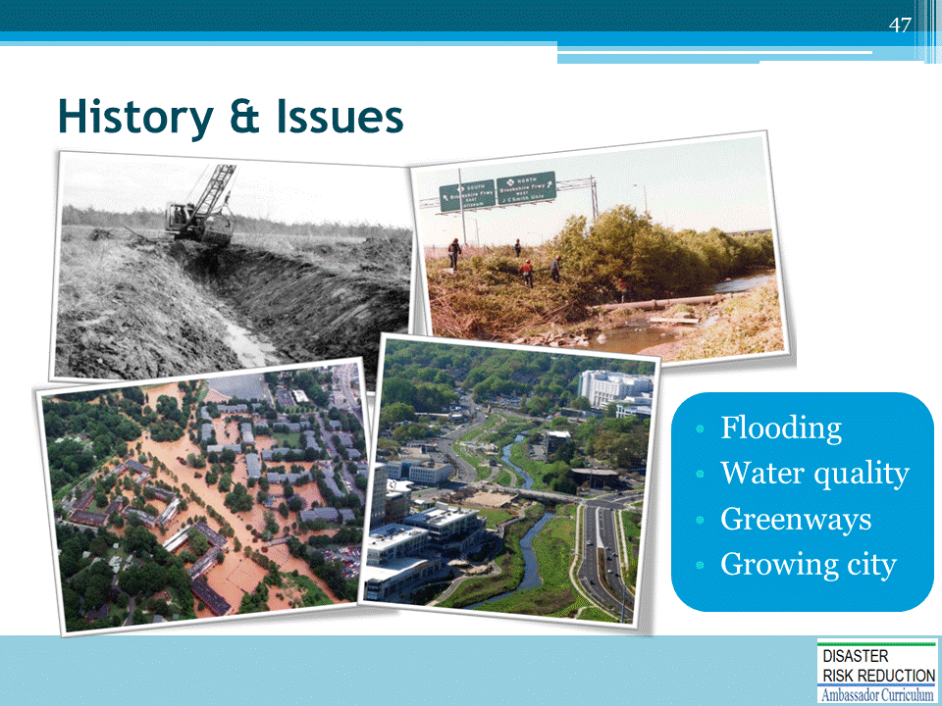
- Widespread flooding from pre-firm development
  - Two relatively large floods in three years
  - Urban flash flooding is typical. Flooding can occur within less than 1 hour of intense rainfall in many floodplain areas.
  - Flooding in some location was observed substantially outside the FEMA Floodplain
  - Several impacted neighborhoods showed up at City Council and County Commission meetings with mops and buckets. They wanted solutions beyond “buy flood insurance”, which was the primary risk reduction tool at the time
- Water quality issues related to erosion and incised streams
  - For decades, our streams and creeks were not viewed as a valuable natural resource that could be an asset to the community.
  - Many creeks were dredged in the 1920’s-1930’s and growth decades later left most in disrepair.
  - Some FEMA streams were also buried under parking lots and buildings that would flood in large rain events.
- Lack of connectivity and recreational trails throughout the community (greenways)
  - Community leader began envisioning an expanded and extensive “greenway” system throughout Mecklenburg County. However, there was a lack of public land and connectivity of neighborhoods.
- Growing city with increasing water and sewer needs
  - Like most growing cities, water and sewer infrastructure growth and expansion is necessary. Charlotte has primarily a gravity fed sew system with runs along most creek corridors. Future growth will lead to needs for parallel systems or larger pipes along floodplain throughout the County.

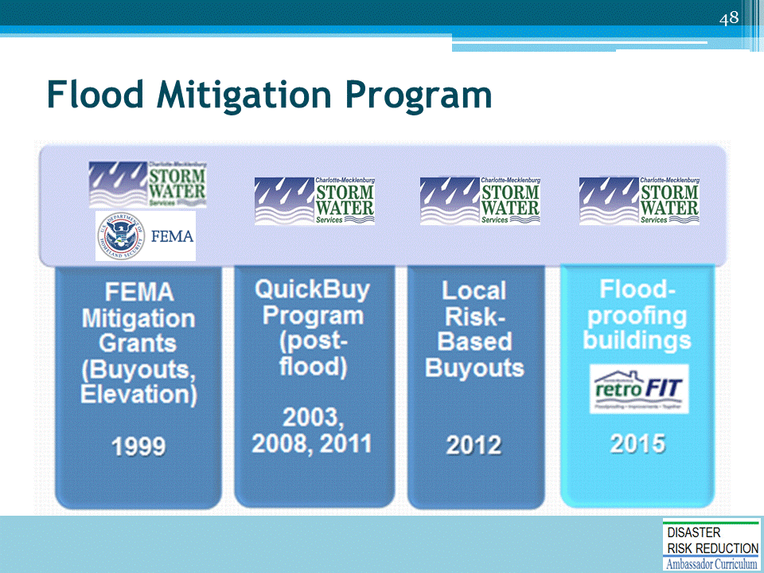
- In 1999 Charlotte-Mecklenburg identified leftover Federal Hazard Mitigation Grant Program funds that needed to be spent on mitigation quickly.
- From recent planning efforts, Storm Water Services quickly identified 118 properties in 6 neighborhoods that could launch our floodplain buyout efforts. We match the $10M grant with over $4M in local funds.
- Storm Water Services made program adjustments to create matching money for these FEMA grants and future ones. These funds would be committed to ongoing strategic buyout efforts. adjustments included:
  - reducing cutting and spraying operations to save costs and re-establish riparian buffers over time
  - shift from hardening rip-rap maintenance projects, to softer bio-engineering projects that were more cost effective
- In the late 90’s and early 00’s, greenway masterplans were adopted by city council and the board of county commissioners.
- These masterplans were helpful in gaining political support and funding for an ongoing buyout program.
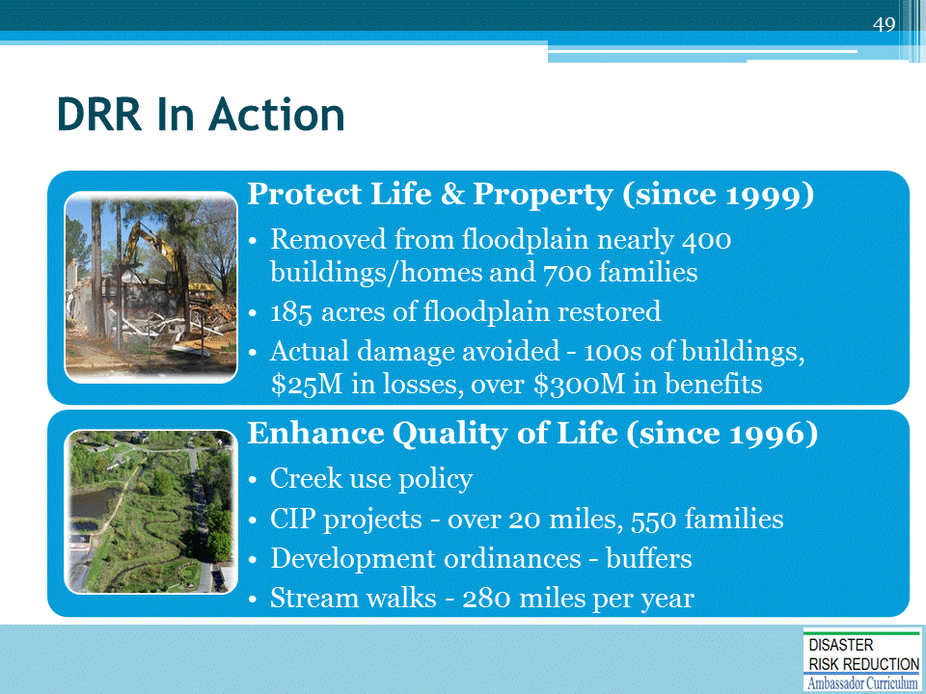
- Protected life and property with no disaster funding!
- 42% overall flood risk reduction in FEMA Floodplains

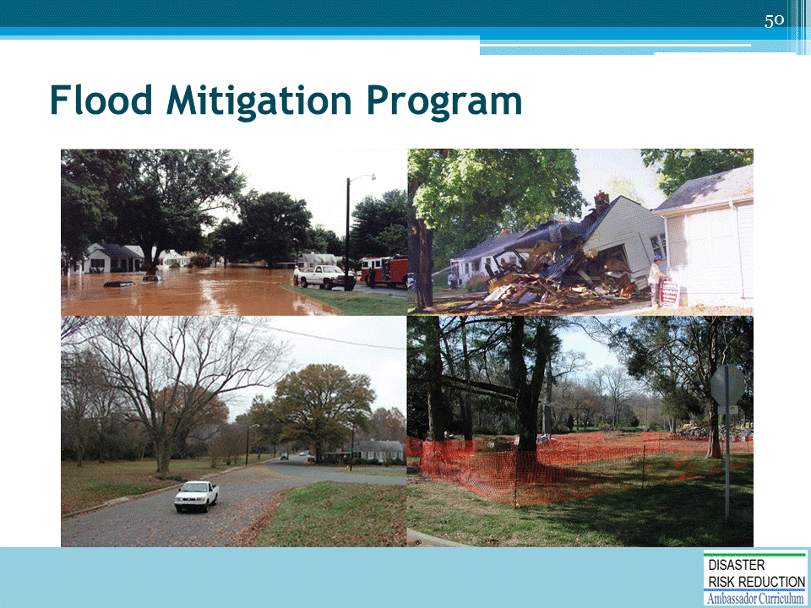
The 1998 “Floodplain Management Guidance Document” contained two key elements that would drastically increase Charlotte-Mecklenburg’s flood resilience over the decades to come.
- Fix the floodplain maps and regulations to ensure new development has minimal flood risk into the future.
- Floodplains are meant to flood, so begin getting buildings out of floodplains
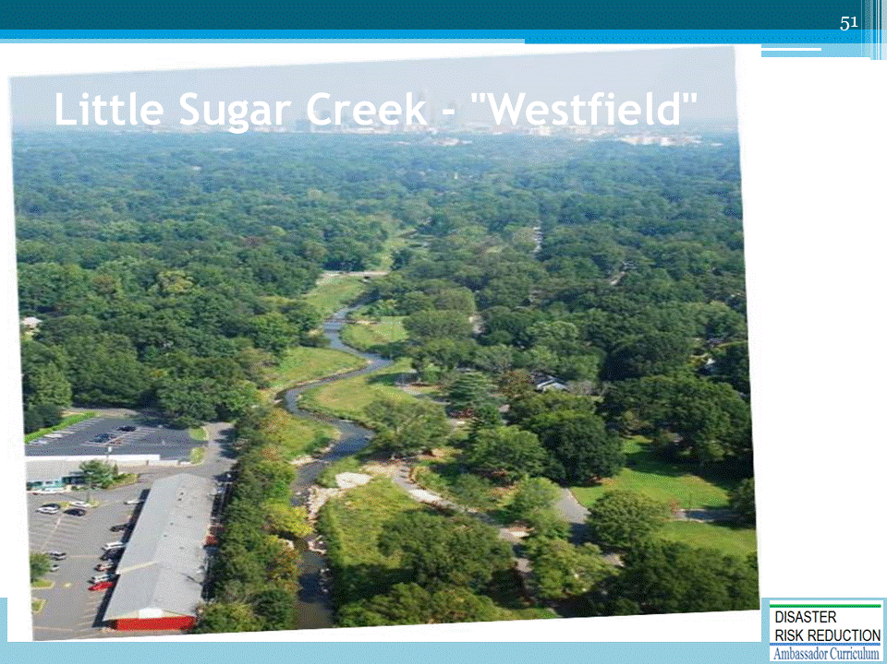

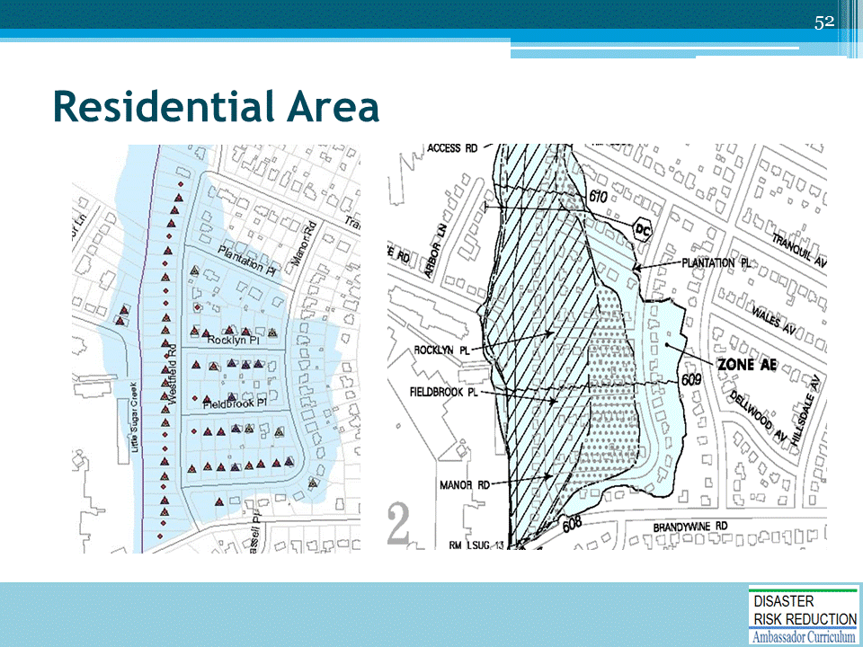

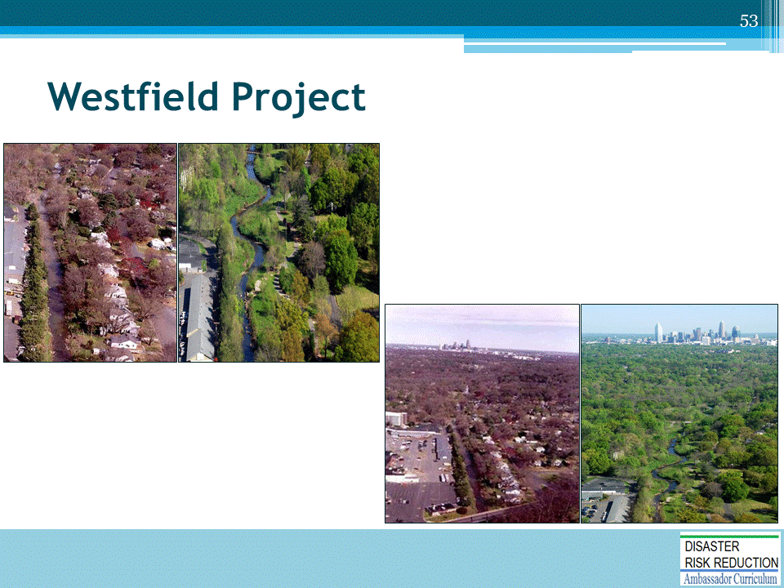

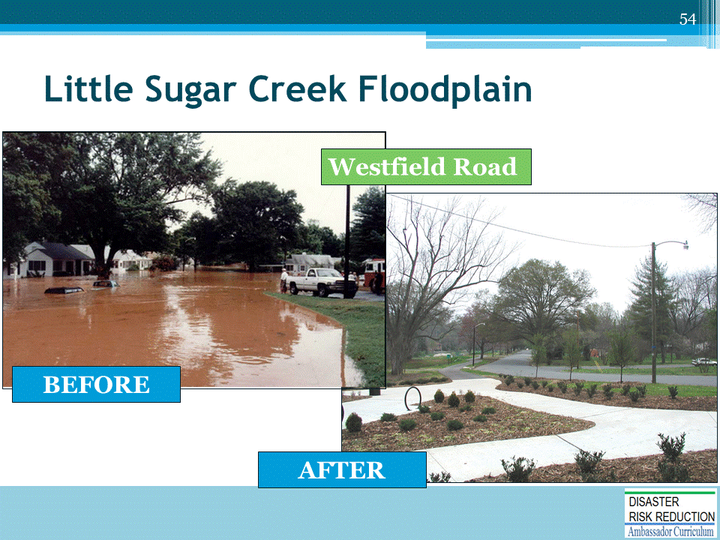

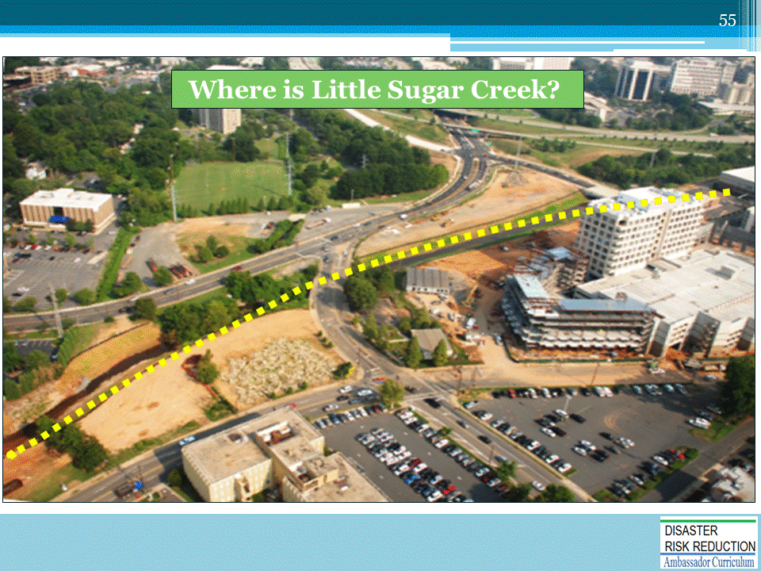

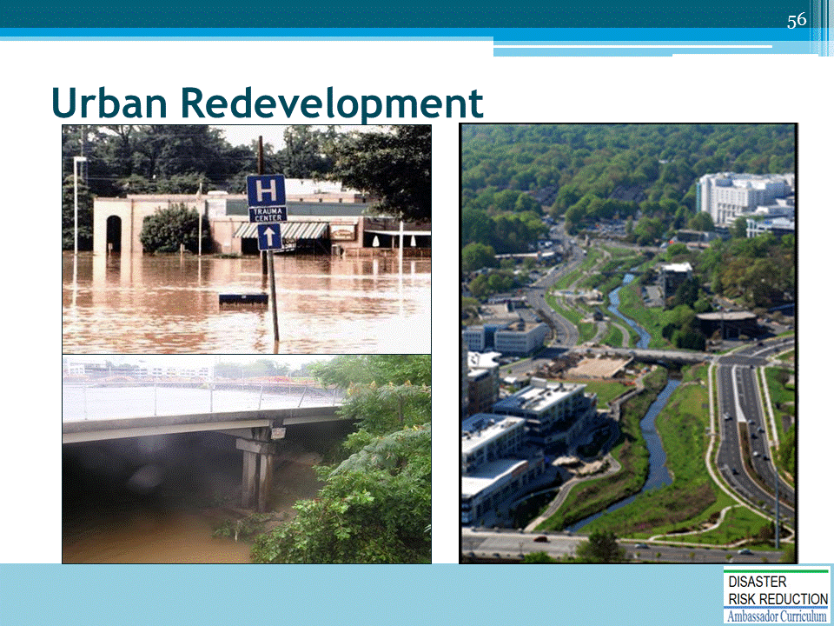

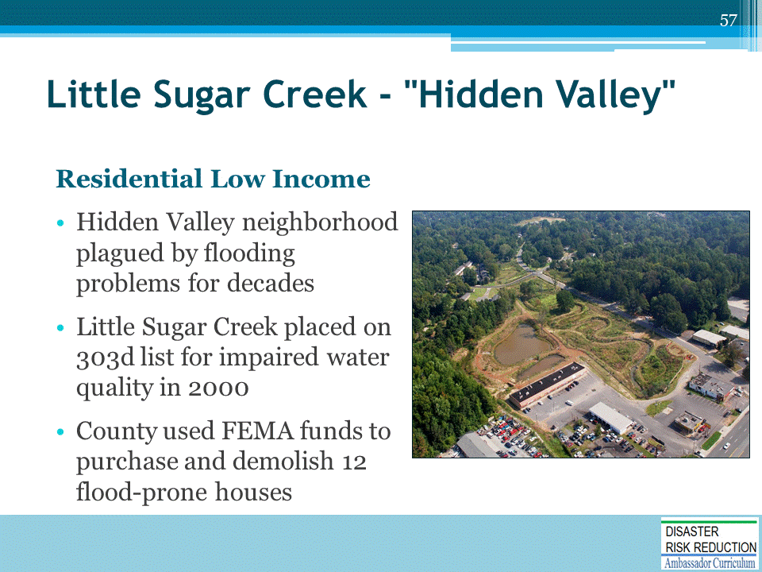

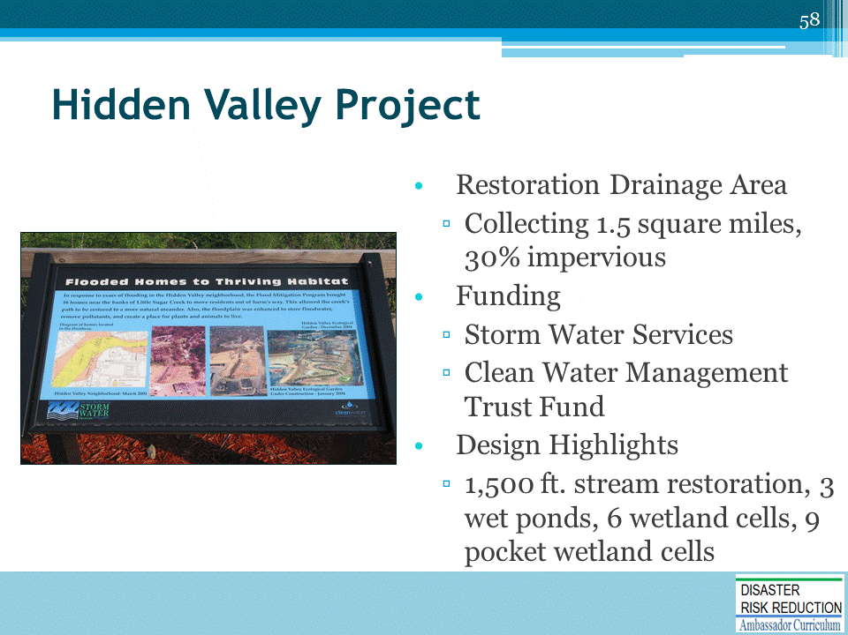

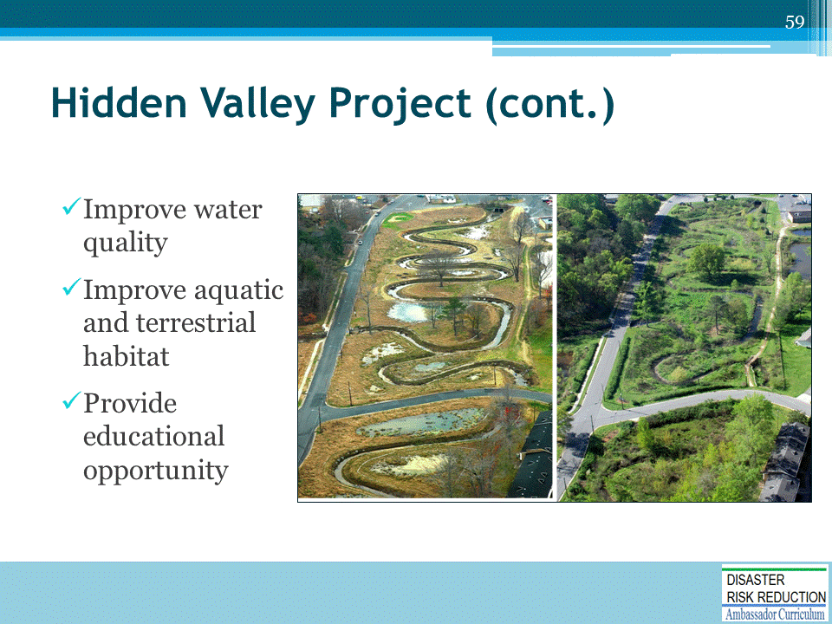

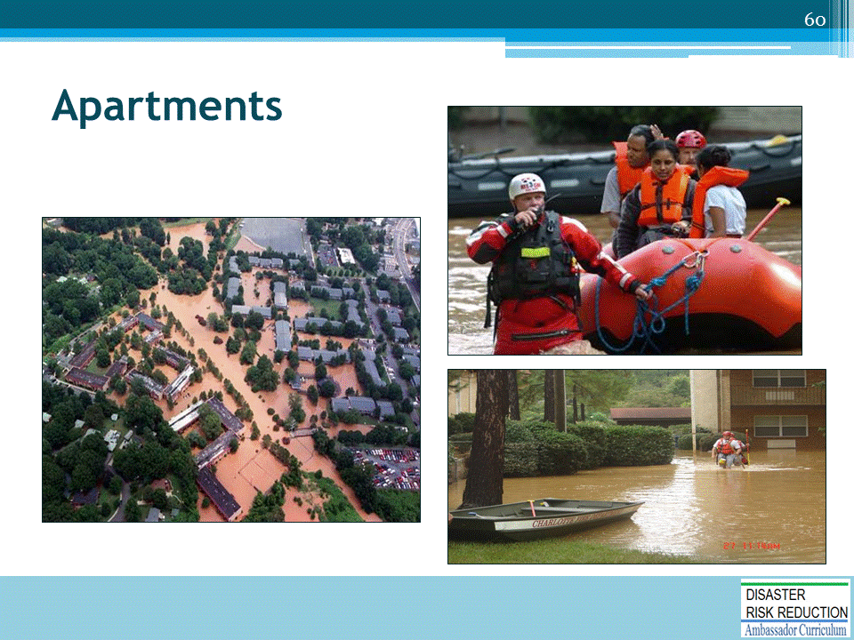

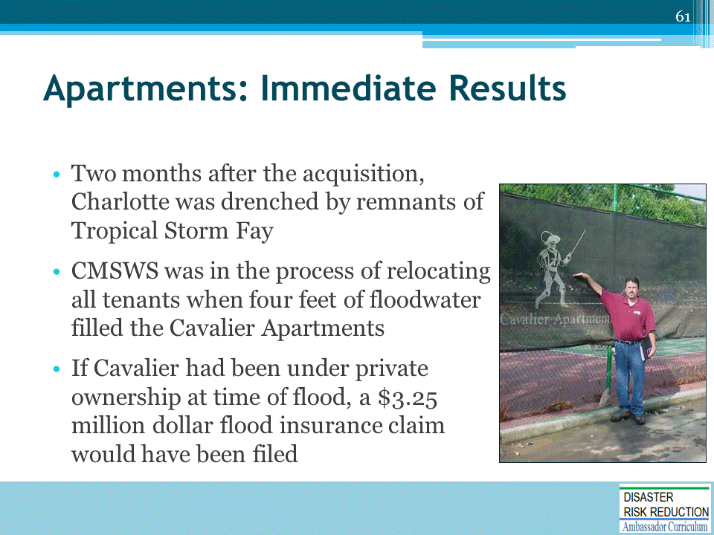

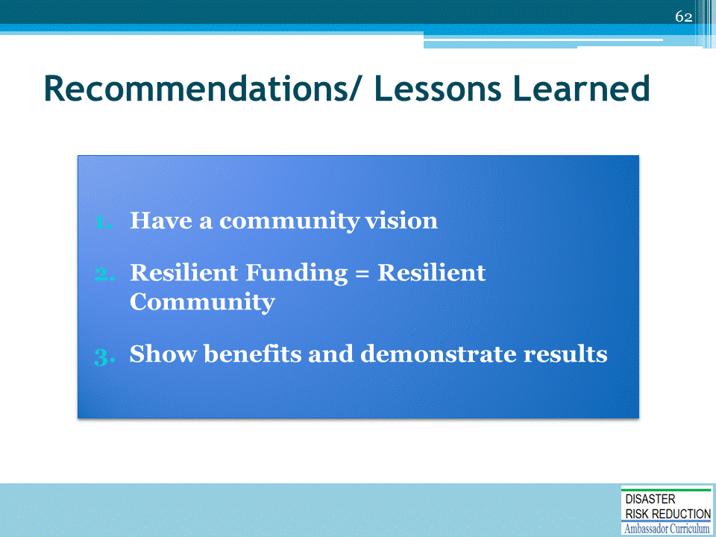

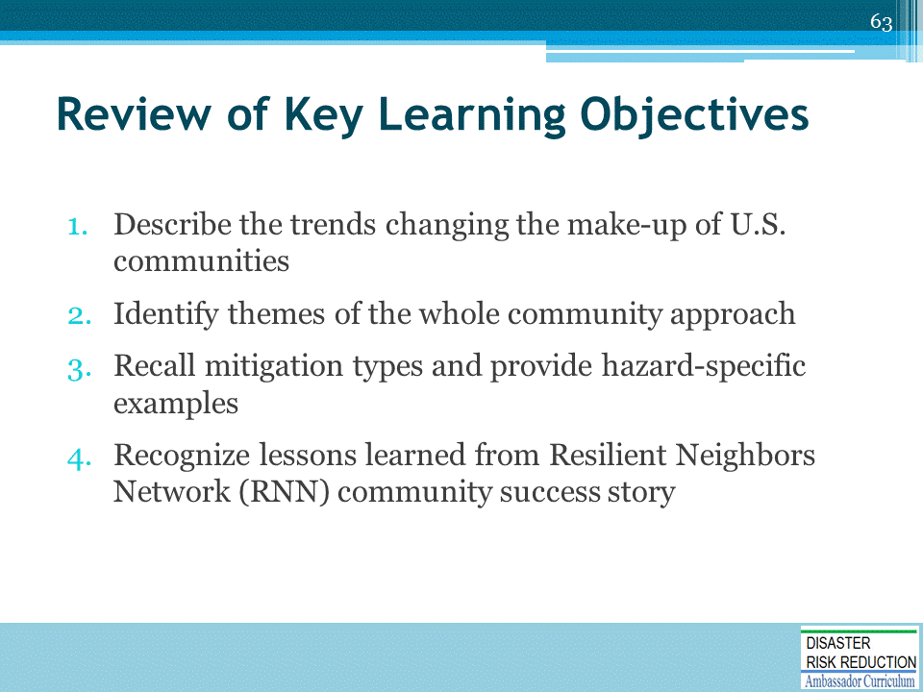

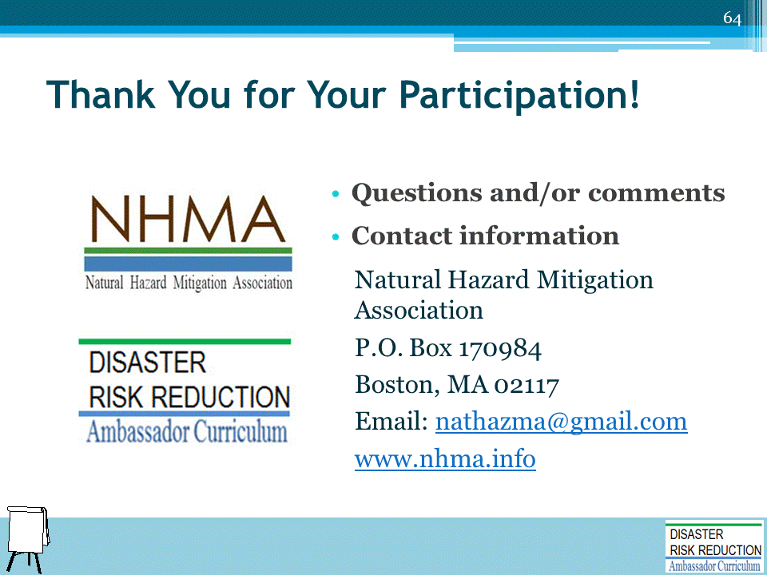

DRR AMBASSADOR CURRICULUM AT-A-GLANCE
I. Disaster Risk Reduction for a Safe and Prosperous Future
1 | Introduction to the Natural Hazard Mitigation Association and Disaster Risk Reduction Ambassador Curriculum
2 | Introduction to Disaster Risk Reduction as a Foundation of Community Resilience
3 | Leadership for Disaster Risk Reduction
4 | Community Disaster Risk Reduction and Adaptation
5 | Approaching the Challenge of Disaster Risk Reduction: NIST Community Resilience Guide
II. Forming a Community’s Vision for Disaster Risk Reduction
6 | Risk Assessment through Storytelling: An Asset-Based Approach
7 | Achieving Community Buy-in for Disaster Risk Reduction: Win-Win Approaches
8 | Leveraging Resources to Improve Disaster Risk Reduction
III. Realizable, Practical, and Affordable Approaches for Moving from a Vision for Disaster Risk Reduction to a Strategy
9 | Selecting and Implementing a Strategy for Addressing Community Disaster Risk Problems
10 | Integrating Hazard Mitigation into Local Planning
11 | Beyond Codes and Low-Impact Development
12 | Creating the Plan: A Sustainable Floodplain Management Process Model
IV. Resources and Tools for Implementing a Community’s Disaster Risk Reduction Strategy
13 | Climate and Weather Tools and Trends
14 | Risk Assessment Basics
15 | Legal and Policy Opportunities for Disaster Risk Reduction
16 | Linking Catastrophe Insurance to Disaster Risk Reduction
V. Resources for Hazard-Specific Disaster Risk Reduction
17 | Living with Water: Inland and Coastal Flooding
18 | Design for Flood Resilience: Part I: Floodplain Management and Flood Resistant Design
19 | Design for Flood Resilience: Part II: Green Infrastructure / Low Impact Development
20 | Overcoming Impediments to Flood Resilience: Paths Forward
21 | Wildfire Mitigation
22 | The Wildfire-Flood Connection
23 | Severe Thunderstorm/ Tornado Safe Rooms
24 | From Policy to Engineering: Earthquake Risks

