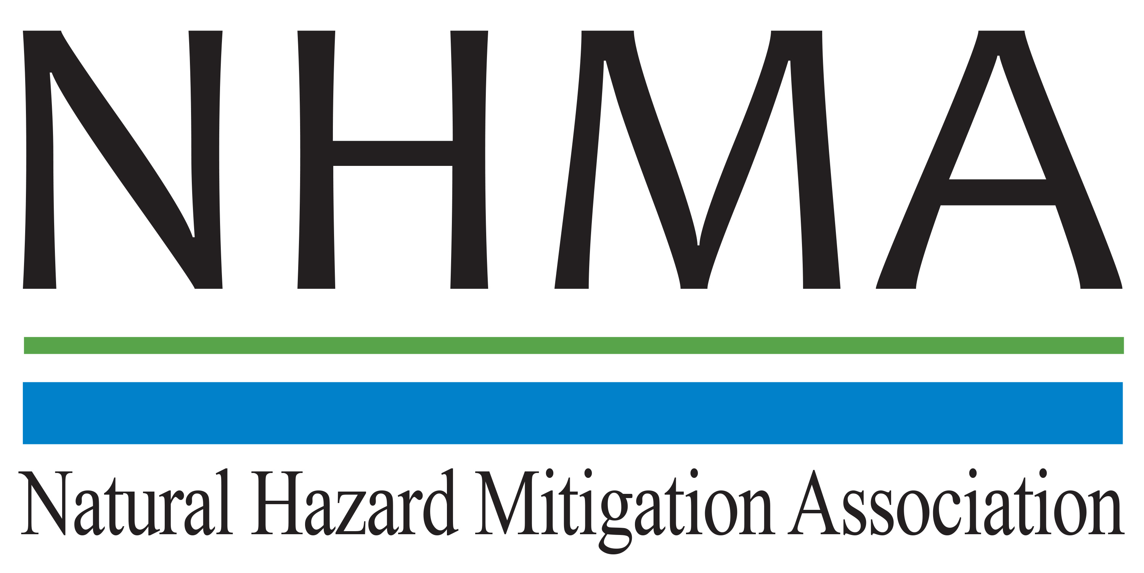

Disaster Risk Reduction (DRR) Ambassador Curriculum

Instructor Guide

Module 5:

Approaching the Challenge of
Disaster Risk Reduction:
NIST Community Resilience Guide

THE DRR AMBASSADOR CURRICULUM
The goal of the DRR Ambassador Curriculum is to facilitate Disaster Risk Reduction efforts for the whole community by:
- Engaging in discussion of how disasters can be reduced through local action
- Sharing insights among local leaders and technical experts to enable the development of cross functional solutions
- Acquiring the best-available information, knowledge of best practices, and analytic tools to enable better-informed decisions before, during, and after disasters
It is important for instructors of DRR Ambassador Curriculum modules to remember this is one module in a 24-module curriculum. The “DRR Ambassador Curriculum At-a-Glance” table, located at the end of this document, lists the modules of the Curriculum. Keep in mind the following context for the module(s) you conduct:
DRR-A CURRICULUM TARGET AUDIENCE
The target audience includes those involved in community development decision-making, such as local community staff, volunteer and stakeholder groups, and federal and state officials.
METHODS OF DELIVERY
Varied delivery methods will provide multiple options for access by the target audience. The DRR Ambassador modules may be presented via webinars hosted by NHMA or partner organizations, presented in conferences and/or classrooms by qualified DRR Ambassador Curriculum instructor(s), or are downloadable for individual study from the NHMA website.
COURSE MATERIALS
Instructors are expected to use the instructional materials housed on the NHMA website to conduct DRR Ambassador Curriculum modules (Instructor Guide, supporting visuals, Participant Guides, and handouts). Instructors may tailor modules to specific audiences or locations as long as they do not revise the learning objectives and do not revise the materials in such a way that the participants cannot correctly complete the post-test. Instructors request the current pre/post-test for the module from NHMA.
CERTIFICATES OF COMPLETION
Certificates of Completion will be awarded by NHMA to participants who successfully complete NHMA-sponsored DRR Ambassador modules. A DRR Ambassador Certificate will be awarded to individuals completing all 24 modules. Participants who choose not to take the post-test may be issued a Certificate of Attendance. Contact NHMA about obtaining certificates. Inform participants to ask their certifying boards about acceptance of NHMA DRR Ambassador certificates for continuing education credits.

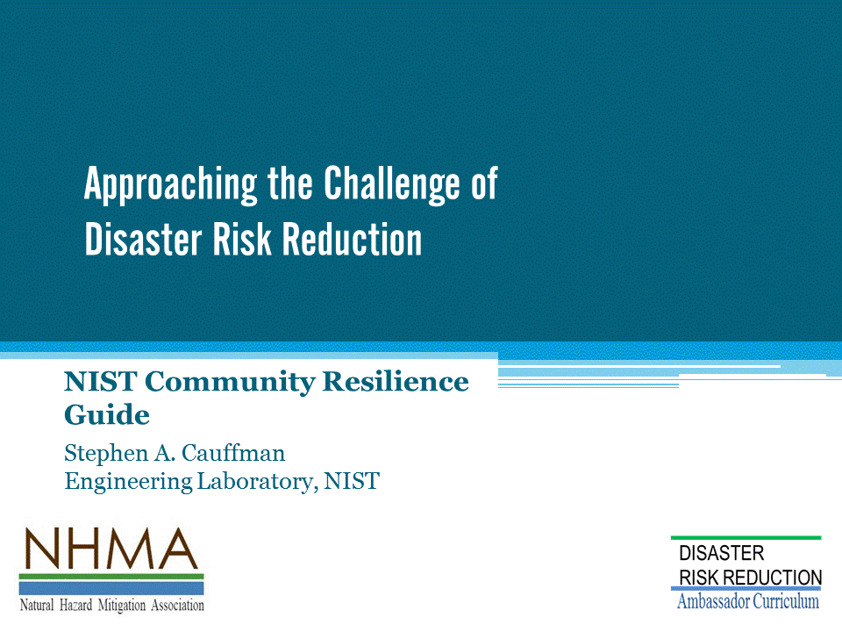
Approximate delivery time: 60 minutes

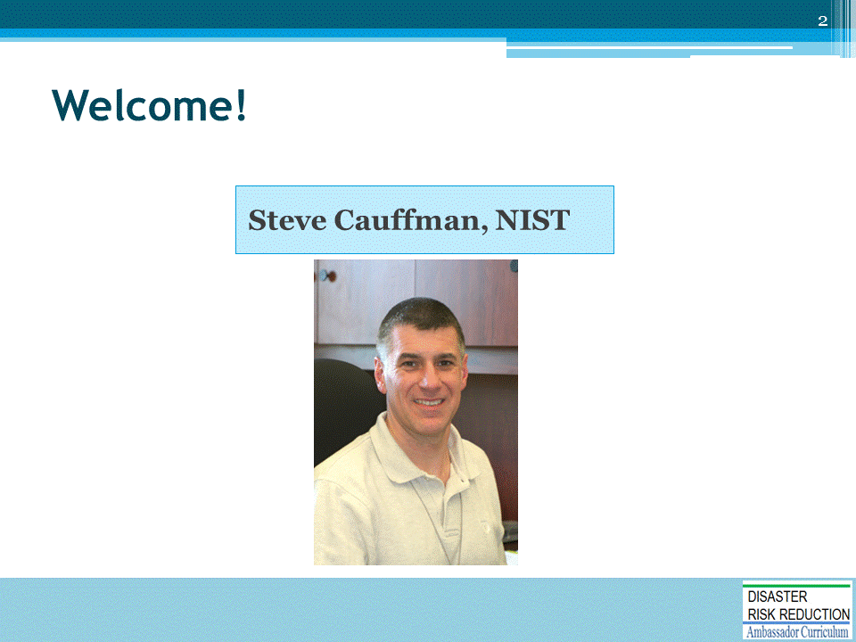
Introductions:
- Each presenter introduces her/himself, including affiliation and brief background.
- OPTIONAL: Have each participant briefly introduce him/herself
Mention: NHMA presentations are based on general principles of law, engineering, policy and emergency management.
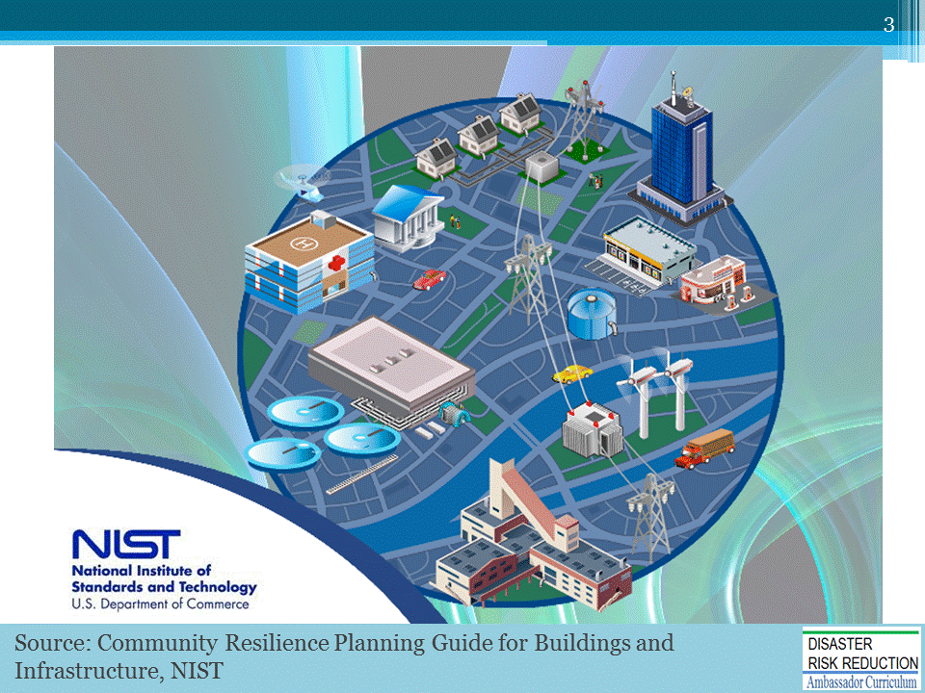
The purpose of this module is to:
- Discuss an approach to preventing hazards from becoming disasters
- Describe the role of infrastructure and buildings in supporting social and economic function
- Provide an overview of the NIST tools and guidance for:
  - Measuring resilience
  - Planning and implementing measures to enhance resilience
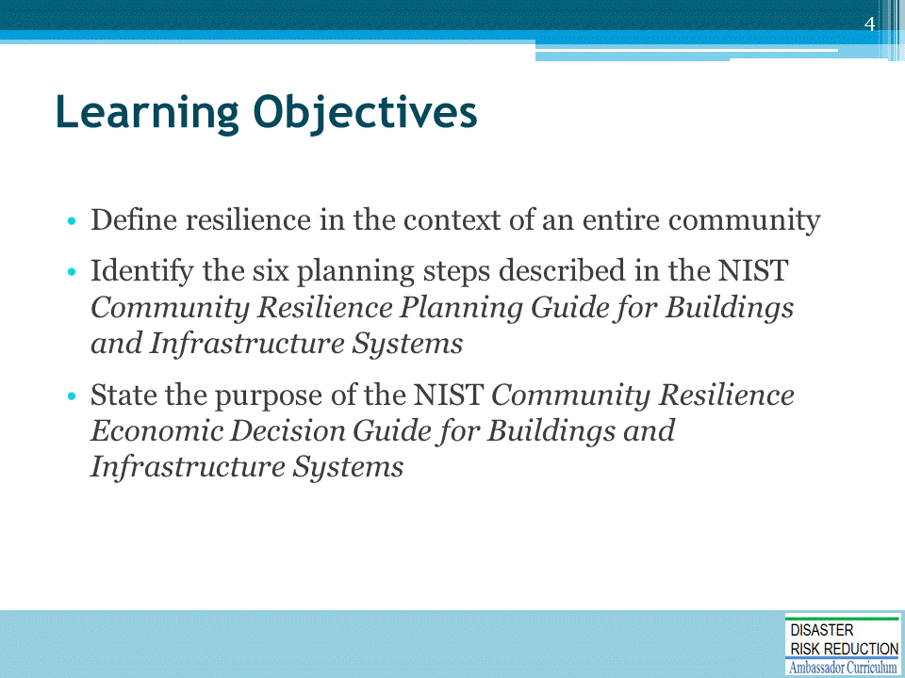

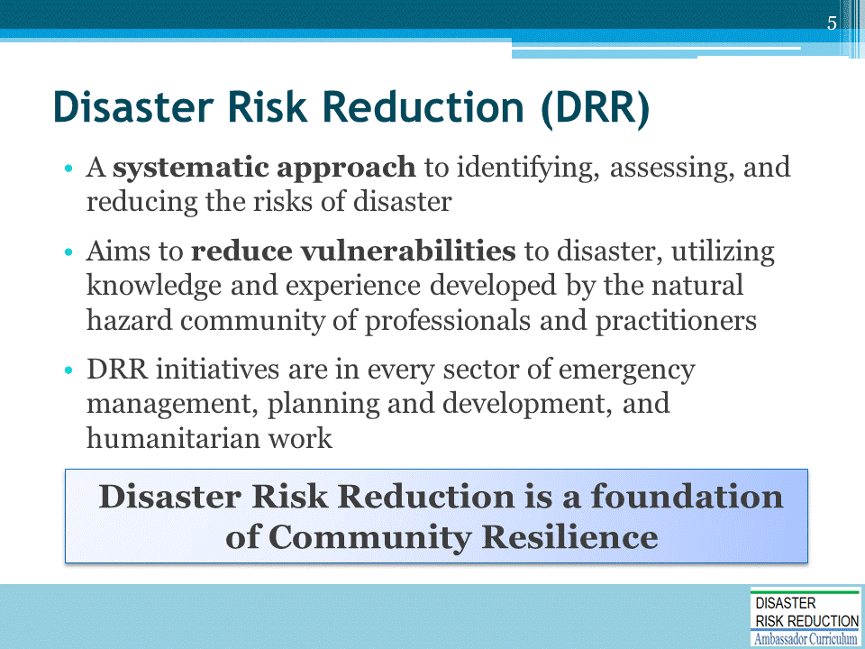

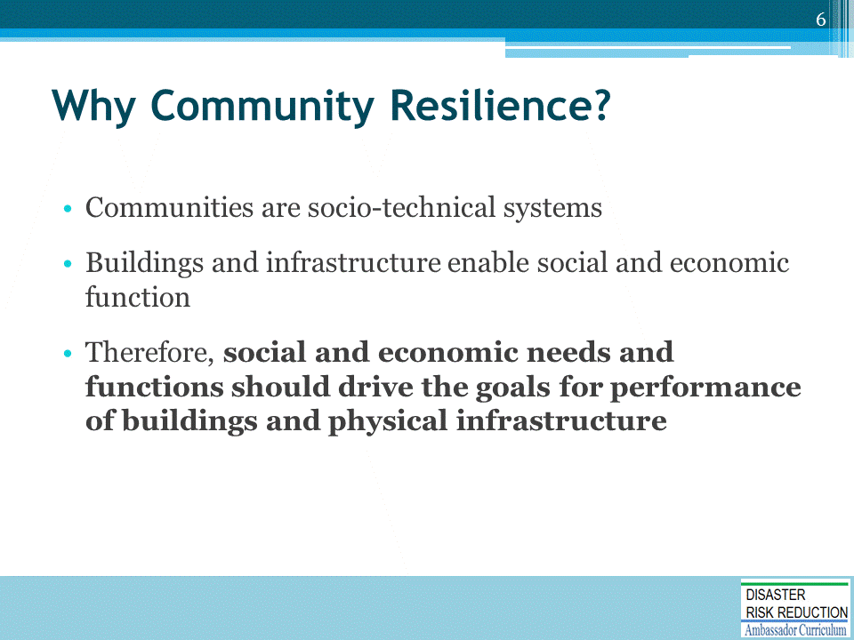
- NIST Engineering Laboratory focuses on how buildings respond in extreme loads (e.g., earthquake, wind)
- Think about community as a system of systems
- Need to think beyond buildings and infrastructure
- Need to focus on social and economic systems that rely on the buildings and infrastructure

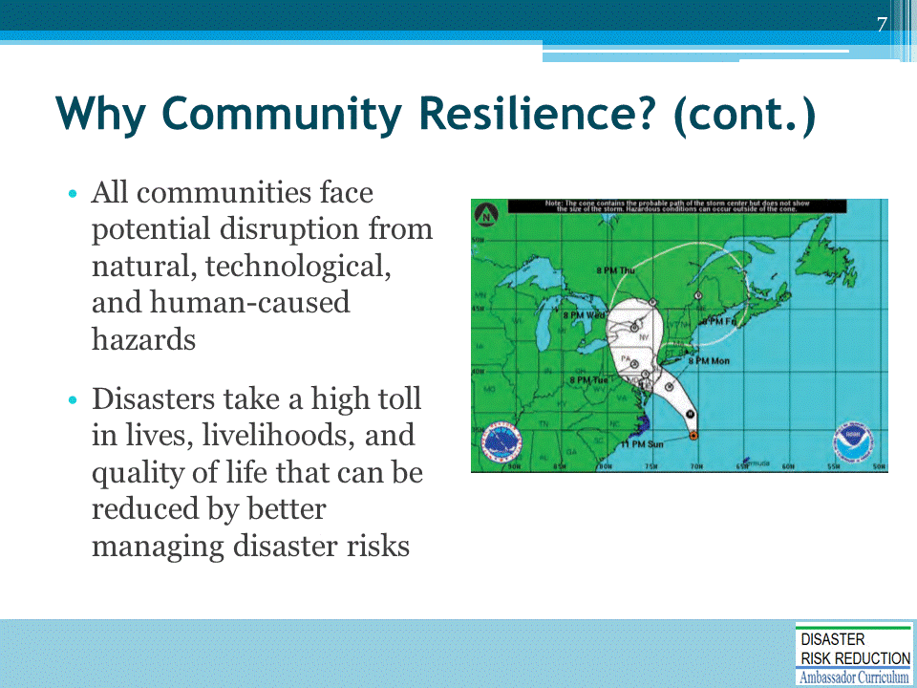

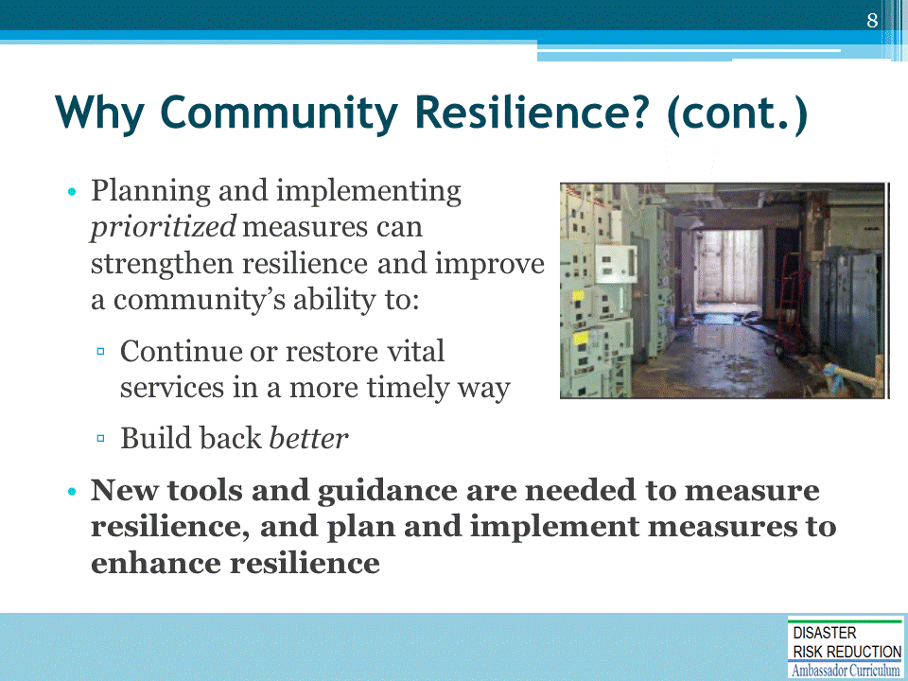
- Goals vary from place to place
- Need to understand community priorities and plan/implement measures that address those priorities
- To do so, need tools and guidance

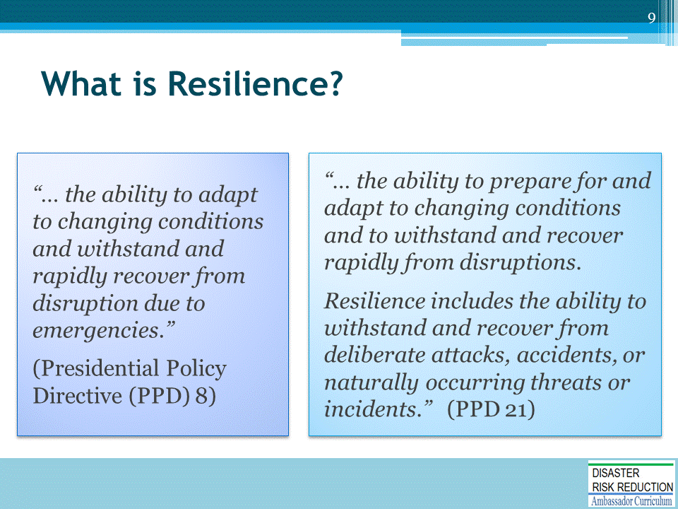
It is important to recognize that resilience is about preparing for and adapting to changing conditions.

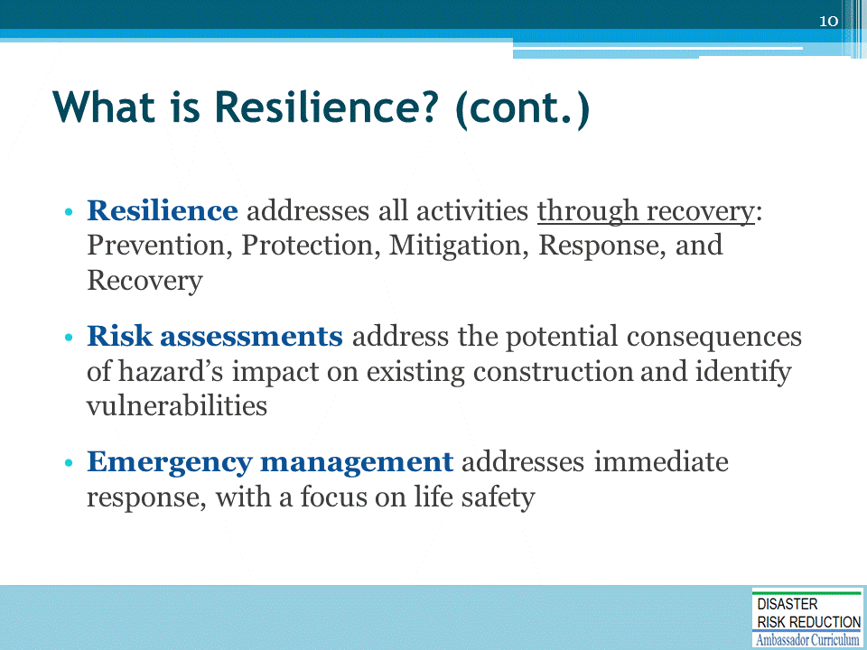
It is important to know how to plan for response and recovery, particularly recovery.

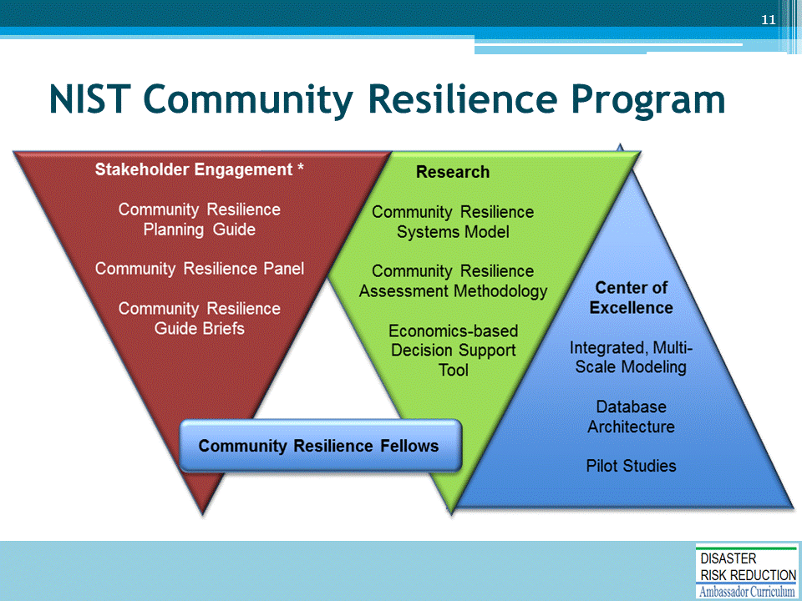
NIST began this work in 2013, formally with internal funding through normal appropriation process.
The first round of funding was for the Stakeholder Engagement portion of NIST Community Resilience Program
- Held series of workshops to gather input on the Community Resilience Planning Guide – produced working drafts, circulated for input, continually revised and expanded guide
- Continued Engagement activities through the Community Resilience Panel (~350 people) to address gaps and barriers that exist to implementing resilience planning
- Augmented Guide through Briefs, which delve into particular topics providing guidance
Community Resilience Fellows – group of experts in particular areas (e.g., infrastructure systems, social sciences, business continuity, emergency management)
- Helped bring Guide to completion and develop Briefs
Research component of the Program geared toward developing tools to help communities understand the levels and gaps of resilience; and to identify and address gaps
- Use of the Economic Decision Support Tool to help communities weigh options in losses avoided and day-to-day benefits accrued
Center of Excellence funded by NIST
- Trying to develop integrated, multi-scale modeling
- Environment to help understand connections between buildings and infrastructure systems and how they are linked to social and economic functions
- Also looking at Database Architectures and how to collect, archive, and analyze data across the resilience spectrum, from preparation and mitigation through response and recovery
- Conducting pilot studies to validate models and Database Architectures
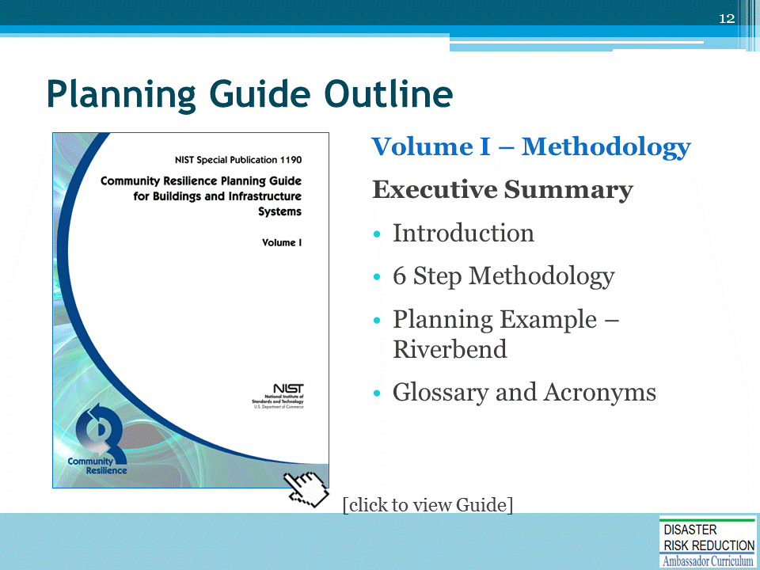
Volume I of Community Resilience Planning Guide for Buildings and Infrastructure
- Includes a planning example: Riverbend community in Oregon; walk through of how the process can be implemented
Weblink to Volume I: https://www.nist.gov/topics/community-resilience/community-resilience-planning-guide
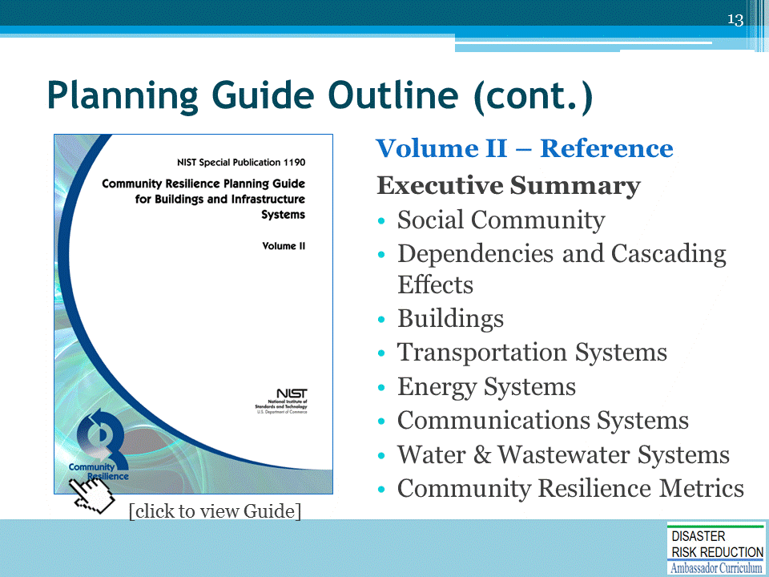
Weblink to Volume II: https://www.nist.gov/topics/community-resilience/community-resilience-planning-guide

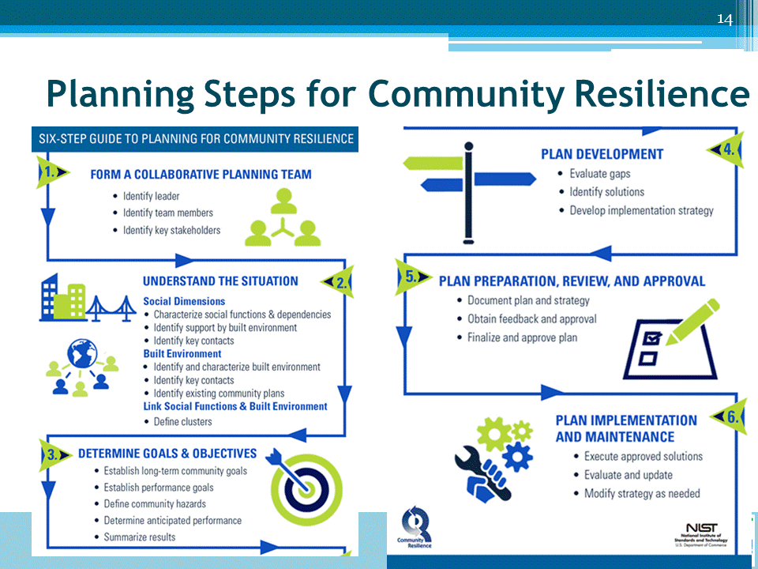
We will talk about each of the 6 steps in process.
- Aligned with FEMA’s National Preparedness Frameworks and associated documents like FEMA’s Comprehensive Preparedness Guide (CPG) 101: Developing and Maintaining Emergency Operations Plans
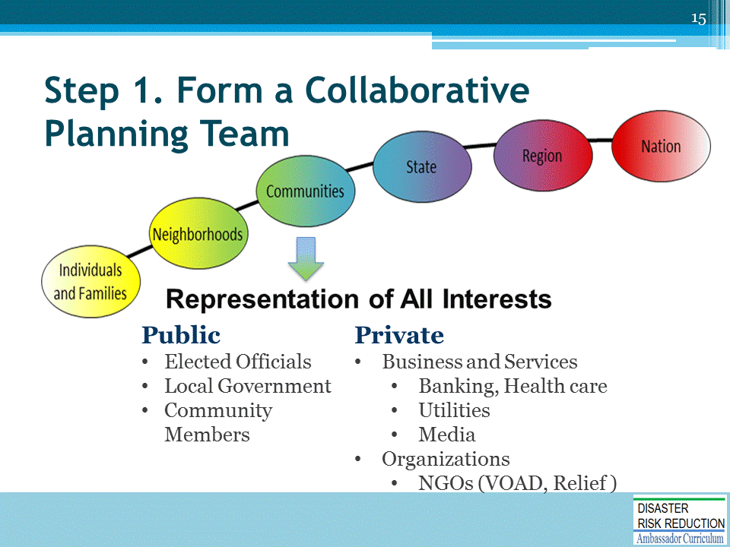
Primary concern is identifying the target audience – the communities
- Reaching down to neighborhoods and individuals and families
- Reaching up to state, regions, and nation

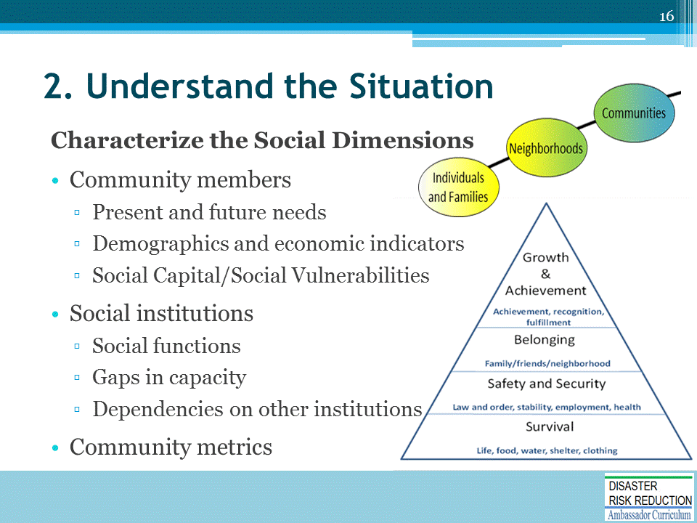
Understanding:
- Community members
- Social institutions – e.g., economic engines, businesses, industry, housing, healthcare, etc.
- Community metrics - Maslow’s Hierarchy of Needs
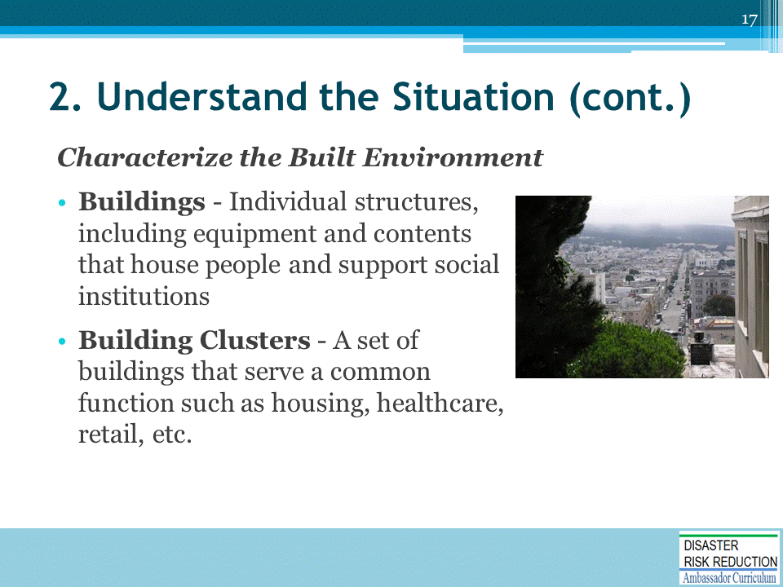
Building Clusters – to simplify analysis, clustered by function and type – e.g., housing; commercial buildings; healthcare buildings

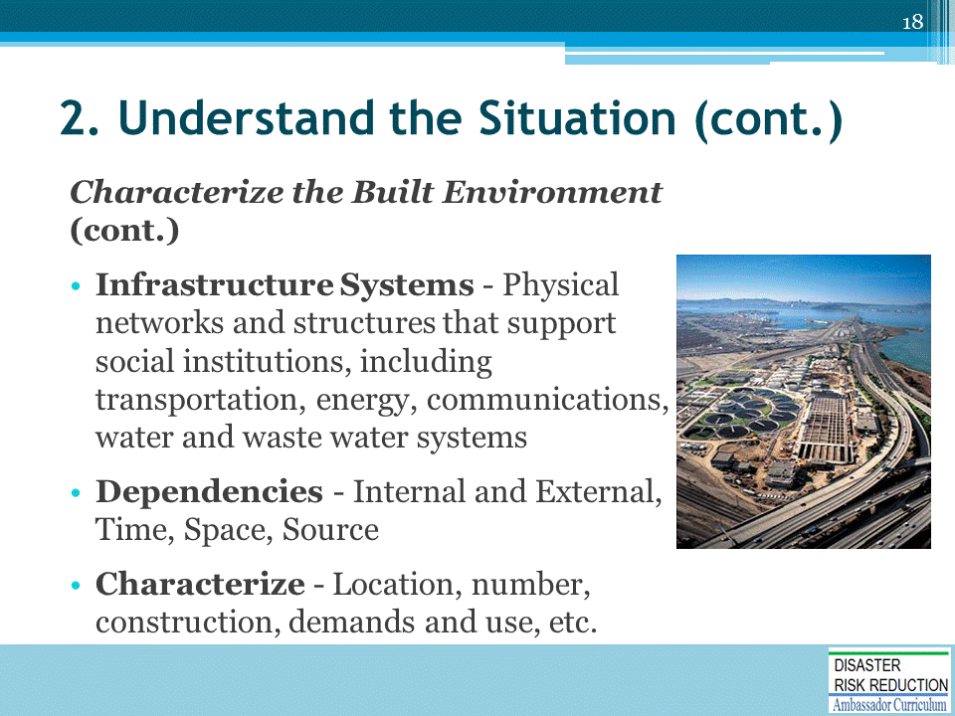
Dependencies
- External dependencies – e.g., water system depends on power for pumping
- Temporal dependencies – i.e., one system needs to be restored before another system can function – e.g., clearing debris from roadways so power lines can be restored
- Spatial dependencies – e.g., water/wastewater facilities located in floodplains
- Source dependencies – i.e., sources are located at a significant distance from users
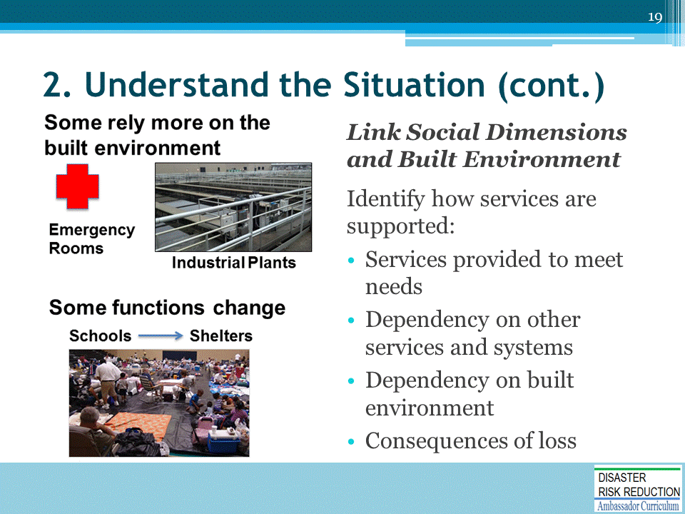

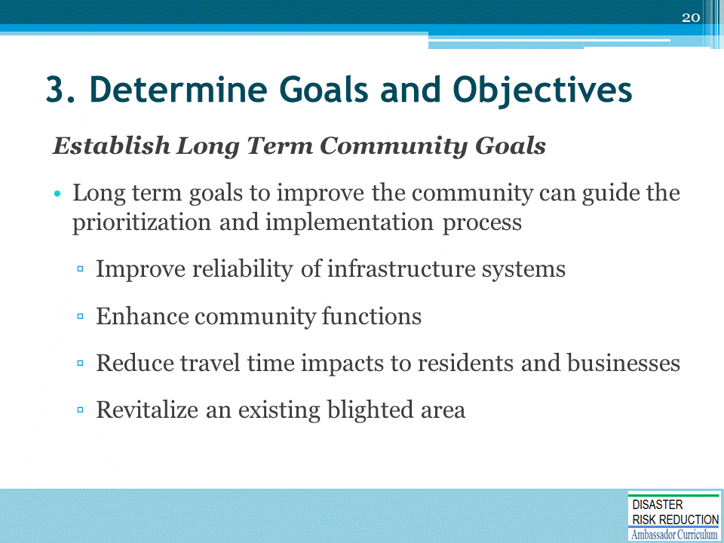
Begin with looking at long term community goals.
- Don’t want to create another plan that just sits on the shelf
- Idea is to begin to use the blends of resilience to integrate a lot of the planning that already goes on in communities, such as comprehensive planning, hazard mitigation planning, emergency operations planning
- Look at how resilience can begin pulling the plans together in a coherent fashion – e.g., there may be goals such as improving reliability of infrastructure that currently exists; reducing travel time; revitalization

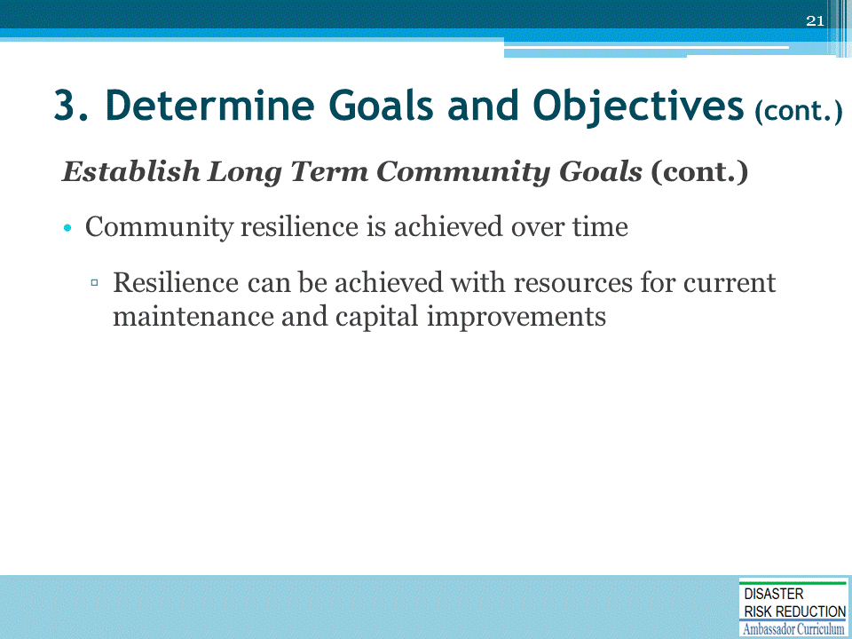
It is IMPORTANT TO RECOGNIZE that resilience is achieved over time!
- Can be built into existing plans and achieved with resources for current maintenance and capital improvements
Instead of changing what you are doing, can adjust priorities to improve resilience.

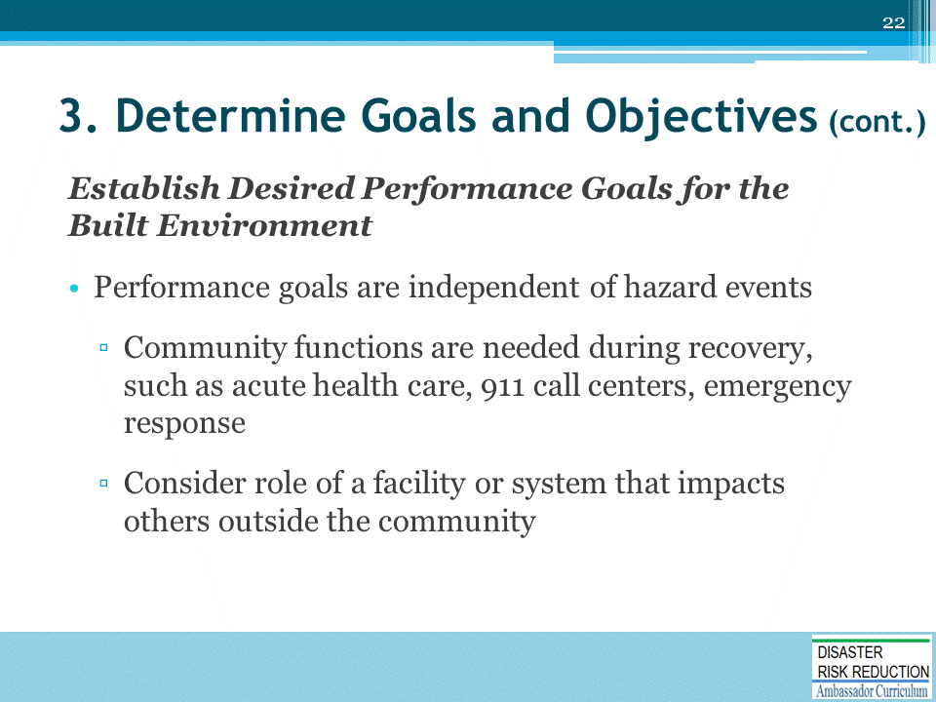

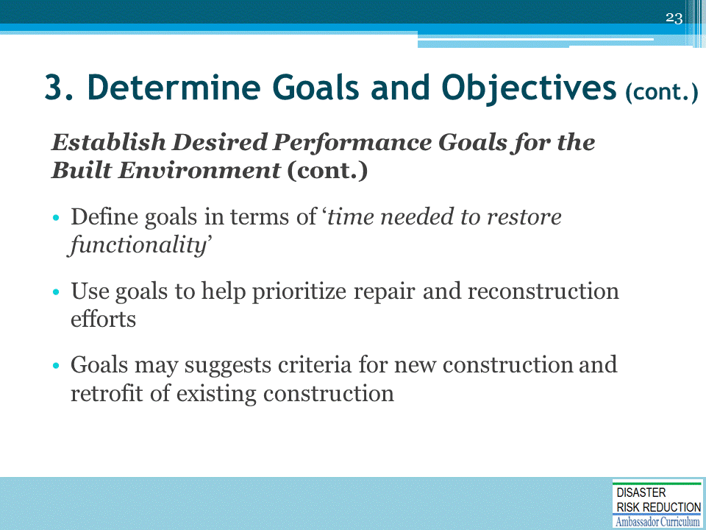
‘Time needed to restore functionality’:
- What is the extent of disruption that can be withstood by the community before detrimental effects begin to occur? (detrimental effects such as people moving away, business closures)
- If you understand timeframes, you can start prioritizing repair and construction.

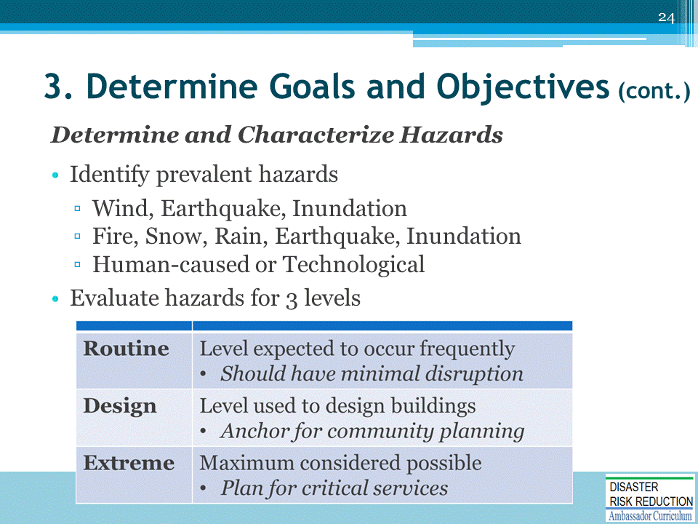
Design level – plan for resilience at this level

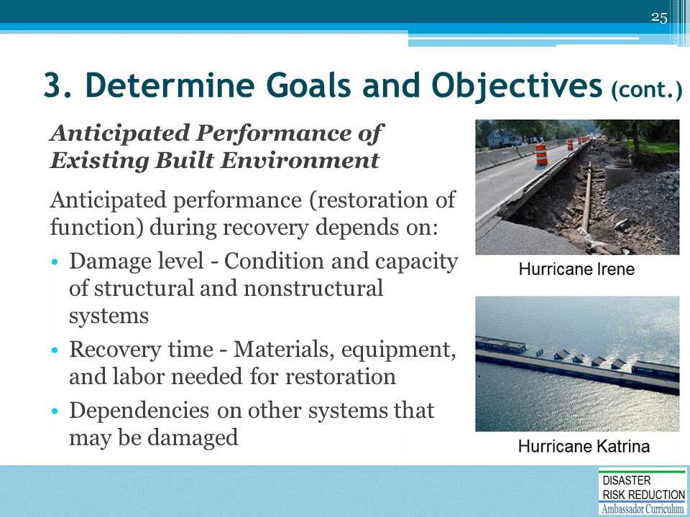

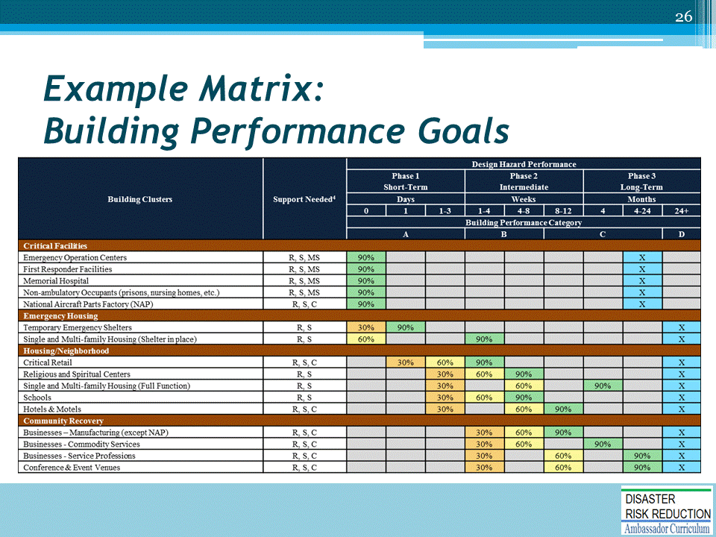
The Guide has a series of matrices (all located in appendices). I will show examples and go through one in detail.
- Critical Facilities example: blue x anticipated performance restoration
- Emergency Housing/Temporary Emergency Shelters: 30% minimal needs met
Support Needed column refers to:
- R=Regional
- S=State
- MS=Multistate
- C=Civil (corporate/local)
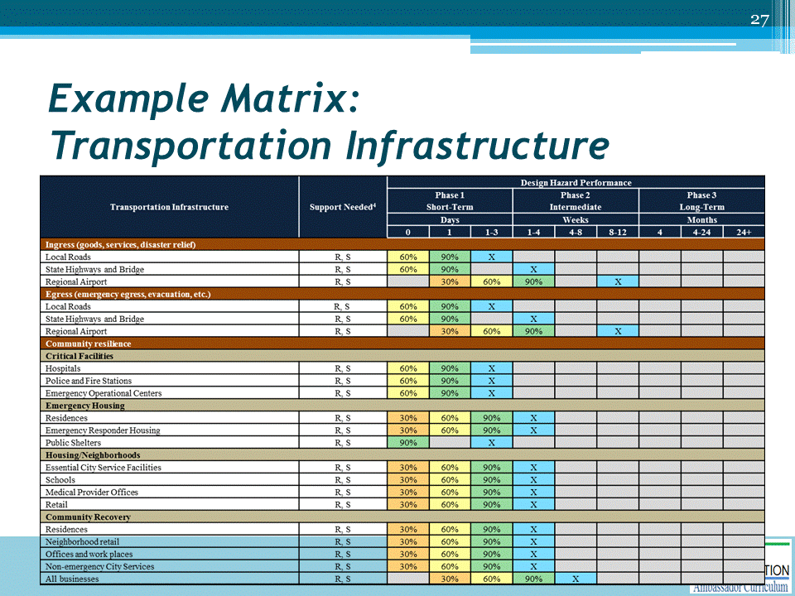

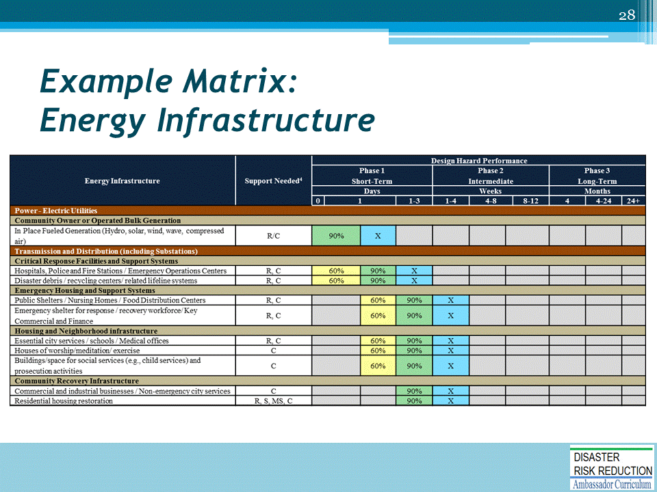

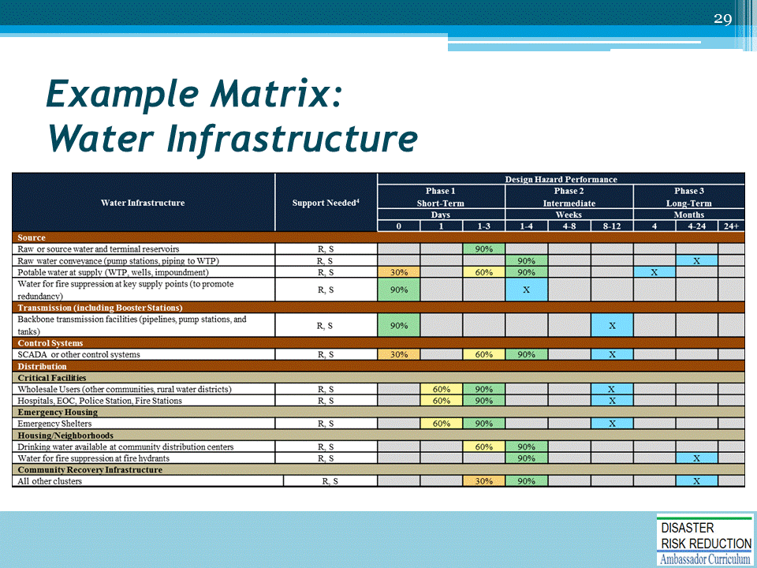

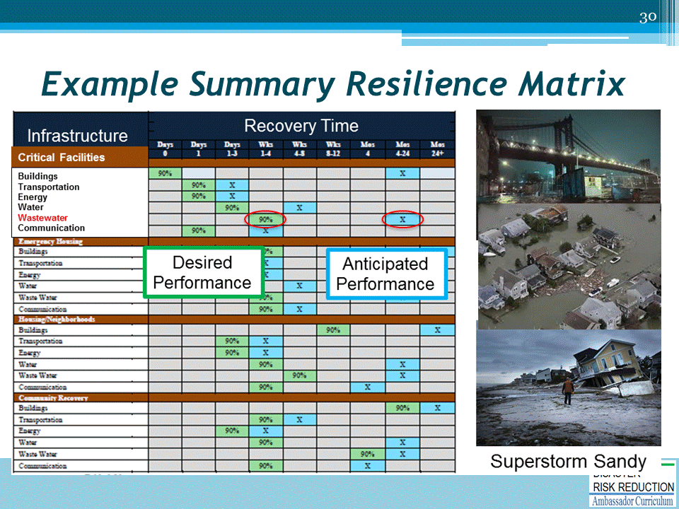
This is a roll up matrix made up of the individual matrices.
- Shows desired performance and anticipated performance
- Allows user to identify gaps and begin prioritization process
- In example: Critical facilities, highlighted wastewater system
- Goal is 1-4 weeks to have wastewater system fully operational and anticipated performance based on analysis is 4-24 months
- There is a gap that represents opportunity for investment to improve resilience
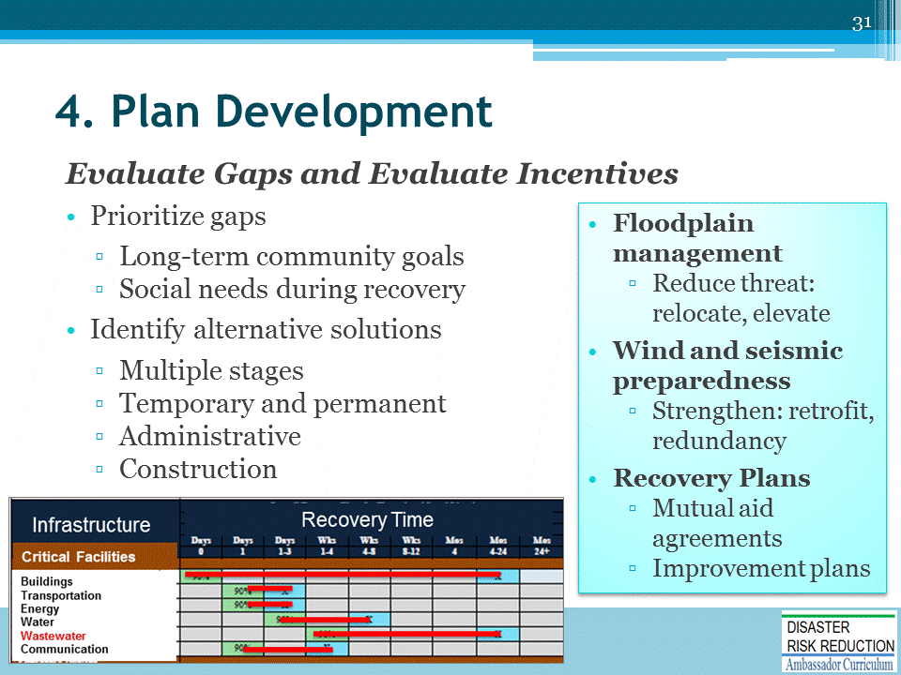

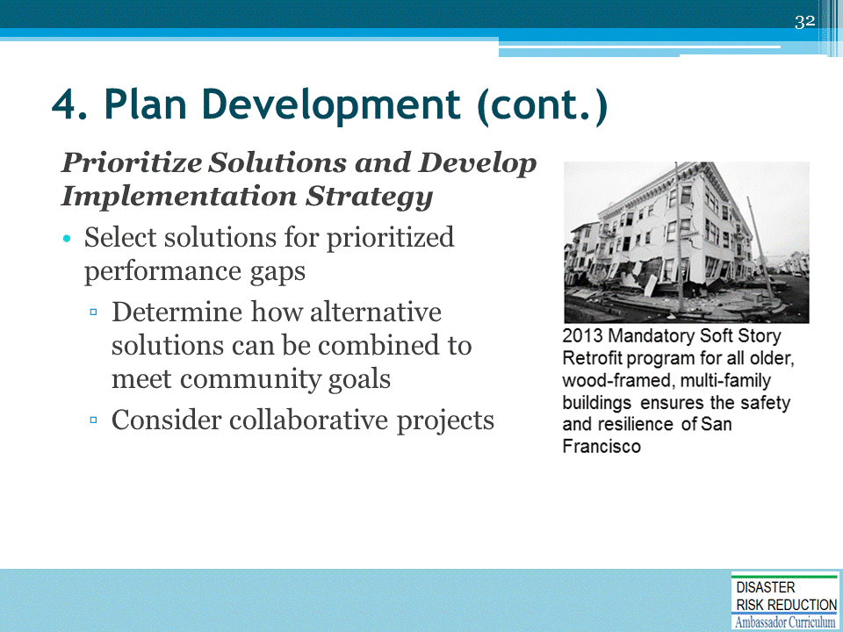

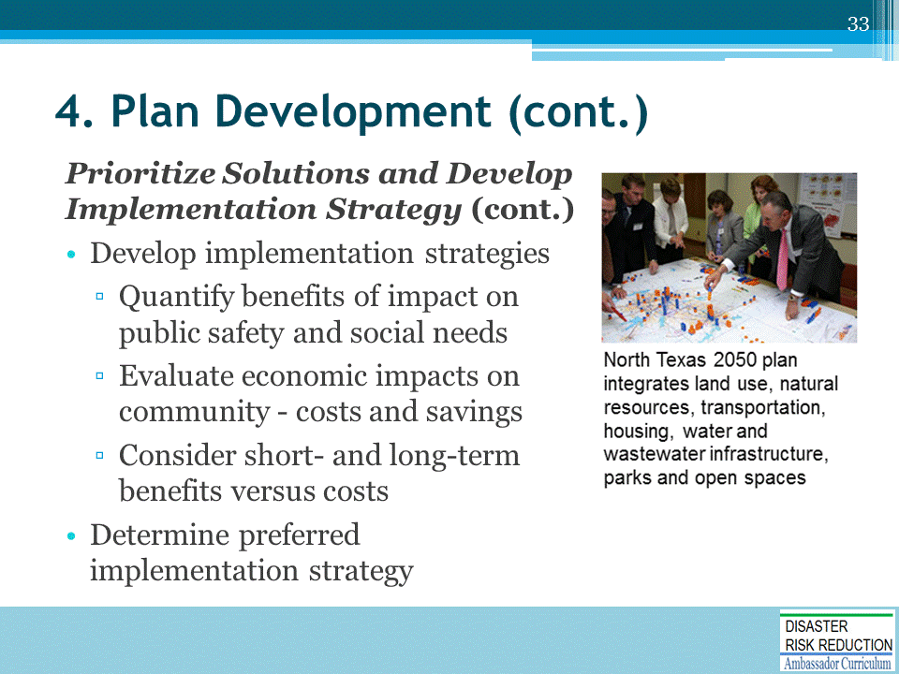

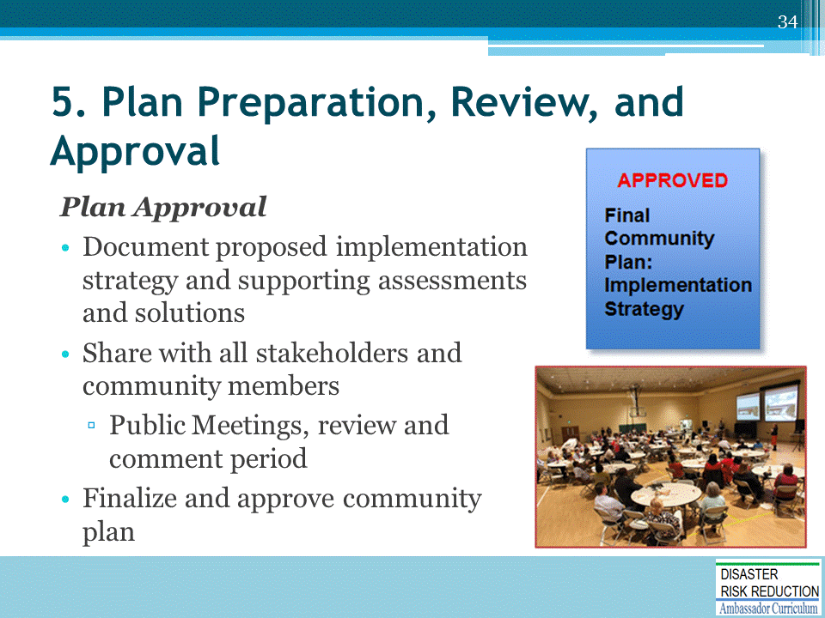

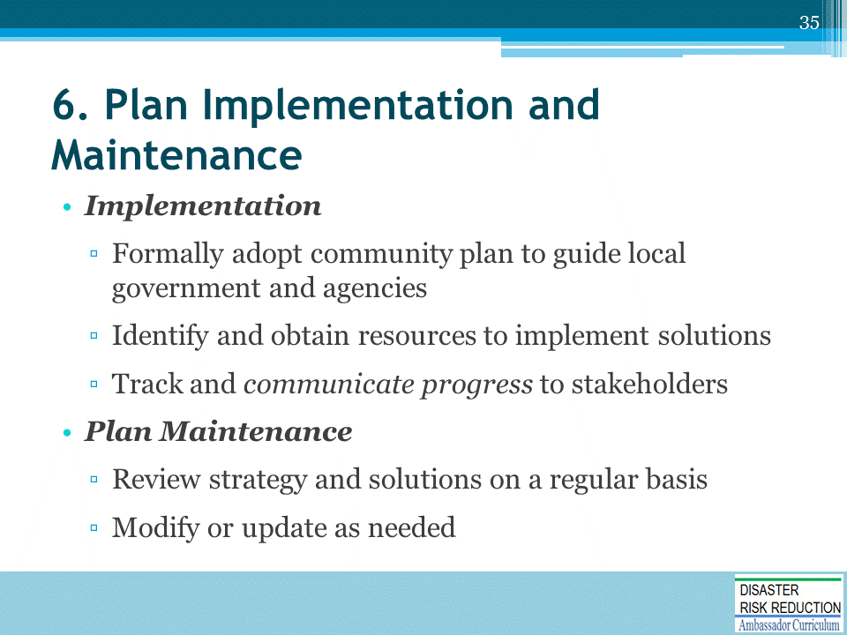

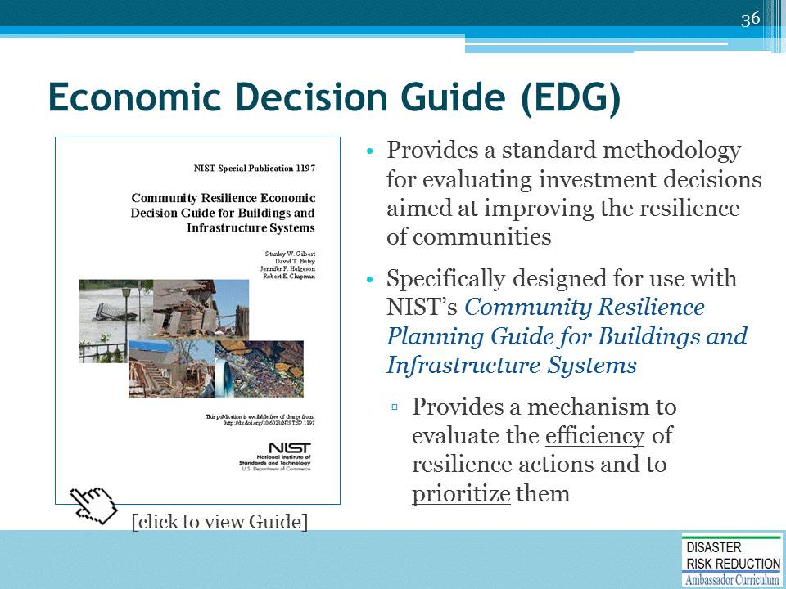
The Economic Design Guide weighs losses avoided and co-benefits.
Weblink to EDG: https://www.nist.gov/publications/community-resilience-economic-decision-guide-buildings-and-infrastructure-systems

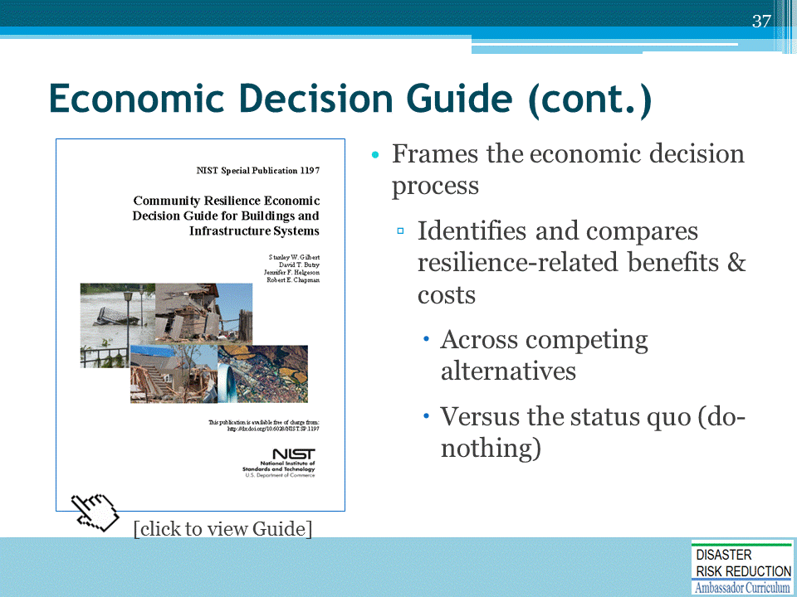
Example in EDG Appendix: bridge crossing that carried a water main
- The bridge was vulnerable to both flooding and seismic activity.
- In EDG, weighed alternatives
  - Retrofit existing bridge
  - Build a new crossing and retrofit existing bridge at a time when it was due for deck replacement
- Second action was most cost effective because of day to day economic benefits accrued because of reduced congestion, etc.
- The EDG gives guidance for making those decisions.

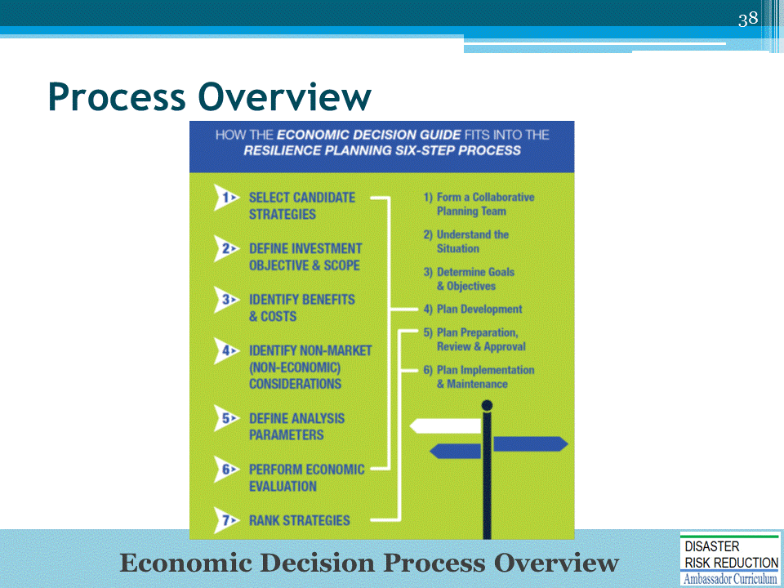
This graphic shows how the Economic Decision Guide and Community Resilience Planning Guide link together.

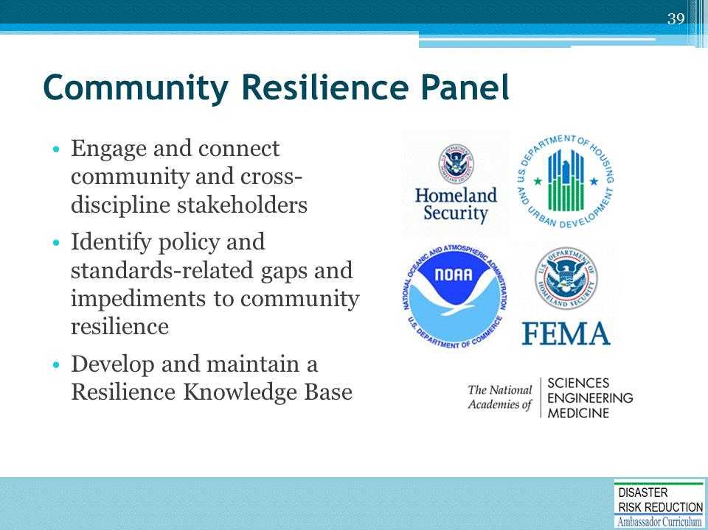

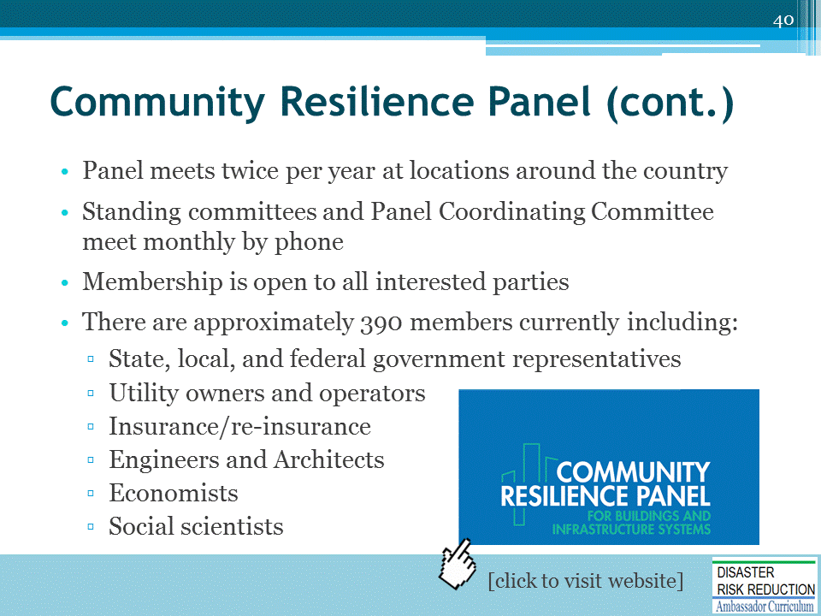
Community Resilience Panel website: https://crpanel.nist.gov/

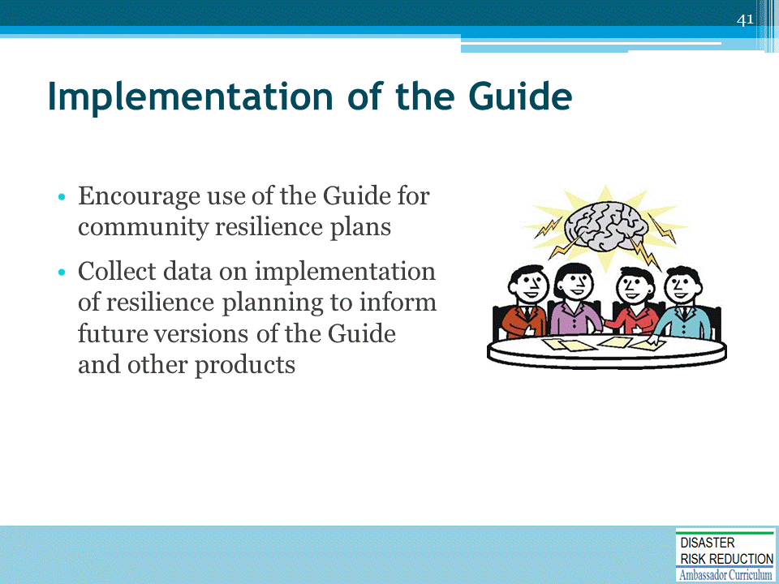

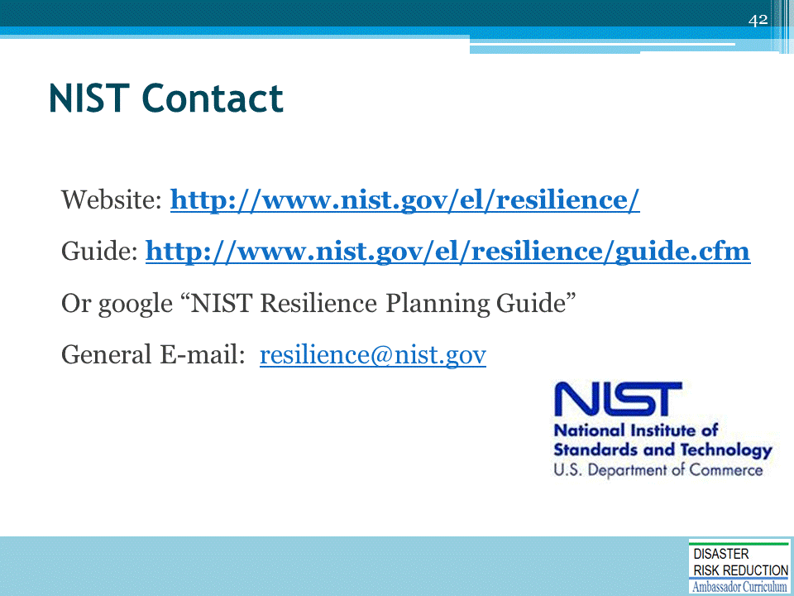

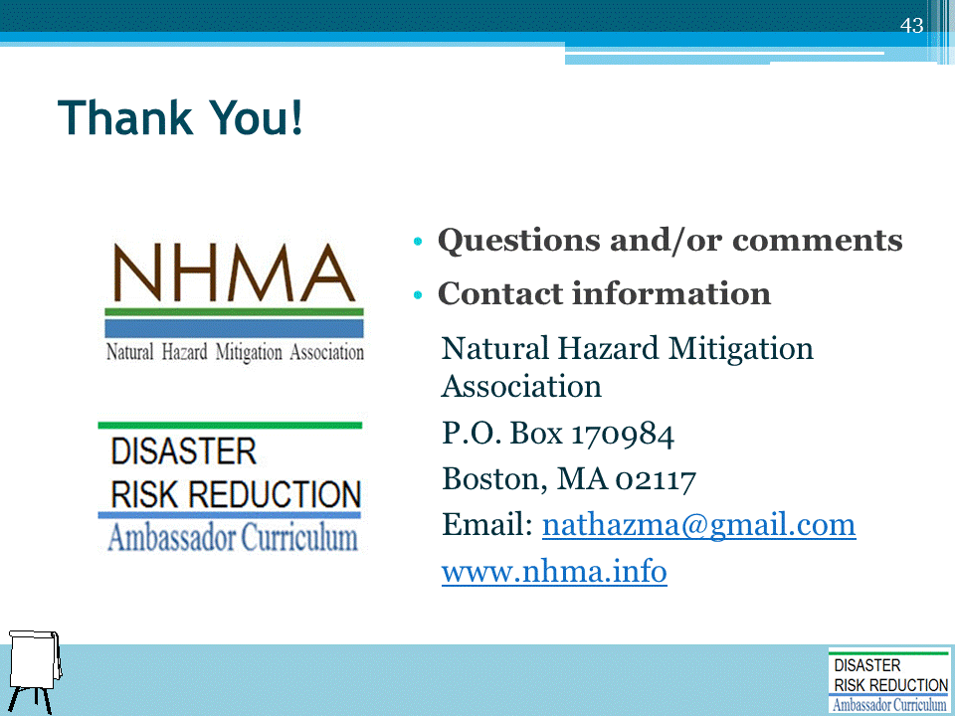
Record on easel pad any recommendations or questions to be addressed outside of the presentation.

DRR AMBASSADOR CURRICULUM AT-A-GLANCE
I. Disaster Risk Reduction for a Safe and Prosperous Future
1 | Introduction to the Natural Hazard Mitigation Association and Disaster Risk Reduction Ambassador Curriculum
2 | Introduction to Disaster Risk Reduction as a Foundation of Community Resilience
3 | Leadership for Disaster Risk Reduction
4 | Community Disaster Risk Reduction and Adaptation
5 | Approaching the Challenge of Disaster Risk Reduction: NIST Community Resilience Guide
II. Forming a Community’s Vision for Disaster Risk Reduction
6 | Risk Assessment through Storytelling: An Asset-Based Approach
7 | Achieving Community Buy-in for Disaster Risk Reduction: Win-Win Approaches
8 | Leveraging Resources to Improve Disaster Risk Reduction
III. Realizable, Practical, and Affordable Approaches for Moving from a Vision for Disaster Risk Reduction to a Strategy
9 | Selecting and Implementing a Strategy for Addressing Community Disaster Risk Problems
10 | Integrating Hazard Mitigation into Local Planning
11 | Beyond Codes and Low-Impact Development
12 | Creating the Plan: A Sustainable Floodplain Management Process Model
IV. Resources and Tools for Implementing a Community’s Disaster Risk Reduction Strategy
13 | Climate and Weather Tools and Trends
14 | Risk Assessment Basics
15 | Legal and Policy Opportunities for Disaster Risk Reduction
16 | Linking Catastrophe Insurance to Disaster Risk Reduction
V. Resources for Hazard-Specific Disaster Risk Reduction
17 | Living with Water: Inland and Coastal Flooding
18 | Design for Flood Resilience: Part I: Floodplain Management and Flood Resistant Design
19 | Design for Flood Resilience: Part II: Green Infrastructure / Low Impact Development
20 | Overcoming Impediments to Flood Resilience: Paths Forward
21 | Wildfire Mitigation
22 | The Wildfire-Flood Connection
23 | Severe Thunderstorm/Tornado Safe Rooms
24 | From Policy to Engineering: Earthquake Risks

