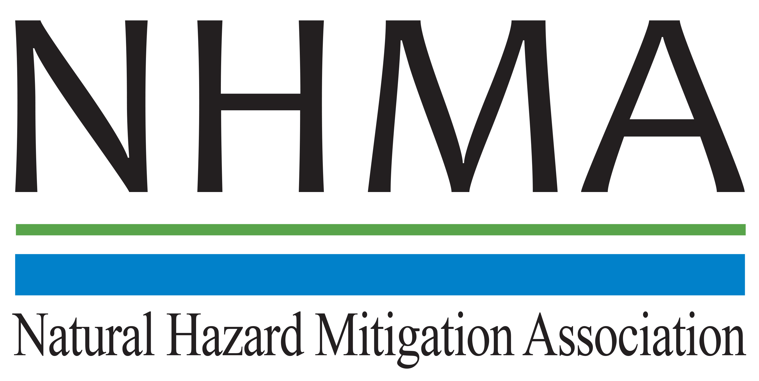

Disaster Risk Reduction (DRR) Ambassador Curriculum

Instructor Guide

Module 6:

Risk Assessment through Storytelling:

An Asset-Based Approach

THE DRR AMBASSADOR CURRICULUM
The goal of the DRR Ambassador Curriculum is to facilitate Disaster Risk Reduction efforts for the whole community by:
- Engaging in discussion of how disasters can be reduced through local action
- Sharing insights among local leaders and technical experts to enable the development of cross functional solutions
- Acquiring the best-available information, knowledge of best practices, and analytic tools to enable better-informed decisions before, during, and after disasters
It is important for instructors of DRR Ambassador Curriculum modules to remember this is one module in a 24-module curriculum. The “DRR Ambassador Curriculum At-a-Glance” table, located at the end of this document, lists the modules of the Curriculum. Keep in mind the following context for the module(s) you conduct:
DRR-A CURRICULUM TARGET AUDIENCE
The target audience includes those involved in community development decision-making, such as local community staff, volunteer and stakeholder groups, and federal and state officials.
METHODS OF DELIVERY
Varied delivery methods will provide multiple options for access by the target audience. The DRR Ambassador modules may be presented via webinars hosted by NHMA or partner organizations, presented in conferences and/or classrooms by qualified DRR Ambassador Curriculum instructor(s), or are downloadable for individual study from the NHMA website.
COURSE MATERIALS
Instructors are expected to use the instructional materials housed on the NHMA website to conduct DRR Ambassador Curriculum modules (Instructor Guide, supporting visuals, Participant Guides, and handouts). Instructors may tailor modules to specific audiences or locations as long as they do not revise the learning objectives and do not revise the materials in such a way that the participants cannot correctly complete the post-test. Instructors request the current pre/post-test for the module from NHMA.
CERTIFICATES OF COMPLETION
Certificates of Completion will be awarded by NHMA to participants who successfully complete NHMA-sponsored DRR Ambassador modules. A DRR Ambassador Certificate will be awarded to individuals completing all 24 modules. Participants who choose not to take the post-test may be issued a Certificate of Attendance. Contact NHMA about obtaining certificates. Inform participants to ask their certifying boards about acceptance of NHMA DRR Ambassador certificates for continuing education credits.

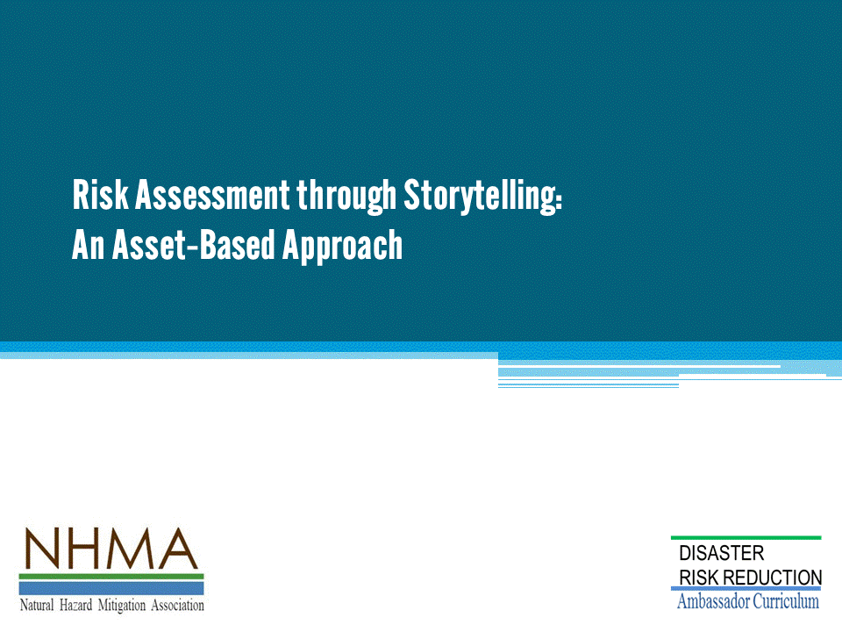
This module is driven by an experiential learning exercise that demonstrates the merits of an “asset-based approach”.
- One third of the session is devoted to presenting concepts and setting up the exercise.
- Two thirds of the time is devoted to play.
- The exercise is first, followed by a discussion of concepts.
This module presents a shortened form of a four hour exercise. It reduces the length of discussion and not the number of tasks.
- Although shortened, it is important that participants form teams and that each team complete three rounds of planning.
This module demonstrates how this methodology can be used with community stakeholder groups.
- When the longer workshop is conducted, participants spend considerable time working in teams.
- The teams go through three rounds of play.
- These teams rotate among themselves in “World-café” fashion during each of the three rounds.
During this shortened exercise the World-café has been eliminated and the participants are expected to come up with a few products during each round, and not a comprehensive list as demanded in the four hour version.

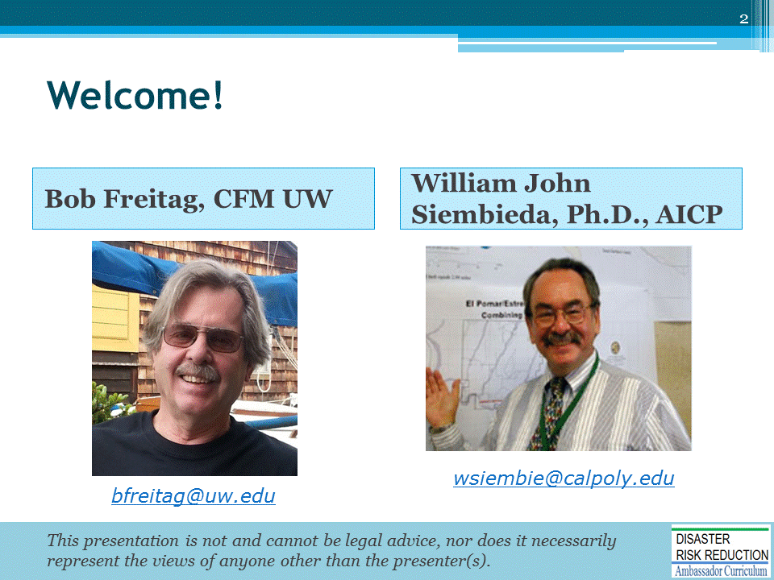
Introductions:
- Each instructor introduces her/himself, including affiliation.
- Each participant should briefly introduce him/herself and affiliation.
Optional:
- Instructors may want to ask participants to state why they are interested in taking this course if they are few (less than 12) or more than 90 minutes has been allotted for the module.
Mention:
- NHMA presentations are based on general principles of law, engineering, policy and emergency management.
Instructor preparation to conduct this module:
- Read through slide deck and speaker notes.
- Read: “Whole Community Resilience: An Asset-Based Approach to Enhancing Adaptive Capacity Before a Disruption - “Journal of the American Planning Association Vol. 80 No. 4 Autumn 2014
- Read: GREEN RECOVERY IN GREENSBURG, KANSAS by Kirstin Kuenzi - PLANNING FOR POST-DISASTER RECOVERY: NEXT GENERATION PAS Report 576 James C. Schwab, AICP, Editor www.greensburgks.org/residents/recovery-planning/sustainable-comprehensive-master-plan/view
- Become familiar with Human Well-being material, http://www.millenniumassessment.org/documents/document.301.as

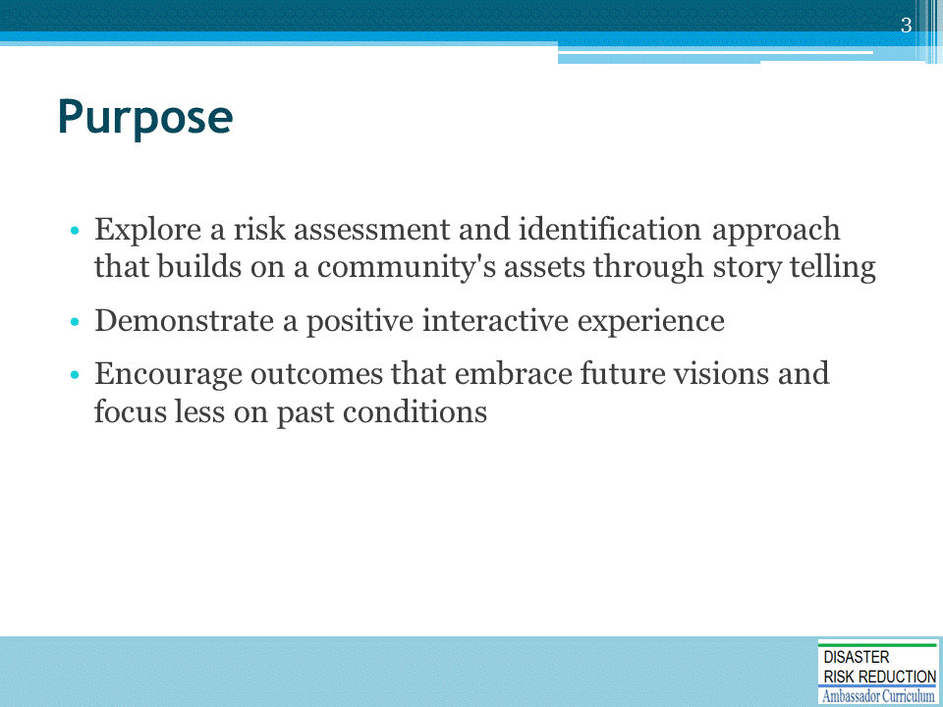
Optional Purpose:
- A “Train the Trainer” purpose is appropriate if the participants are familiar with basic risk concepts and HAZUS - “Train Emergency Managers on the process presented”

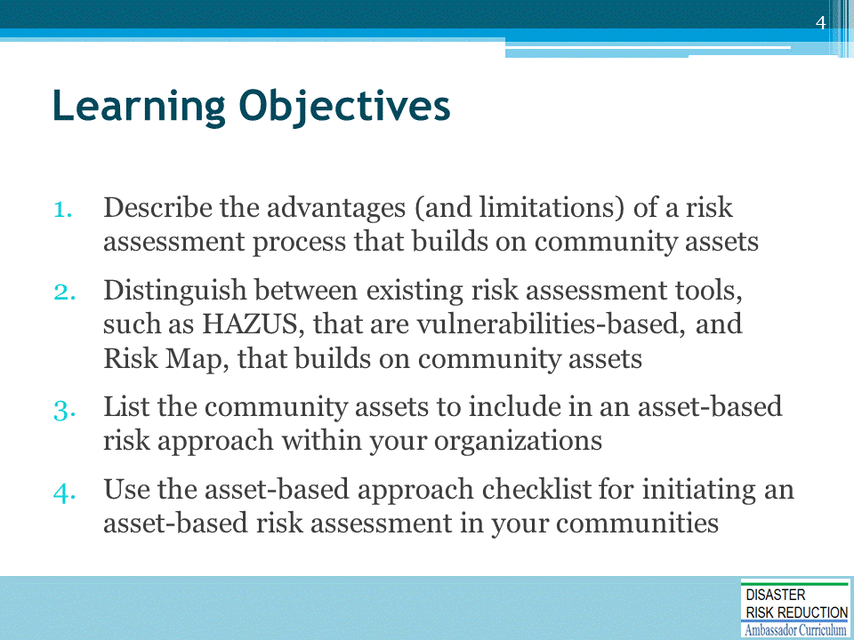

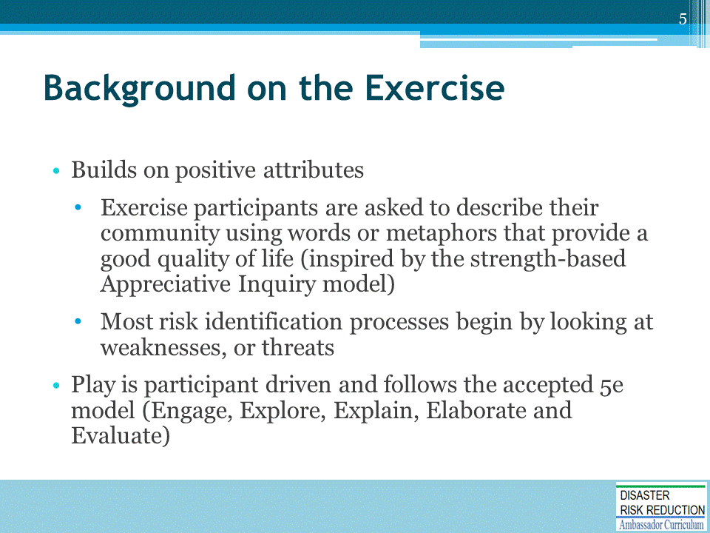
This methodology is conducted as an exercise that builds on positive attributes and is participant- driven.
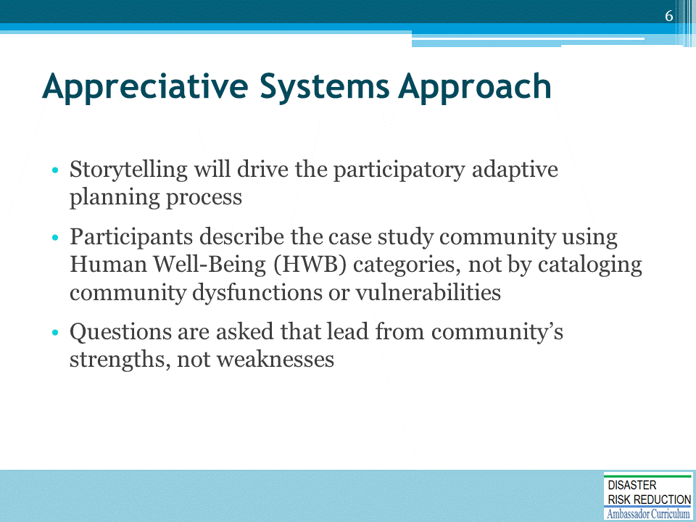
- This process applies principles of assets-based community development to disaster planning (Green & Haines, 2012), specifically the idea that creative thinking leads from strength-based positive approaches to inquiry and action (Emery & Flora, 2012).
- HWB categories include:
- Basic Material for a Good Life
- Health
- Security
- Good Social Relations
- Freedoms and Choice

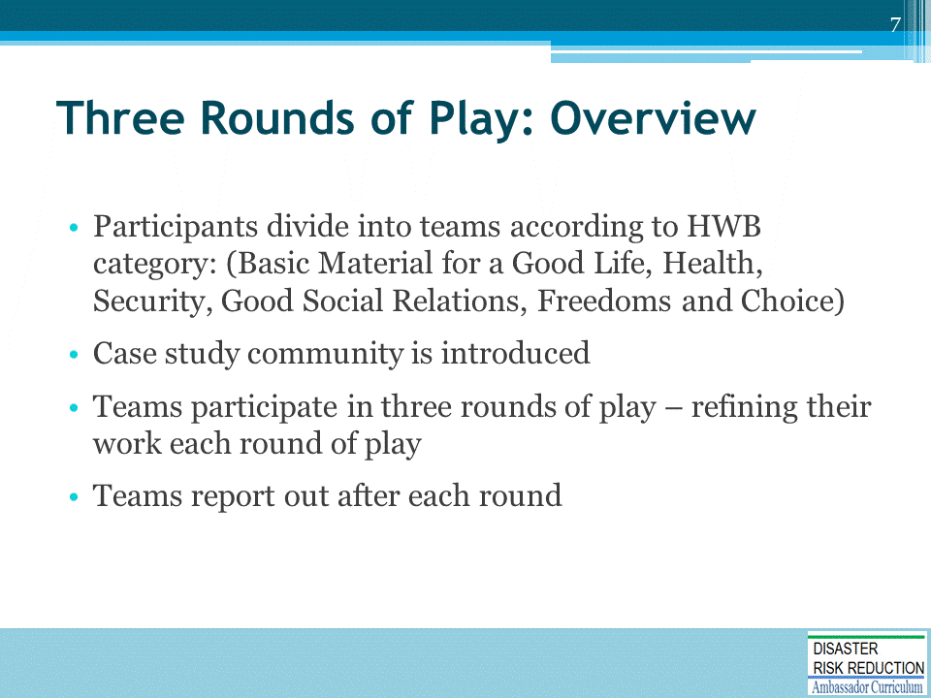
The instructor will have identified a case study community before the session.
- The community should be familiar to all.
- It could be a local city or neighborhood or one that is familiar to all.
If this module is presented at a national meeting or conference, or a webinar available through the NHMA to nationwide audiences, the instructor will have to introduce a generic community or simply pick one to use.
- Consider a short existing video about a real community or a summary that provides the flavor of the community adequately to demonstrate the methodology within this timeframe.
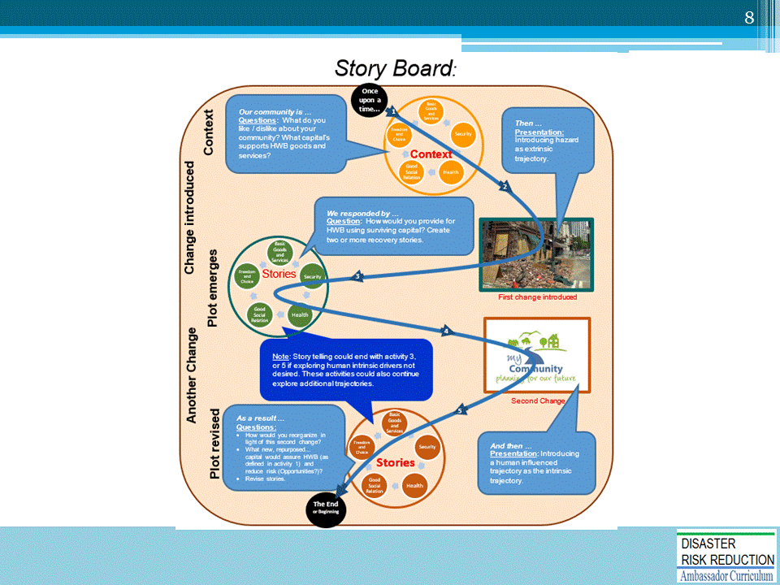
- Mention that the larger circles illustrate rounds of play.
- The smaller circles within the larger circles represent table groups divided into human well-being categories.

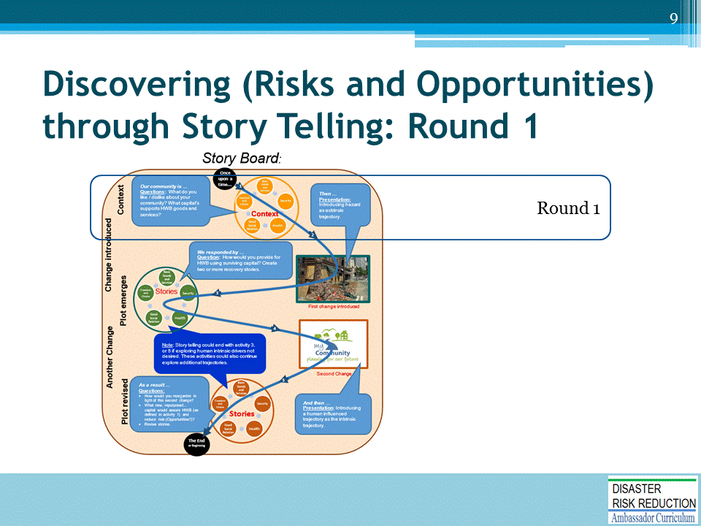
- Orange for round 1

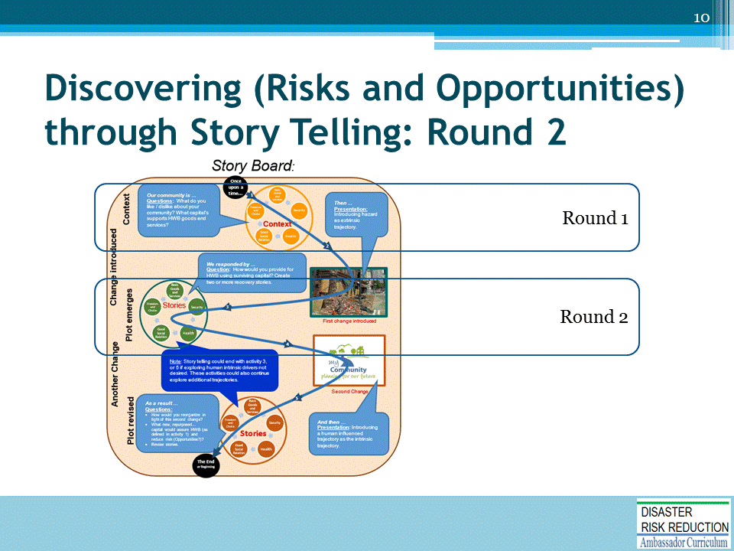
- Green for round 2

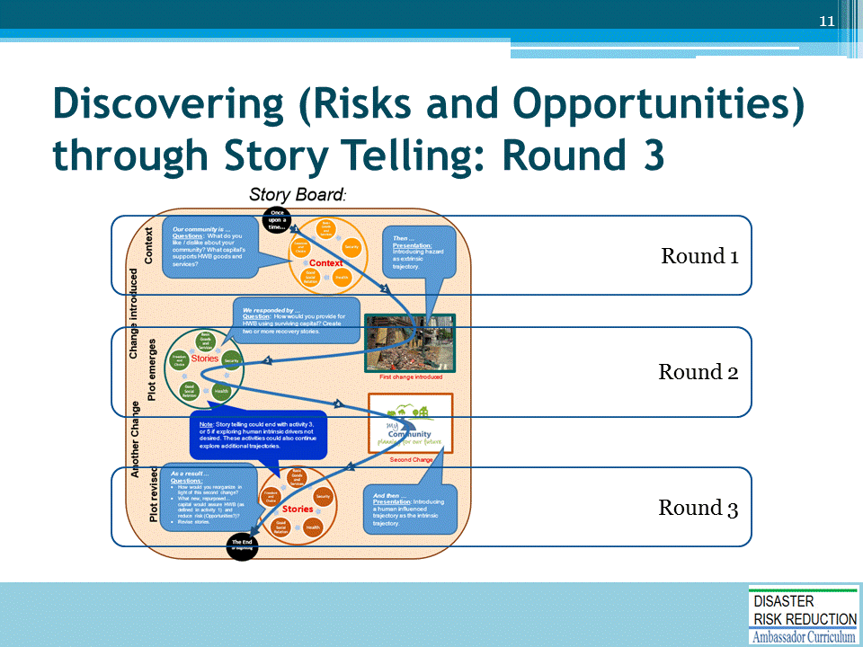
- Brown for round 3

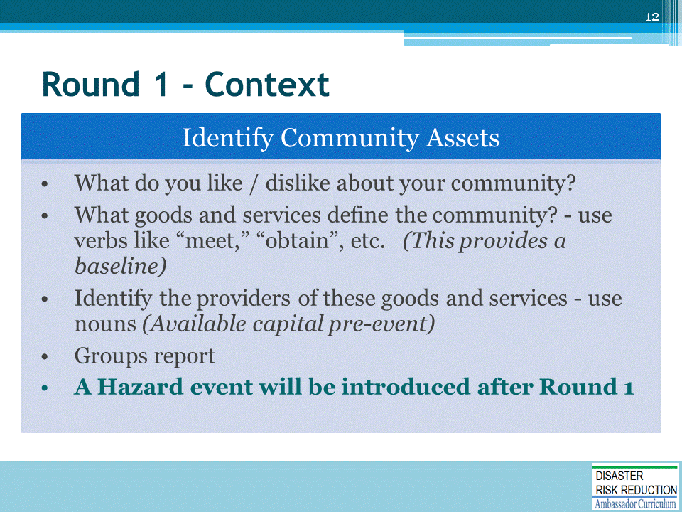
Round 1 is intended to establish a baseline: 2 – 3 descriptions of what participants like about the case study community would be appropriate.

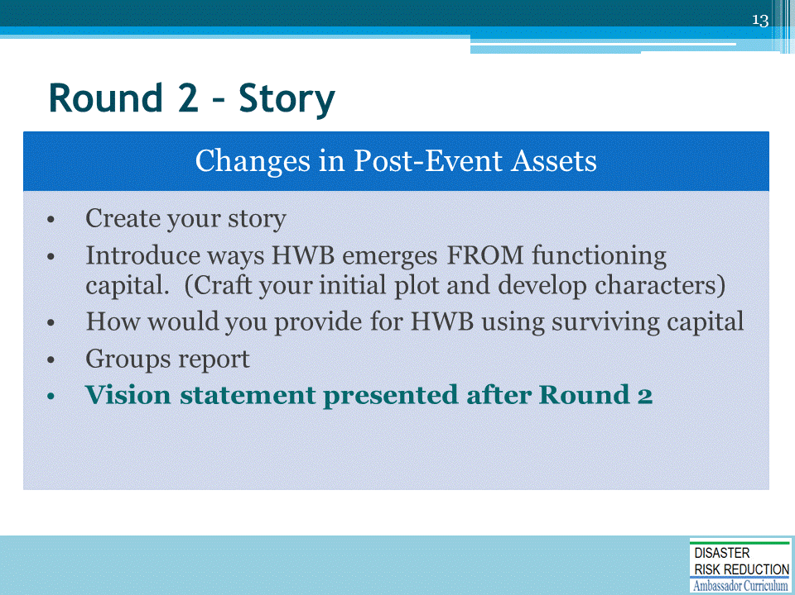
Rounds 2 builds on Round 1.
In Round 2, participant are asked to develop a post-event story describing ways HWB can be achieved, but with some of their “providers” having been non-functional and compromised.

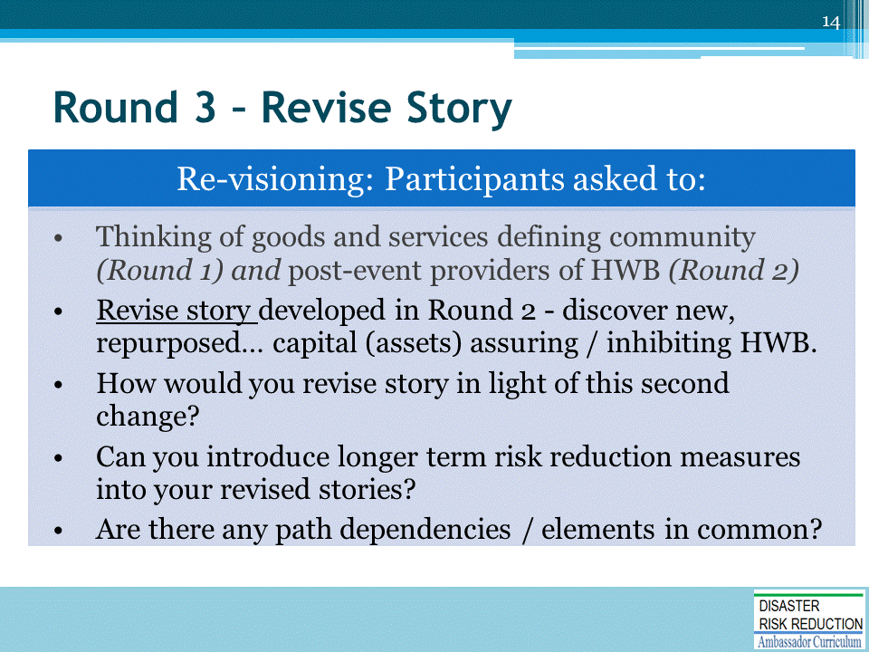
Rounds 2 and 3 build on Round 1.
In Round 3, participants are asked to create a “new normal” – one that recognizes a wider range of providers (building on round 2 insights) and risk reduction measures that create a better or resilient community that is closer to the community’s vision.

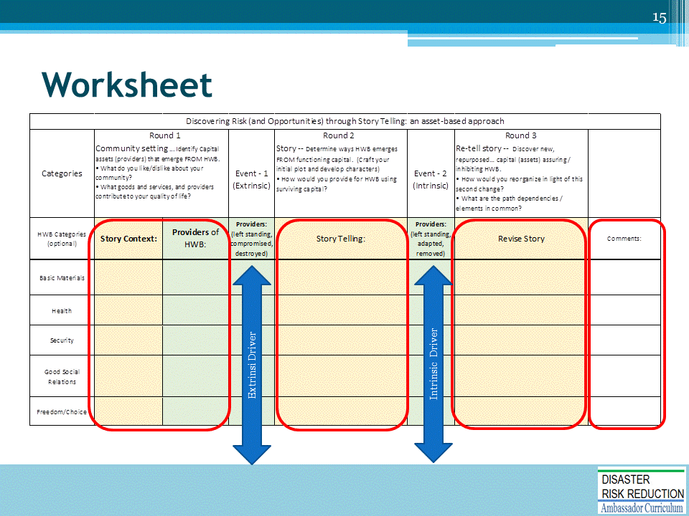
A worksheet is provided for HWB groups to keep track of their ideas and report to the rest of the participants.
- Click once. What do the participants like and dislike about their community. Here participants will record goods and services for our case study community. In the green colored column participants will record the providers of these goods and services. The first blue arrow introduces the change agent - one that could cause significant damage. Earthquake, climate change, flooding… This is also referred to as the “extrinsic” driver.
- Click a second time. Participants will record post-event providers of goods and services necessary for HWB.
- Click a third time Here participants will layer a second trajectory (intrinsic driver) onto their story. Participant will need to revise and re-tell tell their story to include new, repurposed… capital (assets) assuring / inhibiting HWB. How would participants reorganize their story in light of this second change? What are the path dependencies / elements in common? They should include how their community can be improve:
(a) helping the community recover over the long term,
(b) putting the community in better position should another disruption occur, and
(c) meeting the community’s goals for an even better quality of life.

No effort should be made to restrict storytelling. Participants should be allowed if not encouraged to go as far their stories lead them. They may dive into risk reduction measures, exploiting opportunities,, altering vision elements…
4. Click a fourth time. This is the parking lot that allows participants to include general comments, or items needing further research.
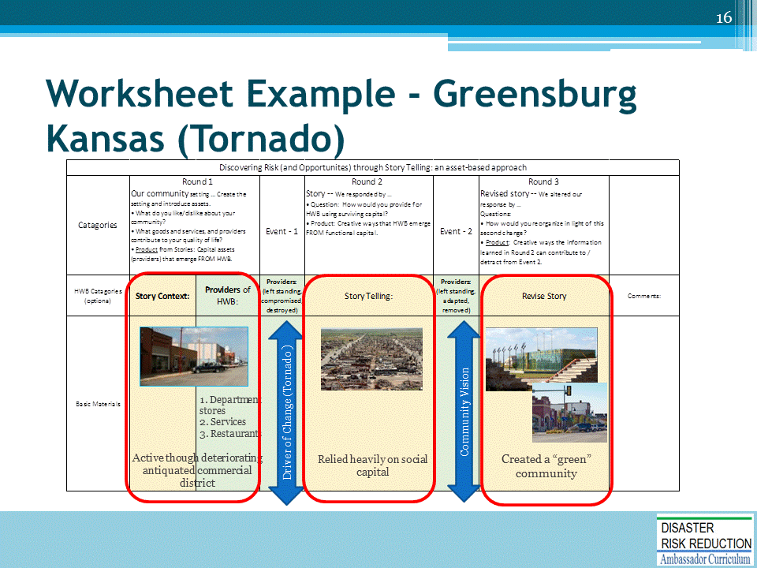
Here is an example of how the exercise should flow.
- Click once: This is picture of what the Greensburg commercial area looked like before the tornado. It was older, need modernizing, but was reported to be functional and used by the larger community. Goods and services include being able to meet friends for a drink, share meals, and purchase necessities.. Essential items for human well-being could be obtained. These goods and services were provided by stores, restaurants… (Proper names could be included)
- Click two: The changing event was a tornado. The instructor should present the description below.
- Click three: The town was totally destroyed. Few providers of goods and services were functional after the event. But herein lied opportunity. Federal assistance and insurance claims provide capital.
- Click four: The community re-visioned their community.
GREEN RECOVERY IN GREENSBURG, KANSAS - Kirstin Kuenzi - For more information, visit “Greensburg GreenTown” at https://www.greensburgks.org/
Although situated in a region often referred to as “Tornado Alley,” Greensburg, Kansas, had never sufficiently planned for its hazards. The Disaster Mitigation Act of 2000 set forth national guidelines requiring an approved Local Hazard Mitigation Plan in order for a jurisdiction to be eligible for federal mitigation grants. But Greensburg GreenTown founder Daniel Wallach said that the city did not have a comprehensive plan in place, let alone a working mitigation or recovery initiative.
On May 4, 2007, at 9:45 p.m., an EF-5 tornado ripped through the heart of the city; although the majority of residents were able to seek safety in time, 11 were killed and more than 60 injured. Ninety percent of Greensburg’s building stock was destroyed and close to half of its residents evacuated, never to return. This still left the town with a golden opportunity— though the population of the rural community had dropped from 1,500 to less than 800 within the past ten years, Greensburg is flourishing more than it ever has before.
Less than a week after the storm, residents began the recovery process by forming the organization Greensburg GreenTown. Kathleen Sebelius, former governor of Kansas, also called upon BNIM Architects, a consulting firm in Kansas City, Missouri. Encouraging in-depth collaboration, BNIM worked alongside residents, Emergency Support Function #14 team of the Federal Emergency Management Agency (FEMA), and Greensburg GreenTown on brainstorming a new vision for the city. Since the entire community had been damaged, residents discussed the idea of a green rebuild, the basis of this plan being rooted in the belief that a better “new normal” was achievable. FEMA, BNIM, and GreenTown (present at each town meeting) described their main goal as making sustainability the corner piece of the rebuilding process, giving the town a distinct new identity and showcasing it as a green revival of America’s heartland.
Greensburg still conjures up important memories for BNIM principal Bob Berkebile and former associate Stephen Hardy. Although BNIM had been working on comprehensive plans for nearly 40 years, the process involved in Greensburg’s plan altered the firm’s viewpoints on the future of community integration. Greensburg still stands as the first example in which Berkebile and Hardy saw an entire community involved in comprehensive planning, including many women, children, and elderly residents.
With FEMA and BNIM’s assistance, residents were committed to the idea of placemaking and wanted to see a rededication for the future generations of Greensburg. As Mayor Bob Dixson (2012) said, “You are either growing or dying, and we needed the attitude that this has to be a better place for us to live and work.” In August 2007, after four large-scale community meetings and 43 resident interviews, FEMA released a long-term community recovery (LTCR) plan for Kiowa County and Greensburg. Projects that were considered most vital to the reconstruction of this community included rebuilding city and county buildings, developing affordable housing opportunities, creating a business incubator, and building a Kiowa County Museum and Tourism Center.
BNIM studied the recovery issues laid out in FEMA’s LTCR plan and released
in early 2008 a separate master plan for the city, titled the Greensburg Sustainable Comprehensive Plan. This plan discussed new additional growth concepts including LEED-Platinum certified buildings and a local wind farm, as well as multiple side projects such as eco-lodging and new home construction. A partnership with renowned brands, including Sun Chips and Ben & Jerry’s, greatly benefitted the municipality’s projects growth, and Greensburg now draws 100 percent of its energy from renewable sources. The town continues to work with the National Renewable Energy Laboratory, a division of the U.S. Department of Energy, on its energy credits while also looking to secure funding resources for the final aspects of BNIM’s plan. With the aid of federal, state, and private grants in addition to corporate donations, a large percentage of the plan has been completed. Most recently in Greensburg, the Big Well Museum and Gift Shop, dedicated to the world’s largest hand-dug well, located here, had its grand opening in May 2012.

One cannot commend the success of Greensburg without acknowledging the city’s difficulties. Stress weighed heavily on both residents and the mayor in office at the time, who resigned and handed his duties off to the subsequent mayor, John Janssen. Financing recovery was increasingly complex, community building exercises saw arguments between residents, and the timeline for redevelopment at times looked bleak. But the city was rewarded for its perseverance. Greensburg, now seen by many as the paragon of green sustainability, is thriving as planned. Other communities, such as Joplin, Missouri (p. 169), also discussed in this chapter, have consulted with Greensburg after the devastating tornadoes that occurred in the spring of 2011. Dixson states that he it was his duty to bring back a strong community to endure lifetimes, and now his town is more than willing to pay it forward.
Long-Term Community Recovery Plan for Kiowa County and Greensburg. Available at www.greensburgks.org/residents/recovery-planning/long-term-community-recovery-plan .
Greensburg Sustainable Comprehensive Master Plan Available at www.greensburgks.org/residents/recovery-planning/sustainable-comprehensive-master-plan/view.
Watch Greensburg’s recovery process, "Greensburg, Kansas: Thriving in the Wake of Disaster,” on the Mother Nature Network at http://planetgreen.discovery.com/tv/greensburg/.

PLANNING FOR POST-DISASTER RECOVERY: NEXT GENERATION, PAS Report 5 7 6, James C. Schwab, aicp, Editor

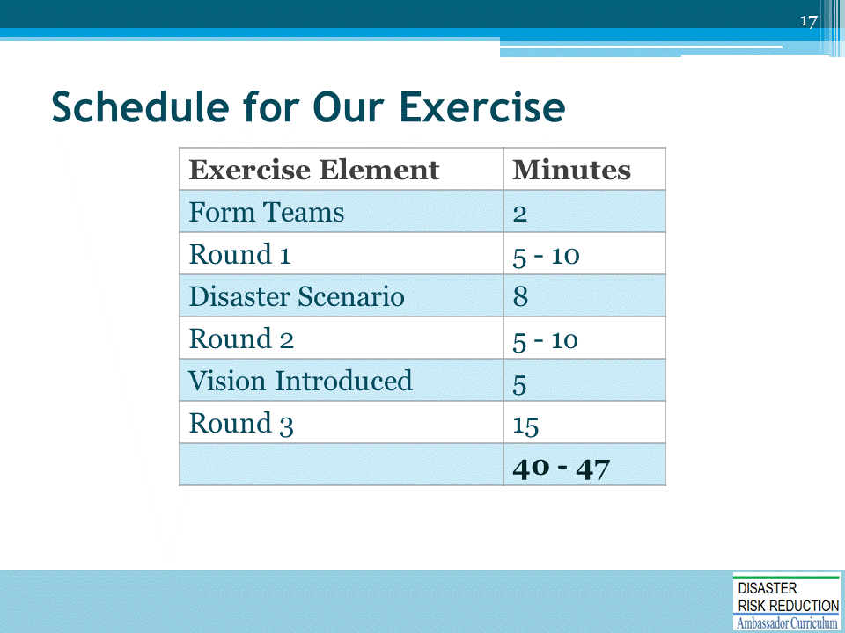
- This section enables participants to walk through a brief version of the exercise.
- Remind participants of how the exercise will progress and how much time is allotted for each element.
- Case study information is provided by the instructor.
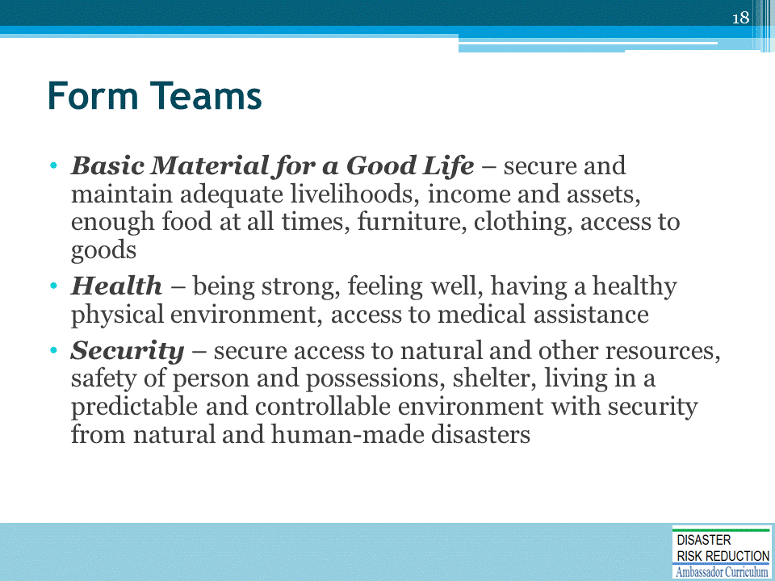
- The instructor divides participants into teams of three to seven participants. Teams will be grouped to represent HWB categories. “Freedoms and Choice” may be made an element of all team activities if there are too few participants.
- Each team must select a lead to report to the larger group following each round.
- For the purposes of this exercise we will use the Millennium Ecosystem Services typology and definitions for HWB.

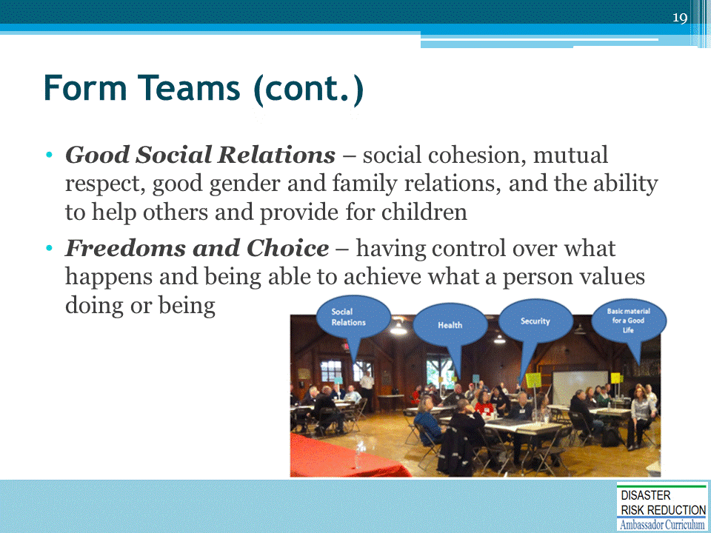

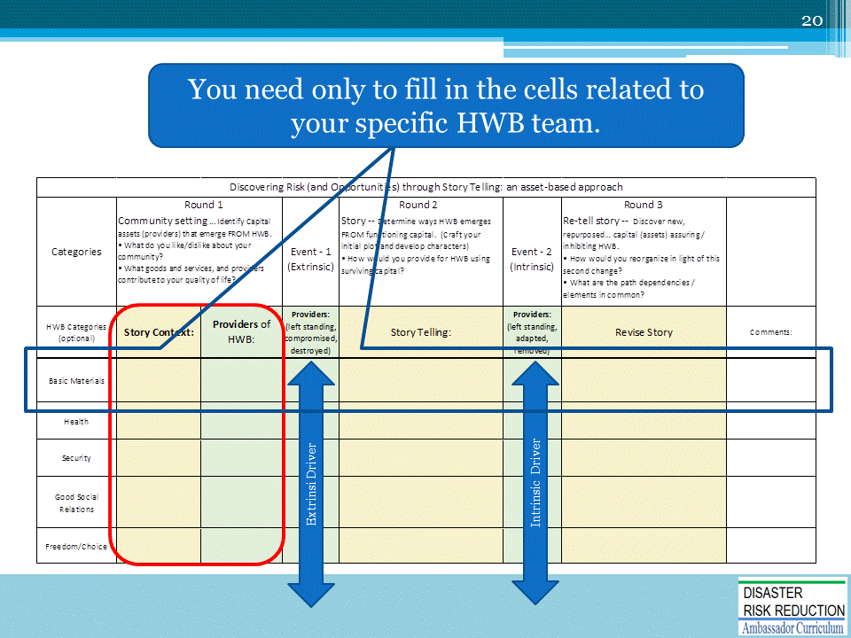
This worksheet could remain on the screen during Round 1, including reporting

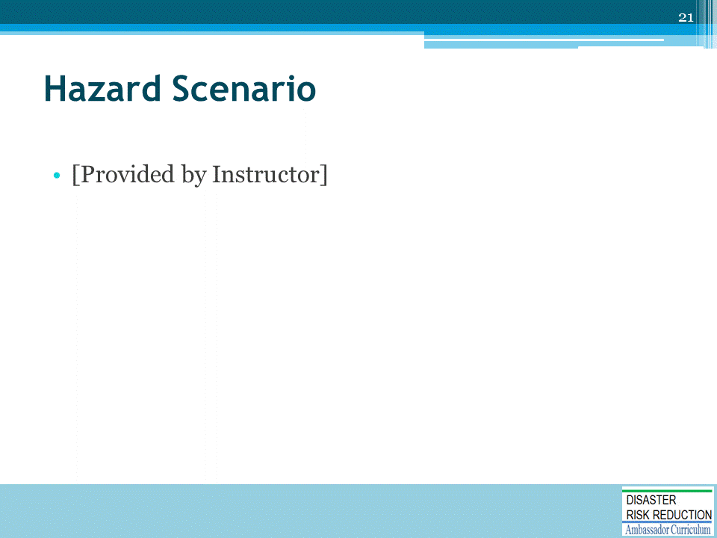
The instructor presents the hazard scenario in less than 10 minutes.
Presentations of the hazard event can be:
- Exploratory – What is likely to happen?
- Predictive – What could happen?
- Aspirational – What do we want to happen?
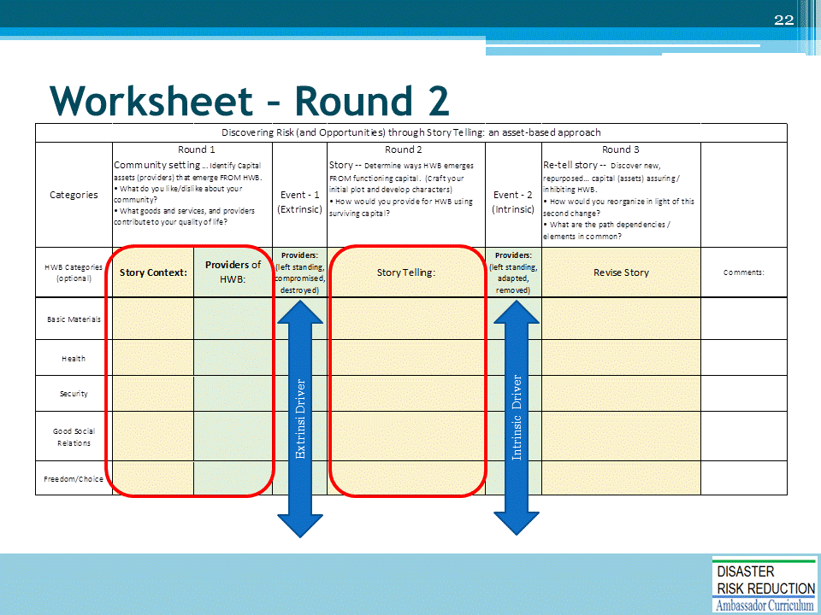
This worksheet should remain on the screen for this round including reporting.
The second round (immediately post-disruption) begins with the introduction of a hazard/change agent.
- HAZUS or RISK Map products should be used if available to describe general categories of impact.
Participants are asked to revise their stories.
- How, during the weeks following the event, would the community obtain (i.e. through what providers) the goods and services they identified during Round One?
- Participants could add to the initial lists of goods/services and sources/providers at any time during the exercise.
- Participants will identify how lost providers of goods and services and how these losses have impacted the assets that defined their case study community.
- Participants are expected to “translate” these event-damaged things (nouns) to goods and services at risk.

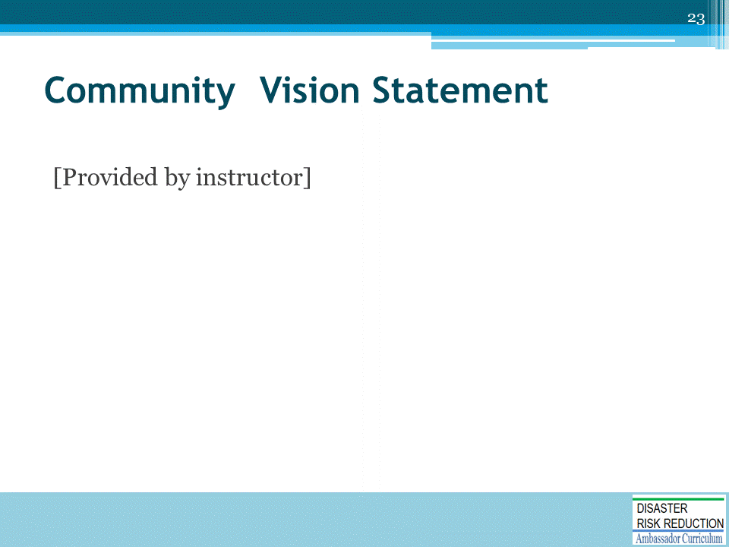
This second intrinsic change, driver, trajectory, as with extrinsic presentation it could be:
- Exploratory – What is likely to happen?
- Predictive – What could happen?
- Aspirational – What do we want to happen?

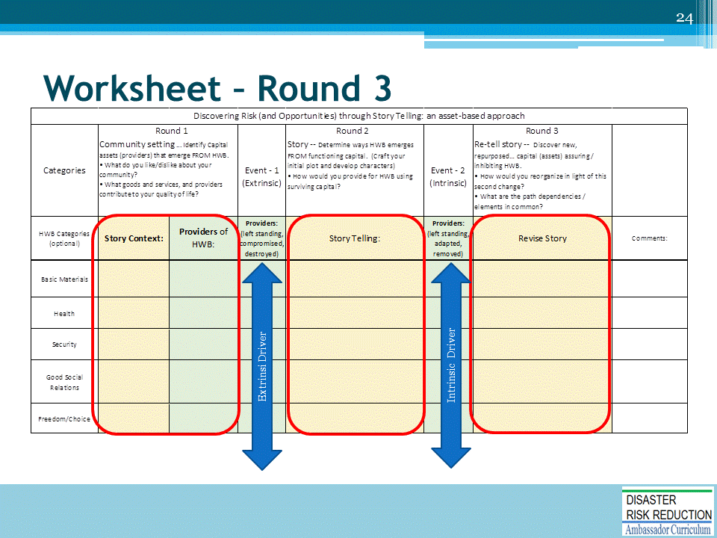
This worksheet could remain on the screen for Round 3 including reporting

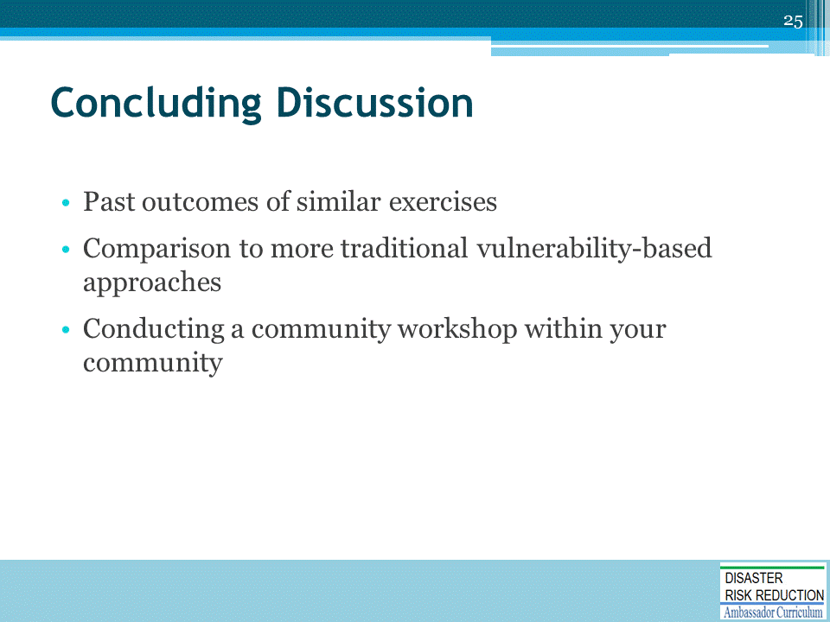
After the exercise the instructor will lead a discussion about the process and how it offers an alternative to a more traditional hazard/ exposure/ vulnerability approach.

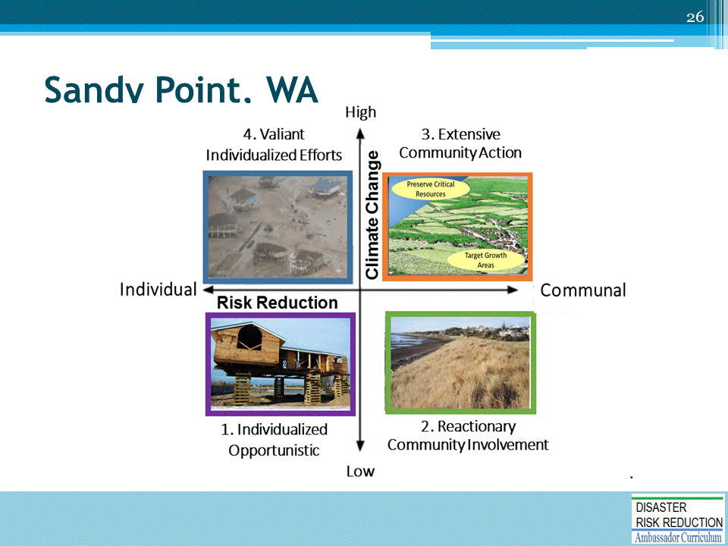
- This is an example of how team results may be illustrated.
- In this example prepared for FEMA and concerning Sandy Point Washington, the hazard or extrinsic driver was sea level rise and the intrinsic drier was whether the community took a more individualistic or communal approach.
- Note the extrinsic Sea Level Risk trajectory is in one direction and the intrinsic driver can be in two directories.
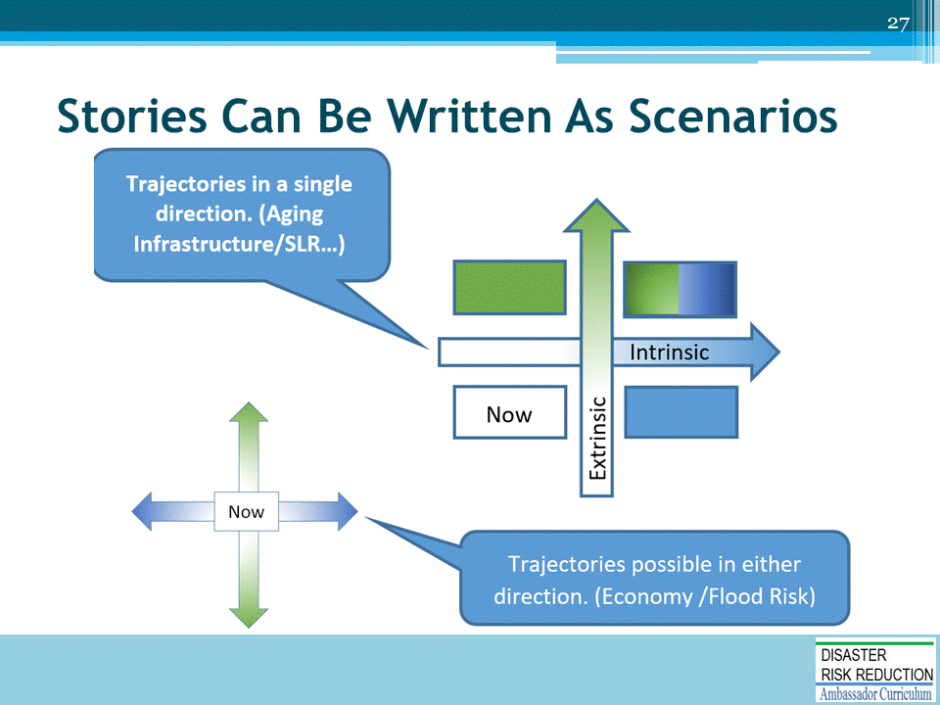
The instructor, or by participants if there is sufficient time, could redraft team conclusions as four or more stories. The intrinsic trajectories can be in one or two directions.

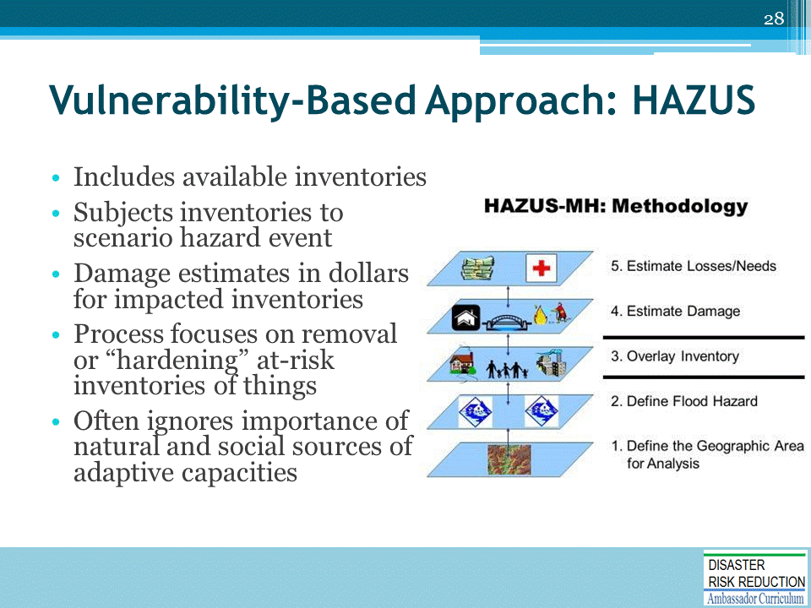
Conventional hazard mitigation and disaster planning processes typically begin with hazard scenarios driven by a probable event and including a vulnerability analyses that is centered on the built environment.
- Accordingly users conclude with preparations for and responses to disruptive events that emphasize elements driving the vulnerability analysis and scenario.
- Typically these include the “hardening” of built-environmental assets or their removal outside threatened areas altogether, often ignoring or understating the importance of natural and social sources of adaptive capacity.
- “Building back better” is typically interpreted as just “building,” and large gaps exist between hazard mitigation plans and general land-use and comprehensive plan.

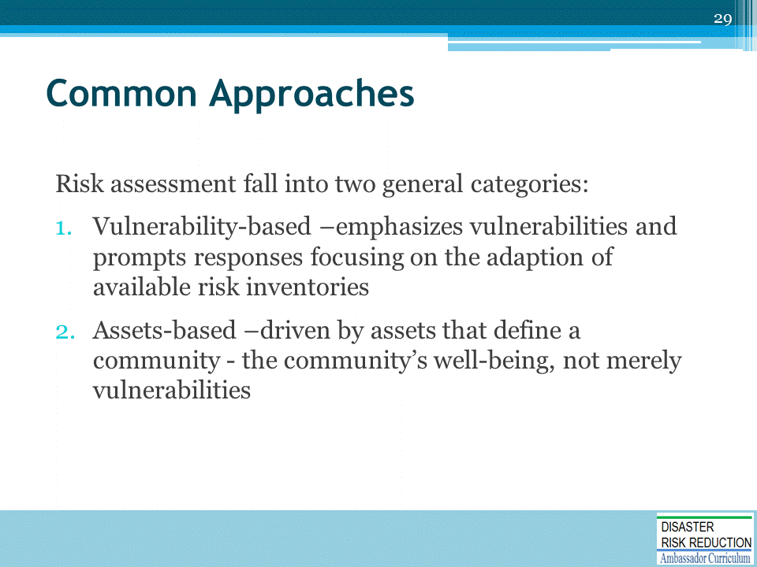
The take-away here is that an asset-based risk assessment approach does not replace the more traditional vulnerability-based one, but adds to it and strengthens it.

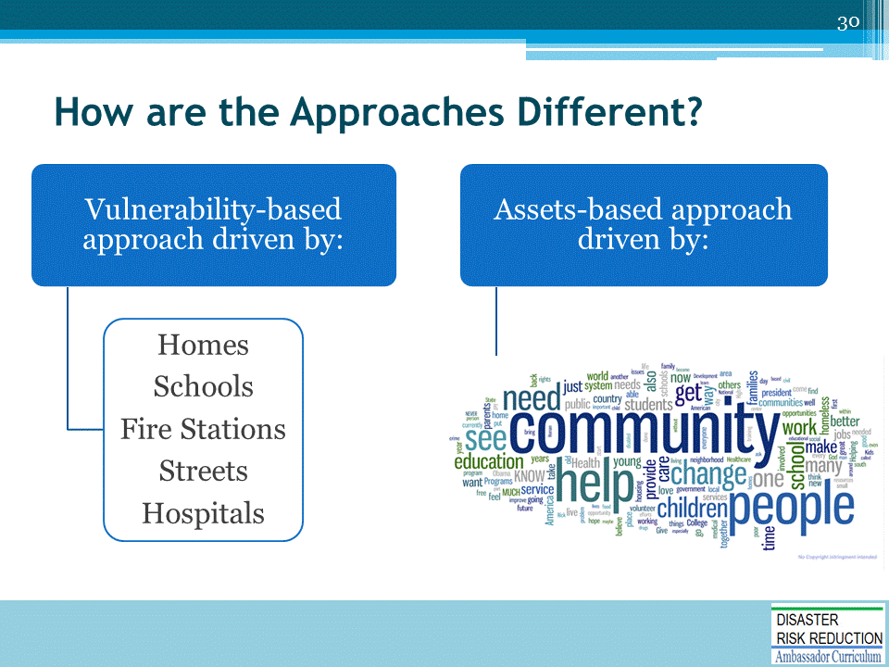
Asset-based risk assessment begins with an understanding of what defines the community

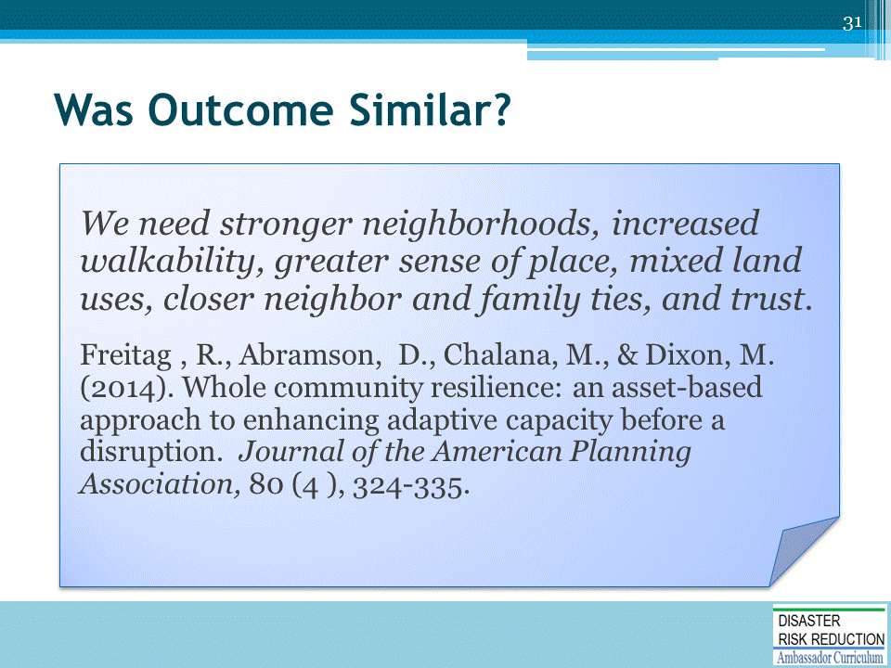
- These were the conclusions of a recent series of community tabletop exercises held in the Washington State Cities of Redmond, Everett and Neah Bay.
- The take way here was that the conclusions reflected more traditional planning “Smart Growth” objectives than those that normally result from a risk oriented exercise.
- What usually results for emergency exercises are recommendations for hardening, retrofitting, warning, evacuation…
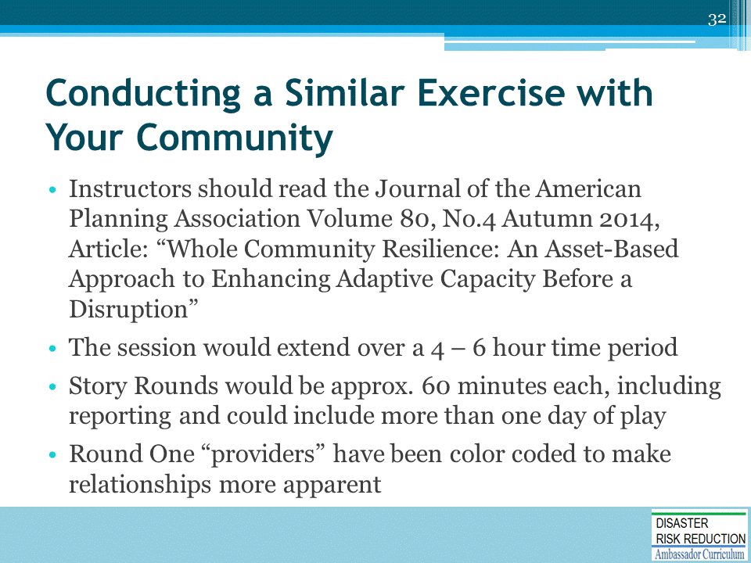
4 – 6 hours should be allowed, when conducted in a community.

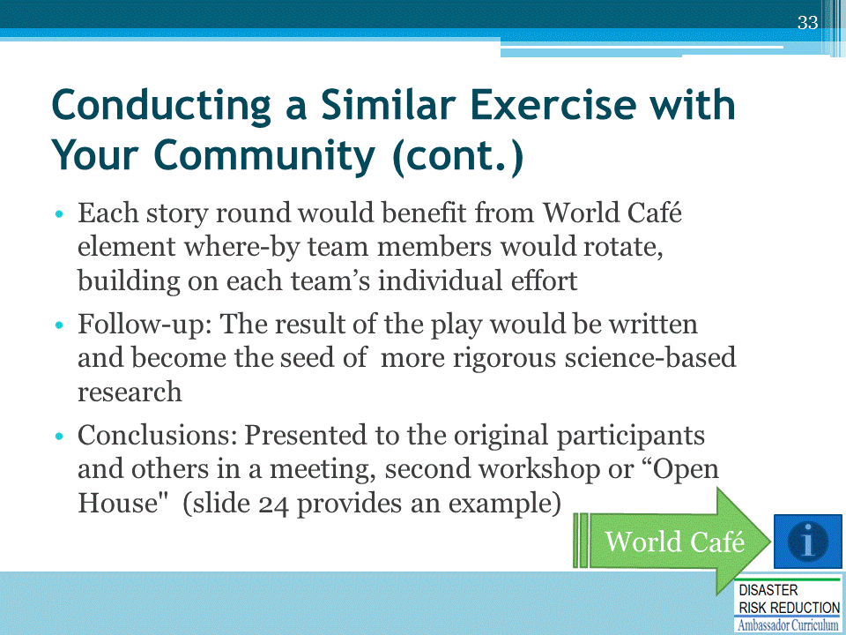

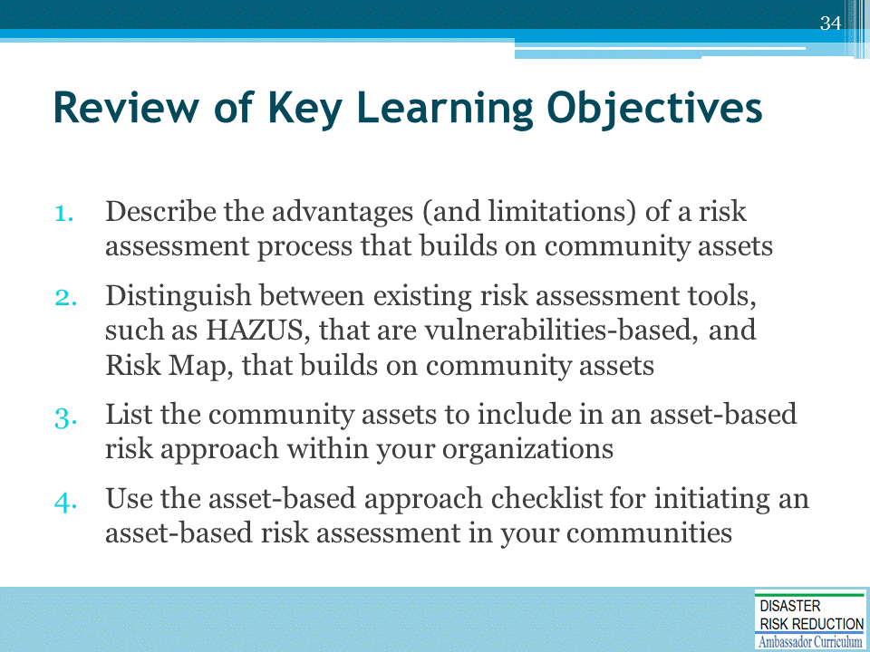
Discussion to engage participants and to assist achievement of Learning Objectives.

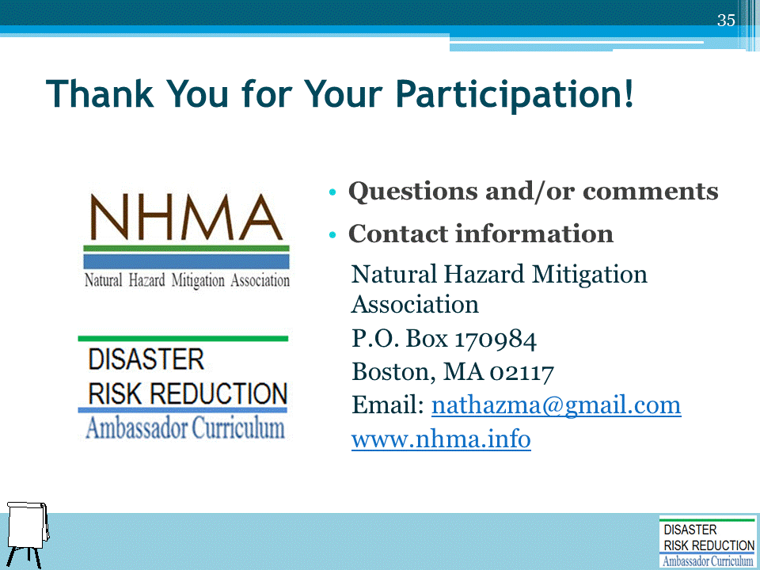
Record on easel pad any recommendations or questions to be addressed outside of the presentation.

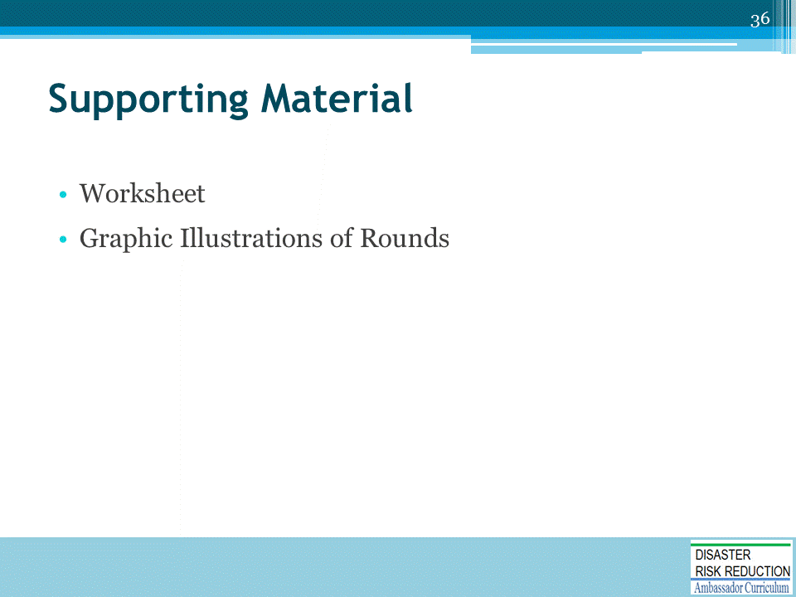

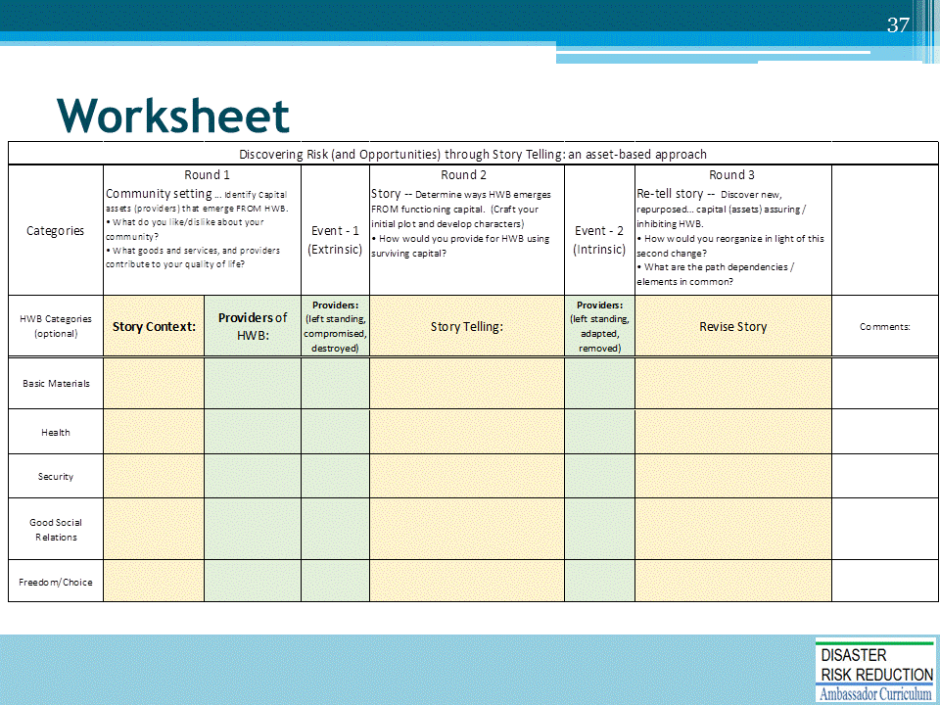
This is the worksheet to print and distribute to the student teams.
One oversized (small poster) will work for each team.

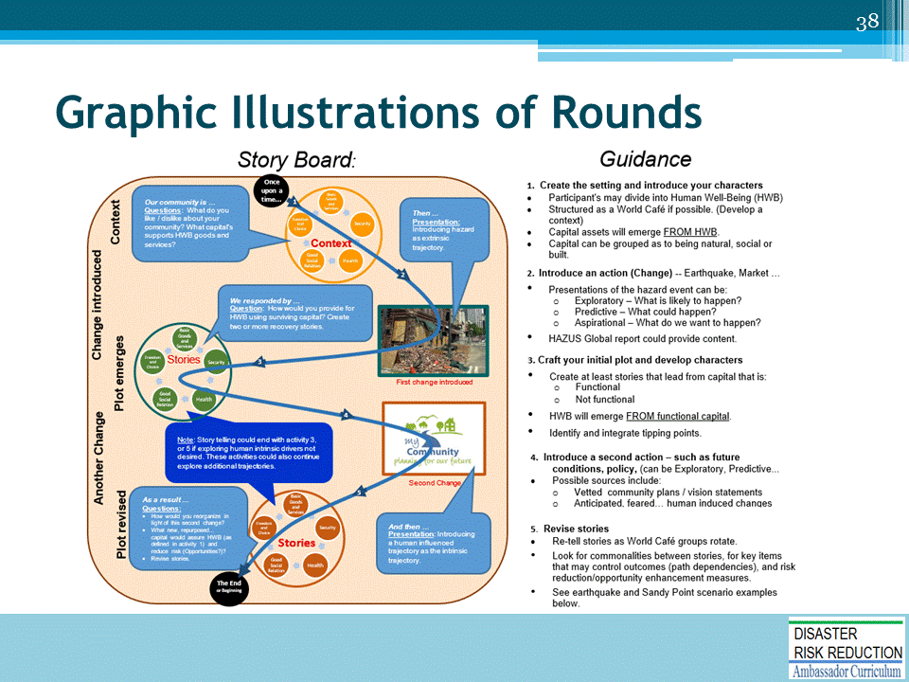
Mention that the larger circles illustrate rounds of play – orange for round 1, green round 2, and brown for round 3.
The smaller circles within the larger circles represent table groups divided into human well-being categories.
Do not discuss the guidance column. This will discussed shortly.

DRR AMBASSADOR CURRICULUM AT-A-GLANCE
I. Disaster Risk Reduction for a Safe and Prosperous Future
1 | Introduction to the Natural Hazard Mitigation Association and Disaster Risk Reduction Ambassador Curriculum
2 | Introduction to Disaster Risk Reduction as a Foundation of Community Resilience
3 | Leadership for Disaster Risk Reduction
4 | Community Disaster Risk Reduction and Adaptation
5 | Approaching the Challenge of Disaster Risk Reduction: NIST Community Resilience Guide
II. Forming a Community’s Vision for Disaster Risk Reduction
6 | Risk Assessment through Storytelling: An Asset-Based Approach
7 | Achieving Community Buy-in for Disaster Risk Reduction: Win-Win Approaches
8 | Leveraging Resources to Improve Disaster Risk Reduction
III. Realizable, Practical, and Affordable Approaches for Moving from a Vision for Disaster Risk Reduction to a Strategy
9 | Selecting and Implementing a Strategy for Addressing Community Disaster Risk Problems
10 | Integrating Hazard Mitigation into Local Planning
11 | Beyond Codes and Low-Impact Development
12 | Creating the Plan: A Sustainable Floodplain Management Process Model
IV. Resources and Tools for Implementing a Community’s Disaster Risk Reduction Strategy
13 | Climate and Weather Tools and Trends
14 | Risk Assessment Basics
15 | Legal and Policy Opportunities for Disaster Risk Reduction
16 | Linking Catastrophe Insurance to Disaster Risk Reduction
V. Resources for Hazard-Specific Disaster Risk Reduction
17 | Living with Water: Inland and Coastal Flooding
18 | Design for Flood Resilience: Part I: Floodplain Management and Flood Resistant Design
19 | Design for Flood Resilience: Part II: Green Infrastructure / Low Impact Development
20 | Overcoming Impediments to Flood Resilience: Paths Forward
21 | Wildfire Mitigation
22 | The Wildfire-Flood Connection
23 | Severe Thunderstorm/ Tornado Safe Rooms
24 | From Policy to Engineering: Earthquake Risks

