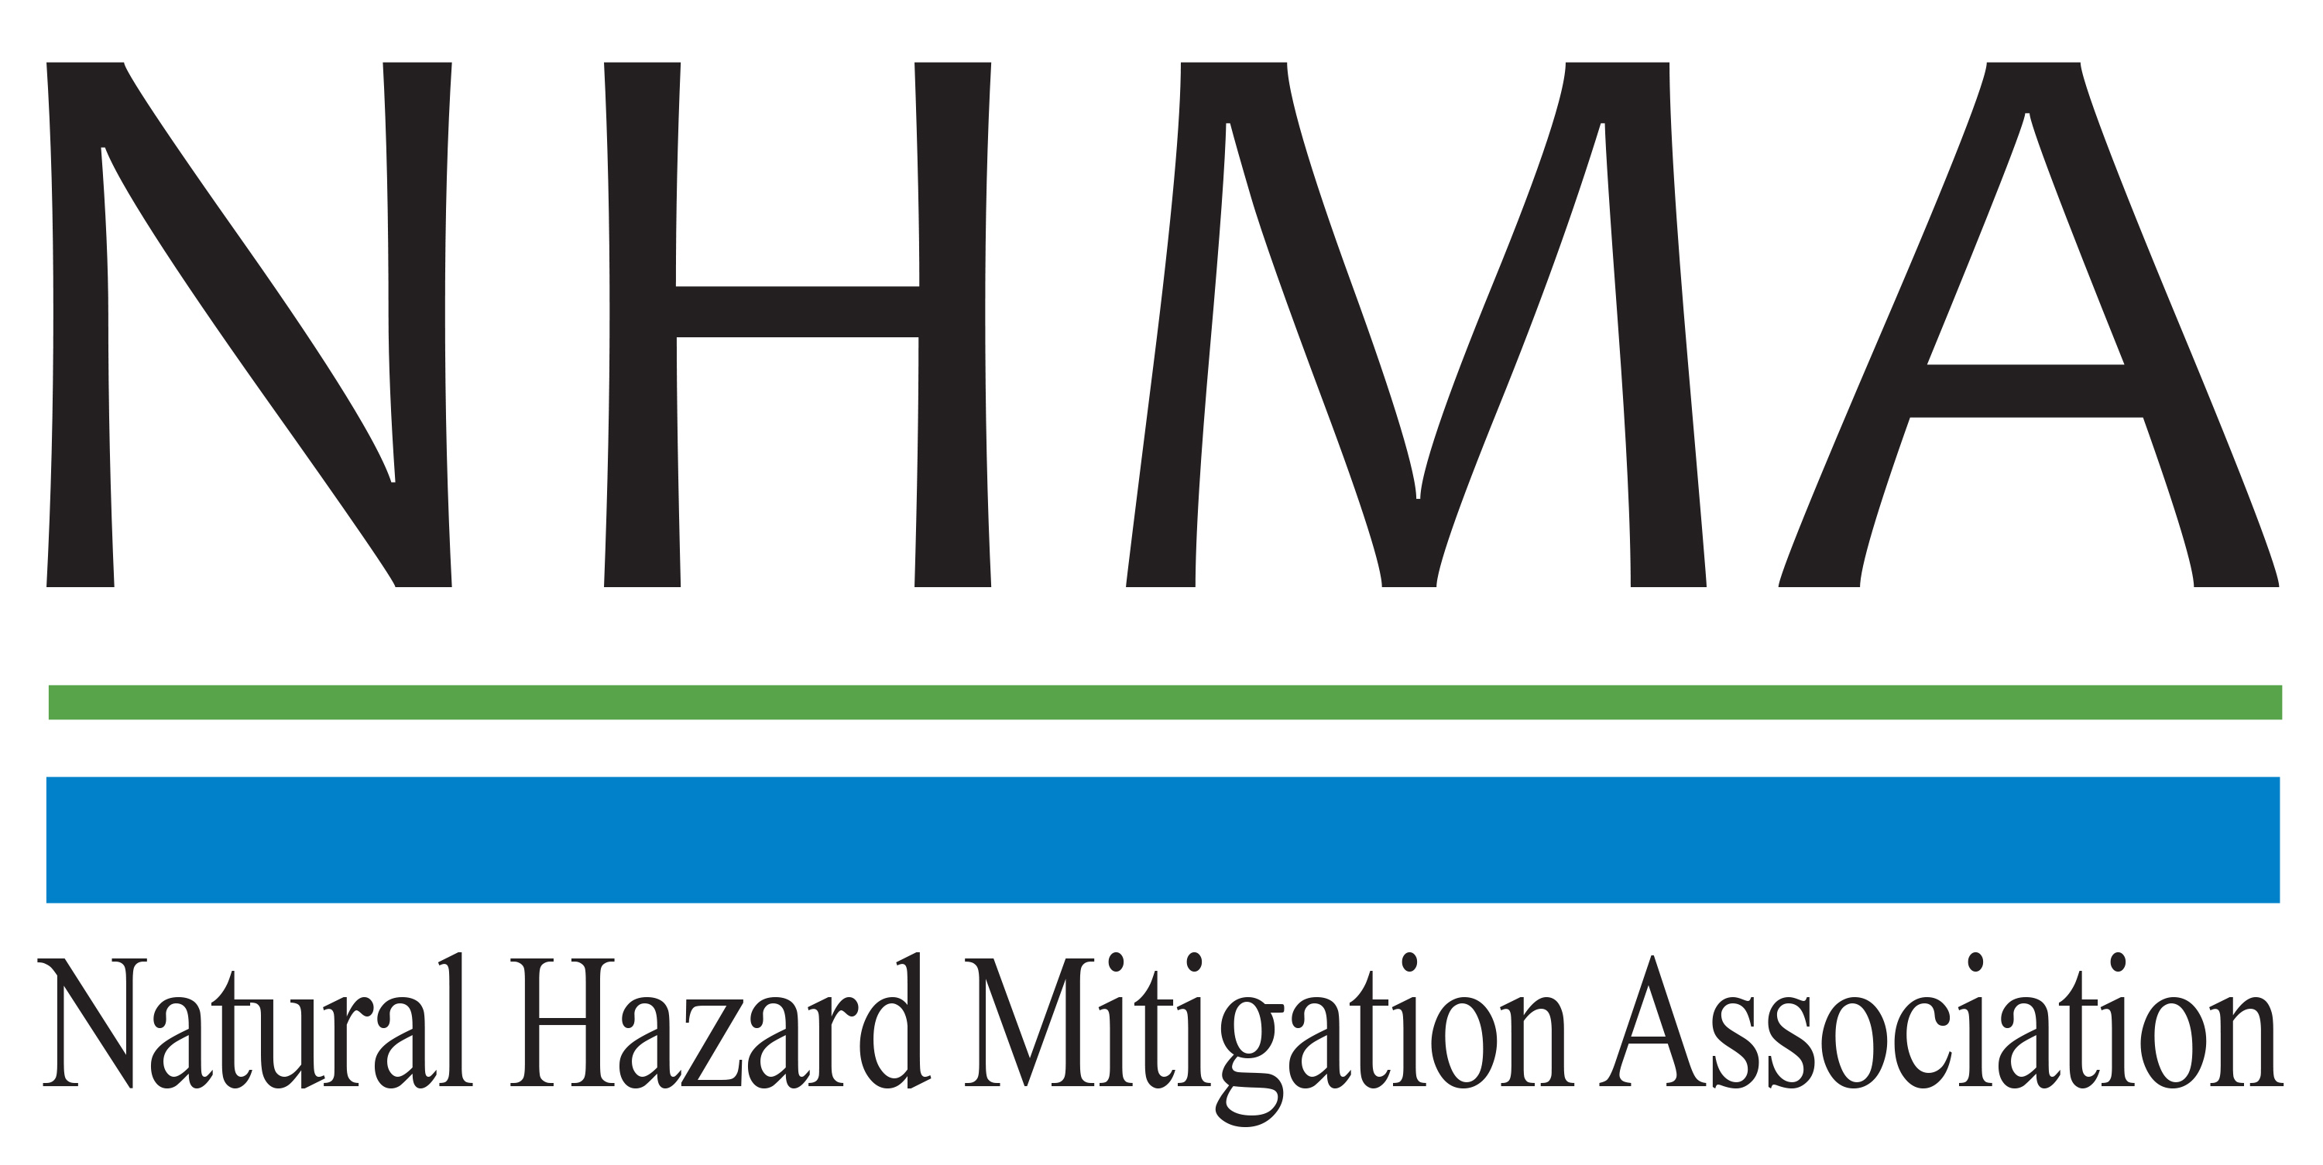

Disaster Risk Reduction (DRR) Ambassador Curriculum

Participant Guide

Module 6:

Risk Assessment through Storytelling:

An Asset-Based Approach

THE DRR AMBASSADOR CURRICULUM
The goal of the DRR Ambassador Curriculum is to facilitate DRR efforts for the whole community by:
- Engaging in discussion of how disasters can be reduced through local action
- Sharing insights among local leaders and technical experts to enable the development of cross functional solutions
- Acquiring the best-available information, knowledge of best practices, and analytic tools to enable better-informed decisions before, during, and after disasters
There are 24-modules in the curriculum. The “DRR Ambassador Curriculum At-a-Glance” table, located at the end of this document, lists the modules of the Curriculum.
DRR-A CURRICULUM TARGET AUDIENCE
The target audience includes those involved in community development decision-making, such as local community staff, volunteer and stakeholder groups, and federal and state officials.
METHODS OF DELIVERY
There are three delivery methods by which you may be able to complete modules in the DRR-A Curriculum: via webinars hosted by NHMA or partner organizations; presented in conferences and/or classrooms by qualified DRR-A Curriculum instructor(s); or downloadable for individual study from the NHMA website. Watch the NHMA website for announcements about webinars and workshops that include the module(s) in which you are interested.
CERTIFICATES
- Certificates of Completion may be awarded by NHMA to participants who successfully complete NHMA-sponsored DRR Ambassador modules by attending and passing a short post-test.
- Certificates of Attendance may be awarded to participants who attend but choose not to take the post-test may be issued a Certificate of Attendance.
- A Disaster Risk Reduction Ambassador Certificate will be awarded to individuals who successfully complete all 24 modules.
Ask your certifying boards about acceptance of NHMA DRR-A certificates for continuing education credits.
MODULE 6 – Risk Assessment through Storytelling: An Asset-Based Approach
The Learning Objectives for this module are:
- Describe the advantages (and limitations) of a risk assessment process that builds on community assets
- Distinguish between existing risk assessment tools, such as HAZUS, that are vulnerabilities-based, and Risk Map, that builds on community assets
- List the community assets to include in an asset-based risk approach within your organizations
- Use the asset-based approach checklist for initiating an asset-based risk assessment in your communities
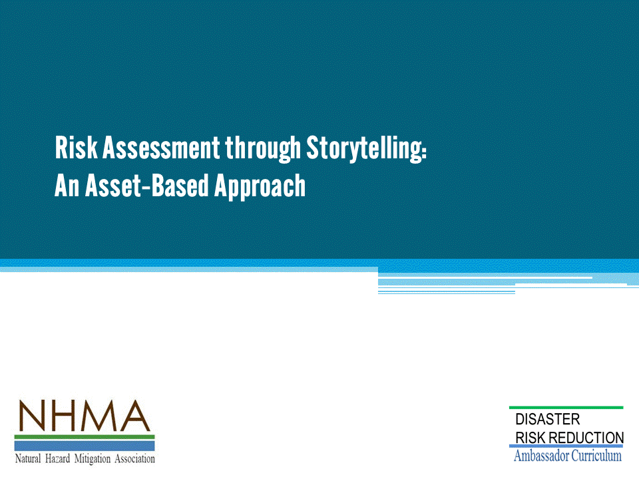

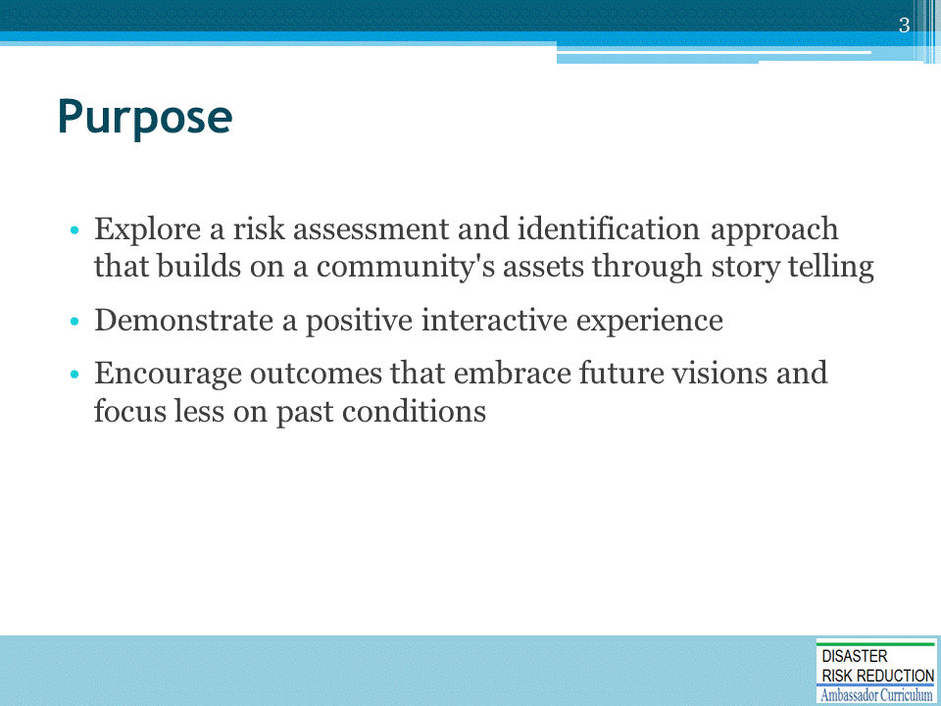

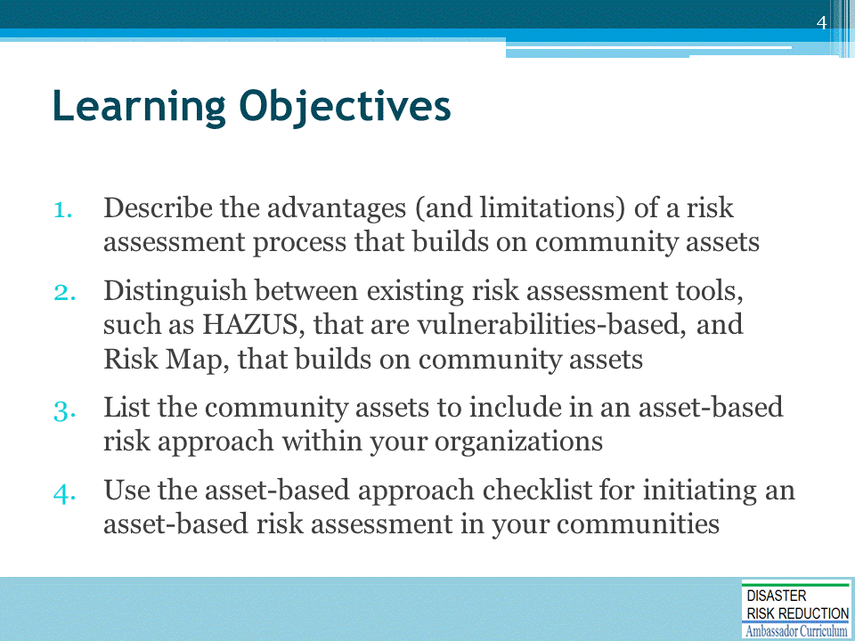

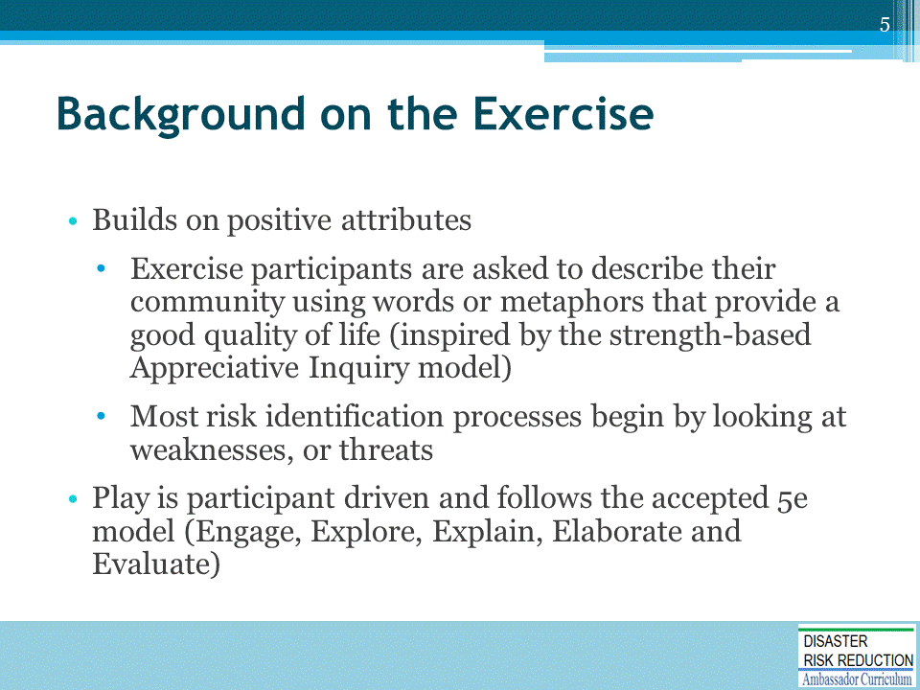

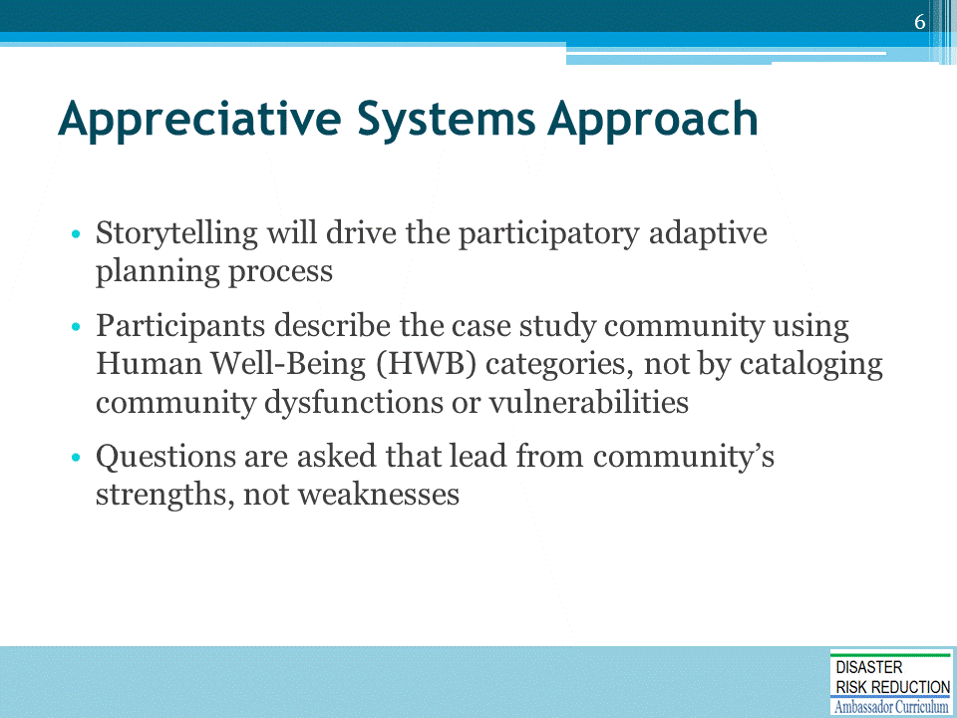

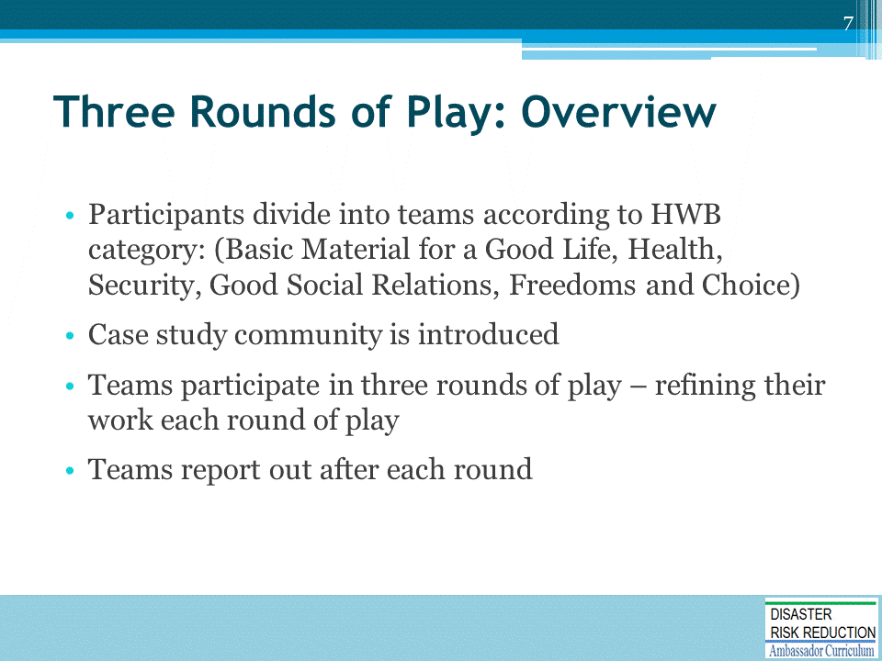

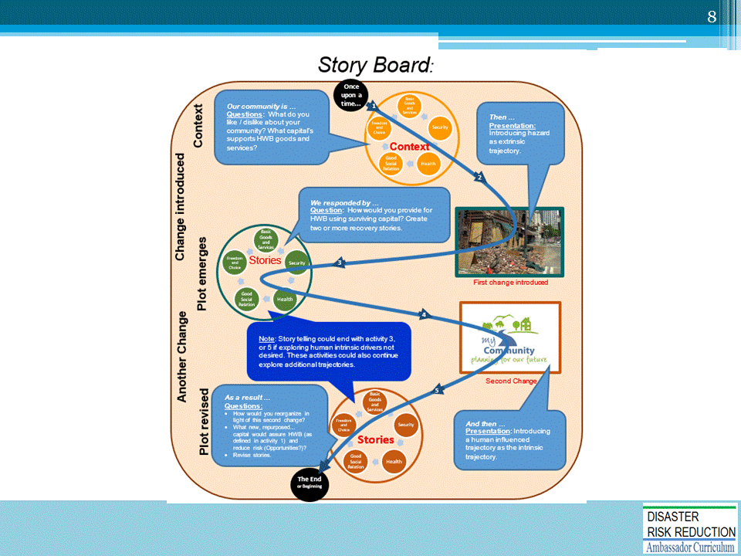

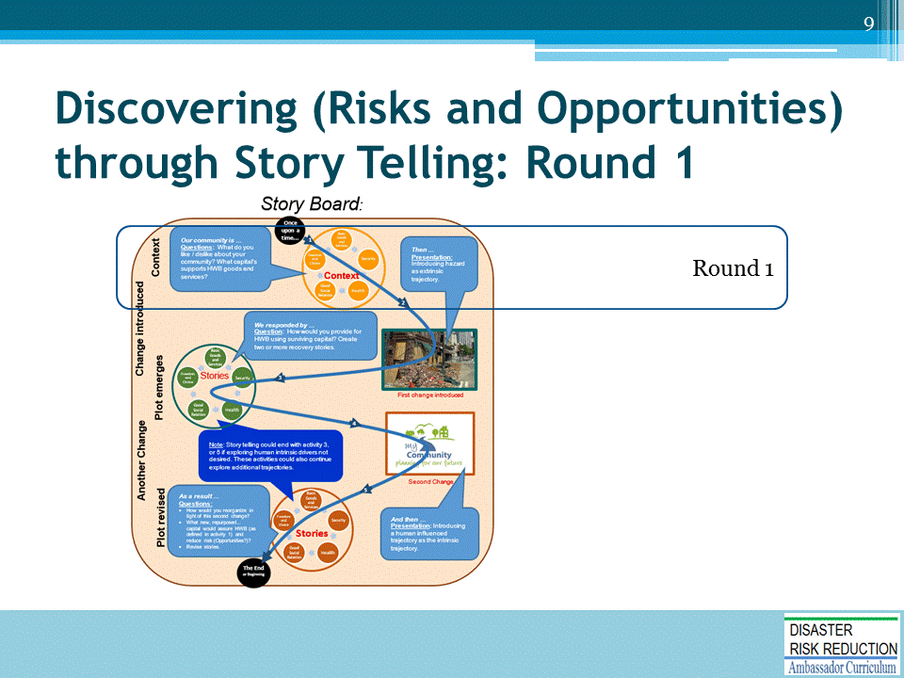

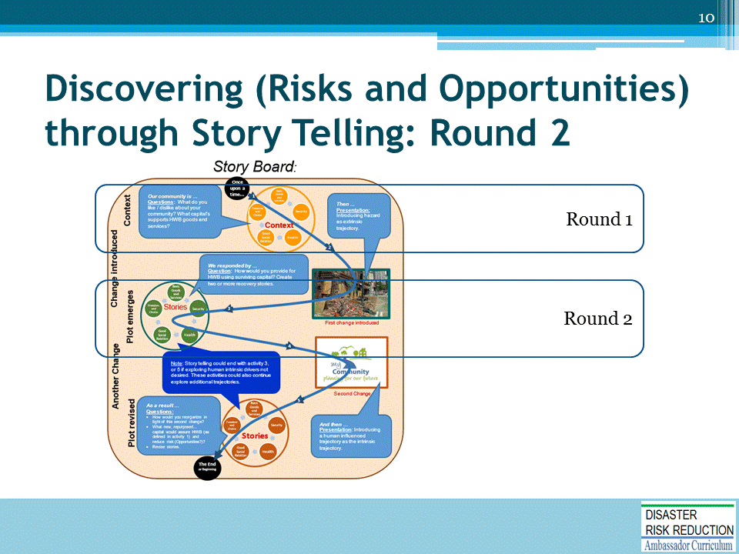

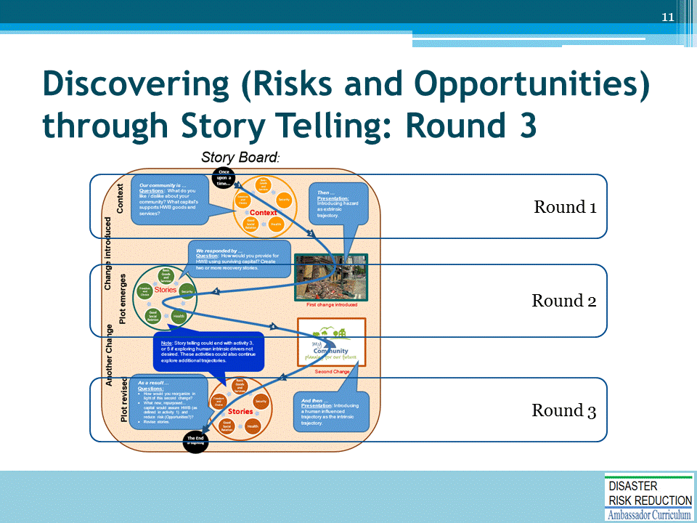

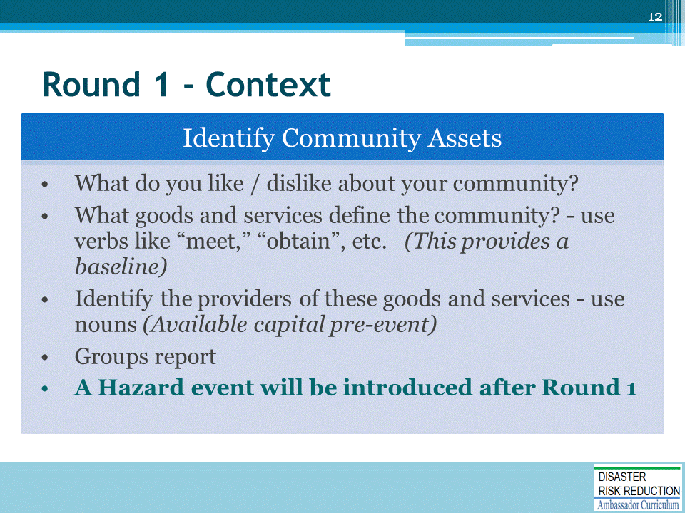

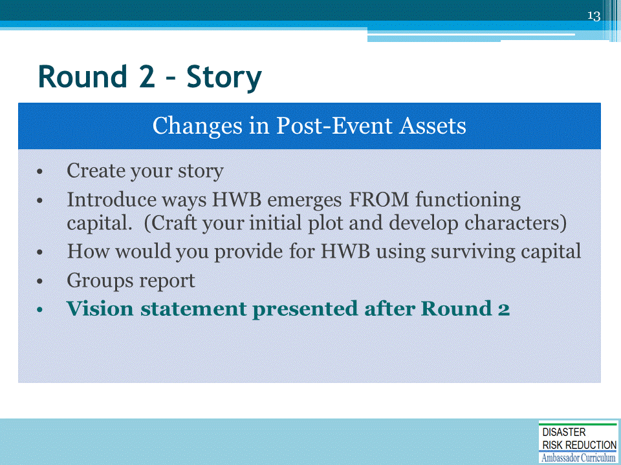

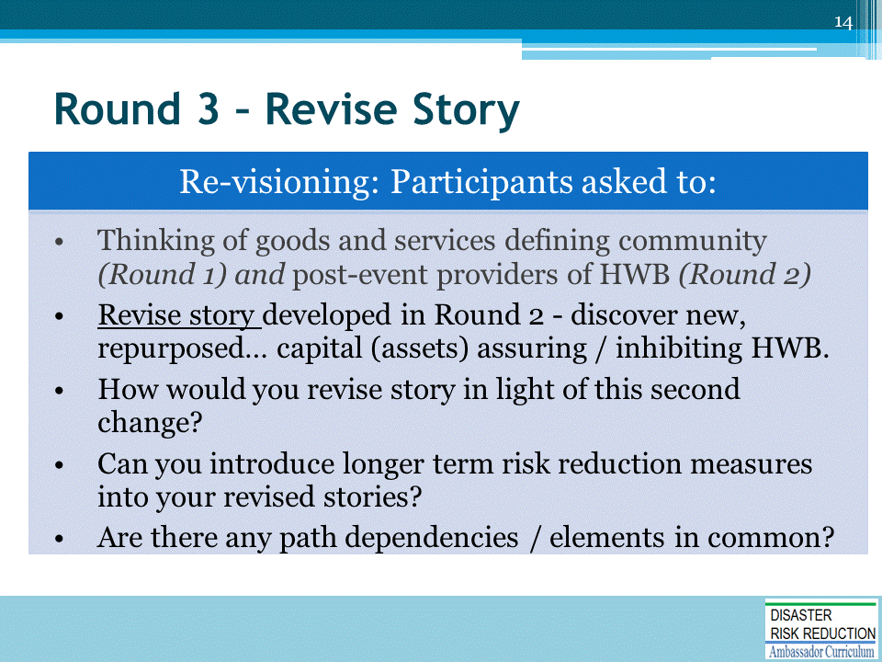

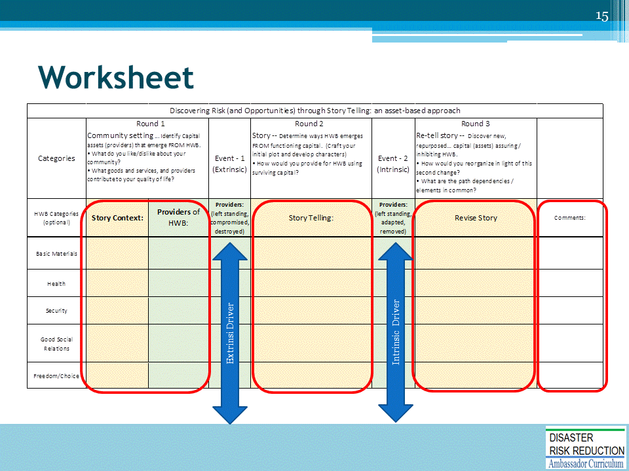

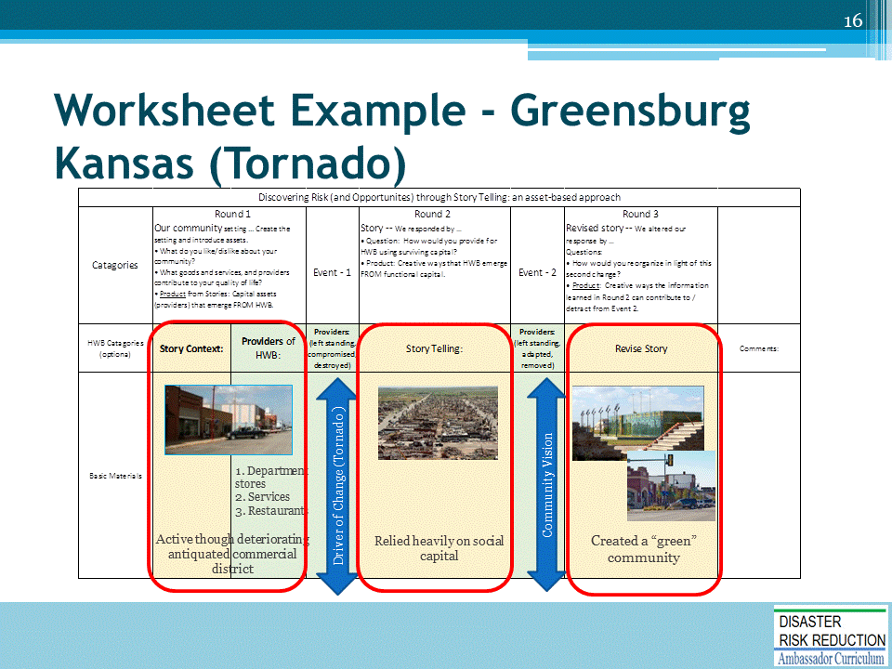
For more information, visit “Greensburg GreenTown” at https://www.greensburgks.org/
Long-Term Community Recovery Plan for Kiowa County and Greensburg. Available at www.greensburgks.org/residents/recovery-planning/long-term-community-recovery-plan .
Greensburg Sustainable Comprehensive Master Plan Available at www.greensburgks.org/residents/recovery-planning/sustainable-comprehensive-master-plan/view.
Watch Greensburg’s recovery process, "Greensburg, Kansas: Thriving in the Wake of Disaster,” on the Mother Nature Network at http://planetgreen.discovery.com/tv/greensburg/.
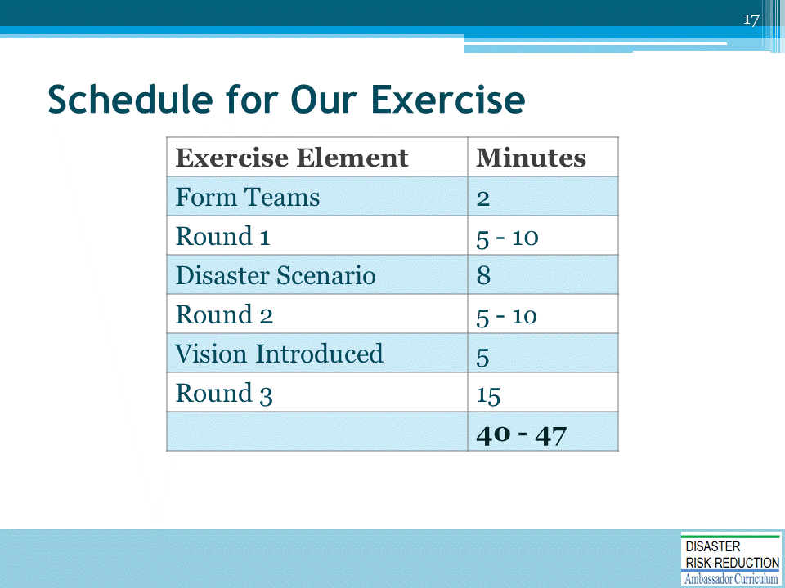

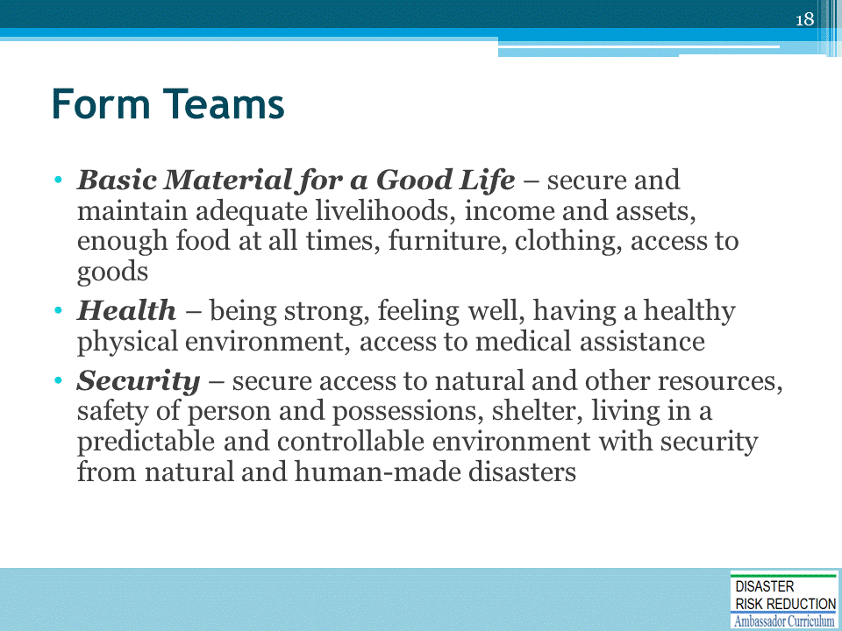

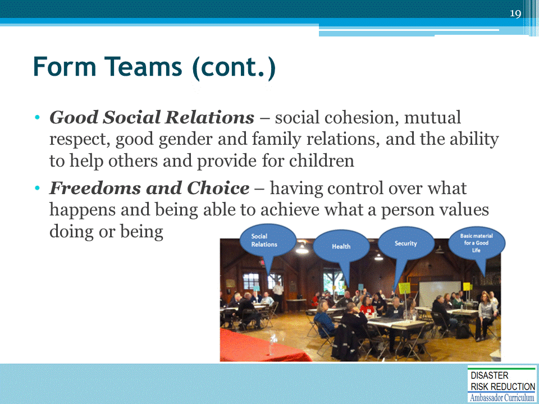

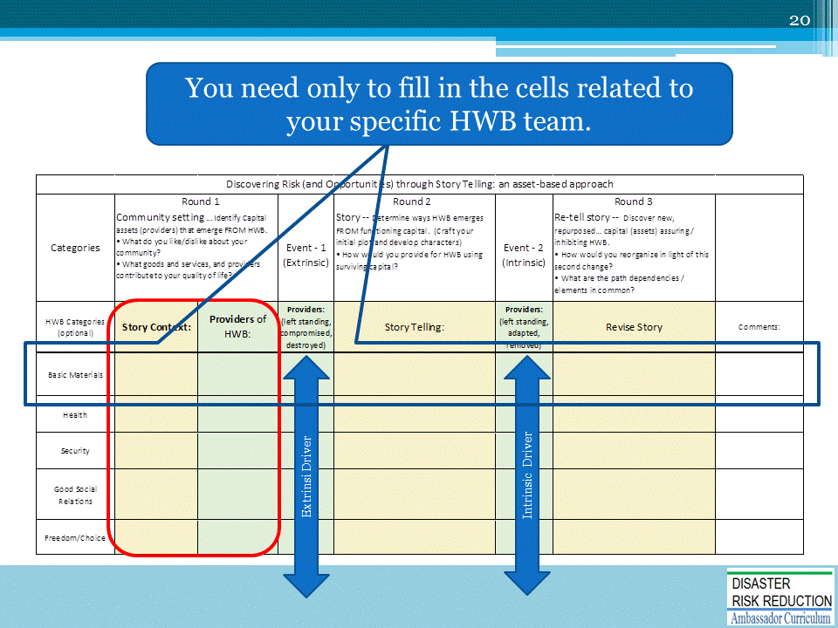

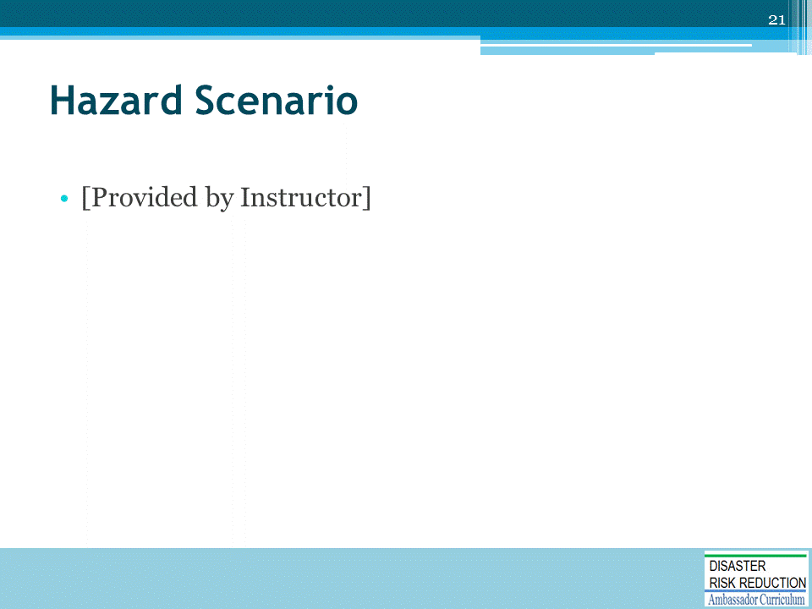

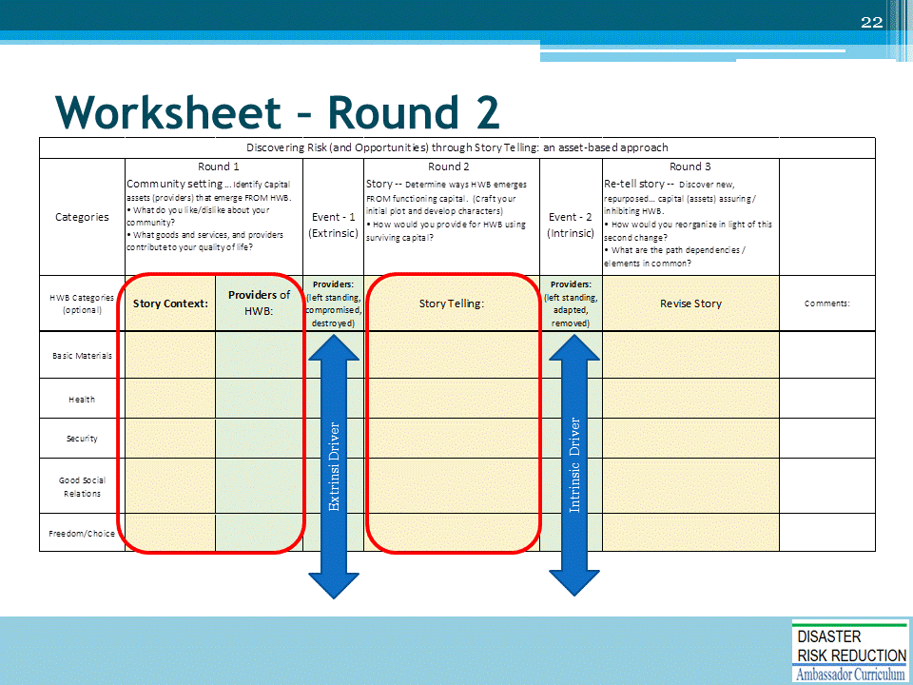

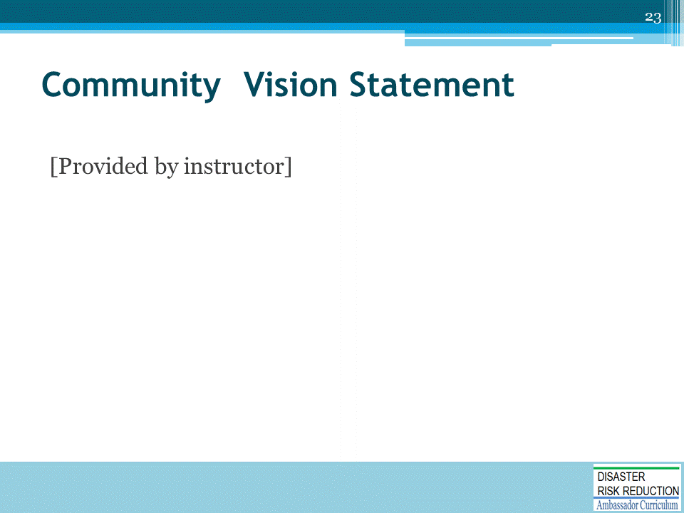

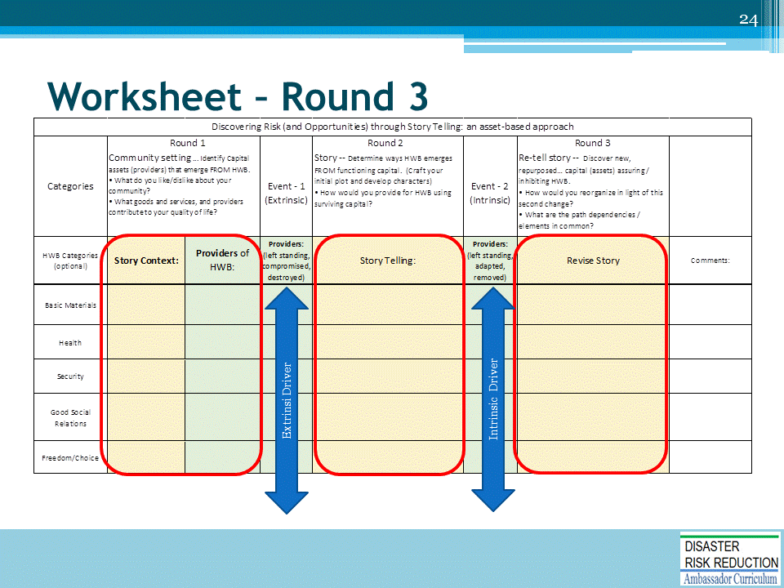

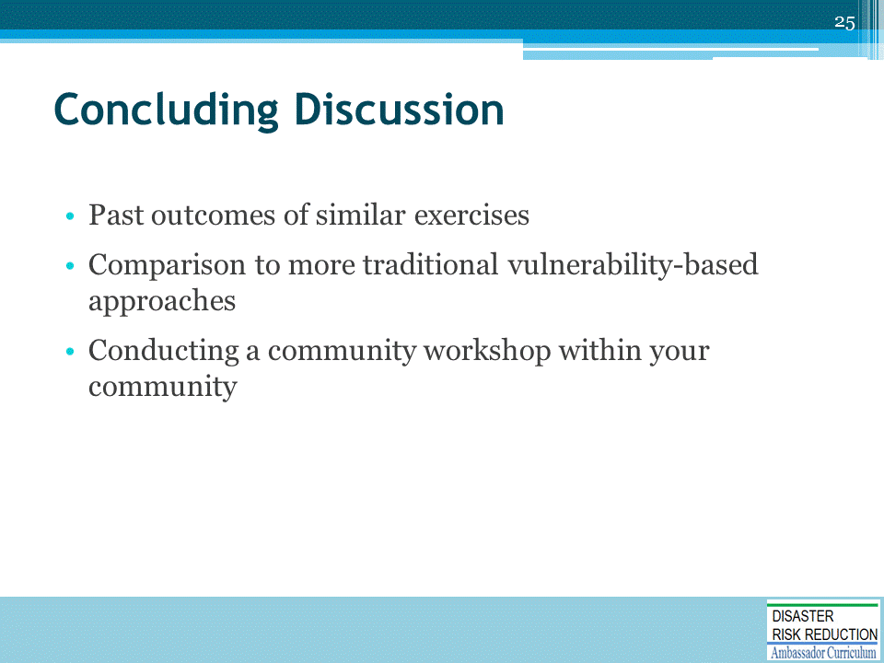

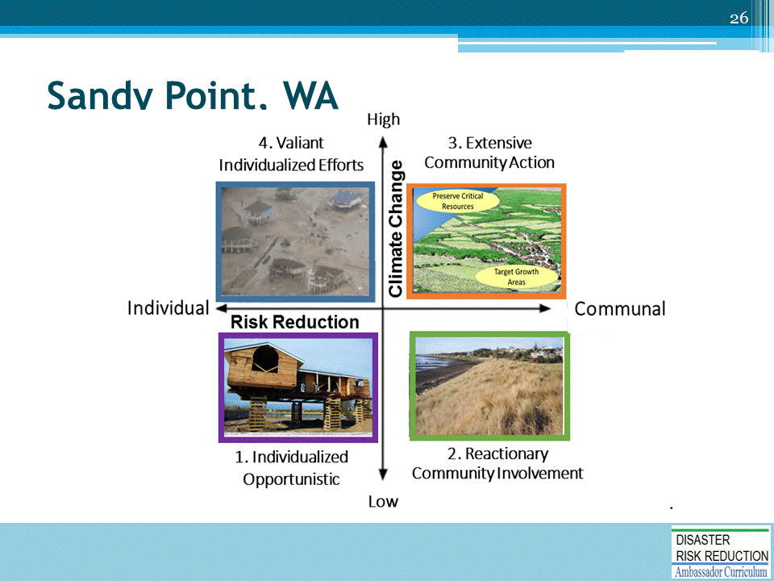
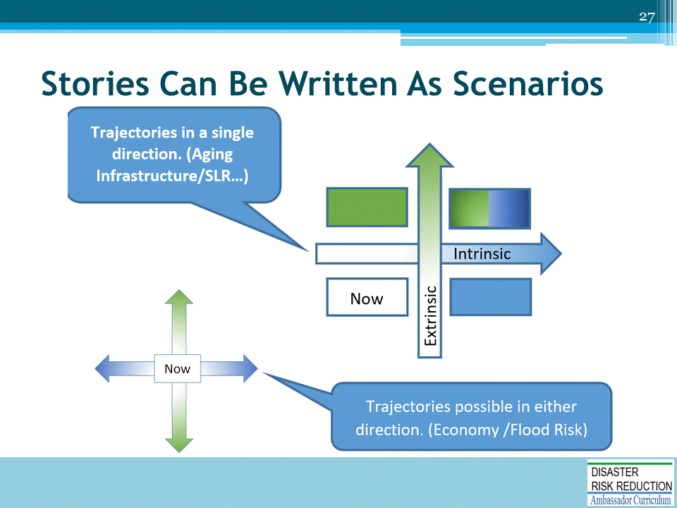

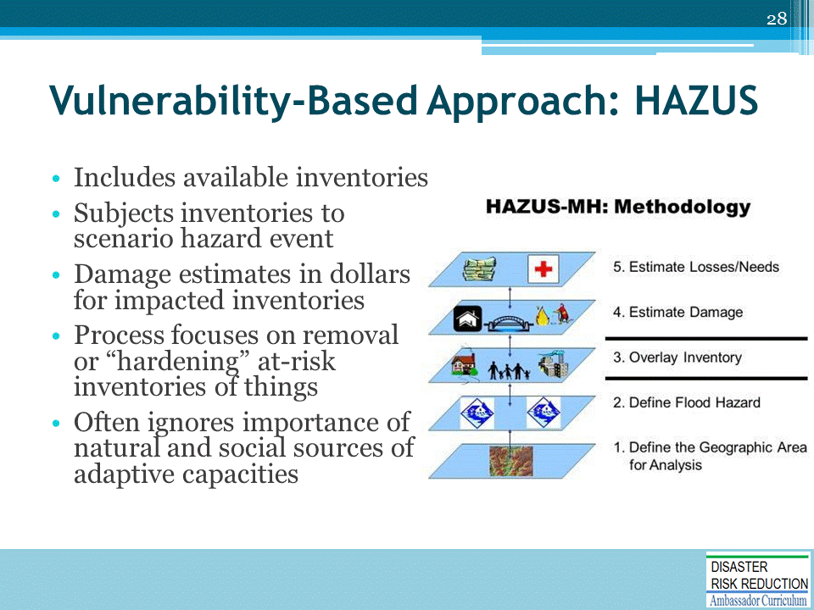

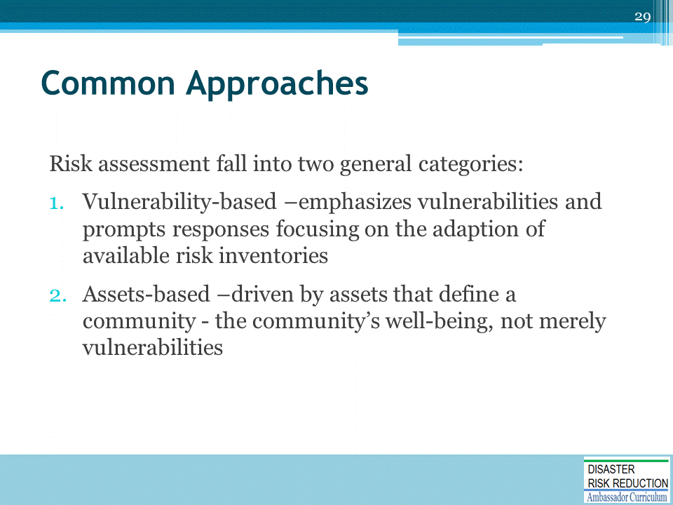

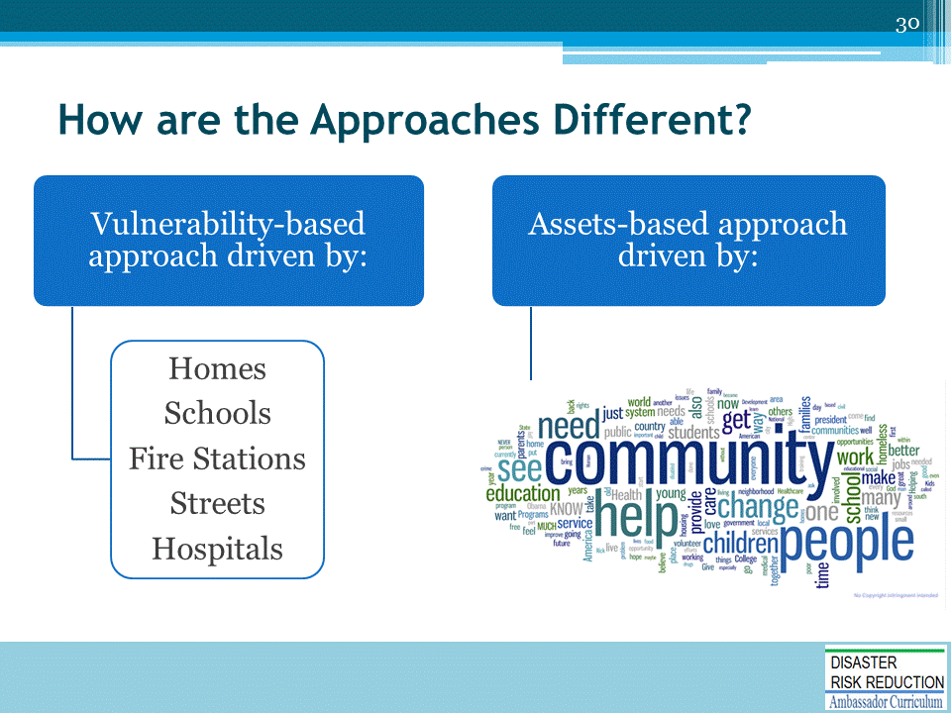

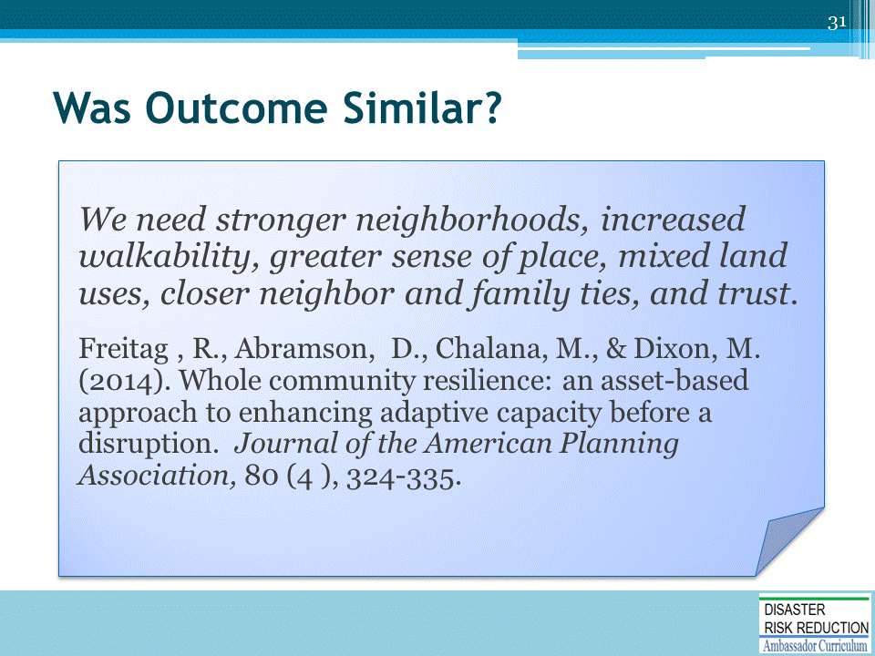

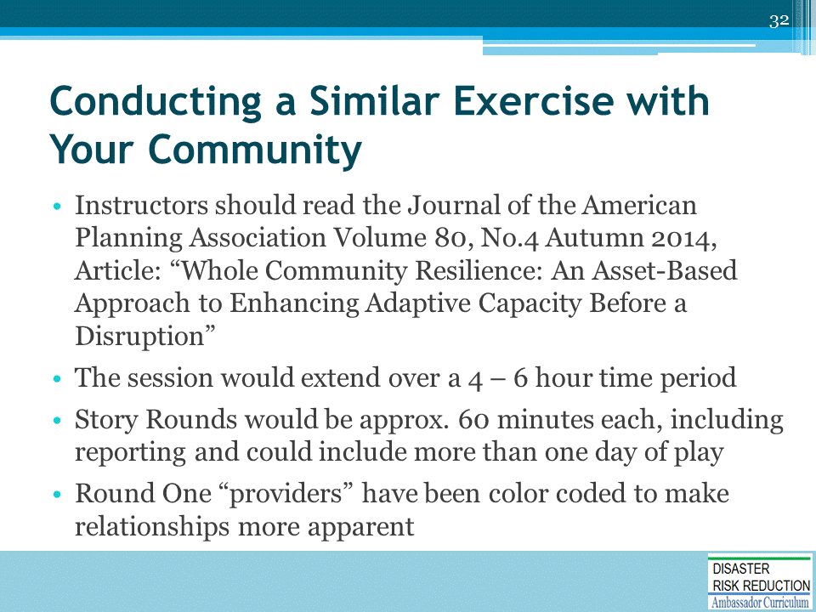

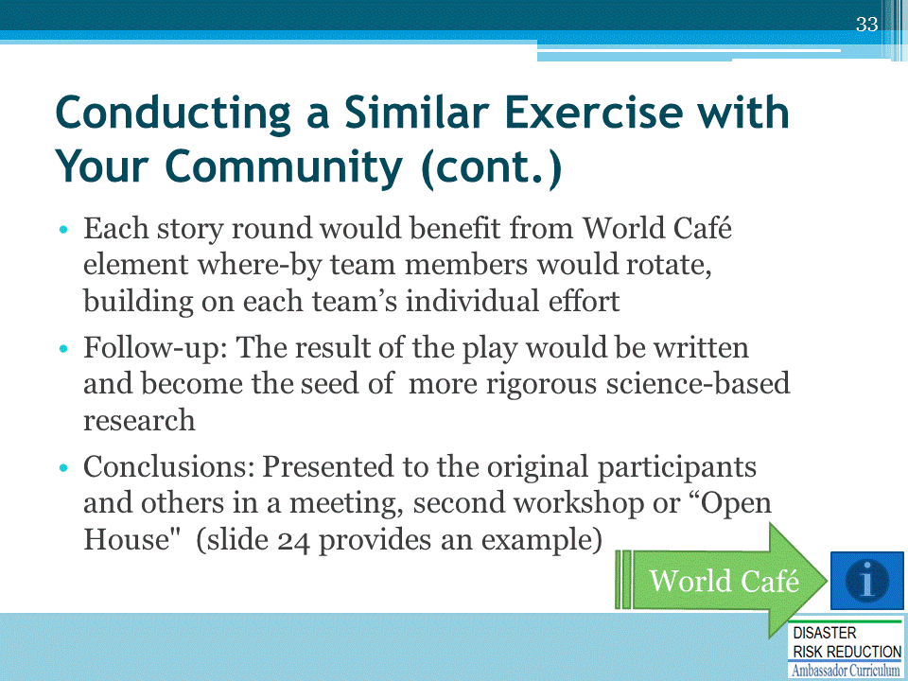
http://www.theworldcafe.com/

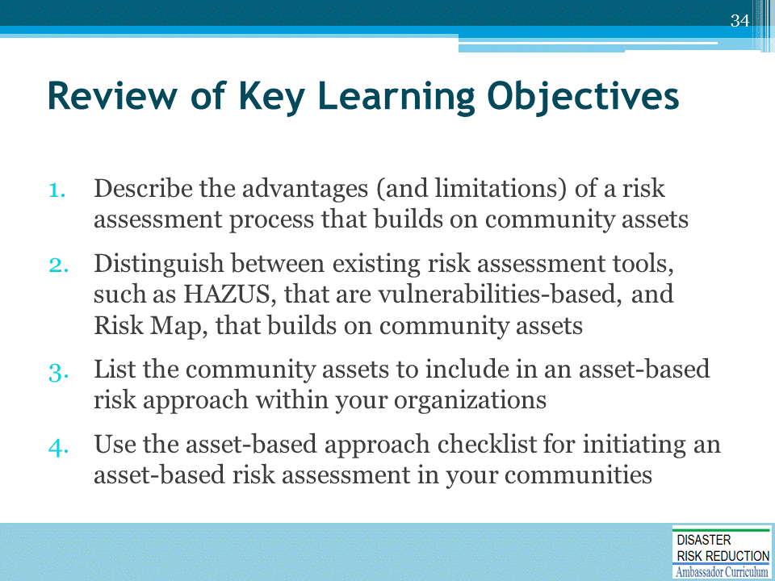

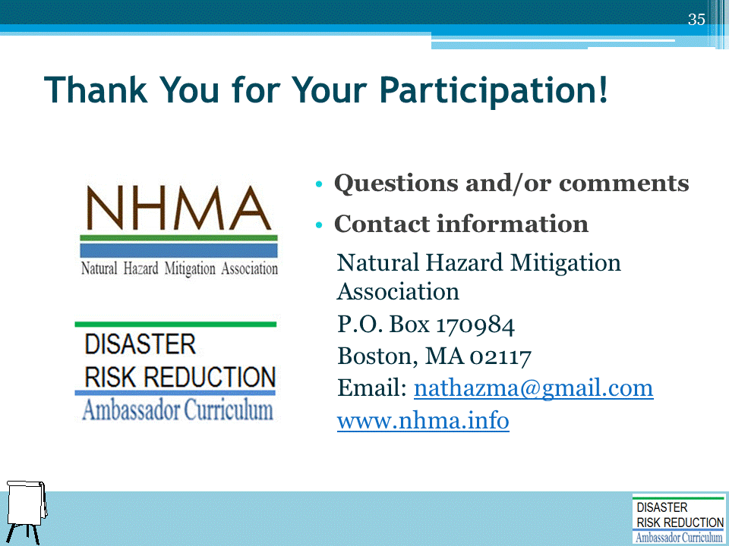

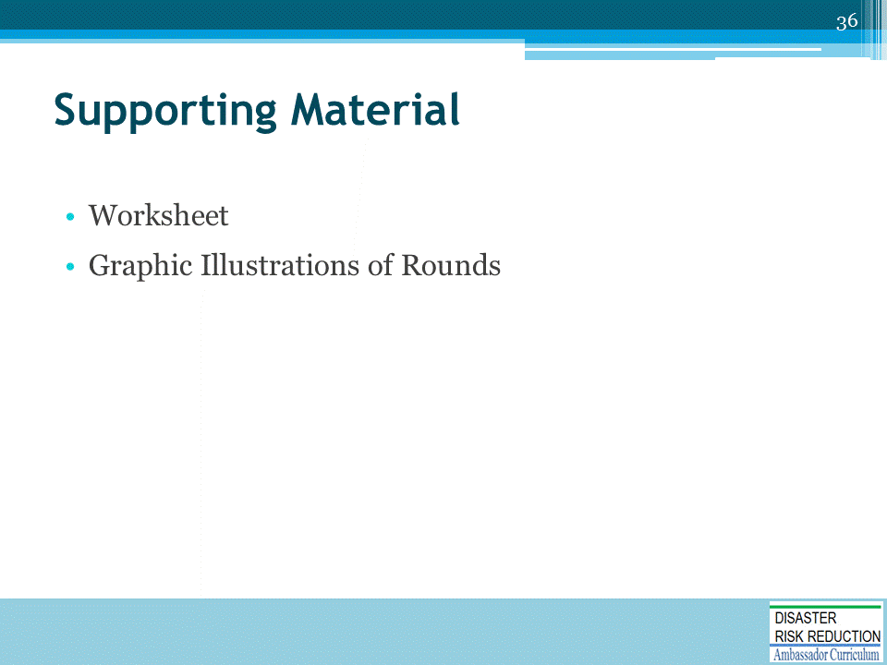

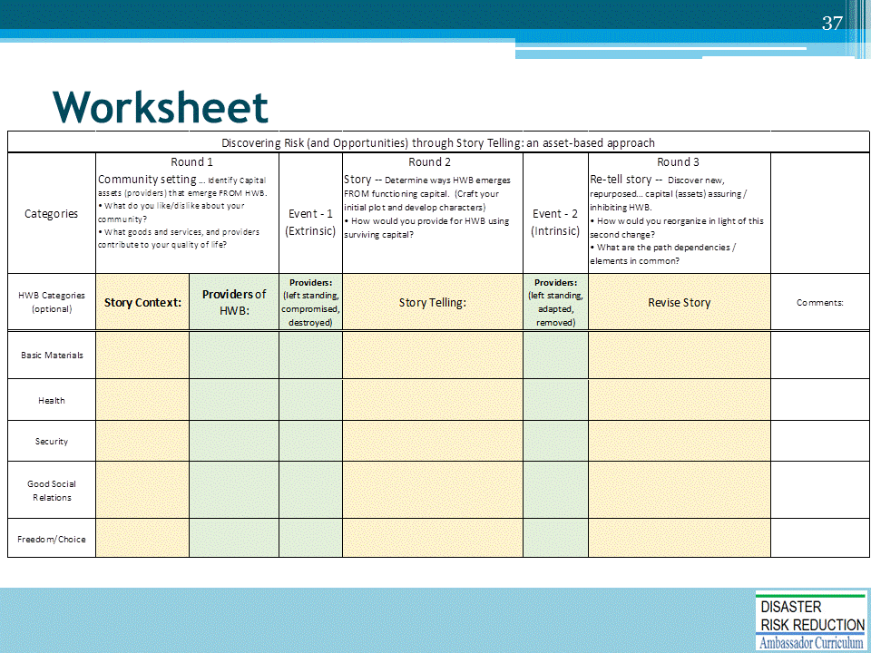

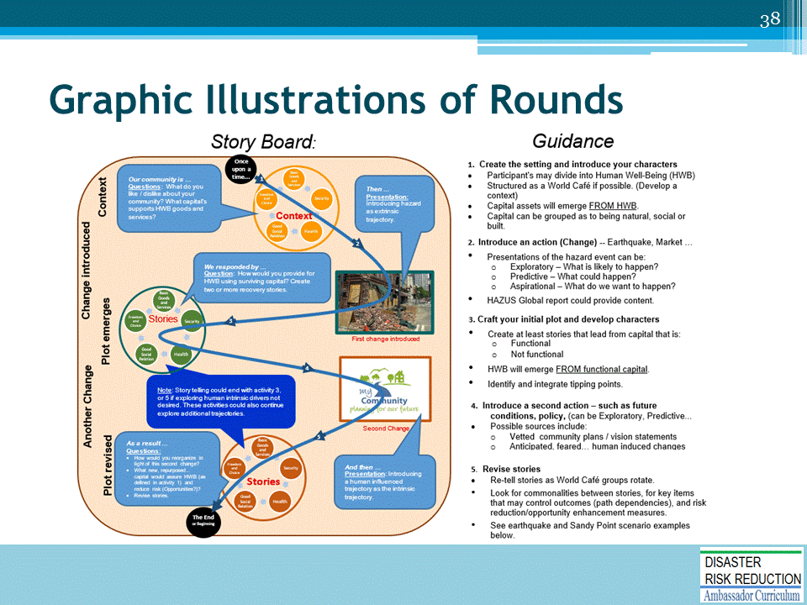

DRR AMBASSADOR CURRICULUM AT-A-GLANCE
I. Disaster Risk Reduction for a Safe and Prosperous Future
1 | Introduction to the Natural Hazard Mitigation Association and Disaster Risk Reduction Ambassador Curriculum
2 | Introduction to Disaster Risk Reduction as a Foundation of Community Resilience
3 | Leadership for Disaster Risk Reduction
4 | Community Disaster Risk Reduction and Adaptation
5 | Approaching the Challenge of Disaster Risk Reduction: NIST Community Resilience Guide
II. Forming a Community’s Vision for Disaster Risk Reduction
6 | Risk Assessment through Storytelling: An Asset-Based Approach
7 | Achieving Community Buy-in for Disaster Risk Reduction: Win-Win Approaches
8 | Leveraging Resources to Improve Disaster Risk Reduction
III. Realizable, Practical, and Affordable Approaches for Moving from a Vision for Disaster Risk Reduction to a Strategy
9 | Selecting and Implementing a Strategy for Addressing Community Disaster Risk Problems
10 | Integrating Hazard Mitigation into Local Planning
11 | Beyond Codes and Low-Impact Development
12 | Creating the Plan: A Sustainable Floodplain Management Process Model
IV. Resources and Tools for Implementing a Community’s Disaster Risk Reduction Strategy
13 | Climate and Weather Tools and Trends
14 | Risk Assessment Basics
15 | Legal and Policy Opportunities for Disaster Risk Reduction
16 | Linking Catastrophe Insurance to Disaster Risk Reduction
V. Resources for Hazard-Specific Disaster Risk Reduction
17 | Living with Water: Inland and Coastal Flooding
18 | Design for Flood Resilience: Part I: Floodplain Management and Flood Resistant Design
19 | Design for Flood Resilience: Part II: Green Infrastructure / Low Impact Development
20 | Overcoming Impediments to Flood Resilience: Paths Forward
21 | Wildfire Mitigation
22 | The Wildfire-Flood Connection
23 | Severe Thunderstorm/ Tornado Safe Rooms
24 | From Policy to Engineering: Earthquake Risks

