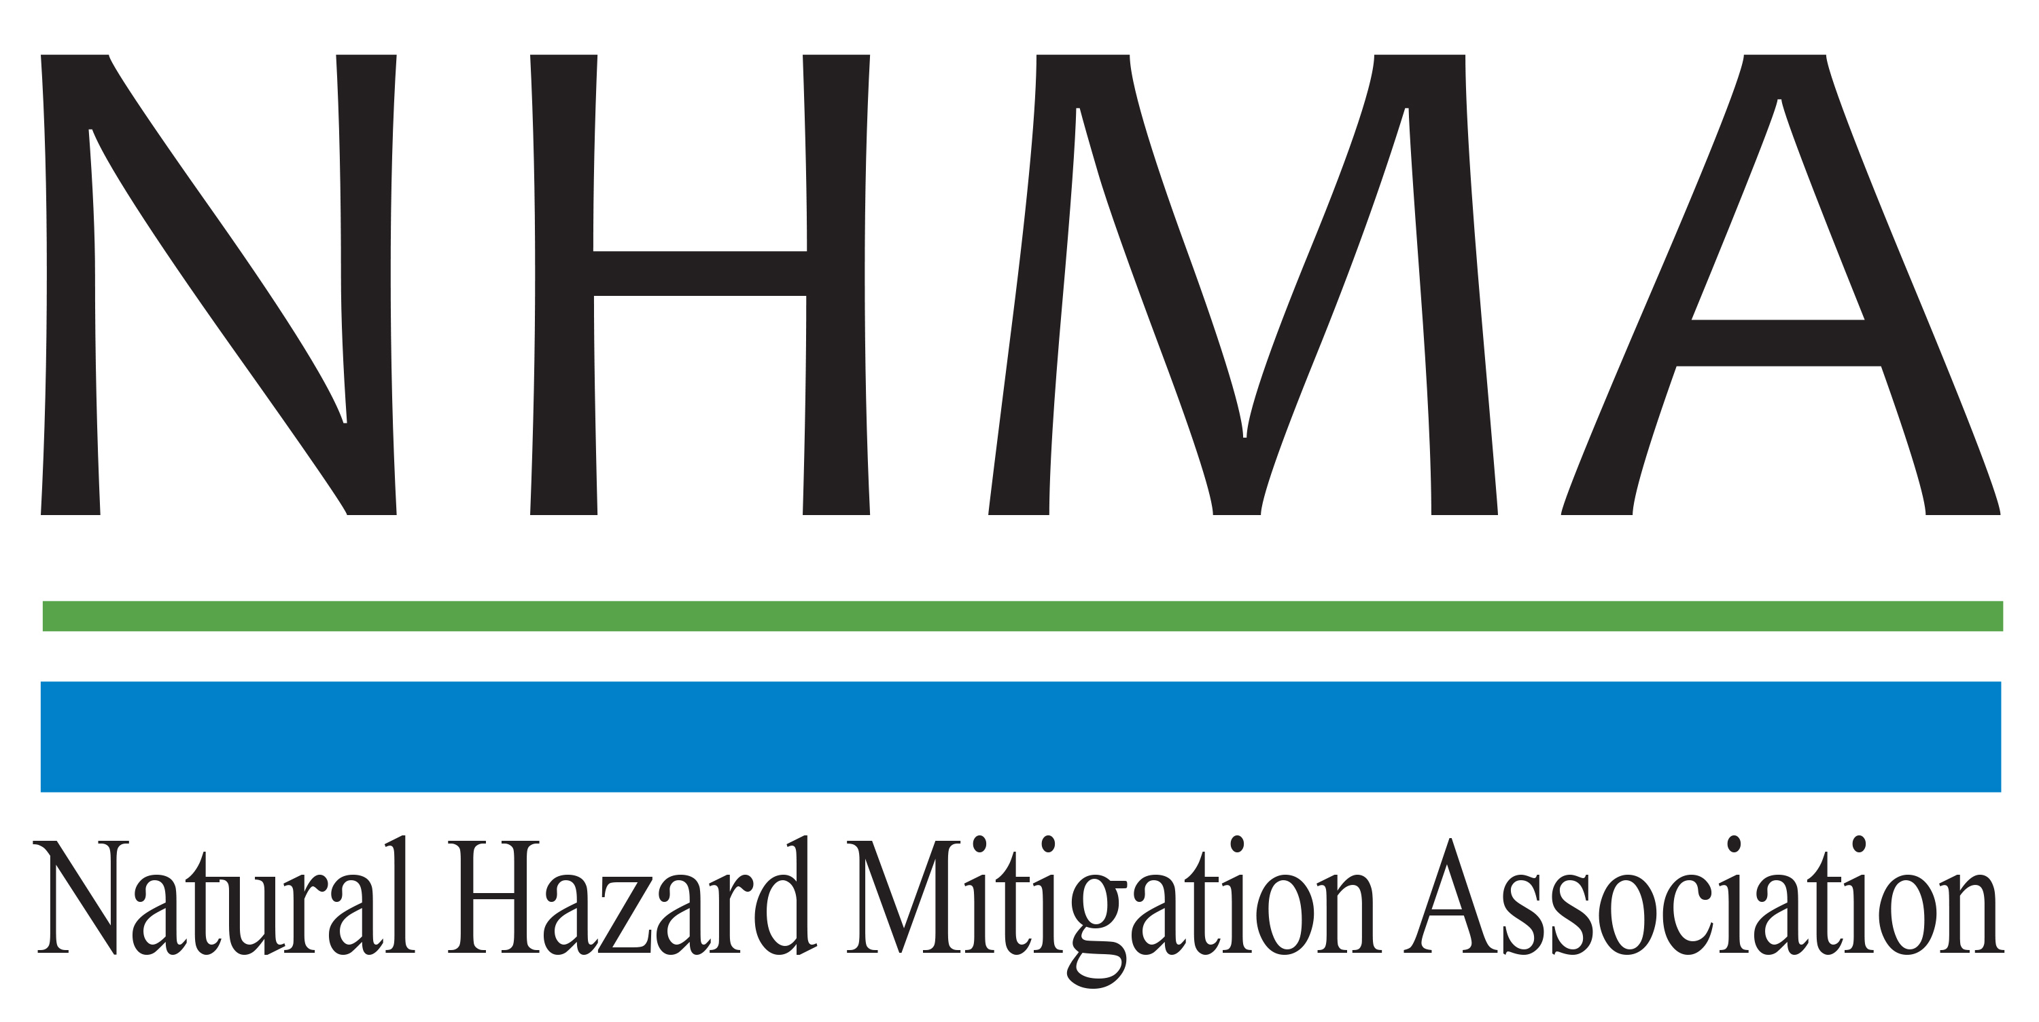

Disaster Risk Reduction (DRR) Ambassador Curriculum

Instructor Guide

Module 7:

Achieving Community Buy-in for
Disaster Risk Reduction:
Win-Win Approaches

THE DRR AMBASSADOR CURRICULUM
The goal of the DRR Ambassador Curriculum is to facilitate Disaster Risk Reduction efforts for the whole community by:
- Engaging in discussion of how disasters can be reduced through local action
- Sharing insights among local leaders and technical experts to enable the development of cross functional solutions
- Acquiring the best-available information, knowledge of best practices, and analytic tools to enable better-informed decisions before, during, and after disasters
It is important for instructors of DRR Ambassador Curriculum modules to remember this is one module in a 24-module curriculum. The “DRR Ambassador Curriculum At-a-Glance” table, located at the end of this document, lists the modules of the Curriculum. Keep in mind the following context for the module(s) you conduct:
DRR-A CURRICULUM TARGET AUDIENCE
The target audience includes those involved in community development decision-making, such as local community staff, volunteer and stakeholder groups, and federal and state officials.
METHODS OF DELIVERY
Varied delivery methods will provide multiple options for access by the target audience. The DRR Ambassador modules may be presented via webinars hosted by NHMA or partner organizations, presented in conferences and/or classrooms by qualified DRR Ambassador Curriculum instructor(s), or are downloadable for individual study from the NHMA website.
COURSE MATERIALS
Instructors are expected to use the instructional materials housed on the NHMA website to conduct DRR Ambassador Curriculum modules (Instructor Guide, supporting visuals, Participant Guides, and handouts). Instructors may tailor modules to specific audiences or locations as long as they do not revise the learning objectives and do not revise the materials in such a way that the participants cannot correctly complete the post-test. Instructors request the current pre/post-test for the module from NHMA.
CERTIFICATES OF COMPLETION
Certificates of Completion will be awarded by NHMA to participants who successfully complete NHMA-sponsored DRR Ambassador modules. A DRR Ambassador Certificate will be awarded to individuals completing all 24 modules. Participants who choose not to take the post-test may be issued a Certificate of Attendance. Contact NHMA about obtaining certificates. Inform participants to ask their certifying boards about acceptance of NHMA DRR Ambassador certificates for continuing education credits.

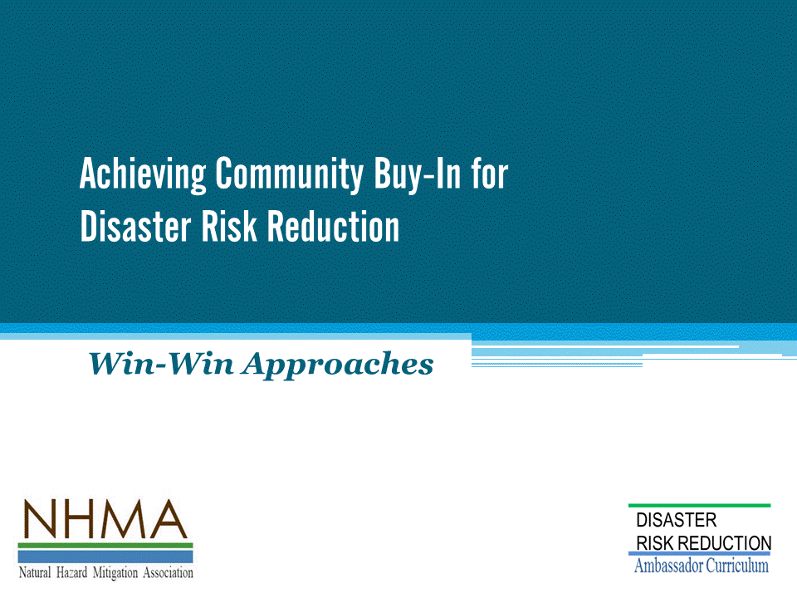
Approximate delivery time: 60-75 minutes

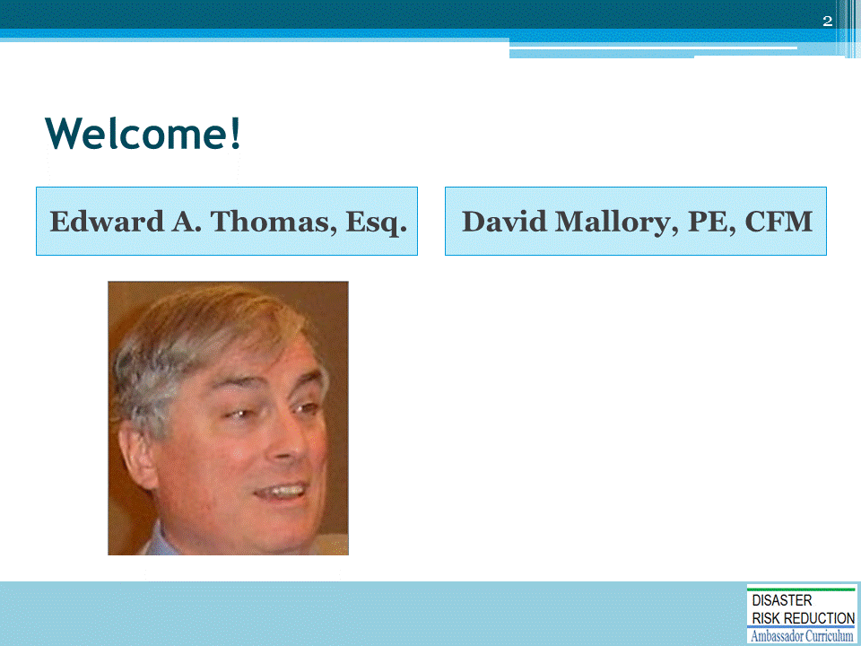
Introductions:
- Each presenter introduces her/himself, including affiliation and brief background.
- OPTIONAL: Have each participant briefly introduce him/herself
Mention: NHMA presentations are based on general principles of law, engineering, policy and emergency management.
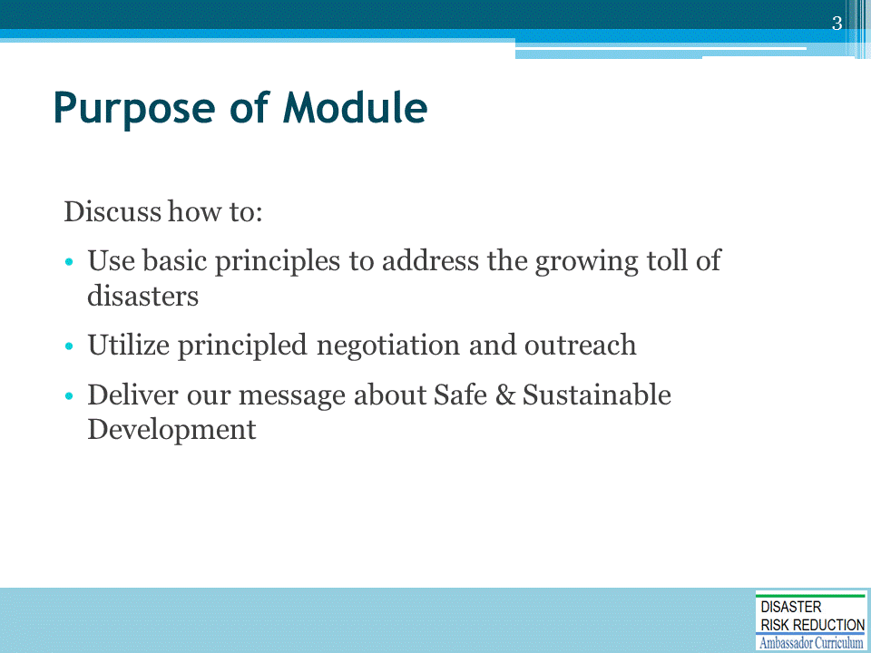
Ignoring the confusion surrounding climate change or fervently held beliefs about the topic is not going to work – BUT we need not change those ideas, just work forward through several steps.
- Use basic principles to address the growing toll of disasters (NOTE: the next slide further discusses this)
- Utilize principled negotiation and outreach to others
- Deliver our message about Safe & Sustainable Development to others who may not share our beliefs, or even have any affinity with or liking for us:
  - In their lingo
  - About their concerns, passions, beliefs, fears, and vision
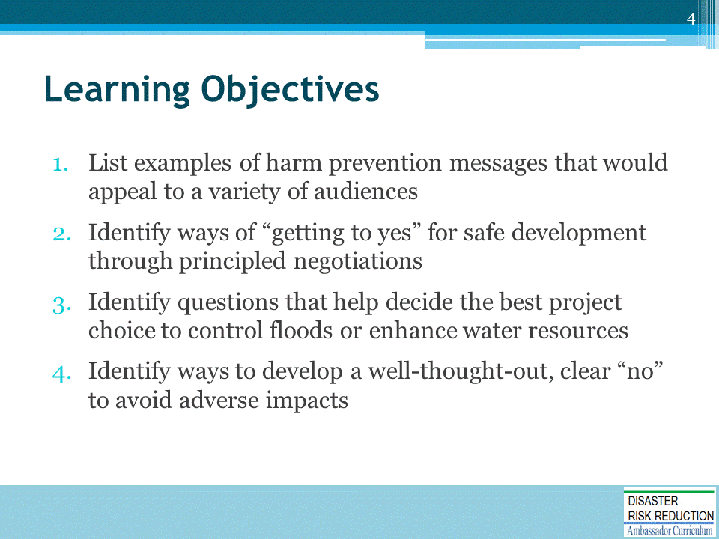
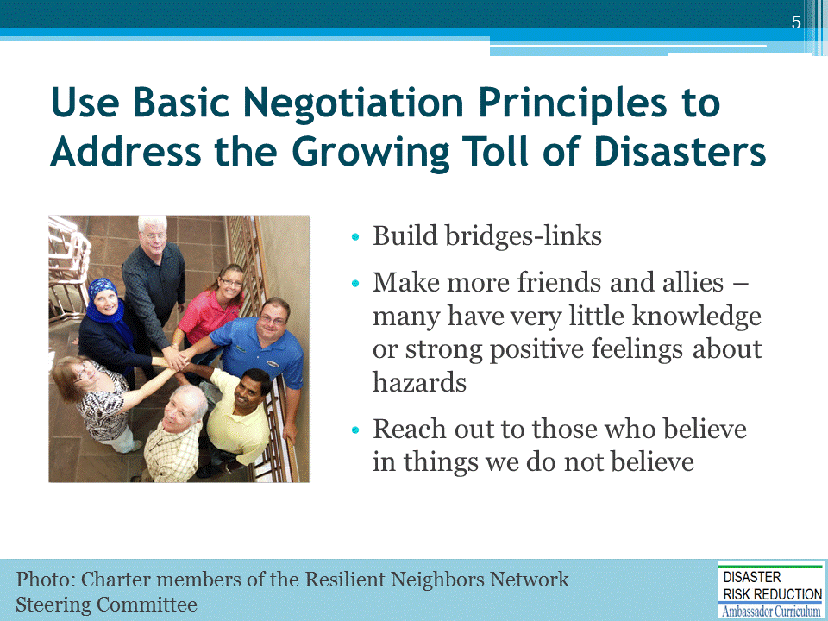
Business as usual is not working well enough.

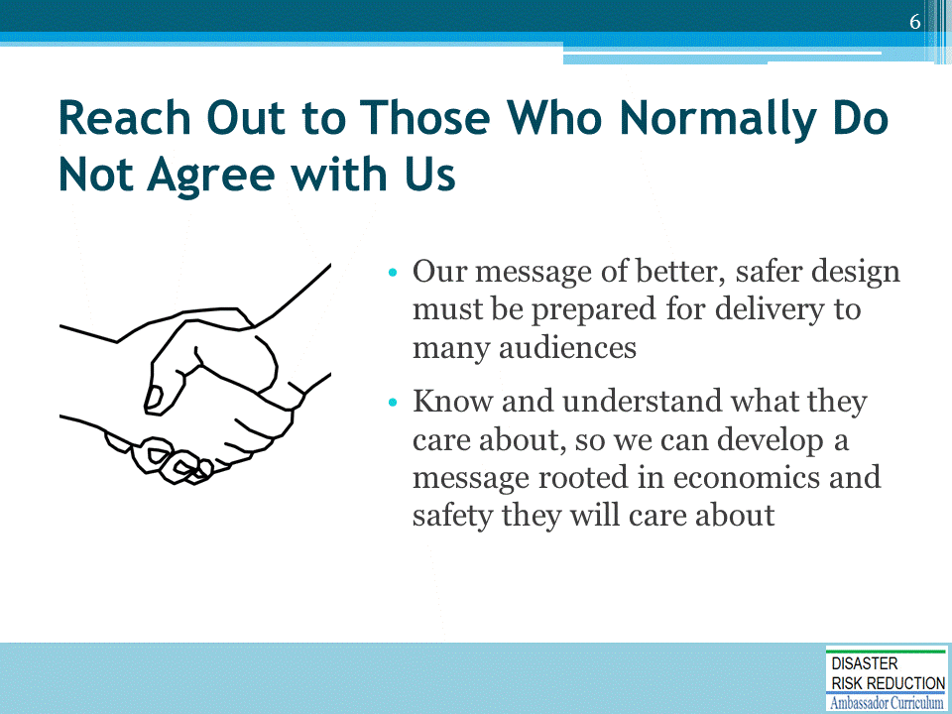

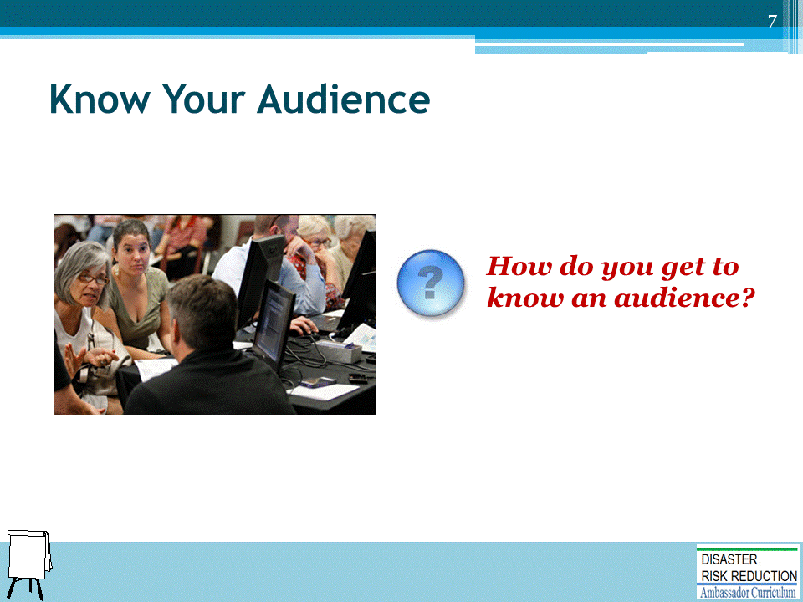
Ask the question and solicit suggestions from participants before showing the suggested answers on the next slide.
Optional: Record their answers on whiteboard.

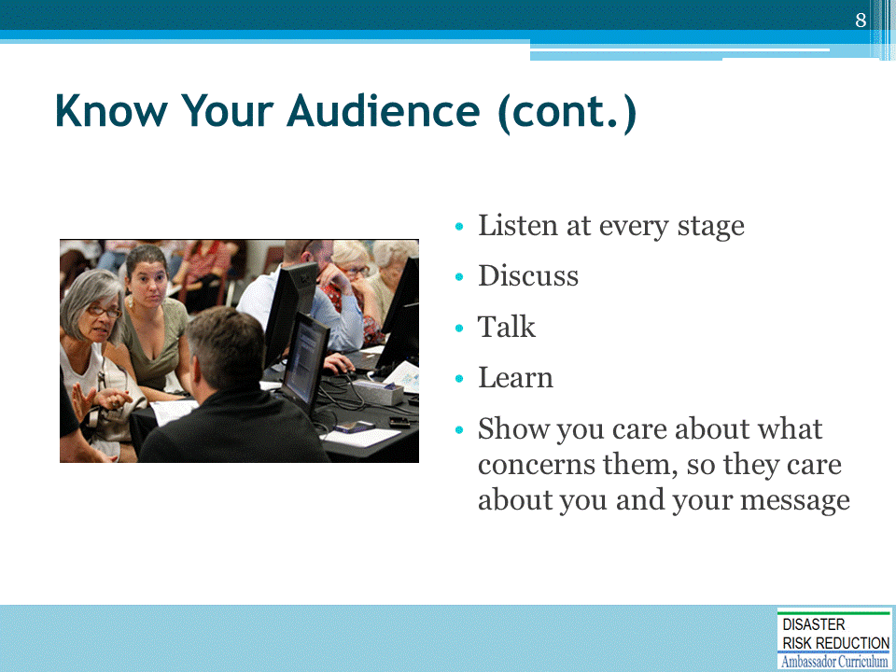

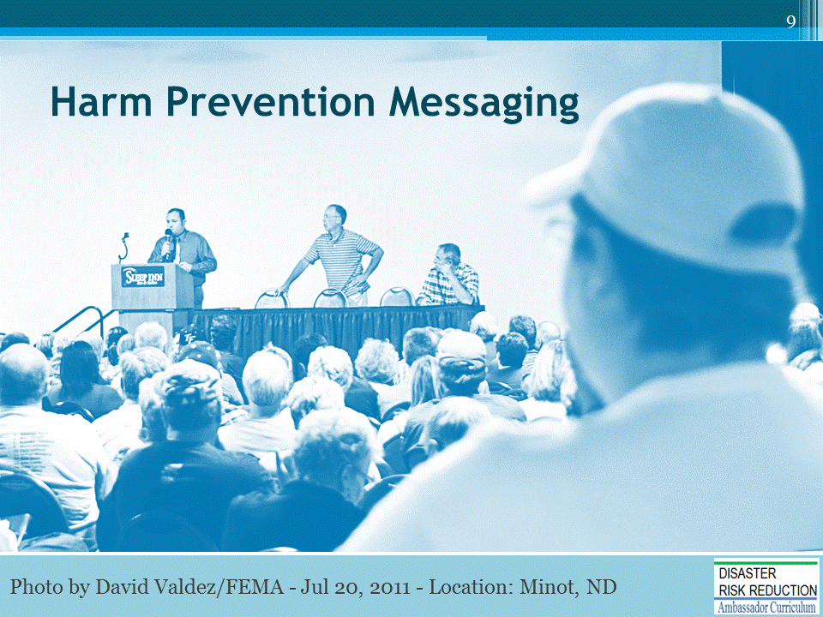
Many people who fervently do not believe in climate variability/uncertainty may have other beliefs, such as in:
- God / “Higher Power”
- The United States
- Helping one’s neighbor
- The need to love and protect land
- Reducing the role of government in their lives
How do we get a harm prevention message across to them?

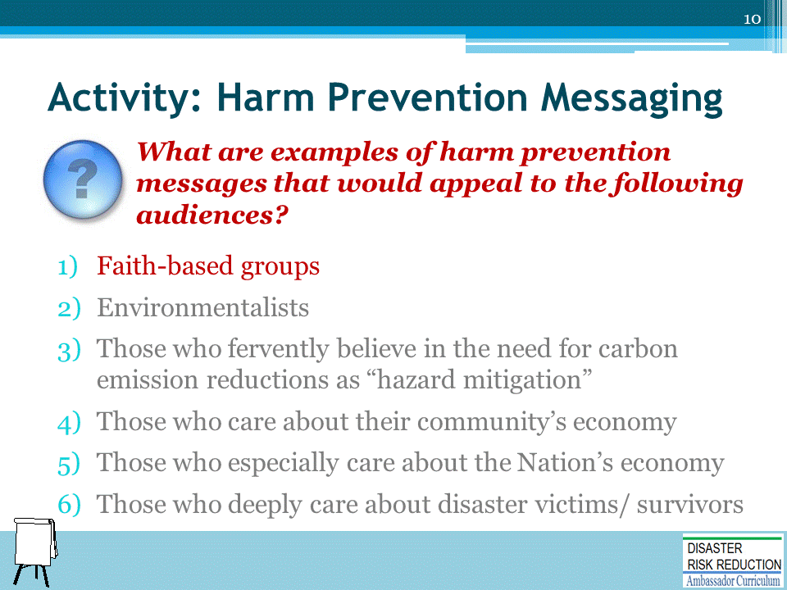
ACTIVITY INSTRUCTIONS
This activity may be conducted in one of two ways:
- Plenary group activity: Ask each question and solicit 1-2 message ideas from participants. Optional: Record their answers on whiteboard.
- Small group activity: Assign to each small group of participants 1-2 audience types. Allow five minutes for the groups to brainstorm messaging ideas for their assigned audience types. Have each group report out 2 messages for each assigned audience type.
Debrief: Review suggested answers listed on the following slide(s).

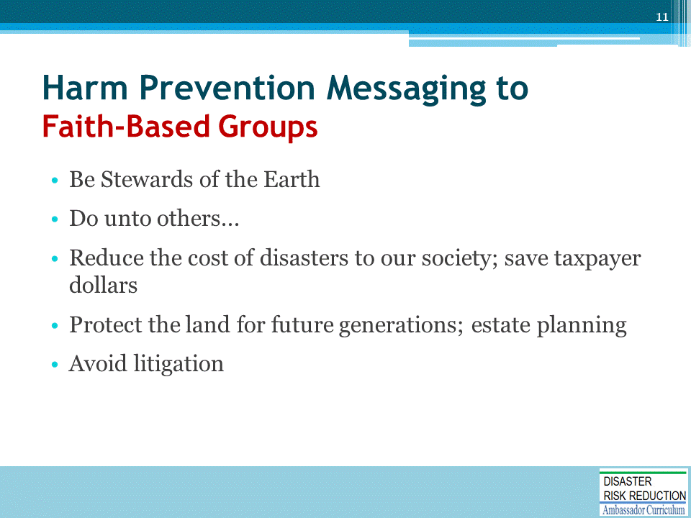

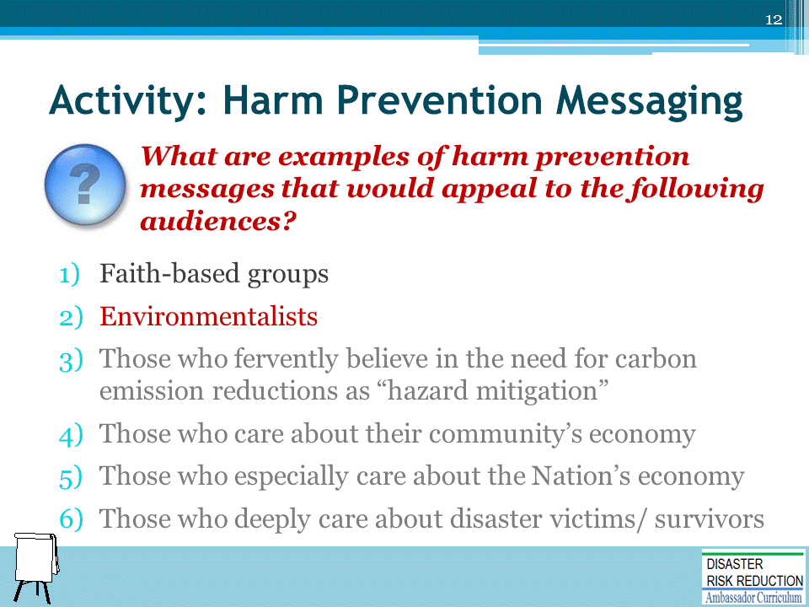
ACTIVITY INSTRUCTIONS
- Plenary group activity: Ask each question and solicit 1-2 message ideas from participants. Optional: Record their answers on whiteboard.
- Debrief: Review suggested answers listed on the following slide(s).

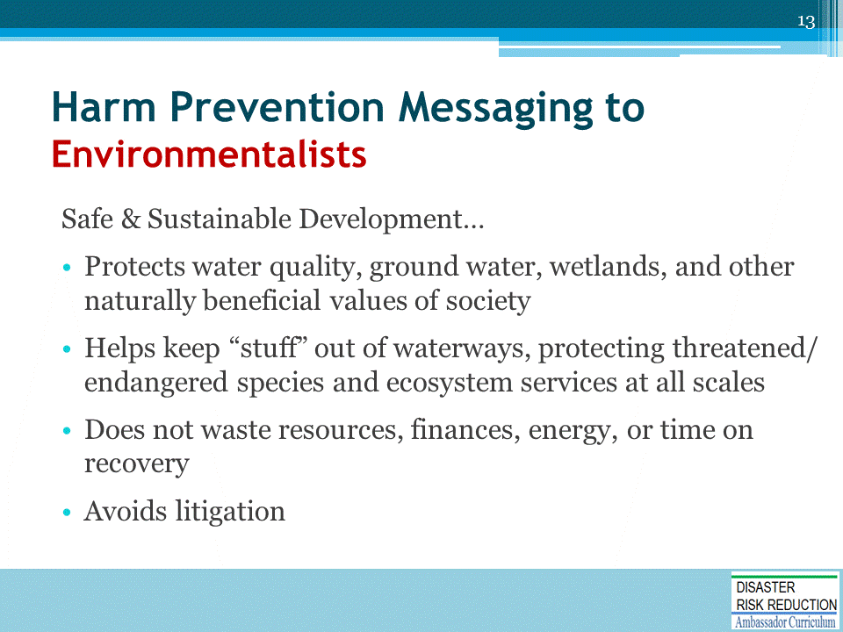

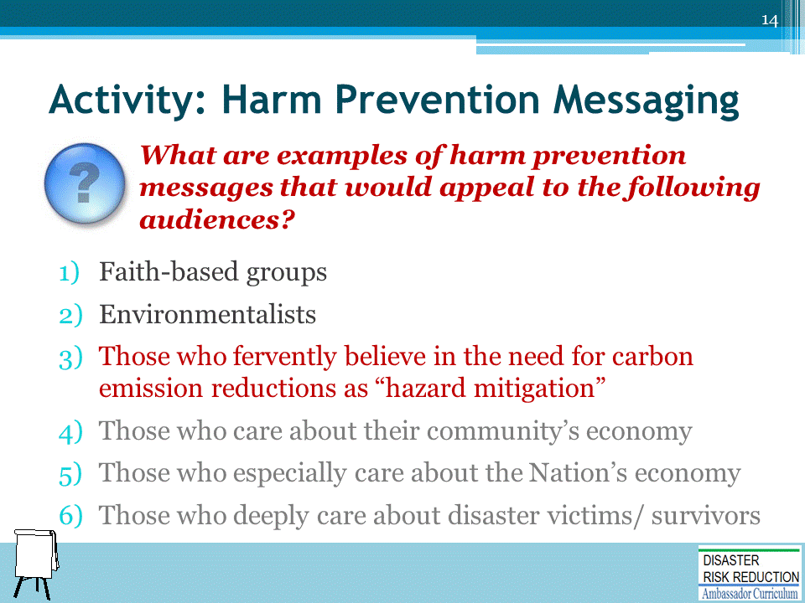
ACTIVITY INSTRUCTIONS
- Plenary group activity: Ask each question and solicit 1-2 message ideas from participants. Optional: Record their answers on whiteboard.
- Debrief: Review suggested answers listed on the following slide(s).

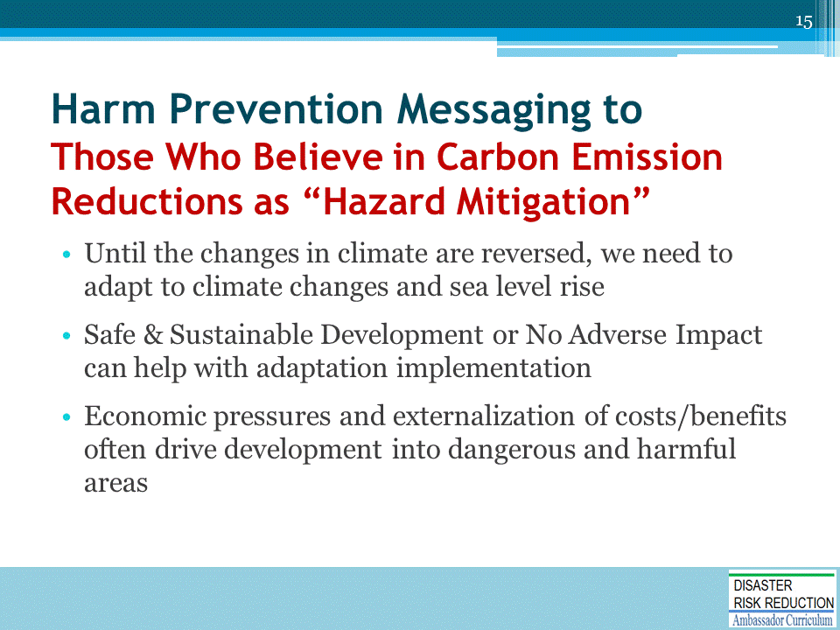

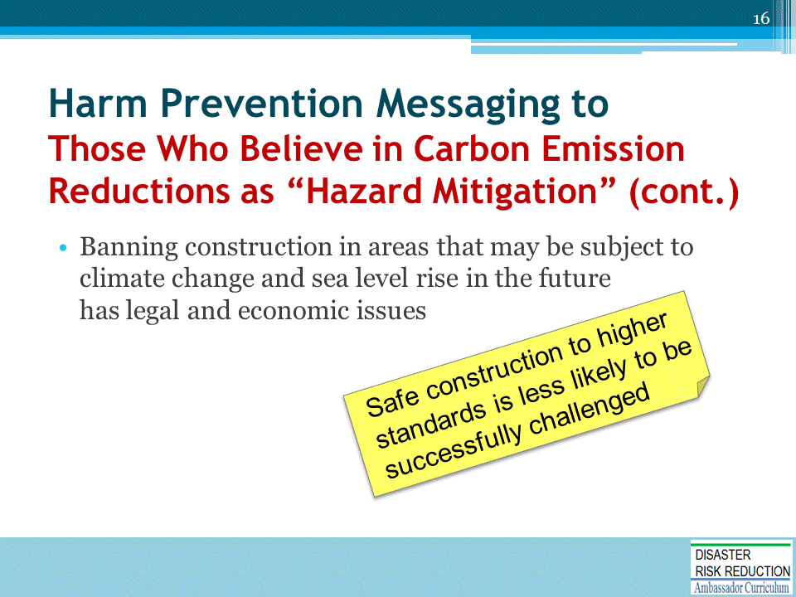

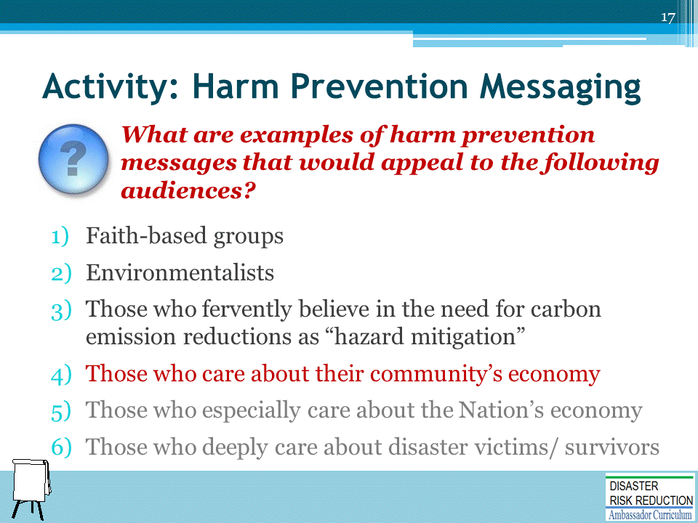
ACTIVITY INSTRUCTIONS
- Plenary group activity: Ask each question and solicit 1-2 message ideas from participants. Optional: Record their answers on whiteboard.
- Debrief: Review suggested answers listed on the following slide(s).

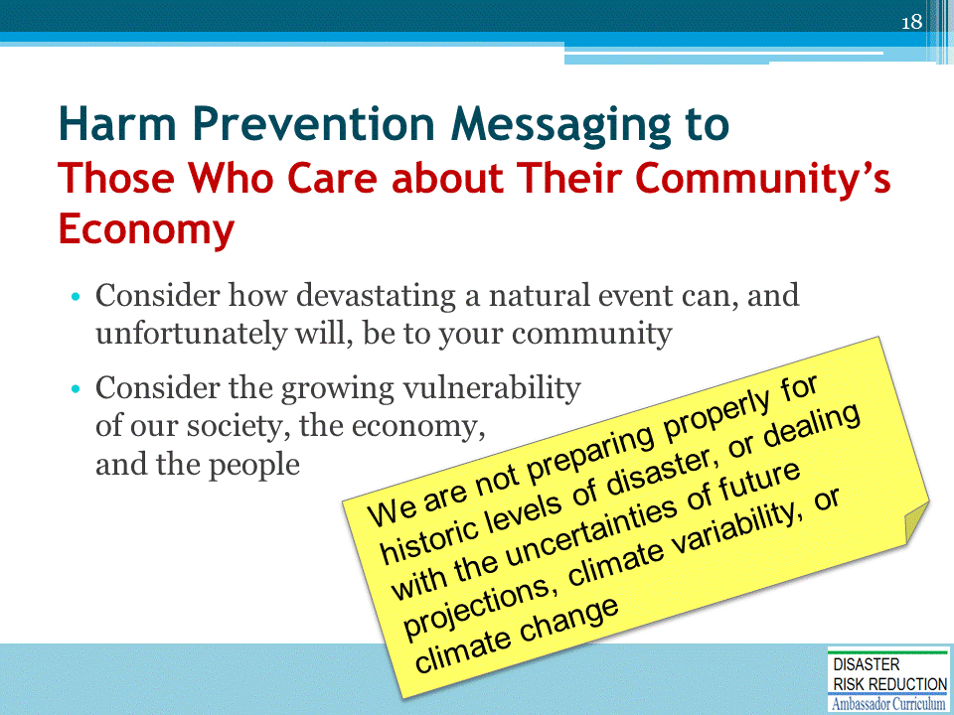
Natural event examples: wildfire, hurricane, earthquake, cascading disaster like flood following wildfire

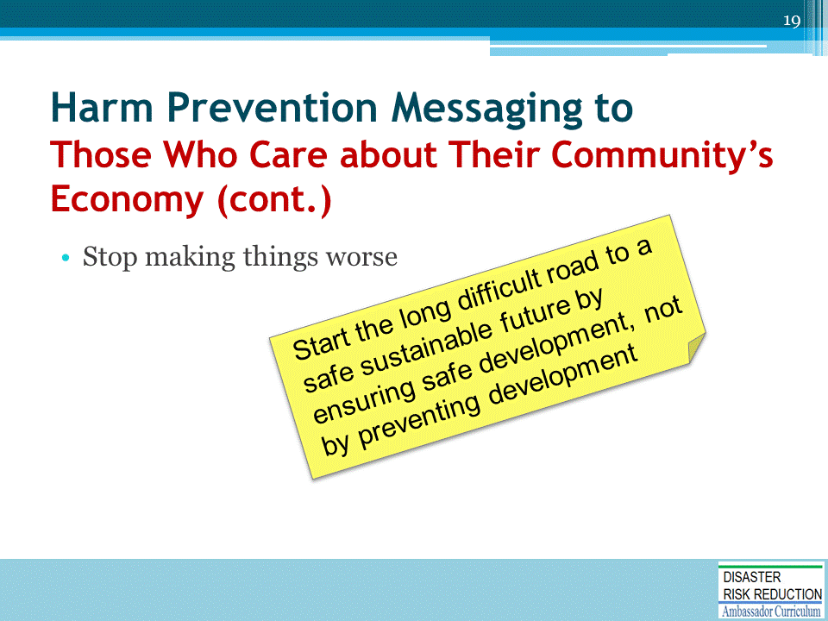

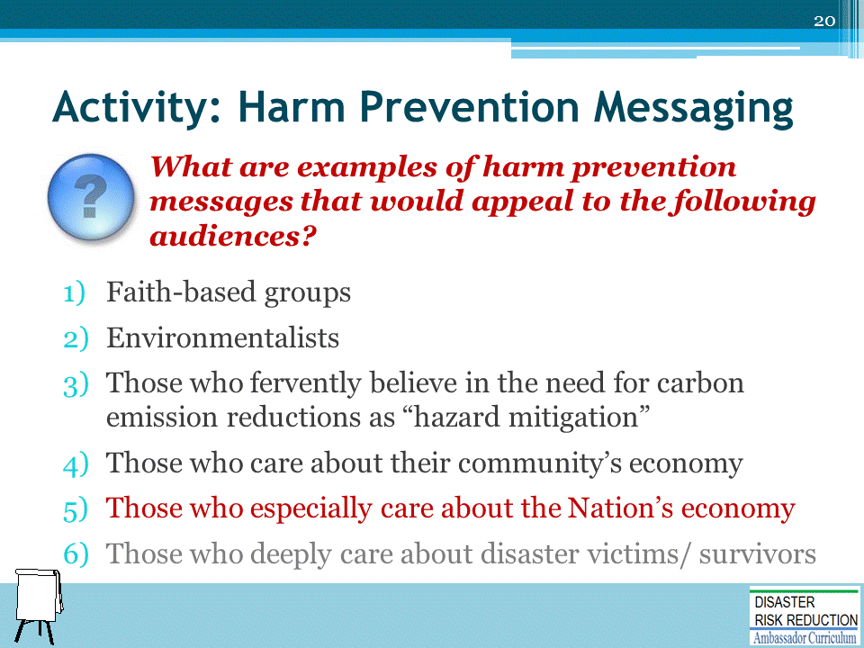
ACTIVITY INSTRUCTIONS
- Plenary group activity: Ask each question and solicit 1-2 message ideas from participants. Optional: Record their answers on whiteboard.
- Debrief: Review suggested answers listed on the following slide(s).
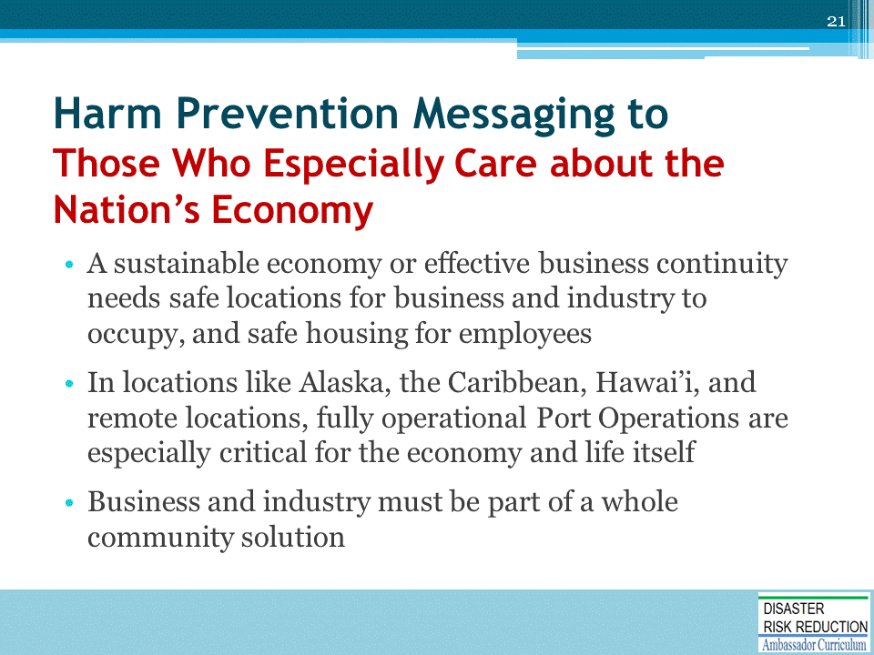
Among the most clear lessons of the horrific aftermath of Hurricane Katrina, the recent wildfires, tsunamis, and the cascading post tsunami disasters:
- There is no possibility of a sustainable economy or effective business continuity without safe housing and safe locations for business and industry to occupy
- We need housing for employees to have businesses and industry – to have an economy at all
- In some locations like Alaska, the Caribbean, Hawai’i, and remote locations, fully operational Port Operations are especially critical for the economy and life itself
- Business and industry must be part of a whole community solution

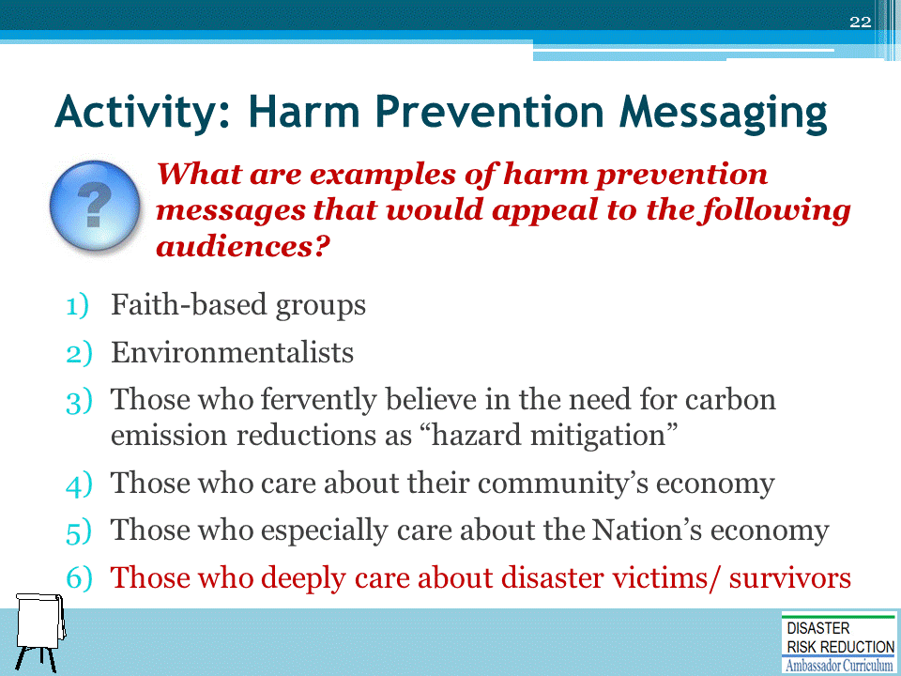
ACTIVITY INSTRUCTIONS
- Plenary group activity: Ask each question and solicit 1-2 message ideas from participants. Optional: Record their answers on whiteboard.
- Debrief: Review suggested answers listed on the following slide(s).

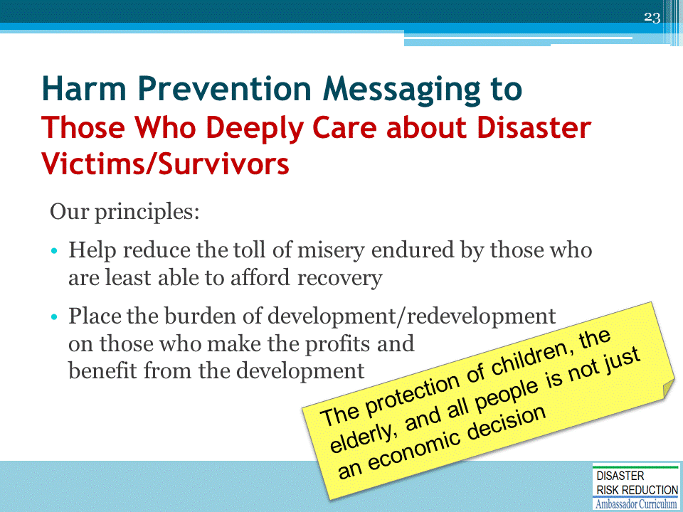

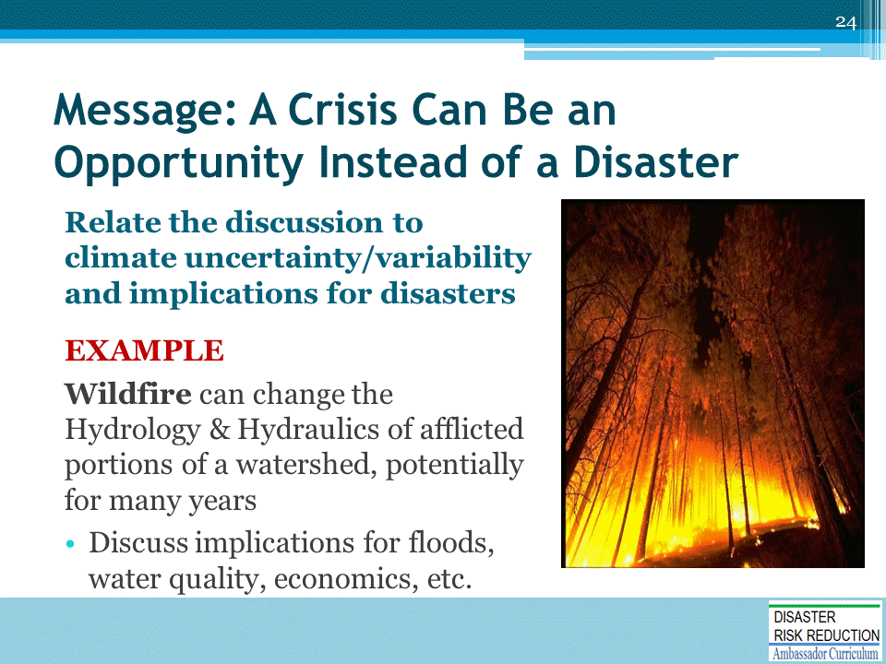
Any crisis is a terrible thing to waste if we can lead the discussion around to providing a message of safe development, delivered focused on the audience’s concerns.
- First, learn what the audience really needs, wants, desires, fears, and loves – KNOW YOUR AUDIENCE!

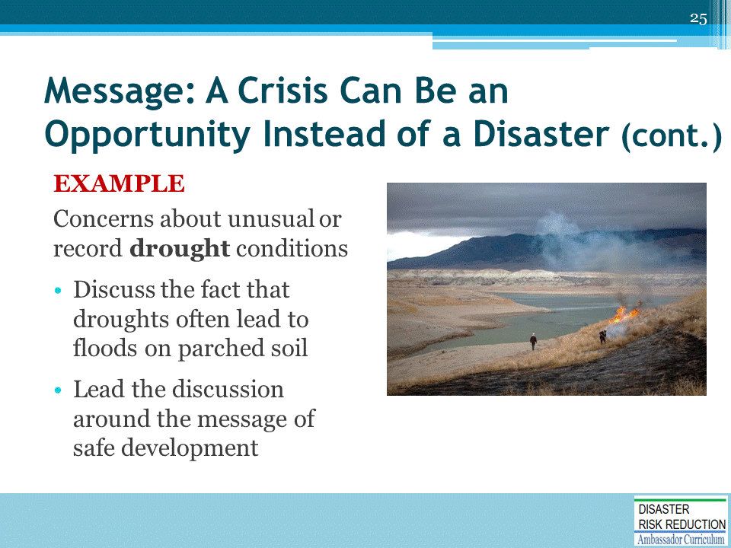
First, know your audience!

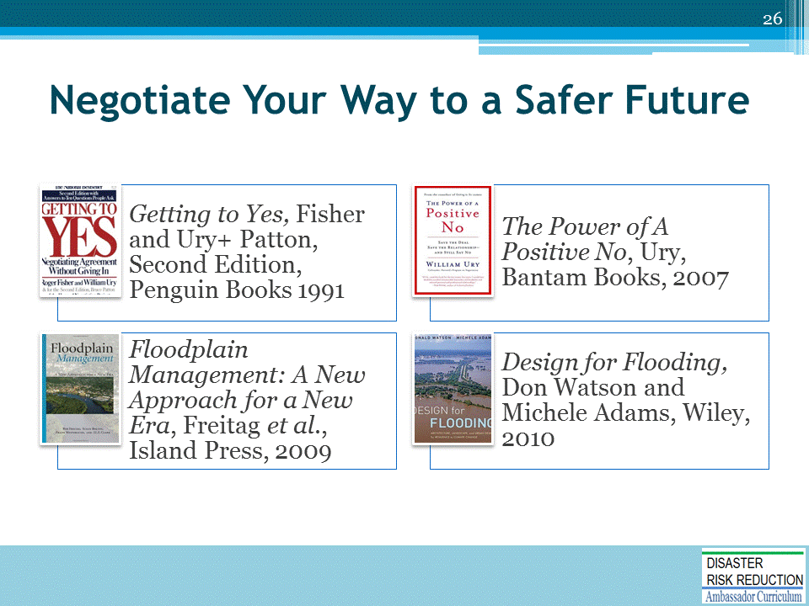

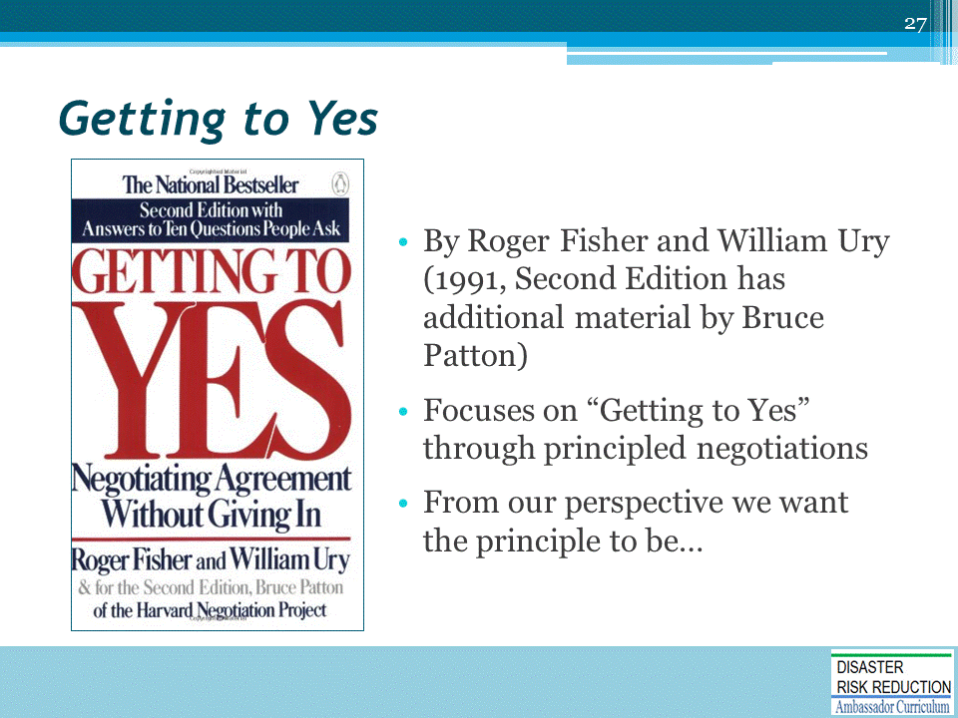

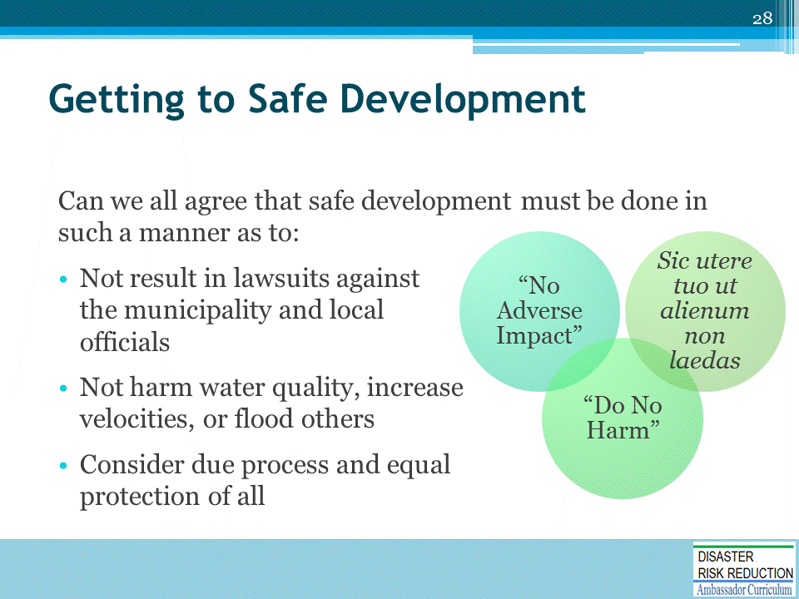
Safe Development is also known as:
- No Adverse Impact
- Do No Harm
- “Sic utere tuo ut alienum non laedas” [Use your property so you do not harm others]

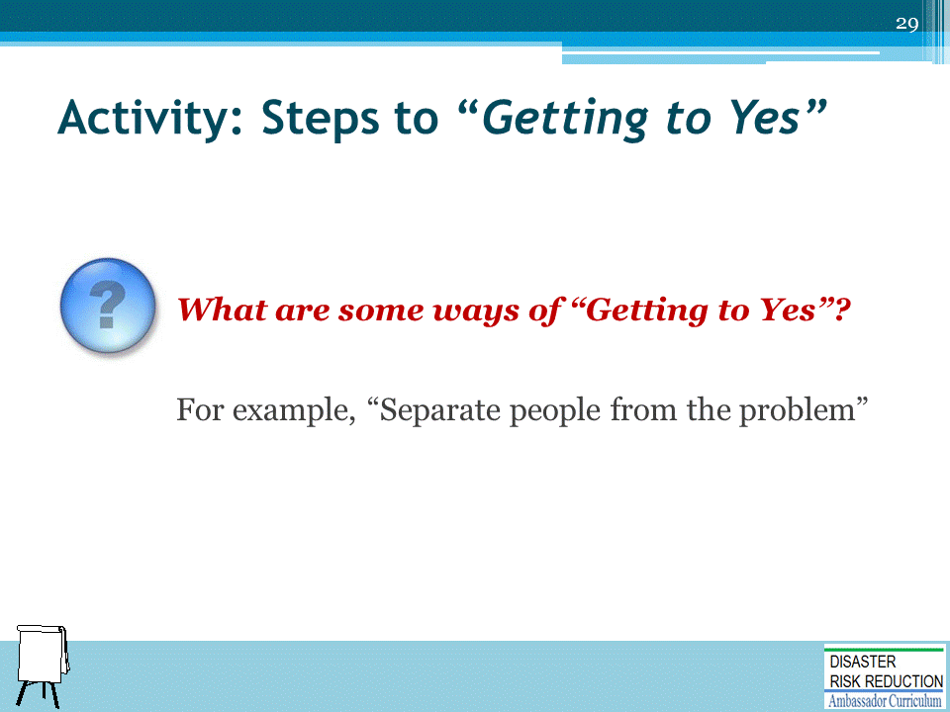
ACTIVITY INSTRUCTIONS
This activity may be conducted in one of two ways:
- Plenary group activity: Ask each participants to volunteer ideas for steps to Getting to Yes. Optional: Record their answers on whiteboard.
- Small group activity: Assign small group of participants to develop three steps to Getting to Yes. Allow five minutes for the groups to brainstorm messaging ideas for their assigned audience types. Have each group report out their messages.
Debrief: Review suggested answers listed on the following 5 build slides.

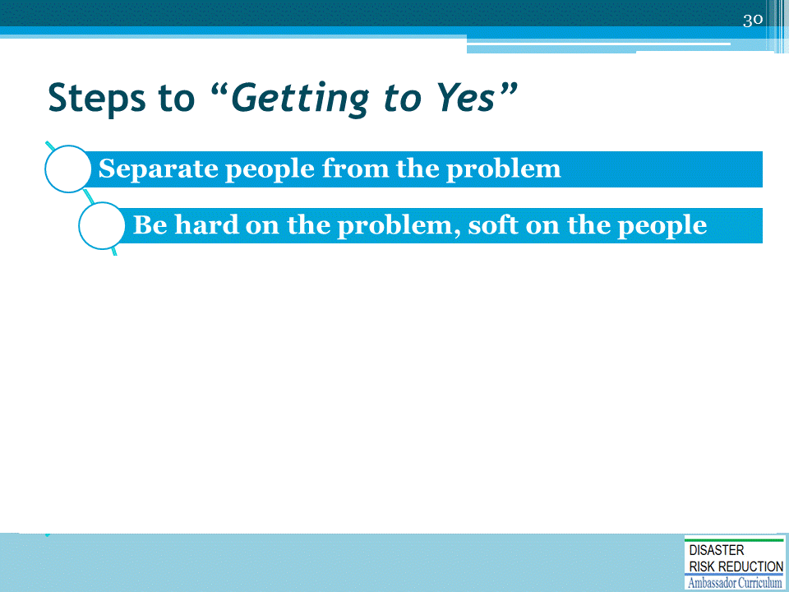

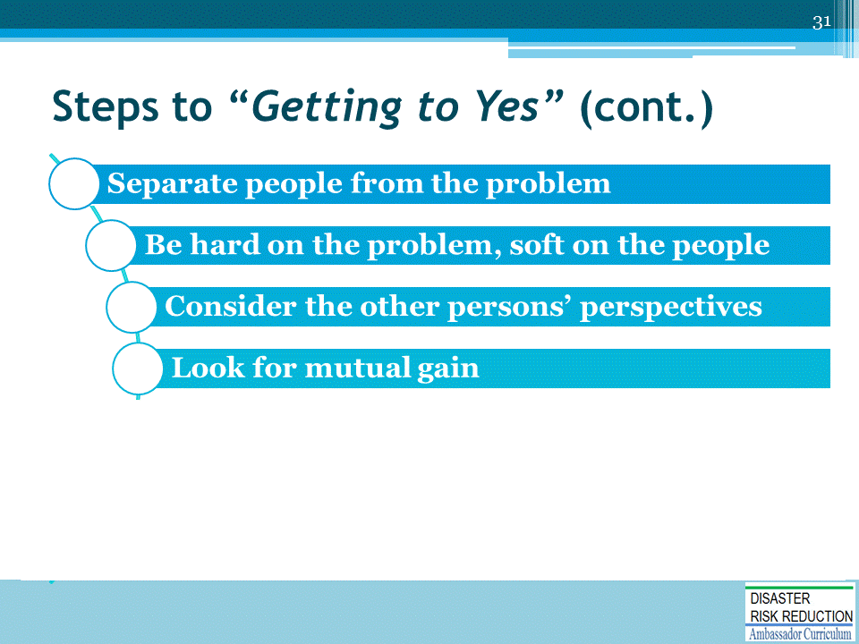

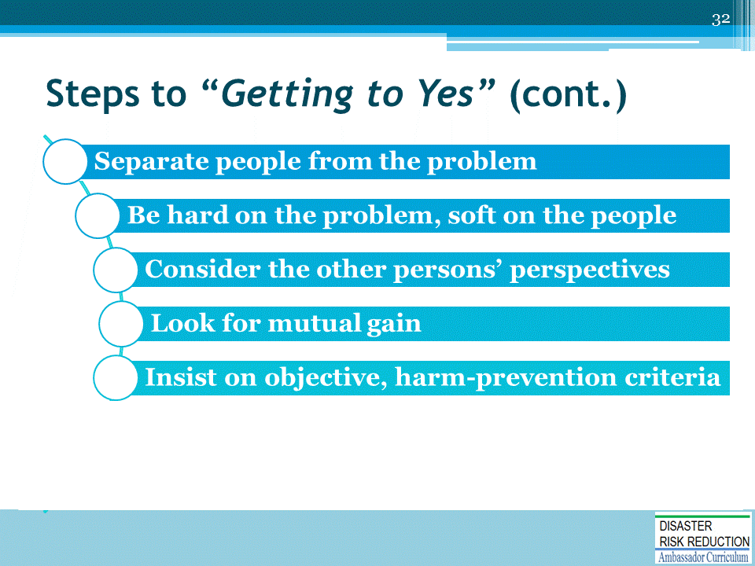

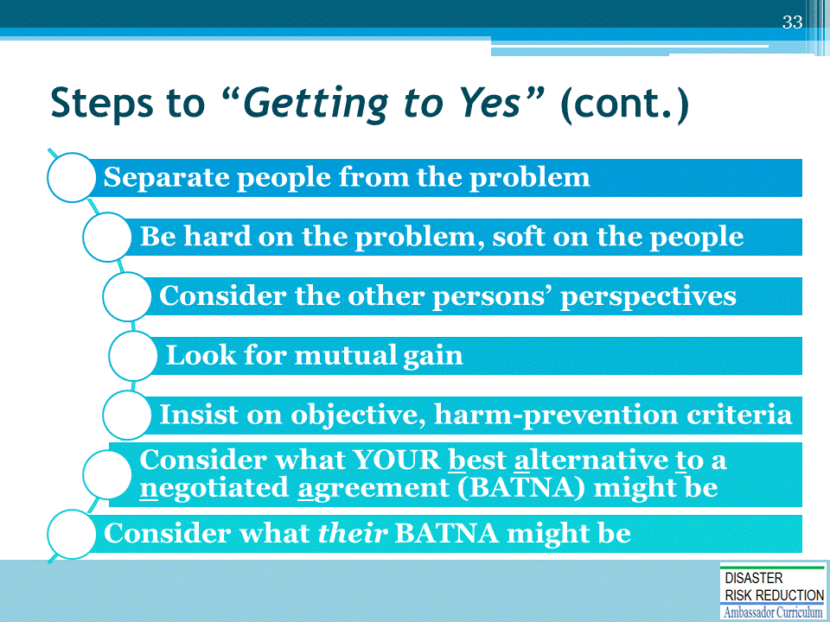

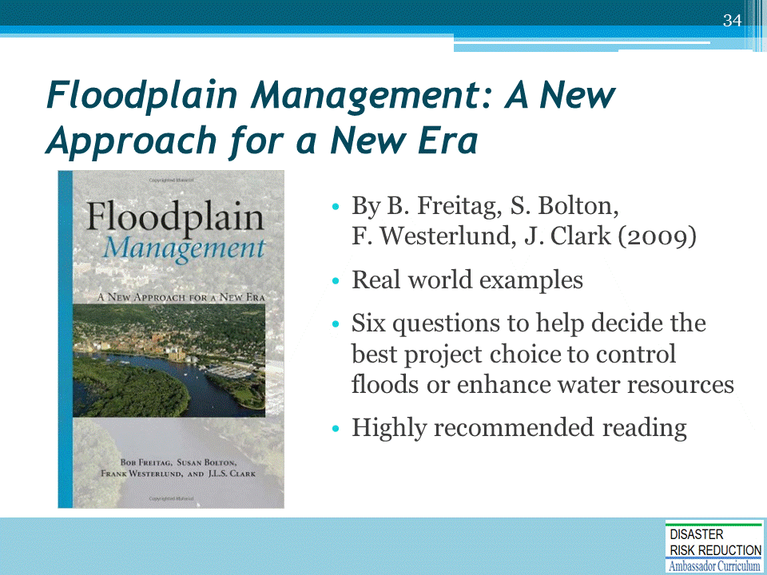

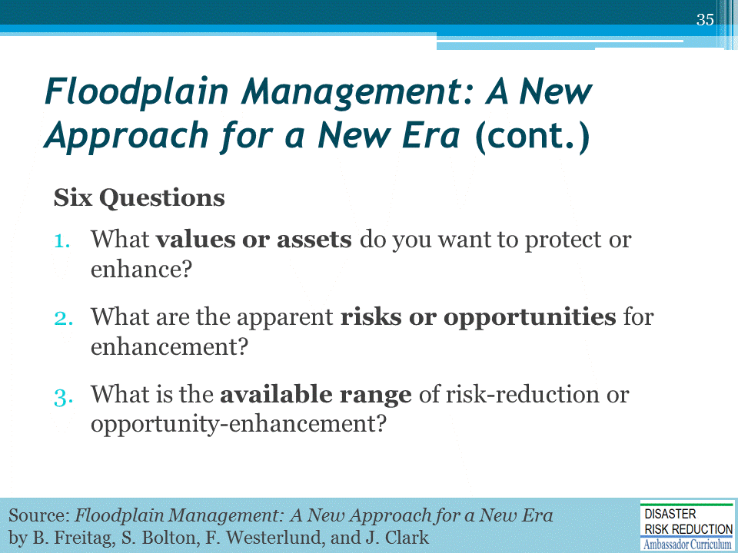
Source: Floodplain Management: A New Approach for a New Era by Bob Freitag, Susan Bolton, Frank Westerlund, and Julie Clark

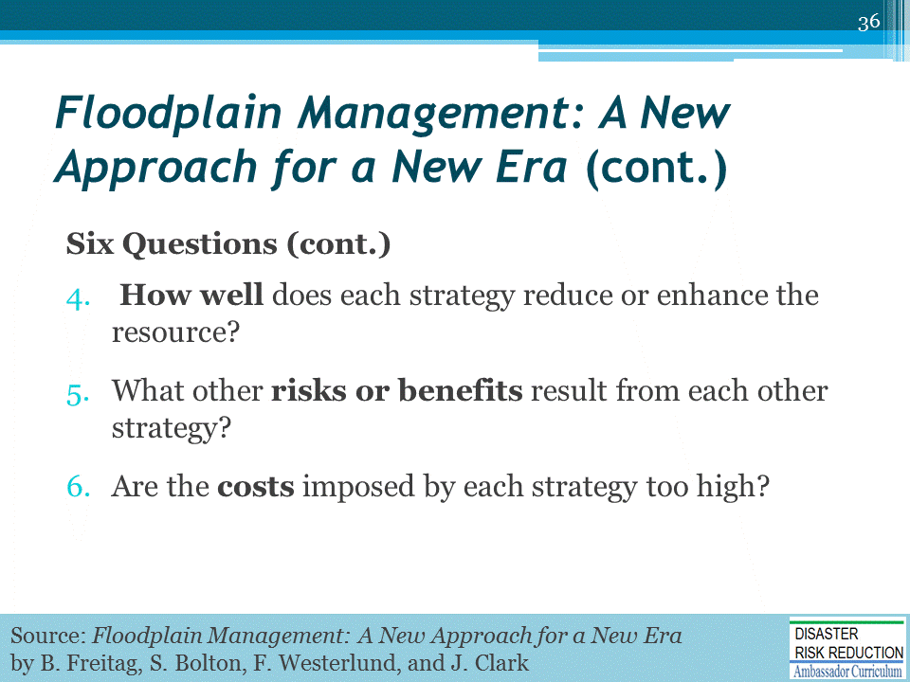

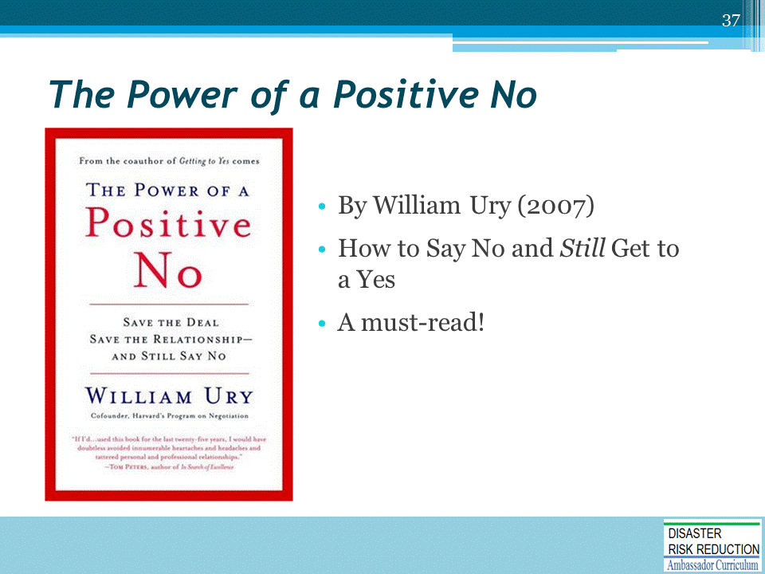

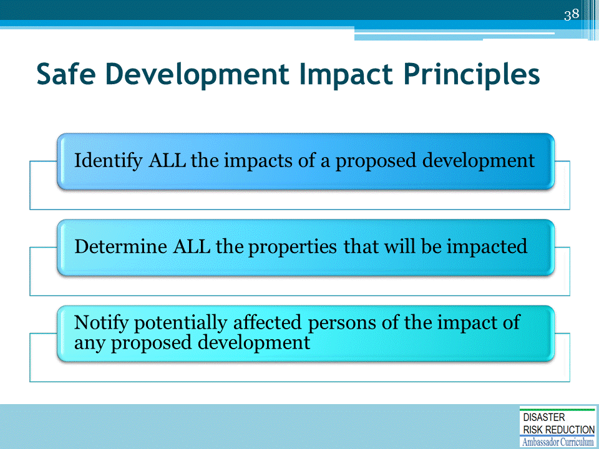

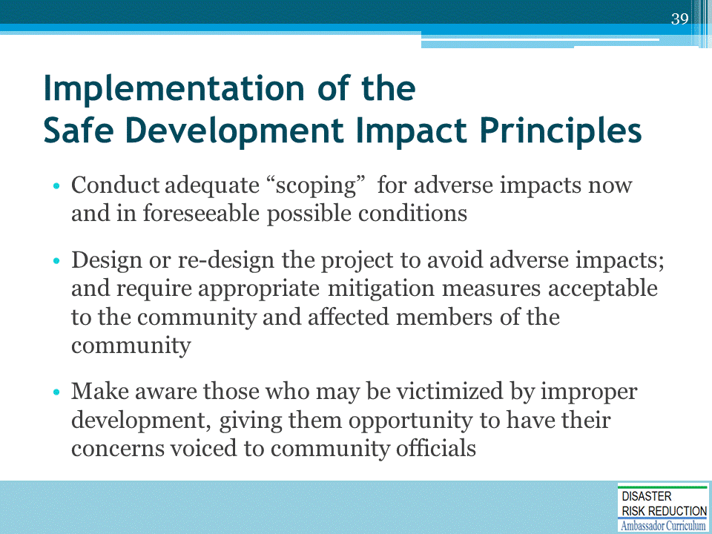
Using these principles turns the usual development process around!

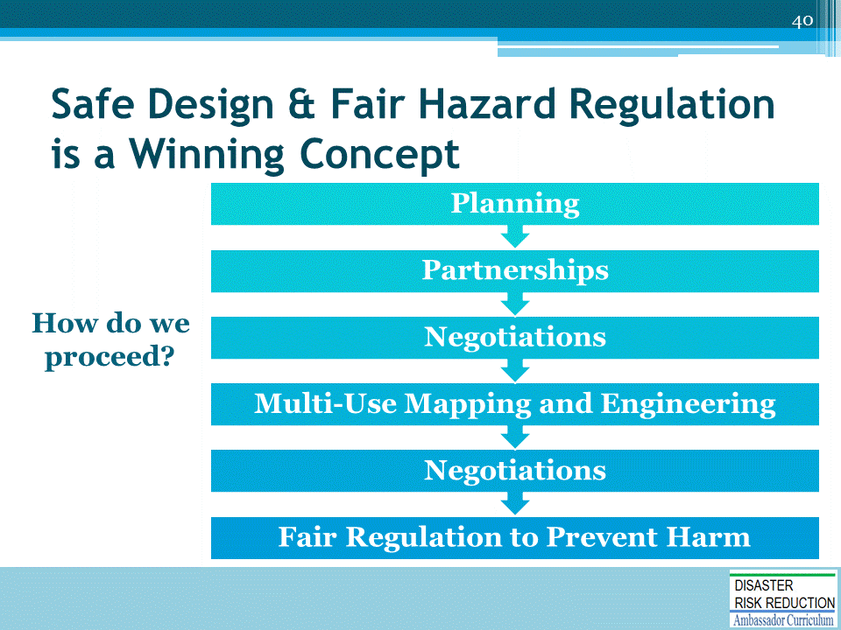

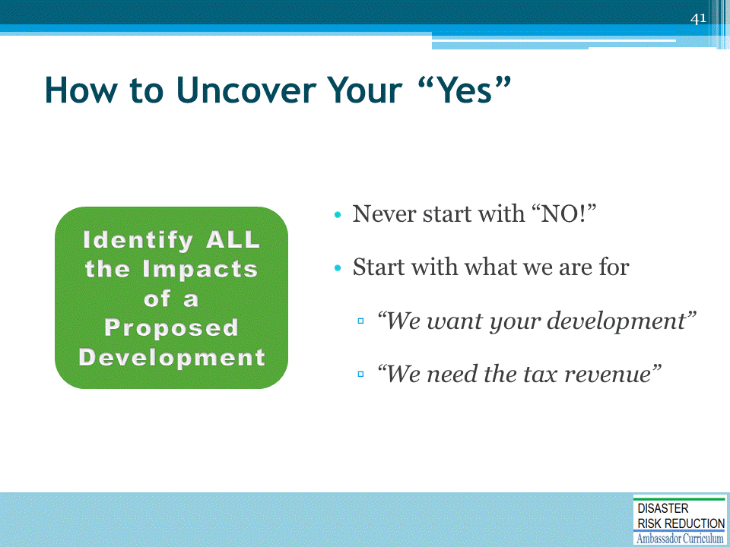
Let’s walk through an example of how to uncover your “YES” with respect to the Safe Development Impact Principles.

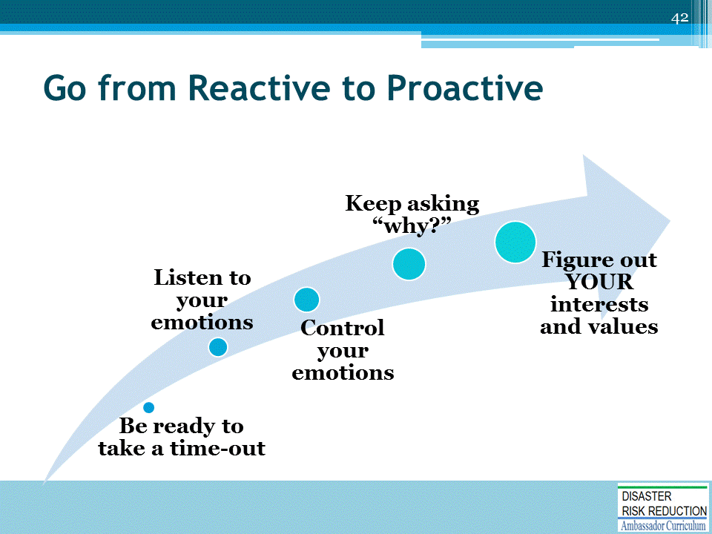
The biggest obstacle to successful negotiations is us!
- Be ready to take a time-out
  - William Ury calls this, “going to the balcony”
- Figure out YOUR values
  - Safety? Sustainability? Protect the rights of all?

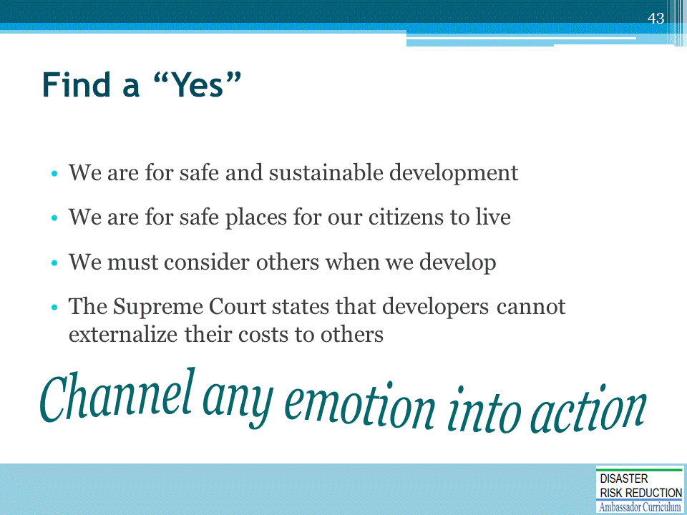

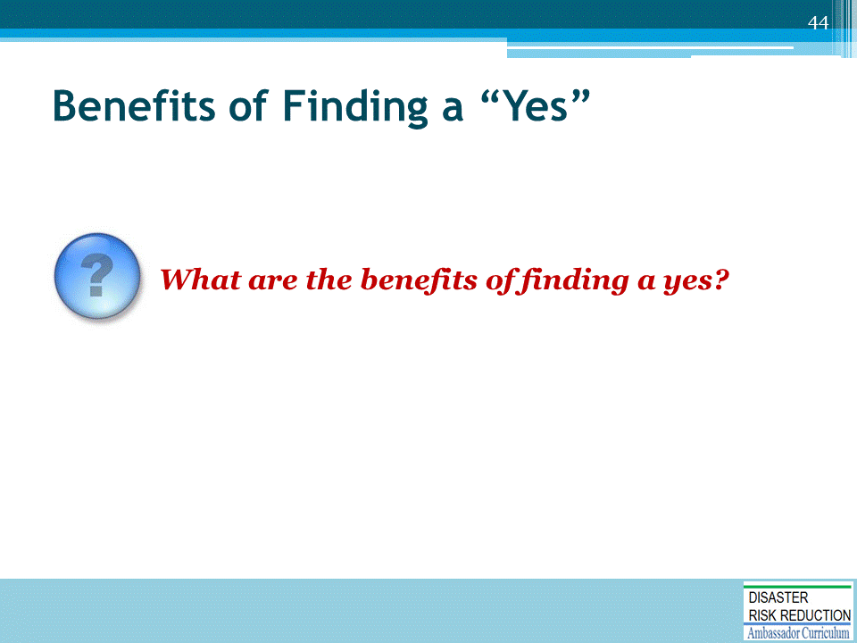
Ask the question and solicit suggestions from participants before showing the suggested answers on the next slide.

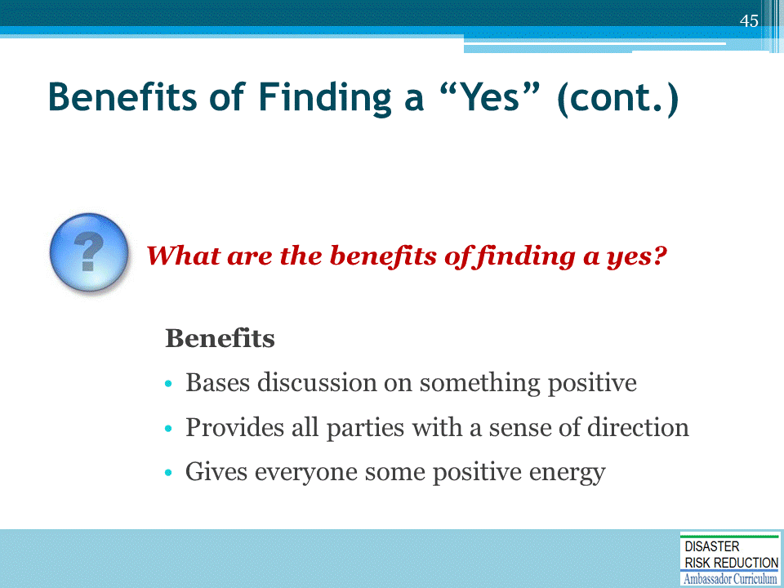

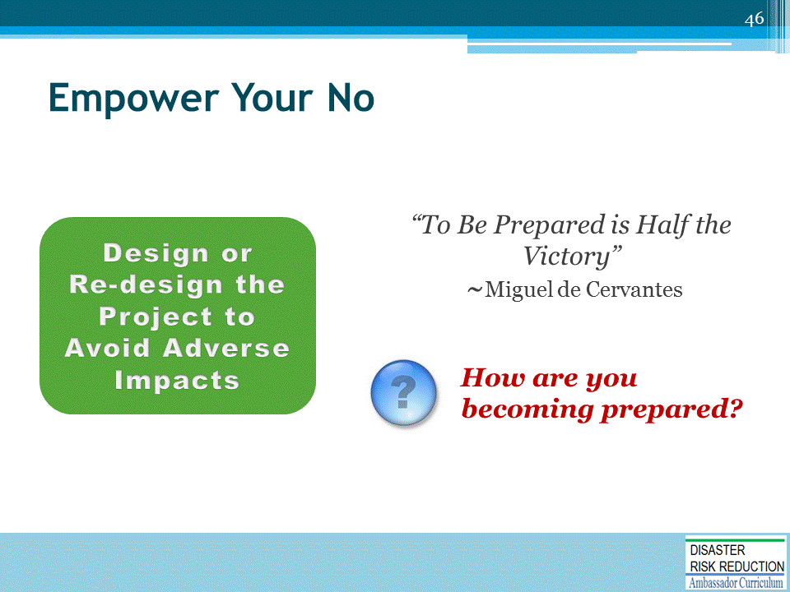
Ask the question and solicit participant responses.
Suggested Answers:
Ways to preparation include:
- Legal Workshops
- Practical Conferences

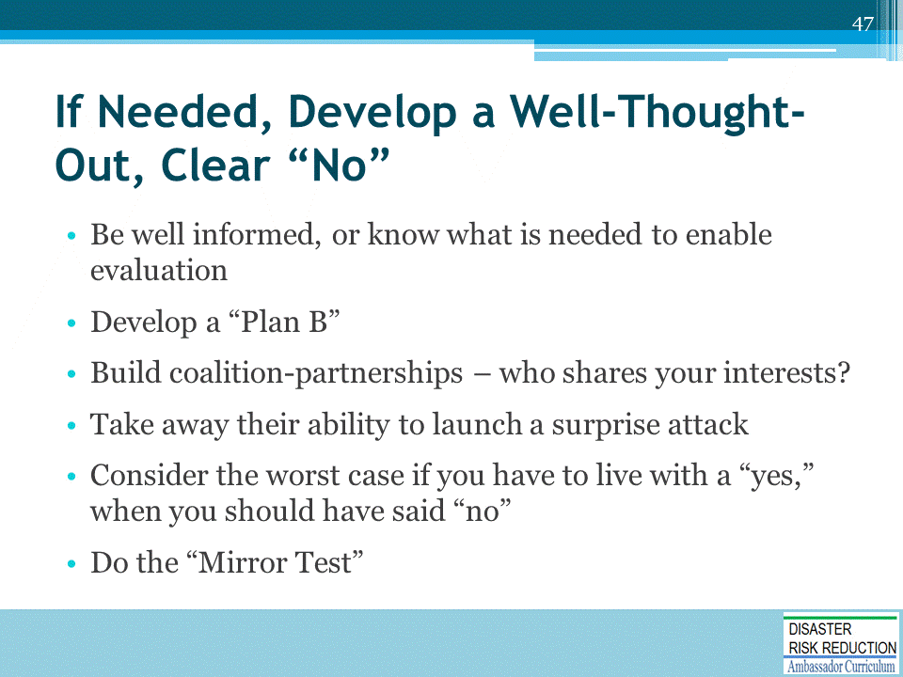
The Mirror Test: You have to be able to look at yourself in the mirror after taking an action which could have awful future consequences.
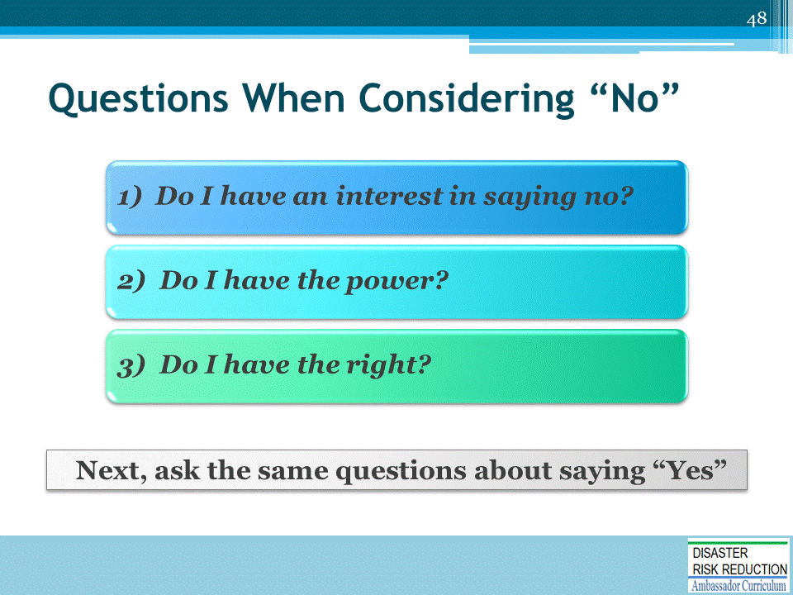

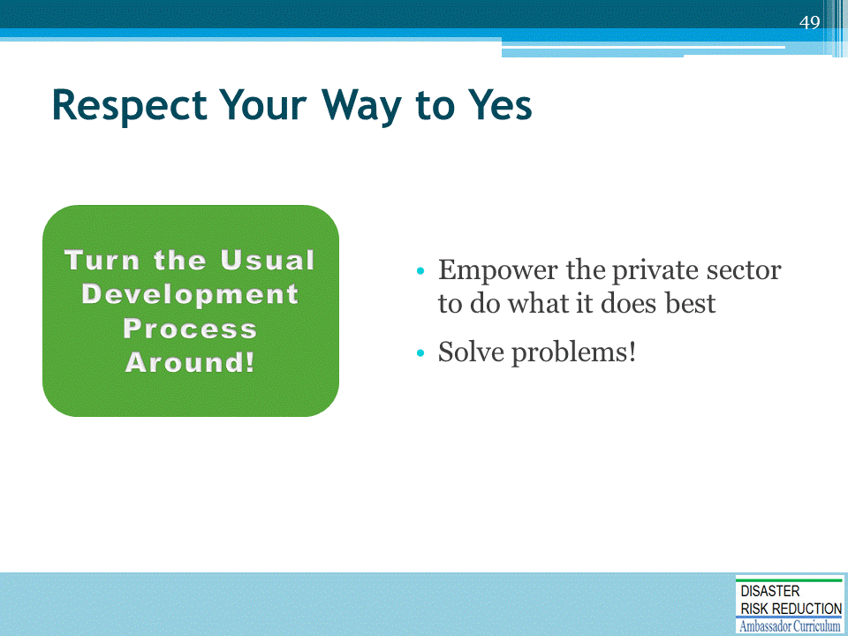

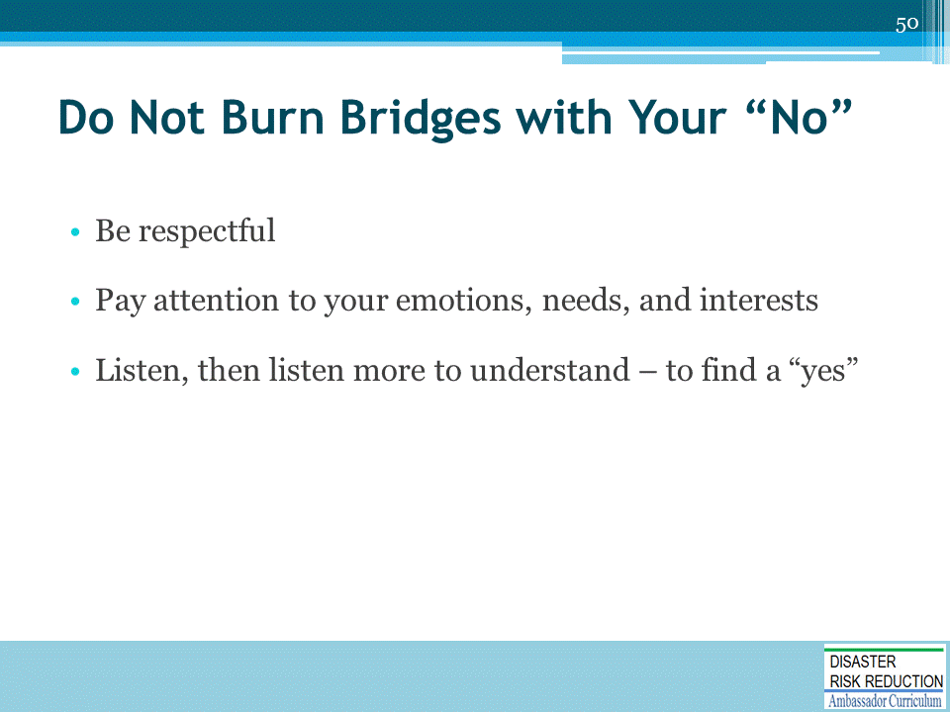
- Be respectful
  - Working in private industry is tough
  - Adopt a positive attitude of respect
- Pay attention to your emotions, needs, and interests
  - Then do the same for the other person
  - Respect them for your best interests!
- Listen, then listen more to understand – to find a “yes”
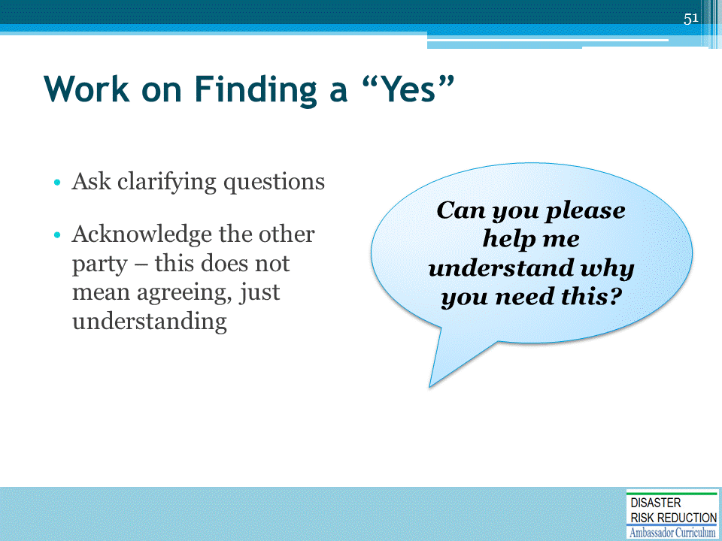

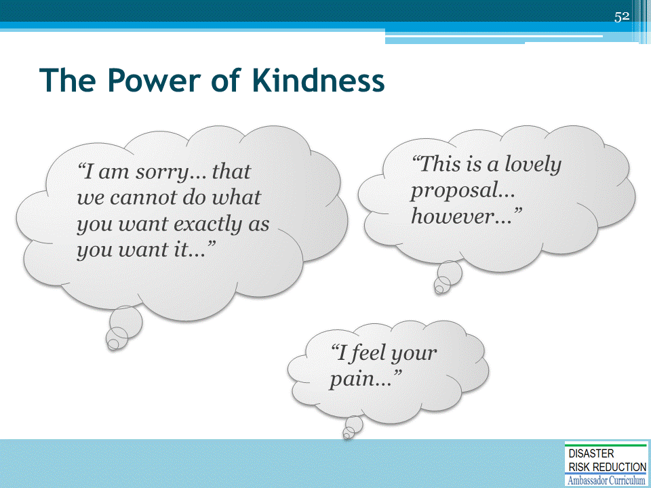

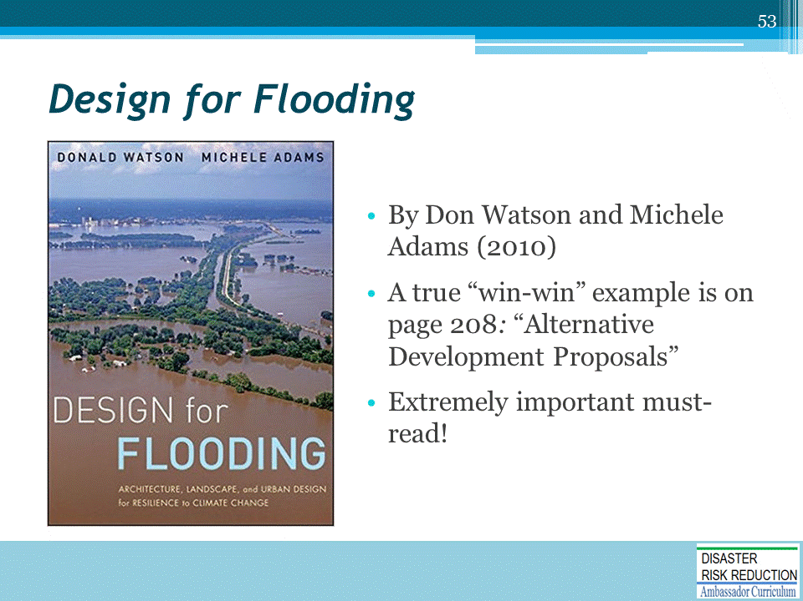
Describe the example of “win-win” that appears on p. 208 of Design with Flooding: “Alternative Development Proposals.”

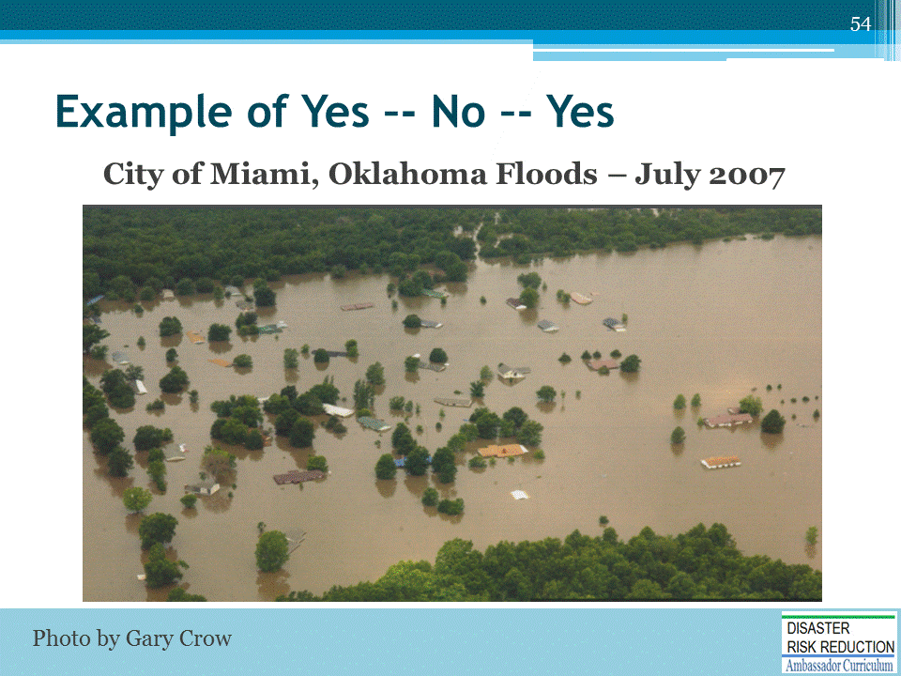
- About 700 homes were damaged, many of which suffered substantial damage with several being hit by over 88 inches of floodwater
- Unfortunately, several of these structures have flooded as many as 21 times over the past 50 years
- Historically, local officials in the City of Miami and Ottawa County have allowed devastated flood victims to rebuild as soon as possible, disregarding all locally adopted NFIP requirements for safe and proper rebuilding of substantially damaged buildings
- This time, however, the new slate of officials in place had a different view about rebuilding after a flood, but they wanted to make sure that they were on solid ground to take strong action and break the cycle once and for all.
- The primary power was City Attorney Erik Johnson. He was very concerned about inverse condemnation and the taking issue if the city did not allow folks to rebuild and go back into their flooded homes.
- General Counsel for the Oklahoma Water Resources Board, Dean Couch, consulted with ASFPM legal experts and contacted Mr. Johnson early on in this process, explaining the role of the floodplain administrator and the justification for performing the substantial damage determinations.

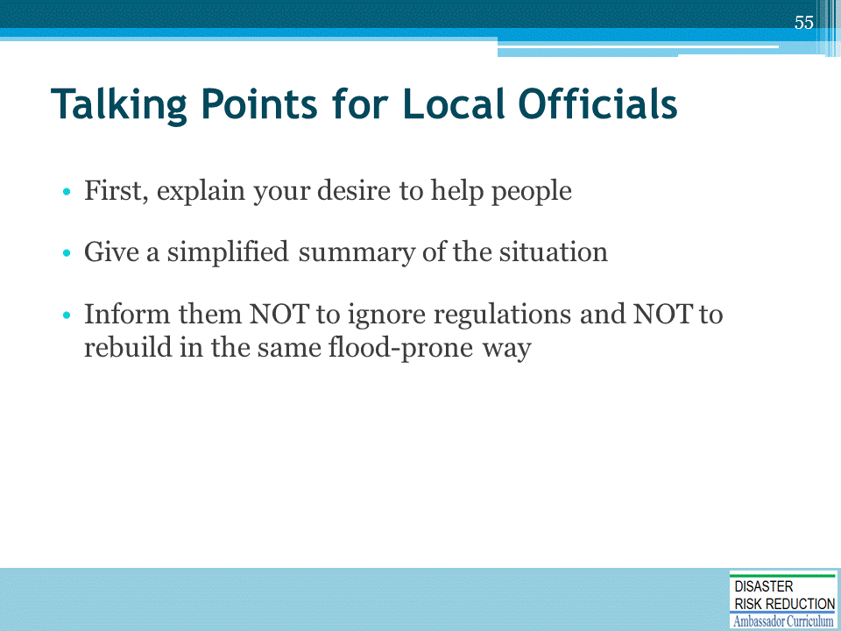
Ed Thomas:
- First, explained my desire to help people - told them that I wanted to help
- Gave people a simplified summary of the situation, explaining how the municipality will be at legal and NFIP risk for failing to fully enforce their regulations unless proper and safe rebuilding is enforced
- Instead of helping folks, ignoring regulations and allowing them to rebuild in the same old flood-prone way would facilitate a time bomb of misery for the residents and multiple future generations
Background:
- The State NFIP Coordinator’s Office sent Oklahoma Water Resources Board employees Gavin Brady, State Coordinator, and long time floodplain manager, Ken Morris, to provide technical support and guidance to local officials.
- Brady and Morris immediately called FEMA Region 6 for support and help in obtaining trailers to house the disaster survivors while a safe rebuilding process takes place.
- Brady and Morris also appealed to ASFPM Headquarters in Madison to provide legal & technical support to bolster State efforts to ensure proper, safe rebuilding.
- ASFPM asked Ed Thomas, an Attorney and Floodplain Manager, at the time employed by Michael Baker Inc., to help with some quick talking points for state officials to use.
- Morris and Brady presented these materials to the City at a large Public Meeting; the City was convinced to continue to enforce their existing floodplain regulations.
- Morris summed up this ongoing success story up by indicating that success was due to the leadership of local officials with the help of the OWRB. “I also believe the Patchwork Quilt document and Ed's words were overwhelmingly convincing,” says Morris.
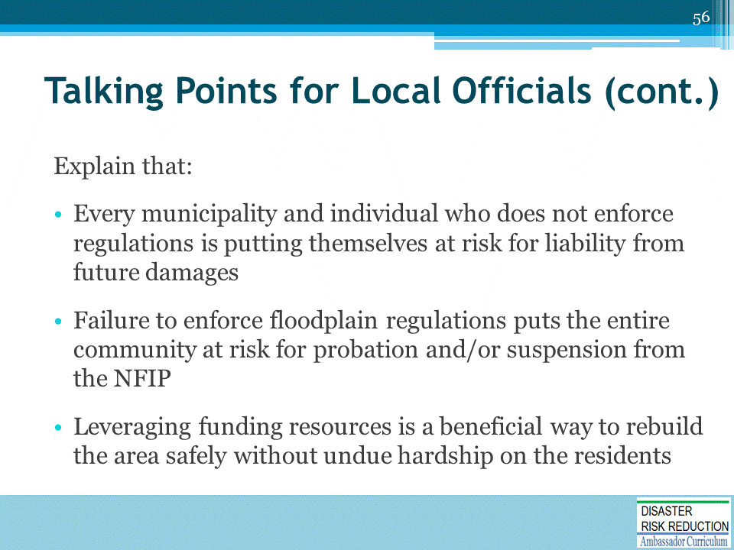

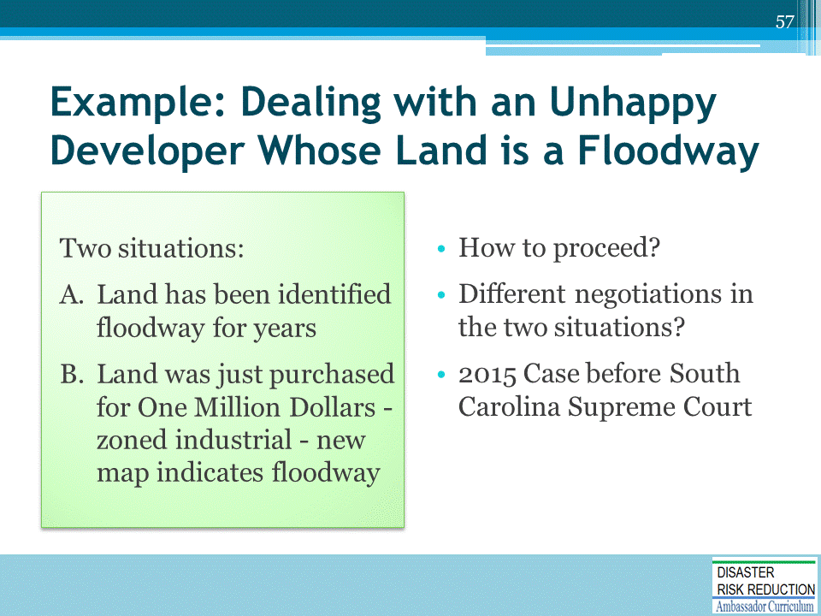
Case before South Carolina Supreme Court from Rob Thomas Inverse Condemnation
No Taking When Owner Prohibited From Developing In Floodplain
- The headline of this post shouldn't be that surprising, especially when the property owner purchased the land already subject to a floodplain designation, and those regulations effectively prohibited development.
- But the two twists in the South Carolina Supreme Court's opinion in Columbia Venture, LLC v. Richland County, No. 27563 (Aug. 12, 2015), were (1) when Columbia Venture purchased the land, the floodplain designation didn't encompass as much of the land as it eventually did, and the larger area was only preliminarily designated, and (2) various county agencies had informed Columbia that there was a chance it might get permission to build even if the regulations were eventually adopted.
- Those twists, however, were not enough to save Columbia's takings claim, and the court rejected both its categorical and Penn Central arguments.
- The facts of the case are somewhat dense, but here's what you need to know. Columbia purchased the property knowing that prior potential buyers (including Columbia's own managing member) had declined to purchase the land because they understood that a large portion of the 4,000 acre parcel next to the Congaree River was in a FEMA-designated floodplain. FEMA updates its floodplain maps every five years, and prior to Columbia's purchase, FEMA preliminarily expanded the floodplain-designated land to encompass nearly 3/4 of the parcel. Between the time FEMA publishes its proposed new maps and their official adoption, the new floodplain designations are required to be recognized by local authorities.But after consultation with county agencies that resulted in a memorandum of understanding that stated the county would consider Columbia's development proposal, Columbia purchased the land anyway, intending to build a $1 billion residential-resort-retail development.
- When the inevitable occurred -- FEMA officially adopted the proposed maps, which prohibited Columbia from developing its land -- it sued in state court for a regulatory taking of its property.
- By consent, the case was tried by a referee, who granted the county summary judgment. The FEMA designation certainly significantly decreased the value of Columbia's land, but the referee concluded this was outweighed by Columbia's unreasonable expectations, In other words, it was not reasonable for Columbia to have purchased the land knowing about the impending floodplain restrictions.
- The South Carolina Supreme Court affirmed. It rejected Columbia's argument that the development prohibition was like a flowage easement, holding instead that it was a garden-variety land use restriction and not a physical taking, as when government action causes flooding. In contrast to government-caused flooding, FEMA's floodplain designation and the county's resultant prohibition on development, did not cause any invasion of Columbia's land. Any flooding that might occur was a result of natural forces, and not government regulation or action.
- Applying Penn Central, the Supreme Court agreed with the referee and concluded that the floodplain designation did not result in a regulatory taking either. As noted above, the key factor was the "distinct investment-backed expectations" prong, and the court held that the overall regulatory scheme had been adopted decades before Columbia's purchase, Columbia's own managing member had backed out of an earlier proposed purchase because of the uncertainties which resulted from a floodplain designation, and Columbia knew the county and FEMA regulations combined to make development impossible in the portion of the property designated as a floodplain. Yes, Columbia had subjective expectations that, "in spite of all this, it would nevertheless be allowed to develop the extensive Green Diamond project," but the court concluded that expectation "was not objectively reasonable." Slip op. at 21.
- Finally, the character of the government action prong weighed against a taking, because the floodplain designations were designed to mitigate the costs of expected flooding along the river, and the regulations don't single out a particular property owner to shoulder public burdens that should be borne by all. All riverfront property is subject to floodplain restrictions.
- So there you go. Not an unexpected result mind you, and we were somewhat surprised that the two twists were enough to get this one the full-blown treatment by the South Carolina Supreme Court.
Columbia Venture, LLC v. Richland County, No. 27563 (S.C. Aug. 12, 2015)

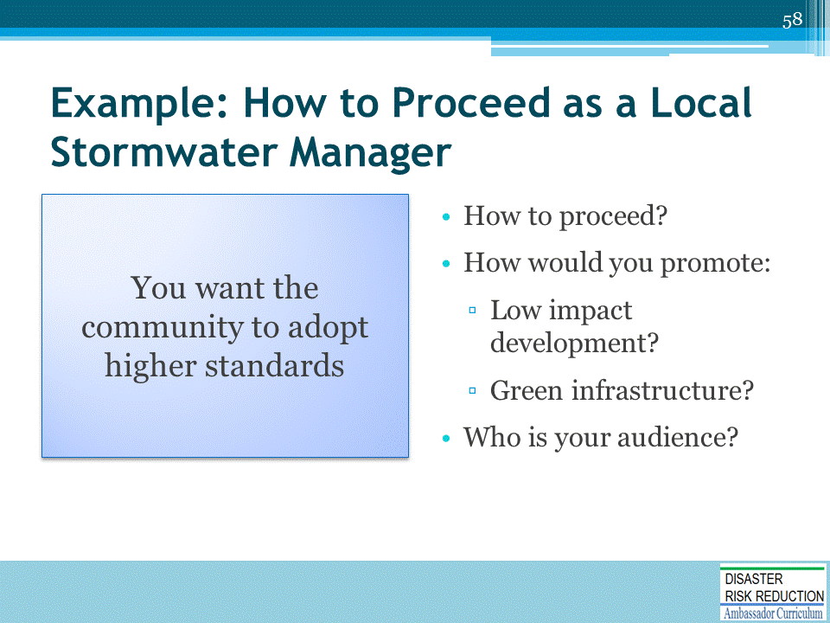

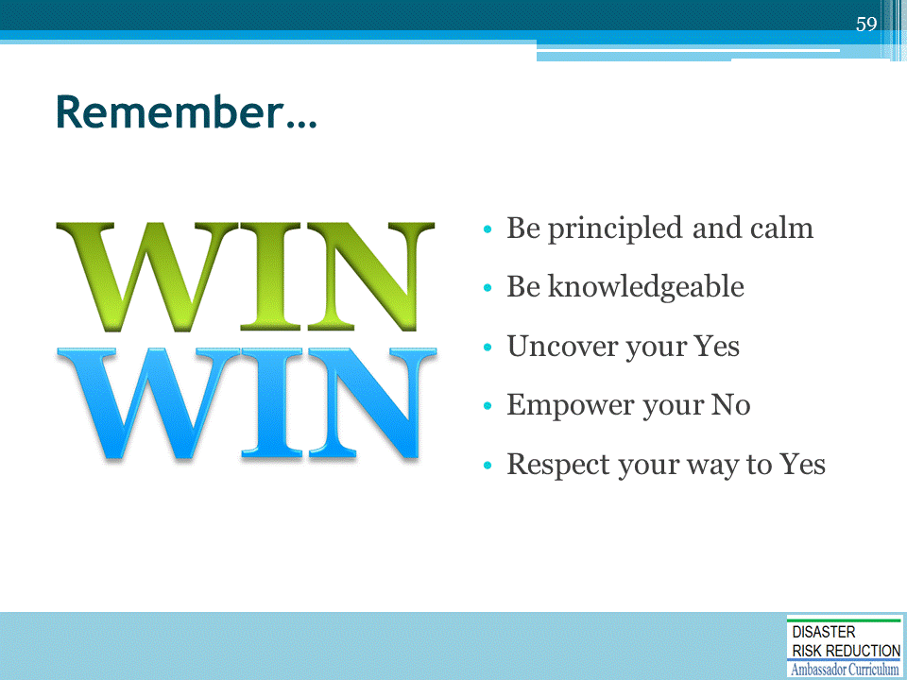

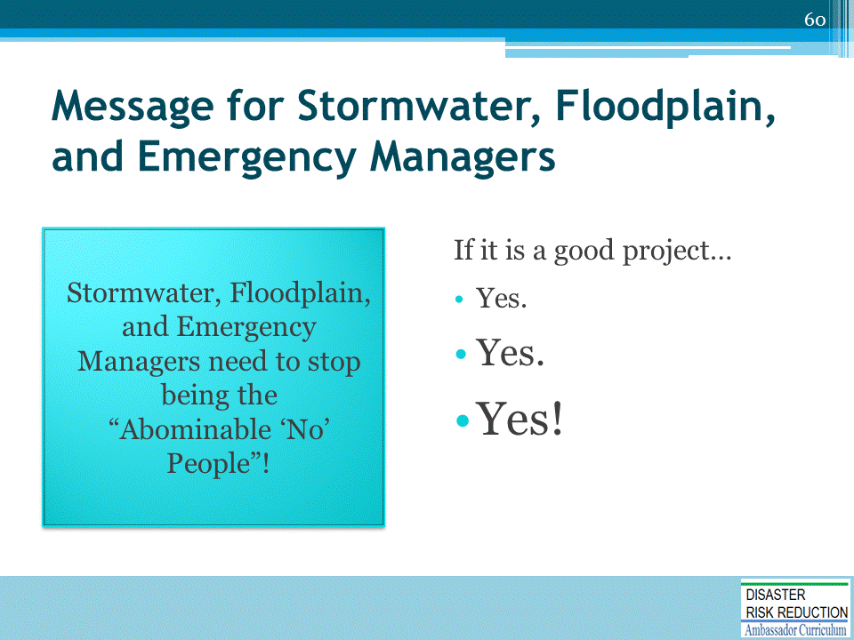

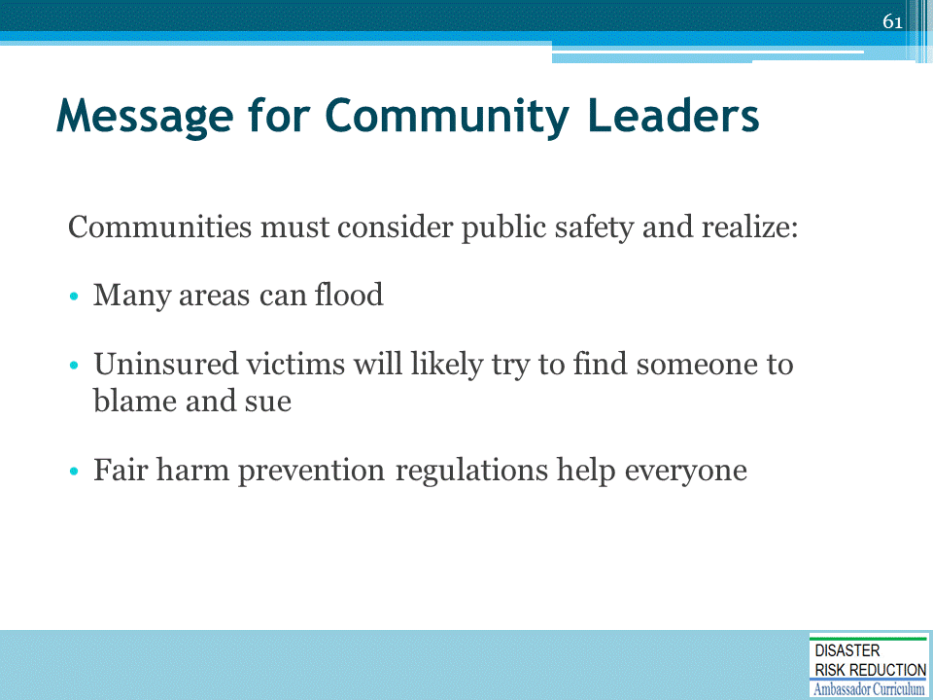
- Three messages
- This is especially important for levee owners or operators.
- They should want all potentially affected by the failure of their facility to have flood insurance to protect their home, pension, community funds.

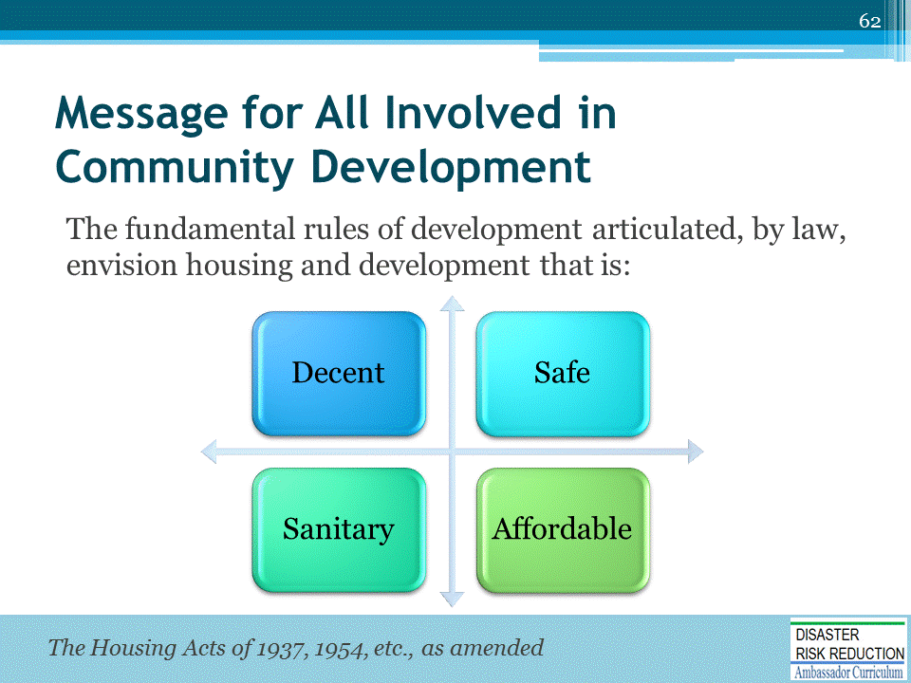

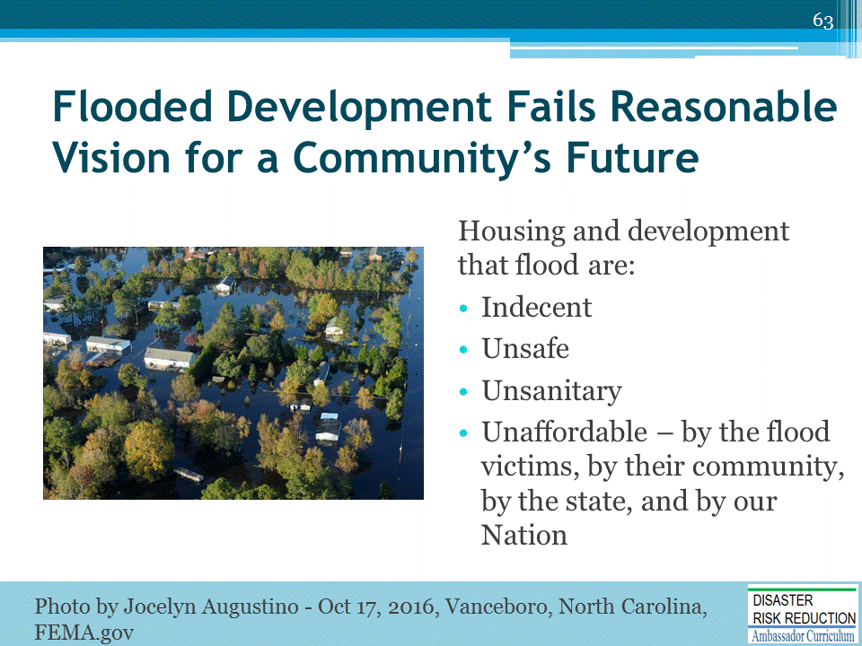
Photo: Vanceboro, NC, USA--October 17, 2016--Floodwaters remain high and surround many houses in Craven County. Residents impacted by the recent flooding are encouraged to call FEMA to register for assistance. Photo by Jocelyn Augustino

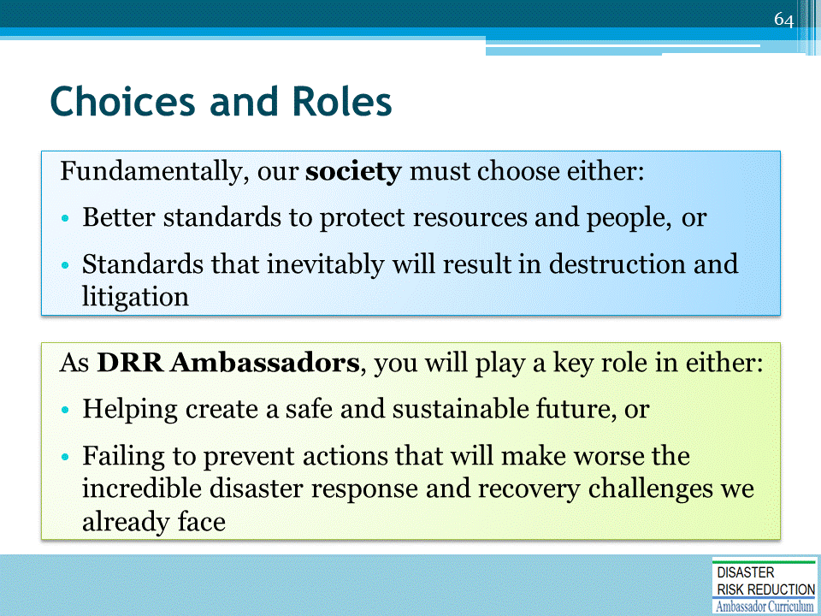

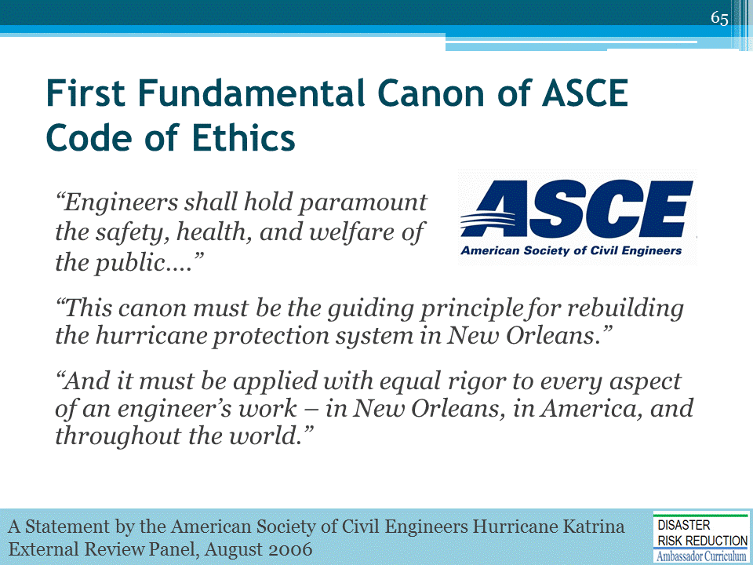
This quote if from A Statement by the American Society of Civil Engineers Hurricane Katrina External Review Panel issued late August 2006.

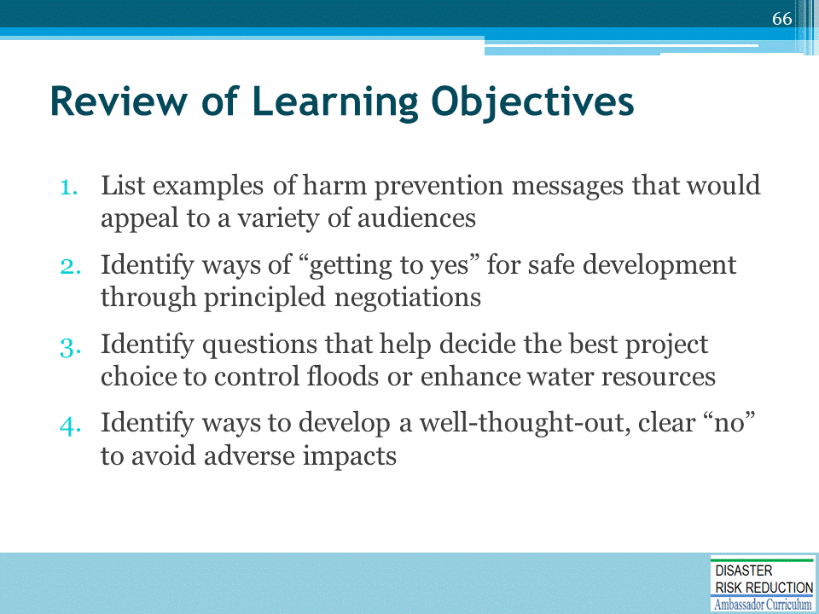
Discussion to engage participants and to assist achievement of Learning Objectives.

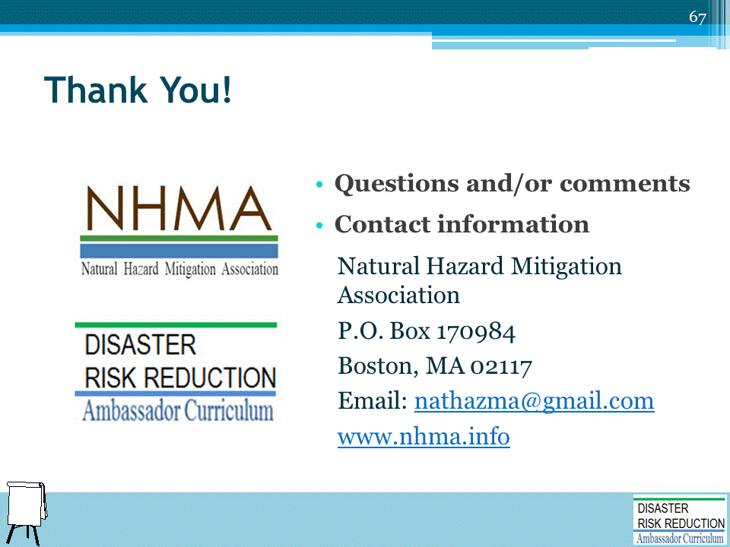
Record on easel pad any recommendations or questions to be addressed outside of the presentation.

DRR AMBASSADOR CURRICULUM AT-A-GLANCE
I. Disaster Risk Reduction for a Safe and Prosperous Future
1 | Introduction to the Natural Hazard Mitigation Association and Disaster Risk Reduction Ambassador Curriculum
2 | Introduction to Disaster Risk Reduction as a Foundation of Community Resilience
3 | Leadership for Disaster Risk Reduction
4 | Community Disaster Risk Reduction and Adaptation
5 | Approaching the Challenge of Disaster Risk Reduction: NIST Community Resilience Guide
II. Forming a Community’s Vision for Disaster Risk Reduction
6 | Risk Assessment through Storytelling: An Asset-Based Approach
7 | Achieving Community Buy-in for Disaster Risk Reduction: Win-Win Approaches
8 | Leveraging Resources to Improve Disaster Risk Reduction
III. Realizable, Practical, and Affordable Approaches for Moving from a Vision for Disaster Risk Reduction to a Strategy
9 | Selecting and Implementing a Strategy for Addressing Community Disaster Risk Problems
10 | Integrating Hazard Mitigation into Local Planning
11 | Beyond Codes and Low-Impact Development
12 | Creating the Plan: A Sustainable Floodplain Management Process Model
IV. Resources and Tools for Implementing a Community’s Disaster Risk Reduction Strategy
13 | Climate and Weather Tools and Trends
14 | Risk Assessment Basics
15 | Legal and Policy Opportunities for Disaster Risk Reduction
16 | Linking Catastrophe Insurance to Disaster Risk Reduction
V. Resources for Hazard-Specific Disaster Risk Reduction
17 | Living with Water: Inland and Coastal Flooding
18 | Design for Flood Resilience: Part I: Floodplain Management and Flood Resistant Design
19 | Design for Flood Resilience: Part II: Green Infrastructure / Low Impact Development
20 | Overcoming Impediments to Flood Resilience: Paths Forward
21 | Wildfire Mitigation
22 | The Wildfire-Flood Connection
23 | Severe Thunderstorm/Tornado Safe Rooms
24 | From Policy to Engineering: Earthquake Risks

