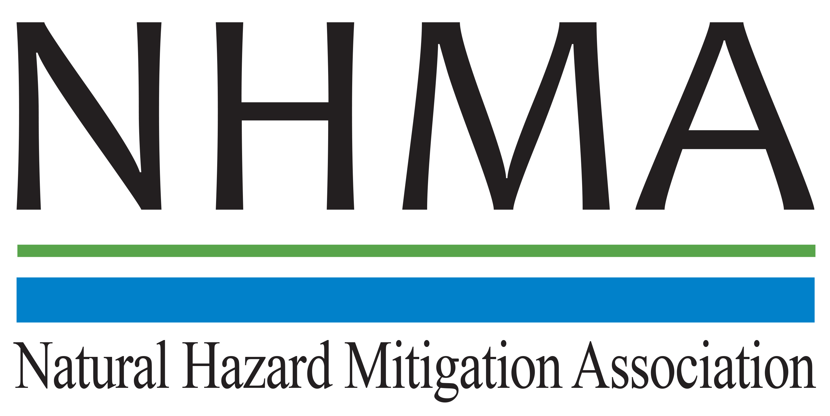

Disaster Risk Reduction (DRR) Ambassador Curriculum

Participant Guide

Module 7:

Achieving Community Buy-in for
Disaster Risk Reduction:
Win-Win Approaches

THE DRR AMBASSADOR CURRICULUM
The goal of the DRR Ambassador Curriculum is to facilitate DRR efforts for the whole community by:
- Engaging in discussion of how disasters can be reduced through local action
- Sharing insights among local leaders and technical experts to enable the development of cross functional solutions
- Acquiring the best-available information, knowledge of best practices, and analytic tools to enable better-informed decisions before, during, and after disasters
There are 24-modules in the curriculum. The “DRR Ambassador Curriculum At-a-Glance” table, located at the end of this document, lists the modules of the Curriculum.
DRR-A CURRICULUM TARGET AUDIENCE
The target audience includes those involved in community development decision-making, such as local community staff, volunteer and stakeholder groups, and federal and state officials.
METHODS OF DELIVERY
There are three delivery methods by which you may be able to complete modules in the DRR-A Curriculum: via webinars hosted by NHMA or partner organizations; presented in conferences and/or classrooms by qualified DRR-A Curriculum instructor(s); or downloadable for individual study from the NHMA website. Watch the NHMA website for announcements about webinars and workshops that include the module(s) in which you are interested.
CERTIFICATES
- Certificates of Completion may be awarded by NHMA to participants who successfully complete NHMA-sponsored DRR Ambassador modules by attending and passing a short post-test.
- Certificates of Attendance may be awarded to participants who attend but choose not to take the post-test may be issued a Certificate of Attendance.
- A Disaster Risk Reduction Ambassador Certificate will be awarded to individuals who successfully complete all 24 modules.
Ask your certifying boards about acceptance of NHMA DRR-A certificates for continuing education credits.
MODULE 7 – ACHIEVING COMMUNITY BUY-IN FOR DISASTER RISK REDUCTION: WIN-WIN APPROACHES
The Learning Objectives for this module are:
- List examples of harm prevention messages that would appeal to a variety of audiences
- Identify ways of “getting to yes” for safe development through principled negotiations
- Identify questions that help decide the best project choice to control floods or enhance water resources
- Identify ways to develop a well-thought-out, clear “no” to avoid adverse impacts

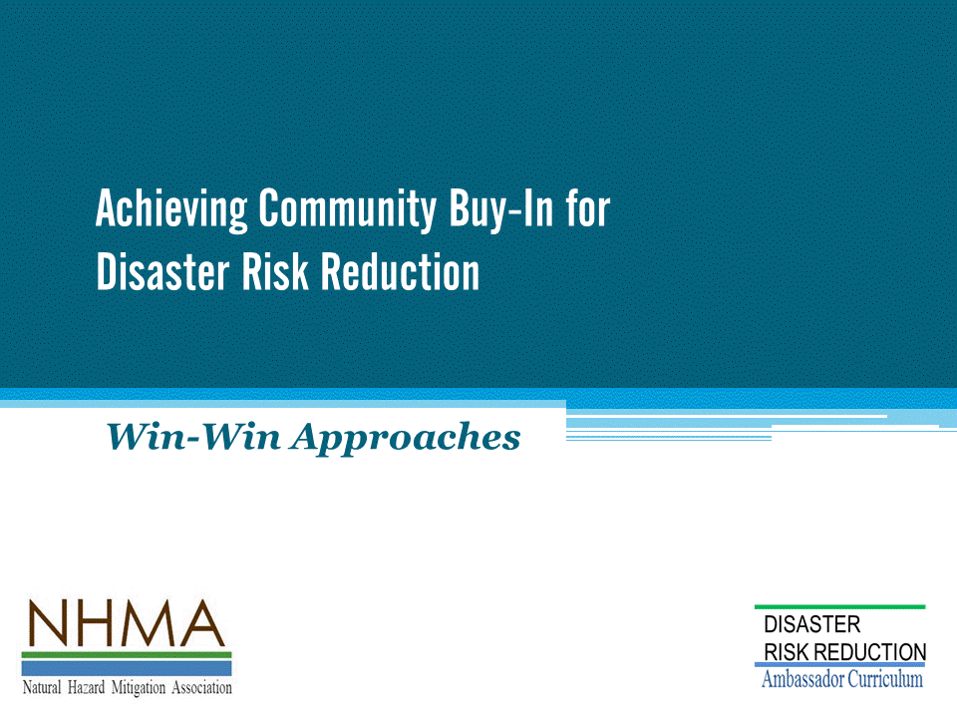

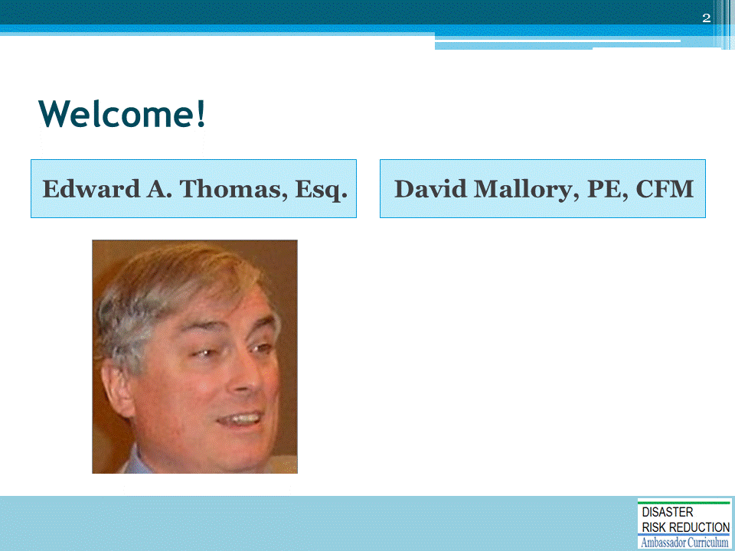

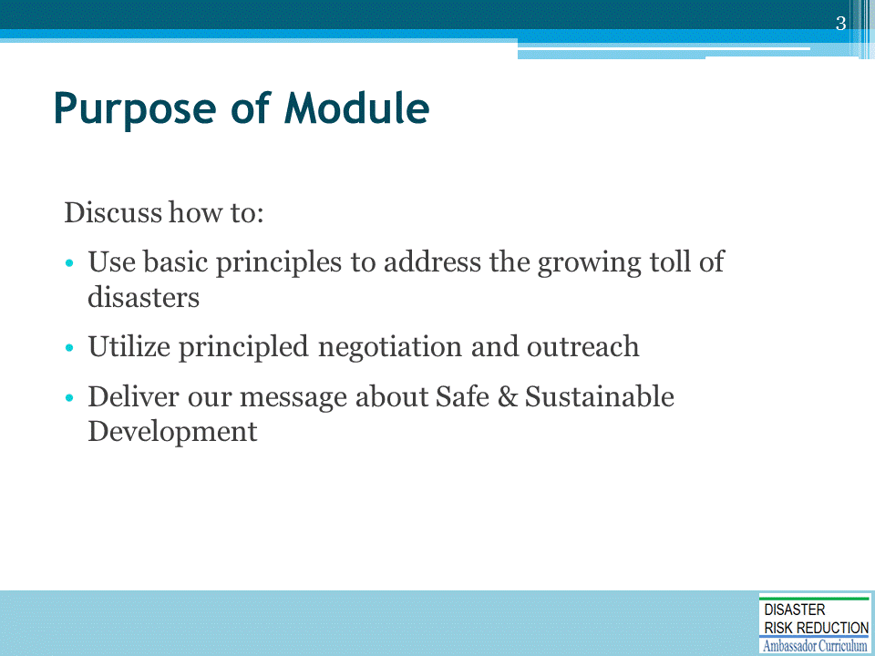

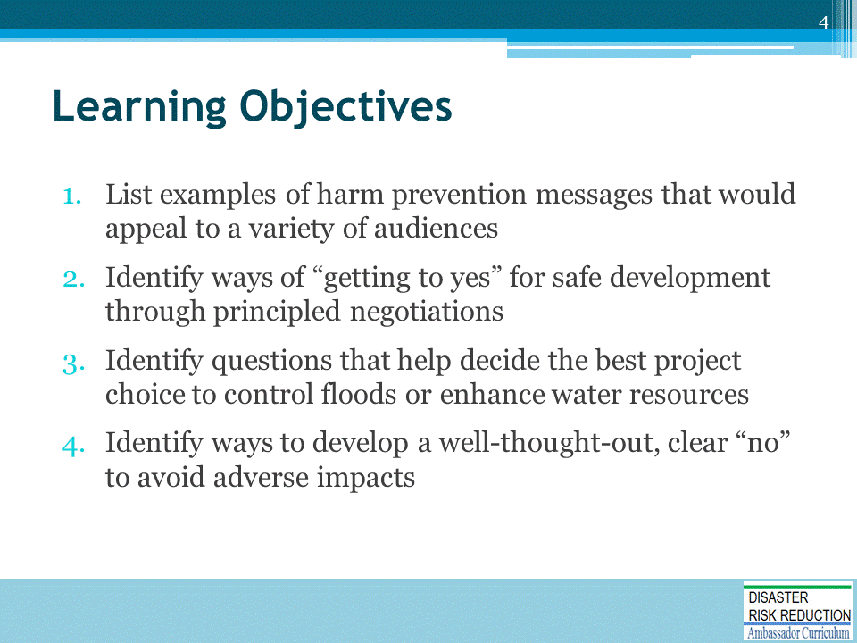

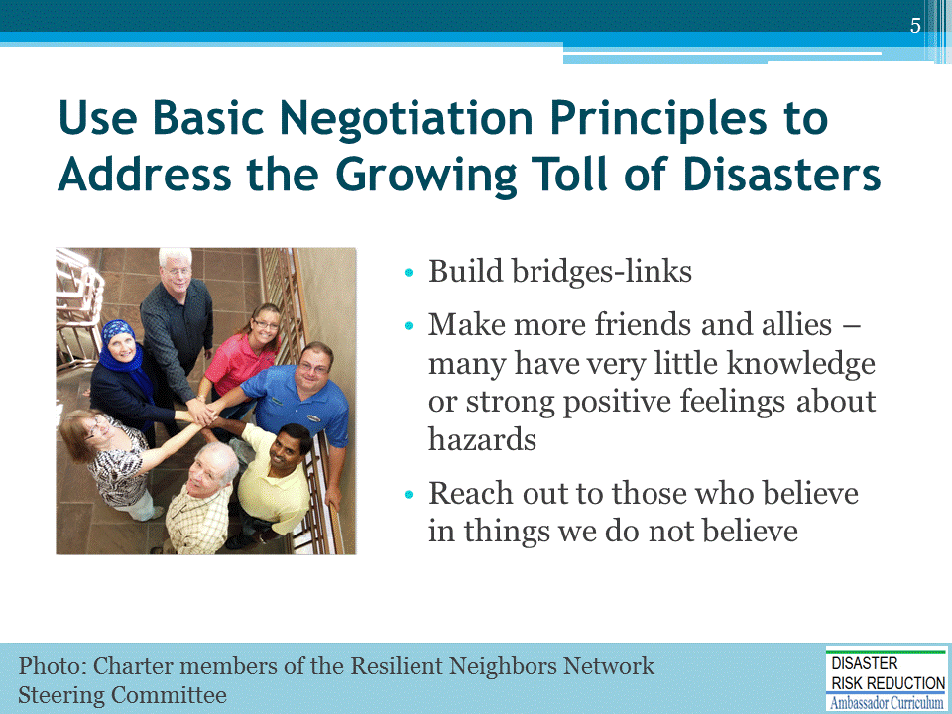

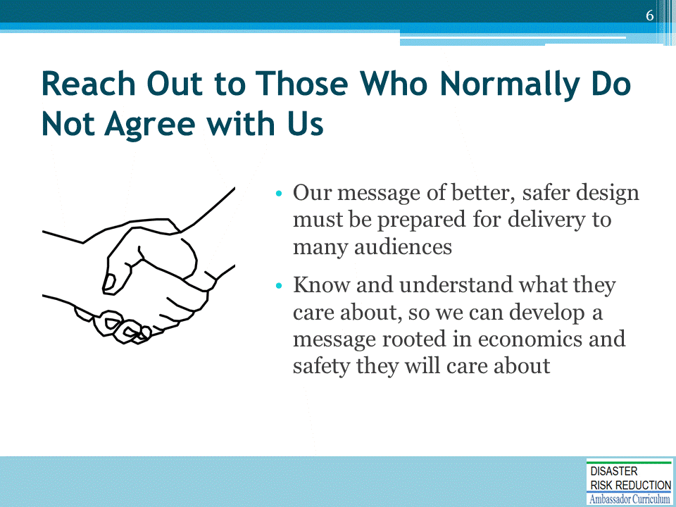

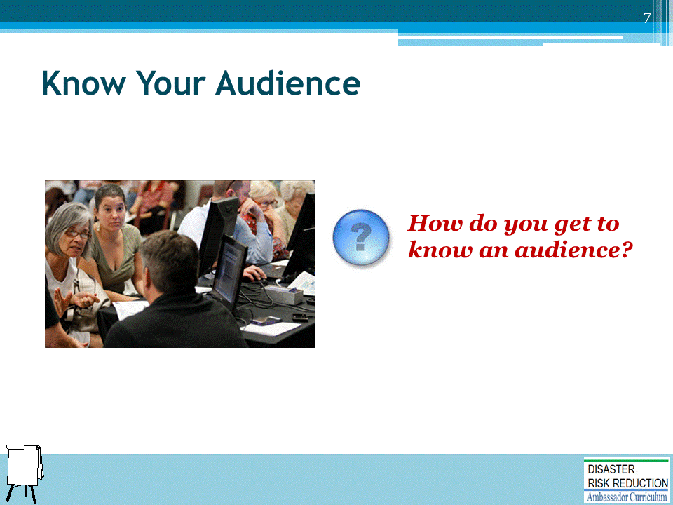

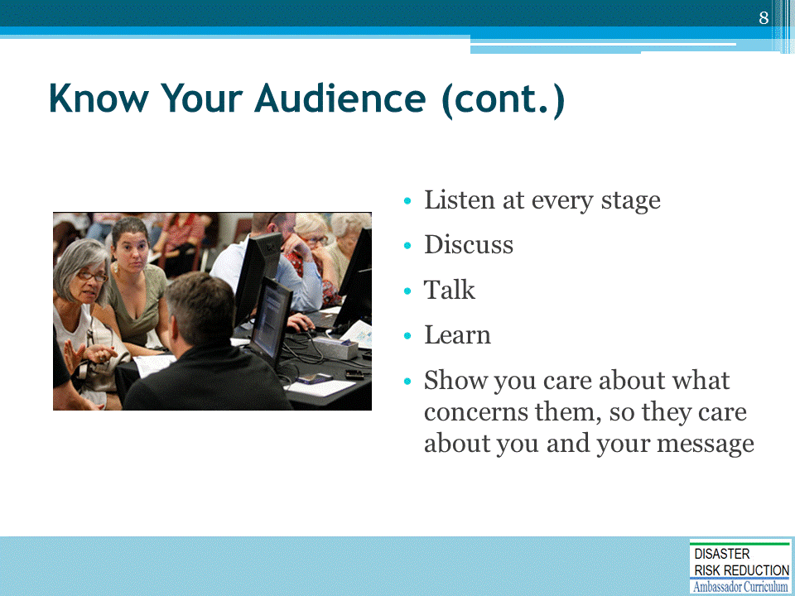

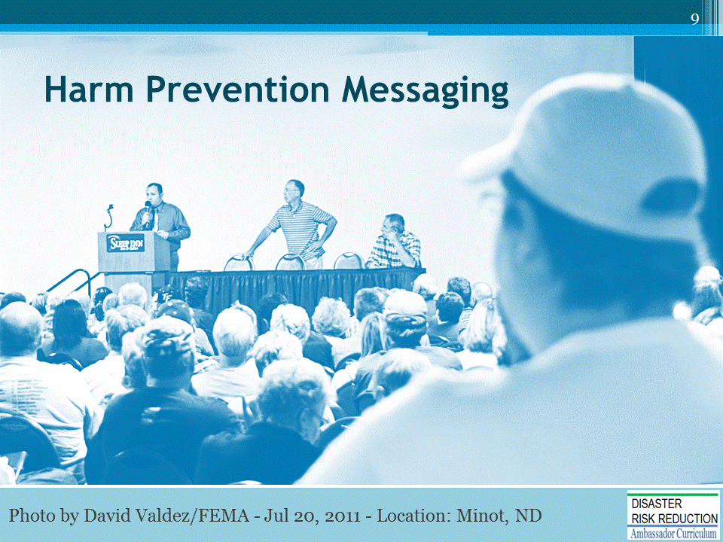

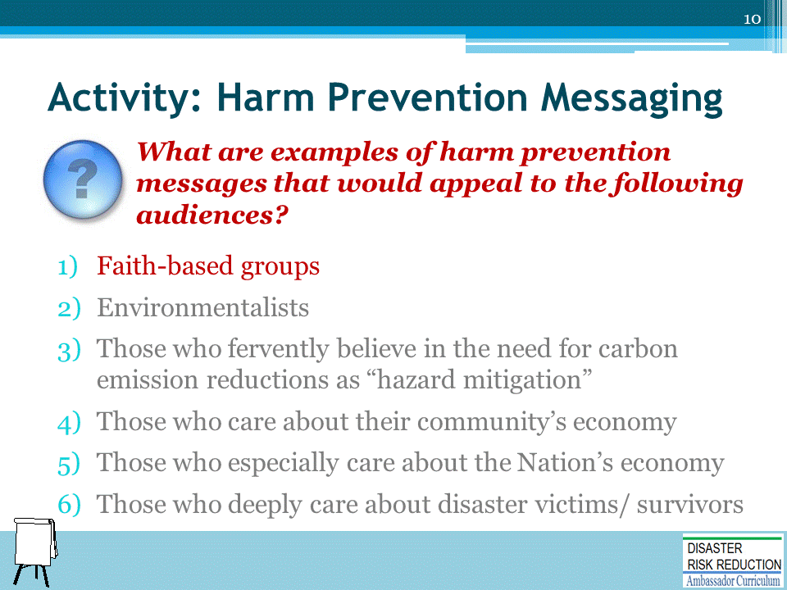

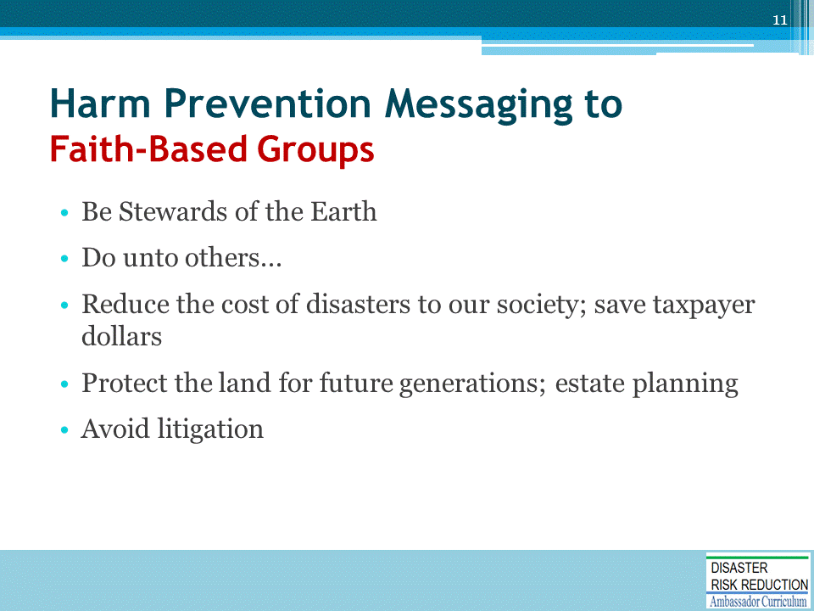

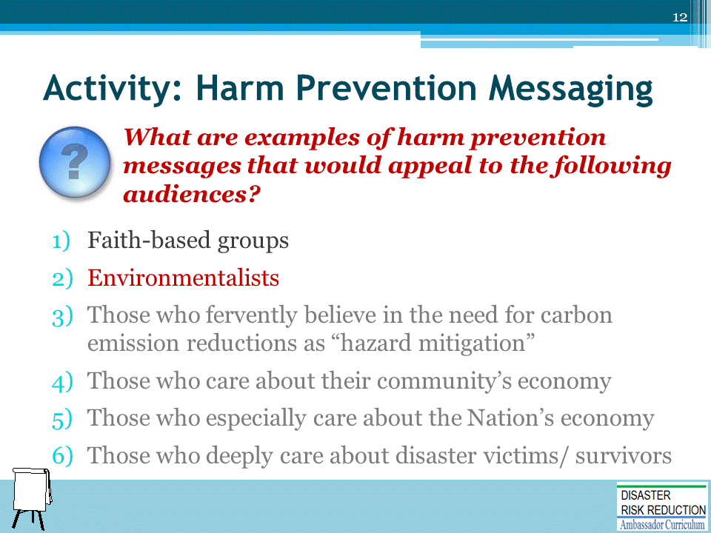

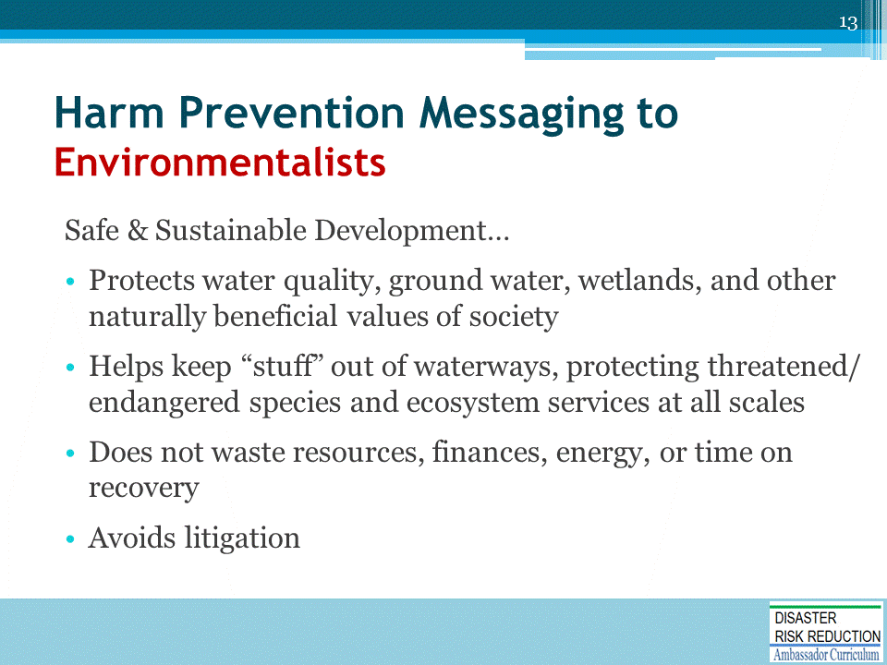

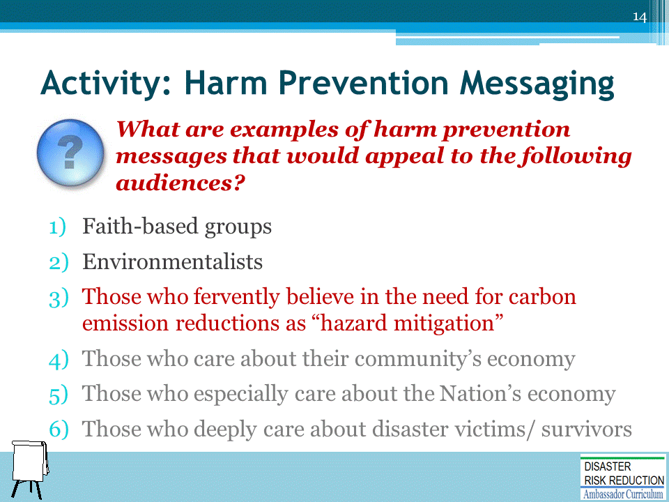

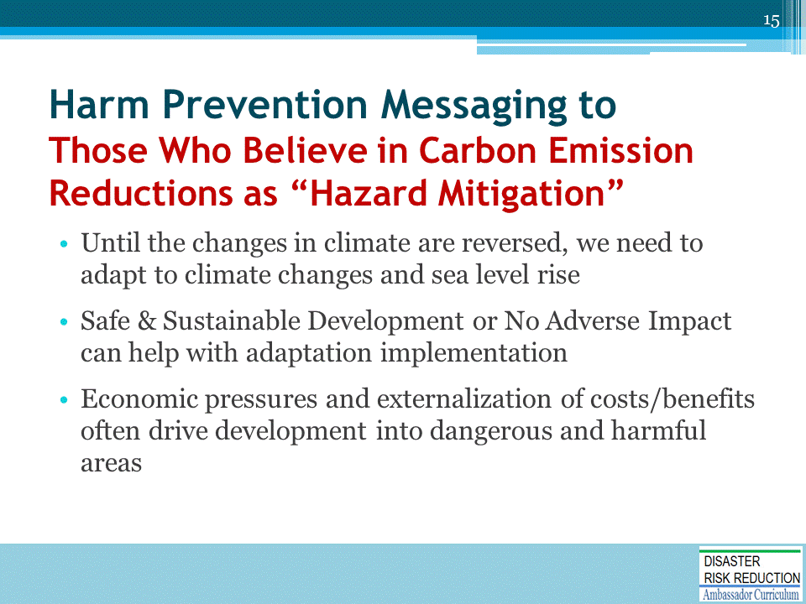

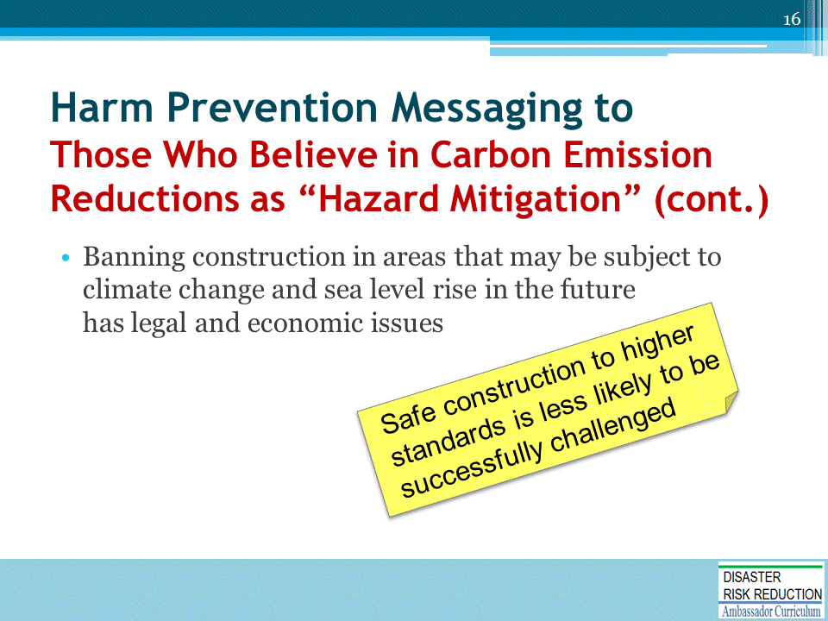

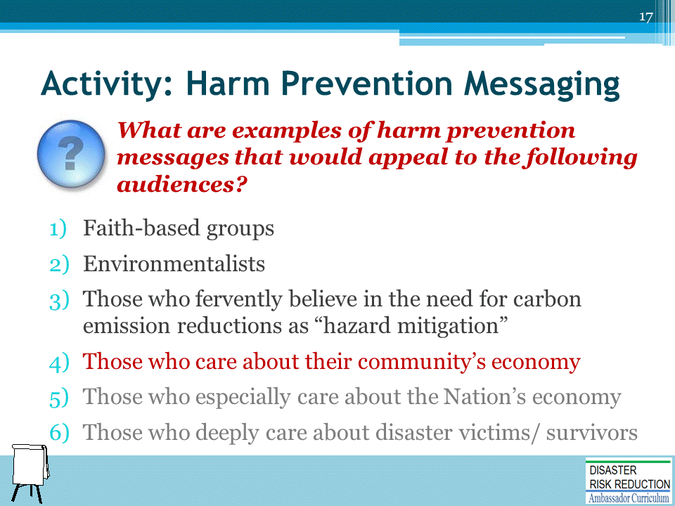

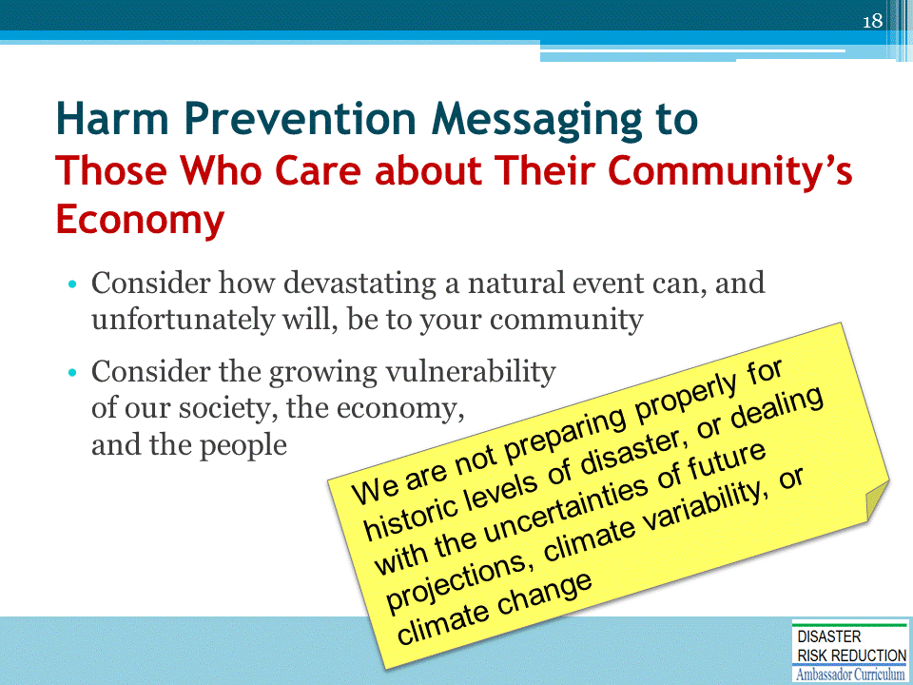

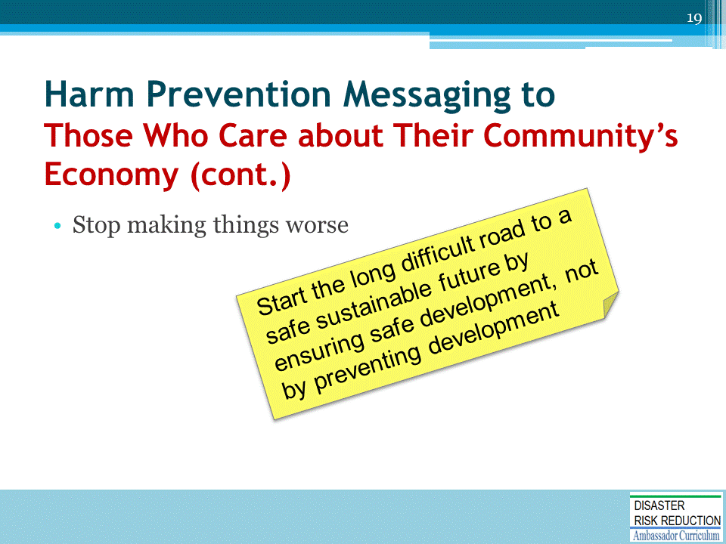

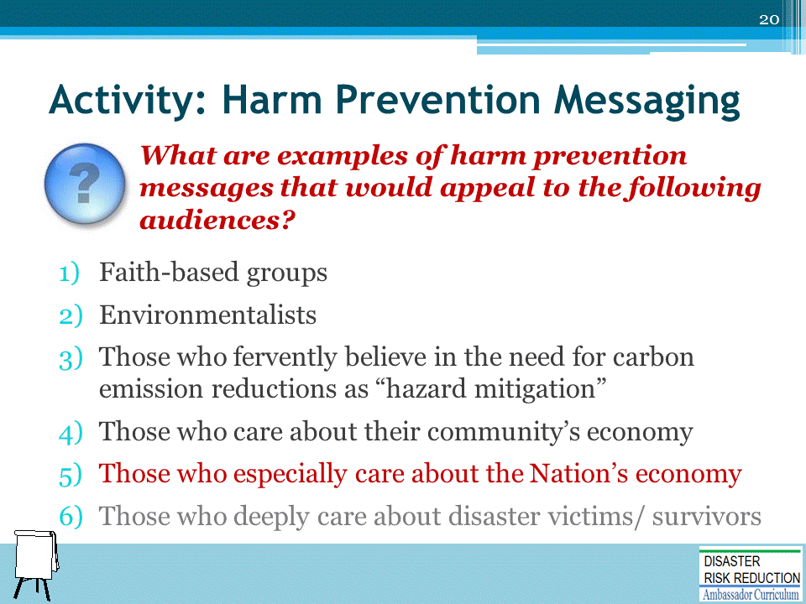

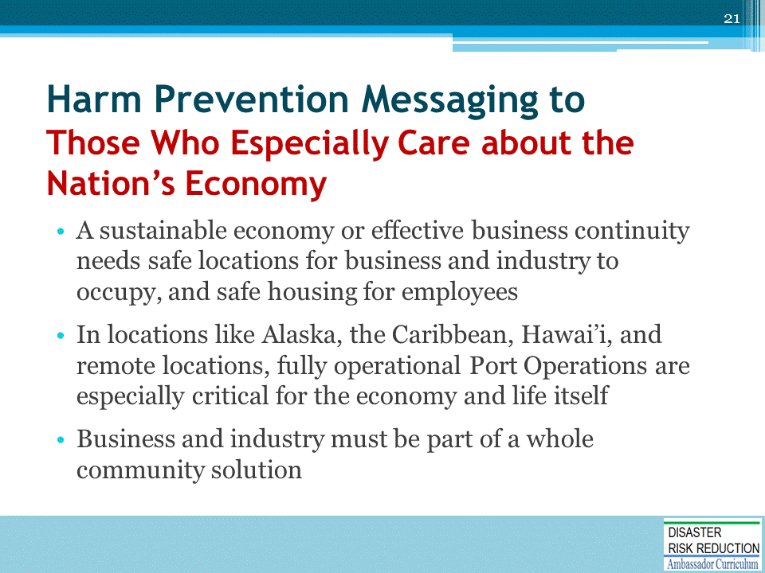

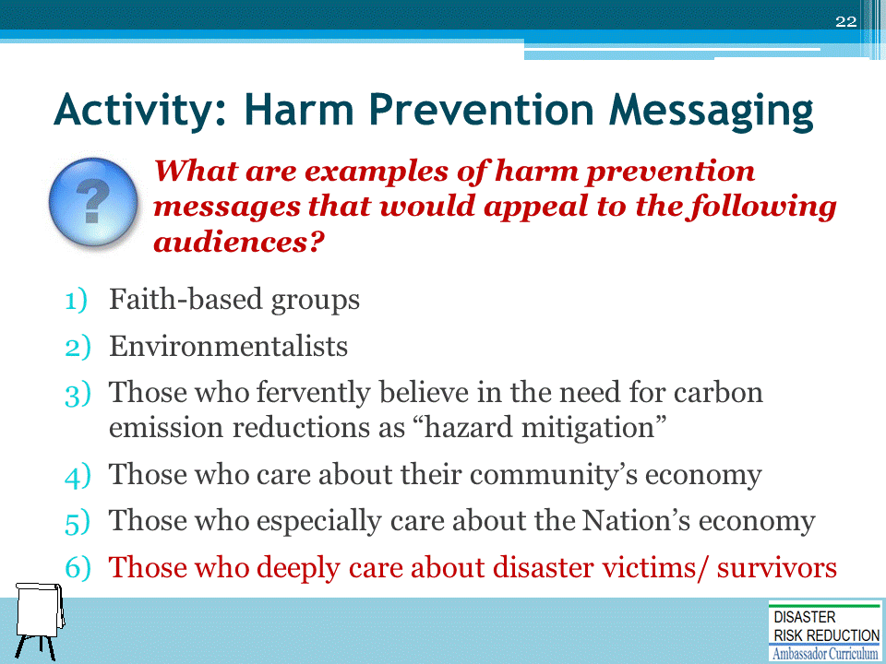

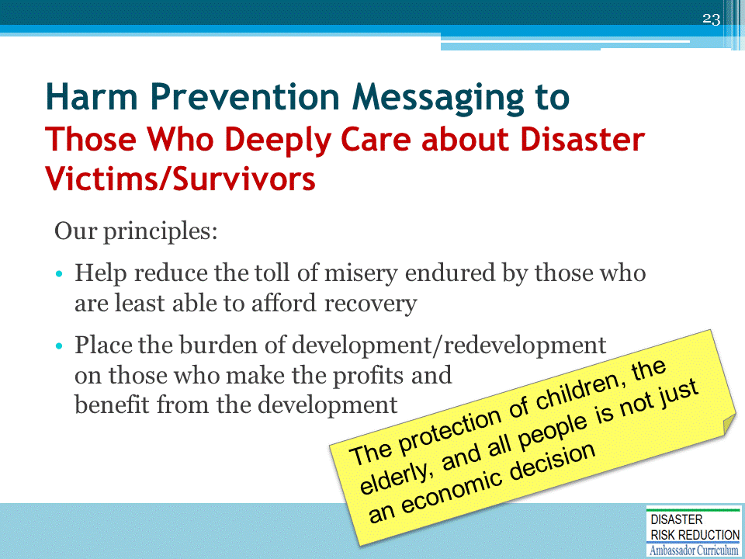

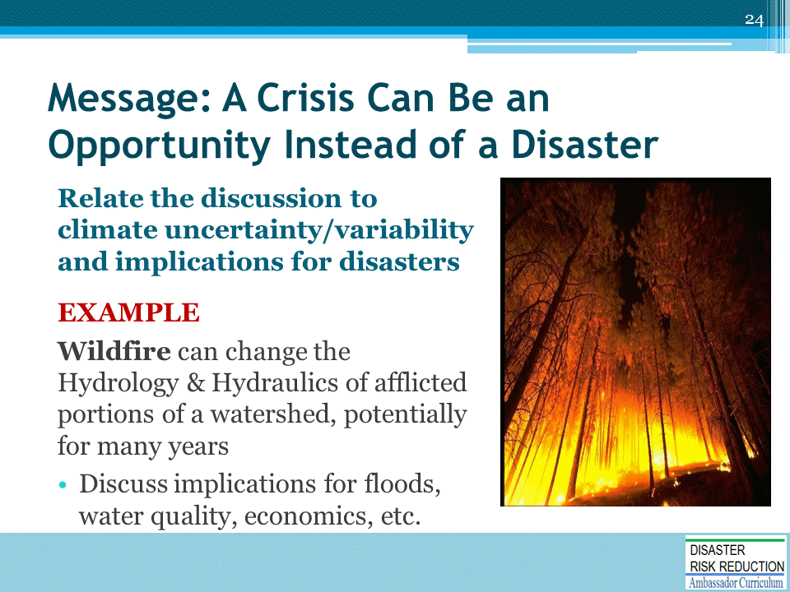

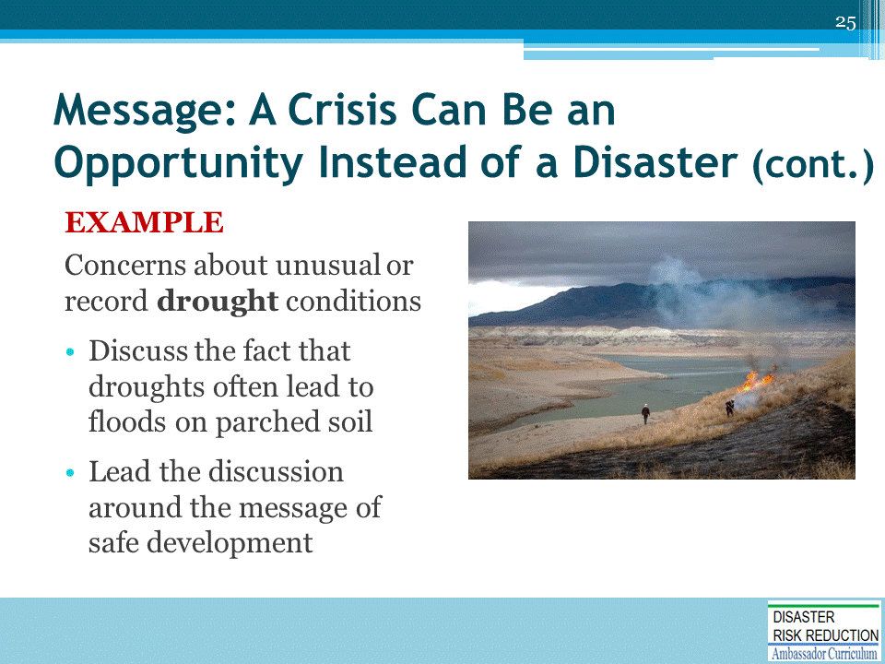

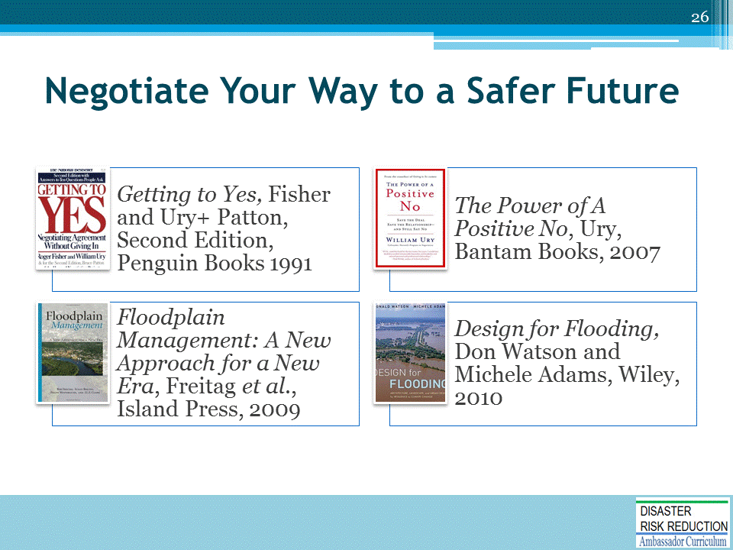

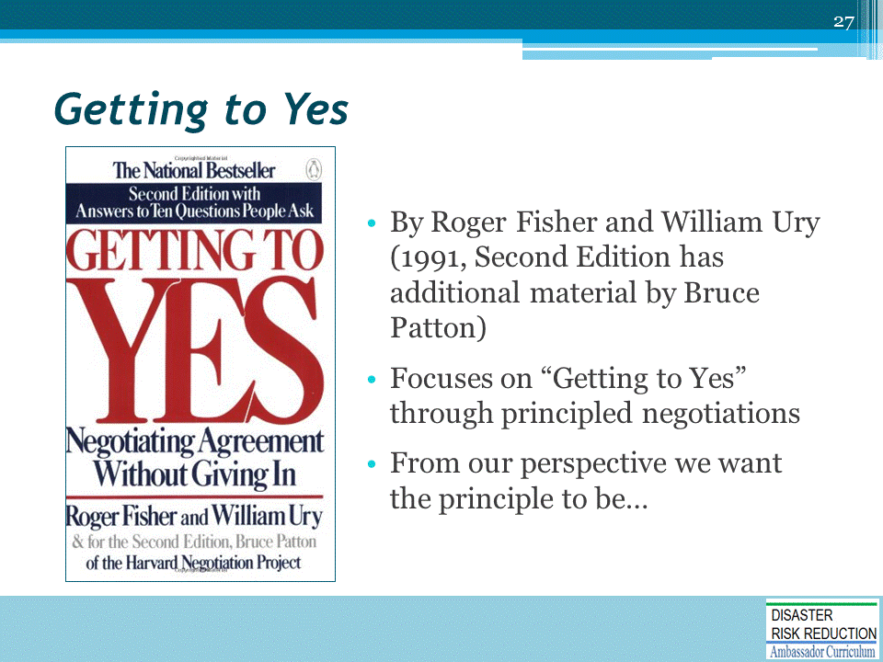

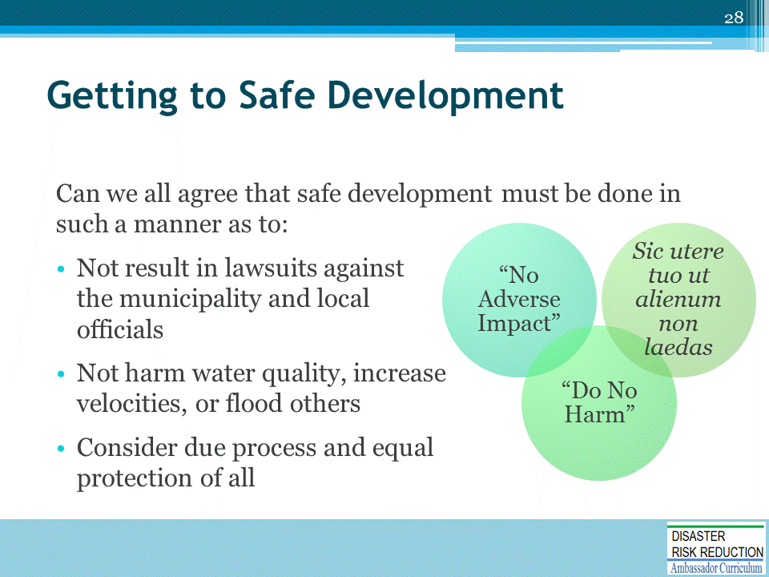

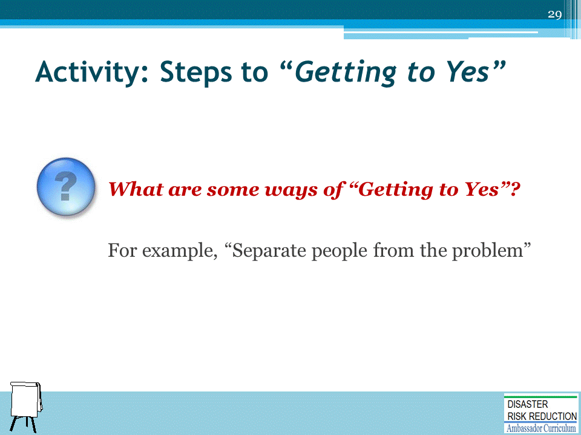

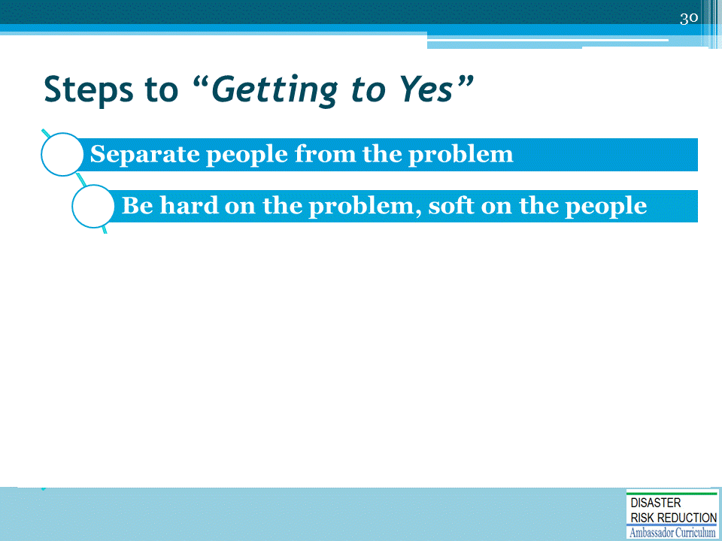

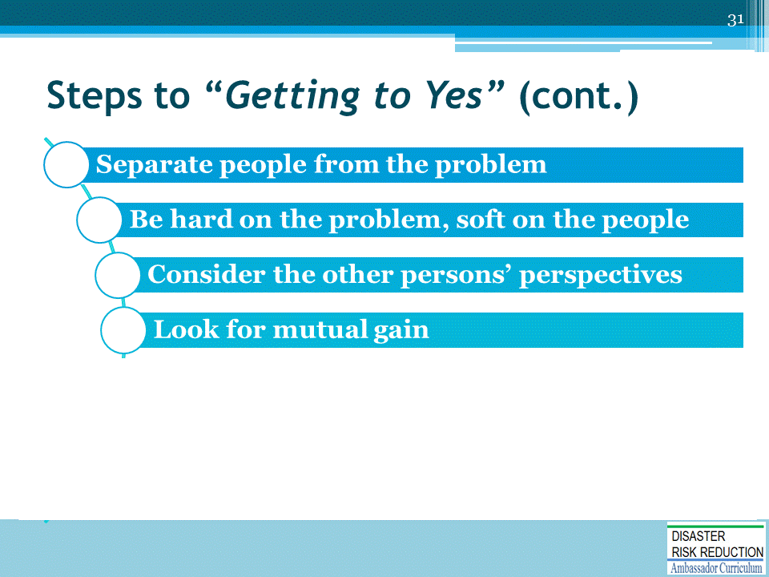

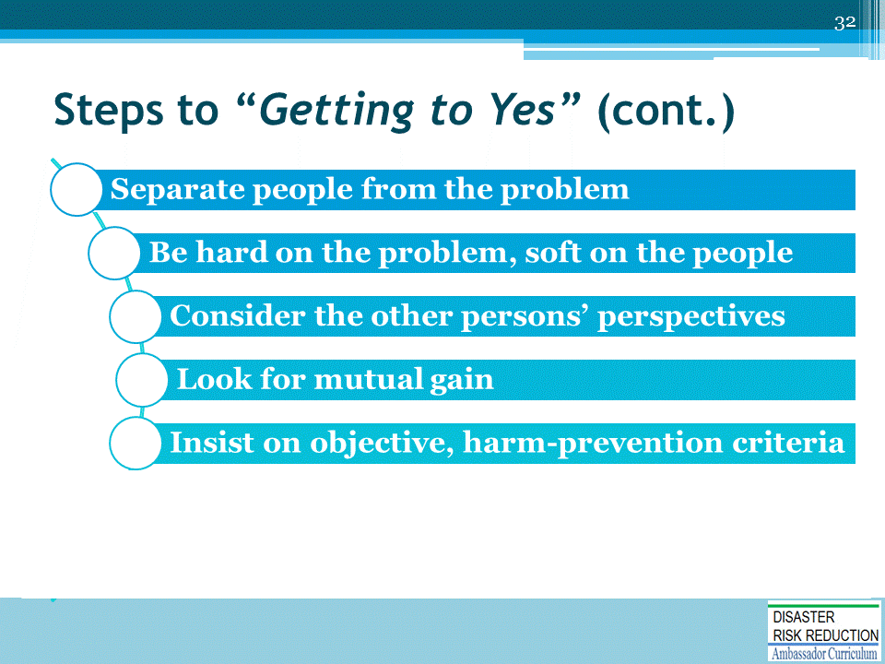

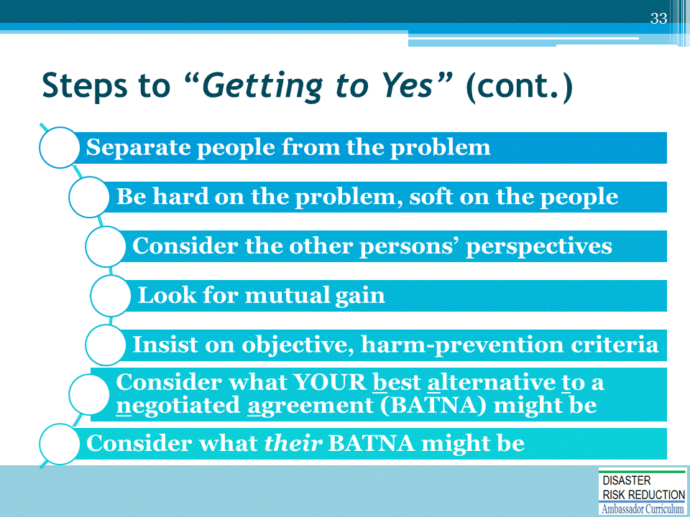

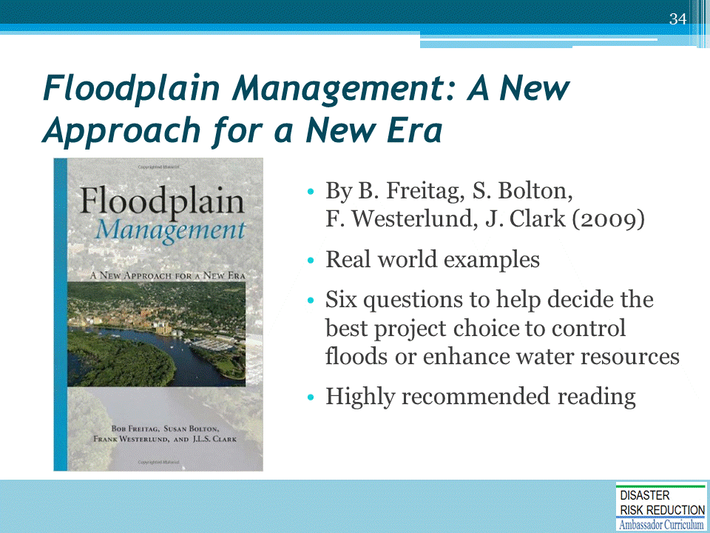

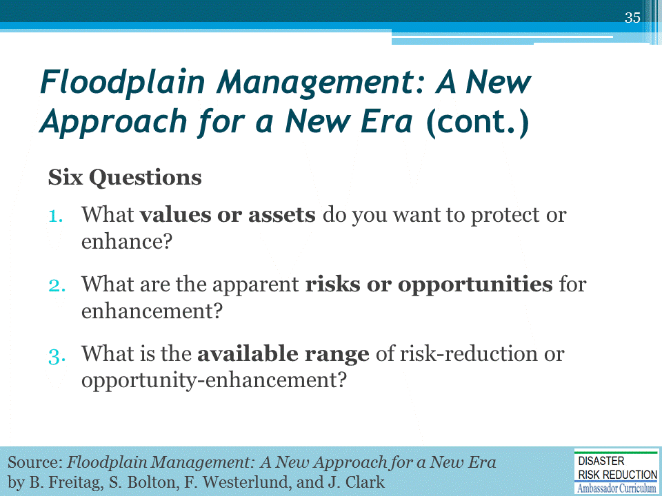

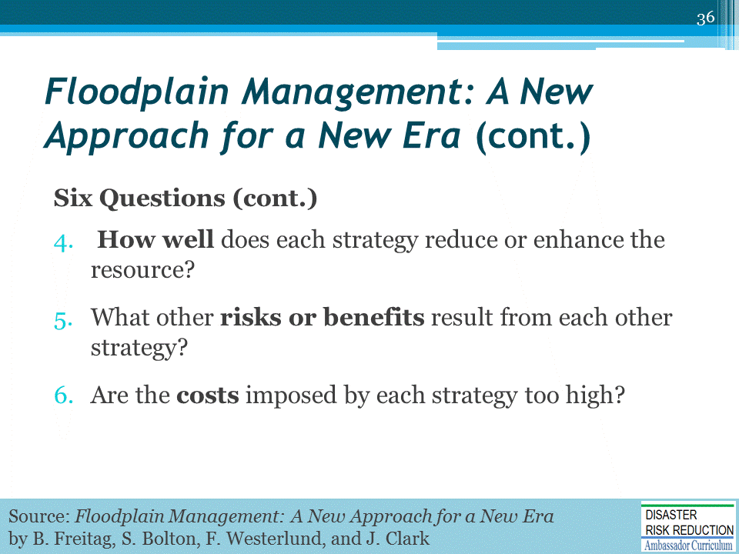

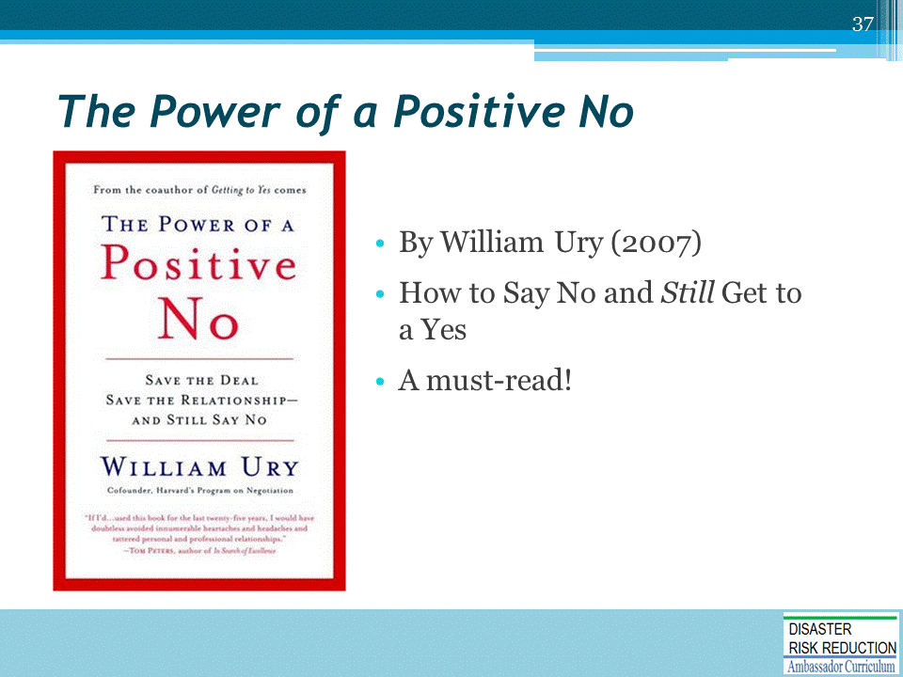

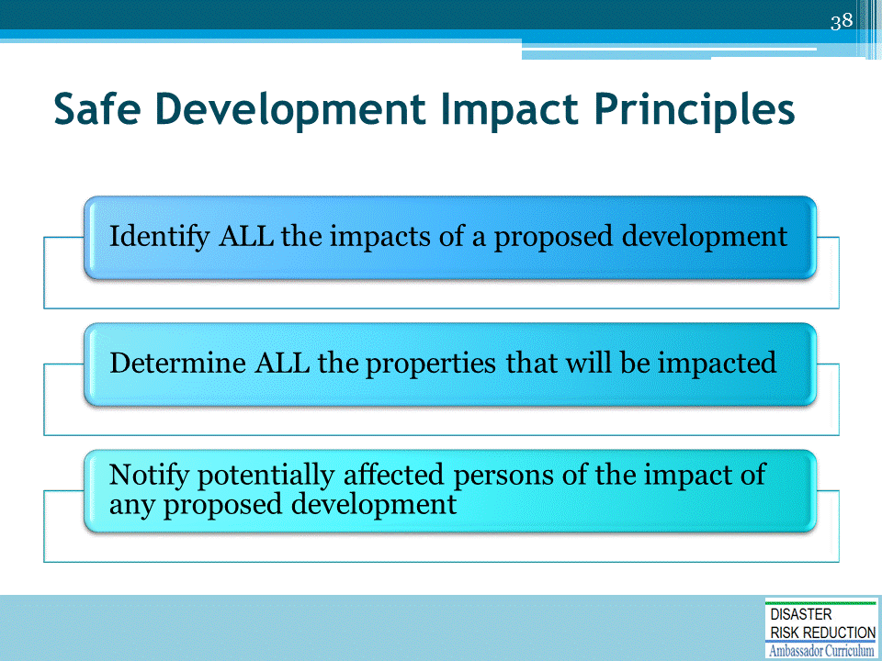

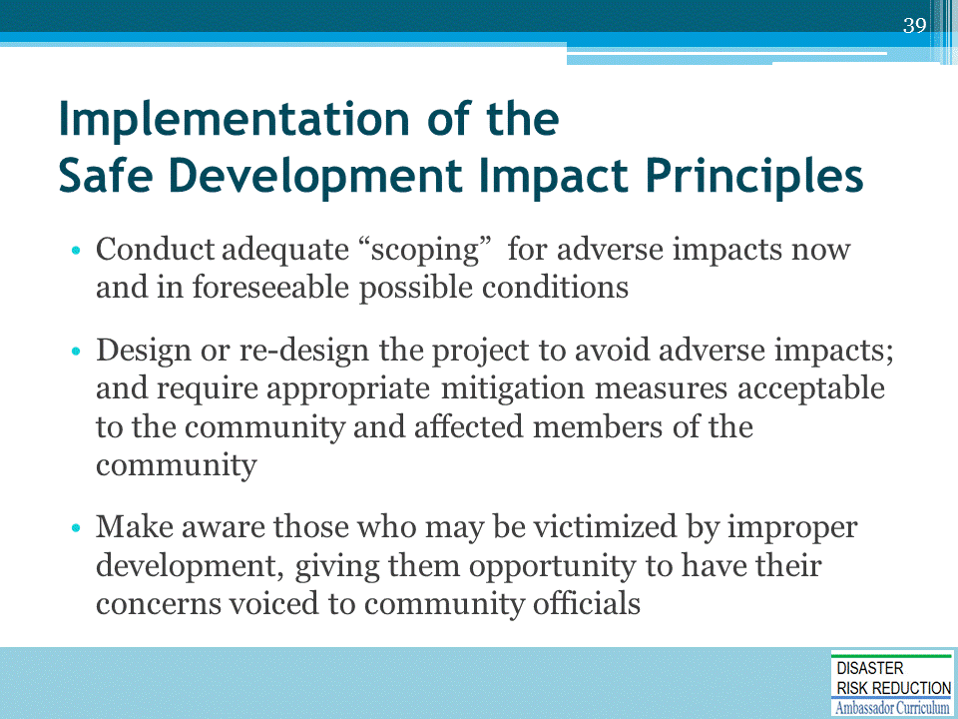

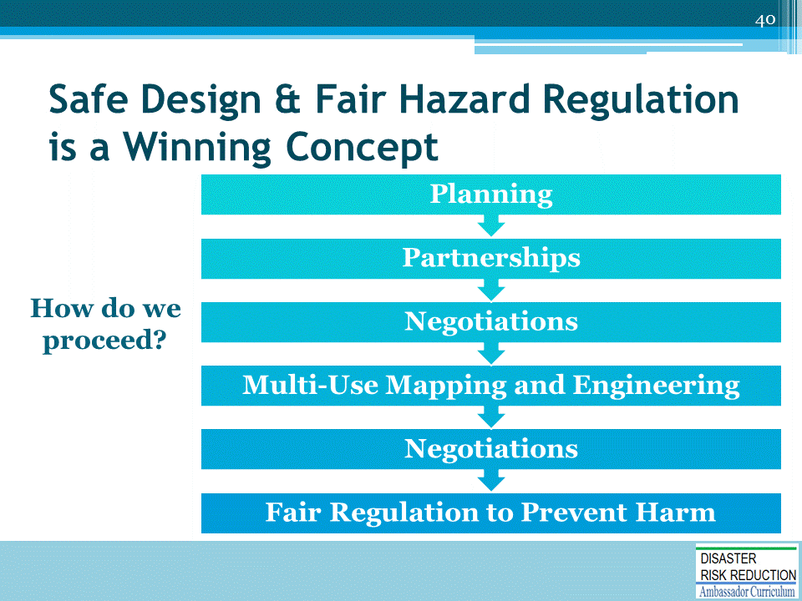

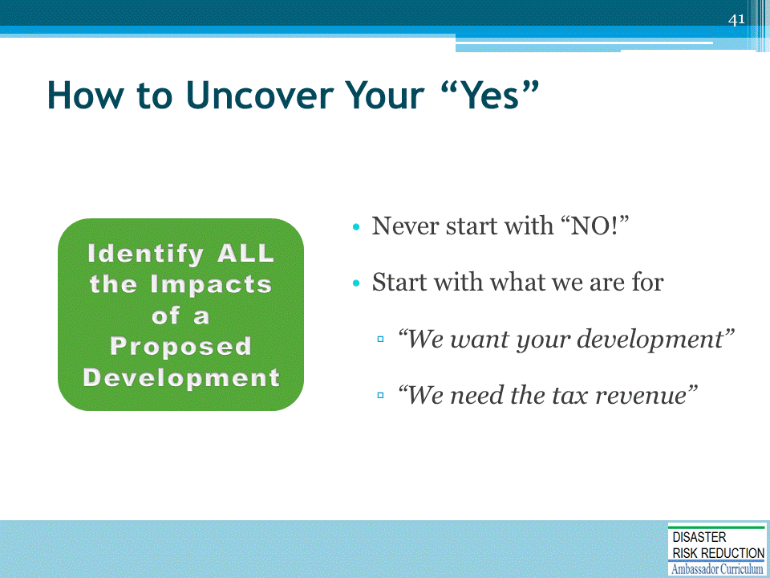

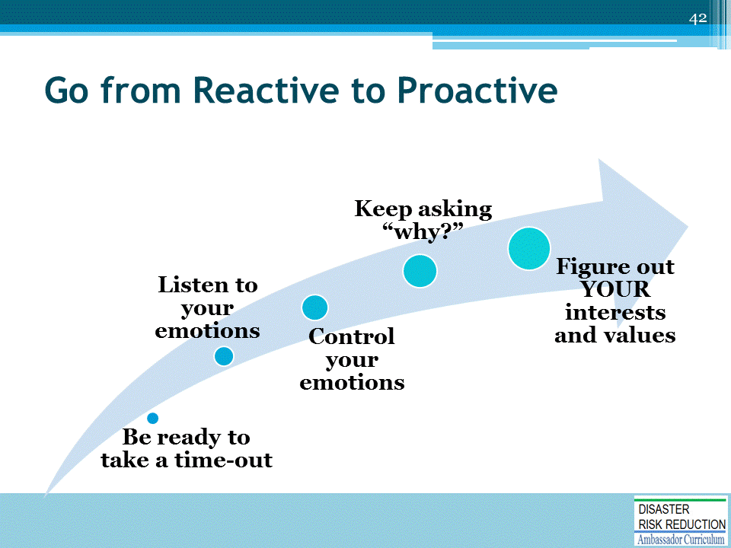

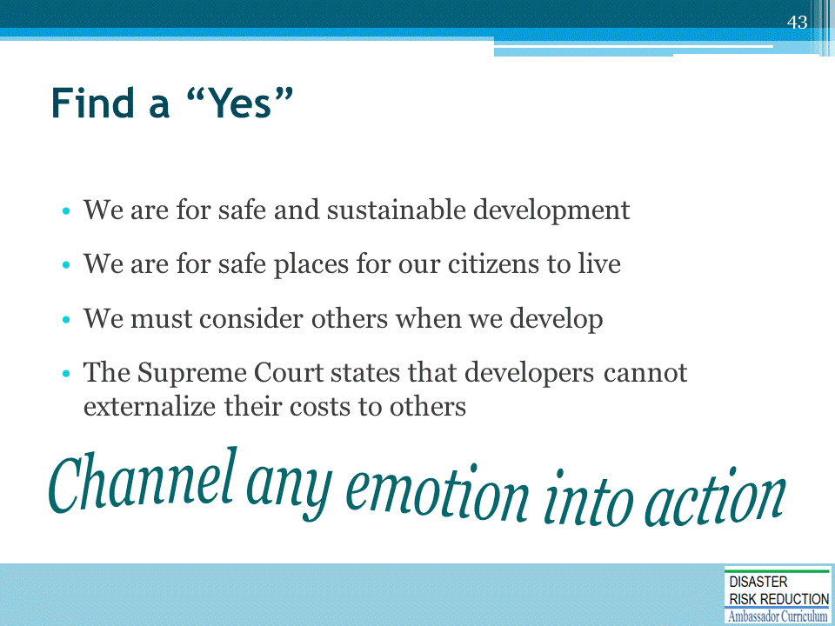

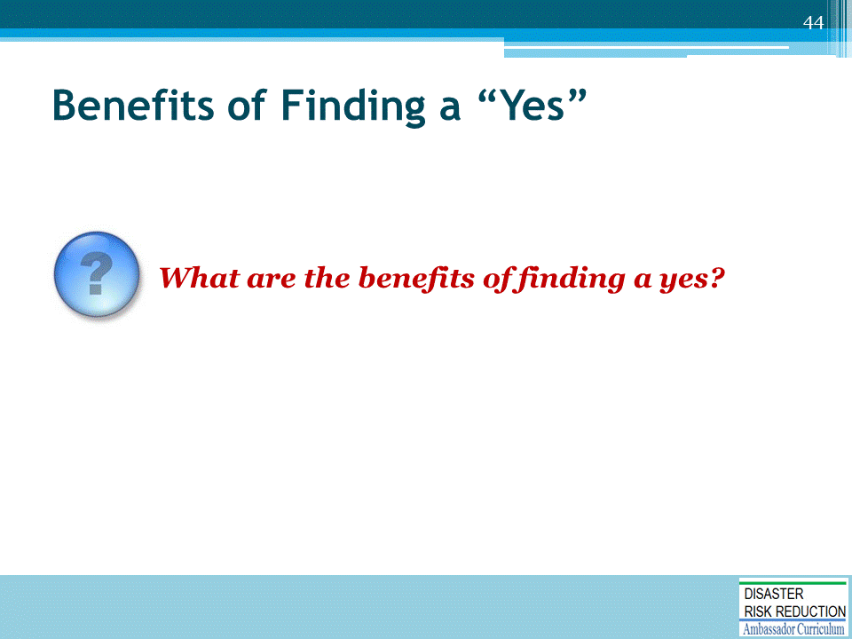

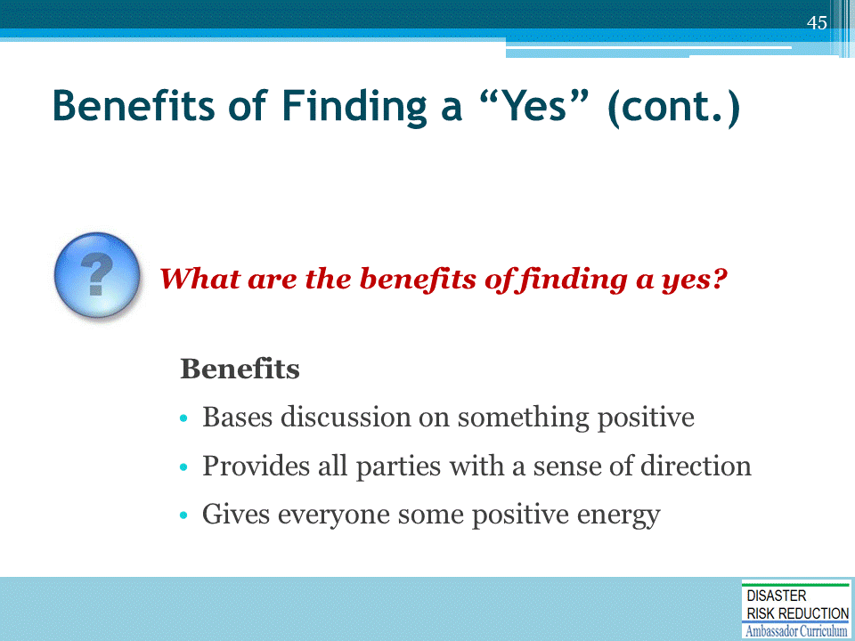

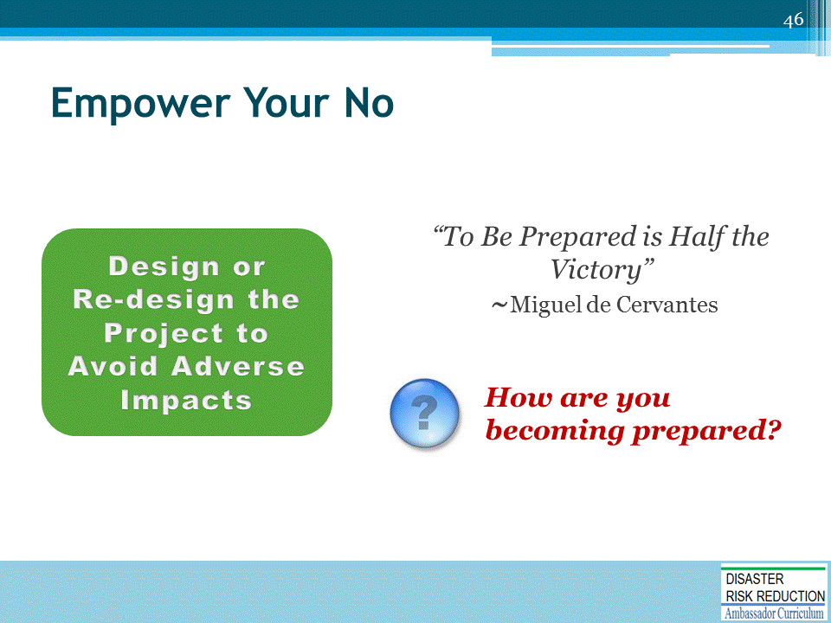

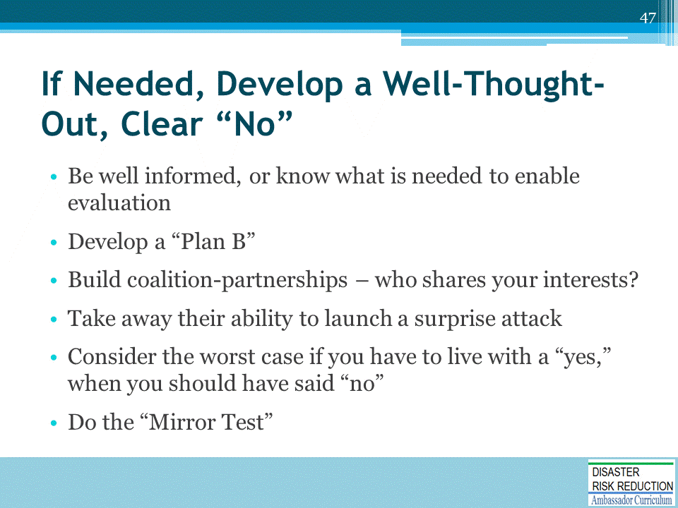

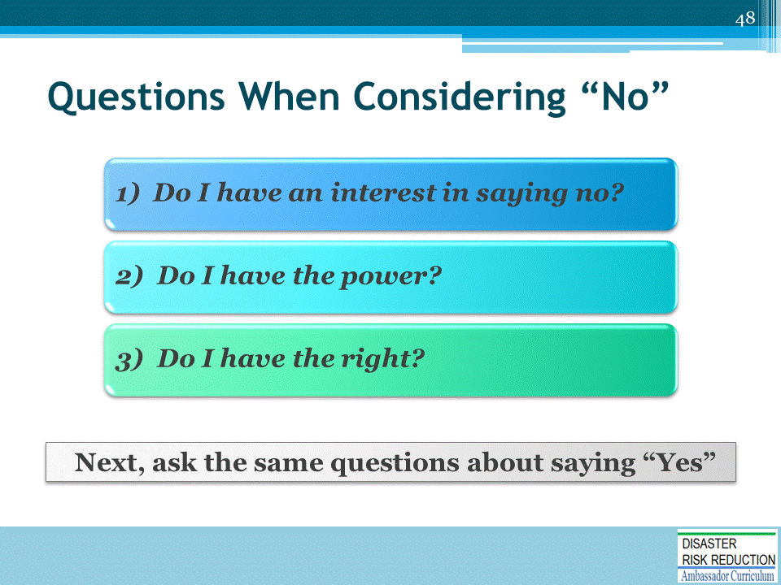

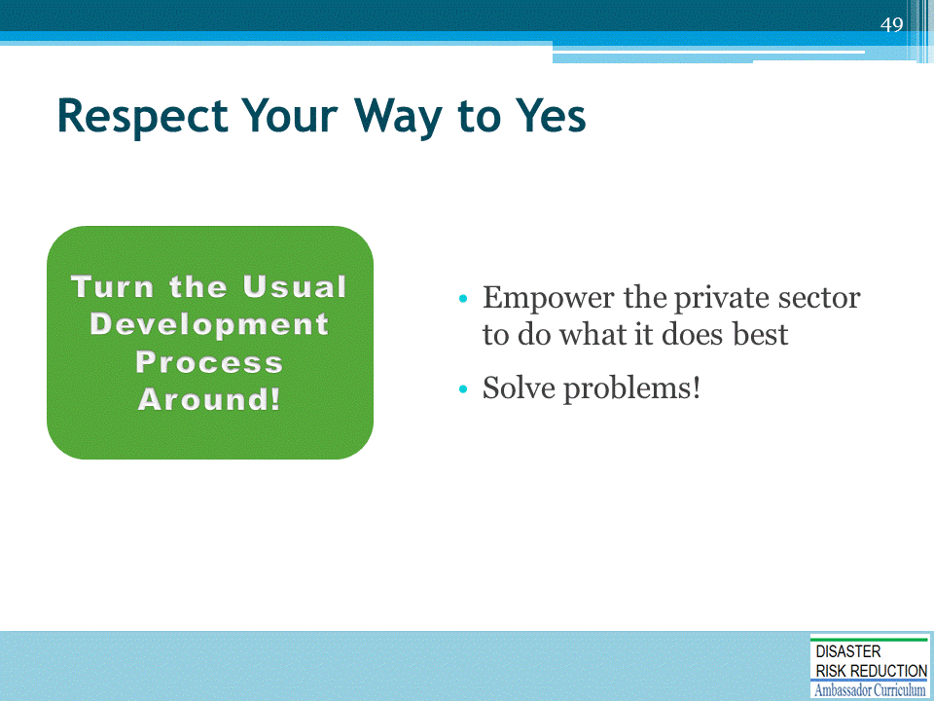

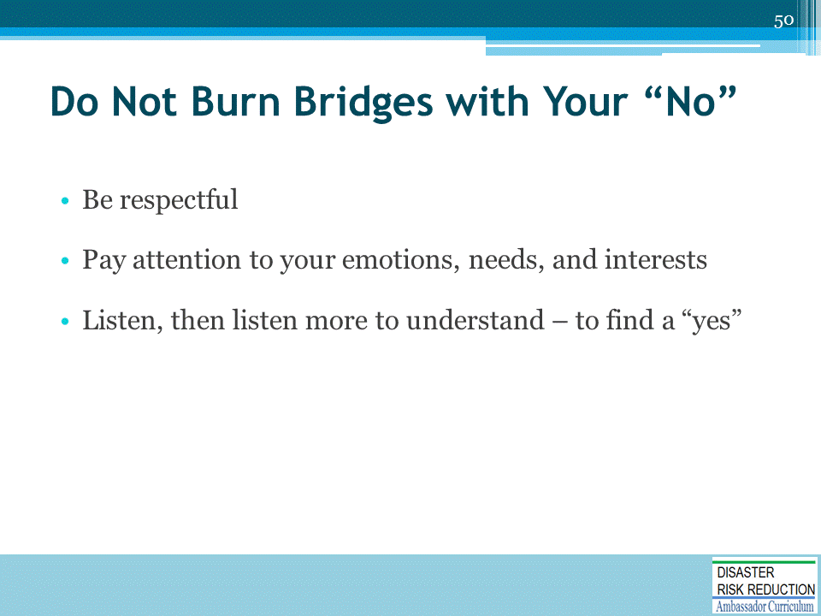

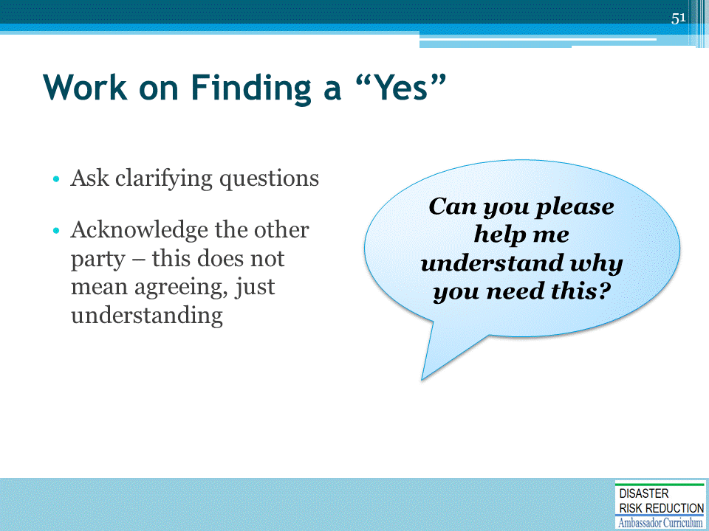

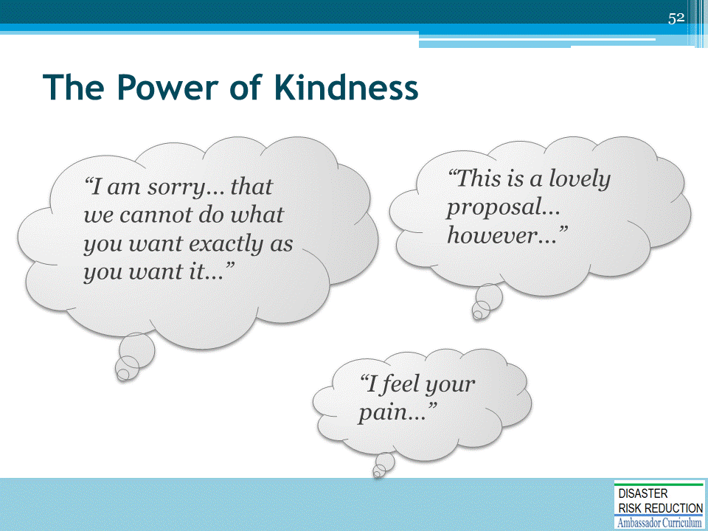

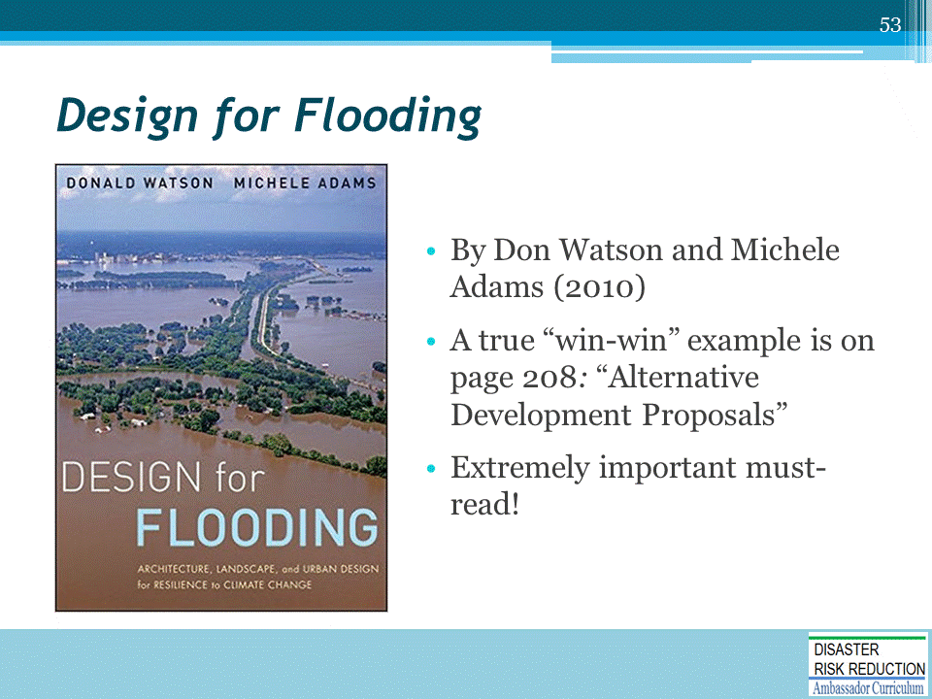

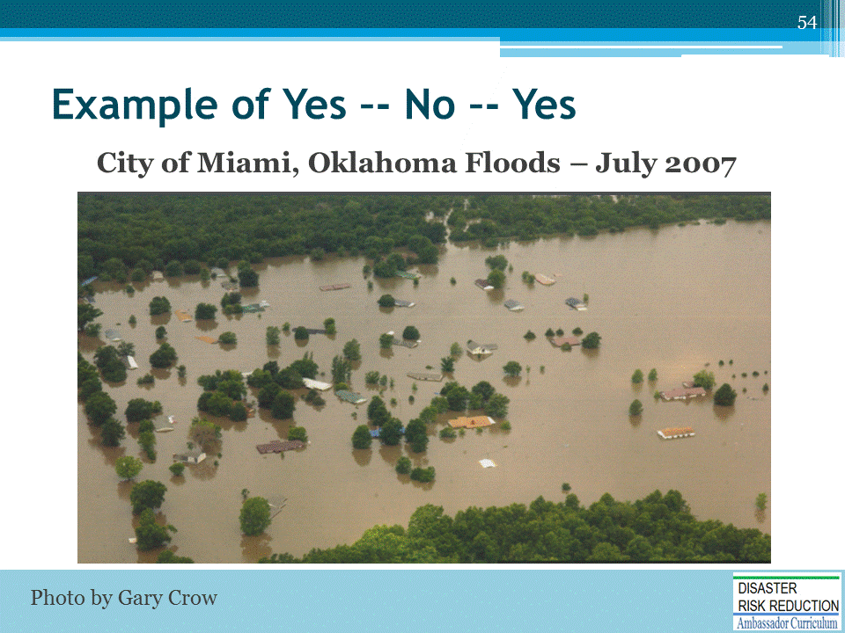
- About 700 homes were damaged, many of which suffered substantial damage with several being hit by over 88 inches of floodwater
- Unfortunately, several of these structures have flooded as many as 21 times over the past 50 years
- Historically, local officials in the City of Miami and Ottawa County have allowed devastated flood victims to rebuild as soon as possible, disregarding all locally adopted NFIP requirements for safe and proper rebuilding of substantially damaged buildings
- This time, however, the new slate of officials in place had a different view about rebuilding after a flood, but they wanted to make sure that they were on solid ground to take strong action and break the cycle once and for all.
- The primary power was City Attorney Erik Johnson. He was very concerned about inverse condemnation and the taking issue if the city did not allow folks to rebuild and go back into their flooded homes.
- General Counsel for the Oklahoma Water Resources Board, Dean Couch, consulted with ASFPM legal experts and contacted Mr. Johnson early on in this process, explaining the role of the floodplain administrator and the justification for performing the substantial damage determinations.

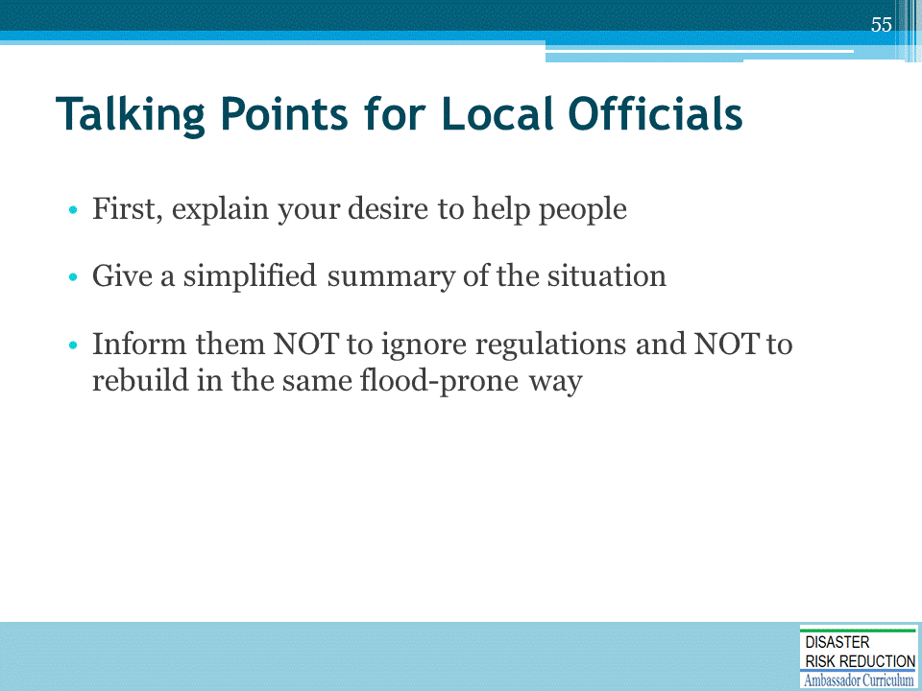

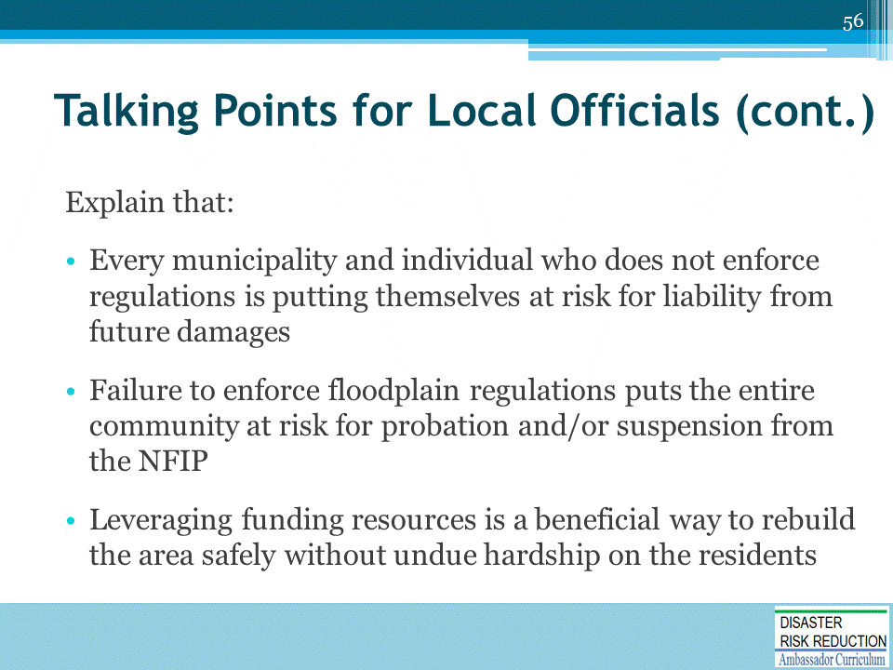

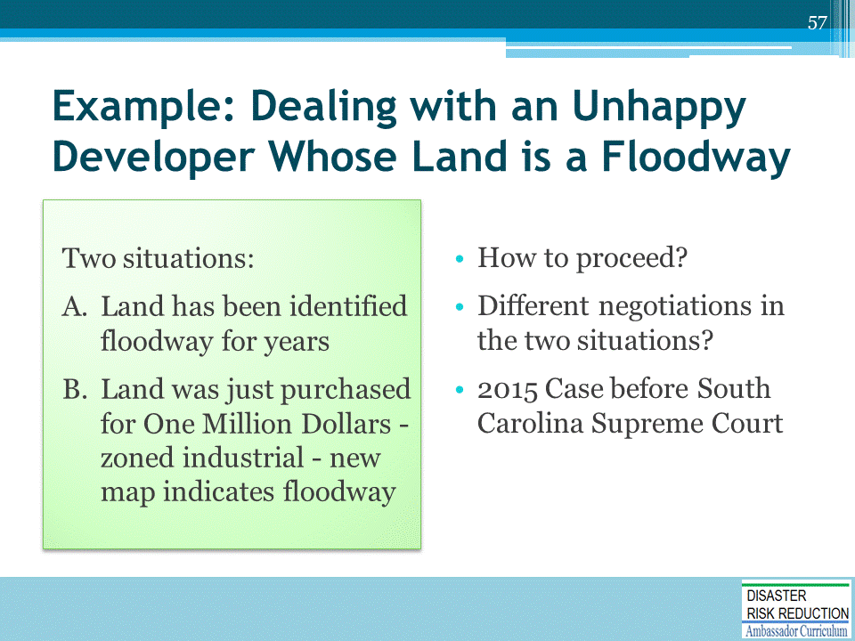
Case before South Carolina Supreme Court from Rob Thomas Inverse Condemnation
No Taking When Owner Prohibited From Developing In Floodplain
Columbia Venture, LLC v. Richland County, No. 27563 (S.C. Aug. 12, 2015)

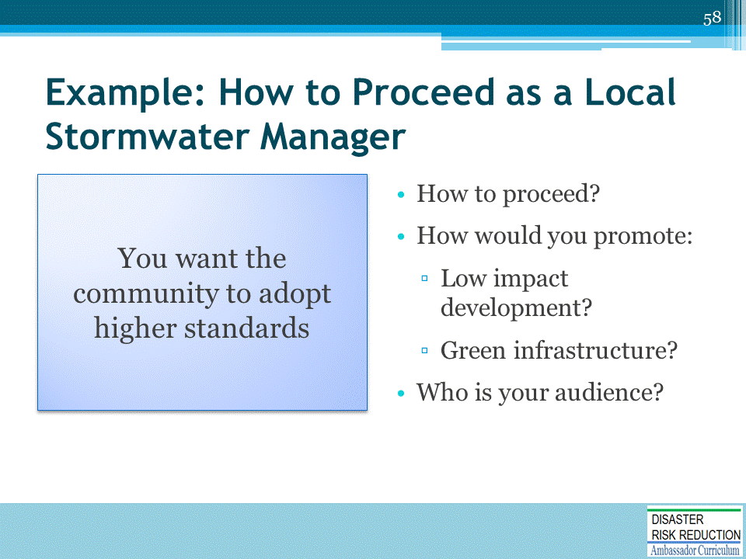

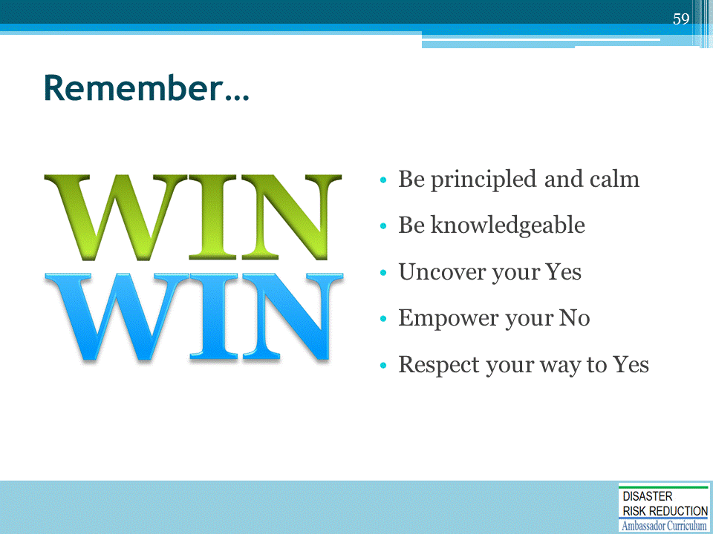

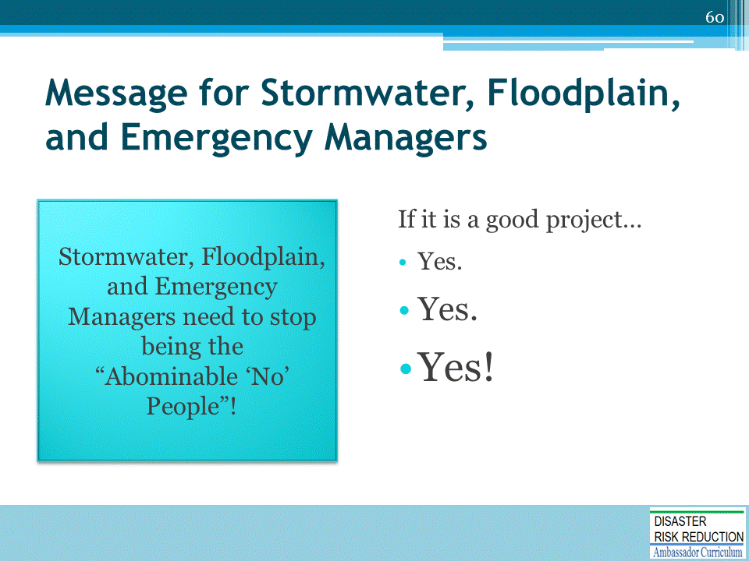

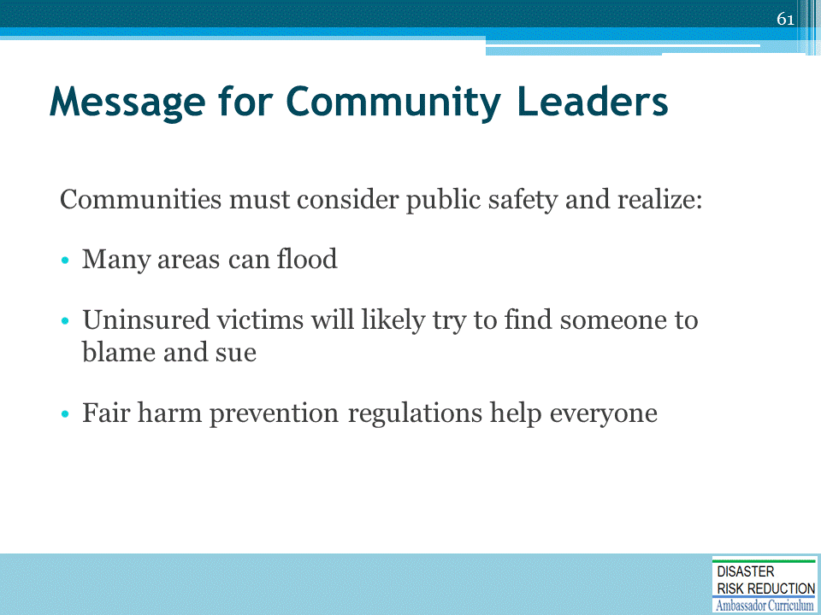

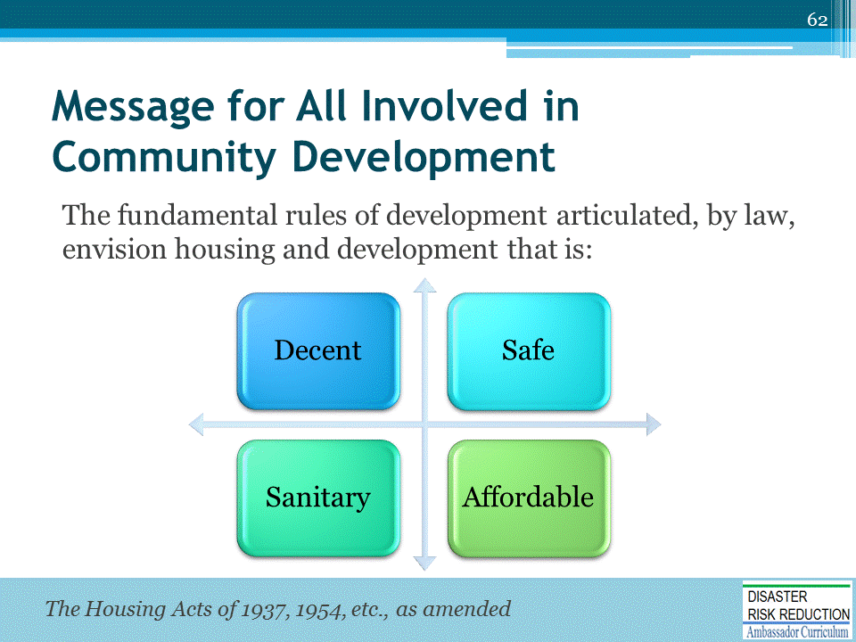

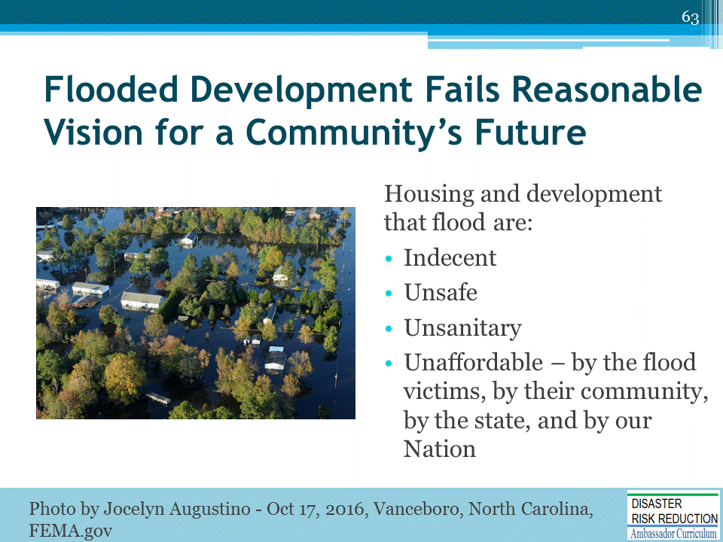
Photo: Vanceboro, NC, USA--October 17, 2016--Floodwaters remain high and surround many houses in Craven County. Residents impacted by the recent flooding are encouraged to call FEMA to register for assistance. Photo by Jocelyn Augustino

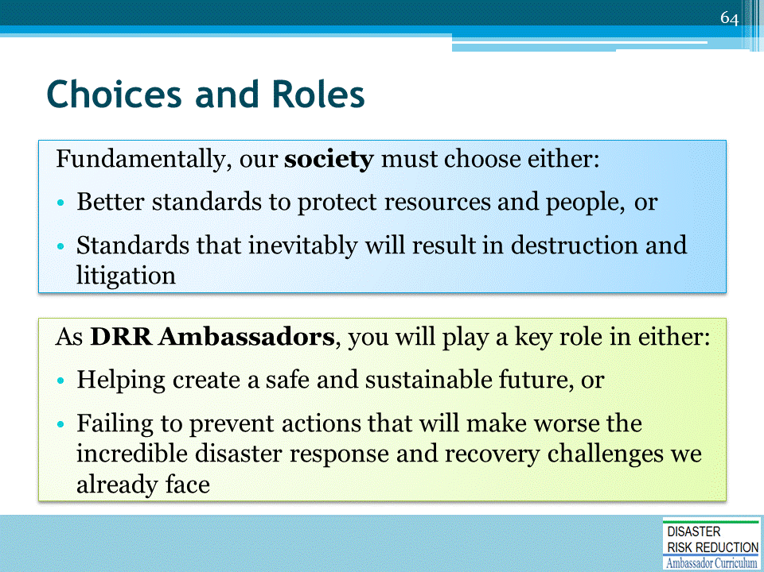

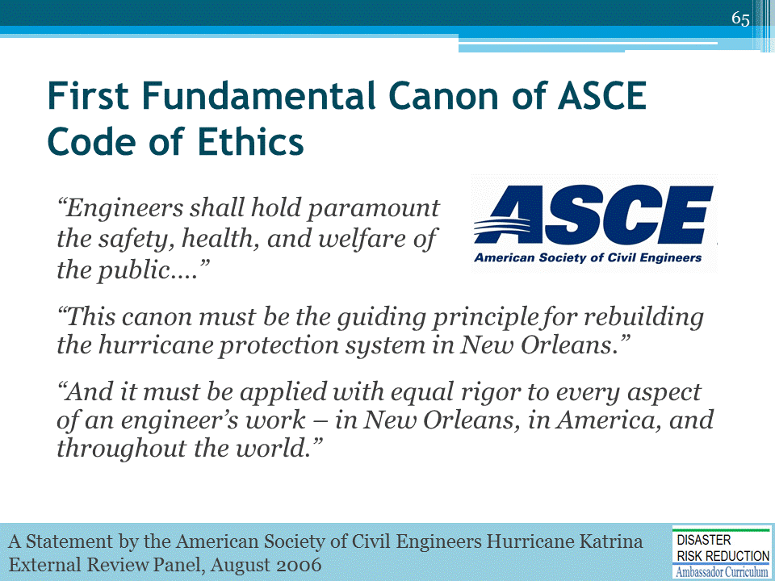
This quote if from A Statement by the American Society of Civil Engineers Hurricane Katrina External Review Panel issued late August 2006.

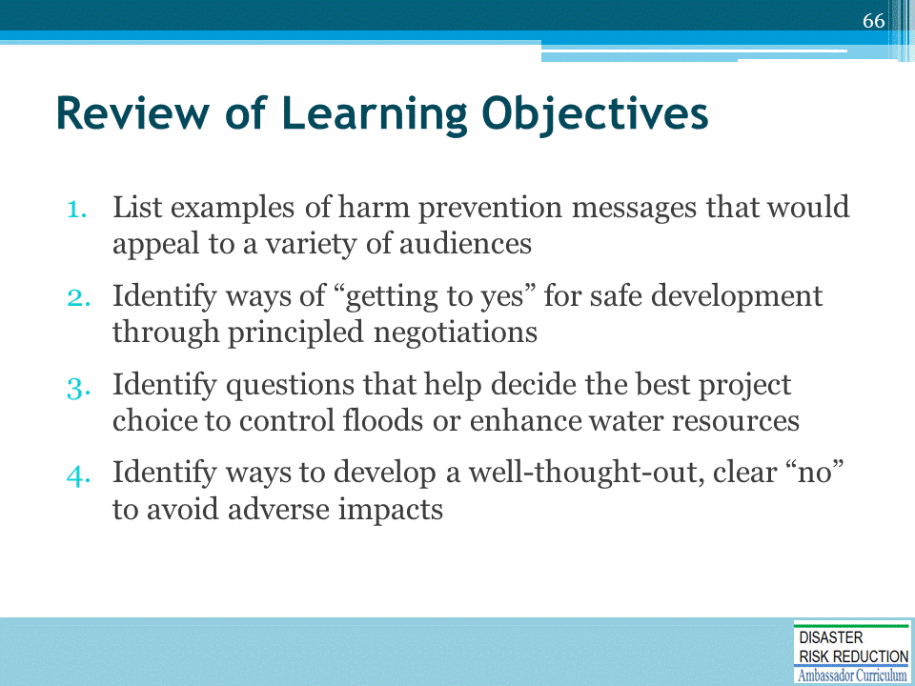

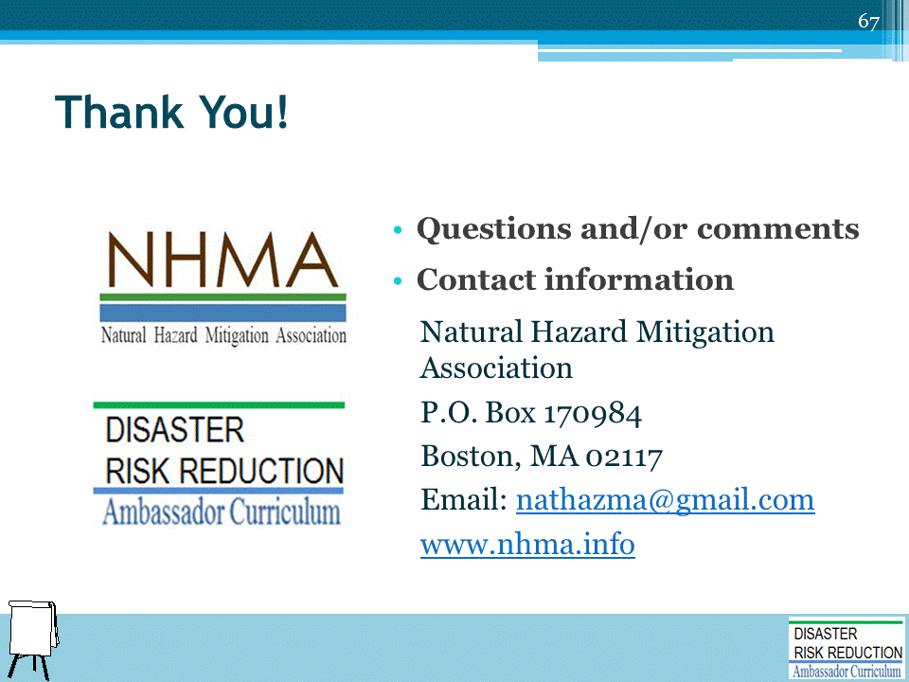

DRR AMBASSADOR CURRICULUM AT-A-GLANCE
I. Disaster Risk Reduction for a Safe and Prosperous Future
1 | Introduction to the Natural Hazard Mitigation Association and Disaster Risk Reduction Ambassador Curriculum
2 | Introduction to Disaster Risk Reduction as a Foundation of Community Resilience
3 | Leadership for Disaster Risk Reduction
4 | Community Disaster Risk Reduction and Adaptation
5 | Approaching the Challenge of Disaster Risk Reduction: NIST Community Resilience Guide
II. Forming a Community’s Vision for Disaster Risk Reduction
6 | Risk Assessment through Storytelling: An Asset-Based Approach
7 | Achieving Community Buy-in for Disaster Risk Reduction: Win-Win Approaches
8 | Leveraging Resources to Improve Disaster Risk Reduction
III. Realizable, Practical, and Affordable Approaches for Moving from a Vision for Disaster Risk Reduction to a Strategy
9 | Selecting and Implementing a Strategy for Addressing Community Disaster Risk Problems
10 | Integrating Hazard Mitigation into Local Planning
11 | Beyond Codes and Low-Impact Development
12 | Creating the Plan: A Sustainable Floodplain Management Process Model
IV. Resources and Tools for Implementing a Community’s Disaster Risk Reduction Strategy
13 | Climate and Weather Tools and Trends
14 | Risk Assessment Basics
15 | Legal and Policy Opportunities for Disaster Risk Reduction
16 | Linking Catastrophe Insurance to Disaster Risk Reduction
V. Resources for Hazard-Specific Disaster Risk Reduction
17 | Living with Water: Inland and Coastal Flooding
18 | Design for Flood Resilience: Part I: Floodplain Management and Flood Resistant Design
19 | Design for Flood Resilience: Part II: Green Infrastructure / Low Impact Development
20 | Overcoming Impediments to Flood Resilience: Paths Forward
21 | Wildfire Mitigation
22 | The Wildfire-Flood Connection
23 | Severe Thunderstorm/Tornado Safe Rooms
24 | From Policy to Engineering: Earthquake Risks

