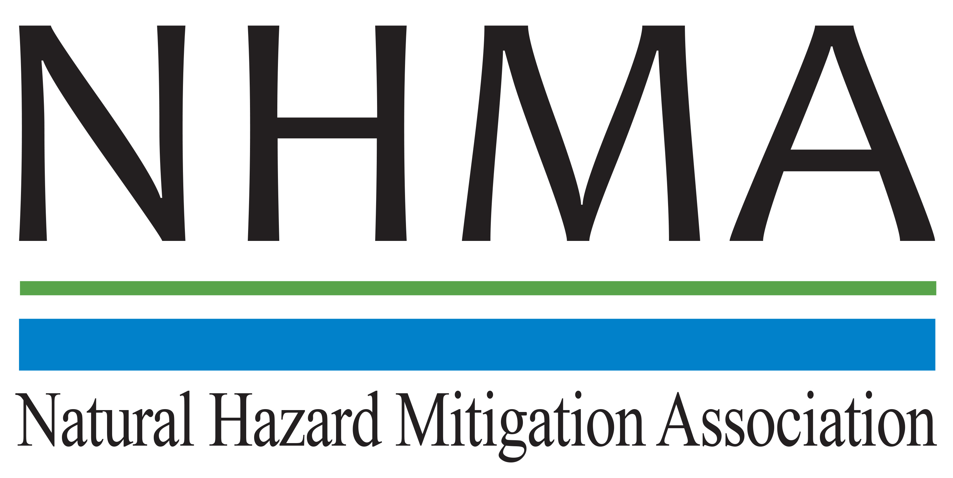

Disaster Risk Reduction (DRR) Ambassador Curriculum

Participant Guide

Module 10:

Integrating Hazard Mitigation
into Local Planning

THE DRR AMBASSADOR CURRICULUM
The goal of the DRR Ambassador Curriculum is to facilitate DRR efforts for the whole community by:
- Engaging in discussion of how disasters can be reduced through local action
- Sharing insights among local leaders and technical experts to enable the development of cross functional solutions
- Acquiring the best-available information, knowledge of best practices, and analytic tools to enable better-informed decisions before, during, and after disasters
There are 24-modules in the curriculum. The “DRR Ambassador Curriculum At-a-Glance” table, located at the end of this document, lists the modules of the Curriculum.
DRR-A CURRICULUM TARGET AUDIENCE
The target audience includes those involved in community development decision-making, such as local community staff, volunteer and stakeholder groups, and federal and state officials.
METHODS OF DELIVERY
There are three delivery methods by which you may be able to complete modules in the DRR-A Curriculum: via webinars hosted by NHMA or partner organizations; presented in conferences and/or classrooms by qualified DRR-A Curriculum instructor(s); or downloadable for individual study from the NHMA website. Watch the NHMA website for announcements about webinars and workshops that include the module(s) in which you are interested.
CERTIFICATES
- Certificates of Completion may be awarded by NHMA to participants who successfully complete NHMA-sponsored DRR Ambassador modules by attending and passing a short post-test.
- Certificates of Attendance may be awarded to participants who attend but choose not to take the post-test may be issued a Certificate of Attendance.
- A Disaster Risk Reduction Ambassador Certificate will be awarded to individuals who successfully complete all 24 modules.
Ask your certifying boards about acceptance of NHMA DRR-A certificates for continuing education credits.
MODULE 10 – INTEGRATING HAZARD MITIGATION INTO LOCAL PLANNING
The Learning Objectives for this module are:
- List references for FEMA hazard mitigation plan requirements
- Describe the concept of a safe growth audit and how it can be applied in the local community
- Describe ways to integrate hazard mitigation throughout the community’s planning process
- List common barriers to integration of hazard mitigation in the planning process

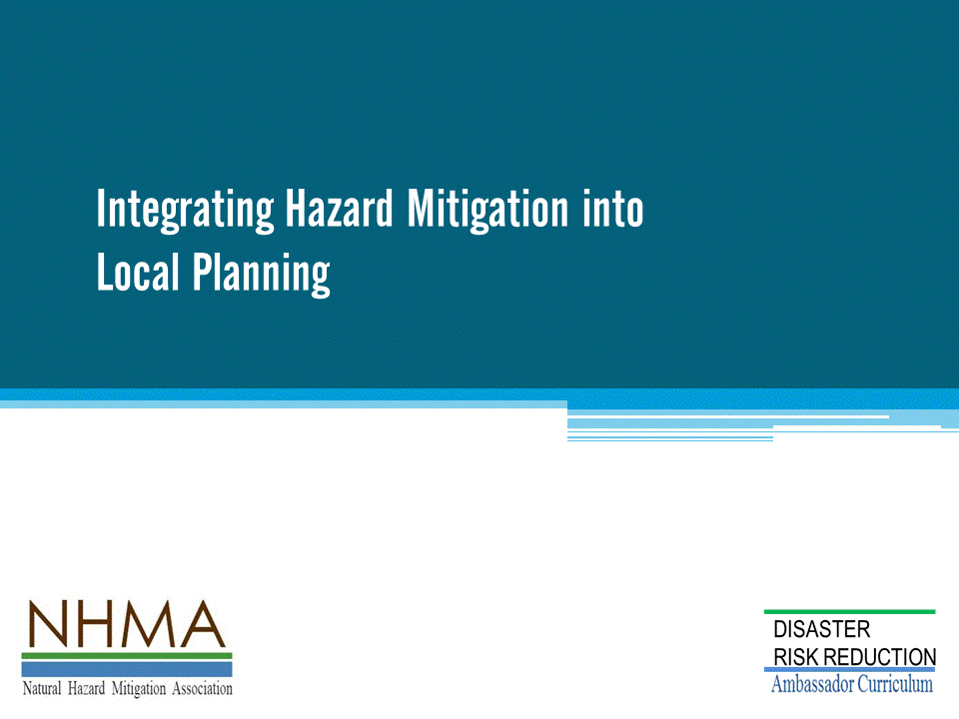

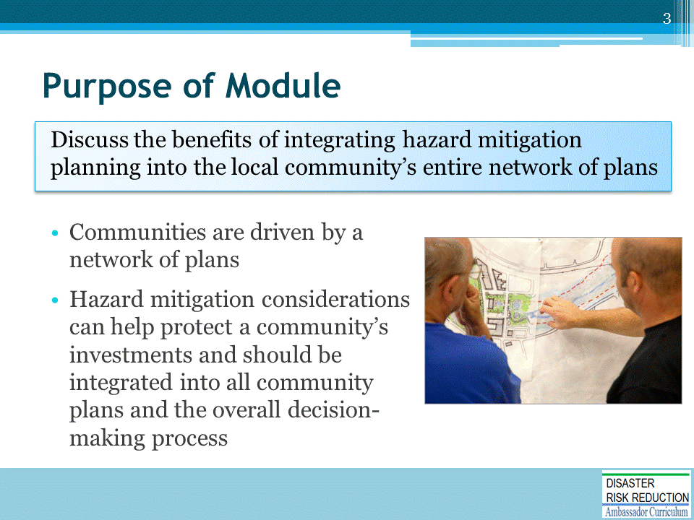

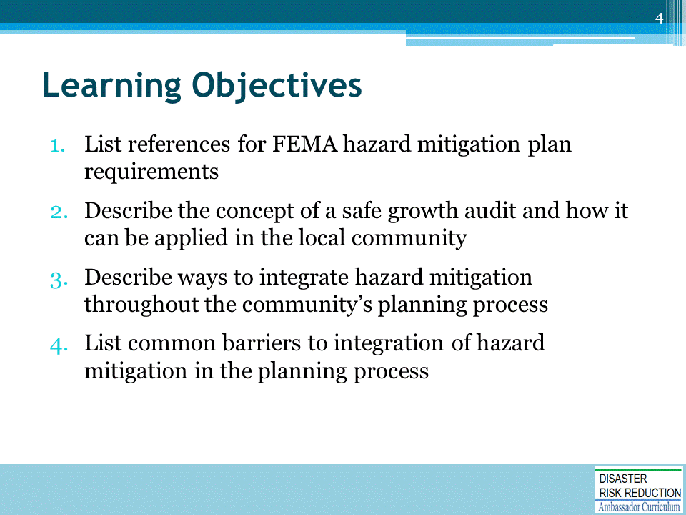

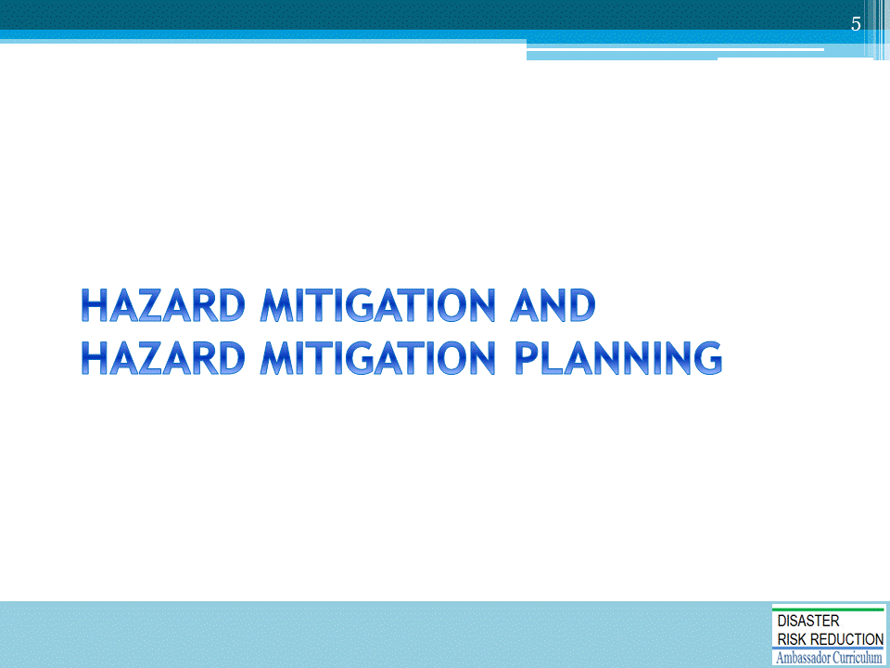

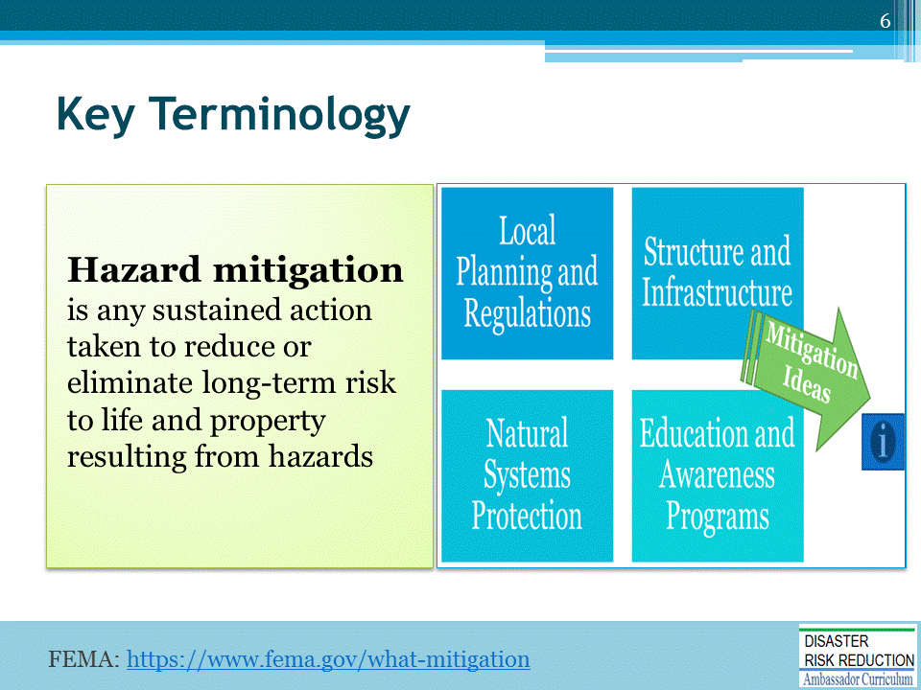
Source: https://www.fema.gov/what-mitigation
FEMA document, Mitigation Ideas: A Resource for Reducing Risk to Natural Hazards: https://www.fema.gov/media-library-data/20130726-1904-25045-0186/fema_mitigation_ideas_final508.pdf
Website: Beyond the Basics: Best Practices in Local Mitigation Planning: http://mitigationguide.org/task-6/mitigation-actions/

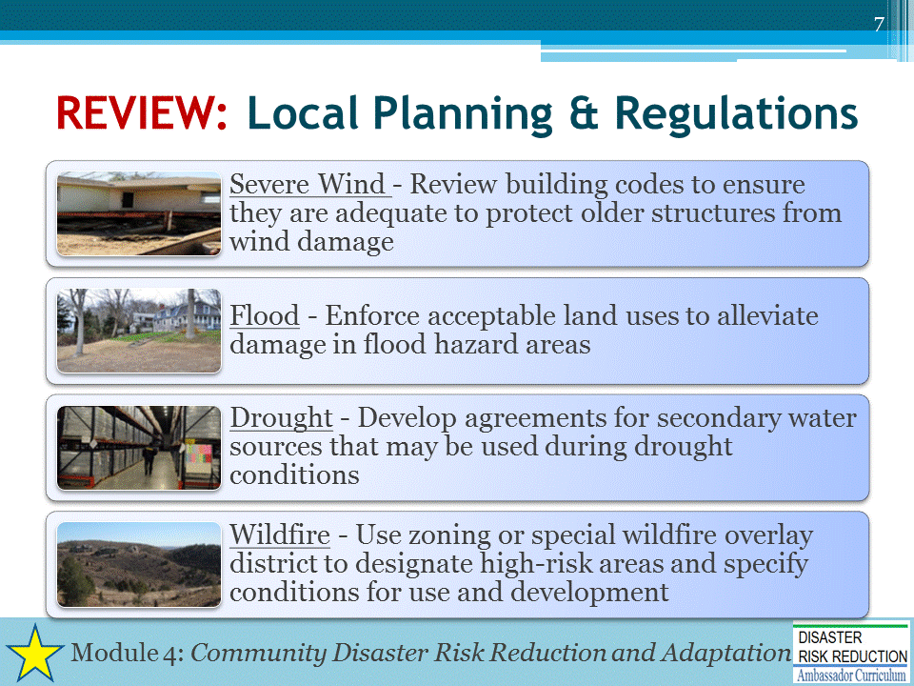
FEMA photos:
https://www.fema.gov/media-library/assets/images/54993
https://www.fema.gov/media-library/assets/images/67042
https://www.fema.gov/media-library/assets/images/90937
https://www.fema.gov/media-library/assets/images/96452
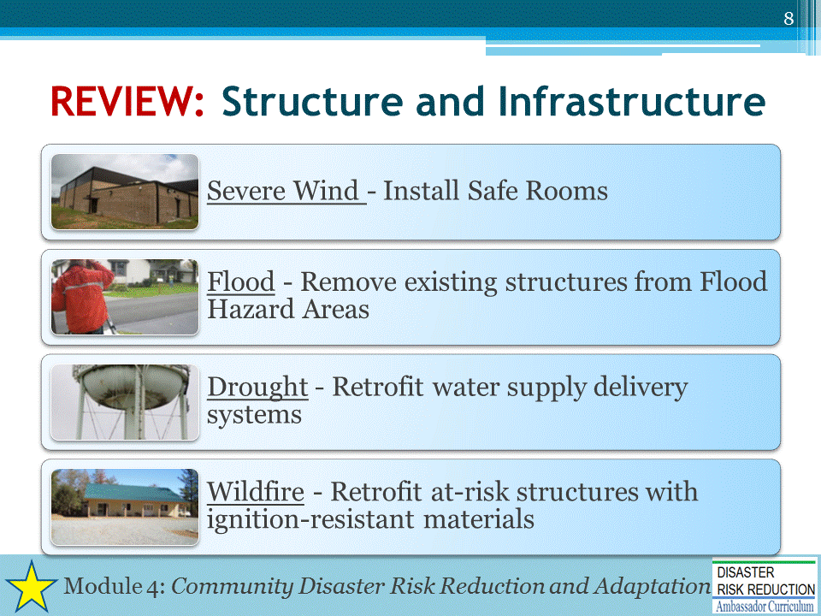
FEMA photos:
https://www.fema.gov/media-library/assets/images/96497
https://www.fema.gov/media-library/assets/images/56239
https://www.fema.gov/media-library/assets/images/69590
https://www.fema.gov/media-library/assets/documents/111784
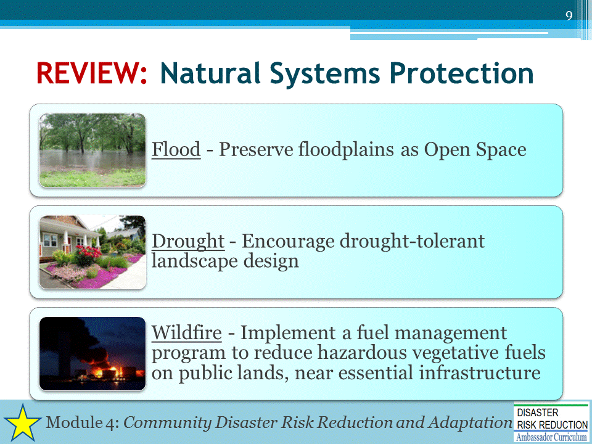
FEMA photos:
https://www.fema.gov/media-library/assets/images/41557
https://www3.epa.gov/watersense/docs/water-efficient_landscaping_508.pdf
https://www.fema.gov/media-library/assets/images/41209
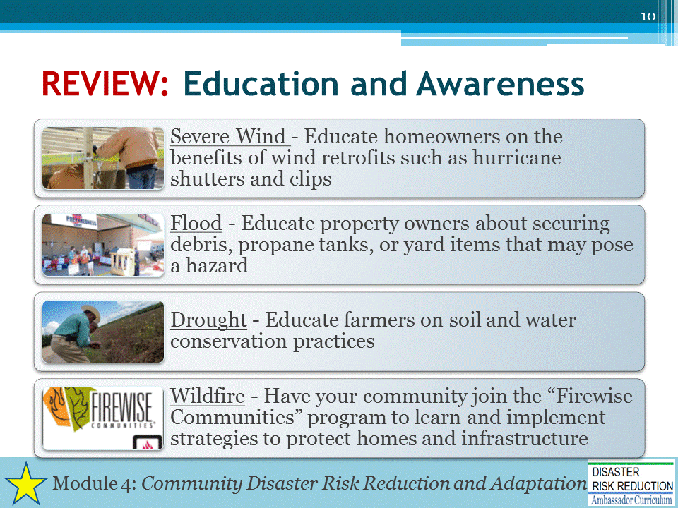
FEMA photos:
https://www.fema.gov/media-library/assets/images/69506
https://www.fema.gov/media-library/assets/images/72208
https://www.fema.gov/media-library/assets/images/123745
http://www.firewise.org/
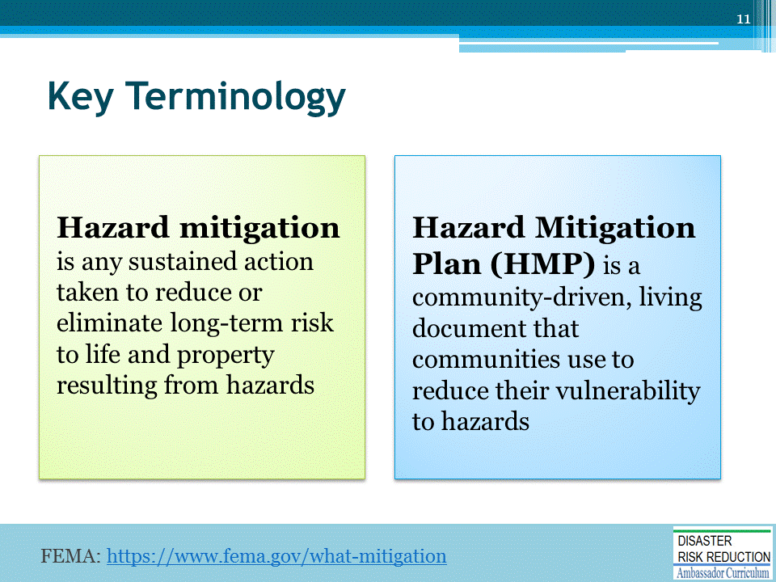
Source: https://www.fema.gov/what-mitigation

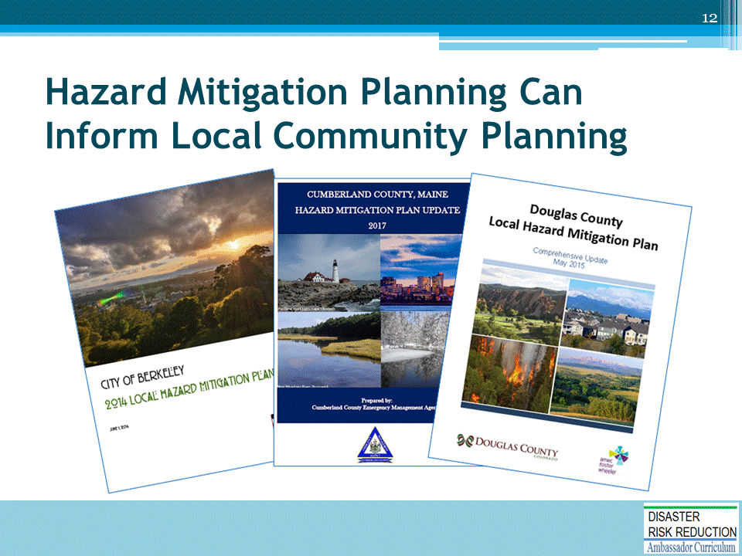

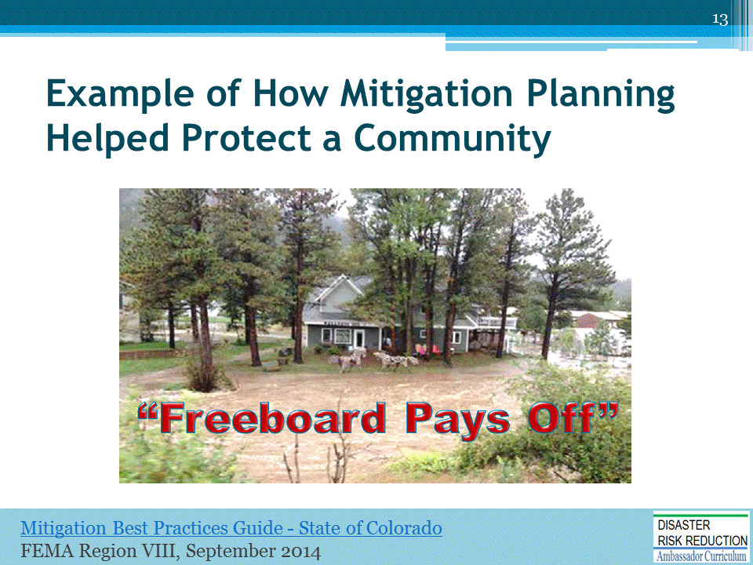
This is an example of how adhering to good mitigation planning practices can help protect individuals can be found in the story of a business owner in Estes Park, CO.

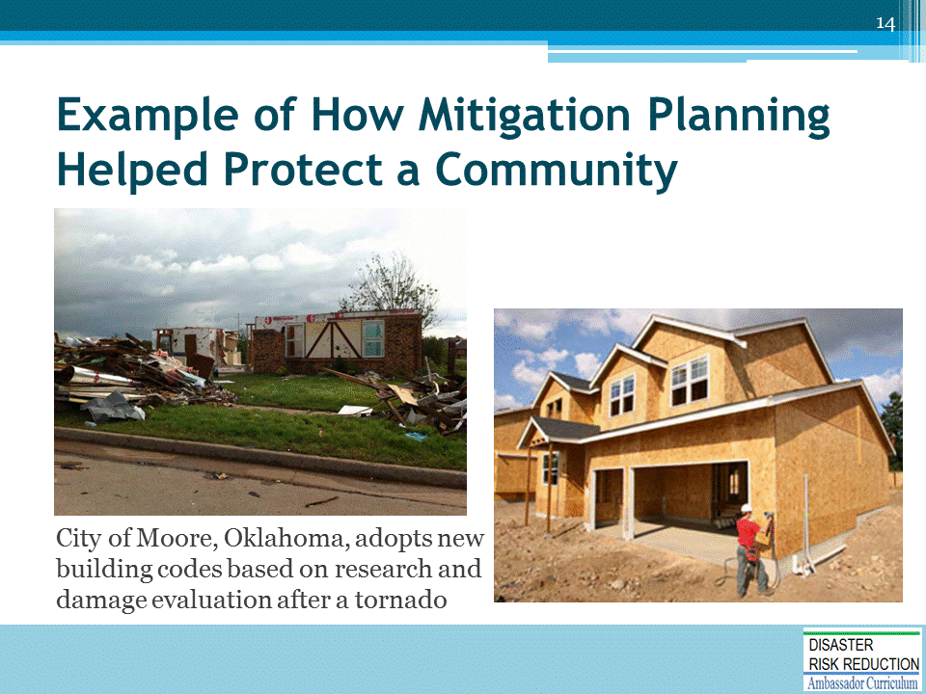
City of Moore Website: “City Adopts New Building Codes, First in the Nation”: https://www.cityofmoore.com/node/2111

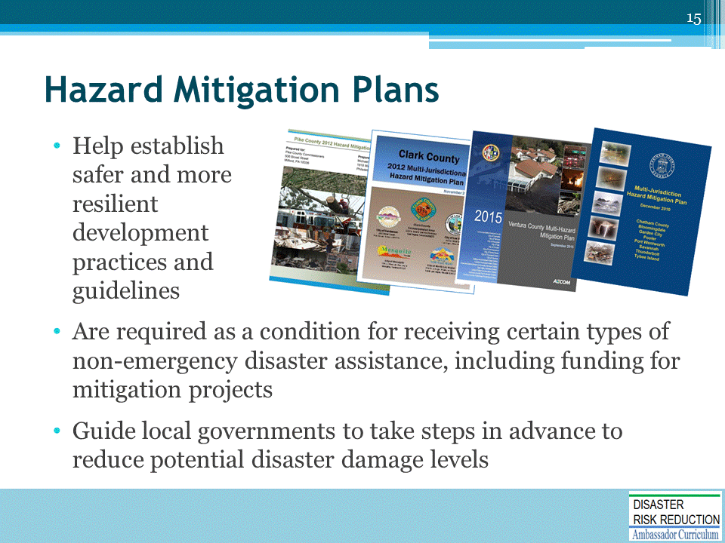

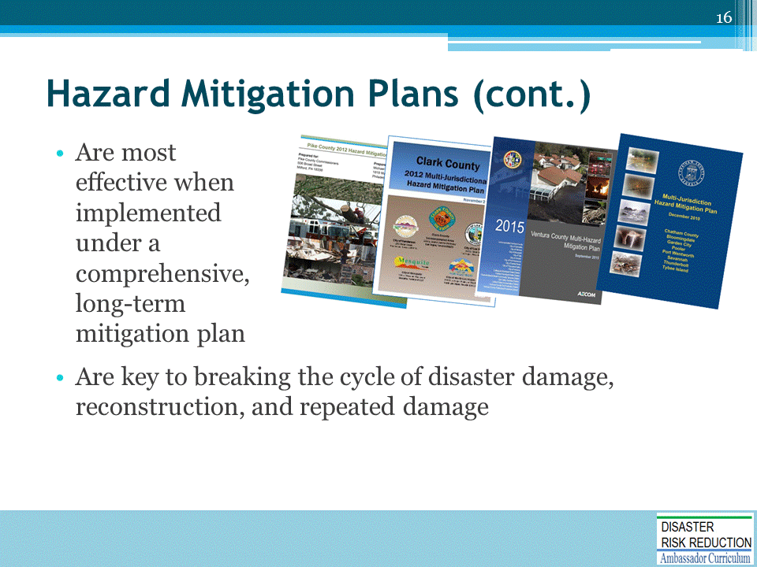

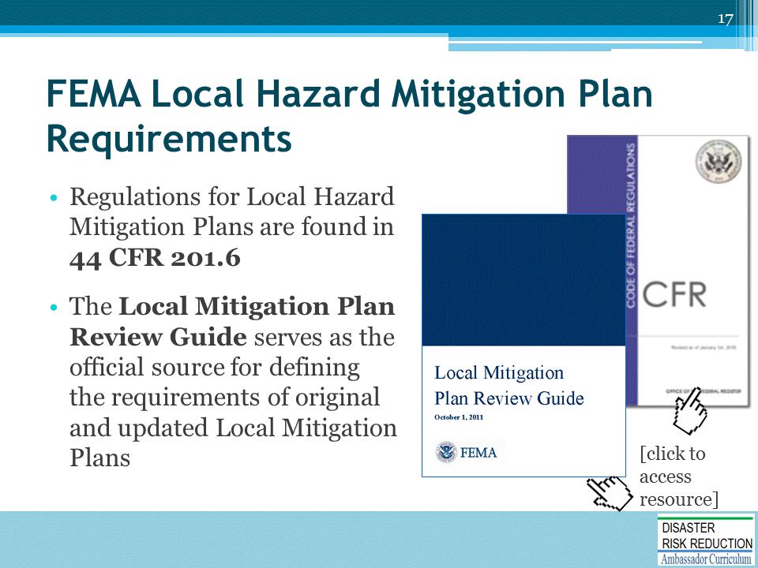
Local Mitigation Plan Review Guide: https://www.fema.gov/media-library-data/20130726-1809-25045-7498/plan_review_guide_final_9_30_11.pdf
44 CFR 201.6: https://www.gpo.gov/fdsys/pkg/CFR-2010-title44-vol1/pdf/CFR-2010-title44-vol1-sec201-6.pdf

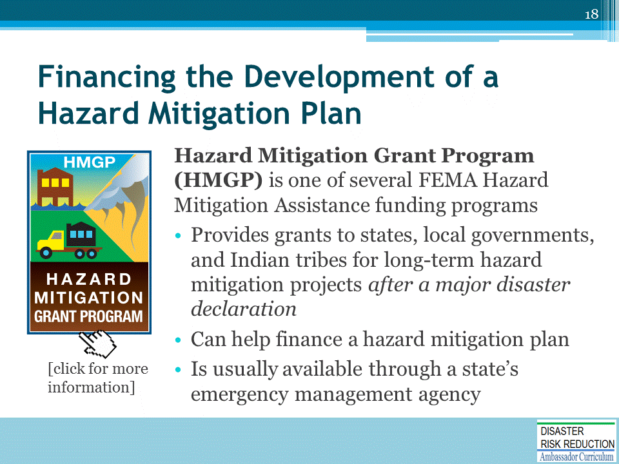

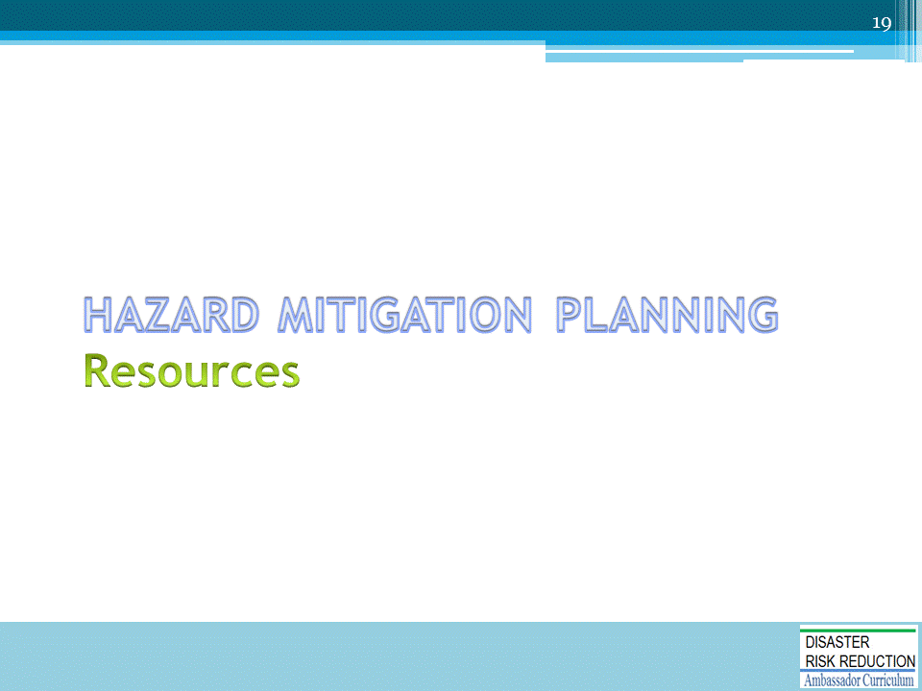

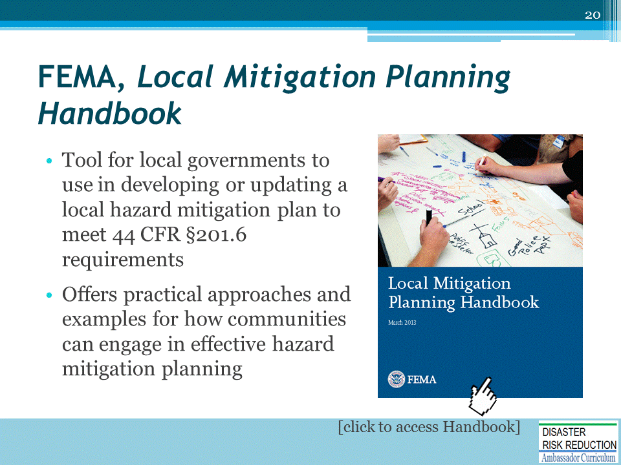
Local Mitigation Planning Handbook: https://www.fema.gov/media-library-data/20130726-1910-25045-9160/fema_local_mitigation_handbook.pdf

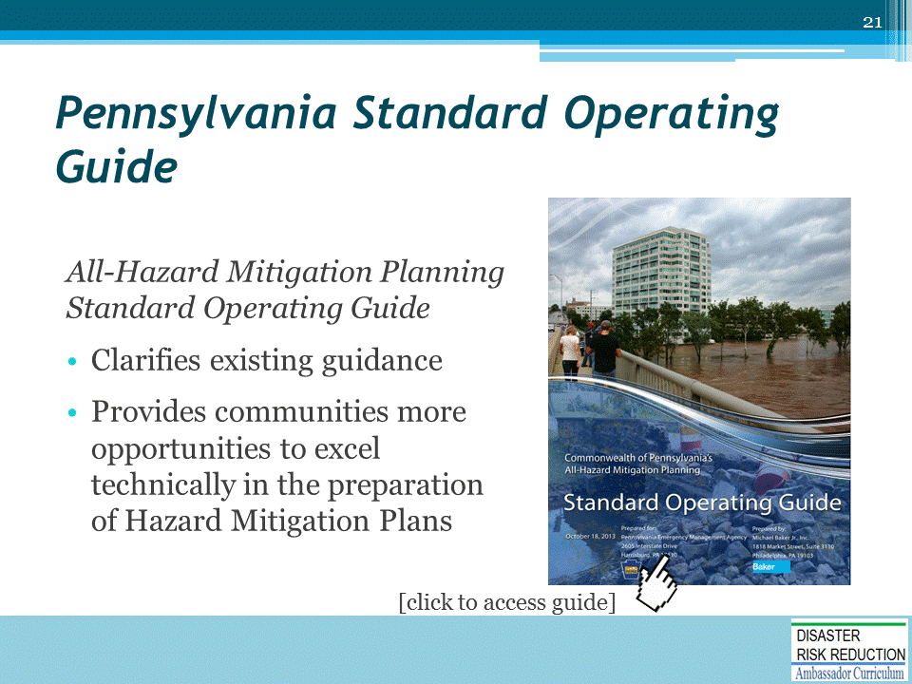
STATE-SPECIFIC GUIDE
All-Hazard Mitigation Planning Standard Operating Guide
http://www.pema.pa.gov/responseandrecovery/Disaster-Assistance/Documents/PA HMP Standard Operating Guide.pdf
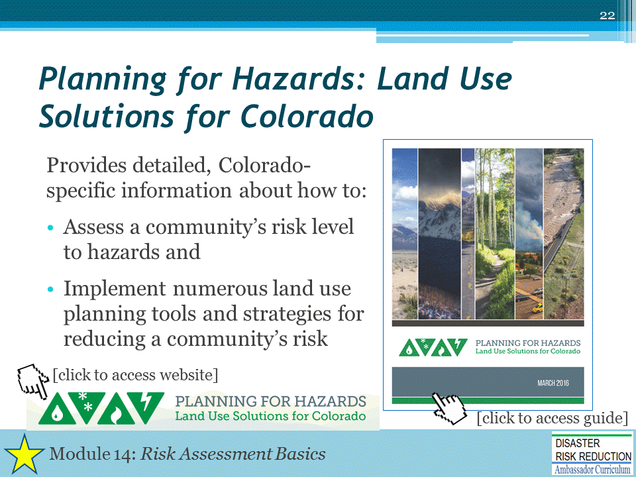
STATE-SPECIFIC GUIDE
Planning for Hazards: Land Use Solutions for Colorado: https://www.planningforhazards.com/sites/planningforhazards.com/files/document/pdf/Planning%20for%20Hazards%20Full%20Guide_0.pdf
Planning for Hazards website: https://www.planningforhazards.com/home
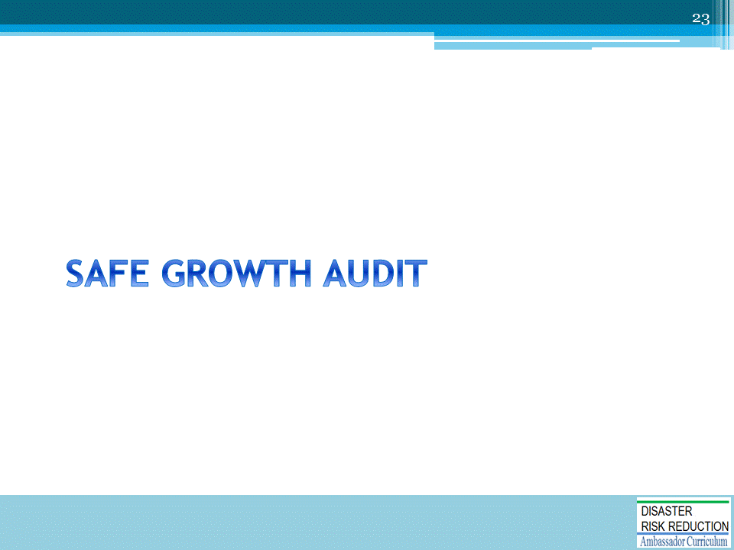

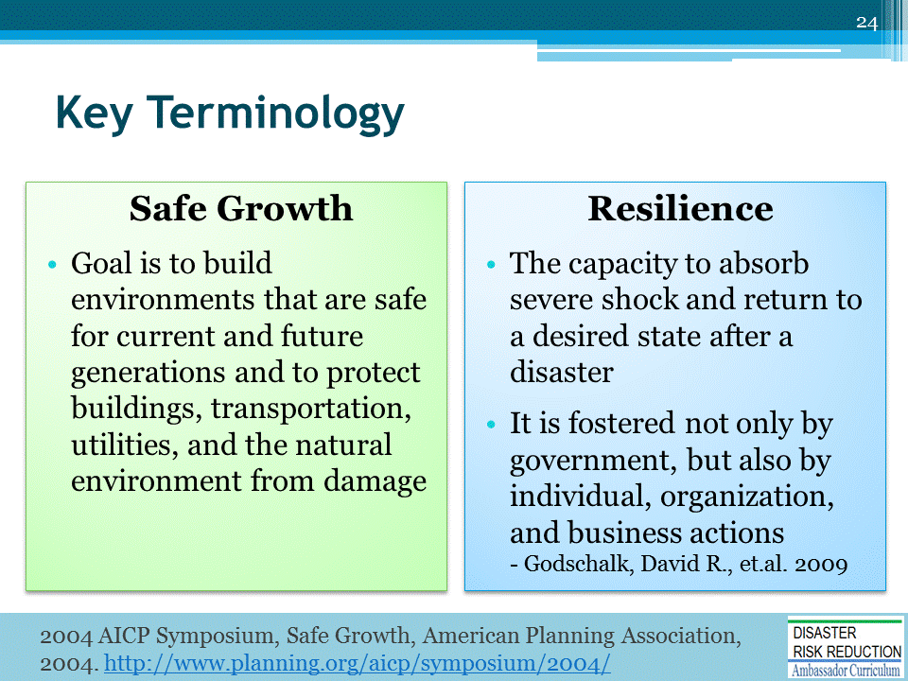
Safe Growth
- Source: 2004 AICP Symposium, Safe Growth, American Planning Association, 2004. http://www.planning.org/aicp/symposium/2004/
Resilience
- Godschalk, David R., et.al. 2009. “Estimating the Value of Foresight: Aggregate Analysis of Natural Hazard Mitigation Benefits and Costs.” Journal of Environmental Planning and Management 52(6):739-56.
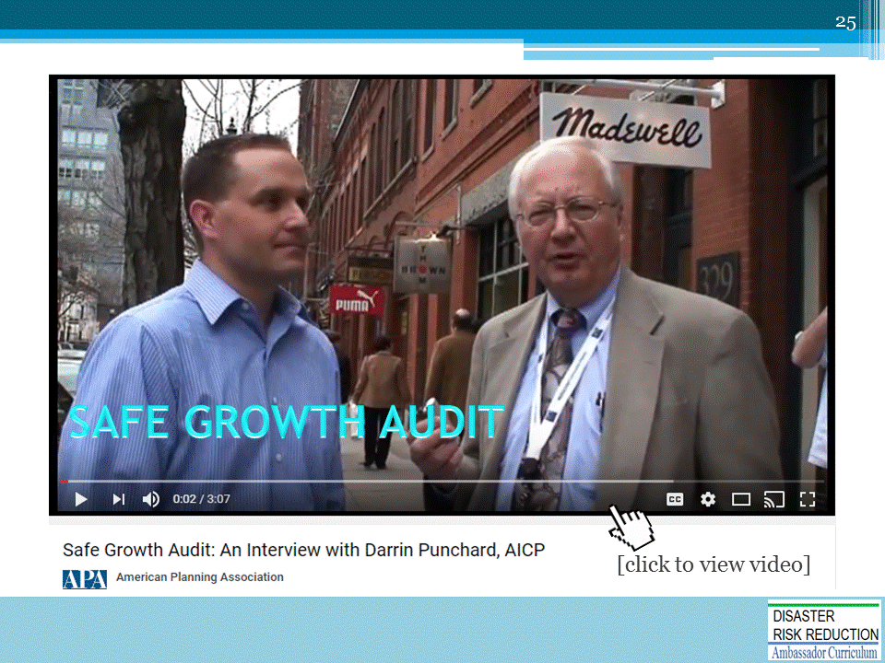
Safe Growth Audit: An Interview with Darrin Punchard, AICP: https://www.youtube.com/watch?v=xgChq1v9pVE

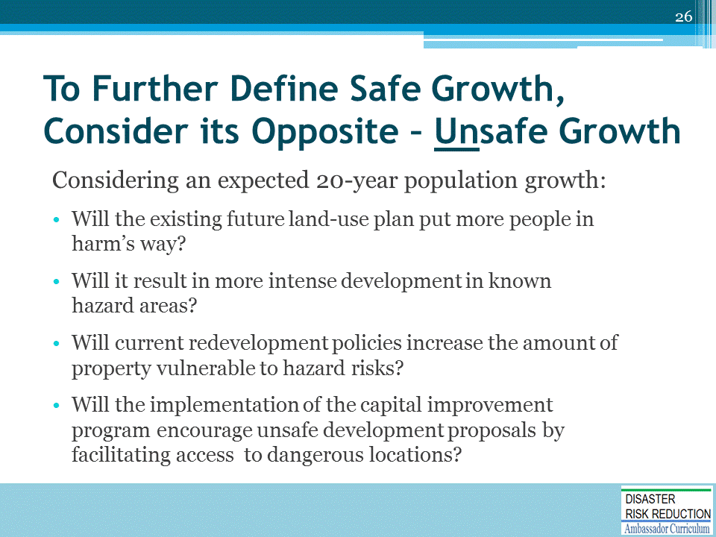

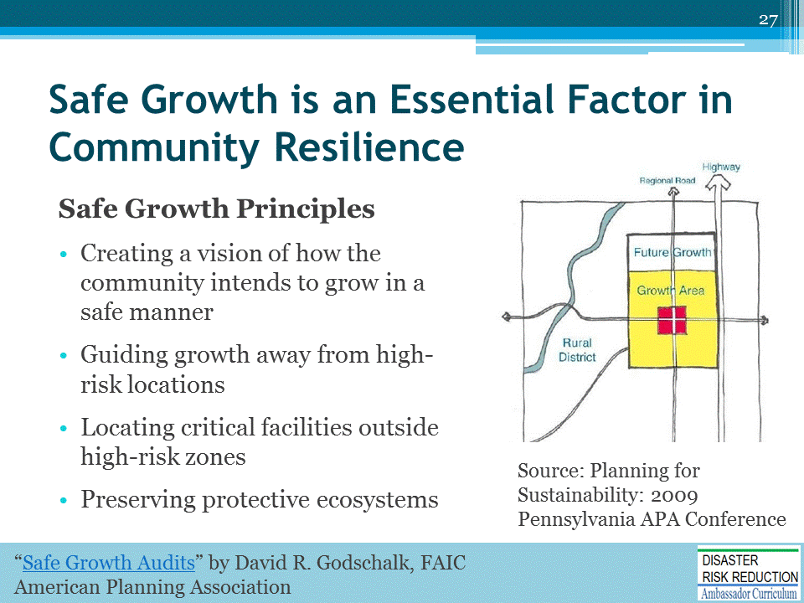
Planning for Sustainability: 2009 Pennsylvania APA Conference: https://www.slideshare.net/wrtdesign/planning-for-sustainability-2009-pennsylvania-apa-conference-2113506

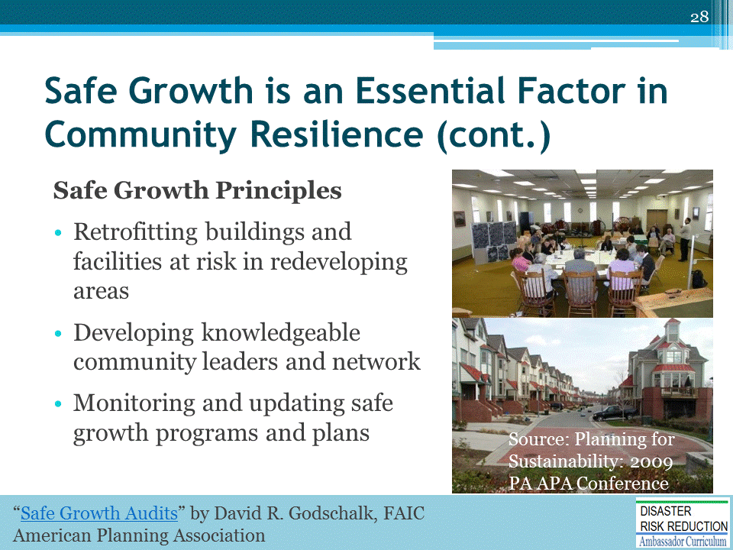

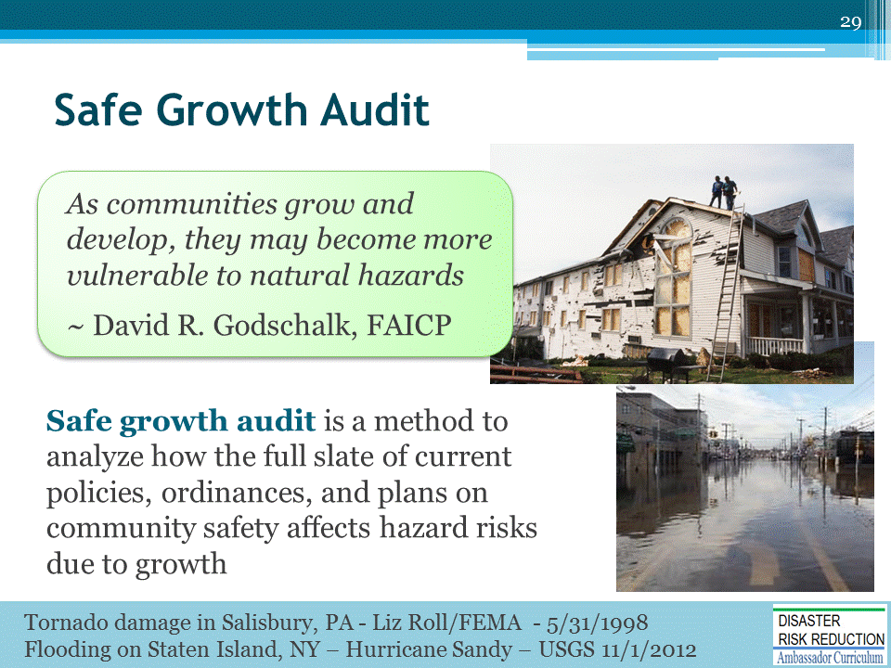

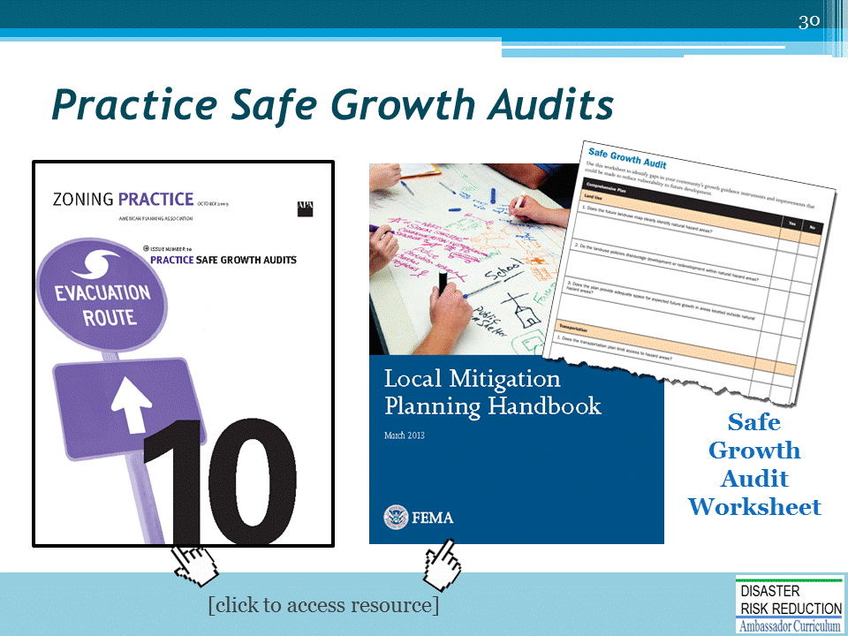
APA’s Practice Safe Growth Audits, by David R. Godschalk, FAICP, gives the community a comprehensive, concise evaluation of the extent to which local communities are positioned to grow safely relative to natural hazards (http://planning-org-uploaded-media.s3.amazonaws.com/legacy_resources/zoningpractice/open/pdf/oct09.pdf). The APA Zoning Practice is available for free on APA’s website: https://www.planning.org/
FEMA’s Local Mitigation Handbook has a worksheet (page A-23) that communities can use to identify gaps in growth guidance instruments and assess improvements that can be made to reduce vulnerability to future development. (https://www.fema.gov/media-library-data/20130726-1910-25045-9160/fema_local_mitigation_handbook.pdf)
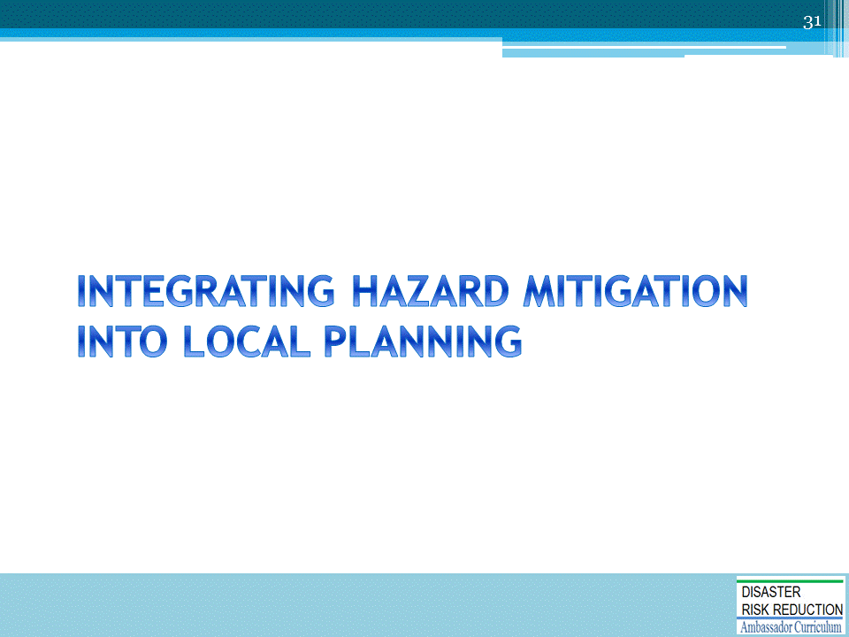

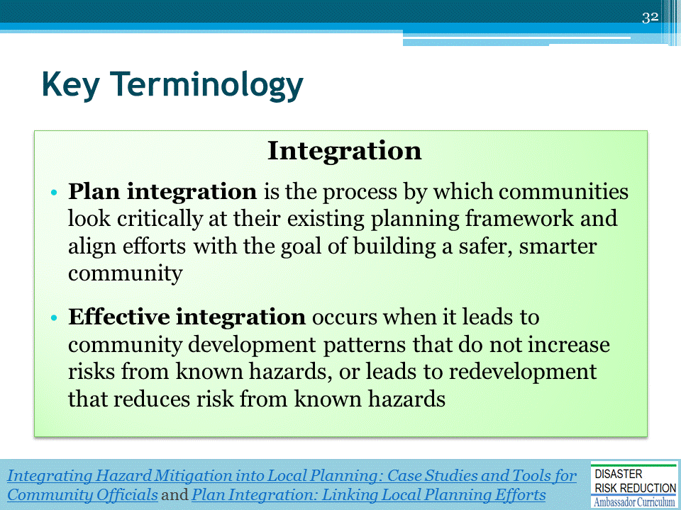
Integrating Hazard Mitigation into Local Planning: Case Studies and Tools for Community Officials (March 2013)
https://www.fema.gov/media-library-data/20130726-1908-25045-0016/integrating_hazmit.pdf
FEMA’s Plan Integration: Linking Local Planning Efforts
https://www.fema.gov/media-library-data/1440522008134-ddb097cc285bf741986b48fdcef31c6e/R3_Plan_Integration_0812_508.pdf

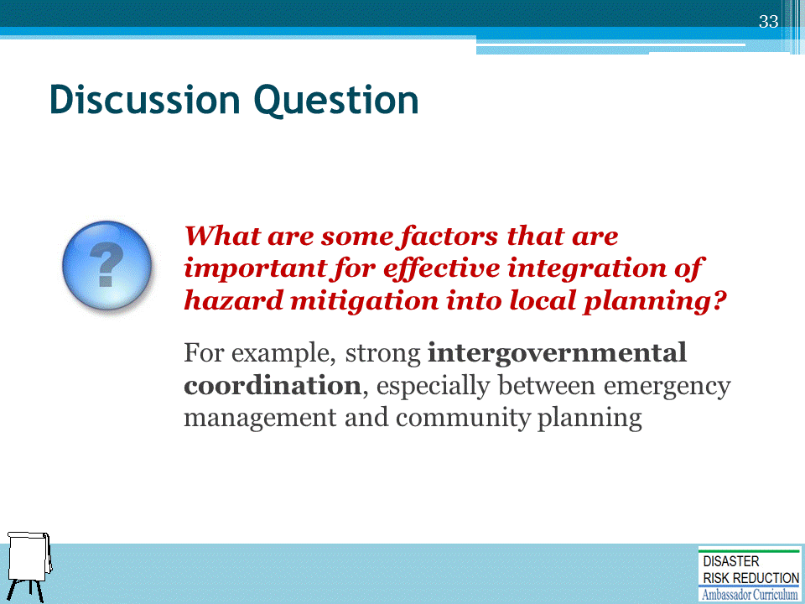

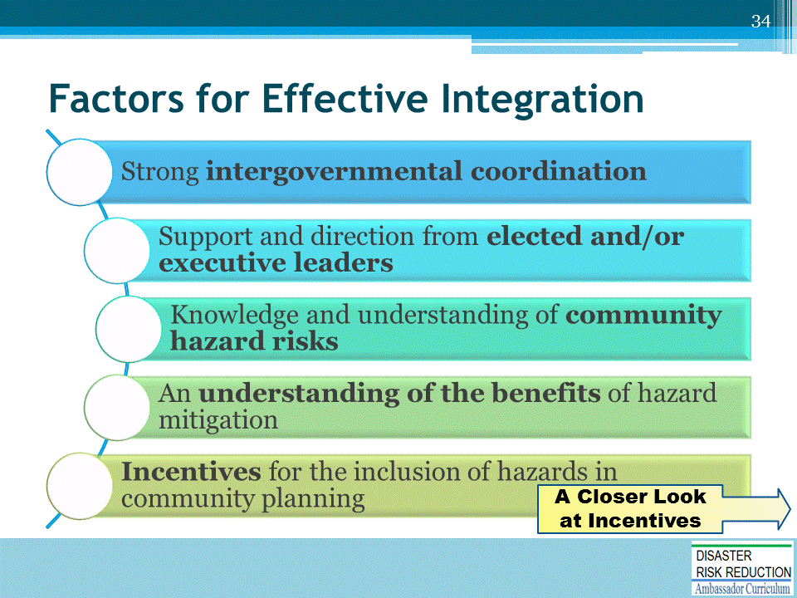

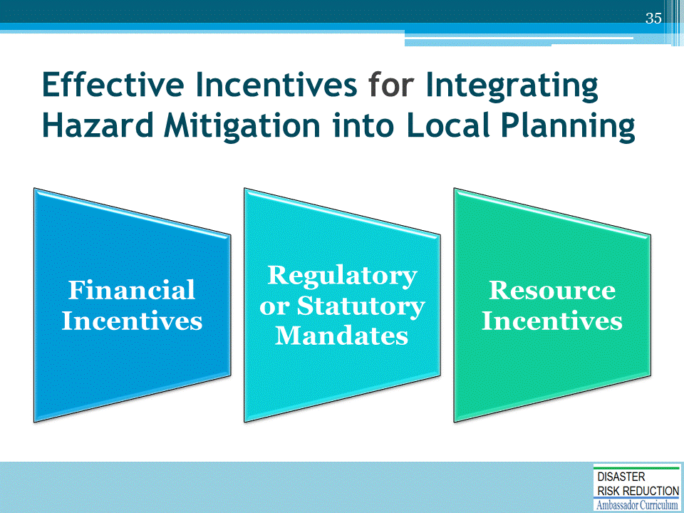

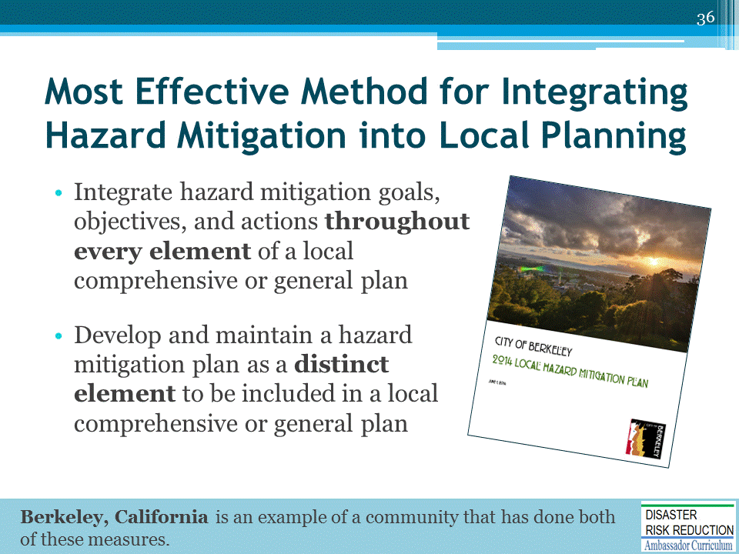

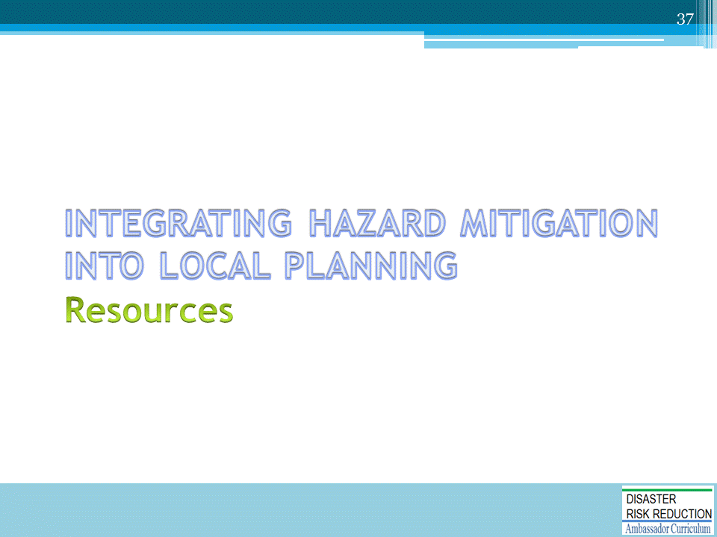

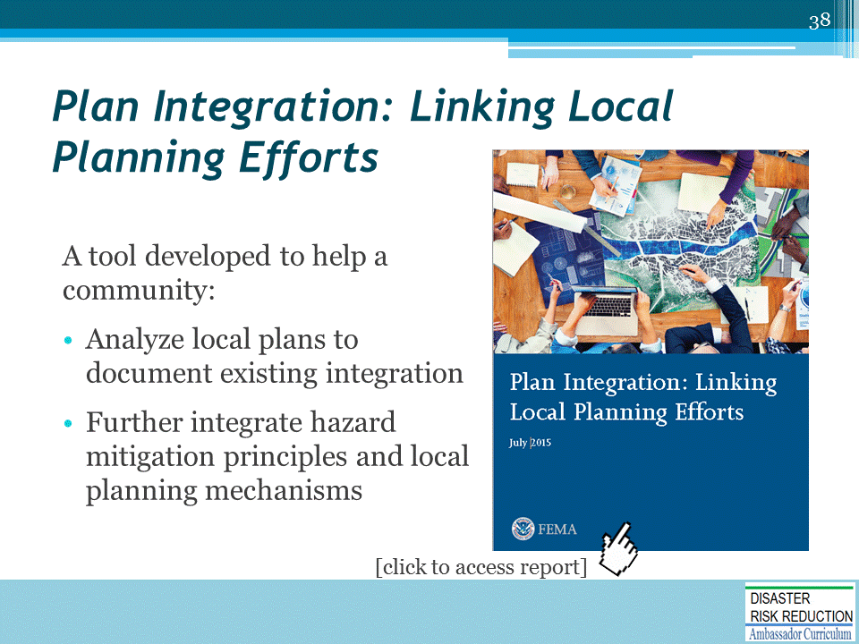
FEMA, Plan Integration: Linking Local Planning Efforts (https://www.fema.gov/media-library-data/1440522008134-ddb097cc285bf741986b48fdcef31c6e/R3_Plan_Integration_0812_508.pdf)

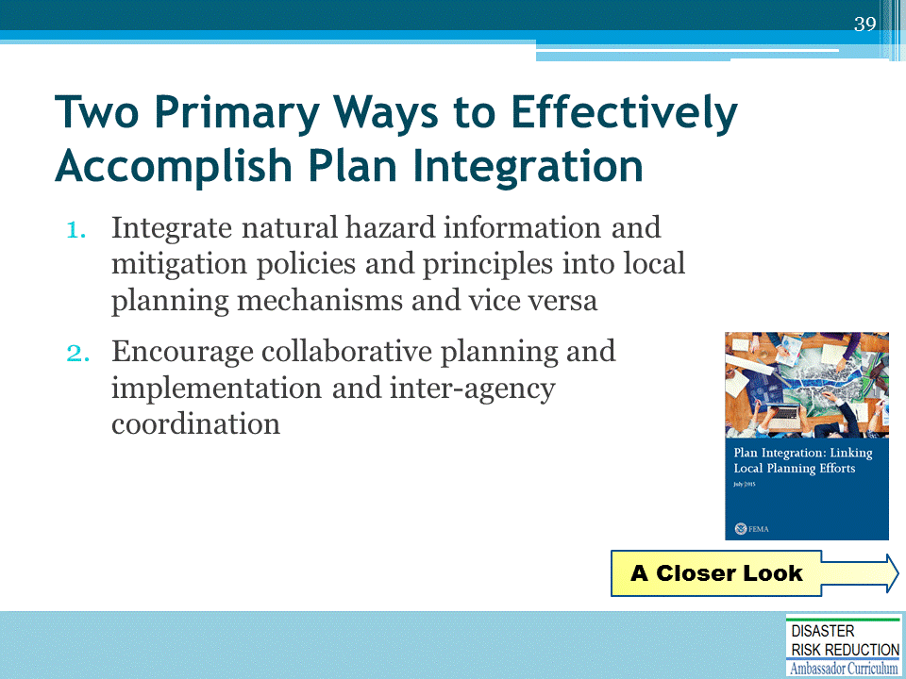
Source: FEMA, Plan Integration: Linking Local Planning Efforts (https://www.fema.gov/media-library-data/1440522008134-ddb097cc285bf741986b48fdcef31c6e/R3_Plan_Integration_0812_508.pdf)

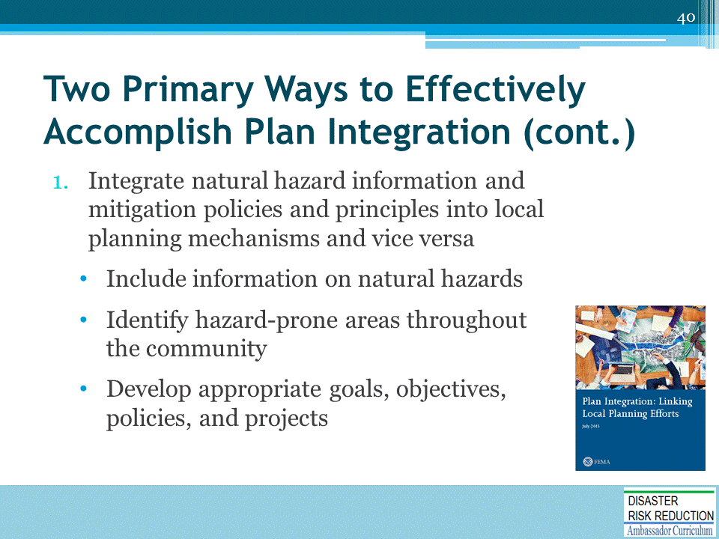
Source: FEMA, Plan Integration: Linking Local Planning Efforts (https://www.fema.gov/media-library-data/1440522008134-ddb097cc285bf741986b48fdcef31c6e/R3_Plan_Integration_0812_508.pdf)

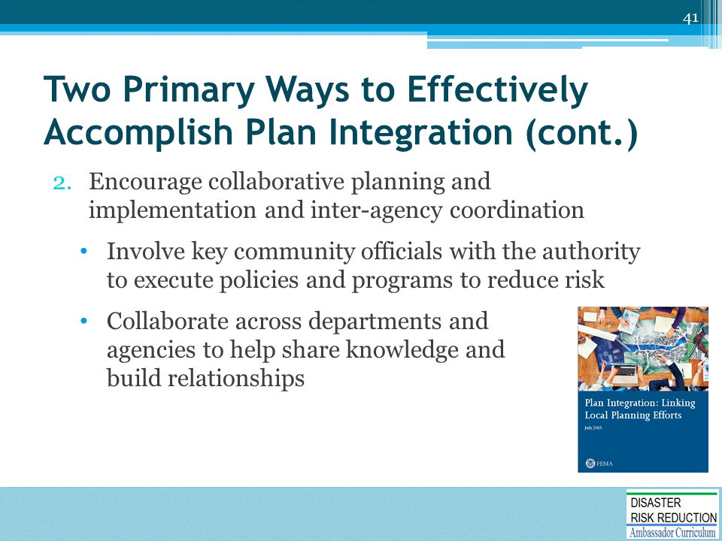
Source: FEMA, Plan Integration: Linking Local Planning Efforts (https://www.fema.gov/media-library-data/1440522008134-ddb097cc285bf741986b48fdcef31c6e/R3_Plan_Integration_0812_508.pdf)

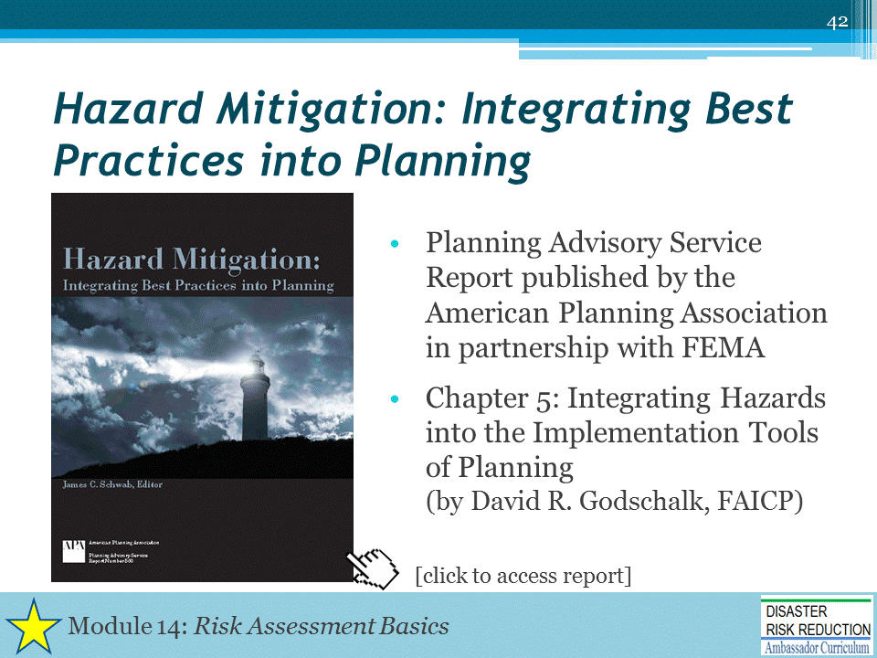
Hazard Mitigation: Integrating Best Practices into Planning, a joint effort by the American Planning Association and FEMA (May 2010). (https://www.fema.gov/media-library/assets/documents/19261)

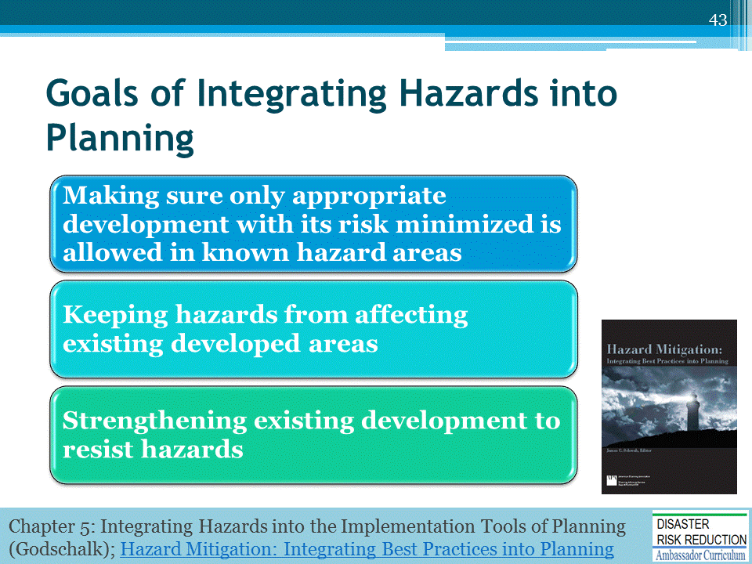
See Chapter 5 of Hazard Mitigation: Integrating Best Practices into Planning: https://www.fema.gov/media-library/assets/documents/19261

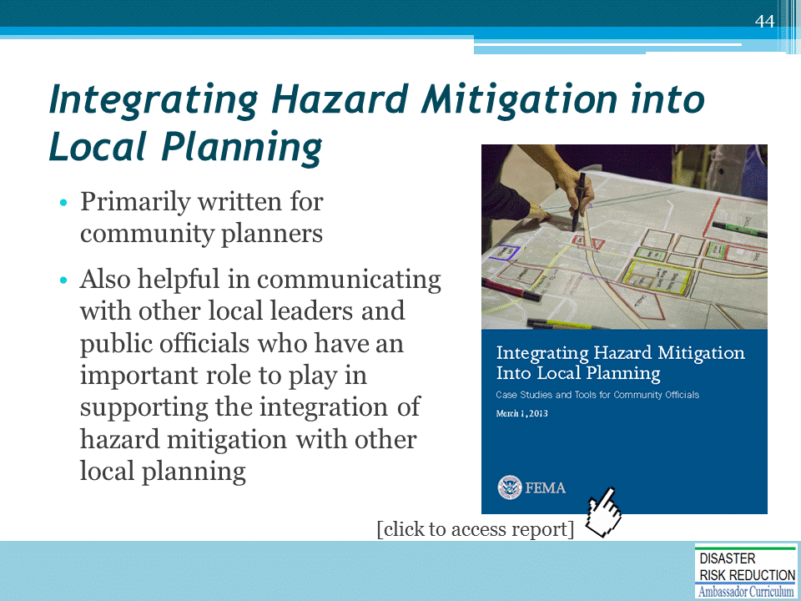
Integrating Hazard Mitigation into Local Planning: Case Studies and Tools for Community Officials (March 2013)
https://www.fema.gov/media-library-data/20130726-1908-25045-0016/integrating_hazmit.pdf

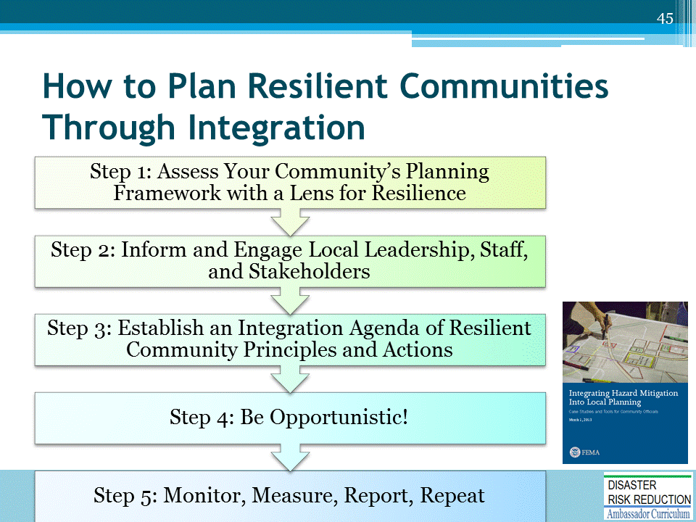
Source: Integrating Hazard Mitigation into Local Planning: Case Studies and Tools for Community Officials (March 2013)
https://www.fema.gov/media-library-data/20130726-1908-25045-0016/integrating_hazmit.pdf
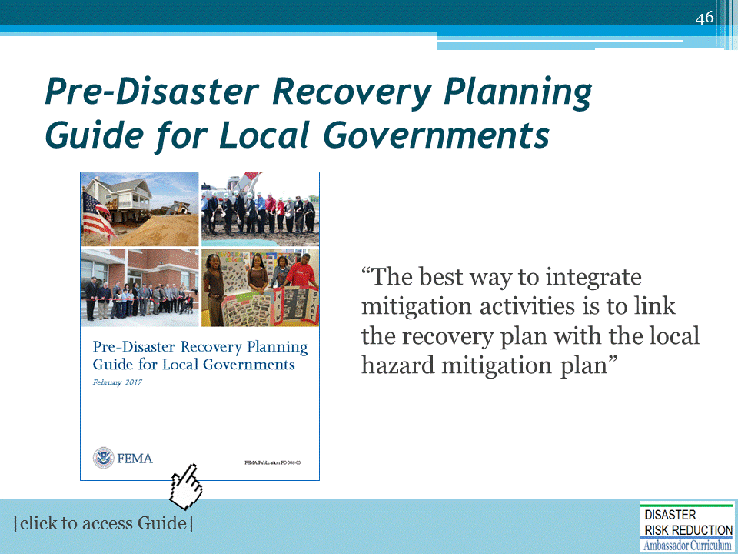
See page 9 of Pre-Disaster Recovery Planning Guide for Local Governments
(https://www.fema.gov/media-library-data/1487096102974-e33c774e3170bebd5846ab8dc9b61504/PreDisasterRecoveryPlanningGuideforLocalGovernmentsFinal50820170203.pdf)

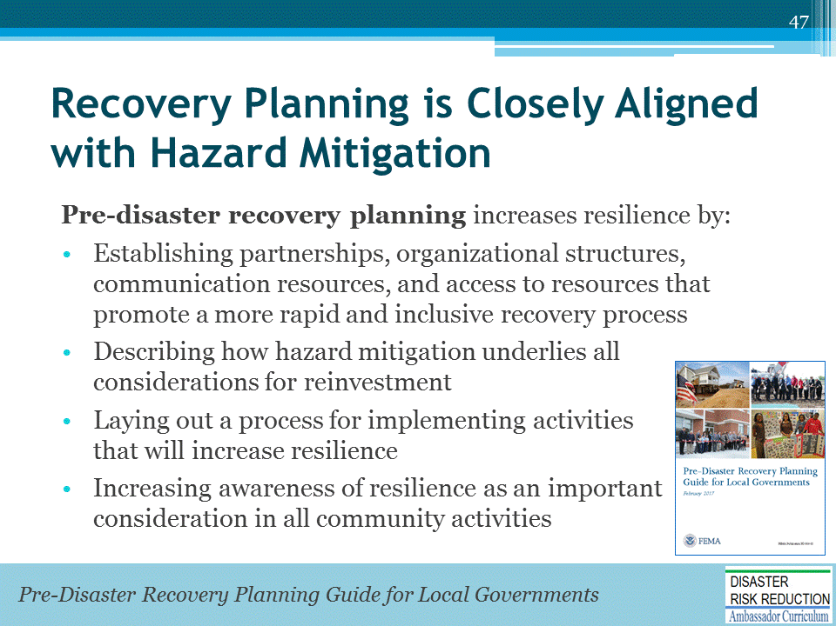
See page 14 of Pre-Disaster Recovery Planning Guide for Local Governments
(https://www.fema.gov/media-library-data/1487096102974-e33c774e3170bebd5846ab8dc9b61504/PreDisasterRecoveryPlanningGuideforLocalGovernmentsFinal50820170203.pdf)
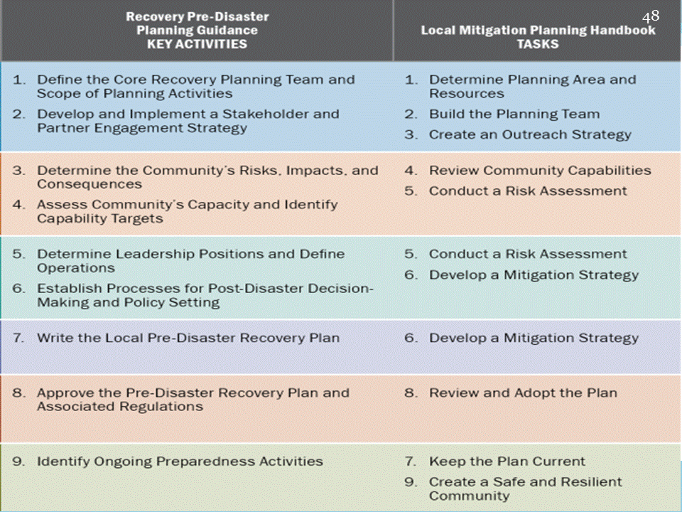
See page 73 of Pre-Disaster Recovery Planning Guide for Local Governments
(https://www.fema.gov/media-library-data/1487096102974-e33c774e3170bebd5846ab8dc9b61504/PreDisasterRecoveryPlanningGuideforLocalGovernmentsFinal50820170203.pdf)
Local Mitigation Planning Handbook: https://www.fema.gov/media-library-data/20130726-1910-25045-9160/fema_local_mitigation_handbook.pdf).
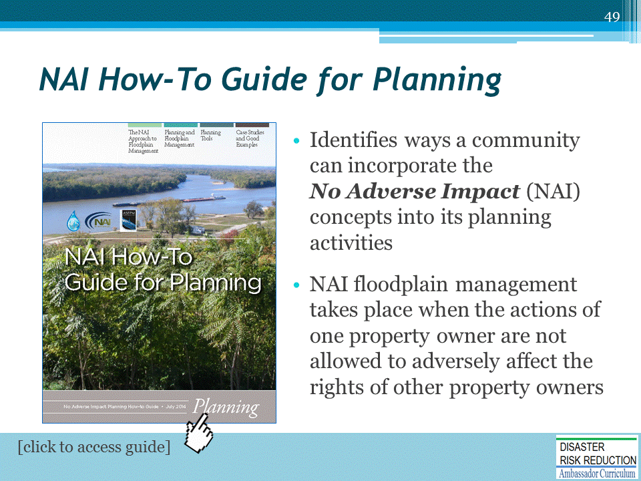
NAI How-To Guide for Planning: http://www.floods.org/NoAdverseImpact/NAI_Planning_How_to_Guide_Final.pdf
No Adverse Impact Toolkit: http://www.floods.org/NoAdverseImpact/NAI_Toolkit_2003.pdf
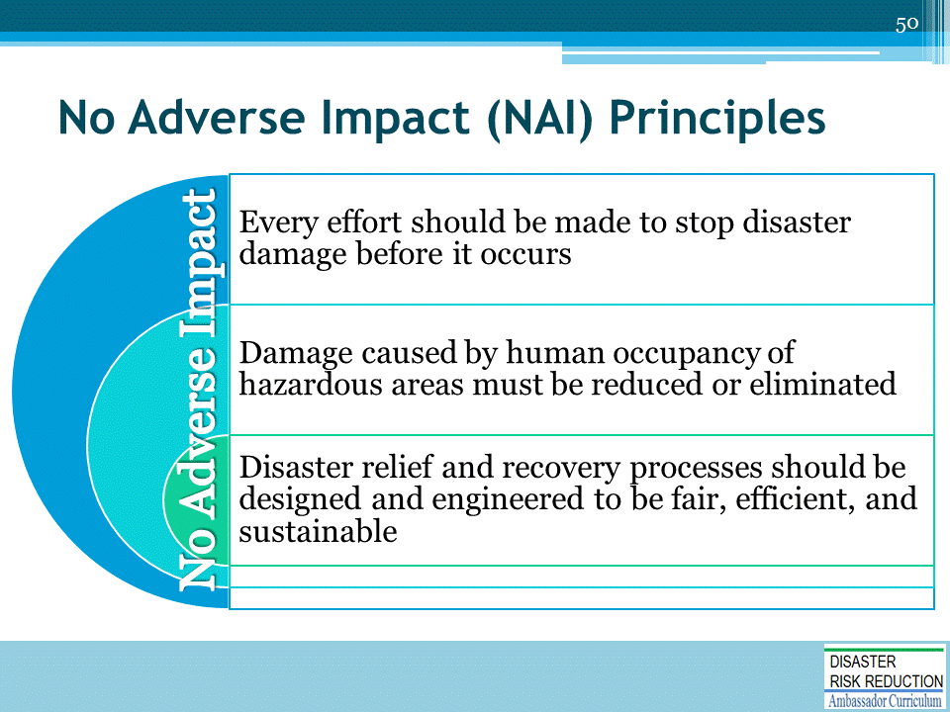

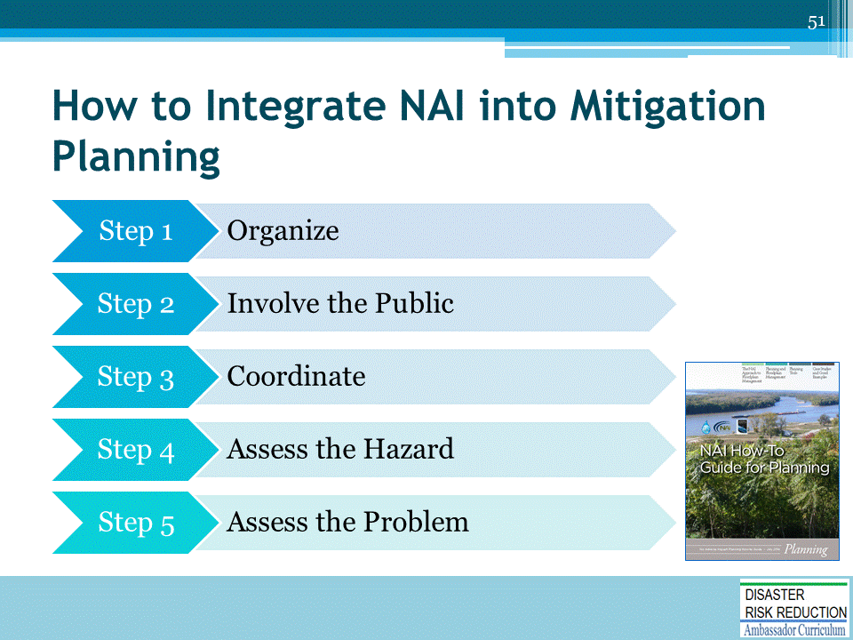
Source: NAI How-To Guide for Planning: http://www.floods.org/NoAdverseImpact/NAI_Planning_How_to_Guide_Final.pdf

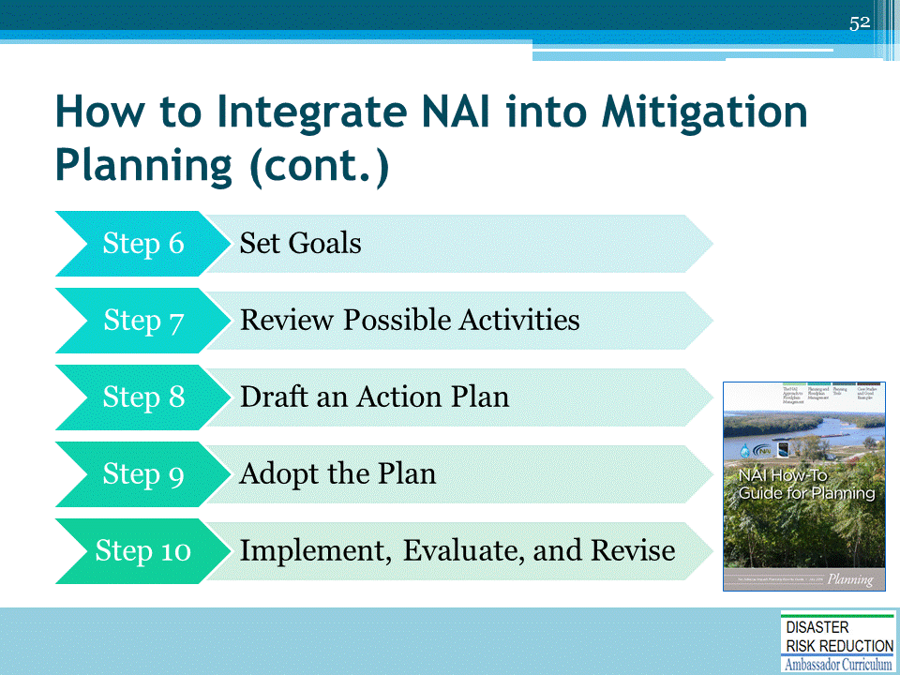
Source: NAI How-To Guide for Planning: http://www.floods.org/NoAdverseImpact/NAI_Planning_How_to_Guide_Final.pdf

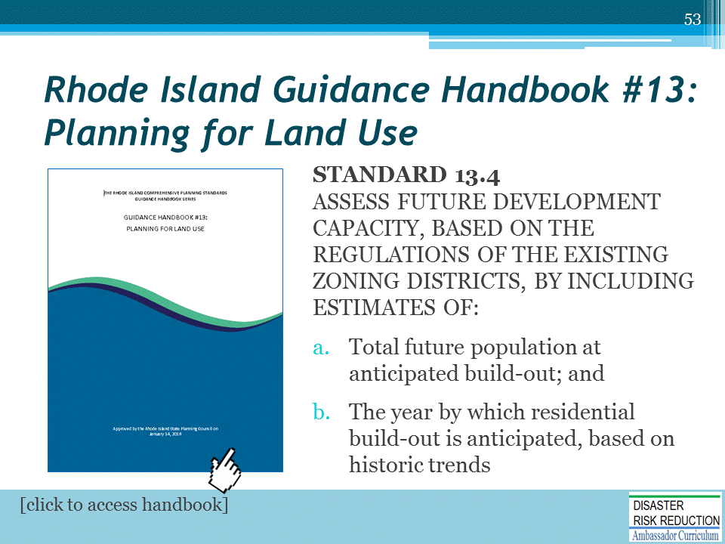
Source: Guidance Handbook #13: Planning for Land Use: http://www.planning.ri.gov/documents/comp_handbook/13_LandUse.pdf

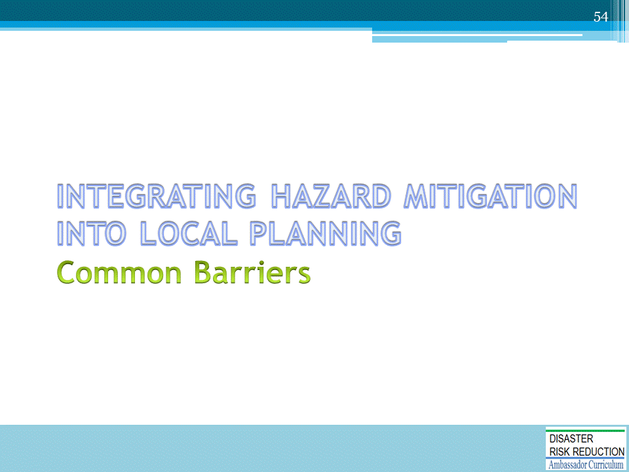

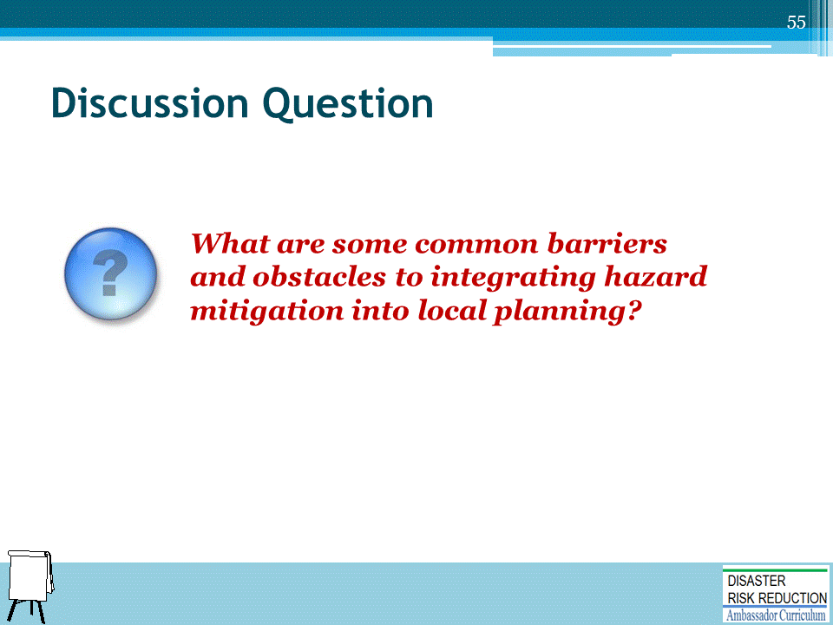

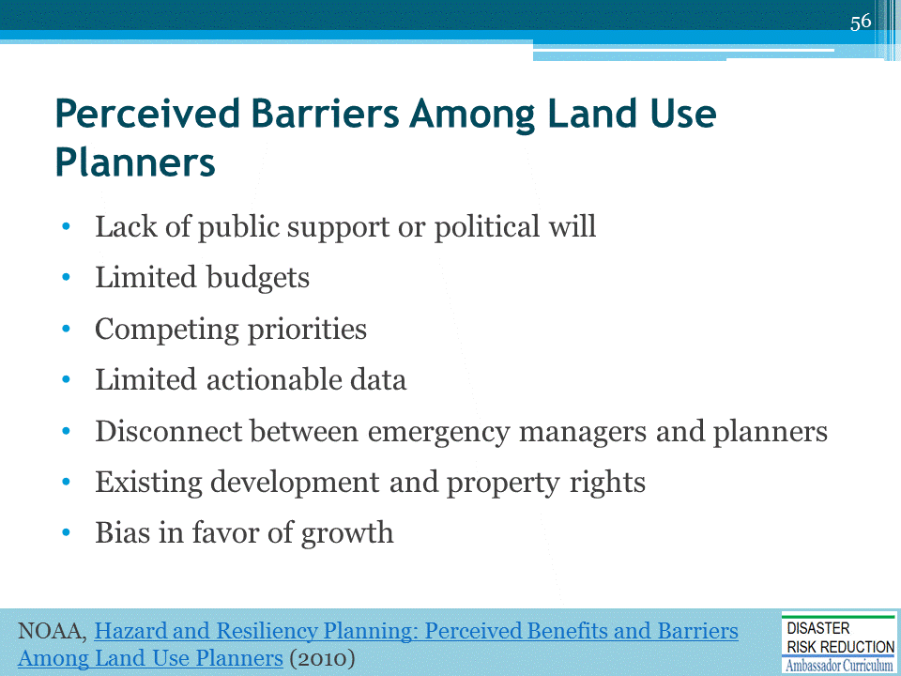
NOAA, Hazard and Resiliency Planning: Perceived Benefits and Barriers Among Land Use Planners (2010): https://coast.noaa.gov/data/digitalcoast/pdf/hazard-planning.pdf

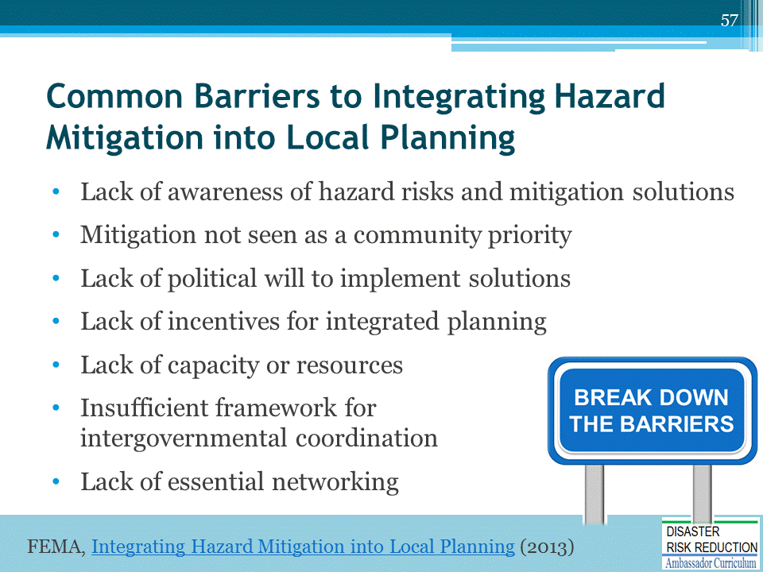
Source: FEMA, Integrating Hazard Mitigation into Local Planning (2013): https://www.fema.gov/media-library-data/20130726-1908-25045-0016/integrating_hazmit.pdf

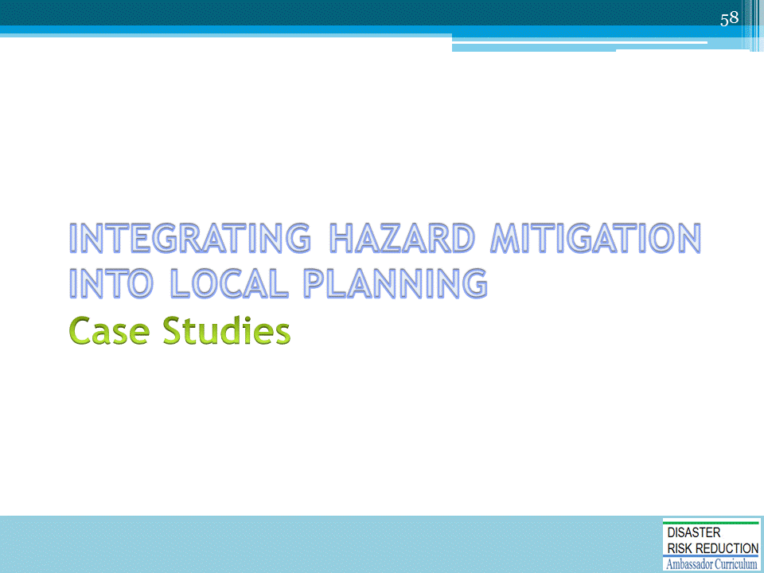

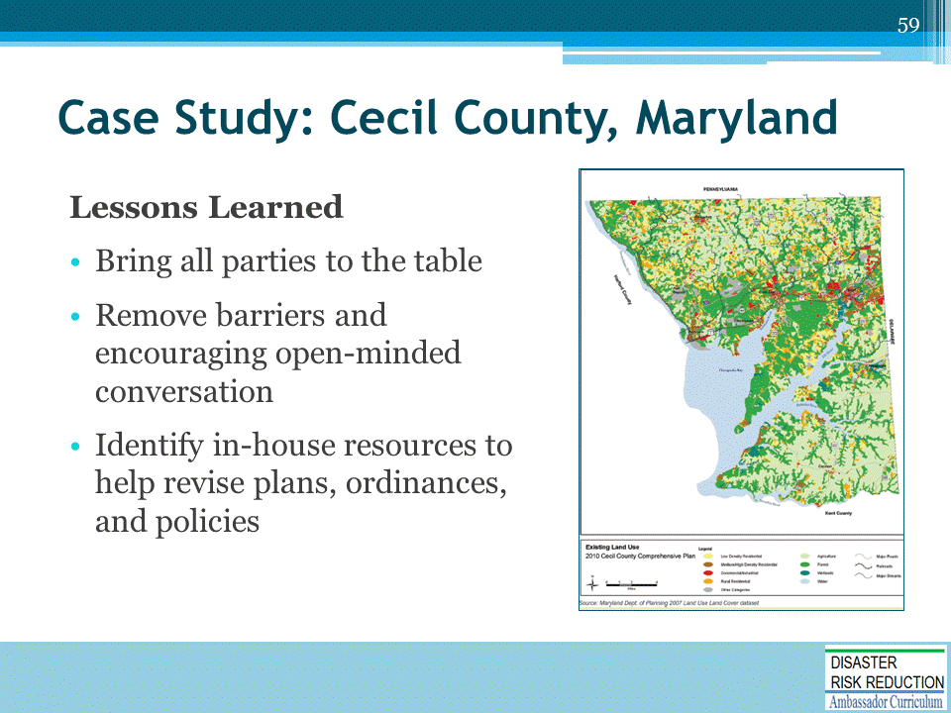
Cecil County performed plan integration with the goal of making the County more resilient to disasters.

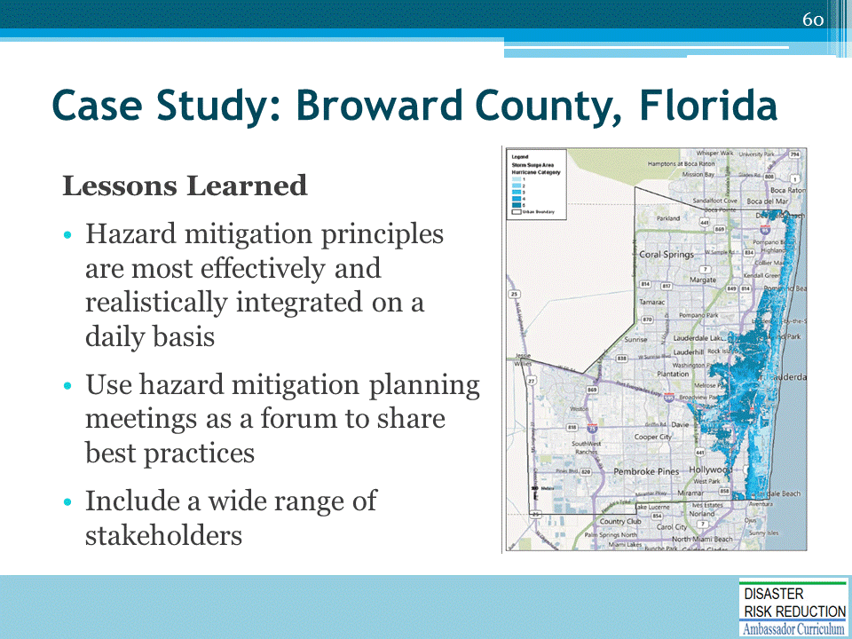
Broward County identified hazard mitigation integration opportunities and existing examples as part of a federal and state grant-funded process to establish a road map for Broward County stakeholders to make realistic incremental improvements toward making the county a model resilient, disaster resistant, and sustainable community.

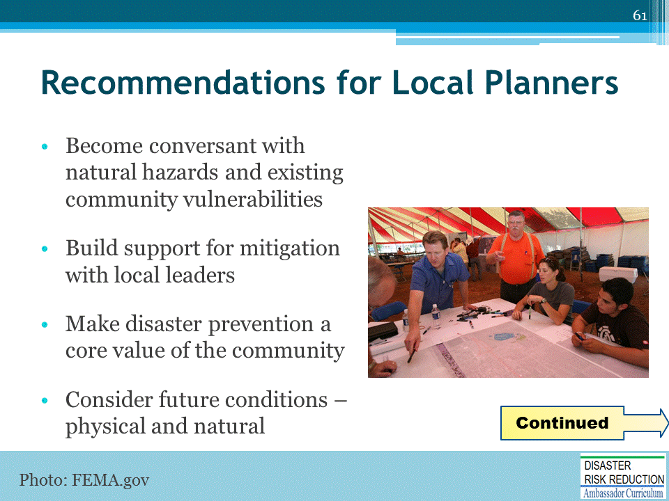

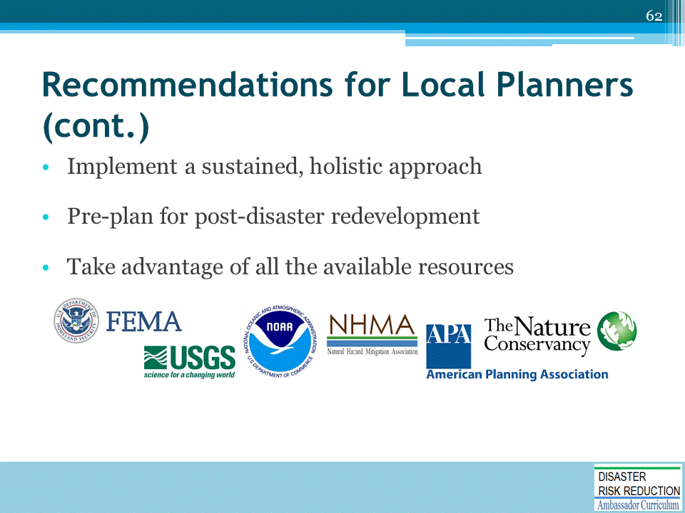

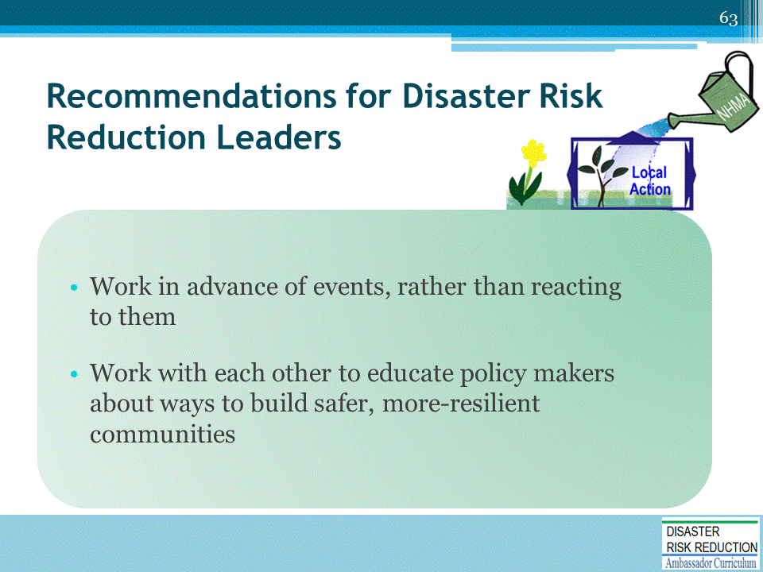

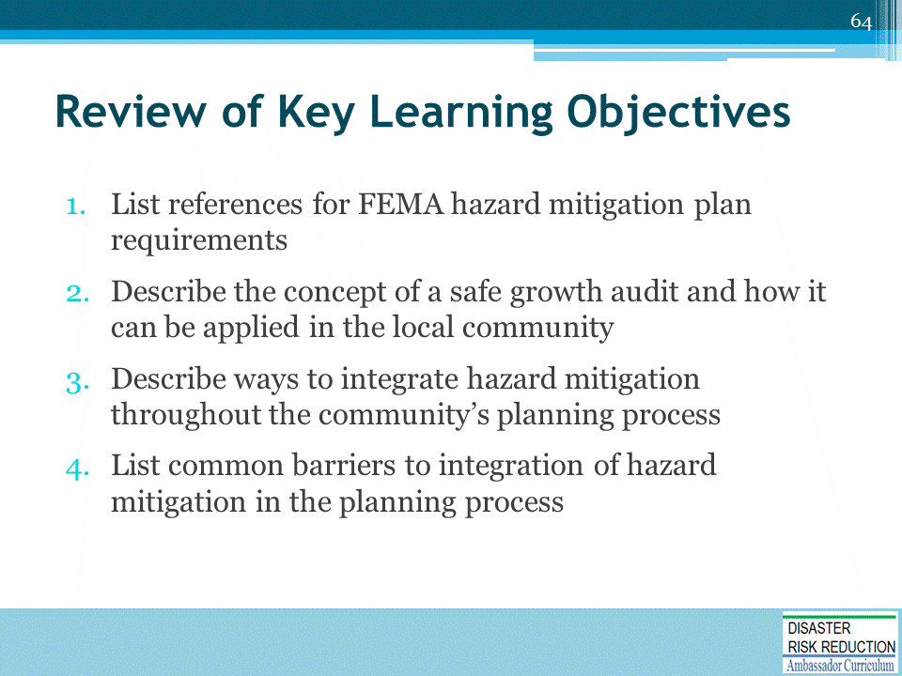

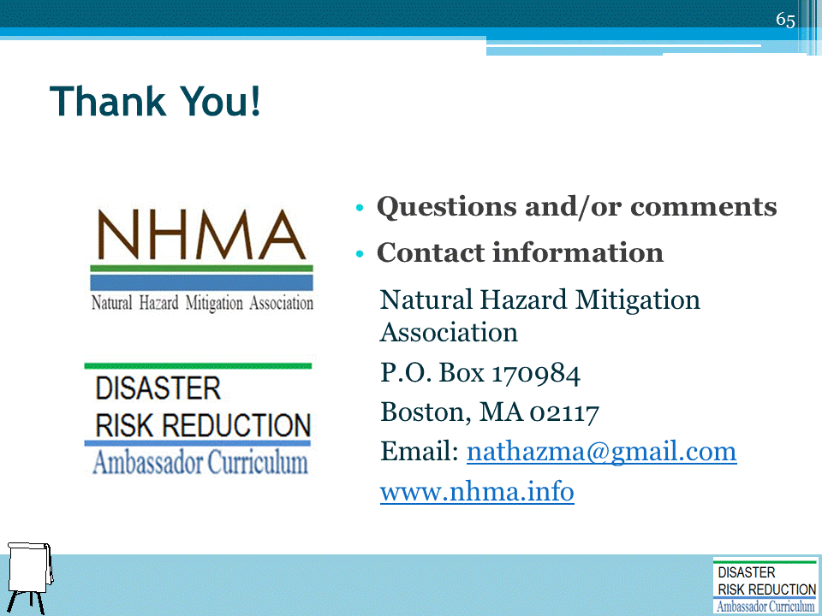

DRR AMBASSADOR CURRICULUM AT-A-GLANCE
I. Disaster Risk Reduction for a Safe and Prosperous Future
1 | Introduction to the Natural Hazard Mitigation Association and Disaster Risk Reduction Ambassador Curriculum
2 | Introduction to Disaster Risk Reduction as a Foundation of Community Resilience
3 | Leadership for Disaster Risk Reduction
4 | Community Disaster Risk Reduction and Adaptation
5 | Approaching the Challenge of Disaster Risk Reduction: NIST Community Resilience Guide
II. Forming a Community’s Vision for Disaster Risk Reduction
6 | Risk Assessment through Storytelling: An Asset-Based Approach
7 | Achieving Community Buy-in for Disaster Risk Reduction: Win-Win Approaches
8 | Leveraging Resources to Improve Disaster Risk Reduction
III. Realizable, Practical, and Affordable Approaches for Moving from a Vision for Disaster Risk Reduction to a Strategy
9 | Selecting and Implementing a Strategy for Addressing Community Disaster Risk Problems
10 | Integrating Hazard Mitigation into Local Planning
11 | Beyond Codes and Low-Impact Development
12 | Creating the Plan: A Sustainable Floodplain Management Process Model
IV. Resources and Tools for Implementing a Community’s Disaster Risk Reduction Strategy
13 | Climate and Weather Tools and Trends
14 | Risk Assessment Basics
15 | Legal and Policy Opportunities for Disaster Risk Reduction
16 | Linking Catastrophe Insurance to Disaster Risk Reduction
V. Resources for Hazard-Specific Disaster Risk Reduction
17 | Living with Water: Inland and Coastal Flooding
18 | Design for Flood Resilience: Part I: Floodplain Management and Flood Resistant Design
19 | Design for Flood Resilience: Part II: Green Infrastructure / Low Impact Development
20 | Overcoming Impediments to Flood Resilience: Paths Forward
21 | Wildfire Mitigation
22 | The Wildfire-Flood Connection
23 | Severe Thunderstorm/Tornado Safe Rooms
24 | From Policy to Engineering: Earthquake Risks

