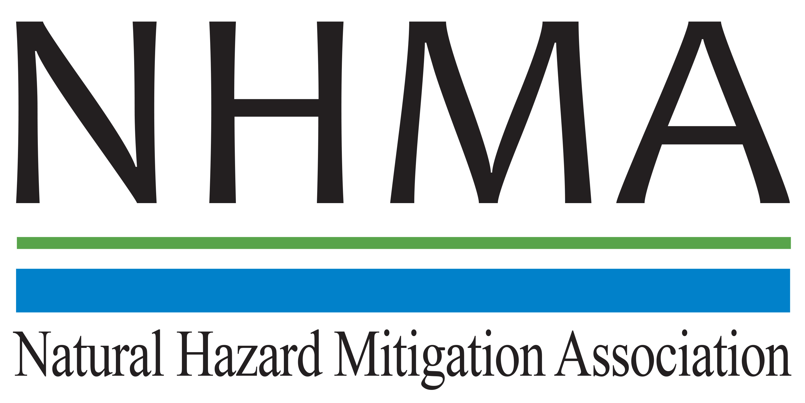

Disaster Risk Reduction (DRR) Ambassador Curriculum

Instructor Guide

Module 12:
Creating the Plan: A Sustainable Floodplain Management Process Model

THE DRR AMBASSADOR CURRICULUM
The goal of the DRR Ambassador Curriculum is to facilitate Disaster Risk Reduction efforts for the whole community by:
- Engaging in discussion of how disasters can be reduced through local action
- Sharing insights among local leaders and technical experts to enable the development of cross functional solutions
- Acquiring the best-available information, knowledge of best practices, and analytic tools to enable better-informed decisions before, during, and after disasters
It is important for instructors of DRR Ambassador Curriculum modules to remember this is one module in a 24-module curriculum. The “DRR Ambassador Curriculum At-a-Glance” table, located at the end of this document, lists the modules of the Curriculum. Keep in mind the following context for the module(s) you conduct:
DRR-A CURRICULUM TARGET AUDIENCE
The target audience includes those involved in community development decision-making, such as local community staff, volunteer and stakeholder groups, and federal and state officials.
METHODS OF DELIVERY
Varied delivery methods will provide multiple options for access by the target audience. The DRR Ambassador modules may be presented via webinars hosted by NHMA or partner organizations, presented in conferences and/or classrooms by qualified DRR Ambassador Curriculum instructor(s), or are downloadable for individual study from the NHMA website.
COURSE MATERIALS
Instructors are expected to use the instructional materials housed on the NHMA website to conduct DRR Ambassador Curriculum modules (Instructor Guide, supporting visuals, Participant Guides, and handouts). Instructors may tailor modules to specific audiences or locations as long as they do not revise the learning objectives and do not revise the materials in such a way that the participants cannot correctly complete the post-test. Instructors request the current pre/post-test for the module from NHMA.
CERTIFICATES OF COMPLETION
Certificates of Completion will be awarded by NHMA to participants who successfully complete NHMA-sponsored DRR Ambassador modules. A DRR Ambassador Certificate will be awarded to individuals completing all 24 modules. Participants who choose not to take the post-test may be issued a Certificate of Attendance. Contact NHMA about obtaining certificates. Inform participants to ask their certifying boards about acceptance of NHMA DRR Ambassador certificates for continuing education credits.

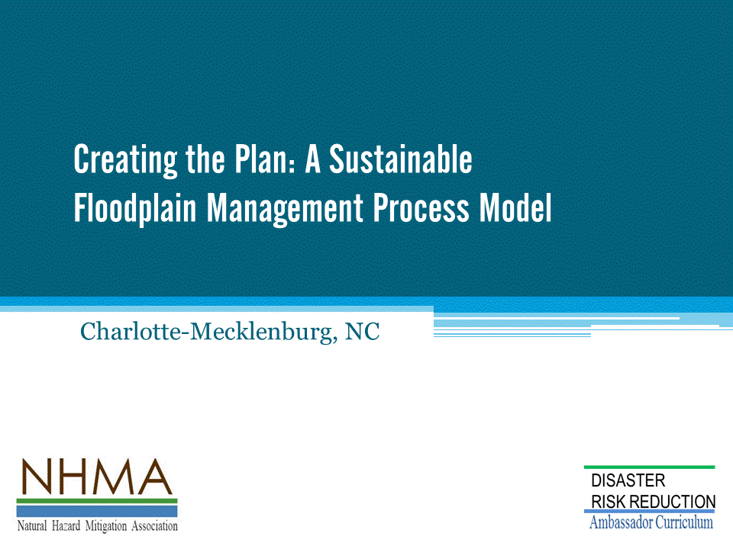

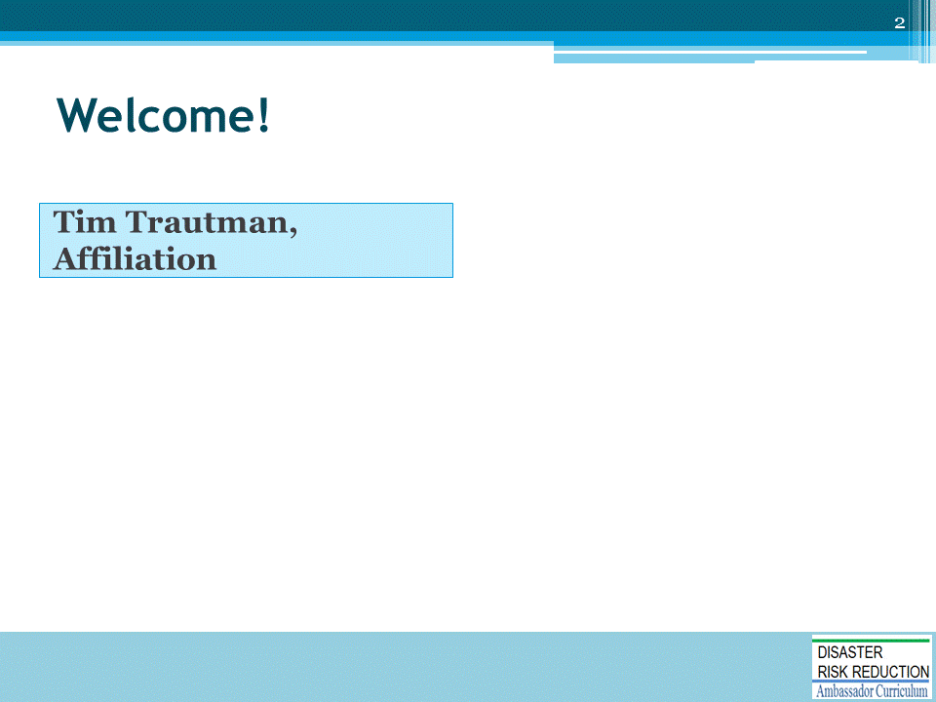
Introductions:
- Each presenter introduces her/himself, including affiliation and brief background.
- OPTIONAL: Have each participant briefly introduce him/herself
Mention:
- NHMA presentations are based on general principles of law, engineering, policy and emergency management.
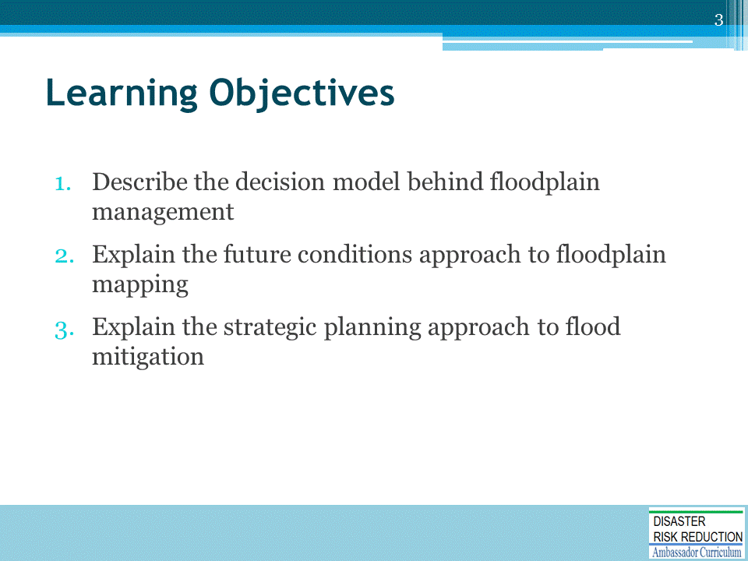

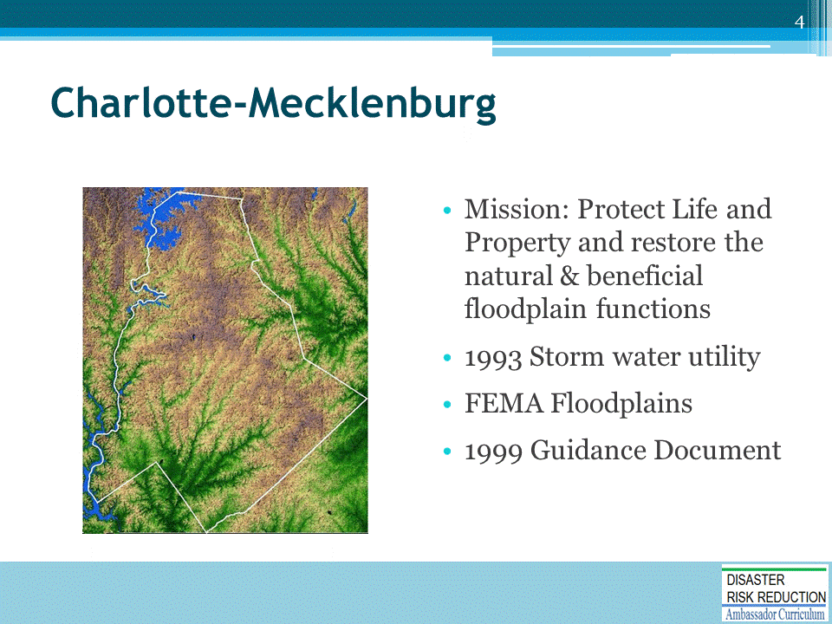

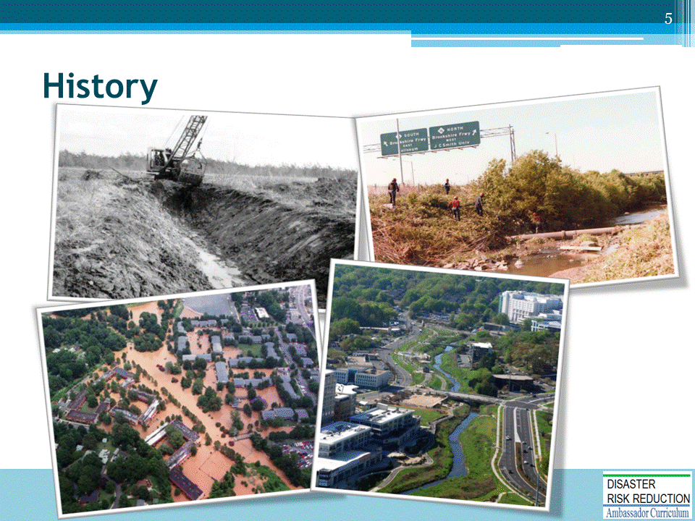

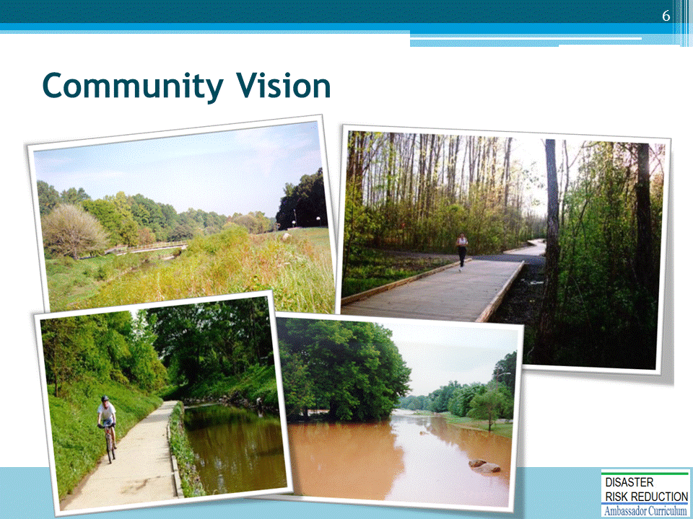

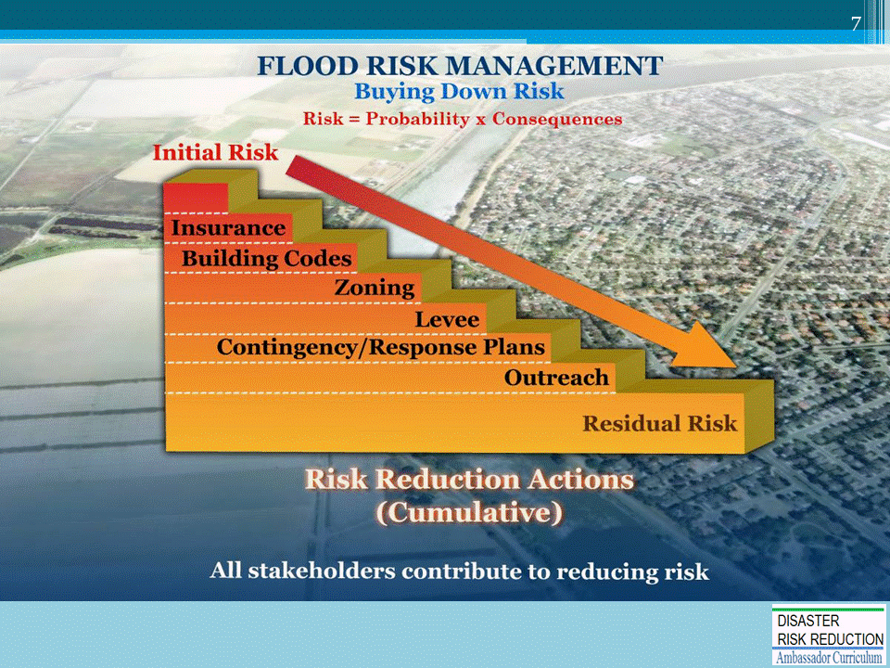

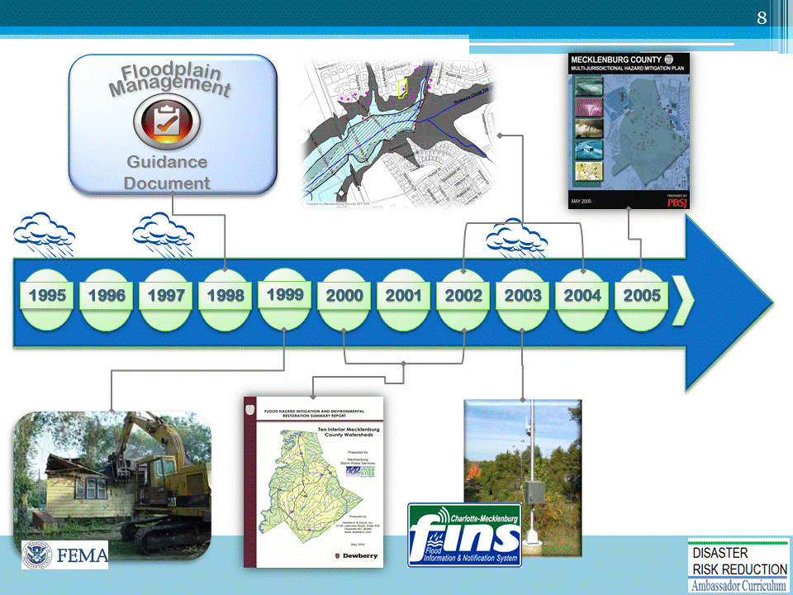

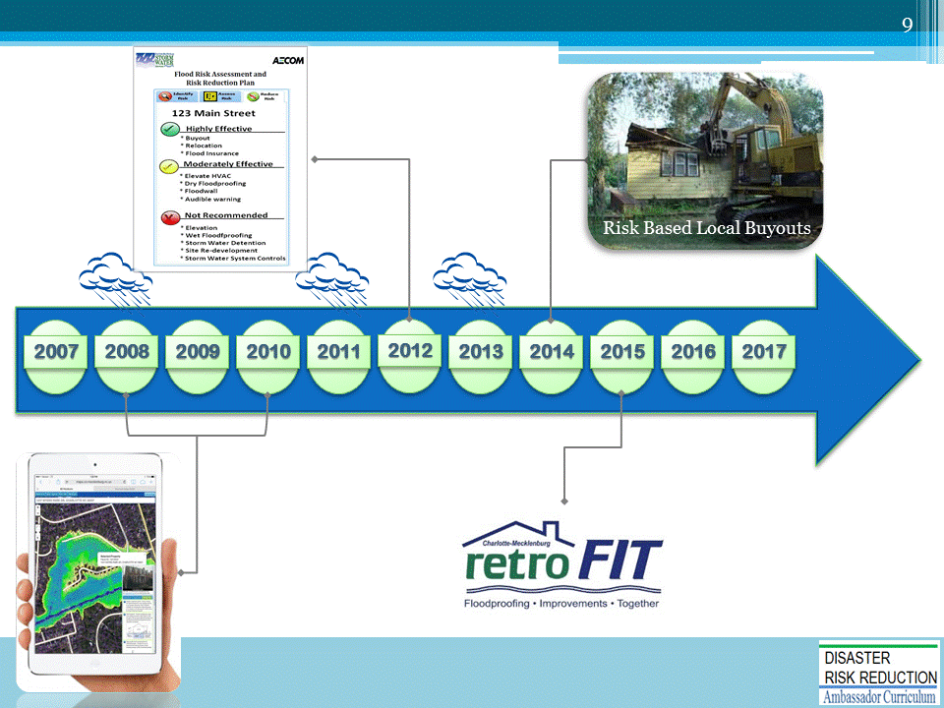

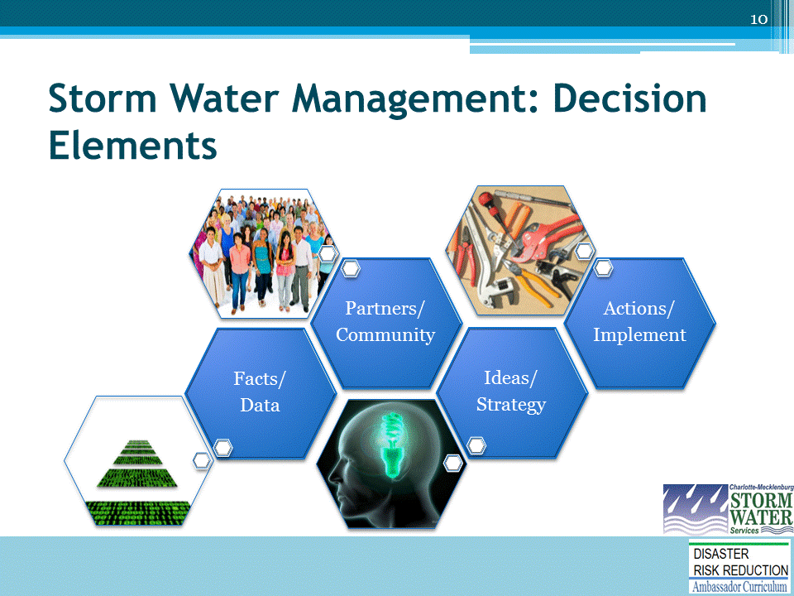

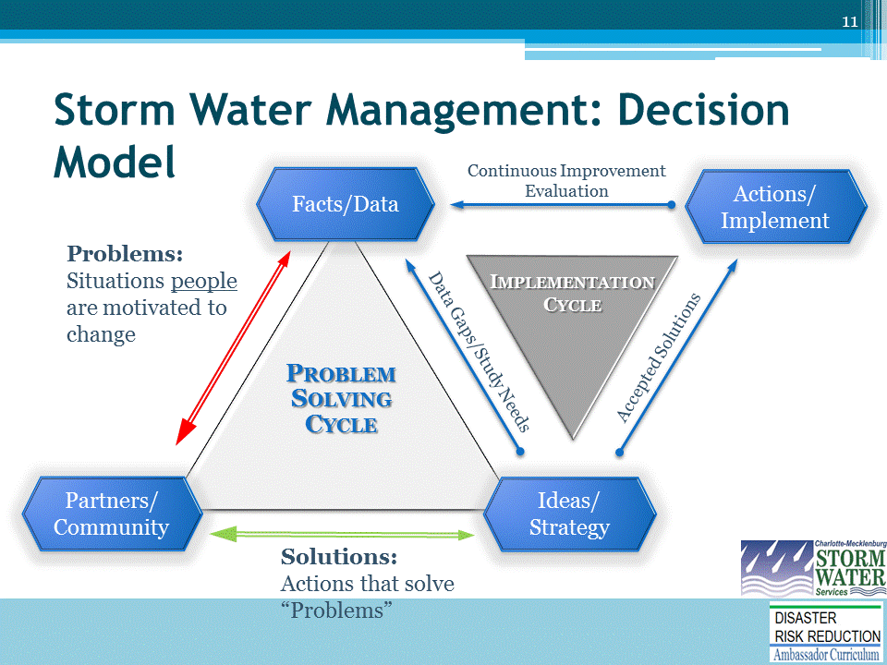

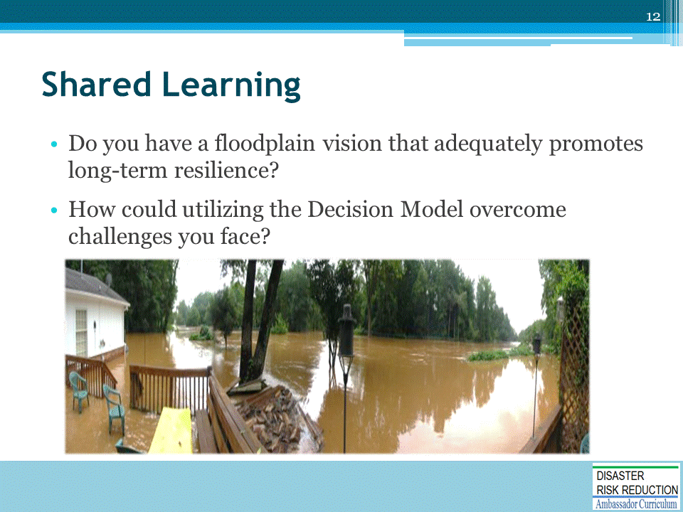

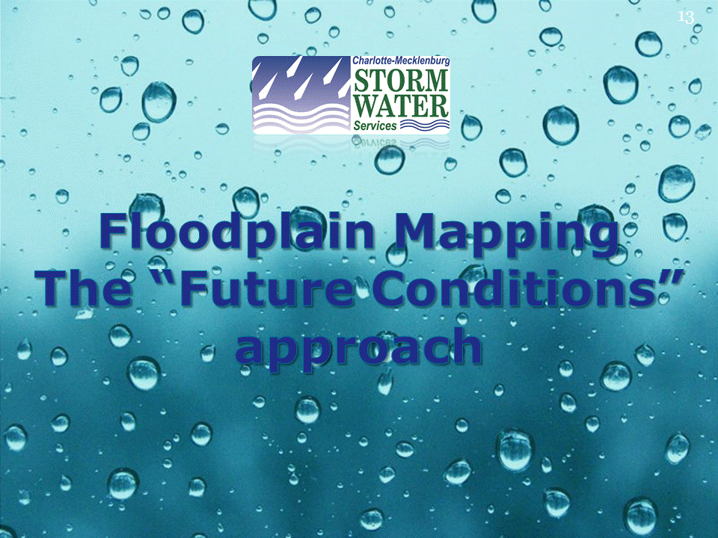

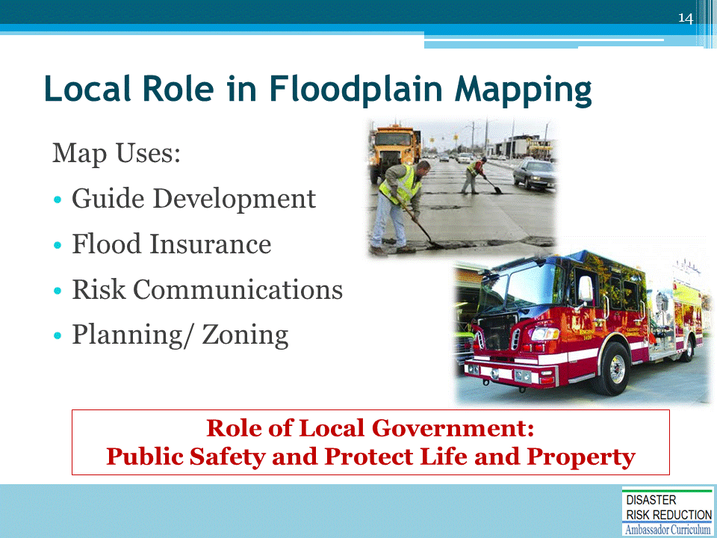

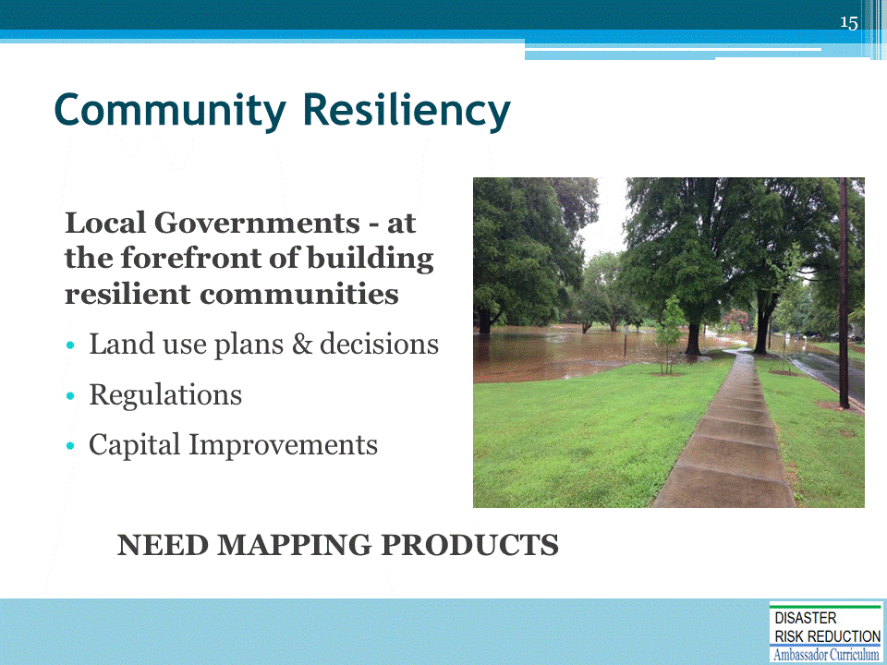
- Control land use decisions
- Regulations and higher standards
- Control capital expenditures & storm water utilities

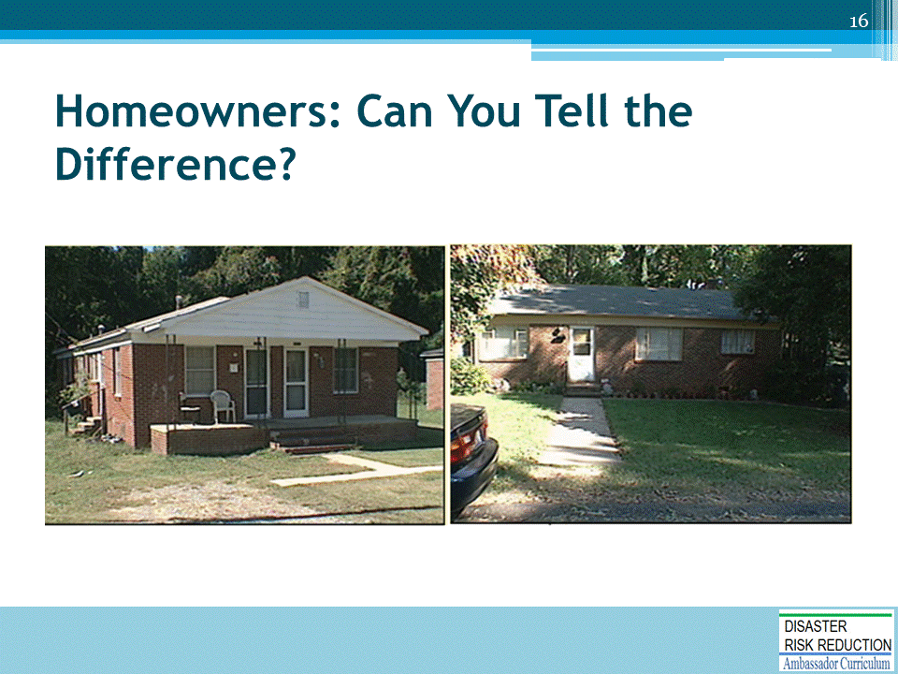

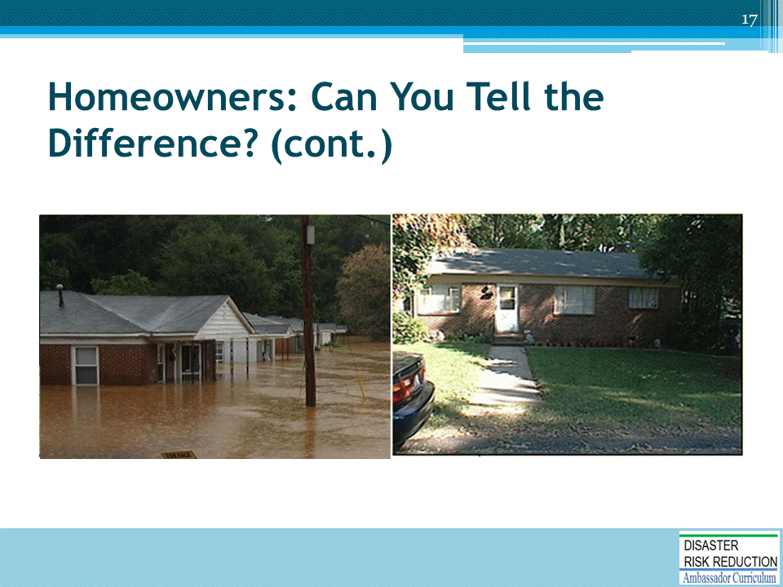

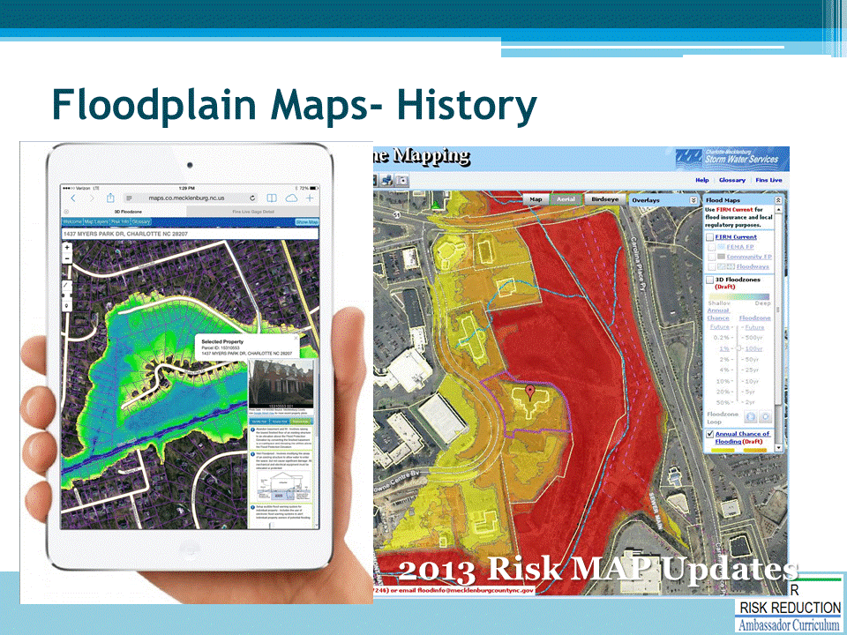

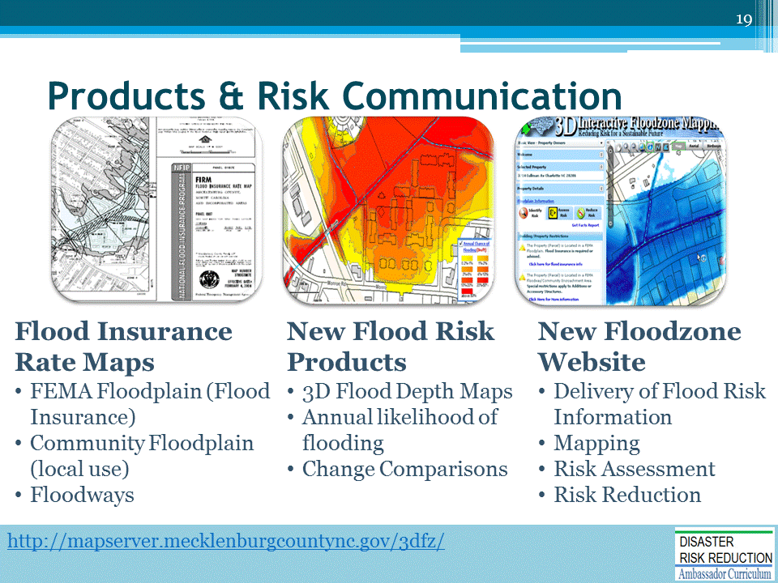

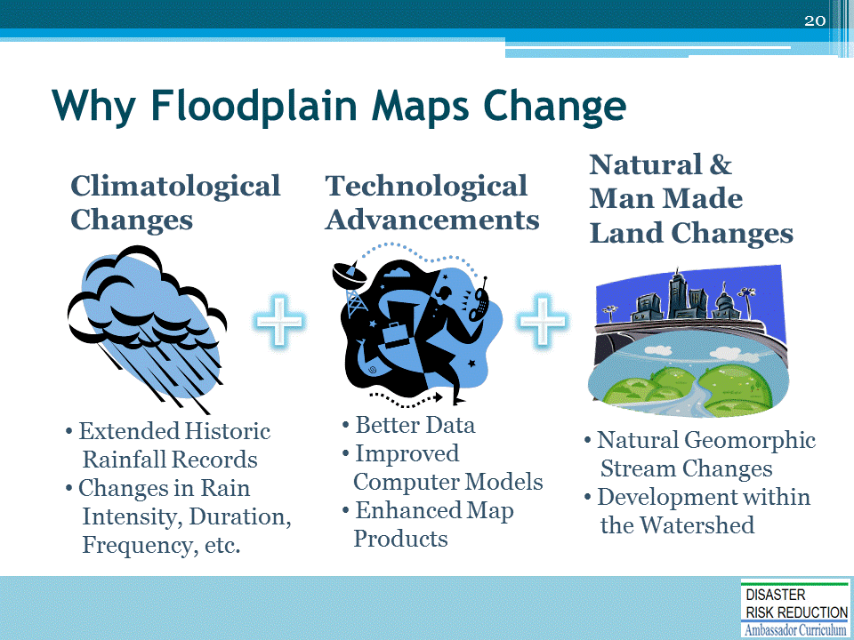
Flood Risk Changes Over Time

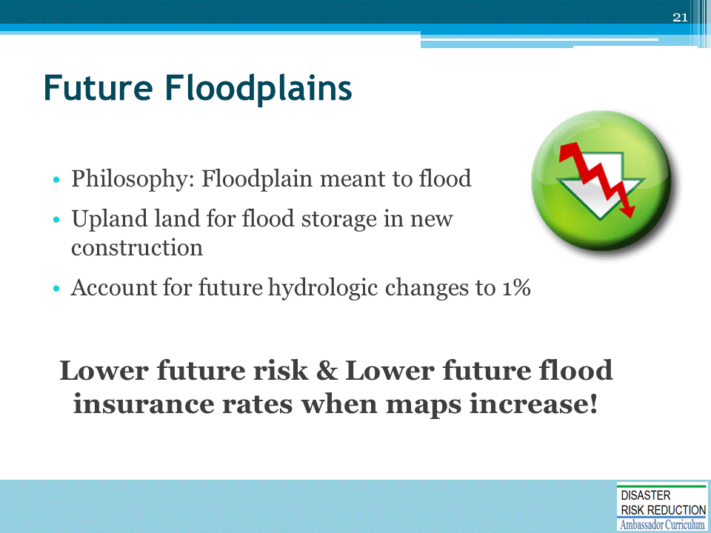
Not HOW
Not WHERE
But, WHY

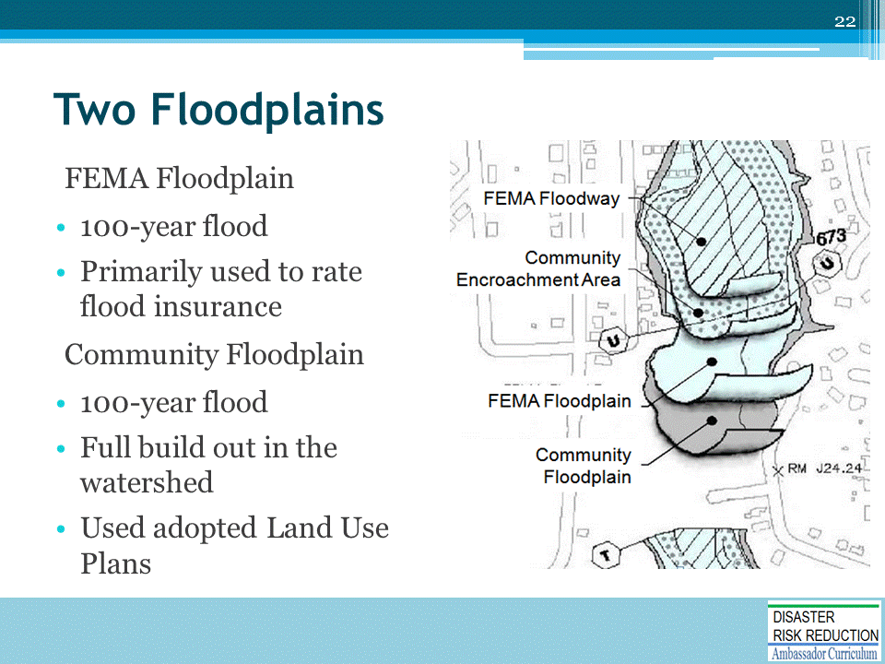

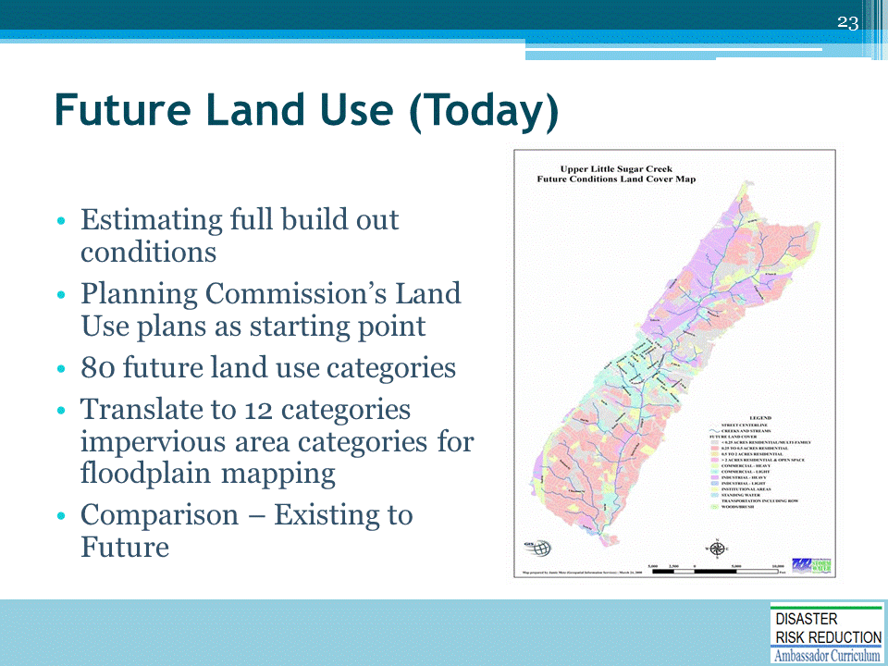

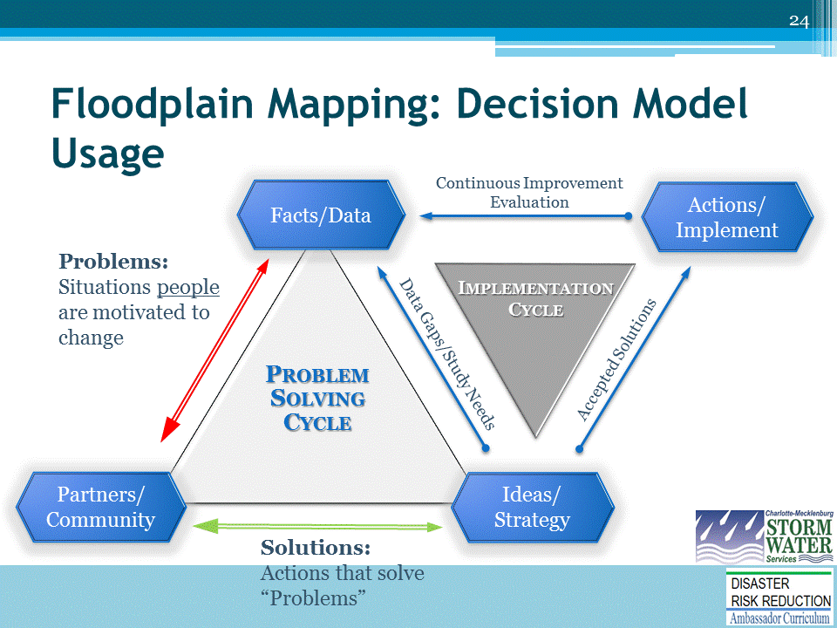

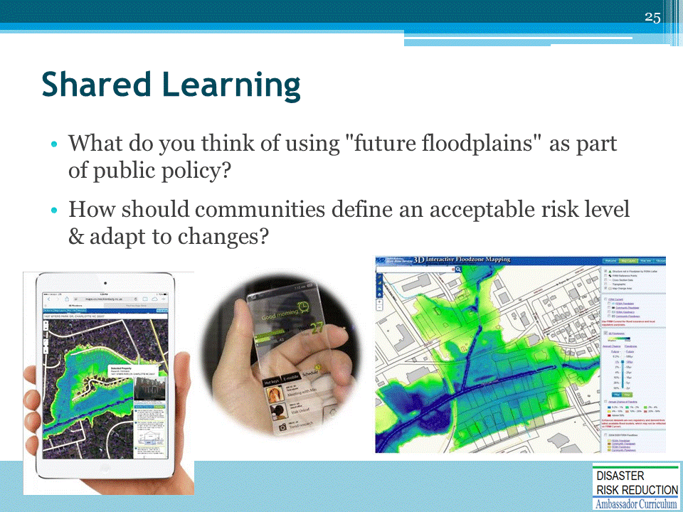

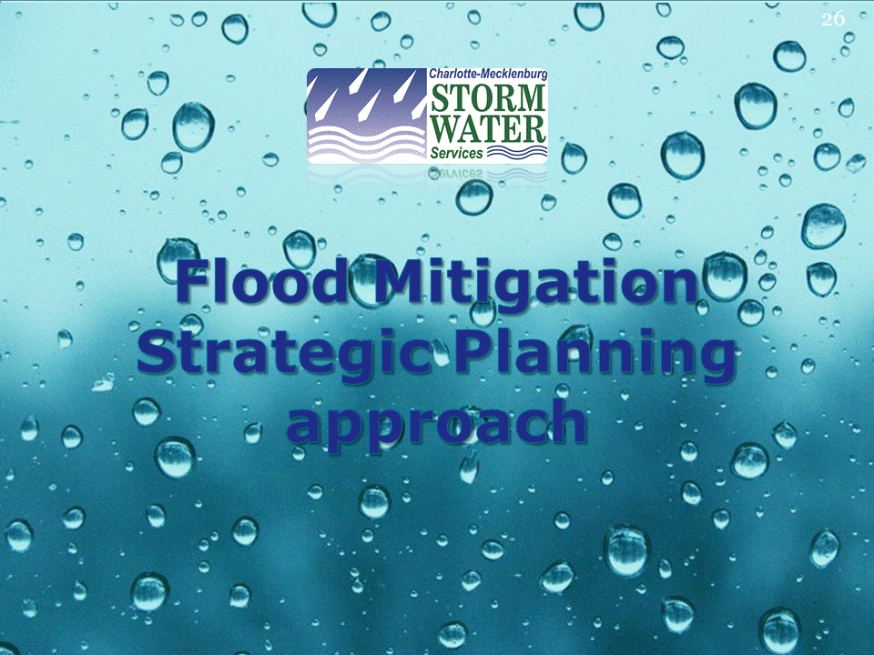

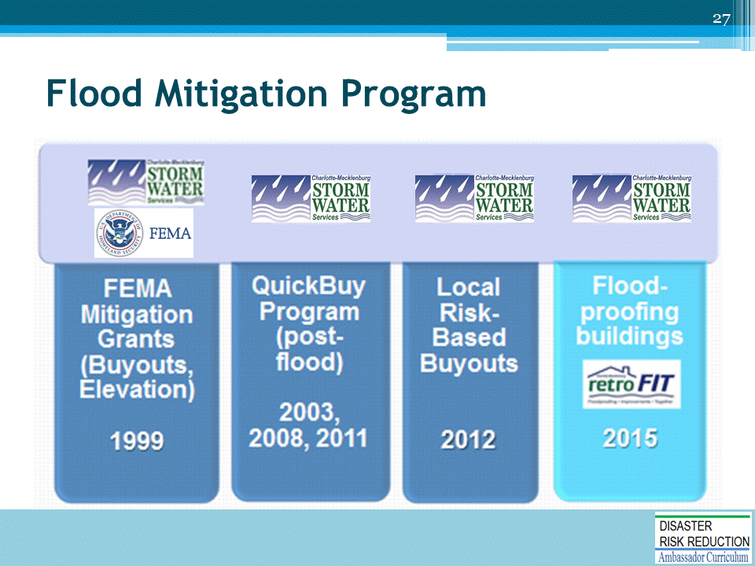

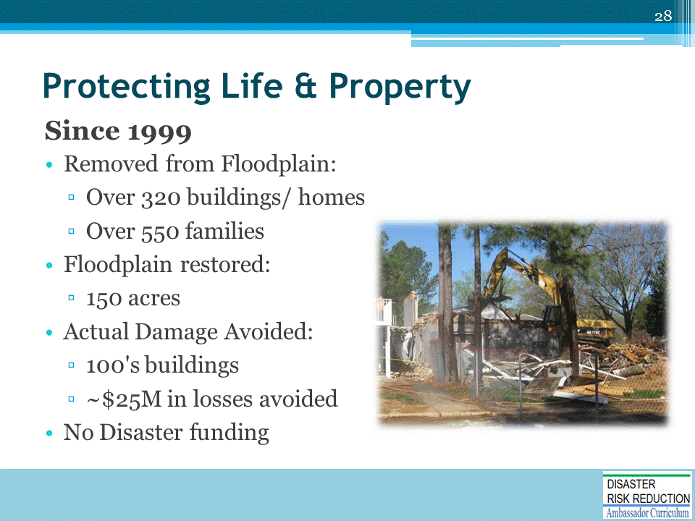
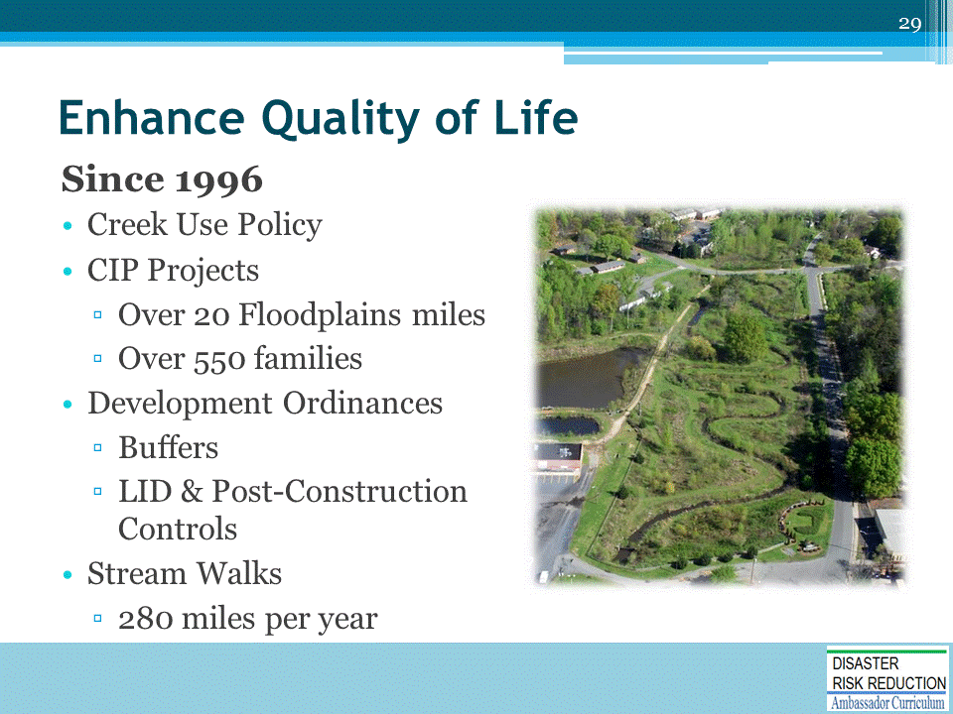

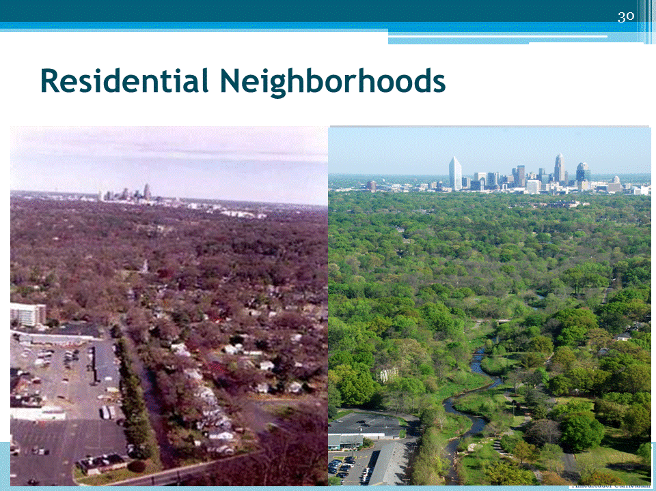

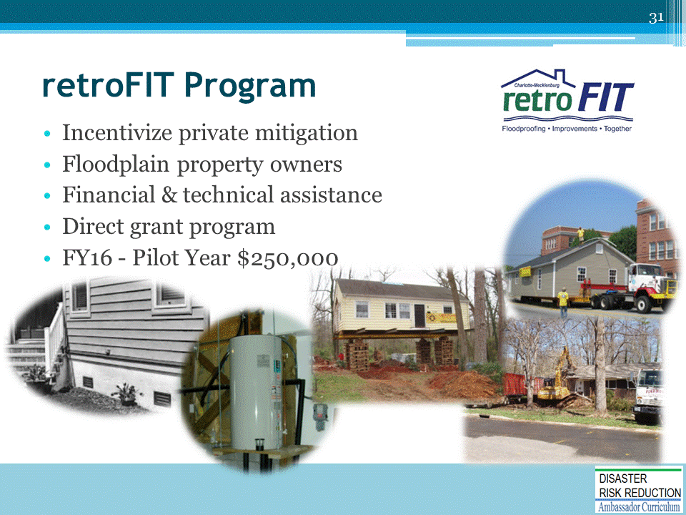

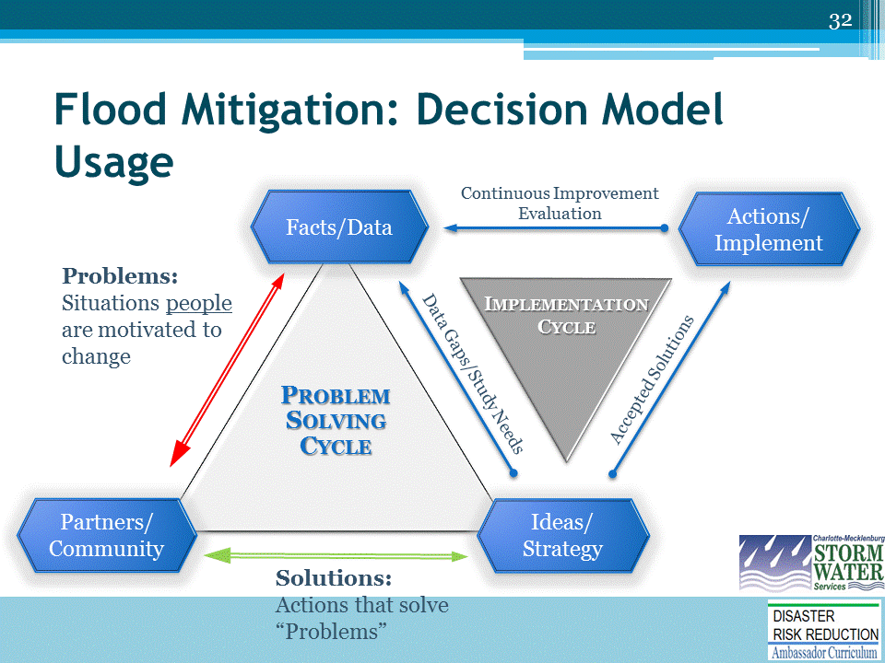

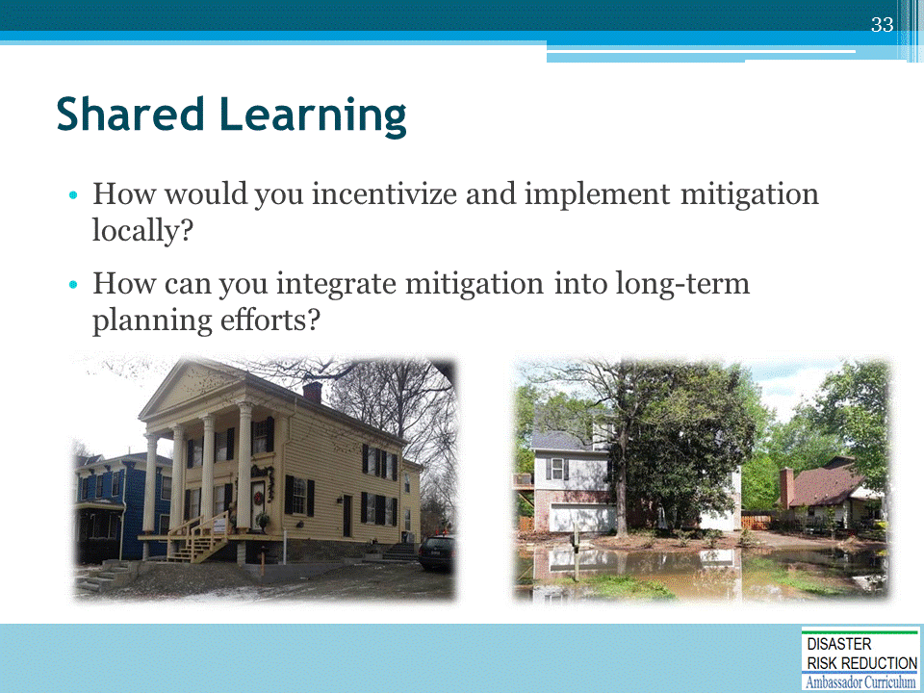

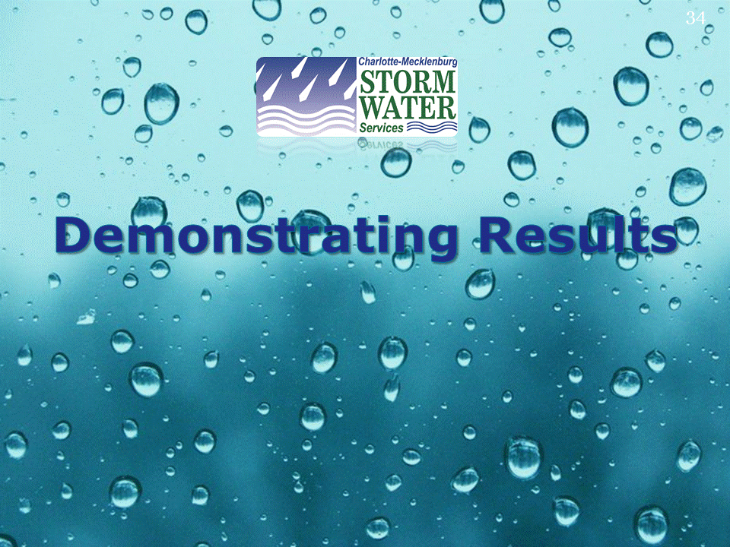

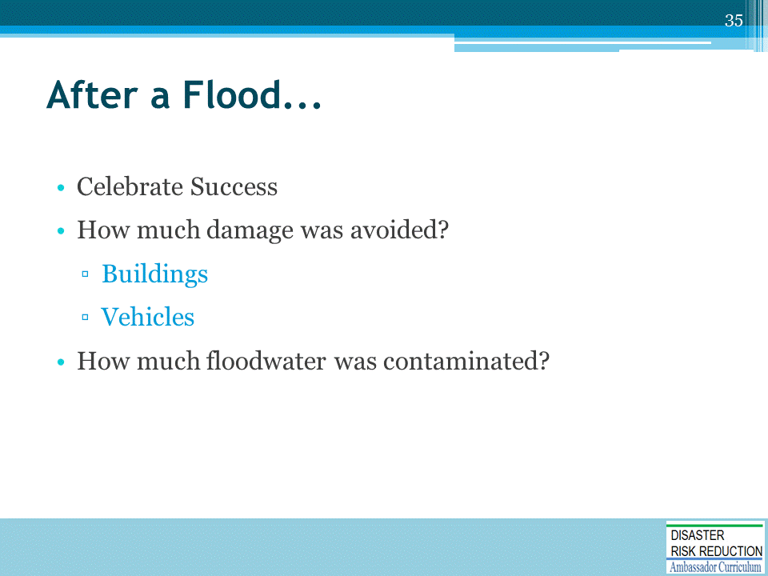

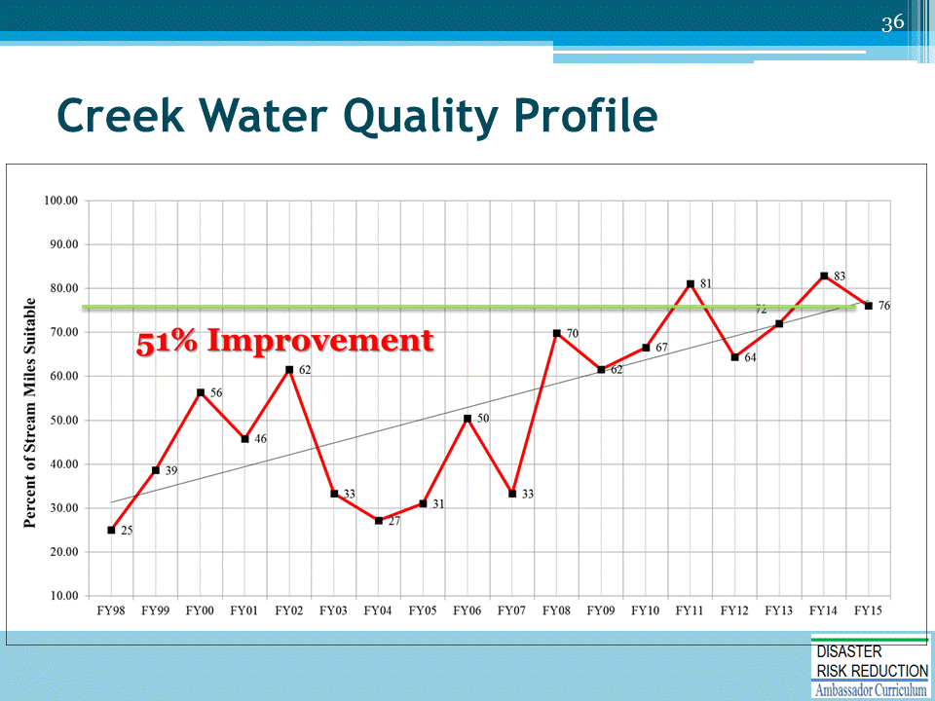
Charlotte-Mecklenburg, NC

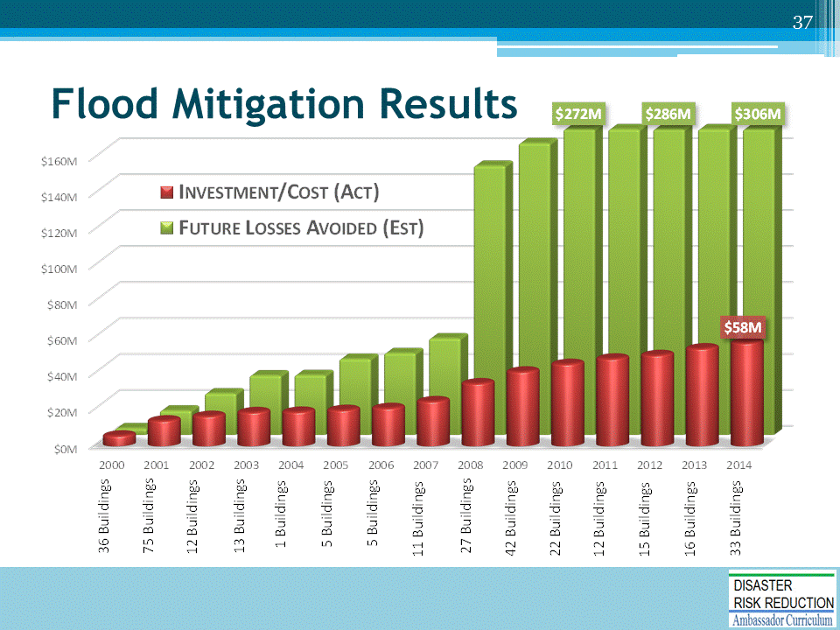

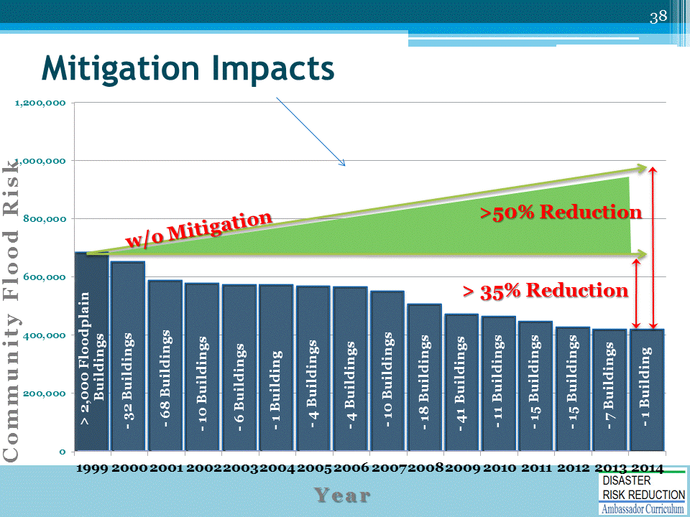
Charlotte-Mecklenburg, NC - Flood Risk Profile
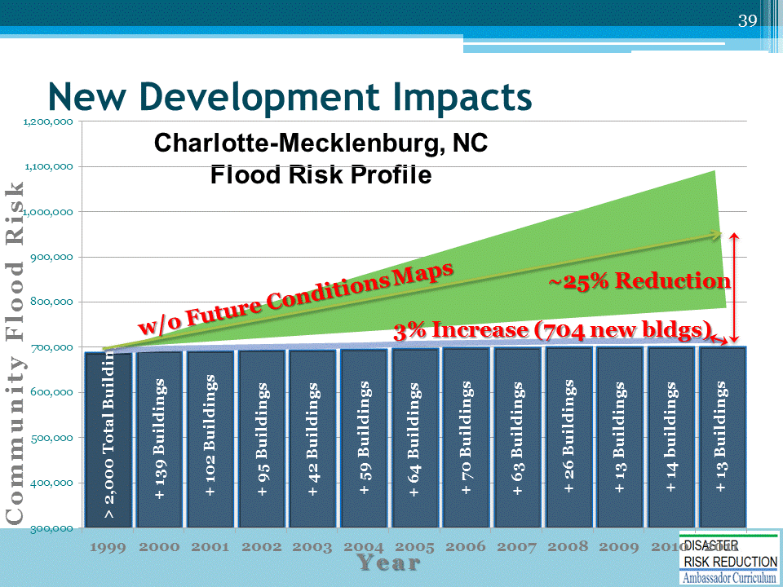

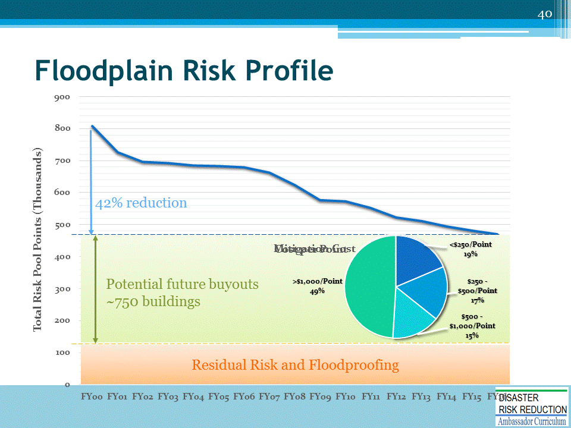
Charlotte-Mecklenburg, NC

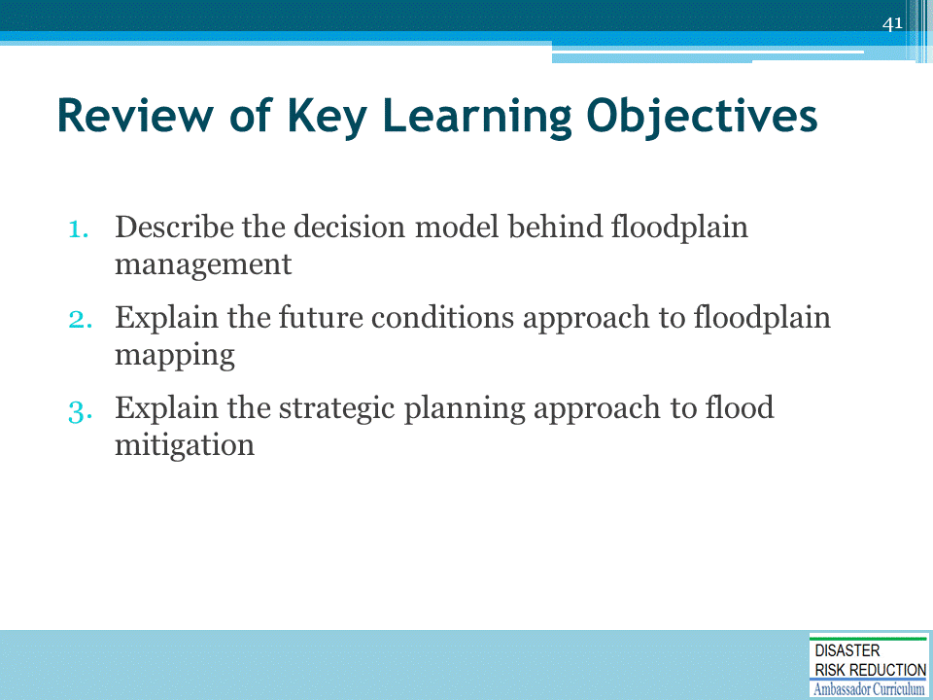

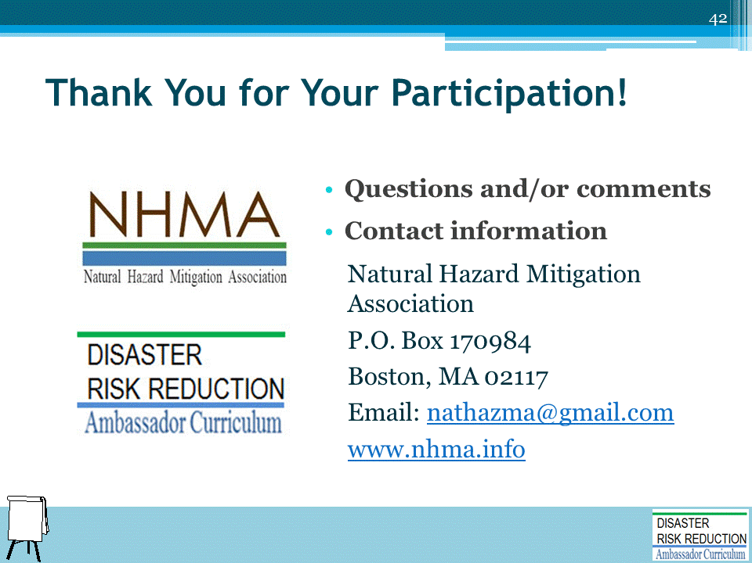
Record on easel pad any recommendations or questions to be addressed outside of the presentation.

DRR AMBASSADOR CURRICULUM AT-A-GLANCE
I. Disaster Risk Reduction for a Safe and Prosperous Future
1 | Introduction to the Natural Hazard Mitigation Association and Disaster Risk Reduction Ambassador Curriculum
2 | Introduction to Disaster Risk Reduction as a Foundation of Community Resilience
3 | Leadership for Disaster Risk Reduction
4 | Community Disaster Risk Reduction and Adaptation
5 | Approaching the Challenge of Disaster Risk Reduction: NIST Community Resilience Guide
II. Forming a Community’s Vision for Disaster Risk Reduction
6 | Risk Assessment through Storytelling: An Asset-Based Approach
7 | Achieving Community Buy-in for Disaster Risk Reduction: Win-Win Approaches
8 | Leveraging Resources to Improve Disaster Risk Reduction
III. Realizable, Practical, and Affordable Approaches for Moving from a Vision for Disaster Risk Reduction to a Strategy
9 | Selecting and Implementing a Strategy for Addressing Community Disaster Risk Problems
10 | Integrating Hazard Mitigation into Local Planning
11 | Beyond Codes and Low-Impact Development
12 | Creating the Plan: A Sustainable Floodplain Management Process Model
IV. Resources and Tools for Implementing a Community’s Disaster Risk Reduction Strategy
13 | Climate and Weather Tools and Trends
14 | Risk Assessment Basics
15 | Legal and Policy Opportunities for Disaster Risk Reduction
16 | Linking Catastrophe Insurance to Disaster Risk Reduction
V. Resources for Hazard-Specific Disaster Risk Reduction
17 | Living with Water: Inland and Coastal Flooding
18 | Design for Flood Resilience: Part I: Floodplain Management and Flood Resistant Design
19 | Design for Flood Resilience: Part II: Green Infrastructure / Low Impact Development
20 | Overcoming Impediments to Flood Resilience: Paths Forward
21 | Wildfire Mitigation
22 | The Wildfire-Flood Connection
23 | Severe Thunderstorm/ Tornado Safe Rooms
24 | From Policy to Engineering: Earthquake Risks

