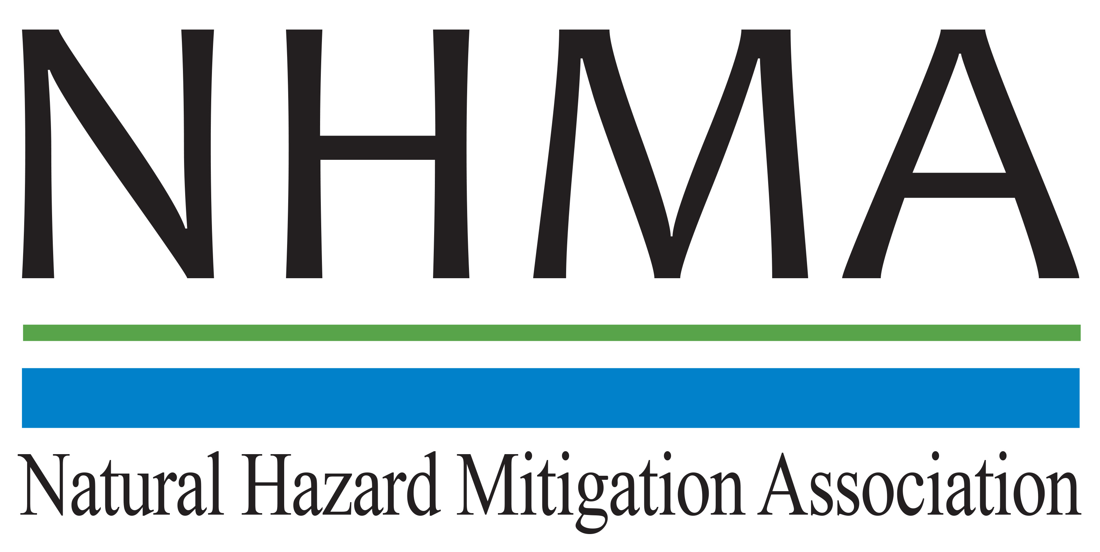

Disaster Risk Reduction (DRR) Ambassador Curriculum

Instructor Guide

Module 15:

Legal and Policy Opportunities for
Disaster Risk Reduction

THE DRR AMBASSADOR CURRICULUM
The goal of the DRR Ambassador Curriculum is to facilitate Disaster Risk Reduction efforts for the whole community by:
- Engaging in discussion of how disasters can be reduced through local action
- Sharing insights among local leaders and technical experts to enable the development of cross functional solutions
- Acquiring the best-available information, knowledge of best practices, and analytic tools to enable better-informed decisions before, during, and after disasters
It is important for instructors of DRR Ambassador Curriculum modules to remember this is one module in a 24-module curriculum. The “DRR Ambassador Curriculum At-a-Glance” table, located at the end of this document, lists the modules of the Curriculum. Keep in mind the following context for the module(s) you conduct:
DRR-A CURRICULUM TARGET AUDIENCE
The target audience includes those involved in community development decision-making, such as local community staff, volunteer and stakeholder groups, and federal and state officials.
METHODS OF DELIVERY
Varied delivery methods will provide multiple options for access by the target audience. The DRR Ambassador modules may be presented via webinars hosted by NHMA or partner organizations, presented in conferences and/or classrooms by qualified DRR Ambassador Curriculum instructor(s), or are downloadable for individual study from the NHMA website.
COURSE MATERIALS
Instructors are expected to use the instructional materials housed on the NHMA website to conduct DRR Ambassador Curriculum modules (Instructor Guide, supporting visuals, Participant Guides, and handouts). Instructors may tailor modules to specific audiences or locations as long as they do not revise the learning objectives and do not revise the materials in such a way that the participants cannot correctly complete the post-test. Instructors request the current pre/post-test for the module from NHMA.
CERTIFICATES OF COMPLETION
Certificates of Completion will be awarded by NHMA to participants who successfully complete NHMA-sponsored DRR Ambassador modules. A DRR Ambassador Certificate will be awarded to individuals completing all 24 modules. Participants who choose not to take the post-test may be issued a Certificate of Attendance. Contact NHMA about obtaining certificates. Inform participants to ask their certifying boards about acceptance of NHMA DRR Ambassador certificates for continuing education credits.

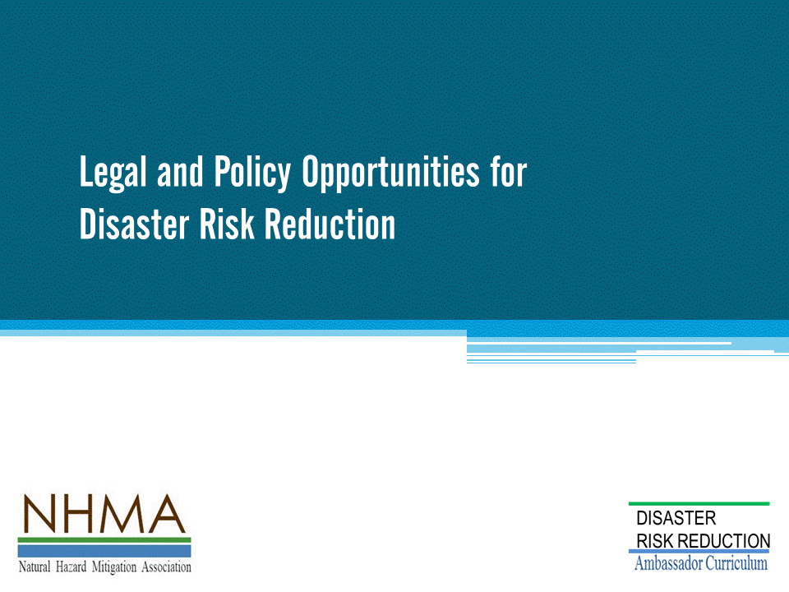
Approximate delivery time: 90-120 minutes

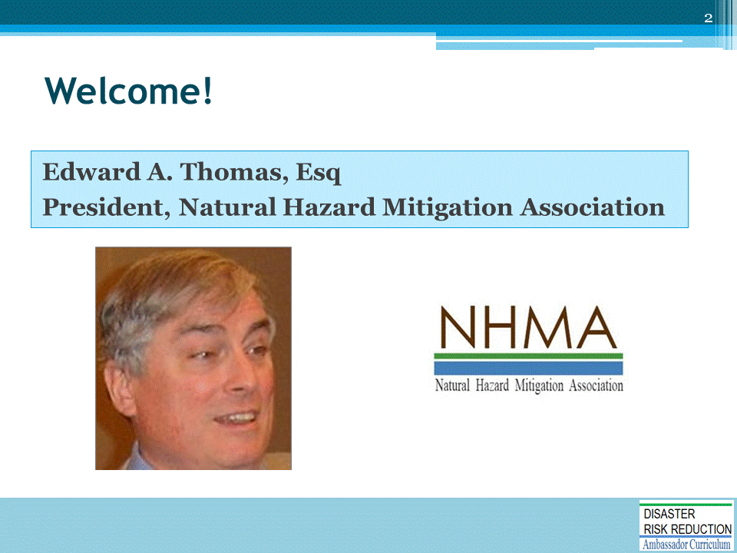
Introductions:
- Each presenter introduces her/himself, including affiliation and brief background.
- OPTIONAL: Have each participant briefly introduce him/herself
Mention: NHMA presentations are based on general principles of law, engineering, policy, and emergency management.
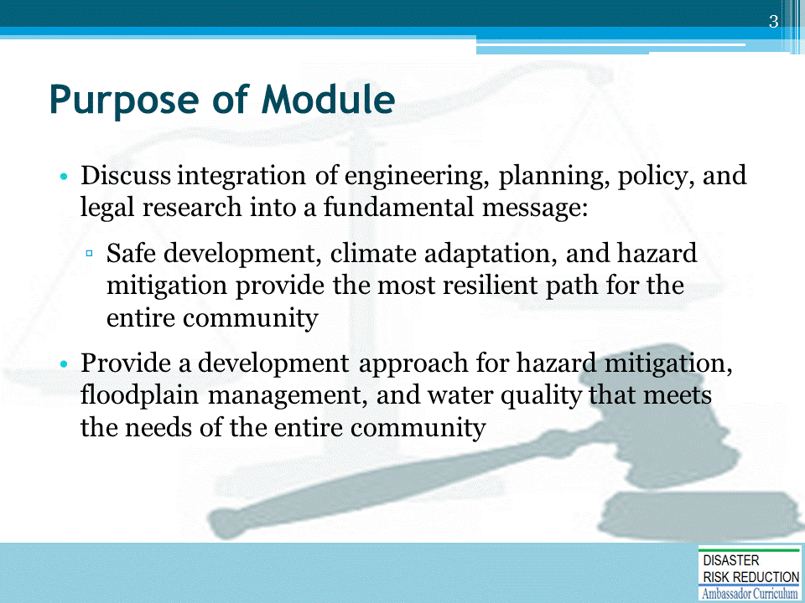
This module is specifically designed to fit into the FEMA Risk Mapping, Assessment and Planning (aka Risk MAP) vision of using the National Flood Insurance Program (NFIP) as the basis of future planning and hazard mitigation.
- What impediments are there to hazard mitigation, such as perceived legal concerns or external dynamics?
- What do communities learn from disasters?
- What makes sense for pre-disaster preparation for local jurisdictions and insurance requirements of reconstruction?
- What is the law?
- What are the problems associated with establishing laws, standards, and best practices of disaster risk reduction (DRR) to meet emerging standards of public health and safety?
The American Bar Association (ABA) has taken the position that lawyers can, and should, play a key role in adopting and implementing hazard mitigation best practices in local communities —including legal consultants most likely to challenge mitigation measures at the state and local levels.
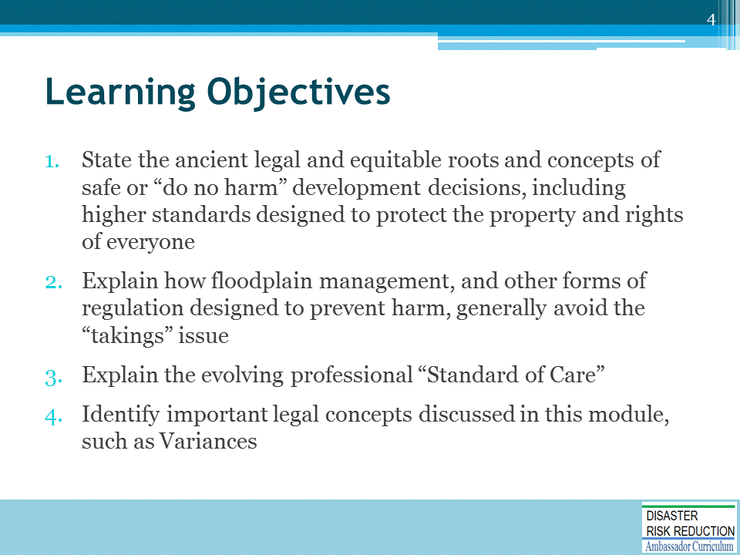

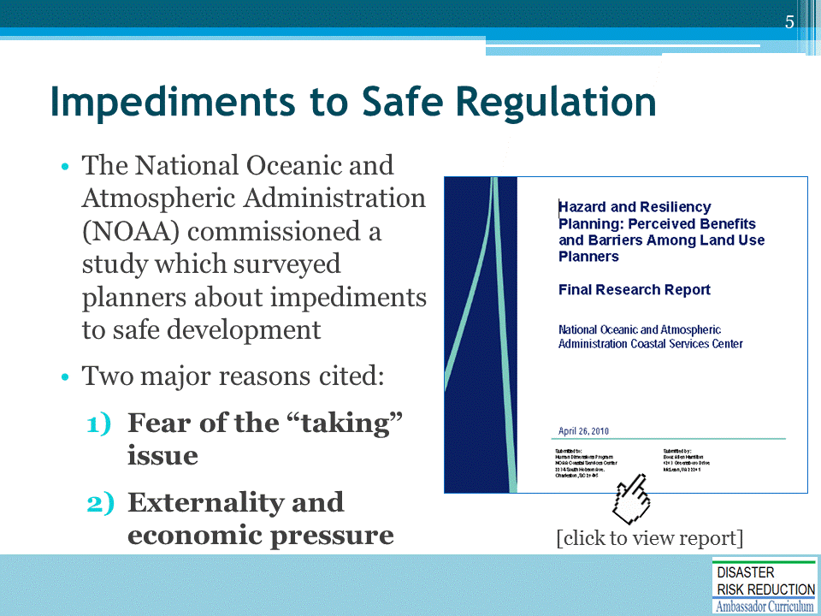
We have long recognized that there are two major impediments to safe regulation.
Link to Research Report: https://coast.noaa.gov/data/digitalcoast/pdf/hazard-planning.pdf
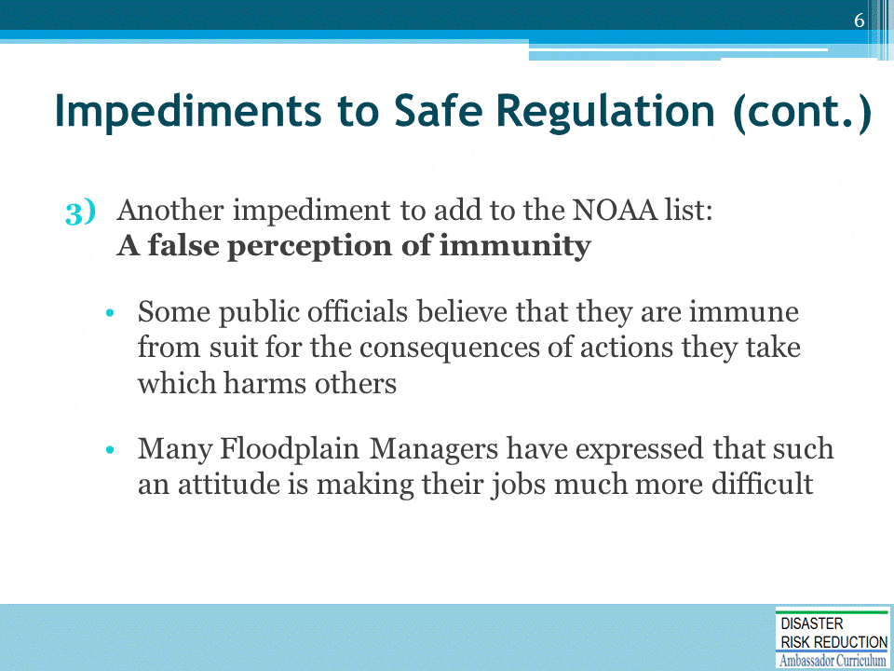
We need to also recognize a third major impediment to safe development: A perception of immunity.
We will spend a few minutes on Immunity in your state.
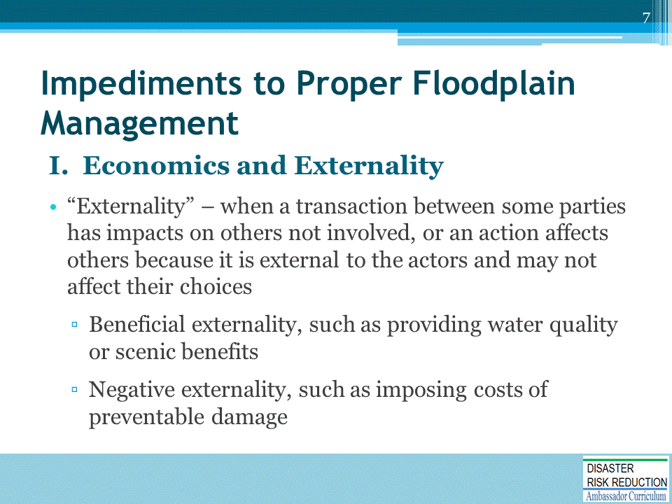
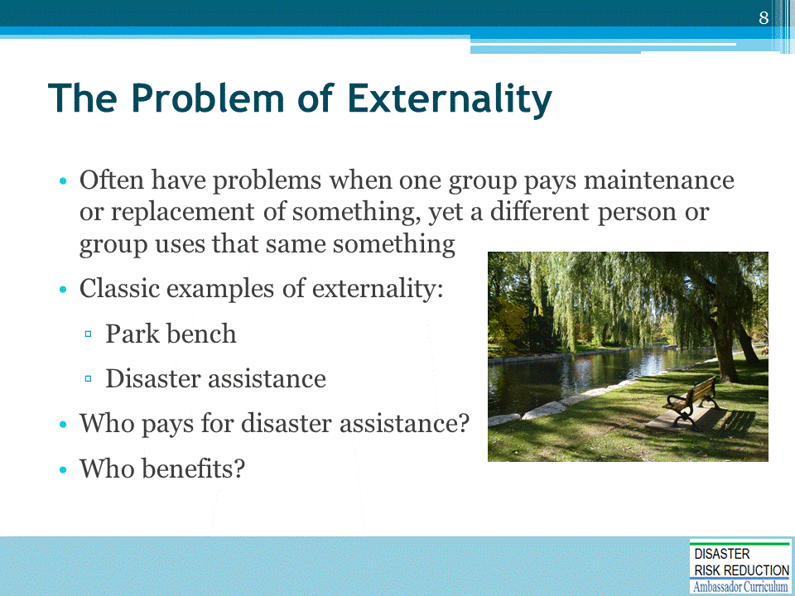
One of the fundamental floodplain management challenges that we face as a Nation is Externality.
- This means that at least the short term benefits of unwise or improper floodplain development flow to:
  - Developers (profit on sale and occupancy)
  - Local governments (real estate and sales taxes-jobs, etc.)
  - State government (some sales tax-jobs, etc.)
  - Mortgage companies (profits on loans, etc.)
  - The occupants of floodplains who may benefit from a lovely place to stay for a while, anyway
Unfortunately, the costs of flooding are usually largely borne by:
- The Federal and sometimes the State Taxpayer through IRS Casualty Losses, SBA Loans, Disaster CDBG funds, and the whole panoply of federal and private disaster relief described in my publication "Patchwork Quilt; and
- Disaster victims themselves.
The resulting externalizing of the costs by those who benefit from improper development is exacerbated in our Nation by the fact that those who benefit also usually make the decisions about land use; and those who pay usually have little influence on land use.
- The NFIP, especially through the CRS program, has made a good start at solving this problem.
But, the NFIP alone will likely not be enough.
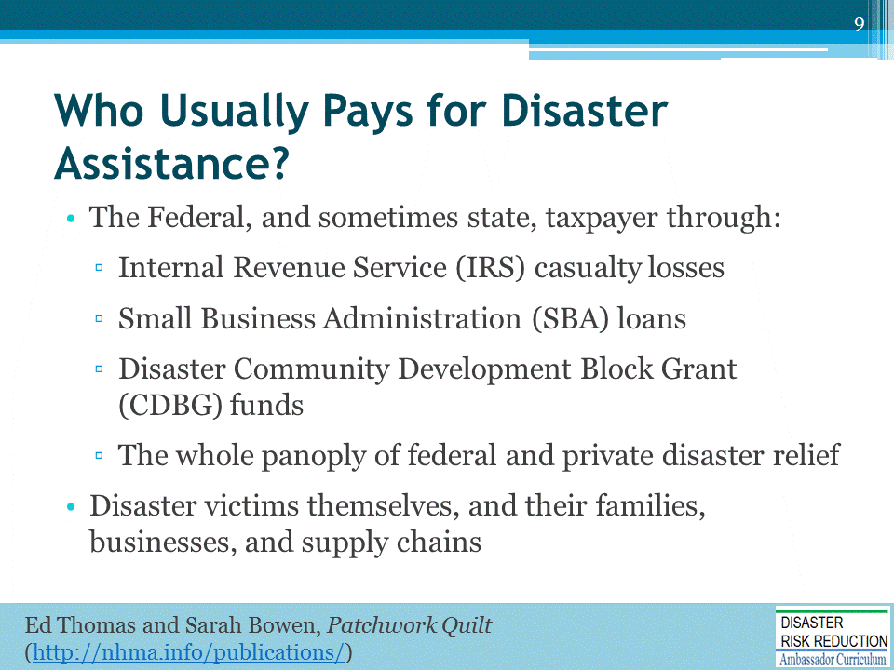
Note the National Flood Insurance Program was more than self-supporting on premium income for over 20 years.

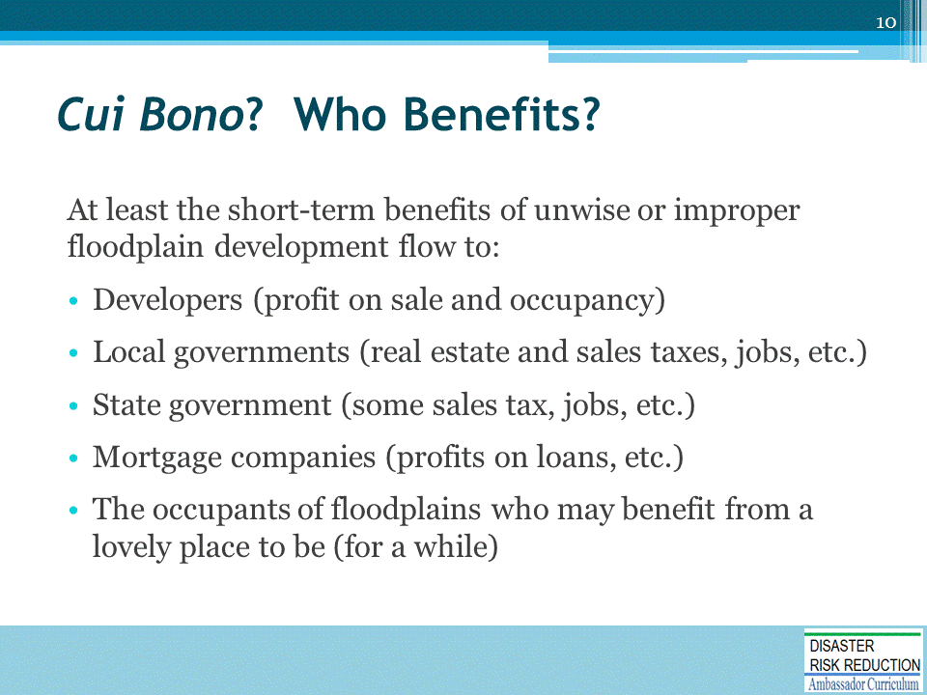
Cui bono ("To whose benefit?", literally "[being] good for whom?") is a Latin adage that is used either to suggest a hidden motive or to indicate that the party responsible for a thing may not be who it appears at first to be.
- With respect to motive, a public works project which is purported to benefit the city may have been initiated rather to benefit a favored campaign contributor with a lucrative contract.
This commonly the phrase is used to suggest that the person or people guilty of committing a crime may be found among those who have something to gain, chiefly with an eye toward financial gain.
- The party that benefits may not always be obvious or may have successfully diverted attention to a scapegoat, for example.

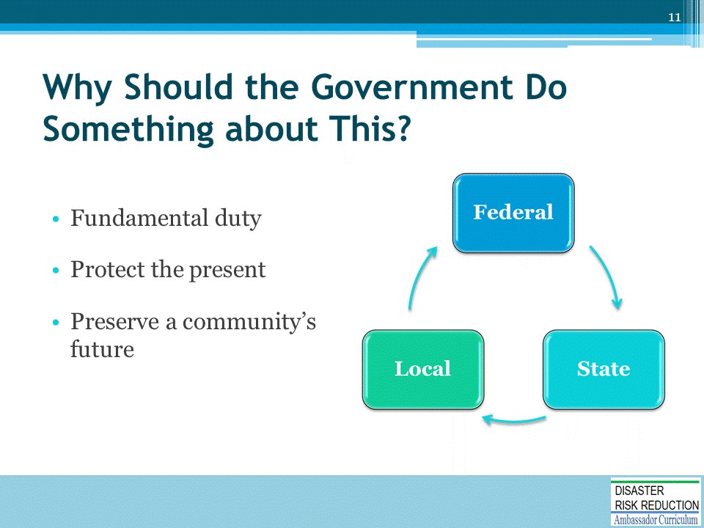
Recall that this was first introduced in Module 2, Introduction to DRR as a Foundation of Community Resilience.

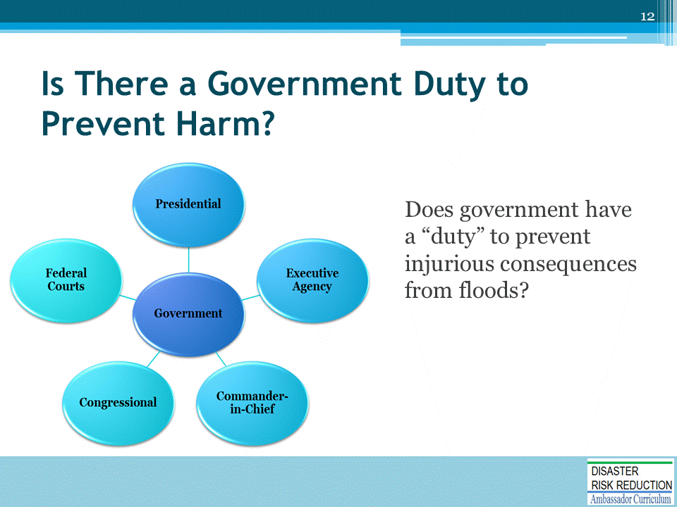
When anyone has a duty and does not do that duty: what happens?
Good stuff? Bad stuff?
More about the bad stuff: litigation.

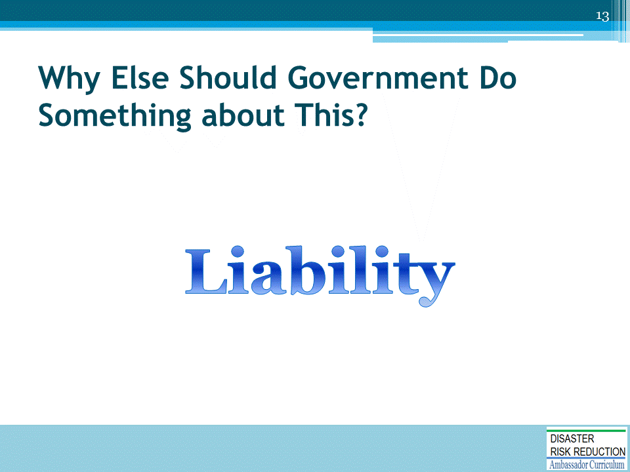
Recall that this was first introduced in Module 2, Introduction to DRR as a Foundation of Community Resilience.
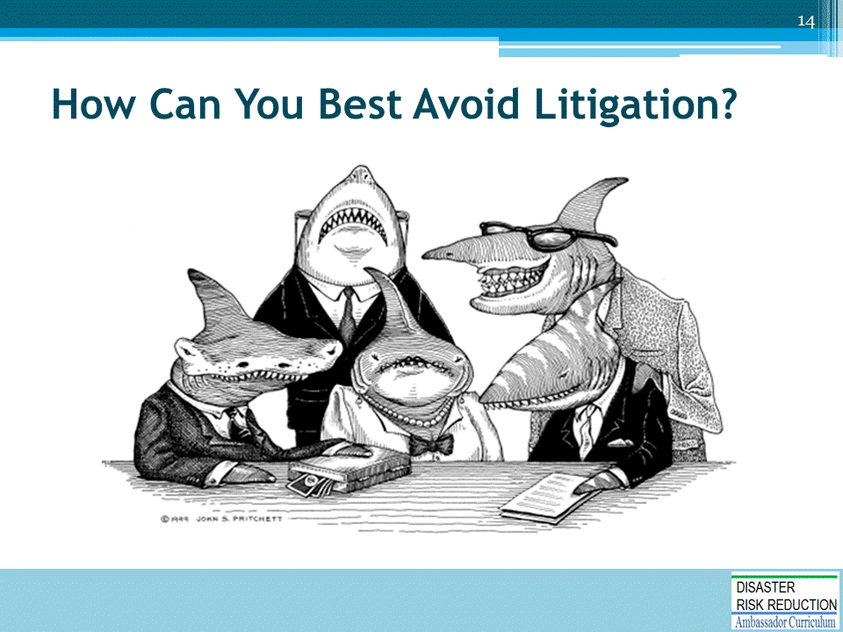

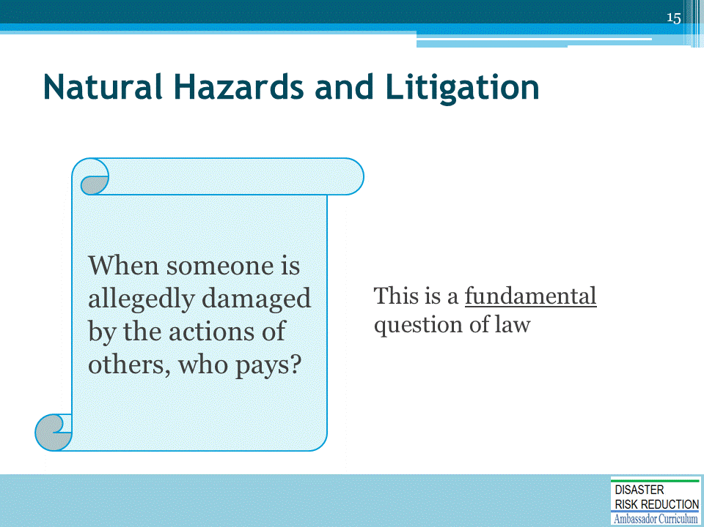

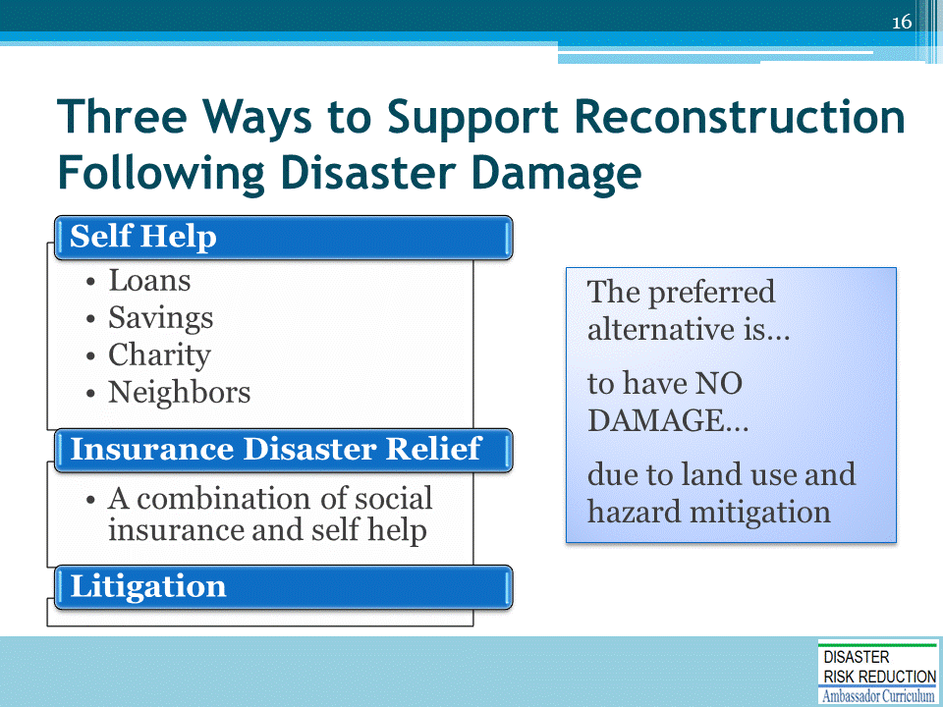

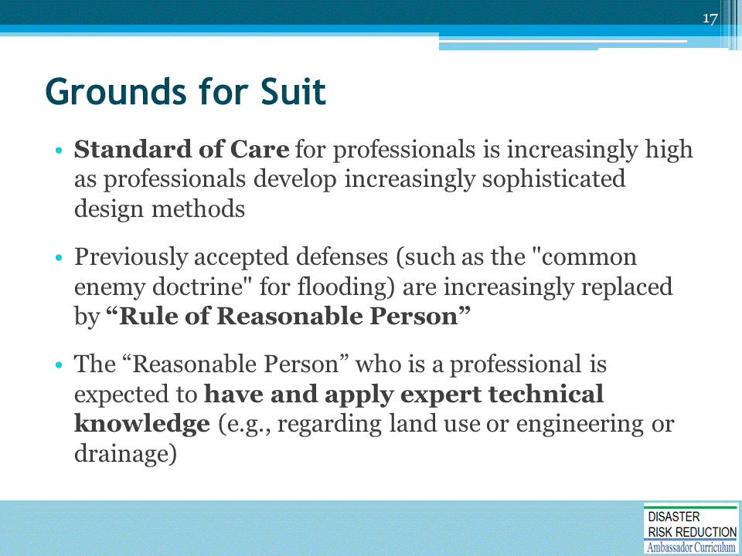
- For example, a federal court in a famous case, The T.J. Hooper, held that the owner of a tug company was liable to the owner of two barges lost in a storm because:
  - It failed to equip its tug boats with radios (which would have provided timely warnings of the approaching storm)
  - Although such radios were not in 1928 a common practice on tugs
- The court observed that the radios could have been provided at small cost and would have been of great value.
- The court further observed with regard to evidence of custom or usage that: “What usually is done may be evidence of what ought to be done, but what ought to be done is fixed by a standard of reasonable prudence, whether it usually is complied with or not.”
See:
- The T.J. Hooper, 60 F.2d 737 (2d Cir., 1932)
- Stewart v. State, 597 P.2d 101 (Wash., 1979)
- Riley v. Burlington Northern, Inc., 615 P.2d 516 (Wash., 1980), in which the Court held that the decision of Yakima County not to install a more sophisticated warning system than a non-mechanical railroad approach warning sign at a railroad crossing was nondiscretionary and subject to potential suit for negligence
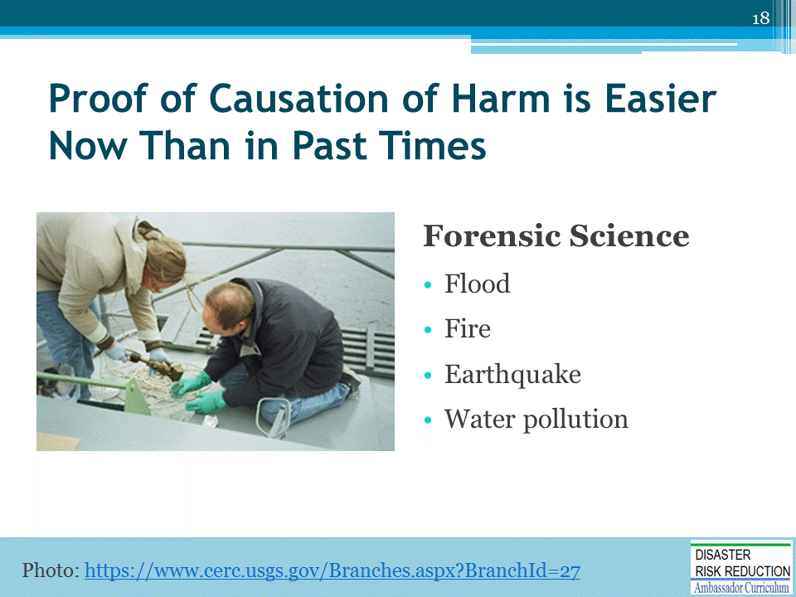
Today, sophisticated modeling techniques facilitate proof of causation and allocation of fault, although proof may still be difficult.
The late great Engineer Jim Owen, famously observed that Forensic Science has totally changes the profession of Engineering - litigation will make Engineers and design professionals more cautious and desirous of doing what they should have been doing all along.
See, for example, The Legal Consequences of Ignoring Climate Change, in Governing: The States and Localities, by Laurie Mazur and Edward A. Thomas, October 19, 2015. The article is available at http://www.governing.com/gov-institute/voices/col-legal-consequences-local-decision-makers-ignoring-climate-risk.html
And also, Natural Hazard Disaster Risk Reduction as an Element of Resilience: Considerations about Insurance and Litigation by Edward A. Thomas, Esq. (2016) In Linkov, I., & Florin, M.-V. (Eds.), IRGC Resource Guide on Resilience. Available at: https://www.irgc.org/risk-governance/resilience/
Why Current Disaster Planning Doesn’t Cut it, and What We Can Do Instead, by Laurie Mazur and Edward A. Thomas, Esq., in The Hill September 9, 2016. Available at: http://thehill.com/blogs/congress-blog/economy-budget/295101-why-current-disaster-planning-doesnt-cut-it-and-what-we

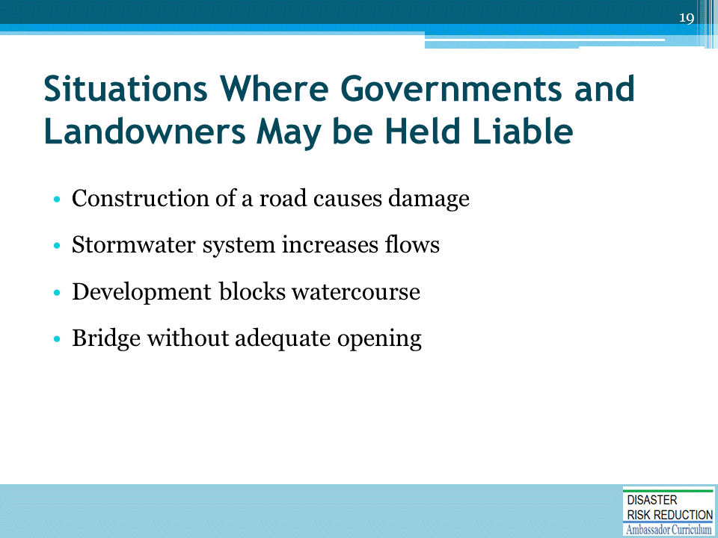
Many cases are listed in Jon Kusler and Ed Thomas detailed legal materials on:
- NHMA website: http://nhma.info/
- ASFPM website: http://www.floods.org/

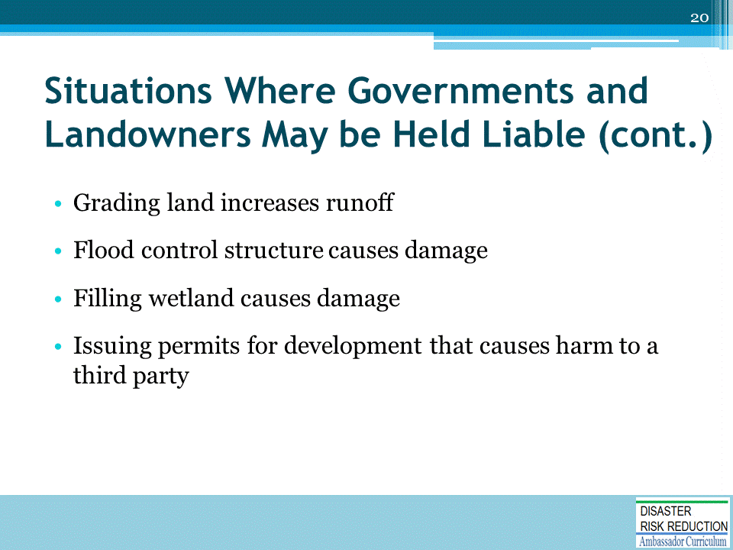

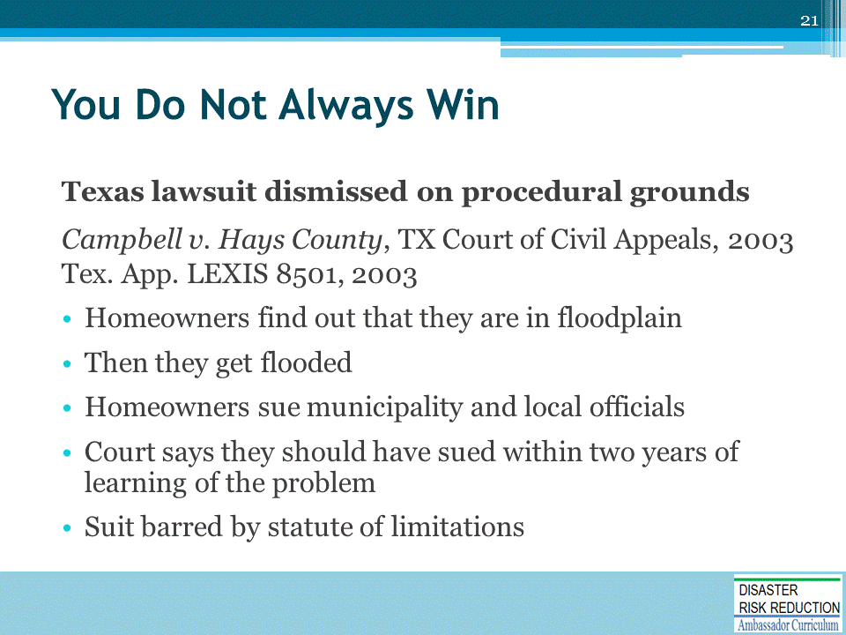
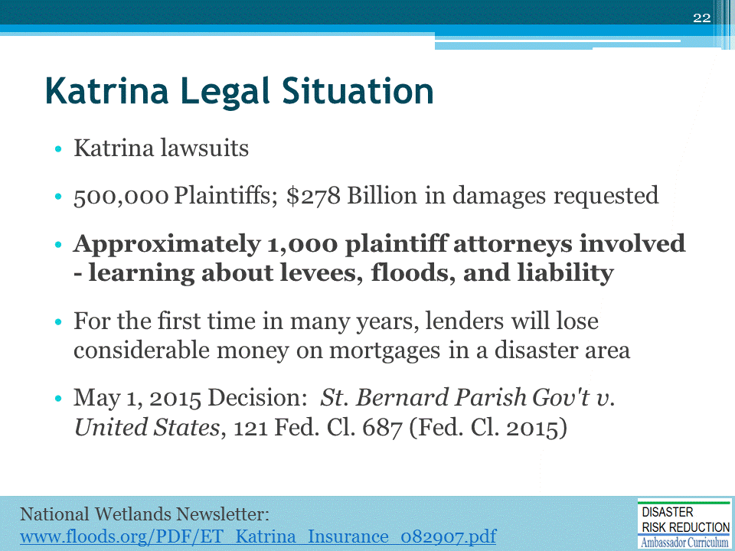
Major Court Decision with implications for Climate Adaptation, Hazard Mitigation and a Safer and More Just Future
By Edward A. Thomas Esq., President, Natural Hazard Mitigation Association, May 7, 2015
On May 1, 2015, the U.S. Court of Federal Claims issued an enormously important decision concerning flood damage caused by Hurricane Katrina and subsequent hurricanes. That case, Saint Bernard Parish Government v. United States, No. 05-1119L (May 1. 2015), found the United States government liable for potentially huge sums of money. (http://www.inversecondemnation.com/inversecondemnation/2015/05/cfc-katrina-flooding-is-a-taking.html)
In St. Bernard Parish, The CFC essentially agreed with the plaintiffs that the U.S. Army Corps of Engineers construction, maintenance and operation of a portion of the enormous Mississippi Rivers and Tributaries project, in particular a portion of the project designed and built for navigation rather than flood control, called "MR-GO" resulted in temporary takings by causing increased flooding of the plaintiffs’ properties during Hurricane Katrina other flood events.
It appears that the results of this case enormously validates what some of us predicted, following the decision in the 2013 Arkansas Game and Fish case, 132 S. Ct. 1856 (2012), with respect to constriction of immunity for actions by government which harm people and property. Further information on Arkansas Game and Fish, as well as other important cases involving constitutional protections including Koontz v. St Johns River Water Management District, 133 S. Ct. 2586 (2013), can be found in a webinar featuring Professor Lisa Sun, Ed Thomas, and Dr. John Wiener available at: https://player.vimeo.com/video/83390903 . Further details on Koontz can be found in this article, “Turning Koontz Into an Opportunity for More Resilient Communities," which I co-authored with Lynsey R. Johnson.
(http://www.americanbar.org/content/dam/aba/administrative/state_local_government/land_use.authcheckdam.pdf)
Both Arkansas Fish and Game and the St. Bernard Parish lawsuit are essentially a successful end run around the very broad immunity provided to the United States pursuant to the Mississippi Flood Control Act of 1928, 33 U.S.C. §702c:
no liability of any kind shall attach to or rest upon the United States for any damage from or by floods or flood waters at any place.In reviewing previous cased involving damages allegedly relating to federal flood control projects, courts had previously almost always dismissed claims of damages based on federally legislated immunity. For example, in United States v. James, 478 U.S. 597 (1986), despite a finding by the trial court that the flood control project operating agency “willfully and maliciously failed to warn of a known danger”, the United States was nevertheless immune from damages pursuant to 33 U.S.C. §702 c. In James, the Supreme Court observed:
As the facts in this case demonstrate, one can well understand why the Court of Appeals sought to find a principled way to hold the Government responsible for its concededly negligent conduct. But our role is to effectuate Congress' intent, and Congress rarely speaks more plainly than it has in the provision we apply here. If that provision is to be changed, it should be by Congress and not by this Court. We therefore follow the plain language of 702c, a section of the 1928 Act that received careful consideration by Congress and that has remained unchanged for nearly 60 years, and hold that the Federal Government is immune from suit in this type of case. The plaintiffs in both Arkansas Game and Fish and St. Bernard Parish very cleverly avoided attempting to sue for damages under the Federal Tort Claims Act as would be more usual in a case where there was not such a specific grant of immunity. While federally legislated immunity from damages involving flood control projects is the law, the U.S. Constitution trumps federal legislation. If one can manage to successfully find a provision in the Constitution on which to litigate, one has a chance in court. In this case the plaintiffs chose to litigate based on the provisions contained in the Fifth Amendment to the Constitution prohibiting government taking of property without compensation.
It seems to me that the St. Bernard Parish decision really emphasizes the importance of science and engineering in determining foreseeability, and better understanding that a legally required “standard of care” is ever evolving, as our knowledge and human understanding increase. Architects, Engineers, developers, community officials and all others involved with development decision-making need to realize that legal liability may involve a jury of ordinary folks evaluating whether a person, agency or company was legally culpable for failure to take foreseeable natural hazards into account when undertaking some activity which later resulted in misery harm or even death.
Recent litigation supports and enforces a view that based on ancient principles of law, morality and equity; folks do not possess the right to harm their neighbors. Actions which harm others have consequences beyond karmic payback, to include both civil and even in some unusually egregious situations, criminal penalties. Today, due to it is much easier to show through forensic sciences such as forensic hydrology, forensic earthquake engineering, forensic fire science, forensic chemistry, and forensic hydraulics that the actions of one person or group caused harm to another person or group. Future litigation for situations such as climate refugees may well be based on forensic climate science?
In essence, today due to greatly improved understanding of natural and foreseeable processes we can much more easily answer the question posed by Jimmy Cagney in the wonderful old movie, Mr. Roberts: "All right, who did it; I want to know who did it?"
In part, the solutions to today’s problems involve our nation and the world following the wisdom of the First Nations; redeveloping a sense of stewardship of the earth; and following of the ancient maxim of law: sic utere tuo ut alienum non laedas, (use your property so as not to harm others). The great moralist Mohandas Gandhi described sic utere tuo ut alienum non laedas as "a grand doctrine of life and the basis of ahimsa (peaceful relations between neighbors). This maxim of law has also been called inarguable and universally accepted.
Litigation may well help us begin to solve our serious problems of moral hazard, including dissuading activities which exacerbate climate change, whereby one person or group externalizes the true cost of an activity to others. We know that way too often the folks most harmed by that externalization of costs are the most vulnerable and underrepresented populations, much as described in the excellent NAACP publication, Equity in Building Resilience in Adaptation Planning, by Jacki Patterson.
In 2007, I wrote an article for the Environmental Law Institute which posed a question in its title: Recovery Following Hurricane Katrina: Will Litigation and Uncertainty Today Make for an Improved Tomorrow? [National Wetlands Newsletter, vol. 29, no. 5.] (http://nhma.info/uploads/resources/ET_Katrina_Insurance_082907.pdf). In that article I expressed the hope that the Katrina Litigation would prod society to do a better job of at providing a safer, more just and resilient future for our Nation.
The article went on to urge:
As Katrina so clearly demonstrated, we must do a better job of providing for the rebuilding of shattered lives following a catastrophe. At the same time, our land use and building decisions must improve dramatically. Otherwise, the problems we currently face in hazard management will only get worse. Today I renew all the thoughts in the National Wetlands Newsletter I wrote in 2007.

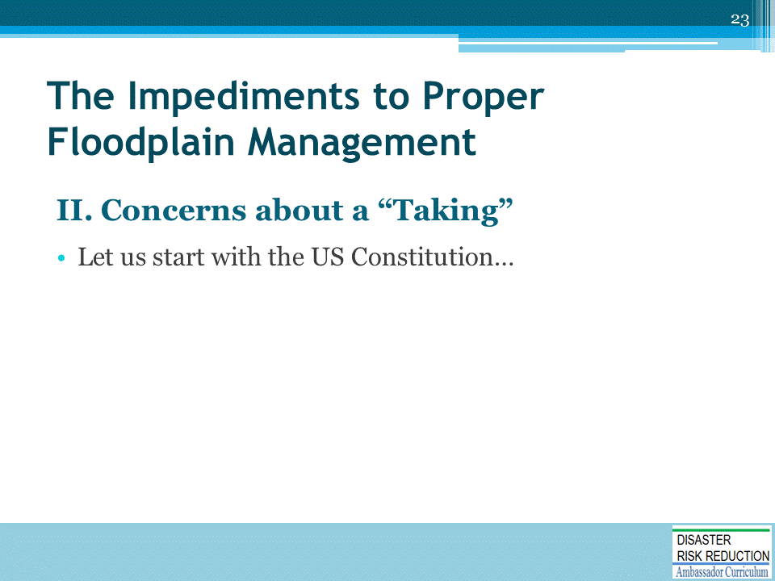

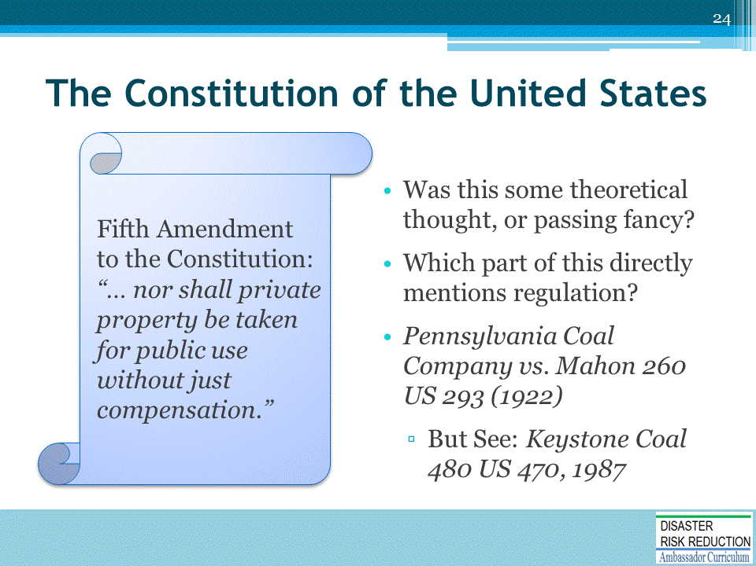
Pennsylvania Coal was a bit strange - Haddacheck v Sebastian-Habeas Corpus etc. 87% loss; Mugar v. KS total loss; Keystone Coal seems to overturn Pennsylvania Coal without ever saying so.
See, for more detail: Mitigating Misery: Land Use and Protection of Property Rights Before the Next Big Flood. Authors: Edward A. Thomas Esq. and Sam Riley Medlock JD. Vermont Journal of Environmental Law, Vol. 9, 2008.
Law Review Article on the National Flood Insurance Program and the concept of No Adverse Impact Floodplain Management.
Located at: http://www.floods.org/PDF/Mitigation/ASFPM_Thomas&Medlock_FINAL.pdf

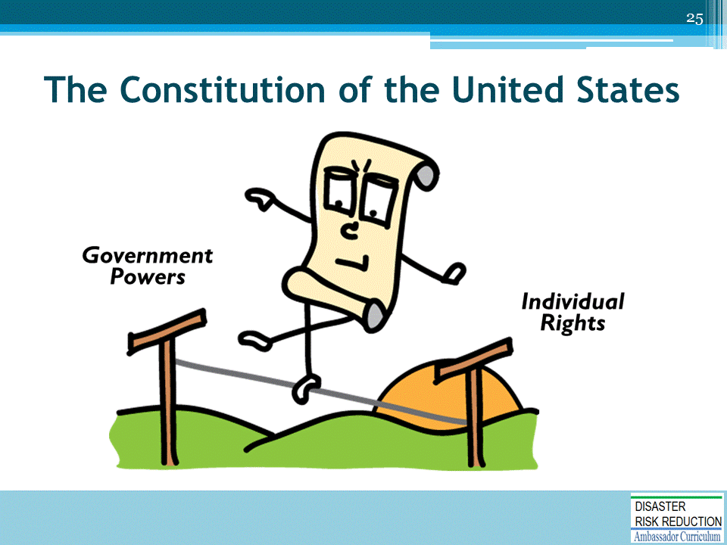
A unique aspect of the American system of government is that, while the rest of the world views the United States as one country, domestically American constitutional law recognizes a federation of state governments separate from (and not subdivisions of) the federal government, each of which is sovereign over its own affairs.
However, each state's sovereignty is limited by the U.S. Constitution, which is the supreme law of both the United States as a nation and each state; in the event of a conflict, a valid federal law controls.
- As a result, although the federal government is recognized as sovereign and has supreme power over those matters within its control, the American constitutional system also recognizes the concept of "State sovereignty," where certain matters are susceptible to government regulation, but only at the State and not the federal level.
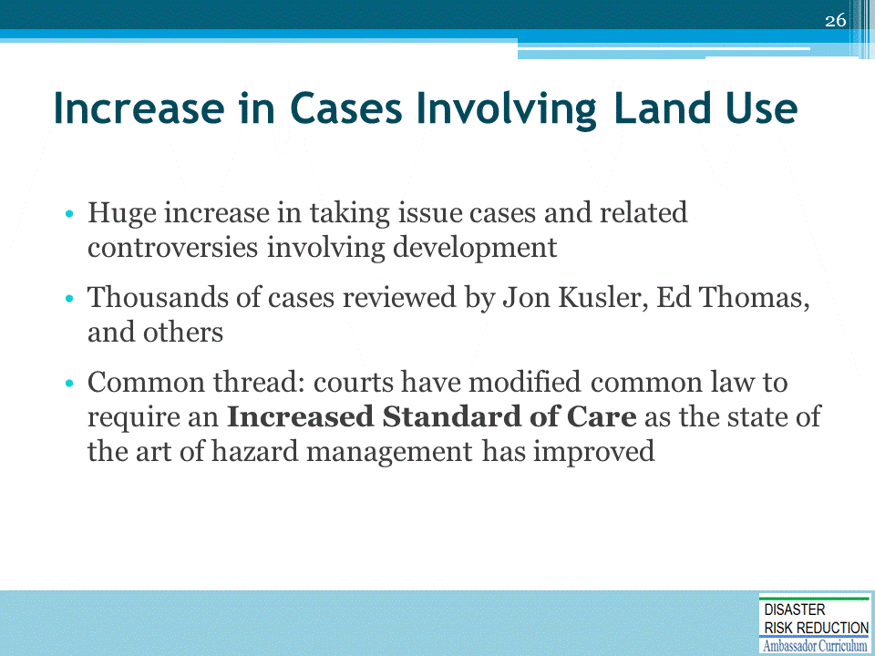
- Developers are vastly more likely to be sued for permitting development that causes problems - roads, stormwater systems bridges runoff etc.
- VASTLY means not one but TWO full orders of magnitude more likely to be successfully sued - ONE HUNDRED (100) times more likely to be sued for permitting or doing improper development!
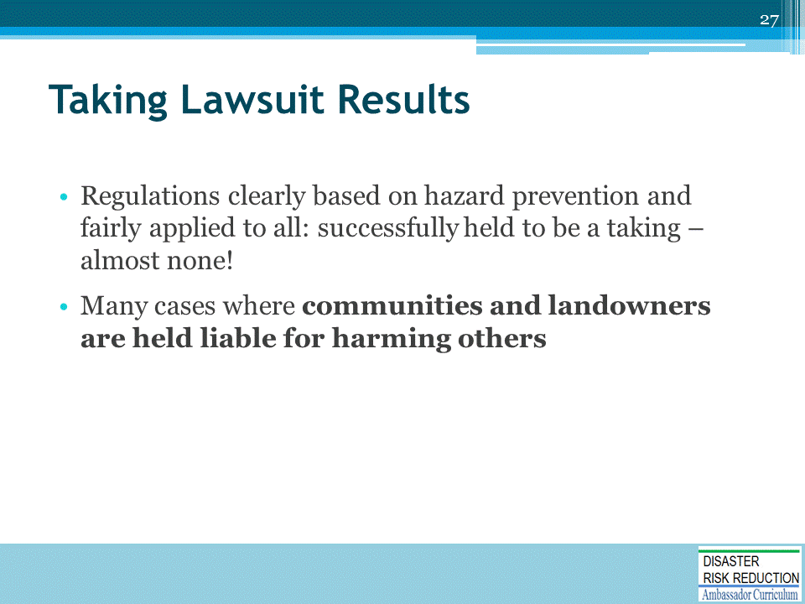
- Lucas-essentially denial of all economic use where others allowed to build; Lutherglen upheld on appeal
- Not quite what you may hear from unhappy permit seekers, is it?

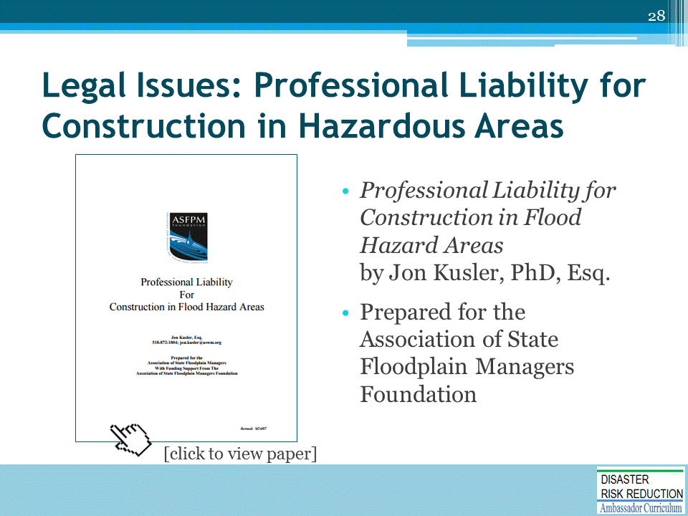
Excellent paper by Jon Kusler, PhD, Esq.: https://www.floods.org/PDF/ASFPM_Professional_Liability_Construction.pdf

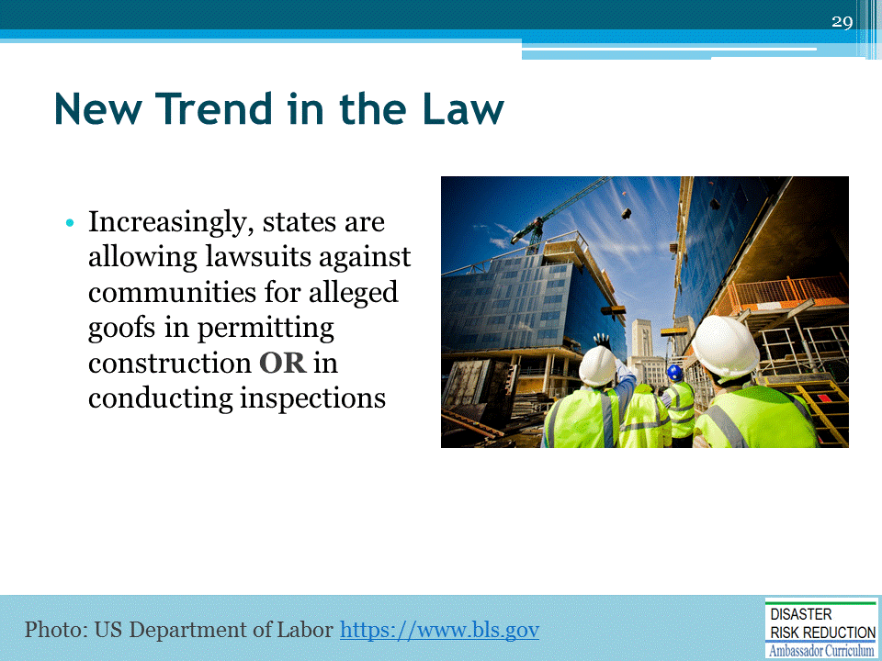
Reference paper by Attorney Jon Kusler PhD at www.floods.org
A COMPARATIVE LOOK AT PUBLIC LIABILITY FOR FLOOD HAZARD MITIGATION
http://www.floods.org/PDF/Mitigation/ASFPM_Comparative_look_at_pub_liability_for_flood_haz_mitigation_09.pdf

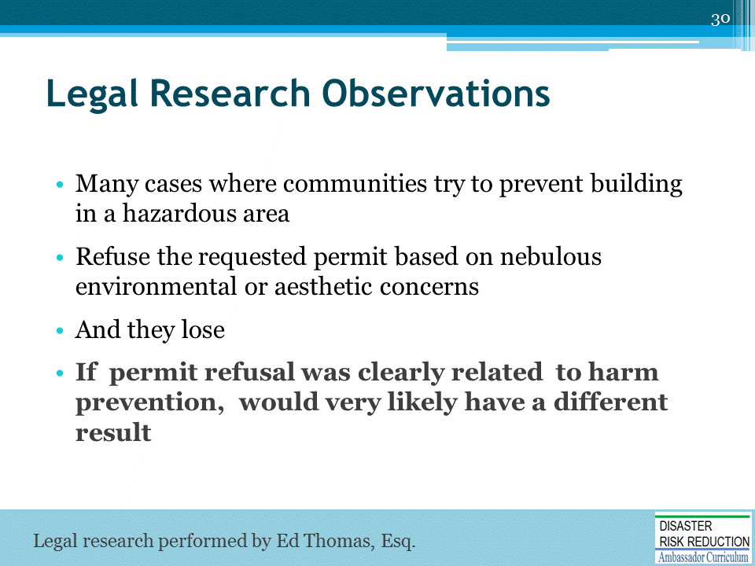
Edward A. Thomas & Sam Riley Medlock, Mitigating Misery: Land Use and Protection of Property Rights Before the Next Big Flood, 9 Vt. J. Envtl. L. 155 (2008).
"This material has been copyrighted by the Vermont Environmental Law Journal. It is made available for posting on this web site and use by floodplain managers by special arrangement between Edward A. Thomas Esq. and the Vermont Environmental Law Journal.“
http://www.floods.org/PDF/Mitigation/ASFPM_Thomas&Medlock_FINAL.pdf

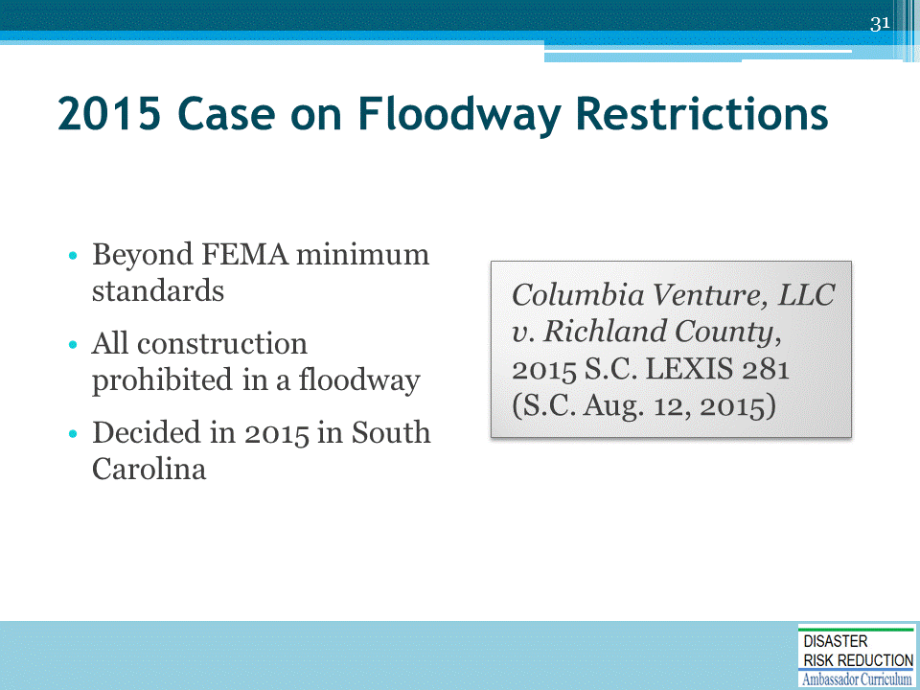
From Rob Thomas, Inverse Condemnation:
No Taking When Owner Prohibited from Developing in Floodplain
The headline of this post shouldn't be that surprising, especially when the property owner purchased the land already subject to a floodplain designation, and those regulations effectively prohibited development.But the two twists in the South Carolina Supreme Court's opinion in Columbia Venture, LLC v. Richland County, No. 27563 (Aug. 12, 2015), were (1) when Columbia Venture purchased the land, the floodplain designation didn't encompass as much of the land as it eventually did, and the larger area was only preliminarily designated, and (2) various county agencies had informed Columbia that there was a chance it might get permission to build even if the regulations were eventually adopted.
(http://www.inversecondemnation.com/files/27563.pdf)
Those twists, however, were not enough to save Columbia's takings claim, and the court rejected both its categorical and Penn Central arguments. The facts of the case are somewhat dense, but here's what you need to know. Columbia purchased the property knowing that prior potential buyers (including Columbia's own managing member) had declined to purchase the land because they understood that a large portion of the 4,000 acre parcel next to the Congaree River was in a FEMA-designated floodplain. FEMA updates its floodplain maps every five years, and prior to Columbia's purchase, FEMA preliminarily expanded the floodplain-designated land to encompass nearly 3/4 of the parcel. Between the time FEMA publishes its proposed new maps and their official adoption, the new floodplain designations are required to be recognized by local authorities. But after consultation with county agencies that resulted in a memorandum of understanding that stated the county would consider Columbia's development proposal, Columbia purchased the land anyway, intending to build a $1 billion residential-resort-retail development. When the inevitable occurred -- FEMA officially adopted the proposed maps, which prohibited Columbia from developing its land -- it sued in state court for a regulatory taking of its property. By consent, the case was tried by a referee, who granted the county summary judgment. The FEMA designation certainly significantly decreased the value of Columbia's land, but the referee concluded this was outweighed by Columbia's unreasonable expectations, In other words, it was not reasonable for Columbia to have purchased the land knowing about the impending floodplain restrictions. The South Carolina Supreme Court affirmed. It rejected Columbia's argument that the development prohibition was like a flowage easement, holding instead that it was a garden-variety land use restriction and not a physical taking, as when government action causes flooding. In contrast to government-caused flooding, FEMA's floodplain designation and the county's resultant prohibition on development, did not cause any invasion of Columbia's land. Any flooding that might occur was a result of natural forces, and not government regulation or action. Applying Penn Central, the Supreme Court agreed with the referee and concluded that the floodplain designation did not result in a regulatory taking either. As noted above, the key factor was the "distinct investment-backed expectations" prong, and the court held that the overall regulatory scheme had been adopted decades before Columbia's purchase, Columbia's own managing member had backed out of an earlier proposed purchase because of the uncertainties which resulted from a floodplain designation, and Columbia knew the county and FEMA regulations combined to make development impossible in the portion of the property designated as a floodplain. Yes, Columbia had subjective expectations that, "in spite of all this, it would nevertheless be allowed to develop the extensive Green Diamond project," but the court concluded that expectation "was not objectively reasonable." Slip op. at 21.Finally, the character of the government action prong weighed against a taking, because the floodplain designations were designed to mitigate the costs of expected flooding along the river, and the regulations don't single out a particular property owner to shoulder public burdens that should be borne by all. All riverfront property is subject to floodplain restrictions. So there you go. Not an unexpected result mind you, and we were somewhat surprised that the two twists were enough to get this one the full-blown treatment by the South Carolina Supreme Court. Columbia Venture, LLC v. Richland County, No. 27563 (S.C. Aug. 12, 2015)
https://www.scribd.com/document/274422057/Columbia-Venture-LLC-v-Richland-County-No-27563-S-C-Aug-12-2015

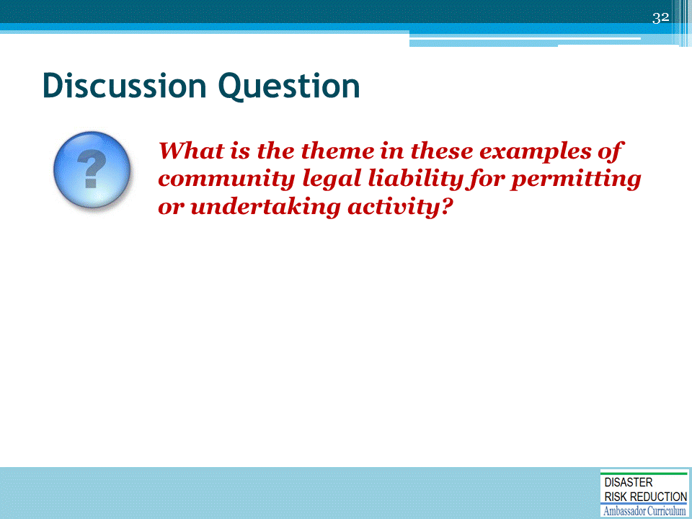
ASK the discussion question and solicit answers from participants before proceeding to the suggested answers on the following slides.

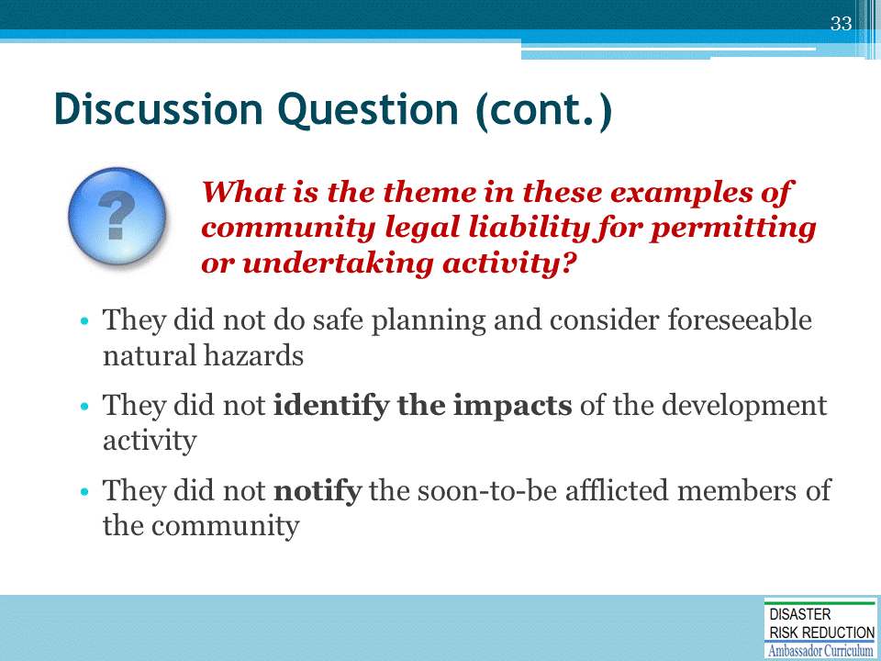

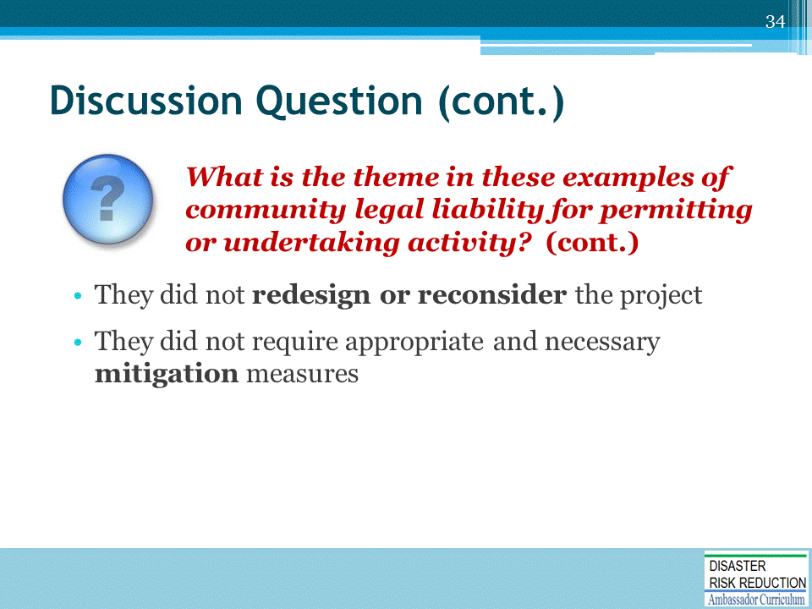

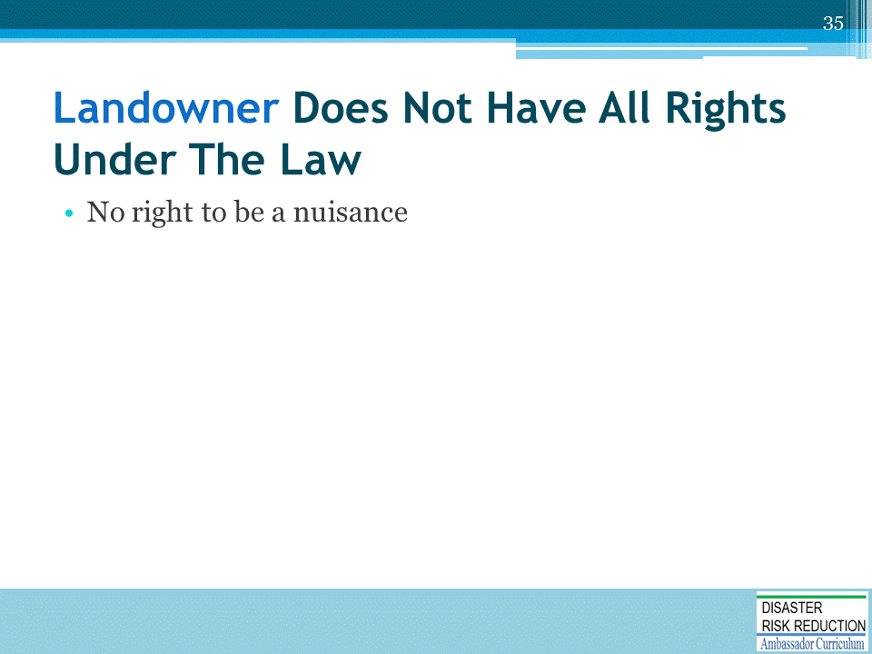
This and the next five slides introduce bullet points one at a time.
DISCUSS each point one at a time.
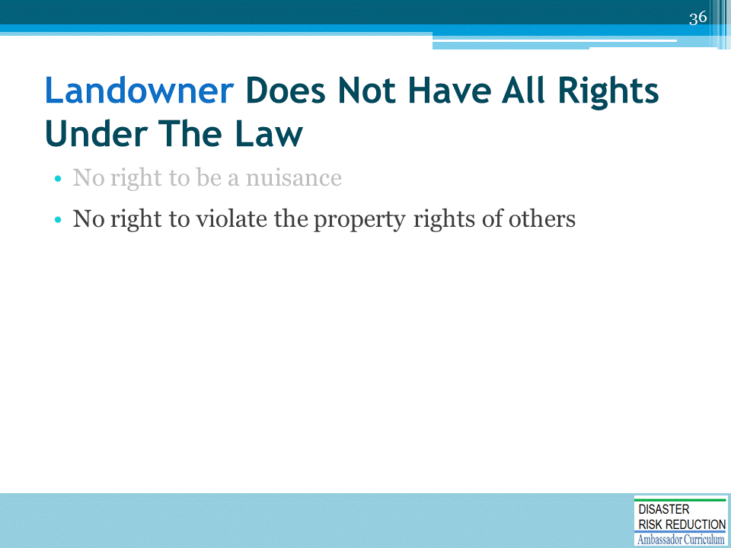

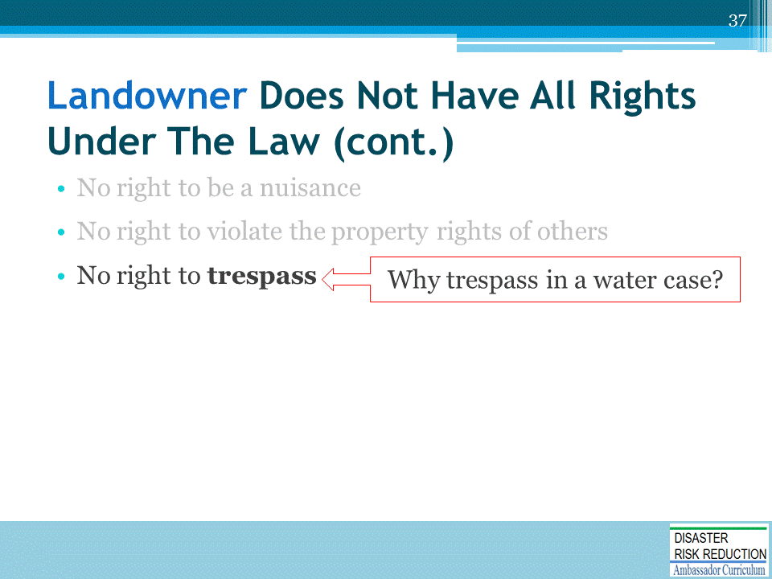

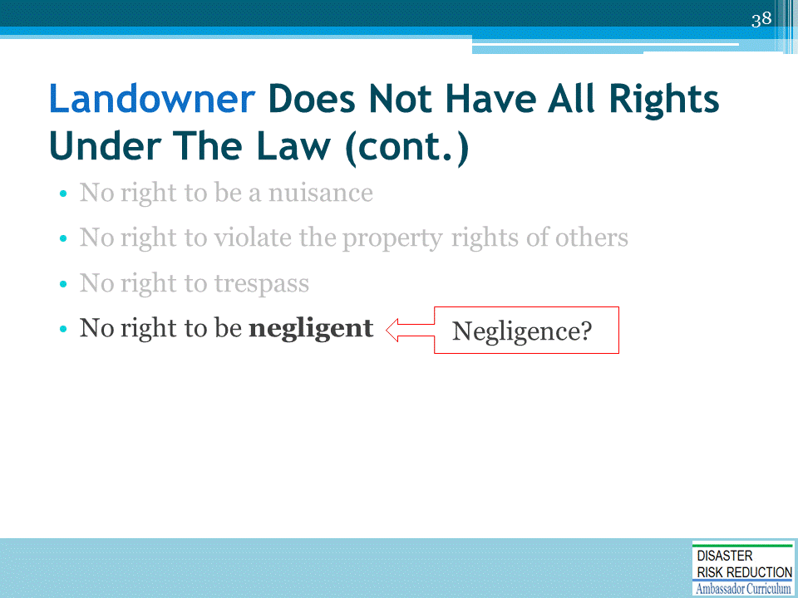

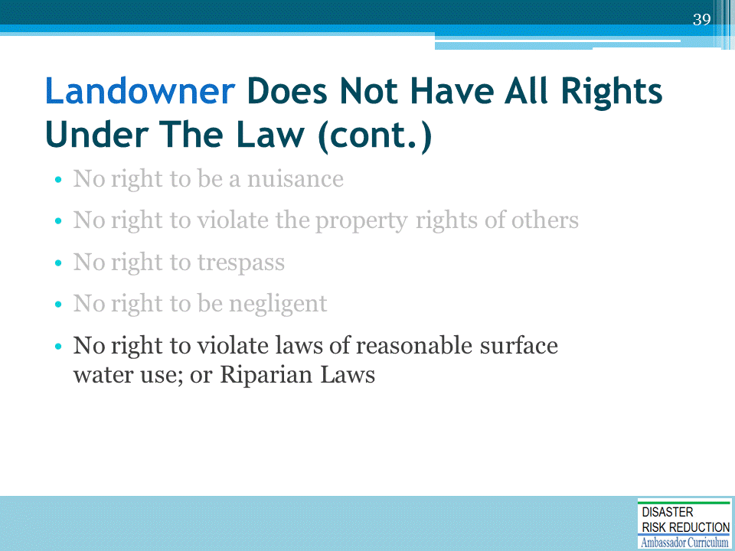

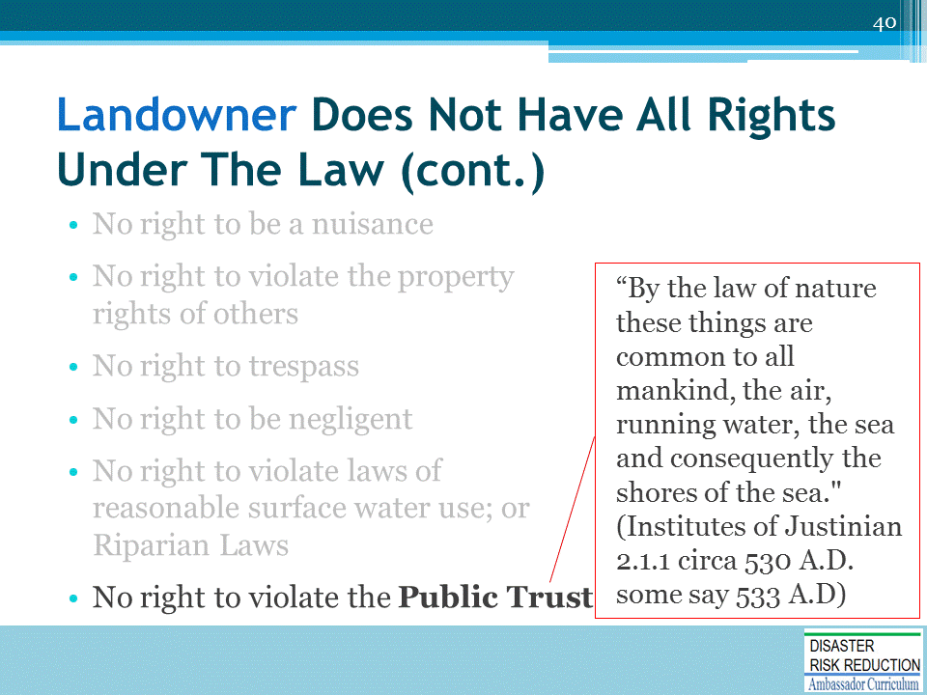

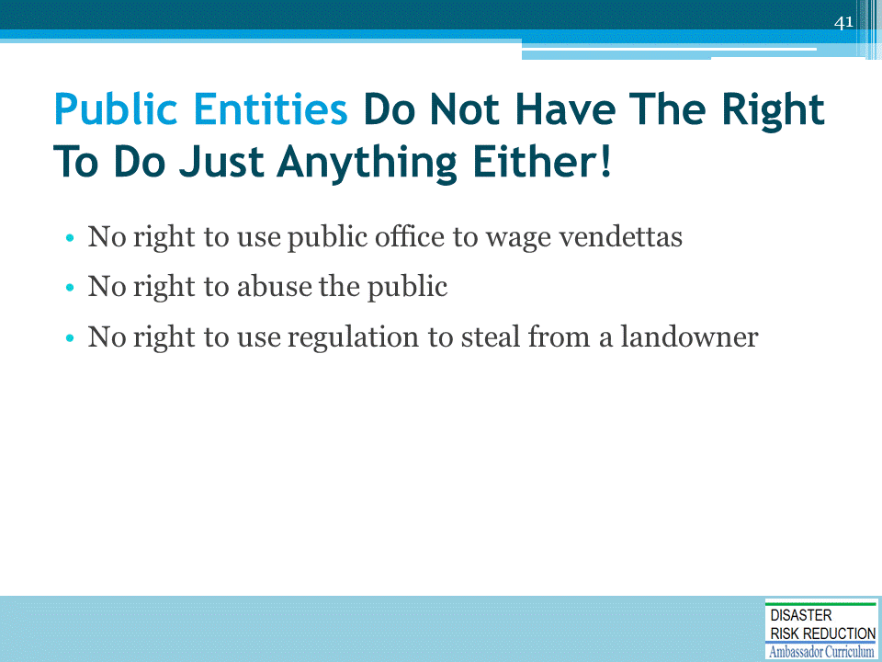

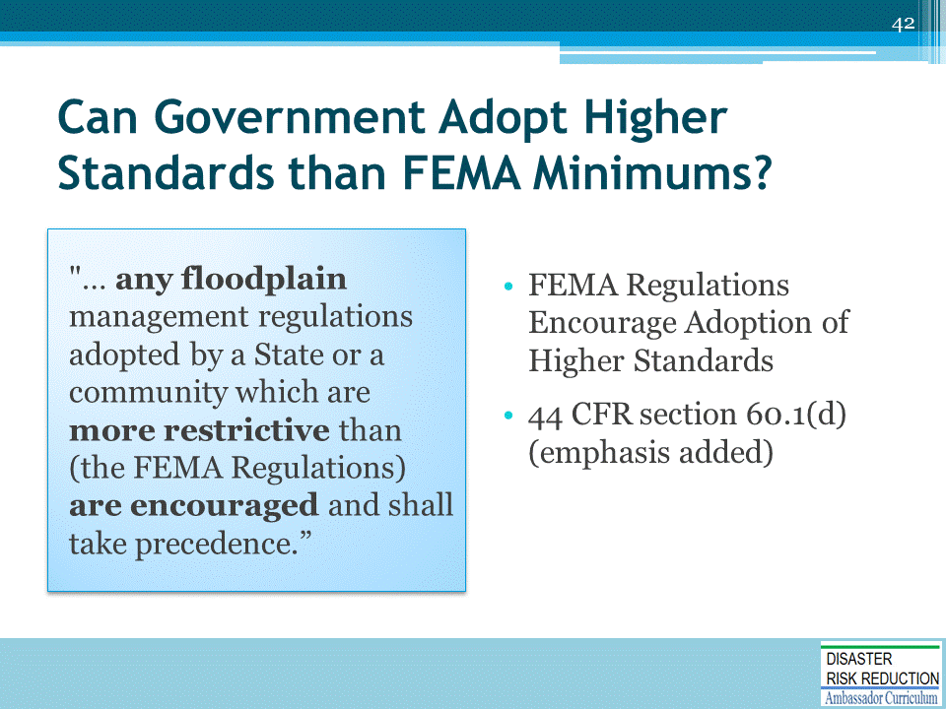
Case law; e.g., FEMA Elevation = 156 locals enforce 160 OK.
MICHAEL GIRARD et al v. ZONING COMMISSION OF THE TOWN OF SIMSBURY NO. CV 93 052 46 39S SUPERIOR COURT OF CONNECTICUT, JUDICIAL DISTRICT OF HARTFORD - NEW BRITAIN, AT HARTFORD 1994 Conn. Super. LEXIS 2365 September 15, 1994, Decided September 16, 1994, Filed.

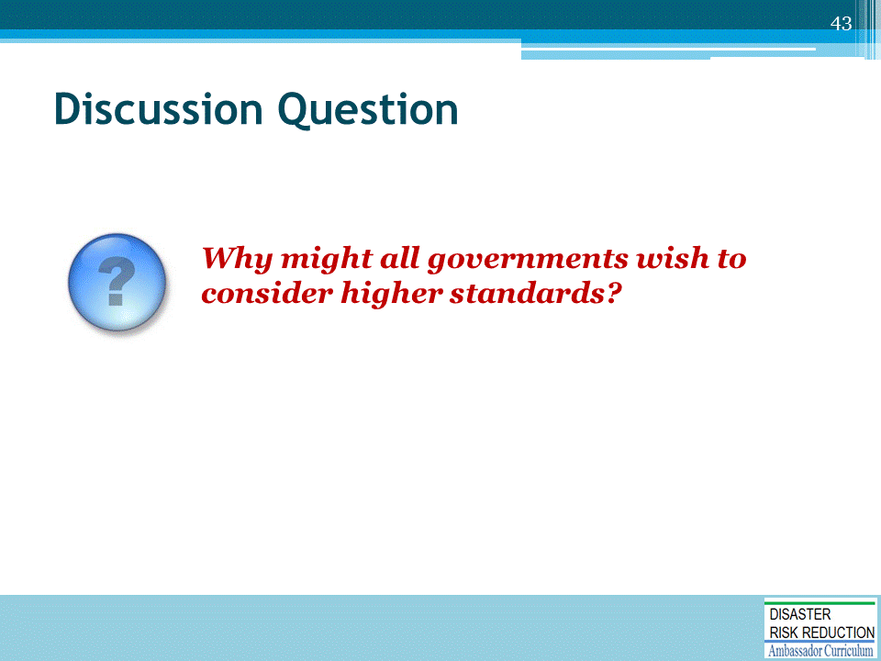
Depending upon available class time, ASK the discussion question and solicit answers from participants before proceeding to the suggested answers on the following slides.

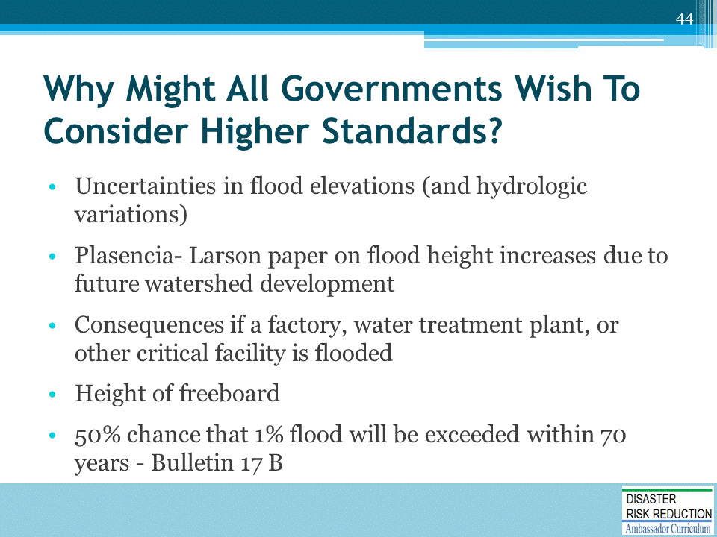

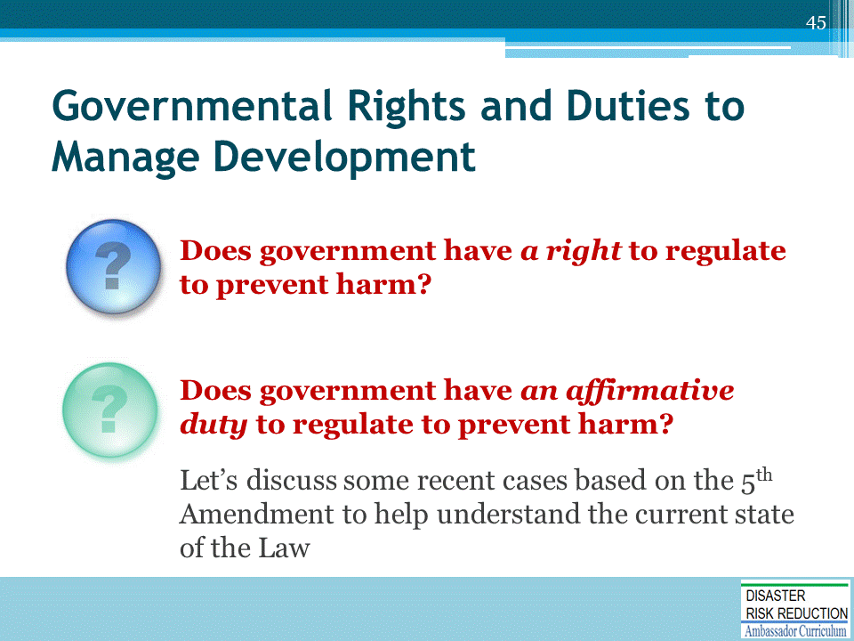
Preventing us from harming each other is at the core of the very reason government exists.
Courts are more and more finding an affirmative duty to regulate.
Hazards have become more “foreseeable” and predictable. The potential for private and government liability has increased as the techniques and capabilities for defining hazard areas and predicting individual hazard events have improved and actual mapping of hazard areas has taken place. With improved predictive capability and the actual mapping of areas, hazard events are now (to a greater or lesser extent) “foreseeable” and failing to take such hazards into account may constitute negligence. See, e.g., Barr v. Game, Fish, and Parks Commission, 497 P.2d 340 (Col., 1972.)
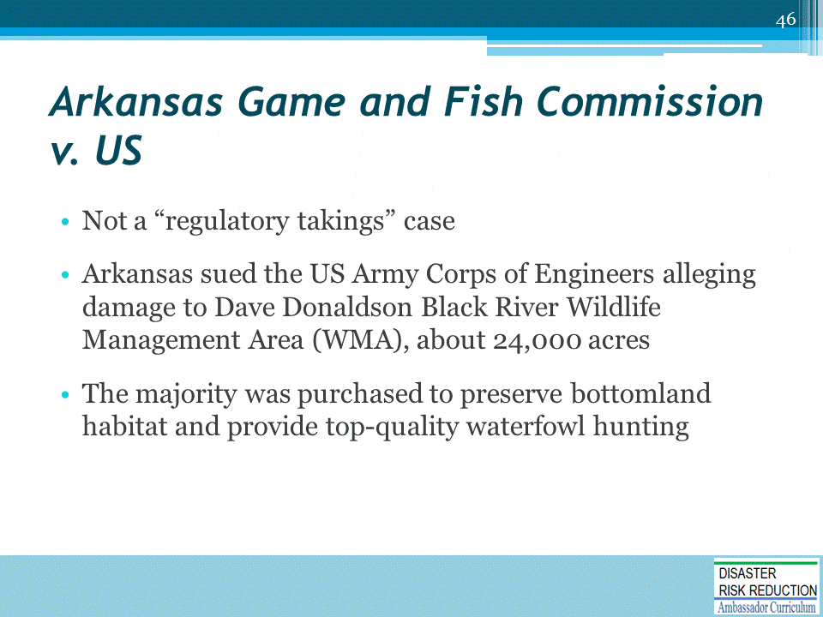

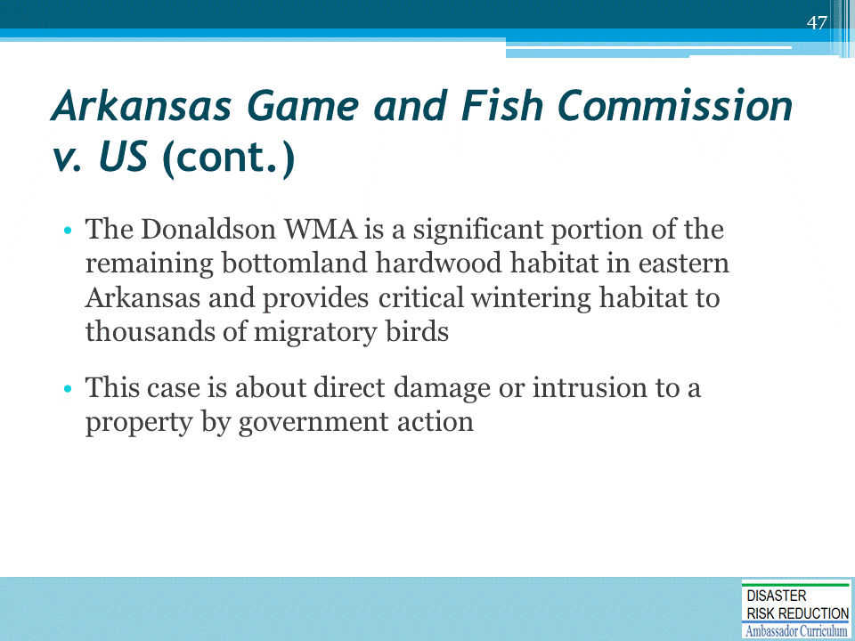

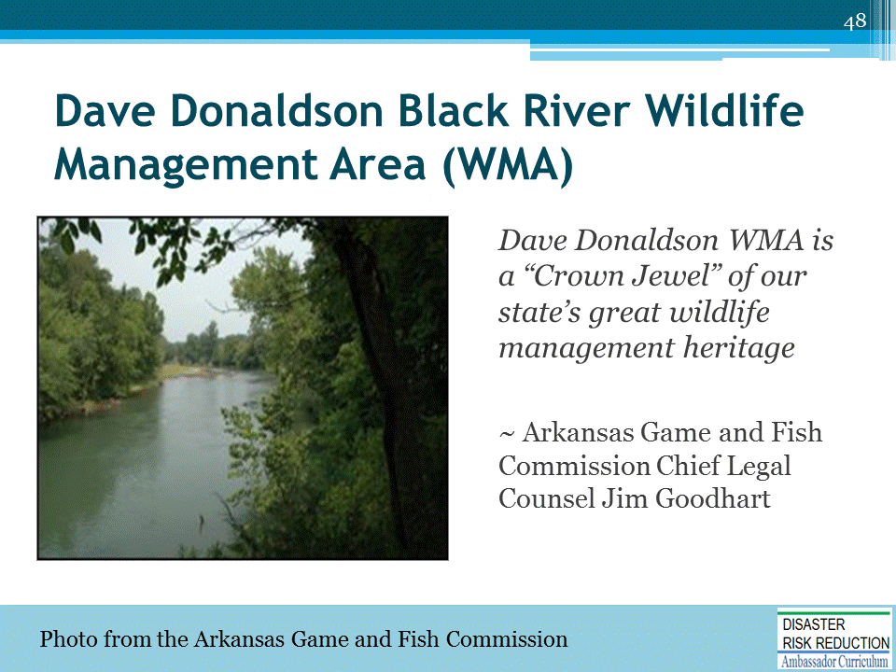

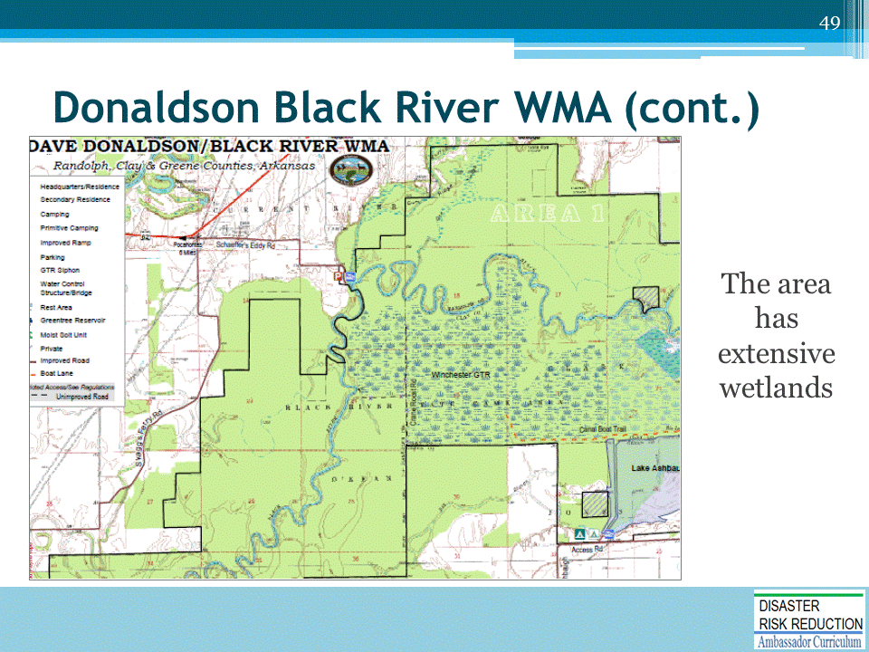

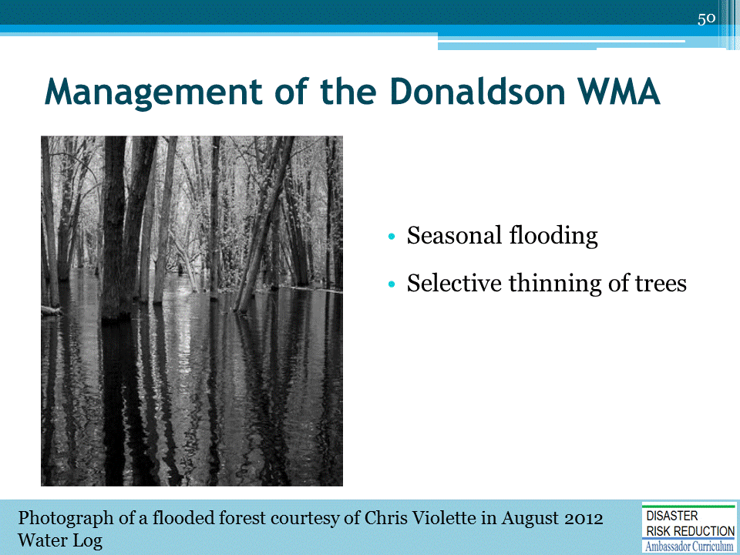
This is not a nature preserve! It floods. It needs to flood!
- Seasonal flooding of about 7,000 acres of green timber to attract waterfowl is done yearly
- Selective thinning of trees is done to stimulate the growth of new timber, to provide a diverse habitat type, and to remove unhealthy or unproductive trees from the forest
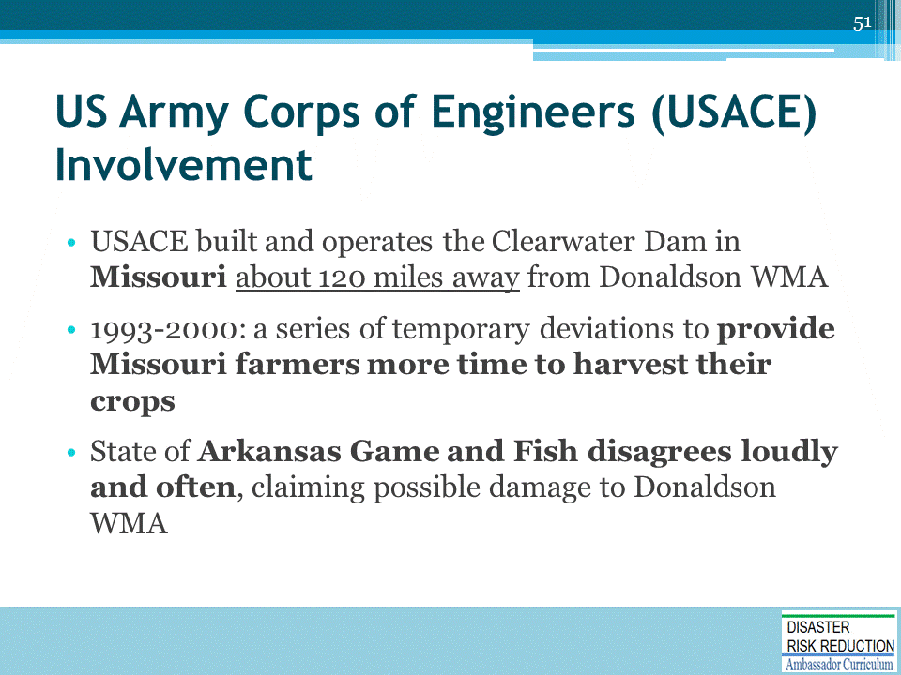
- The Clearwater Dam was constructed in 1948 for flood control
- Operating Plan developed in 1953 – lays out release rates from the dam, but allows some deviations

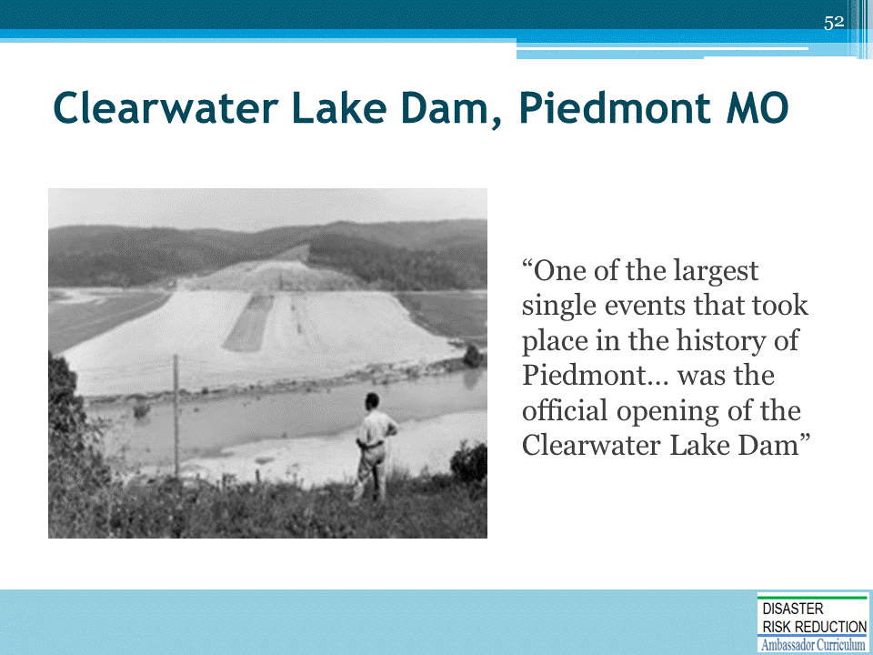
- Although Clearwater Lake's purpose was flood control, today it has become one of the largest tourist attractions in Southeast Missouri
- Estimate is that over a million people per year come to enjoy camping, canoeing, boating, fishing, swimming, and just plain relaxing
- This dam and the water it impounds is a big deal locally!!

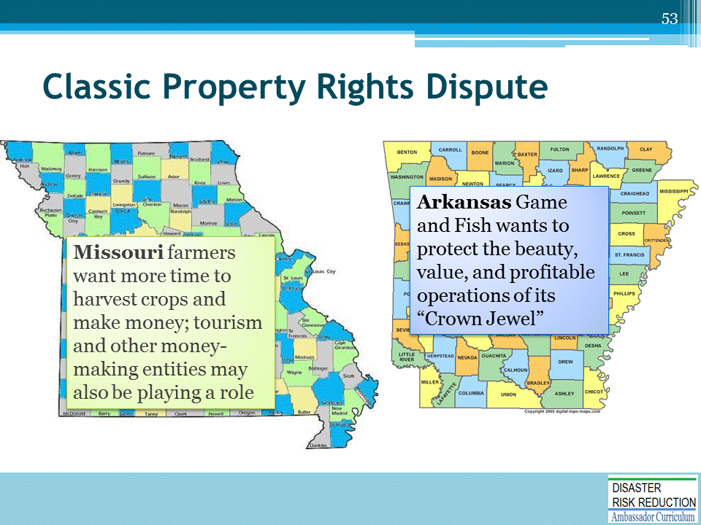

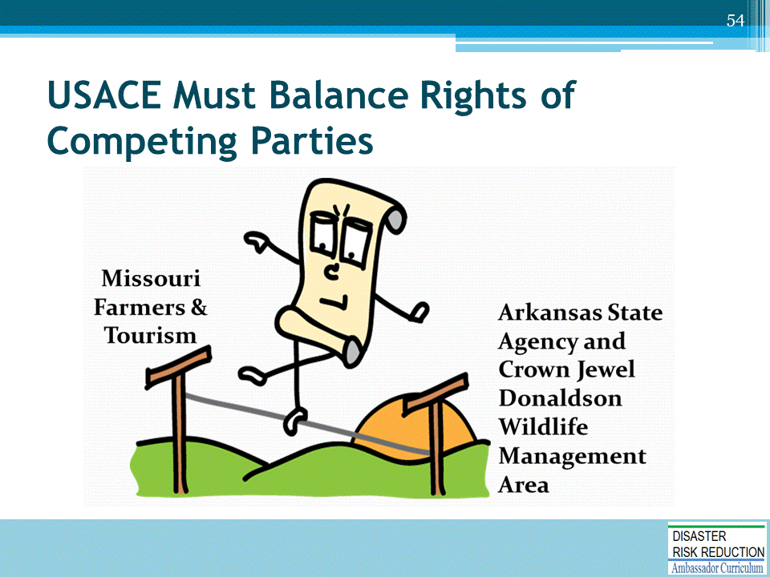

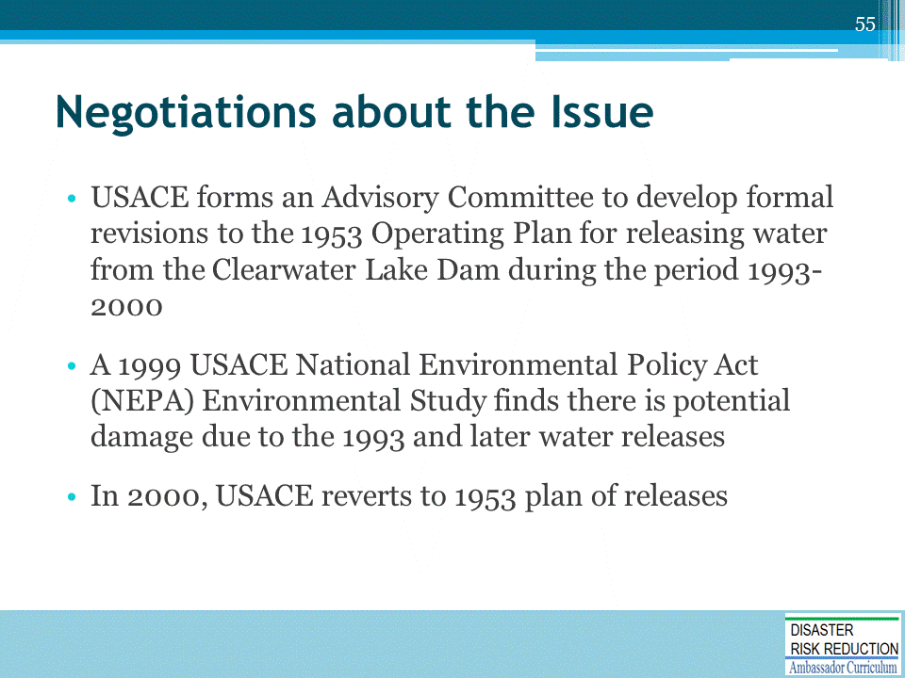
The Advisory Committee includes Arkansas Game and Fish.

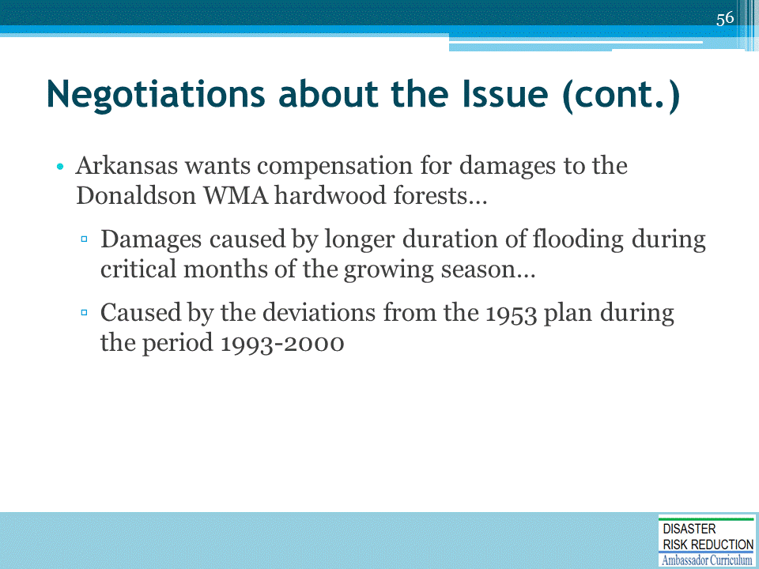

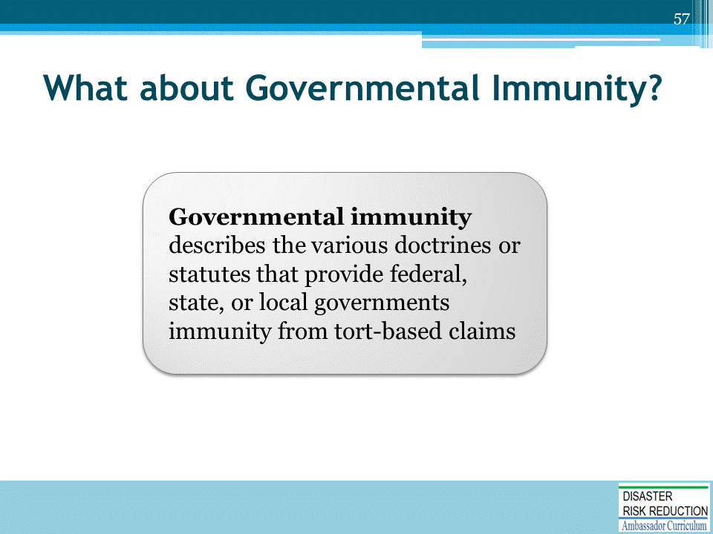

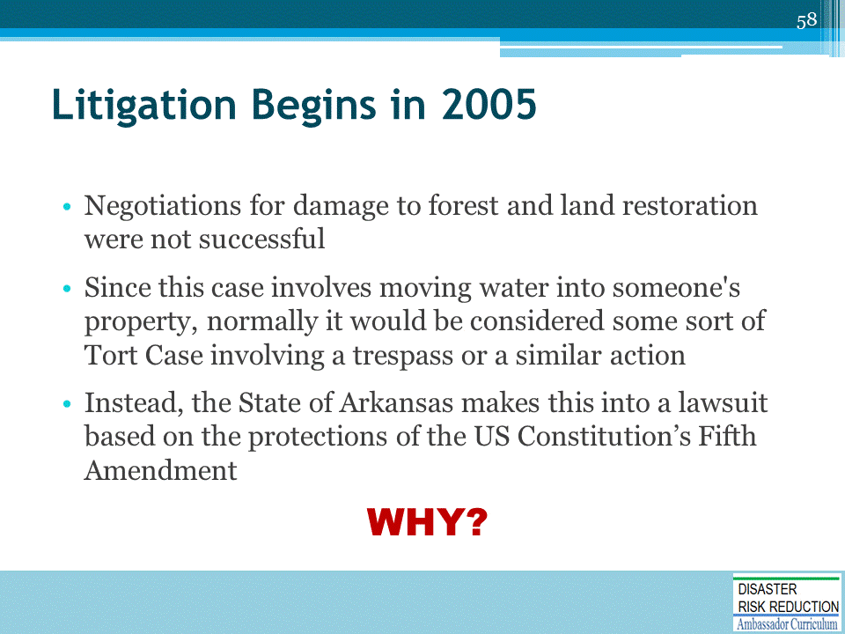

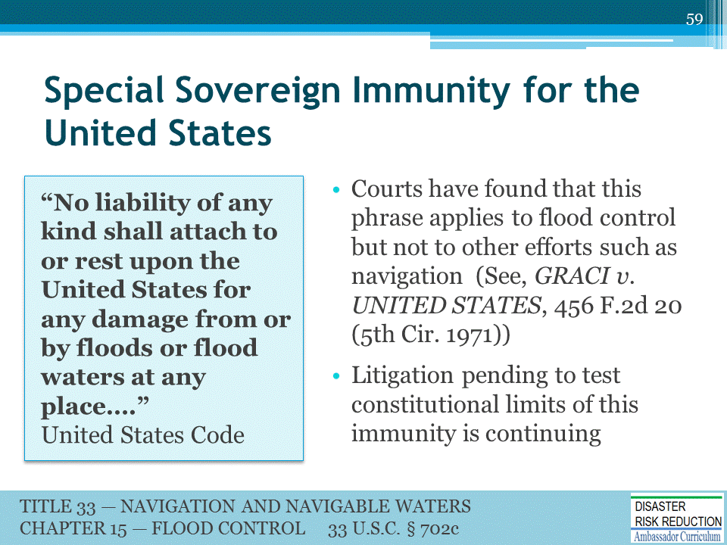

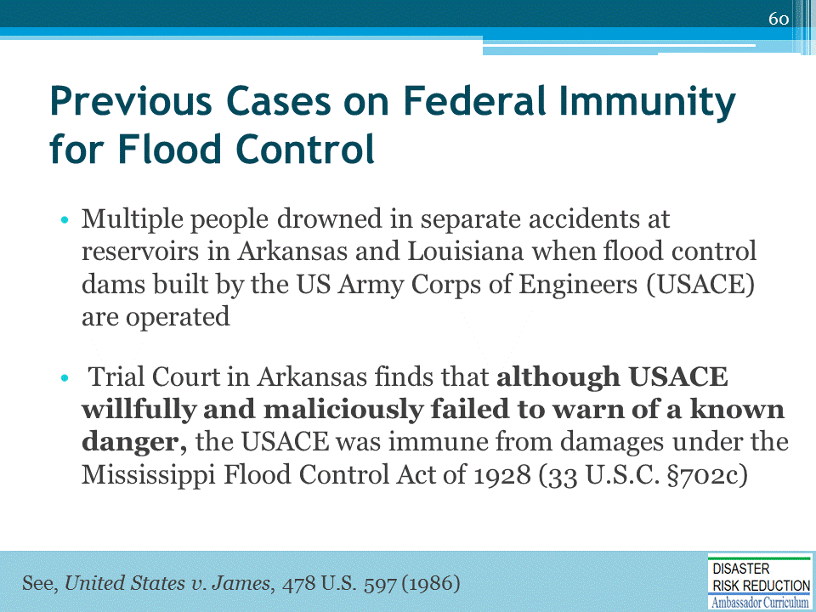
The Mississippi Flood Control Act of 1928 (33 U.S.C. §702c) states that "no liability of any kind shall attach to or rest upon the United States for any damage from or by floods or flood waters at any place.”
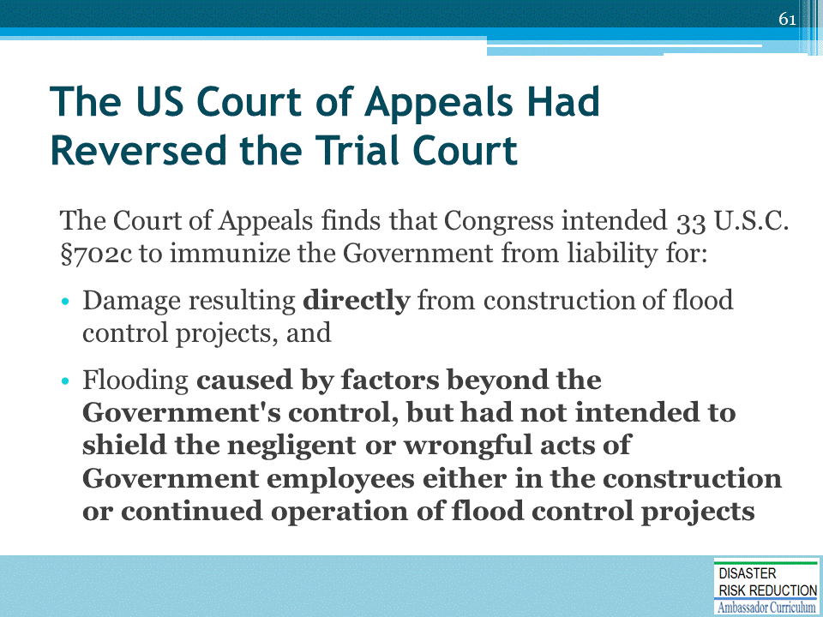
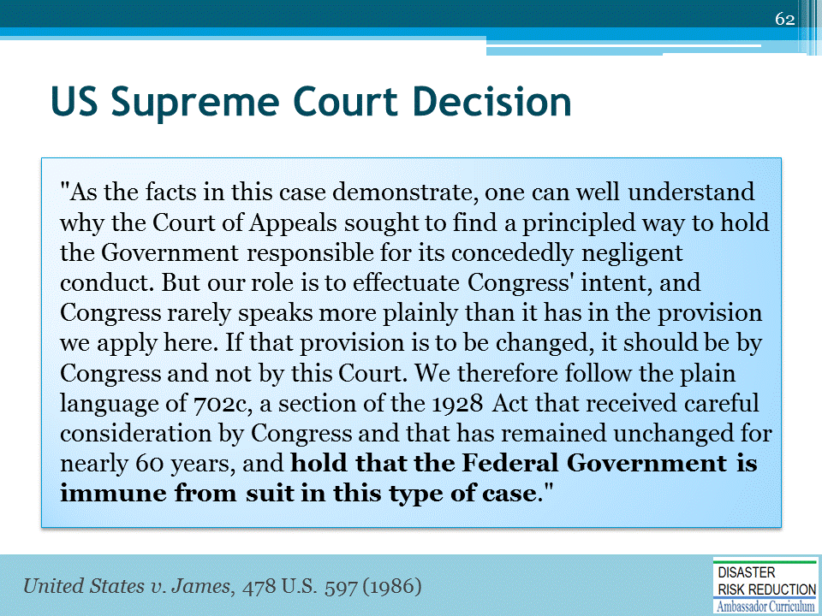

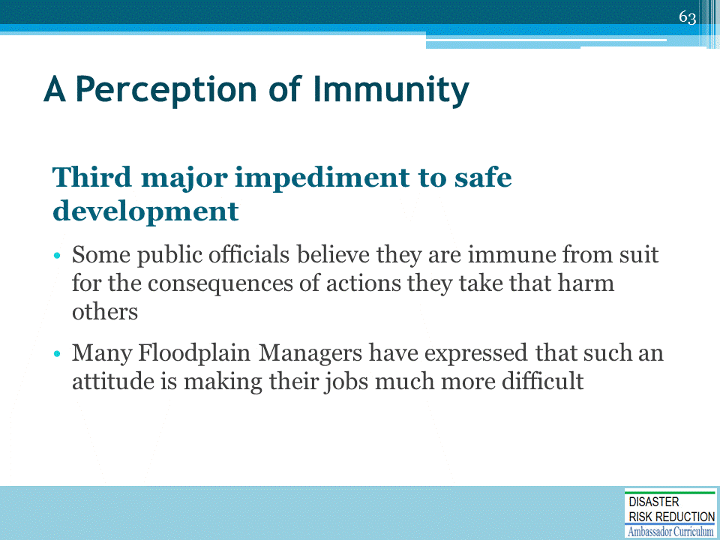
- This topic was covered at some length in a FEMA funded Workshop put on by the Arkansas Association of Floodplain Managers through the Association of State Floodplain Managers
- PowerPoints and a CD of the Workshop are available on the Arkansas Floodplain Managers and the NHMA websites
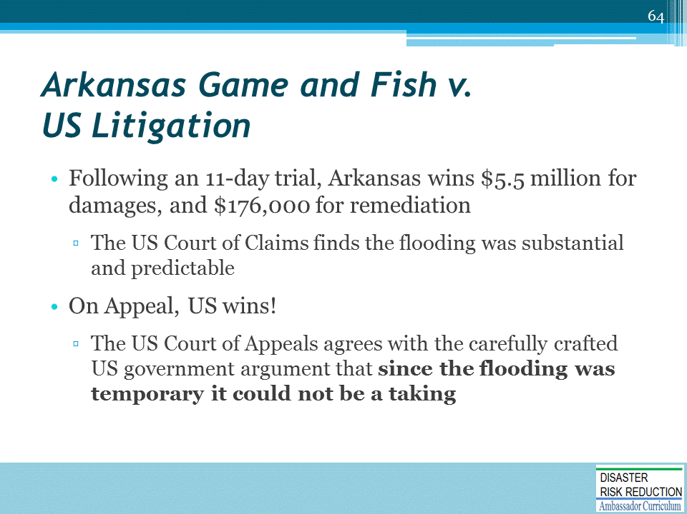
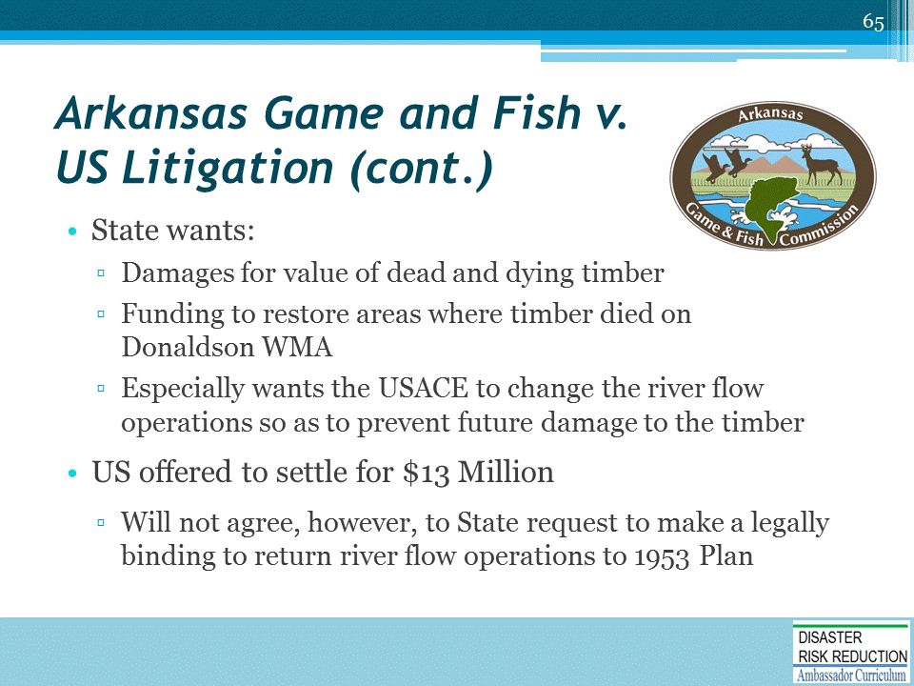

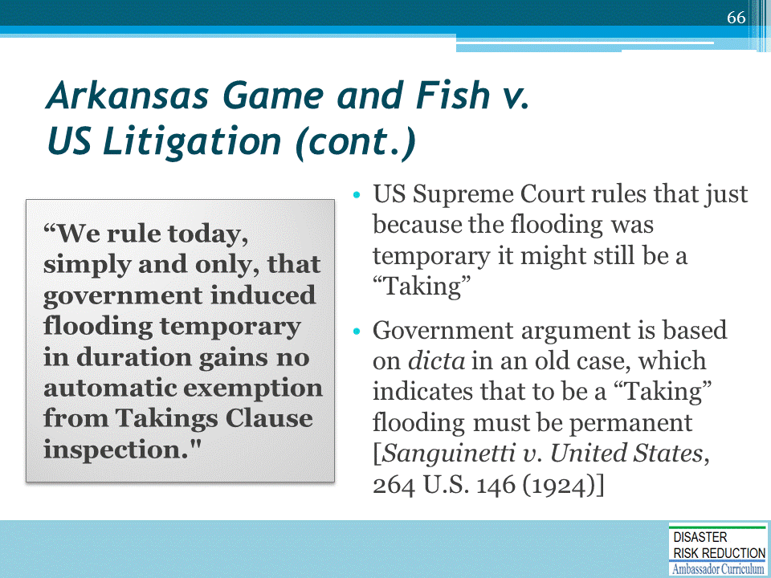
Dicta is a legal term for a statement or comment in a court’s holding that is not central to the ruling.
- Presumably, it was well-informed but does not have the force of the ruling itself, which is legally usually very carefully narrowed to facts and issues raised in the case itself.

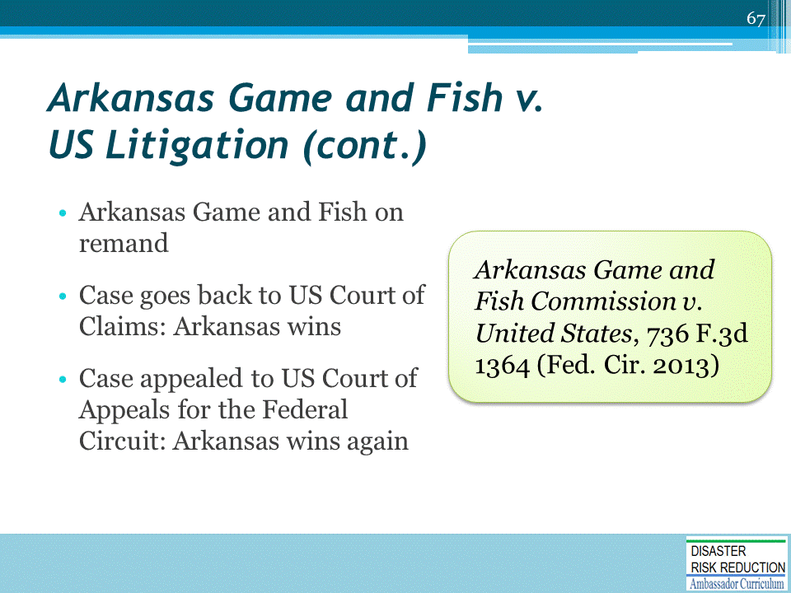
In order for a taking to occur, it is not necessary that the government intend to invade the property owner's rights, as long as the invasion that occurred was the foreseeable or predictable result of the government's action
Instead, to determine whether a taking has occurred, a court must consider whether the injury was caused by authorized government action, whether the injury was the foreseeable result of that action, and whether the injury constituted a sufficiently severe invasion that interfered with the landowner's reasonable expectations as to the use of the land. Ark. Game & Fish Comm'n v. United States, 736 F.3d 1364 *, 2013 U.S. App. LEXIS 24006, 43 ELR 20260, 2013 WL 6231552 (Fed. Cir. 2013)
In order for a taking to occur, it is not necessary that the government intend to invade the property owner's rights, as long as the invasion that occurred was "the foreseeable or predictable result" of the government's actions. Moden v. United States, 404 F.3d 1335, 1343 (Fed. Cir. 2005); [**18] accord Ridge Line, Inc. v. United States, 346 F.3d 1346, 1357 (Fed. Cir. 2003). The trial court found that the Corps of [*1373] Engineers could have foreseen that the series of deviations approved during the 1990s would lead to substantially increased flooding of the Management Area and, ultimately, to the loss of large numbers of trees there. We uphold the court's conclusion as to that issue. Ark. Game & Fish Comm'n v. United States, 736 F.3d 1364, 1372-1373, 2013 U.S. App. LEXIS 24006, *16-18, 43 ELR 20260, 2013 WL 6231552 (Fed. Cir. 2013)

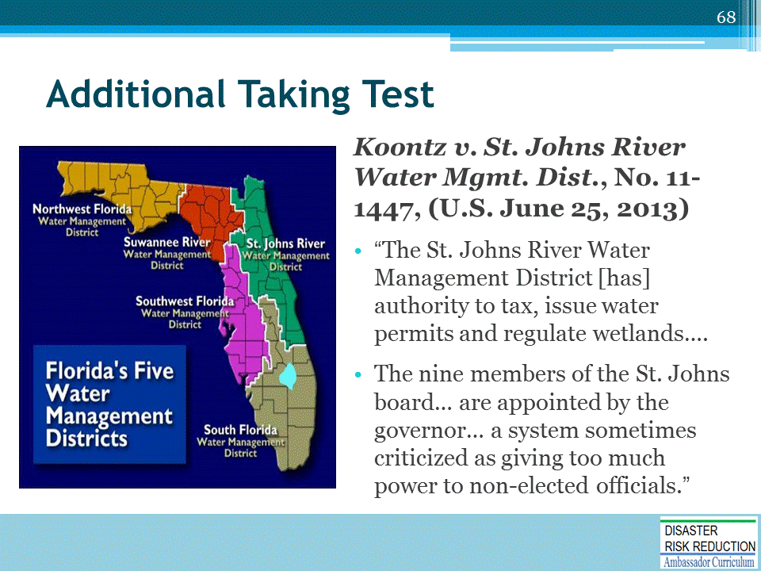
The district includes 18 counties; and has roughly 700 employees.

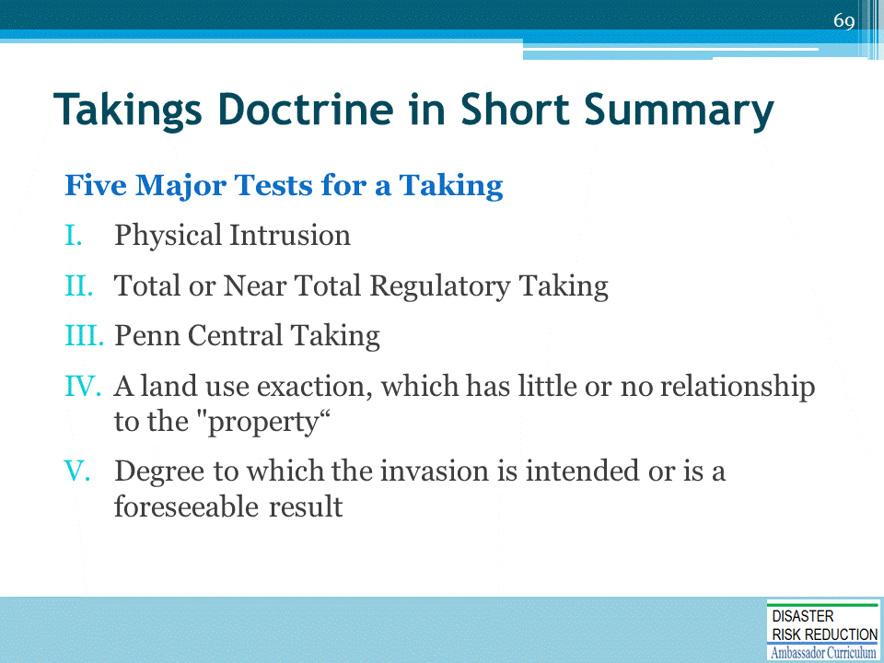
ASK: Do harm prevention or NAI ever bear no relationship to public good?
Suggested Response: No, the whole idea is to link harm prevention to government action.
IV Land use Exactions which are not really related to the articulated government interest as in Nollan v. California Coastal Commission 483 US 825 (1987) where the California Coastal Commission conditioned a permit to expand an existing beachfront home on the owner granting an easement to the public to cross his beachfront land. The articulated government interest was that the lateral expansion of the home would reduce the amount of beach and ocean the public on the road side of the home could see. The Court indicated that preserving public views from the road really did not have an essential nexus with allowing folks to cross a beach. The Court also cited the Dolan v. Tigard 512 US 374 (1994) case where someone wanted to expand a plumbing store and the community wanted the store to give the community some adjacent flood plain property and an easement for bike path in return for the possible increase in traffic caused by the expansion of the store. Again, in Dolan the court basically indicated that there was really no relationship between the government interest and the exaction attempted. Basically the Court is saying no to plans of extortion.
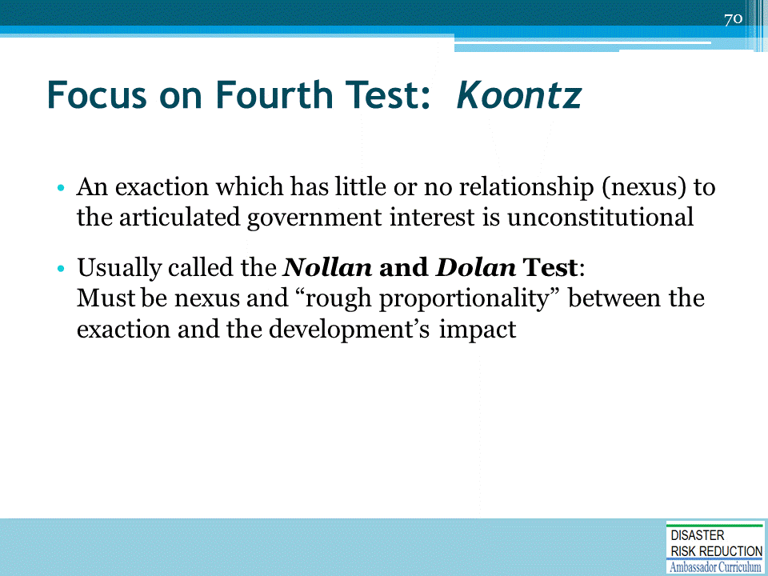

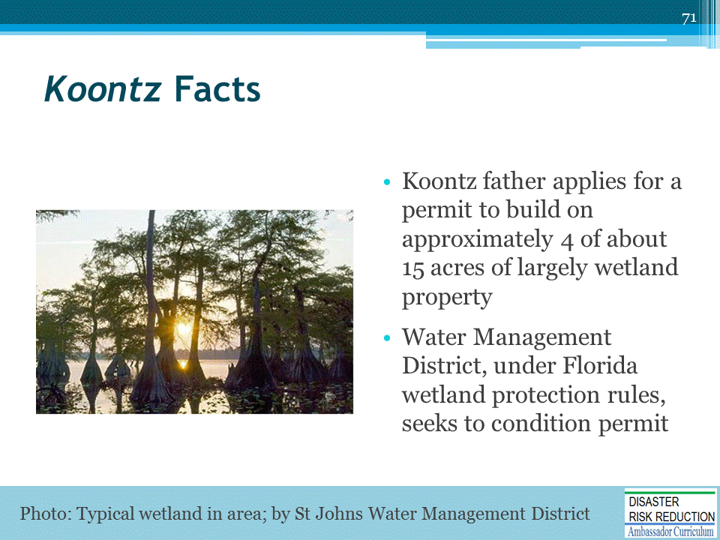
Turning Koontz into an Opportunity for More Resilient Communities, by Edward A. Thomas Esq., and Lynsey R. Johnson J.D., in National Wetlands Newsletter, March/April 2014, vol.36, no.2.
Located on the American Bar Association Website at: http://www.americanbar.org/content/dam/aba/administrative/state_local_government/land_use.authcheckdam.pdf

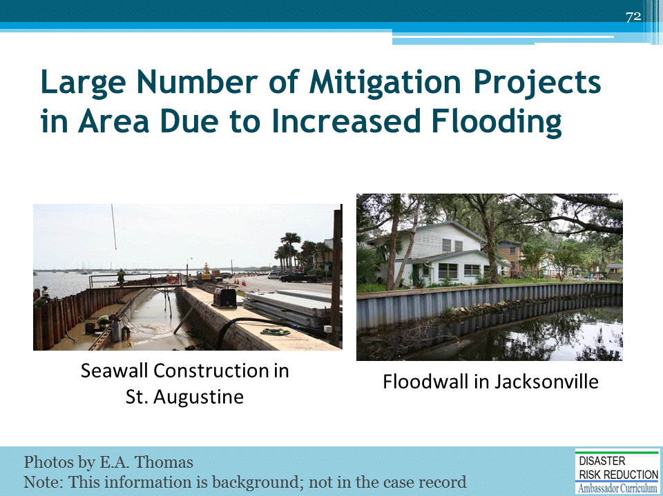

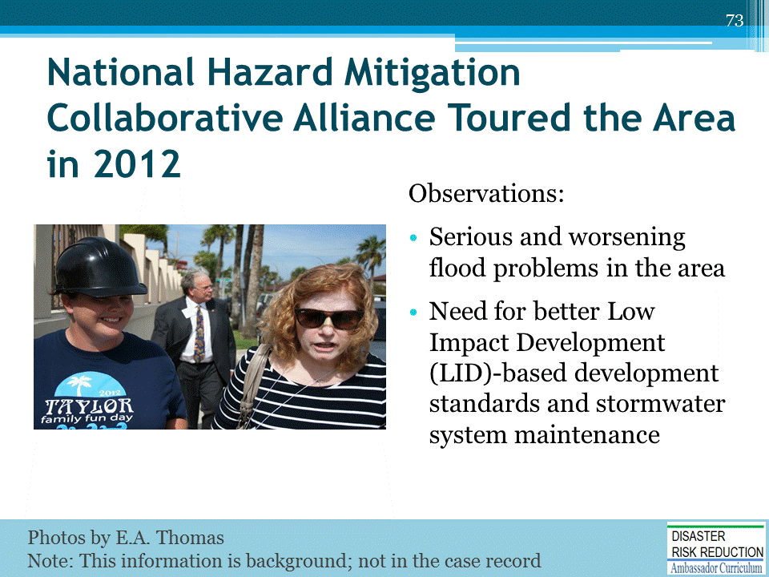
Some takeaways from the tour:
- There are serious and worsening flood problems in the area.
- There is a need for better Low Impact Development (LID)-based development standards and stormwater system maintenance.
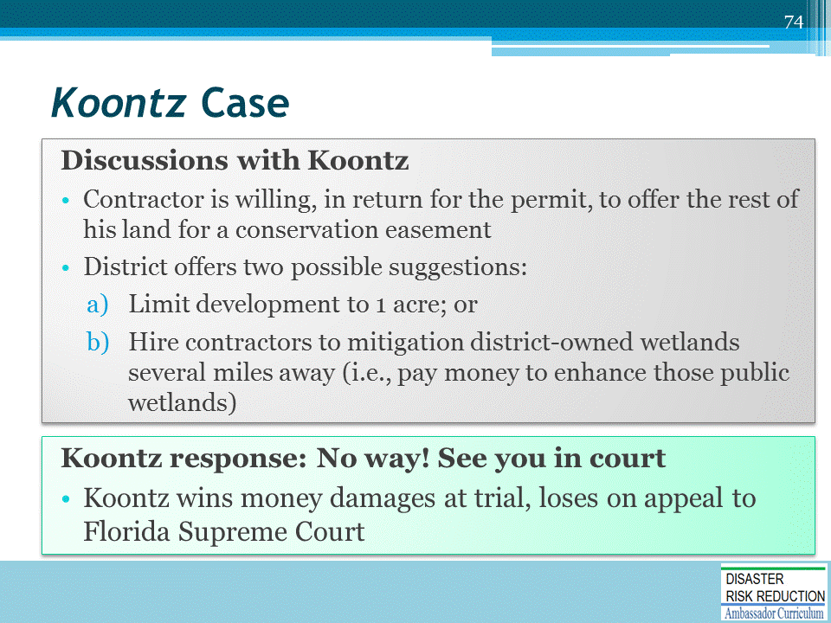
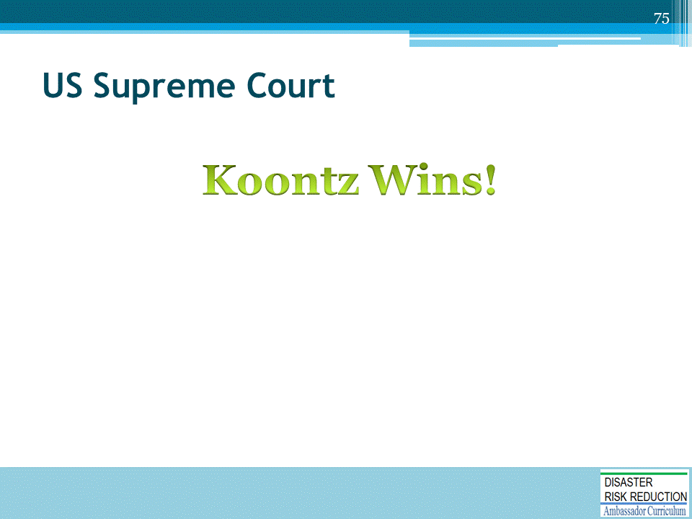

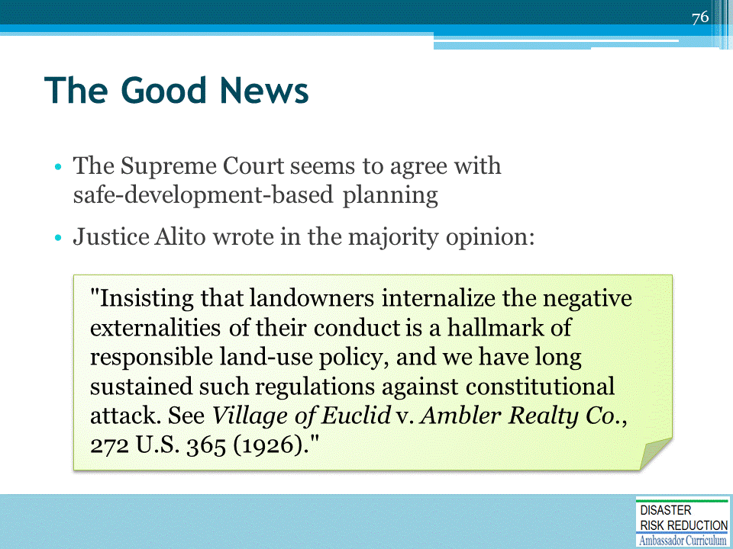

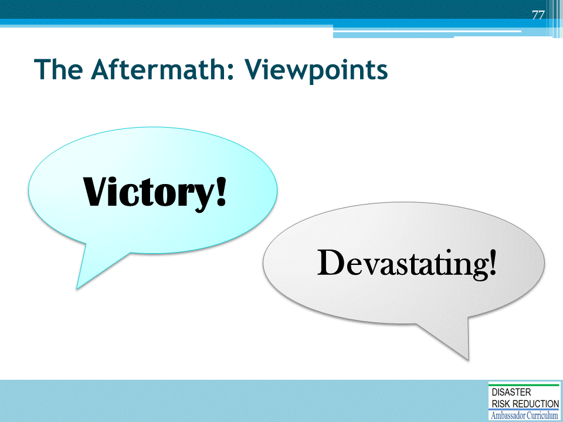
- Many commentators view this case as a major victory for property owners and a defeat for government regulation.
- There are articles quoting attorneys who claim that subjecting monetary exactions to taking analysis will be "devastating“ to land use planning and will limit the ability and incentive of local governments to negotiate for conditions that mitigate the impacts of proposed development.
  - There are all sorts of alarmist articles quoting attorneys who are basically predicting that the sky is falling.

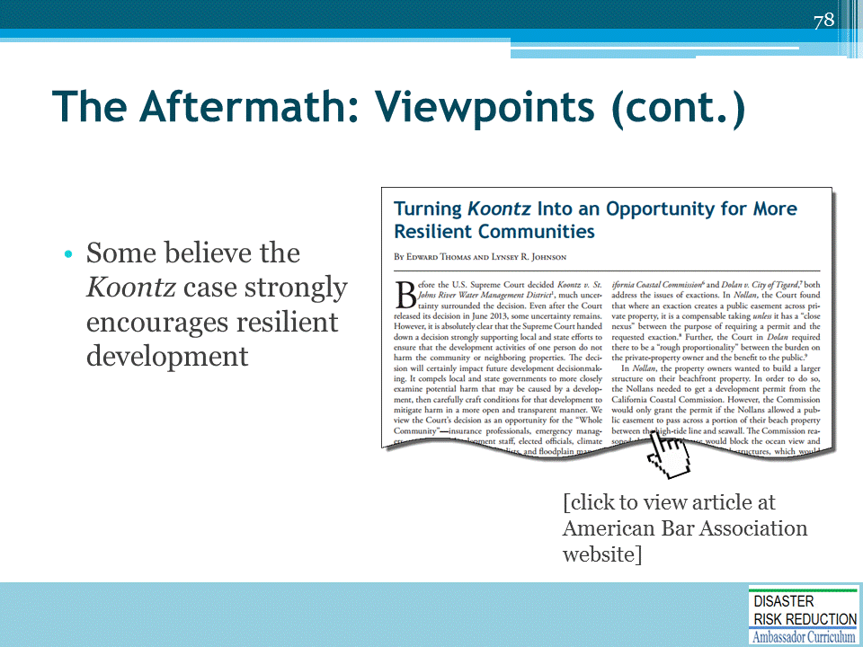
“Turning Koontz into an Opportunity for More Resilient Communities”
by Edward A. Thomas Esq., and Lynsey R. Johnson J.D., in National Wetlands Newsletter, March/April 2014, vol.36, no.2
Located on the American Bar Association Website at: http://www.americanbar.org/content/dam/aba/administrative/state_local_government/land_use.authcheckdam.pdf

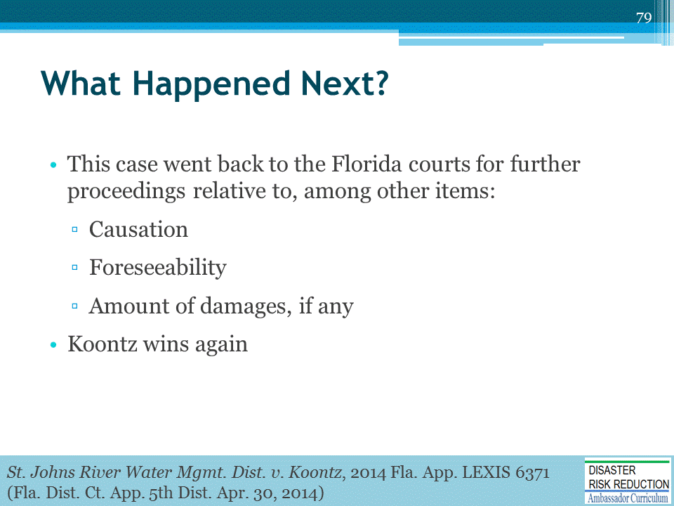

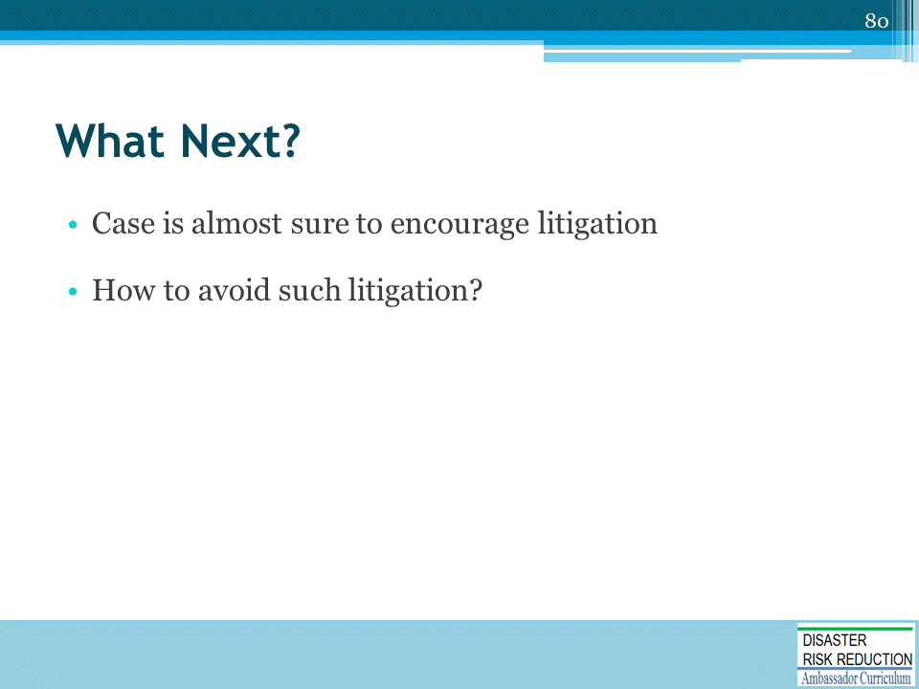
- David Mallory and Ed Thomas have suggestions about how to avoid such litigation.
- They have been presenting Workshops and webinars on principled, successful safe development/No Adverse Impact Negotiations for years.

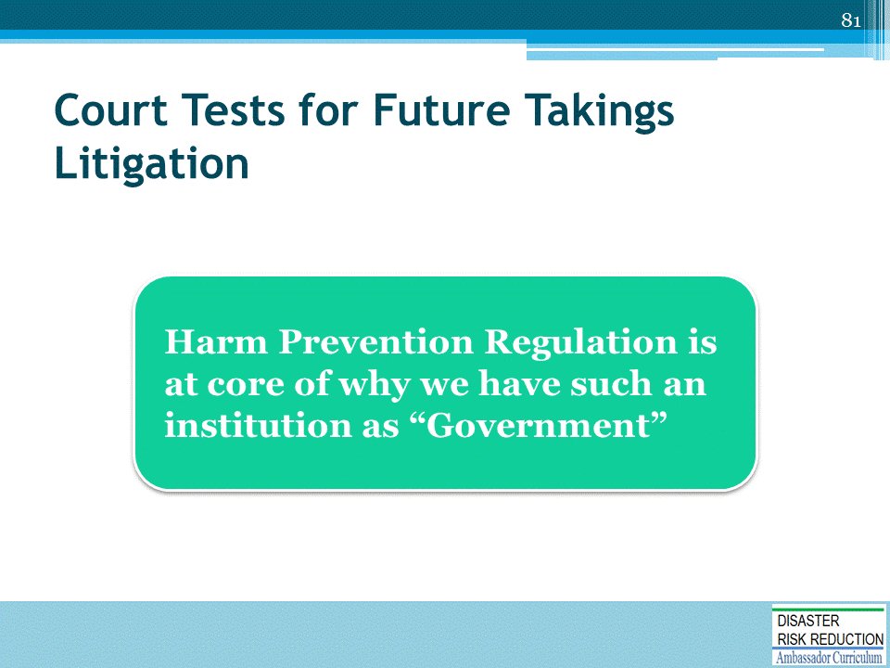
- The tests for a “Taking” described in the writings and lectures of Dr. Jon Kusler, Sam Riley Medlock, and Edward Thomas, extensively examine the details of what is a “Taking.”
- Bottom Line: Harm Prevention Regulation is at core of why we have such an institution as “Government”
- Virtually no successful litigation alleging taking when harm prevention regulations are sensible and fairly applied

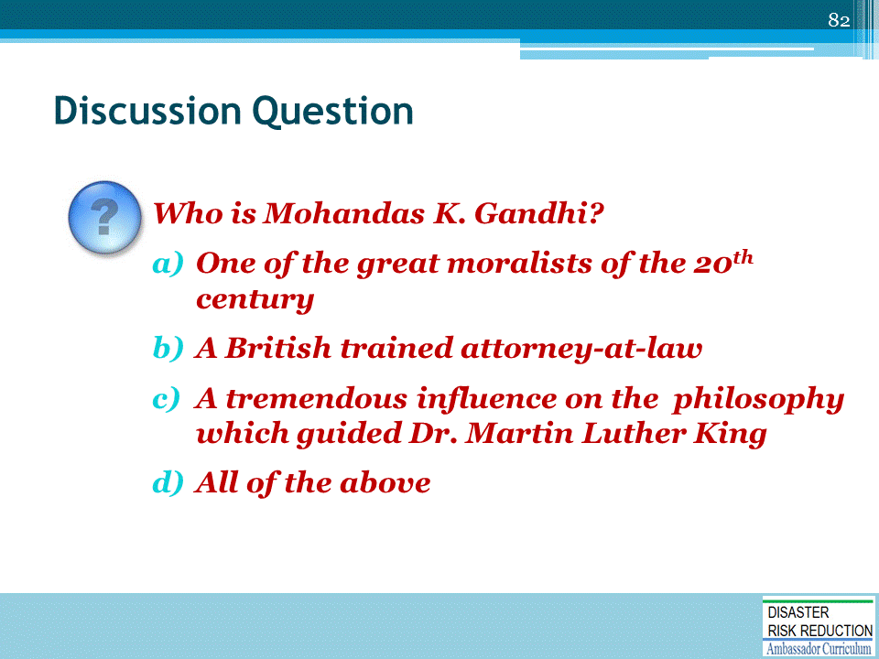
Ask the question and solicit suggestions from participants before providing the suggested answer below.
Hint: He Was called the Mahatma, or enlightened one
Answer: All of the above - and the father of non-violent resistance as well as Indian independence

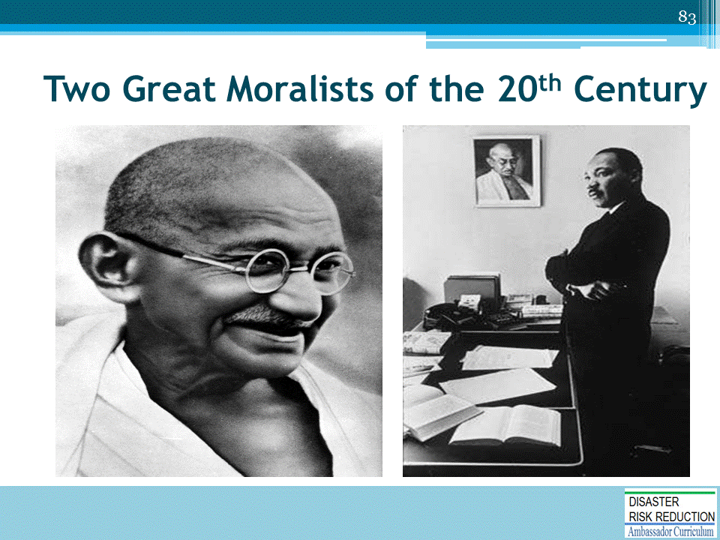

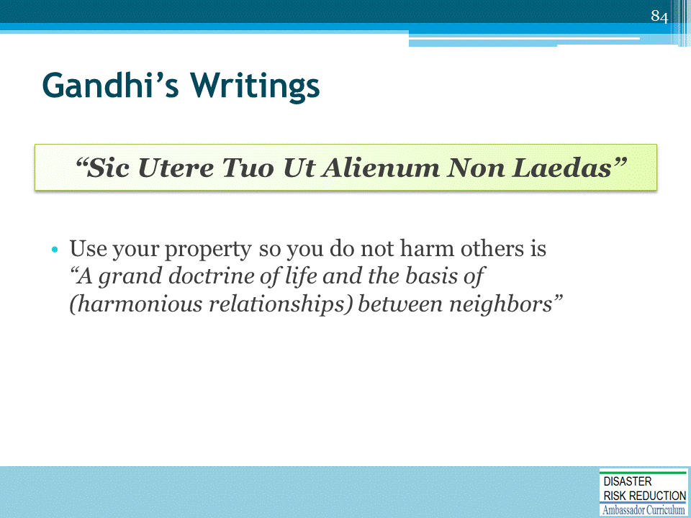
The concept of using property so it does not harm others:
- Is important to all aspects of what we do in developing and redeveloping communities
- Will help us understand how to proceed for current community decisions and for the future, as we shall see
Our Courts in the US are Courts of both law and equity.
Law, well law is statute, legal precedent, the US and State Constitutions, Treaties, etc. coupled with evolving standards of reasonable action
Equity is very important for our discussions.
- Equity is based on fairness, influenced by concepts of morality.
- Sometimes courts will really get very innovative to come out with a moral, decent result.
- Juries seem to often try to help the underdog for similar reasons.
- Victims of a dam or levee failure may be considered by some to be deserving some special considerations for some sort of “equitable” reason.
- Large companies, insurers, and government agencies may come out on the short end of a case in such a situation.

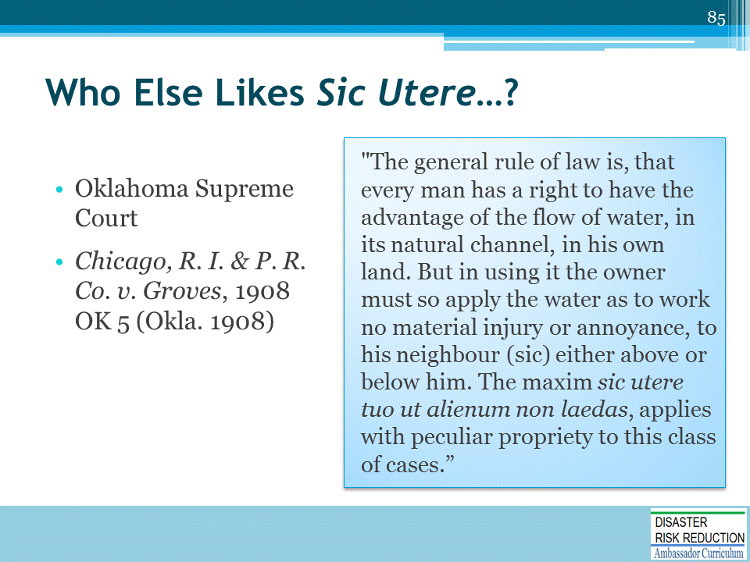
Virtually every other state supreme court has something similar to write about sic utere.

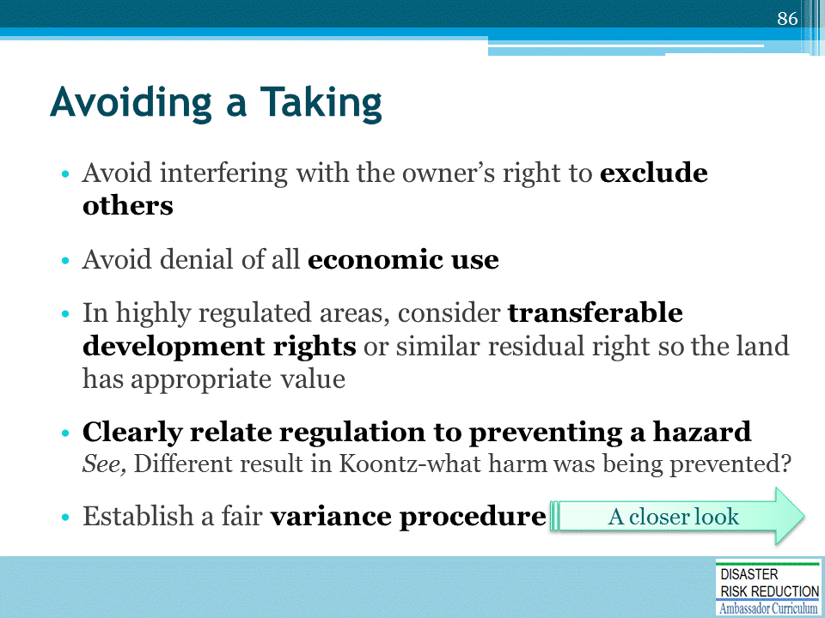
See, also American Planning Association (APA) Policy Guide on Takings adopted in 1995.
- Located at: https://planning.org/policy/guides/adopted/takings.htm
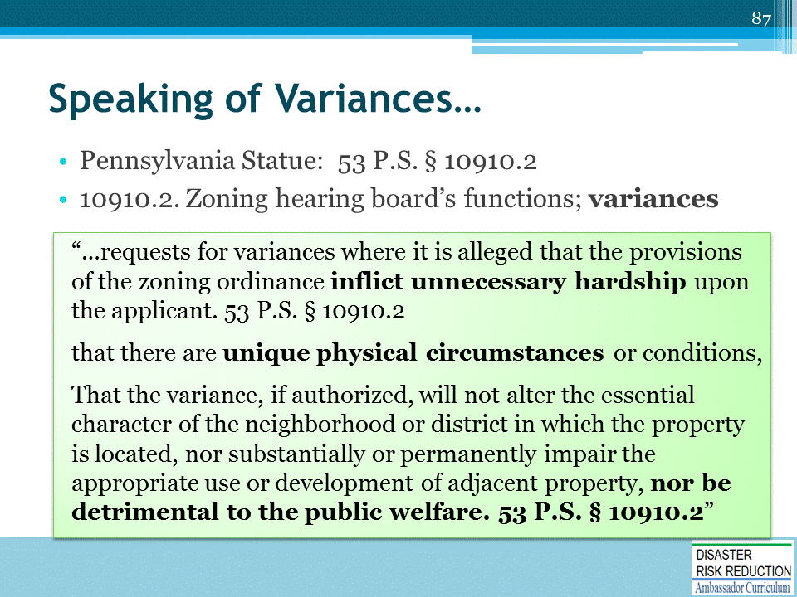
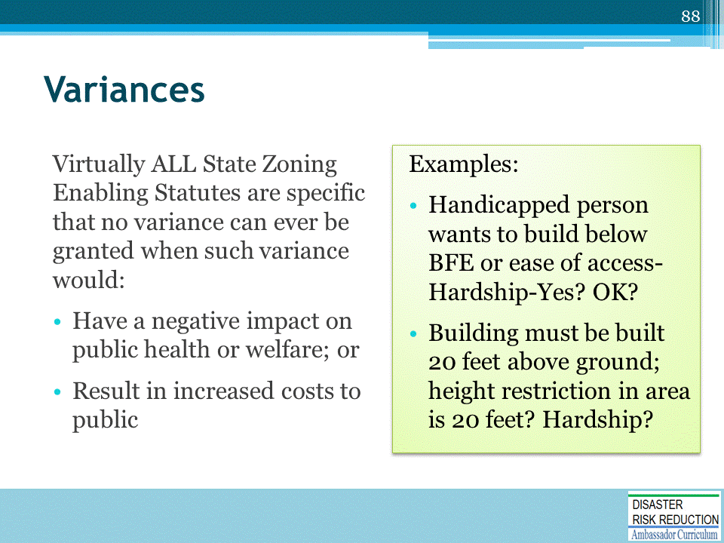
Other than height restrictions, ASK if the Zoning Appeals Board has even the authority under state law to grant variances.

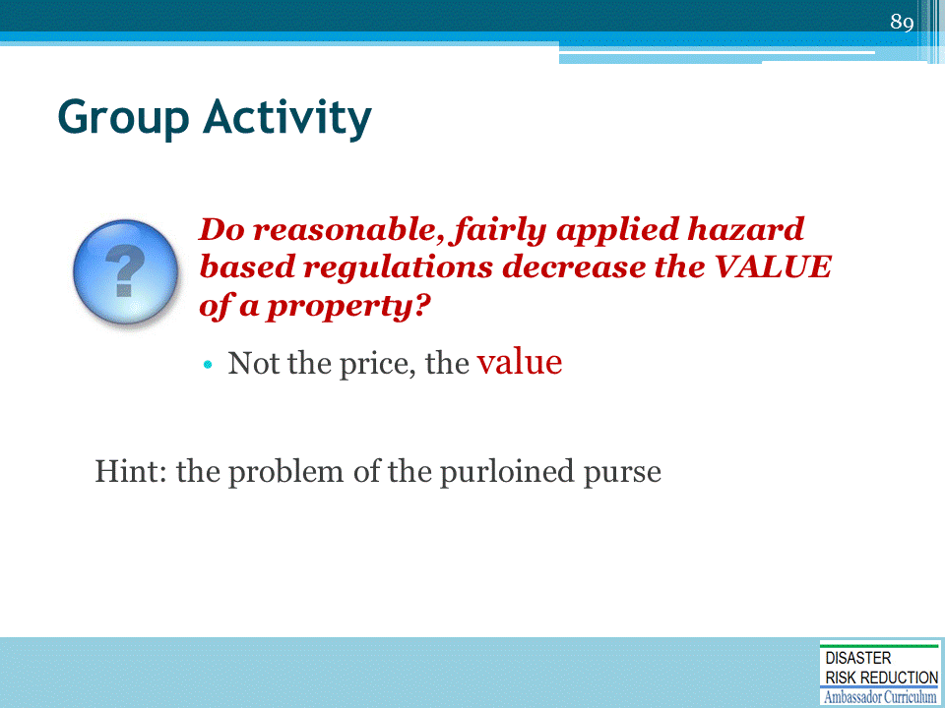
Describe the scenario, as follows. Then ask the question on the slide.
- Thief creeps into room takes person’s purse and runs
- We rise up and corner the “nogoodnick”
- Cop comes and asks him to hand over purse
- Thief says, “No way! This is property. I want compensation!”

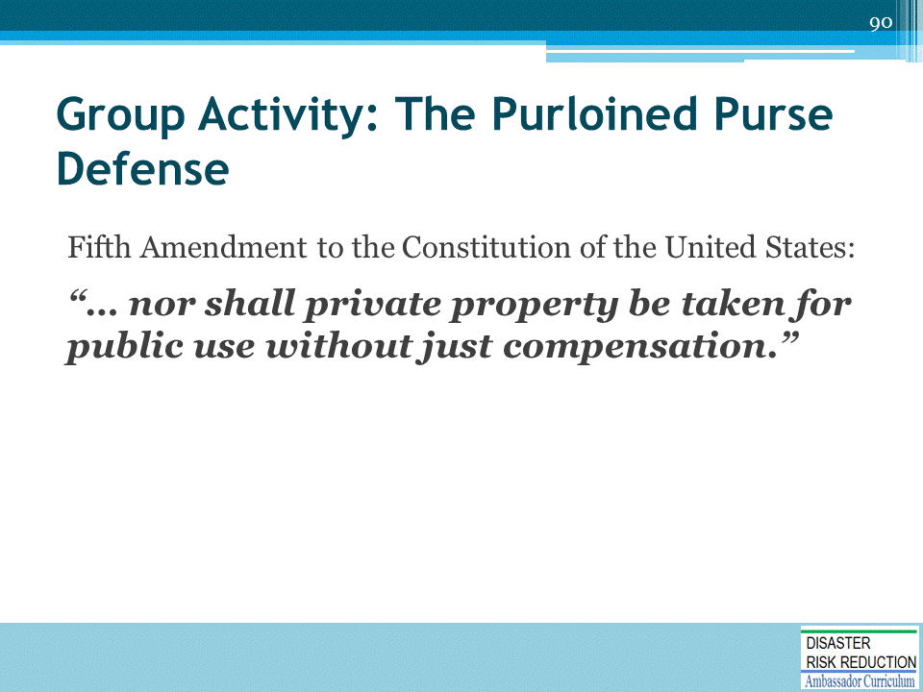
Any problems with this defense???
- It is not his!
- Who owns the right to flood MS. Smith land?-
  - She does!
  - Is it a valuable right you bet - USACE says when it buys the right to flood property it usually pays something like 80% or more of the fair market value of the property!
- So, like the purse, when someone floods property with improper construction is it not just like the purloined purse?

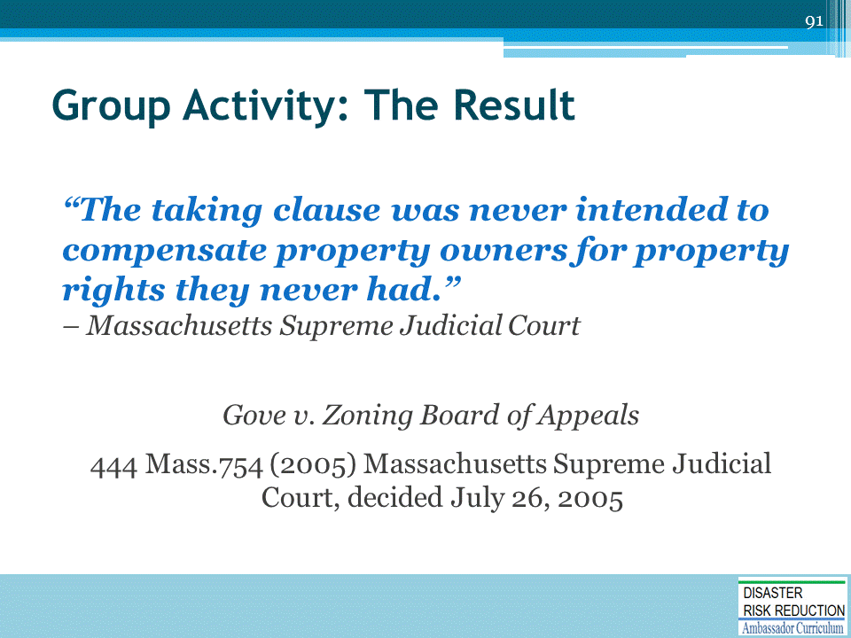
There are extensive materials on this at www.nhma.info

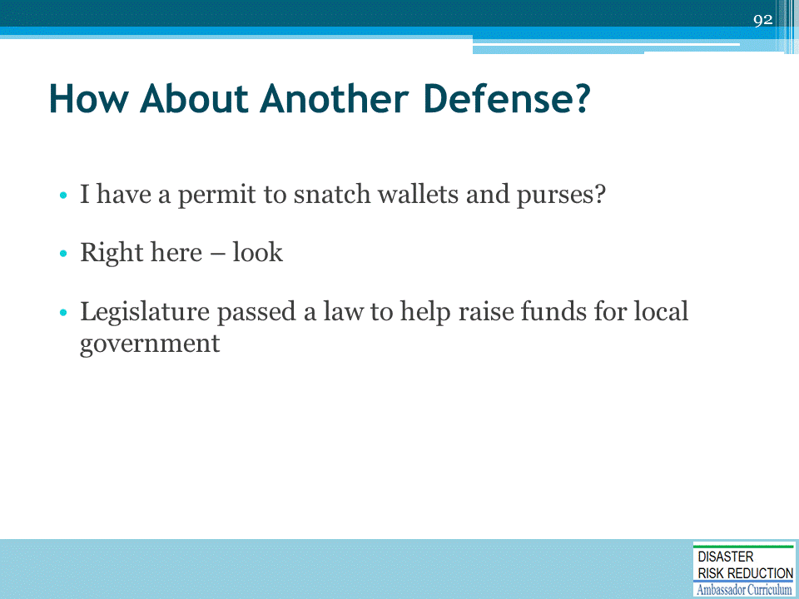
Do you know of States which might pass such a law? I do!

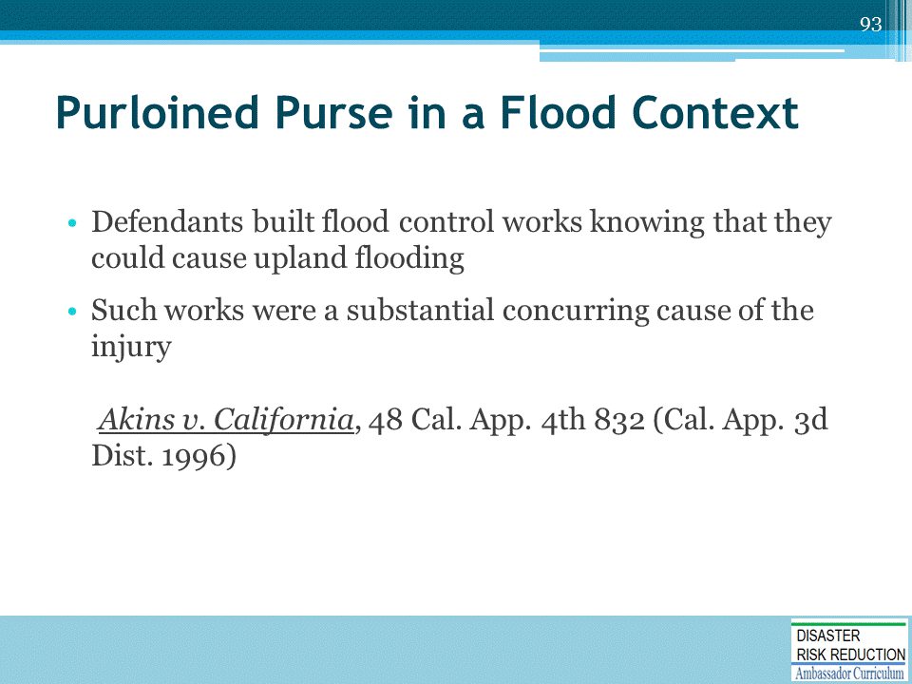
State liable for damages

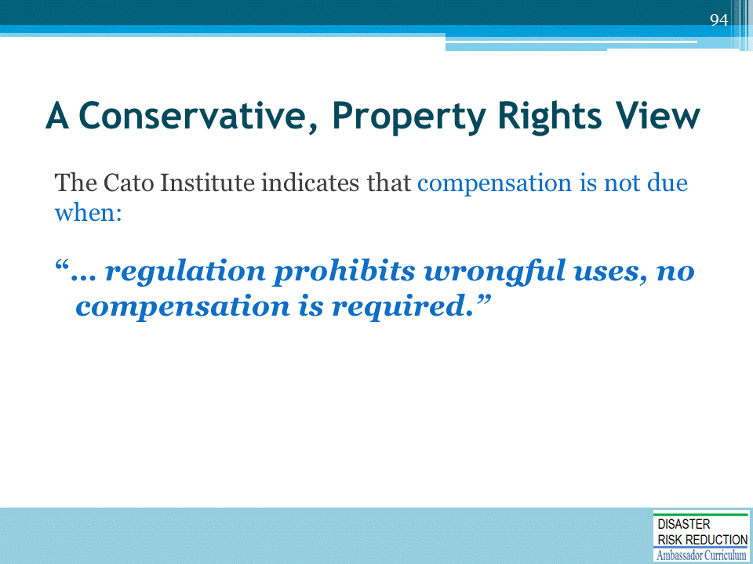
Has anyone heard of the Cato Institute?
- It is a conservative Think Tank closely associated with the “Constitution in Exile’ and other similar causes.
- This quote from the 1995 Publication of the Cato Institute “Protecting Property Rights from Regulatory Takings” Chapter 22, p230.
  - The Institute has also testified before Congress about legislation requiring government paying landowners for Regulations limiting what a property owner can do.
  - The Institute testified that there should be provided a “…nuisance exception to the compensation requirement….When regulation prohibits wrongful uses, no compensation is required.”
(Testimony of Roger Pilon Senior Fellow and director, Center for Constitutional Studies, Cato Institute. Before the Subcommittee on Constitution, Committee on Judiciary, US House of Representatives, February 10,1995.)
- Seems like the Cato Institute is OK with NAI thinking, too!
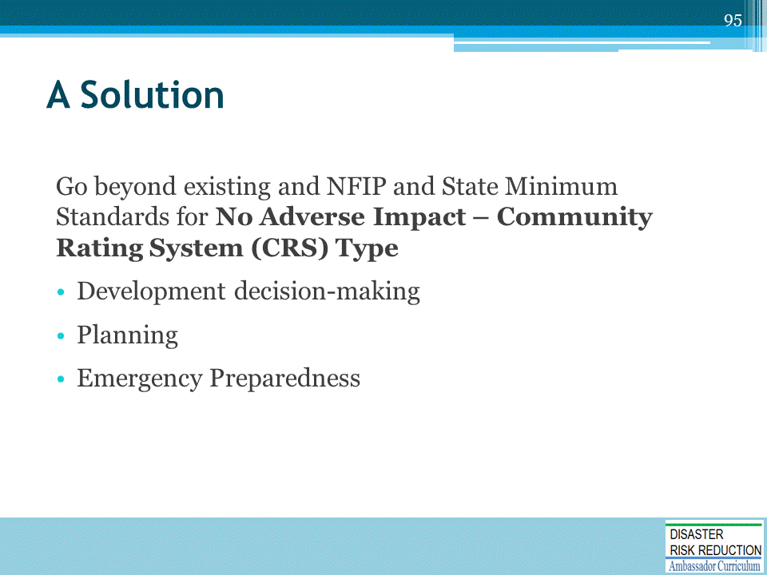

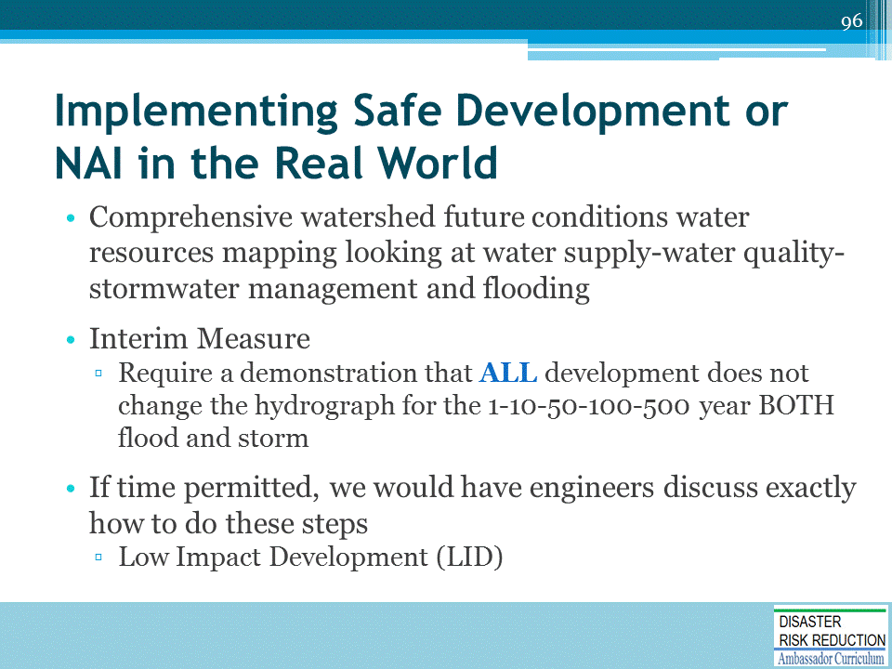
This is very much in line with the brilliant duo: Don Watson, FAIA, and Michele Adams, PE, modules on the topic:
- Module 18, Design for Flood Resilience: Part I: Floodplain Management and Flood Resistant Design
- Module 19, Design for Flood Resilience: Part II: Green Infrastructure / Low Impact Development
Also, this is very much in line with suggestions from the USACE in:
CECW-A/CECW-P 8 Dec 1997
MEMORANDUM FOR MAJOR SUBORDINATE COMMANDS AND DISTRICT COMMANDS
SUBJECT: Policy Guidance Letter (PGL) No. 52, Flood Plain Management Plans
6. The four main strategies and their related tools which should be considered, and which may be included as elements of the FPMP are:
a. modify human susceptibility to flood damage and disruption, with
- land use regulations, such as a regulatory floodway designation which is more restrictive than NFIP regulatory floodway criteria of 1-foot rise in the 100-year flood elevation.
- public development & redevelopment policies, such as “no net increase in runoff” requirements for new development within its jurisdiction and/or first floor elevation requirements for new development within the post-project flood plain that exceed the NFIP requirements.
- flood warning systems, including detailed response plans for the post-project flood plain which provides adequate warning and response to prevent loss of life and reduce flood damages to contents of structures.
- flood damage reduction measures such as floodproofing of structures in the 7 post-project flood plain and/or permanent relocation of structures from the post project flood plain

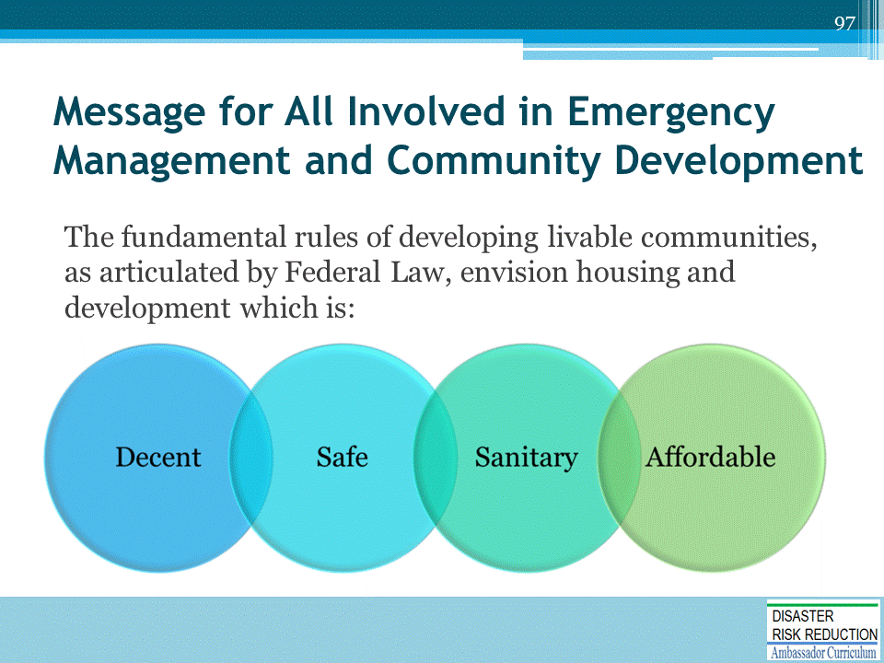
The Housing Acts of 1937, 1954, etc., as amended

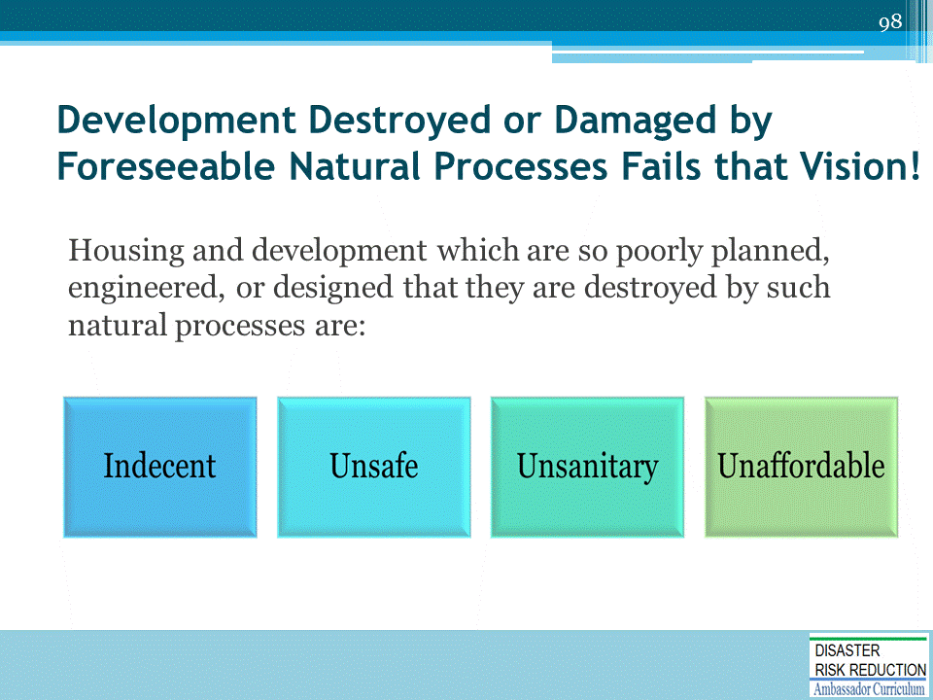
Unaffordable – by the flood victims, by their Community, by the State, and by our Nation

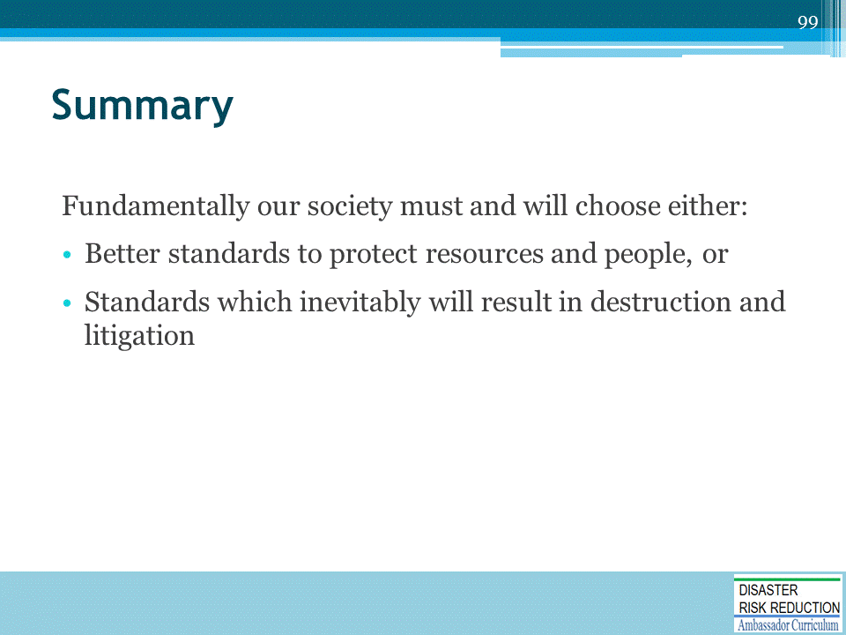
The higher regulations suggested in this Disaster Risk Reduction Curriculum and in the FEMA Community Rating System are, I think, taking us in the right direction.
- Each of you will play a key role in helping create a safe and sustainable future; or in continuing and making worse the incredible mess in which we already are in.
- You have made a choice towards helping make things better by learning how, right here. Please keep going!

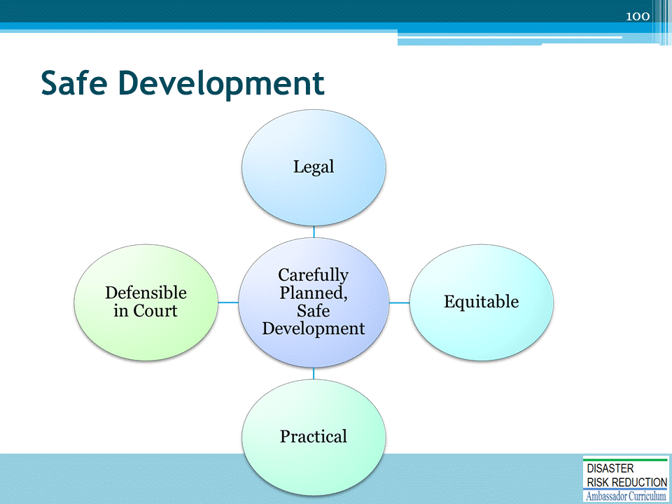
Carefully planned, safe development is:
- Legal
- Equitable
- Practical
- Defensible in Court
Don’t flood thy neighbor!

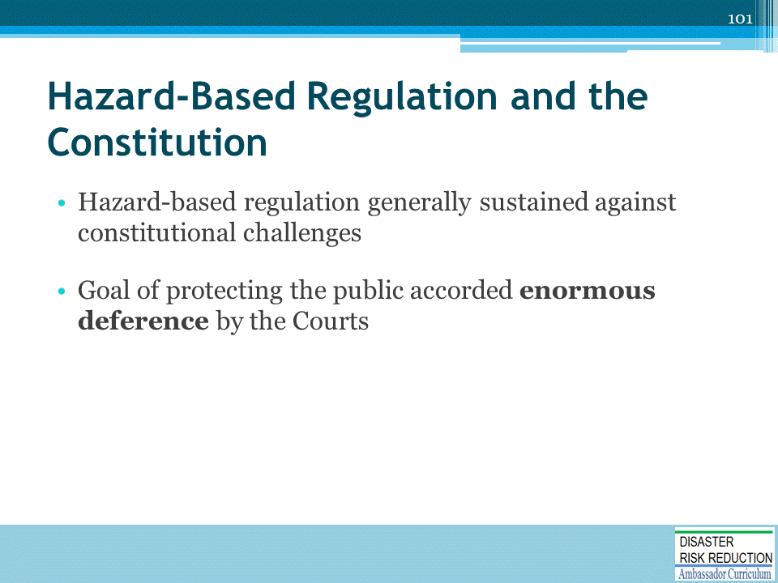
The more compelling the Public need, the more likely to be sustained.
DISCUSS the two cases: Lucas-Haddacheck vs. Annacelli

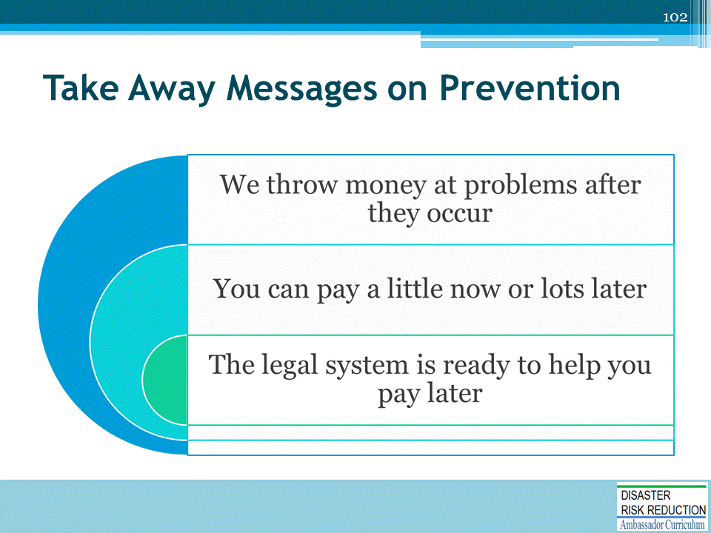
- And Pay and Pay and Pay
- Three messages, 27 words: Steve Stockton led the Annual National Association of Flood and Stormwater Management Agencies (NAFSMA) conference off with the first statement; Gerry Galloway contributed the second statement; Ed Thomas added the third statement

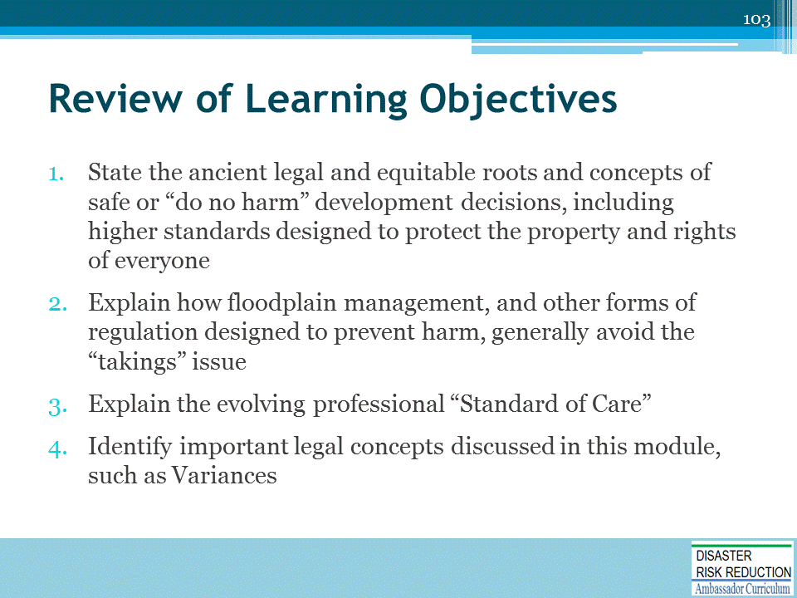
Discussion to engage participants and to assist achievement of Learning Objectives.

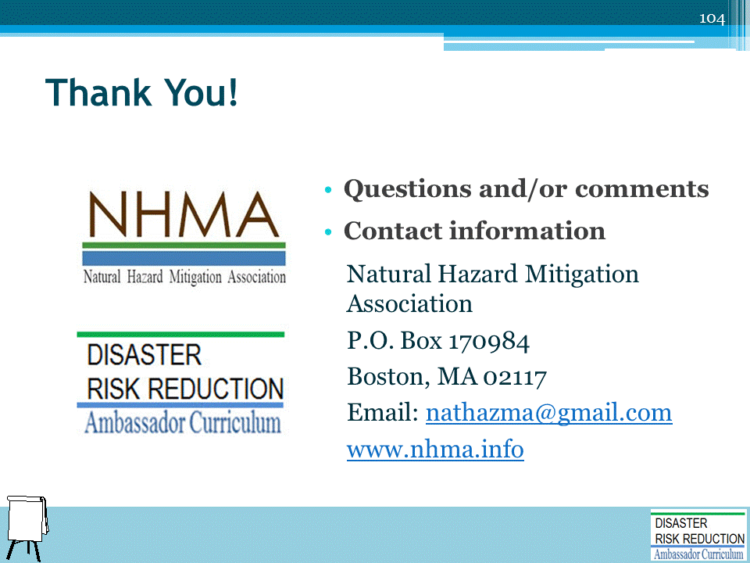
Record on easel pad any recommendations or questions to be addressed outside of the presentation.

DRR AMBASSADOR CURRICULUM AT-A-GLANCE
I. Disaster Risk Reduction for a Safe and Prosperous Future
1 | Introduction to the Natural Hazard Mitigation Association and Disaster Risk Reduction Ambassador Curriculum
2 | Introduction to Disaster Risk Reduction as a Foundation of Community Resilience
3 | Leadership for Disaster Risk Reduction
4 | Community Disaster Risk Reduction and Adaptation
5 | Approaching the Challenge of Disaster Risk Reduction: NIST Community Resilience Guide
II. Forming a Community’s Vision for Disaster Risk Reduction
6 | Risk Assessment through Storytelling: An Asset-Based Approach
7 | Achieving Community Buy-in for Disaster Risk Reduction: Win-Win Approaches
8 | Leveraging Resources to Improve Disaster Risk Reduction
III. Realizable, Practical, and Affordable Approaches for Moving from a Vision for Disaster Risk Reduction to a Strategy
9 | Selecting and Implementing a Strategy for Addressing Community Disaster Risk Problems
10 | Integrating Hazard Mitigation into Local Planning
11 | Beyond Codes and Low-Impact Development
12 | Creating the Plan: A Sustainable Floodplain Management Process Model
IV. Resources and Tools for Implementing a Community’s Disaster Risk Reduction Strategy
13 | Climate and Weather Tools and Trends
14 | Risk Assessment Basics
15 | Legal and Policy Opportunities for Disaster Risk Reduction
16 | Linking Catastrophe Insurance to Disaster Risk Reduction
V. Resources for Hazard-Specific Disaster Risk Reduction
17 | Living with Water: Inland and Coastal Flooding
18 | Design for Flood Resilience: Part I: Floodplain Management and Flood Resistant Design
19 | Design for Flood Resilience: Part II: Green Infrastructure / Low Impact Development
20 | Overcoming Impediments to Flood Resilience: Paths Forward
21 | Wildfire Mitigation
22 | The Wildfire-Flood Connection
23 | Severe Thunderstorm/Tornado Safe Rooms
24 | From Policy to Engineering: Earthquake Risks

