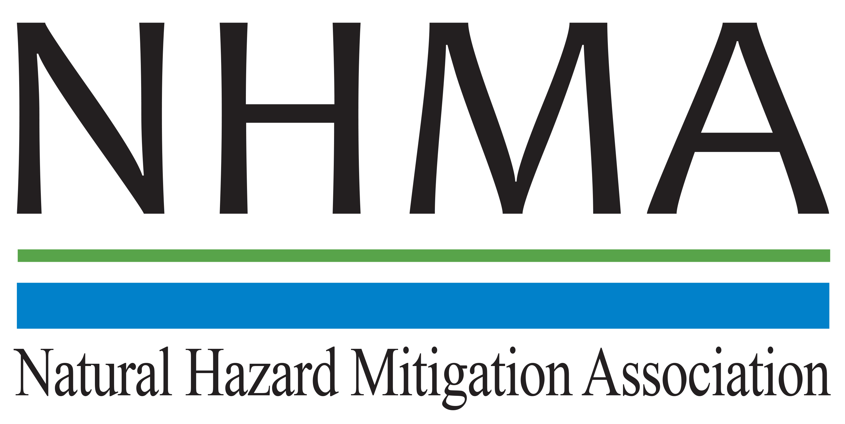

Disaster Risk Reduction (DRR) Ambassador Curriculum

Participant Guide

Module 15:

Legal and Policy Opportunities for
Disaster Risk Reduction

THE DRR AMBASSADOR CURRICULUM
The goal of the DRR Ambassador Curriculum is to facilitate DRR efforts for the whole community by:
- Engaging in discussion of how disasters can be reduced through local action
- Sharing insights among local leaders and technical experts to enable the development of cross functional solutions
- Acquiring the best-available information, knowledge of best practices, and analytic tools to enable better-informed decisions before, during, and after disasters
There are 24-modules in the curriculum. The “DRR Ambassador Curriculum At-a-Glance” table, located at the end of this document, lists the modules of the Curriculum.
DRR-A CURRICULUM TARGET AUDIENCE
The target audience includes those involved in community development decision-making, such as local community staff, volunteer and stakeholder groups, and federal and state officials.
METHODS OF DELIVERY
There are three delivery methods by which you may be able to complete modules in the DRR-A Curriculum: via webinars hosted by NHMA or partner organizations; presented in conferences and/or classrooms by qualified DRR-A Curriculum instructor(s); or downloadable for individual study from the NHMA website. Watch the NHMA website for announcements about webinars and workshops that include the module(s) in which you are interested.
CERTIFICATES
- Certificates of Completion may be awarded by NHMA to participants who successfully complete NHMA-sponsored DRR Ambassador modules by attending and passing a short post-test.
- Certificates of Attendance may be awarded to participants who attend but choose not to take the post-test may be issued a Certificate of Attendance.
- A Disaster Risk Reduction Ambassador Certificate will be awarded to individuals who successfully complete all 24 modules.
Ask your certifying boards about acceptance of NHMA DRR-A certificates for continuing education credits.
MODULE 10 – INTEGRATING HAZARD MITIGATION INTO LOCAL PLANNING
The Learning Objectives for this module are:
- State the ancient legal and equitable roots and concepts of safe or “do no harm” development decisions, including higher standards designed to protect the property and rights of everyone
- Explain how floodplain management, and other forms of regulation designed to prevent harm, generally avoid the “takings” issue
- Explain the evolving professional “Standard of Care”
- Identify important legal concepts discussed in this module, such as Variances
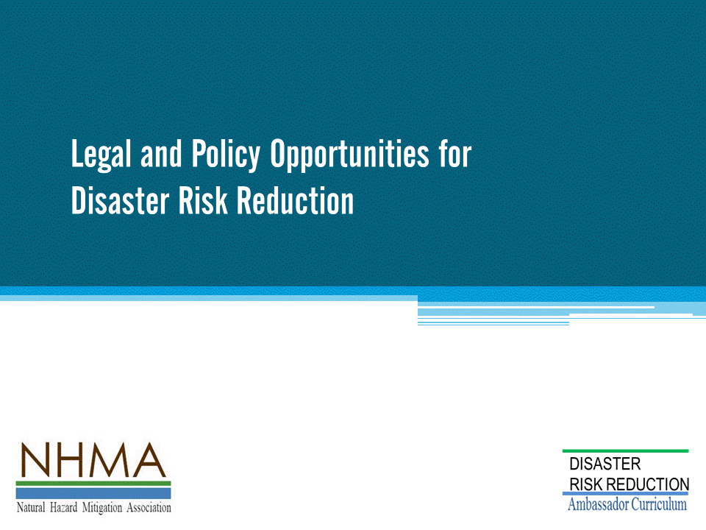

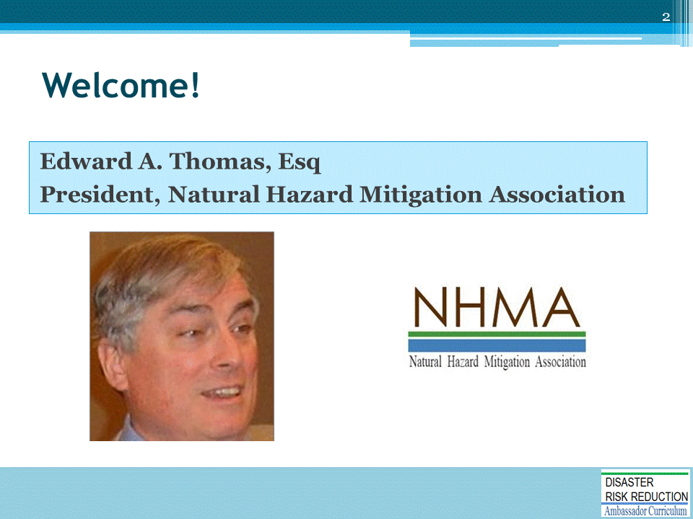

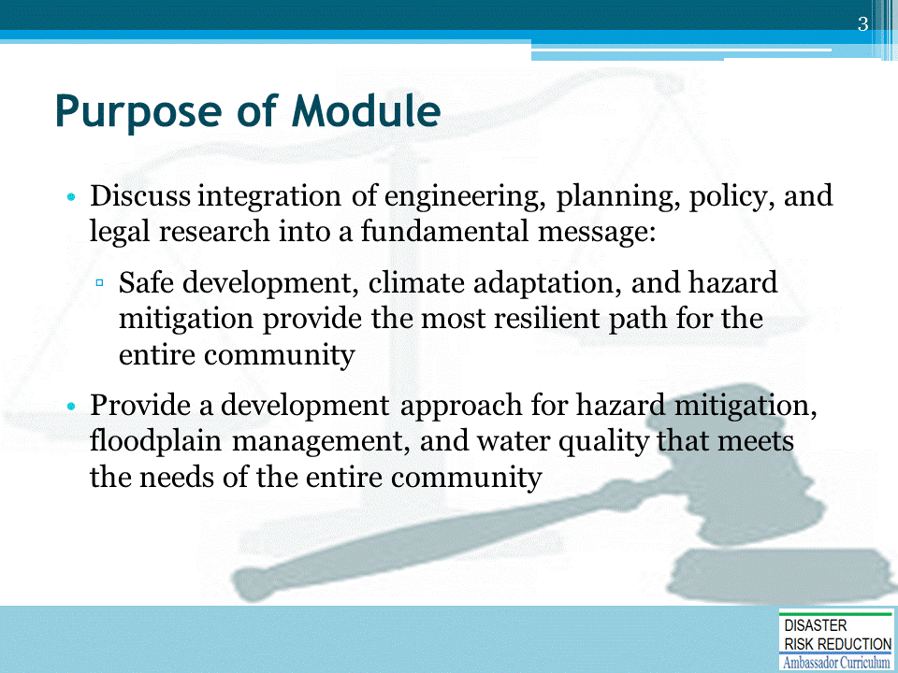
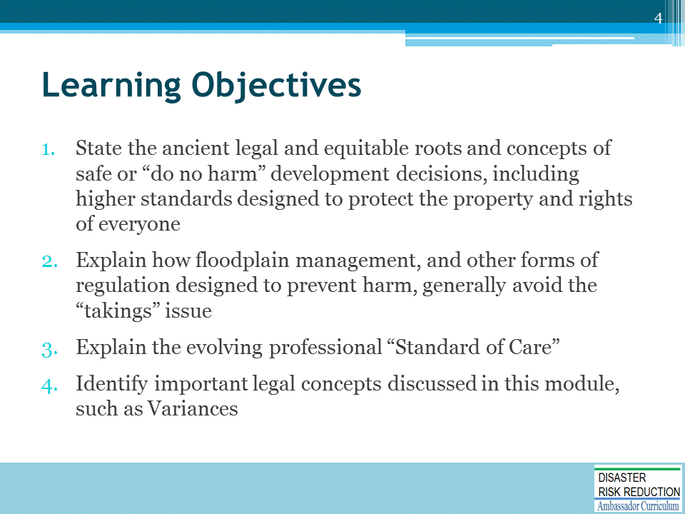

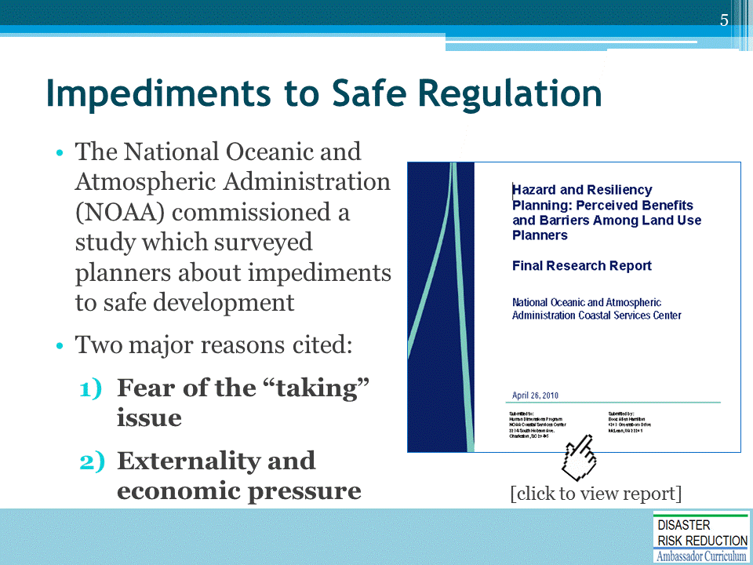
Link to Research Report: https://coast.noaa.gov/data/digitalcoast/pdf/hazard-planning.pdf

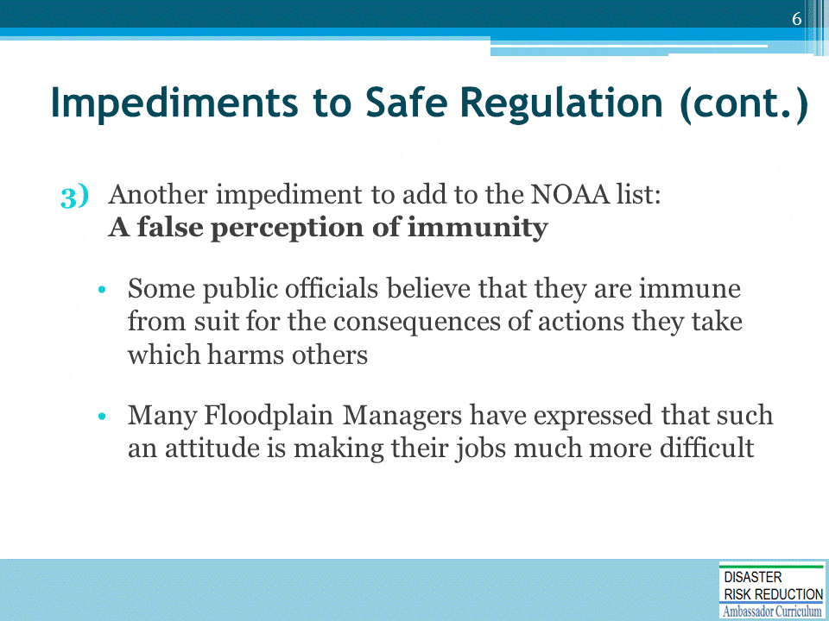

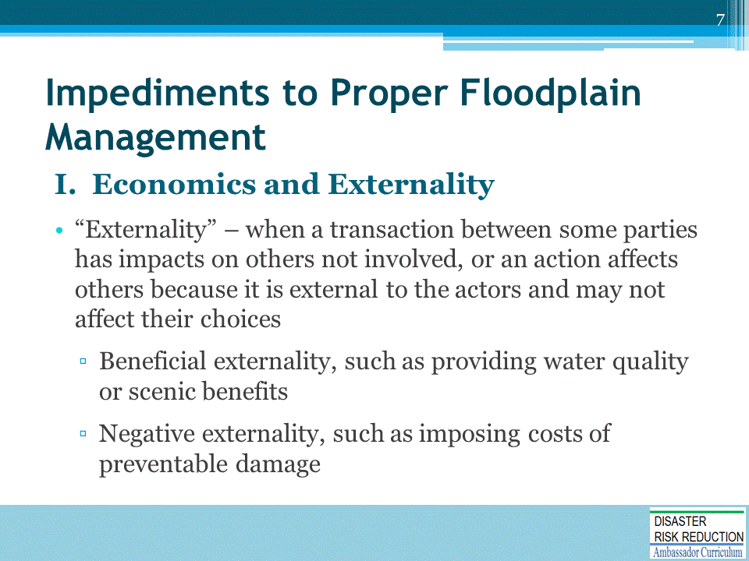

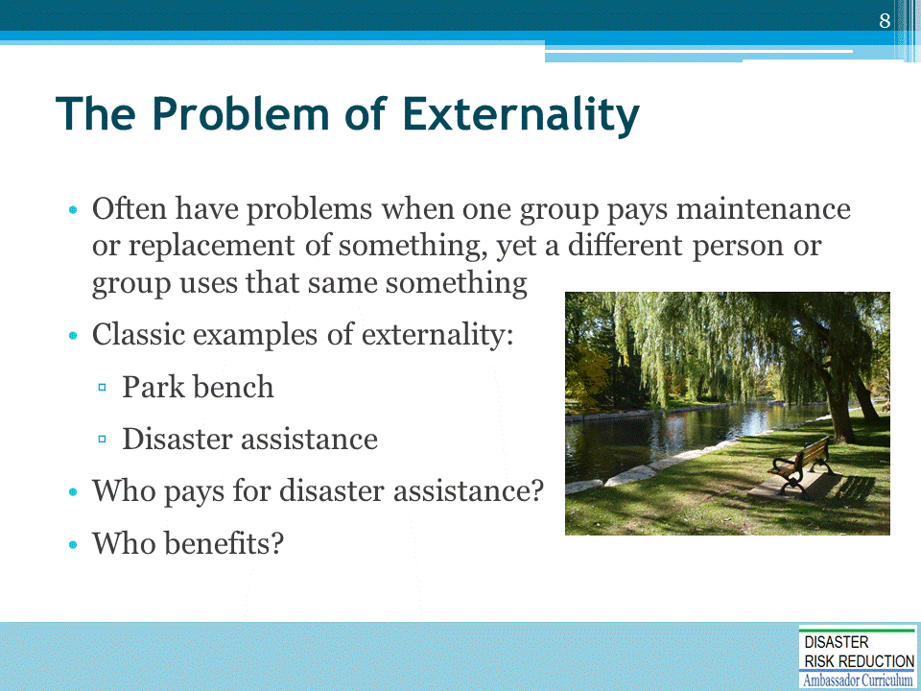

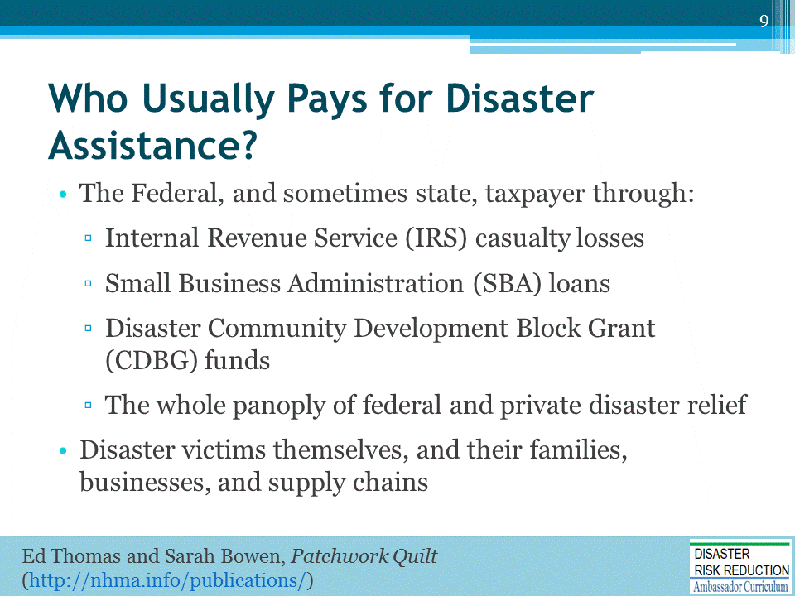

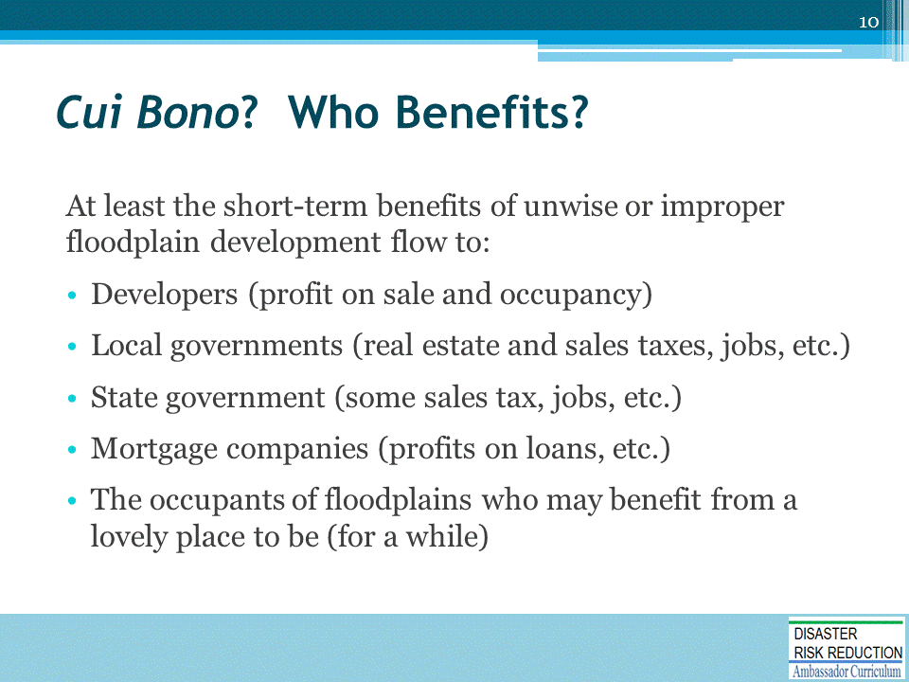

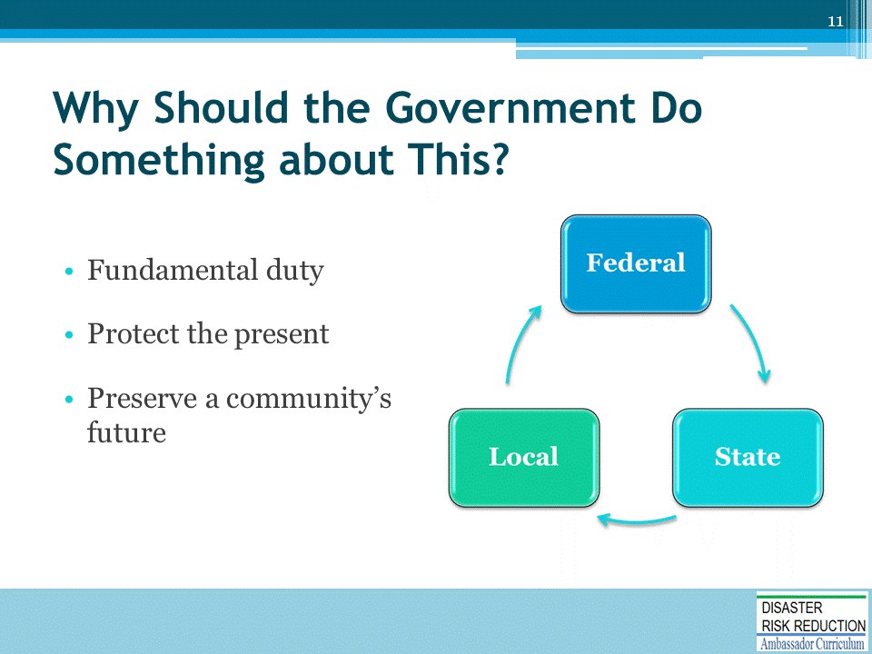

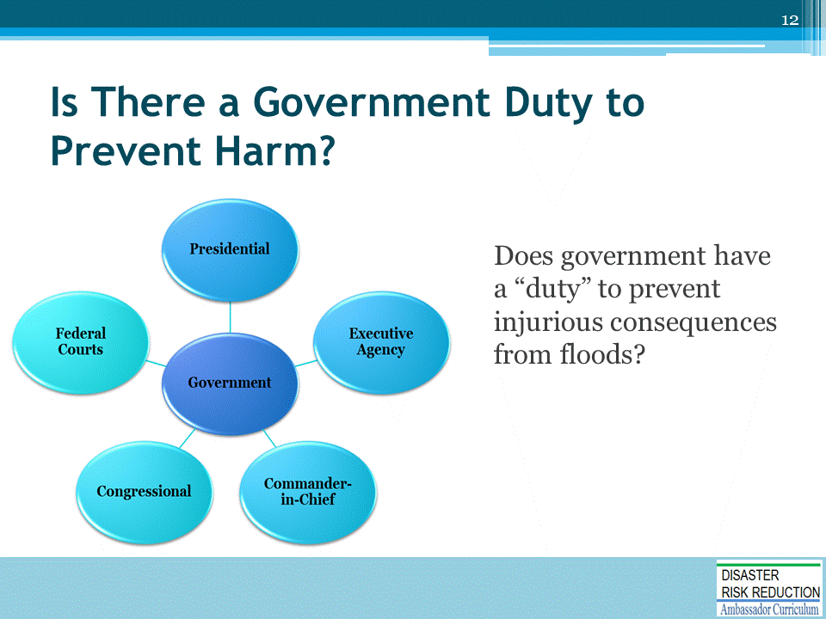

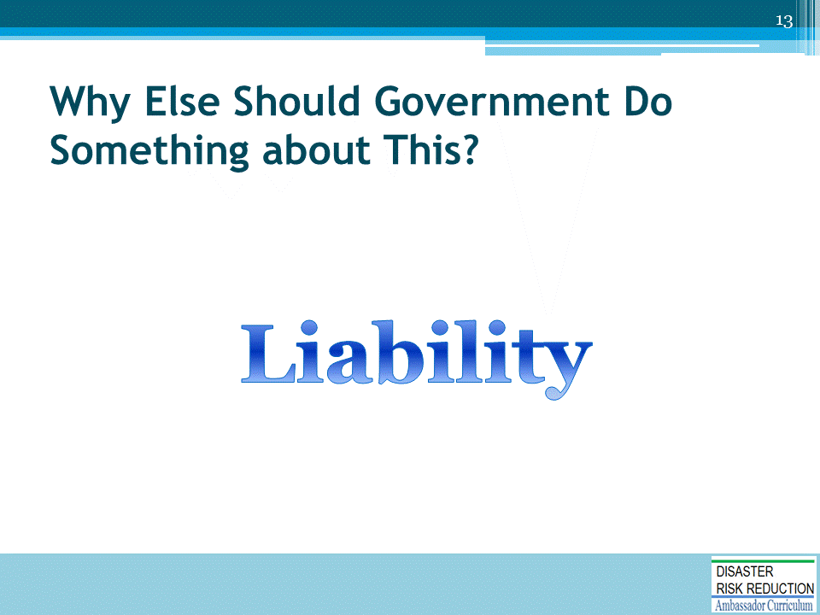

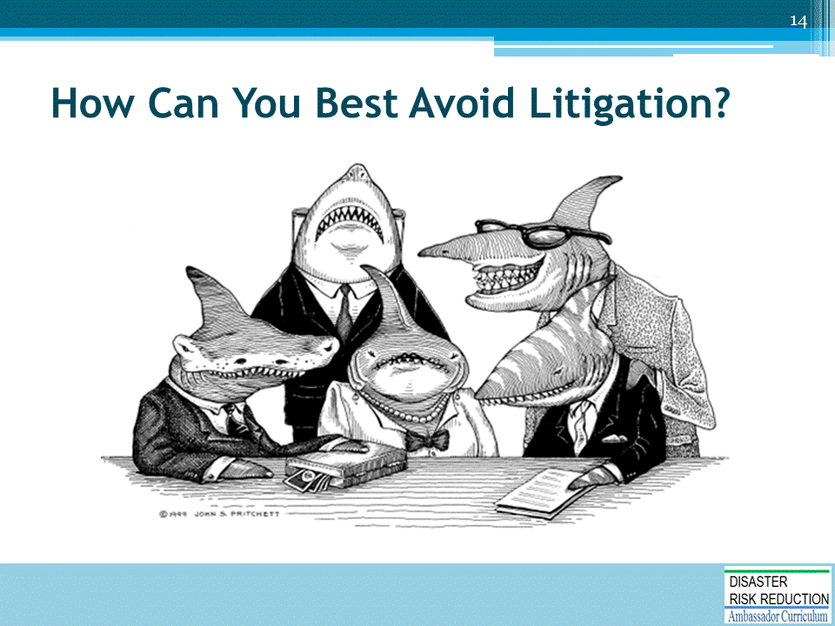

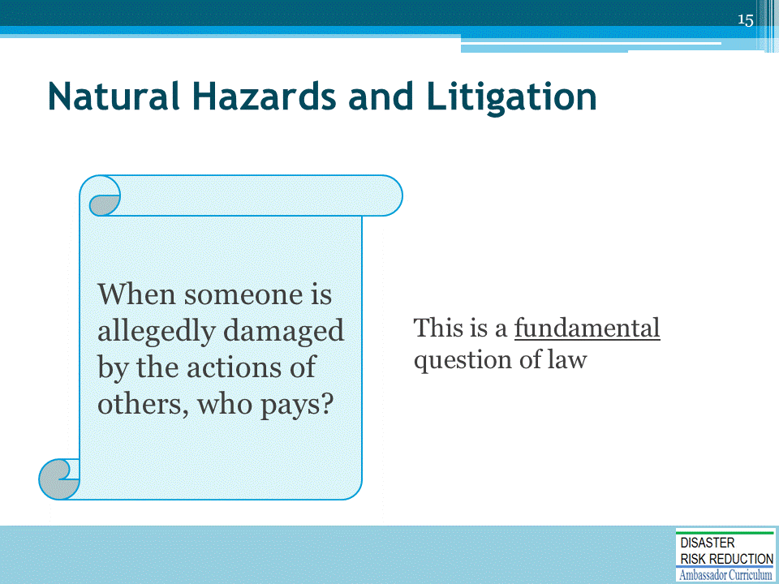

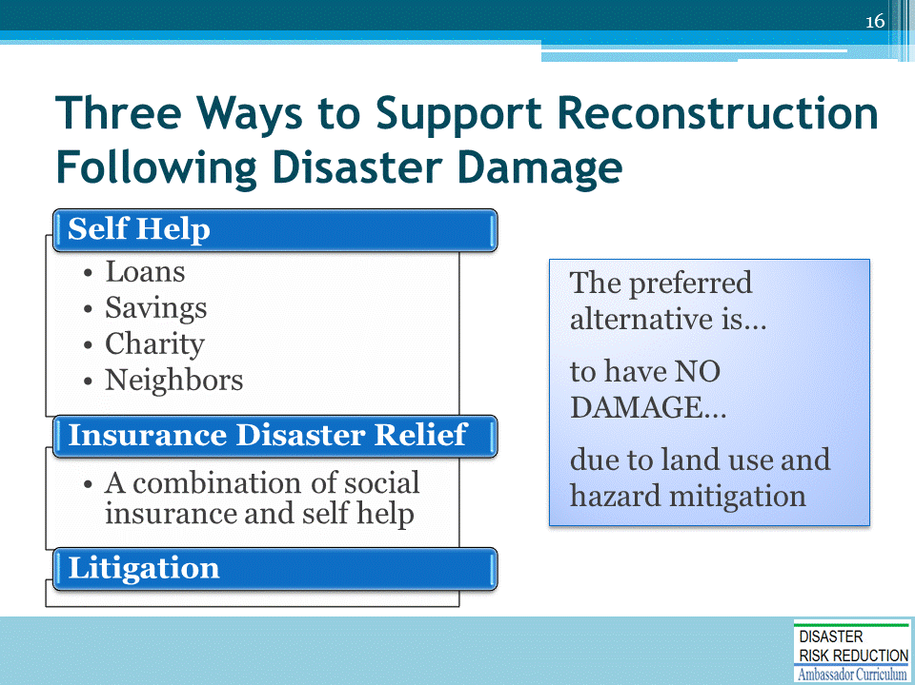

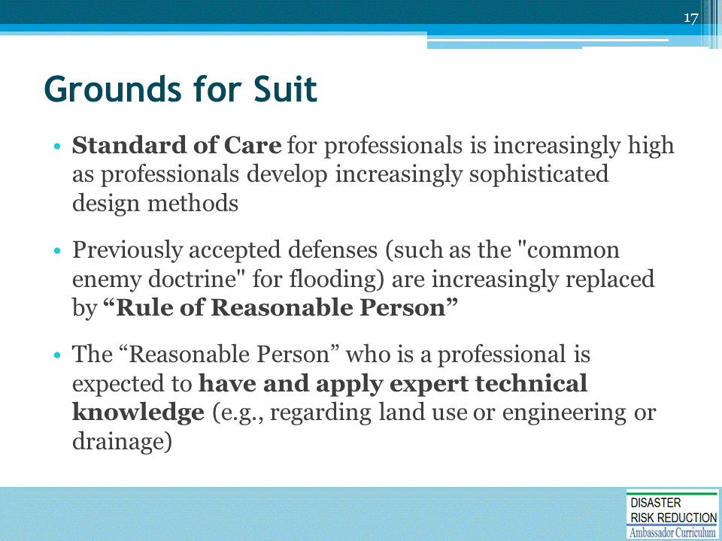
See:
- The T.J. Hooper, 60 F.2d 737 (2d Cir., 1932)
- Stewart v. State, 597 P.2d 101 (Wash., 1979)
- Riley v. Burlington Northern, Inc., 615 P.2d 516 (Wash., 1980), in which the Court held that the decision of Yakima County not to install a more sophisticated warning system than a non-mechanical railroad approach warning sign at a railroad crossing was nondiscretionary and subject to potential suit for negligence

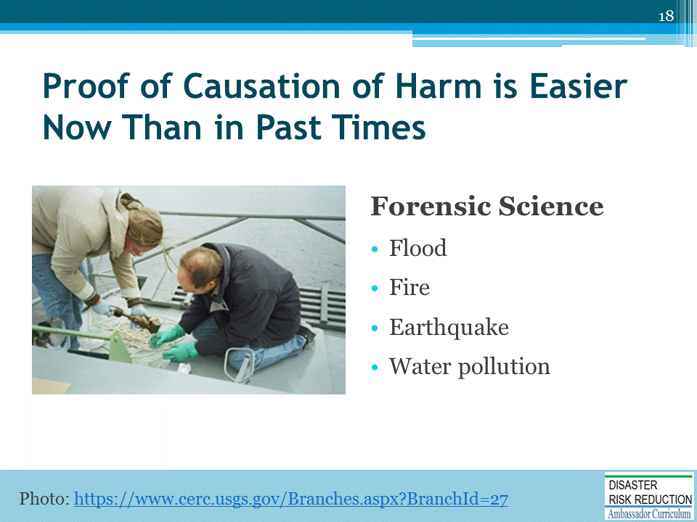
See, for example, The Legal Consequences of Ignoring Climate Change, in Governing: The States and Localities, by Laurie Mazur and Edward A. Thomas, October 19, 2015. The article is available at http://www.governing.com/gov-institute/voices/col-legal-consequences-local-decision-makers-ignoring-climate-risk.html
And also, Natural Hazard Disaster Risk Reduction as an Element of Resilience: Considerations about Insurance and Litigation by Edward A. Thomas, Esq. (2016) In Linkov, I., & Florin, M.-V. (Eds.), IRGC Resource Guide on Resilience. Available at: https://www.irgc.org/risk-governance/resilience/
Why Current Disaster Planning Doesn’t Cut it, and What We Can Do Instead, by Laurie Mazur and Edward A. Thomas, Esq., in The Hill September 9, 2016. Available at: http://thehill.com/blogs/congress-blog/economy-budget/295101-why-current-disaster-planning-doesnt-cut-it-and-what-we

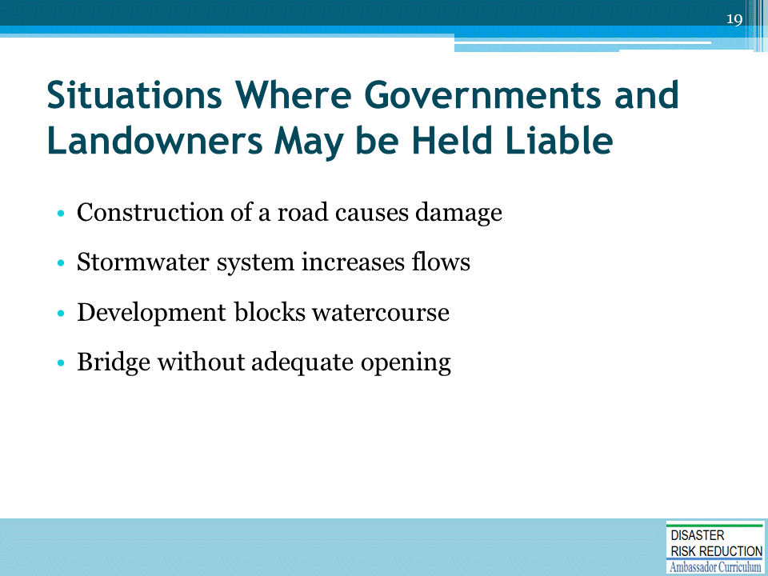
Many cases are listed in Jon Kusler and Ed Thomas detailed legal materials on:
- NHMA website: http://nhma.info/
- ASFPM website: http://www.floods.org/

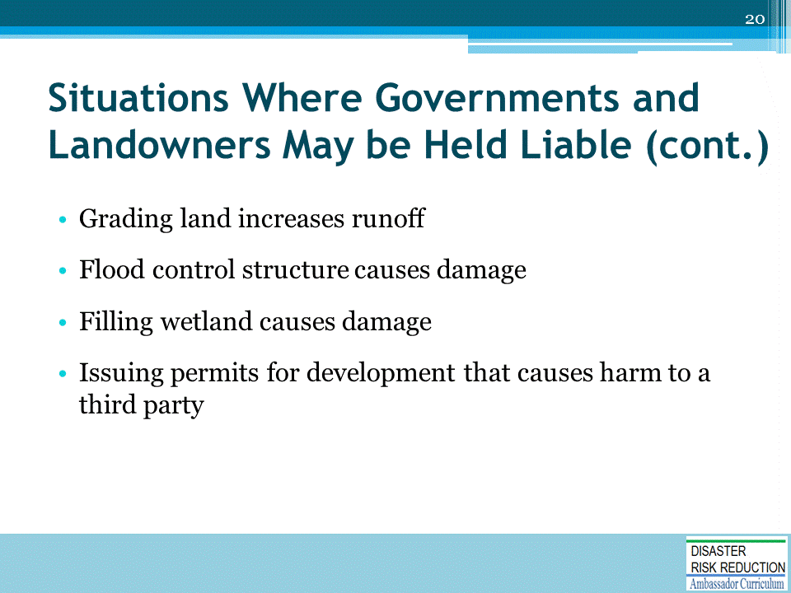

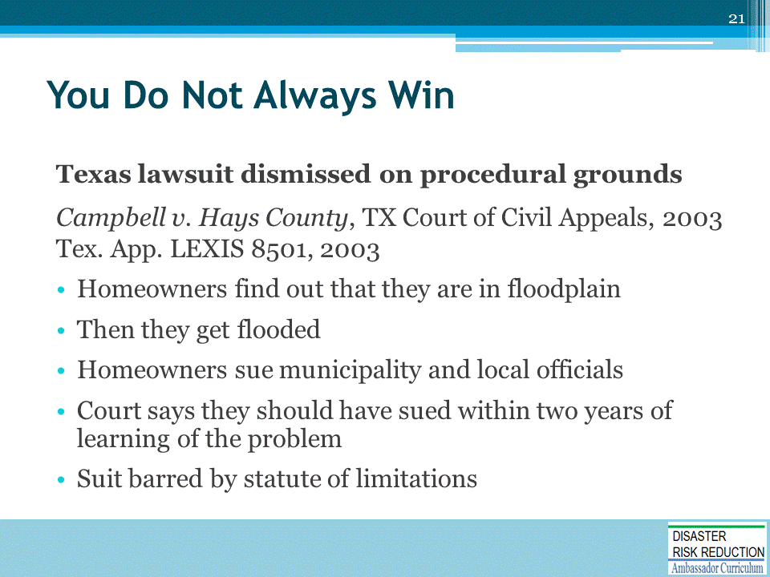

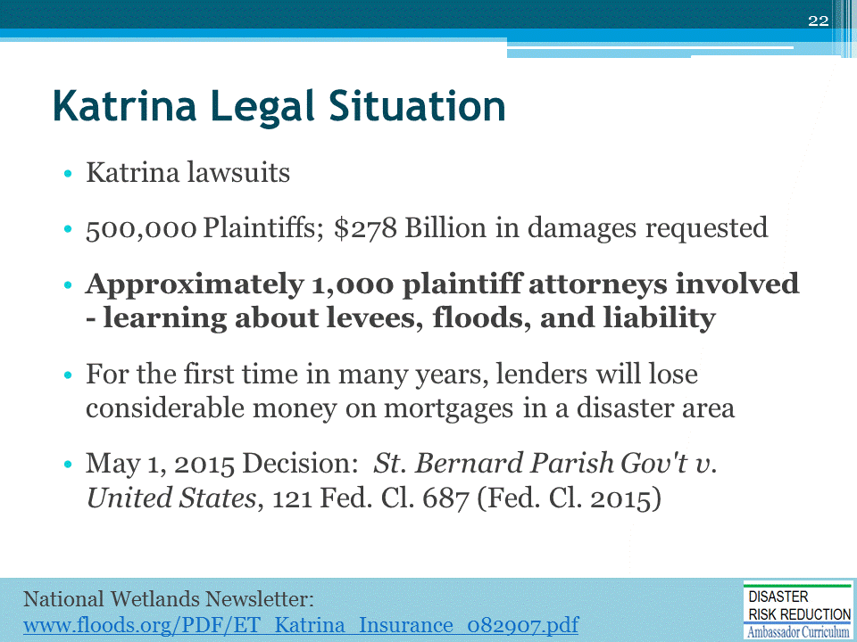
Major Court Decision with implications for Climate Adaptation, Hazard Mitigation and a Safer and More Just Future By Edward A. Thomas Esq., President, Natural Hazard Mitigation Association, May 7, 2015
On May 1, 2015, the U.S. Court of Federal Claims issued an enormously important decision concerning flood damage caused by Hurricane Katrina and subsequent hurricanes. That case, Saint Bernard Parish Government v. United States, No. 05-1119L (May 1. 2015), found the United States government liable for potentially huge sums of money. (http://www.inversecondemnation.com/inversecondemnation/2015/05/cfc-katrina-flooding-is-a-taking.html)
Further information on Arkansas Game and Fish, as well as other important cases involving constitutional protections including Koontz v. St Johns River Water Management District, 133 S. Ct. 2586 (2013), can be found in a webinar featuring Professor Lisa Sun, Ed Thomas, and Dr. John Wiener available at: https://player.vimeo.com/video/83390903 . Further details on Koontz can be found in this article, “Turning Koontz Into an Opportunity for More Resilient Communities," which I co-authored with Lynsey R. Johnson.
(http://www.americanbar.org/content/dam/aba/administrative/state_local_government/land_use.authcheckdam.pdf)
Recovery Following Hurricane Katrina: Will Litigation and Uncertainty Today Make for an Improved Tomorrow? [National Wetlands Newsletter, vol. 29, no. 5.] (http://nhma.info/uploads/resources/ET_Katrina_Insurance_082907.pdf).

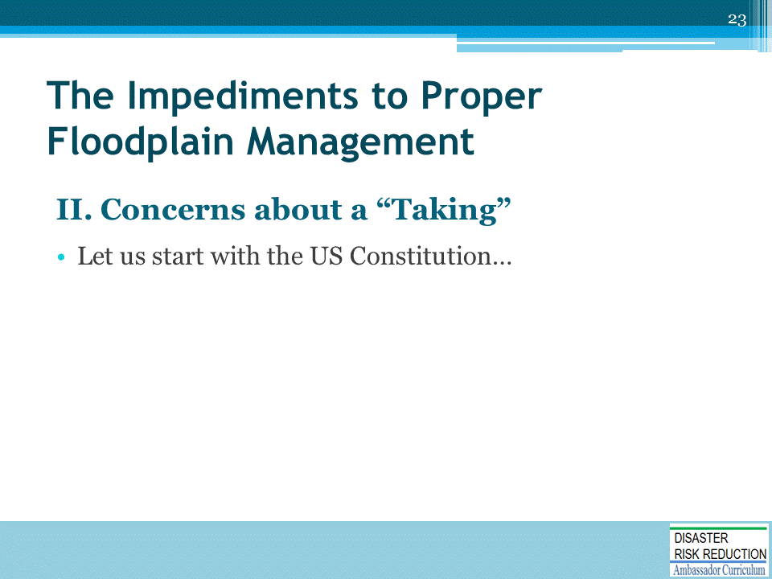

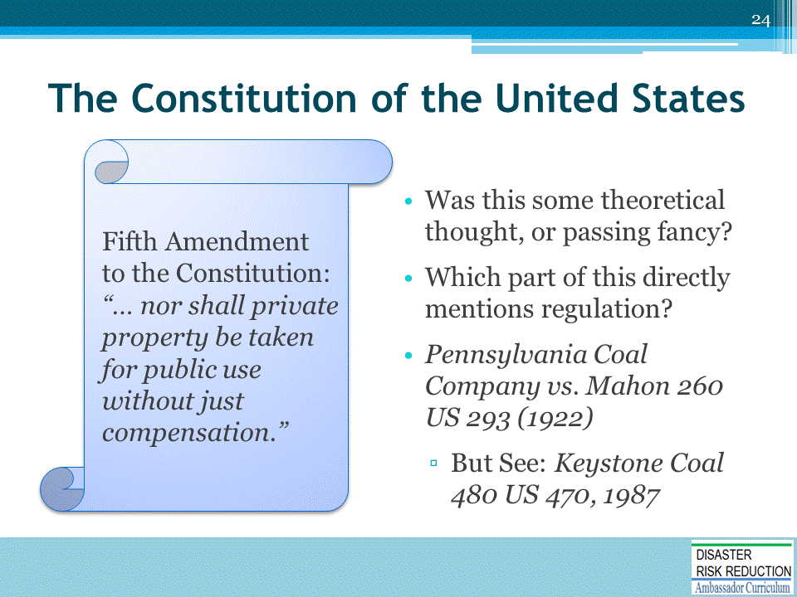
See, for more detail: Mitigating Misery: Land Use and Protection of Property Rights Before the Next Big Flood. Authors: Edward A. Thomas Esq. and Sam Riley Medlock JD. Vermont Journal of Environmental Law, Vol. 9, 2008.
Law Review Article on the National Flood Insurance Program and the concept of No Adverse Impact Floodplain Management.
Located at: http://www.floods.org/PDF/Mitigation/ASFPM_Thomas&Medlock_FINAL.pdf

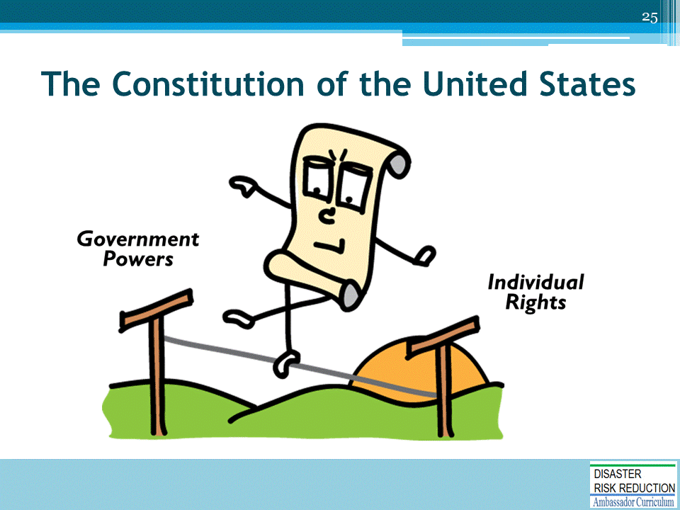

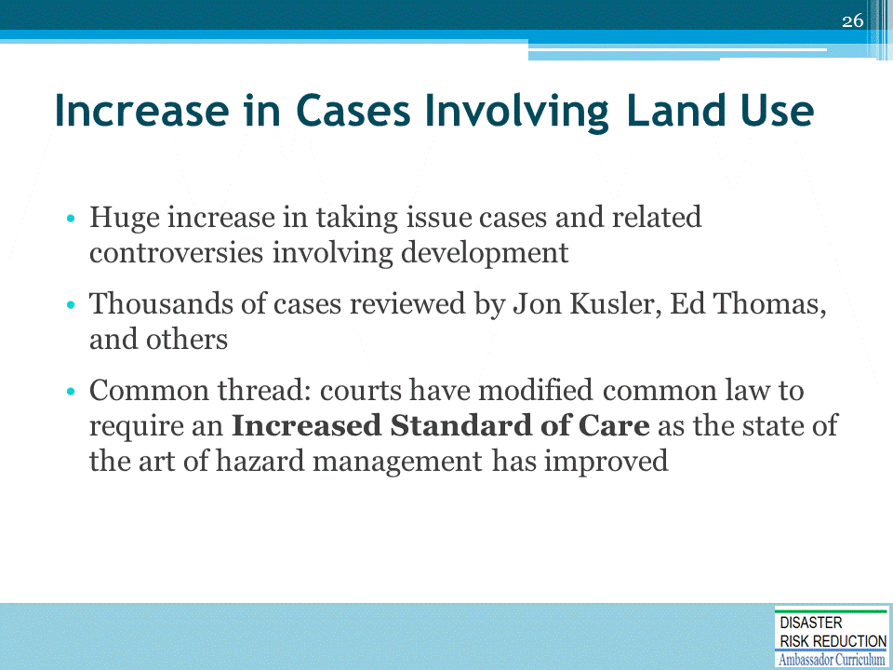

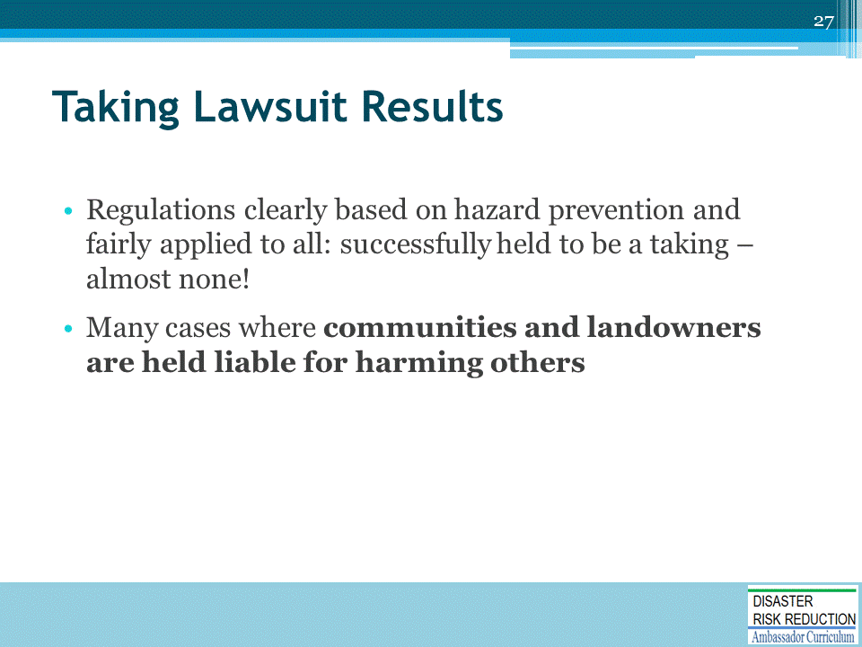

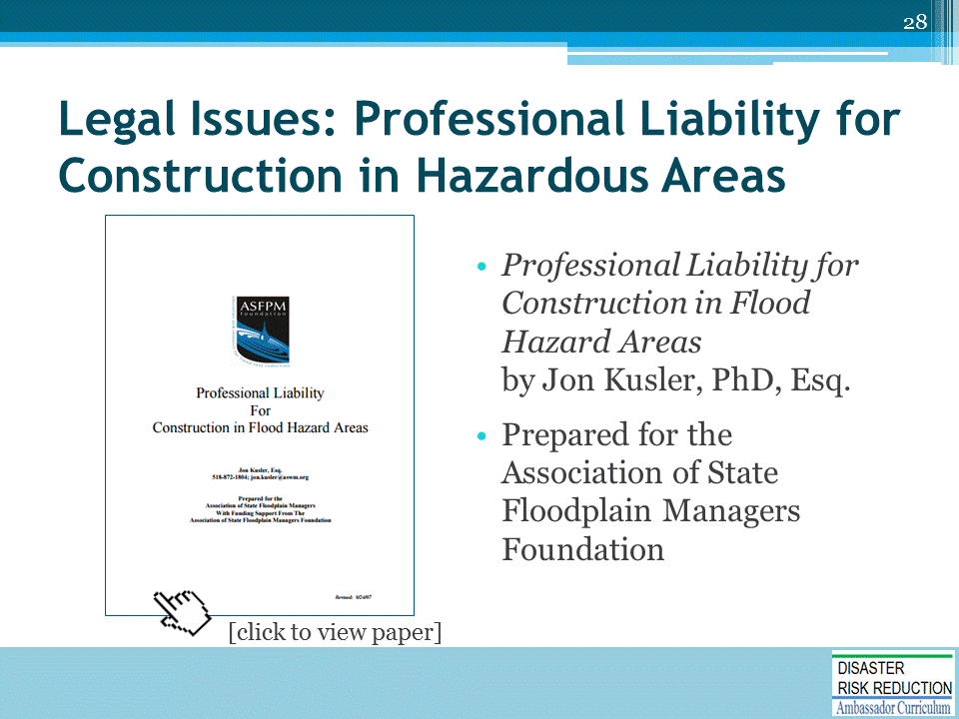
Excellent paper by Jon Kusler, PhD, Esq.: https://www.floods.org/PDF/ASFPM_Professional_Liability_Construction.pdf

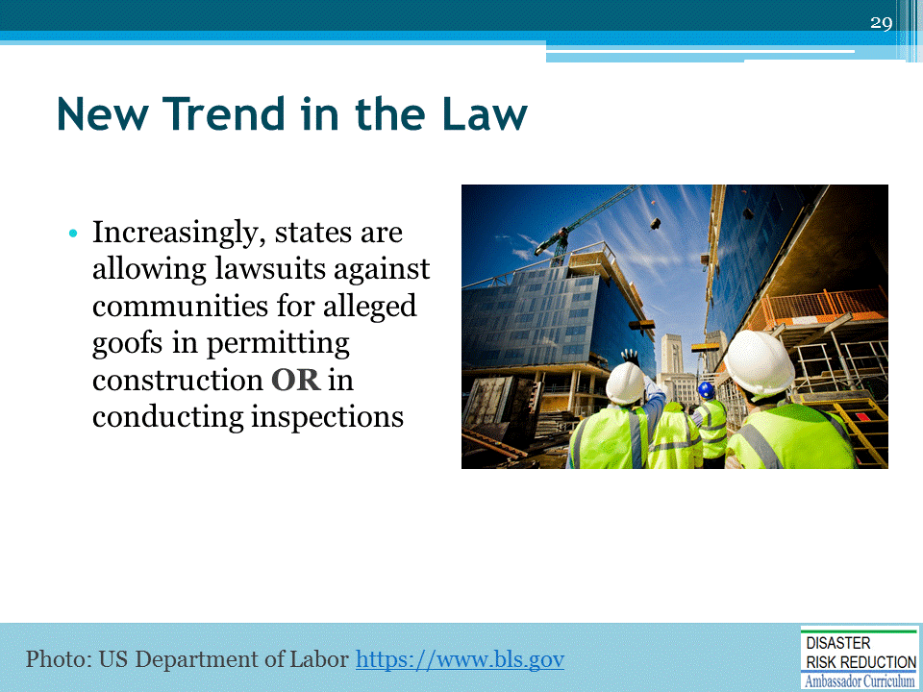
Reference paper by Attorney Jon Kusler PhD at www.floods.org
A COMPARATIVE LOOK AT PUBLIC LIABILITY FOR FLOOD HAZARD MITIGATION
http://www.floods.org/PDF/Mitigation/ASFPM_Comparative_look_at_pub_liability_for_flood_haz_mitigation_09.pdf

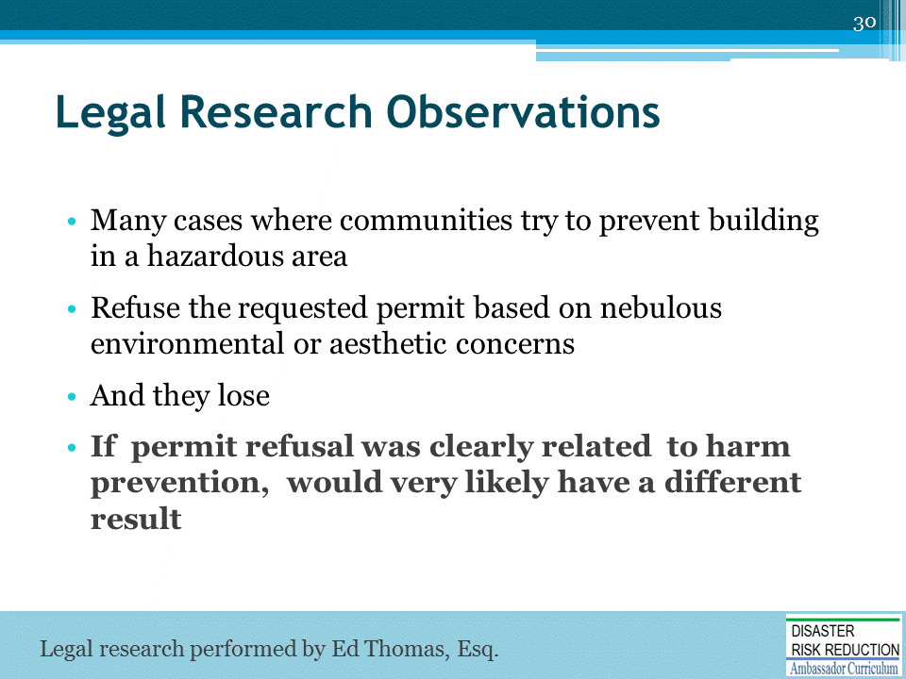
Edward A. Thomas & Sam Riley Medlock, Mitigating Misery: Land Use and Protection of Property Rights Before the Next Big Flood, 9 Vt. J. Envtl. L. 155 (2008).
"This material has been copyrighted by the Vermont Environmental Law Journal. It is made available for posting on this web site and use by floodplain managers by special arrangement between Edward A. Thomas Esq. and the Vermont Environmental Law Journal.“
http://www.floods.org/PDF/Mitigation/ASFPM_Thomas&Medlock_FINAL.pdf

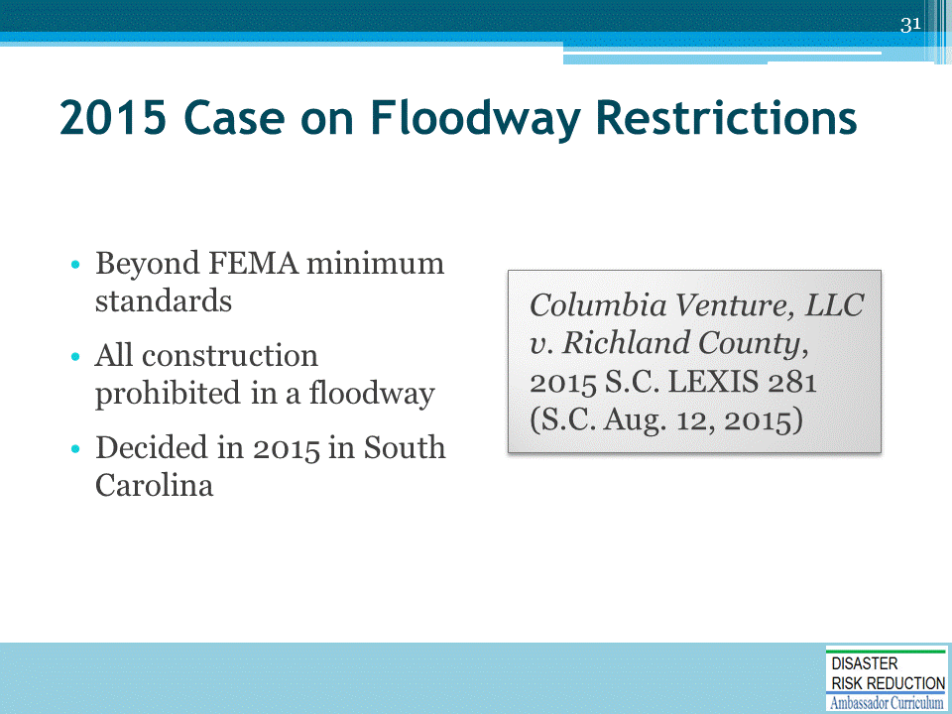
From Rob Thomas, Inverse Condemnation:
No Taking When Owner Prohibited from Developing in Floodplain http://www.inversecondemnation.com/files/27563.pdf
Columbia Venture, LLC v. Richland County, No. 27563 (S.C. Aug. 12, 2015) https://www.scribd.com/document/274422057/Columbia-Venture-LLC-v-Richland-County-No-27563-S-C-Aug-12-2015

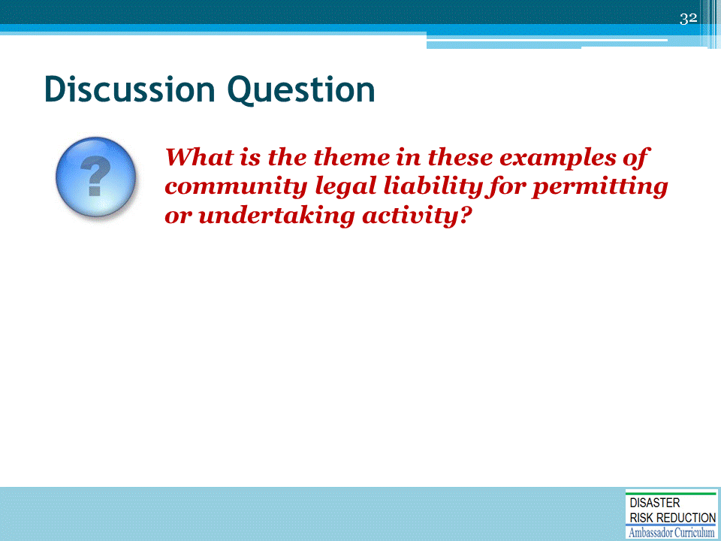

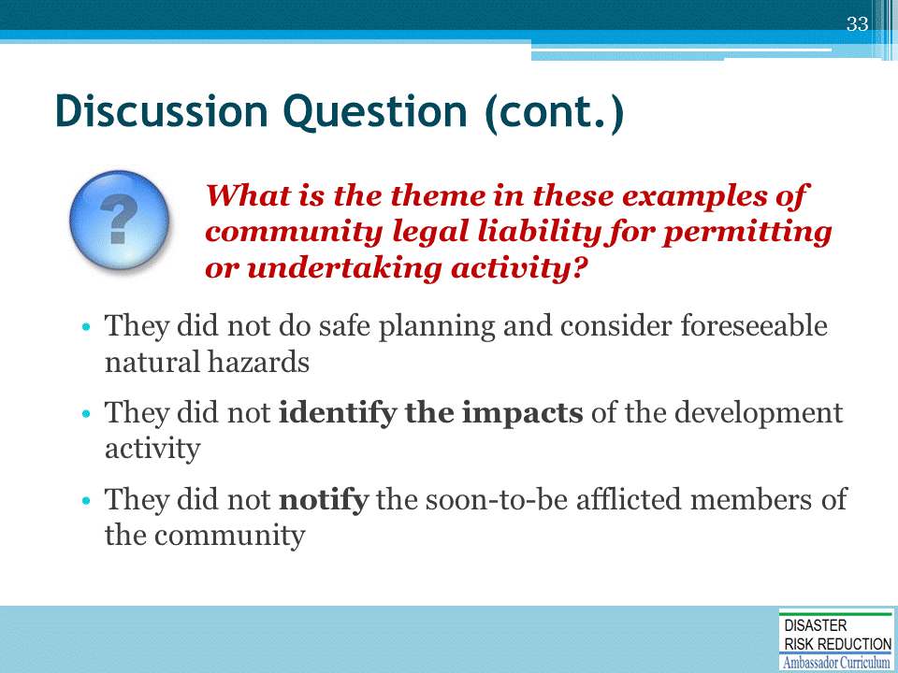

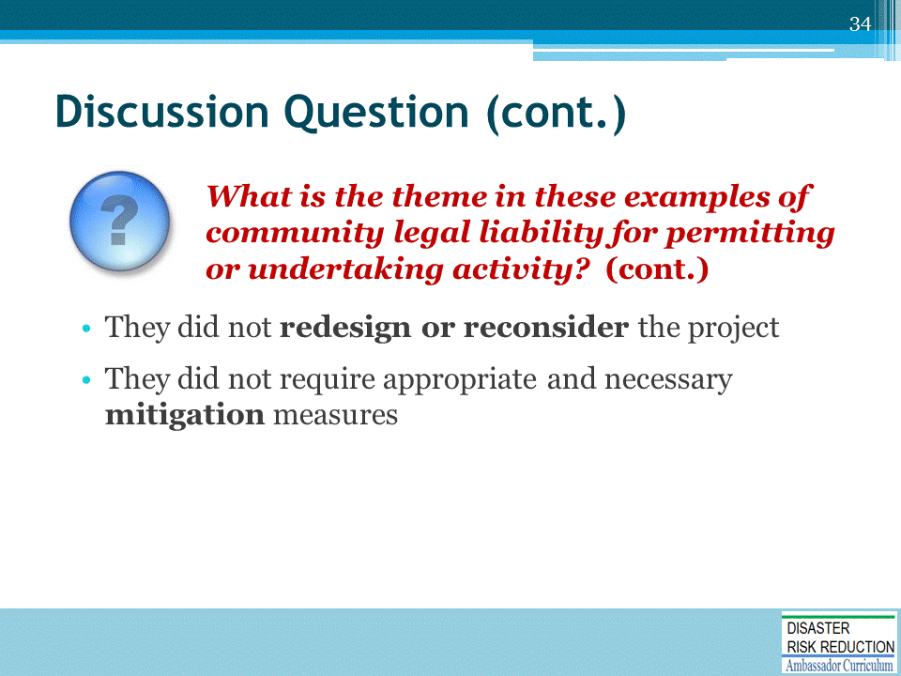

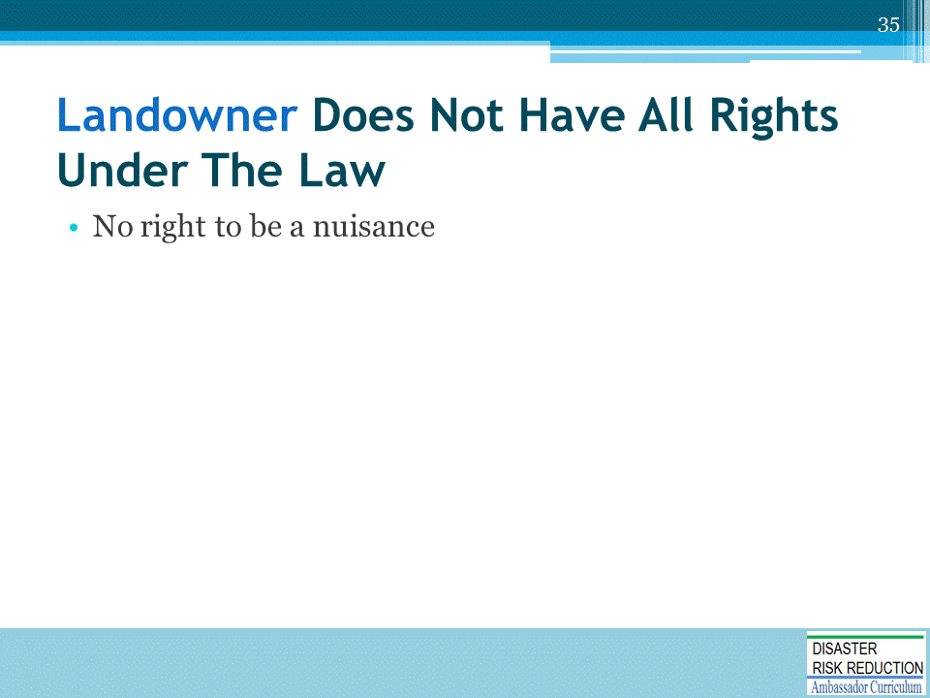

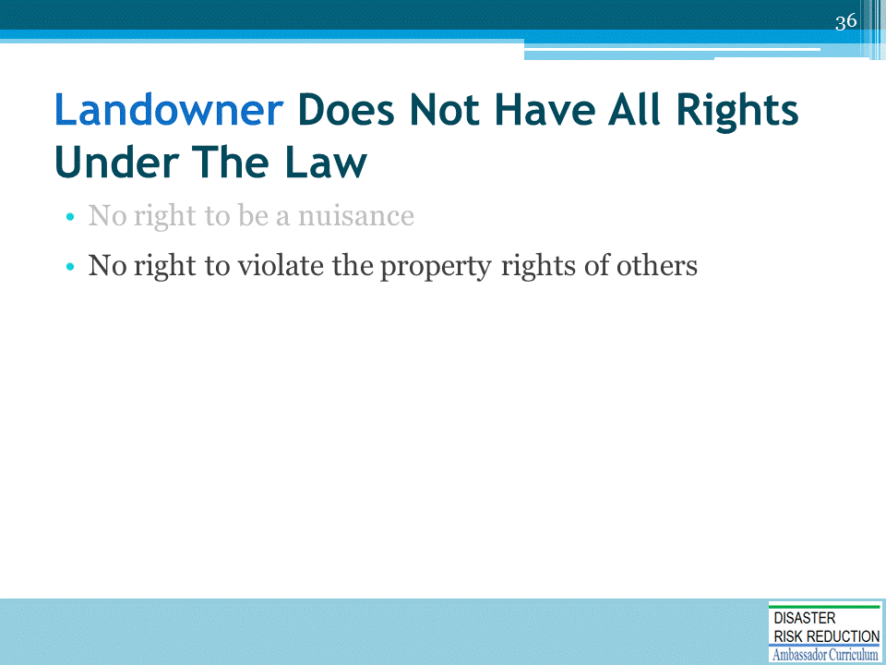

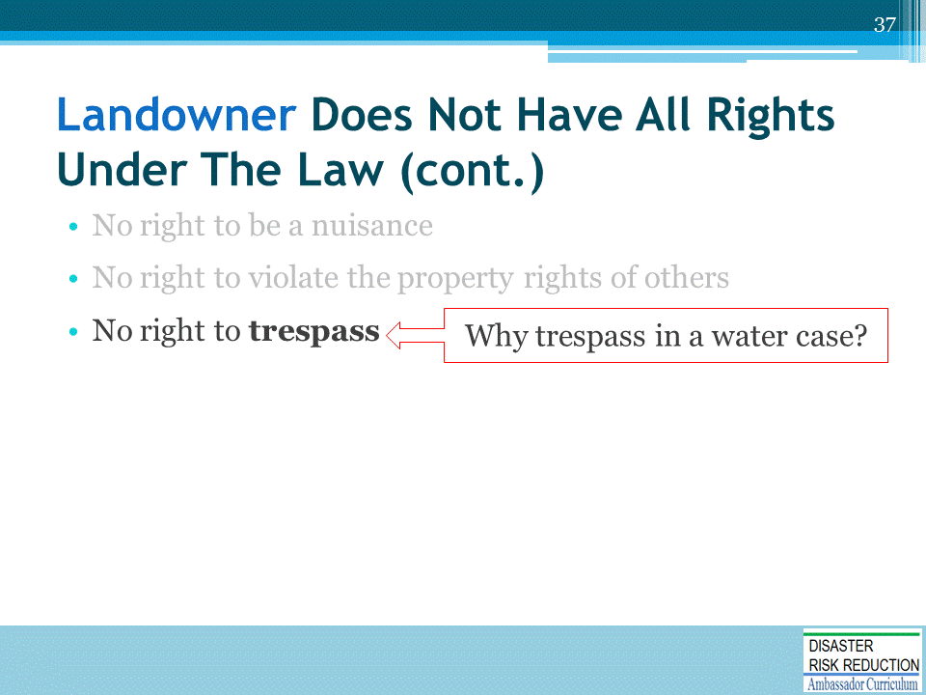

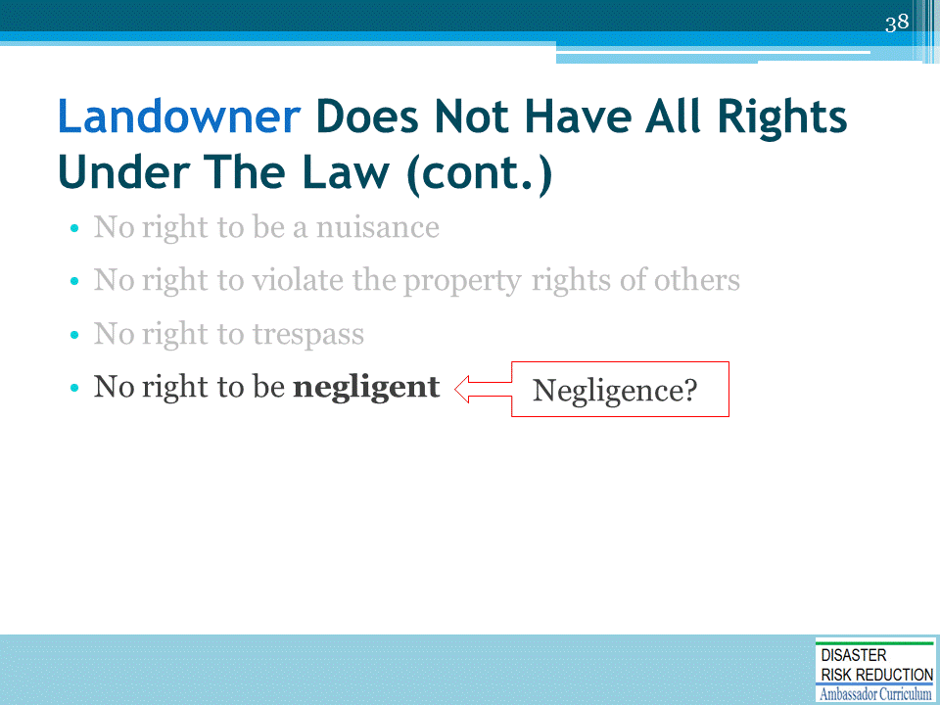

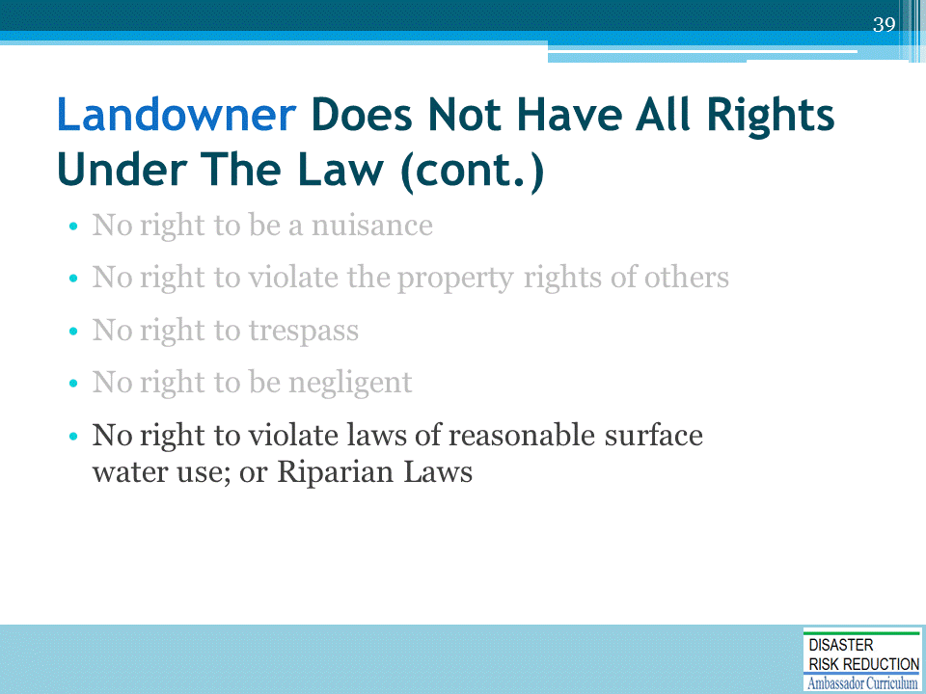

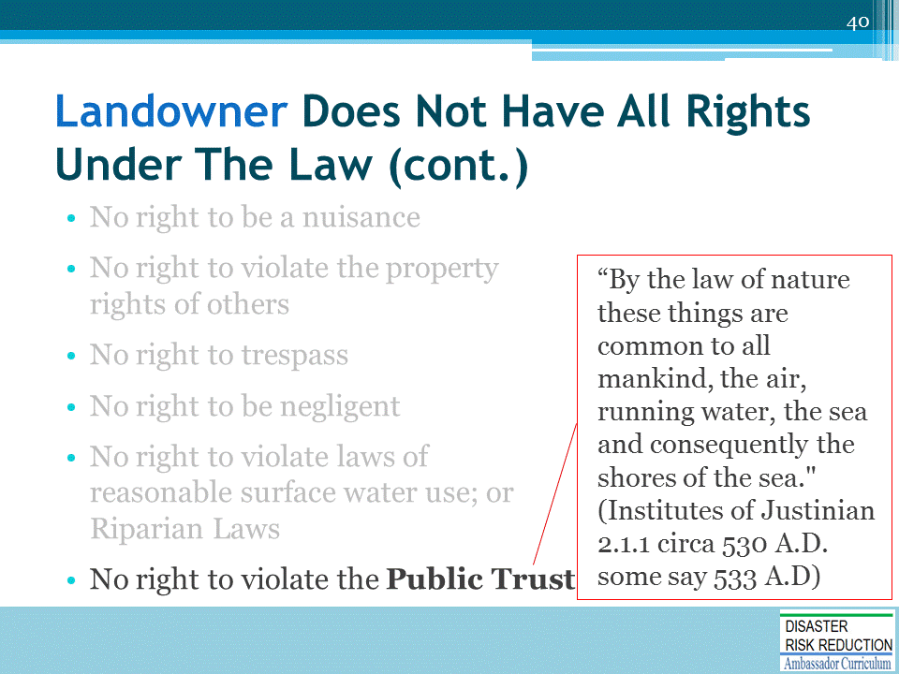

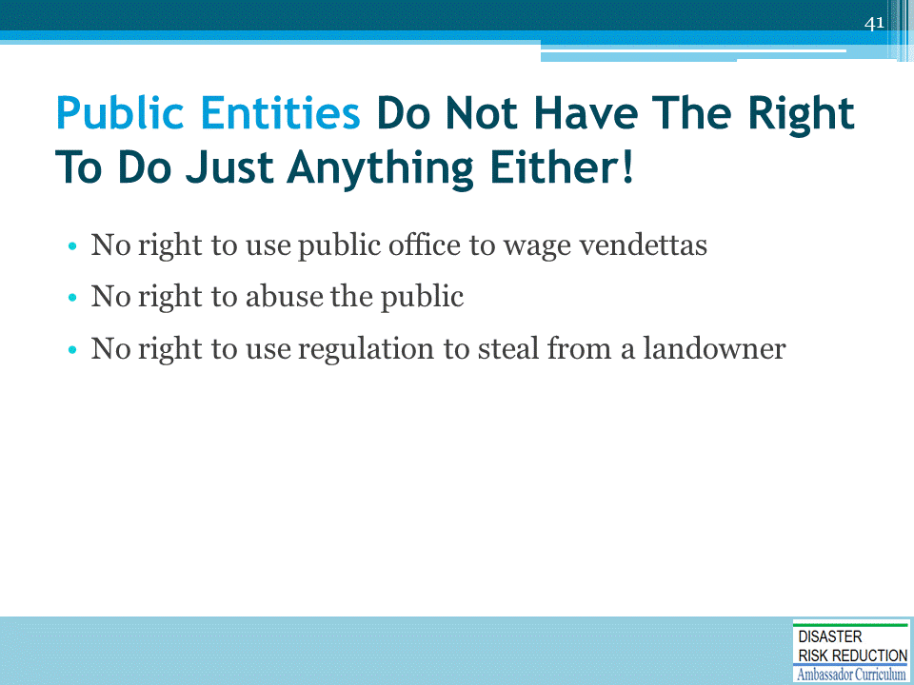

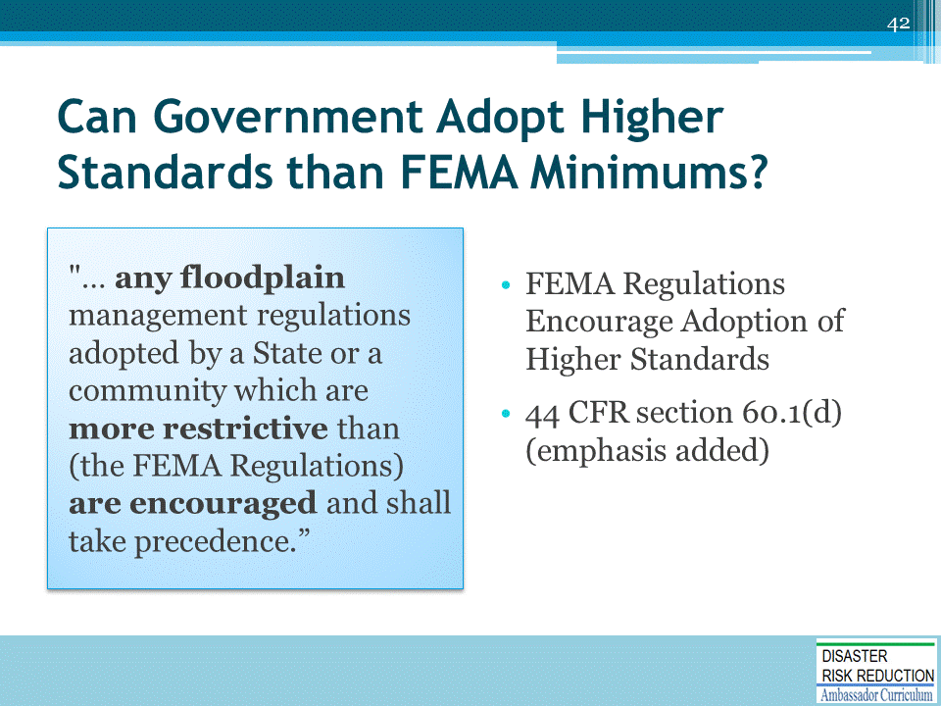
Case law; e.g., FEMA Elevation = 156 locals enforce 160 OK.
MICHAEL GIRARD et al v. ZONING COMMISSION OF THE TOWN OF SIMSBURY NO. CV 93 052 46 39S SUPERIOR COURT OF CONNECTICUT, JUDICIAL DISTRICT OF HARTFORD - NEW BRITAIN, AT HARTFORD 1994 Conn. Super. LEXIS 2365 September 15, 1994, Decided September 16, 1994, Filed.

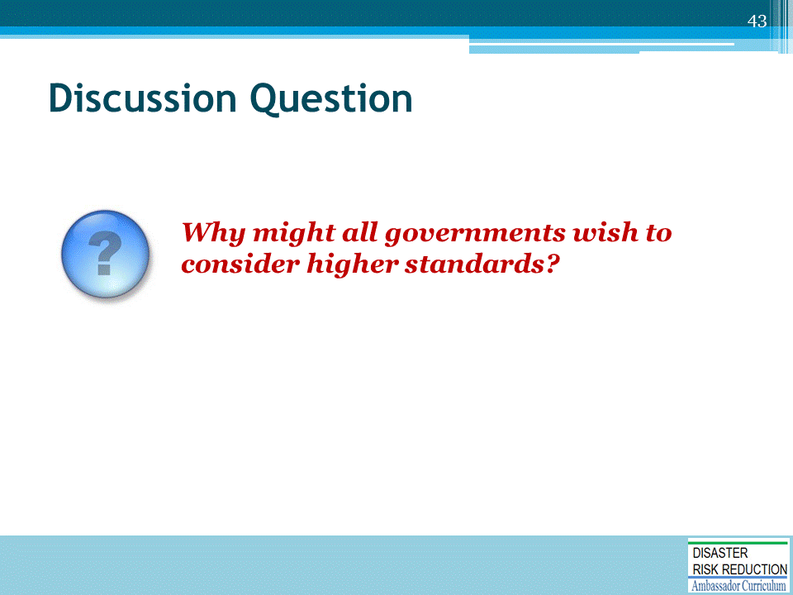

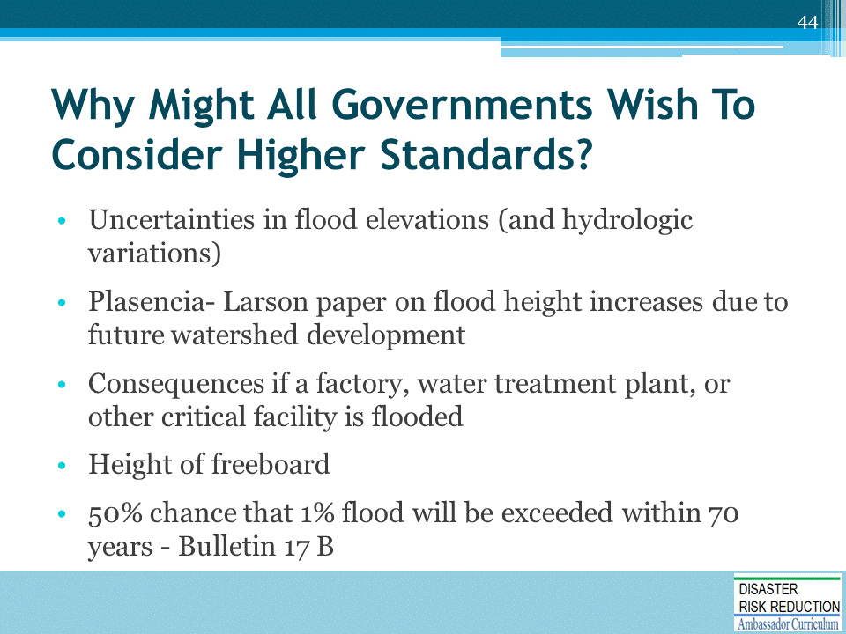

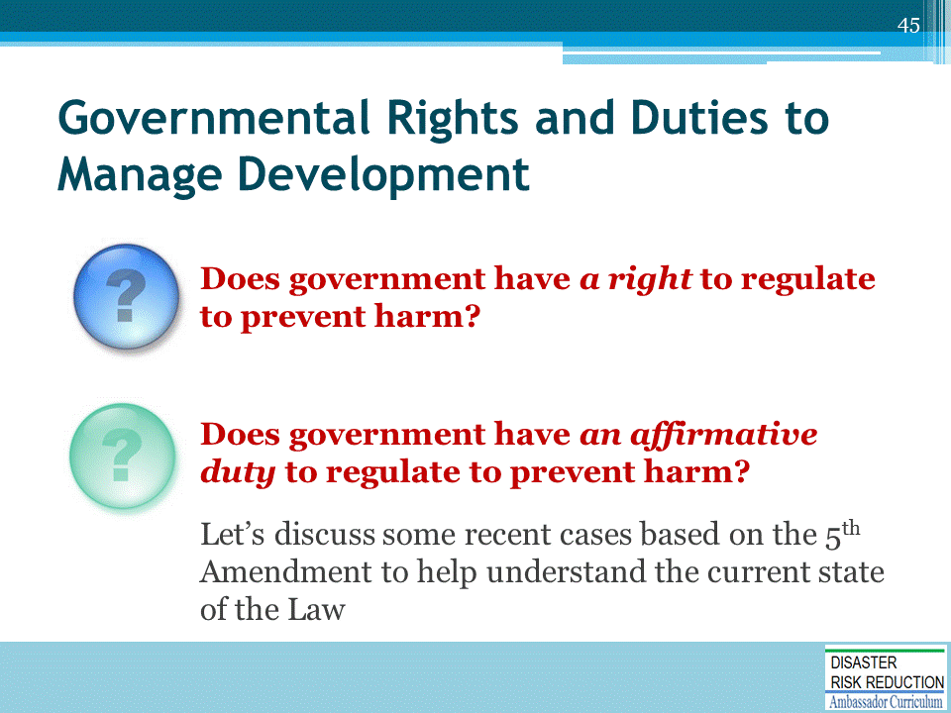

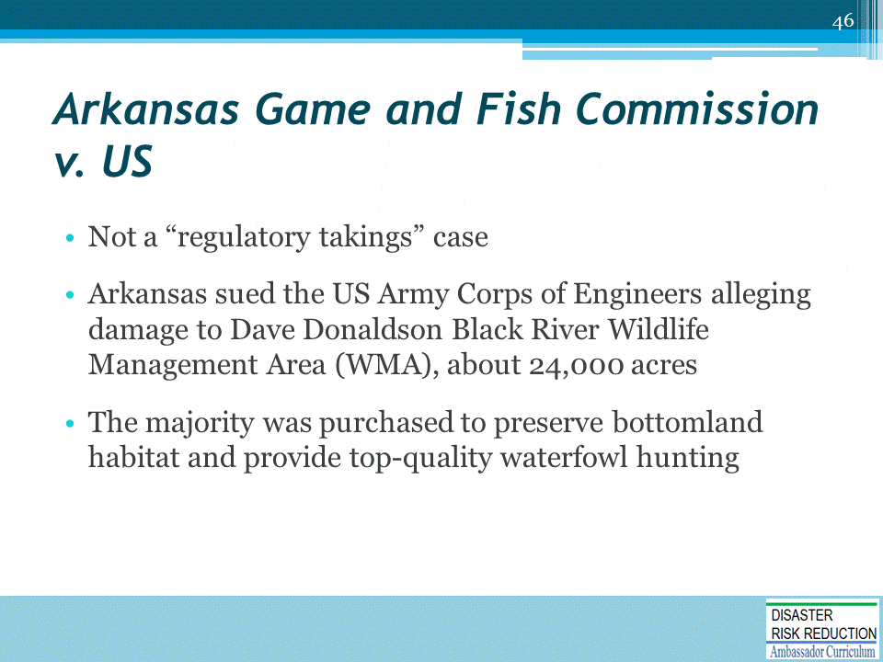

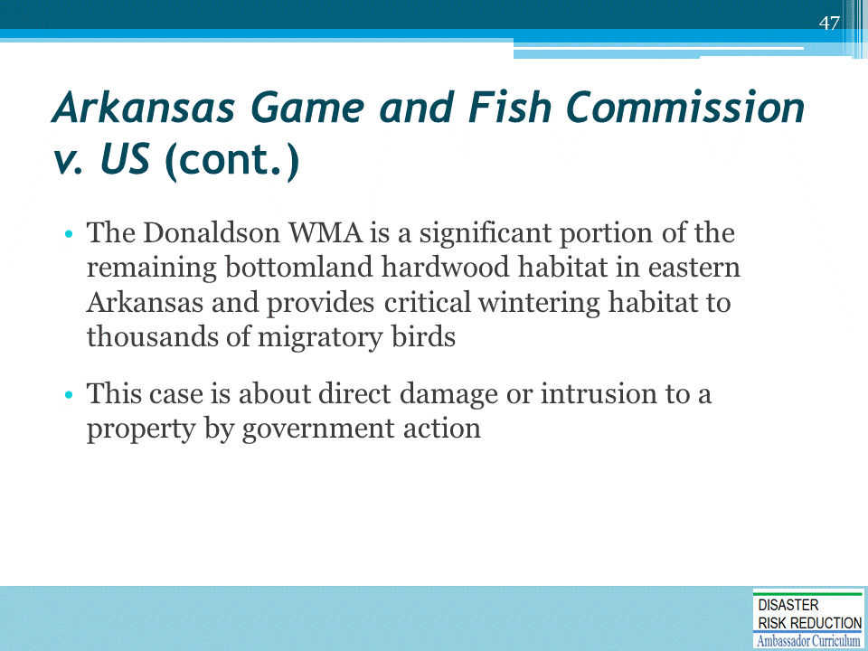

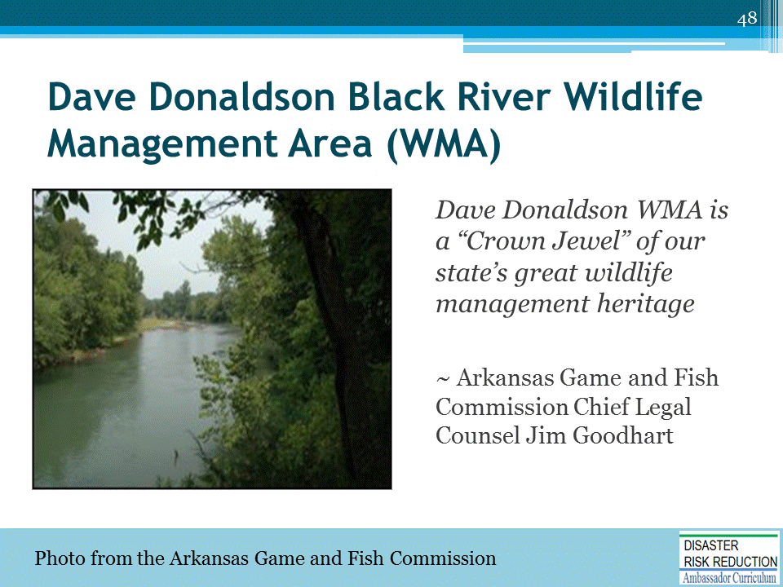

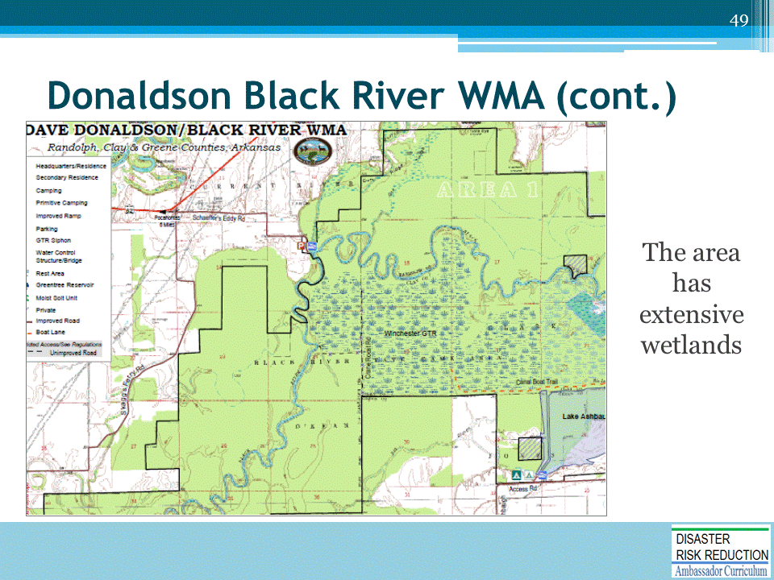

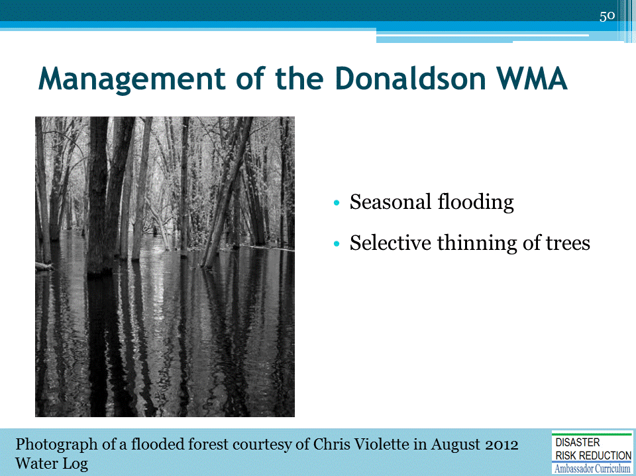

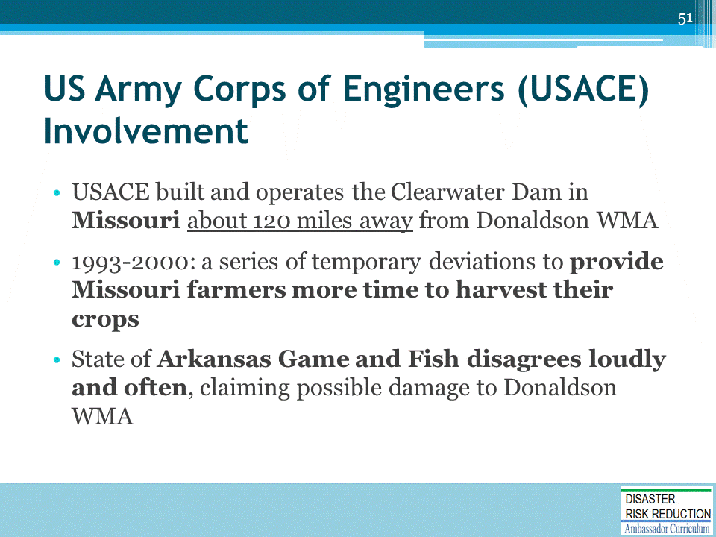

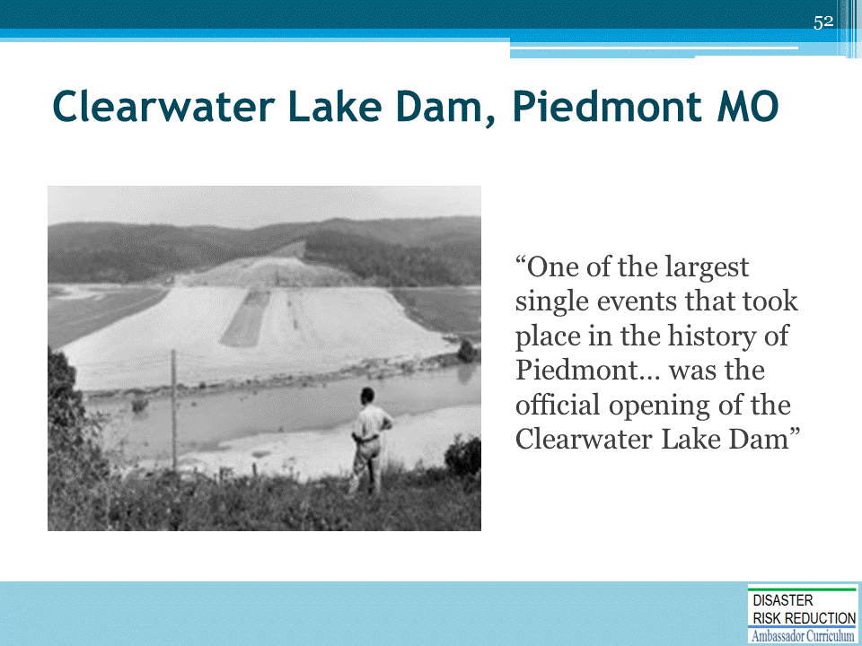

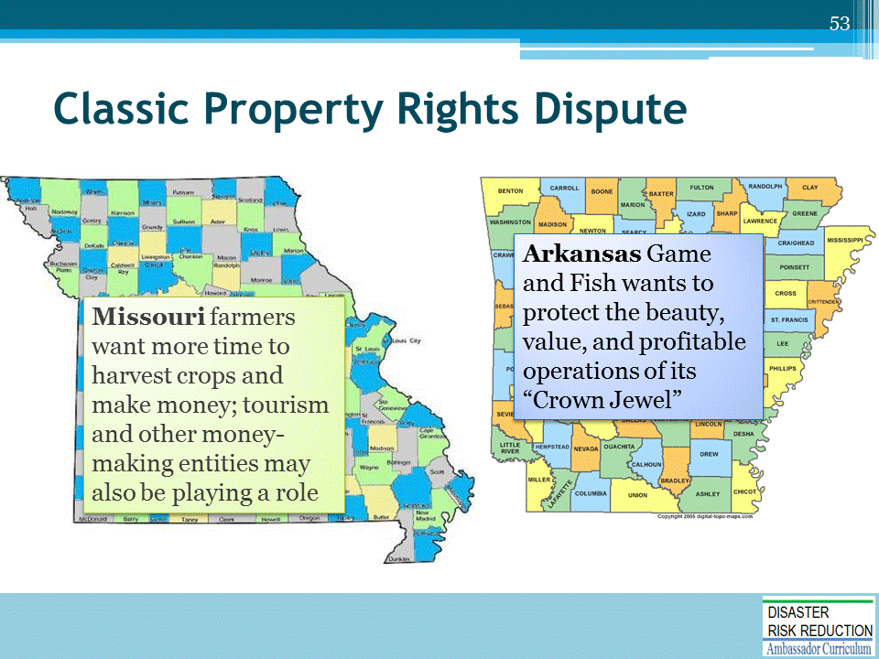

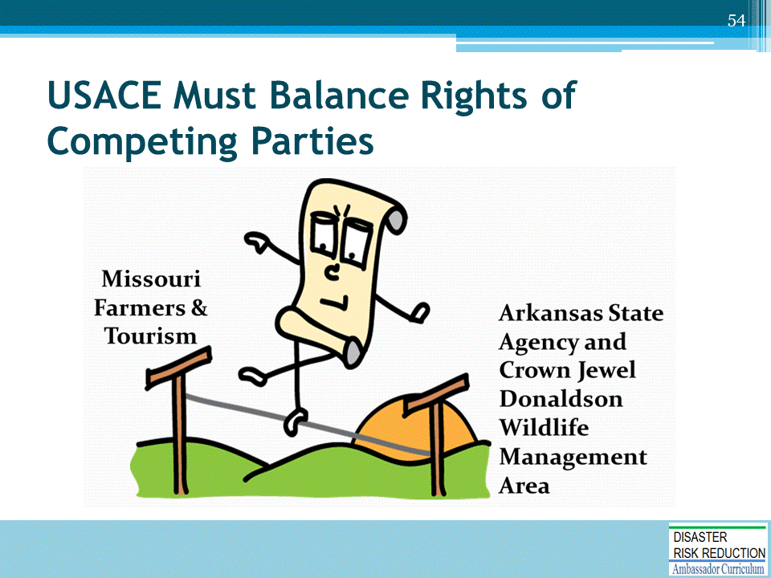

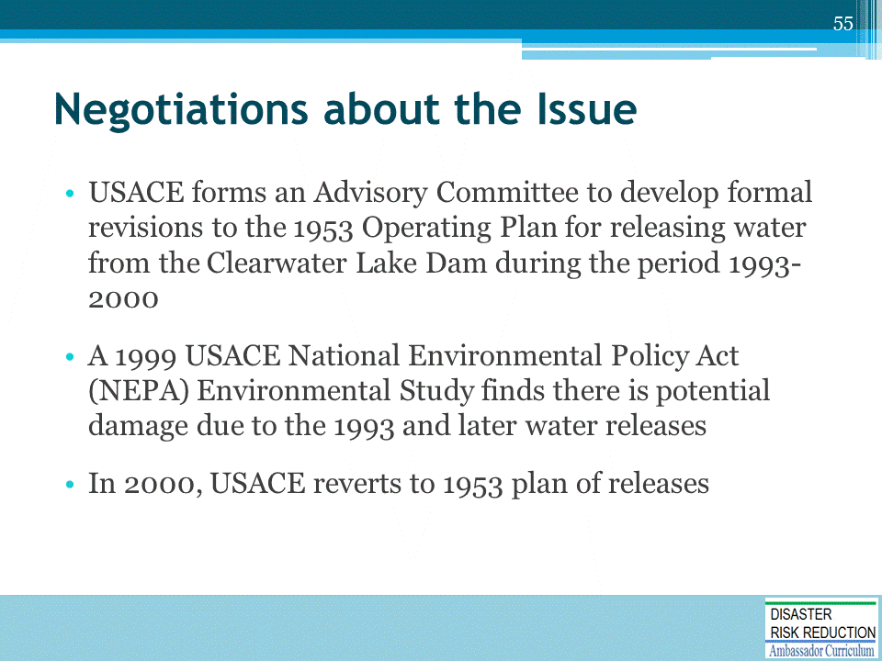

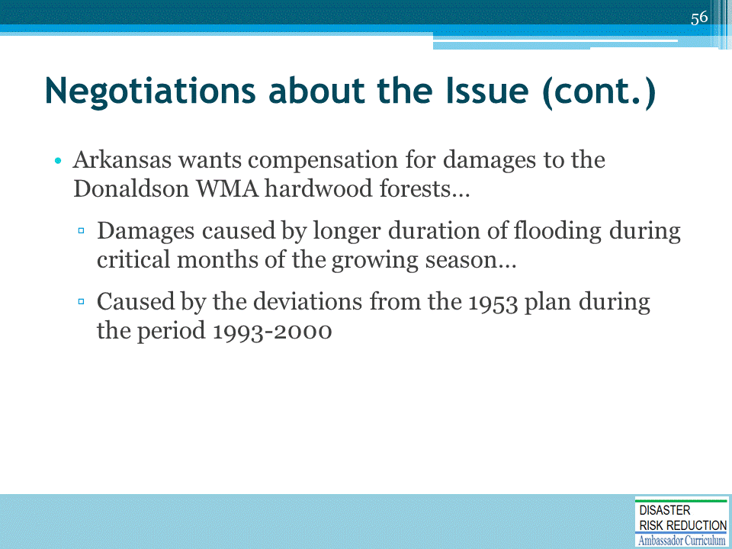

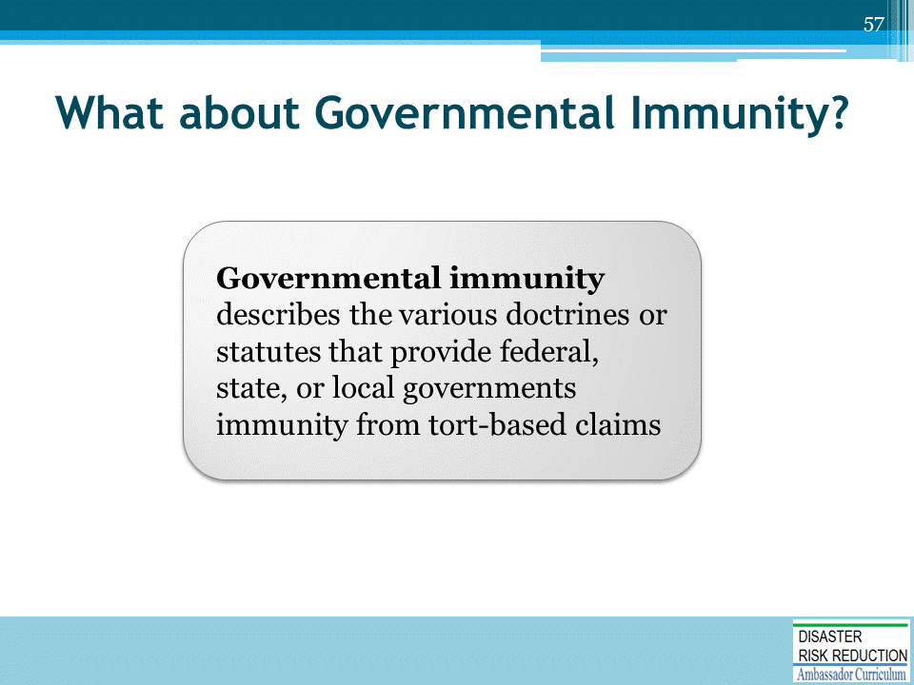

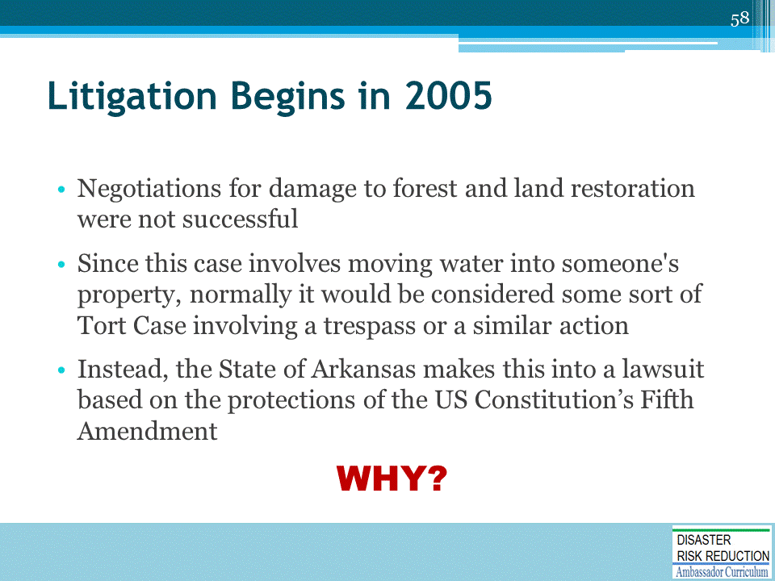

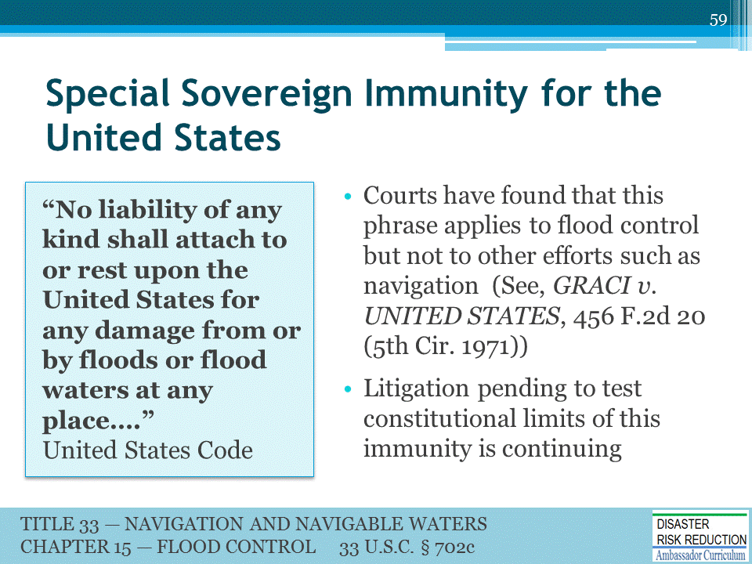

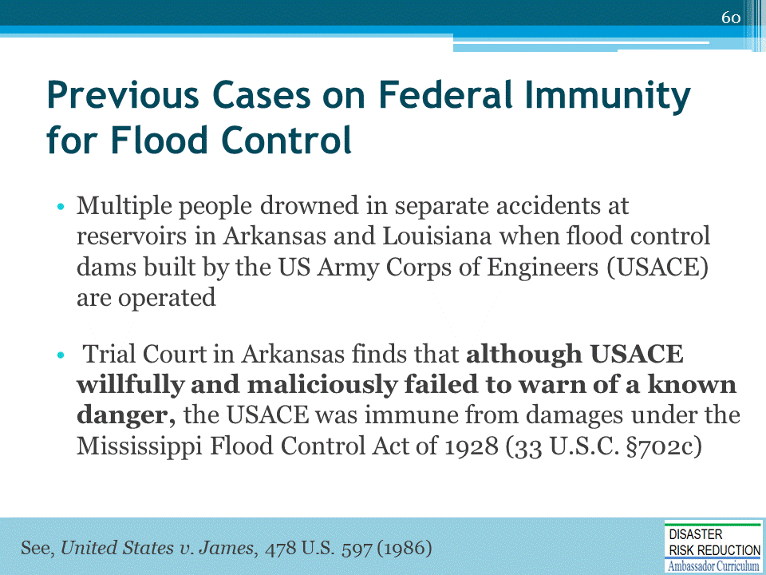

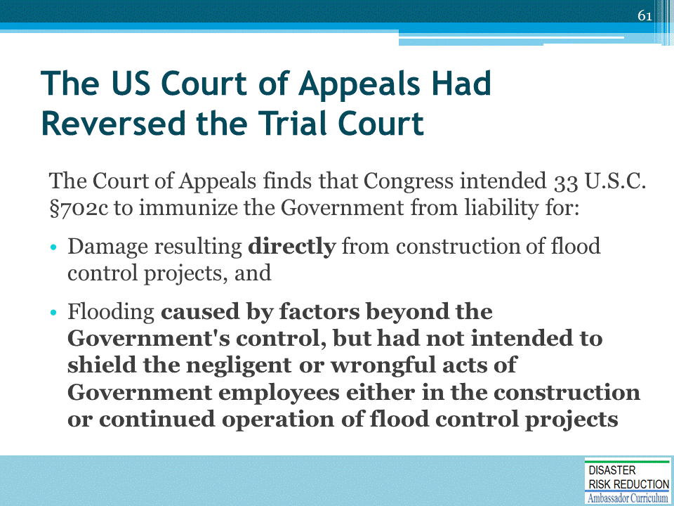

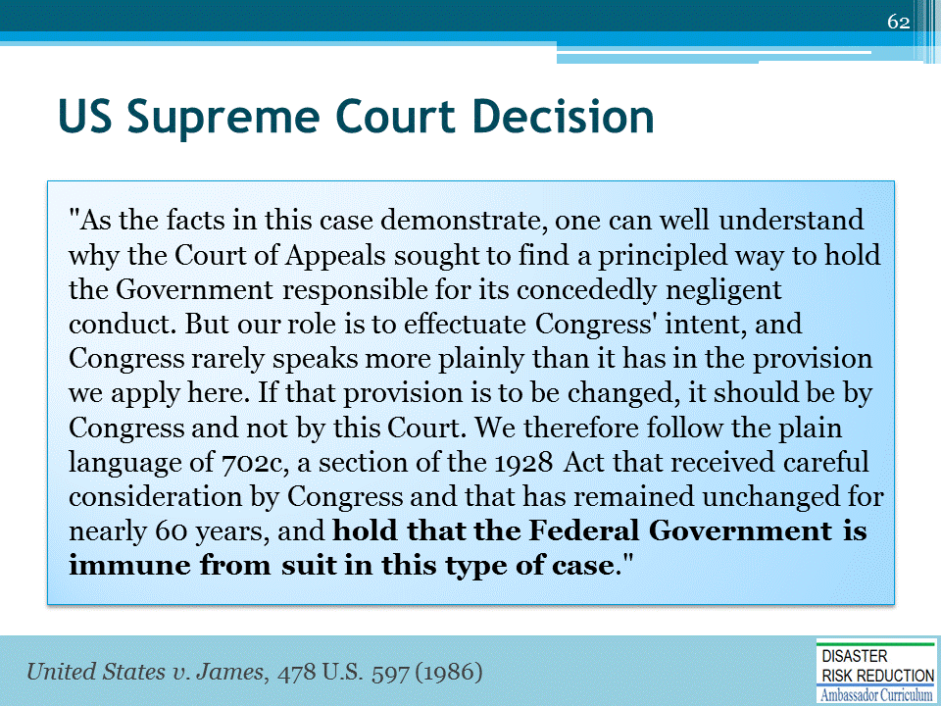

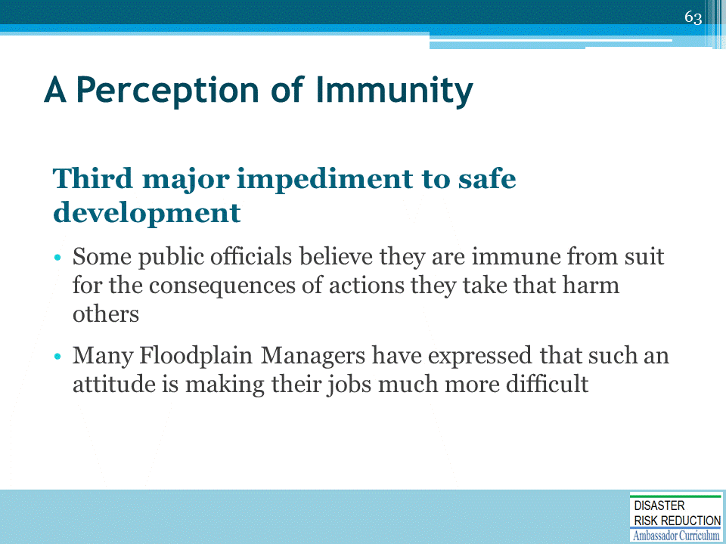

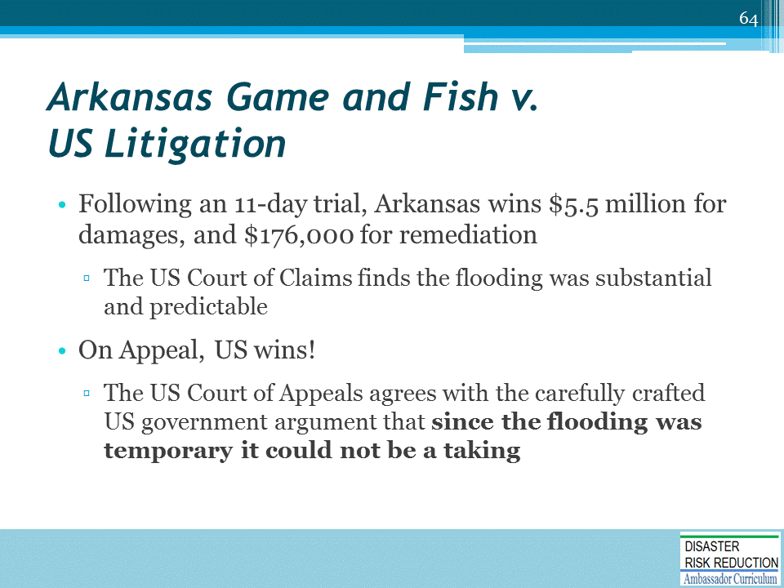

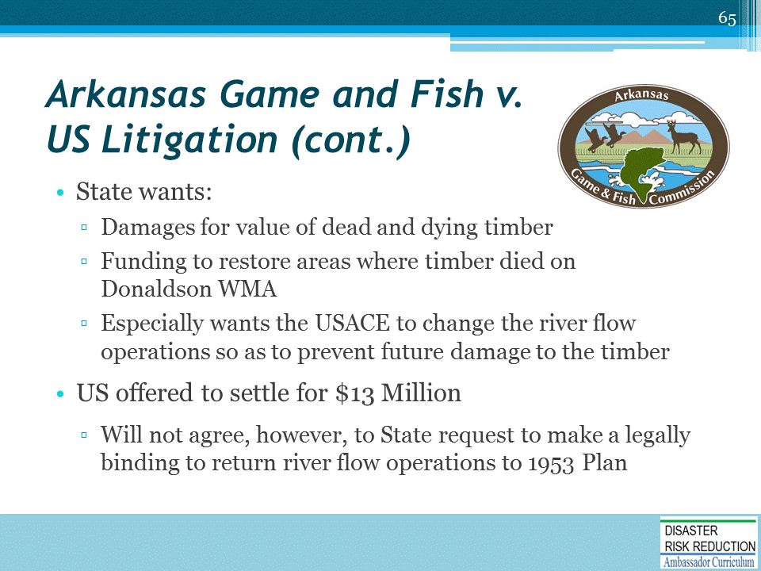

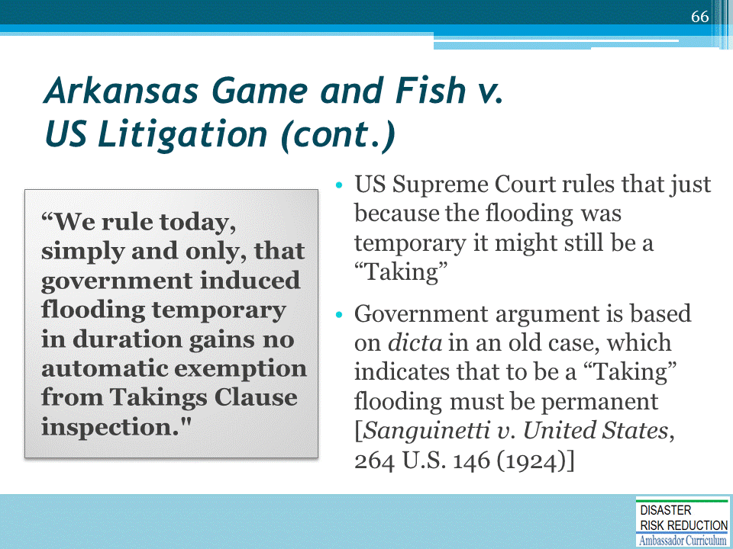

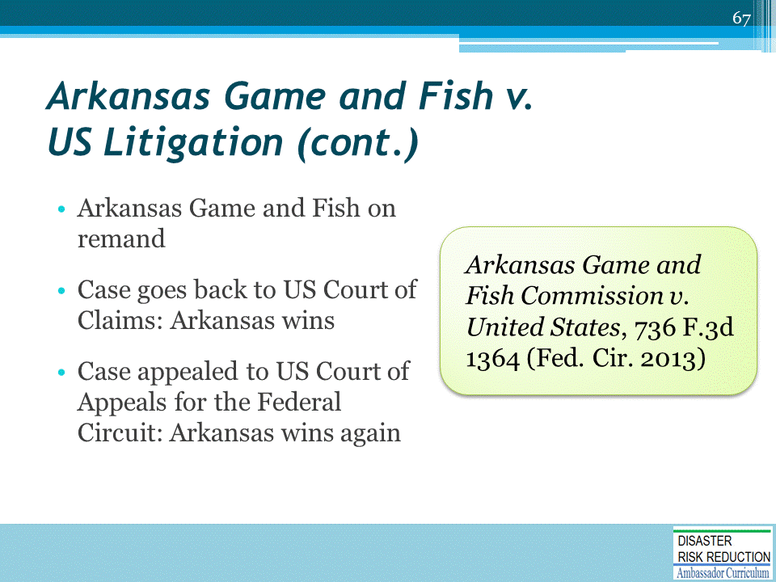

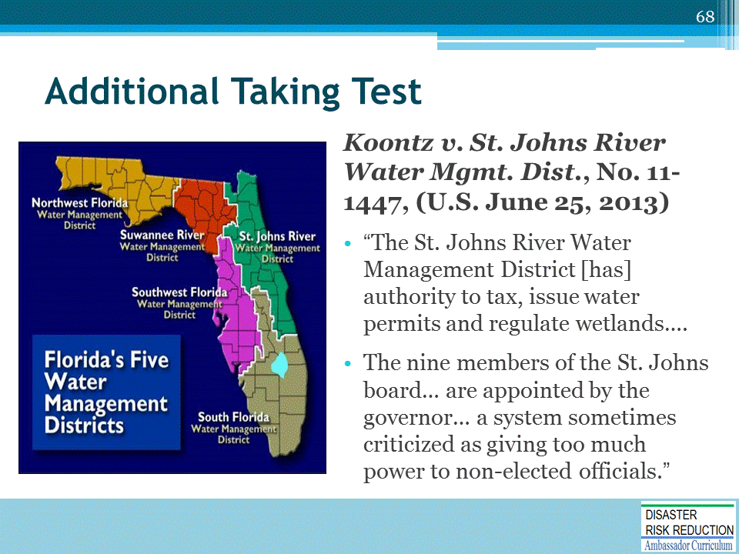

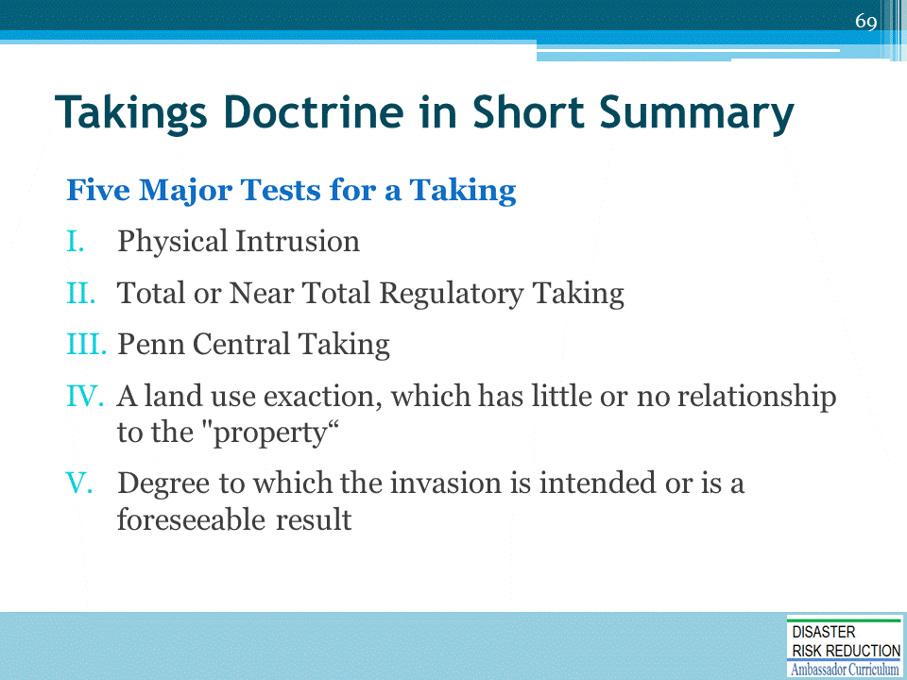

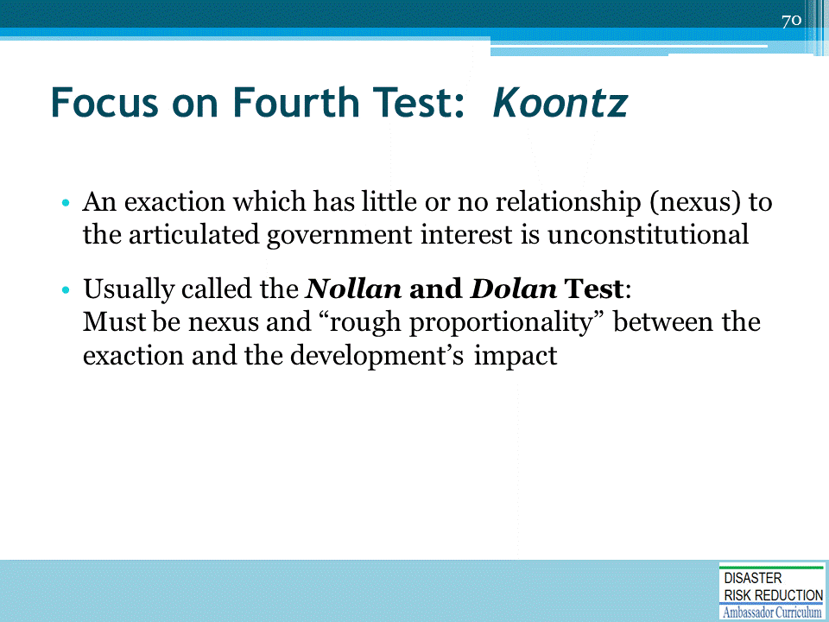

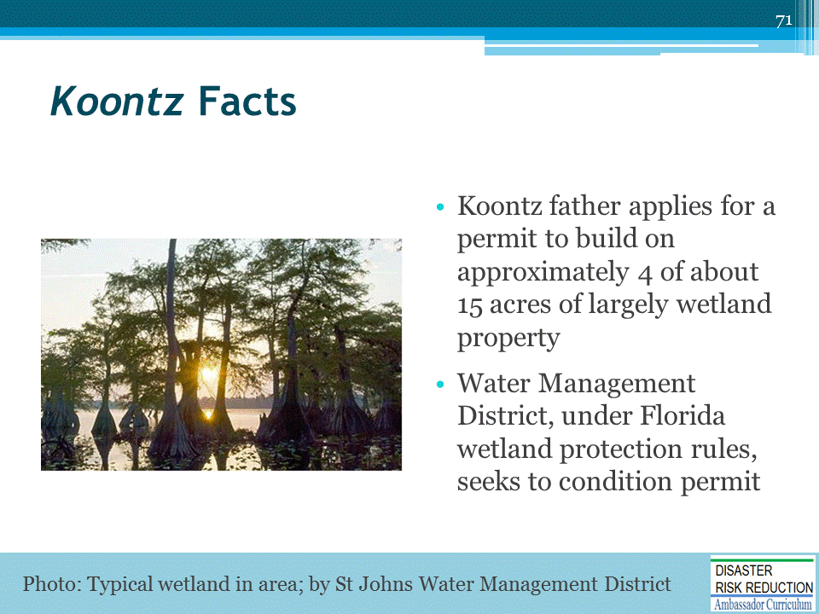
Turning Koontz into an Opportunity for More Resilient Communities, by Edward A. Thomas Esq., and Lynsey R. Johnson J.D., in National Wetlands Newsletter, March/April 2014, vol.36, no.2.
Located on the American Bar Association Website at: http://www.americanbar.org/content/dam/aba/administrative/state_local_government/land_use.authcheckdam.pdf

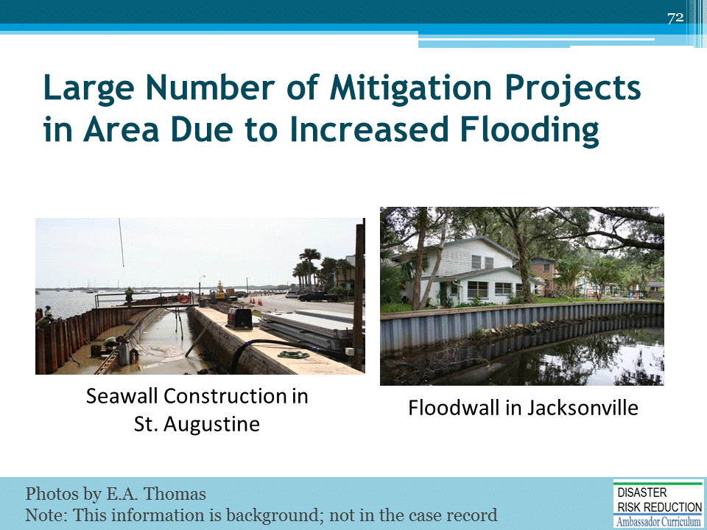

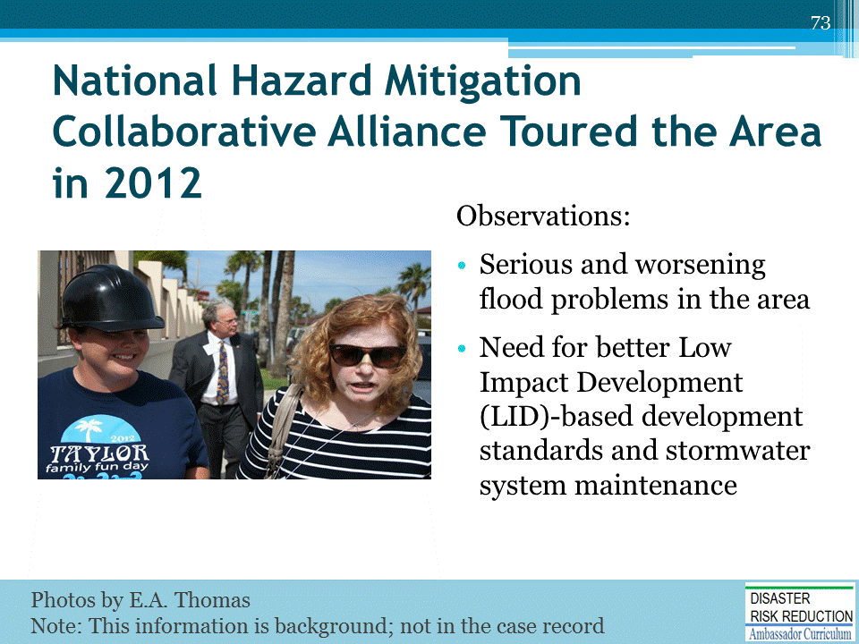

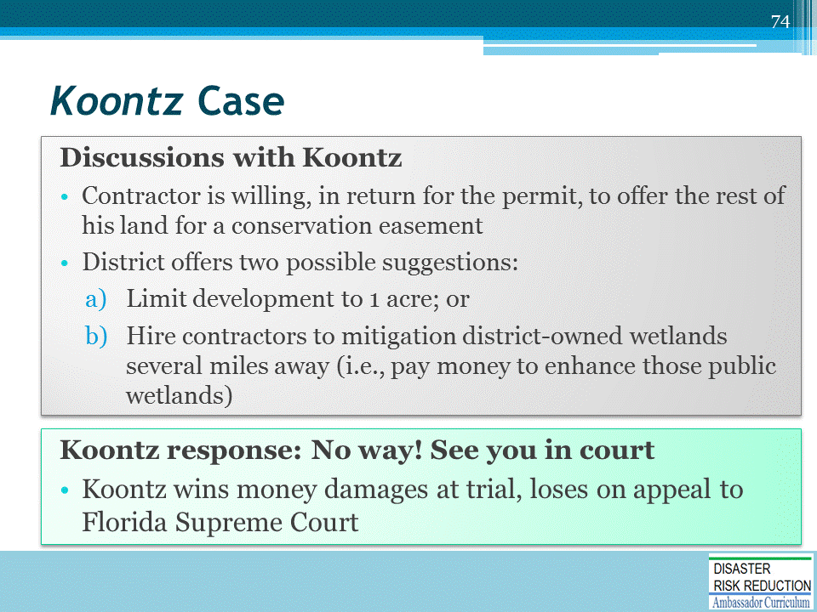

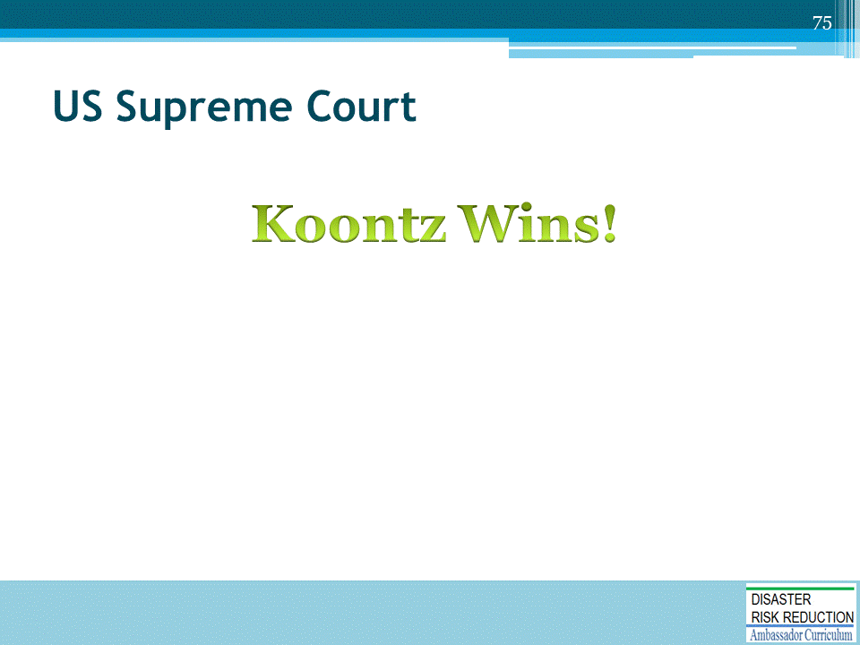

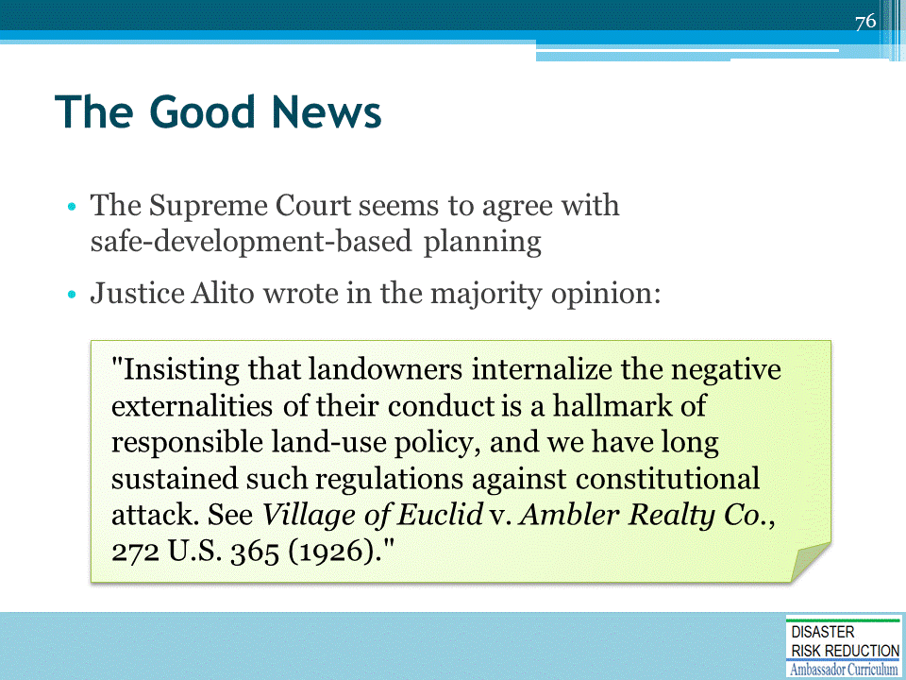

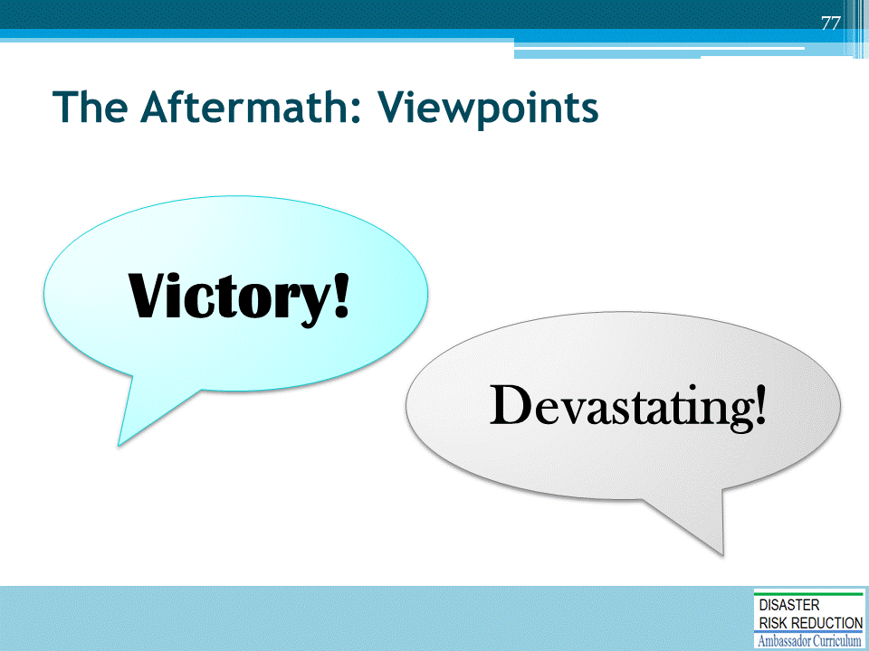
Many commentators view this case as a major victory for property owners and a defeat for government regulation.
There are articles quoting attorneys who claim that subjecting monetary exactions to taking analysis will be "devastating“ to land use planning and will limit the ability and incentive of local governments to negotiate for conditions that mitigate the impacts of proposed development. There are all sorts of alarmist articles quoting attorneys who are basically predicting that the sky is falling.

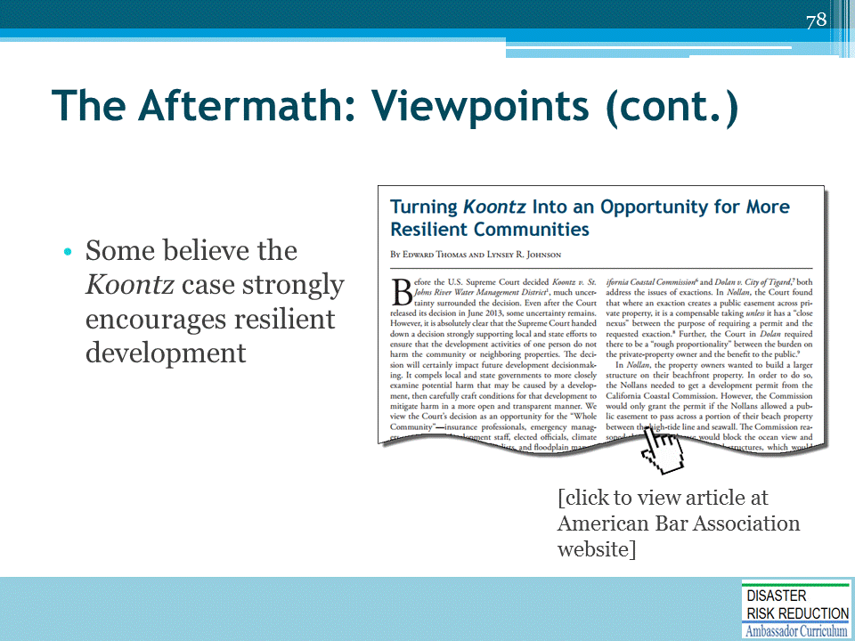
“Turning Koontz into an Opportunity for More Resilient Communities”
by Edward A. Thomas Esq., and Lynsey R. Johnson J.D., in National Wetlands Newsletter, March/April 2014, vol.36, no.2
Located on the American Bar Association Website at: http://www.americanbar.org/content/dam/aba/administrative/state_local_government/land_use.authcheckdam.pdf

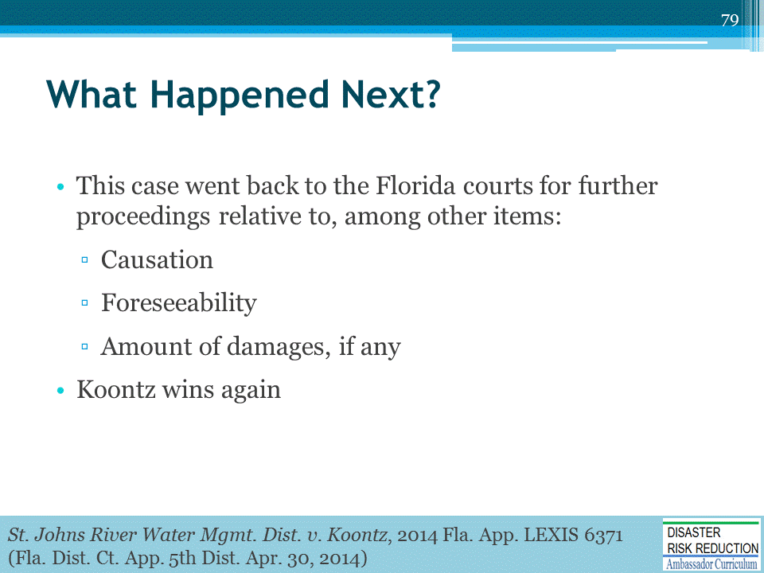

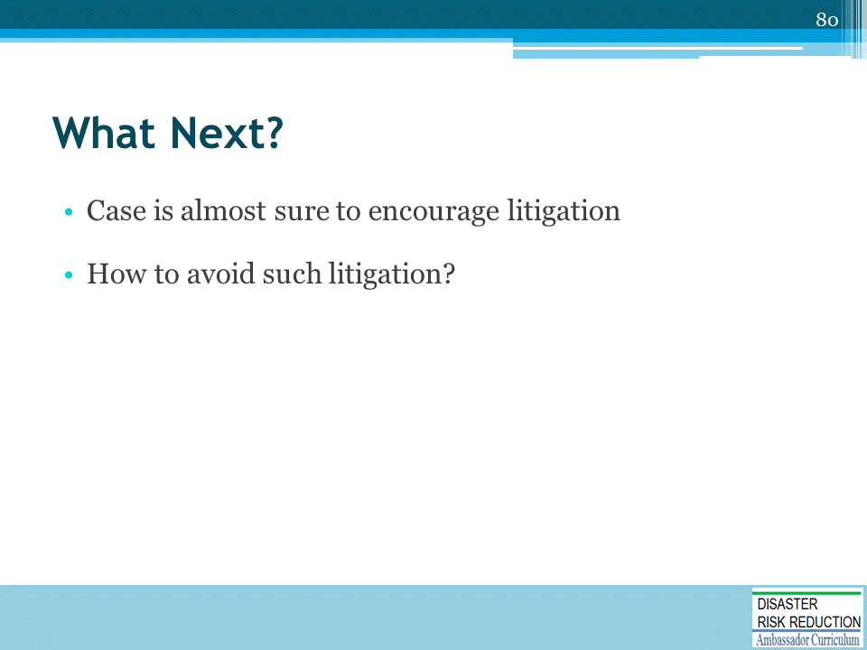

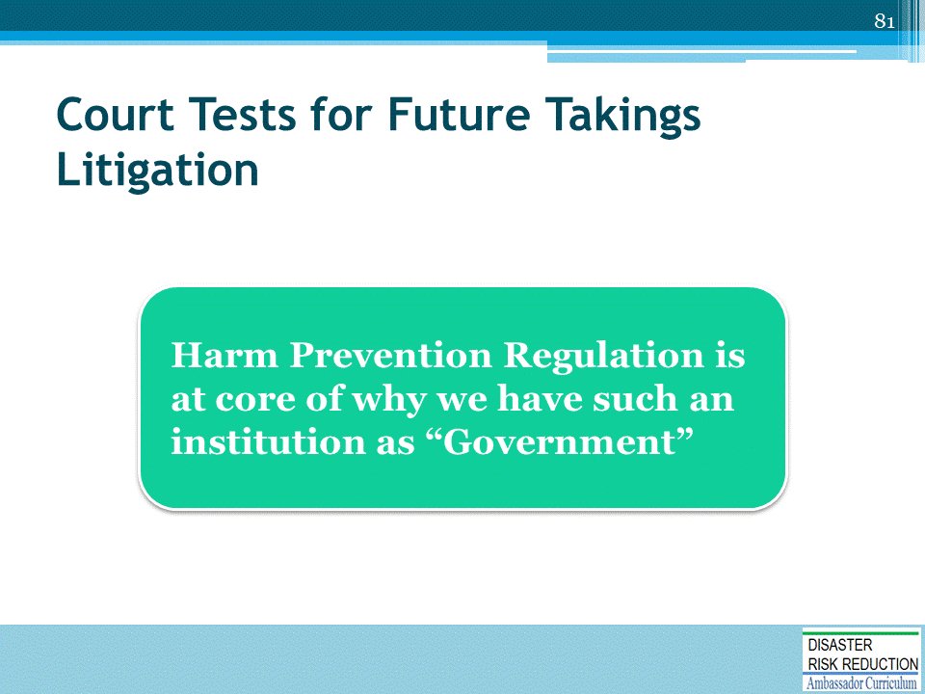

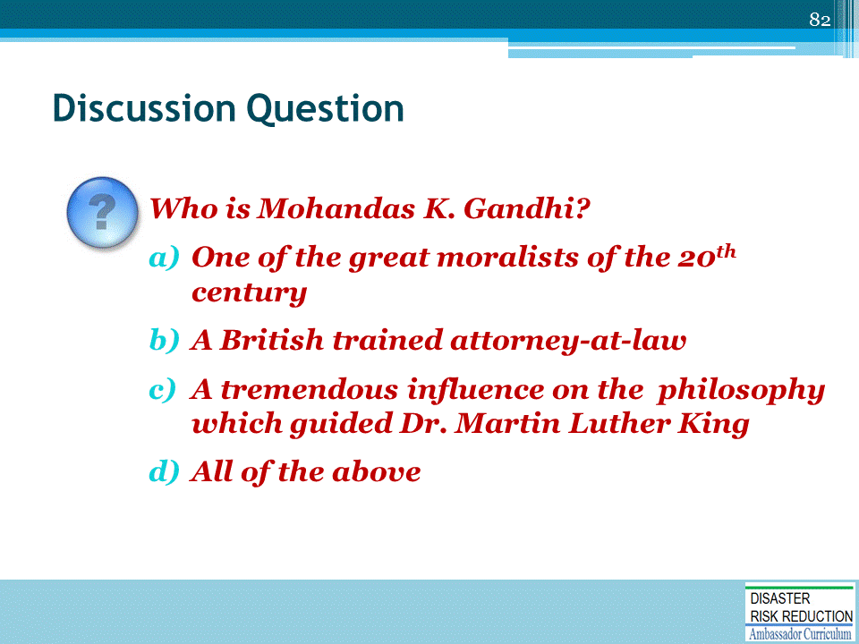

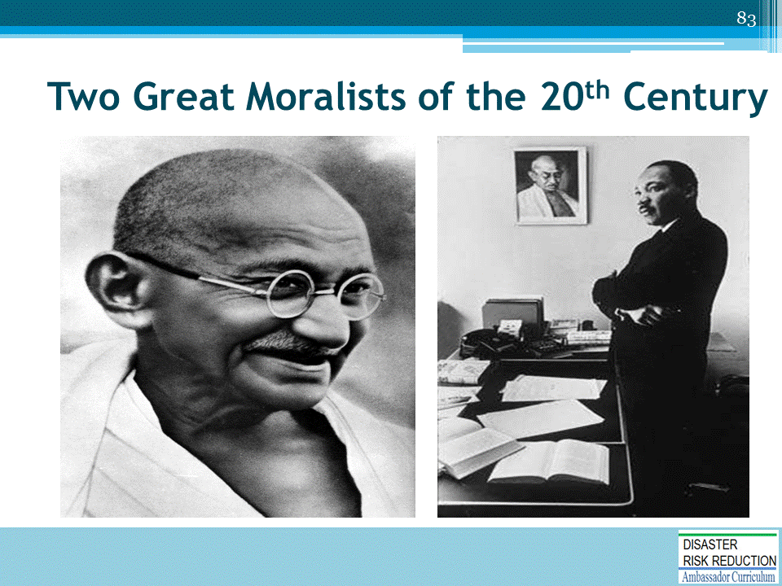

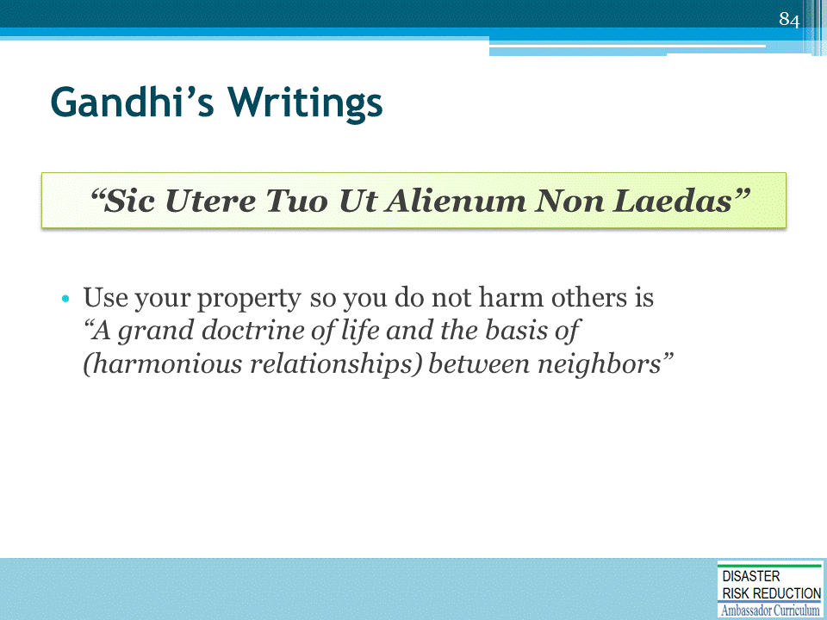

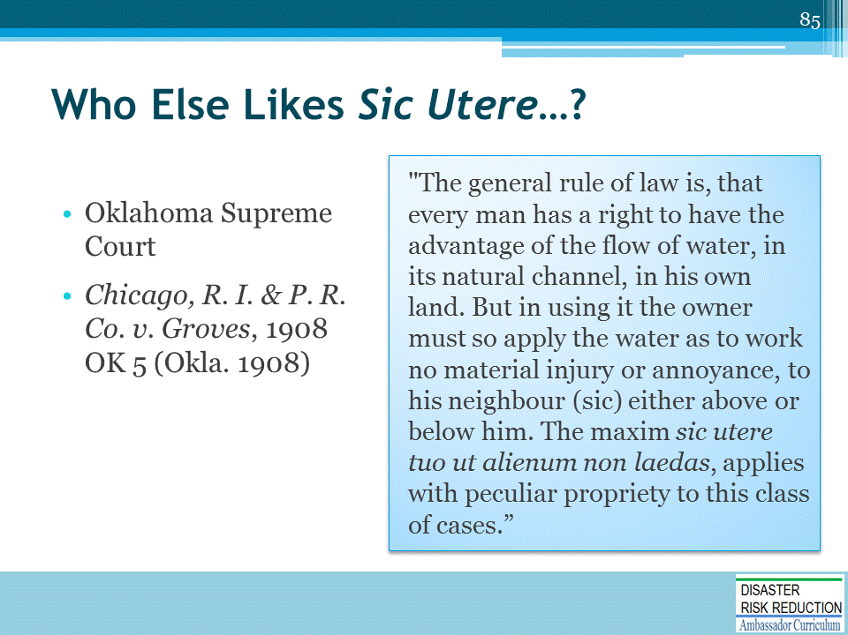

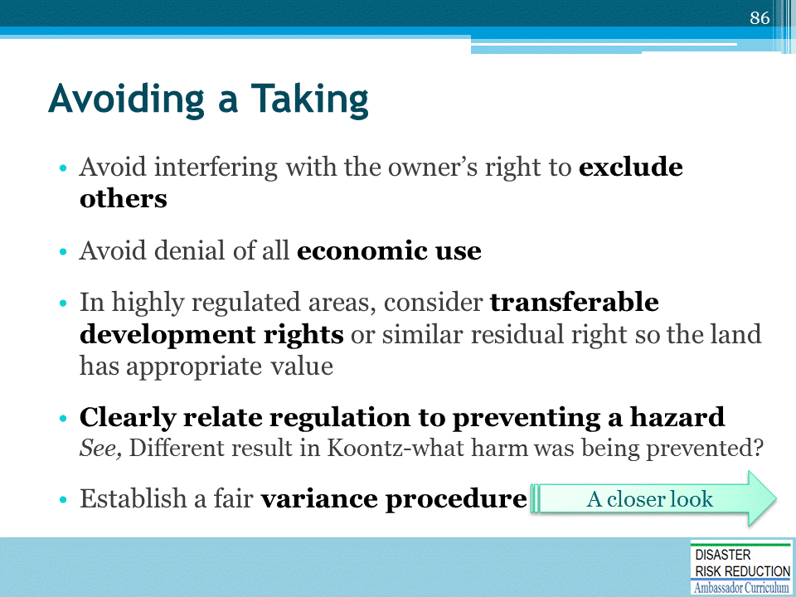
See, also American Planning Association (APA) Policy Guide on Takings adopted in 1995.
Located at: https://planning.org/policy/guides/adopted/takings.htm
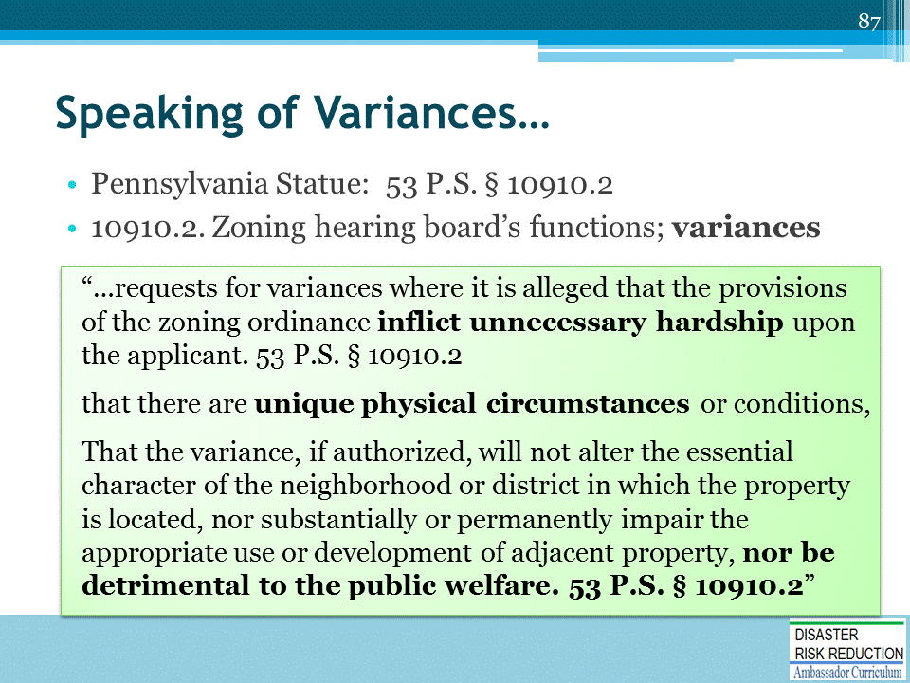

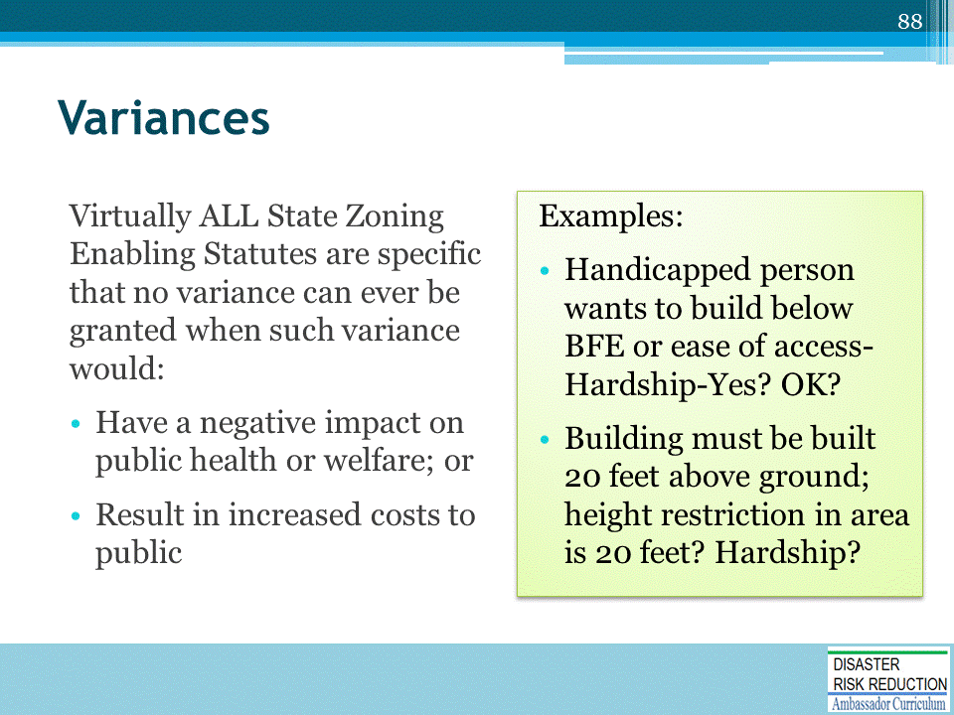

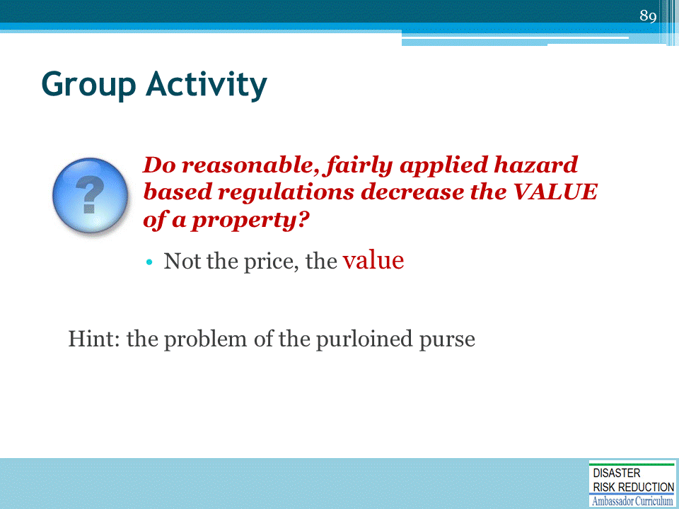

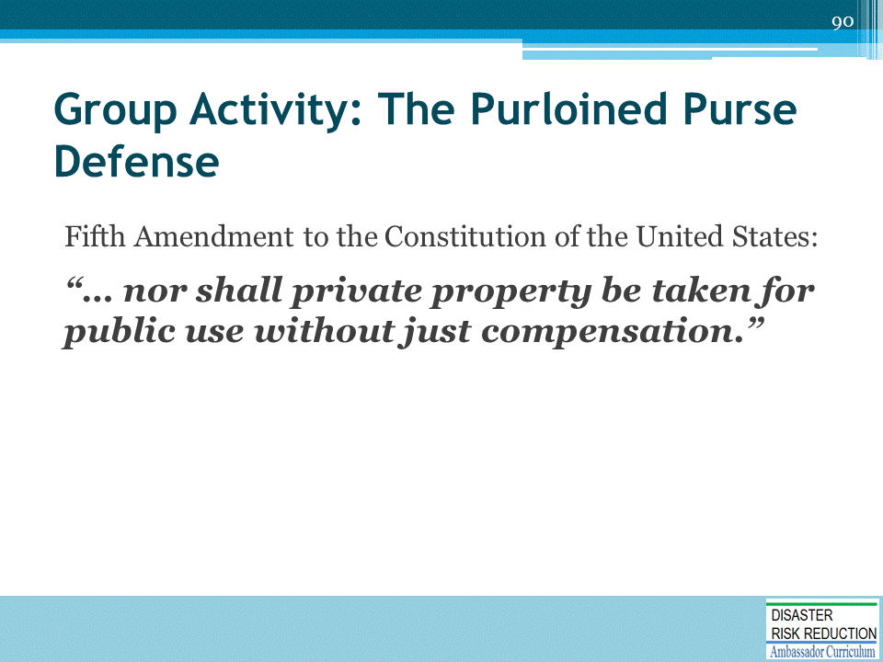

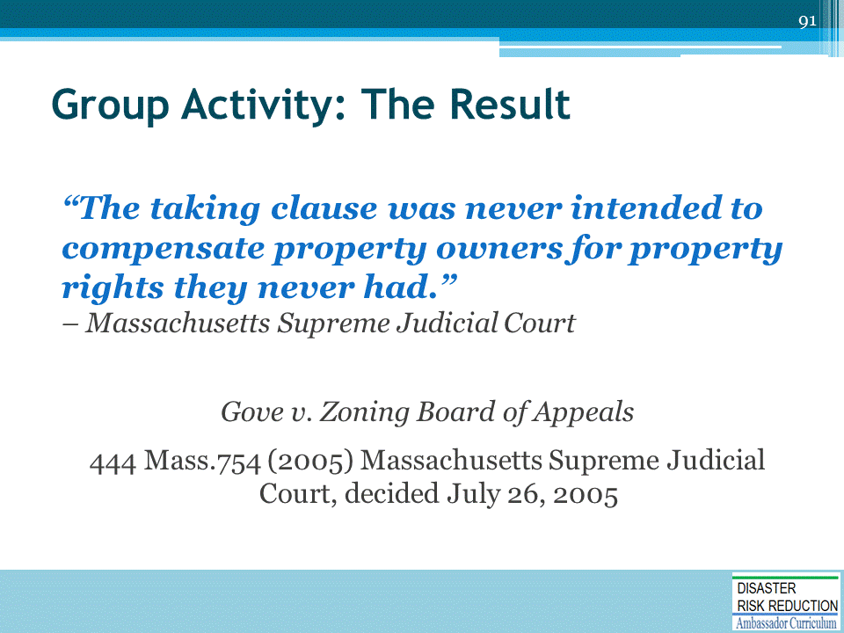
There are extensive materials on this at www.nhma.info

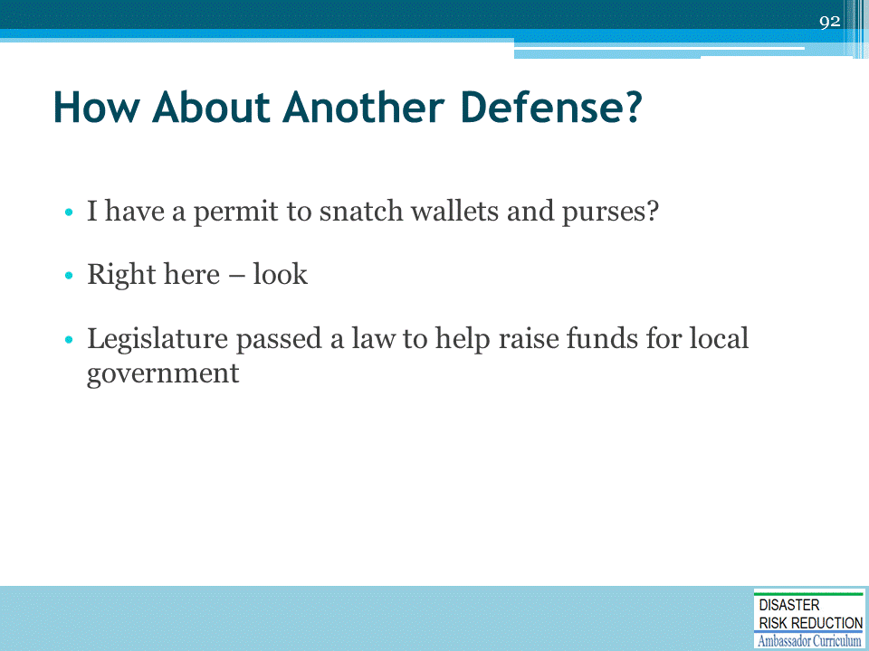

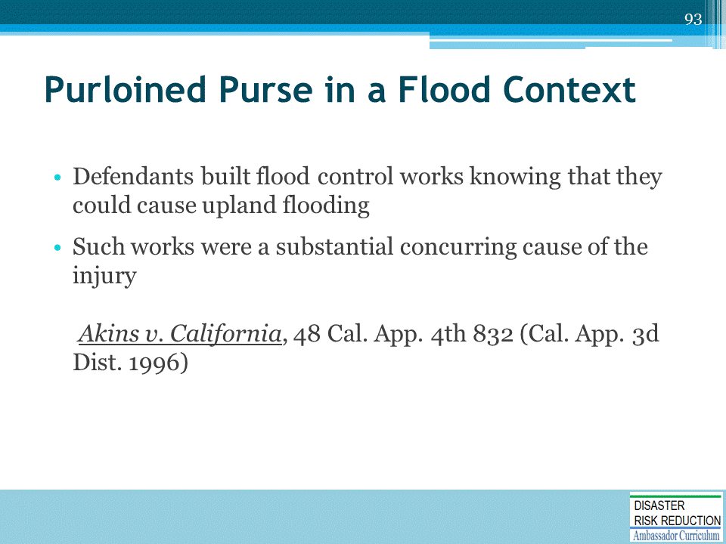

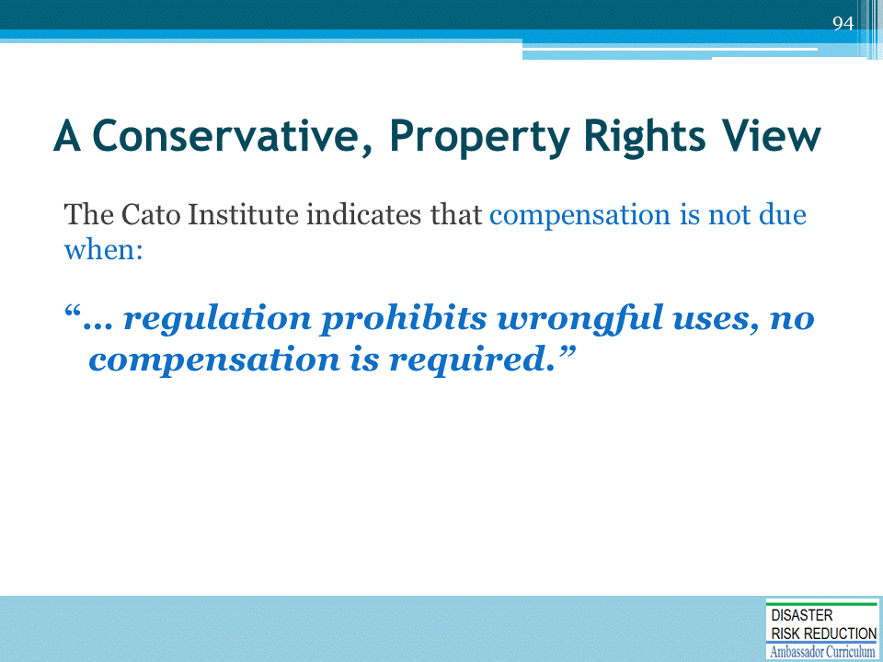

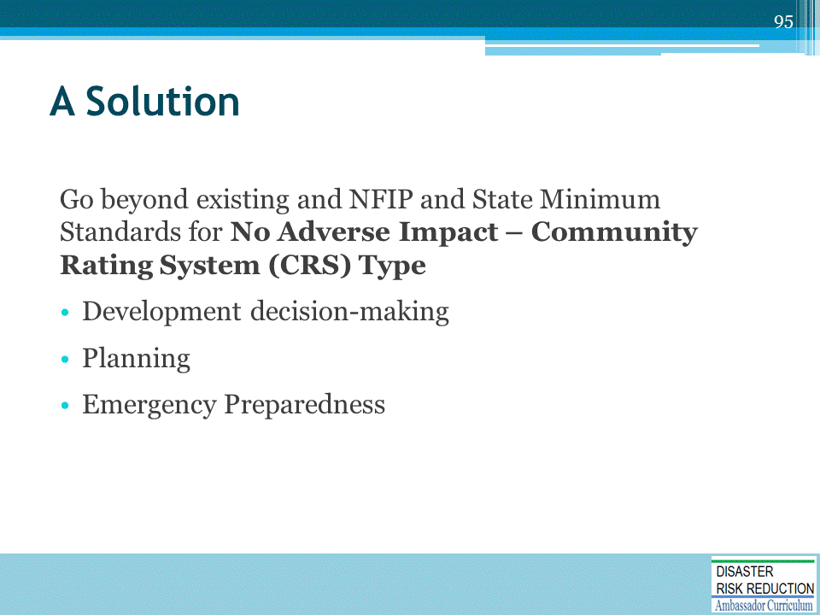

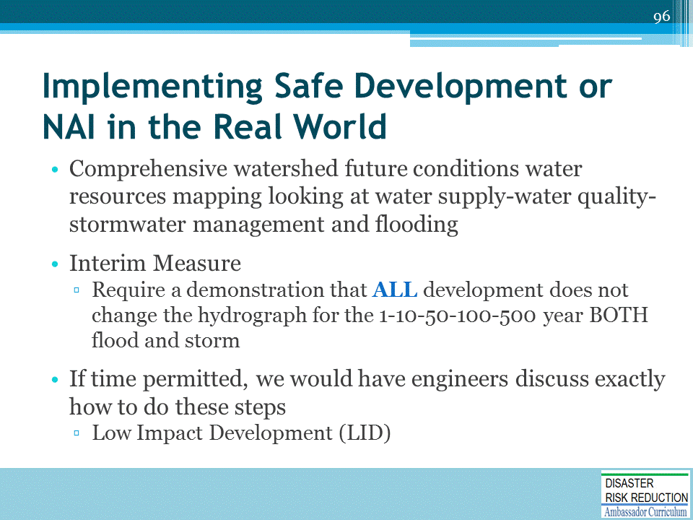

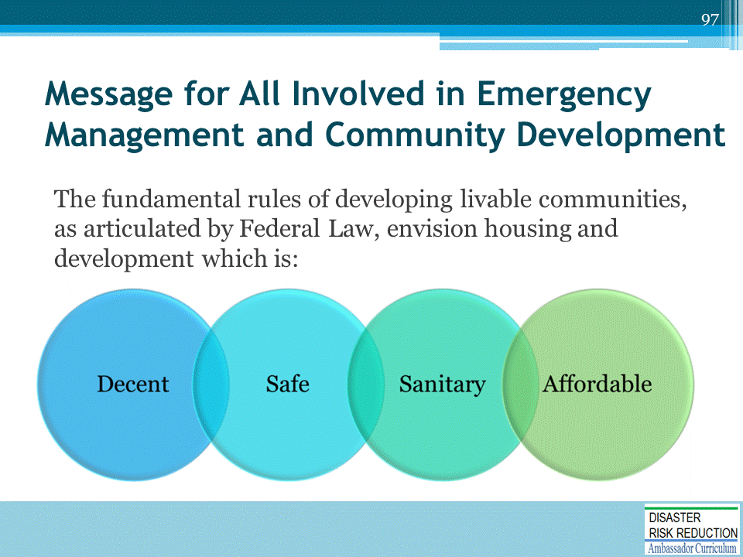

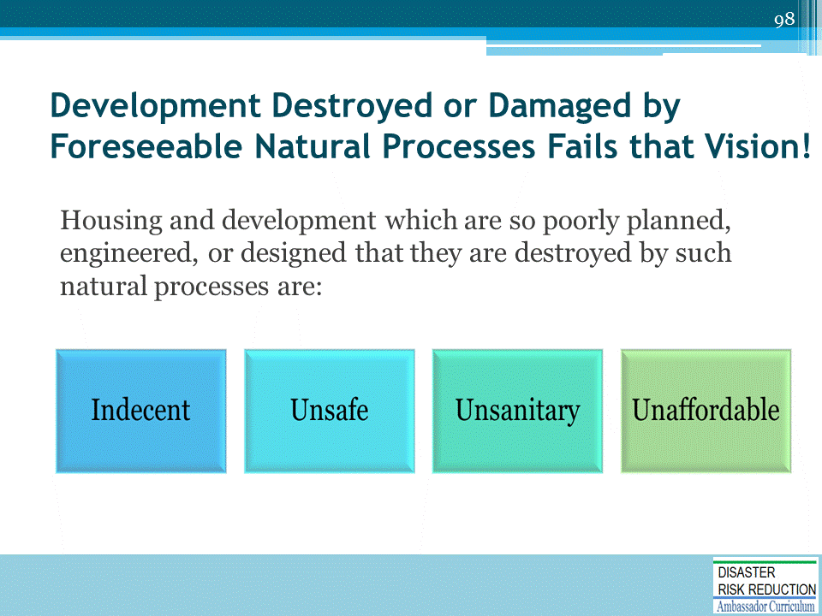

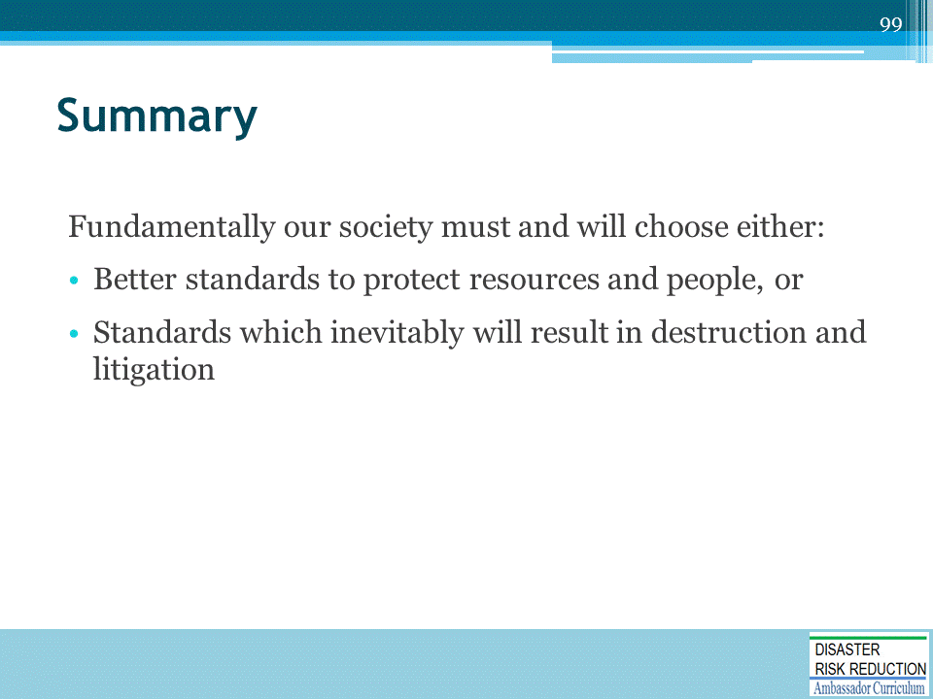

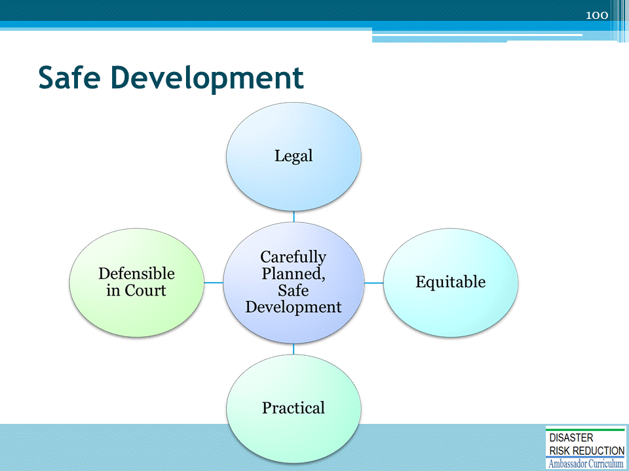

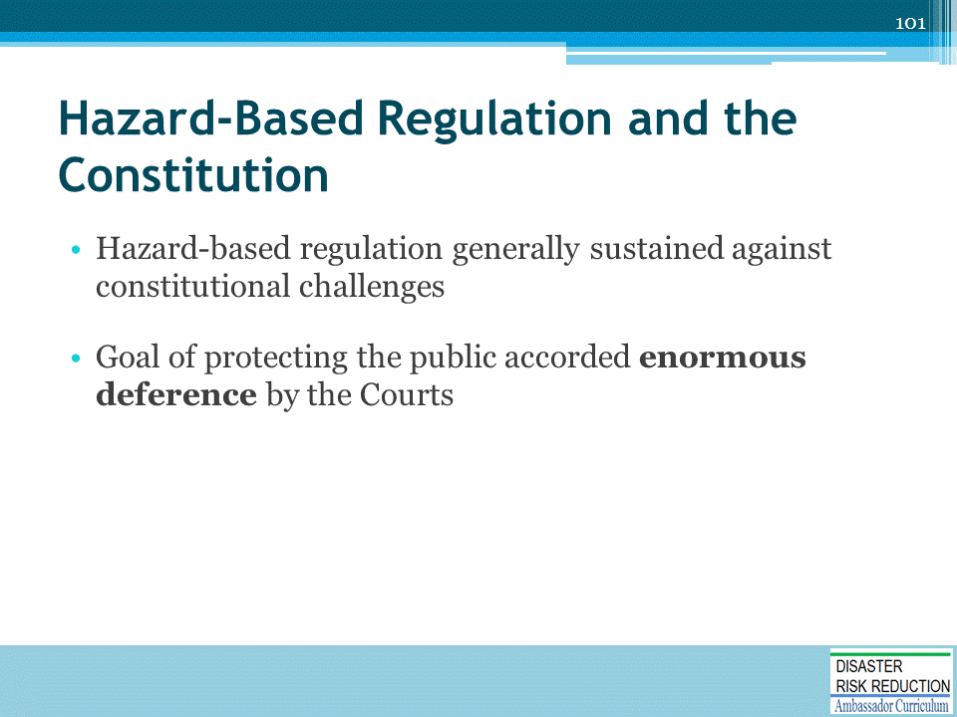

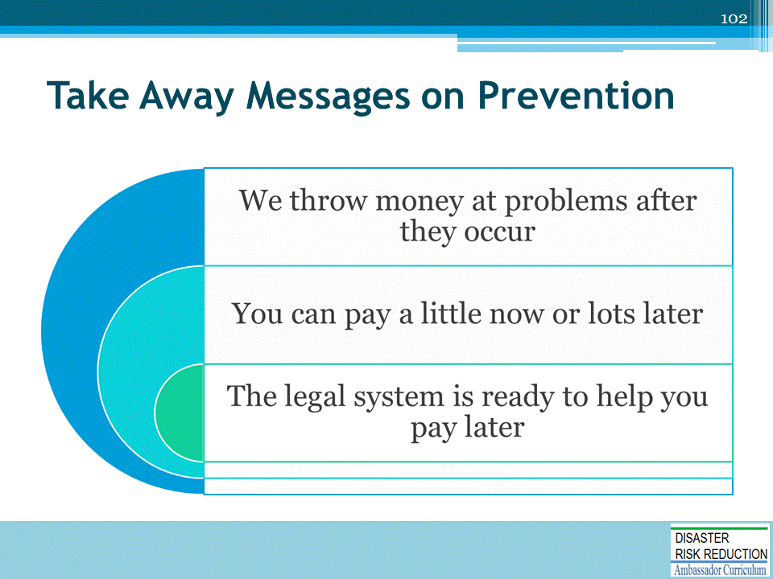

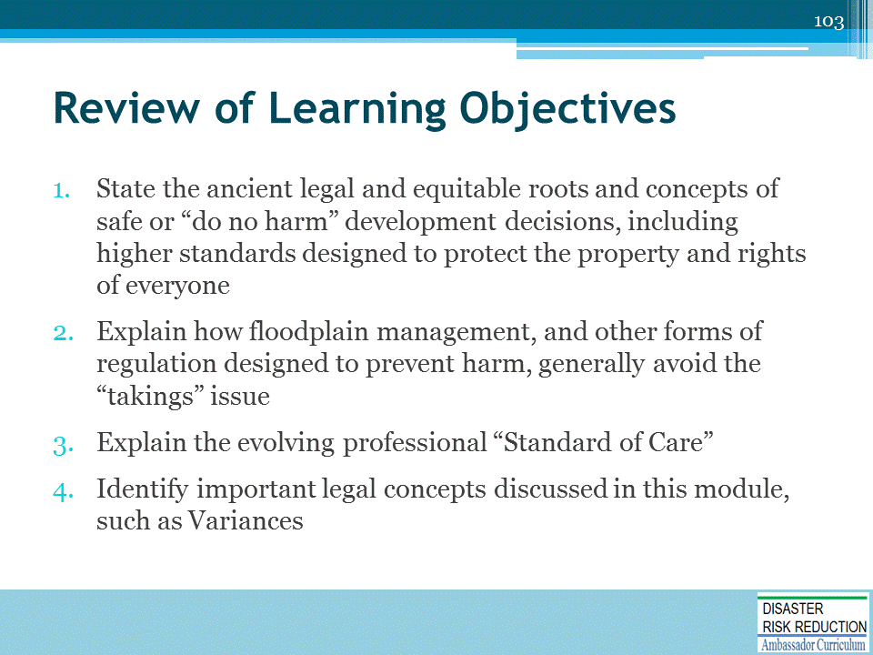

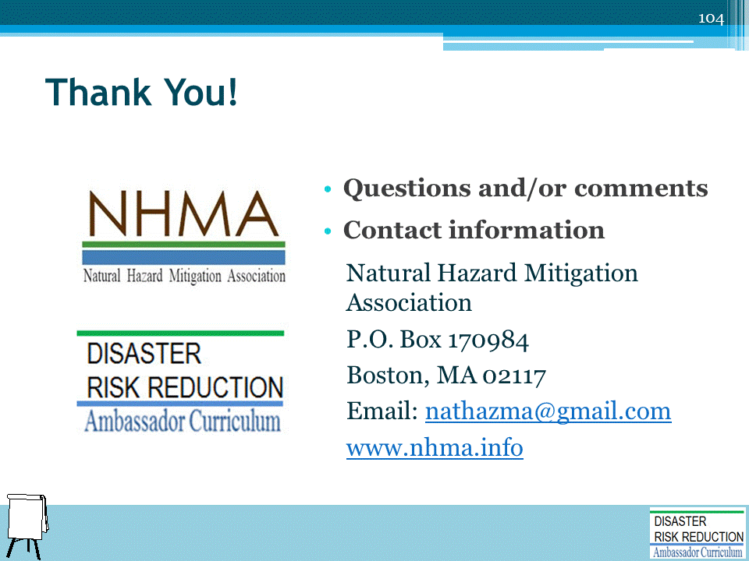

DRR AMBASSADOR CURRICULUM AT-A-GLANCE
I. Disaster Risk Reduction for a Safe and Prosperous Future
1 | Introduction to the Natural Hazard Mitigation Association and Disaster Risk Reduction Ambassador Curriculum
2 | Introduction to Disaster Risk Reduction as a Foundation of Community Resilience
3 | Leadership for Disaster Risk Reduction
4 | Community Disaster Risk Reduction and Adaptation
5 | Approaching the Challenge of Disaster Risk Reduction: NIST Community Resilience Guide
II. Forming a Community’s Vision for Disaster Risk Reduction
6 | Risk Assessment through Storytelling: An Asset-Based Approach
7 | Achieving Community Buy-in for Disaster Risk Reduction: Win-Win Approaches
8 | Leveraging Resources to Improve Disaster Risk Reduction
III. Realizable, Practical, and Affordable Approaches for Moving from a Vision for Disaster Risk Reduction to a Strategy
9 | Selecting and Implementing a Strategy for Addressing Community Disaster Risk Problems
10 | Integrating Hazard Mitigation into Local Planning
11 | Beyond Codes and Low-Impact Development
12 | Creating the Plan: A Sustainable Floodplain Management Process Model
IV. Resources and Tools for Implementing a Community’s Disaster Risk Reduction Strategy
13 | Climate and Weather Tools and Trends
14 | Risk Assessment Basics
15 | Legal and Policy Opportunities for Disaster Risk Reduction
16 | Linking Catastrophe Insurance to Disaster Risk Reduction
V. Resources for Hazard-Specific Disaster Risk Reduction
17 | Living with Water: Inland and Coastal Flooding
18 | Design for Flood Resilience: Part I: Floodplain Management and Flood Resistant Design
19 | Design for Flood Resilience: Part II: Green Infrastructure / Low Impact Development
20 | Overcoming Impediments to Flood Resilience: Paths Forward
21 | Wildfire Mitigation
22 | The Wildfire-Flood Connection
23 | Severe Thunderstorm/Tornado Safe Rooms
24 | From Policy to Engineering: Earthquake Risks

