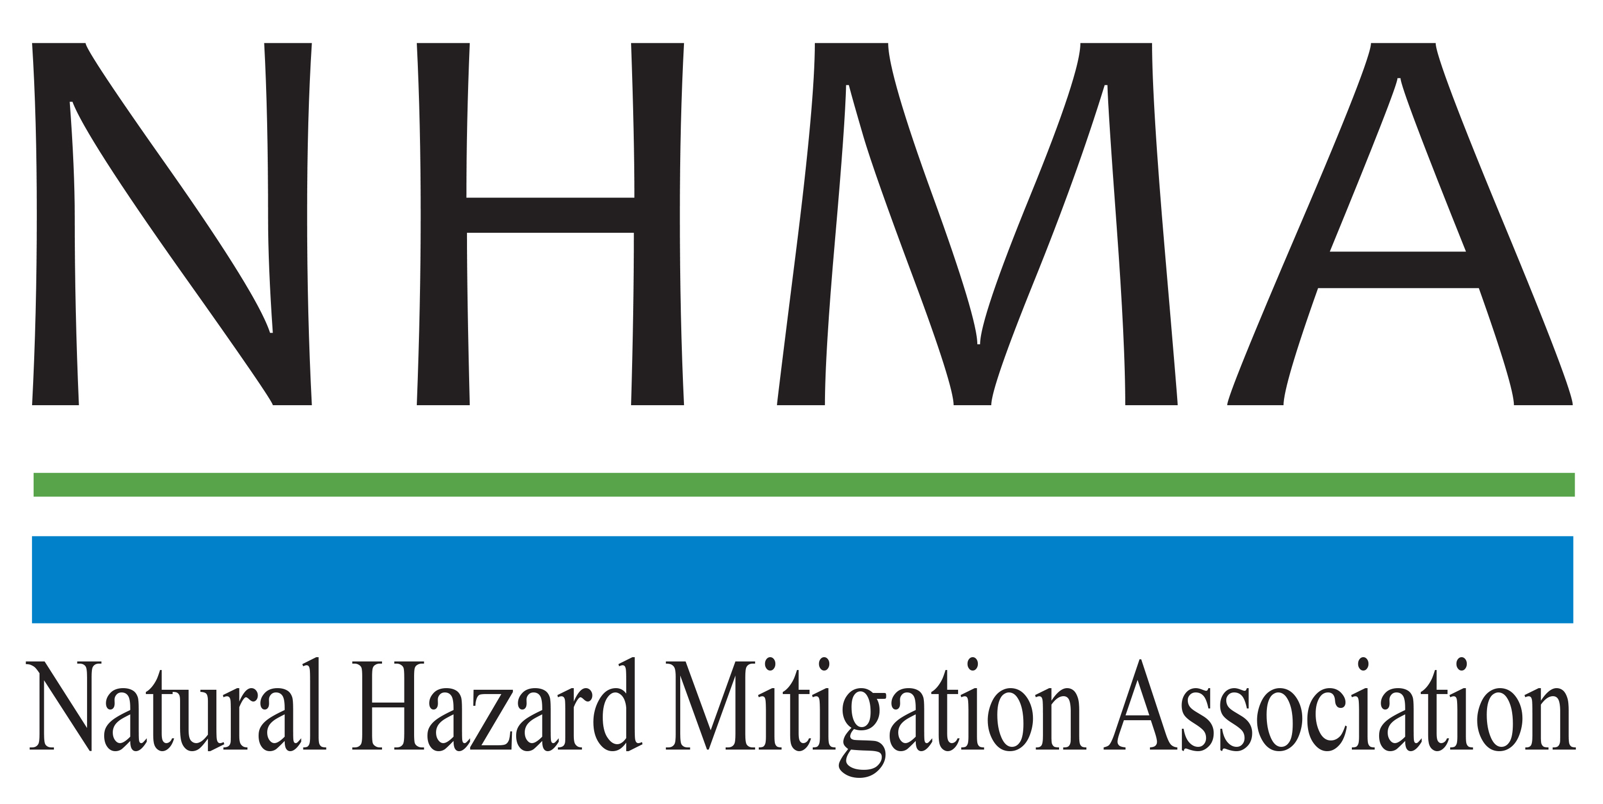

Disaster Risk Reduction (DRR) Ambassador Curriculum

Instructor Guide

Module 16:
Linking Catastrophe Insurance
to Disaster Risk Reduction

THE DRR AMBASSADOR CURRICULUM
The goal of the DRR Ambassador Curriculum is to facilitate Disaster Risk Reduction efforts for the whole community by:
- Engaging in discussion of how disasters can be reduced through local action
- Sharing insights among local leaders and technical experts to enable the development of cross functional solutions
- Acquiring the best-available information, knowledge of best practices, and analytic tools to enable better-informed decisions before, during, and after disasters
It is important for instructors of DRR Ambassador Curriculum modules to remember this is one module in a 24-module curriculum. The “DRR Ambassador Curriculum At-a-Glance” table, located at the end of this document, lists the modules of the Curriculum. Keep in mind the following context for the module(s) you conduct:
DRR-A CURRICULUM TARGET AUDIENCE
The target audience includes those involved in community development decision-making, such as local community staff, volunteer and stakeholder groups, and federal and state officials.
METHODS OF DELIVERY
Varied delivery methods will provide multiple options for access by the target audience. The DRR Ambassador modules may be presented via webinars hosted by NHMA or partner organizations, presented in conferences and/or classrooms by qualified DRR Ambassador Curriculum instructor(s), or are downloadable for individual study from the NHMA website.
COURSE MATERIALS
Instructors are expected to use the instructional materials housed on the NHMA website to conduct DRR Ambassador Curriculum modules (Instructor Guide, supporting visuals, Participant Guides, and handouts). Instructors may tailor modules to specific audiences or locations as long as they do not revise the learning objectives and do not revise the materials in such a way that the participants cannot correctly complete the post-test. Instructors request the current pre/post-test for the module from NHMA.
CERTIFICATES OF COMPLETION
Certificates of Completion will be awarded by NHMA to participants who successfully complete NHMA-sponsored DRR Ambassador modules. A DRR Ambassador Certificate will be awarded to individuals completing all 24 modules. Participants who choose not to take the post-test may be issued a Certificate of Attendance. Contact NHMA about obtaining certificates. Inform participants to ask their certifying boards about acceptance of NHMA DRR Ambassador certificates for continuing education credits.

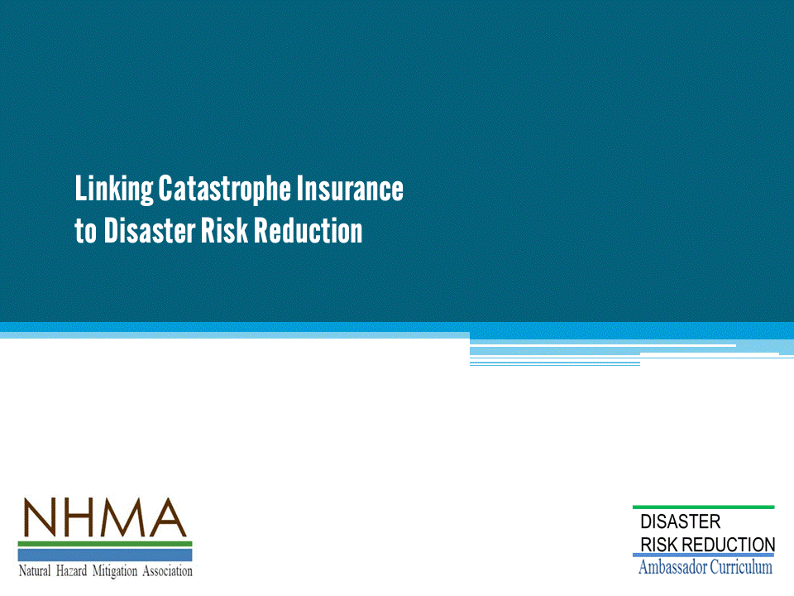
Approximate delivery time: 45-60 minutes

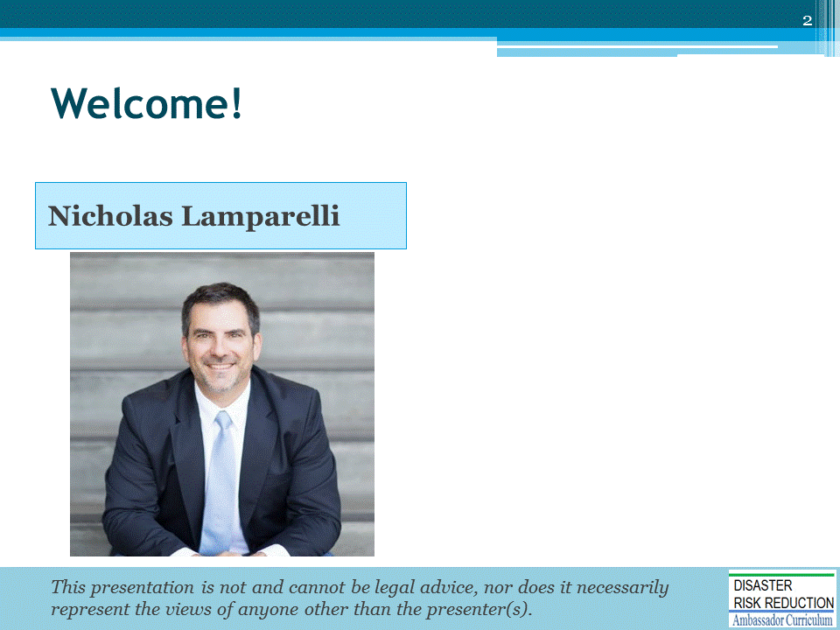
Introductions:
- Each presenter introduces her/himself, including affiliation and brief background.
- OPTIONAL: Have each participant briefly introduce him/herself
Mention: NHMA presentations are based on general principles of law, engineering, policy and emergency management.
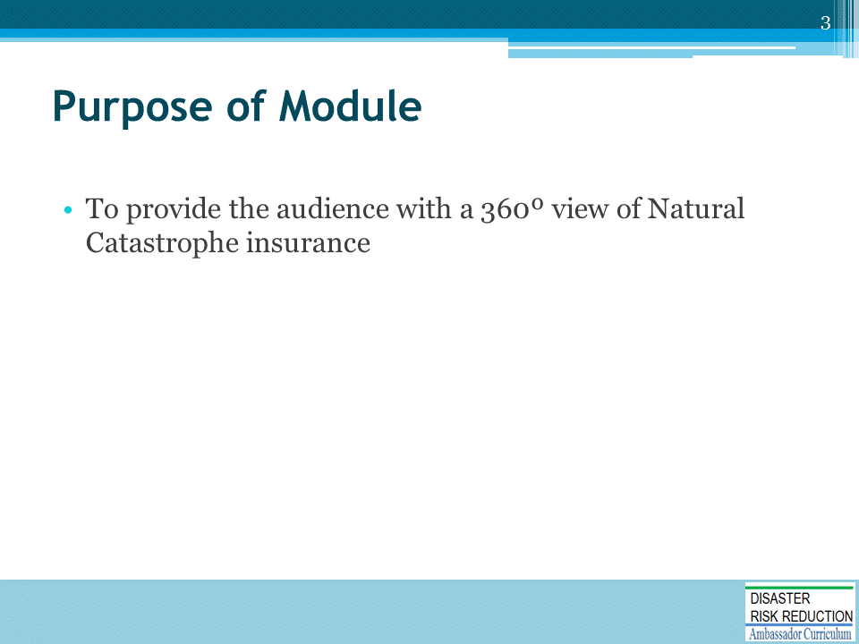

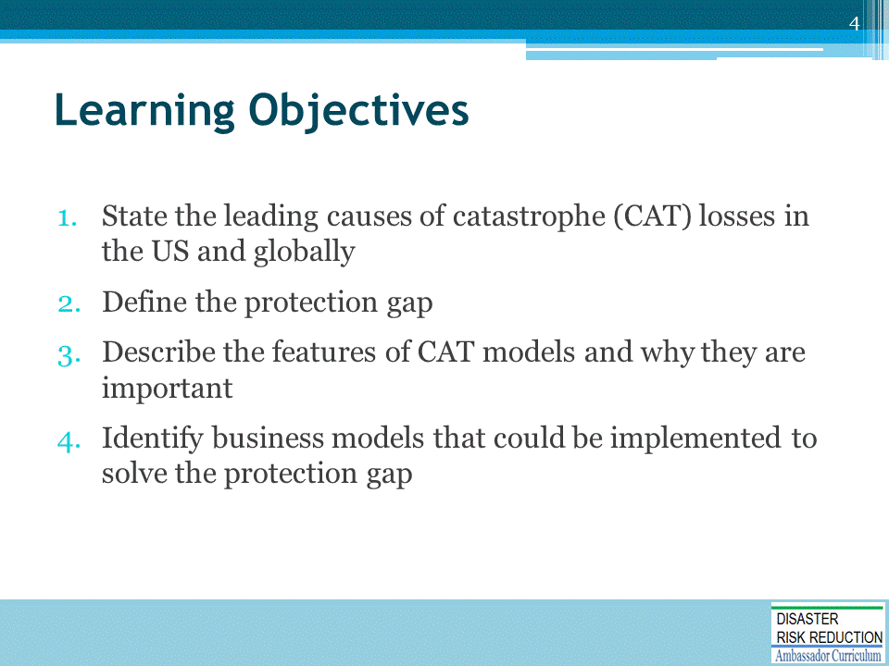

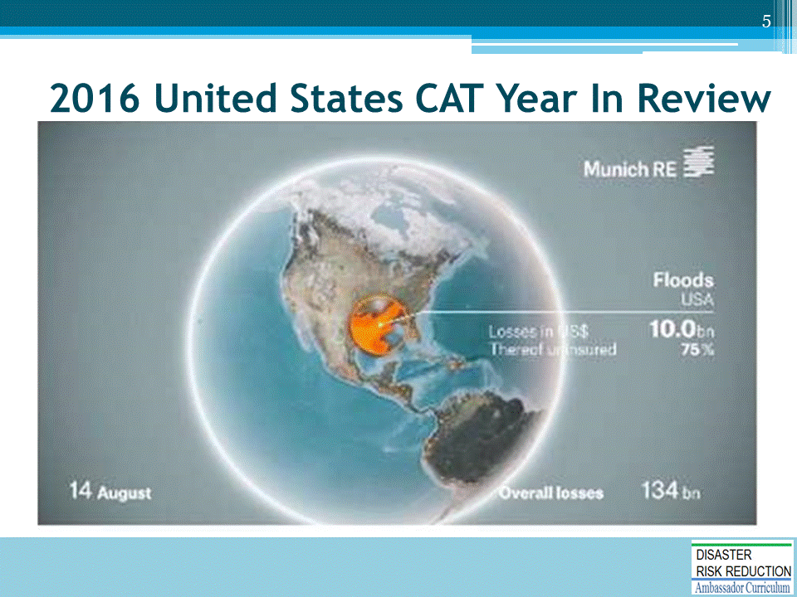
2016 US CAT losses were dominated by 2 events, less than 2 months apart.
- On August 14th, central Louisiana near Baton Rouge had received nearly 2-3 feet of rain within a 3 day period (https://en.wikipedia.org/wiki/2016_Louisiana_floods ). That amount was more that the total rainfall during Hurricane Katrina.
- In early October, Hurricane Matthew crawled the entire length of Florida’s Atlantic coastline as a category 5 storm. Luckily it remained offshore until it made landfall near Myrtle Beach, SC. https://en.wikipedia.org/wiki/Hurricane_Matthew
- The off shore movement of Matthew prevented wide spread wind related losses. Unfortunately, the path and intensity of the storm produced storm surges in excess of 10 feet in many areas from southern Florida to North Carolina, along with inland flooding from intense rainfall as the storm stalled overland.
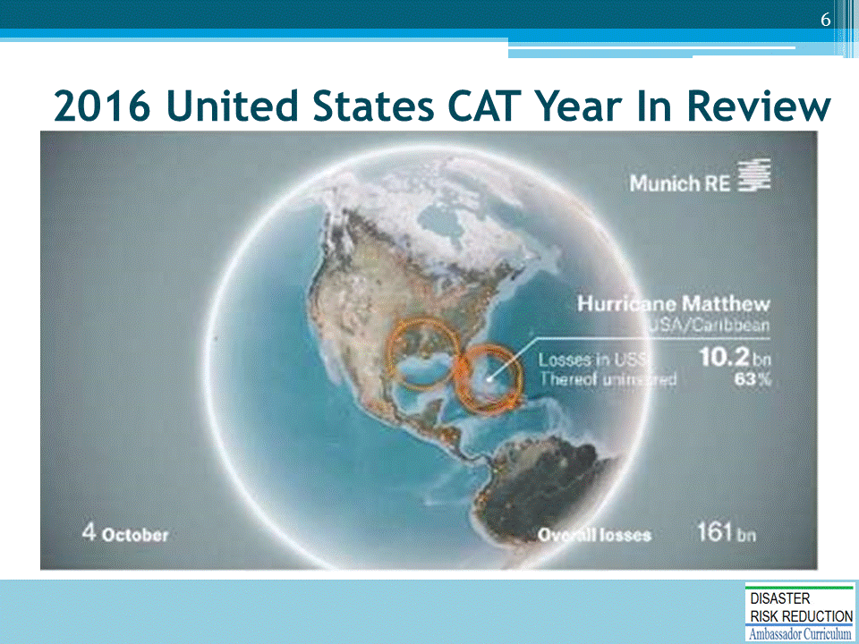
2016 US CAT losses were dominated by 2 events, less than 2 months apart.
- On August 14th, central Louisiana near Baton Rouge had received nearly 2-3 feet of rain within a 3 day period (https://en.wikipedia.org/wiki/2016_Louisiana_floods ). That amount was more that the total rainfall during Hurricane Katrina.
- In early October, Hurricane Matthew crawled the entire length of Florida’s Atlantic coastline as a category 5 storm. Luckily it remained offshore until it made landfall near Myrtle Beach, SC. https://en.wikipedia.org/wiki/Hurricane_Matthew
- The off shore movement of Matthew prevented wide spread wind related losses. Unfortunately, the path and intensity of the storm produced storm surges in excess of 10 feet in many areas from southern Florida to North Carolina, along with inland flooding from intense rainfall as the storm stalled overland.
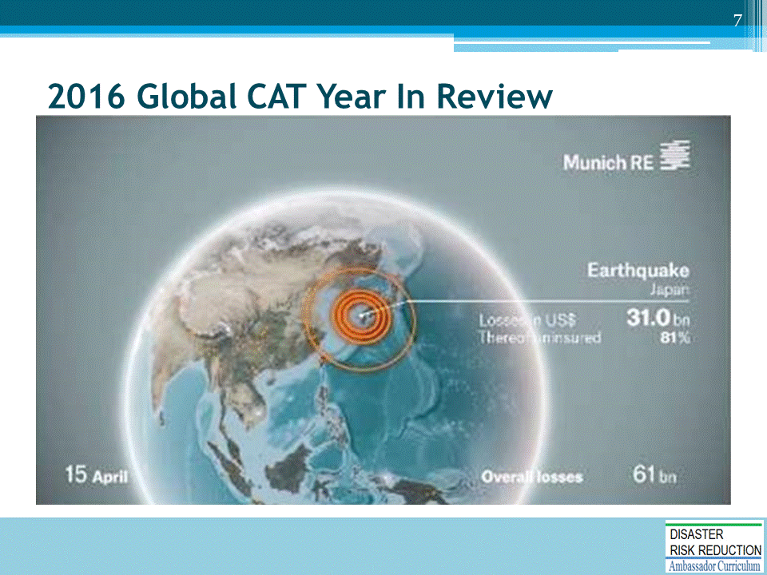
- Global natural catastrophes rose to the highest level in 4 years. Total losses were estimated at $175 billion which was about 67% larger than 2015 and almost as high as the $180 billion in losses set in 2012 (the year of Sandy).
- Astonishingly, only $50 billion of the $175 billion (or 30%) WAS INSURED!
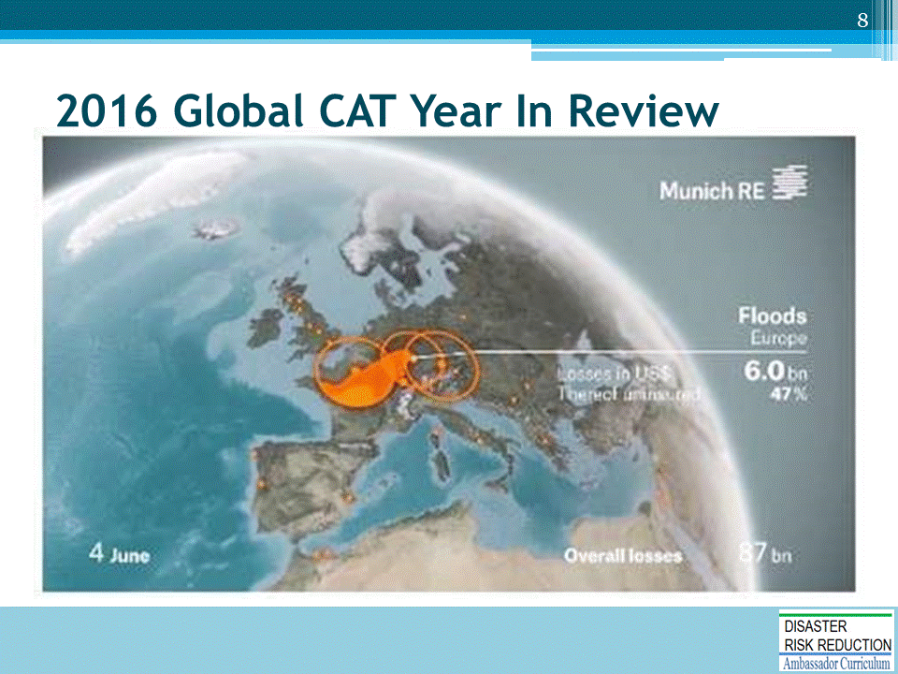
- Global natural catastrophes rose to the highest level in 4 years. Total losses were estimated at $175 billion which was about 67% larger than 2015 and almost as high as the $180 billion in losses set in 2012 (the year of Sandy).
- Astonishingly, only $50 billion of the $175 billion (or 30%) WAS INSURED!
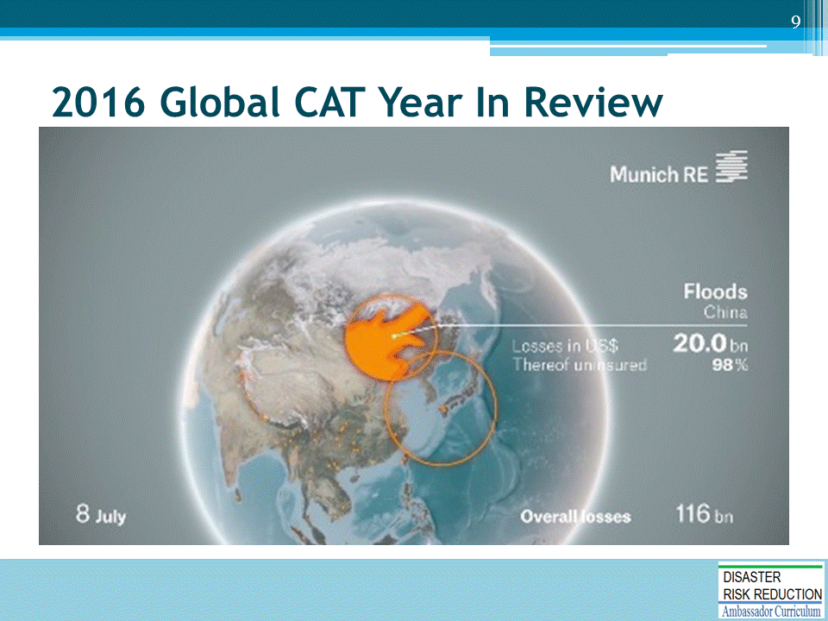
- Global natural catastrophes rose to the highest level in 4 years. Total losses were estimated at $175 billion which was about 67% larger than 2015 and almost as high as the $180 billion in losses set in 2012 (the year of Sandy).
- Astonishingly, only $50 billion of the $175 billion (or 30%) WAS INSURED!
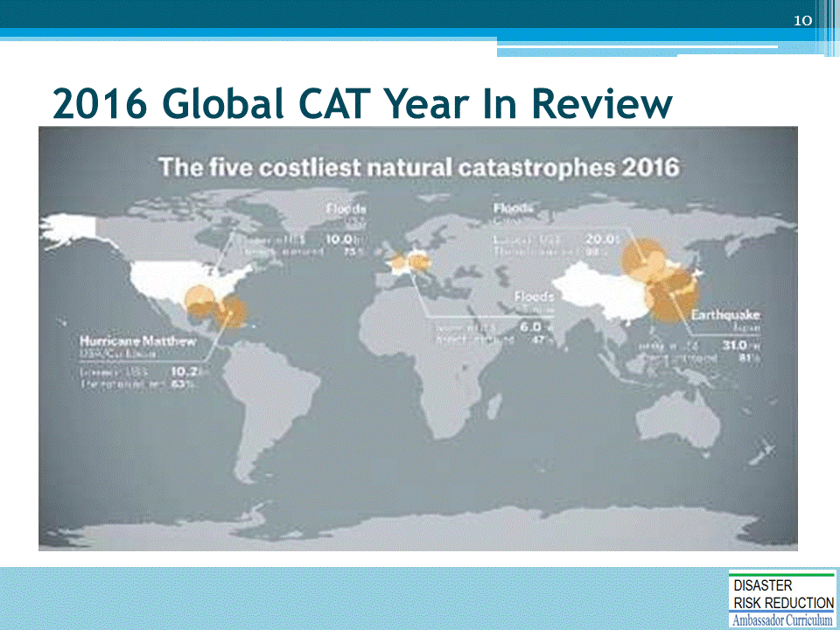

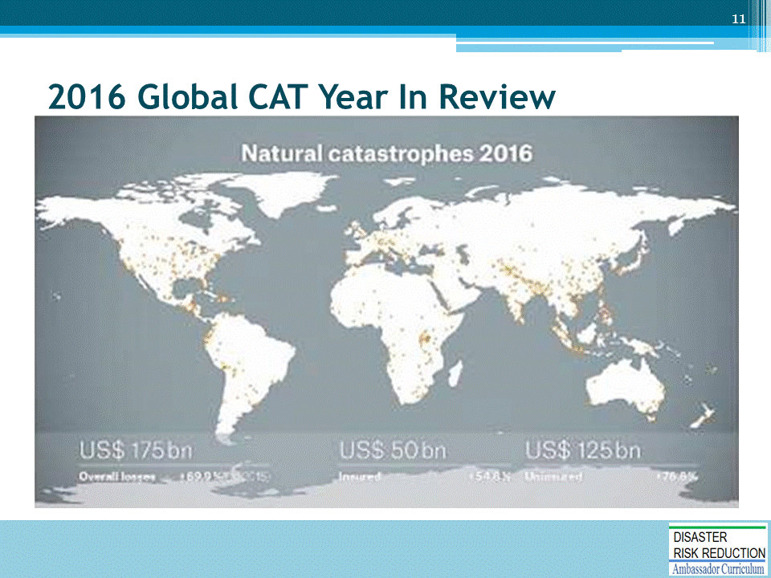

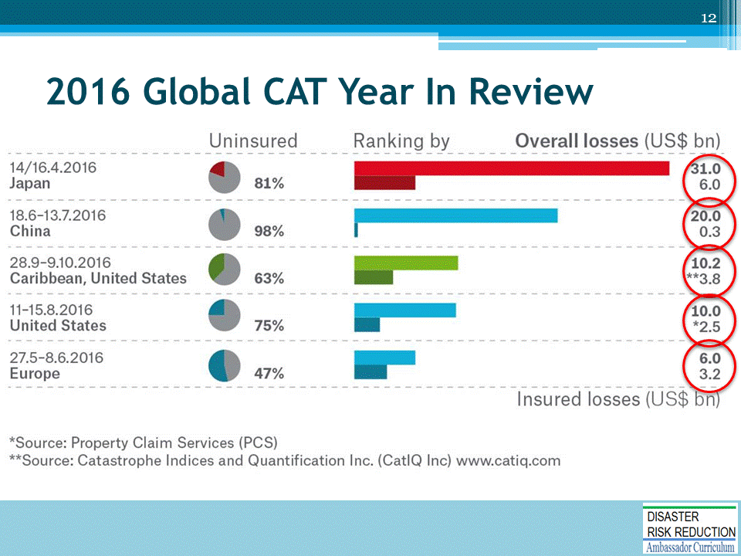
- The red circles highlight the major problem society must deal with when it comes to natural disasters; that is, that the amount of actual damage insured is only a very minor percentage of the total actual damage.
- This is called the protection gap.
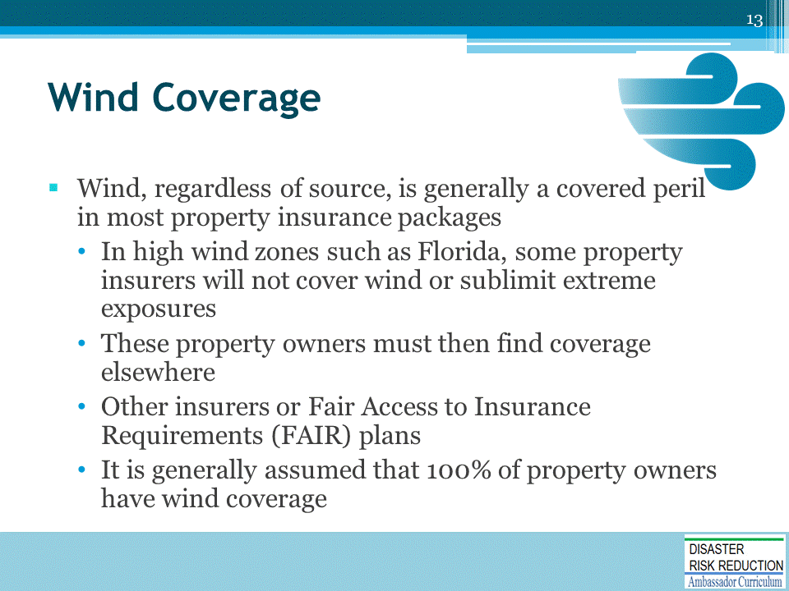
- FAIR = Fair Access to Insurance Requirements. These are state mandated insurance facilities where the state becomes the insurer of last resort for property owners who cannot get coverage through typical placements. The exposures are allocated to all insurers in the state based on their proportion of market share in the state.
- https://www.thebalance.com/fair-plan-policies-2645392
- A FAIR plan CEO once told me that the job of the FAIR plan CEO, unlike a traditional insurance company CEO, is to find ways to make their portfolio SMALLER, not larger.
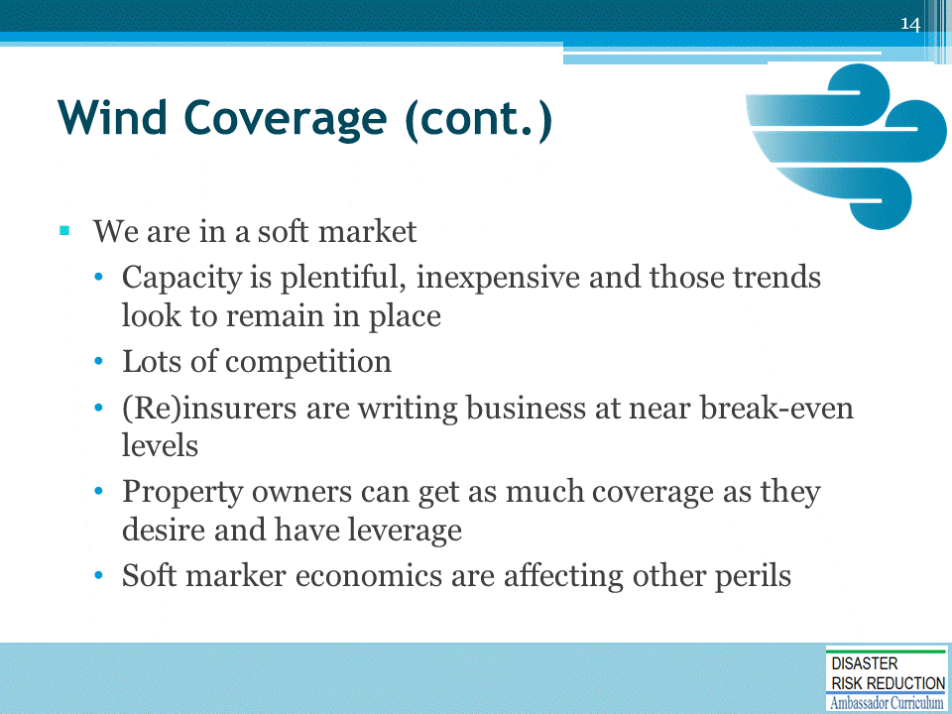
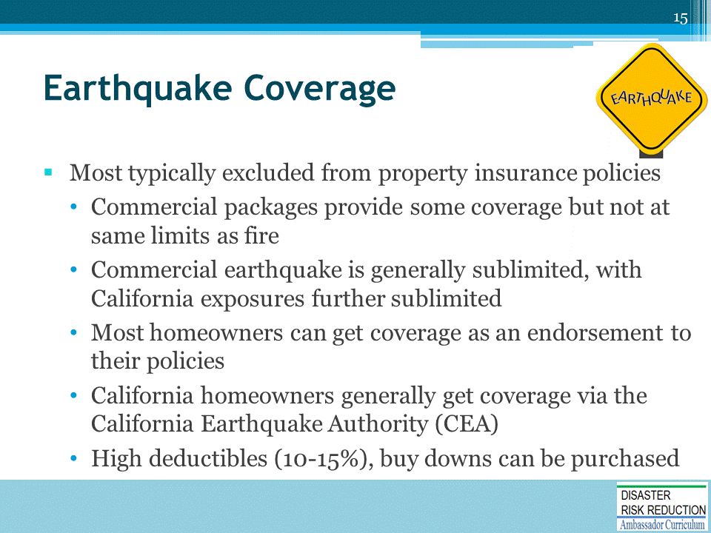
- Earthquake is different from wind because it is not standard coverage, it is most often sold as a separate policy.
- This creates strange incentives and attracts above-average hazard exposure.
- Thus, the risk pool is strained because low-risk exposures generally opt out.
- High risk pools = high premiums.
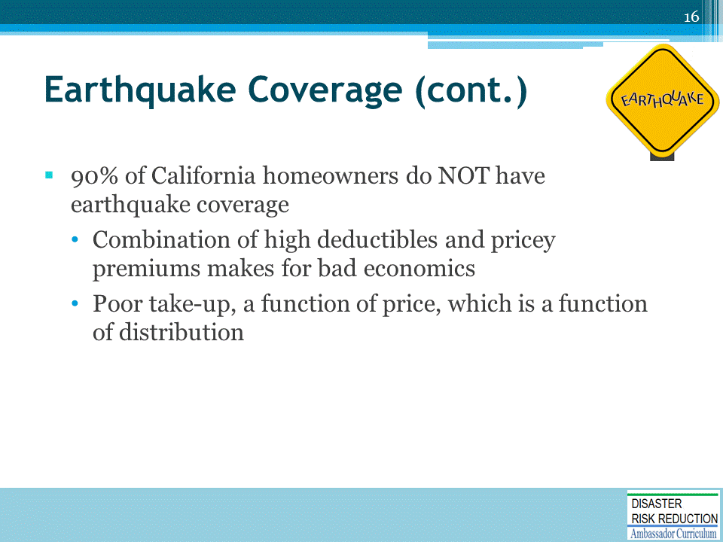

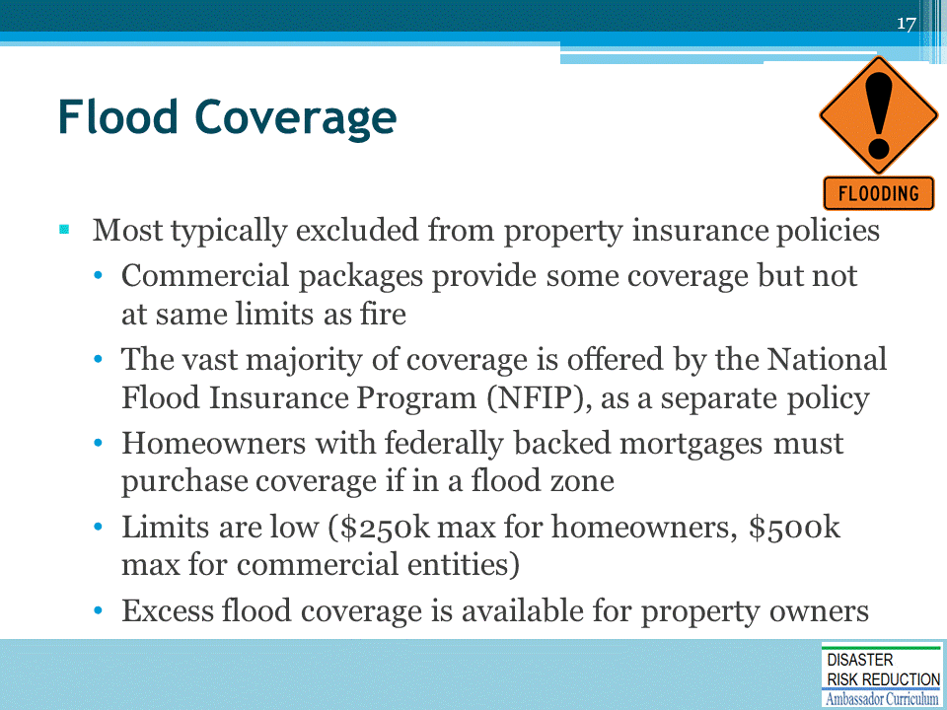
- Flood is different from wind because it is not standard coverage, it is most often sold as a separate policy.
- As with earthquake coverage, this mono-line feature makes adverse selection a reality.
- The premiums are generally high because of this.
- 75-80% of the NFIP portfolio is in moderate to extreme flood zones.
- Getting additional off flood plain exposures into the portfolio would de-risk the portfolio and provide premium flexibility.

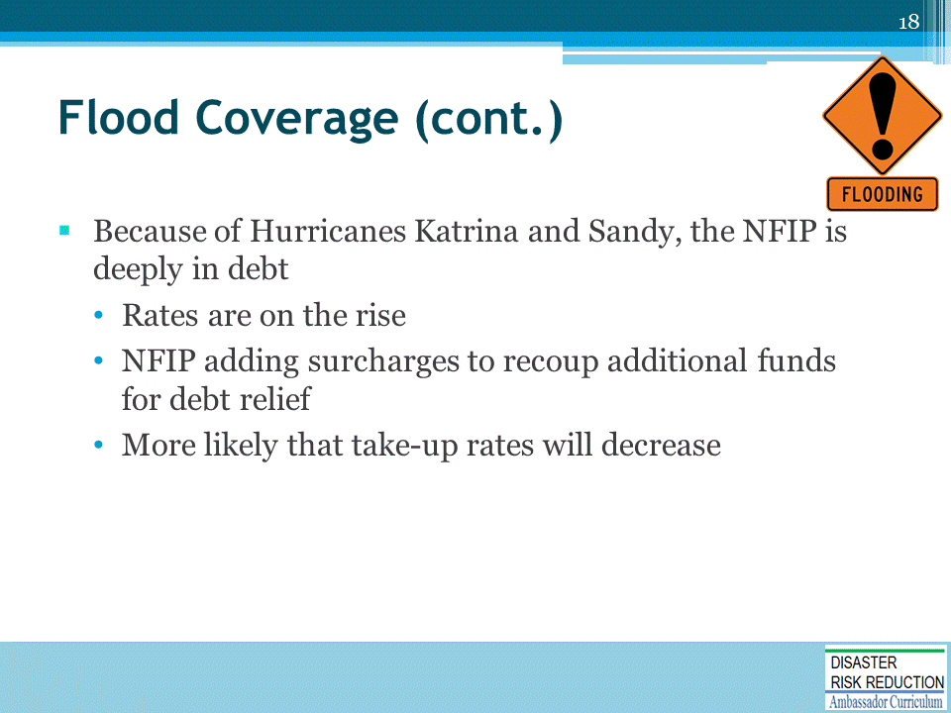
- Flood insurance is getting more expensive.
- The Biggert Waters act of 2012 legislates that the NFIP must move towards actuarial sound rates.
- More recent legislation has slowed down the implementation of these rates.
- Nevertheless, rates are still increasing along with surcharges as the NFIP looks to recoup some of the debt to the US Treasury (now at $25 billion)
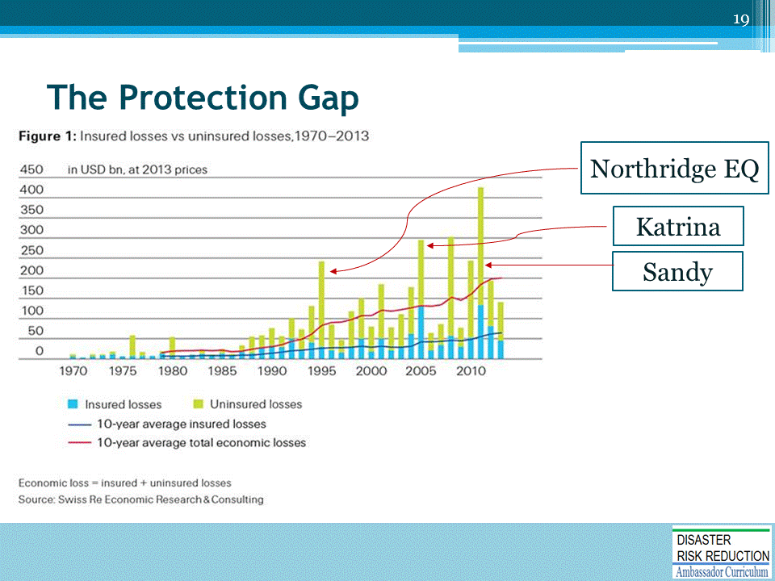

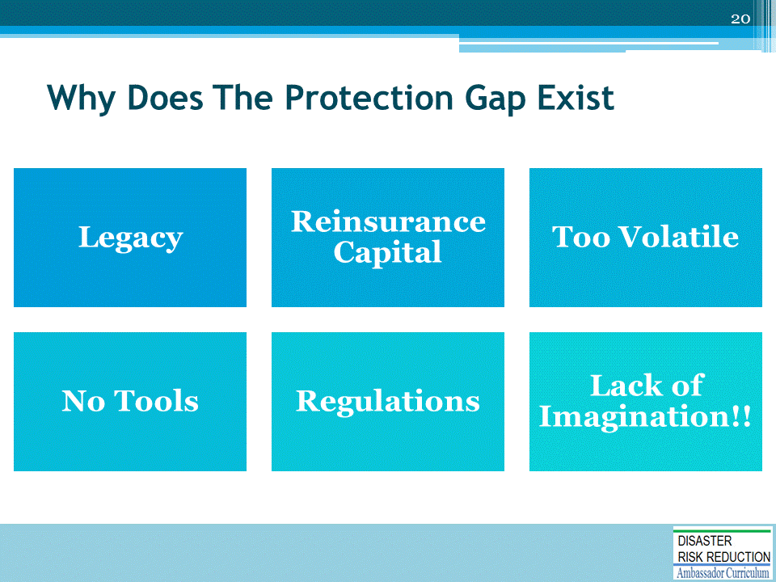
- Legacy – Initial package policies included wind but did not contemplate flood or EQ
- Reinsurance capital – reinsurance capital was tied up in other insurance
- Too volatile – Flood and EQ risk are very volatile to earnings. Without reinsurance, management will not stick their necks out
- No tools – Loss models, maps
- Regulations – National laws discourage private flood. State laws.
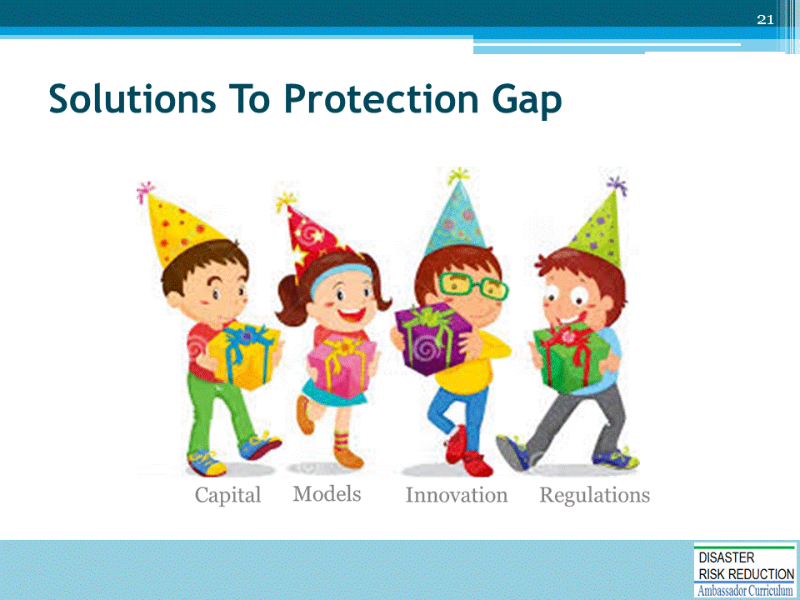

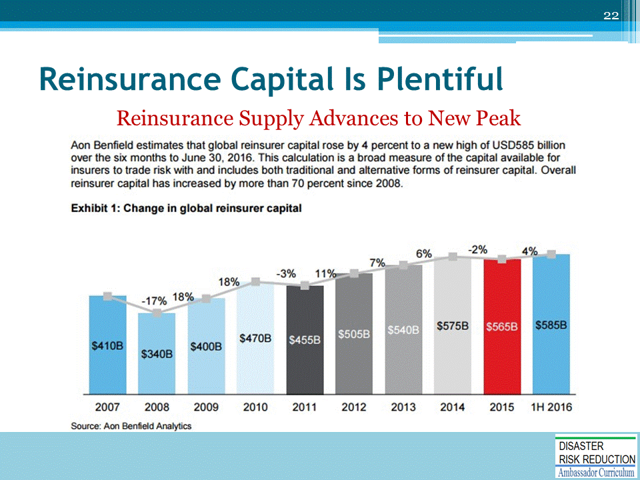

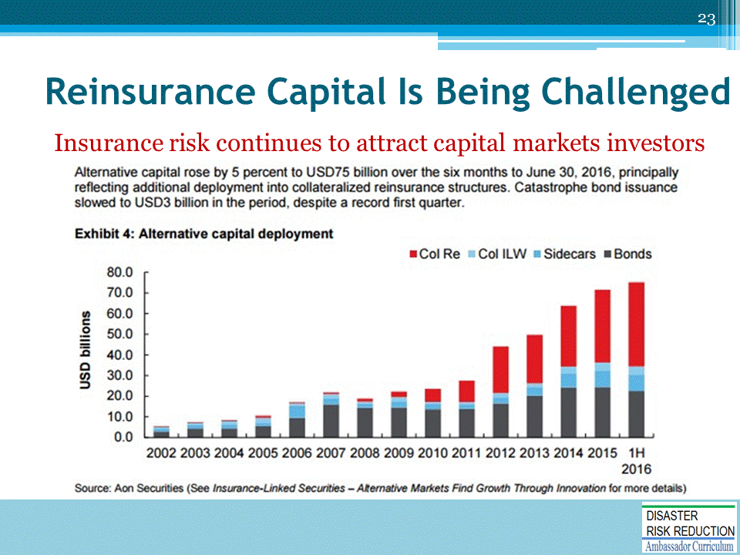
‘Capital from private equity and non-insurance sources have flooded into the insurance sector and now represent > 10% of all reinsurance capacity

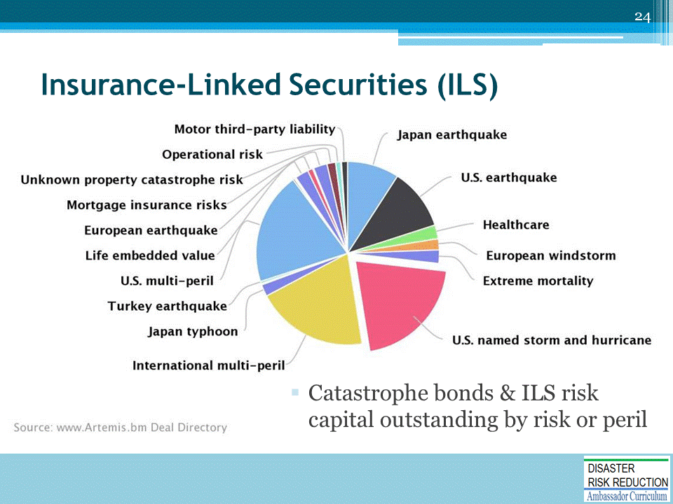

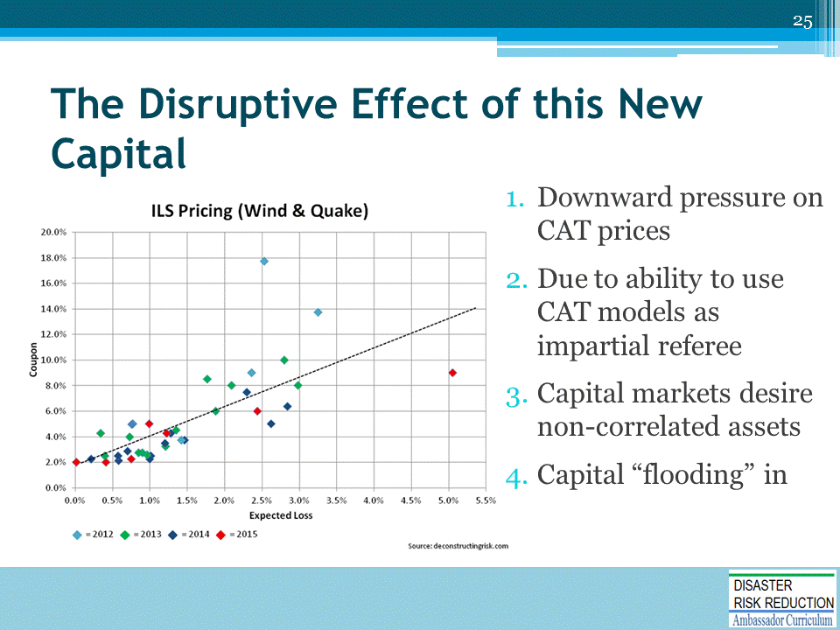

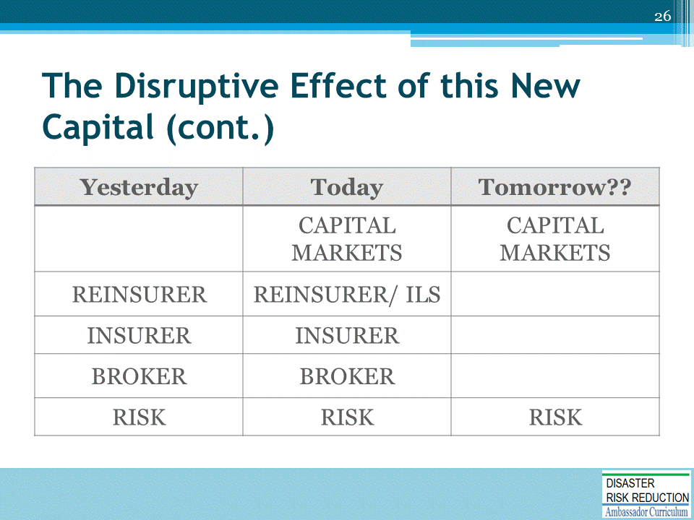

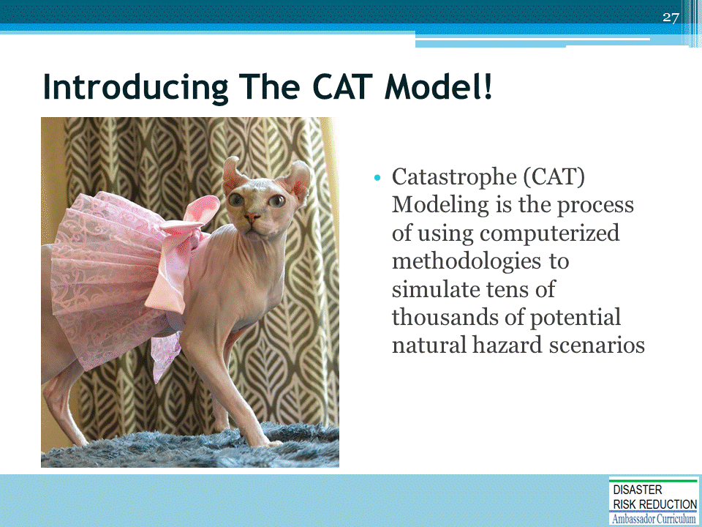
In order to understand catastrophe insurance, it is important to understand CAT models.
- CAT models have become ubiquitous in insurance.
- They are so commonplace, that the models drive CAT pricing.
- But they are not crystal balls. They cannot be used to predict events that will occur next year or the year after (or the year after that).
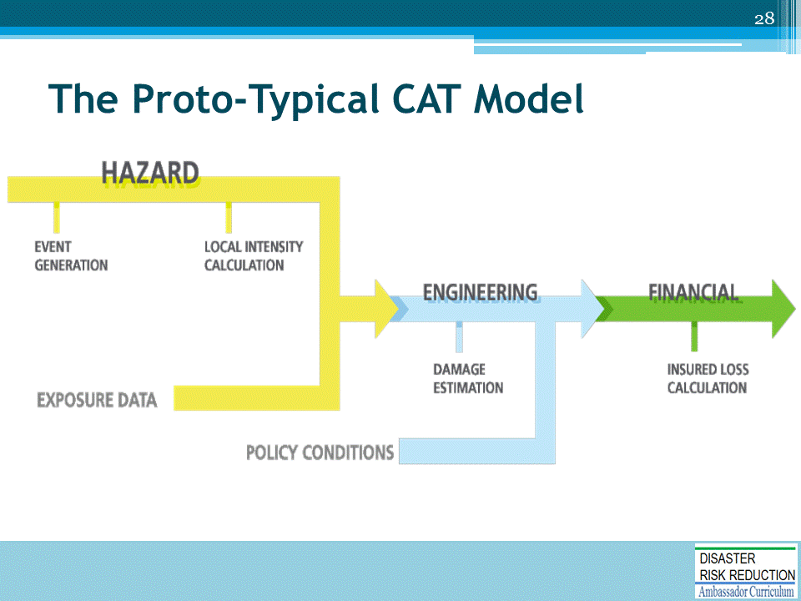
Regardless of modeling firm or developer, all CAT models follow this process:
- The first layer or module of any CAT model is to determine the range of possible events that can occur. This is called the Hazard component.
- Next, the model must determine the distance between the property and the source of the event. How much wind energy or ground shaking actually makes it to a property can then be used to estimate how much damage will actually occur. Damage estimation is part of the Engineering component of the model.
- Finally, once we can estimate a range of property damage, we apply limits, deductibles and other terms & conditions found in an insurance policy to estimate the actual financial loss to all stakeholders.
- So, regardless of vendor, all CAT models follow this basic format. Differences between models lie is assumptions about each module, such as whether a CAT 5 hurricane could make landfall in New York City…

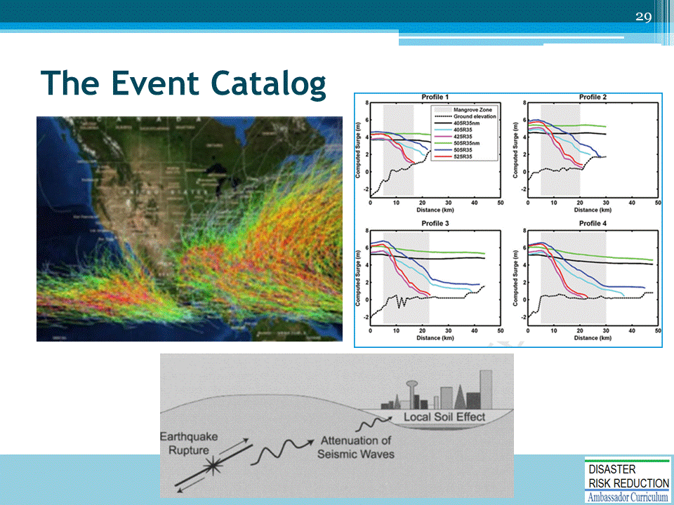
Every CAT model has an event catalog which is a database of all the events which as simulated.
The top/ left photo is a typical “spaghetti” chart showing all of the events being simulated.
Differences between model makers could be seen by different event track patterns and different intensities (denoted by color).
Given a particular event that is being simulated, the model then estimates how the physical intensity of the wind, ground shaking, blast or whatever energy is being created dissipates or attenuates over distance and time to the property in question.

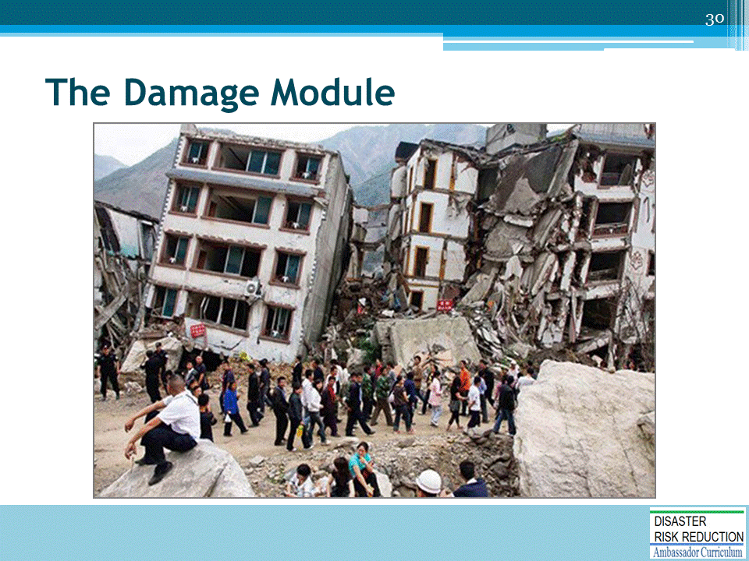
- The damage module is also known as the engineering or vulnerability module.
- Engineers can estimate losses in a computerized simulation by looking at past losses.

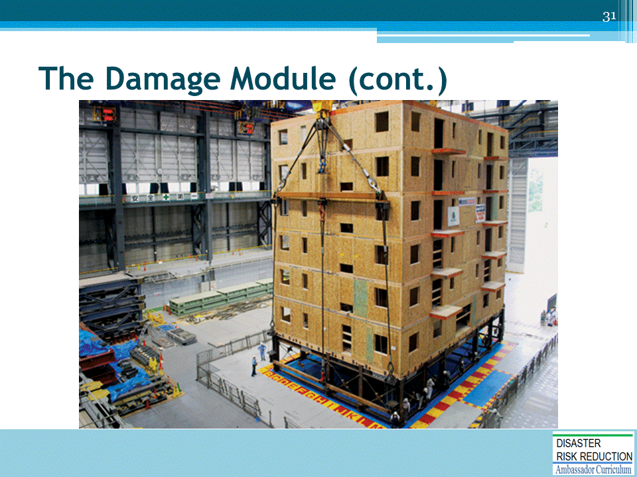
- Engineers can also estimate simulation losses by actually simulating hazards themselves, such as in a wind tunnel or in this photo, a VERY large shake table.
- Engineers take the results of these experiments and use them to estimate how buildings will perform when faced with extreme wind, shaking or forces.

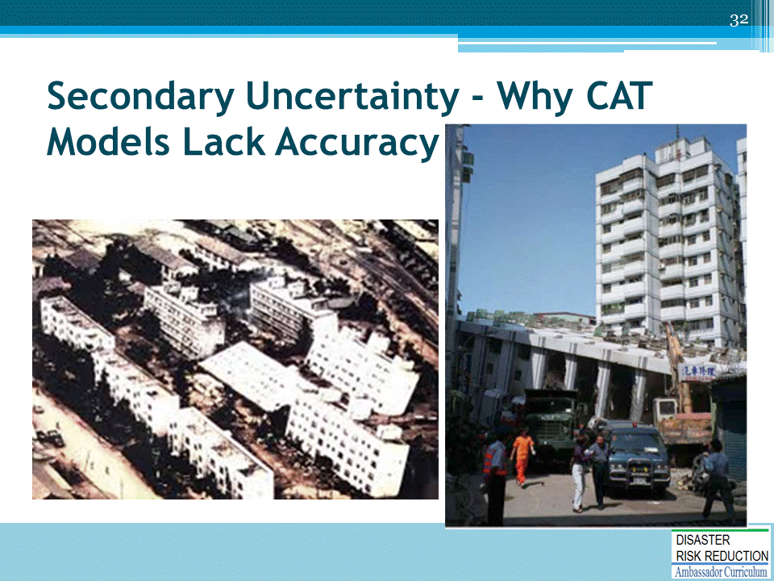
CAT models can never be ultra-accurate at small degrees of resolution.
What we have learned from other catastrophic events is that we are constantly surprised.
As the pictures above show, identical structures can behave very differently when put under pressure.
There can be many reasons for this:
- Conditions can vary from location to location.
- Ground soil can have an interface between really hard rock and really soft rock, for instance in earthquake modeling.
- Or one building could be facing the brunt of a wind storm while another nearby is getting a benefit from being shielded by those same winds.
- Sometimes, the difference is more sinister. Such as did the building contractor evade code standards in order to save costs (such as the following photo)

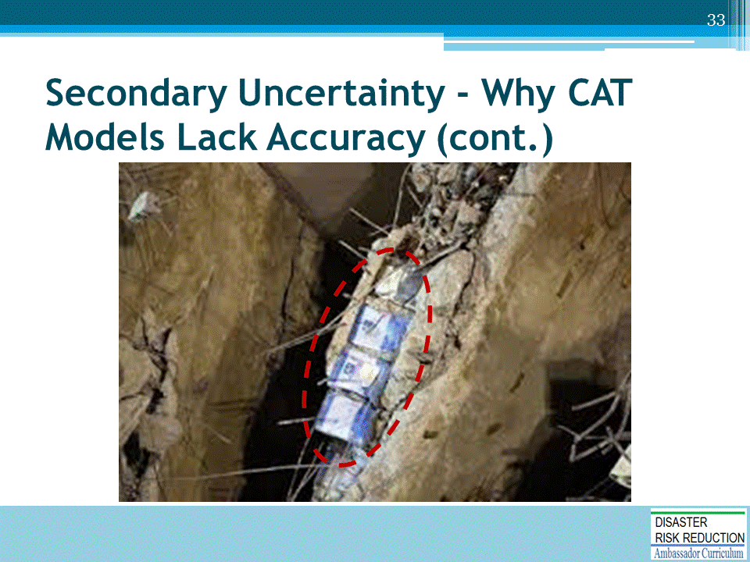
No matter how sophisticated a model, we will never be able to capture this level of data.
In this photo, the building contractor in Turkey, used paint cans between building floors to save money on concrete expenses.
After every event, modeling teams descend onto the hardest hit areas to assess how the model did.
After each event, modeling teams report back their findings which often include notes about lack of building code adherence.

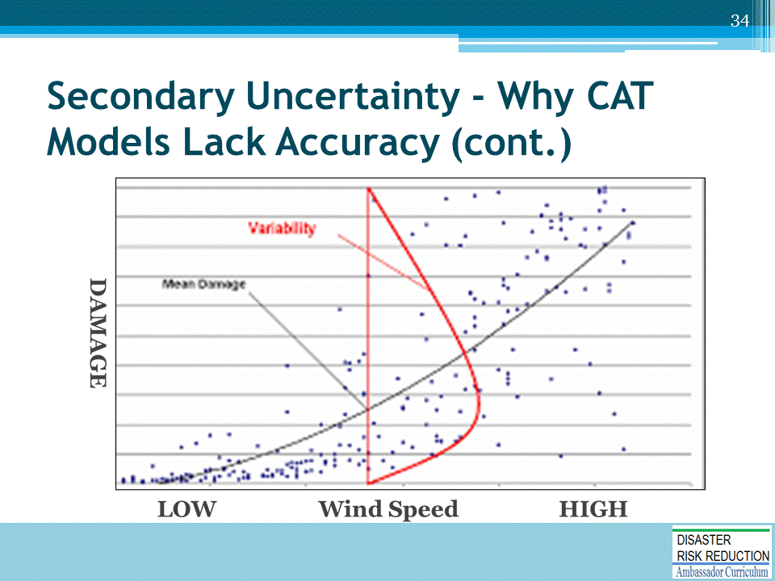
This is a chart of damage to wind speed.
- The red line and curve show the vast ranges of damage given one specific wind speed.
A good CAT model needs to provide stakeholders with an estimate.
We often use an average estimate. But these averages can have wide standard deviations as you can see.
So it is NOT reasonable to expect CAT models to produce “accurate” event level damage estimates.

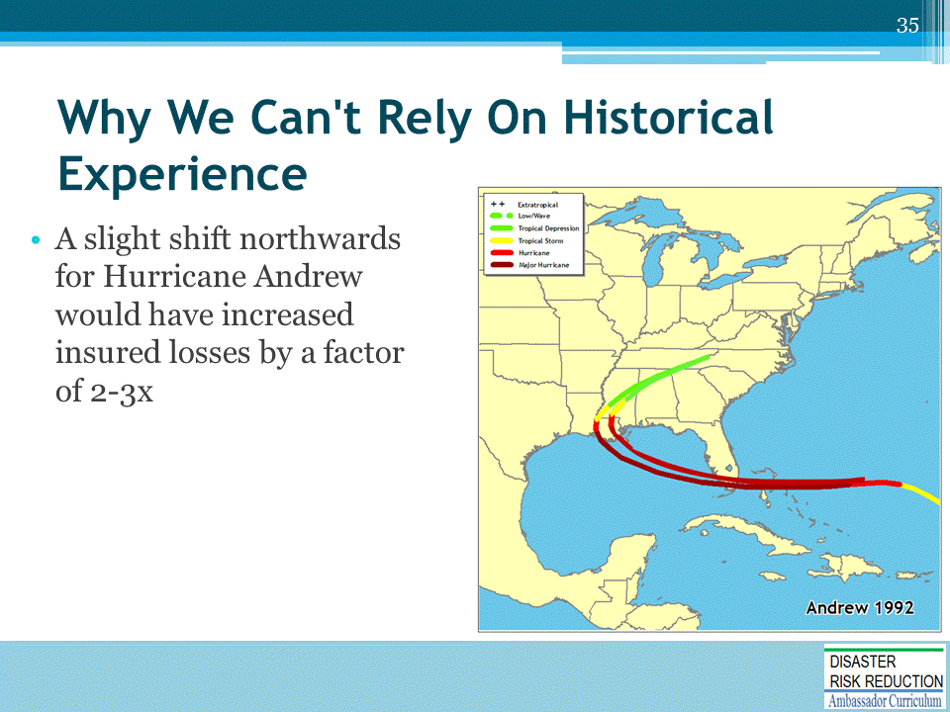
- Using historical experience alone would eventually be disastrous for a company with a large concentration of business in Miami/Ft. Lauderdale/ Palm Beach area
- Using simulation of events that have not occurred, we can estimate losses for various combinations of event frequency, size and random epicenters
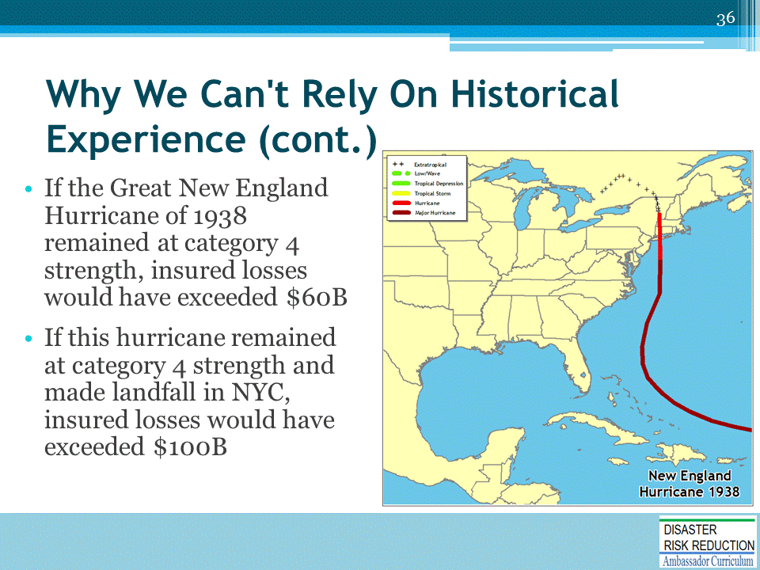
Simulation modeling attempts to remove the “luck” or randomness factor out of the historical experience
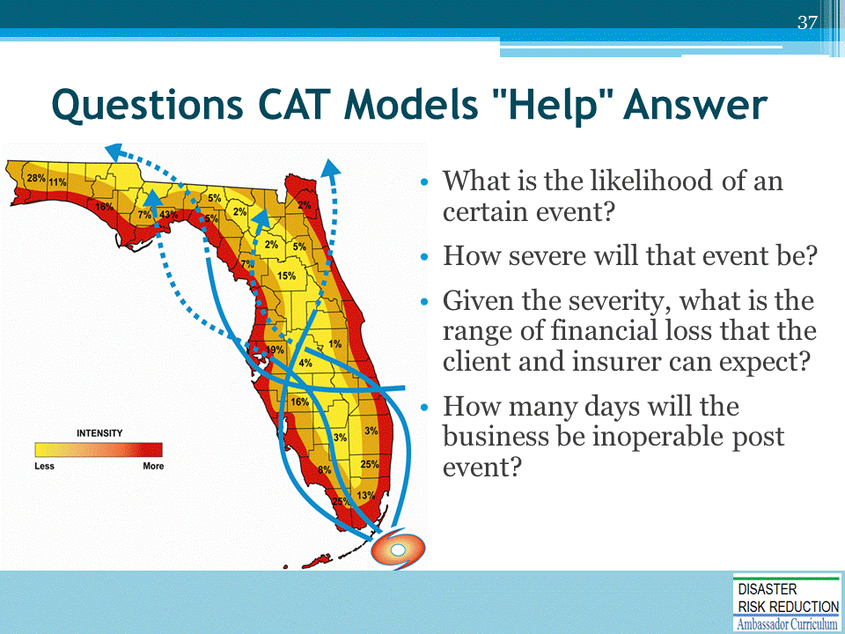

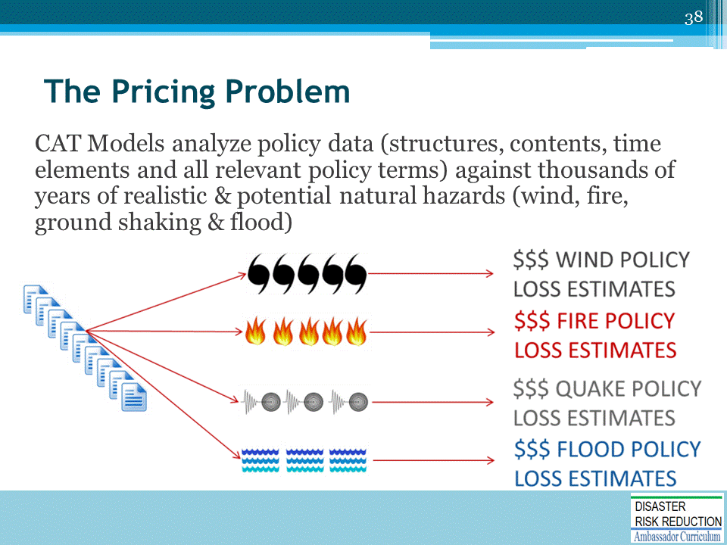
The Pricing Problem- Using CAT Models to Price Policies

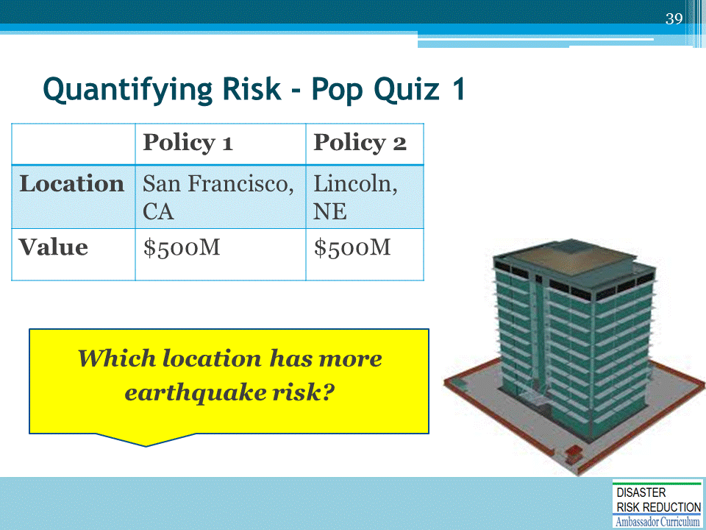
Which location has more earthquake risk?
- This is a pretty simple question.
- 100% of everyone I ask knows that California is “earthquake country” and Nebraska isn’t.

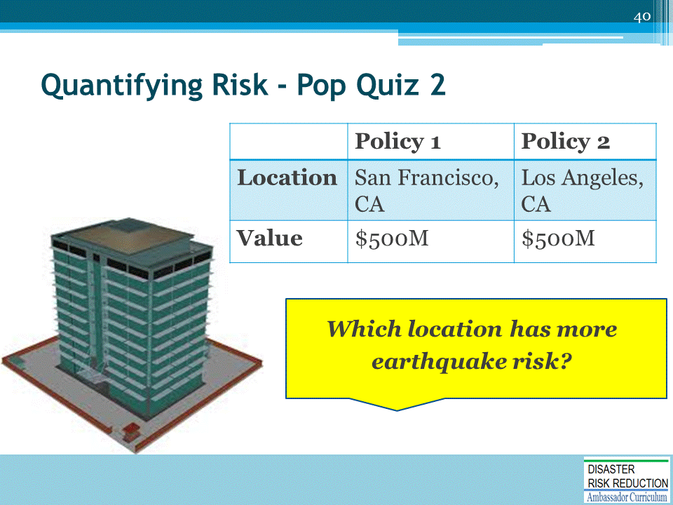
Which location has more earthquake risk?
- This question is a bit tougher.
- Both locations are in earthquake country, so which location has higher risk? This is why we need CAT models. There are just too many random variables floating around and only a model can perform all of the necessary billions of calculations required to get to an answer with confidence.
- In case you are curious, San Francisco sits closer to TWO major faults, the San Andreas and the Hayward. Both can produce earthquakes exceeding Magnitude 7. San Francisco is expected to see slightly more frequency of events and those events will generally produce more significant ground shaking in San Francisco than what will be expected to arise from faults around Los Angeles.

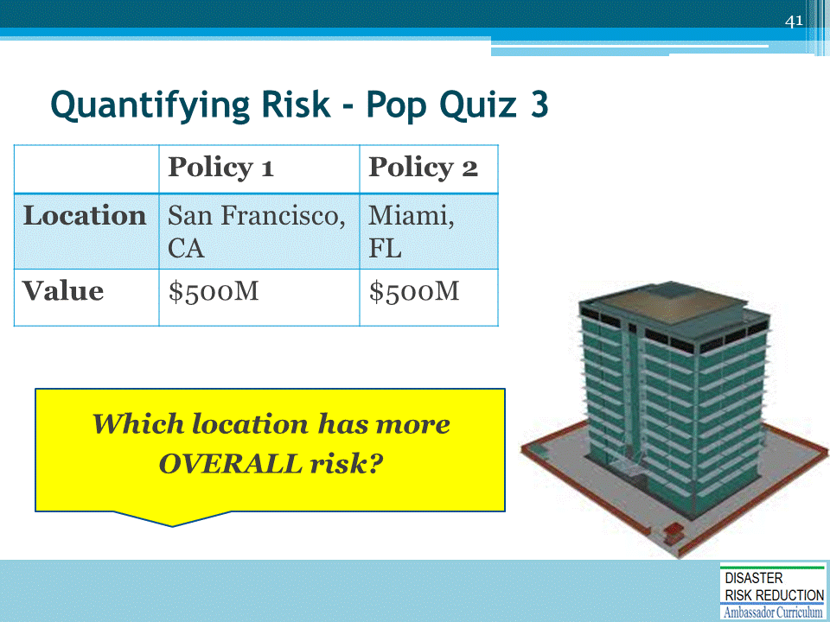
- This question is to challenge the participant to think about risk across disparate perils.
- This is another question which highlights the benefits of using a CAT model.
- The model not only needs to know what types of events each building thousands of miles away from one another would be exposed to, but also be able to reconcile building codes and how buildings behave when shaken by wind or ground motion.
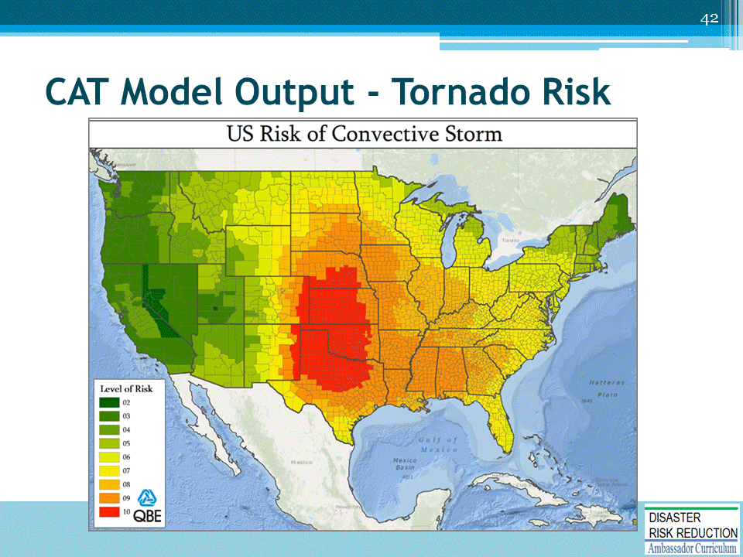
- This is a map of estimated losses from simulations generated by a CAT model.
- As is to be expected, the central US is highly vulnerable to tornadoes and severe storms.
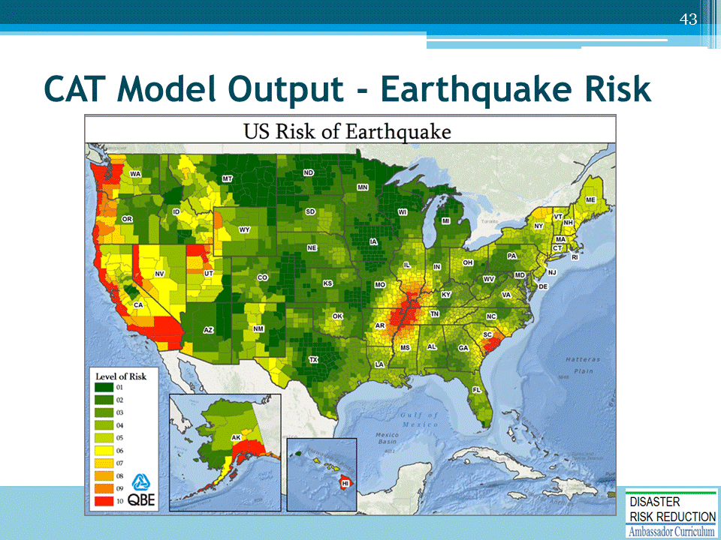
- This is a map of estimated losses from simulations generated by a CAT model for earthquake risk in the U.S.
- Notice how there are regions in the U.S. where earthquake risks are higher than in California.
- The largest ever recorded earthquake in the lower 48 states occurred in 1811-1812 in New Madrid, MO. The earthquakes was in the 7.5 magnitude range. This is severe and extreme. Shaking was felt all the way to Boston. https://earthquake.usgs.gov/earthquakes/events/1811-1812newmadrid/summary.php
- In 1886, Charleston, SC was hit with a 6.9-7.3 earthquake. Shaking was felt as far away as Boston and Milwaukee. https://en.wikipedia.org/wiki/1886_Charleston_earthquake
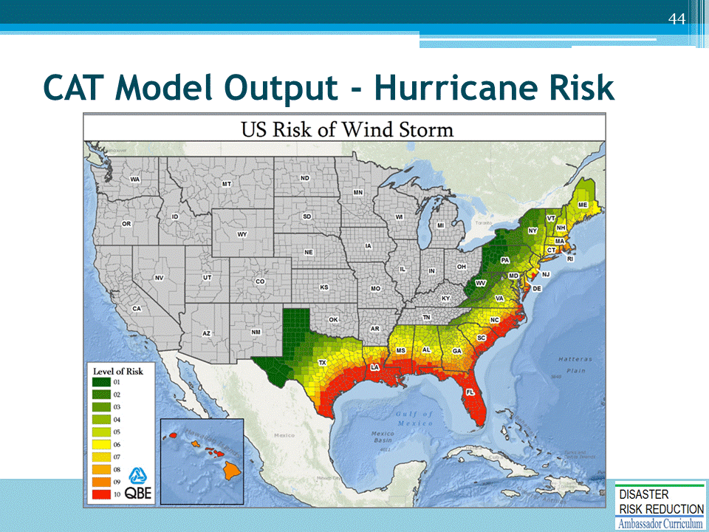
- Here is a map of estimated losses from simulations generated by a CAT model for hurricane risk in the US.
- In recent years, modeling firms have extended hurricane wind fields to generate losses all the way up to Missouri and Ohio.
- This was in response to Hurricane Ike, which after landfall, re-strengthened by merging with another system.
- Losses exceeded $1 billion in the upper Mid-west.
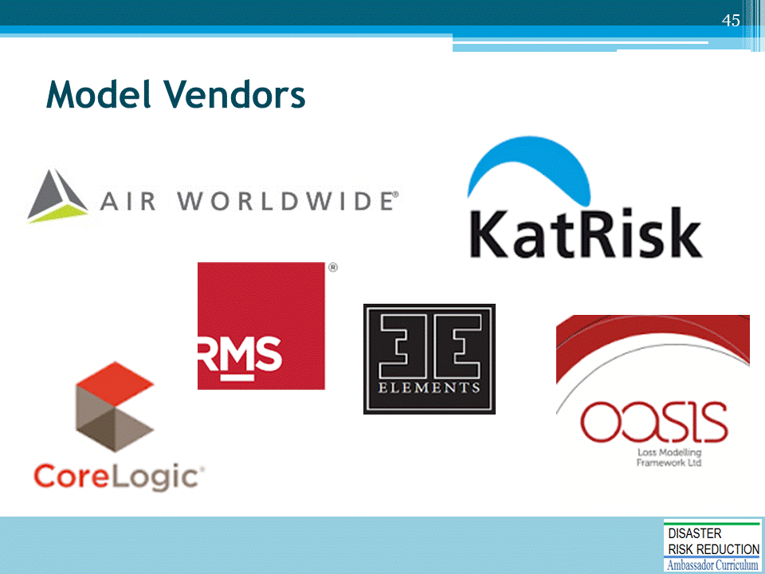

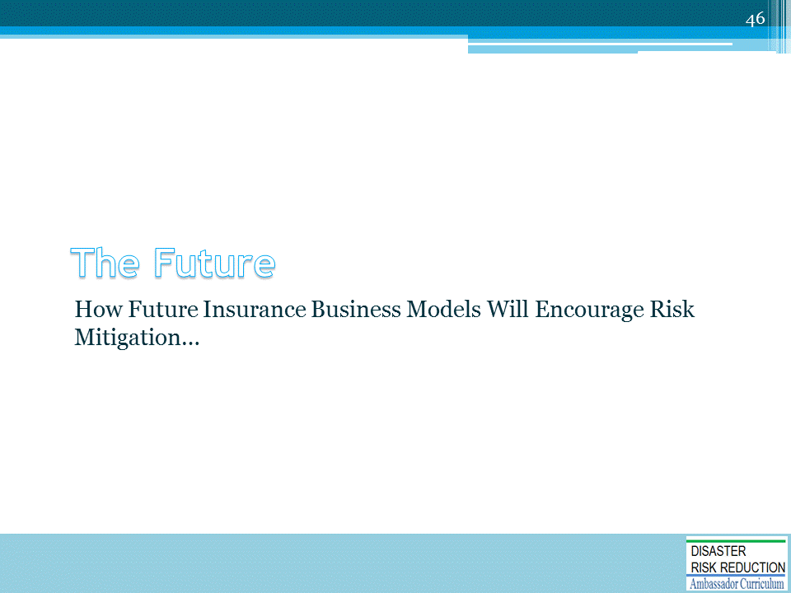

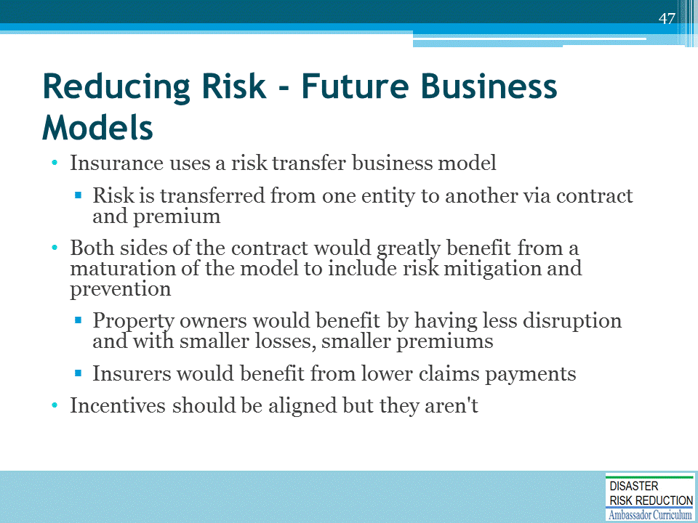

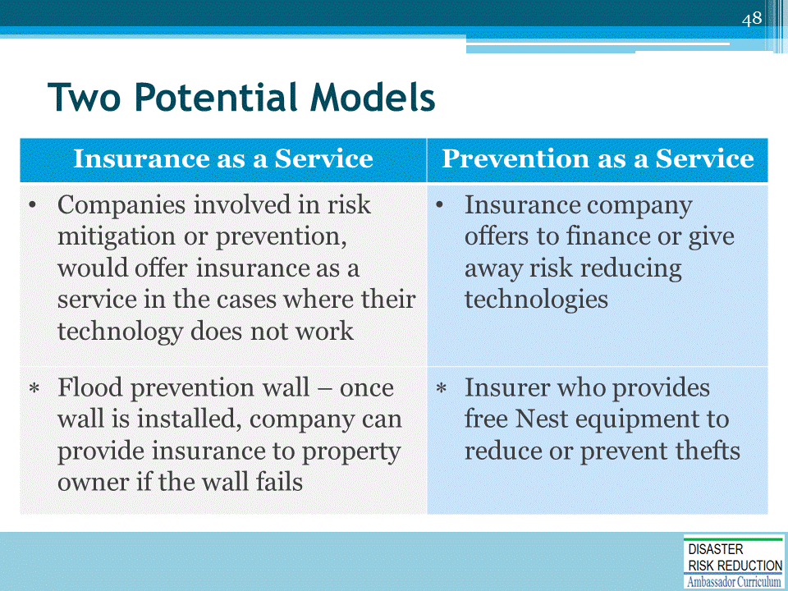
The last row provides an example of each.

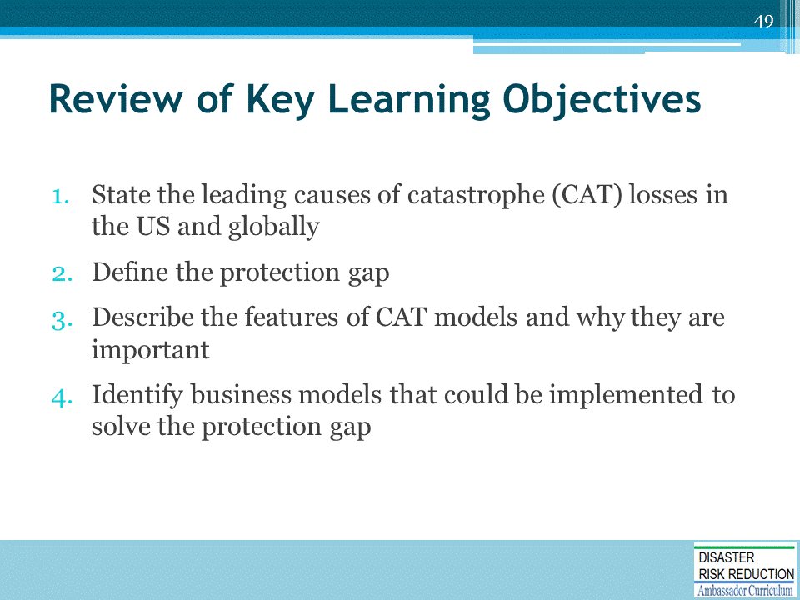

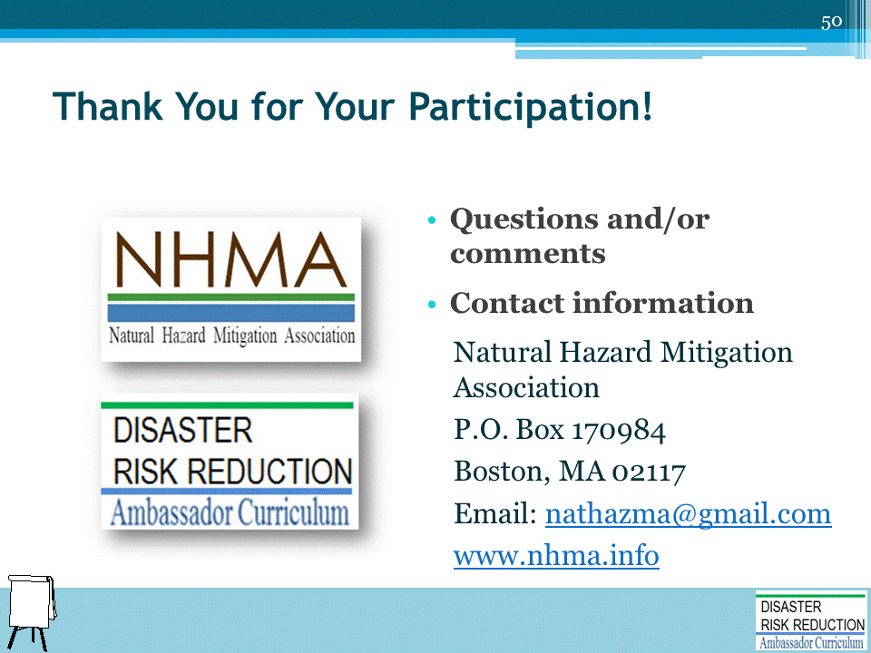
Record on easel pad any recommendations or questions to be addressed outside of the presentation.

DRR AMBASSADOR CURRICULUM AT-A-GLANCE
I. Disaster Risk Reduction for a Safe and Prosperous Future
1 | Introduction to the Natural Hazard Mitigation Association and Disaster Risk Reduction Ambassador Curriculum
2 | Introduction to Disaster Risk Reduction as a Foundation of Community Resilience
3 | Leadership for Disaster Risk Reduction
4 | Community Disaster Risk Reduction and Adaptation
5 | Approaching the Challenge of Disaster Risk Reduction: NIST Community Resilience Guide
II. Forming a Community’s Vision for Disaster Risk Reduction
6 | Risk Assessment through Storytelling: An Asset-Based Approach
7 | Achieving Community Buy-in for Disaster Risk Reduction: Win-Win Approaches
8 | Leveraging Resources to Improve Disaster Risk Reduction
III. Realizable, Practical, and Affordable Approaches for Moving from a Vision for Disaster Risk Reduction to a Strategy
9 | Selecting and Implementing a Strategy for Addressing Community Disaster Risk Problems
10 | Integrating Hazard Mitigation into Local Planning
11 | Beyond Codes and Low-Impact Development
12 | Creating the Plan: A Sustainable Floodplain Management Process Model
IV. Resources and Tools for Implementing a Community’s Disaster Risk Reduction Strategy
13 | Climate and Weather Tools and Trends
14 | Risk Assessment Basics
15 | Legal and Policy Opportunities for Disaster Risk Reduction
16 | Linking Catastrophe Insurance to Disaster Risk Reduction
V. Resources for Hazard-Specific Disaster Risk Reduction
17 | Living with Water: Inland and Coastal Flooding
18 | Design for Flood Resilience: Part I: Floodplain Management and Flood Resistant Design
19 | Design for Flood Resilience: Part II: Green Infrastructure / Low Impact Development
20 | Overcoming Impediments to Flood Resilience: Paths Forward
21 | Wildfire Mitigation
22 | The Wildfire-Flood Connection
23 | Severe Thunderstorm/ Tornado Safe Rooms
24 | From Policy to Engineering: Earthquake Risks

