Disaster Risk Reduction (DRR) Ambassador Curriculum

Instructor Guide

Module 18:
Design for Flood Resilience: Part I: Floodplain Management and Flood Resistant Design
Pennsylvania Flood Challenges and Opportunities

THE DRR AMBASSADOR CURRICULUM
The goal of the DRR Ambassador Curriculum is to facilitate Disaster Risk Reduction efforts for the whole community by:
- Engaging in discussion of how disasters can be reduced through local action
- Sharing insights among local leaders and technical experts to enable the development of cross functional solutions
- Acquiring the best-available information, knowledge of best practices, and analytic tools to enable better-informed decisions before, during, and after disasters
It is important for instructors of DRR Ambassador Curriculum modules to remember this is one module in a 24-module curriculum. The “DRR Ambassador Curriculum At-a-Glance” table, located at the end of this document, lists the modules of the Curriculum. Keep in mind the following context for the module(s) you conduct:
DRR-A CURRICULUM TARGET AUDIENCE
The target audience includes those involved in community development decision-making, such as local community staff, volunteer and stakeholder groups, and federal and state officials.
METHODS OF DELIVERY
Varied delivery methods will provide multiple options for access by the target audience. The DRR Ambassador modules may be presented via webinars hosted by NHMA or partner organizations, presented in conferences and/or classrooms by qualified DRR Ambassador Curriculum instructor(s), or are downloadable for individual study from the NHMA website.
COURSE MATERIALS
Instructors are expected to use the instructional materials housed on the NHMA website to conduct DRR Ambassador Curriculum modules (Instructor Guide, supporting visuals, Participant Guides, and handouts). Instructors may tailor modules to specific audiences or locations as long as they do not revise the learning objectives and do not revise the materials in such a way that the participants cannot correctly complete the post-test. Instructors request the current pre/post-test for the module from NHMA.
CERTIFICATES OF COMPLETION
Certificates of Completion will be awarded by NHMA to participants who successfully complete NHMA-sponsored DRR Ambassador modules. A DRR Ambassador Certificate will be awarded to individuals completing all 24 modules. Participants who choose not to take the post-test may be issued a Certificate of Attendance. Contact NHMA about obtaining certificates. Inform participants to ask their certifying boards about acceptance of NHMA DRR Ambassador certificates for continuing education credits.

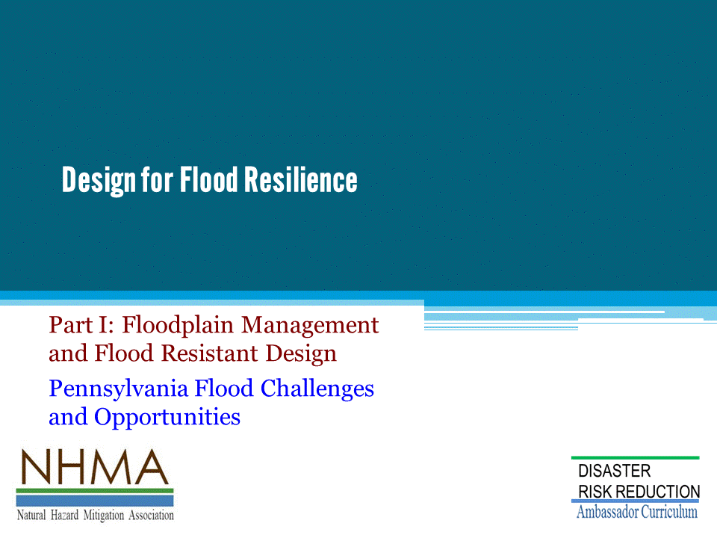
Design for Flood Resilience, to protect communities and regions (1) by Floodplain Management (2) by Flood Resistant Design of buildings and infrastructure, with a focus on the special challenges and opportunities in Pennsylvania…

- Donald Watson, FAIA is an architect and author. He has been involved in disaster mitigation planning and community development in the U.S. and abroad for over 50 years.
- This presentation includes illustrations from his most recent book, Design for Flooding, co-authored with Michele Adams, P.E.
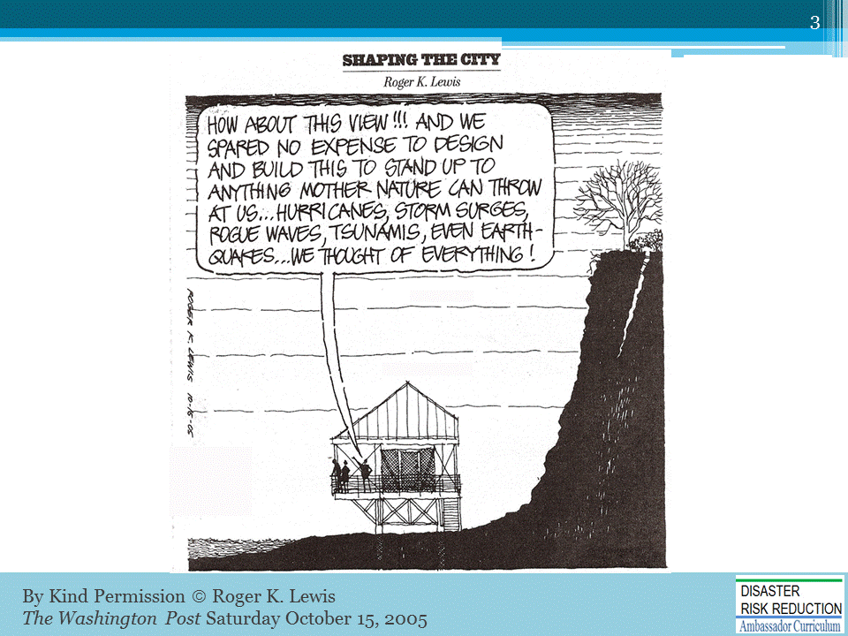
The caption in the bubble reads…“How about this VIEW!!!...We spared NO expense…to stand up to anything nature can throw at us...we thought of everything!”

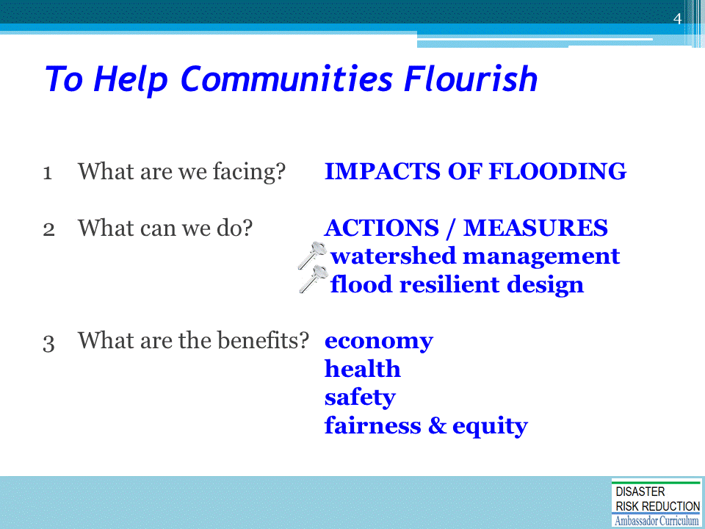
This module describes the impacts of flooding on our communities. It reviews the actions we can take to reduce flood risks—to save lives, property, and investments—and that sustain the economy, health, safety, and well-being of the whole community.

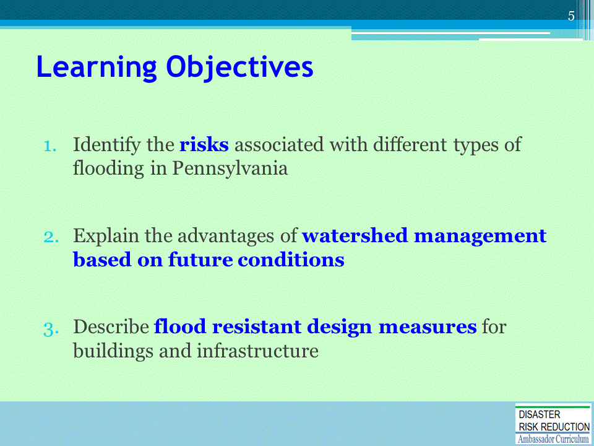
The Learning Objectives of this Module

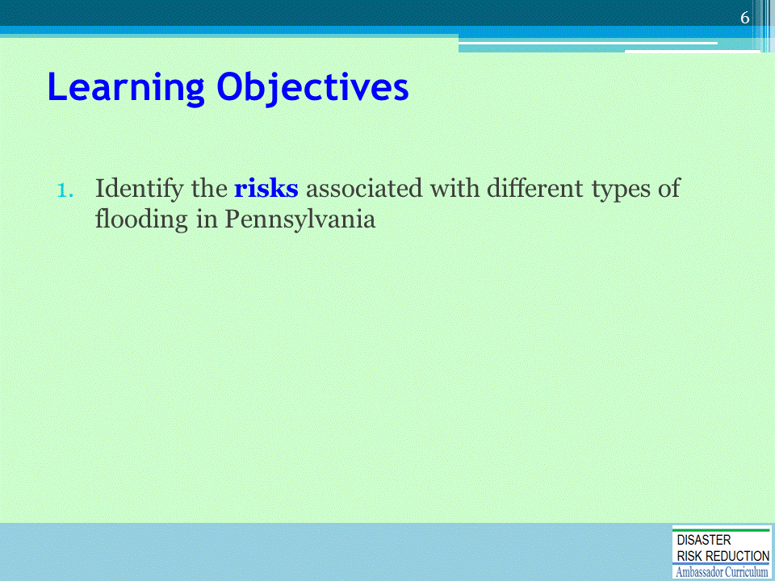
The 1st Learning Objective of this Module

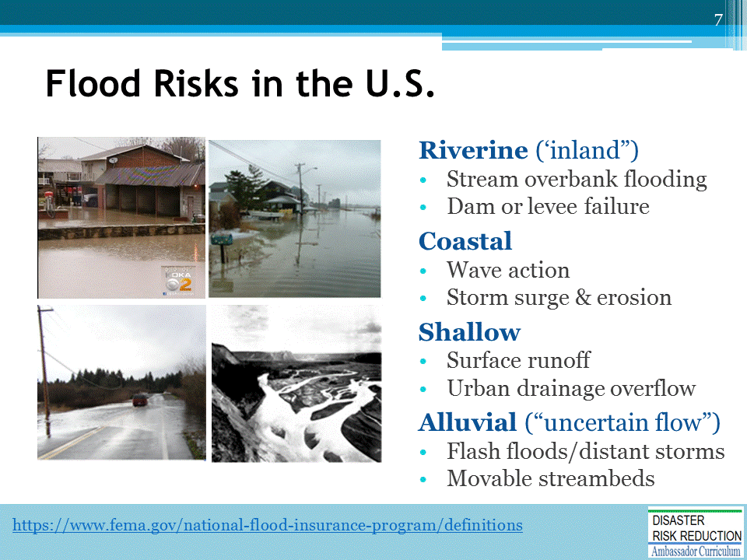
In Pennsylvania, flood risks are principally “riverine” (inland flooding). All types of flooding may occur in the event.
- Riverine flooding occurs when excessive rain, snow melt, or ice jams cause a river or stream to overflow.
- Coastal flooding may be experienced with extremely high tides, rising sea levels, and ocean storms.
- Shallow water flooding results when heavy rainfall overcomes or blocks urban drainage systems.
• Alluvial floods occur in mountainous regions, spreading debris flows into valley floors in a fan-shaped pattern. Alluvial floods can originate from a distant storm, follow any random path, are difficult to predict, and thus, also referred to as “uncertain flow.”
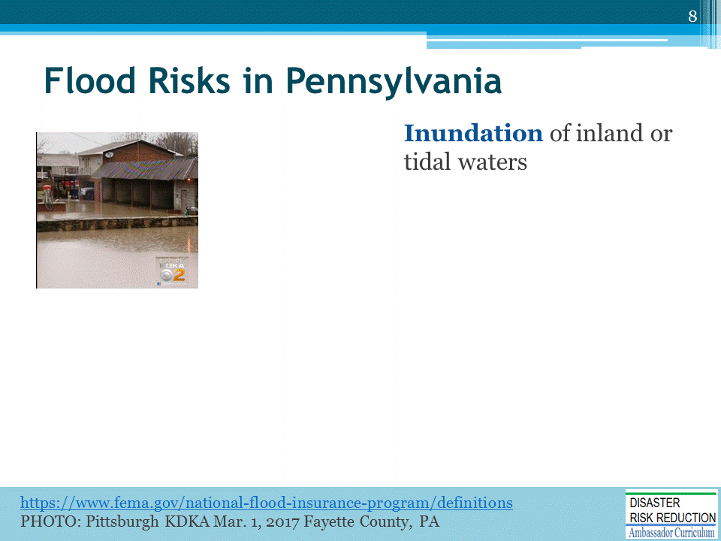
Flooding is defined by FEMA as a general and temporary condition of partial or complete inundation of normally dry land… [of 2 or more acres, or, of 2 or more properties].

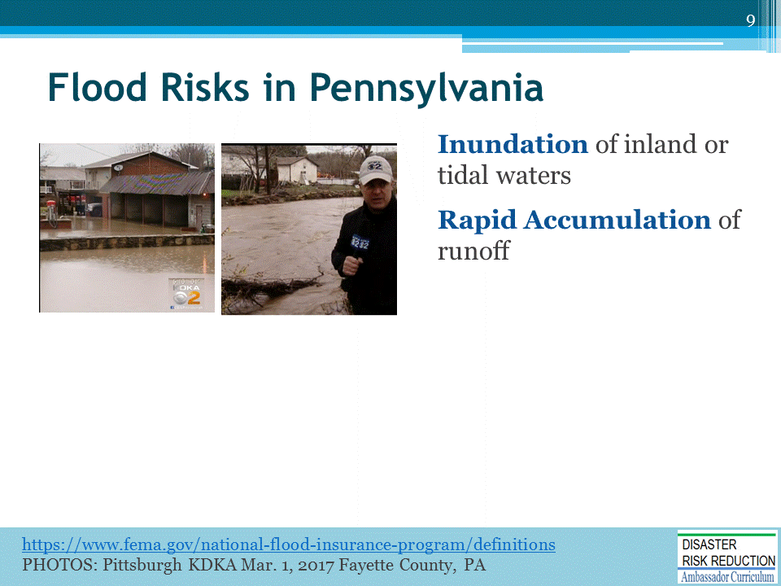
Flooding by rapid accumulation of stormwater may occur within minutes or hours of excessive rainfall, a dam or levee failure, or by ice jam release.

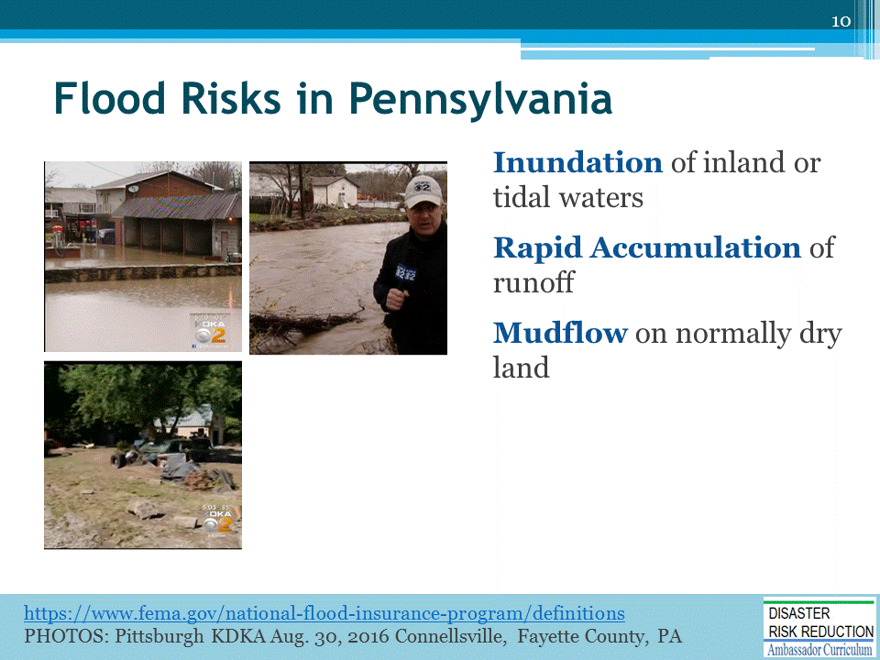
FEMA’s flood definition includes mudflows and landslides caused by flooding, and qualify for federal flood disaster assistance.

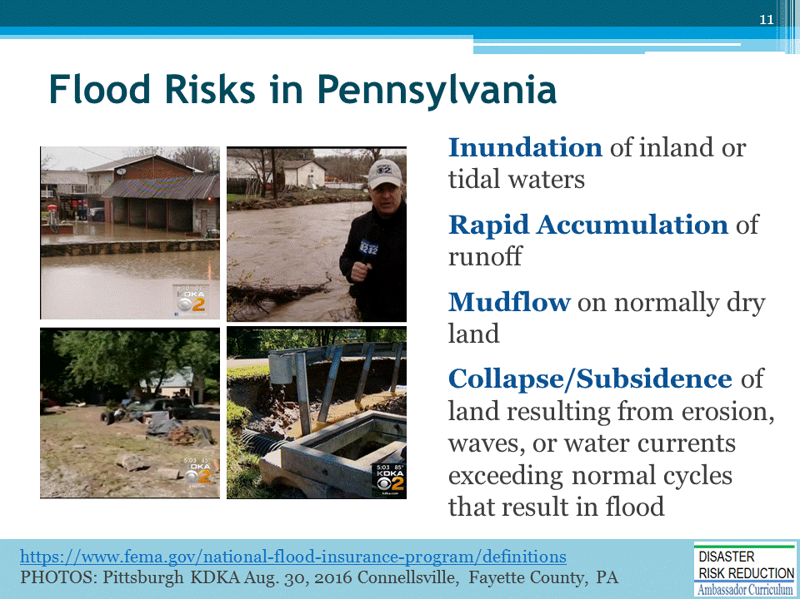
… [FEMA’s definition ] also includes the collapse of land, roads, and other infrastructure caused by flooding.
These images are from recent Pennsylvania floods (2016-17), reported by KDKA Pittsburgh. Video footage on the KDKA website tells a more dramatic story of the lives and livelihoods disrupted by flooding in Pennsylvania.
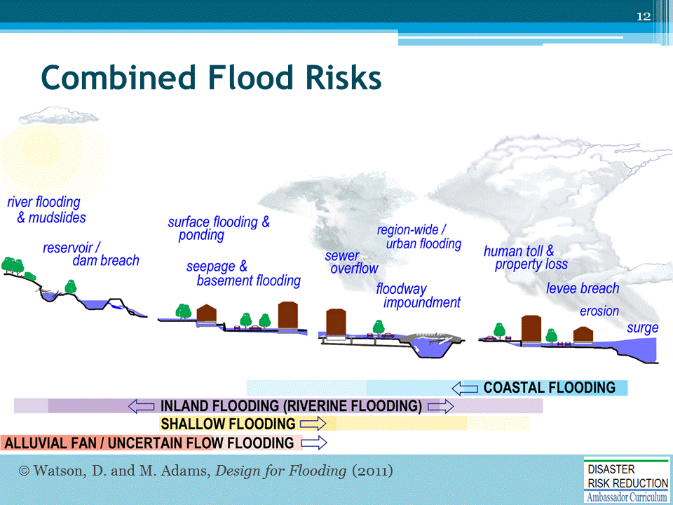
Flood risks compound one another…Some due to the direct impacts of a storm—rain, wind, hail, ice, or snow.
Indirect impacts result when buildings and infrastructure fail, overwhelmed by the forces of wind and water.
We cannot reduce the direct impacts of severe weather and climate—[ ] We can reduce our vulnerability to risks of the indirect impacts by preparedness: responsible management of our floodplains and by safer, stronger buildings and infrastructure.
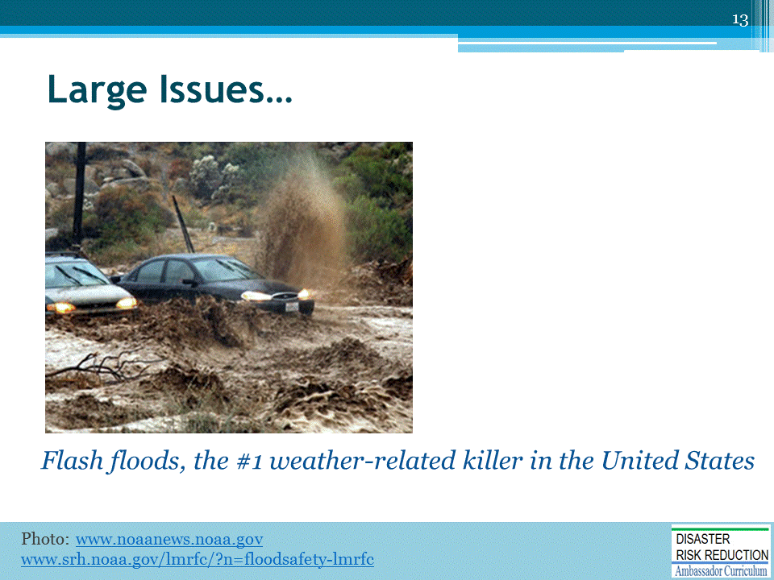
Flash floods may occur within minutes or hours of excessive rainfall … [dam or levee failure, or ice jam release.]
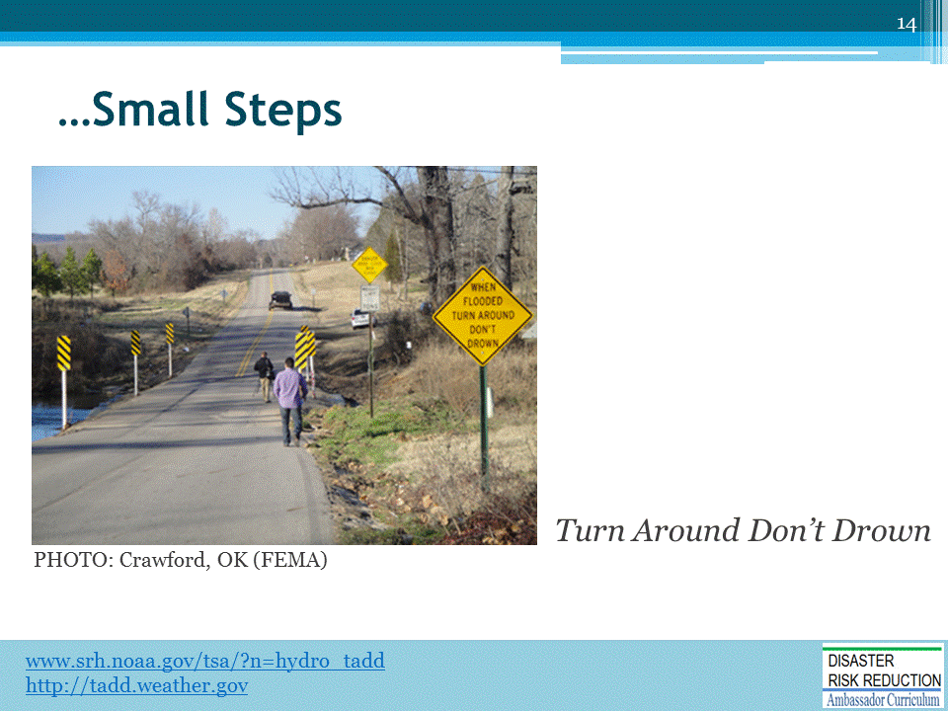
WE CAN address high priority risks (such as flashfloods) with low cost, easily implemented actions.
“Turn Around Don’t Drown” or “TADD” is a National Weather Service campaign to warn of the hazards of walking or driving though flood waters.
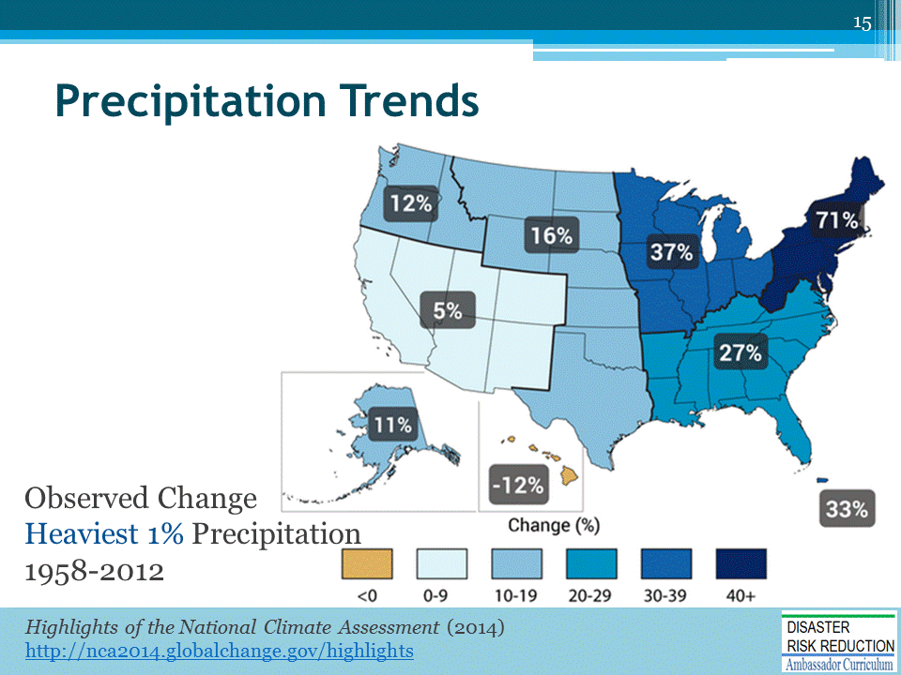
Heavy downpours—the heaviest 1% of all daily events—have increased across the U.S. over the past three to five decades. The most dramatic increase is in the Northeast, including Pennsylvania.

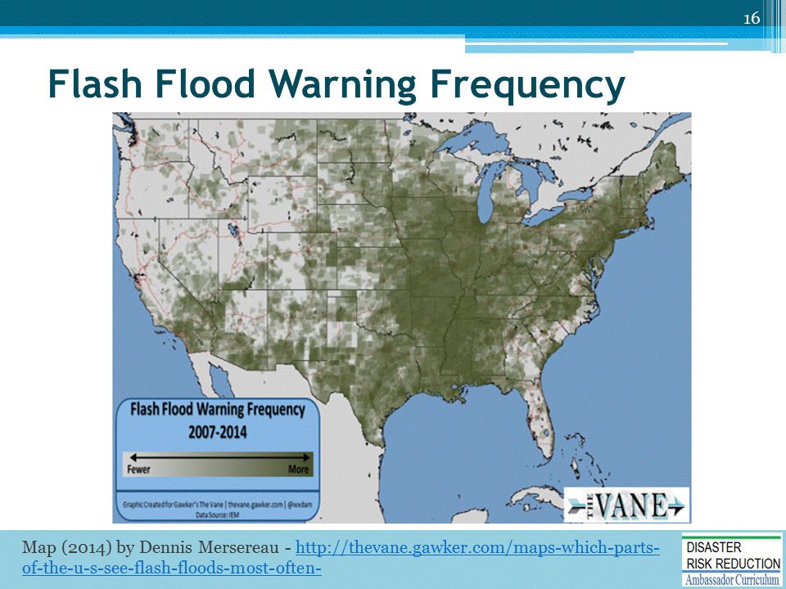
Flash floods are more common with the increase of heavy rain events, but also with increased spread of urban land development. [“Weather Dude” Dennis Mersereau mapped the locations and frequency of flash flooding (2007-2014), by recording Emergency Alert System warnings.]

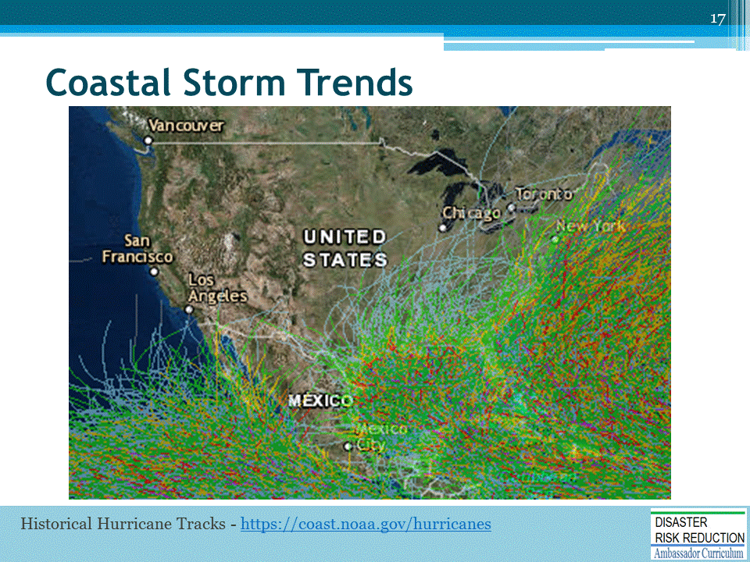
There are more frequent and intense coastal storms*
- Coastal storms reach far into the U.S. mainland, and have been the origin of major flood events in Pennsylvania.
* [The intensity, frequency, and duration of North Atlantic hurricanes—as well as the frequency of the strongest hurricanes—have increased since the early 1980s]
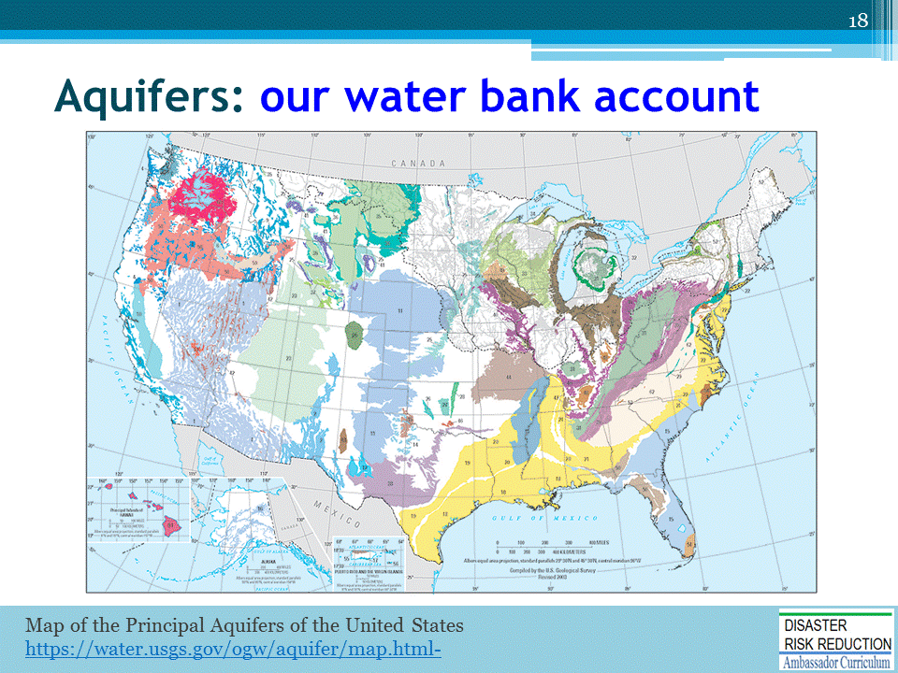
Managing floodplains should include “aquifer renewal.”

- The aquifer [= underground layers of water-bearing rock and soils that retain water]. Our water income = rain, snow melt, and flooding if allowed to discharge back into the landscape and soil. The aquifer is our savings account —“our fund for a ‘non-rainy day’—available for withdrawals by springs and wells. [Floodwaters that overflow / discharge elsewhere = “lost income.”]

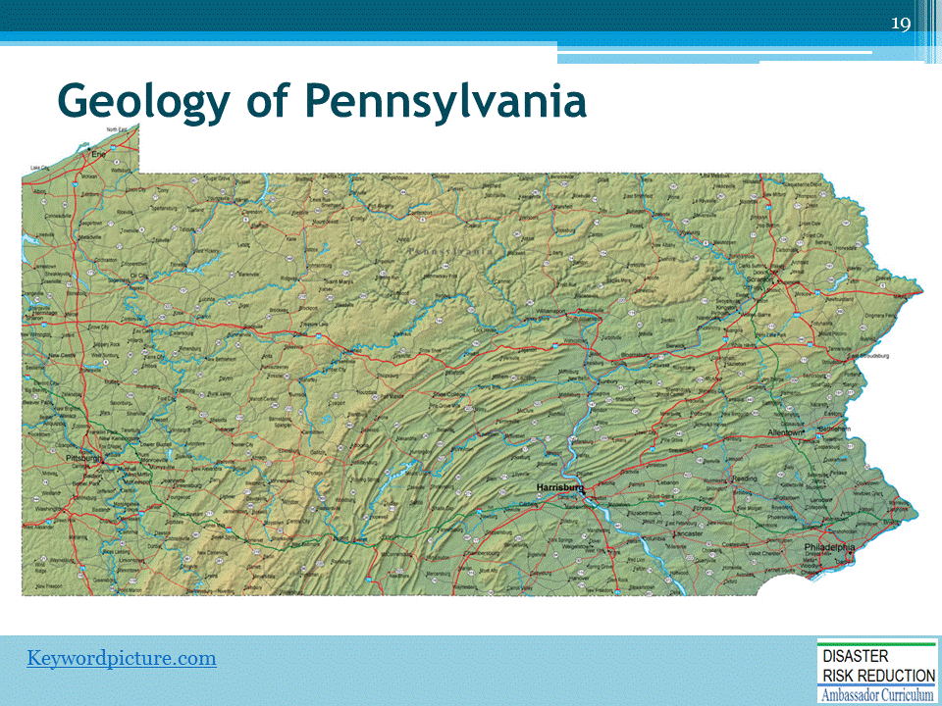
Pennsylvania’s geologic ridges, rifts, and valleys funnel water to the Susquehanna—in times (of flooding) acting as an all-too-efficient floodwater collector.
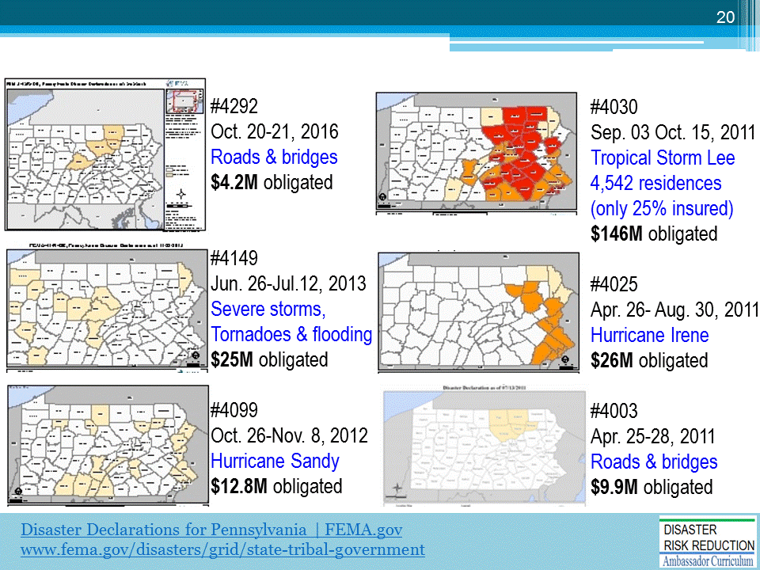
This slide highlights major flood events in Pennsylvania of the past 5 years. Nearly all parts of the State have been impacted, with incidents occurring from Jan. to Sept.
(SPEAKER OPTION: discussion w/ participants for stories/ experiences with these events)

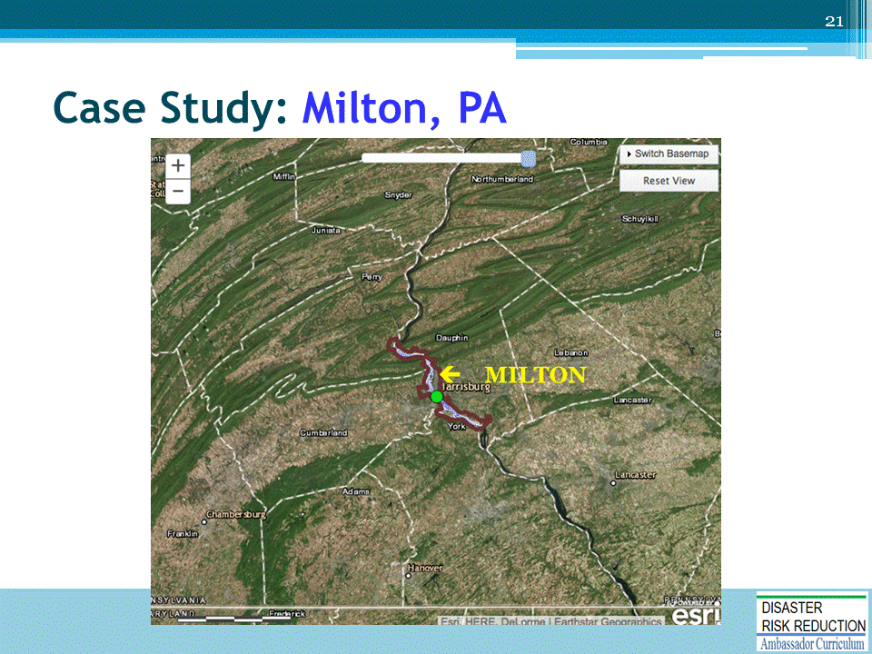
The Town of Milton is one of many historic Pennsylvania communities along the Susquehanna River.

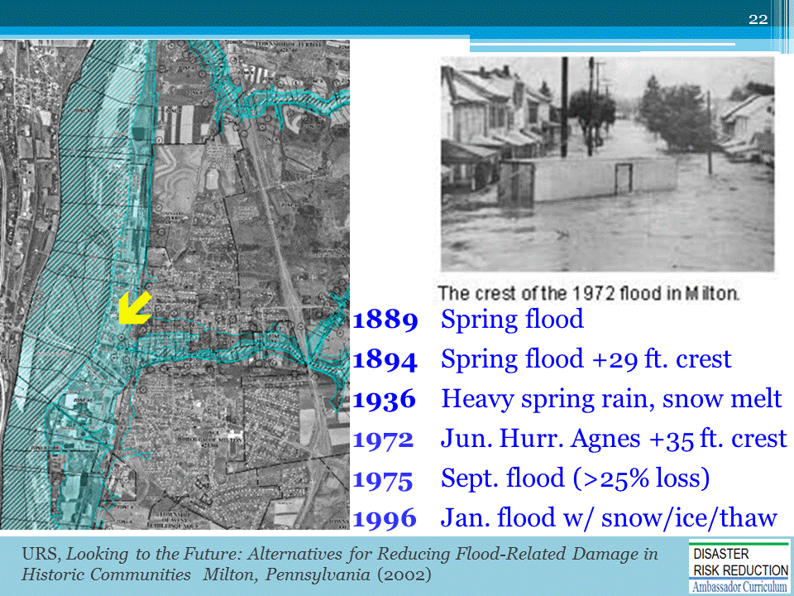
Since 1846, forty floods have exceeded Milton’s +19 ft. flood stage.
(review dates / history of flood). [time of year: Incidents from January to Sept.]

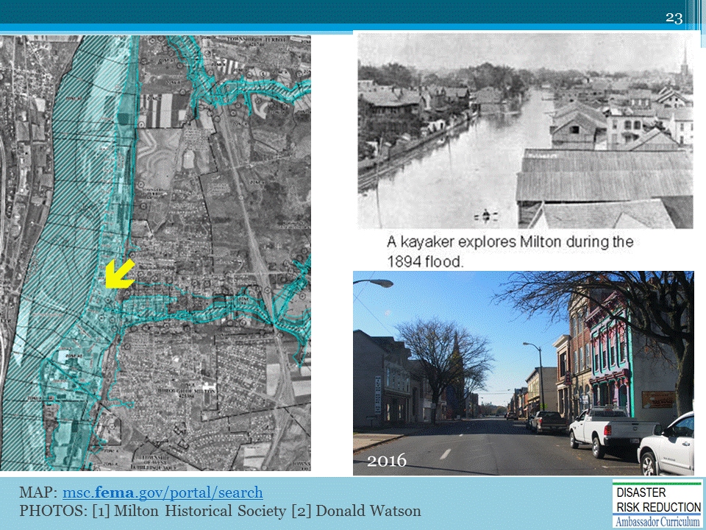
The yellow arrow indicates Broadway and Front Streets, with a recent photo at the bottom right.
This historic main street, with beautiful buildings of great cultural and economic value, represents the public and private assets most at risk of flooding in Pennsylvania communities.

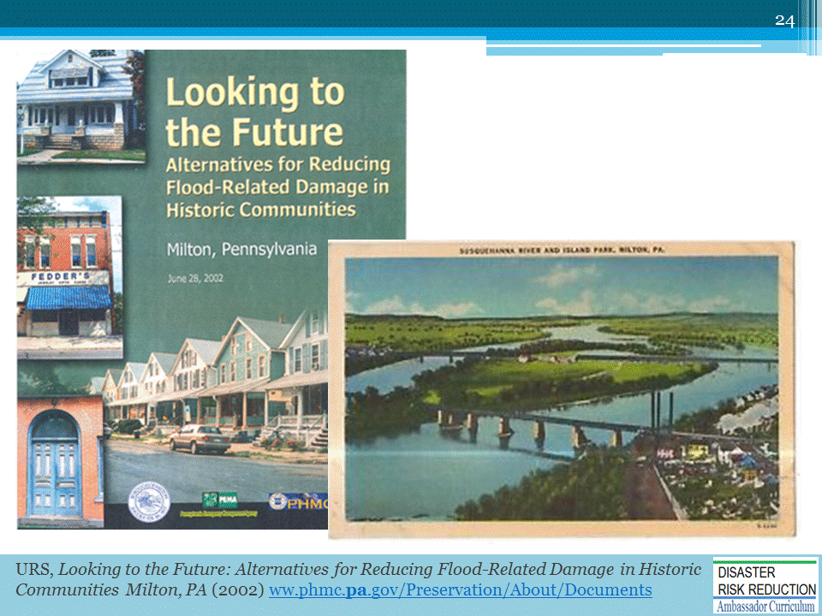
A worthy report by URS Corp.—Looking to the Future: Alternatives for Reducing Flood-Related Damage in Historic Communities—summarizes flood mitigation measures applicable to Milton, but also to many Pennsylvania communities. Recommendations include…

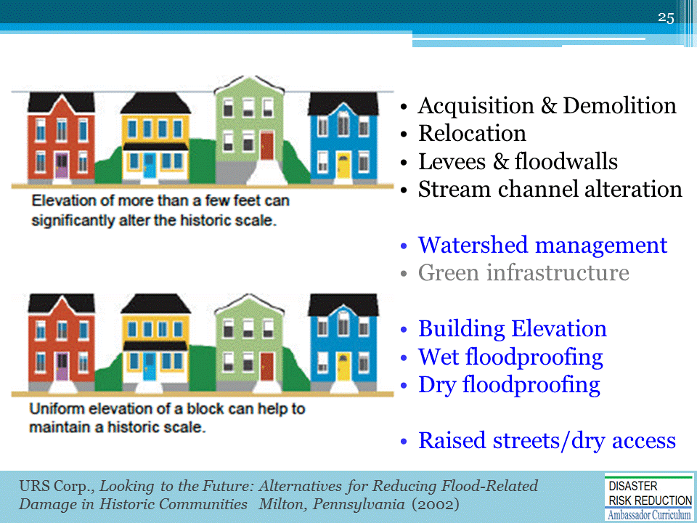
[review list on slide]
The last measure on the list —“Raised streets / dry access” (for EMS access and evacuation)— is not included in the URS report, but is also worth considering [to be illustrated later in this presentation].
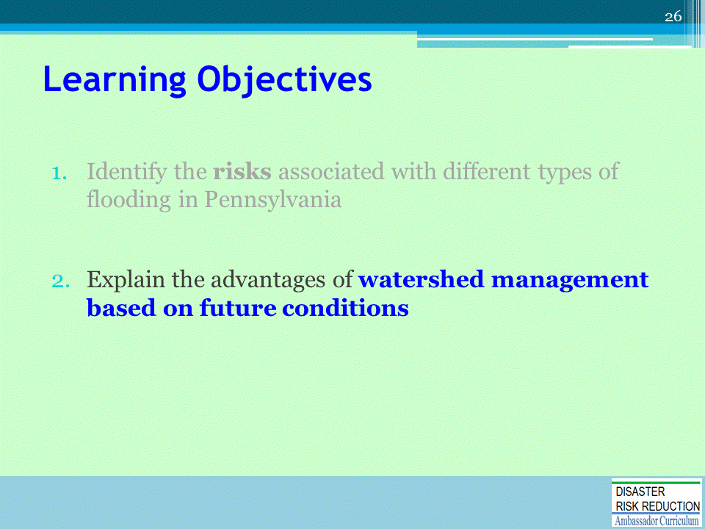
The 2nd Learning Objective of this Module

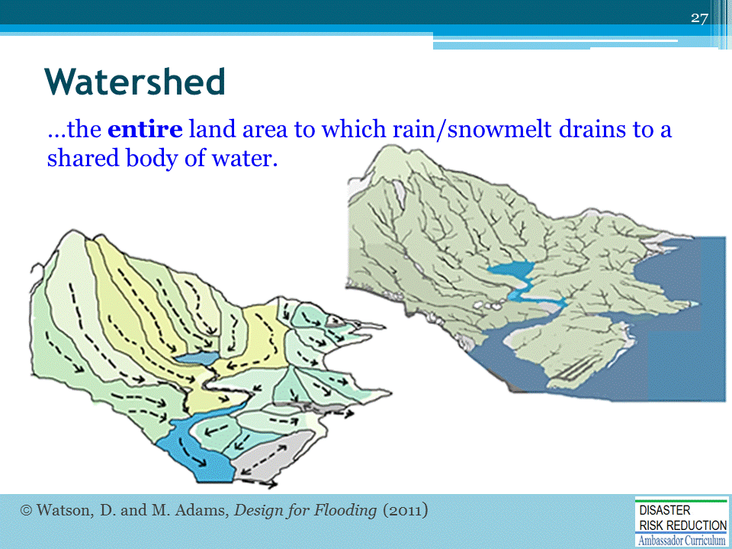
A “watershed” is the “entire area of land to which rain and snowmelt drains to a shared body of water.”
What is the difference between a watershed and a floodplain?
Simply stated…The watershed is everywhere that rain (and snow) falls and flows…

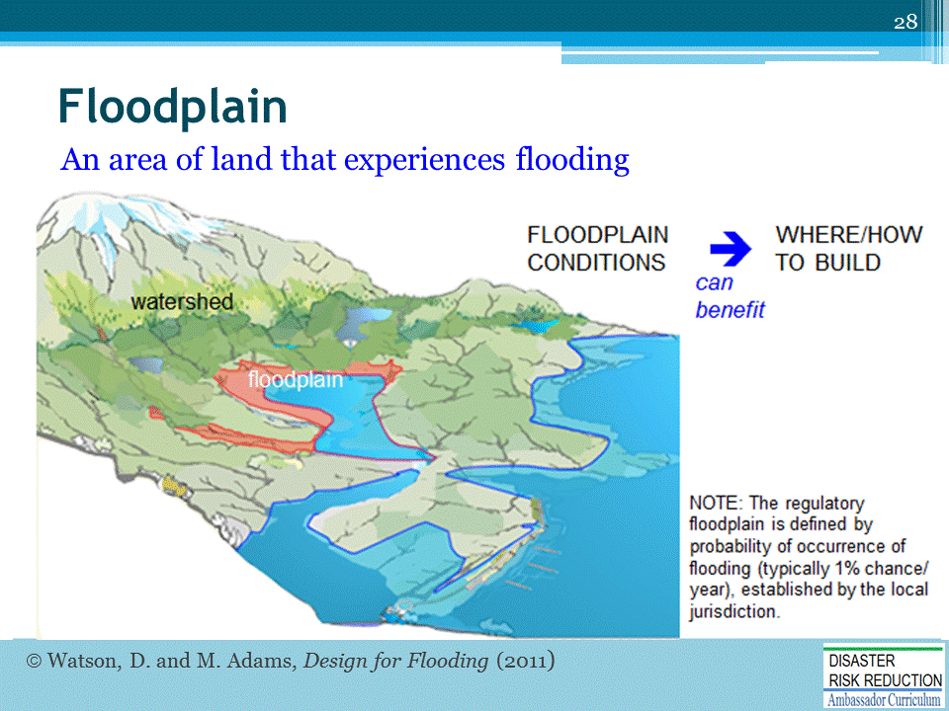
… “The Floodplain” is where floodwaters accumulate (on normally dry land).
Floodplain conditions—[properly accounted for]—do not have to be a risk and can benefit a community:
(1) Providing open space, river trail corridors, access to water resources, cooler surrounds, lower cost infrastructure (by cost and risk avoidance ….building only where it is flood safe).
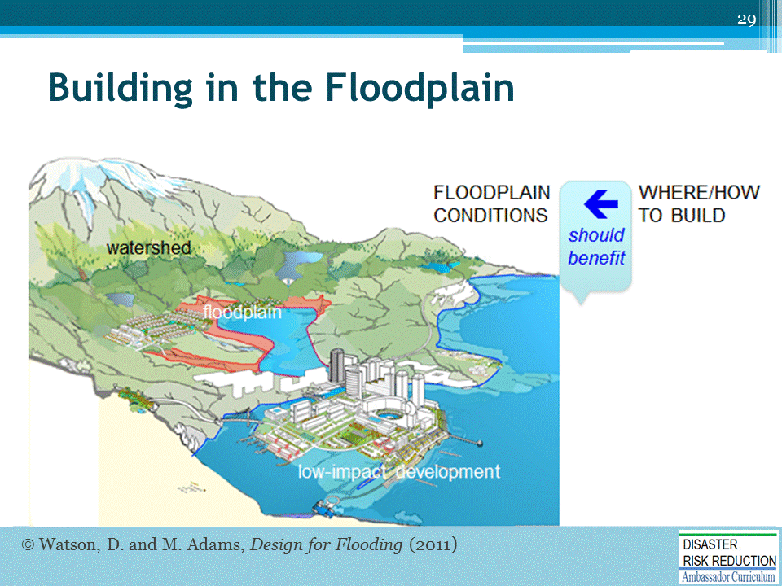
In turn, building and infrastructure can and should benefit floodplain conditions.
(2) Improving community health, security, and safety, along with economic and recreational benefits (“Low Impact Development”),
(3) Connecting the “ecosystem” functions of landscape, soil, water courses, and aquifers (“green infrastructure”).
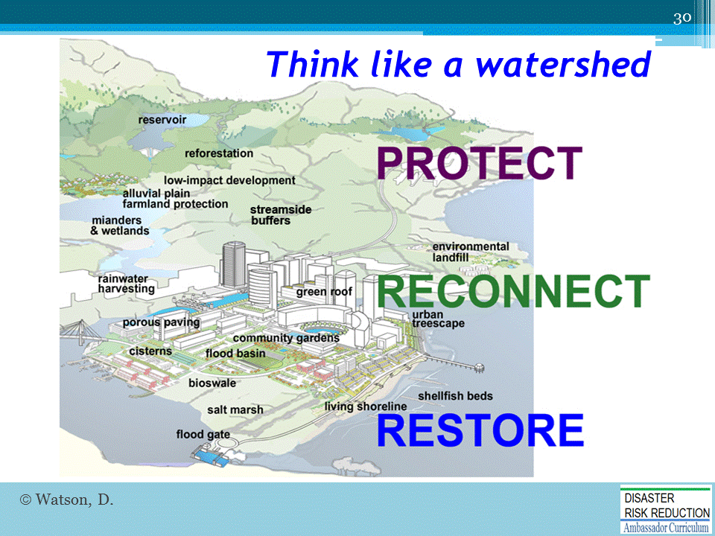
When floodplain management extends to the entire watershed, more options are available to reduce flooding. Advantages include: upstream and small scale measures may be more feasible, lower cost, with broader participation, and more rapid implementation.
Dramatic improvements can be made simply by reconnecting open spaces and water courses.
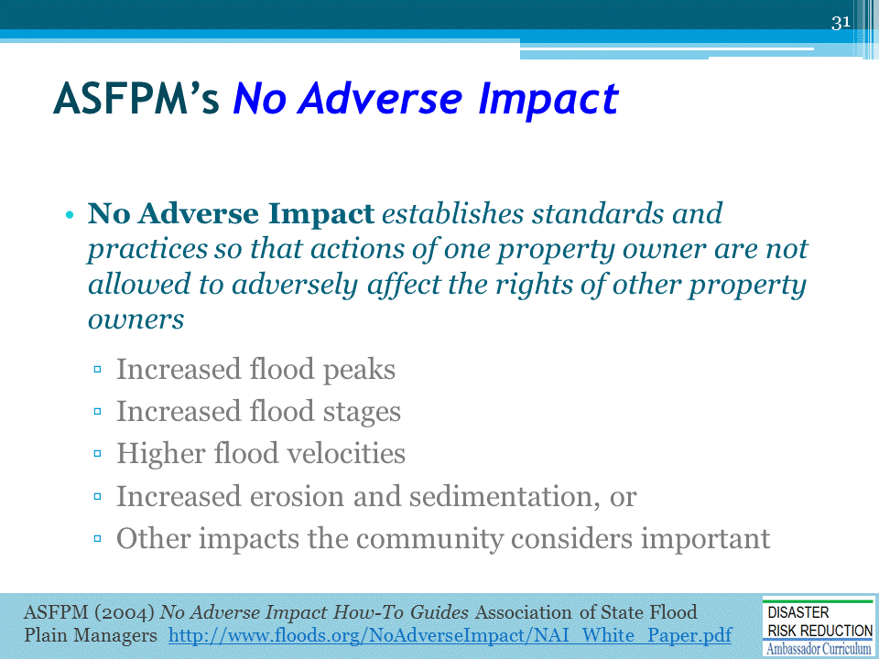
The Association of State Floodplain Managers (ASFPM) has published a set of recommended standards for floodplain management [included in References at the end of this module] for “No Adverse Impact,” based upon the common principle of law, that… “actions of one property owner are not allowed to adversely affect the rights of other property owners”
Defining specific criteria as (listed on slide…)
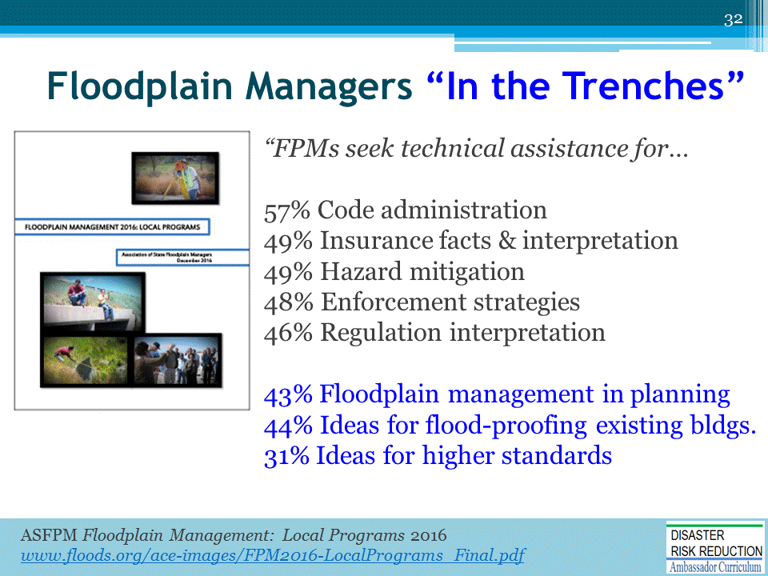
The ASFPM Report—Floodplain Management 2016: Local Programs—offers recommendations to support local floodplain managers “in the trenches” … (review Slide list topics)
* [survey of over 820 State and municipal officials]…

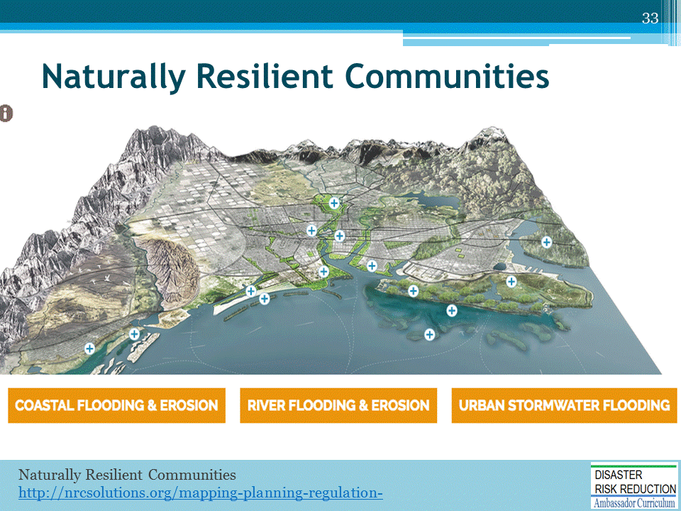
Best practices of floodplain management emphasizing nature-based measures (such as green infrastructure) are nicely summarized on the website, “Naturally Resilient Communities / NRCsolutions.”
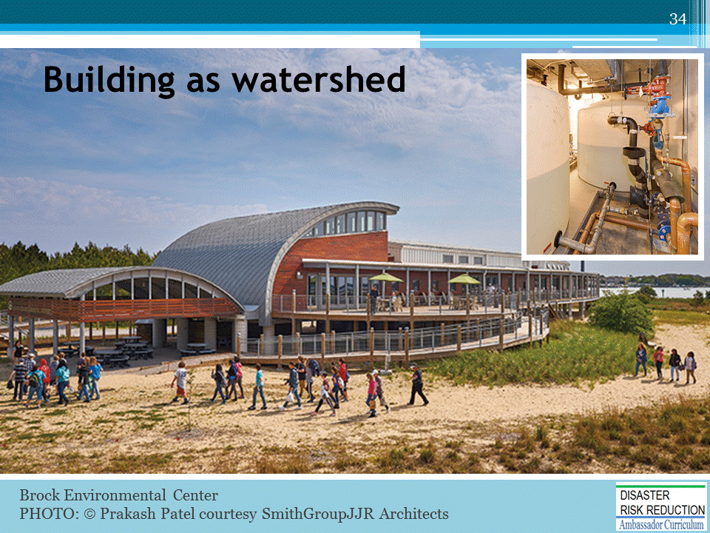
Opportunities exist at every scale: Brock Environmental Center, Virginia Beach VA is a mini-watershed…. the first commercial building in the U.S. permitted to capture and treat rainfall as drinking water…
The structure, elevated above surge level, provides shaded picnic and parking beneath. Cisterns (“the mini-aquifer”) are two 1,600+ gallon tanks, where water is disinfected and protected within a dry-floodproofed and earthbermed enclosure.

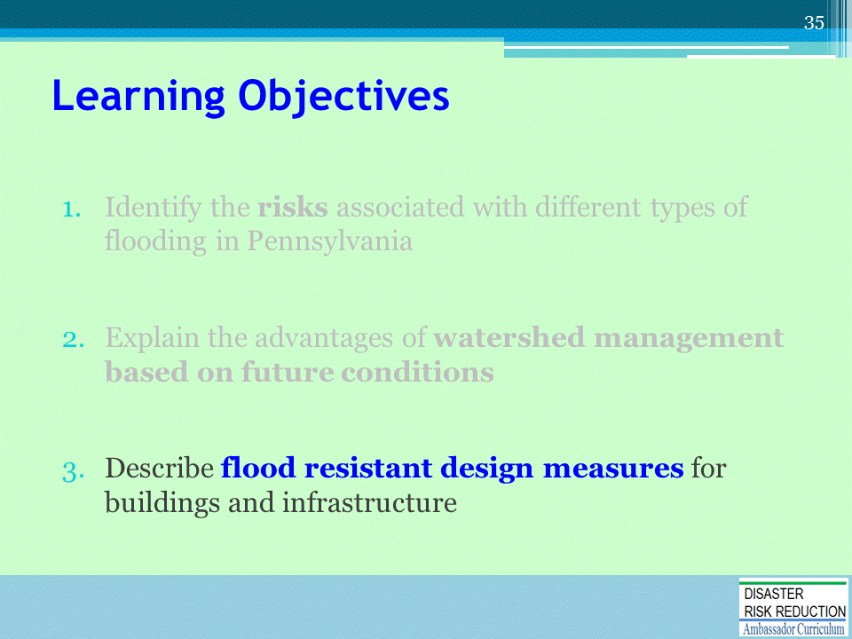
The 3rd Learning Objective of this Module

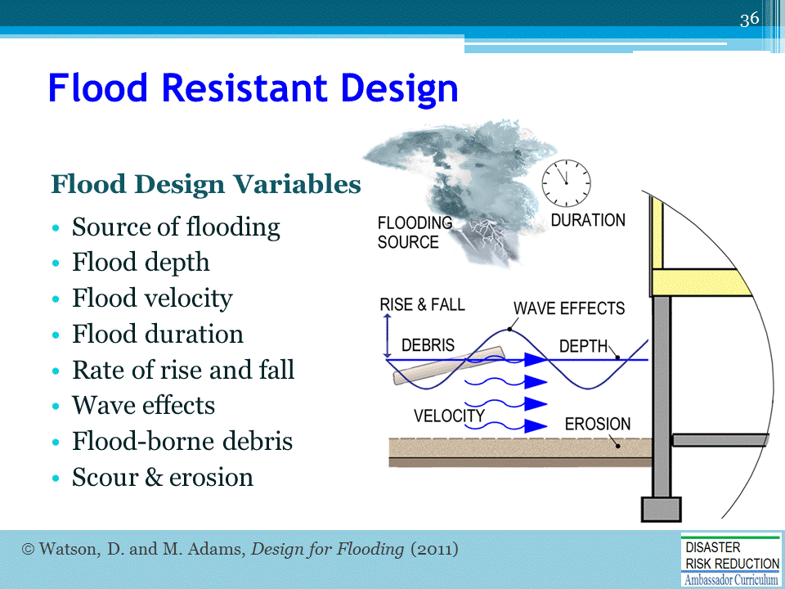
Flood-resistant design requires architects and engineers to consider a range of design variables.
(review those listed on slide)
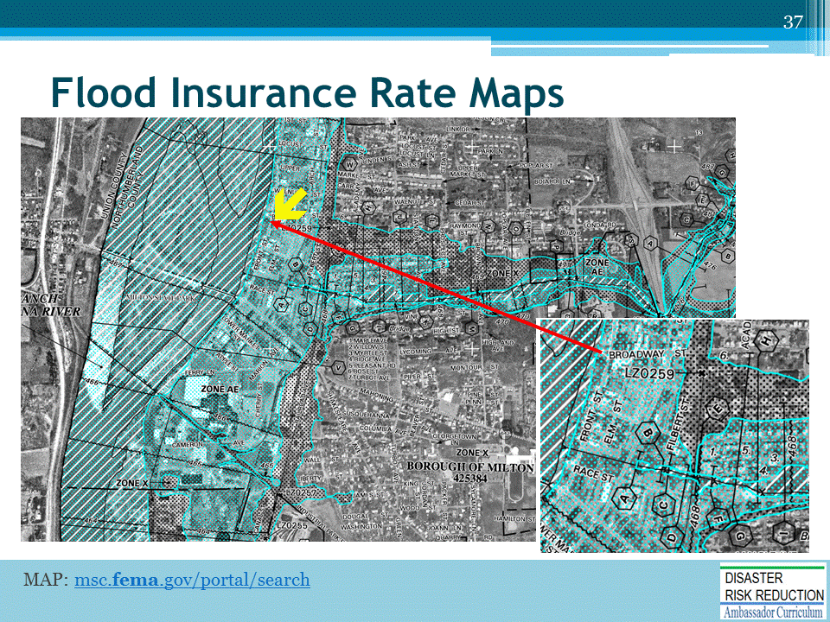
Flood Insurance Rate Maps (FIRMs) define Special Flood Hazard Areas (SFHAs) for purposes of National Flood Insurance Program (NFIP) insurance rates.
[This FIRM is of Milton PA. The arrow indicates Front and Broadway streets shown earlier.]
Flood maps are not—in and of themselves—a sufficient guide to future flood risks.
[to be discussed in detail in upcoming Mod. 20 “Limitations of FEMA Flood Maps]

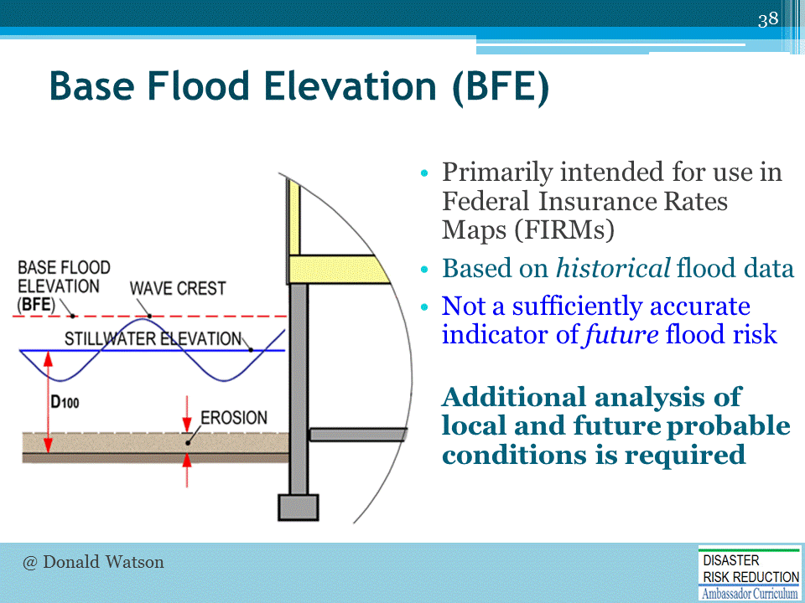
Base Flood Elevation (BFE) is defined [in FEMA guidance and on NFIP Insurance Rate Maps] as the elevation of flooding [including estimated wave heights] with a 1% probability of being equaled or exceeded in any given year. This designation is based upon historical data and does not include future conditions (land alteration, climate change). Additional analysis of local and future probable conditions is required.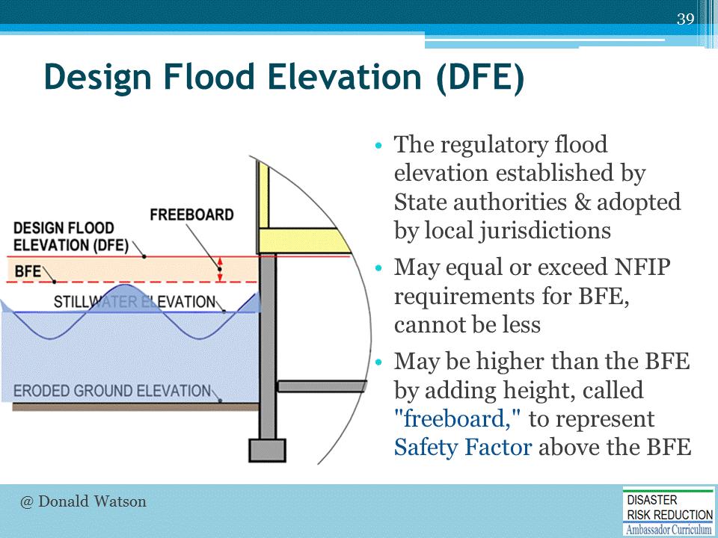
Design Flood Elevation (DFE) is the elevation adopted in State and local zoning and building codes, as a minimum “design criteria” required for permitting. “DFE” may be adopted by the State or local jurisdictions as equal to “BFE,” or may be higher, adding a a safety factor above the BFE minimum, [the added height is called “freeboard.”]
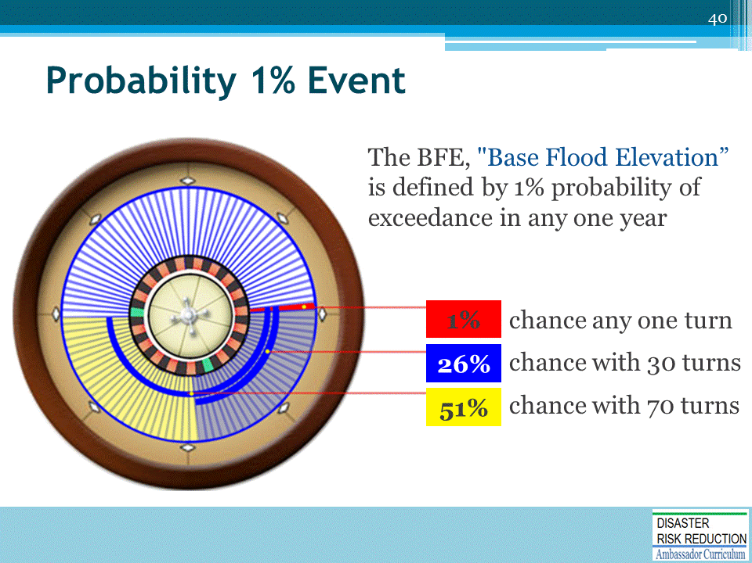
1% probability in any one year represents 26% chance over 30 years, or a 51% chance over 70 years.

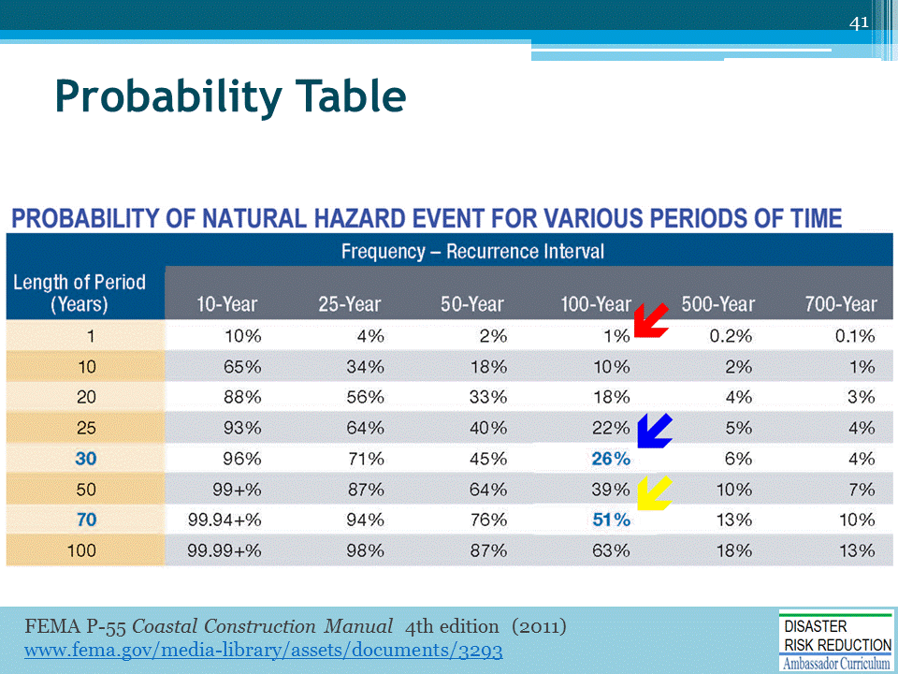
This Probability Table shows the % probabilities that a flood event may be equaled or exceeded based upon the assumptions that one makes.
[RED ARROW: I% any one year. BLUE: 26% chance in any 30-year period. YELLOW: 51% chance in any 70-year period.]
If flood regulations were to adopt the statistical “500-year base flood” as the “DFE minimum design standard,” risk probabilities are greatly reduced (by a factor of 4-5).
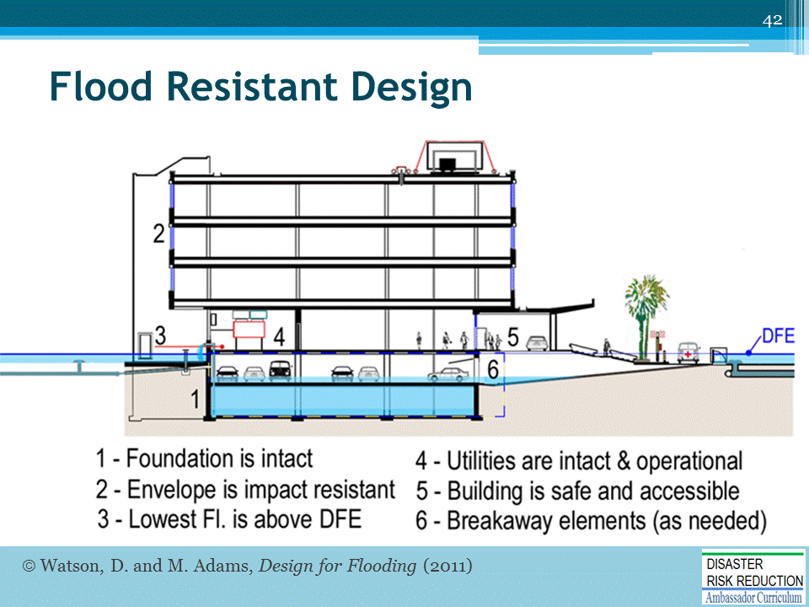
Principles of flood resistant design for commercial buildings are… [indicated on this slide]

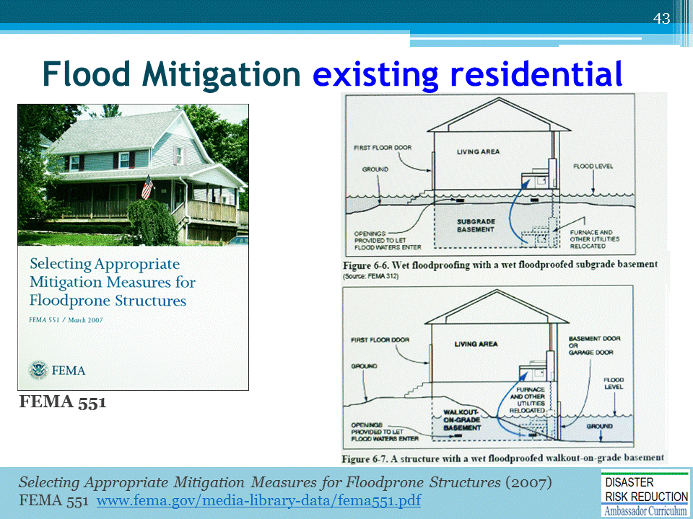
Existing residential structures present challenges to achieve flood resistant design.

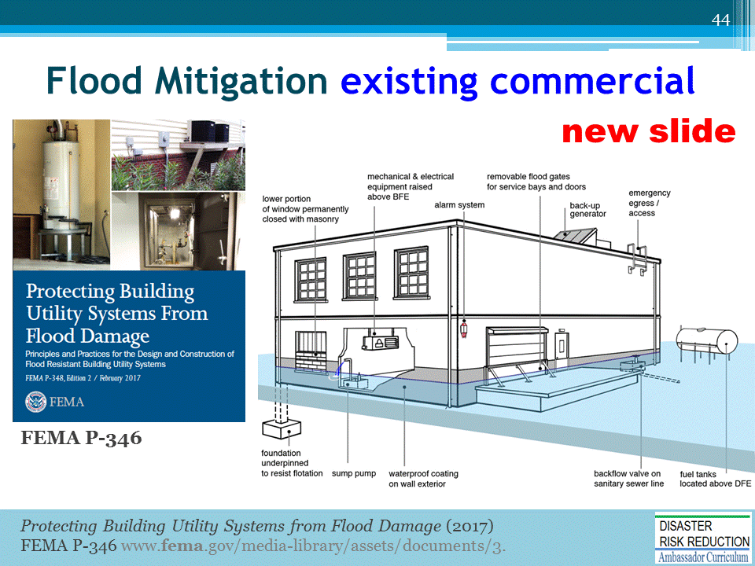
Commercial and institutional buildings may use dry floodproofing measures in upgrading existing buildings or new construction, subject to local regulatory approvals. THIS IS A NEW SLIDE: to include FEMA P-346 Protecting Utility Systems from Flood Damage … an excellent new release from FEMA that details measures for both residential and commercial buildings.

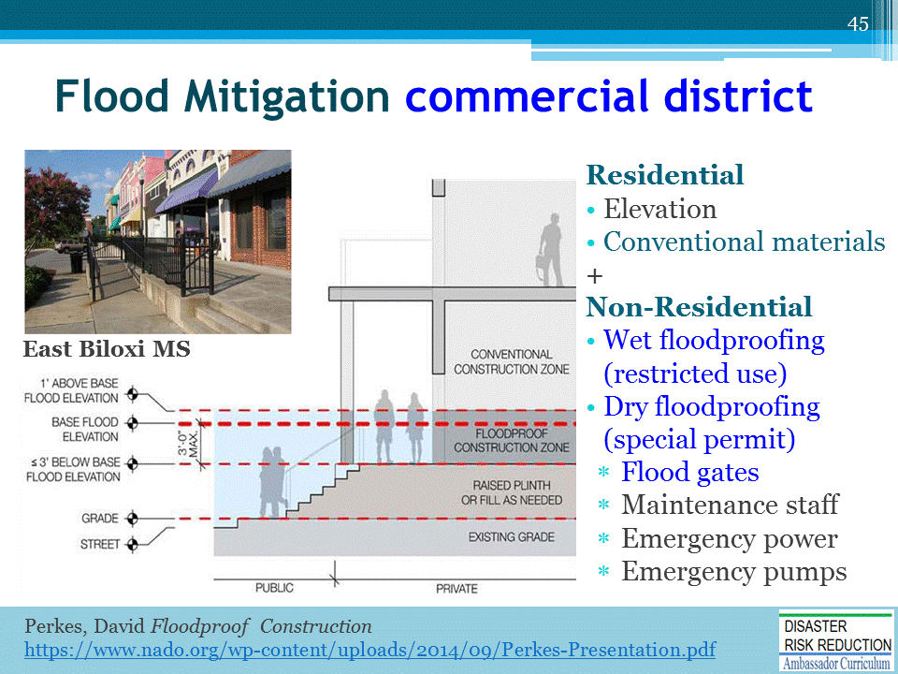
In recovery after Hurricane Katrina, “build back better” actions along East Biloxi’s principal Commercial Street including: (1) raised sidewalks, (2) “dry-floodproofing” for commercial properties (shops), and (3) mixed-use zoning, permitting residential or commercial uses above.

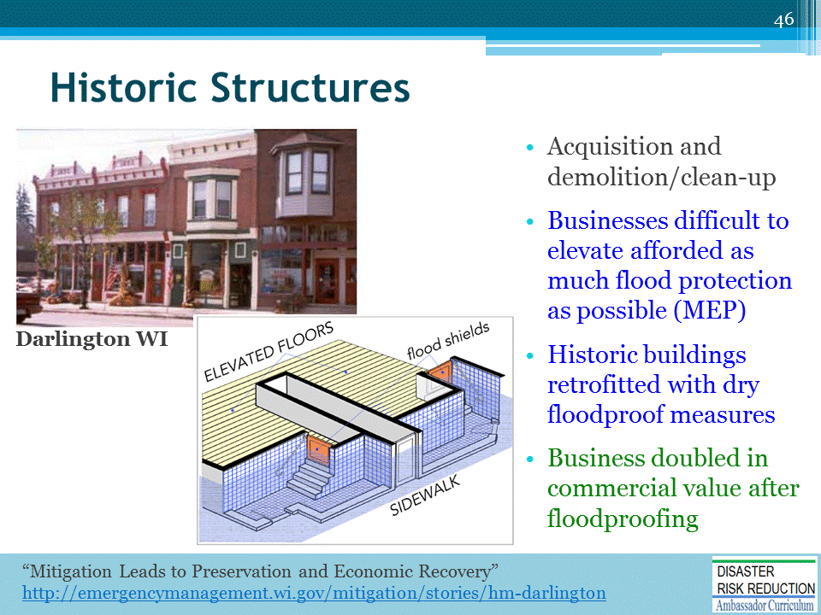
In recovery from 1993 Midwest flooding, historic Darlington Wisconsin Main Street has been restored, including dry floodproofing, with flood gates installed inside the entryways, to preserve the character and appearance of the historic street.

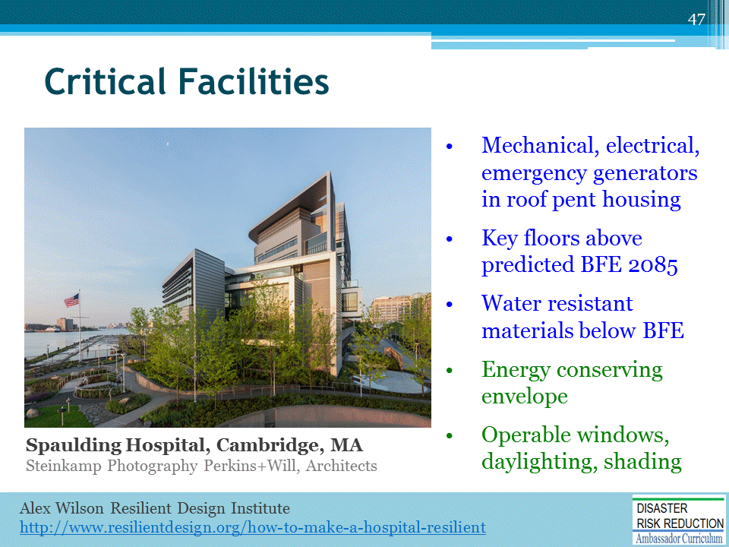
Critical facilities may include police, fire, emergency offices, community shelters, hospitals, schools and day-care centers, power generating stations, water and wastewater treatment plants, and, by local designation, may also include food depots and stores, pharmacies, and gas stations. Spaulding Hospital goes beyond regulatory requirements and addresses future probable conditions of climate change and sea level rise.

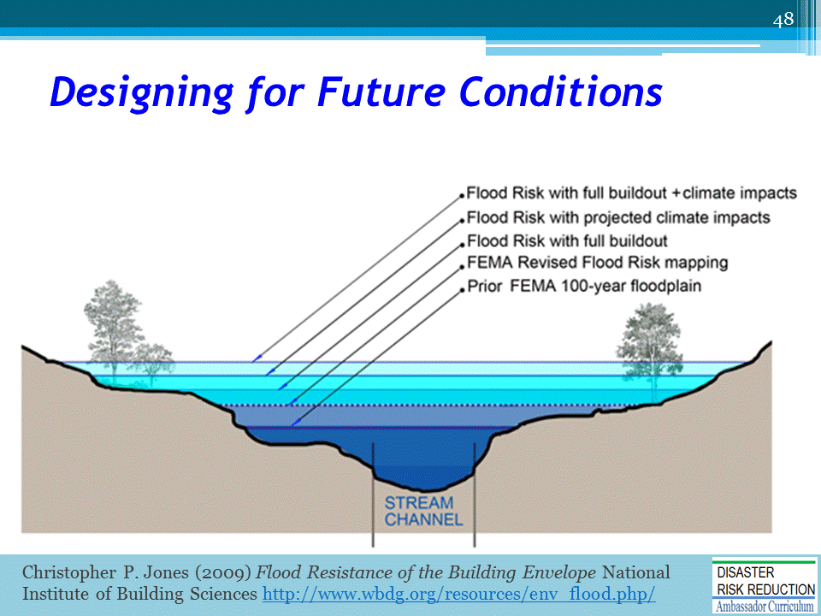
FEMA considers future conditions in flood mapping if the community being studied requests and participates in the study. An exemplar is Charlotte-Mecklenburg NC […a module in the NHMA Curriculum].

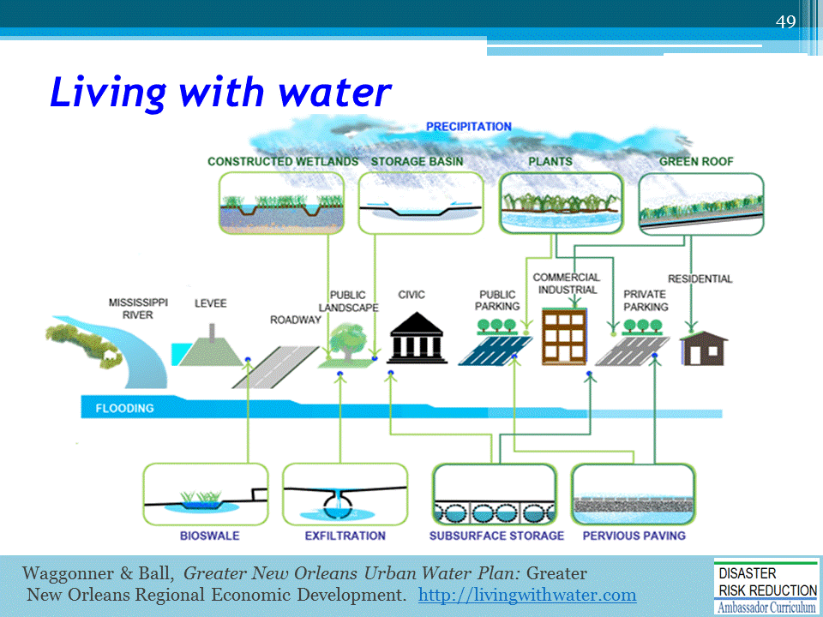
New Orleans’s Urban Water Plan, “living with water” proposes a comprehensive program to convert sites into “water gardens,” to replace roads with permeable sidewalks, and to extend green infrastructure, including subsurface storage.

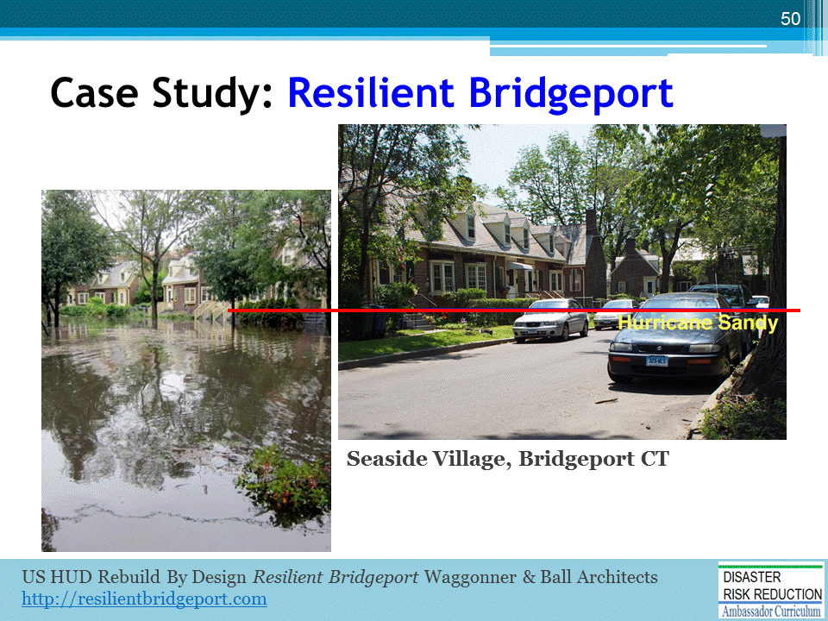
Seaside Village, Bridgeport CT is one of the first garden communities in the U.S., built in 1918 during Bridgeport’s manufacturing heyday, to provide emergency housing for defense workers.
[About 257 units, @1,000 square feet, designed to resemble a European village, added to the National Register of Historic Places in 1990.]

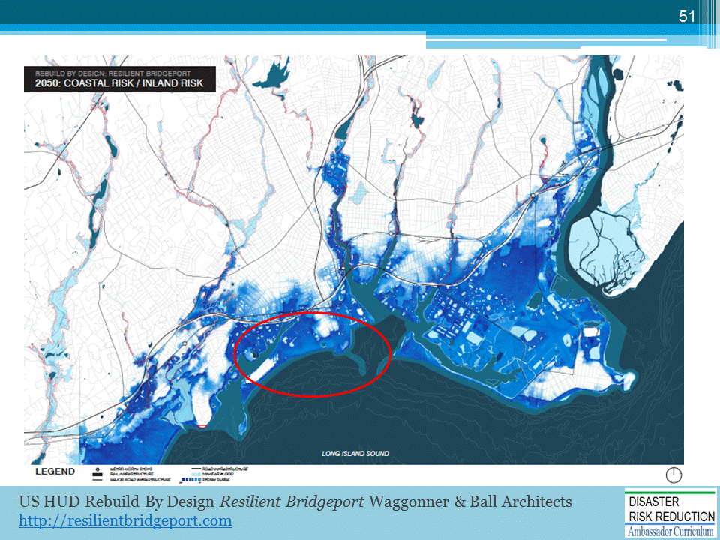
2050 projection of coastal and inland flood risk

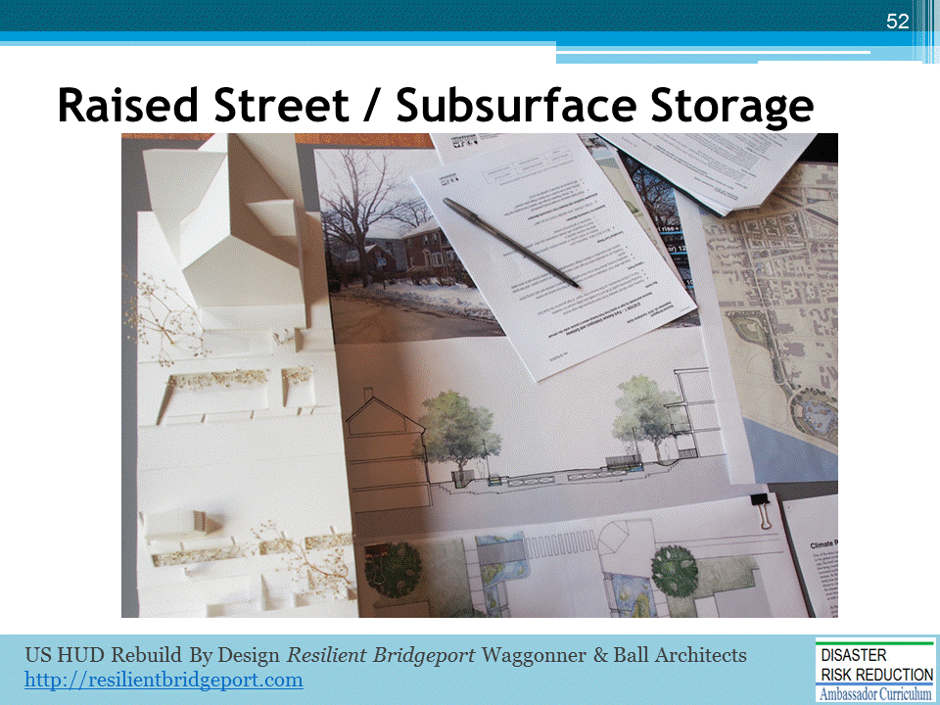
Proposed raised street (providing dry access and emergency egress) PLUS subsurface storage system (stormwater detention). To help community members visualize options, the use of physical models…

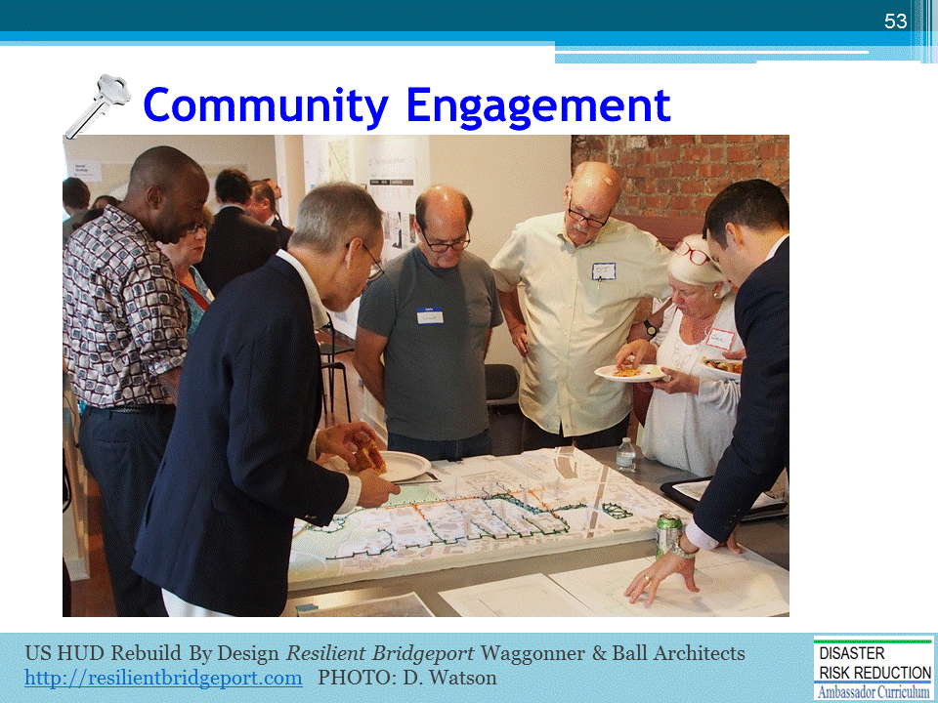
….proved to be invaluable as a communication/decision tool. Shown here is a physical model of the hydrology (stormwater infrastructure and surface flow downstream). [community engagement meetings held in an open street-front office with staffed “walk-in” hours.]
Community engagement is a key to successful watershed planning and floodplain management.
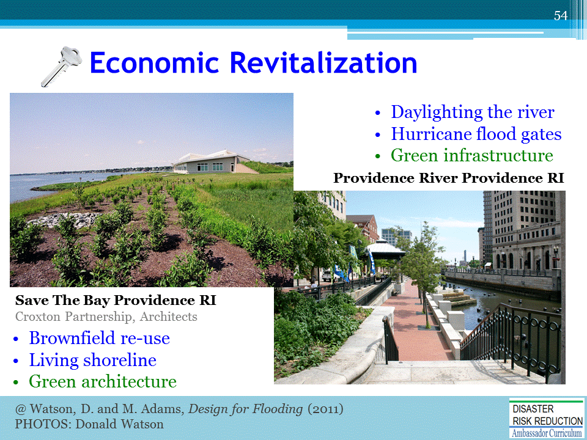
A second key is to integrate watershed management into comprehensive plans for community economic planning and renewal.

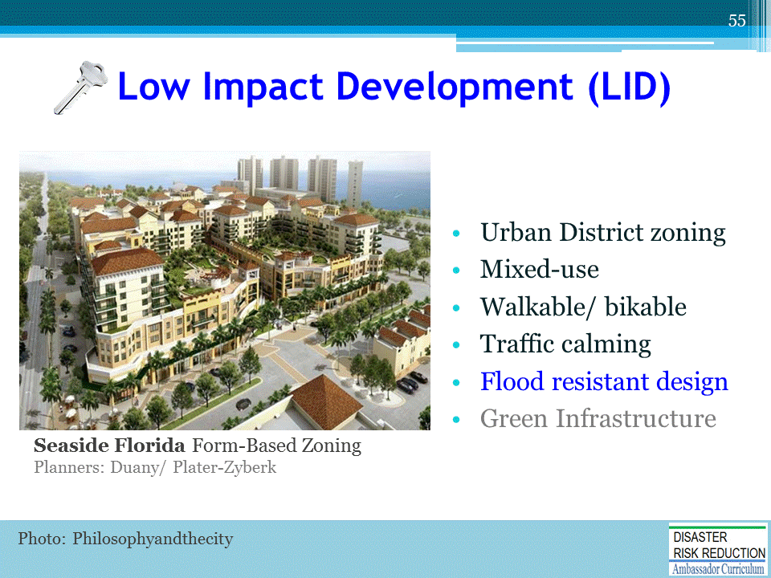
A third key is to combine the best practices of energy saving and Low Impact Development (LID) by encouraging compact, efficient land coverage and infrastructure [including green nfrastructure].
The following module 19 by Michele Adams describes these measures in more detail.

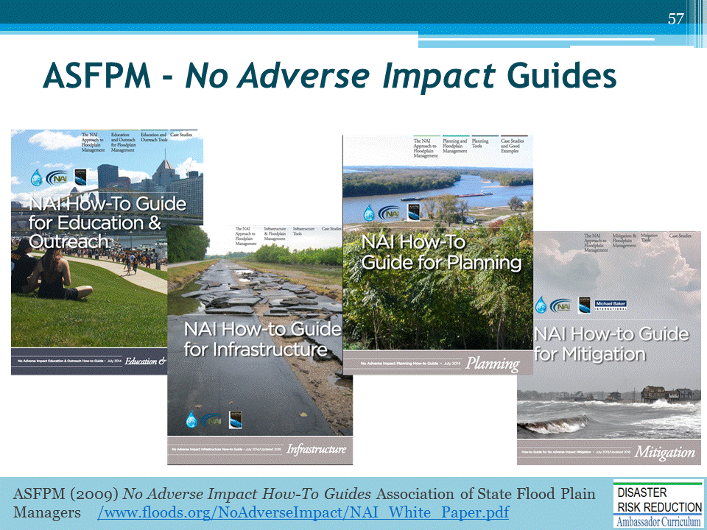
The Association of State Flood Plain Managers (ASFPM) provides detailed guides to floodplain management best practices to achieve “No Adverse Impact.”

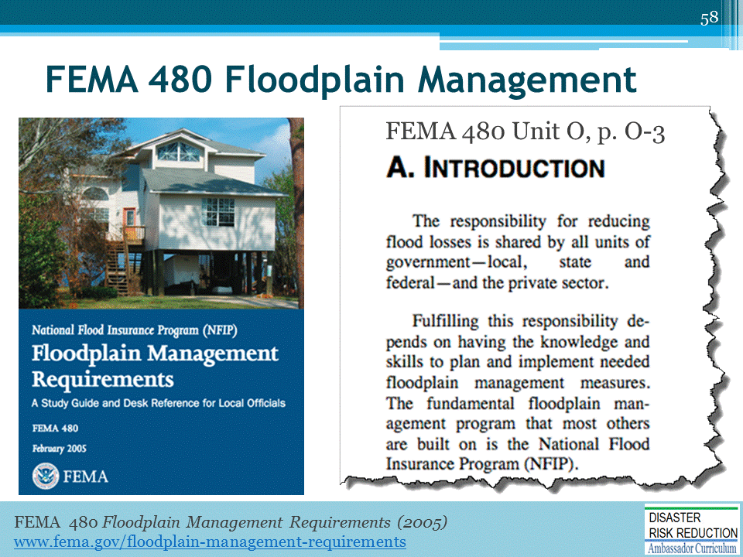

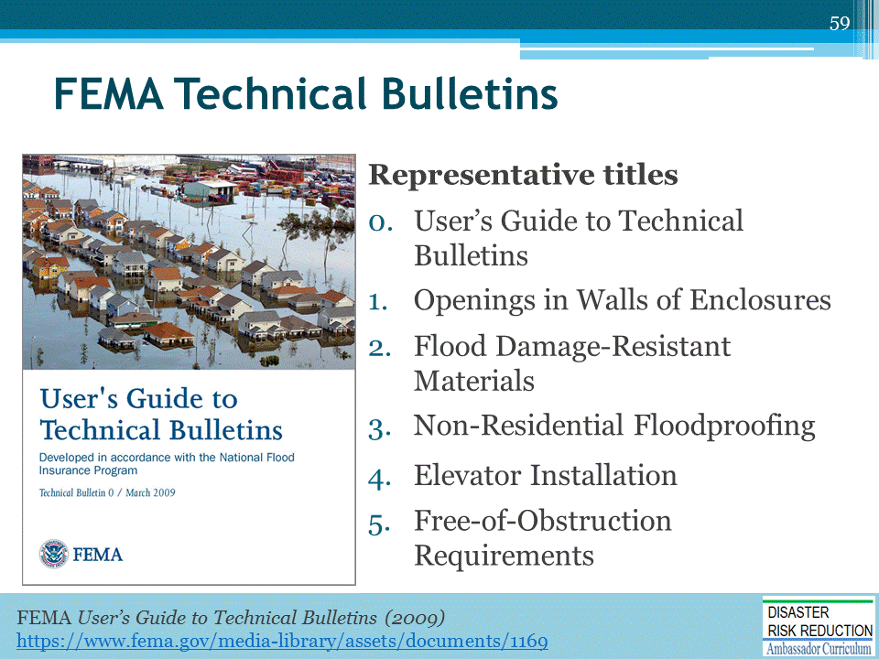
FEMA Technical Bulletins provide detailed recommendations for specific flood resistant measures, informed by post-disaster forensic analysis and lessons learned.

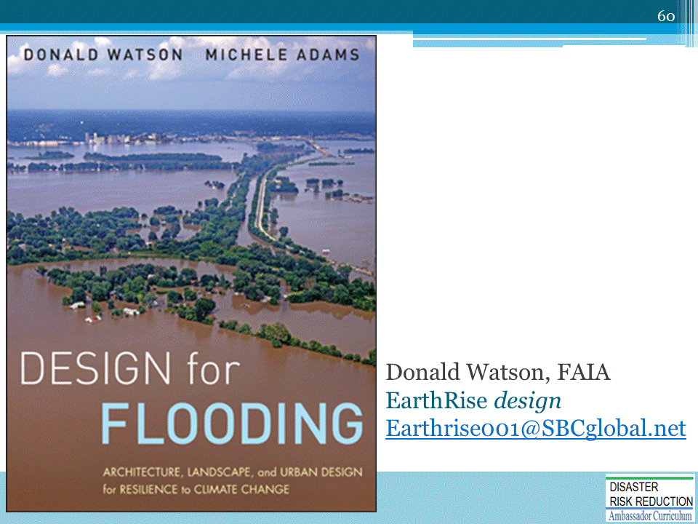
This presentation is based on material originally published in Design for Flooding, Donald Watson and Michele Adams, authors. John Wiley Publishing. 2011.

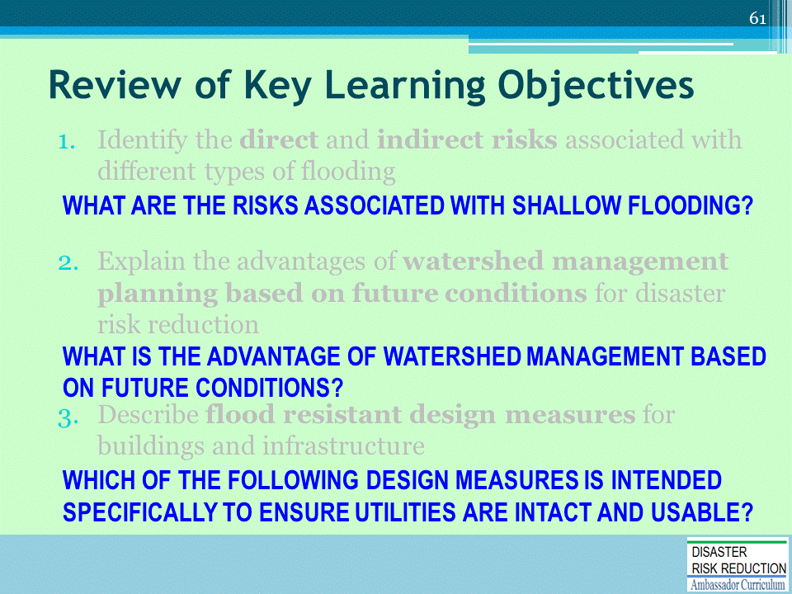
Discussion to engage participants and to assist achievement of Learning Objectives
- What are the risks associated with shallow flooding?
- What is the advantage of watershed management based on future conditions?
- Which of the following design measures is intended specifically to ensure utilities are intact and usable?

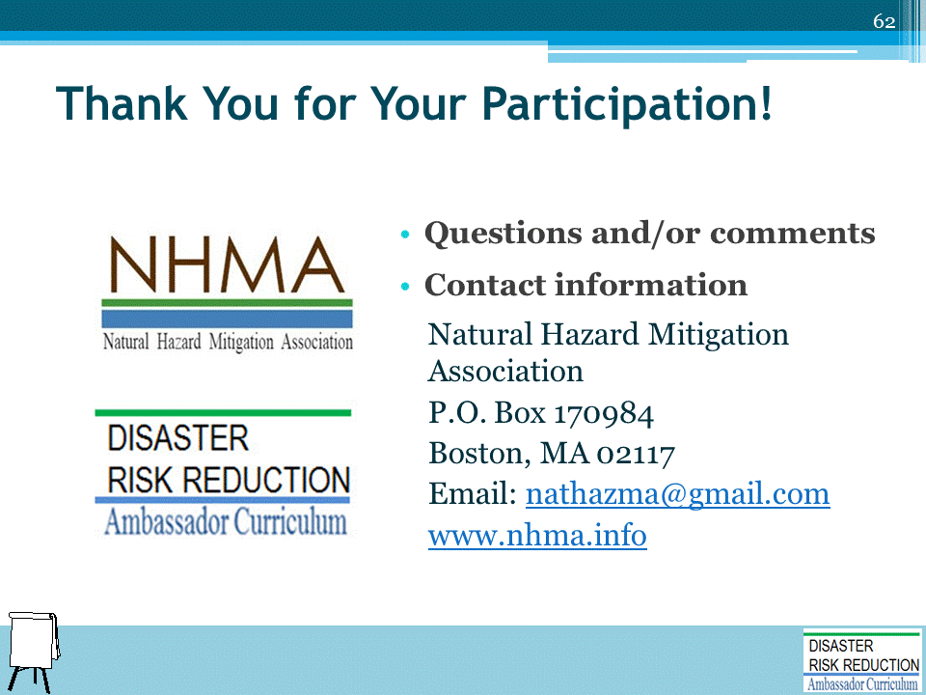
Record on easel pad any recommendations or questions to be addressed outside of the presentation.

DRR AMBASSADOR CURRICULUM AT-A-GLANCE
I. Disaster Risk Reduction for a Safe and Prosperous Future
1 | Introduction to the Natural Hazard Mitigation Association and Disaster Risk Reduction Ambassador Curriculum
2 | Introduction to Disaster Risk Reduction as a Foundation of Community Resilience
3 | Leadership for Disaster Risk Reduction
4 | Community Disaster Risk Reduction and Adaptation
5 | Approaching the Challenge of Disaster Risk Reduction: NIST Community Resilience Guide
II. Forming a Community’s Vision for Disaster Risk Reduction
6 | Risk Assessment through Storytelling: An Asset-Based Approach
7 | Achieving Community Buy-in for Disaster Risk Reduction: Win-Win Approaches
8 | Leveraging Resources to Improve Disaster Risk Reduction
III. Realizable, Practical, and Affordable Approaches for Moving from a Vision for Disaster Risk Reduction to a Strategy
9 | Selecting and Implementing a Strategy for Addressing Community Disaster Risk Problems
10 | Integrating Hazard Mitigation into Local Planning
11 | Beyond Codes and Low-Impact Development
12 | Creating the Plan: A Sustainable Floodplain Management Process Model
IV. Resources and Tools for Implementing a Community’s Disaster Risk Reduction Strategy
13 | Climate and Weather Tools and Trends
14 | Risk Assessment Basics
15 | Legal and Policy Opportunities for Disaster Risk Reduction
16 | Linking Catastrophe Insurance to Disaster Risk Reduction
V. Resources for Hazard-Specific Disaster Risk Reduction
17 | Living with Water: Inland and Coastal Flooding
18 | Design for Flood Resilience: Part I: Floodplain Management and Flood Resistant Design
19 | Design for Flood Resilience: Part II: Green Infrastructure / Low Impact Development
20 | Overcoming Impediments to Flood Resilience: Paths Forward
21 | Wildfire Mitigation
22 | The Wildfire-Flood Connection
23 | Severe Thunderstorm/ Tornado Safe Rooms
24 | From Policy to Engineering: Earthquake Risks

