Disaster Risk Reduction (DRR) Ambassador Curriculum

Instructor Guide

Module 19:
Design for Flood Resilience, Part II: Green Infrastructure/ Low Impact Development

THE DRR AMBASSADOR CURRICULUM
The goal of the DRR Ambassador Curriculum is to facilitate Disaster Risk Reduction efforts for the whole community by:
- Engaging in discussion of how disasters can be reduced through local action
- Sharing insights among local leaders and technical experts to enable the development of cross functional solutions
- Acquiring the best-available information, knowledge of best practices, and analytic tools to enable better-informed decisions before, during, and after disasters
It is important for instructors of DRR Ambassador Curriculum modules to remember this is one module in a 24-module curriculum. The “DRR Ambassador Curriculum At-a-Glance” table, located at the end of this document, lists the modules of the Curriculum. Keep in mind the following context for the module(s) you conduct:
DRR-A CURRICULUM TARGET AUDIENCE
The target audience includes those involved in community development decision-making, such as local community staff, volunteer and stakeholder groups, and federal and state officials.
METHODS OF DELIVERY
Varied delivery methods will provide multiple options for access by the target audience. The DRR Ambassador modules may be presented via webinars hosted by NHMA or partner organizations, presented in conferences and/or classrooms by qualified DRR Ambassador Curriculum instructor(s), or are downloadable for individual study from the NHMA website.
COURSE MATERIALS
Instructors are expected to use the instructional materials housed on the NHMA website to conduct DRR Ambassador Curriculum modules (Instructor Guide, supporting visuals, Participant Guides, and handouts). Instructors may tailor modules to specific audiences or locations as long as they do not revise the learning objectives and do not revise the materials in such a way that the participants cannot correctly complete the post-test. Instructors request the current pre/post-test for the module from NHMA.
CERTIFICATES OF COMPLETION
Certificates of Completion will be awarded by NHMA to participants who successfully complete NHMA-sponsored DRR Ambassador modules. A DRR Ambassador Certificate will be awarded to individuals completing all 24 modules. Participants who choose not to take the post-test may be issued a Certificate of Attendance. Contact NHMA about obtaining certificates. Inform participants to ask their certifying boards about acceptance of NHMA DRR Ambassador certificates for continuing education credits.

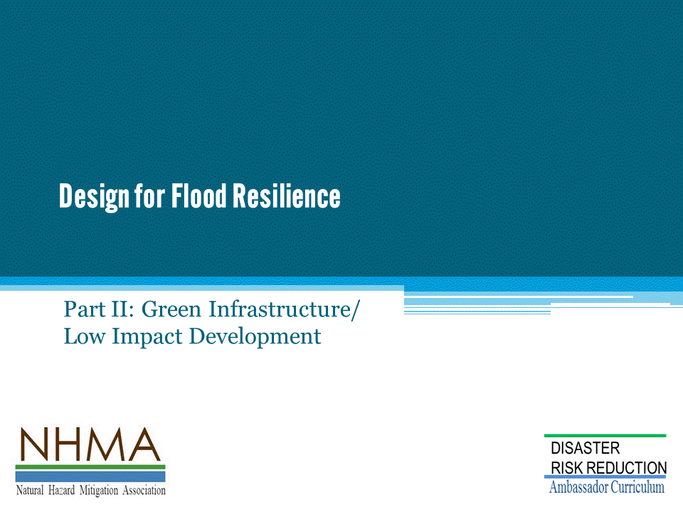

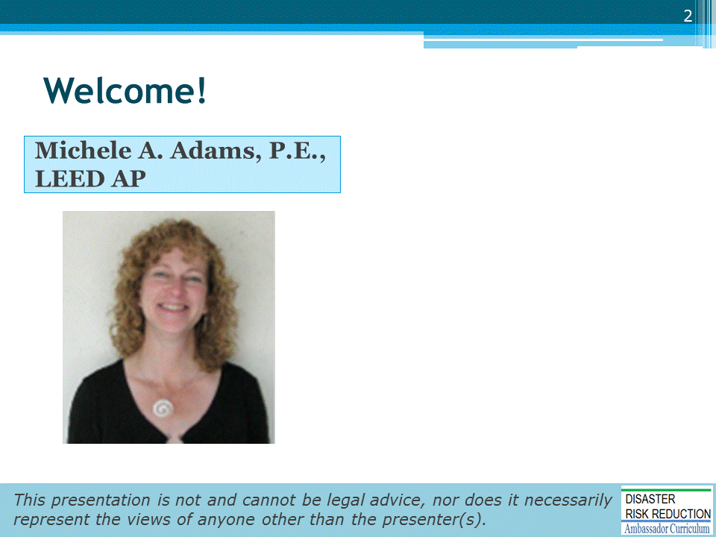
Introductions:
- Each presenter introduces her/himself, including affiliation and brief background.
- OPTIONAL: Have each participant briefly introduce him/herself
Mention:
- NHMA presentations are based on general principles of law, engineering, policy and emergency management.
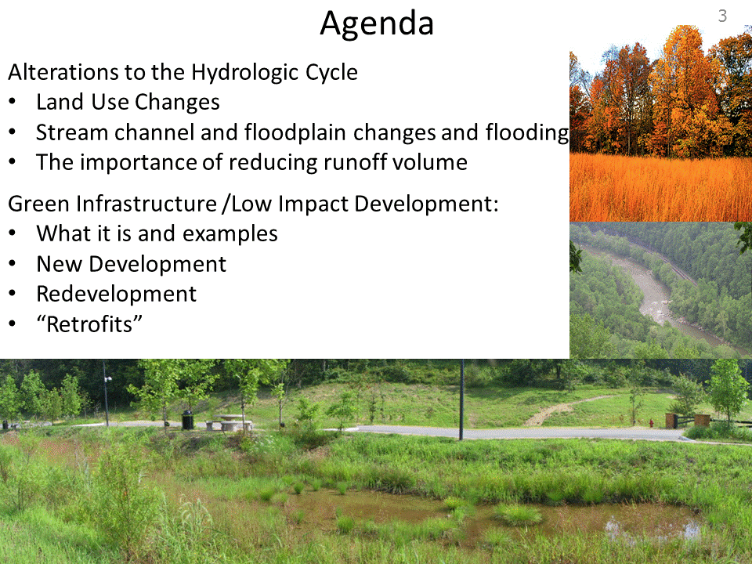

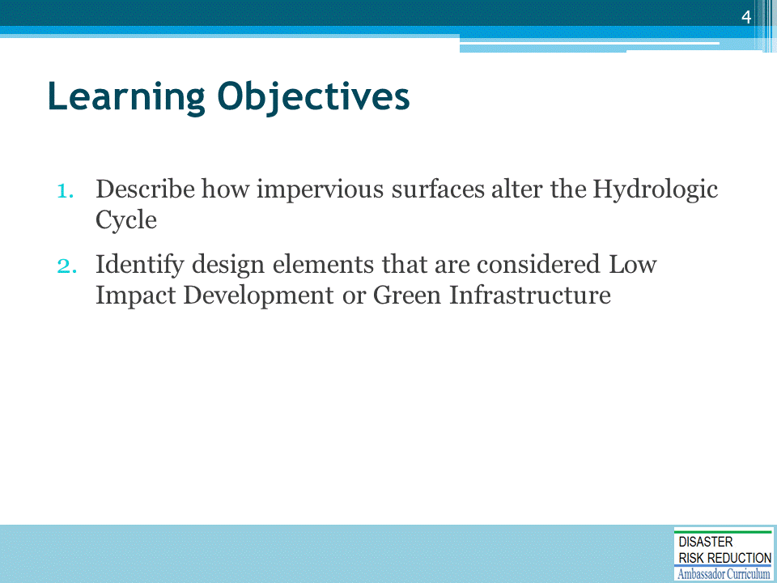

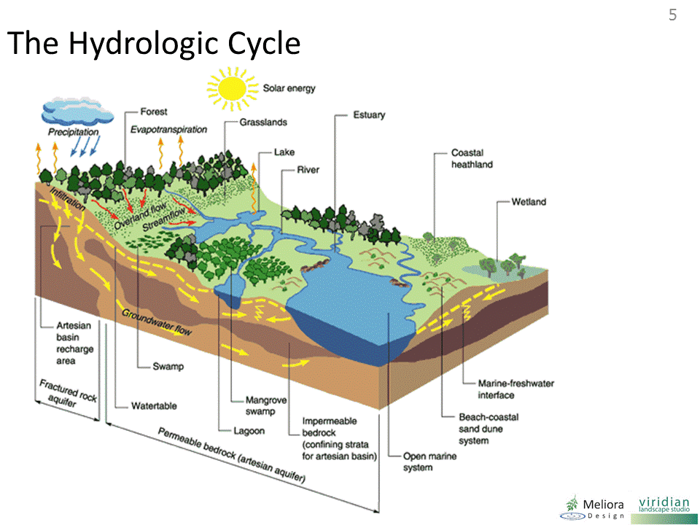
We’re all familiar with the idea of the “water balance”. Rain falls, soils and vegetation absorb, blah blah. Pretty basic

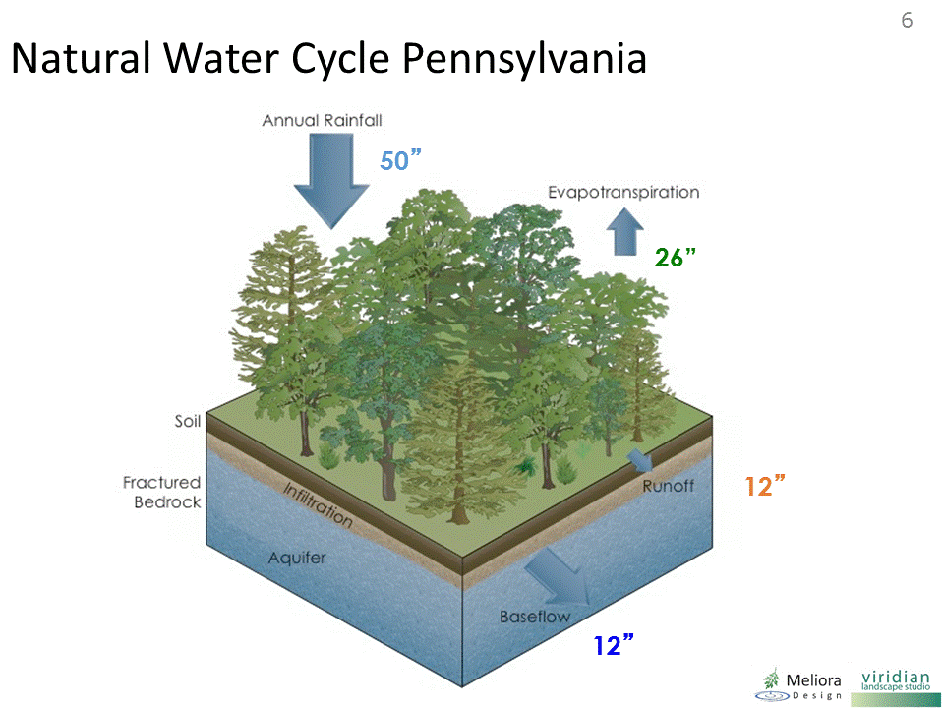
But it’s hard to quantify in our minds what this means and how our landscape changes change the water cycle.
Imagine just one acre of forest when it was Penn’s Woods before we build.
In this area, that parcel of land that receives about 45” per year of rainfall. (and this doesn’t vary that much along the Piedmont from NY to the Carolinas)
Nearly all the rainfall is absorbed by the soil and vegetation, which return about half of that water to the atmosphere via evapotranspiration.
Most of the remainder – maybe 12-15” per year, soaks into the soil and makes it way to streams and wetlands, and some goes deeper to supply our groundwater.
Only a very small amount “runs off”.

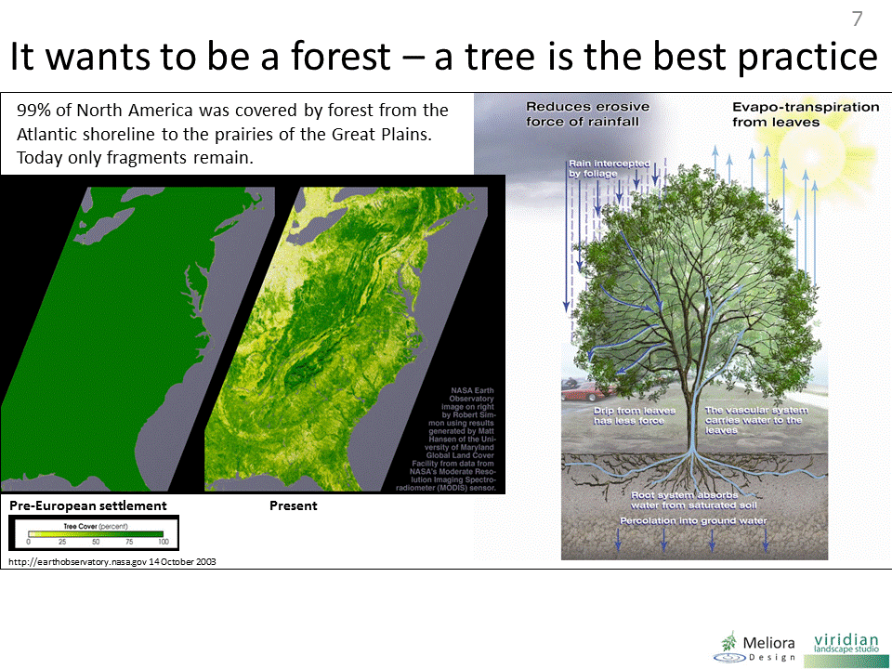
Trees intercept rainfall and reduce the energy of rain hitting soil. Very small storms are intercepted by the leaves and branches – think about standing under a tree or in a forest in the rain.
The forest litter acts as a sponge and the roots carry water into the soil. Recent research has found that trees not only “pump water up” via ET, but when it rains they actively “pump water down” into the lower soils for future use.
The Trees grow as nature’s response to the amount of rainfall we receive here.
As rainfall levels decline in the Midwest, prairies are the natural landscape, and so on.
But whether we are water rich (like here) or water poor, the water balance works much the same way.

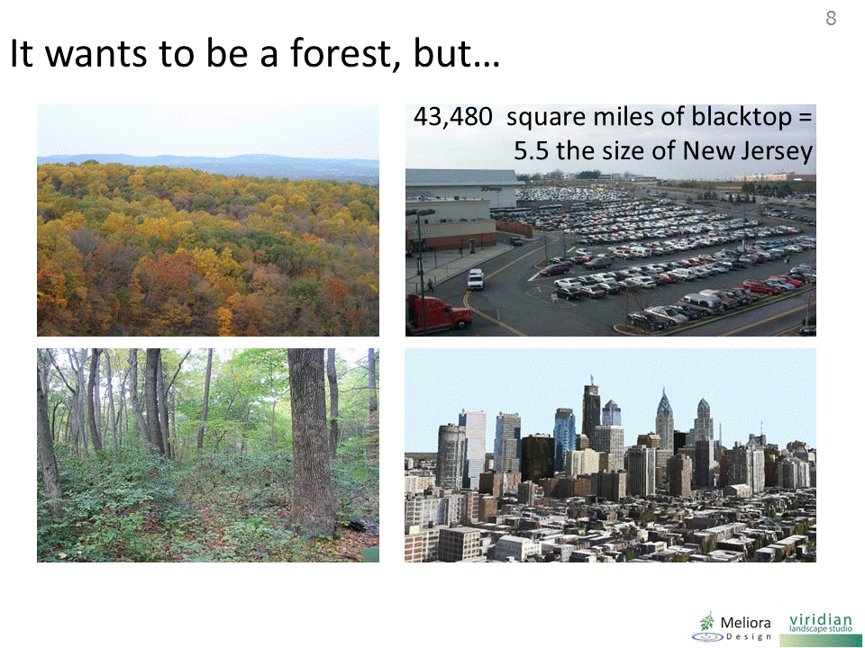

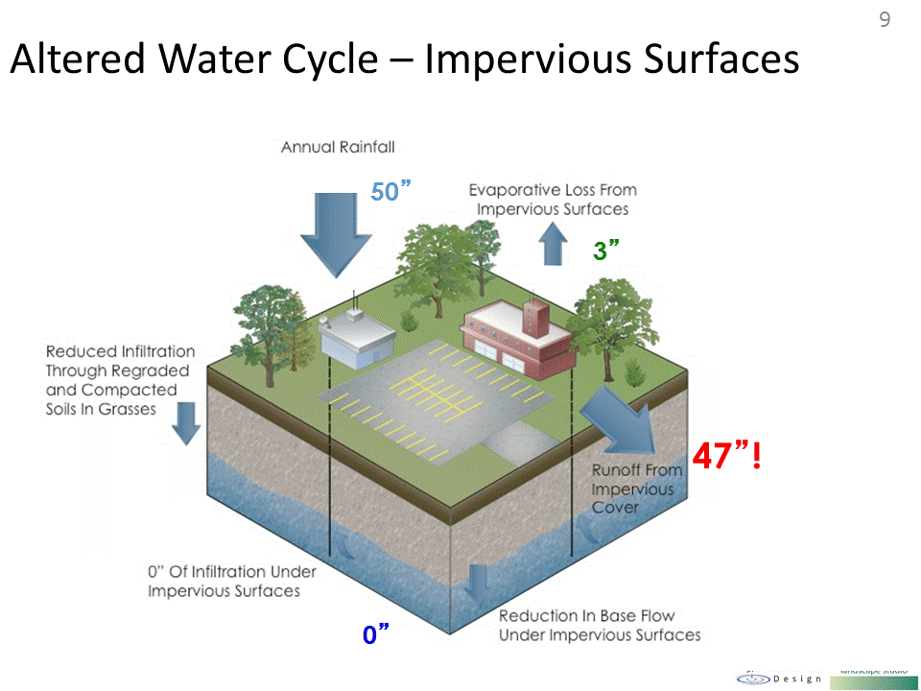
After development, there is virtually no infiltration and nearly all rainfall runs off impervious surfaces.
That’s about 3 feet MORE runoff every year!

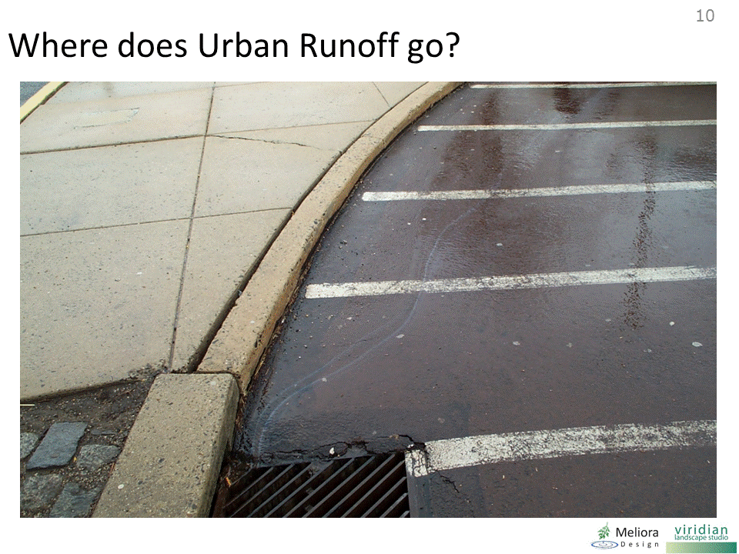

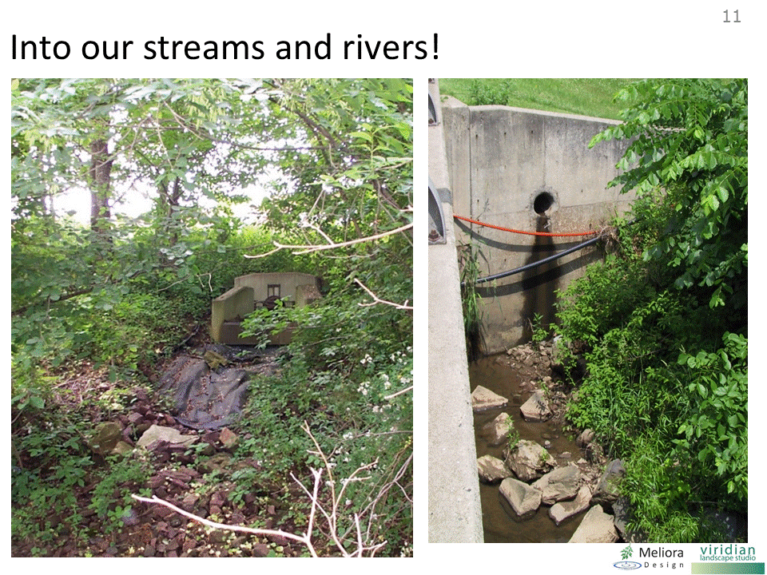
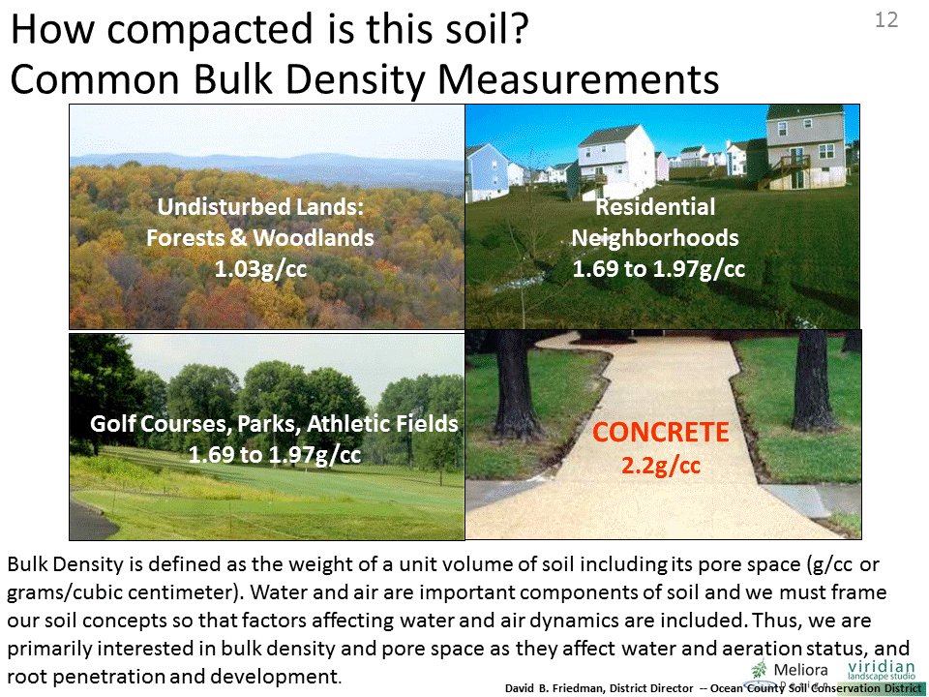
Research from New Jersey (Ocean County) as well as other places indices that our “pervious” landscapes are nearly as compacted as pavement!
When soil is compacted, water does not drain well and plant roots cannot establish well.
NRCS has suggested linking ideal bulk densities to soil texture.
Permeability has an inverse relationship to bulk density.
Frequent mowing compacts surface soils!

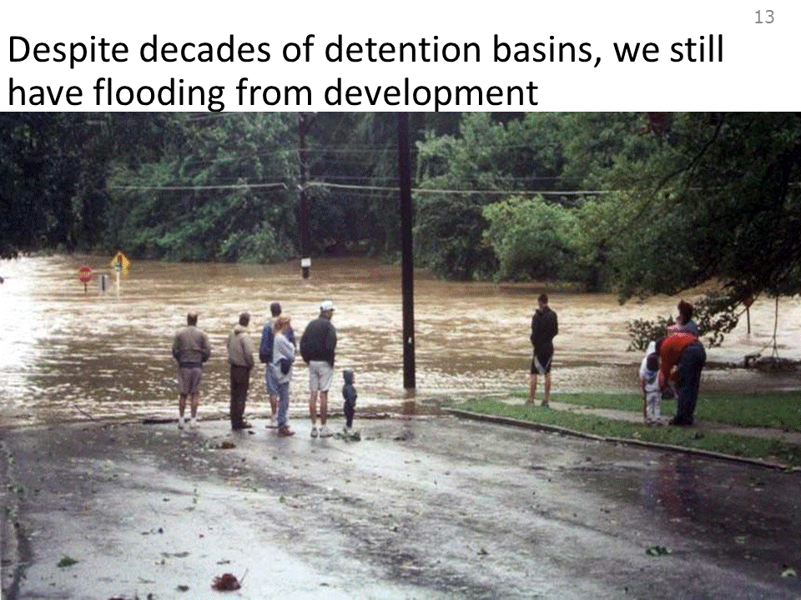

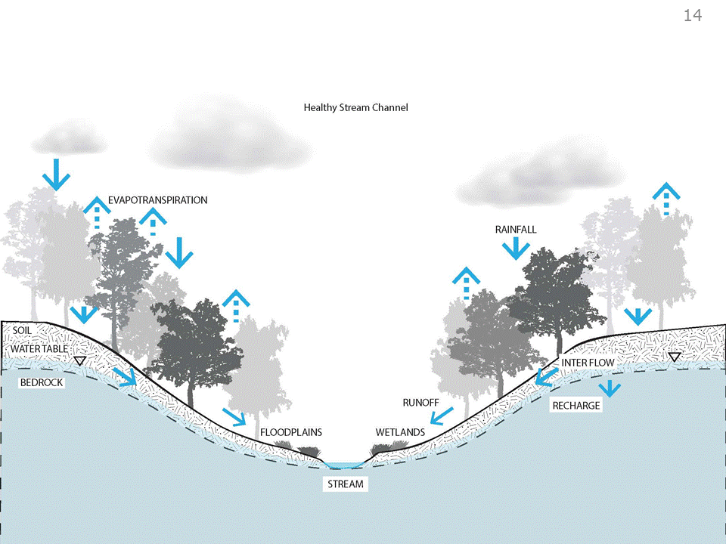

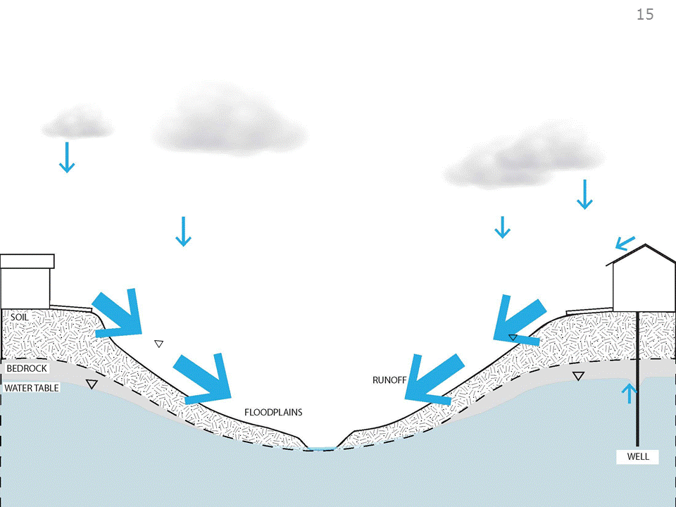

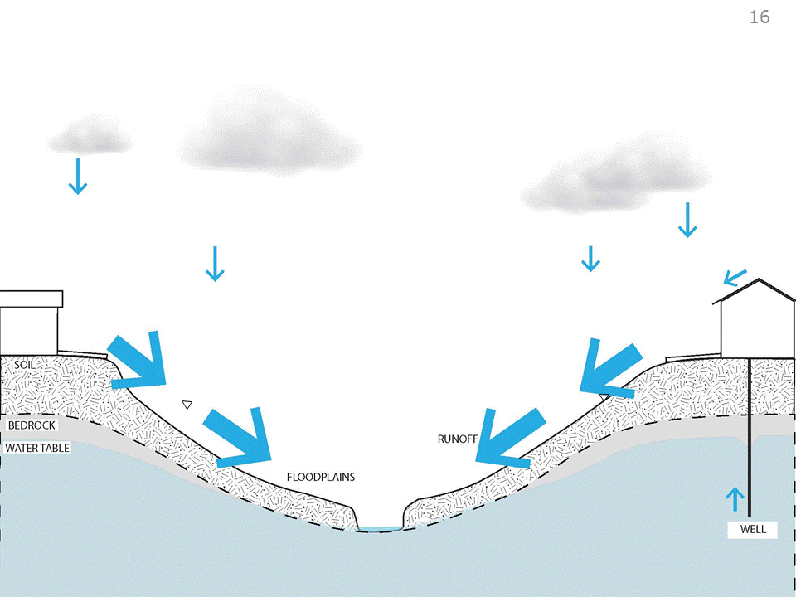

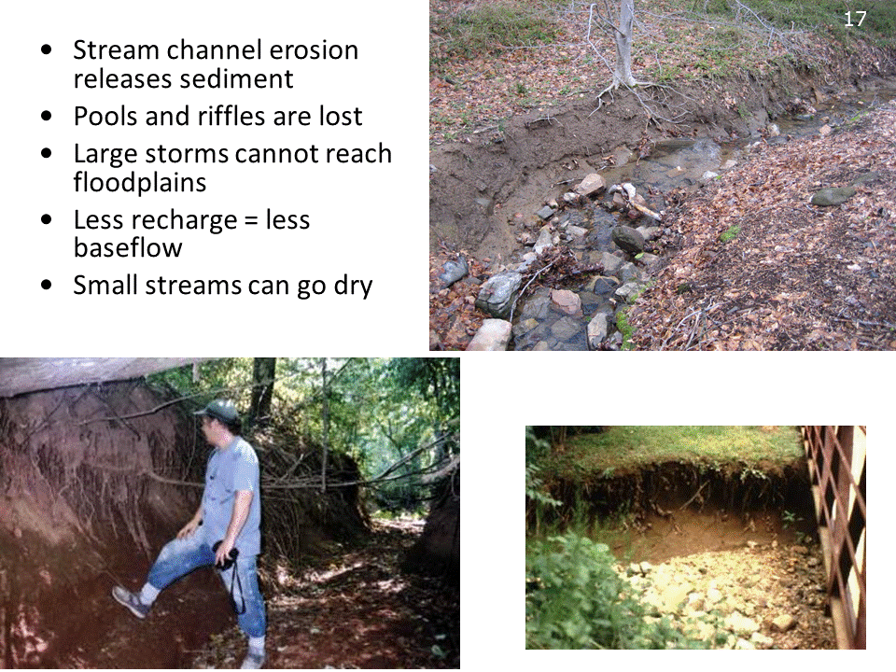
With less recharge, the water table can drop.
Small streams can go dry.
Outfalls on slopes can create massive dry gullies.
At Tyler Arboretum, as the stream channel cut down to handle more runoff volume, it cut below the organic layer. Water would then “weep” from the wooded soils faster and dry the woodlands out – eroded channels can effect vegetation!
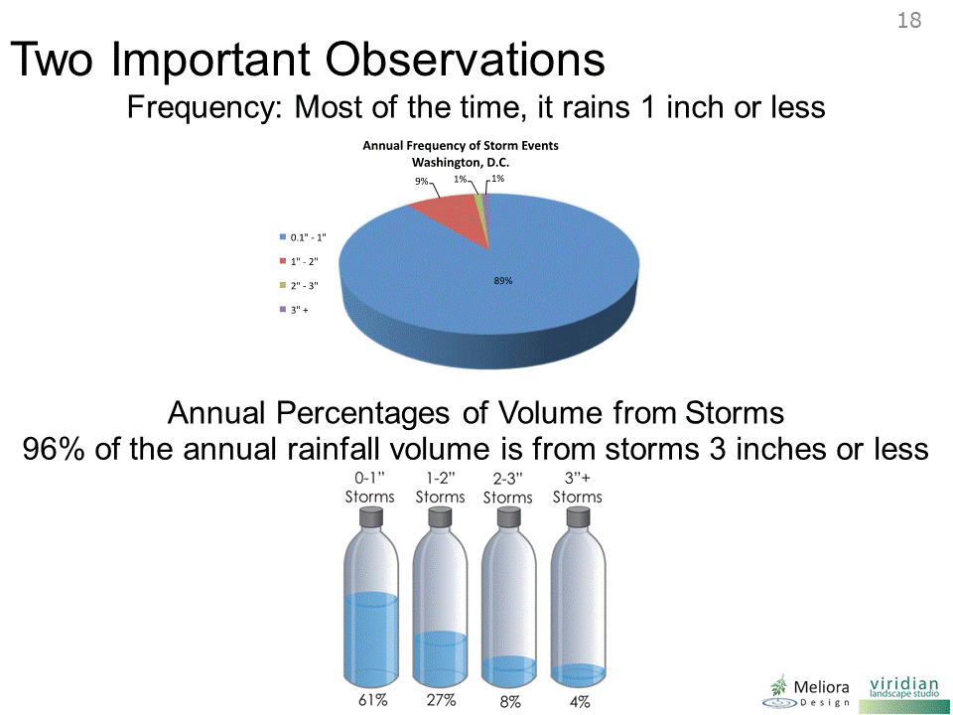
It’s also important to think about how rainfall occurs.
Most of the time (nearly 90% of the time), it rains a little bit – less than an inch – and those little rainfalls of less than an inch add up over the year- they make up more than 60% of the 45 inch total rainfall.
Storms between 1 and 2 inches make up most of the rest –
Close to 90% of the total volume of rainfall (or about 40 out of the 45 inches) is in storms less than 2”.
And what’s interesting is that even though the total amount of rainfall varies from place to place, this pattern of small rainfalls making most of the total is the same everywhere – even LA.
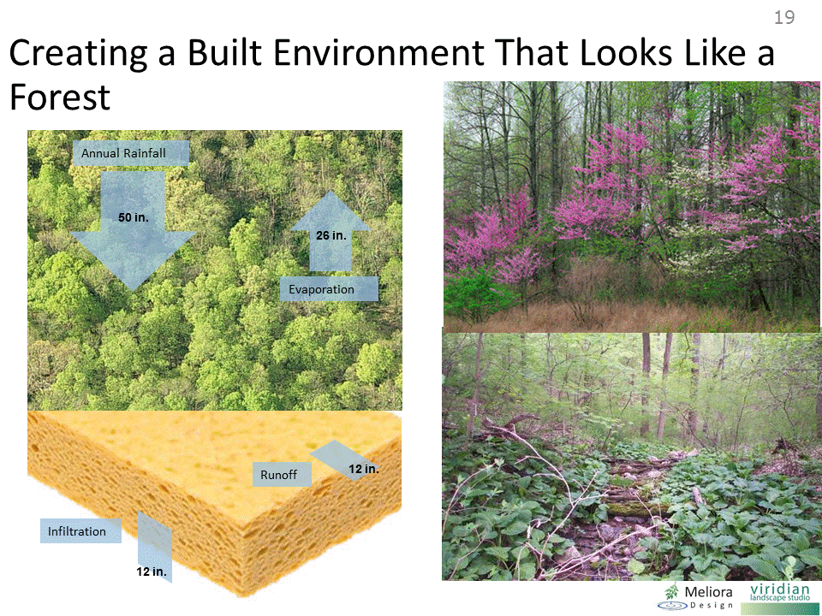
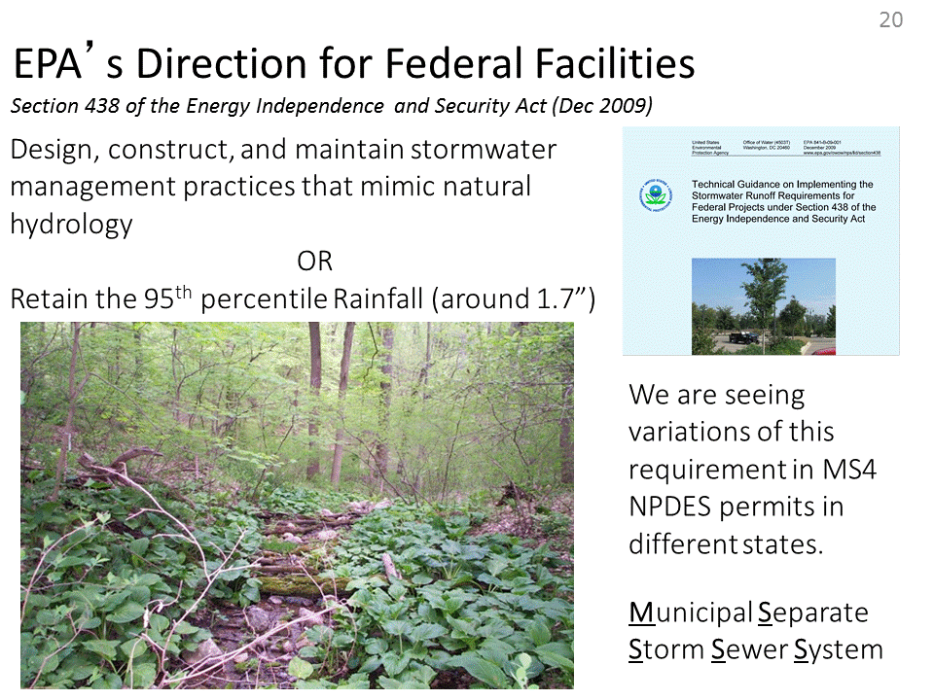

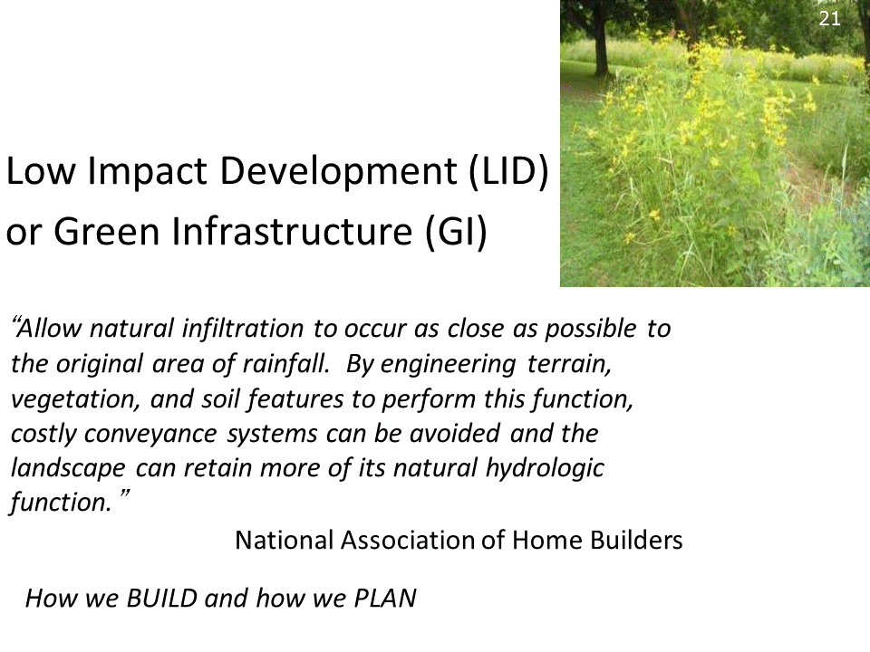
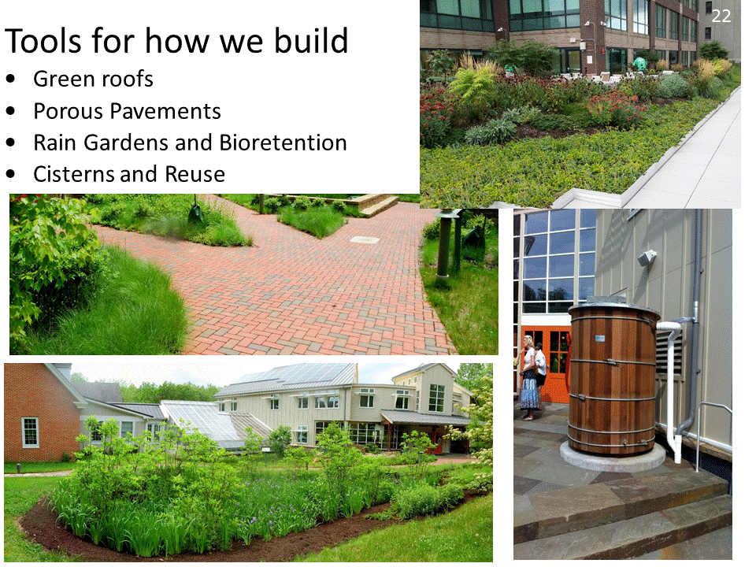
But it's hard to quantify in our minds what this means and how our landscape changes change the water cycle.
Imagine just one acre of forest when it was Penn’s Woods before we build.
In this area, that parcel of land that receives about 45” per year of rainfall. (and this doesn’t vary that much along the Piedmont from NY to the Carolinas)
Nearly all the rainfall is absorbed by the soil and vegetation, which return about half of that water to the atmosphere via evapotranspiration.
Most of the remainder – maybe 12-15” per year, soaks into the soil and makes it way to streams and wetlands, and some goes deeper to supply our groundwater.
Only a very small amount “runs off”.

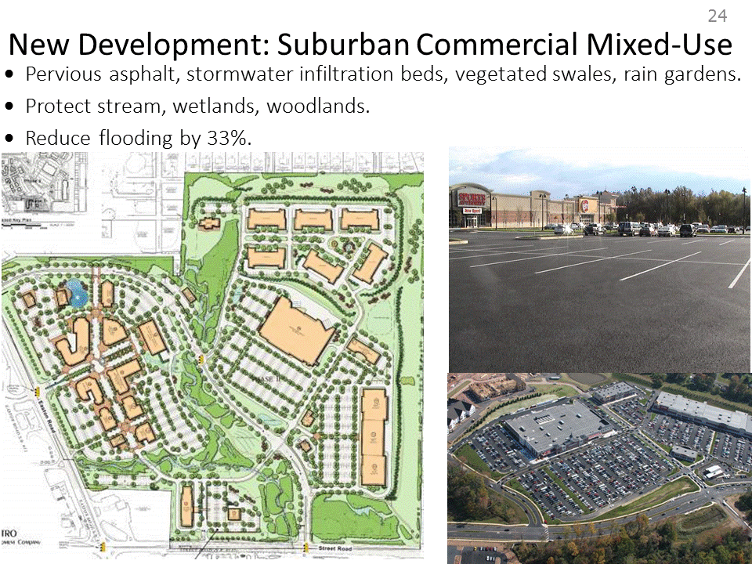

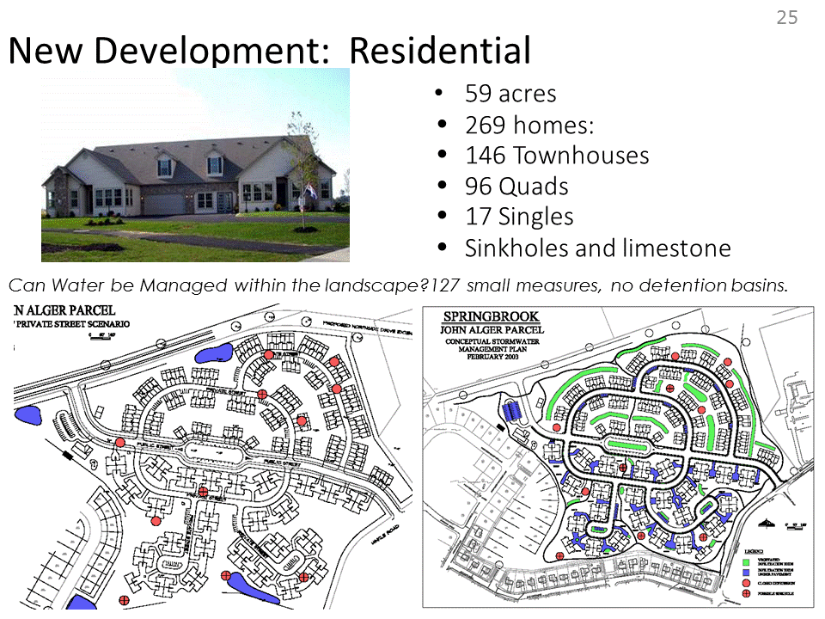

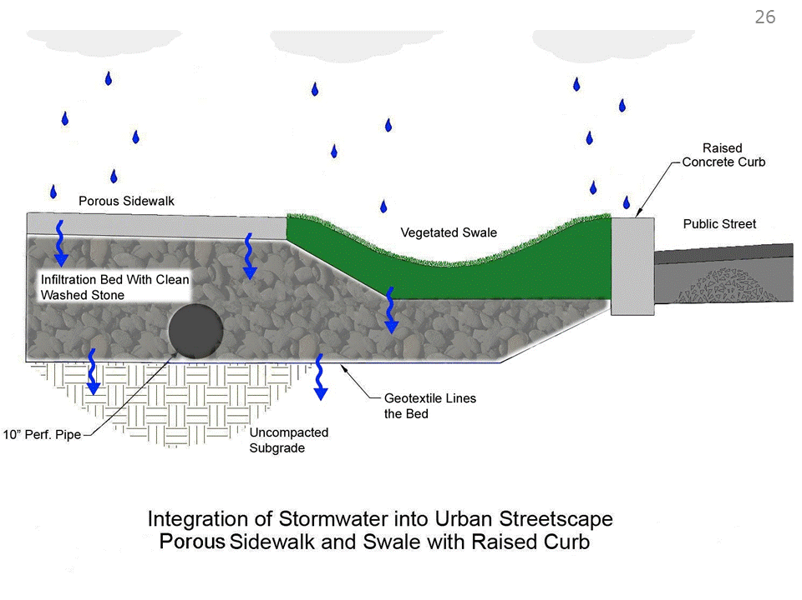

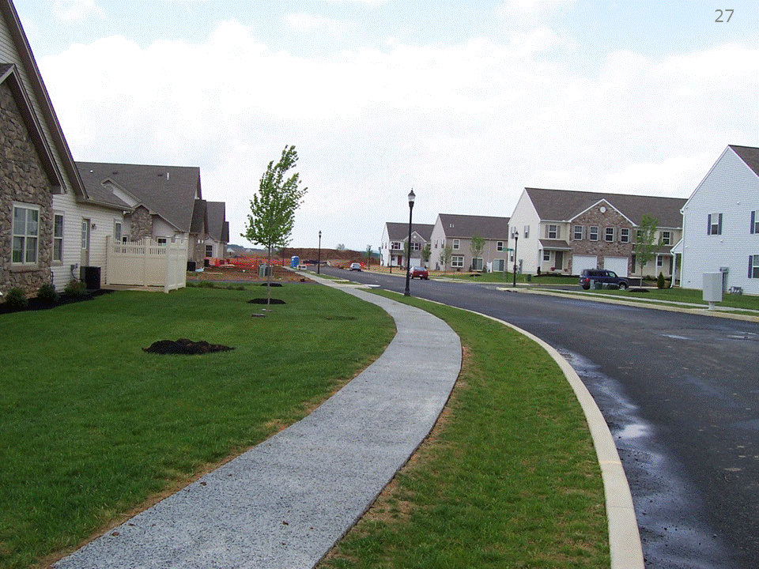

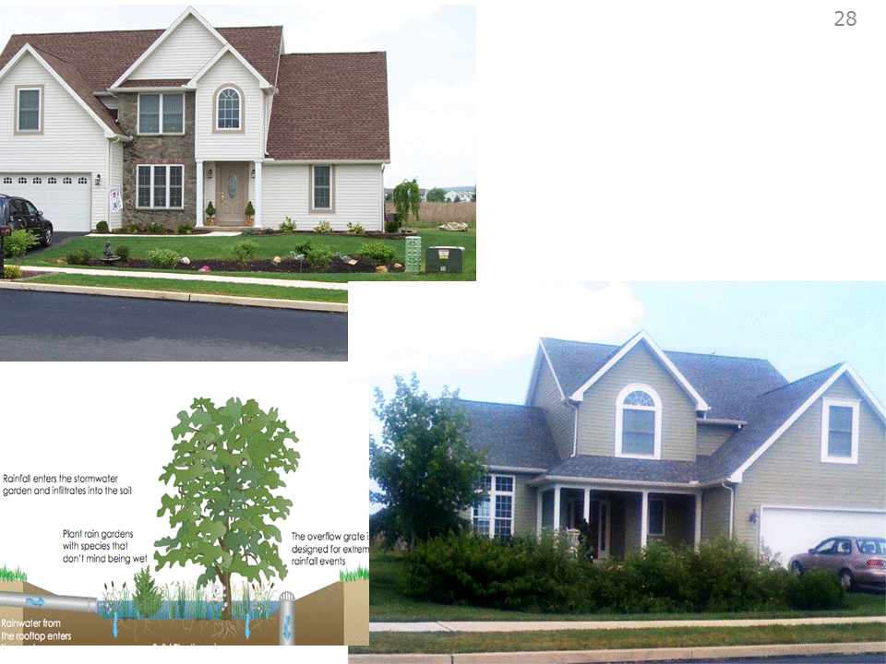

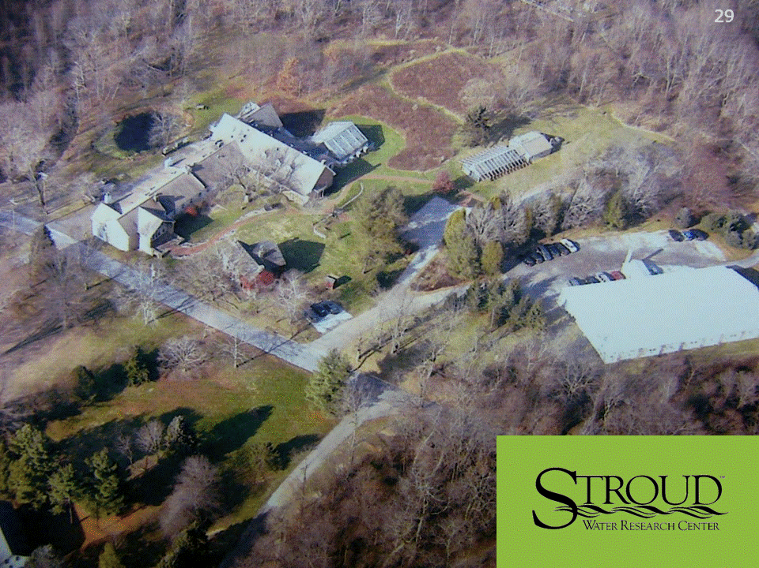

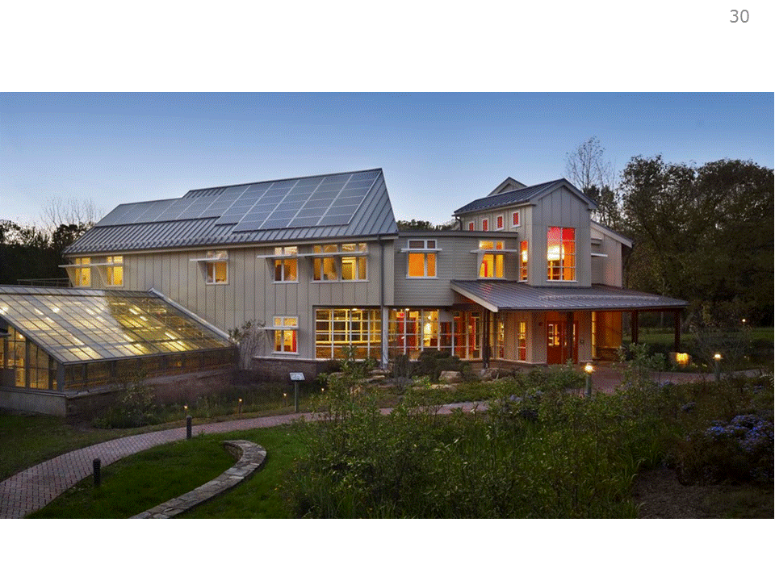

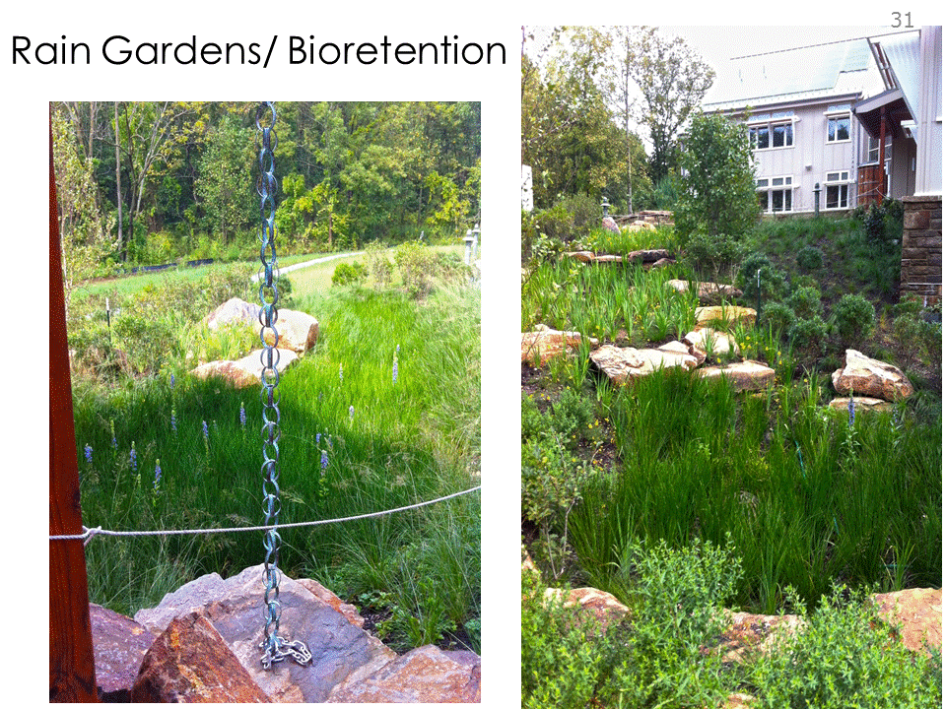

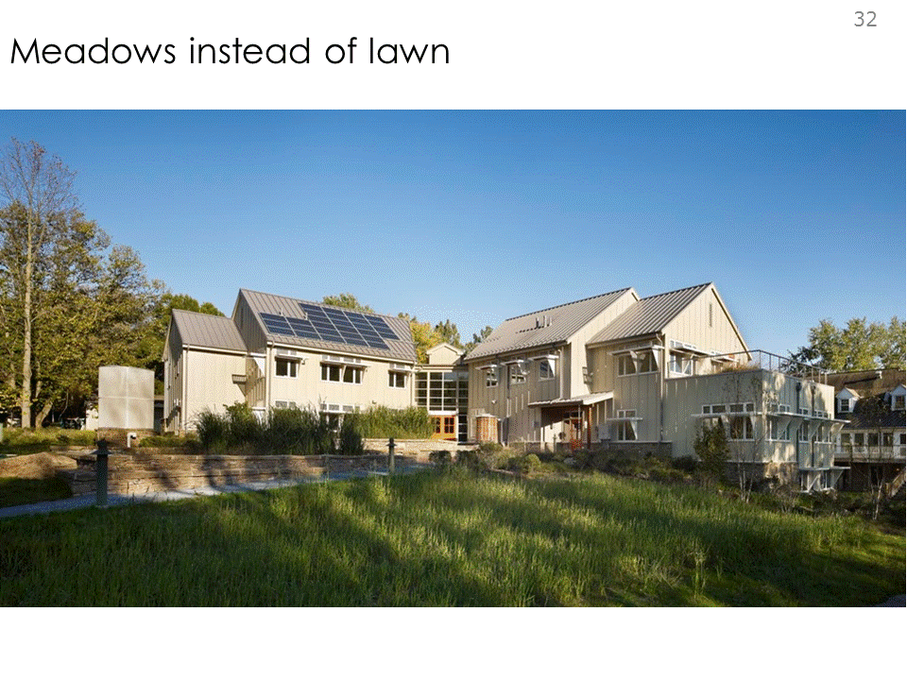

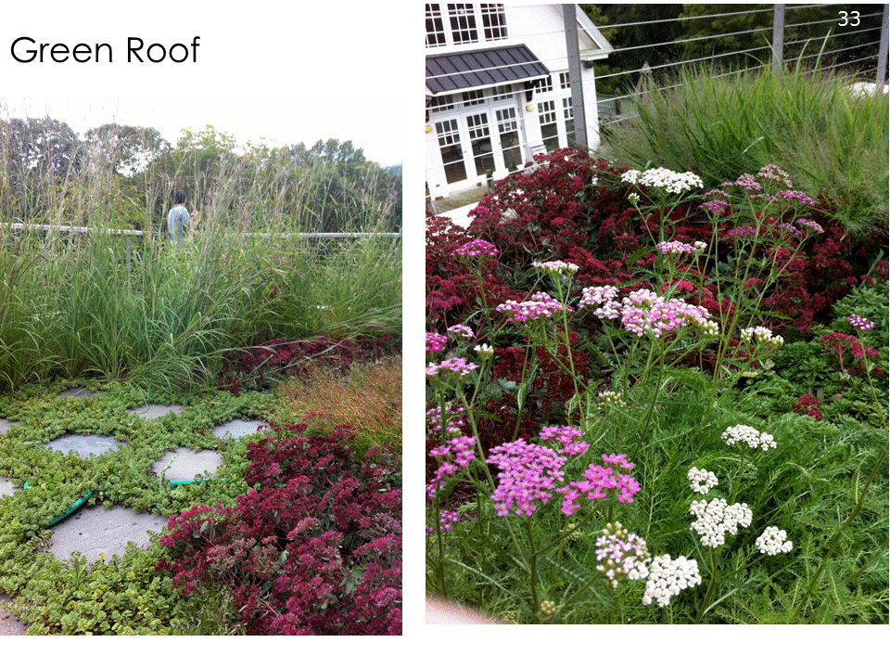

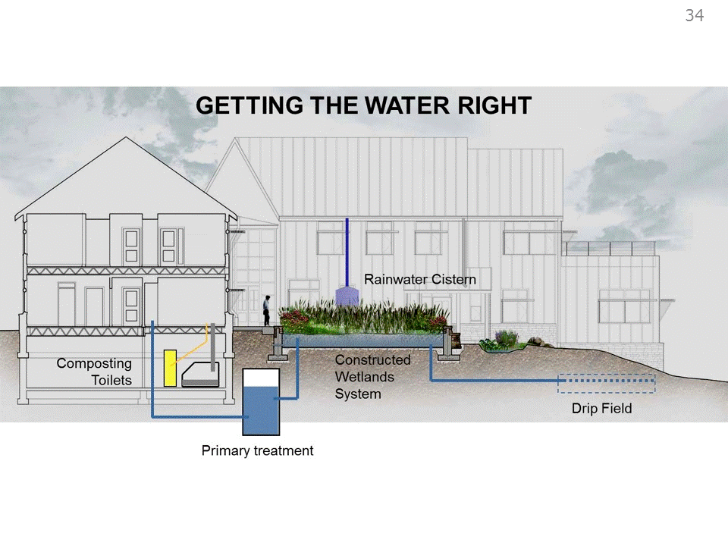
Shows the full water cycle

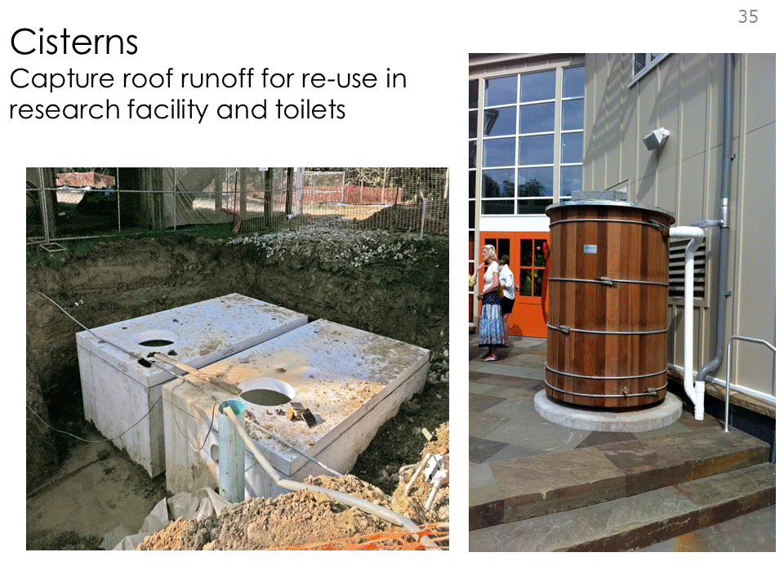

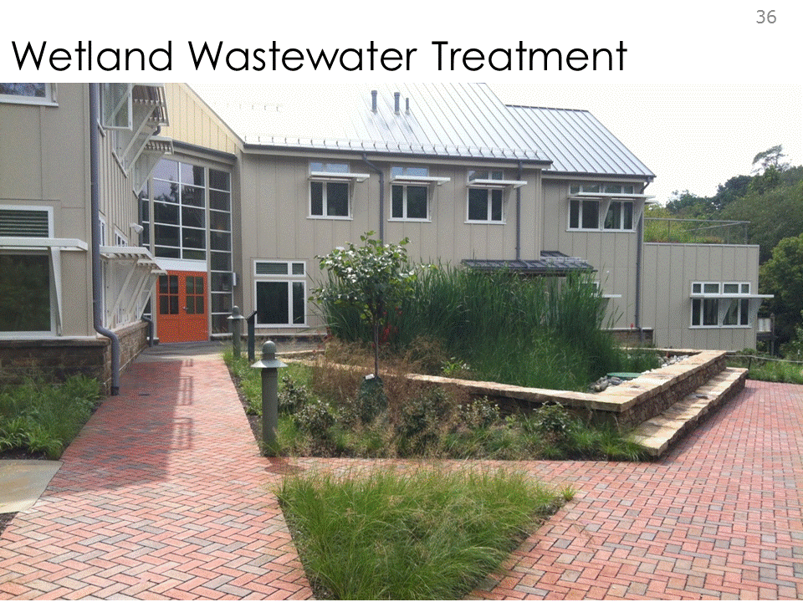

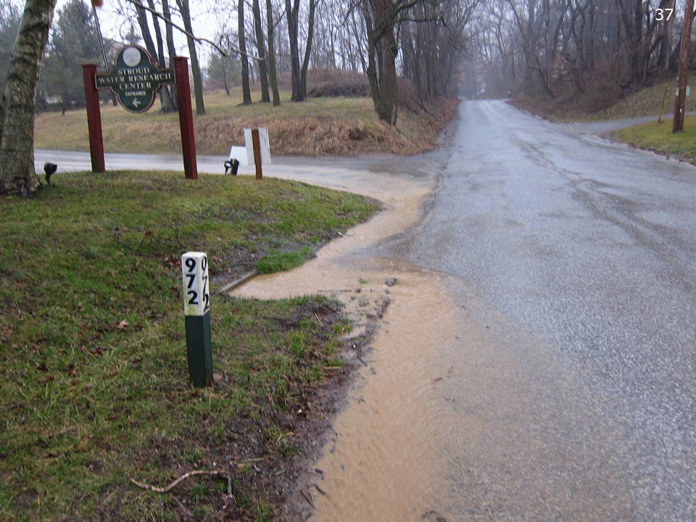
Is it really working?
Bfore...

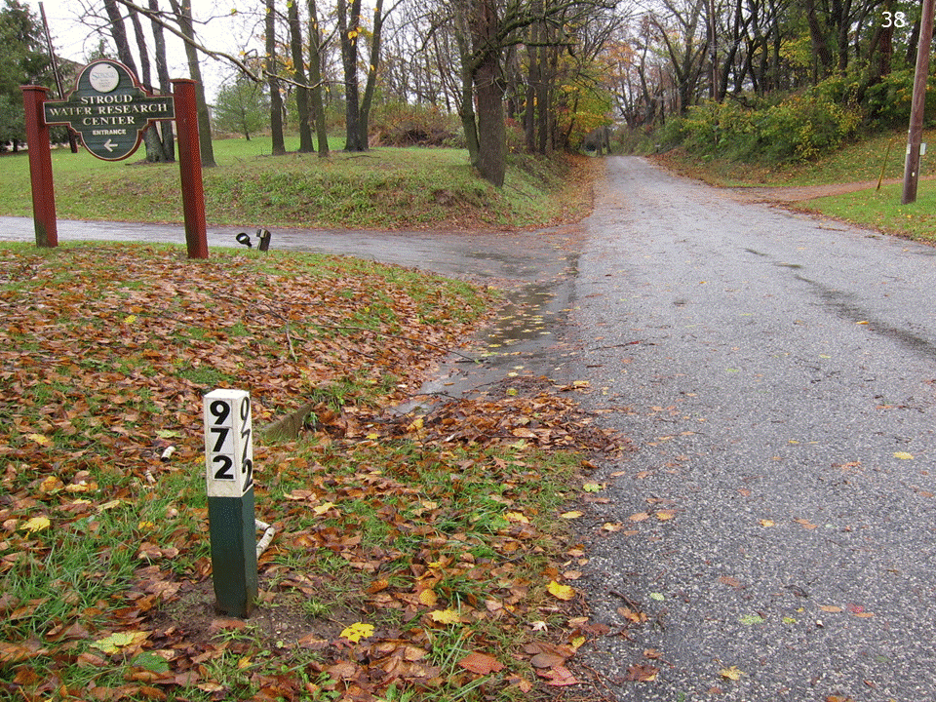
After Hurricane Sandy

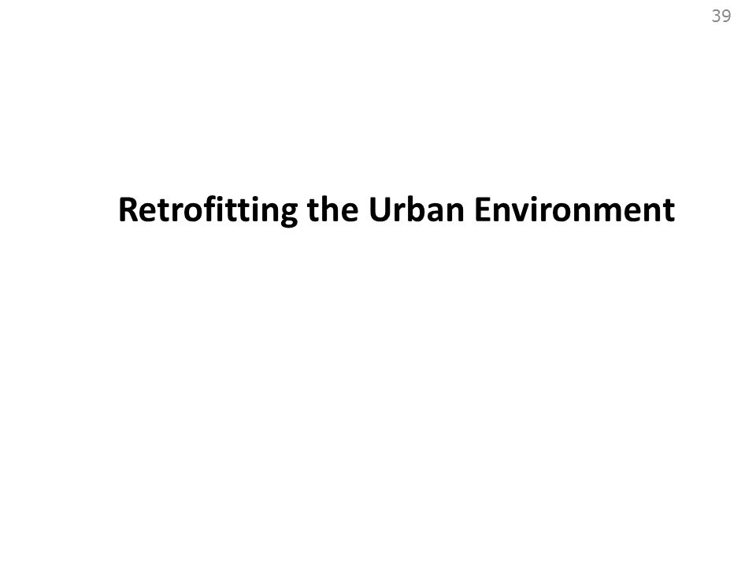

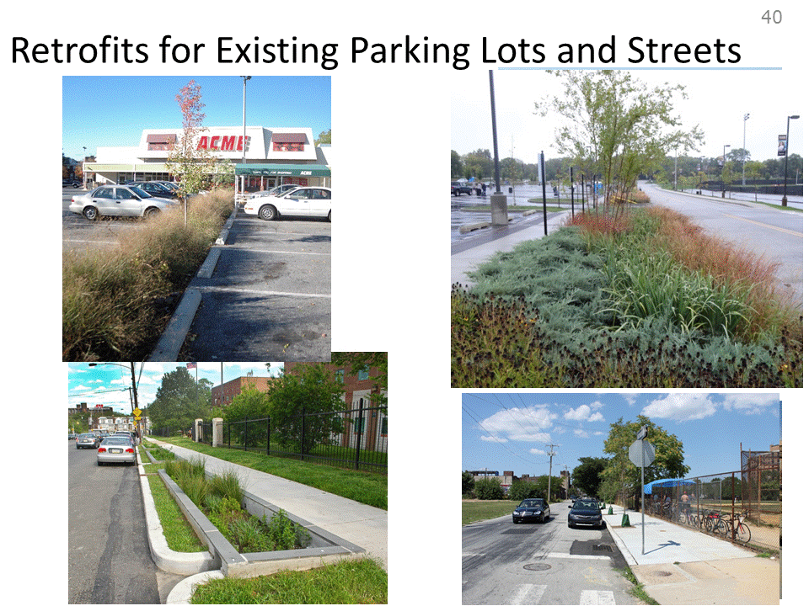

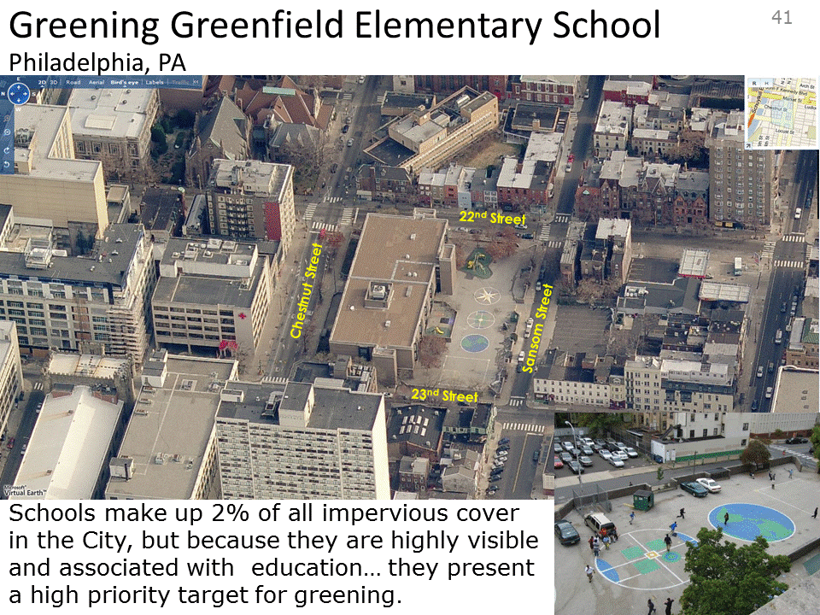

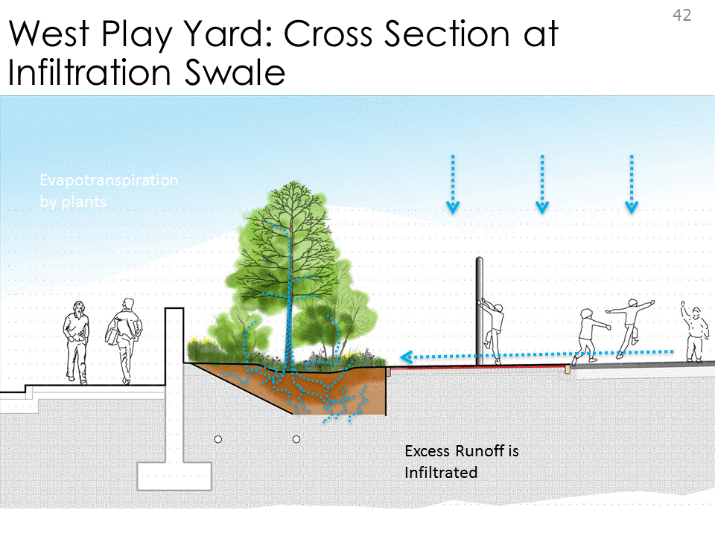
Porous rubber play pad

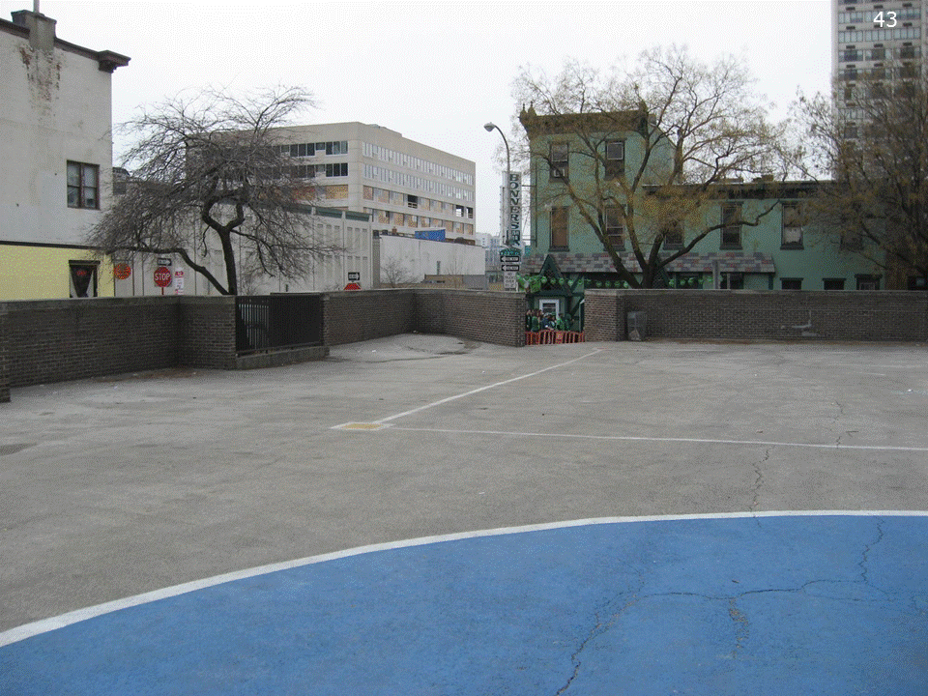
Before...

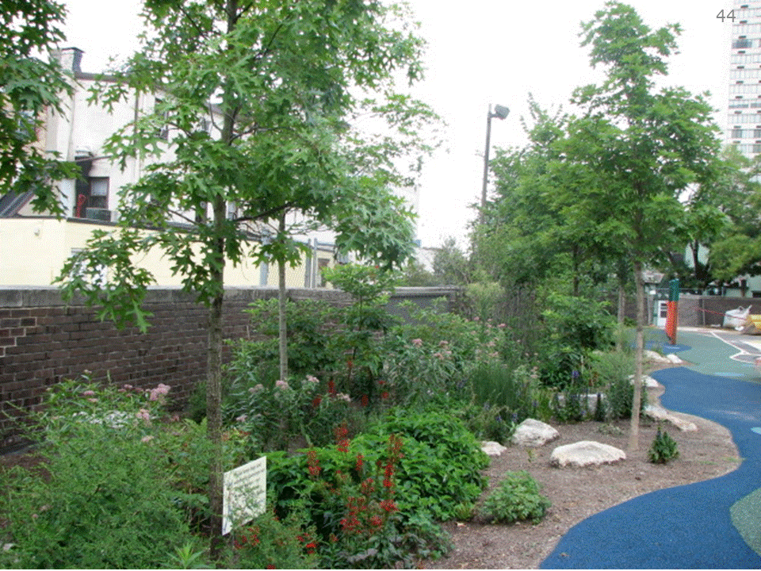
After... with green spaces

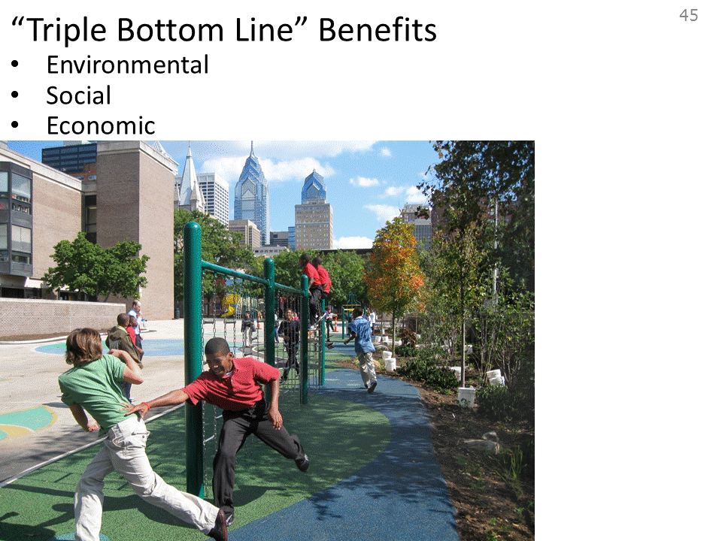

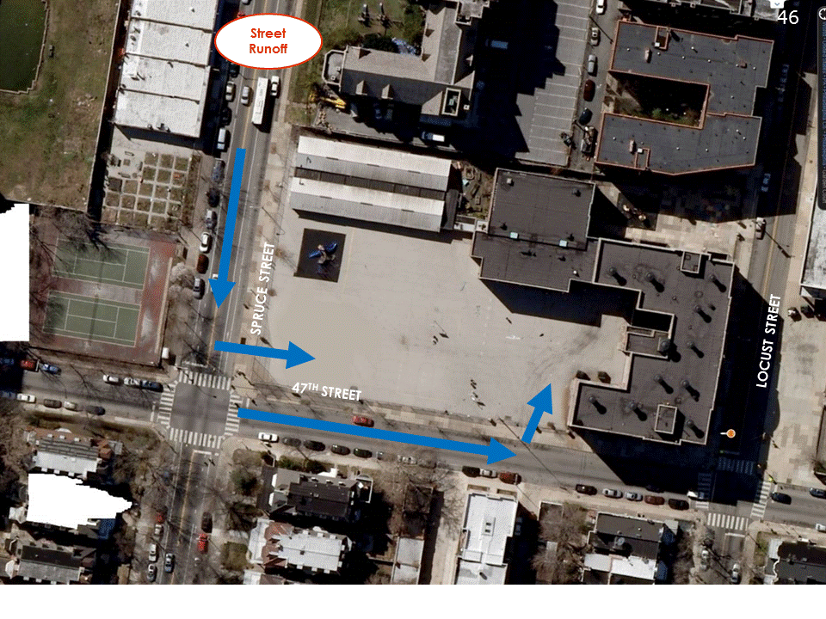

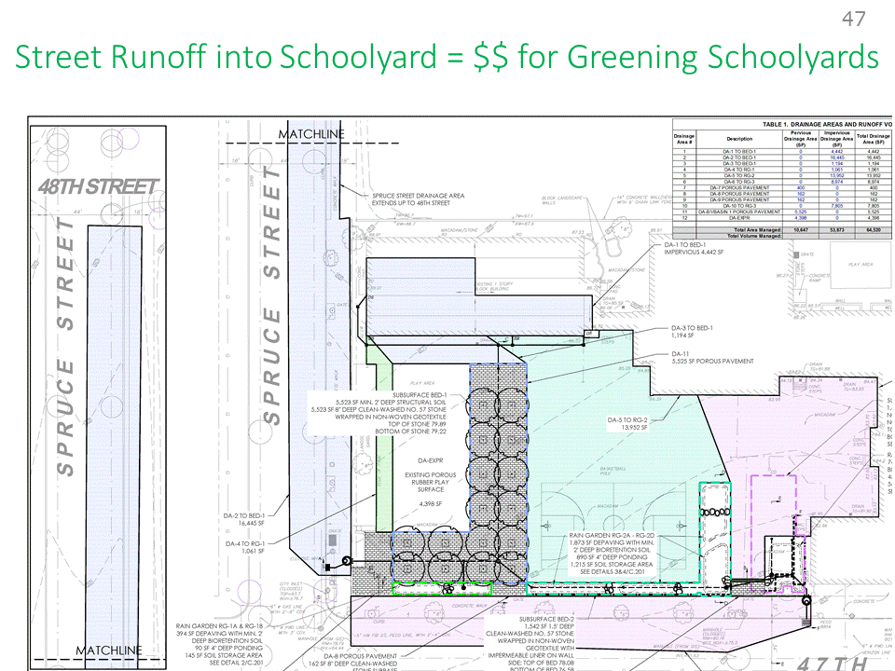

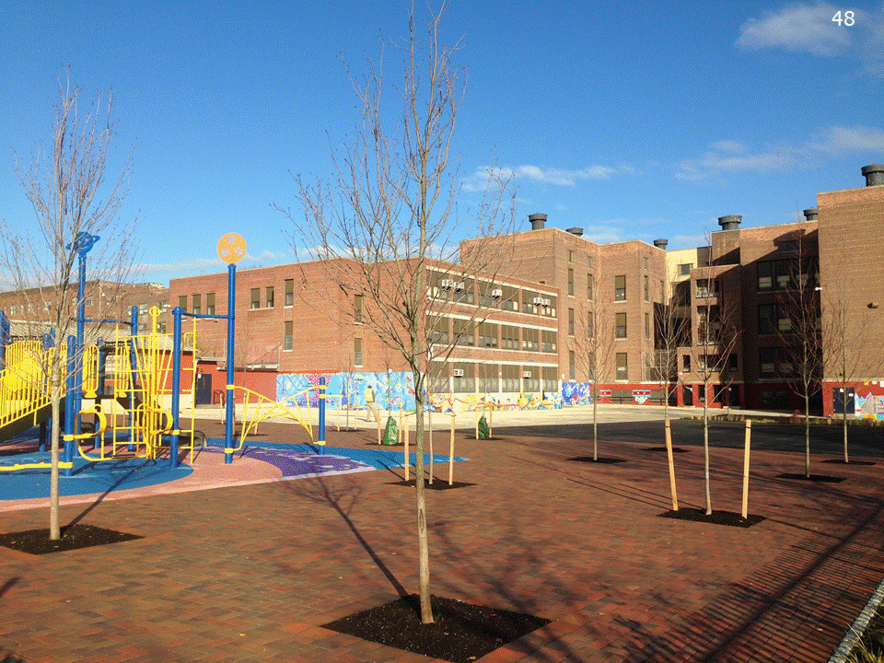

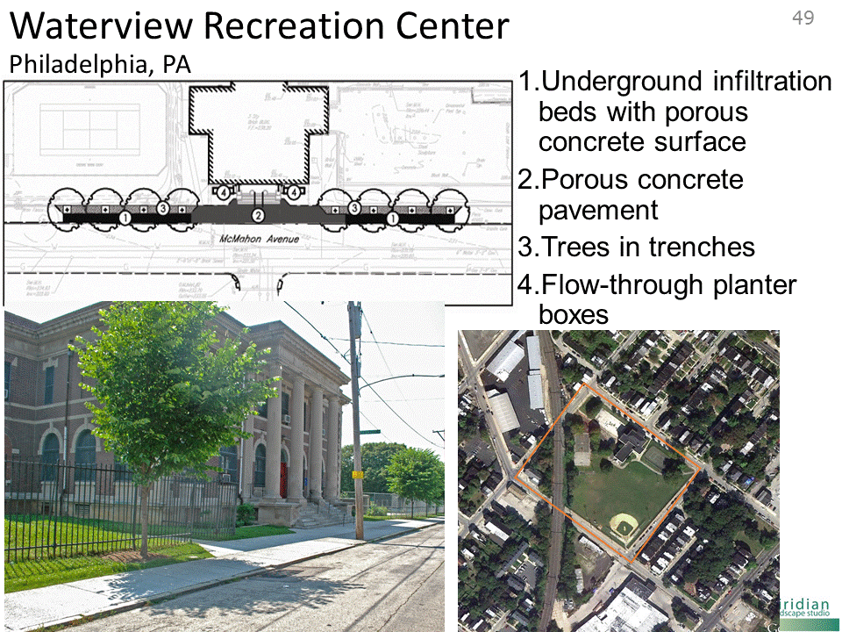

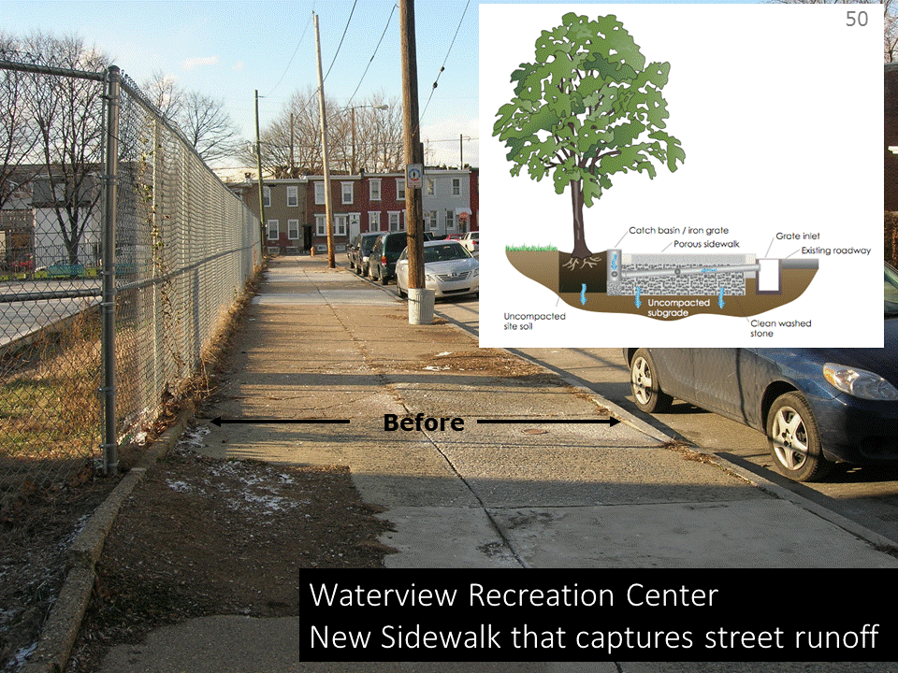

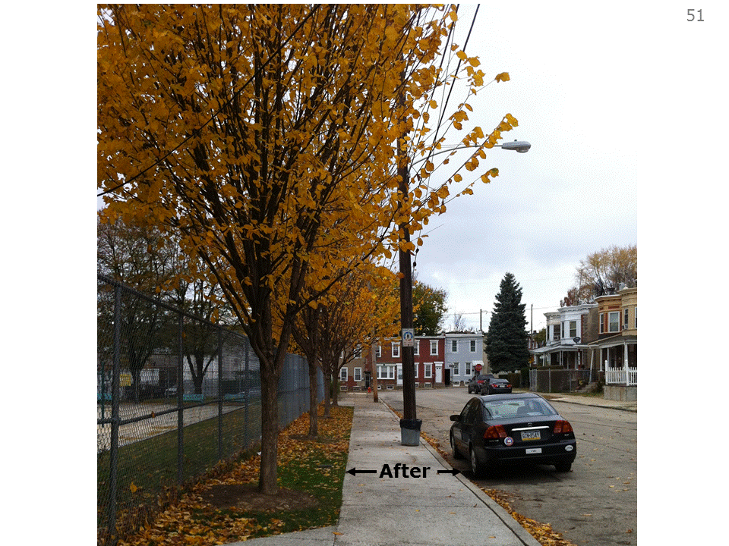

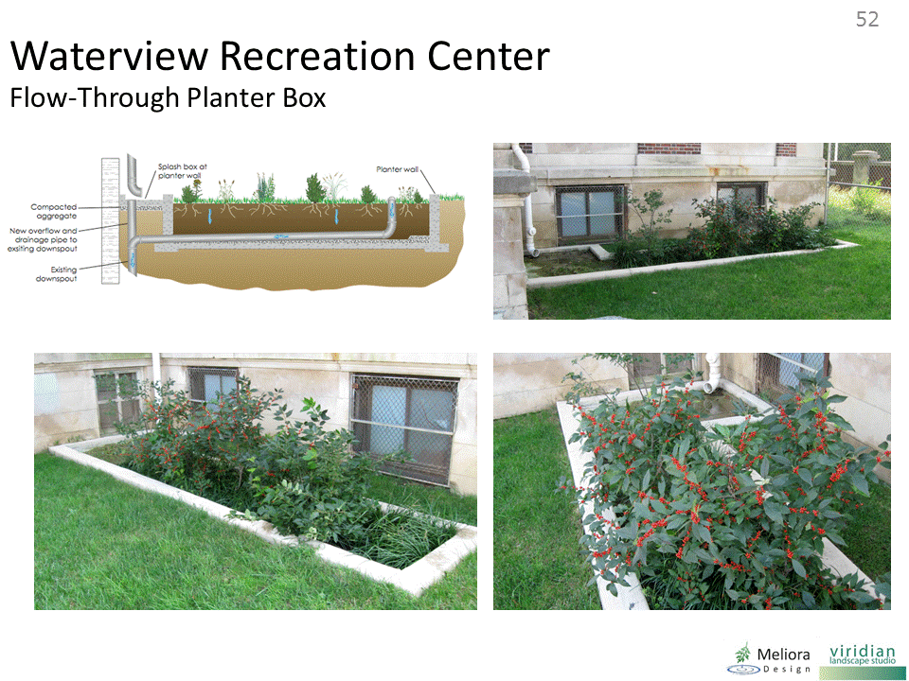

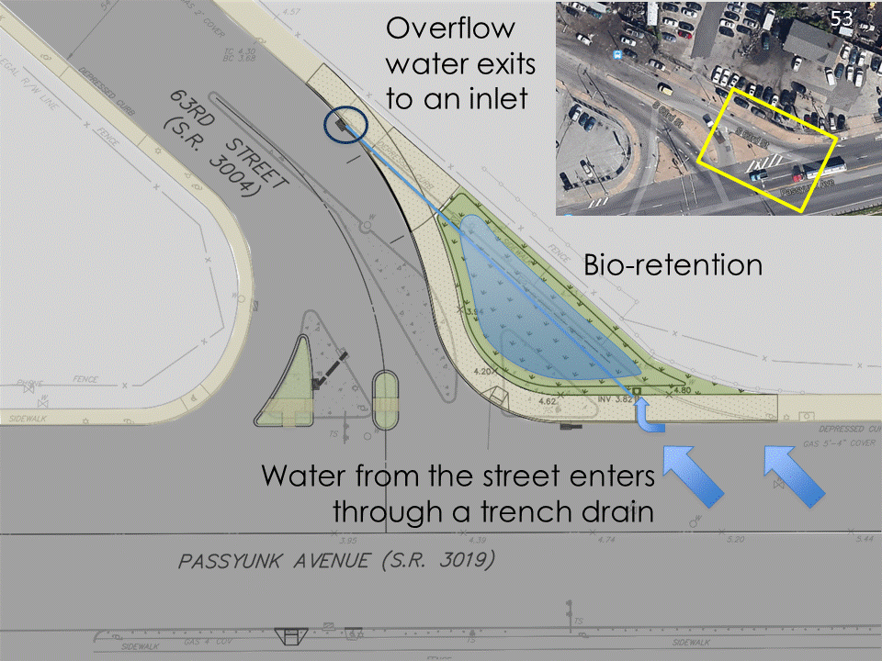
JUST CLICK ONCE!

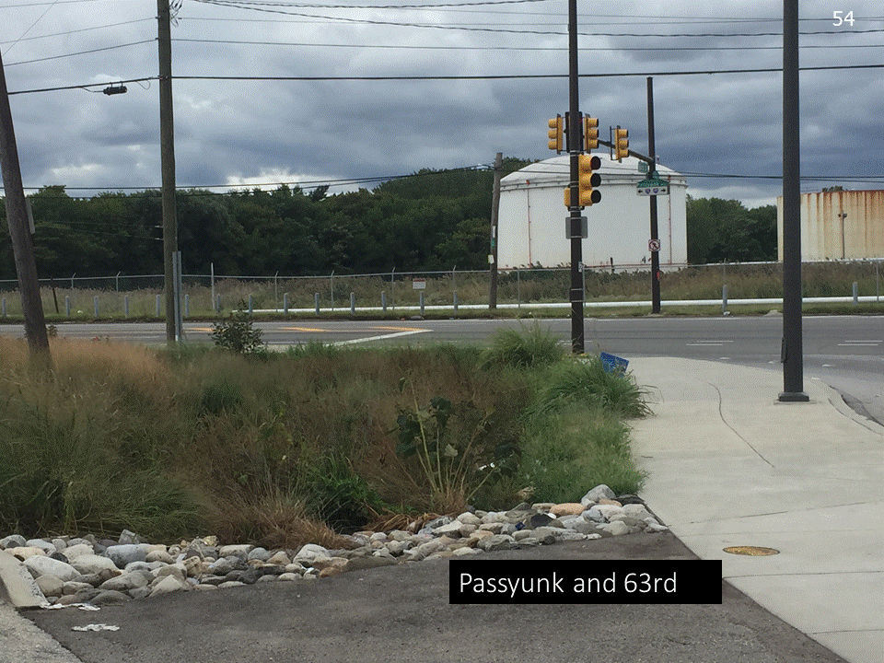

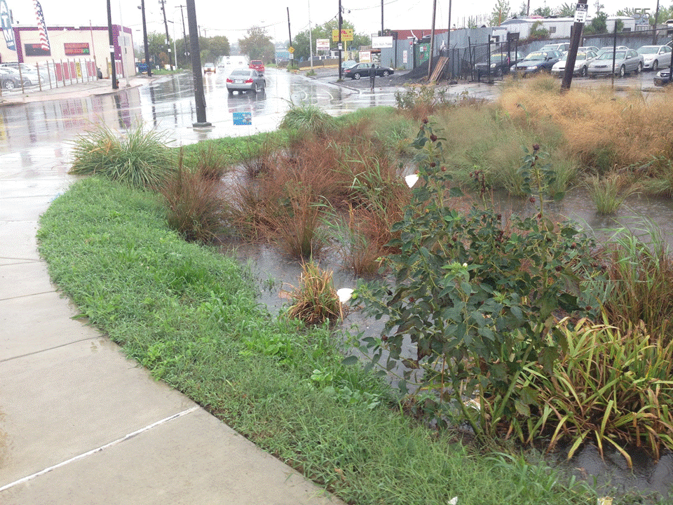

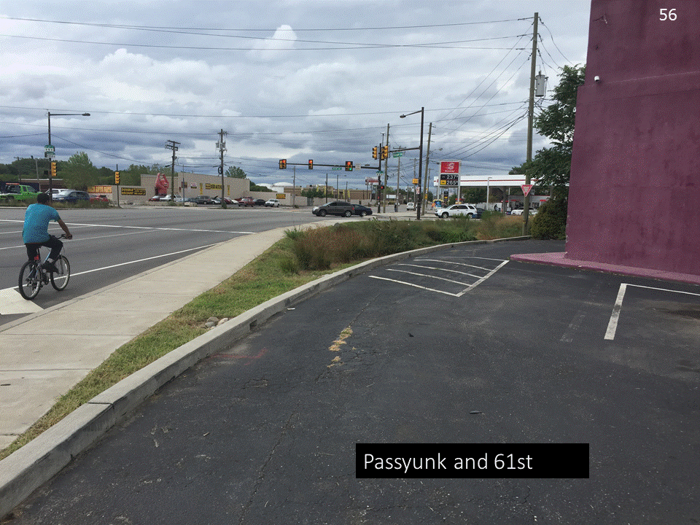
JUST CLICK ONCE!

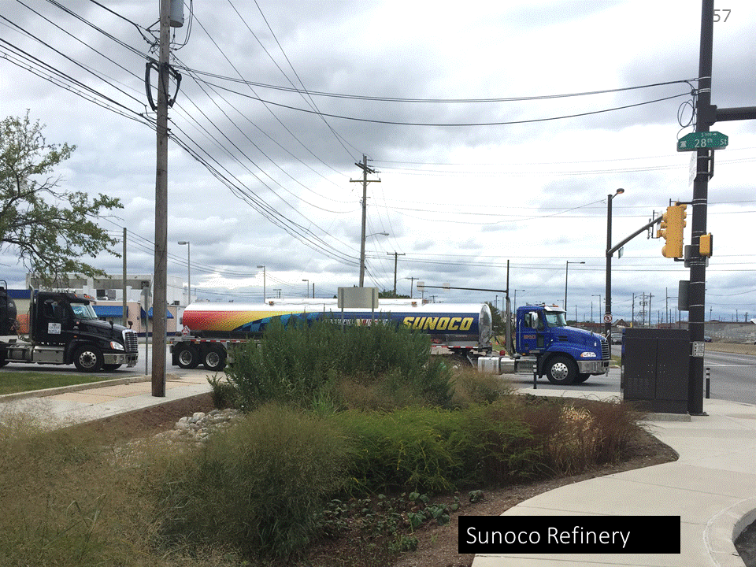

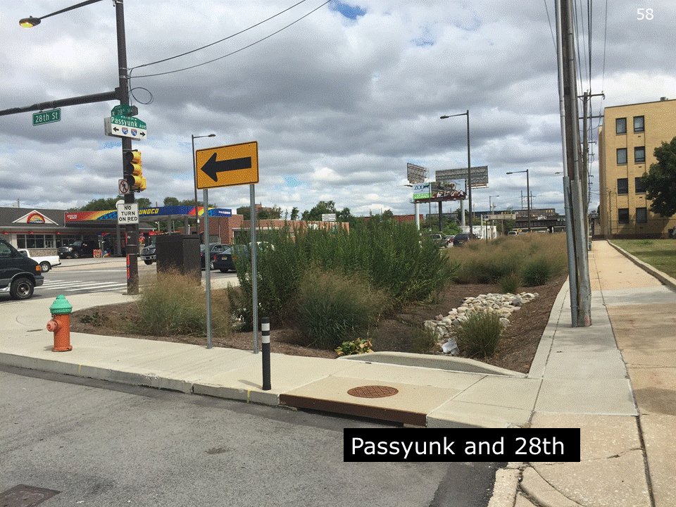

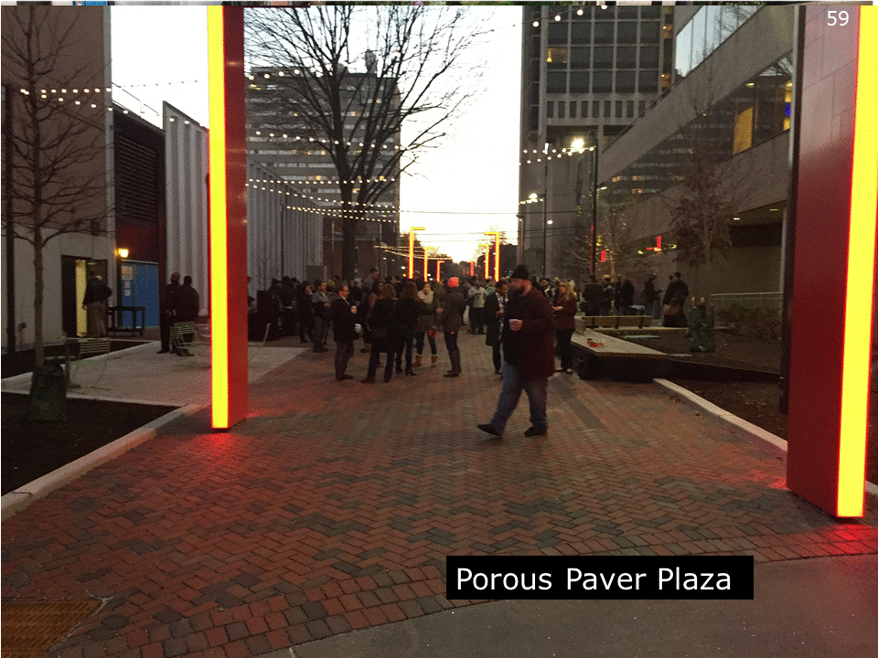

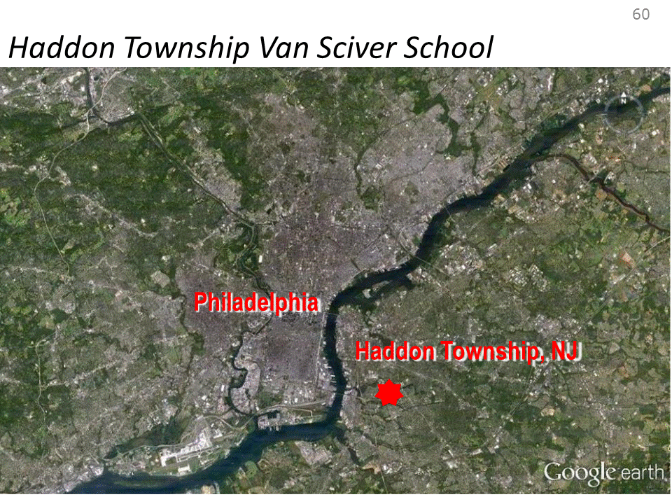
Riverkeeper network
Improve water quality and reduce flooding

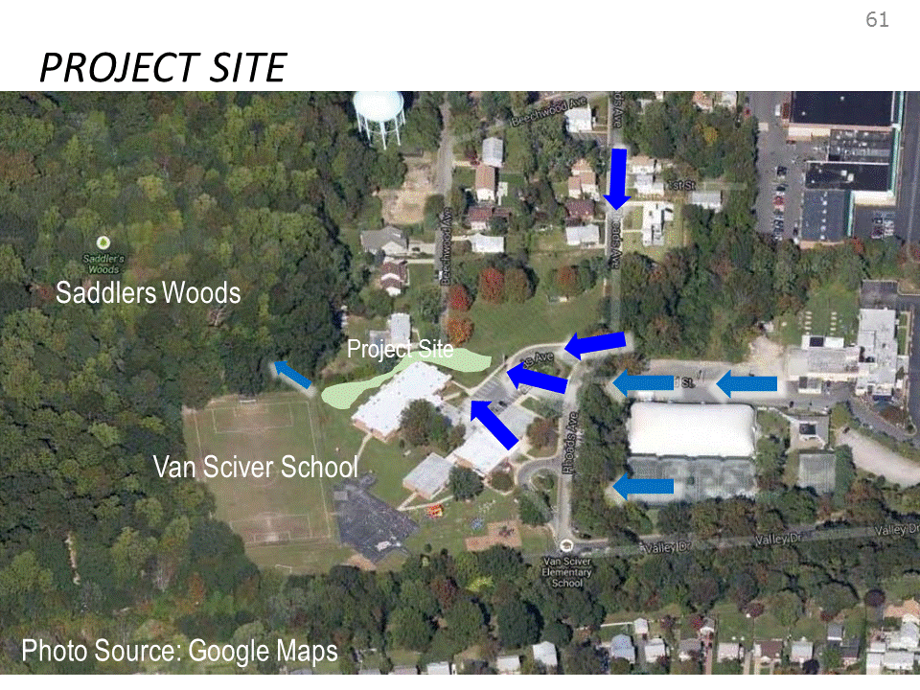
Rain gardens hold water and stop flooding.

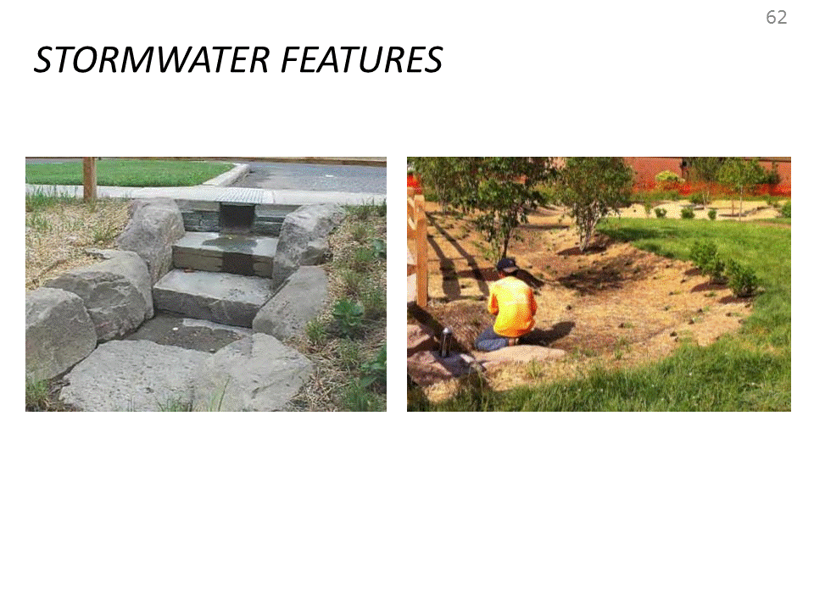
Structured designs are easy to take care of and maintain.

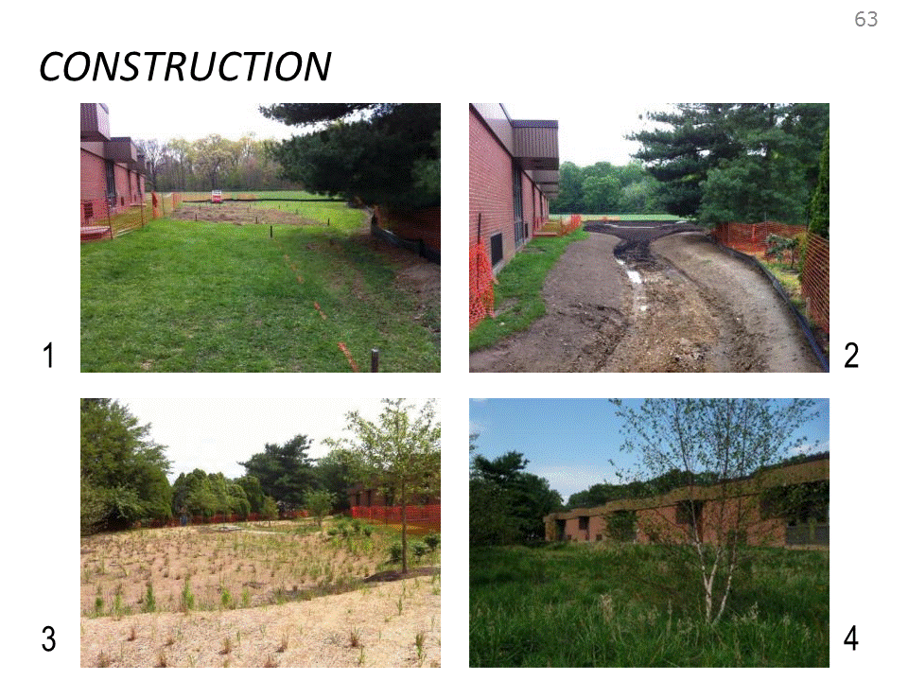
Series of rain gardens being constructed.

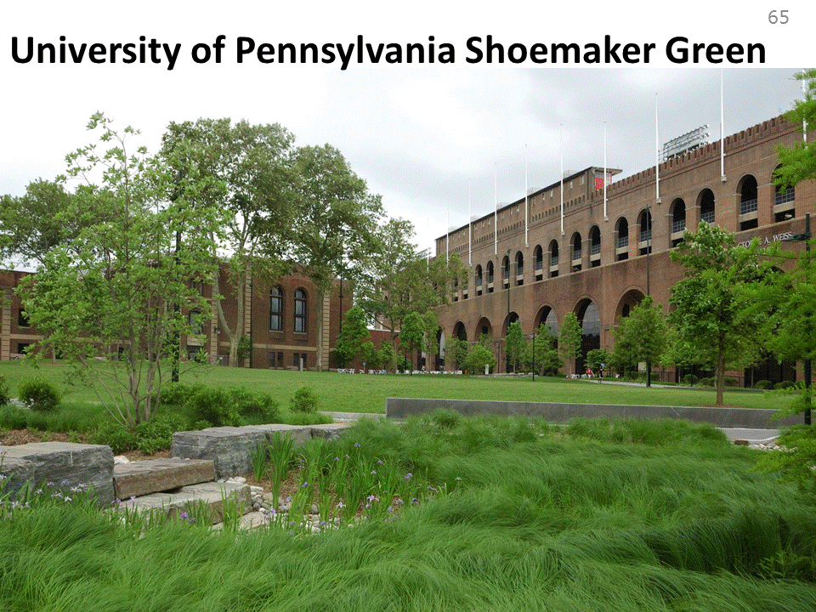
This project collected actual data on how well green infrastructure works.

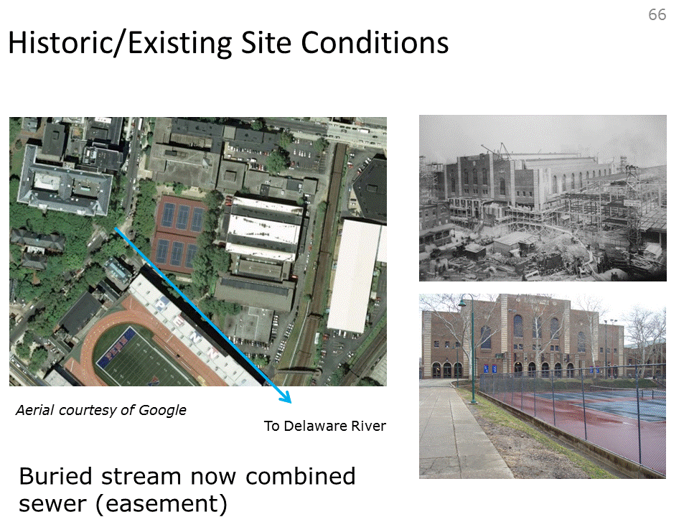

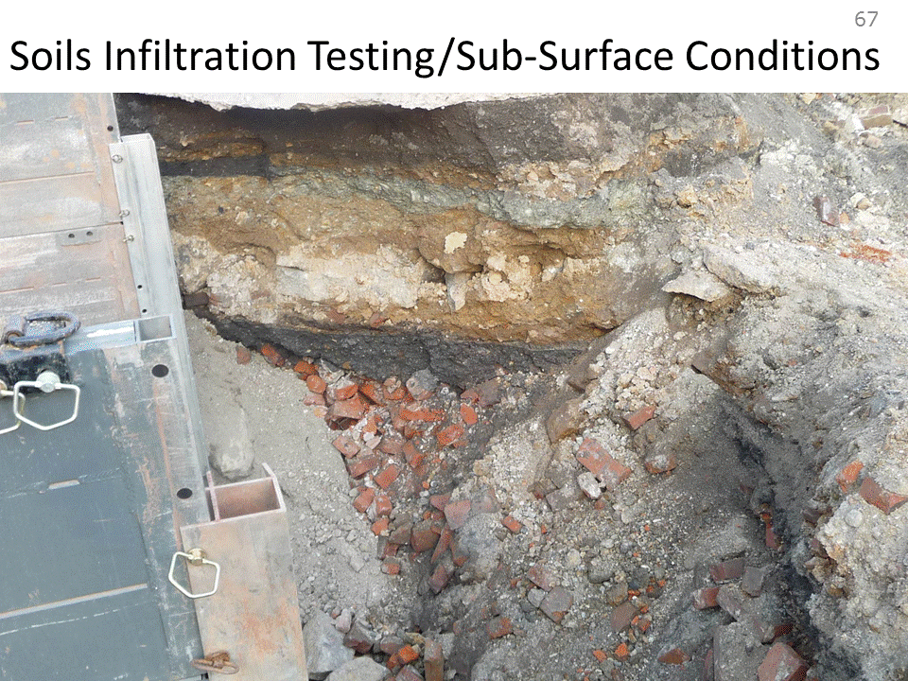
30-40ft of urban rubble

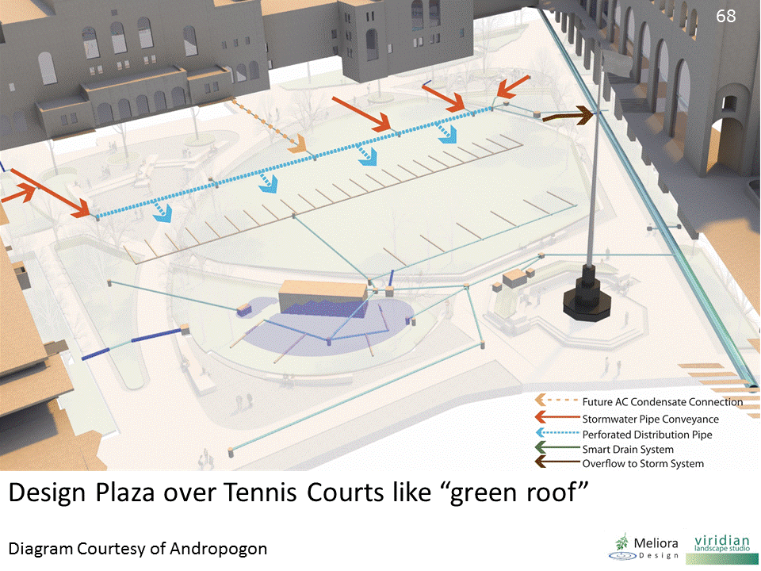

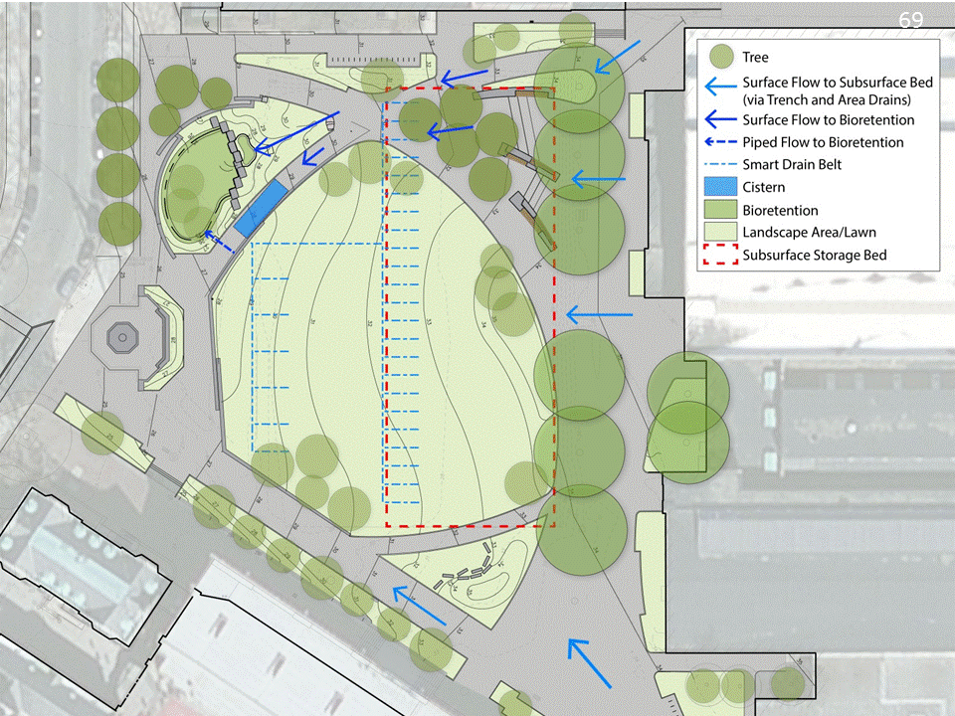

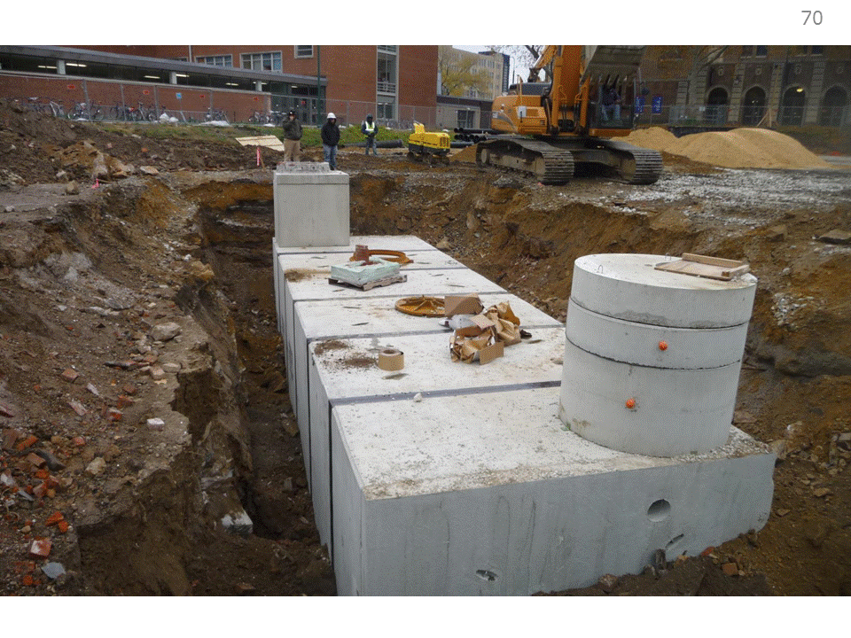
XX gallon cistern collects overflow, which is reused to irrigate system.

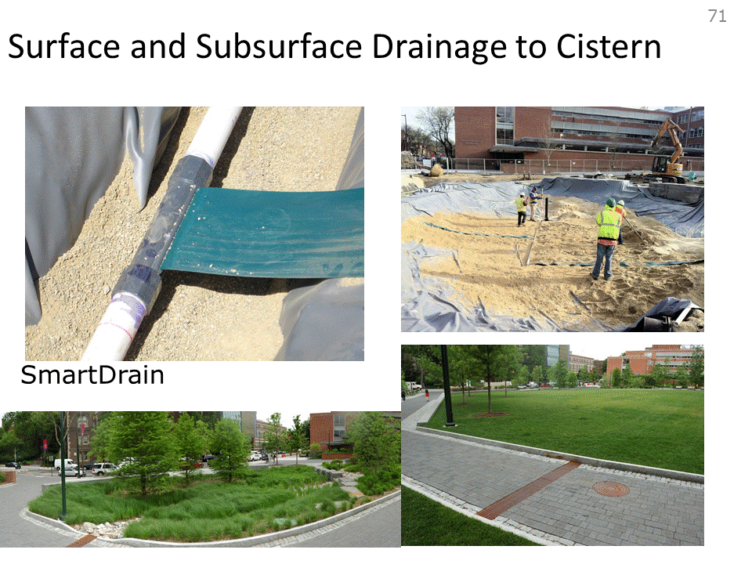
Picture on upper left shows the SmartDrain capillary from the golf industry.

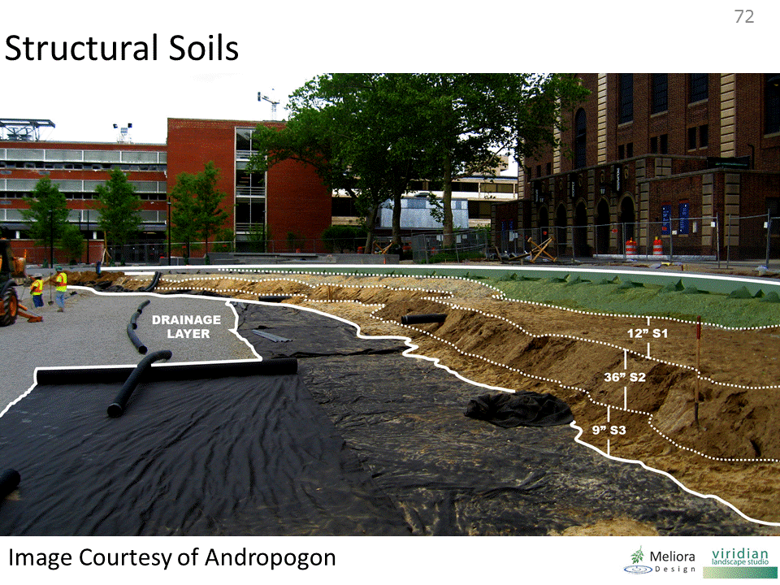
- Sand-based soils hold water and allow it to go back up.
- Vegetation is working.

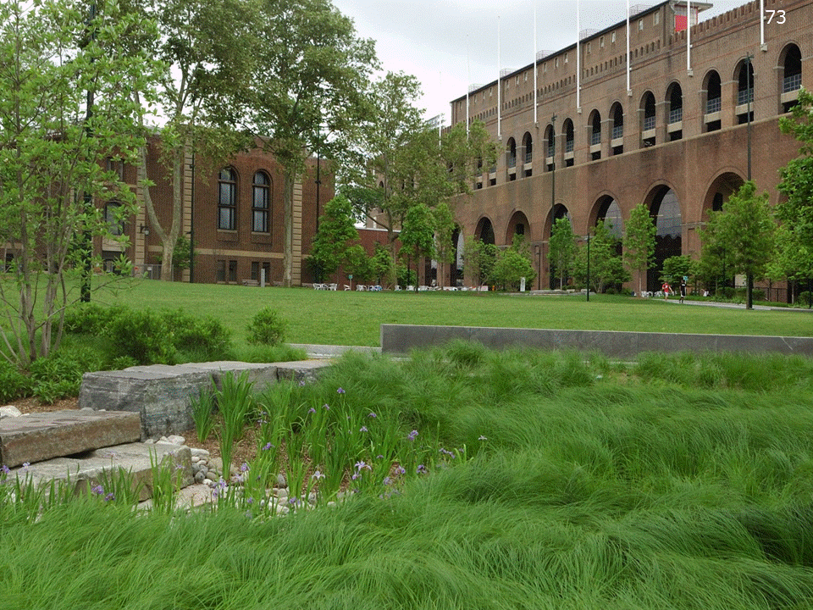
Rain Garden

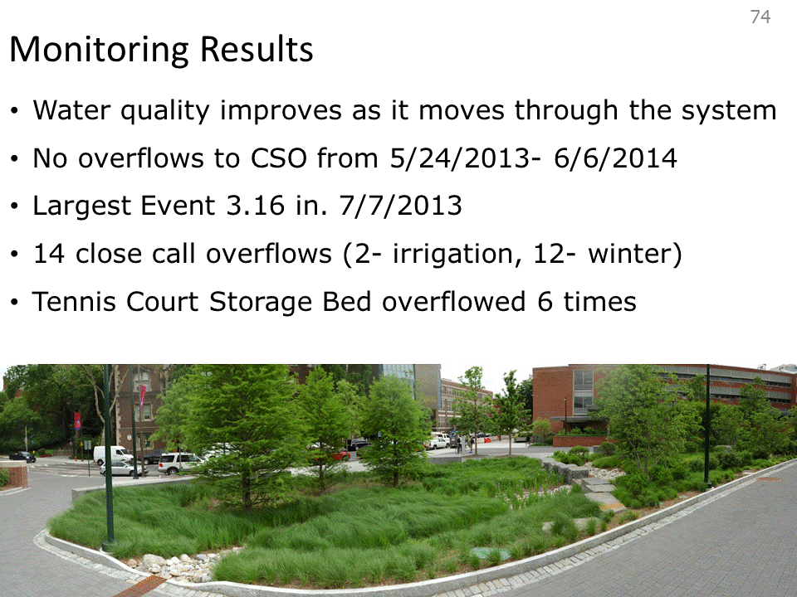
- 3 years of monitoring
- No discharge from site
- If we can get better at quantifying data, it will be a great asset to reduce flooding.

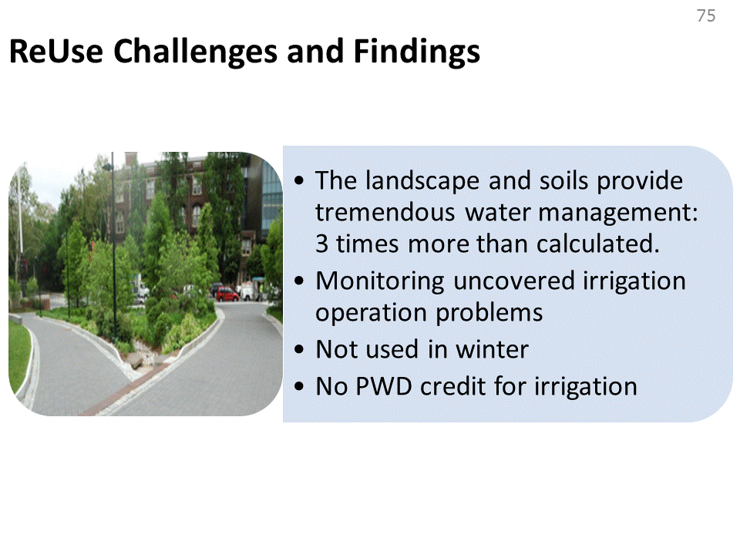
This is one of the concrete pools that was part of the exhibit.

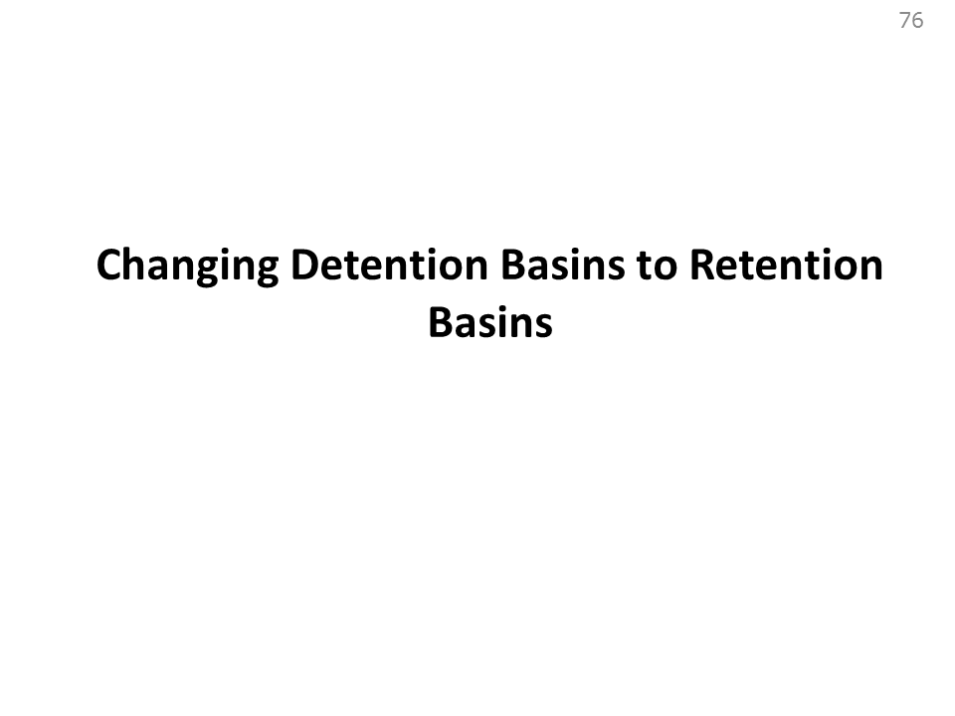

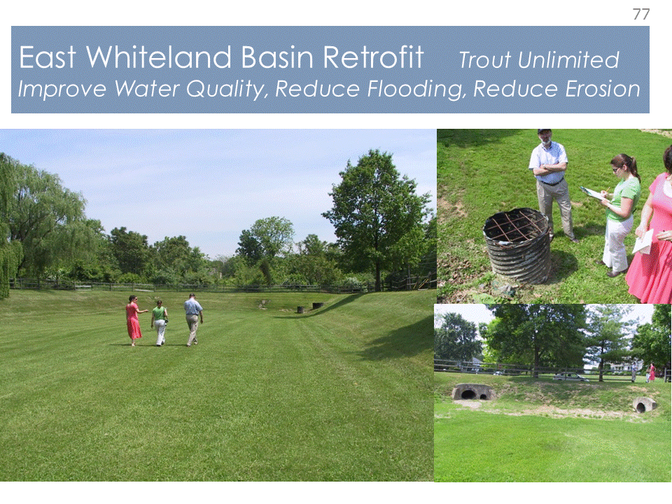

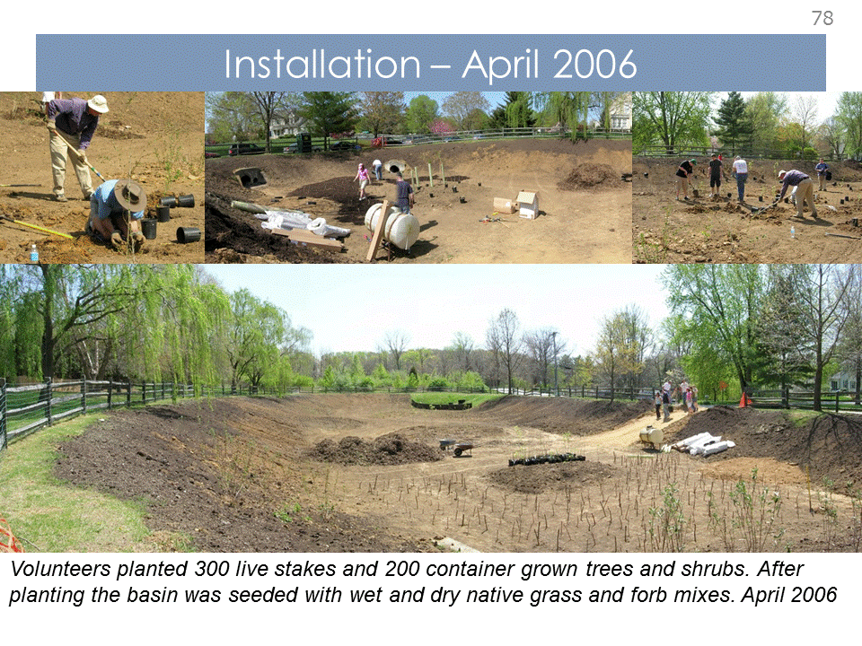

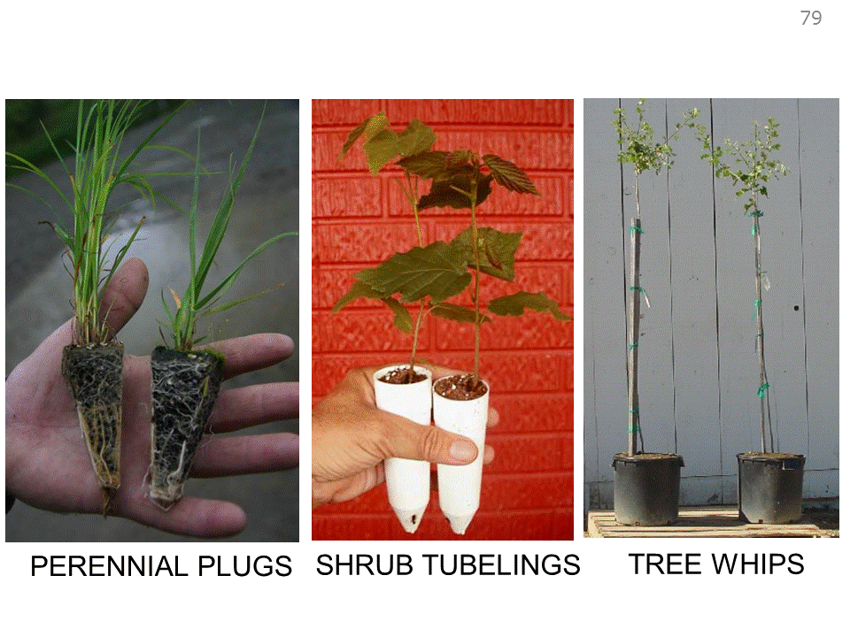

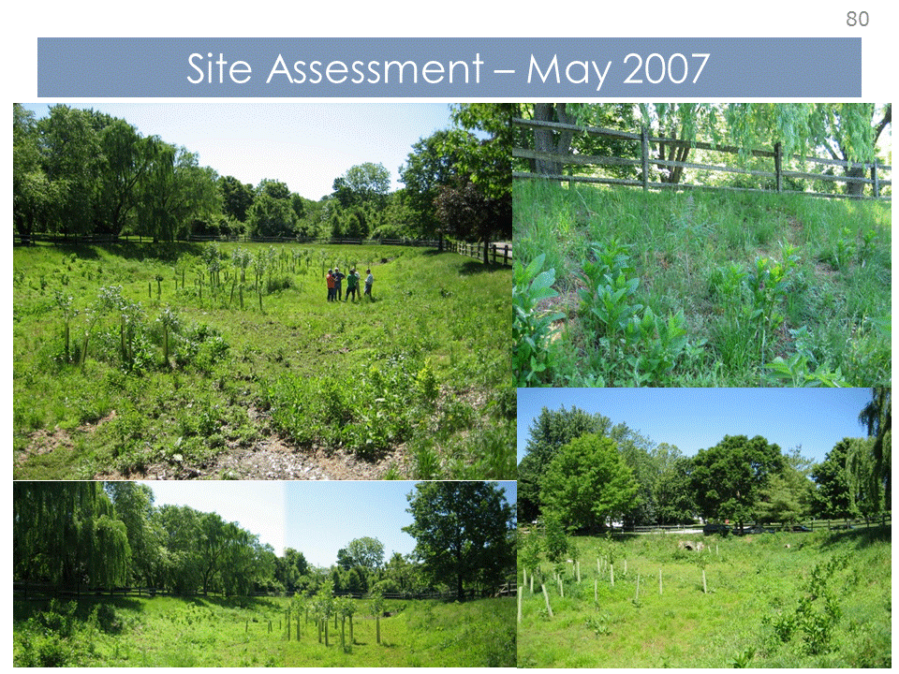

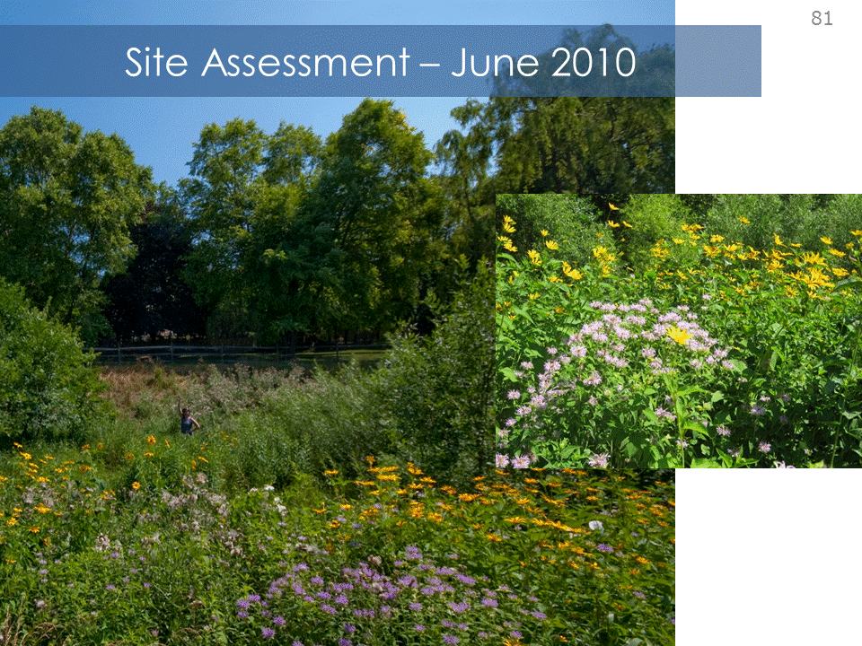

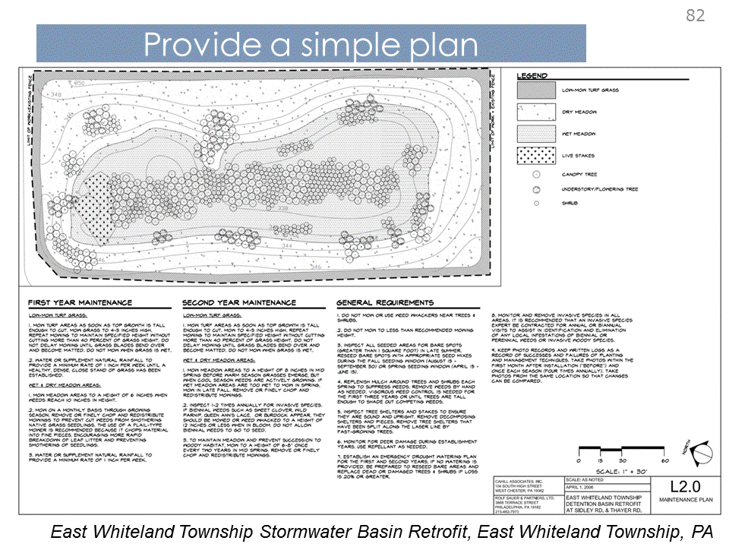
Rs – the proposed sitework includes a number of projects that will affect the land, starting with the widening of Rte 93, which will fill in the borrow pit and create a new landscape edge to the site; the entry road to CVI is another swath, along with the 1-1/2 acre footprint for the maintenance facility, and on to the CVI bldg and parking areas

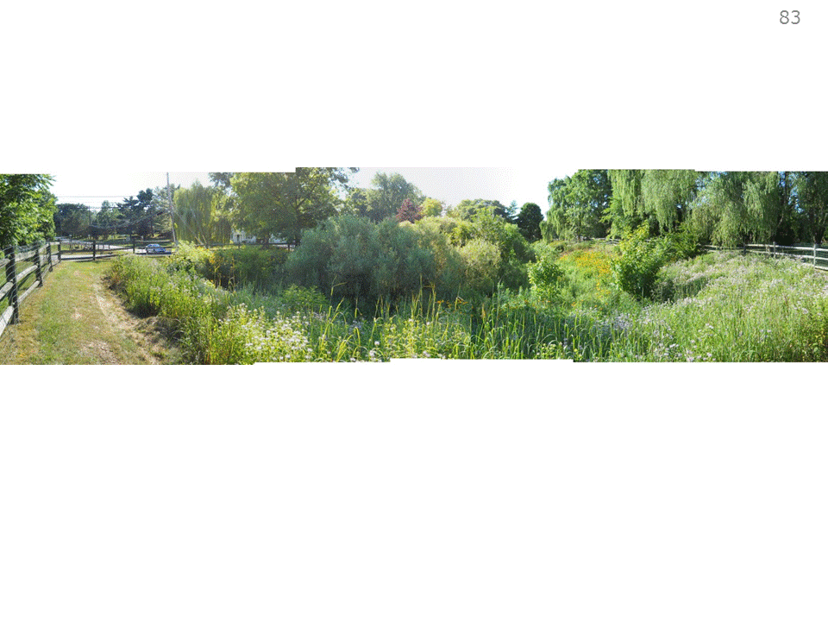

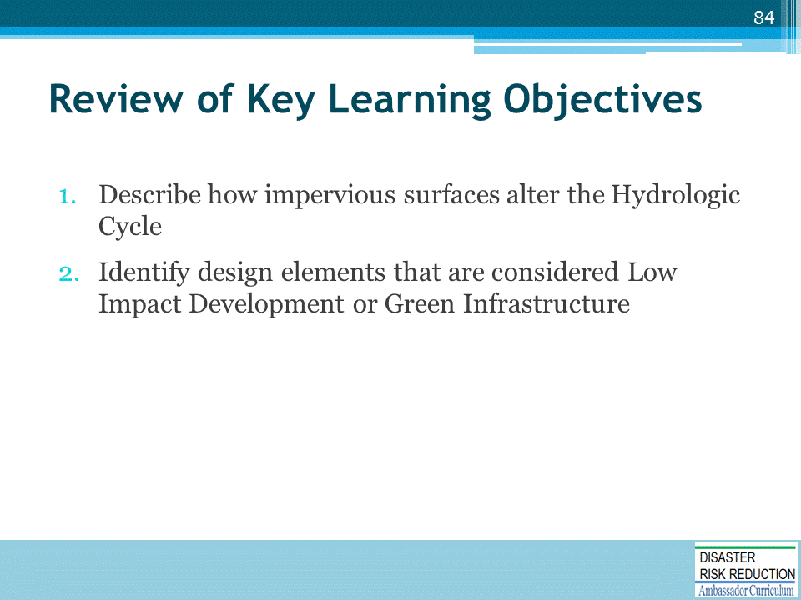

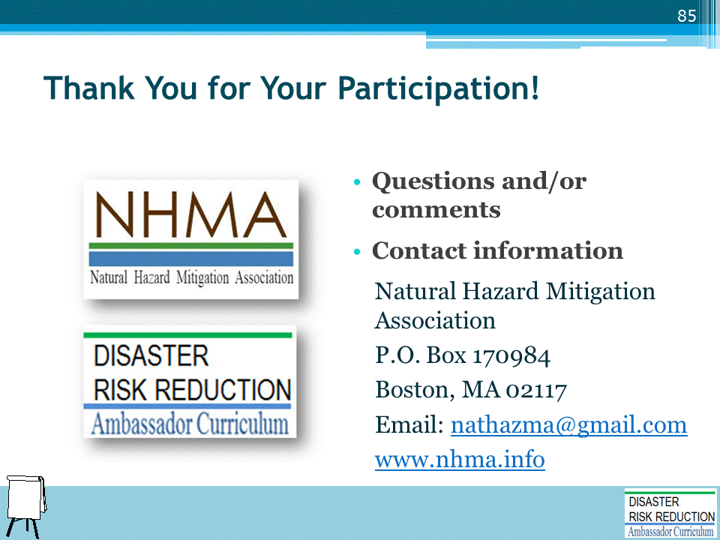

DRR AMBASSADOR CURRICULUM AT-A-GLANCE
I. Disaster Risk Reduction for a Safe and Prosperous Future
1 | Introduction to the Natural Hazard Mitigation Association and Disaster Risk Reduction Ambassador Curriculum
2 | Introduction to Disaster Risk Reduction as a Foundation of Community Resilience
3 | Leadership for Disaster Risk Reduction
4 | Community Disaster Risk Reduction and Adaptation
5 | Approaching the Challenge of Disaster Risk Reduction: NIST Community Resilience Guide
II. Forming a Community’s Vision for Disaster Risk Reduction
6 | Risk Assessment through Storytelling: An Asset-Based Approach
7 | Achieving Community Buy-in for Disaster Risk Reduction: Win-Win Approaches
8 | Leveraging Resources to Improve Disaster Risk Reduction
III. Realizable, Practical, and Affordable Approaches for Moving from a Vision for Disaster Risk Reduction to a Strategy
9 | Selecting and Implementing a Strategy for Addressing Community Disaster Risk Problems
10 | Integrating Hazard Mitigation into Local Planning
11 | Beyond Codes and Low-Impact Development
12 | Creating the Plan: A Sustainable Floodplain Management Process Model
IV. Resources and Tools for Implementing a Community’s Disaster Risk Reduction Strategy
13 | Climate and Weather Tools and Trends
14 | Risk Assessment Basics
15 | Legal and Policy Opportunities for Disaster Risk Reduction
16 | Linking Catastrophe Insurance to Disaster Risk Reduction
V. Resources for Hazard-Specific Disaster Risk Reduction
17 | Living with Water: Inland and Coastal Flooding
18 | Design for Flood Resilience: Part I: Floodplain Management and Flood Resistant Design
19 | Design for Flood Resilience: Part II: Green Infrastructure / Low Impact Development
20 | Overcoming Impediments to Flood Resilience: Paths Forward
21 | Wildfire Mitigation
22 | The Wildfire-Flood Connection
23 | Severe Thunderstorm/ Tornado Safe Rooms
24 | From Policy to Engineering: Earthquake Risks

