Disaster Risk Reduction (DRR) Ambassador Curriculum

Instructor Guide

Module 20:

Overcoming Impediments to Flood Resilience:
Paths Forward

THE DRR AMBASSADOR CURRICULUM
The goal of the DRR Ambassador Curriculum is to facilitate Disaster Risk Reduction efforts for the whole community by:
- Engaging in discussion of how disasters can be reduced through local action
- Sharing insights among local leaders and technical experts to enable the development of cross functional solutions
- Acquiring the best-available information, knowledge of best practices, and analytic tools to enable better-informed decisions before, during, and after disasters
It is important for instructors of DRR Ambassador Curriculum modules to remember this is one module in a 24-module curriculum. The “DRR Ambassador Curriculum At-a-Glance” table, located at the end of this document, lists the modules of the Curriculum. Keep in mind the following context for the module(s) you conduct:
DRR-A CURRICULUM TARGET AUDIENCE
The target audience includes those involved in community development decision-making, such as local community staff, volunteer and stakeholder groups, and federal and state officials.
METHODS OF DELIVERY
Varied delivery methods will provide multiple options for access by the target audience. The DRR Ambassador modules may be presented via webinars hosted by NHMA or partner organizations, presented in conferences and/or classrooms by qualified DRR Ambassador Curriculum instructor(s), or are downloadable for individual study from the NHMA website.
COURSE MATERIALS
Instructors are expected to use the instructional materials housed on the NHMA website to conduct DRR Ambassador Curriculum modules (Instructor Guide, supporting visuals, Participant Guides, and handouts). Instructors may tailor modules to specific audiences or locations as long as they do not revise the learning objectives and do not revise the materials in such a way that the participants cannot correctly complete the post-test. Instructors request the current pre/post-test for the module from NHMA.
CERTIFICATES OF COMPLETION
Certificates of Completion will be awarded by NHMA to participants who successfully complete NHMA-sponsored DRR Ambassador modules. A DRR Ambassador Certificate will be awarded to individuals completing all 24 modules. Participants who choose not to take the post-test may be issued a Certificate of Attendance. Contact NHMA about obtaining certificates. Inform participants to ask their certifying boards about acceptance of NHMA DRR Ambassador certificates for continuing education credits.

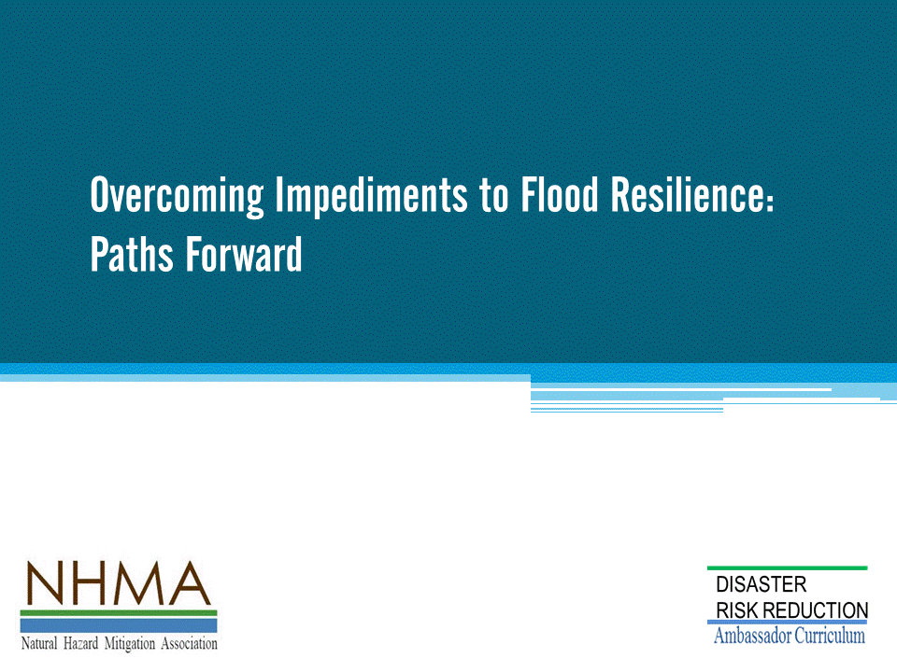
Approximate delivery time: 60-75 minutes

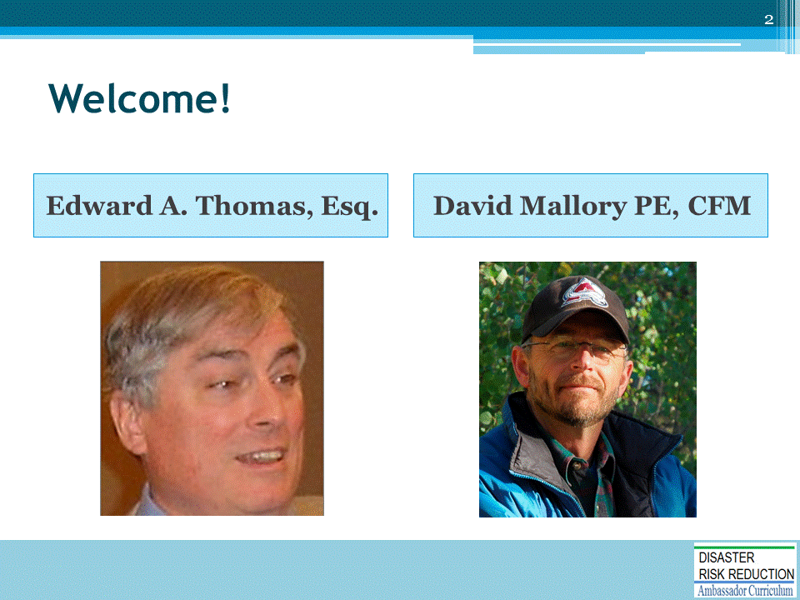
Introductions:
- Each presenter introduces her/himself, including affiliation and brief background.
- OPTIONAL: Have each participant briefly introduce him/herself
Mention: NHMA presentations are based on general principles of law, engineering, policy and emergency management.
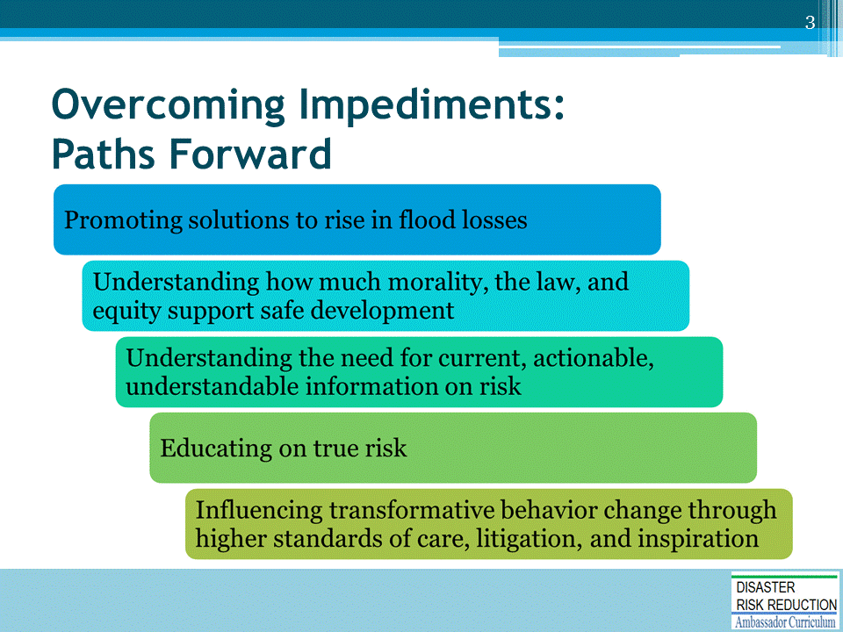
Introduce this module by providing a brief overview of the concepts that will be discussed.

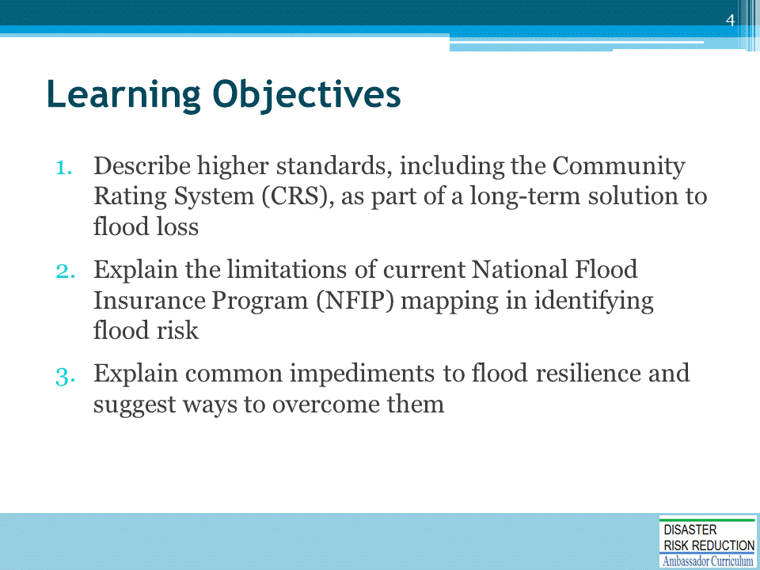

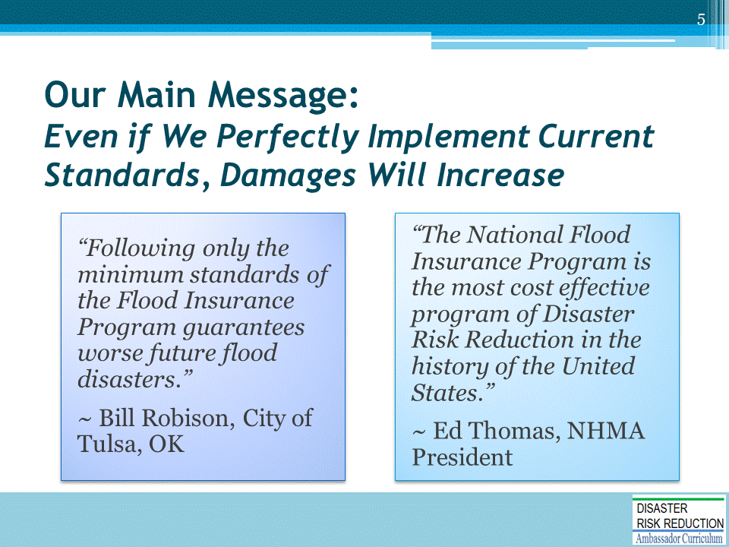
Remember, we have done a number of positive things, both non-structural and structural, but… We’ll discuss why that is…
For example:
- The nation’s taxpayers have paid for over $100 billion in structural works
- The NFIP has resulted in 19,000 communities regulating new and improved development
- Numerous agriculture programs provide stream buffers and wetland preservation

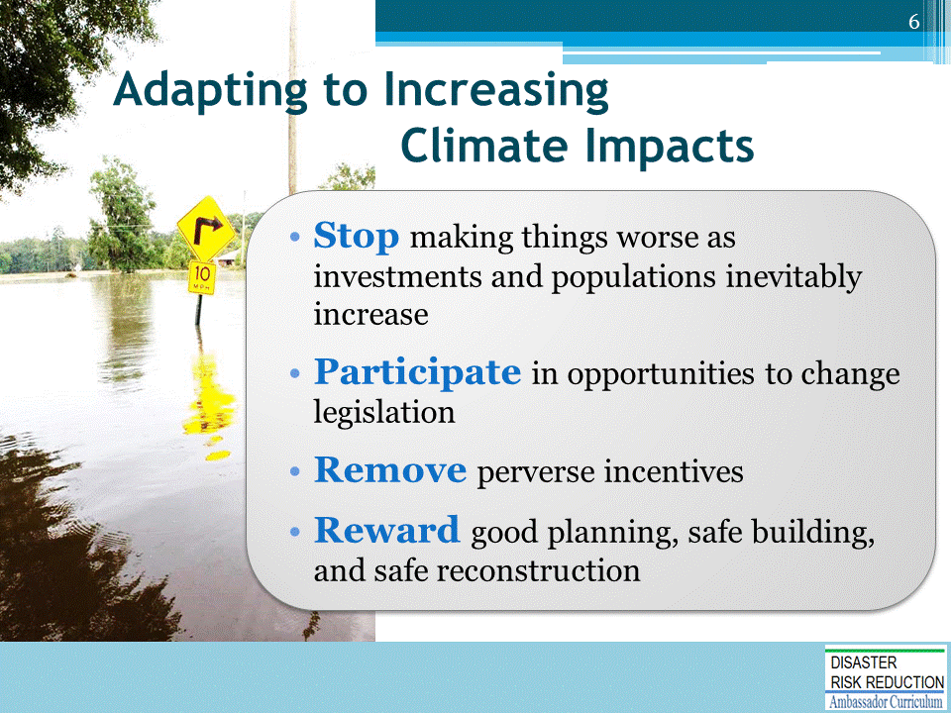
We have serious problems… changing hydrology, sea level rise, fire risks and exposures, and other climate impacts…
We must stop making things worse as investments and populations inevitably increase
- We will have opportunities to change legislation over the next few years
Right now we have a system which rewards dangerous behavior that hurts far too many, now and for a long time…
- We need to adapt by removing perverse incentives, reward good planning, safe building, and safe reconstruction

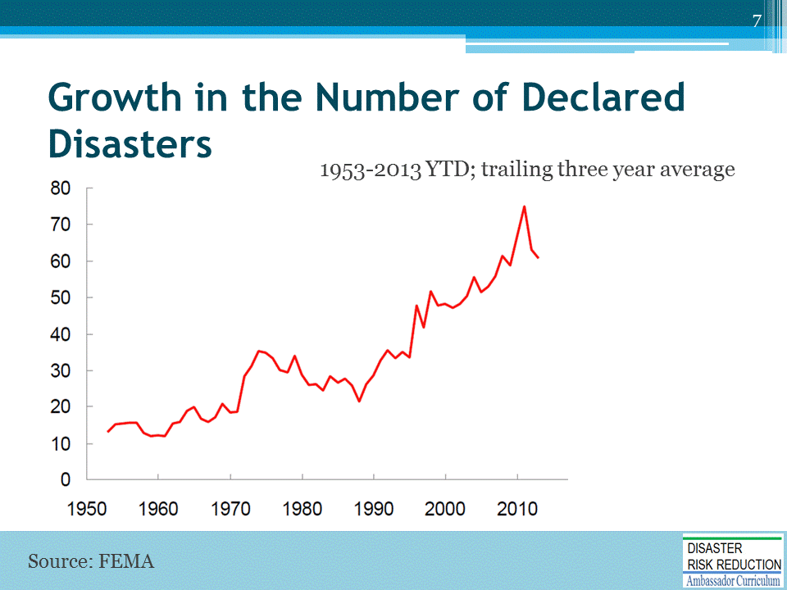
- Since 2010, 85 percent of all U.S. counties have suffered a declared disaster; and 223 counties have had 5 or more major declared disasters since 2010.
- In 2016 alone, our nation has witnessed two “once-in-a-thousand-year floods” and several 500-year events with 38 federally declared major disasters.
- And until Matthew, only one of this year’s damaging weather events was a named storm (Hurricane Hermine).
Slide courtesy of Harriet Tregoning, Financing Resilience presentation (March 2017)

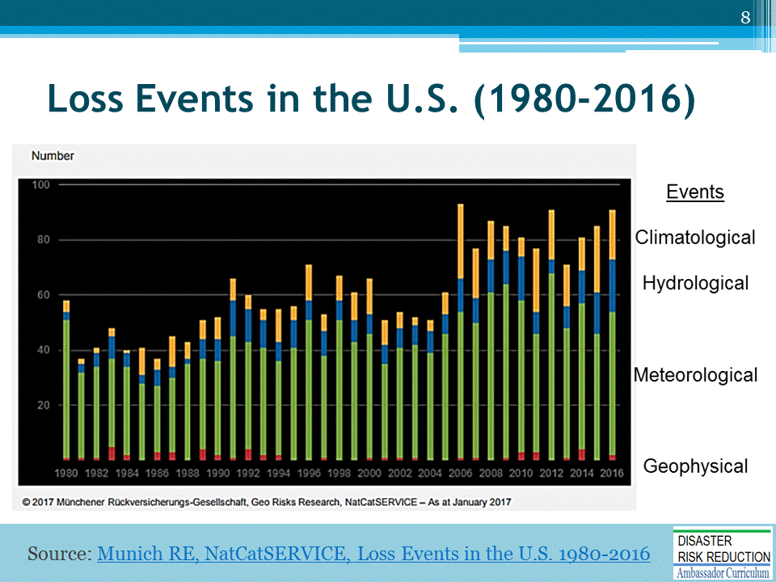
Recall from Module 2 that flood and wind disasters have been increasing most.
FIGURE LEGEND
Red bars: Geophysical events (earthquake, tsunami, volcanic activity)
Green bars: Meteorological events (tropical storm, extratropical storm, convective storm, local storm)
Blue bars: Hydrological events (flood, mass movement)
Orange bars: Climatological events (extreme temperature, drought, forest fire)
Source: https://www.munichre.com/site/mram-mobile/get/documents_E1982729150/mram/assetpool.mr_america/Images/5_Press_News/Press%20Releases/2016/1980_2016_Paket_USA.pdf

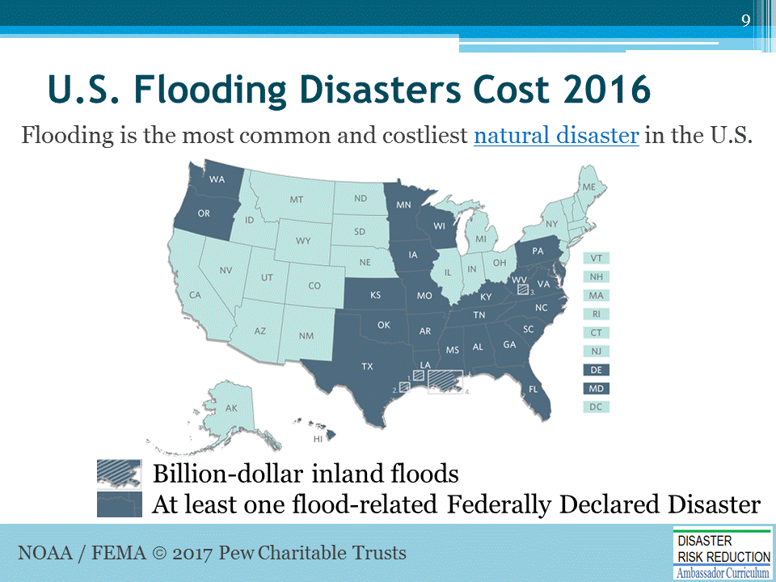
In 2016, the federal government declared 36 disasters involving floods or hurricanes.
- As of December 2016, the damage from four of the storms that triggered those declarations was estimated to exceed $1 billion each. (https://www.ncdc.noaa.gov/billions/)

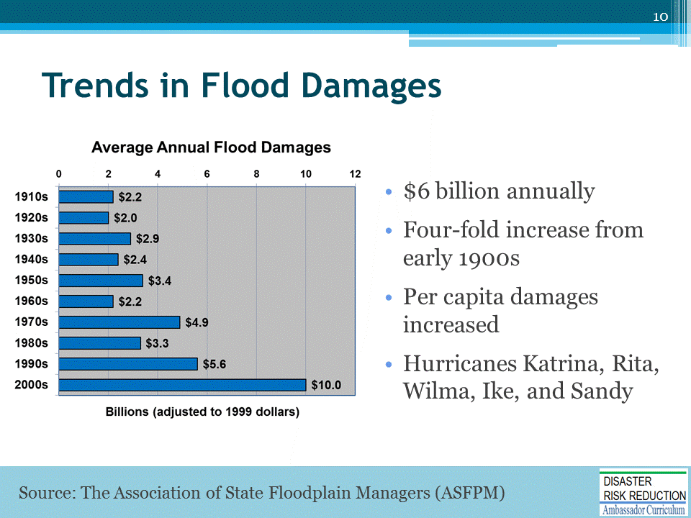
Flood losses are increasing, but this was not supposed to happen!
- The National Flood Insurance Program (NFIP) intended to cut losses.
- In 1976 a HUD-sponsored economic analysis predicted that by the year 2000 or 2025 flood losses would begin to decline…
In reality, flood losses are increasing!
- $6 billion annually
- Four-fold increase from early 1900s
- Per capita damages increased by more than a factor of 2.5 in the previous century in real dollar terms
- And then there was Katrina, Rita, Wilma, Ike, and Sandy
The key here is that despite what we have done and the money we have spent this century, damages continue to go up unnecessarily (in our opinion).

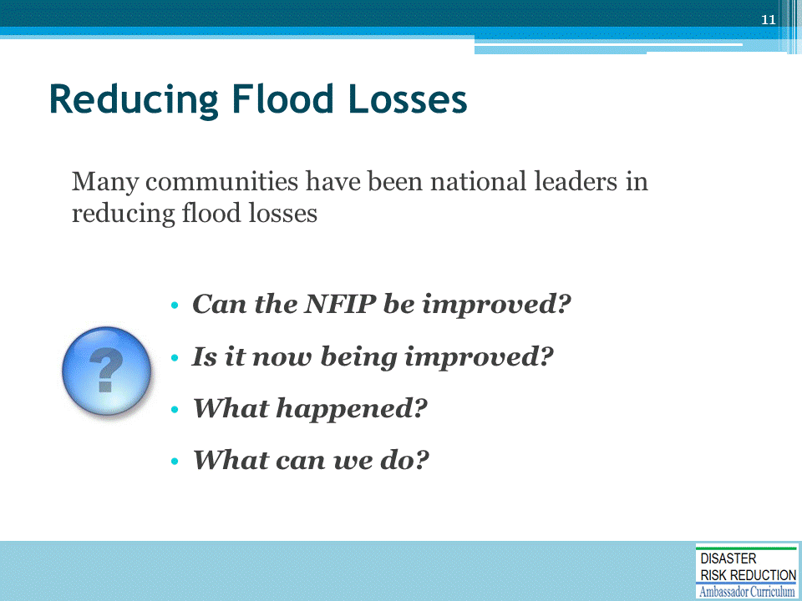
We believe that the National Flood Insurance Program is the most cost effective program of disaster risk reduction in the history of the United States.
- Many communities have been national leaders in reducing flood losses
- Leading communities include Tulsa, Urban Drainage and Flood Control District, and Charlotte Mecklenberg.
Facilitate discussion around the questions listed on this slide.
If time allows: Tell story of South Florida Building Codes and Hurricane Andrew.
What happened clean water act.. demographics, people living where they want.
If time allows: Tell the following Ed & Kathy Lee in the floodplain story:
- Kathy and Ed Thomas live in a Special Flood Hazard Area, even though Ed has worked about 200 disasters and is well aware of the risks and consequences. Why?
- Because they made a deliberate choice to live where they want, have taken steps to minimize risks and consequences, have plans to evacuate and lots of insurance.
- See, The Blue Mind by Wallace Nichols for fuller explanation.

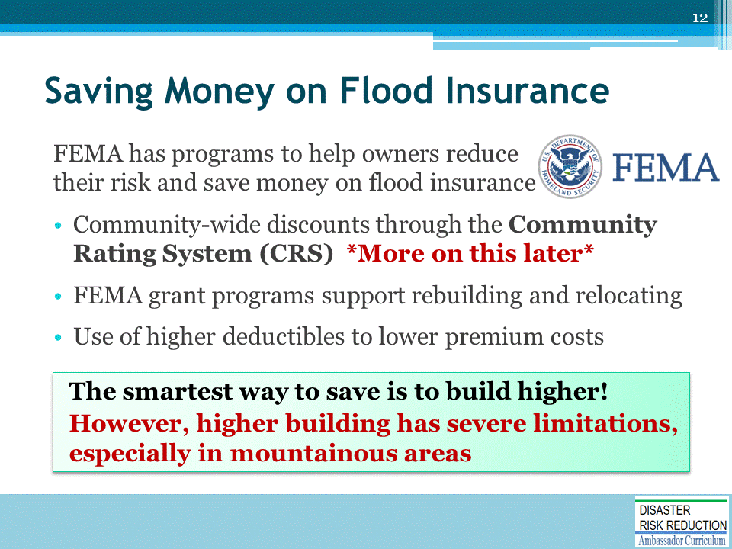
Ask audience members to raise their hand in response to the following question: Do you know of these programs?
NOTE: The CRS will be discussed in more detail later in this presentation.
- Community Rating System (CRS) discounts are not affected by the Biggert-Waters Flood Insurance Reform Act of 2012 (BW-12).
  - If your community participates in the CRS program, savings may apply.
- FEMA grant programs may also be available to support rebuilding or relocating – depending on the State’s priorities for use of grant funding.
- Higher deductibles can also lower premium costs; however, policyholders will be financially responsible for that expense at the time of loss.
  - It is important that you maintain documentation in your files of your policyholder’s request.
- But, the smartest way to save is to build higher!
  - However, building higher has severe limitations, especially in mountainous areas

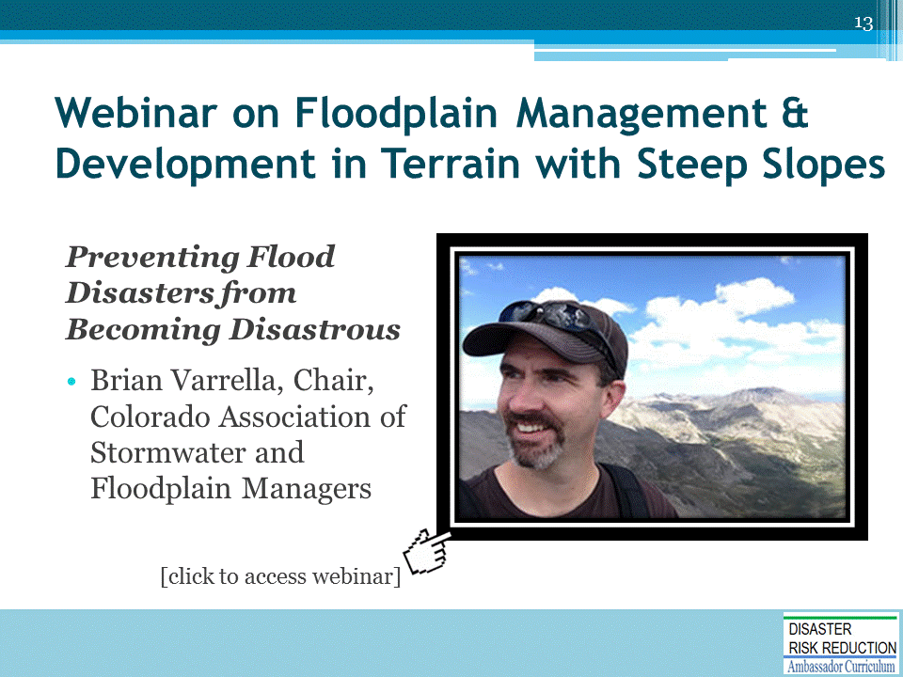
We encourage you to watch this highly informative webinar.
Website hosting the webinar: http://www.aswm.org/-nffa/7033-2014-recorded-nffa-webinars#071414

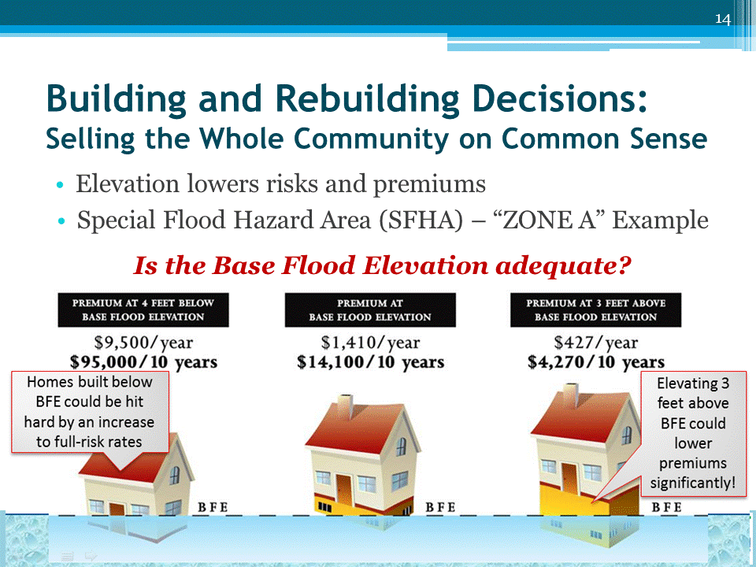
Elevating a home lowers risk and saves money on flood insurance.
Flood insurance premiums are lower for buildings in high-risk areas that are elevated above minimum requirements, so rebuilding higher provides immediate flood insurance benefits.
Example
- Example here is a single family home without a basement in a high risk zone, with coverage for $ 250,000 building coverage and $100,000 contents, number. The house has smart vents, in an AE zone, with standard deductible. NOTE: These are rounded rates shown on existing trifold. Check a rate table for precise savings examples. You’ll find even more telling examples.
- The example refers to base flood elevation, or BFE. BFE is defined as the elevation reached by a flood that has a one percent annual chance of occurring, also known as the 100-year flood. Communities use the base flood elevation – or in most coastal communities, an elevation x number of feet higher than that – as the building standard for the height of building’s first floor.
In the example, the worst case scenario is a home that was not built to the community’s current elevation standard. Perhaps it is pre-FIRM (built before the first flood map and not improved since then), or it could be a home built to an earlier standard that no longer complies, due to changing risks. If the property is sold, rates for the new owner will be the full-risk rates. And if advisory base flood elevations, or new maps issued in the future, show higher risks, the current owner would also be subject to full risk rates, based on an elevation BELOW the new BFE.

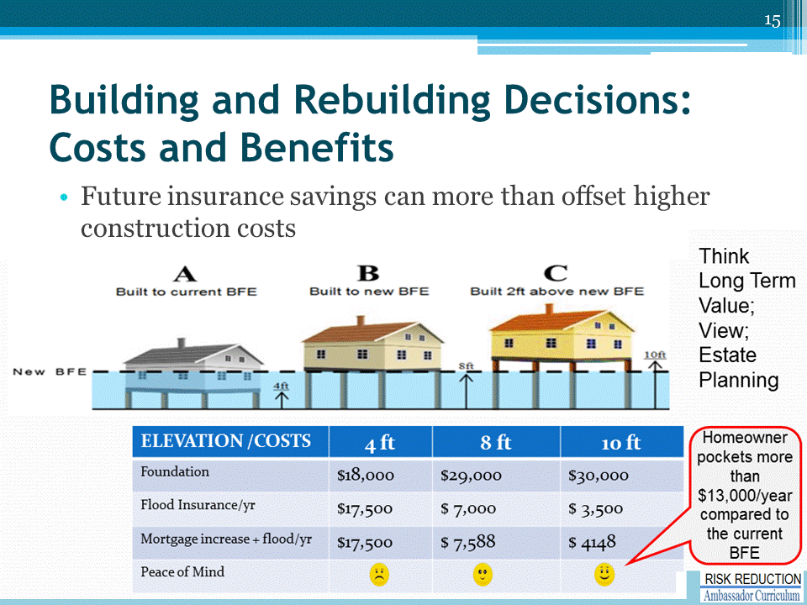
Flood insurance savings can be substantial enough to offset higher construction costs!
- In this example, the current Base Flood Elevation (BFE) is 4’ above grade, as it is in many coastal communities.
- The Advisory Base Flood Elevation (ABFE) shows the elevation 4 feet higher, at 8 feet – as it will for many New Jersey and New York communities.
- This is also predictive of what the community’s new standard is likely to be, once new maps are adopted.
- The example shows an estimate of the additional cost to rebuild on pilings to the current BFE, the ABFE, or 2 feet above the ABFE.

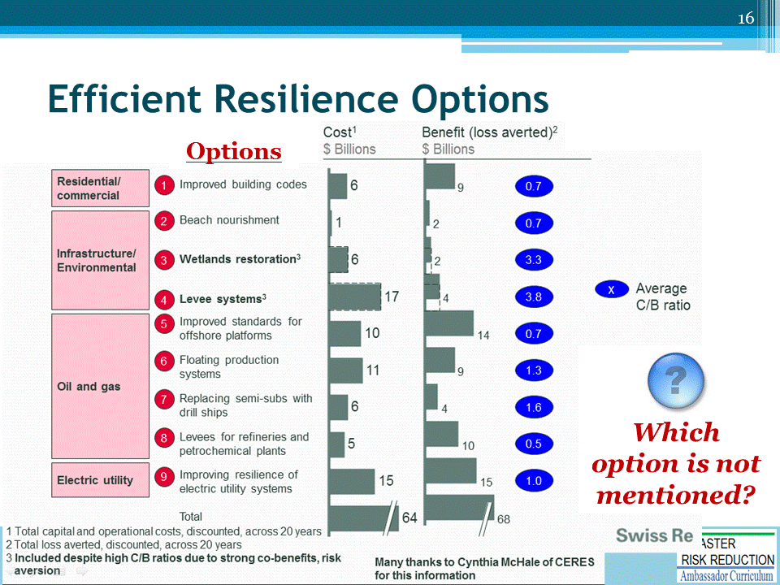
ASK the question on the slide: Which option is not mentioned?
ANSWER: Zoning
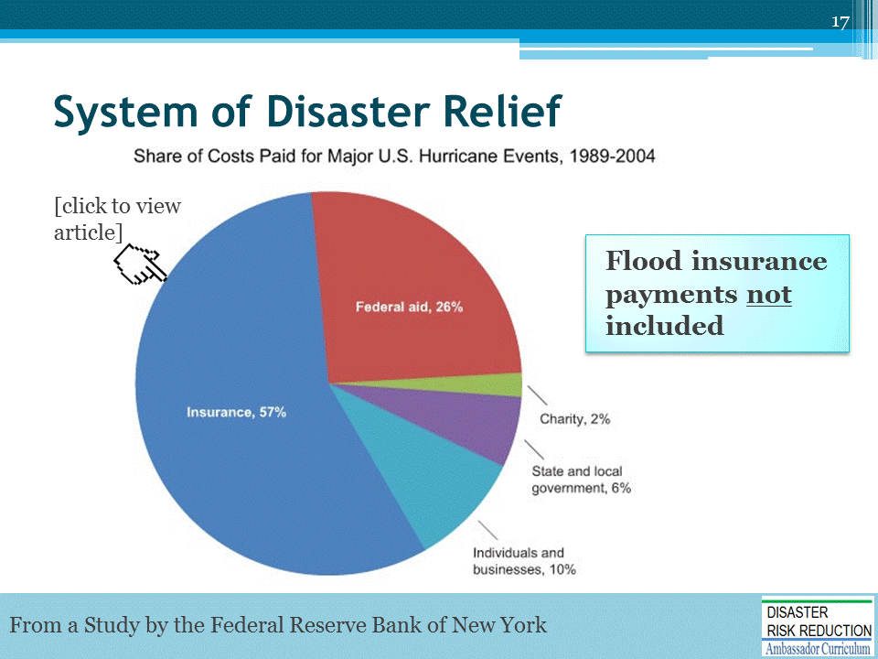
Let’s look at our system of disaster relief.
From a Study by the Federal Reserve Bank of New York: http://libertystreeteconomics.newyorkfed.org/2012/12/how-will-we-pay-for-superstorm-sandy.html#.U5sjaEDyTgA
Source: Authors’ calculations, based on “Federal Financial Exposure to Natural Catastrophe Risk,” by J. David Cummins, Michael Suher, and George Zanjani, 2010. In Measuring and Managing Federal Financial Risk. NBER Conference Report. Chicago: University of Chicago Press.
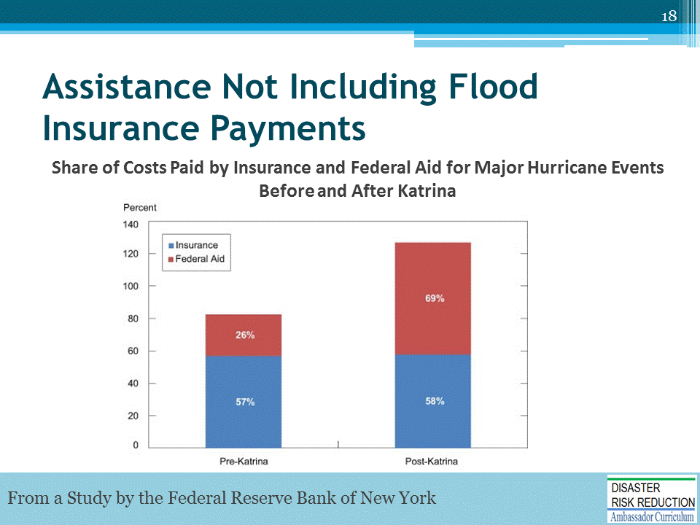
From a Study by the Federal Reserve Bank of New York: http://libertystreeteconomics.newyorkfed.org/2012/12/how-will-we-pay-for-superstorm-sandy.html#.U5sjaEDyTgA
Source: Authors’ calculations, based on data in “Federal Financial Exposure to Natural Catastrophe Risk,” by J. David Cummins, Michael Suher, and George Zanjani, 2010. In Measuring and Managing Federal Financial Risk. NBER Conference Report. Chicago: University of Chicago Press.

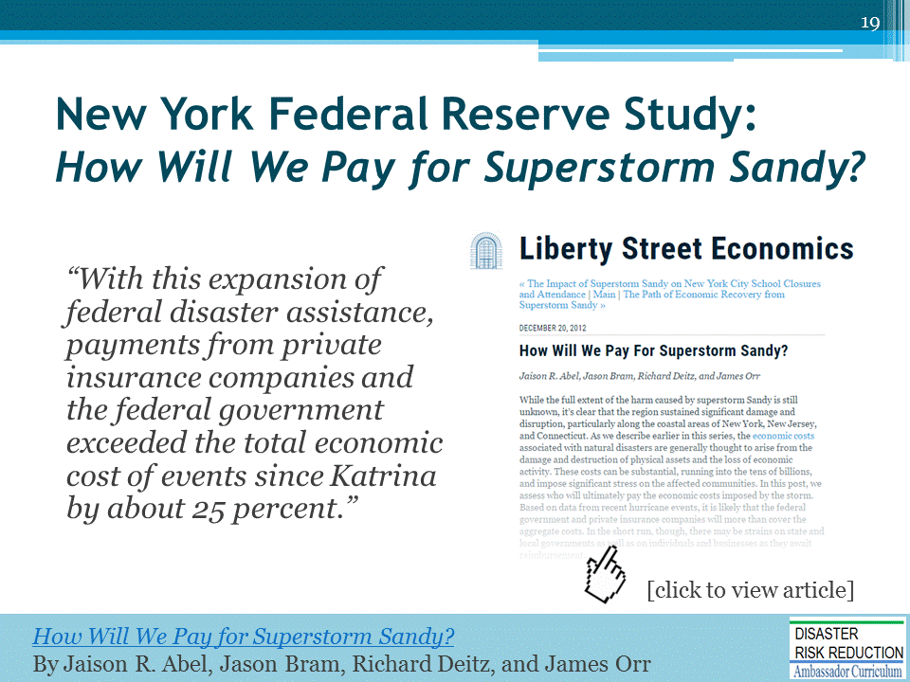
“This pattern suggests that an excess amount was distributed to state and local governments and affected individuals and businesses…
Clearly, though, some businesses or individuals may not have been fully reimbursed for their out-of-pocket expenses, despite the excess payments in aggregate.” (JR Abel, J Bram, R Deitz, J Orr – How Will We Pay for Superstorm Sandy? December 20, 2012)
“Understanding the magnitude of the support for post disaster reconstruction is a good start. A very nice paper, How Will We Pay For Superstorm Sandy? published by the blog of the Federal Reserve Bank of New York helps explain how much society supports post disaster reconstruction, without even including funds spent on NFIP claims.” (Edward A. Thomas Esq. – 8/13/2016 Working Draft for Concept for a White Paper on Development, Disasters and Flood Insurance)
Comments on the National Flood Insurance Program
- The National Flood Insurance Program has been the most cost effective program of harm prevention and hazard mitigation in our nation’s history
- But it can be made better - especially through local action
- That is a fundamental message we are trying to get across
From a Study by the Federal Reserve Bank of New York: http://libertystreeteconomics.newyorkfed.org/2012/12/how-will-we-pay-for-superstorm-sandy.html#.U5sjaEDyTgA

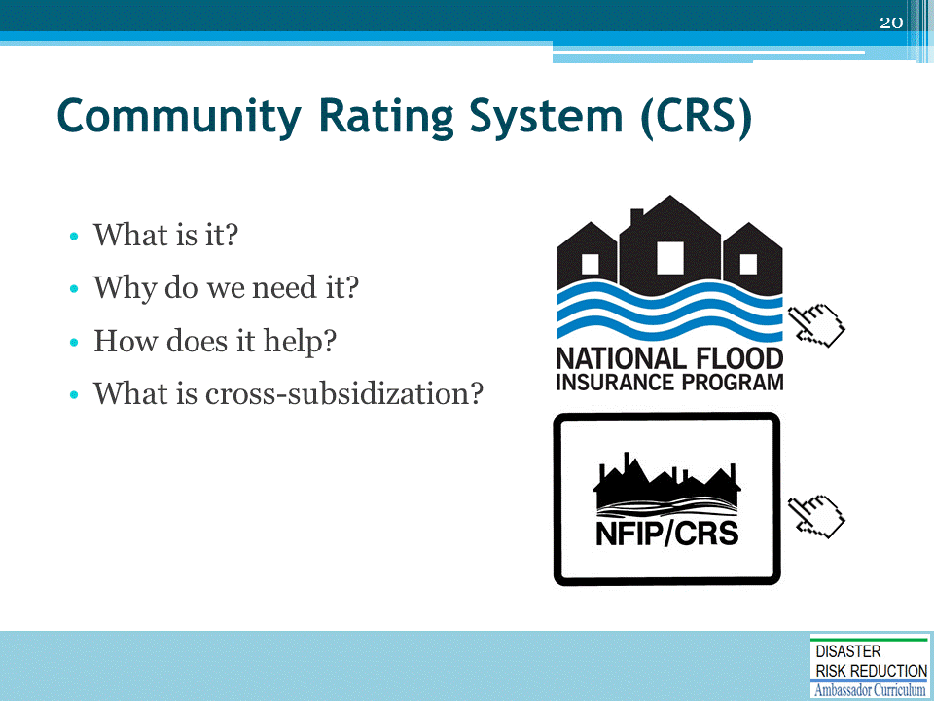
ANSWERS TO THE QUESTIONS ON THE SLIDE ARE PROVIDED BELOW.
What is the CRS?
- The CRS is a voluntary program for the National Flood Insurance Program's (NFIP's) participating communities.
- For a community to qualify for the CRS, it must be in full compliance with all aspects of the NFIP.
- The goals of the CRS are:
  - Reduce flood damage to insurable property,
  - Strengthen and support the insurance aspects of the NFIP, and
  - Encourage a comprehensive approach to floodplain management.
Why do we need the CRS?
- Purpose is to promote the awareness of flood insurance, mitigate flood losses, and facilitate accurate insurance rating
How does the CRS help?
- A chief way in which the CRS mitigates losses is to provide incentives (i.e., premium discounts) for communities to extend beyond the minimum floodplain management requirements by developing extra measures to provide protection from flooding.
What is cross-subsidization?
- Cross subsidization is the practice of charging higher prices to one group of consumers to subsidize lower prices for another group.

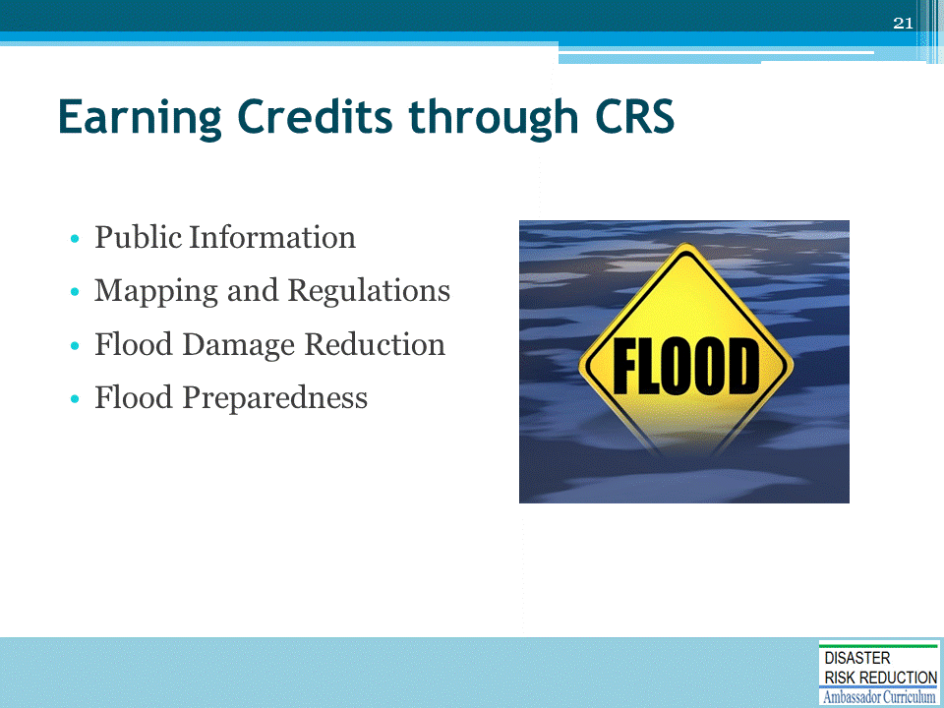
- The lessons drawn from the establishment and enhancement of the CRS show that the first step is to identify the most important and meaningful activities that earn incentives. By definition, these would be activities that represent best practices and can demonstrate measurable improvement.
- Under the CRS, there is an incentive for communities to do more than just regulate construction of new buildings to minimum national standards.
- Communities earn credit by engaging in 18 activities organized under four categories:
  - Public Information,
  - Mapping and Regulations,
  - Flood Damage Reduction, and
  - Flood Preparedness.
- CRS class designation is determined by how many credits a community earns through these activities. CRS classes range from a Class 9 (requiring 500-999 CRS credits) to a Class 1 (requiring 4,500 or more CRS credits).
- Under the CRS, flood insurance premiums are adjusted.
- For CRS participating communities, flood insurance premium rates are discounted in increments of 5%; i.e., a Class 1 community would receive a 45% premium discount, while a Class 9 community would receive a 5%.
- The CRS classes for local communities are based on 18 creditable activities, organized under four categories: (i) Public Information, (ii) Mapping and Regulations, (iii) Flood Damage Reduction, and (iv) Flood Preparedness

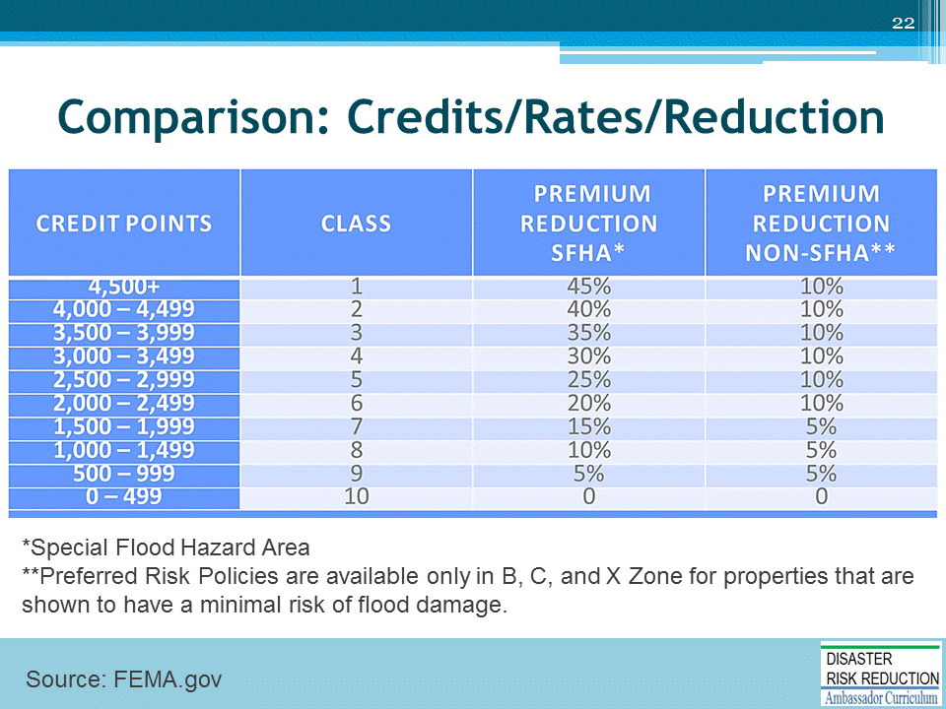
The Preferred Risk Policy does not receive premium rate credits under the CRS because it already has a lower premium than other policies.
- The CRS credit for AR and A99 Zones are based on non-Special Flood Hazard Areas (non-SFHAs) (B, C, and X Zones).
- Credits are:
  - Classes 1-6: 10%
  - Classes 7-9: 5%
- Premium reductions are subject to change.

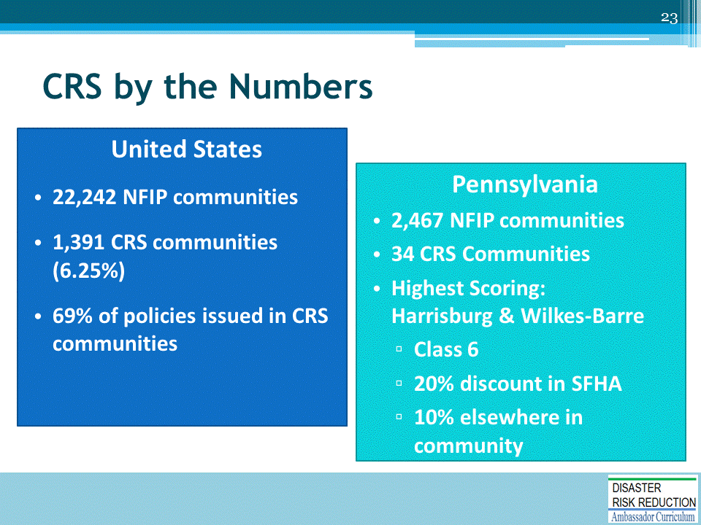
2016/2017 CRS Data Sources:
- https://www.fema.gov/national-flood-insurance-program-community-status-book
- https://www.fema.gov/media-library-data/1476294162726-4795edc7fe5cde0c997bc4389d1265bd/CRS_List_of_Communites_10_01_2016.pdf
- https://www.fema.gov/media-library-data/1469718823202-3519e082e89a8c780670bb03f167bbae/NFIP_CRS_Fact_Sheet_May_03_2016.pdf

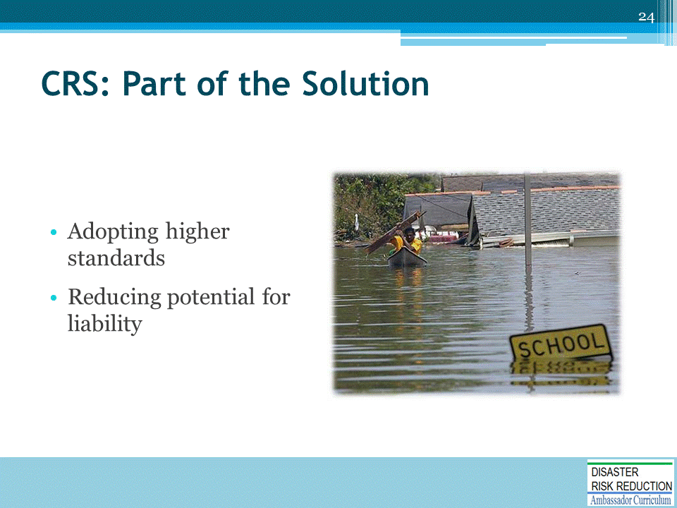
- Communities that fall back on the minimum federal NFIP standards may allow diversion of floodwaters onto other properties, loss of channel conveyance and storage, and an increase in erosive velocities, ALL of which may make the community liable for resulting harm.
- The NFIP allows improvements valued at up to 50% of the building’s pre-improvement value to be permitted without meeting the flood protection requirements. Over the years, a community may issue a succession of permits for different repairs or improvements to the same structures. This can greatly increase the overall flood damage potential within a community as well as the insurance liability to FEMA.
- This element provides credit to a community that ensures that the total value of all improvements or repairs permitted over the years does not exceed 50% of the value of the structure. When the total value does exceed 50%, the original building must be protected according to the ordinance requirements for new buildings.
- This element may require no specific ordinance language, but simply a policy decision to interpret the 50% improvement threshold as cumulative. In such cases, the documentation must include a legal opinion or directive from the community’s legal counsel stating how the ordinance is to be interpreted. Either way, the community needs to maintain permit records by parcel number or address, so that the history of improvements or repairs to a particular structure is checked before the next permit is issued.
If a community does not regulate for cumulative substantial improvements, it may still receive credit for regulation of additions. Additions within the footprint of the original building would have to be to a floor above the base flood elevation. Additions outside the footprint of the original building would have to be elevated (or, for non-residential structures, floodproofed) above the base flood elevation.

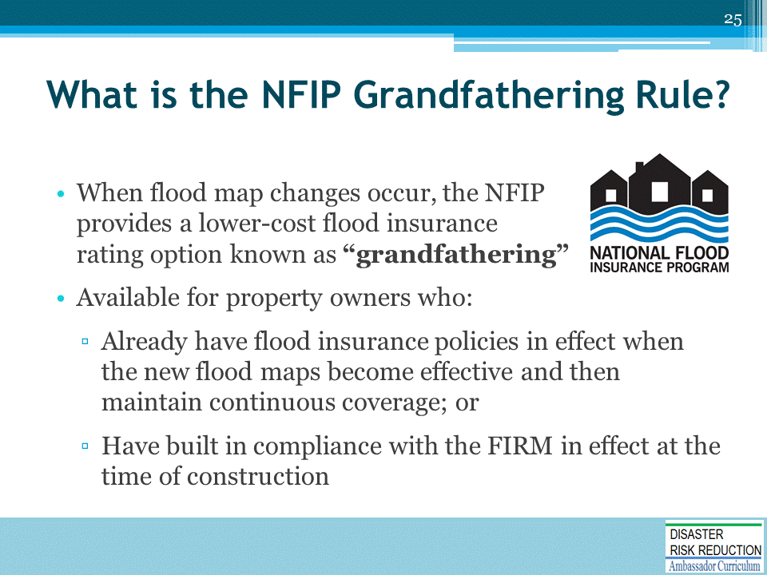
NFIP Grandfathering Rules - A Fact Sheet for Insurance Agents: https://www.fema.gov/media-library/assets/documents/16686

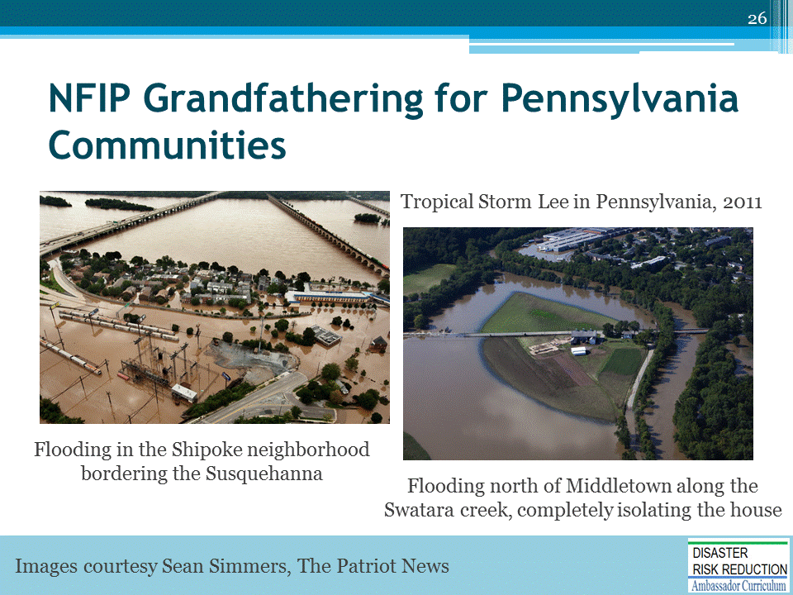
Grandfathering is a big issue in Pennsylvania because:
- We have a lot of old river towns with primary (and secondary) homes, businesses and historic structures - many were built well before the NFIP started
- These structures have policy premiums that, as long as they are kept current, have passed from one family member to another
- If the policy lapsed for one day – it goes to the actual rate.
  - But, with the BW12 and HFIAA changes, the rates are slowly moving to actual; eventually, all the “grandfathered” rates will be to the actual rate (7 or 8 years).
- Many of these homes have been inherited and have the elderly on fixed incomes, so they discontinue their NFIP premiums.
- We have seen the movement from NFIP flood insurance to private policies and surplus line carriers for flood insurance.
  - Pennsylvania used to be in the top 10 but now has fallen to #14 in the number of FEMA NFIP policies in force.
- Plus, the wild card is, not sure what will happen with the NFIP reauthorization that has to take place in August 2017 (things are heating up now with NFIP forums and discussions)
Photos from National Weather Service, NOAA: http://www.weather.gov/ctp/TSLeeFlooding

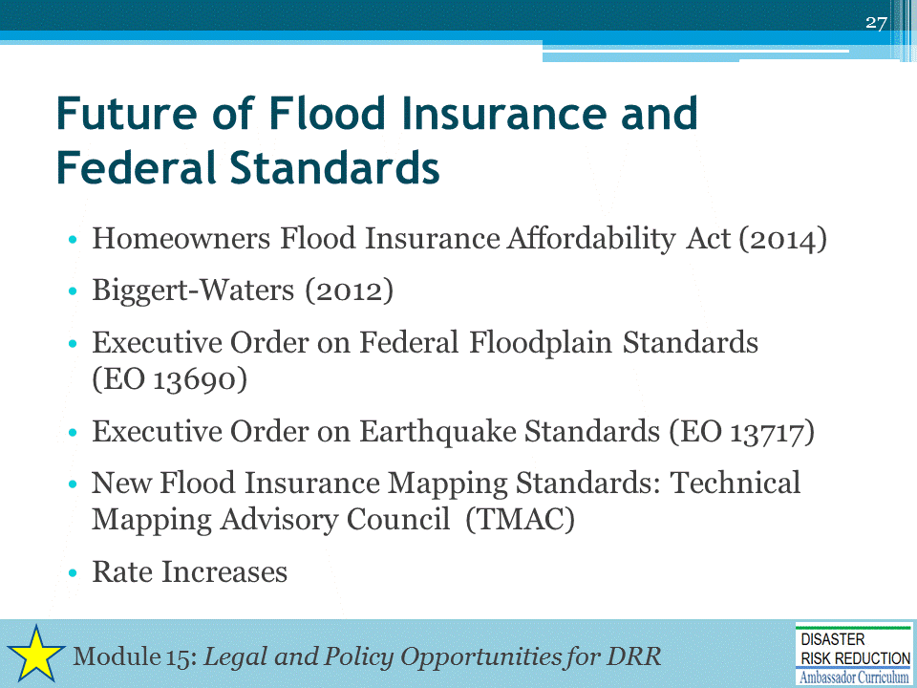
What does this mean for a proper Standard of Care for all?
- This gets into a discussion of liability, which is covered in Module 15, Legal and Policy Opportunities for DRR, of the Disaster Risk Reduction Ambassador Curriculum.

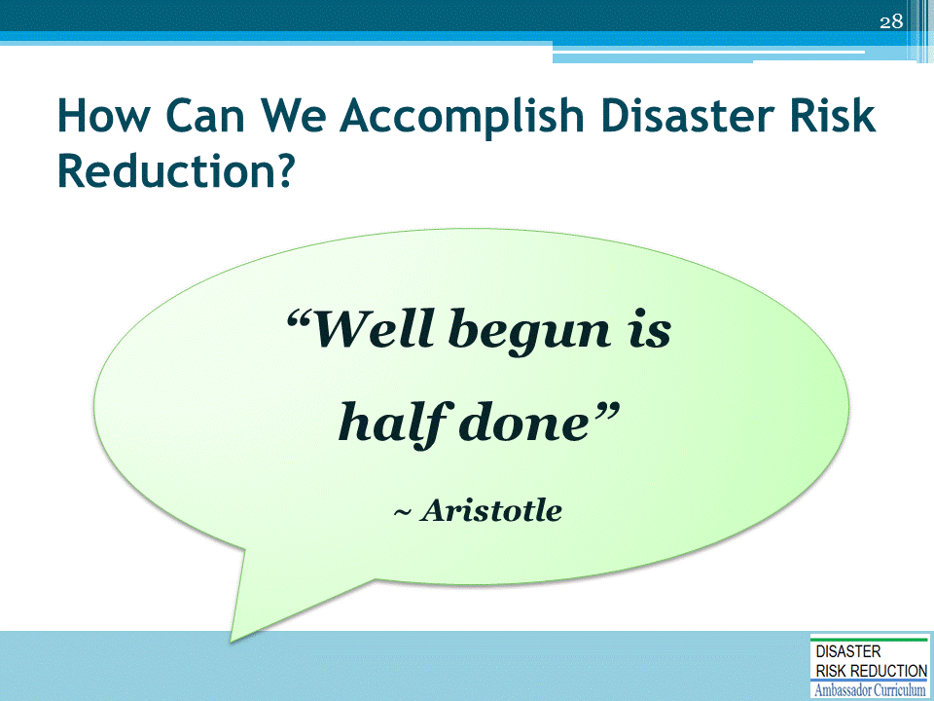
Do you agree with the old saying that “Well begun is half done”?
- Many claim that there are insufficient funds for Hazard Mitigation/Climate Adaptation/Disaster Risk Reduction
- There is a way to get the job “half done”
- Would “half done” be very well begun?
We need to recognize that constantly demanding more federal or other public money to correct past mistakes of planning and community development, which result in disasters when foreseeable natural events take place, is a not a path to success.
- The best and most creative manner to find funds to prevent disasters is simply to plan, design, and build so natural foreseeable events do not devastate our people, environment, and economy.

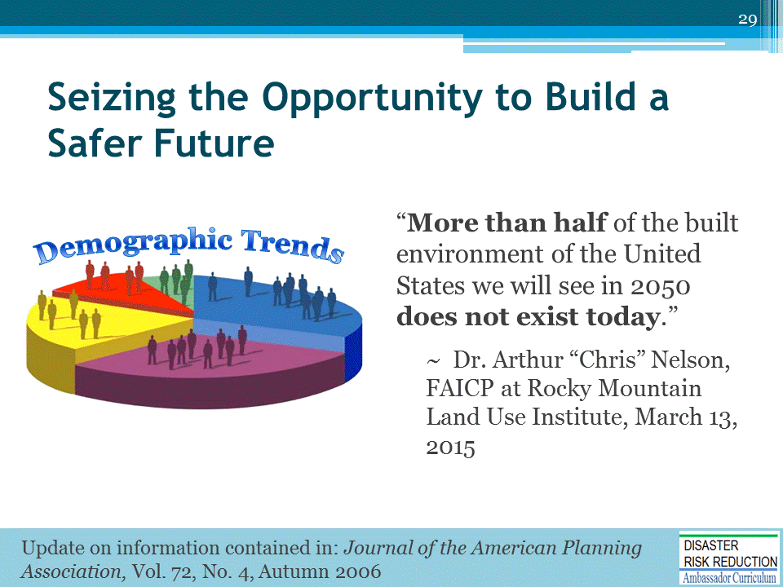
Recall from Module 2 that “More than half of the built environment of the United States we will see in 2050 does not exist today.”
- This demographic fact gives us an enormous opportunity to correct problems before they become disasters.
- Now is the time to seize our opportunity to build a safer future by planning, designing, and constructing new and renovated development in a manner to reduce rather than exacerbate future disasters!

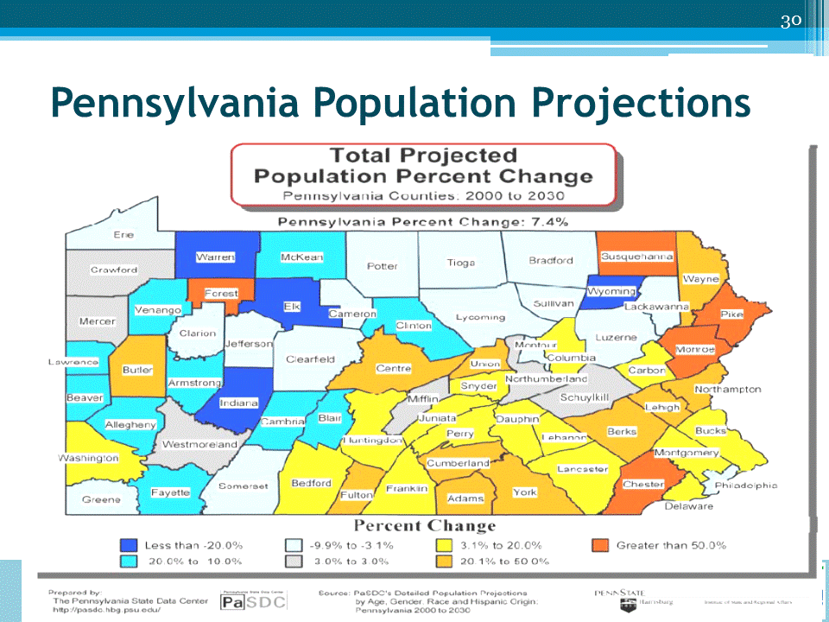

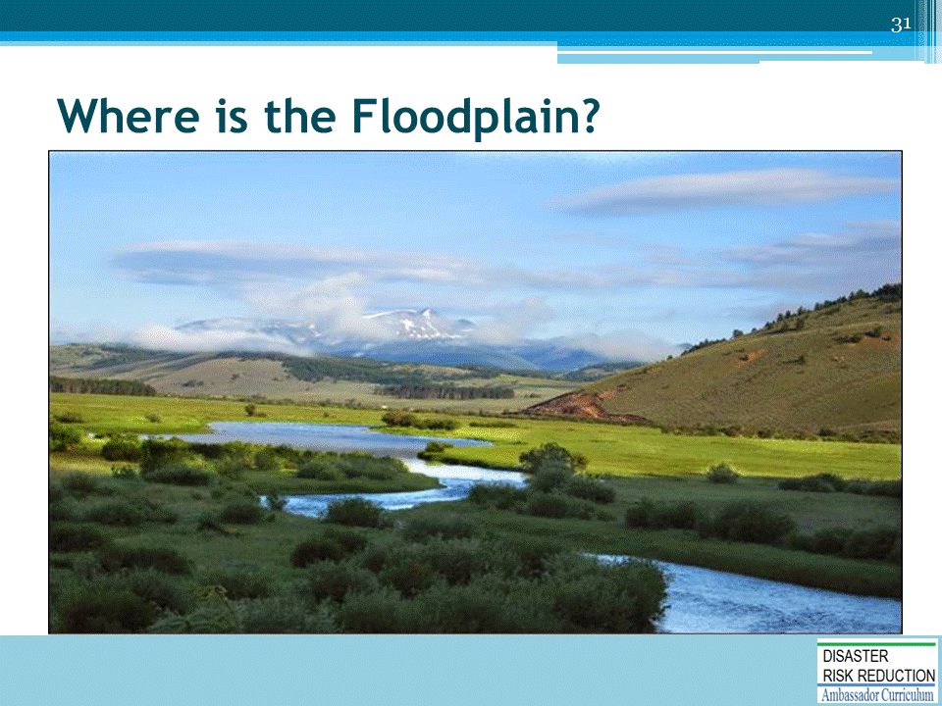
Ask: Can you look at this and tell what will flood?

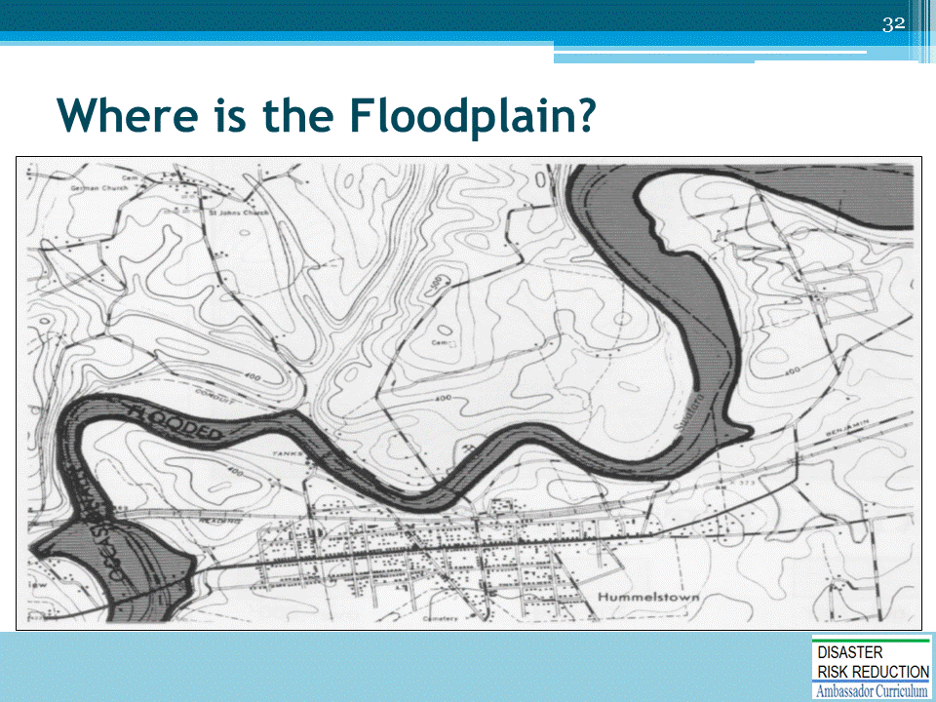
Ask: How about this map? Can you tell where it will flood?

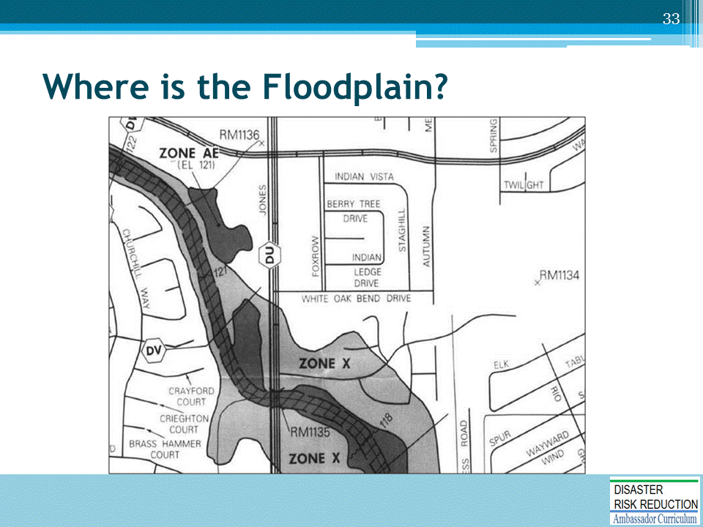
Ask: How about a standard FEMA Flood Insurance Rate Map?
- The point is that the floodplain is the whole map.
- Mother Nature tells us regularly that she does not read flood maps for guidance when she floods places!
- 25-30-40 percent of NFIP Claims are from those who voluntarily purchased flood insurance outside the SFHA and were flooded!

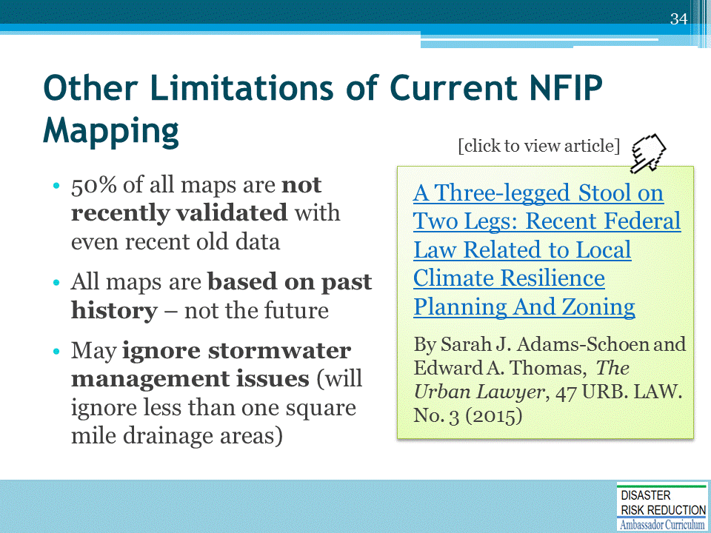
Discuss: Old insurance proverb - what we lose on the bananas we make up for on the oranges—if the map meets current standards it can be used for insurance risk rating purposes, but not necessarily for engineering and architectural design.
See also A Three-legged Stool on Two Legs: Recent Federal Law Related to Local Climate Resilience Planning And Zoning: http://nhma.info/wp-content/uploads/2015/06/HazMitig-Hot-Topic2015.pdf

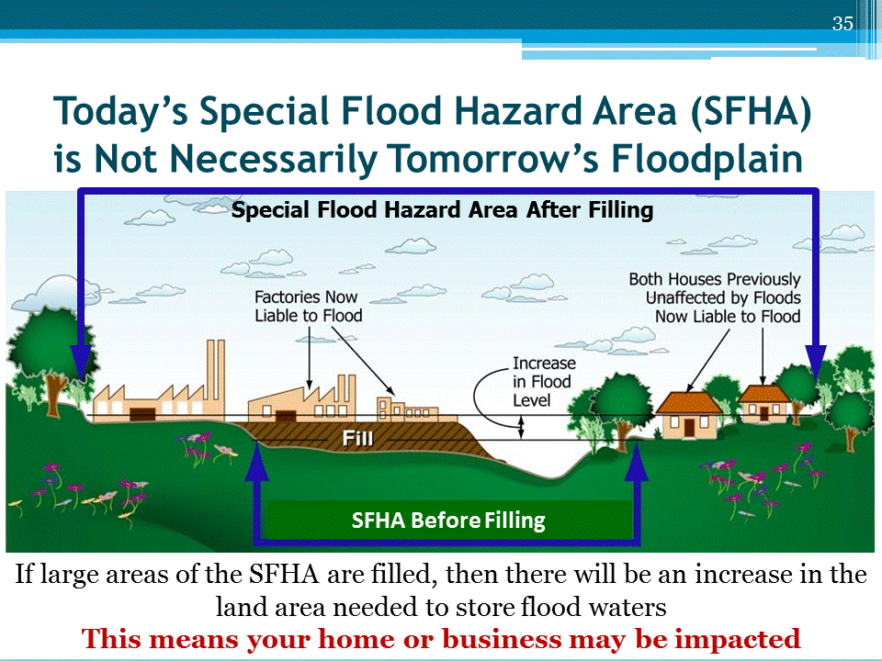
- Point out the SFHA development
- Point out where the SFHA has been developed with fill and buildings. Such development in the SFHA & flood fringe will ultimately lead to higher flood levels.
WE USED SFHA DEVELOPMENT FOR EASE OF GRAPHICS
The result:
- Homes that already existed will now be subject to flooding
- Homes that are built to the flood level on the map, will not be protected to the 1% flood level, like they thought they were.
- Larson-Plasencia Article: 6 ft. rise documented in Charlotte, etc.
(No Adverse Impact: A New Direction in Floodplain Management Policy, by Larry Larson and Doug Plasencia; Published in Natural Hazards Review Nov. 2001, IAAN 1527-6988: http://www.floods.org/NoAdverseImpact/NAIjournal.pdf)

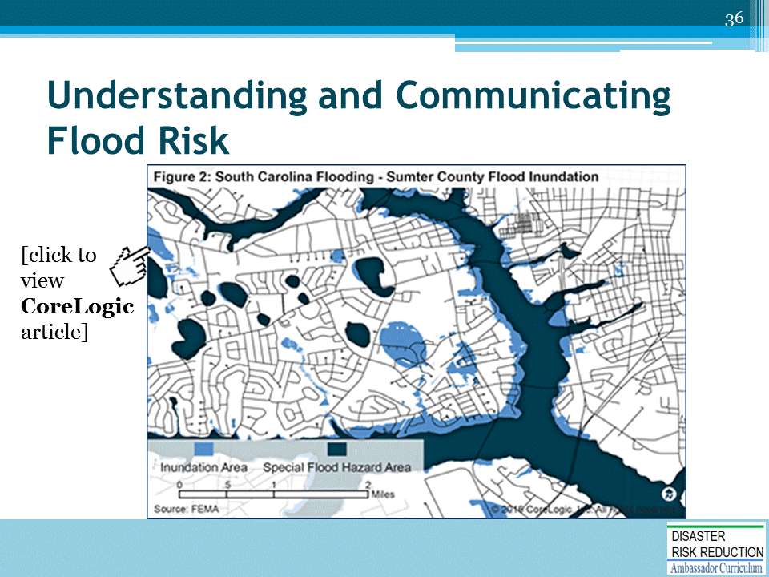
Understanding and Communicating Flood Risk: Expanding the National Conversation by Scott Giberson
http://www.corelogic.com/blog/authors/scott-giberson/2016/02/understanding-and-communicating-flood-risk.aspx?WT.mc_id=crlg_160229_QU9hu
Figure 2: South Carolina Flooding – Sumter County Flood Inundation
…knowing whether an area is mapped as a Special Flood Hazard Area is not determinative of whether it is at any risk to flood. This map compares the flooding that occurred in an area of southwest Sumter, South Carolina (based on preliminary inundation data released by FEMA) to the mapped Special Flood Hazard Area based on the current flood map. Importantly, the Special Flood Hazard Area represents the predicted area subject to flooding from an event of a single frequency (the 1 percent annual chance flood). More granular flood risk assessment and analysis helps demonstrate several things: that risk exists beyond areas mapped for a single probabilistic event; that such flood maps do not show typical or necessarily expected inundation; and that actual inundation depends, to a certain extent, on unpredictable amounts of rainfall in unpredictable localities.”

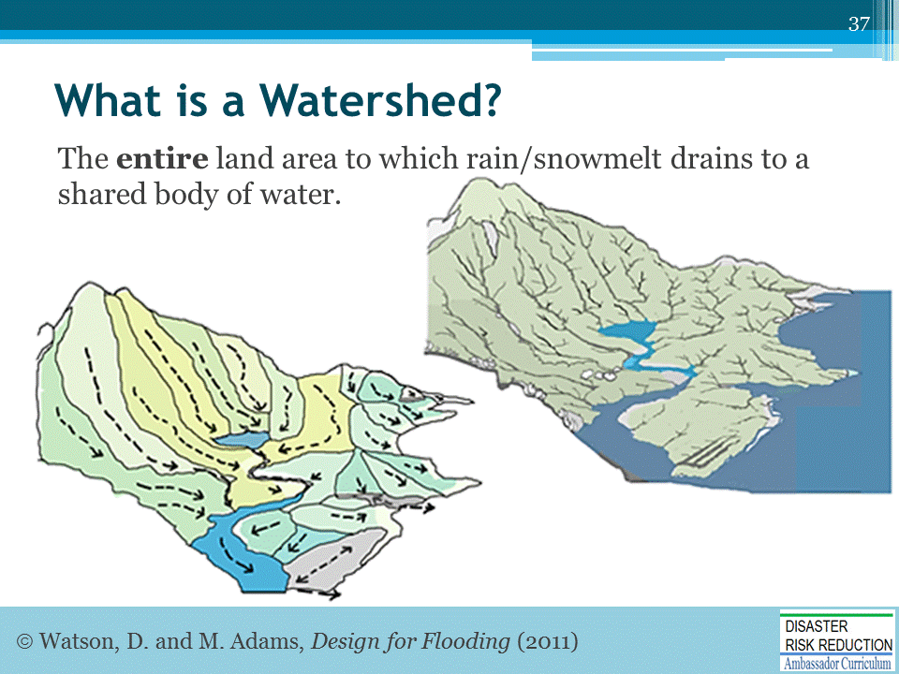
Recall from Module 18 that a watershed is everywhere that rain (and snow) falls and flows…..
Slide courtesy of Don Watson’s Module 18 presentation, Design for Flood Resilience, Part I

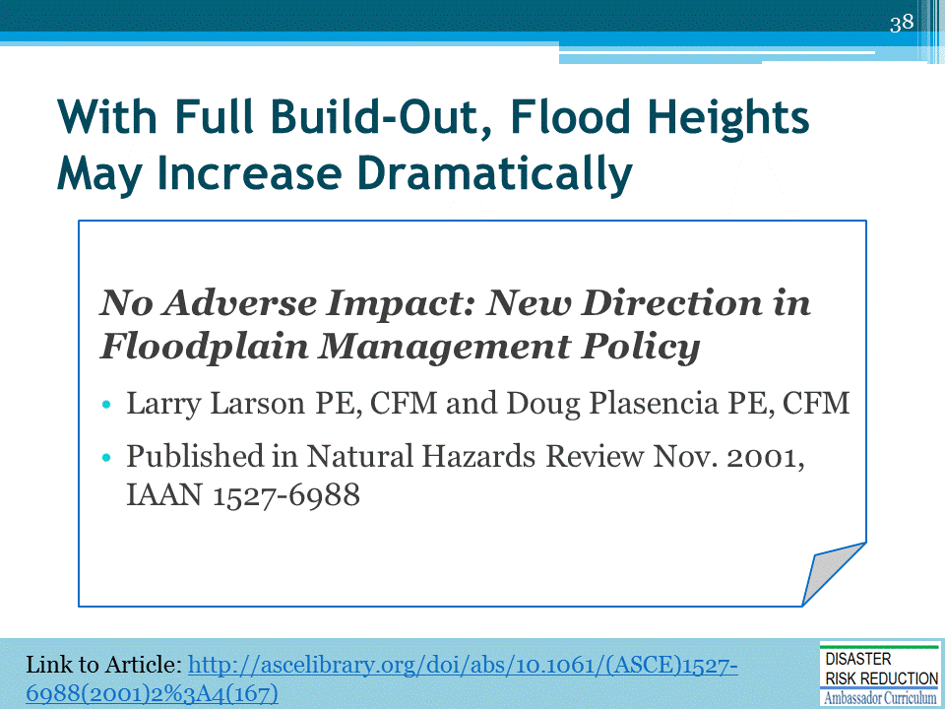
- The City of Charlotte and Mecklenburg County area (including six towns) is located in south-central North Carolina. The County is 525 square miles in size and has increased in population by 245,000 in the last 20 years. It is estimated that an additional 300,000 residents will locate in Charlotte-Mecklenburg over the next 25 years.
- In the past, traditional stormwater/floodplain management techniques were employed, such as joining the NFIP, using voter-approved bond funds for the protection of property losses due to erosion, and requiring detention on commercial development.
- Starting in 1994, Charlotte-Mecklenburg initiated a stormwater management program, funded by a stormwater fee, to address infrastructure problems on private property and expand the existing floodplain management program.
- In 1995 and 1997, flooding caused $20 million and $60 million in losses, respectively. During this period and as part of the expansion of the floodplain program, Mecklenburg County was in the process of developing the Mecklenburg County Floodplain Management Guidance Document, adopted in late 1997.
- By updating the FEMA map computer models to 2000 land use conditions, flood heights increased 2-3 feet. However, when the ultimate land use in the watershed was loaded into the models, flood height increased another 2-3 feet. Therefore, if the County continues to rely on FEMA for floodplain mapping, the maps will not be keeping up with the impact of development. There is a possibility that new development would be permitted that will ultimately be as much as 4-6 feet below future flood heights.

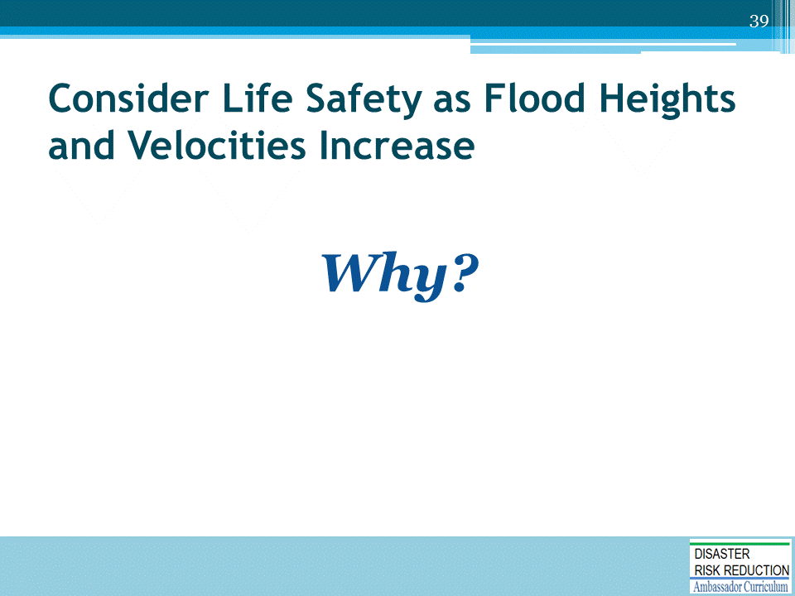

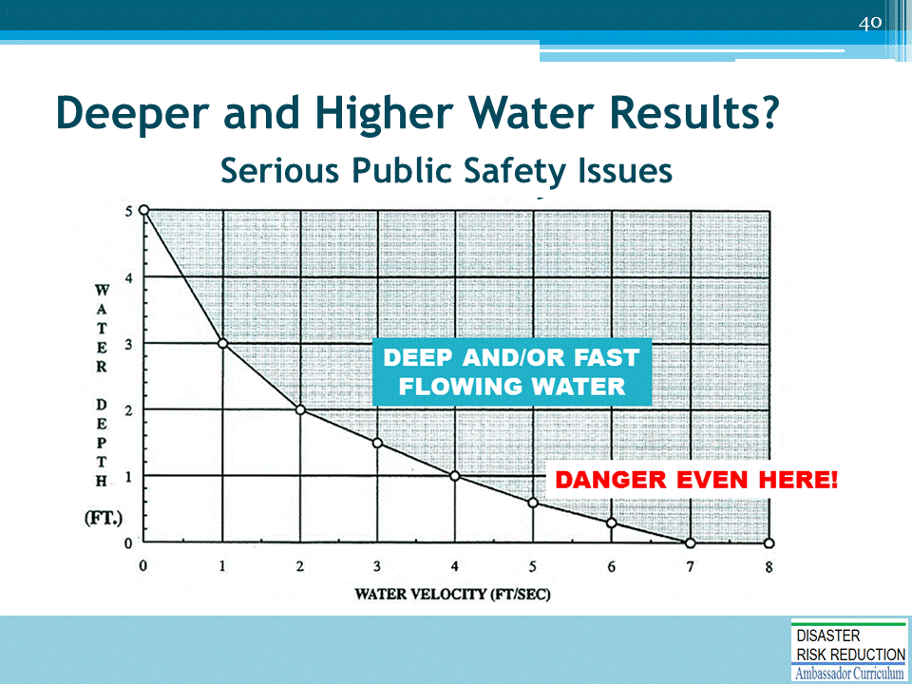
Consider life safety as flood heights and velocities increase.
Typical rule of thumb first developed by Bureau of Reclamation. Instituted by Pierce County, Washington.

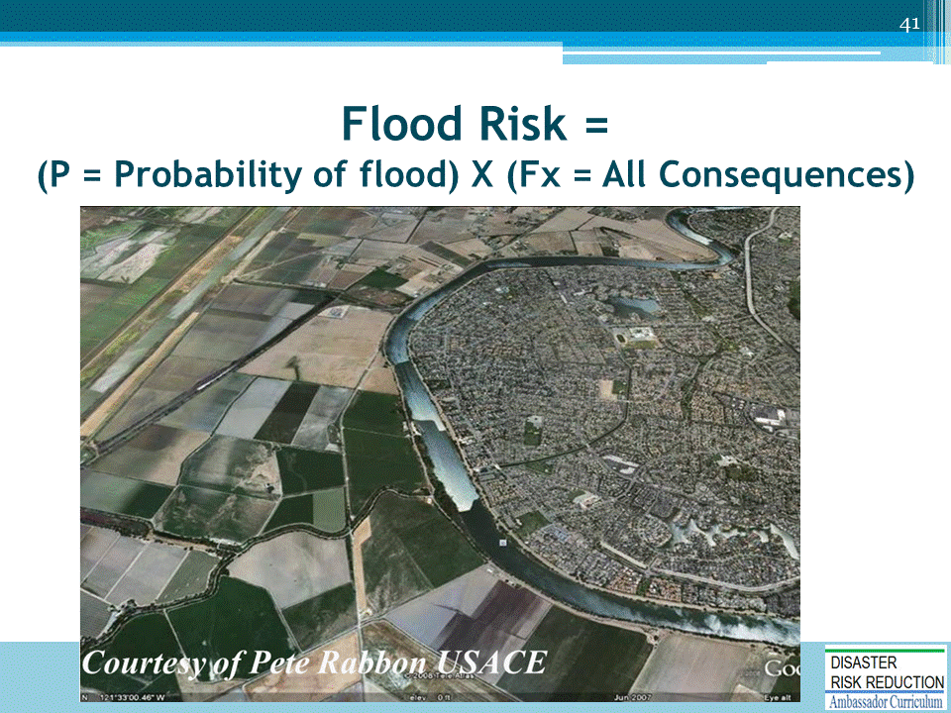

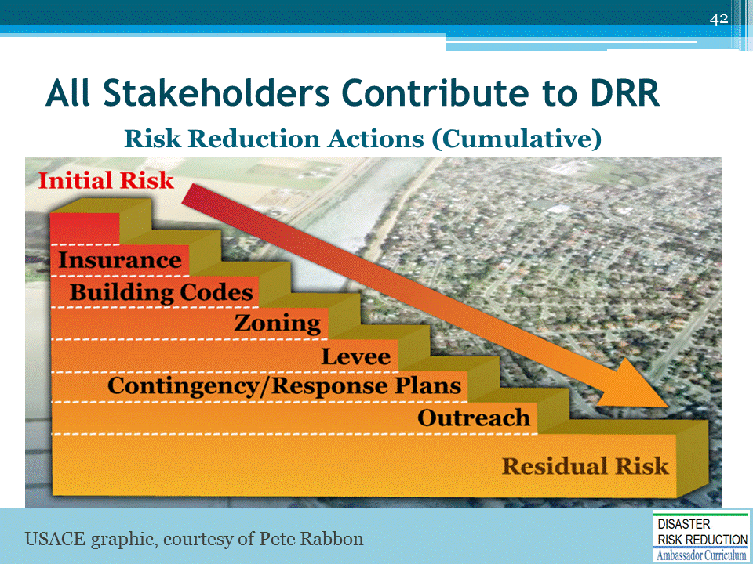
Recall from Module 2 that all stakeholders contribute to reducing risk.
- The “ideal” concept is we start with an initial risk and reduce it through human activity.

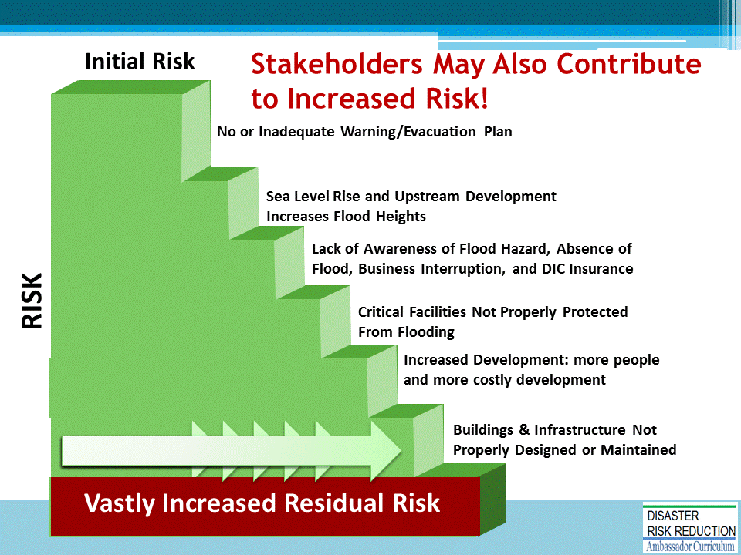
Also recall from Module 2 that stakeholders may also contribute to increased risk.

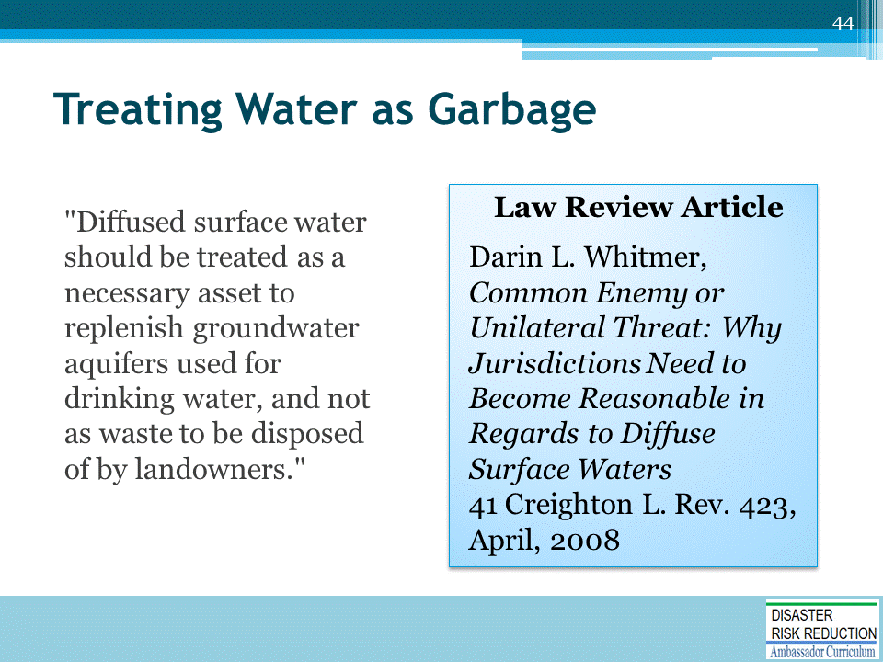

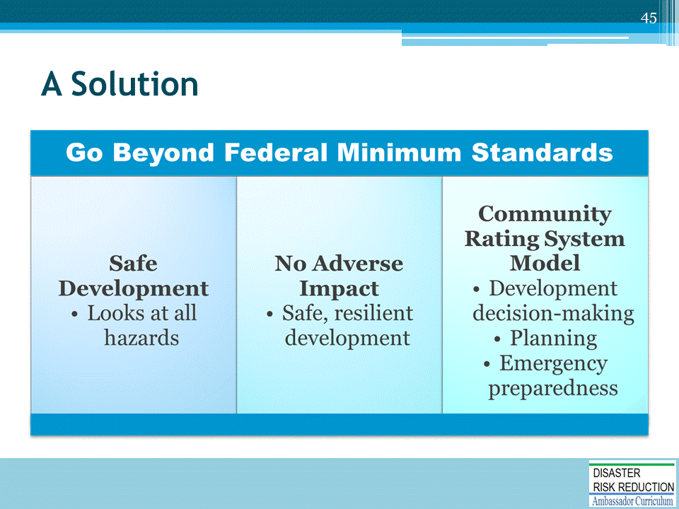
Recall from Module 2 that the NFIP Community Rating System (CRS), has successfully provided incentives for communities to exceed floodplain standards.
- The lessons drawn from the establishment and enhancement of the CRS show that the first step is to identify the most important and meaningful activities that earn incentives.
- By definition, these would be activities that represent best practices and can demonstrate measurable improvement.

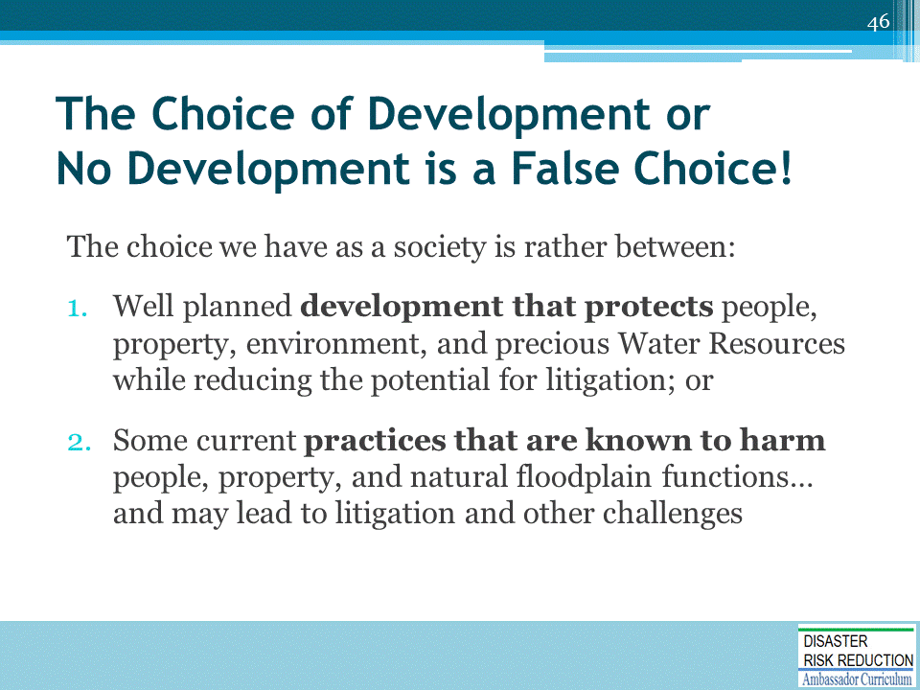
Sustainability and Triple Bottom Line (TBL)
Excerpt from article, The Triple Bottom Line: What Is It and How Does It Work?
By Timothy F. Slaper, Ph.D. and Tanya J. Hall
http://www.ibrc.indiana.edu/ibr/2011/spring/article2.html
“The TBL is an accounting framework that incorporates three dimensions of performance: social, environmental and financial. This differs from traditional reporting frameworks as it includes ecological (or environmental) and social measures that can be difficult to assign appropriate means of measurement. The TBL dimensions are also commonly called the three Ps: people, planet and profits.
Well before [John] Elkington introduced the sustainability concept as "triple bottom line," environmentalists wrestled with measures of, and frameworks for, sustainability. Academic disciplines organized around sustainability have multiplied over the last 30 years. People inside and outside academia who have studied and practiced sustainability would agree with the general definition of Andrew Savitz for TBL. The TBL "captures the essence of sustainability by measuring the impact of an organization's activities on the world ... including both its profitability and shareholder values and its social, human and environmental capital.”

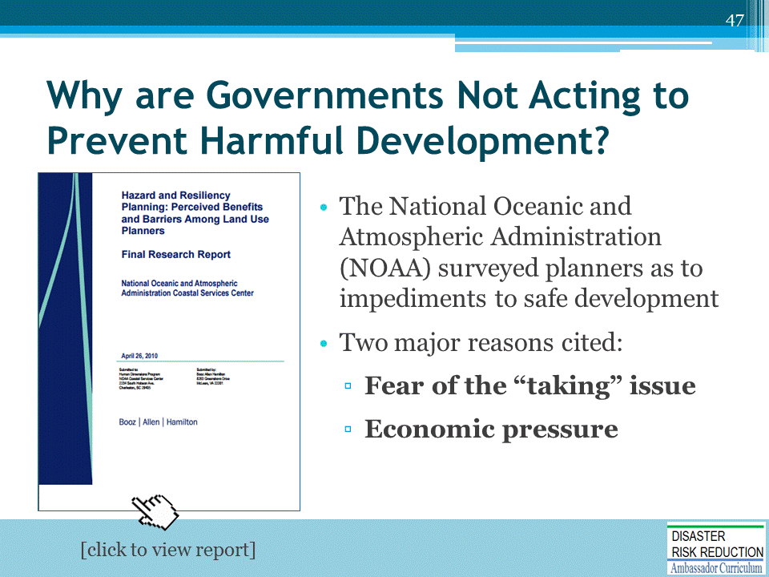
Source: Hazard and Resiliency Planning: Perceived Benefits and Barriers Among Lan Use Planners, Final Research Report, NOAA: https://coast.noaa.gov/data/digitalcoast/pdf/hazard-planning.pdf

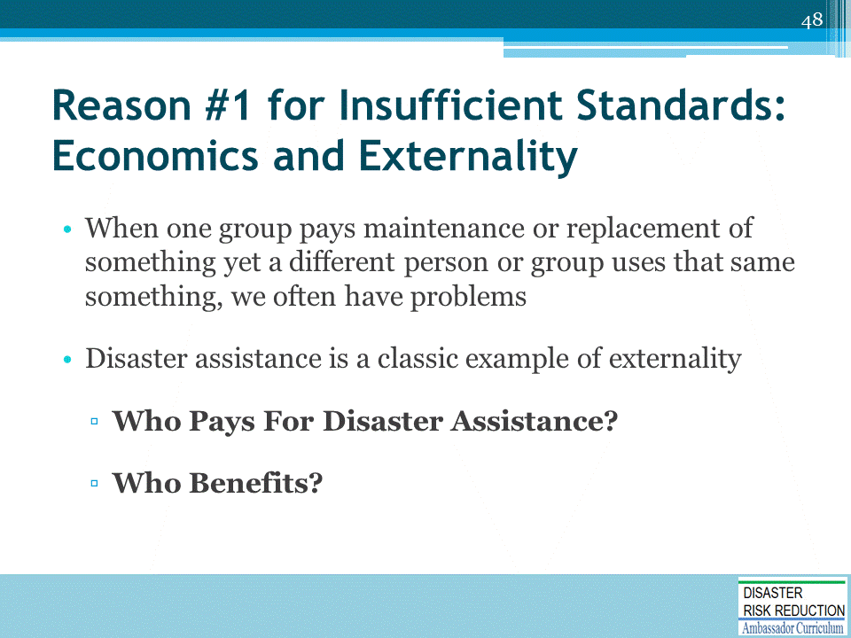

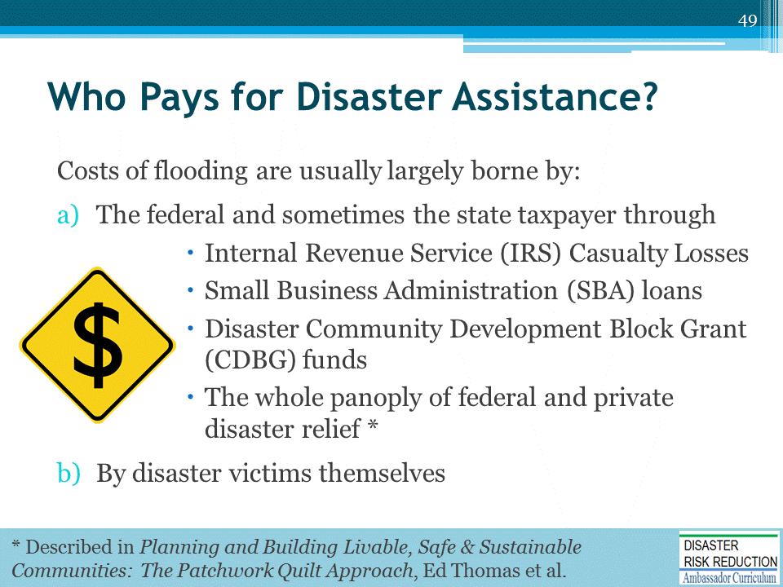
Planning and Building Livable, Safe & Sustainable Communities: The Patchwork Quilt Approach: http://nhma.info/publications/the-patchwork-quilt/

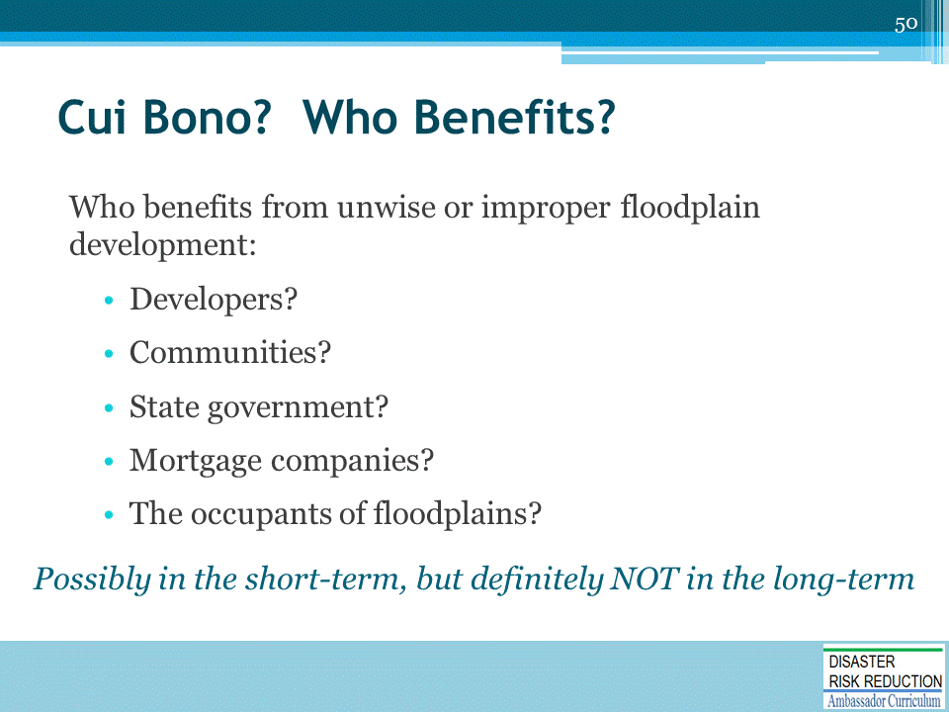
Cui bono ("To whose benefit?", literally "[being] good for whom?") is a Latin adage that is used either to suggest a hidden motive or to indicate that the party responsible for a thing may not be who it appears at first to be.
- With respect to motive, a public works project which is purported to benefit the city may have been initiated rather to benefit a favored campaign contributor with a lucrative contract.
- This commonly the phrase is used to suggest that the person or people guilty of committing a crime may be found among those who have something to gain, chiefly with an eye toward financial gain.
- The party that benefits may not always be obvious or may have successfully diverted attention to a scapegoat, for example.

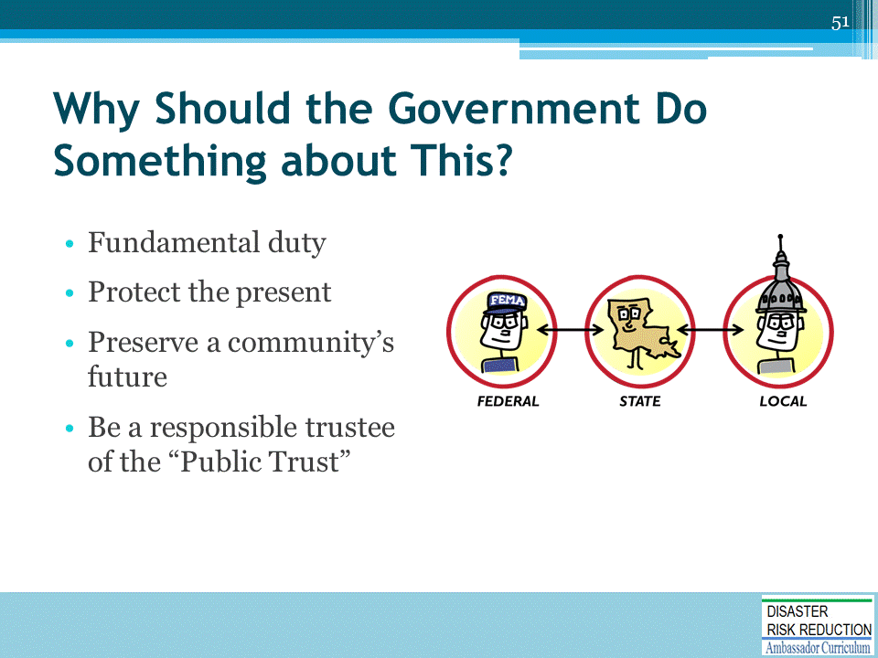
Recall from Module 2 that there are several reasons why the government is responsible for protecting the public from harmful development practices.

Recall from Module 2…
The word liability is one of the most significant words in the field of law.
- Liability means legal responsibility for one's acts or omissions.
- Failure of a person or entity to meet that responsibility leaves him/her/it open to a lawsuit for any resulting damages or a court order to perform (as in a breach of contract or violation of statute).
Source: http://dictionary.law.com/Default.aspx?selected=1151
MENTION that these topics are covered more fully in Module 15 of the DRR Ambassador Curriculum.

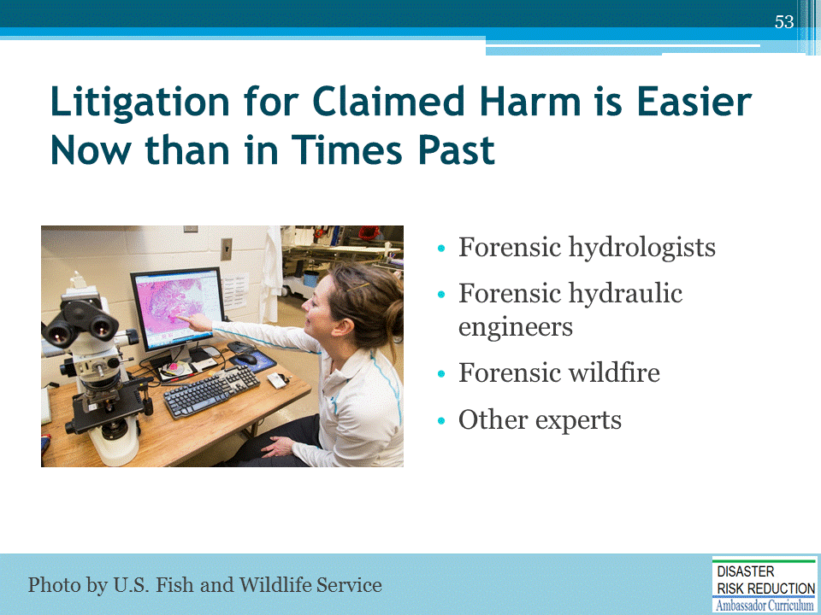
Today, sophisticated modeling techniques facilitate proof of causation and allocation of fault, although proof may still be difficult.
See, e.g., Lea Company v. North Carolina Board of Transportation, 304 S.E.2d 164 (N.C., 1983)
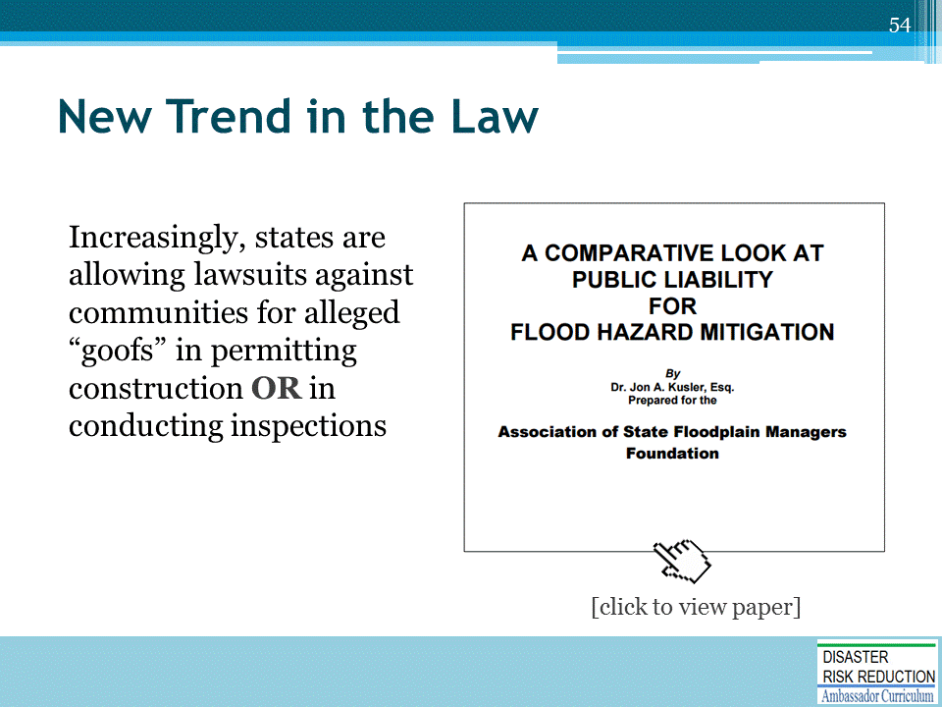
Excellent paper by Attorney Jon Kusler PhD for The Association of State Floodplain Managers (ASFPM) Foundation:
A Comparative Look at Public Liability for Flood Hazard Mitigation
(http://www.floods.org/PDF/Mitigation/ASFPM_Comparative_look_at_pub_liability_for_flood_haz_mitigation_09.pdf)

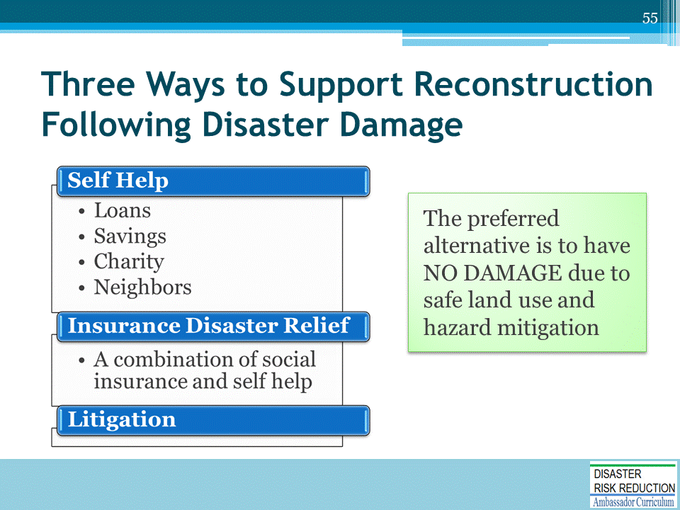

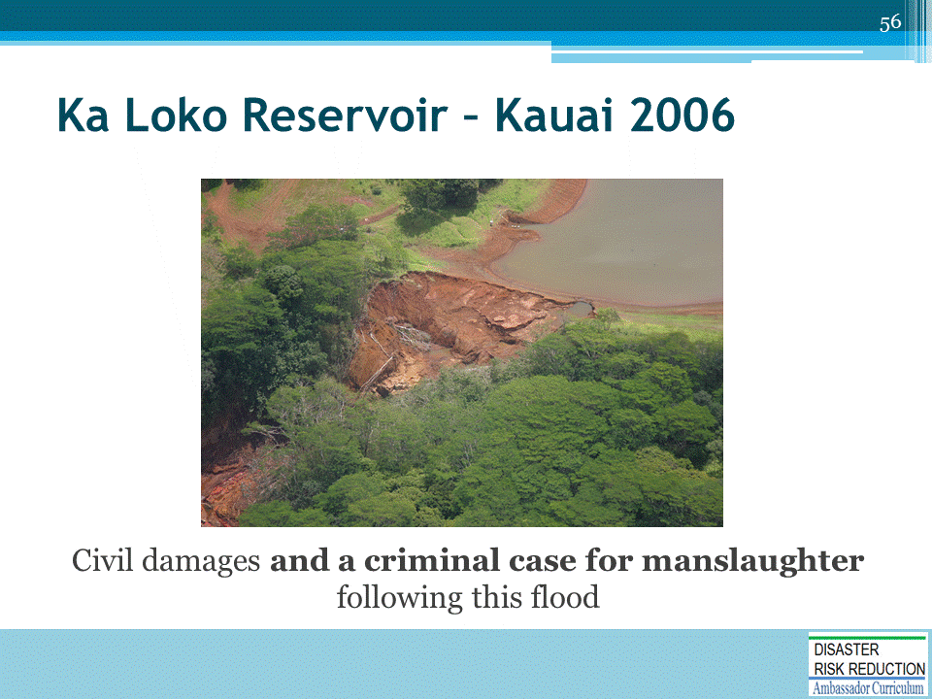

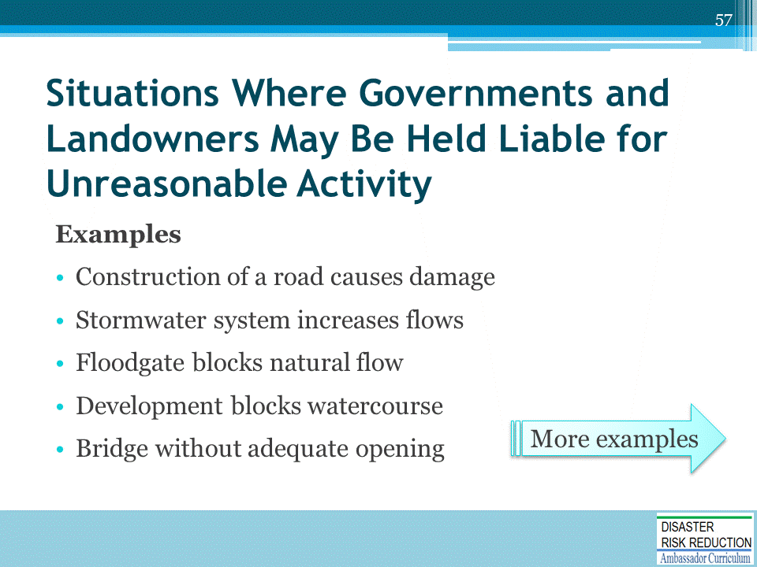
Recall from Module 2 that there are many situations where governments and landowners may be held liable for unreasonable activity. In these examples, the development permitted caused someone harm. Even without regulation there can be legal redress using many theories of liability such as Negligence.
STOP – TAKE THEM ONE AT A TIME!
- Floodgate blocks natural flow See, e.g. Greasy Slough Outing Club v. Amick, 224 Ark. 330 (Ark. 1954)
- Development blocks watercourse See, e.g. Turner v. Smith, 217 Ark. 441 (Ark. 1950)
- Bridge without adequate opening See, e.g.,Missouri P. R. Co. v. Barron, 196 Ark. 244, 248 (Ark. 1938)
Many of these Utah cases are on motions for Summary Judgment so we are not necessarily sure how they turned out.

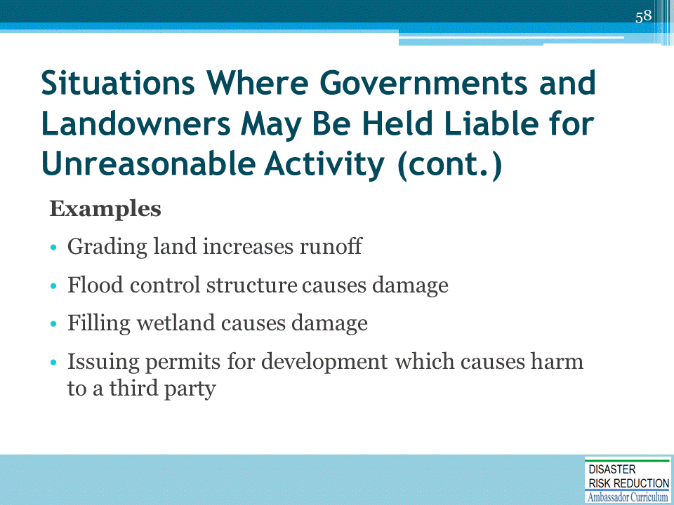
STOP – TAKE THEM ONE AT A TIME!
Many of these Utah cases are on motions for Summary Judgment so we are not necessarily sure how they turned out.

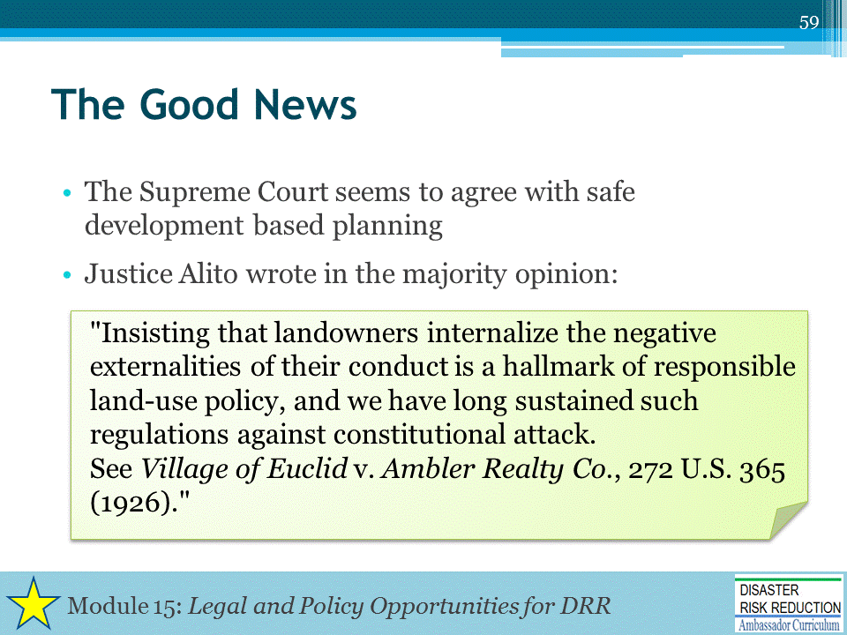

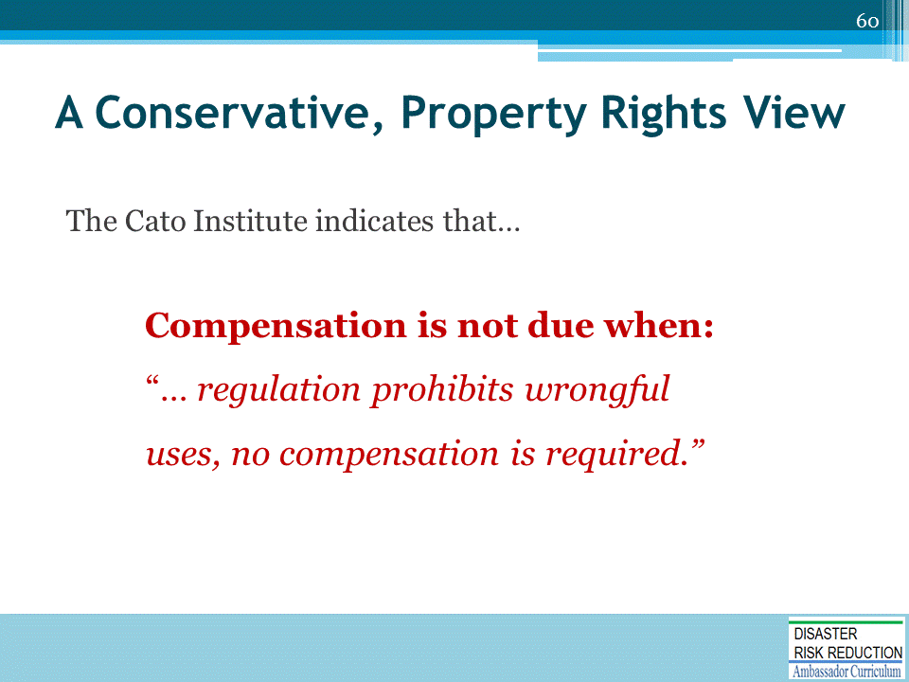
Has anyone heard of the Cato Institute? It is a conservative Think Tank closely associated with the “Constitution in Exile’ and other similar causes.
This quote from the 1995 Publication of the Cato Institute “Protecting Property Rights from Regulatory Takings” Chapter 22, p230.
- The Institute has also testified before Congress about legislation requiring government paying landowners for Regulations limiting what a property owner can do.
- The Institute testified that there should be provided a “…nuisance exception to the compensation requirement….When regulation prohibits wrongful uses, no compensation is required.”
(Testimony of Roger Pilon Senior Fellow and director, Center for Constitutional Studies, Cato Institute. Before the Subcommittee on Constitution, Committee on Judiciary, US House of Representatives, February 10,1995.)
Seems like the Cato Institute is OK with NAI thinking too!

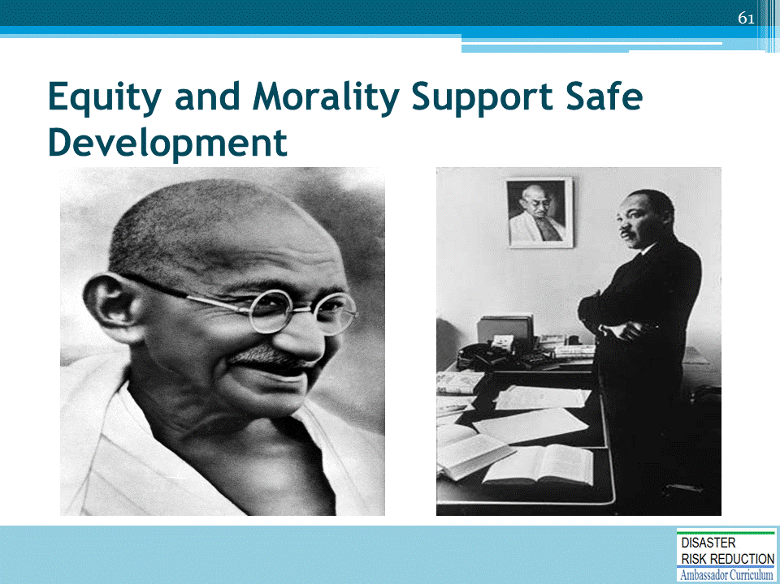
Our Courts in the US are Courts of both law and equity.
Law, well law is statute, legal precedent, the US and State Constitutions, Treaties, etc. coupled with evolving standards of reasonable action.
Equity is very important for our discussions.
- Equity is based on fairness, influenced by concepts of morality.
- Sometimes courts will really get very innovative to come out with a moral, decent result.
- Juries seem to often try to help the underdog for similar reasons.
- Victims of a dam or levee failure may be considered by some to be deserving some special considerations for some sort of “equitable” reason.
- Large companies, insurers, and government agencies may come out on the short end of a case in such a situation.

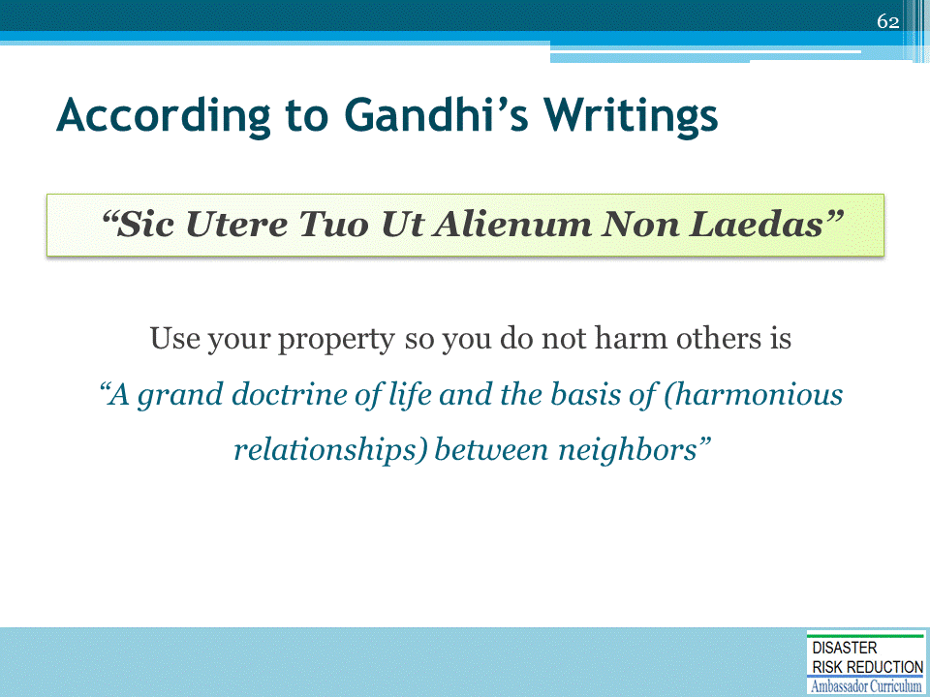
The concept of using property so it does not harm others:
- Is important to all aspects of what we do in developing and redeveloping communities
- Will help us understand how to proceed for current community decisions and for the future, as we shall see

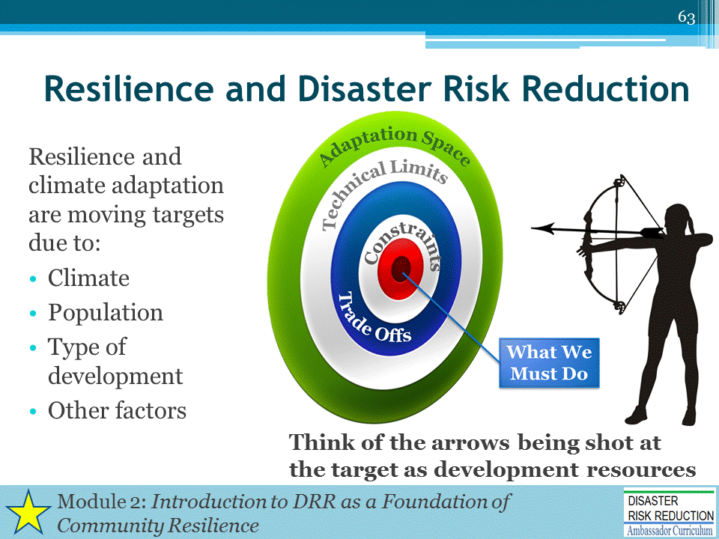
Recall from Module 2 that our goal of disaster risk reduction and community resilience is:
- Shown as a moving target, just as climate varies and changes; and
- Shown as a bullseye, at which we shoot the arrows of community development resources both public and private, all too often not aligned in real world community development practice with anything resembling resilience.
  - The target is instead on actions which may well benefit one stakeholder in the short term, but are externalized such that the bulls-eye ends up on the head or chests of innocent bystanders like: the taxpayer, the environment, threatened and endangered species, the economy etc.
  - Development resource arrows thus go all over, maladaptively cutting down and possibly murdering those innocent bystanders.

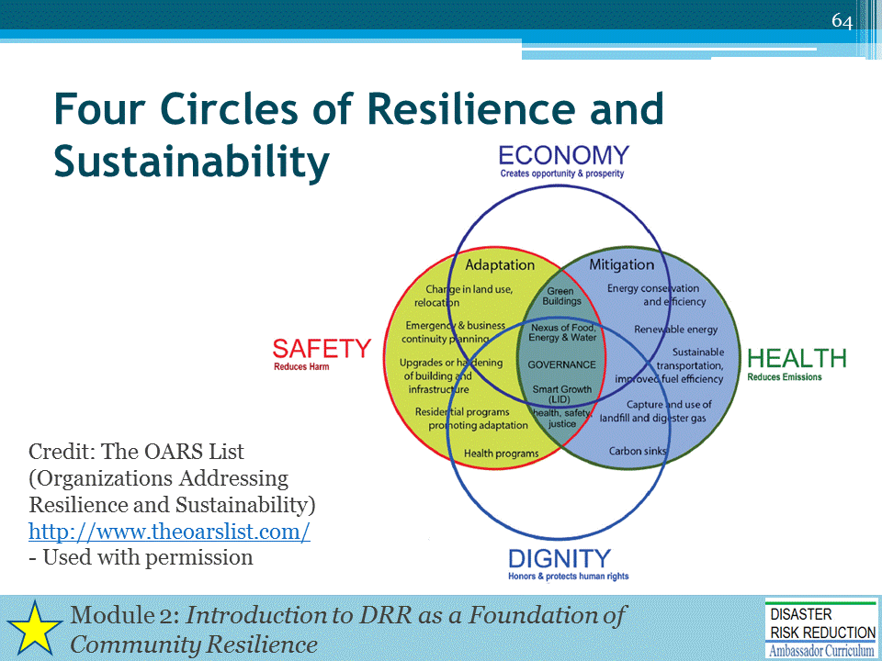
Recall from Module 2 these Four Circles of Resilience and Sustainability represent an approach to "lift all boats" to capture the largest constituency.
From The OARS List website (http://www.theoarslist.com/about.html):
“The nexus of public health, safety, economic and humanitarian values
Policies and practices for health and safety, environmental conservation and protection, emergency management and disaster response, job creation and economic opportunity—fashioned over decades in separate laws and practices—are interconnected and mutually dependent, with human dignity an overriding pledge of ethical / religious values and civic governance to establish fairness and justice for all. A weak-link or failure of one cannot be addressed alone or apart. The advancement of one helps all.”
Four Circles
- Economy: Creates opportunity and property
- Health: Reduces emissions
- Dignity: Honors and protects human rights
- Safety: Reduces harm
Climate Adaptation
- Actions taken to help communities cope with changing climate condition
- Actions taken to lower the risks posed by the consequences of climatic changes
Mitigation
“Mitigation is the effort to reduce loss of life and property by lessening the impact of disasters” ~ FEMA

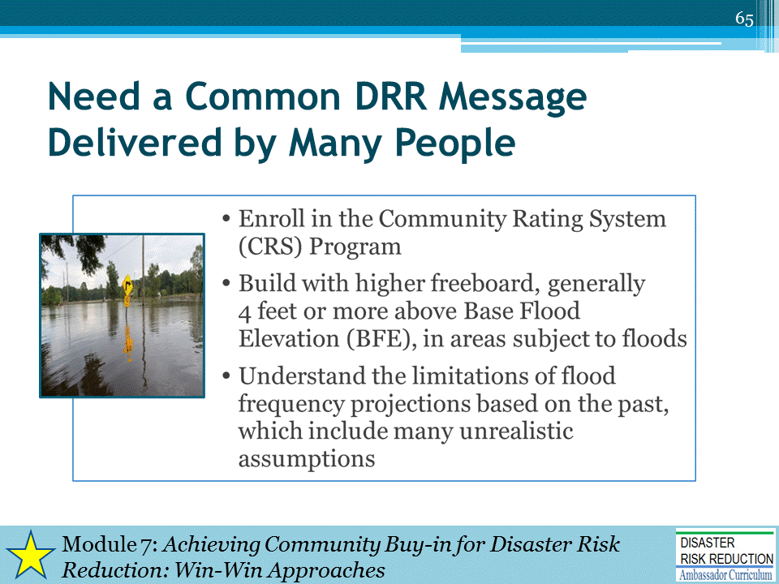
Recall from Module 2 that it is important to repeatedly deliver knowledgeable messages of disaster vulnerability reduction, safety, and security, with regional and locally based mitigation suggestions.
- Also, regarding the “4-feet or more above BFE” message: many States and communities have incorporated freeboard requirements into the elevation and floodproofing requirements stipulated by the NFIP. Freeboard requirements range up to 4 feet, and it is up to the community to decide what is most appropriate given their location and other community conditions.

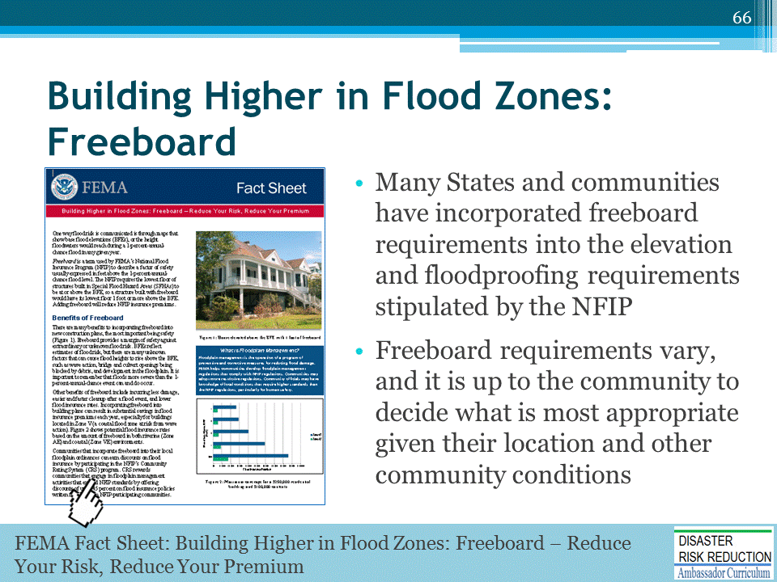
FEMA Fact Sheet: Building Higher in Flood Zones: Freeboard – Reduce Your Risk, Reduce Your Premium (https://www.fema.gov/media-library-data/1438356606317-d1d037d75640588f45e2168eb9a190ce/FPM_1-pager_Freeboard_Final_06-19-14.pdf)

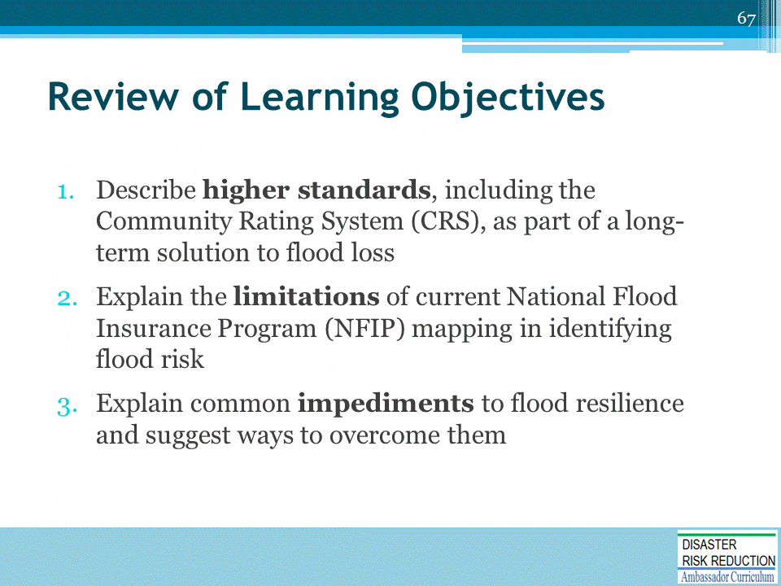
Discussion to engage participants and to assist achievement of Learning Objectives (repetition and review)
For example, ask attendees to discuss and answer:
- Describe two ways the CRS contributes to the long term solution to flood loss.
- List three limitations of current NFIP mapping.
- List three common impediments to flood resilience/safe development and ways to overcome them.

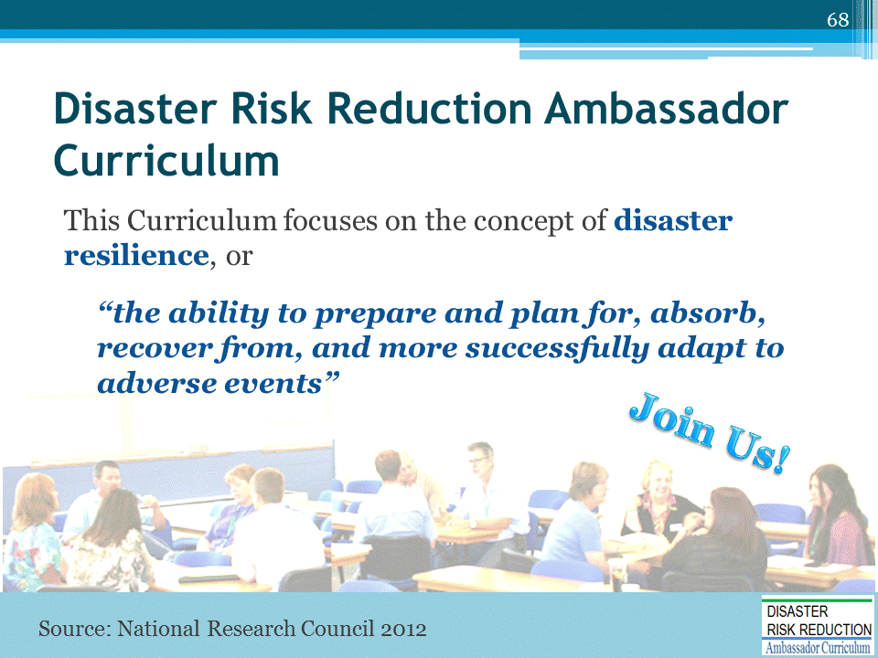
Refer participants to the DRR Ambassador Curriculum At-a-Glance table, located in their Participant Guide.
(If available, refer to the DRR Ambassador Curriculum poster)
- Encourage the audience members to take advantage of the wide array of DRR Curriculum modules offered through workshops and webinars
- Provide information on upcoming workshops and webinars

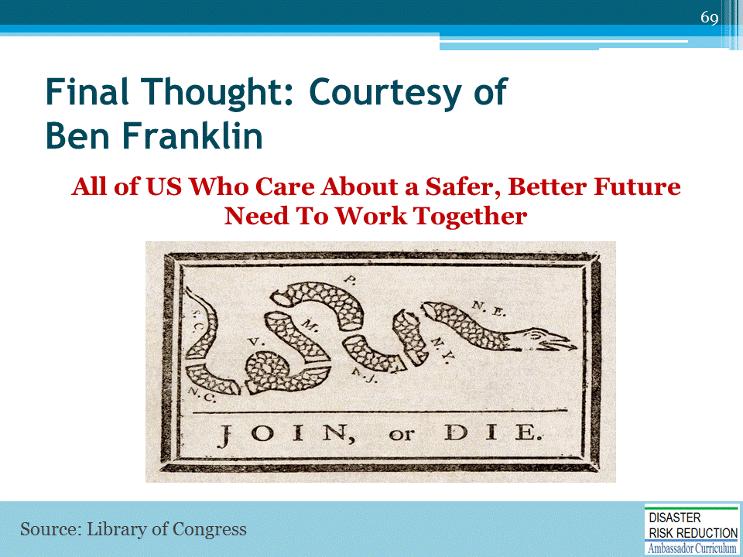

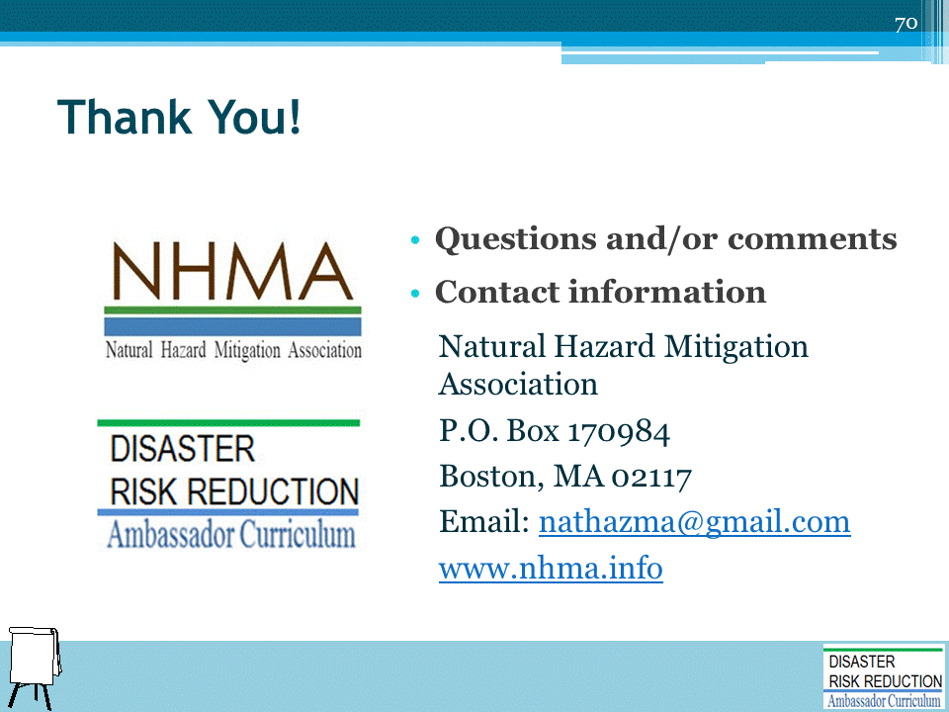
Record on easel pad any recommendations or questions to be addressed outside of the presentation.

DRR AMBASSADOR CURRICULUM AT-A-GLANCE
I. Disaster Risk Reduction for a Safe and Prosperous Future
1 | Introduction to the Natural Hazard Mitigation Association and Disaster Risk Reduction Ambassador Curriculum
2 | Introduction to Disaster Risk Reduction as a Foundation of Community Resilience
3 | Leadership for Disaster Risk Reduction
4 | Community Disaster Risk Reduction and Adaptation
5 | Approaching the Challenge of Disaster Risk Reduction: NIST Community Resilience Guide
II. Forming a Community’s Vision for Disaster Risk Reduction
6 | Risk Assessment through Storytelling: An Asset-Based Approach
7 | Achieving Community Buy-in for Disaster Risk Reduction: Win-Win Approaches
8 | Leveraging Resources to Improve Disaster Risk Reduction
III. Realizable, Practical, and Affordable Approaches for Moving from a Vision for Disaster Risk Reduction to a Strategy
9 | Selecting and Implementing a Strategy for Addressing Community Disaster Risk Problems
10 | Integrating Hazard Mitigation into Local Planning
11 | Beyond Codes and Low-Impact Development
12 | Creating the Plan: A Sustainable Floodplain Management Process Model
IV. Resources and Tools for Implementing a Community’s Disaster Risk Reduction Strategy
13 | Climate and Weather Tools and Trends
14 | Risk Assessment Basics
15 | Legal and Policy Opportunities for Disaster Risk Reduction
16 | Linking Catastrophe Insurance to Disaster Risk Reduction
V. Resources for Hazard-Specific Disaster Risk Reduction
17 | Living with Water: Inland and Coastal Flooding
18 | Design for Flood Resilience: Part I: Floodplain Management and Flood Resistant Design
19 | Design for Flood Resilience: Part II: Green Infrastructure / Low Impact Development
20 | Overcoming Impediments to Flood Resilience: Paths Forward
21 | Wildfire Mitigation
22 | The Wildfire-Flood Connection
23 | Severe Thunderstorm/Tornado Safe Rooms
24 | From Policy to Engineering: Earthquake Risks

