AIA Floodplain Design Course
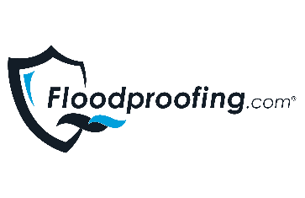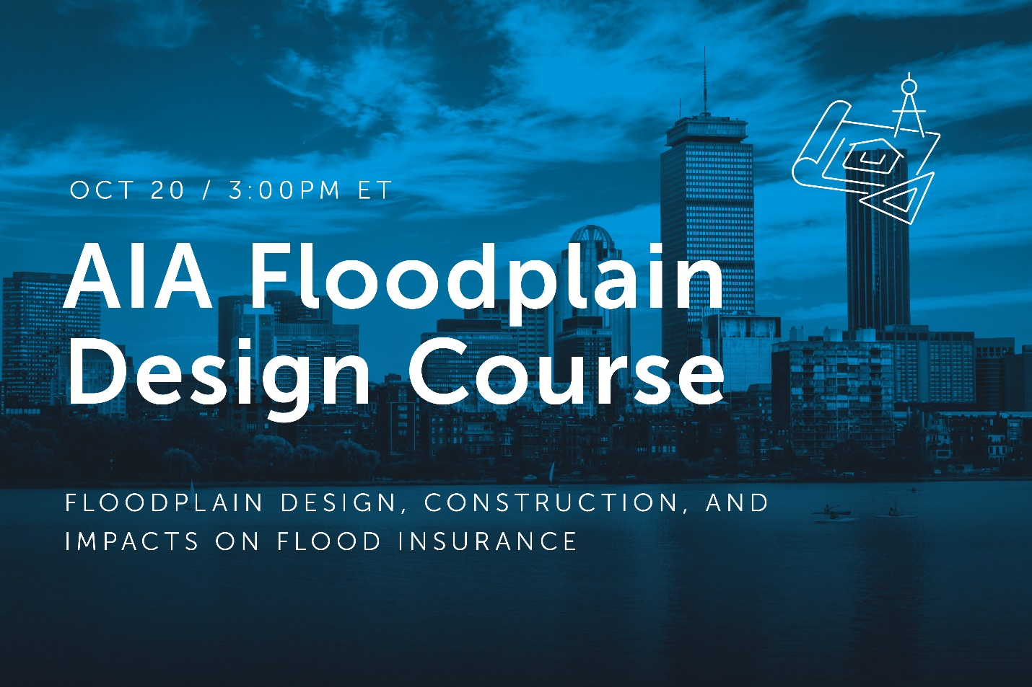

Join us TOMORROW for our AIA Floodplain Design Course!

Our national monthly AIA Floodplain Design Course, Floodplain Design, Construction, and Impacts on Flood Insurance is TOMORROW at 3PM ET. Be sure to join us and receive CEU credits!
WE WILL:
• Describe floods, floodplains, and the potential hazards to buildings
• Explain the differences between wet floodproofing and dry floodproofing techniques and acceptable applications
• Identify regulations, codes, and standards as they relate to sustaining foundations in flood hazard areas
• Analyze the role of building compliance in securing lowering flood insurance rates and what mitigation solutions are available
Can't make it? Take a look at the remainder of our 2021 schedule and register for any other desired course(s)!
Credit: 1 AIA-HSW, 1 CFM-CEC | AIA Provider #: T058 | AIA Program #: FP04

REGISTER NOW!

Check Out Our Flood Protection Products Online

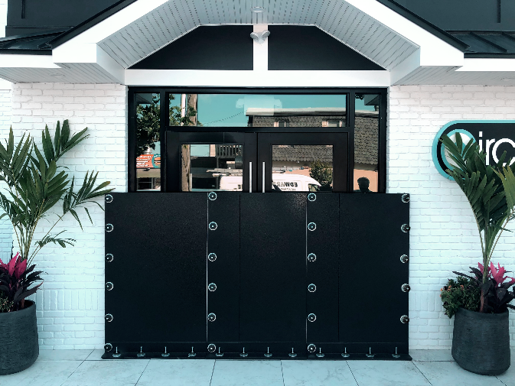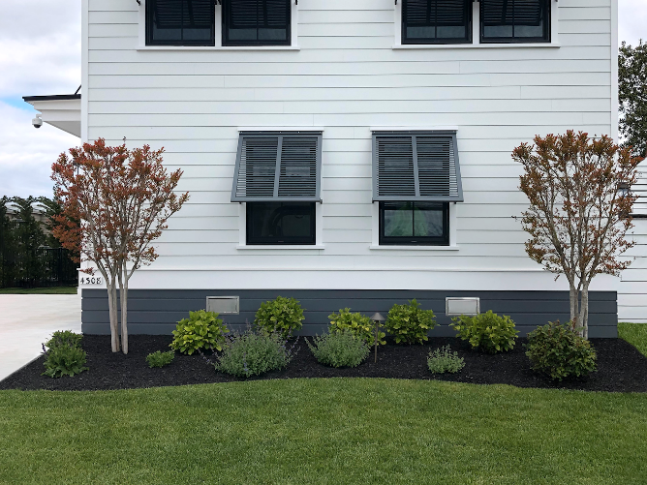
DRY FLOODPROOFING WET FLOODPROOFING

The Flood Design Team

The Flood Design Team of Floodproofing.com is an experienced group of Certified Floodplain Managers and Engineers that provide a complimentary, in-depth analysis of your project in the floodplain, in order to recommend the best flood protection solutions that meet your needs.

• Helps navigate the complex codes and standards associated with building in a floodplain, so you can design smarter, safer and more efficiently
• Provides the perfect solution for your project from our portfolio of products, helping you fit in your budget, improve timelines, and alleviate issues
• Delivers an in-depth design analysis complete with custom 3-part specs, floodproofing approach, & schedule that will free you up to focus on other design aspects
Start the process by clicking below or emailing plans@floodproofing.com.
LEARN MORE

Do You Have Our Updated 3-Part Specs?

Over the course of time, we have been continually updating our 3-Part Specs for all of our products. For the most up-to-date specs of Smart Vent's Engineered Flood Vents, Custom FRA Flood Panel, Standardized ILC Flex-Cover® Door, FENEX Flood Window, and more, click the link below to visit our Floodproofing.com 3-Part Specs library!

DOWNLOAD 3-PART SPECS

GET IN TOUCH

1 (800) 507-0865
info@floodproofing.com

Copyright © 2021 Floodproofing.com®, All rights reserved.
Our mailing address is:
Floodproofing.com
430 Andbro Drive, Unit 1,
Pitman, NJ 08071
Want to change how you receive these emails?
You can update your preferences or unsubscribe from this list.

