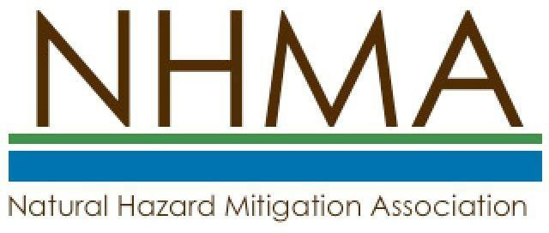

Corporate / Institutional/Partnership / Student Chapter
Membership Application Form

Name: Organization: Title:
Mailing Address: City: State/ZIP/Country: Phone:
Email:

□ Please send me additional information on NHMA.

Enclosed is a check for dues for members for this Calendar Year in the following amount(s):
□ Institutional/Partnership - $250 (includes up to 5 Professional members)
Please indicate Affiliate members below:
1. Affiliate Name: ______________________ E-mail: _________________________
2. Affiliate Name: ______________________ E-mail: _________________________
3. Affiliate Name: ______________________ E-mail: _________________________
4. Affiliate Name: ______________________ E-mail: _________________________
5. Affiliate Name: ______________________ E-mail: _________________________

□ Corporate Membership - $500 (includes up to 10 Professional members)
Please indicate Affiliate members below:
1. Affiliate Name: ______________________ E-mail: _________________________
2. Affiliate Name: ______________________ E-mail: _________________________
3. Affiliate Name: ______________________ E-mail: _________________________
4. Affiliate Name: ______________________ E-mail: _________________________
5. Affiliate Name: ______________________ E-mail: _________________________
6. Affiliate Name: ______________________ E-mail: _________________________
7. Affiliate Name: ______________________ E-mail: _________________________
8. Affiliate Name: ______________________ E-mail: _________________________
9. Affiliate Name: ______________________ E-mail: _________________________
10. Affiliate Name: ______________________ E-mail: _________________________

□ Student Chapters - $250 (includes up to 20 student members)
Please indicate Affiliate members below:
1. Affiliate Name: ______________________ E-mail: _________________________
2. Affiliate Name: ______________________ E-mail: _________________________
3. Affiliate Name: ______________________ E-mail: _________________________
4. Affiliate Name: ______________________ E-mail: _________________________
5. Affiliate Name: ______________________ E-mail: _________________________
6. Affiliate Name: ______________________ E-mail: _________________________
7. Affiliate Name: ______________________ E-mail: _________________________
8. Affiliate Name: ______________________ E-mail: _________________________
9. Affiliate Name: ______________________ E-mail: _________________________
10. Affiliate Name: ______________________ E-mail: _________________________
11. Affiliate Name: ______________________ E-mail: _________________________
12. Affiliate Name: ______________________ E-mail: _________________________
13. Affiliate Name: ______________________ E-mail: _________________________
14. Affiliate Name: ______________________ E-mail: _________________________
15. Affiliate Name: ______________________ E-mail: _________________________
16. Affiliate Name: ______________________ E-mail: _________________________
17. Affiliate Name: ______________________ E-mail: _________________________
18. Affiliate Name: ______________________ E-mail: _________________________
19. Affiliate Name: ______________________ E-mail: _________________________
20. Affiliate Name: ______________________ E-mail: _________________________

Make checks payable to: NHMA Mail application to
Natural Hazard Mitigation Association PO Box 170984
Boston, MA 02117

www.nhma.info

