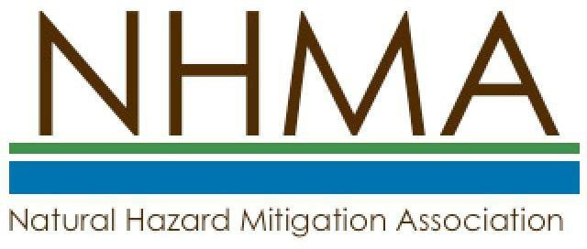

Name: Organization: Title:
Mailing Address: City: State/ZIP/Country: Phone:
Email:

□ Please send me additional information on NHMA.

Enclosed is a check for dues for members for this Calendar Year in the following amount(s):
□ Professional - $75
□ Student - $15
□ Retiree - $15
□ Institutional/Partnership - $250 (includes up to 5 Professional members)
*Please Use NHMA Corporate / Institutional / Student Chapters Membership Form.
□ Corporate Membership - $500 (includes up to 10 Professional members)
*Please Use NHMA Corporate / Institutional / Student Chapters Membership Form.
□ Student Chapters - $250 (includes up to 20 student members)
*Please Use NHMA Corporate / Institutional / Student Chapters Membership Form.

Make checks payable to: NHMA
Mail application to
Natural Hazard Mitigation Association PO Box 170984
Boston, MA 02117

www.nhma.info

